Original Research Article
Isolation, Purification and pathogenicity of Fusarium oxysporum f. sp. ciceris causing chickpea wilt.

ABSTRACT
Fusarium wilt incited by Fusarium oxysporum f. sp. ciceri is a soil borne fungus that is a permanent threat to the chickpea (Cicer arietinum L.) causing wilt disease. Chickpea plant showing typical wilt symptoms were collected from three different chickpea cultivating districts of Telangana. The pathogen was isolated from infected chickpea plants in roving survey conducted during rabi 2024-2025 and purified. Further its cultural and morphological characteristics were studied for identification. The results of the analysis showed that the pathogen cultivated on PDA media had morphological characteristics of macroconidia, microconidia, and chlamydospores and cultural characteristics of mycelium colour, texture, pigmentation, type, and radial growth, all of which are consistent with Fusarium oxysporum f. sp. ciceris. Koch’s postulates were performed by standard method for all eight isolates and they gave different response in form of varied disease incidence. Among eight isolates one isolate FOC 3 showed high pathogenicity, i.e more than 75 % of pathogenicity. On the basis of cultural, morphological and pathogenicity test, the fungal pathogen was confirmed as F. oxysporum f. sp. ciceri. The study helped to solve this problem by offering important insights into the pathogen, which in turn helped to develop affordable ways to manage chickpea wilt disease and boost crop output for the farmers.
INTRODUCTION
Chickpea (Cicer arietinum L.), 2n = 16 commonly called as gram or bengal gram, is the second most important leguminous crop after dry beans in tropical, subtropical and temperate regions and is greatly valued for its nutritional qualities and improvement of soil fertility. It is a bushy annual plant of the pea family, with short, hairy pods containing usually two seeds.
Chickpea seeds are major source of human food and animal feed because of their high content of lysine-rich protein. Among pulses, chickpea is an important cool season legume crop rich in nutrients and an important source of energy (Jukanti et al. 2012). Chickpea is a good source of carbohydrates and proteins, which together constitute about 80% of the total dry seed mass. The starch content of chickpea has been reported to vary from 41% to 50%. The crude protein content of chickpea varies from 12.4% to 31.5%. Chickpea contains about 6% fat that is important in the vegetarian diet for poor consumers. It is also rich in minerals like iron, magnesium, phosphorous and potassium. It also has vitamin B₁ and B₆ in abundance (Hirdyani et al. 2014). It is mainly grown for its highly proteinated edible seeds, this crop can be used for both seed and forage production (Yadav et al. 2011).
Chickpea is affected by various biotic and abiotic stresses; The major abiotic constraints affecting the crop are moisture stress, heat, drought, cold and salinity. Biotic stresses are mainly due to variety of pathogens such as bacteria, fungus, viruses, mycoplasma and nematodes. This crop is infected with 172 pathogens and among these, fungi are predominantly associated with the major diseases. The major fungal diseases affecting the crop are Ascochyta blight (Didymella rabiei), Fusarium wilt (Fusarium oxysporum f. sp. ciceris), dry root rot (Rhizoctonia bataticola), botrytis grey mold (Botrytis cinerea) and collar rot (Sclerotium rolfsii). Among these, Fusarium wilt is most devastating and major cause for low productivity of chickpea in India (Sunkad et al. 2019). The disease is widespread in chickpea growing areas of the world and is reported from atleast 33 countries causing 10-15% annual losses (Nene et al. 1996; Singh and Dahiya, 1973).
Fusarium wilt is the most important soil-borne disease of chickpea throughout the world. Butler in 1918 for the first time identified Fusarium wilt disease in India. The wilt fungus is primarily root inhabiting, seed and soil-borne pathogen which survives in soil for 4-5 years. Wilt symptoms appearing 20–30 days after sowing are termed early wilt, while those manifesting during the flowering-podding stage are referred to as late wilt. Early wilt results in a yield decline of 77–90%, whereas late wilt causes losses of 24–65%, Partial wilt occurs when only certain plant parts wilt (Jimenez-Diaz et al. 2015). It is typical vascular disease, causing xylem browning or blackening which shows wilting at differential growth stages and influences the yield loss. In India, the average annual yield loss due to Fusarium wilt was around 10-15 per cent (Dubey et al. 2007). Eight races of this pathogen have been reported, of which six (1A, 2, 3, 4, 5 and 6) cause wilting symptoms (Gowda et al. 2009). Similarly, in northwestern Mexico, races 0, 1B/C, 5 and 6 were identified (Arvayo-Ortiz et al. 2011). These races exhibit variations in pathotypes and geographic distributions, with races IA and 6 categorized as wilting pathotypes, while races 0 and 1B/C are designated as yellowing pathotypes (JimenezGasco et al. 2001).
Host plant resistance is major environmental approach for controlling this disease. High pathogenic variability and evolution of new races of pathogen is resulting in the loss of resistance by new varieties of the crop. So, to develop new resistant varieties with durable resistance, identification of existing pathogenic variability is necessary. Keeping this in view, we have carried out this research in order to know the cultural, morphological characteristics and pathogenic of isolates from three different chickpea cultivating districts of Telangana.
MATERIALS AND METHODS
The research was undertaken during the rabi (November– March, 2024-25) at the Department of Plant Pathology and Central Instrumentation Cell, Professor Jayashankar Telangana State Agricultural University, Rajendranagar, Hyderabad, Telangana, India. The study focused on the Isolation, Purification and Pathogenic variability of Fusarium oxysporum f. sp. ciceris inciting wilt disease in chickpea.
2.1. Collection of samples
During the Rabi season of 2024-25, a roving survey was conducted in the chickpea growing areas of Adilabad, Nizamabad and Jogulamba Gadwal districts in Telangana state to collect infected samples of chickpea wilt and to assess the incidence of wilt disease caused by F. oxysporum f. sp. ciceris). The survey was conducted in fields where local varieties like Annigeri, JG 11 was most frequently grown by the farmers.
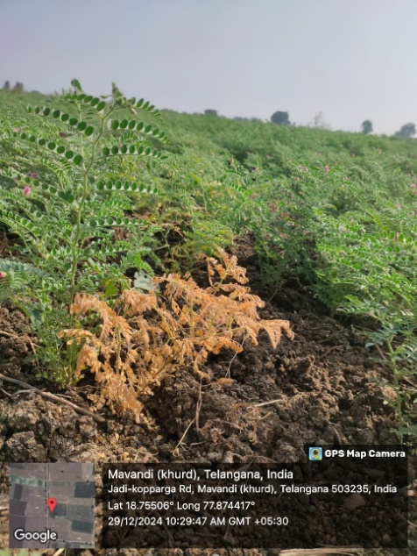
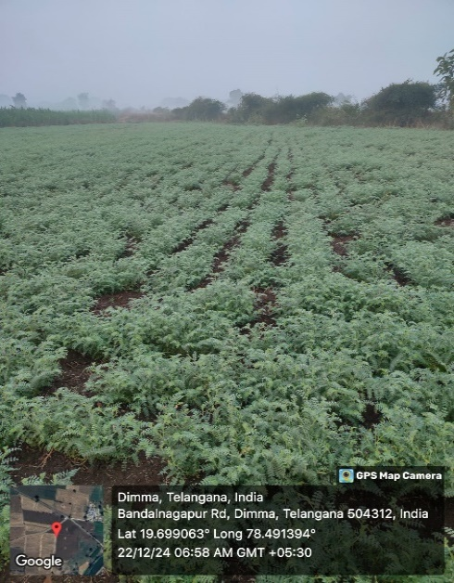
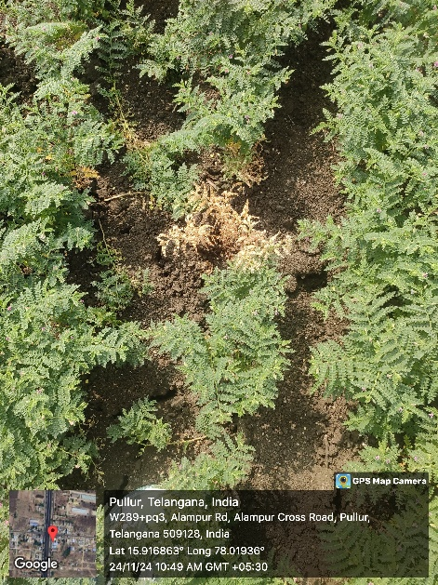
Figure 1 and 2: Wilt infected chickpea plants during roving survey 2024-2025

Figure 3: Healthy plants during roving survey 2024-2025

2.2 Symptomology
Erwin (1957) characterized chickpea wilt by yellowing of leaves and necrosis of the xylem. Leaves of the wilted plants turned greyish green, then became dull yellow and wilted. The xylem and pith become darkened and discoloured. Westerlund et al. (1974); Prasad and Padwick et al., (1939) found that the disease occurs at seedling and flowering stage of plant growth. The symptoms which can be observed are drooping of petioles and rachis, yellowing and drying of leaves from base to upward, browning of vascular bundles, improper branching, withering of plants and finally death of plants. Pande et al. (2007) stated that Fusarium wilt of chickpea is seed-borne and seeds harvested from wilted plants when mixed with healthy seeds can carry the wilt fungus to new areas and can establish the disease in the soil to economic threshold levels within three seasons.
Isolation of Fusarium oxysporum f.sp. ciceri isolates
Few wilted plants of chickpea were collected from different farmer’s field different districts of Telangana and surface sterilized was done with 2 per cent sodium hypochlorite (Rangaswamy and Mahadevan, 1999). The samples are cut into pieces of disease part along with healthy tissue. These pieces are place aseptically on sterilized Potato Dextrose Agar (PDA) medium in Petri plates. Pure culture was done by transfer of a pinch of mycelium on sterilized PDA medium in Petri plates and incubated in BOD at 28 ± 2℃ (Aneja, 2003). The fungus was identified by colony growth, pigmentation and microscopic characteristics of F. oxysporum f. sp. ciceri. The isolates of the pathogen were primarily identified based on colony characters and spore morphology (Booth, 1971).
Cultural and Morphological variability
In order to study cultural characteristics, 5 mm mycelia bits of each and every isolate were taken from the actively growing cultures and centrally placed on 90 mm Petri plates containing sterilized PDA medium. After inoculation Petri plates were incubated at 28 ± 2℃ for 7 days. Each plate is replicated three times. After seven days radial growth of pathogen was recorded. others characteristics viz; pigmentation, sporulation of different isolates was recorded by observing culture plate after complete growth of the mycelium which showed slight pinches of colour. In morphological studies were carried out by taking small amount of mycelium from fourteen days old pure culture plates using a sterile needle and transferred onto a cleaned glass slide. The culture was taken from five different positions of the culture plate, four from adjacent side and one from middle. The mycelium was stained with 0.1 % lactophenol cotton blue and observed under compound microscope. Spores size was measured by software Y W Camera.
Pathogenicity test
In pathogenicity test the susceptible variety JG 62 was used. Twenty seeds of the susceptible variety were sown in surface sterilized earthen pots (37% formaldehyde) filled with 1 kg of sterilized soil inoculated with 10 days old pathogen multiplied on sorghum grain 100 g sterilized at 15 mins and 121 pounds of pressure. The inoculum of each isolate of Fusarium oxysporum f. sp. ciceri was prepared on half boiled sorghum media and incubated at 28⁰C for 10 days. These inoculums were used for soil inoculation at 40 g kg⁻¹ soil in all the pots. Three replications of each isolate were maintained including the control (Kala et al. 2016). The pots were regularly watered to maintain sufficient moisture needed by the plants. Wilt symptoms developed was observed for 30 days after sowing and the per cent disease incidence was calculated (Jamil and Ashraf, 2020).
$$percent disease incidence=\frac{Total number of wilted plants per pot}{Total number of plants per pot }×100$$
Results and Discussion
3.1. Isolation and purification of pathogen
The wilt affected chickpea plants were identified in the field based on key symptoms like withering, yellowing of leaves and drying of plants. Roots of wilt infected plants when split open vertically showed brown discoloration of the xylem vessels. The pathogen was isolated from wilt affected plants using tissue segment method on PDA. The fungus was further purified by single hyphal tip method on PDA. Cultural studies revealed differences among isolates in mycelium growth pattern, pigmentation, growth rate and sporulation on PDA media. The variations in morphological traits such as conidia size, shape and colour as well as chlamydospore size, shape and colour across all isolates was recorded as shown in Figure 6 and 7.
Cultural, morphological and molecular characters of different isolates of Fusarium oxysporum f. sp. ciceri
All eight isolates of F. oxysporum f. sp. ciceri were separately grown on PDA in Petriplates and incubated at 28 ± 2ºC for seven days. Observations on cultural characters viz., colony colour and type, growth and pigmentation were recorded a week after inoculation. Morphological characters of spores of different isolates were studied by observing in cotton blue stained slides under imaging microscope. Measurements of macro-micro conidia and chlamydospores were made with the help of imaging microscope which shows size of conidia and diameter of chlamydospores (Figure 4). Sporulation was recorded by microscopic examinations using following scale given by Tuite (1969).
Among eight isolates, colony of three isolates (FOC 4, FOC 5, FOC 8) were observed fuffly growth, while three (FOC 1, FOC 3, FOC 7) had dense cottony mycelium and two had isolate (FOC 2, FOC 6) white mycelium growth. The mycelium colour difference was observed in the isolates as initially they were white then gradually changed with different pigments like light yellow in FOC 1, FOC 2 whereas creamy white in FOC 3, FOC 4 and FOC 6 and yellow white in FOC 5, FOC 7, FOC 8. Sporulation was profuse in FOC 3, it was moderate in FOC 1, FOC 4, FOC 5, FOC 6, FOC 7 and FOC 8. Lowest sporulation was observed in the isolate FOC 2. The radial growth of colony diameter was variable in different isolates ranging from 68 mm in FOC 5 to highest 88 mm in FOC 3 at seven days after inoculation at 26+1⁰C in 90 mm Petri plate. Other isolates FOC 6, FOC 7, FOC 4, FOC 2, FOC 1 and FOC 6 had 70mm, 77mm, 82mm, 86mm respectively as shown in Table 1 and Figure 4.
This has been supported by Patil et al. (2005) who revealed that the isolates of F. oxysporum f. sp. ciceri had variation in number and size of macro and microconidia, cultural characters, growth pattern, pigmentation and sporulation. Venkataramanamma et al. (2019) also studied isolates of Fusarium oxysporum f. sp. ciceri from different districts of A.P. and studied the range of pigmentation and cultural characters are in accordance to the present findings. The largest size of the micro-conidia was obtained from the isolate Foc-14 (3.7× 4.5, 3.1 × 5.0 μm) and the smallest size was from isolates Foc-21 (3.0 × 3.7 μm). Whereas, the biggest size 7.5× 20.10 μm of the macro - conidia was obtained from the isolates Foc-25 and the smallest size of 3.5× 22.5 μm were obtained from isolates Foc-11 respectively

Sample ID | Location | Colony chatacter | Pigmentation | Sporulation | Radial growth (mm) | Type of growth | Macroconidia (μm) |  |  | Microconidia (μm) |  |  | Clamydospores
 |  |  |  |  |  |  | Size | Septation | Shape | Size | Septation | Shape
FOC 1 | Adilabad | Dense cottony white mycelium | Light yellow | ++ | 84 | Fast | 16.89×3.22 | 1 | blunt | 5.45×3.21 | No septa | oval | 8.04
FOC 2 | Adilabad | Cottony white mycelium | Light yellow | + | 82 | Fast | 20.88×3.56 | 1-2 | blunt | 6.25×3.62 | No septa | oval | -
FOC 3 | Adilabad | Dense cottony white mycelium | Creamy white | +++ | 88 | Fast | 16.43×3.72 | 1-3 | sickle | 10.62×3.89 | No septa | oval | -
FOC 4 | Nizambad | Fluffy cottony white mycelium | Creamy white | +++ | 77 | Moderate | 19.20×3.02 | 1-2 | blunt | 4.53×2.34 | No septa | oval | 9.52
FOC 5 | Nizambad | Fluffy cottony  white mycelium | Yellow white | ++ | 68 | Slow | 17.45×4.63 | 1 | sickle | 5.77×2.12 | No septa | oval | -
FOC 6 | Nizambad | Cottony white mycelium | Creamy white | +++ | 86 | Fast | 16.28×3.21 | 1 | blunt | 8.94×4.65 | No septa | oval | -
FOC 7 | Jogulamba Gadwal | Dense cottony white mycelium | Yellow white | ++ | 70 | Moderate | 22.85×4.24 | 1-3 | blunt | 7.62×3.76 | No septa | oval | 8.72
FOC 8 | Jogulamba Gadwal | Fluffy cottony white mycelium | Yellow white | ++ | 84 | Fast | 19.22×3.86 | 1-2 | blunt | 7.58×2.32 | No septa | oval | -
Sporulation – Profuse (+++), Moderate (++), Slightly moderate (+)
Table 1: Cultural and morphological characteristics of isolates of F. oxysporum f. sp. ciceris isolated from different chickpea growing areas of Telangana
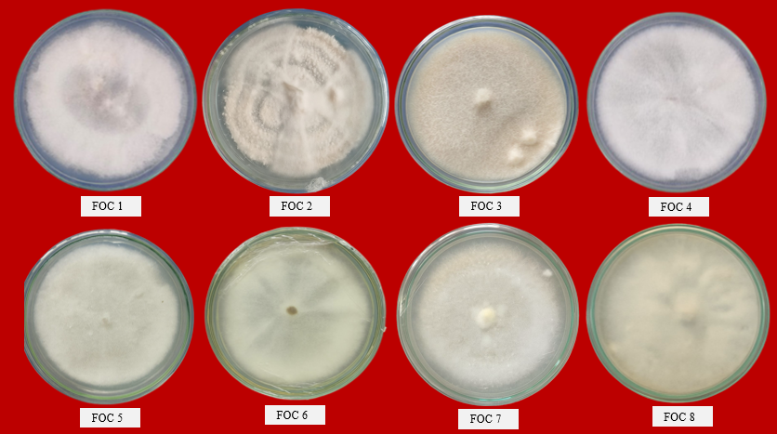
Figure 4: Pure cultures of all the FOC isolates



Figure 6: Subculturing of pathogen
Figure 5: Isolation of pathogen from infected stem bits

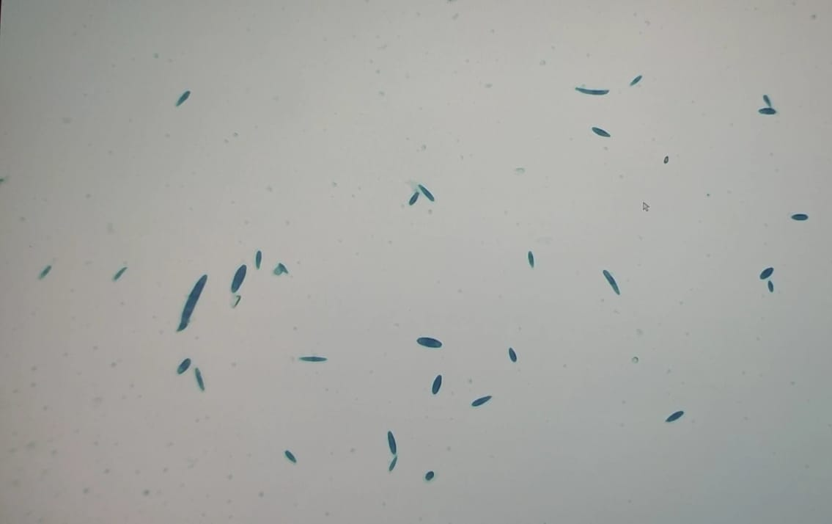

Figure 7: Microconidia and macroconidia of FOC isolate

Morphological variability in isolates
Morphological character such as size, shape, septation and colour of conidia were studied using of PDA medium. Conidiophores were elongated and sparsely branched; each branch usually terminated with a bearing spore. The pathogen bearing two types of asexual spores i.e. macro-conidia and micro-conidia. The size of macro-conidia was ranged from 16.28 x 3.21 µm to 22.85 x 4.24 µm; size of micro-conidia was ranged from 8.94 x 4.65 to 5.45 x 3.21 µm (Table 1). The number of septation is varying with isolates. The isolates FOC 3, FOC 7 showed 3-4 septas whereas FOC 2, FOC 4, FOC 8 showed 2-3 septas. FOC 1, FOC 5 and FOC 6 showed only 2 septa. Most of the isolates showed macroconidia with blunt ends whereas FOC 3 and FOC 5 showed sickle shape macroconidia. In microconidia all the isolates showed oval shape. All the isolates showed hyaline conidia. Clamydospores production was only found in FOC 1, FOC 4 and FOC 7 with diameter 8.04, 9.52 and 8.72 respectively as shown in Table 1 and Figure 8.
Honnareddy et al. (2007) studied morphological characters like shape, size of microconidia, macroconidia and chlamydospores with temporary slides prepared in lactophenol and cotton blue under calibrated compound microscope to determine the variation in morphology of the isolates.
Pathogenic variability in isolates
In pathogenicity test, pot culture experiment was done and on the basis of percentage of wilt isolates are graded different way. Isolate FOC 4 and FOC 8 showed least disease incidence of 25 to 50 %. FOC-1, FOC-2, FOC-5, FOC 6 and FOC -7 isolates is showed 50.1 to 75 % wilt, which are considered as pathogenic isolates. Isolate FOC-3 showed more than 75% wilt, graded at highly pathogenic isolates. Golakiya et al. (2018) studied pathogenic nature of fifteen isolates tested on chickpea wilt susceptible cultivar JG-62 among which two isolates (Char, Choki) were found non-pathogenic which gave zero percent disease incidence (PDI), while one isolate (Chittal) found highly pathogenic as shown in Table 2 and Figure 8
Table 2: Pathogenicity of isolates
Sl No. | Isolates | Pathogenicity | Reaction
1 | FOC 1 | +++ | Pathogenic
2 | FOC 2 | +++ | Pathogenic
3 | FOC 3 | ++++ | Highly pathogenic
4 | FOC 4 | ++ | Moderately pathogenic
5 | FOC 5 | +++ | Pathogenic
6 | FOC 6 | +++ | Pathogenic
7 | FOC 7 | +++ | Pathogenic
8 | FOC 8 | ++ | Moderately pathogenic

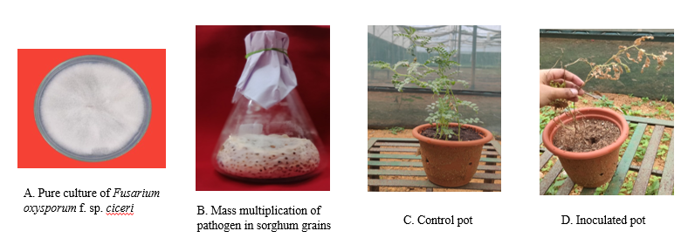
Figure 8: Pathogenicity test

CONCLUSION
In the present study cultural, morphological and pathogenic variability of some isolates causing wilt of chickpea in different districts of Telangana showed that the radial growth of colony diameter was different of different isolates. The colony diameter was ranged from 88 mm to 68 mm at seven days after inoculation at 26±10C in 90 mm Petri plates. Initially the colour of all isolates was white which changed gradually with different pigments like creamy white, yellow white, light yellow etc. Growth of the isolates, some are cottony like, some are dense and some are fluffy growth. The size of macro-conidia was ranged from 16.28 x 3.21 µm to 22.85 x 4.24 µm; size of micro-conidia was ranged from 8.94 x 4.65 to 5.45 x 3.21 µm. The shape of macro-conidia is mostly blunt but sickle in few isolates and micro-conidia are round to oval. Among all isolates FOC 3 showed highest pathogeniciy causing wilt disease of chickpea. The present investigation has generated information for epidemiology and evolutionary potential of this pathogen and could help in development of improved practice for managing Fusarium wilt disease of chickpea.
REFERENCES
Aneja, K.F., 2003. Experiments in microbiology, plant pathology and biotechnology, 4th edition. New Age International Publishers. New Delhi 30–105.
Arvayo-Ortiz, R.M., Esqueda, M., Acedo-Felix, E., Sanchez, A., Gutierrez, A., 2011. Morphological variability and races of Fusarium oxysporum f. sp. ciceris associated with chickpea (Cicer arietinum) crops. American Journal of Agricultural Biological Sciences. 6(1):114–121.
Booth, C. (1971). The genus Fusarium, Commonwealth Mycological Institute, Kew (Surry), England, 137.
DES 2023, MOAF&W, GOI.
Dubey, S. C., Suresh, M and Singh, B., 2007. Evaluation of Trichoderma species against Fusarium oxysporum f. sp. ciceris for integrated management of chickpea wilt. Biological control. 40(1): 118-127.
Erwin, D. C. (1957). Fusarium and Verticillium wilt diseases of Ciceris arietinum L Phytopathology 47: 10.
Golakiya, B. B., Bhimani, M. D and Akbari, L. F., 2018. Characterization of Indian isolates of Fusarium oxysporum f. sp. ciceri causing chickpea wilt. International Journal of Current Microbiology and Applied Sciences. 7(3): 1152-1162.
Gowda, S. J. M., P. Radhika, N. Y. Kadoo, L. B. Mhase and V. S. Gupta. 2009. Molecular mapping of wilt resistance genes in chickpea. Molecular Breeding. 24(2): 177-183.
Hirdyani, H., 2014. Nutritional composition of chickpea (Cicer arietinum L.) and value-added products. Indian Journal of Community Health. 26: 102-106.
Honnareddy, N and Dubey, S. C., 2007. Morphological characterization of Indian isolates of Fusarium oxysporum f. sp. ciceri causing chickpea wilt. Indian Phytopathology. 60(3): 373-376.
Jamil, A., Ashraf, S., 2020. Utilization of chemical fungicides in managing the wilt disease of chickpea caused by Fusarium oxysporum f. sp. ciceri. Archives of Phytopathology and Plant Protection. 53(17–18): 876–898.
Jiménez-Díaz, R. M., Castillo, P., del Mar Jiménez-Gasco, M., Landa, B. B and Navas-Cortés, J.A., 2015. Fusarium wilt of chickpeas: Biology, ecology and management. Crop Protection. 73: 16-27
Jimenez-Gasco, M., Perez-Artes, E., Jimenez-Diaz, R.M., 2001. Identification of pathogenic races 0, 1B/C, 5, and 6 of Fusarium oxysporum f. sp. ciceris with random amplified polymorphic DNA (RAPD). European Journal of Plant Pathology. 107(2): 237–248.
Kala, C., Gangopadhyay, S. and Godara S. L. 2016. Eco-friendly management of wilt caused by Fusarium oxysporum f. sp. ciceri in chickpea. Legume Research - An International Journal. 39(1):129-134.
Nene, Y.L., Sheila, V.K. and Sharma, S.B. (1996). A world list of chickpea (Cicer arietinum) and Pigeonpea (Cajanus cajan (L.) Millsp.) pathogens.5th edu. ICRISAT, Patancheru, India, 27.
Padwick, G.W., 1941. The genus Fusarium VI. A recent attempt at mass revision. Indian Journal of Agricultural Sciences. 11(5): 663–74.
Patil, P. D., Mehetre, S. S., Mandare, V. K. and Dake, G. N. 2005. Pathogenic variation among Fusarium isolates associated with wilt of chickpea. Annals of plant protection science. 13:427-430.
Pande, S., Rao, J. N. and Sharma, M. (2007). Establishment of the Chickpea Wilt Pathogen F. oxysporum f. sp. ciceris in the Soil through Seed Transmission. Plant Pathology Journal. 23(1): 3-6.
Prasad, N. and Padwick, G. W. (1939). The genus Fusarium 11. A species of Fusarium as a cause of wilt of gram (C. arietinum L.). Indian Journal of Agricultural Sciences. 9: 731.
Rangaswamy, G and Mahadevan, A. 1999. Diseases of crop plants in India (4th edition), Prentice Hall of India Pvt. Ltd., New Delhi. 607.
Singh, K.B. and Dahiya, S.S. (1973). Breeding for wilt in chickpea. Symposium on wilt problem and breeding for wilt resistance in Bengal gram. September 1973 at Indian Agricultural Institute, New Delhi, India: 13-14.
Sunkad, G., Deepa, H., Shruthi, T. H and Singh, D. 2019. Chickpea wilt: status, diagnostics and management. Indian Phytopathology. 72: 619-627.
Tuite, J. 1969. Plant Pathological Methods Fungi and Bacteria. Burgess Publishing Company Minneapolis. Minnesotta. 239.
Venkataramanamma, K., Reddy, B. V., Saradajayalakshmi, R., Jayalakshmi, V. and Prasad, K. V., 2023. Identification of races of Fusarium oxysporum f. sp. ciceris, inciting wilt of chickpea in Andhra Pradesh and parts of Telangana. Legume Research-An International Journal. 46(4): 506-512.
Westerlund, F. V., Campbell, R. N and Kimble, K. A. (1974). Fungal root rot and wilt of chickpea in California. Phytopathology. 64: 432–436.
Yadav J., Verma, J. P., Tiwari, K. N. 2011. Plant growth promoting activities of fungi and their effect on chickpea plant growth. Asian Journal of Biological Sciences. 4 (3): 291– 299.

