*Original Research Article*

Market gardening in the town of Sarh (Chad): Current situation and production constraints

.

ABSTRACT

|  |
| --- |
| This study aims to assess vegetable production by examining the sociodemographic characteristics of vegetable farmers, cultivated areas, access methods, crop irrigation, soil fertilization, crop diversity, and the constraints that hinder the development of this urban agriculture. It is based on field surveys conducted with vegetable farmers at their production sites. The data collected and processed showed that 84.35% of vegetable farmers are men, compared to 15.65% women, with an average age of 33. With an area of approximately 122,640 m² devoted to market gardening, it appears that the majority of market gardeners surveyed (63.6%) work on an agricultural area of less than 500 m² in the sites surveyed. The most common means of access to land is inheritance, with more than half of market gardeners (51.02%) followed by occupation of public land, with 22.45% of producers surveyed. The study identified a total of 15 vegetable species divided into 13 genera and 8 botanical families at the three market gardening production sites, with a predominance of leafy vegetables, particularly lettuce, which accounts for 47% of total production at the three sites. Market gardening in the city of Sarh continues to face several constraints, including land insecurity, the low level of technical expertise among market gardeners, and difficulties in obtaining agricultural inputs. However, by seriously addressing this land issue and providing technical support to producers, it is possible to move this multifunctional form of agriculture toward a bright future. |

*Keywords: Vegetable production, vegetables, cultivated species, Sarh, Chad*

1. INTRODUCTION

Globally, the urban population is growing fast. According to the United Nations, the number of urban dwellers will rise from 3.6 billion in 2011 to 6.3 billion in 2050 (De Filipe et al, 2015). In Sub-Saharan Africa, the urban population has been growing very rapidly in recent years (Massounga et al, 2025). Africa's urbanization rate will reach 50% by 2035, and 60% to 70% by 2050; that's around 1.2 billion urban dwellers (Batel, 2015). Africa is therefore at the heart of accelerated urbanization. For most African countries, this urbanization took off immediately after independence (Arnaud et al, 1998). It is taking place in a diversified way, as it is not limited to the expansion of a single city, but several, within the same country (Fall and Coulibaly, 2016). The rapid growth of urban populations raises the question of food supply in cities (Olanrewaju et al., 2004).

The demand for nutrients will have to double, just as the production of waste and effluent will quadruple in cities (Moustier and Fall, 2004). What is worrying is how all city dwellers will feed themselves in the current context of food crisis, high unemployment (Bricas et al, 2016; Ndiaye et al, 2010) and climate change (Diedhiou et al, 2018). Policies aimed at slowing or preventing rural exodus have often proved ineffective (Nazal, 2019; Nguegang, 2008). As a result, urban agriculture is becoming an option for tackling the problem of food supply in cities, thereby helping to improve food security for city dwellers. Urban agriculture could be a response to city dwellers' demand for food (Aubry, 2013) and a lever for building competitive, sustainable cities (Dasylva, 2018). It is increasingly recognized for its ability to combat food vulnerability and impoverishment, particularly in cities in the South (Robineau, 2018). Moreover, the underperformance of rural agriculture and the food deficit are further encouraging the development of urban agriculture, which supports thousands of families in the cities of developing countries (De Bon et al, 2010). Although it is often condemned by the authorities, urban agriculture is a reality in most cities in the South (Mougeot, 2006). It occupies a very important and significant part of the economic activities of the population of many cities in sub-Saharan Africa according to recent general trends (Sanni Bio et al., 2023). However, it is therefore necessary to deepen the studies relating to these practices in each of the cases.

In Chad, the government has for many years been faced with the phenomenon of youth migration to urban centers. The major cities are experiencing significant growth rates. The current urban growth rate of 27.6% will reach 41.2% by 2030 (MATUH, 2011). Thus, by 2030, the population of the city of Sarh is expected to be in the range of 258,119 to 294,098 inhabitants, double the current population (132,938 inhabitants) (MATUH, 2011). In addition to its demographic implications (unemployment, underemployment, impoverishment of the majority of urban populations...), this migratory flow has negative repercussions on the environment, available resources and food supplies. What's more, the people who have migrated to the city have abandoned their subsistence farming and production, adding to the number of people they have to feed. Urban agriculture, through its main component market gardening, has become an activity that responds effectively to urban food demand and plays an important socio-economic role in part of the city.

A wide range of actors, in terms of socio-cultural or economic background, are involved in the production and marketing activities of this urban production system. For Nazal (2019), socio-political recognition of the multifunctional nature of this component of agriculture will enable this activity to remain in situ (in the intra- and peri-urban context). Thanks to its multifunctionality, agriculture could constitute a strategic axis of sustainable development of the city of Sarh. The city of Sarh has strong agricultural potential given its climate which provides it with favorable rainfall for diversified agricultural production spread throughout the year. However, agricultural areas are threatened by urbanization in this city. Population growth is sustained. Although there is a craze for urban agriculture, vegetable production is low in relation to the population's needs. In addition, nutritional quality is undermined by the overuse of pesticides, chemical fertilizers and inappropriate practices.

In this context, Sarh's urban farmers are faced with a number of poorly documented production constraints, due in particular to anthropogenic and natural factors. Faced with these challenges, it is important to describe the market garden activities practiced in the town of Sarh and the role these activities play in food supply, and to identify the strategies to be followed in order to support production dynamics. Research results on market garden crops are available (Cissé et al, 2028, Diaité et al, 2020; Ganacadja et al, 2022; Nazal, 2019), however those on vegetable cultivation practices in the town of Sarh are almost non-existent. Nevertheless, research should focus more on the development of appropriate cultivation techniques to improve the nutritional quality of vegetables.

The main objective of this study is to contribute to a better understanding of the practice of urban agriculture in the city of Sarh with a view to encouraging its promotion and development. Specifically, the objective is to diagnose vegetable production practices and identify major production constraints.

2. material and methods

**2.1 Geographical scope of the study**

Located in southern Chad, in the province of Moyen Chari, the town of Sarh lies between 9.150° North latitude and 18.390° East longitude, with an average altitude of 370 m. It lies on the western edge of the Chari River and the eastern edge of the Barh-Kôh River, on a plain of around 3,000 hectares, stretching over 12 km from north to south. With an average annual temperature of around 27.5°C, the town of Sarh has a humid tropical Sudanian climate, ideal for agriculture. The climate is characterized by a dry season lasting approximately 6 months (November to May) and a wet season (June to October), with an average annual rainfall of 1,046 mm (with a maximum of 1,432 mm in 1950 and a minimum of 699 m during 1984). The town of Sarh is bordered by the Chari and Bahr-Kôh rivers. These two rivers join downstream of the town. This hydrographic layout favors market gardening. The pedology of the town of Sarh is essentially made up of 3 types of soil typical of the Sudanian zone: hydromorphic soils, leached ferralitic soils and red, sandy soils at depth. These soils are ideal for agriculture.

**2.2 Choice of production sites**

The geographical scope of the study covers the urban market garden sites of Sarh. Three main market garden production sites were identified. Production, variability, consumption of market garden produce and the importance of market gardening in this town justify the choice of sites. These are the "Kamati", "Tombalbaye" and "Jardin" sites.

**2.3 Sampling and data collection**

In this study, the target population was urban market gardeners, and the random sampling technique was used to select the individuals to be surveyed.

To obtain a representative sample of market gardeners to be surveyed, the sample size was obtained using Schularts' (1995) formula: $n=\frac{t²p(1-p)}{e²}$

With: n=sample size; t=confidence level deduced from the confidence rate (traditionally t=1.96 for a 95% confidence rate for the normal distribution). P= estimated proportion of the population with the characteristic studied in the study; mathematically expressed as: P= n/N

At significance level α=7%; t=1.96. The chosen margin of error is e=0.07.

Based on the P-value (25%) from the exploratory phase of the study, 147 randomly selected market gardeners were surveyed for this study, 49 per market garden site. The data for this study were collected between February and April 2025. The study methodology is based on field surveys using a semi-structured questionnaire among market gardeners in the town of Sarh. The variables selected were those of Moustier et al. (2004), used in the typology of market-garden cropping systems, namely: socio-demographic characteristics of the farmer (age, gender, level of education, marital status, main activity), farm characteristics (land, surface area), labor force, source of water used, fertilizers, phytosanitary products and vegetables grown.

**2.4 Statistical Analysis**

Descriptive statistics (averages, frequencies, graphs) were produced using Excel 2021 spreadsheet software, and STATISTICA software was used to perform the Pearson Chi2 test of independence, a non-parametric test to verify whether there is a link between two variables from the same population.

3. results and discussion

**3.1 Socio-demographic profile of market gardeners**

The main component of urban agriculture in Sarh, market gardening, is mainly a male activity, with women only involved in marketing. In fact, of the sample surveyed, 15.65% were women. This low representation of women can be explained by the physical strength required for this activity. For Ganacadja et al, (2022), the high representation of men is due to the arduousness and constant availability required for maintenance activities on a market garden site, as women are generally called upon to carry out household activities and look after the children. According to Nazal (2019), market gardening requires a quasi-permanent presence on the farms (from morning to night) for maintenance and surveillance in order to avoid damage, given the vulnerability of these crops. Yet women are primarily responsible for domestic activities, so they cannot maintain a constant presence on the farms. The study carried out by Benjamine and Wadou (2023) in the town of Maroua showed that only 14% of women are involved in market garden production. Ganacadja et al, (2022) and Ondo (2011) had reported 1.45% and 5.6% respectively as the proportion of women in three provinces of Gabon and in the Libreville area. In Kampala, men perceive agricultural production as a marginal activity, culturally reserved for women Boland (2005). Studies by Nguegang (2008) in the urban core of Yaoundé also showed that an above-average 65% of market gardeners were women, who took up this activity because of their family responsibilities. On the whole, this relatively young adult population represents a high potential for market gardening in terms of manpower. The age of those surveyed ranged from 16 to 58, but the majority of market gardeners (83%) were under 40. The average age was 33. The results obtained in this work are close to those obtained by Ahouangninou (2013) in the towns of southern Benin, where the average age is 36.7 years. Nazal (2021) and Nguegang (2008) obtained an average age of 36.80 and 35 respectively in N’Djamena and Yaoundé. The dominance of young people was also observed among market gardeners in Ouagadougou, Burkina, by Tarnagda et al. (2017) and in Dakar by Diop (2013). In contrast, Ngakiama et al. (2019) obtained the mean age of market gardeners in the city of Kinshasa of 47.29 years with extremes of 19 and 85 years.

In terms of education, 85.72% of market gardeners were educated, with 42.85% having primary education and 42.17% having secondary education. Those who have never been to school represent 14.28% of growers, while those with a university degree account for 0.68% of market gardeners surveyed. These values are lower than those reported by Nazal (2021), who show that around 39.58% of producers in the city of N’Djamena have a university degree. The proportion of 14.28% of illiterates in this study is slightly below the 22.81% and 34% of illiterates reported respectively by Ganacadja et al (2022) and Sandrine et al (2017). Farming does not necessarily require a high level of education. However, the level of education has an impact on the mastery of farming techniques, farm management, evaluations and decisions in the face of constraints.

Married men are the most numerous in market garden production. They represent 80.95% of those surveyed. In N’Djamena and Niamey, they represent 62.30% (Nazal, 2019) and 73.33% of surveyed growers respectively (Djibo, 2014). 13.60% of single growers are also market gardeners. Widowers and divorcees represent 3.40% and 2.04% of market gardeners respectively.

**Table 1. Characteristics of surveyed producers**

|  |  |  |
| --- | --- | --- |
| Variable | | Frequency |
| Gender | Male | 84.35 % |
| Women | 15.65 % |
| Age | < 20 years | 03.40% |
| 20 – 29 years | 36.73% |
| 30 – 39 years | 42.86% |
| 40 – 49 years | 06.80% |
| ≥ 50 years | 10.20% |
| Marital status | Single | 13.60 % |
| Married | 80.95 % |
| Widowed | 03.40 % |
| Divorced | 02.04 % |
| Education level | Illiterate | 14.28% |
| Primary | 42.85% |
| Secondary | 42.17% |
| Higher | 00.68% |

**3.2 Cultivated areas**

The majority of market gardeners surveyed (63.6%) work on farmland of less than 500 m². A third of growers work on land with an area of less than the average 250 m². Two-thirds, i.e. 40% and 26.67%, farm between 250 and 500 m² and between 500 and 1,000 m² respectively. Figure 2 shows the distribution of market gardeners by surface area class (in m²). Urban market gardeners in Sarh farm small plots (less than 1,000 m²). According to Tano et al, (2011), urban market gardening in Yamoussoukro is also characterized by a majority of farms (69%) with a surface area of between 100 m² and 1,000 m². In Libreville, Ondo (2011) notes areas of between 800 m² and 10,000 m². Confronted with the problem of access to land, Togolese market gardeners farm areas that vary widely from 0.9 are to 1,200 ares (Kanda et al, 2014). In contrast, a study by Doudoua et al (2020) showed that market gardening in Moundou occupies large areas, with 60% of market gardeners having plots larger than 1,000 m².

**Fig. 1. Farmed area class (m²)**

A total area of around 122,640 m² is devoted to the cultivation of market garden produce at the sites surveyed. The proportion of farmland varies according to production site, as shown in figure 3. The difference between surface area and production site is highly significant, i.e. the 2 variables are closely linked and therefore the surface area of producers depends on the production site (ddl =12 and p-value = 0.000 at the 5% threshold). Figure 2 shows the Tombalbaye site as a pioneering market gardening site in the town of Sarh.

**Fig. 2. Production site surface areas**

**3.3 Access to land**

Land is an important production factor in any agricultural activity. Sarh market gardeners have several types of access to land. Figure 4 shows the breakdown by type of land ownership. The most common mode of access is inheritance, with more than the majority of market gardeners (51.02%). Doudoua et al (2020) also found inheritance to be the most common mode of access, with 68.90% of farms surveyed in Moundou. Only 22.45% of market gardeners farm land belonging to the public domain. This means that urban agriculture has not been taken into account in the town's development plan. Most market gardeners (89%) in Togo work on state-owned land, and 9% work on rented land on the coast (Dovlo, 2007), whereas in Libreville (Gabon), the most common method of plot acquisition is renting (85%) (Ganacadja et al, 2022). Some market gardeners’ resort to sharecropping (11.56%), renting (8.84%) and buying (6.12%). However, there is no access to land through tenant farming or donations.

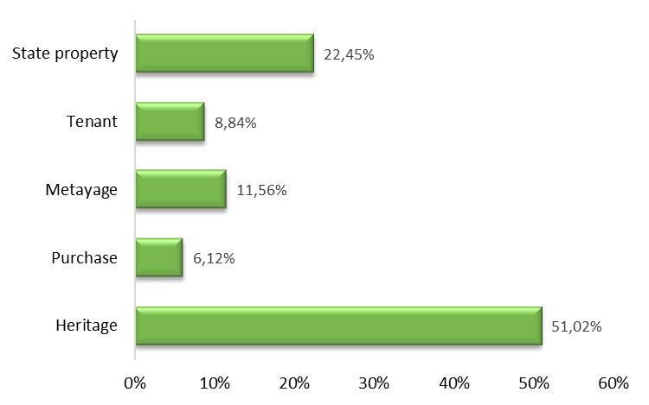

**Fig. 3. Access to land**

**3.4 Crop irrigation**

Water is an essential production factor in both rain-fed and dry-season agriculture. Its availability is particularly sensitive in off-season agriculture (dry season). Irrigation sources for market garden crops are river water and well water. These two sources of water were reported by Benjamine & Wadou (2023) in Maroua. On the other hand, growers on the same production site use the same water source. Growers at 2 production sites, Kamati and Jardin, located near the Barh-Kôh river, use the river's water to water their crops. On the other hand, growers on the Tombalbaye site use water from traditional wells: a total of 41 wells have been dug to irrigate crops on this site. This zonal variability in water supply sources for crops has been observed in a number of African cities by several authors: N'Djaména by Nazal (2021), Moundou by Doudoua et al (2020), Libreville by Ondo (2011). Only one watering method is used on all sites in the study area: manual watering with a watering can.

**3.5 Soil fertilization**

Market gardening is an intensive cultivation system requiring regular fertilization. The relatively small size of the plots, compared with large fields, calls for intensification to optimize production. In all basins, market gardeners use organic and mineral fertilizers. Growers use organic and mineral fertilizers to fertilize the soil. Organic manure (compost or manure) was used by 85.03% of market gardeners surveyed (Table 2). The results of our survey showed that all market gardeners used chemical fertilizers on all study sites. However, the type of fertilizer used varied more according to the growers' financial means than according to the plant's demand. The majority of market gardeners (57.14%) use a combination of NPK and urea chemical fertilizers. 19.73% use only urea and 4.08% only NPK. It should be noted that some growers use NPKBS chemical fertilizers, which were intended for cotton crops. Market gardeners in Sarh and elsewhere are well aware of the need to add fertilizers to their crops. This is essential for all crops (Nabyenda, 2006). The majority of growers combine organic and mineral fertilization, because for most market gardeners, the combination of chemical and organic fertilizers results in higher yields. The widespread practice of organic fertilizers and the persistence of chemical or mineral fertilizers have been observed by BA Abou and Cantoreggi (2018), IAGU (2011), Abdulkadir et al., 2012 and Ahouangninou, 2013. These results are also in line with those of Ouédraogo et al. (2019), who showed that 92% of market gardeners in the Bobo-Dioulasso area combine organic substrates with mineral fertilizers.

**Table 2. Fertilizer use in the study area**

|  |  |  |
| --- | --- | --- |
| Fertilizer Type | | Frequency |
| Organic Fertilizer | Yes | 85.03 % |
| No | 14.97 % |
| Mineral Fertilizer | Urea | 19.73% |
| NPK and Urea | 57.14% |
| NPK | 04.08% |
| NPKBS | 19.05% |

**3.6 Crop Protection**

La protection des cultures se fait par l’usage des produits phytosanitaires dont les dosages ainsi que les intervalles de traitement sont arbitraires et dépendent de l’appréciation de chaque maraicher. Tous les maraichers enquêtés ont annoncé avoir utilisé des pesticides à des proportions variables. L'usage systématique des pesticides chimiques pourrait s'expliquer par le fait que la plupart des maraîchers ne conçoivent pas le fait de produire des légumes et de faire des profits sans pesticides chimiques (Ahouangninou, 2013). Le produit le plus couramment utilisé est le Cypercal 50 EC (19.73%), l’Emacot 050 WG (17.01%), le Conquest 176 EC (14.29%) et l’Emir fort (11.56%) comme le montre le table 3. D'autres produits comme Vizir 92 EC (8.84%), Perfect killer (7.48%), Thalis 56 EC (6.12%), DD Force (5.44%), Penncozeb (5.44%) et K-Optimal (4.08%) sont également utilisés mais avec des fréquences plus faibles.

**Table 3. Type and frequency of phytosanitary products used in Sarh’s market gardening**

|  |  |  |  |
| --- | --- | --- | --- |
| Trading name | Active ingredients | Family | Frequency |
| Cypercal | Cyperméthrine 50g/l | Pyréthrinoides | 19.73% |
| Emacot 050 WG | Emamectine benzoate à 50g/kg WG | Avermectine | 17.01% |
| Emirfort |  | Carbamates | 11.56% |
| K-optimal 20sp | Lambda-cyhalotrine 15g/l et l’Acétamipride 20g/l | Pyréthrinoides | 4.08% |
| Penncozeb | Mancozeb | Dithiocarbamates | 5.44% |
| Conquest 176 EC | Cyperméthrine 144g/l + Acetamipride 32g/l | Néonicotinoides | 14.29% |
| Perfect Killer | Chlorpyriphos-ethyl 480 g/l | Organophosphoré | 7.48% |
| DD force | Dichlorvos 1000 g/l | Organophosphoré | 5.44% |
| Vizir 92 EC | Cypermethrine 72 g/l  Albamectine 20 g/l | Pyrethrinoide | 8.84% |
| Thalis 56 EC | Emamectine benzoate 24 g/l  Acétamipride 32g/l | Neonicotinoide | 6.12% |

**3.7 Diversity of species grown, with a predominance of leafy vegetables**

Figure 4 shows the diversity of vegetable crops grown at the sites surveyed in the study area. The survey identified a total of 15 vegetable species: local sorrel (Hibiscus sabdariffa), celery (Apium graveolens), lettuce (Lactuca sativa L), parsley (Petroselnum sativum), rocket (Eruca sativa), crin-crin (Corchorus olitorius), cabbage (Brassica oleracea), amaranth (Amaranthus hybridus), okra (Hibiscus esculentus), green bean (Phaseolus vulgaris), cowpea (Vigna unguiculata), carrot (Daucus carota), beet (Beta vulgaris), Chinese turnip (Brassica rapa) and green onion (Allium ascalonicum). The crops most frequently grown by market gardeners are lettuce (67.14%), celery (45.23%), parsley (39.39%), guinea sorrel (35.18%), green onion (28.52%), carrot (25.42%), rocket (22.20%) and Chinese turnip (21.01%). But their relative importance varies from site to site. Less important but more localized crops are green beans (15.80%), crin-crin corète (13.25%), amaranth (9.97%) and cabbage (7.20%). Crops such as okra (5.63%), tomato (4.07%), chilli pepper (3.71%), eggplant (3.55%) and beet (1.70%) are grown in low proportions.

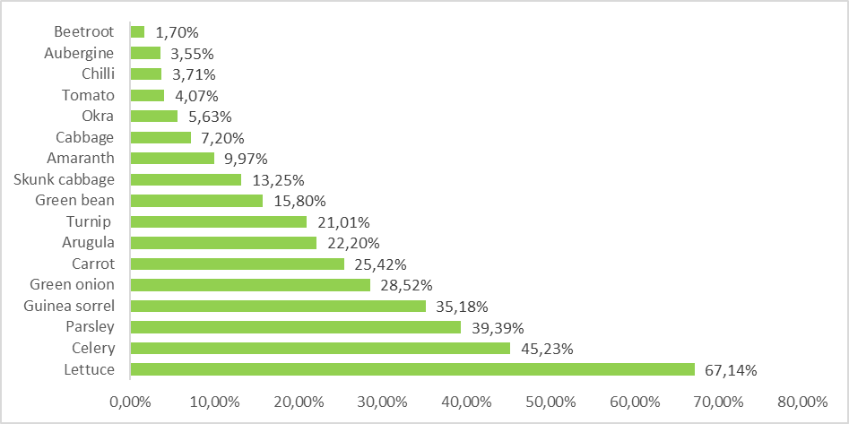

**Fig. 4. Diversity of cultivated vegetable species**

According to the organs consumed (figure 5), the distribution of species shows that 47% are grown for their leaves, 29% for their fruits and 24% for their roots or bulbs.

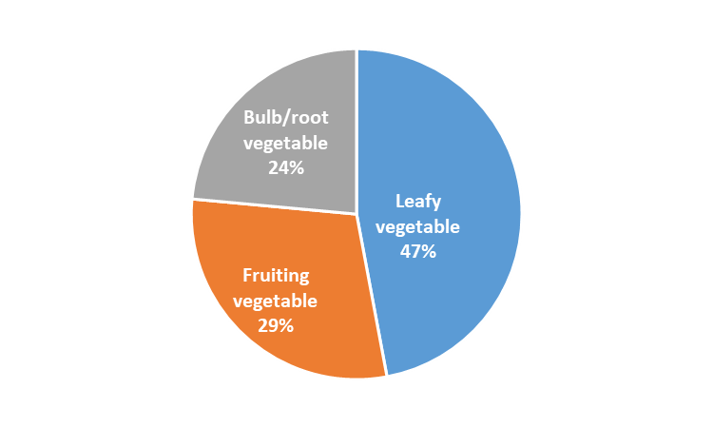

**Fig. 5. Distribution of species according to organs consumed**

The results of the study showed that several species are grown, in this case leafy vegetables with 47% of the species grown. This diversity of vegetables with a dominance of leafy vegetables was mentioned by Minengu et al (2024) in Kinshasa, Nazal (2021) in N’Djamena, Doudoua et al (2020) in Moundou, Ouédraogo et al (2019) in Bobo-Dioulasso and Kanda et al. (2014) in certain towns in Togo.

**3.8 Marketing of market garden produce**

Two (2) sales methods are used: on-site sales and market sales. 75% of producers sell locally. Many of them are women, known as Mosso women, who come to the production sites to buy supplies (figures 6 and 7). Vegetables are sold by the board, and in most cases the money is paid after the sale. Prices are negotiated the day before. Negotiations focus on both the quality and density of the bed. Harvesting takes place in the morning, and the vegetables are taken to the various markets in the area. The price per plank varies according to the season. Generally speaking, it's in the rainy season that the lowest prices are recorded for most vegetables.

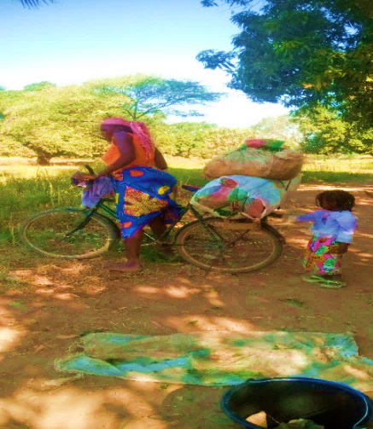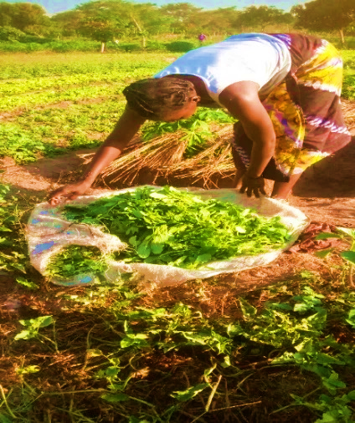

**Fig. 6. Vegetable seller on the garden site Fig. 7. Transporting vegetables to market**

**3.9 Constraints to the development of market gardening**

Market garden production in the town of Sarh still faces several constraints. These constraints fall into three categories:

* Upstream of production, insecure land tenure and flooding are the major limitations to the development of market gardening.
* With regard to production itself, limitations are mainly linked to the low level of technical skills of market gardeners, difficulties in obtaining agricultural inputs (tools, seeds, fertilizers, pesticides) and pathogen attacks.
* Downstream of production, there is strong competition with market garden produce from surrounding villages, and sometimes difficulties in selling produce.

Land tenure insecurity is a major constraint to the development of market gardening in the town of Sarh. It makes farming precarious and prevents yields from being optimized through sustainable investment. The urban struggle between housing and agricultural space, resulting from the rapid expansion of the town of Sarh and the scarcity of land, is a reality. Urban sprawl is reducing the size of cultivated areas. The demand for land for urban development is pushing back the city limits, and this is a sign of vulnerability for market garden production. As a result, the Tombalbaye and Jardin sites are set to disappear, as the municipality invokes the argument of public utility. These sites are thus considered state reserves for urbanization. If this were to happen, we would lose most of the land allocated to market gardening in the town of Sarh.

The land problem faced by market gardeners in Sarh has also been raised in other towns in the country, in N’Djamena by Nazal (2019), Nazal et al (2017) and Ndogonoudji (2014), in Moundou by the study carried out by Doudoua et al (2020) and is also found in many other African towns as mentioned by Moustier & Fall (2004). These authors pointed out that urban farmers mostly cultivate land over which they have no land control, and that the pressure of urbanization tends to limit surfaces.

On the other hand, we agree with Doudoua et al (2020), Nazal (2019), Nazal et al (2017) and Kanda et al, (2014), that beyond the land aspect, the difficulty of accessing the phytosanitary products recommended to protect crops and that of accessing suitable agricultural equipment are constraints that limit good market garden production with a view to obtaining good yields and therefore benefiting from good market prices. All market gardeners in Sarh work the land with rudimentary hand tools. Market garden crops are subject to many diseases and pests, which can lead to major losses. To preserve their harvests, market gardeners’ resort to the uncontrolled use of synthetic pesticides, with all the consequences for human health and the environment. Forbidden products, products intended for cotton cultivation, are frequently used by market gardeners to protect their crops against bio-aggressors.

The market gardening sector in Sarh does not benefit from a specific seed or fertilizer supply system, as is the case for other crops. Market gardeners are forced to turn to the market, where they buy seeds and mineral fertilizers at relatively high prices, which are not always available. For some species, market gardeners produce their own seeds. In most cases, however, seeds are imported, sometimes from Europe. Seeds are not always available on time, and in most cases have low germination capacity, due to poor storage conditions.

The fact that the town of Sarh is surrounded by two rivers also poses a threat to market garden production. Indeed, most of Sarh's market-gardening sites, which are generally located on the banks of the river and in the lowlands, only function normally in the dry season, due to flooding in the rainy season. Most market gardening areas in Kinshasa are generally located in valleys and normally only operate in the dry season (Minengu, 2024). According to Doudou al (2020), market gardening in the urban area of Moundou takes place around lakes Wey and Taba, on the banks of the Logone River, and in the lowlands of Koutou and Belaba 1.

Despite the diversity and abundance of the various water resources used to supply crops with water, irrigation modernization is lagging far behind, resulting in a waste of available water resources. Indeed, most market gardeners still use rudimentary drainage and irrigation systems. Although new, more water-efficient techniques exist in the city (such as drip irrigation and mechanized drainage), they are out of reach for growers in terms of acquisition costs, resulting in poor water management (water wastage) and the consequent drying up of wells on production sites.

Market garden production is essentially intended for domestic urban demand, which it is unable to satisfy, as imports are necessary to meet demand. Market gardening faces a number of other constraints that hamper its development. These include the interruption of supervision and support for the sector, since the dissolution of National Office for the Development of Horticulture (ONADEH) in 1991, putting an end to efforts to structure and organize the sector. Agents from the Ministry of Agriculture, who are supposed to supervise market garden producers, lack the financial support they need to provide training, awareness-raising, extension and technical-economic support. This situation was observed in Kinshasa by Minengu et al. (2021).

4. Conclusion

The study revealed that the majority of market gardeners are male, relatively young and have a high level of education. They are not trained in good cultivation practices, which leads to unreasonable use of chemical fertilizers and phytosanitary products. This state of affairs raises the issue of consumer health and the fate of these chemicals in the soil if these poor practices persist. It is therefore imperative that agro-ecological practices be disseminated to these growers, to ensure that urban agriculture is sustainable and healthy for the environment.

The diagnosis of vegetable production in the town highlighted the diversity of vegetable species grown in Sarh. Leafy vegetables predominate, as they are in greater demand on the market. The results of this study, which identified and characterized the various vegetable species grown in the town of Sarh, provide a basis for reflection on actions to be taken to improve and maintain quality vegetable production with a view to intensifying market gardening.

Growers involved in market gardening report difficulties common to each production site: land pressure, flooding problems, difficulties in obtaining agricultural inputs, sensitivity of market garden crops to disease and pest attacks, competition from produce from surrounding villages.

To overcome these constraints, a genuine organizational dynamic is essential, acting as a driving force for mobilization and strategy development within market garden farms. This requires the political will to support, subsidize, train and encourage market gardeners to develop this activity. The securing and extension of market garden sites must be included in Sarh's urban development plans, and the dynamics of urban agriculture must be taken into account.

DISCLAIMER (ARTIFICIAL INTELLIGENCE)

Author(s) hereby declare that NO generative AI technologies such as Large Language Models (ChatGPT, COPILOT, etc) and text-to-image generators have been used during writing or editing of this manuscript.

COMPETING INTERESTS DISCLAIMER:

Authors have declared that they have no known competing financial interests OR non-financial interests OR personal relationships that could have appeared to influence the work reported in this paper.

References

Ahouangninou, C. (2013). Sustainability of Market Gardening Production in Southern Benin: A Test of the Ecosystem Approach. Single Doctoral Thesis, University of Abomey-Calavi, Benin, 333 p.

Arnaud, M. et al. (1998). Dynamics of Urbanization in Sub-Saharan Africa. ISTED, Secretariat of State for Cooperation and Francophonie. 28 p.

Aubry, C. (2013). Urban Agriculture, a Contributor to the Food Strategies of Megacities? 24th Scientific Conference on the Environment, The Ecological Transition of Megacities, AgroParisTech, February 12-14, 2013, Créteil, France. JSE, (5) (2013) 11.

BA, A. & Cantoreggi, N. (2018). Urban and Peri-Urban Agriculture (UPA) and the Economics of Agri-Urban Households in Dakar, Senegal. International Journal of Environment, Agriculture and Biotechnology 3(1), pp. 195-207.

Batel, L. (2015). The Challenge of African Cities. Towards an Acceleration of Urbanization in Africa. 13 pp., URL: audace-afrique.org/attachments/article/657/Villes%20africaines.pdf

Benjamine, A. & Wadou, B. (2023). Diversity of Cultivated Species and Adaptation Strategies to Climate Change: The Case of Market Gardening in the Maroua 1st District, Cameroon. https://doi.org/10.19044/esipreprint.7.2023.p116

Boland, J. (2005). Urban Agriculture: Growing Vegetables in the City. 2nd edition, Agrodok Series No. 24. Agromisa Foundation, Wageningen.

Bricas, N., Tchamda, C. & Martin, P., (2016). Are West and Central African cities so dependent on food imports? Cah. Agric. 2016; 25:55001

Cisse, P.N., Diallo, M.D., Assigbetse, K.B., Goalbaye, T., Diop, A. & Guisse, A., (2018). Effect of litter from some plant species of the Great Green Wall of Ferlo (Senegal) on onion (Allium cepa L.) growth under semi-controlled conditions. Rev. Mar. Sci. Agron. Vet. 6 (1): 30-35.

Dasylva, M., (2018). Characterization and analysis of intra- and peri-urban agriculture in the municipality of Ziguinchor"; Doctoral thesis in agricultural and environmental science, Assane Seck University of Ziguinchor, 262 p.

Diaite, B., Mariama, D.D., Touroumgaye, G., Siré D., Abdourahmane, D., Ramata, T., Aliou D. & Aliou G., (2020). Effect of applying different doses of organic fertilizers on the growth and yield of tomato (Solanum lycopersicum L.) under semi-controlled conditions. Journal of Animal & Plant Sciences (J.Anim.PlantSci.) Vol. 44(1); 7553-7566. ISSN 2071-7024) https://doi.org/10.35759/JAnmPlSci.v44-1.2

Diedhiou, S. O., Sy, O., Margetic, C., (2018). Urban Agriculture in Ziguinchor (Senegal): Self-Consumption Practices Favoring the Development of Sustainable Urban Supply Chains. Espace Populations Sociétés, 2018-3, DOI: 10.4000/eps.8250

Diop, A., (2013). Diagnosis of Pesticide Use Practices and Quantification in the Niayes Area of Dakar (Senegal). Doctoral Thesis in Analytical Chemistry from the University of the Littoral Côte d’Opale, France. P. 241.

Djibo, H., (2014). Market Gardening in Niamey: A Socio-Anthropological Approach. International Journal of Innovation and Applied Studies Vol. 8 No. 1 Sep. 2014, pp. 243-250 ISSN 2028-9324 http://www.ijias.issr-journals.org/

Doudoua, Y., Yengué J.L., & Djondang K., (2020). Market Gardening: Production Techniques and Challenges Encountered by Producers in Moundou, Chad. Journal of Space, Territories, Societies and Health, Vol. 3, No. 5, June 2020, pp. 49-66.

Dovlo, K.A., (2007). Some Socio-Cultural and Ecological Aspects of Pesticide Use in Market Gardening in the Port Area of Lomé. DEA Thesis, University of Lomé, 58p

Fall M. & Coulibaly S., (2016). Diversified Urbanization: The Case of Côte d'Ivoire. Development Directorate, Countries; Regions. World Bank Group, 209 p.

Ganacadja, C., Mavoungou, J. F., Mouketou, A., Biroungou, C. & Nzengue E., (2022). Analysis of Some Characteristics of the Market Gardening Sector in Three Provinces of Gabon. ESI Preprints, August 2022. https://doi.org/10.19044/esipreprint.8.2022.p55

IAGU, (2011). Urban Market Gardening in Lendeng (Rufisque, Senegal). Study Report, 73 p.

INSEED, (2009). Second General Population and Housing Census (RGPH2). National Institute of Statistics, Economic and Demographic Studies. Overall Results, pp. 66-88.

Kanda, M., Akpavi, S., Wala, K., Boundjou, GD., & Akpagana K., (2014). Diversity of Crop Species and Production Constraints in Market Gardening in Togo. Int. J. Biol. Chem. Sci. 8(1): pp. 115-127.

Massounga, Y.C., Allogo Abessolo, R., Mouketou, A., Mbeang Beyeme, A.M., Nzandi, H., Okili Okie I., et al., (2025). Socio-demographic study of market gardeners, their cultivation and fertilization practices in Franceville and Moanda, southeastern Gabon. European Scientific Journal, ESJ, 21 (12), 166. https://doi.org/10.19044/esj.2025.v21n12p166

MATUH, (2011). Urban Development Support Project: Updating the Reference Urban Plan for the City of Sarh. Ministry of Territorial Planning, Urban Development and Housing of Chad, Final Report, 150p.

Minengu, JDD., Ikonso Mwengi, A., Kawanga, R., Mwengi, S. & Yama OM., (2024). Main market garden crops cultivated in urban and peri-urban areas of the city of Kinshasa (Literature Summary). African Journal of Environment and Agriculture, 7(2), 83-102. DOI: https://dx.doi.org/10.4314/rafea.v7i2.9

Minengu, J.D.D., Ikonso Mwengi, A., Mbumba Bandi, M., Kawanga, R., Mangunda, O., Mwengi, S., et al., (2021). Use of Synthetic Pesticides in Market Gardening in Kinshasa. African Journal of Environment and Agriculture, Special Issue 02, 14-29.

Mougeot, L.J.A., (2006). Growing Better Cities, Urban Agriculture and Sustainable Development. Ottawa, Dakar, Cairo: IDRC, p. 113.

Moustier, P., Moumbélé, M. & Huât, J., (2004). Concerted and Sustainable Management of Urban Vegetable Sectors. In: Smith O., Moustier P., Mougeot L.J.A., Fall A. Sustainable Development of Urban Agriculture in French-Speaking Africa: Issues, Concepts, and Methods. CIRAD/CRDI: Montpellier, pp. 79-113.

Moustier, P. & Fall S.A. (2004). The Dynamics of Urban Agriculture: Characterization and Evaluation. In: Sustainable Development of Urban Agriculture in French-Speaking Africa. Issues, Concepts, and Methods. O.B. Smith, P. Moustier, A.J.L. Mougeot, and A. Fall (Eds.), CIRAD/CRDI, pp. 23-43.

Nabyenda, P. (2006). Plants Cultivated in Tropical High-Altitude Regions of Africa. Gembloux Agricultural Press. CTA. Netherlands. 189 p.

Nazal, A.M., (2021). Quality assurance approach in the microbiological risk control plan related to the production of vegetables from urban and peri-urban agriculture in the city of N'Djamena. Doctoral thesis in Agronomy, Faculty of Agronomy, Abdou Moumouni University of Niamey (Niger).

Nazal, A.M., Tidjani, A., Doudoua, Y. & Balla, A. (2017). Market gardening in urban and peri-urban areas: the case of the city of N'Djamena in Chad. Journal of Universities and International Development Cooperation (JUNCO). Turin, Italy, pp. 269-281.

Nazal, A.M., (2019). Multifunctional Analysis of Urban Agriculture in Chad: The Case of Market Gardening in the City of N'Djamena. European University Publishing, 87p.

Ndiaye, M. L., Pfeifer, H.-R., Niang, S., Dieng, Y., Tonolla, M. & Peduzzi, R., (2010). Urban Sprawl at the Risk of Agro-Pastoral Activities in Abidjan. », VertigO - the Electronic Journal in Environmental Sciences, Volume 10 Issue 2, [Online], URL: http://vertigo.revues.org/9965

Ngakiama, G.N., Mbela, G.K., Pole, C.S., Kyela, C.M. & Komanda J.A., (2019). Analysis of the knowledge, attitudes, and practices of market gardeners in the city of Kinshasa regarding pesticide use and the impact on human health and the environment. Afrique SCIENCE 15(4) (2019) 122-133 122. ISSN 1813-548X.

Nguegang, A.P. (2008). Urban and peri-urban agriculture in Yaoundé: a multifunctional analysis of a growing activity in a survival economy. Doctoral thesis in Agricultural Sciences and Biological Engineering, Université Libre de Bruxelles, Faculty of Sciences, 200p.

Olanrewaju, S.B., Moustier, P., Mougeot, L.J.A. & Fall, A. (2004). Sustainable development of urban agriculture in French-speaking Africa: issues, concepts, and methods. Paris, CIRAD/Ottawa, IDRC.

Ondo, J.O. (2011). Vulnerability of market garden soils in Gabon (Libreville region): acidification and mobility of metallic elements. Doctoral thesis in Terrestrial Environmental Sciences, University of Provence, France.

Ouédraogo, R.A., Kambiré, F.C., Kestemont, M-P & Bielders, C.L., (2019). Characterizing the diversity of market gardening farms in the Bobo-Dioulasso region of Burkina Faso to facilitate their agroecological transition. Cah. Agric. 28: 20

Sandrine, M. B. L., Auguste, N. N., & Frédéric, F. C., (2017). Peri-urban market gardening in Libreville and Owendo (Gabon): cultural practices and sustainability. Cah. Agric. 26, 45002.

Sanni Bio B., Sounon, B.B., Djohy, G. L., Yabi J. A., (2023). Urban and peri-urban agriculture under the influence of land dynamics in Africa: Current status and perspectives. Annals of the University of Moundou, Series A-FLASH Vol. 10 (2), aflash-revue-mdou.org.

Tano, B.F., Abo, K., Dembele, A. & Fondio, L., (2011). Production systems and risky practices in urban agriculture: the case of market gardening in the city of Yamoussoukro in Côte d'Ivoire. Int. J. Biol. Chem. Sci. 5(6): 2317-2329, ISSN 1991-8631.

Tarnagda, B., Tankoano, A., Tapsoba, F., Sourabié, P. B., Abdoullahi, H. O., Djbrine, A.O., & al. (2017). Evaluation of agricultural practices for leafy vegetables: the case of pesticide and chemical input use in market gardening sites in Ouagadougou, Burkina Faso. Journal of Applied Biosciences 117: 11658-11668.