***Original Research Article***

**STUDIES ON THE LEVEL OF EFFICIENCY OF BIO-PRODUCTS AGAINST FALL ARMY WORM (*SPODOPTERA FRUGIPERDA*) AND MAIZE WEEVILS (*SITOPHILUS ZEAMAIS),* IN ERITREA**

# ABSTRACT

A laboratory experiment was conducted at Hamelmalo Agricultural College to isolate Trichoderma spp. (Entomopathogenic Fungi – EPF) from various soil types and evaluate their bio-efficacy alongside botanical extracts (neem seed kernel, tobacco, and *Lantana* leaves) against Spodoptera frugiperda (Fall Armyworm-FAW) and Sitophilus zeamais (maize weevil). Soil samples from humus-rich, orchard, cultivated, and forest areas were used for fungal isolation. The study assessed mortality and repellence effects of treatments. Neem extract (NSKE) caused the highest larval mortality in FAW, followed by *Tricho*-1, though all treatments were statistically at par at a 5% significance level. Tobacco extract showed significant lethality to maize weevil at 5% concentration in both topical and seed dressing applications. *Lantana* extract demonstrated the highest repellence effect, which was statistically significant at 5%. All soil sources yielded Trichoderma spp., with *Tricho*-1 showing better persistence under sunlight than *Tricho*-2. The EPF isolates also exhibited lethal effects on the maize weevil at parental and 10² concentrations. The findings support the potential of EPF and botanicals as eco-friendly pest management alternatives.

**Keywords**: Entomopathogenic fungi, Fall Armyworm, weevils, biological control, Botanicals, *Trichoderma spp.*

### Introduction

Maize (Zea mays L.), known as the “queen of cereals,” contains 61% starch and is rich in essential amino acids. Its kernel comprises 13.5% moisture, 10% protein, 4.3% oil, and 70.3% carbohydrates. With high production potential, maize is used as food, animal feed, and in beverages. Its stover and grain have industrial applications in pharmaceuticals, cosmetics, and textiles. Maize contributes to food security, crop diversification, and agro-industry development, particularly with varieties like popcorn (Martin *et al*., 2006). The preservation of perishable agricultural produce has evolved from being solely an economic concern to a critical humanitarian issue. Insect pests, among various organisms that disrupt agricultural productivity, are the most economically damaging, affecting crops both in the field and during storage through direct feeding and transmission of viral diseases. Historically, natural populations of insect pests were regulated by pathogenic microorganisms, which are now integrated into pest management strategies worldwide. Microbial control has yielded promising results in regions such as Asia and South America (Fuxa, 1987), with increasing efforts in Africa to develop microbial-based pest control. Entomopathogenic fungi (EPF), which infect and kill insects, play a vital role in managing pest populations and are among the earliest known biological control agents. To date, over 750 fungal species pathogenic to insects and mites have been identified, representing most major fungal groups (Moorhouse *et al*., 1992; Hajek and Leger, 1994; Ramanujam *et al.,* 2014). Botanical pesticides, derived from naturally occurring plant substances, represent another eco-friendly alternative to synthetic chemicals. Over 2,400 plant species have been documented for their pesticidal properties. Botanical insecticides may take the form of crude extracts, powdered plant materials, or essential oils. These substances exert their effects through various modes of action, including repellency, oviposition and feeding deterrence, physiological interference, and direct toxicity to pests.

In Eritrea, maize is the 7th most important food crop following sorghum, pearl millet, taff, barley, wheat, and finger millet during the years 2021 and 2022 (MoA, 2022). In this country, maize production remains low due to constraints such as limited water availability, insect pest infestations, disease outbreaks, and inappropriate use of synthetic pesticides. Therefore, the present study was designed to evaluate the efficacy of eco-friendly bio-pesticides as alternatives to conventional chemical control methods. Specifically, this study aimed to assess the effectiveness of Trichoderma spp. and botanical pesticides—including neem seed kernel extract (NSKE), Lantana camara leaf extract, and tobacco leaf extract—against the last larval instar of Spodoptera frugiperda (Fall Armyworm) and adult Sitophilus zeamais (Maize Weevil). Recent advancements in EPF research indicate their growing importance as core components of IPM strategies. This research aims to promote sustainable pest management by evaluating environmentally sound and locally adaptable biological alternatives. The general objective is to assess the efficiency of isolated entomopathogenic fungal (EPF) strains and selected botanical extracts against key insect pests. Specifically, the study seeks to isolate and identify EPF strains from selected soil samples, determine their efficacy against Spodoptera frugiperda (Fall Armyworm) and Sitophilus zeamais (Maize Weevil), and evaluate the lethal and repellent effects of botanical extracts on these targeted pests.

# Materials and Methods

**2.1. Area of Research and Sample Collection:** The experiment was conducted in the laboratory of Plant Health, Hamelmalo Agricultural College, which is located 10km North of Keren on the side of the Keren–Nakfa road line. The altitude of the area is approximately 1,330m above mean sea level, and the average annual rainfall and temperature are 436mm and 24°C, respectively (Anonymous, 2000). Soil samples were collected from different sites at Hamelmalo Agricultural College, such as humus-rich, orchard, cultivated field, and forest. Each soil sample was collected to a depth of 10cm in the upper surface, including the rhizosphere*.*

**2.2. Inoculation Methods:** Each soil samples were inoculated on both Potato Dextrose Agar (PDA) and oatmeal media. Soil inoculations were done by the dilution technique. The dilution method was the commonly used method by which a variety of fungi are obtained, but species that sporulate profusely are most often selected, though fungi in the mycelial condition are rarely isolated (ISTA, 1996).

**2.3. Abundance of *Trichoderma spp*. on a selected site:** After the inoculation on media, thesoil samples were incubated for 14–17 days to check the abundance of *Trichoderma* species. Records on the abundance of *Trichoderma* species were obtained through the presence of fungal mycelia/conidia on the PDA media (Aneja, 2004).

***2.4. Fungus Culture and Conidia Harvesting:*** *Trichoderma* isolates of EPFs were cultured on PDA (200g of pilled potato, glucose 20g, agar 20g dissolved in 1000 ml of water). Petri-dishes were autoclaved at 121°C for 15-20 minutes, then incubated at room temperature (25 ºC). Conidia were harvested from the 14-15-day-old culture with the help of an inoculation needle and placed in water. The conidia-containing solution was stirred by shaking it for 10 seconds in order to gain for homogeneous suspension. The conidial concentration was calculated through a Hemocytometer. (Aneja, 2004; Barnet and Hunter, 1972; Ellis, 1971; Rifai, 1969; Gilman, 1957; and Nagamani *et al*., 2006).

**2.5. Insect Rearing:** Fall Armyworm (FAW) larvae were collected from maize fields and reared in ethanol-sterilized plastic cages. To prevent overcrowding and cannibalism, larvae were kept separately and fed daily with maize leaves and an artificial diet prepared from ground beans, ascorbic acid, yeast, agar, and oats. Pupae were placed in tissue-lined Petri dishes for adult emergence. Adults were fed with a 10% sugar solution, and eggs were collected for hatching. The culture was maintained up to seven generations, using the sixth for bioassays. Maize weevils were also collected from stored maize seeds kept in plastic cylinder jars for further experimentation (Simon *et al.,* 2015).

**2.6. Preparation of Botanical Pesticides:**

***2.6.1. Lantana Leaf Extraction:*** Plant parts were washed and cleaned with water and exposed to the sun until fully dried. Plant leaves were ground and sieved until fine powders were acquired. The maceration process was then carried out by mixing 5g of ground *Lantana* leaf into 100 ml of water with the addition of 1g of detergent, forming 5% solution, then stored in a container and tightly closed, accompanied by stirring it to mix with the solvent. After soaking for 24 hours, filtering was done using gauze. The filter results were in the form of a stored suspension for later use. A similar procedure was followed for making a 10% solution (Eweis and Amber, 2011).

***2.6.2. Preparation of Neem Seed Extracts:*** Neem seed kernel extraction (NSKE) was prepared by pounding from seeds in a motor to obtain the kernels of neem after removal of the outer cover. The kernels were ground into a paste, and 5g was mixed in 100ml of water and 1g of detergent and soaked for 24 hours, forming 5% solution. Using the same procedure, 10g of ground neem seed kernel was mixed in 100ml of water for 24 hours, forming a 10% solution (Schmutterer, 1990, and Ugwu *et al.,* 2017).

***2.6.3. Preparation of Tobacco Leaf Extract:*** Grinded and dried leaves of tobacco, about 6.2g, was boiled in 250ml of water for 20 minutes to prepare a 6.2 % solution of tobacco. The same procedure was used to prepare 12.4g of tobacco in 250 ml of water to make a 12.4% tobacco solution (Anumudu, 2019).

**2.7. Application of Botanicals and EPF (*Trichoderma* spp.) on Fall armyworm:** The experiment included four treatments and a control, each with three replications. Four final instar Fall Armyworm (FAW) larvae per replication were dipped in the treatment solution for 10 seconds and placed individually in containers with food. Mortality and non-feeding behavior were recorded at 48-hour intervals to assess the effectiveness of each treatment (Aminudin *et al.,* 2022).

***2.7.1. Method of dressing and topical application of the bio-products and entomopathogenic fungus (Trichoderma spp.) on Sitophilus zeamais mortality:*** Maize weevils (*Sitophilus zeamais*) were treated with botanical pesticides and entomopathogenic fungi (EPF) using both spraying and seed dressing methods. For the spraying method, two concentrations—5% and 10%—were prepared for each botanical extract. In the case of tobacco, solutions of 6.2% and 12.4% were used. For the 5% solution, four replications were maintained , each consisting of 10 adult weevils treated by spraying. For the 10% solution, four replications were also used, with 5 adult weevils treated per replication. In the dressing method, 0.20 g of each botanical treatment was mixed with the grains, and four replications were maintained , each with 10 adult weevils. Observations were recorded at 48-hour intervals to evaluate the effects of the treatments on weevil mortality. Additionally, *Trichoderma* isolates were applied using topical application at parent concentrations of *Tricho*-1 (1.35 × 10⁸ conidia/mL) and *Tricho*-2 (1.15 × 10⁸ conidia/mL).

***2.7.2. Repellency Test:*** Transparent plastic cylinders (15 cm × 2 cm) were used to assess the repellency of botanical powders against Sitophilus zeamais. One end of each cylinder was sealed with fine mesh tulle, while the opposite end contained 0.2 g of powdered leaf material from the test plants. Four adult maize weevils were introduced through the mesh end per replication, with four replications per treatment, totaling 16 cylinders. The setup was left undisturbed for 8 hours (Rejitha *et al.,* 2014).

After exposure, the number of weevils that moved towards the mesh and the total distance traveled were measured and recorded to assess repellency (Table 1).

## Table 1. Rating the degree of repellence of each test material

|  |  |  |
| --- | --- | --- |
| **Distance(cm) from the bottom of the cylinder towards the untreated plug** | **Description** | **Rating** |
| 0 | Ineffective | 1 |
| 1-3 | Slight repellent(SR) | 3 |
| 4-6 | Moderately repellent (MR) | 5 |
| 7-9 | Highly repellent (HR) | 7 |
| 10-12 | Extremely repellent (ER) | 9 |

* + 1. ***Survival rate of Trichoderma sp. at one-and-a-half-hour sunlight exposure:*** The effect of sunlight on the *Trichoderma* isolates was tested for one-and-a-half-hour exposure at an average temperature of 28.75°C, while the control was kept unexposed (at room temperature). The relative survival rate was recorded by counting the colony-forming units every 24 hours (Trutmann and Keane, 1990).

The data collected throughout the experiment period was subjected to statistical analysis using GENSTAT software, and mean comparison was done at 5 % level of significance.

1. **Results and Discussion**

Based on the study of the efficiency levels of bio-products against Fall armyworm (*Spodoptera frugiperda*) and maize weevil (*Sitophilus zeamais*), data was collected and recorded, on the mortality rate using the bio-products from neem, *Lantana*, tobacco, *Trichoderma spp*., and control, the repellency rate of the botanical pesticides, and the tolerance of the *Trichoderma spp*. towards sunlight effects.

## 3.1. Mortality effect of *Trichoderma sp*. and botanical pesticide on Fall-Army Worm

The results illustrate the **larval mortality of Fall Armyworm (FAW)** (in percent) over time under the effect of different treatments: ***Lantana*, Neem, Tobacco, *Tricho*-1, *Tricho*-2, and Control.** Mortality was observed at six different time intervals: **96, 144, 192, 240, and 288 hours**. It was observed that the **Neem** consistently showed the highest larval mortality, reaching nearly **80% at 288 hours**, indicating strong insecticidal effect. ***Tricho*-1** showed progressive mortality, after to Neem, reaching about **50% at 288 hours**, whereas ***Tricho*-2, Tobacco,** and ***Lantana*** also showed increased mortality but to a lesser extent (around 20–30% at 288 hours). **Control** treatment showed negligible mortality across all time intervals, confirming the effect is due to the treatments. Mortality rate increased with time for all treatments, indicating **cumulative toxic or pathogenic effects.** It is stated that the **Neem and *Tricho*-1** are the most effective treatments against FAW larvae, followed by *Tricho*-2 and botanical extracts like Tobacco and *Lantana* (Fig. 1). *Lantana* leaf extracts were among the least performing treatments. This is because lantana leaves contain fewer bioactive components compared to the stem and twigs (Majekodunmi *et al*., 2002). In addition, the results indicated that the highest rate (16.67 after 144 and 186 hours) of mycotized larvae of fall armyworm was recorded from *Tricho*-1.

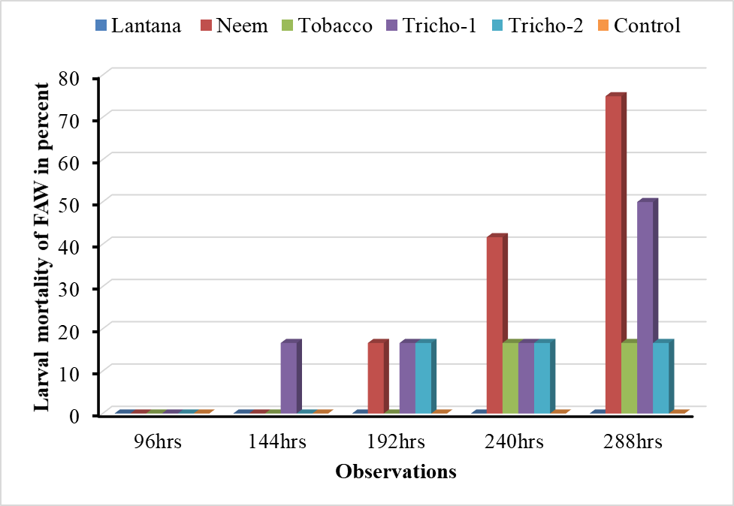

Figure 1. Mortality rate of FAW at 5% of Trichoderma spp. and botanical pesticides

**3.2. Mortality effect on maize weevil at 5% throughdressing and spraying methods of botanical pesticides and *Trichoderma sp*. :** The mortality rate of *Sitophilus zeamais* (maize weevil) with botanical pesticides at 5% concentration and *Trichoderma* spp. at 1.35 × 10⁸ conidia/mL showed no significant differences among treatments in the second observation. However, observations 2, 3, 4, and 5 revealed statistically significant differences among treatments. Tobacco extract demonstrated the highest mortality effect and was statistically superior to the other treatments at the 5% LSD level. In the final observation, no significant differences were observed among treatments. The results suggest that tobacco extract, particularly at a 6.2% concentration in topical applications, is the most effective in inducing mortality in maize weevils (Fig. 2). A similar trend was observed with dressing applications of botanical extracts on maize weevil mortality. Although variation existed among treatments, the differences were not statistically significant, indicating a relatively uniform effect (Fig. 3). Previous studies have reported that neem seed kernel extract (NSKE) is highly effective in controlling pests and diseases (Rajani *et al*., 2014).

(obs-2= 96hrs; obs-3= 144hrs; obs-4= 192hrs; obs-5= 240hrs; and obs-6=288hrs)

Figure 2. Maize weevil mortality rate spray at 5% of the Trichoderma spp. and botanical pesticides

Figure 3. Maize mortality rate dressing at 5% of the botanical pesticides

(obs-2= 96hrs; obs-3= 144hrs; obs-4= 192hrs; obs-5= 240hrs; and obs-6=288hrs)

## 3.3. Mortality effect of botanicals on the maize weevil spray at 10% concentration: During the experimental study, bioassay was carried out on maize weevils with botanicals at 10% concentration to check the correlations between the efficacy and increment in the level of concentration from 5% to 10%. The current results statistically proved that there was no significant difference at 5% level of significance among the applied botanical treatments. However, Neem effects were found to be higher than the other treatment applications (Fig. 4).

(obs-2= 96hrs; obs-3= 144hrs; obs-4= 192hrs; obs-5= 240hrs; and obs-6=288hrs)

Figure 4. Mortality effect of botanical pesticides at 10% concentration on Sitophilus zeamais

**3.4. Repellency rate**: Observations on repellency action of the test materials were conducted using the repellency rating of the botanicals (neem, *Lantana*, and tobacco). Observations at 8 hours were carried out to identify the most repellent botanical agent. *Lantana* showed the highest repellency rate and was rated as extremely repellent, followed by neem and tobacco. It was recorded with the highest mean and found significantly different among the applied treatments, whereas, the rest treatments were remained at par at 5% level of significance (Fig. 5). The current result agreed with the reports of Samuel et al, (2019), the effect of *Lantana* and neem was higher and extremely repellent with 76.3% and 83.3%, respectively. According to Fitsum *et al*. (2011), the use of volatile compounds has been studied and proved to possess a significant repellent effect. The use of *Lantana* has been found to have immense repellency against female Anopheles mosquitoes (Akumu *et al*., 2013).

Figure 5. Repellency rate on *Sitophilus zeamais*

## 3.5. Abundance of EPF (*Trichoderma sp*.) on media from the selected sites: The quantity (100%) of *Trichoderma spp*. grown on media from the four selected sites 1.2. and 3, i.e., cultivated, orchard, humus-rich field, respectively; and the site indicated 4 is a forest site that has shown 75% abundance of *Trichoderma spp*. Generally, in this experiment, the calculated rate or probability of abundance of *Trichoderma spp*. on the selected site showed no significant difference, indicating that that *Trichoderma spp*. were available in all selected sites (Fig. 6).

Figure 6. Abundance of the Entomopathogenic fungus (Trichoderma spp.) on the selected sites

## 3.6 Effect of *Trichoderma* isolates on maize weevil (*Sitophilus zeamais*) survival: The effect of spraying *Trichoderma spp*. as a parent solution at 102 concentration solutions was evaluated. There was great variability in the effectiveness of treatments, and statistically significant results were analyzed by comparing the control group. Both treatments (*Tricho*-1, *Tricho*-2) have similar mortality effects on maize weevil and are noted as on par in all observations (Fig. 7). It is stated that *Trichoderma* species can antagonize plant pathogens (Howell, 2003; Benitez *et al*., 2004; Schuster and Schmoll, 2010).

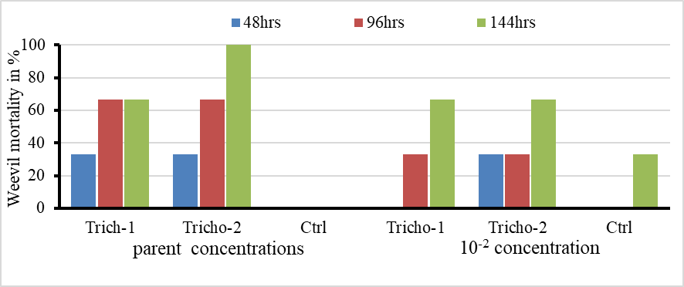

Figure 7. Weevil mortality at parental and 102 concentration

* 1. **Relative survival of *Trichoderma* *sp*. isolates (*Tricho*-1 &*Tricho*-2) growing on media for sunlight exposure:** The tolerance effect of *Trichoderma spp*. was recorded by exposing them to the sunlight for half an hour and one hour. The isolates, Tricho-1 and Tricho-2, at concentrations of 1.35 × 10⁷ and 1.15 × 10⁷ con/ml, respectively, showed no significant variation in any observation; however, Tricho-1 recorded the highest colony-forming unit counts in the third and fourth observations. Therefore, treatments showed similar persistence toward the sunlight exposure (Fig. 8). The compiled data results revealed that all the treatments of the observation have insignificant results at 1-hour exposure when comparing the probability; however, the last observation reflects significant results in which *Tricho*-1 scored higher colony-forming units count compared to *Tricho*-2 at 5% level of significance (Fig9). *Trichoderma* *spp*. fungi may be act in response to the environmental conditions, producing adverse conditions (Benitez *et al*., 2004).

obs-1= 24 hrs., obs-2=48hrs, obs-3=72hrs, obs-4=96hrs).

Figure 8. Relative survival rate (CFU count) at half-hour exposure (101 concentration)

obs-1= 24 hrs., obs-2=48hrs, obs-3=72hrs, obs-4=96hrs).

Figure 9. Relative survival rate (CFU count) at one-hour exposure (101 concentration)

1. **Conclusion:** The study demonstrated the efficacy of botanical extracts and Trichoderma isolates against Spodoptera frugiperda (Fall Armyworm) and Sitophilus zeamais (Maize Weevil). NSKE showed the highest larval mortality against S. frugiperda, followed by the *Tricho*-1 isolate. Tobacco extract caused significant mortality of S. zeamais at 5% concentration via both topical and dressing applications. Lantana leaf extract exhibited the highest repellence effect, which was statistically significant at the 5% level. All sampled soils (humus-rich, cultivated, forest, and orchard) contained Trichoderma spp., from which two isolates (*Tricho*-1 and *Tricho*-2) were identified. Both isolates exhibited similar sunlight tolerance and showed no significant difference from the control. They also displayed lethal effects against S. zeamais at parent and 10² concentrations. These findings highlight the potential of botanical bio-pesticides and Trichoderma spp. as effective, eco-friendly alternatives for the integrated management of key insect pests in stored and field crops.

# References

Akumu, E.O., S. Kebenei, S.T Anthoney and C.M Ngule. (2013). Repellency of *Lantana* *camara* leaves smoke against female anopheles mosquitoes. *International Journal of Bioassays,* 3(1): 1695-1698.

Aminudin Afandhi, Ito Fernando, Tita Widjayanti, Agrintya Kurnia Maulidi, Hirzi Ilman Radifan and Yogo Setiawan. (2022). Impact of the fall armyworm, *Spodoptera frugiperda* (J. E. Smith) (Lepidoptera: Noctuidae), invasion on maize and the native *Spodoptera litura* (Fabricius) in East Java, Indonesia, and evaluation of the virulence of some indigenous entomopathogenic fungus isolates for controlling the pest. *Egyptian Journal of Biological Pest Control. 32:48.* <https://doi.org/10.1186/s41938-022-00541-7> .

Aneja K.R. (2004). Experiment in microbiology, plant pathology and biotechnology. 4th Ed, New Age International (P) Limited Publishers, New Delhi India, pp. 121-128.

Anonymous (2000). Ministry of Agriculture, Horticulture Division Report, Asmara, Eritrea.

Anumudu CK, Nwachukwu MI, Obasi CC, Nwachukwu IO, Ihenetu FC (2019). Antimicrobial Activities of Extracts of Tobacco Leaf (*Nicotiana tabacum*) and Its Grounded Snuff (*Utaba*) on *Candida albicans* and *Streptococcus* *pyogenes*. J Trop Dis 7: 300. DOI: 10.4172/2329-891X.1000300.

Barnett, H L, and Hunter, B B. (1972). Illustrated Genera of Imperfect Fungi. Burgess Publishing Company. Minneapolis.

Benitez T., A.M Rincon, M.C Limon and A.C Codon. 2004. Biocontrol mechanisms of *Trichoderma* strains. *Int. Microbiol*. 7 (4): 249−260.

Ellis, M.B. (1971). *Dematiaceous hyphomycetes*. Kew, UK: Commonwealth Agricultural Bureaux, International Mycological Institute. 608 pp.

Eweis M., S. Amber, S. (2011). International journal of botany. 7(4). Control of *Beta vulgaris* using *Lantana camera.* Linn. Essential oil in vitro. Egypt.

Fitsum, F.D., T Kassahun, B. Göran,S. Emiru,T. Habte and R.H Rickard Iand Sharon. (2011). Fresh, dried or smoked Repellent properties of volatile emitted from ethnomedicinal plant leaves against malaria and yellow fever vectors in Ethiopia. Malaria Journal, 10: 1-14.

Fuxa JR. (1987). Ecological considerations for the use of entomopathogens in IPM. *Annual Review of Entomology.* 1987; 32:225-251. 11

Gilman J.C. (1957). *A manual of soil fungi*, 2nd edn, Iowa State Univ. Press, USA, pp 450.

Hajek A.E and R.J St Leger. (1994). Interactions between fungal pathogens and insect hosts. *Annual* *review of entomology*. 39(1):293-322.

Howell C.R. 2003. Mechanisms employed by *Trichoderma* species in the biological control of plant diseases; the history and evolution of current concepts. *Plant Dis*. 87 (1): 4−10.

ISTA (International Seed Testing Association). (1996). *International Rules for Seed Testing*. Vol. 24, Zurich, Switzerland.

Majekodunmi O. Fatope, Labaran Salihu, K Stephen. Asante and Yoshio Takeda. 2002. Larvicidal Activity of Extracts and Triterpenoids from Lantana camara, Pharmaceutical Biology, 40:8, 564-567, DOI: 10.1076/phbi.40.8.564.14654.

Martin, J.H., Waldren, R.P. and Stamp, D.L. (2006). Principles of Field Crop Production. Pearson Education, Inc., Upper Saddle River.

MoA. 2023. National wheat and maize conference, Hotel Asmara Palace, Selam Conference Centre, Asmara, Eritrea.

Moorhouse E.R, A.T Gillespie, E.K Sellers and A.K Charnley.(1992). Influence of fungicides and insecticides on the entomogenous fungus *Metarhizium anisopliae* a pathogen of the vine weevil, *Otiorhynchus sulcatus*. *Biocontrol Science and Technology*. 2(1):49-58.

Nagamani A, Kumar I K, and Manoharachary, C. (2006). Handbook of Soil Fungi, IK International Publishing House Pvt. Ltd, New Delhi, India.

Rajani Kanta Sahu, Buxi Jagabandhu Bidlyadhar. (2014). *Research Journal of medicinal plant* 8 (6): 269-276.1993.

Ramanujam B., R Rangeshwaran, G Sivakmar, M Mohan and M.S Yandigeri. (2014). Management of Insect Pests by Microorganisms. *Proceedings of Indian National Science Academy* .80(2):455-471.

Rejitha T.P., Reshma J.K., Mathew A. (2014). Study of repellent activity of different plant powders against cockroach (*Periplaneta americana*). *International Journal of Pure and Applied Bioscience* 2(6): 185–194.

Rifai, M.A. (1969). A revision of the genus *Trichoderma, Mycological papers*.

Schmutterer, H. (1990). Properties and potential of natural pesticides from the neem tree, *Azadirachta indica*. *Annu. Rev. Entomol.* 35:271–297.

Schuster A and M Schmoll. (2010). Biology and biotechnology of *Trichoderma*. *Appl. Microbiol*. *Biotechnol*. 87 (3): 789−799.

Simon Pierre Yinyang Danga, Elias Nchiwan Nukenine, Gabriel Tagne Fotso, and Cornel Adler. (2015). Use of NeemPro, a neem product to control maize weevil *Sitophilus zeamais* (Motsch.) (Coleoptera: Curculionidae) on three maize varieties in Cameroon. *Agric & Food Secur. 4:18.* DOI 10.1186/s40066-015-0039-z.

Trutmann, P. and Keane, P.J. (1990). *Trichoderma koningii* as a biological control agent for *Sclerotinia sclerotiorum* in southern Australia. *Soil Bio. Biochem*., 22 (1): 43-50.

Ugwu, C. C., Ezeonu, I. M., Mbah-Omeje. K. N., Agu, C. C., and Onuorah, S. C. (2017). Evaluation of the Antimicrobial Effects of *Syzygium aromaticum* (Clove) and *Garcinia kola* (Bitter kola) extracts singly and in Combination, on Some Bacteria. *World Journal of Pharmacy and Pharmaceutical Sciences*, 6(12): 1-13.