Short communication
Growth and Reproductive performance of Srinidhi Birds under semi intensive system of rearing

Abstract
The present study was carried out on 300 nos. of one day old chicks of Srinidhi birds maintained semi intensive in lamphou pasna village of Chandel district of Manipur. The body weight was recorded upto the 20th weeks of age and body weight gain were recorded at weekly intervals. The mean values of body weight at 0,4th,8th,12th ,16th and 20th week of age were 37.10$±$0.86g,412$.50±3.06$g,1045$.25±6.82g ,1508.65±8.65g and 2031.75±11.20g 2875.35±12.08, respectively$ as the growth rate in scavenging system of rearing, were recorded as 38.12$±0.59g$ , 65.35$±0.79$ , 378.30 ± 2.78g, 910.87 ± 6.45g, 1277.73 ± 8.20gand1894.12 ± 16.40g and 2578$±16.25$respectively, in Srinidhi birds under free range condition .The average age at first egg lay was observed to be 170.85$±2.40 and 178.65±2.43$cumulative egg production upto 40 week of age was recordedas108.75$±$1.70 eggs per bird per year but only 92.67$±1.68 eggs per year per bird under scavenging system.likewise$The average egg weight during this period was found to be 55.19$±1.35g and survivability rate of the birds under the farm management system w$as recorded as 97.85% under semi intensive management system of rearing whereas in scavenging syatem record was found as 50.08$±1.23g and {96.76}^{}survibality.$.
Key words: Body weight ,age of first laying,laying capacity ,egg weight and survibality
Introduction
Backyard poultry farming is primarily a traditional practice and reared mainly for egg and meat production in rural areas of the North East hill region and can be advantageously promoted in hilly areas. Though the large commercial poultry production continues to be concentrated in urban and peri urban locations which help as powerful tool for alleviation of rural poverty, eradication of malnutrition and creation of gainful employment in vast rural areas but farmers mostly in hilly district of Manipur rear few nos of local birds for their consumption purpose only. Srinidhi, a dual purpose chicken breed developed by the Directorate of Poultry Research, Hyderabad (Telangana) by adopting specific breeding strategies. The birds have potential to produce more eggs and meat than desi chicken. This breed has multi-colored plumage, longer shank, high general immune competence, faster growth than desi hen and more eggs which are brown in color. Body weight of a bird indicates its genetic constitution and adaptation with respect to the specific environment and measure the cumulative growth. Keeping in view, the present study was undertaken to study the growth, age at first lay, egg production and survivability of Srinidhi birds under farm management condition in Demonstration farm of KVK Chandel to see the production performance of the Srinidhi breed to transfer the technology.
Materials and Method
The study was carried out on 300 nos of day old chicks of Srinidhi breed were procured from ICAR Manipur centre. Before arrival of the chicks proper cleaning, disinfection and fumigation the recommended temperature and humidity were maintained for artificial brooding. Chicks were brooded under hover brooder up to 3 weeks of age. During brooding, the chicks were provided with ad libitum broiler pre-starter feed and clean potable drinking water with 8 per cent glucose after arrival at farm. These chicks were also given Hostacycline powder @ 0.5 g per liter of water, vimeral @ 5.0 ml /100 chicks daily in drinking water for four days. The chicks were also vaccinated against Ranikhet diseases as per standard vaccination schedule. Chicks were maintained under deep litter system of management. After attaining 3 weeks out of 200 birds, 100 nos were allowed to rear under free range system for feeding in day time from 9 am till 5 pm and allowed for night shelter in separate room daily till 20th week of age. Data on body weights from 0 to20 weeks of age, age at first egg, egg production up to 40 weeks of age, egg weight and survivability percentage were recorded. Statistical analysis of the generated data were analyzed as per Snedecor and Cochran (1994).

Brooding Management
Prior to the arrival of the chicks, the brooding shed underwent thorough cleaning and disinfection using appropriate disinfectants to eliminate any residual pathogens. Fumigation was carried out with potassium permanganate and formalin mixture in closed rooms for effective microbial control. The brooding environment was stabilized to maintain recommended temperature and relative humidity, ensuring an optimal microclimate for the incoming chicks.

Feeding and Watering Practices
Upon arrival, all chicks were provided with ad libitum broiler pre-starter feed formulated to meet the nutritional requirements of chicks during their initial growth phase. The feed was offered in clean chick feeders and replenished frequently to ensure freshness and avoid feed contamination. For hydration and to reduce transportation stress, chicks were given clean potable water supplemented with 8% glucose during the first few hours of arrival. Additionally, to prevent early chick mortality and boost immunity, Hostacycline powder (an antibiotic) was administered at the rate of 0.5 g per liter of water. A multivitamin supplement, Vimeral, was also provided at 5.0 ml per 100 chicks per day in drinking water for four consecutive days post-arrival to enhance metabolic function and support immune development.

Health and Vaccination Schedule
Health care measures were strictly followed. The chicks were vaccinated against Newcastle Disease (Ranikhet Disease) following the standard vaccination schedule:
- First dose (LaSota strain) administered via eye drops or drinking water at 5–7 days of age.
- Routine health checks were carried out to monitor any signs of illness or stress, and sick or weak chicks were isolated for special care.

Housing and Rearing Management
The chicks were raised under a deep litter system using a bedding material such as rice husk, sawdust, or chopped straw. The litter was maintained at an optimal thickness of 4–6 inches, turned regularly to maintain dryness, and replaced as needed to prevent ammonia build up and disease incidence. Adequate space, light, and ventilation were ensured inside the poultry shed, along with the provision of sufficient feeders and drinkers to reduce competition and stress.
Birds in the free-range group were allowed to roam freely during the daytime (9:00 AM to 5:00 PM) in a fenced and secure area enriched with natural vegetation, insects, and supplemental feed sources. This allowed the birds to express natural behaviors such as scratching, foraging, and dust bathing. Morning feeding was done before release, and the birds were sheltered in a separate housing facility during the nighttime to protect them from predators and adverse weather conditions.
The following data were meticulously recorded:
- Body weight of chicks at weekly intervals from 0 to 20 weeks of age.
- Age at first egg (sexual maturity).
RESULTS AND DISCUSSION
Growth performance The body weights of Srinidhi birds recorded at weekly interval have been presented in table 1. The body weight at 0, 1st ,4th ,8th ,12th ,16thand 20th week of age were found to be 37.10 ± 0.6g, 68.26 ± 0.84, 412.50 ± 3.05g, 1045.20± 6.80g, 1508.65± 8.47, 2031.75± 10.21g, 2578$±16.25$respectively, in Srinidhi birds under farm management condition whereas the data of birds rearing under free range system are as 38.12 ± 0.59, 65.35$±0.79$ , 378.30 ± 2.78, 910.87 ± 6.45, 1277.73 ± 8.20,1894.12 ± 16.4 and2578$±16.25$ respectively, in Srinidhi birds under free range condition . The Average daily gain at 0-4, 4-8, 8-12 and 12-16 week was estimated as 12.68 ± 0.18, 21.94 ± 0.25, 16.67 ± 0.42 and 18.44 ± 0.50 g, respectively. However, higher body weight at 4th week of age (592.40 ± 6.81 g) was reported by Rajkumar et al (2018) under farm condition. Lower body weight at 8th week of age (742.13±5.86 g) was reported by Sarma et al (2018) and Singh et al (2018) in Srinidhi birds under field condition. The higher mean body weights recorded under farm condition might be attributed to the better management practices and feeding condition of the birds. Table 1. Body weight (g) of Srinidhi bird.
Table 1. Body weight (g) of Srinidhi birds under farm system of management.
Period (Week) | Body weights ± S.E. (g)Intensive system | Body weights ± S.E. (g) Free Range
0 | 37.10$±$0.86g, | 38.12 ± 0.59
1 | 68.26 ± 0.84 | 65.35$±0.79$
4 | 412$.50±3.06$g | 378.30 ± 2.78
8 | 1045$.25±$6.82 | 910.87 ± 6.45
12 | 1508.65$±8.65$ | 1277.73 ± 8.20
16 | $2031.75±11.20$ | 1894.12 ± 16.40
20 | $$2875.35±12.08$$ | 2578$±16.25$

Fig 1 : Body weight of Srinidhi Birds under different management systems.
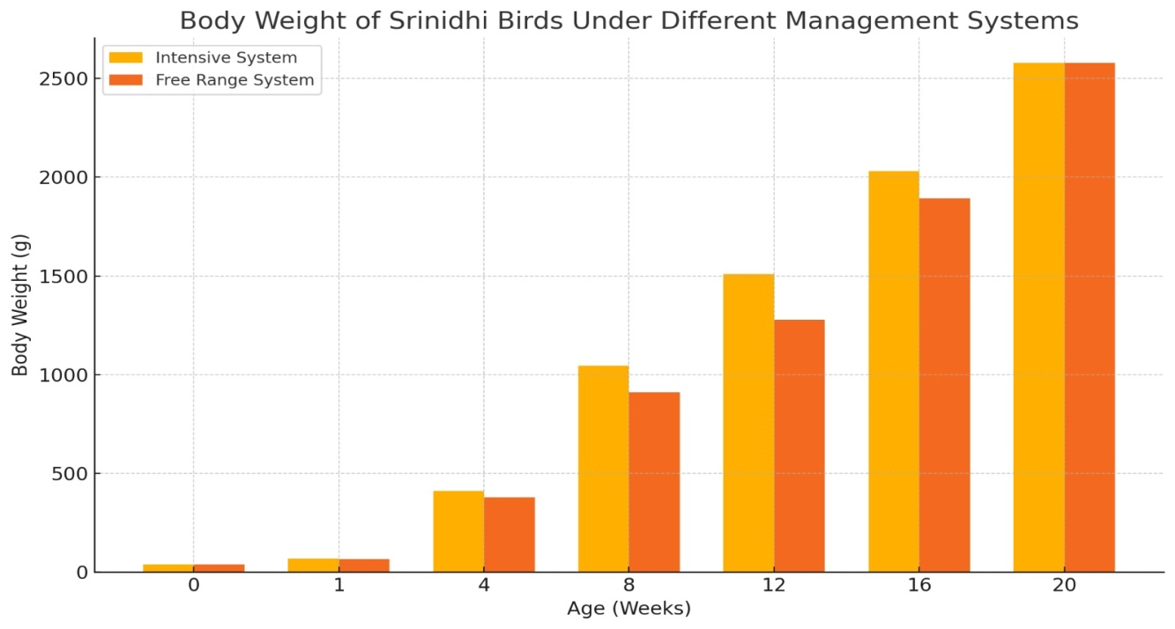
Table 2.Economic trait.
Economic trait | Value under Intensive system | Value under Free range system
Age at first egg (days) | 170.85 ± 2.3 | 178.65$±2.43$
Egg production no. ( up to 40 week ) | 108.75$±1.70$ | 102.42$±1.75$
Egg weight (40 week) g | 55.19$±1.35$ | 51.30$±1.32$
Laying capacity | $$150.33eggs/bird/year$$ | 143.25eggs/bird/year
Survivability % | 97.85 | 96.76

Fig 2 : Production Performance Srinidhi Birds
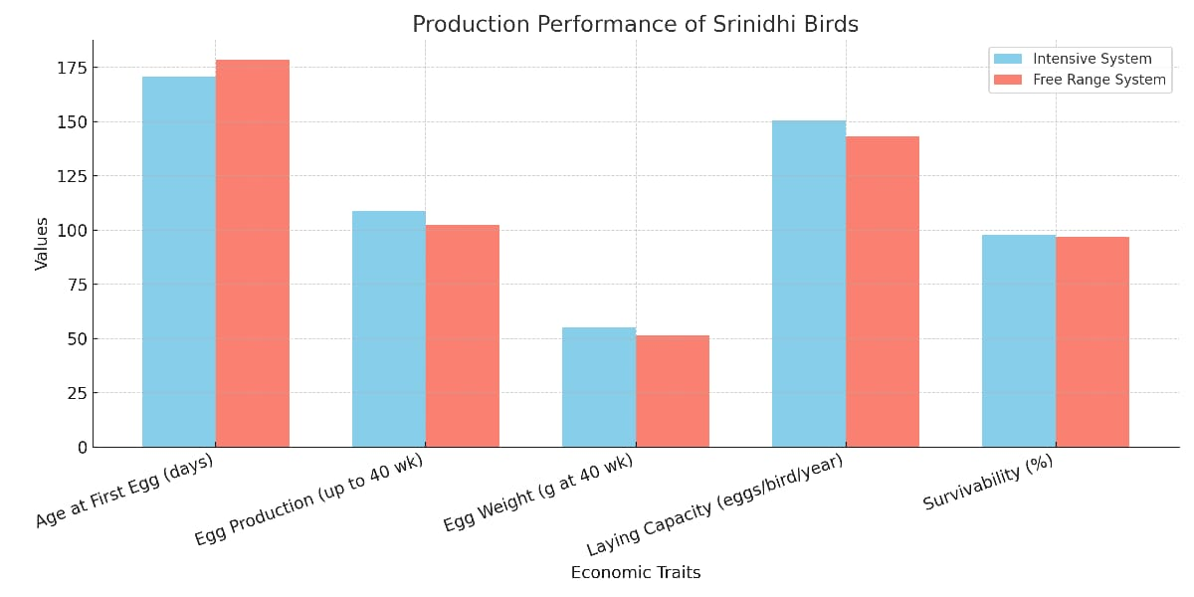
Production Performance
The mean age at first egg was recorded 170.85 ± 2.33d in Srinidhi birds and178.65$±2.43$ . Higher age at first egg was observed by Sarma et al (2018) in Srinidhi and Vanraja birds under field condition. However, lower age at first egg (150-162 d) was reported by Singh et al (2018) in Srinidhi birds under farm system of management. Higher age of first egg (173.00±1.35 ds) in Gramapriya and 181.53±1.29 d in Vanaraja birds were reported by Singh et al (2018) under field condition. The average egg production up to 40 weeks of age was found to be 105.42 ± 1.65 eggs in Srinidhi birds. However, 195 eggs up to 72 wk of age were reported by Singh et al (2018) in Srinidhi birds under farm condition. The lower egg production (50.93±0.28) up to 40 week of age was estimated by Sarma et al (2018) in traditional farming system. Similarly, the average egg weight at 40 wk of age was estimated to be 54.40 ± 1.22 g. The present study was close with those reported by Singh et al (2018) and Sarma et al (2018) in Srinidhi birds under farm and field conditions. However higher egg weight was recorded by Singh et al (2018) in Vanraja birds. The survivability percentage up to 40wk of age was observed as 97.15 under farm condition. Almost similar findings were reported by Zuyie et al (2009) under extensive system of management in Vanraja birds and Singh et al (2018) in Srinidhi birds under farm condition. These results indicated that management provided at farm condition was better than traditional farming system of management.
Srinidhi birds perform better under scientific farm management systems as compared to traditional or backyard systems. Parameters such as age at first egg, total egg production, egg weight, and survivability percentage were significantly improved under farm conditions. The mean age at sexual maturity was lower, and egg production up to 40 weeks was notably higher, indicating that optimal nutrition, controlled environment, and proper healthcare play a vital role in enhancing the productivity of improved poultry breeds.
Moreover, egg weight and bird survivability were also found to be superior under managed systems, reflecting the influence of balanced feeding, biosecurity measures, and regular monitoring. The comparison with literature further validates these results, as similar trends have been reported by various Indian researchers. Hence, it can be concluded that adopting scientific management practices is essential to harness the full genetic potential of dual-purpose birds like Srinidhi, thereby boosting rural poultry production, improving food security, and enhancing the economic status of small and marginal farmers.
CONCLUSION
The present findings showed that the Srinidhi birds performed better in terms of body weight gain, age at sexual maturity, egg production and egg weight in semi intensive system condition than free range system though there was no significant difference between Intensive system and free range system. The bird adopted well in the local climatic conditions ofChandel District. So, farmers from rural areas of Chandel could rear the Srinidhi birds for their livelihood and nutritional security as these multicolour bird are resistant to local climatic condition and better growth and production performance than local desi birds either Intensive system or backyard system is recommended.
Overall, the findings from this study clearly indicate that scientific rearing practices, including proper brooding, balanced nutrition, disease prevention, and hygienic housing, significantly enhance the production performance of improved backyard poultry breeds such a senvironment that supports early sexual maturity, higher egg production, increased egg weight, and better bird survival, ultimately leading to higher economic returns for rural farmers and improved livelihood sustainability Srinidhi. Compared to traditional farming systems, farm-based management provides an……xxxxx (Incomplete sentence)??????
Refrences
1.Rajkumar U, Kumari Kanya R, Raju M V L N, Panda A K, Niranjan M and Rama Rao S V (2014). Evaluation of Performance of Vanaraja and Srinidhi Varieties of Rural Poultry During Nursery Phase Under Different Feeding Regimes. Indian Vet J 91 (3): 95 – 97.
2.Sarma M, Islam R, Borah M K, Sharma P, Mahanta J D, Kalita N and Bhattacharyya, B N (2018). Comparative performance of Vanaraja, Srinidhi and Desi chicken under traditional system among tribal community of Assam. Indian J Anim Res 52(10):1518-1520
3. Singh Mahak, Talimoa Mollier R, Rajesha G, Myngthungo Nguillie A, Rajkhowa D J, Rajkumar U, Paswan Chandan and Chatterjee R N (2018). Backyard Poultry Farming with Vanraja and Srinidhi. Indian Farming 68(01): 80 82.
4. Kumaresan, A., Bujarbaruah, K. M., Pathak, K. A., et al. (2008).Performance of Vanaraja birds under backyard system of rearing in Nagaland Indian Journal of Poultry Science, 43(1), 60–63.
5. Padhi, M. K. (2016).
Backyard poultry farming: A source of livelihood in rural India.Indian Journal of Animal Health, 55(2), 135–140.
6. Kumaresan, A., et al. (2013).
Assessment of sustainable rural poultry production through improved backyard chicken rearing.Indian Journal of Animal Sciences, 83(10), 1039–1043.
7.Sastry, K. V. H., Mohan, J., & Moudgal, R. P. (2006).
Evaluation of egg production potential and egg quality traits in indigenous chickens and their crosses.Indian Journal of Animal Sciences, 76(7), 635–640.
8.Rajkumar, U., Reddy, M. R., Reddy, B. L. N., & Sharma, R. P. (2010). • Comparative performance of different improved chicken varieties for backyard farming.Indian Veterinary Journal, 87(8), 66–68.
9. ICAR-DPR Annual Report (2020–21).Performance of dual-purpose poultry breeds under different agro-climatic zones.Directorate of Poultry Research, Hyderabad.
10. Zuyie, R., Singh, N.P., & Ngullie, T. (2009).Performance of Vanaraja birds under traditional management practices in Nagaland.Indian Veterinary Journal, 86(9), 976–978.
11. Reddy, M.R., Reddy, V.R.A., & Prakash, M.G. (2015).Evaluation of egg production performance of improved backyard poultry birds under different management systems in Andhra Pradesh.Journal of Rural Development and Agriculture, 50(4), 350–354.
12. Kumari, P., Singh, R.V., & Meena, R.K. (2016).Comparative performance of improved backyard poultry strains in field conditions.Veterinary World, 9(10), 1128–1131.

