**FINDINGS OF A MARKET SURVEY ON VEGETABLES AND FISH FOR MGOMBEZI COMMUNITY AQUAPONICS PROJECT**

**Abstract**

The market survey was aimed at collecting comprehensive information on the demand, supply, pricing, and consumer preferences for vegetables and fish among the communities living in the region and its environs. The water circulating system and aerators will be powered by solar energy. However, before any production project can be undertaken, it is a requirement that a market survey has to be conducted to establish the various market dynamics and where the products will be sold, while at the same time identifying the various threats and opportunities. It is in this regard that this market survey was undertaken. Lunga Lunga Municipality relies primarily on road transportation, served by matatus, buses, motorcycles, and bicycles. It is closely linked to Diani Municipality, a major commercial hub, and connected to Nairobi via the Kibaoni-Mwangulu-Kinango-Samburu Highway, which has boosted its trade potential. **Preferences for indigenous vegetables: In most markets there was more preference for indigenous vegetables. This was attributed to the fact that** among health-conscious consumers, **indigenous vegetables were considered organic in nature and highly valued. This is because they were rarely subjected to pesticides as they experienced few pest and diseases. They were also preferred for their good taste especially by the elite and the elderly.** From the findings, vegetable marketing is a vibrant business and offers significant opportunities for growth in businesses in the study area. However, there was need to address the observed challenges and supply chain inefficiencies, seasonality of supplies and price fluctuations to enhance market stability and profitability.

Keywords: market stability, Anglican Development Services, farming system, irrigation system

# **1.0 Introduction**

Mgombezi is a community-based organization (CBO) consisting of eight groups with a membership of 1000 members. It is based in Lunga Lunga Sub-County, a semi-arid area in Kwale County bordering river Umba (Kwale County profile, 2020). This CBO had been earmarked to benefit from a project on Aquaponics technology donated by Friends of Anglican Development Services (ADS) of Anglican Church of Kenya, in Mombasa Diocese. The project aimed at empowering the community to commercially produce vegetables and fish using aquaponics farming system. These vegetables and fish products were aimed at addressing the rampant malnutrition and food insecurity in the region while at the same time generating income for the community. In the aquaponics farming system, the water used in the fish ponds will be circulated into hydroponics system where vegetables will be grown in soilless media (Aich *et al.,* 2020). The water from the irrigation system will be passed through filters to remove any unwanted materials and then pumped back into the fish tanks. The water circulating system and aerators will be powered by solar energy. However, before any production project can be undertaken, it is a requirement that a market survey has to be conducted to establish the various market dynamics and where the products will be sold, while at the same time identifying the various threats and opportunities. It is in this regard that this market survey was undertaken.

## **1.1 Description of Lunga Lunga Municipality /Mgombezi area and its environs**

Lunga Lunga Municipality is a border town between Kenya and Tanzania. To the southwest of Lunga Lunga town lies Mgombezi area while to the north lies Msambweni Sub-County (Mwanga, 2019; Kwale County Integrated Development Plan, 2020) (Figure 2). The Lunga Lunga Municipality thrives from various economic activities such as agriculture and trade, which ultimately contributes to Kwale County's economic development and poverty reduction. The Mgombezi area is located South of Kwale and borders Tanzania on the extreme southern end. The area is served by two seasonal rivers. One of this is river Umba which originates from the hilly Usambara mountainous areas in northeastern Tanzania and flows through Lunga Lunga town (Figure 1) (Lerise, 2005). The river flows East-Ward, forming part of the Kenya-Tanzania border before emptying into the Indian Ocean near Vanga, the extreme marine border town between Kenya and Tanzania (Figures1and 2). This Vanga town is an important fish landing site and receives fish from both Kenyan and Tanzanian fishermen, courtesy of the strong Kenyan currency. Although rivers Umba and Ramisi are seasonal, they are major sources of water for domestic, livestock and irrigation activities for most part of the year. However, during extreme droughts around September and March, sand harvesting becomes a major economic activity for some youth groups which is detrimental to sustainability of the rivers. These rivers enclose much of Mgombezi area, Lunga Lunga town and its environs all the way to areas bordering Kinango Sub-County. These rivers will be an important source of water for the Mgombezi project before a borehole can be drilled.

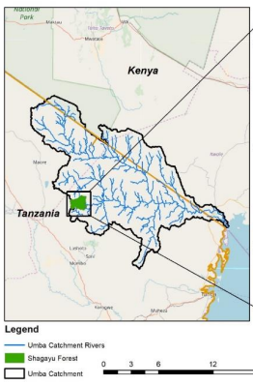

Figure 1: River Umba, origins and catchment area.

## **1.2 Population and land size**

The population of Lunga Lunga Sub-County and its Municipality are shown in Table 1. The Sub-County population is about 200,000 covering an area of 2,765Km2. The Lunga Lunga Municipality covers the whole of Vanga Ward except parts of Godo and Mwereni Ward and has a population of about 54,000 and land size of 284.1Km2 (Kemfsed, 2020). Thus, as one moves away from the Municipality center, the population density decreases progressively with increasing distance. The population density in the Mgombezi area, located on the outskirts of Lunga Lunga town, ranges from moderate to sparse, decreasing towards the south west near the border with Tanzania and Kinango (Table 1 and Plate 1). The households are distantly placed, about 30m or more from one another, with average land units of 5-10 acres per household. However, as one moves northward towards Dzombo and hilly areas of Mrima, the rainfall, tree crops density and population density increases. The population in Lunga Lunga Municipality and the entire Sub-County represents a major potential market for the fish and vegetables to be produced by the Mgombezi project farmers.

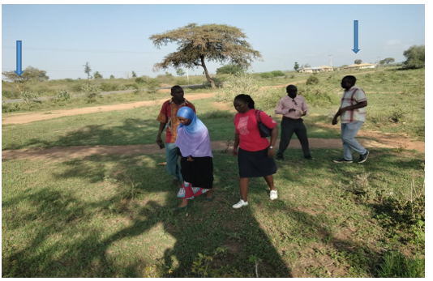

Plate 1: Households in the study area are far removed from each other and area is sparsely populated.

Table 1: Population and land sizes in Lunga Lunga Sub-County and Municipality.

|  |  |  |  |  |
| --- | --- | --- | --- | --- |
|  | Lunga-Lunga | Population (2019 census) | Area | Population density |
|  | Sub-County | 198,423 | 2,765 km² | 71.8/km² |
|  | Municipality | 54,000 | 284.1Km2 | 190.1km2 |

## **1.3 Transportation and infrastructure**

Lunga Lunga Municipality relies primarily on road transportation, served by matatus, buses, motorcycles, and bicycles. It is closely linked to Diani Municipality, a major commercial hub, and connected to Nairobi via the Kibaoni-Mwangulu-Kinango-Samburu Highway, which has boosted its trade potential (Kemfsed, 2020). Ongoing infrastructural projects, like the dueling of the Malindi-Mombasa-Lunga Lunga-Bagamoyo road and tarmacking of other feeder roads, promise a bright future and further development and potential for upscaling Mgombezi project.

## **1.4 Agro-climatology and economic activities**

Lunga Lunga Municipality and its environs (Mgombezi) has a tropical wet and dry or savanna type of climate (Hoffmann and Jackson, 2000). The study area lies in the lower Coastal region of Kenya within the latitudes 380E - 40.00E and longitudes 4.00 - 4.50S (Figure 2). The region lies at an altitude of between 0-100 m above sea level (ASL) (Muli, 2022). The region is characterized by hot and humid type of climate with temperatures ranging between 29 0C and 32 0C for most part of the year except during rainy season in the months of May and June when low temperatures of 23 0C to 28 0C are experienced (Mnyika *et al*., 2020). The coastal strip that stretches from Vanga to Ukunda experiences the highest amounts of rainfall of about 1000 – 1100 mm p.a while the southwestern areas in Mgombezi extending to Mwangulu and Kinango receives between 400- 600mm of precipitation with 163.1 rainy days, annually (44.7% of the time) (Jaezold and Schmidt, 2012). The soils in the area are red deep sandy loam soils with pockets of black cotton clay soils especially towards valley bottoms. With availability of manure, these soils are highly productive except limitations of soil moisture. The Mgombezi area falls under Coastal lowland CL4 transiting to CL5 ecological zones and gives way to agro-ecological zone CL6 (Plate 1) as one approaches the Tanzanian border to the south and Kinango Sub-County to the west. The main economic activities in the area include livestock keeping intermixed with planting of drought tolerant annual crops, vegetables and tree crops (Table 2). Important livestock kept in the area include the local Zebu cattle, goats, sheep and local poultry. The expansive area is littered with heaps of animal manure that represents the sites of livestock bomas (Kraal), and signifies underutilized potential for crop production. The annual crops grown in the area include, green gram, cowpea, maize, cassava, cotton, sorghum and millet (Table 2). The farmers in the area also grow both indigenous and convectional vegetables. These include, amaranthus, black night shade, sukuma (kale), tomato, brinjal, and cowpea.

Table 2: Crops grown in Mgombezi locality and its environs

|  |  |  |  |  |  |
| --- | --- | --- | --- | --- | --- |
|  | Livestock kept | Annual crops | Conventional vegetables | Indigenous vegetables | Tree crops |
|  | Local zebu | Maize | Cowpea | Local Amaranthus | Cashew nut |
|  | Dairy animals (Crossbreeds) | cowpea | Black-night shade | Spider plant | Mango |
|  | Goat | Green gram | Amaranthus | Mchunga | Moringa |
|  | Sheep | Cassava | Brinjal | Tsalakushe | Jack fruit |
|  | Local Poultry | Cotton | Sukuma | Mafa | Citrus |
|  | Guinea fowl | Sorghum | Tomato | Tunguja |  |
|  |  | Millet Pineapple |  | Tindi |  |

Besides these, farmers also grow traditional indigenous vegetables especially during the rainy season that are more preferred compared to the conventional vegetables (Table 2). Tree crops are also of economic importance, and these include cashew nut, mango, citrus, jack fruit and fruits such as pineapple and banana (Table 2). These crop and livestock activities have come of age to be the economic backbone of the area and have supported the communities for generations. Their selection from a wider choice of possible crop varieties and livestock has been through trial and error coupled with natural selection based on cycles of climate scenarios. The earmarked aquaponics raised crops and fish should be able to fit within the prevailing climatic conditions. Thus, while the market survey was conducted to establish markets and market dynamics for the vegetables and fish to be produced, it was also essential to identify vegetables and fish that can be locally produced and fit the food preferences of the local communities and satisfy the market demand and supply.

## **1.5 Statement** **of the** **Problem**

Mgombezi community is earmarked to receive a donation to start vegetable and fish farming project using aquaponics technology to empower the community members to address the wide spread malnutrition and food insecurity in the area (Sustainable development goals (SDGs) 1 and 2). However, there is limited market information regarding the types of vegetables and fish preferred and consumed by the various communities in the area, as well as the potential demand, supply, and pricing for these products.

## **1.6 Aim and objectives of the market survey**

The market survey was aimed at collecting comprehensive information on the demand, supply, pricing, and consumer preferences for vegetables and fish among the communities living in the region and its environs. This information was meant to support the Mgombezi community’s initiative to implement vegetable and fish farming using aquaponics technology, thereby addressing malnutrition and food insecurity while at the same time empowering community members to discover and solve their own problems.

### **1.6.1** Specific objectives of the market survey

### These were to:

1. To determine and understand consumer preferences for the various vegetables and fish consumed in Lunga Lunga and neighboring Sub-Counties
2. To determine demand and supply for the various vegetables and fish sold in the various markets in Lunga Lunga and neighboring Sub-Counties
3. To identify the various pricing trends for the various vegetables and fish sold in the different markets in Lunga Lunga and neighboring Sub-Counties
4. To analyze likely competition between Mgombezi produced vegetables and fish, and those from different markets in Lunga Lunga and neighboring Sub-Counties
5. To determine the effects of seasonality on demand, supply and pricing for the various vegetables and fish sold in the various markets in Lunga Lunga and neighboring Sub-Counties.

## **1.7 Justification**

The information generated from the market survey will facilitate determination of various types of vegetables and fish that could be produced at the proposed Mgombezi Aquaponics Project for purposes of selling to the local markets. It will also gauge the amounts of vegetables and fish that will be required for the different markets in the different seasons and the effects of seasonality on demand, supply and pricing for the various vegetables and fish types.

# **2.0 Methodology**

## **2.1 Study area**

The study area for the market survey included all major and local markets in Lunga Lunga Sub-County and neighboring Sub-Counties, namely Msambweni, Kinango and Matuga (Figure 2 and Table 3). Lunga Lunga Sub-County is bordered by Msambweni Sub-County to the north, Kinango Sub-County to the northwest and Tanzania to the south (Figure 2).

Table 3: Pool for purposive selection of Sub-Counties and Wards for market survey.

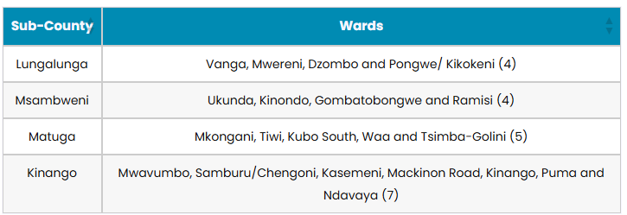

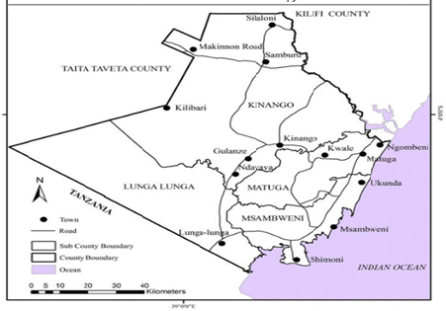

Figure 2: Map of Kwale County and its administrative boundaries showing various Sub-Counties.

## **2.2 Study design**

A survey method of study was employed. Primary and secondary data collection strategies were used. It involved planning for the survey where use of face-to-face interviews, questionnaires, phone calls and observations at markets were adopted. The target population for the survey included vegetable vendors and fish mongers, wholesalers, retailers and some key informants. During planning meetings, all Wards in the three Sub-Counties of Lunga Lunga, Kinango and Msambweni were listed from where sampling was done (Table 3).A week before the commencement of the survey, one of the Mgombezi Community key members visited all important administration offices to seek permission for conducting the survey. These administrative offices included Village elders, Chiefs, Sub-chiefs, Sub-County Commanders and Heads of Police Stations in the respective areas of survey. During planning meetings held in Mombasa for the market survey key informants from the focal area were involved in the identification and selection of markets for the survey and also gave information on market days. Purposive sampling was done to select at least three Sub-Counties and three Wards per Sub-County for the survey. Matuga Sub-County was dropped owing to the fact that its markets were far removed from Lunga Lunga (Kemfsed, 2020). Of the over 100 local market centers in all the Wards in the three Sub-Counties, only 10 markets were selected for data collection (Table 4). Criteria used for selection of the markets included, logistical issues especially the distances involved, impassable roads and also presence or absence of a market or market day. The visit to the markets for data collection was aligned to the market days to obtain hands-on information (Table 4).

Table 4: Markets and their market days in the study area

|  |  |  |  |  |  |  |  |  |
| --- | --- | --- | --- | --- | --- | --- | --- | --- |
| S/No | Market/Days | Mon. | Tues. | Wed. | Thur. | Fri. | Sat. | Sun. |
| 1 | Mwangulu | X |  |  |  |  |  |  |
| 2 | Kinango |  |  | X | X |  |  |  |
| 3 | Ukunda | X | X | X | X | X | X | X |
| 4 | Msambweni |  |  |  |  |  |  | X |
| 5 | Shimoni |  |  |  |  | X |  |  |
| 6 | Mrima |  |  |  | X |  |  |  |
| 7 | Perani |  |  |  |  |  |  | X |
| 8 | Menzamwenye |  |  |  | X |  |  |  |
| 9 | Lunga Lunga |  |  |  |  | X |  |  |
| 10 | Vanga (fish only) |  |  |  |  |  |  |  |

## **2.3 Data collection and assessment**

A questionnaire was formulated that included questions that sought to know vegetables and fish types that had high turnover; vegetables and fish types in high demand; price trends in each market and season; and sources of the vegetables and fish sold. Other data collected included the type of market, open or enclosed in a building or space; source of vegetable and fish in terms of whether locally produced or externally sourced; buying/selling price; perishability, whether high or low; mode of transport, either motorbike or vehicle; market capacity; demand/supply; government interventions, among others (See attached questionnaire). In each market,vendor competition was assessed by observing their pricing strategies, mode of packaging, and branding, and presence of any promotional efforts.Market and price trends were assessed by looking at seasonal variations in vegetable/fish demand and prices and also identifying trends in locally sourced and exotic vegetables. Four groups of enumerators (each group composed of two enumerators) were involved in interviewing the traders, two groups handling vegetables and the other two handling fish. Before starting the interview, the total number of vegetable vendors and fishmongers were identified and 30% of them were randomly selected for interview. Also, in the specific markets, sampling of vegetable traders for interviews was done by identifying those selling locally produced vegetables while the other group of enumerators sampled traders with externally sourced vegetables. The same was applied for fish mongers where one group interviewed those selling fresh fish while the other interviewed those selling dried fish.

## **2.4 Data analysis**

Descriptive data analysis using excel, pie charts, bar charts and tables was used to identify patterns of demand and supply, price fluctuations and vegetable and fish preferences in the individual markets and by Sub-Counties.

# **3.0 Results and discussions**

## **3.1 Vegetables sold in the various markets in the study area**

The findings indicated that there were two types of markets, open and those enclosed in a market building (Plate 2). About 24 different types of vegetables were sold in the different markets in the study area (Table 5). Detailed photographs of these vegetables are in the Appendices. Of these vegetables, three types namely, tomato, sukuma (kale) and amaranthus dominated the entire vegetable market in all the nine sampled markets in the three Sub-Counties.

Table 5: Types of vegetables sold in the study area markets and their consumptive importance

|  |  |  |  |  |  |
| --- | --- | --- | --- | --- | --- |
| S/No | Vegetable type | % Consumptive importance | S/No | Vegetable type | % Consumptive importance |
| 1 | Amaranthus | 13 | 13 | Mrenda | 3 |
| 2 | Sukuma | 11 | 14 | Cowpea | 2 |
| 3 | Tomato | 10 | 15 | Hot Pepper/Chilli | 2 |
| 4 | Spinach | 9 | 16 | Spider Plant | 3 |
| 5 | Capsicum | 6 | 17 | Tindi | 3 |
| 6 | Okra | 7 | 18 | Mitoo | 3 |
| 7 | Brinjal | 7 | 19 | Tsalakushe | 2 |
| 8 | Mchunga | 6 | 20 | Mwangani | 2 |
| 9 | Mnavu | 6 | 21 | Kisenye/ Local Mchicha | 2 |
| 10 | Tunguja | 4 | 22 | Kikosho | 2 |
| 11 | Mafa | 4 | 23 | Vombo | 1 |
| 12 | Dania | 4 | 24 | Madondo/Wild Mnavu | 1 |

These three types of vegetables occupied more than 12% of the market share in all the nine sampled vegetable markets (Figure 3 and Plate 2). Figure 4 indicates that there were four important vegetables namely, tomato, cabbage, onion and carrot that were sold in the local markets but were mainly sourced externally from the study area.

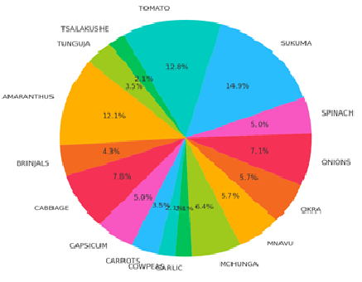

Figure 3: Variety of vegetables sold in the various markets in the study area and their share of market.

These vegetables could not be produced locally and economically due to the hot climatic conditions in the Coastal region. However, some indigenous tomato such as tindi, although of limited preference were grown under local conditions. Some exotic tomato varieties could be grown but they would require intensive level of management and a lot of pesticides and fertilizer application to obtain any meaningful economic production.

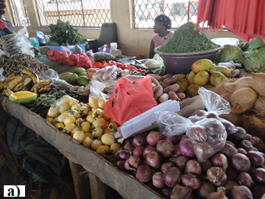 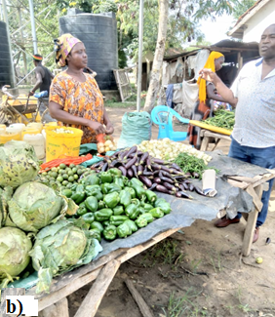 Plate 2: a) Enclosed and b) Open air vegetable markets in Mwangulu and Kinango markets respectively.

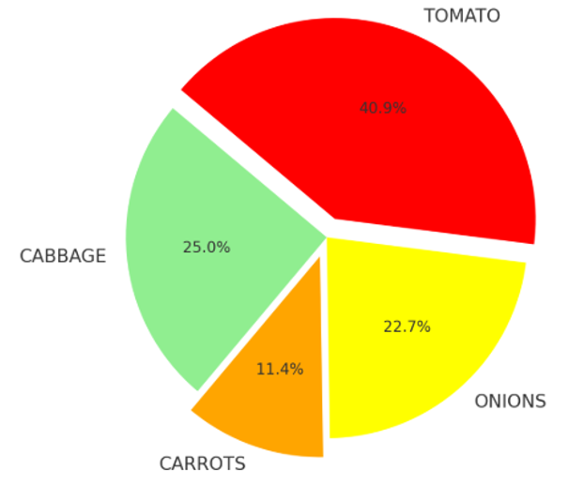

Figure 4: Major vegetables exclusively sourced externally from the study area mainly from Kongowea market in Mombasa, and Taveta.

## **3.2 Vegetables that could be grown locally in the project area of Mgombezi**

Tables 6, 7 and 9 shows vegetables that could be grown locally in the Mgombezi area. They represent vegetables that could be test-grown under aquaponics greenhouse production.

Table 6: Vegetables sold in the local markets that could be grown locally

|  |  |  |
| --- | --- | --- |
|  | Vegetables proposed for trials at Mgombezi aquaponics project | Relative ease of growing  (scale 1-10) |
| 1 | Amaranthus | 10 |
| 2 | Cowpea | 10 |
| 3 | Spinach | 9 |
| 4 | Brinjal | 8 |
| 5 | Mnavu | 7 |
| 6 | Okra | 6 |
| 7 | Tunguja | 6 |
| 8 | Local Sukuma | 5 |
| 9 | Capsicum | 4 |
| 10 | Tomato | 4 |

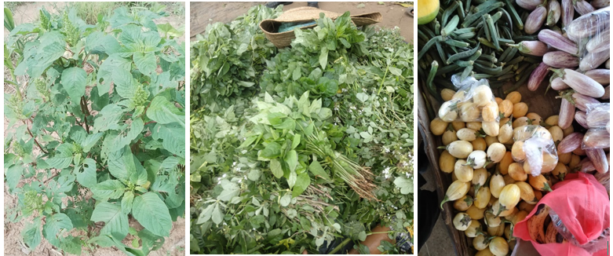

Plate 3: Some vegetables that could be grown locally at Mgombezi.

Table 7 and Plate 3 further outlines vegetables that could be grown locally in Mgombezi and ranked based on their ease of management costs. These vegetables were characterized by having prolonged period of harvest depending on soil fertility and soil moisture availability (Table 7). The Mgombezi area was laden with cattle manure which could easily be deployed to the vegetable farms. These are vegetables that should be given priority when growing under aquaponics system commences (Tables 7 and 9). It is also proposed that outdoor growing of the vegetables should be done both around the project structure and at the community farms. If 100 members of the group each cultivated a 20x10m or 200m2 field, this would result in 20ha of assorted vegetables to complement aquaponics production and meet the weekly 850kg vegetable requirement by the local markets (Table 9). This would enhance the farmers’ participation, ownership and sustainability of the project since they would be able to follow and obtain first-hand experience on performance of the vegetables from their farms.

Table 7: Low production cost vegetables that can grow locally and their time/duration to harvest.

|  |  |  |  |  |  |
| --- | --- | --- | --- | --- | --- |
|  | Vegetables with  low production  cost | Weighted  Importance % | Time to  first harvest | **Duration of continuous harvest | Proposed farm  gate price/kg |
| 1 | Cowpea leaves | 5 | 2-3 weeks | 2-3months | 30 |
| 2 | Tunguja | 8 | 4-5 weeks | 3-4months | 30 |
| 3 | Brinjal | 10 | 4-5 weeks | 3-4months | 30 |
| 4 | Mnavu | 13 | 2-3 weeks | 2-3months | 30 |
| 5 | Okra | 13 | 3-4 weeks | 3-4months | 30 |
| 6 | Spinach | 21 | 2-3 weeks | 3-5months | 30 |
| 7 | Amaranthus | 28 | 2-3 weeks | 3-5months | 30 |

**Subject to good soil fertility and supply of soil moisture.

It is hereby proposed that the Mgombezi farmers should be facilitated to grow these vegetables through provision of the necessary inputs such as seeds and establishment of collection centers for marketing the produce. Packaging materials such as nets would be obtained cheaply if bought centrally in large quantities. Polythene bags (Plates 2 and 3) while they were the best, they are not recommended since they had been outlawed by the National Environment Management Authority (NEMA) on environmental grounds. Table 8 shows the approximate quantities of vegetables and expected revenue each market could handle during a market day. It is evident that only the three major markets namely Ukunda, Kinango and Lunga Lunga could handle large quantities of vegetables of about 850kg or approximately 1 ton during a single market day, each earning on average a revenue of about Ksh. 30,000 per day.

## **3.3 Effect of seasonality on supply and demand**

During the study, it was noted that demand and supply and therefore prices varied with seasonality (Table 8). Thus, during the wet season, production of most locally produced vegetables in the rural areas increased resulting in reduced demand and therefore a decrease in prices in the smaller markets as consumers had other alternative sources of vegetables (Table 8). It was therefore proposed that during wet seasons production or supply should be scaled down to 75% except for Ukunda and Kinango markets where seasonality appeared to have least effect on demand of most locally produced vegetables since these towns served large catchment areas with large populations.

### **3.3.1 Price range for vegetables during low and high season of production**

During the rainy season most rural communities had alternative sources of vegetables (Table 8).

Table 8: Vegetable price variations in the markets due to seasonality

|  |  |  |  |
| --- | --- | --- | --- |
|  |  | Prices (in Ksh). | |
| Vegetable | Unit | Production season | Off-season |
| Tomato | kg | 80 | 200 |
| Onion | kg | 80 | 200 |
| Spinach | bundle | 30 | 70 |
| Cabbage | piece | 80 | 150 |
| Amaranthus | bundle | 30 | 100 |
| Cowpea | bundle | 30 | 100 |
| Tunguja | kg | 50 | 100 |
| Brinjal | kg | 50 | 100 |
| Mnavu | bundle | 30 | 100 |
| Okra | kg | 80 | 120 |

Table 9: Markets and approximate vegetable quantities (in Kg) they could handle during market days during dry* seasons.

|  |  |  |  |  |  |  |  |  |  |  |
| --- | --- | --- | --- | --- | --- | --- | --- | --- | --- | --- |
| Market/  Vegetable | Amaranth | Spinach | Mnavu | Brinjal | Okra | Tunguja | Cowpea | Totals | Unit price | Expected revenue |
| Mwangulu | 10 | 10 | 10 | 10 | 10 | 10 | 5 | 65 | 30 | 1,950 |
| Kinango | 200 | 200 | 200 | 200 | 200 | 200 | 200 | 1400 | 30 | 42,000 |
| Ukunda | 500 | 500 | 500 | 500 | 500 | 500 | 500 | 3500 | 30 | 105,000 |
| Lunga Lunga | 100 | 100 | 100 | 100 | 100 | 100 | 100 | 700 | 30 | 21,000 |
| Msambweni | 10 | 10 | 10 | 10 | 10 | 10 | 5 | 65 | 30 | 1,950 |
| Perani | 15 | 15 | 15 | 15 | 15 | 15 | 15 | 105 | 30 | 3,150 |
| Menzamwenye | 10 | 10 | 10 | 10 | 10 | 10 | 5 | 65 | 30 | 1,950 |
| Shimoni | 5 | 5 | 5 | 5 | 5 | 5 | 5 | 35 | 30 | 1,050 |
| Mrima | 5 | 5 | 5 | 5 | 5 | 5 | 5 | 35 | 30 | 1,050 |
| Totals | 855 | 855 | 855 | 855 | 855 | 855 | 840 | 5,970 | 30 | 179,100 |
| Unit cost | 30 | 30 | 30 | 30 | 30 | 30 | 30 |  |  |  |
| Expected revenue | 25,650 | 25,650 | 25,650 | 25,650 | 25,650 | 25,650 | 200 | 179,100 |  | **179,100** |

*During rainy season demand for local vegetables in most rural areas decreased since most farmers could easily obtain other alternative vegetables from their farms.

**Thus, seasonality resulted** in variation in prices by about 20-30% during off-season periods. Improved weather and soil moisture conditions during rainy season resulted in favorable conditions which enhanced sprouting of leafy weeds most of which constituted indigenous vegetables.

## **3.4 Transportation of vegetables to the markets**

Local production was noted to have comparative advantage of reduced distances to the market since there was no Likoni ferry to cross. Queuing to cross Likoni ferry took several hours especially during rush hours in the morning. Kinango market was noted to be lucrative and stable due to the fact that it served a wider customer catchment area, just like Ukunda market. However, the road via Mwangulu and Ndavaya was earthen and this posed a major challenge during rainy season. Apart from Kinango market, access to all other markets was via tarmac roads making it faster and convenient. Also, except for Kinango and Ukunda markets, delivery of vegetables from Mgombezi to all other markets could be done cheaply using motorbikes. Matatus were also observed to be major couriers of vegetable in these markets since the quantities involved were not as large.

## **3.5 Supply chain**

There were two major sources of vegetable supply to the markets, namely local production in the region and from external sources outside the study area. These external sources included Kongowea market where the vegetables originated from up-country regions such as Taita-Taveta, Central and Western Kenya. Much of the local production was from farms along river basins, or irrigation using underground water sources. This irrigated production was mainly practiced in Mtwapa, Kikambala and Vitaroni in Likoni who were the major suppliers to Kongowea, Kikambala, Ukunda and other markets.

## **3.6** **Challenges facing marketing of vegetables in the study area**

A number of challenges were noted that adversely affected the efficiency of vegetable markets. These included:

i) Poor handling **of vegetables** during transportation from major suppliers, whole sellers and retailers. In most cases leafy vegetables were stashed in sacks and heaped on each other and placed on top of bus or matatu carriage or piled into lorries to their destination. Most traders complained of substantial losses during transportation to markets since there were no organized or designated vehicle transport for vegetables.

ii) Inadequate storage for remnants vegetables after a market day. Most vegetable traders literally “walked” with their merchandise from one market to the next. In most cases there was no organized storage for their merchandise. Else, they had to hire premises to store their remaining merchandise after a market day.

iii) Transportation and delivery delays: This affected freshness and quality of leafy vegetables since the distances involved were large and it took too long to reach the markets.

iv) Harsh climatic and weather conditions: Most traders especially those operating in the open air markets complained of substantial loses of their vegetables during rainy seasons. This was especially so for vegetables such as onion, brinjal, tomato, cabbage and leafy vegetables since they had no shelters. The rain also affected the flow of customers and this affected daily sales and turnover since few customers turned up. Hot weather enhanced perishability and therefore shortened shelf life of leafy vegetables due to dehydration.

v) Lack of cold storage shelves for vegetables: Since most markets were in the rural areas, lack of power supply made it difficult to install cold storage rooms or facilities leading to high rates of spoilage especially after a marketing day.

## **3.7 Market opportunities**

During the survey, a number of opportunities became evident:

**a) Preferences for indigenous vegetables: In most markets there was more preference for indigenous vegetables. This was attributed to the fact that** among health-conscious consumers, **indigenous vegetables were considered organic in nature and highly valued. This is because they were rarely subjected to pesticides as they experienced few pest and diseases. They were also preferred for their good taste especially by the elite and the elderly.**

**b) Value-addition of vegetables: There was limited value addition in the vegetable markets except sorting, grading,** pre-washing and wetting.Little packaging of vegetables was observed unlike in supermarkets where vegetable bundles are wrapped in polythene films to enhance their appearance and shelf life.

**c) Technology integration:** A large number of traders were usingmobile apps for ordering and making payments directly to suppliers and farmers and also from buyers to consumers. Also, using designated SMS facility they were able to check on prevailing market prices and demand in the diverse markets.

d) Add a subtitle: Most traders made individual orders from various individual suppliers for their merchandise. No buying and selling vegetable cooperatives were noted, yet cooperatives would have enhanced efficiency and reduce marketing costs.

## **3.8 Conclusion on vegetable marketing**

From the findings, vegetable marketing is a vibrant business and offers significant opportunities for growth in businesses in the study area. However, there was need to address the observed challenges and supply chain inefficiencies, seasonality of supplies and price fluctuations to enhance market stability and profitability. Addressing customer and consumer preferences should be given the highest priority since they drive demand and ensure sustainability in the long-term.

# **REFERENCES**

Aich, N., Nama, S., Biswal, A., & Paul, T. (2020). A review on recirculating aquaculture

systems: Challenges and opportunities for sustainable aquaculture. *Innovative Farming*, *5*(1), 17-24.

Hoffmann, W. A., & Jackson, R. B. (2000). Vegetation–climate feedbacks in the conversion of

tropical savanna to grassland. *Journal of climate*, *13*(9), 1593-1602.

Jaetzold, R., Schmidt, H., Hornetz, B., & Shisanya, C. (2012). Farm management handbook of Kenya: Part C, East Kenya. II. Ministry of Agriculture, Nairobi, Kenya.

KEMFSED, (2020). Kenya Marine Fisheries and Socio-Economic Development Project.

Enhancing Livelihoods. <https://kemfsed.org>.

Lerise, F. S. (2005). Facilitating Cross-Border Dialogue: The Case of Umba River Ecosystem in

Kenya and Tanzania. *Topics of Integration Watershed Management*, *3*, 69-88.

Lunga Lunga Municipality development plan, (2020). [Https://Lunga Lunga.Municipality.co.ke/#](Https://lungalunga.municipality.co.ke/)

Mwanga, S. S. (2019). *Water dynamics in the Umba river sub-catchment of Tanzania: water*

*resource allocation for livelihoods* (Doctoral dissertation).

Mnyika, A.W., Mbuvi, S.M., & Gogo, E.O. (2020). Superabsorbent polymer and rabbit manure improve soil moisture, growth and yield of eggplant (*Solanum melongena* L). NASS *Journal of Agricultural Sciences*, 2(1), 12 – 20.

Muli, J.M. (2022). Surveillance on Coconut Lethal Yellowing Disease in Kwale County, Kenya.

*Plant Health*, 2020.

.