Original Research Article
Character Association and Path Coefficient Analysis of Yield and
Morpho-Physiological Traits in Foxtail Millet (Setaria italica (L.) P. Beauv.)
Abstract
The character association and path coefficient analysis studies were carried out for 18 yield and morpho-physiological traits in 40 foxtail millet (Setaria italica (L.) P. Beauv.) germplasm accessions. The phenotypic and genotypic correlation analyses revealed strong positive associations of grain yield per plant with straw yield (r_{p}=0.848**, r_{g}=0.900**), chlorophyll fluorescence (r_{p}=0.606**, r_{g}=0.878**), SPAD chlorophyll meter reading (r_{p}=0.569**, r_{g}=0.735**), number of productive tillers (r_{p}=0.594**, r_{g}=0.560**) and harvest index (r_{p}=0.566**, r_{g}=0.517**) among the traits under study and indicating their potential as selection criteria for yield accompanied with photosynthetic efficiency. Genotypic correlations were generally higher than phenotypic, suggesting strong intrinsic genetic relationships despite environmental influences. Path coefficient analysis showed straw yield (P=0.7935, G=0.7349) and harvest index (P=0.5102, G=0.3225) exerted the highest positive direct effects on grain yield, while traits like specific leaf area and protein content had negative direct effects. High positive indirect effects via straw yield were noted for most of the traits, reinforcing its role in yield enhancement. Low residual effects (P=0.0116, G=0.0069) indicated a robust model fit. The study identified plant height, number of productive tillers per plant, panicle length, net photosynthetic rate, chlorophyll fluorescence, SCMR, straw yield per plant, and harvest index as key traits with significant positive direct effects on grain yield per plant. Photosynthetic efficiency in terms of high SCMR, chlorophyll fluorescence, net photosynthetic rate; low specific leaf area and canopy temperature indicates direct correlation with harvest index and yield enhancement. Hence future breeding programmes in foxtail millet, may be targeted for increasing photosynthetic efficiency coupled with grain yield.

Key words: Foxtail millet, Trait association, Direct effects, Net photosynthetic rate, Chlorophyll fluorescence and Yield.

Introduction
Foxtail millet (Setaria italica (L.) P. Beauv.), a self-pollinating, short-duration C₄ cereal in the Poaceae family, is the second most cultivated millet worldwide, producing approximately 5 million tonnes annually (Anonymous, 2022-23a). Primarily grown in China, India and Japan, it is a cornerstone of agriculture, with China as the top producer followed by India. In India, foxtail millet occupies 0.43 million hectares, yielding 0.384 million tonnes with an average productivity of 893 kg/ha (Anonymous, 2022-23b). Major production occurs in Andhra Pradesh, Tamil Nadu, Karnataka and Rajasthan, with Andhra Pradesh contributing 7,631 tonnes from 8,350 hectares at 914 kg/ha (Anonymous, 2022-23c). Valued for its nutritional profile, foxtail millet contains 11–12% protein, 6–8% dietary fiber, 31 mg/100g calcium, 2.8 mg/100g iron, and low fat, making it ideal for diabetic and gluten-free diets (Hariprasanna, 2016). Its compact genome (515 Mb; 2n=2x=18) and short life cycle position made it as a model for studying C₄ metabolism and drought resilience, critical for rainfed semi-arid regions where it bolsters food security (Lata et al., 2013). Foxtail millet is an ideal crop for changing climate conditions due to its unique combination of low water requirements, drought tolerance and high photosynthetic efficiency (Vetriventhan et al., 2012). Understanding trait associations is key to enhancing yield through breeding, as it reveals the strength and nature of relationships among yield and its contributing traits. Phenotypic correlations reflect both genetic and environmental effects, while genotypic correlations highlight heritable associations driven by pleiotropy or linkage. Path coefficient analysis further dissects these correlations into direct and indirect effects, identifying traits with significant impact on yield. This study employs correlation and path analysis to evaluate 18 yield and morpho-physiological traits in 40 foxtail millet germplasm accessions, aiming to pinpoint key selection criteria for improving grain yield and drought tolerance through targeted breeding strategies.

MATERIAL AND METHODS
A field experiment was conducted during the rabi season of 2024-25 at the Wetland Farm, S. V. Agricultural College, Tirupati, Acharya N. G. Ranga Agricultural University, located in the Southern Agro-climatic Zone of Andhra Pradesh, India. The site is situated at 182.9 m above mean sea level, 13° N latitude, and 79° E longitude. The study evaluated 36 foxtail millet germplasm accessions alongside four standard check varieties sourced from the Regional Agricultural Research Station (RARS), Nandyal. An Alpha lattice design with two replications was employed for the experiment. Data were collected from five randomly selected plants per plot for 18 yield and morpho-physiological traits, including days to 50% flowering, days to maturity, plant height (cm), number of productive tillers per plant, panicle length (cm), specific leaf area (cm² g⁻¹), net photosynthetic rate (µmol CO₂ m⁻² s⁻¹), transpiration rate (mmol H₂O m⁻² s⁻¹), stomatal conductance (mmol H₂O m⁻² s⁻¹), relative water content (%), canopy temperature (°C), chlorophyll fluorescence, SPAD chlorophyll meter reading (SCMR), protein content (%), 1000-grain weight (g), straw yield per plant (g), harvest index (%) and grain yield per plant (g). To assess the interrelationships among these traits, genotypic and phenotypic correlation coefficients were calculated using the method given by Johnson et al. (1955). Path coefficient analysis was performed according to Dewey and Lu (1959) to partition correlations into direct and indirect effects on grain yield.

RESULTS AND DISCUSSION
The correlation analysis revealed significant associations between grain yield per plant and various yield and morpho-physiological traits in foxtail millet at both phenotypic and genotypic levels (Table 1). A highly significant positive association was observed with straw yield per plant (r_{p} = 0.848**, r_{g} = 0.900**), chlorophyll fluorescence (rₚ = 0.606**, r_{g} = 0.878**), number of productive tillers per plant (rₚ = 0.594**, r_{g} = 0.560**), SPAD chlorophyll meter reading (rₚ = 0.569**, r_{g} = 0.735**), harvest index (rₚ = 0.566**, r_{g} = 0.517**), stomatal conductance (rₚ = 0.506**, r_{g} = 0.533**), 1000-grain weight (rₚ = 0.487**, r_{g} = 0.651**), net photosynthetic rate (rₚ = 0.406**, r_{g} = 0.423**), panicle length (rₚ = 0.366**, r_{g} = 0.492**), transpiration rate (rₚ = 0.321**, r_{g} = 0.361**), plant height (rₚ = 0.320**, r_{g} = 0.454**), days to maturity (rₚ = 0.255*, r_{g} = 0.259*), and days to 50% flowering (rₚ = 0.233*, r_{g} = 0.280*). These findings are consistent with previous studies, including Prasanna et al., (2013) and Jhansi Rani et al., (2021) for straw yield per plant, Suman et al., (2018) and Kamal et al., (2021) for harvest index, Muzzayyanah et al. (2024) for plant height and Harish et al., 2022; Makwana et al., 2023; Toppo et al., 2023 for panicle length.
In contrast, significant negative correlations were noted with protein content (rₚ = -0.429**, r_{g} = -0.480**) and specific leaf area (rₚ = -0.324**, r_{g} = -0.403**), while canopy temperature exhibited a significant negative association at the genotypic level (r_{g} = -0.428**). These negative associations suggest potential trade-offs, where higher protein content or specific leaf area might reduce grain yield, possibly due to resource allocation. shifts to non-productive tissues. Naidu et al., (2021) reported similar negative associations, attributing this to reduced photosynthetic efficiency under stress and lower temperatures correlate with higher yield, consistent with Bheemesh et al., (2018), reflecting stress tolerance These negative associations suggest potential trade-offs, where higher protein content or specific leaf area might reduce grain yield, possibly due to resource allocation shifts to non-productive tissues. Naidu et al., (2021) reported similar negative associations, attributing this to reduced photosynthetic efficiency under stress. The genotypic correlation coefficients generally exceeded their phenotypic counterparts, indicating a strong intrinsic association among traits, modulated by environmental factors and genotype × environment interactions. This is visually represented in the phenotypic (Fig. 1) and genotypic (Fig. 2) correlation matrices, highlighting the robustness of genetic influences on these relationships.
Thirteen traits viz., straw yield per plant, chlorophyll fluorescence, SPAD chlorophyll meter reading, 1000-grain weight, number of productive tillers per plant, stomatal conductance, harvest index, net photosynthetic rate, panicle length, transpiration rate, plant height, days to 50% flowering, and days to maturity exhibited highly significant positive correlations with grain yield per plant at both levels. These traits can serve as reliable selection criteria for enhancing yield, as their improvement is likely to directly increase grain yield. For instance, an increase in straw yield per plant or chlorophyll fluorescence, which showed the highest correlation coefficients (r_{p} = 0.878** and r_{g} = 0.900**, respectively), could significantly boost overall productivity. This aligns with the findings of Vardhan et al., (2024), who emphasized the role of these traits in yield improvement. The positive interrelationships among physiological traits viz., net photosynthetic rate, transpiration rate, stomatal conductance, and chlorophyll fluorescence and yield attributing traits viz., panicle length, number of productive tillers and straw yield per plant further support their role in enhancing biological yield, which translates to higher economic yield. Notably, chlorophyll fluorescence showed positive associations with plant height, panicle length, and harvest index, suggesting its potential as a proxy for overall plant vigour and yield potential. These findings corroborate the work of Feng et al., (2023), who highlighted the importance of physiological traits in yield optimization.
The higher magnitude of genotypic correlations compared to phenotypic correlations underscores the genetic basis of these associations, though environmental factors and genotype × environment interactions play a critical role. This suggests that selection based on genotypic values could be more effective, particularly under controlled conditions. The negative correlation with protein content and specific leaf area indicates a need for balanced breeding objectives, where yield gains should be weighed against nutritional quality or leaf efficiency. The significant positive associations of physiological traits with grain yield per plant and yield components highlight their utility in breeding programs aimed at improving drought tolerance and productivity. Simultaneous selection for traits like stomatal conductance and transpiration rate, alongside per se performance, could enhance water-use efficiency and resilience, aligning with sustainable agriculture goals. This approach is supported by Pallavi et al., (2020) and Harish et al. (2022), who advocated for integrated trait selection to address environmental challenges

Path coefficient analysis partitioned the correlation coefficients into direct and indirect effects, providing deeper insights into trait contributions to grain yield per plant (Table 2, Figs. 3 and 4). At both levels, straw yield per plant (P = 0.7935, G = 0.7349) and harvest index (P = 0.5102, G = 0.3225) exhibited high positive direct effects, corroborating findings by Vardhan et al., (2024) and Jhansi Rani et al., (2021). Moderate positive direct effects were observed for number of productive tillers per plant (P = 0.0163, G = 0.0404), SPAD chlorophyll meter reading (P = 0.0125, G = 0.2656) and panicle length (P = 0.0095, G = 0.0715), while negative direct effects were noted for specific leaf area (P = -0.0285, G = -0.0285) and protein content (P = -0.0047, G = -0.0116), consistent with Jyothsna et al., (2016) for days to maturity.
Indirect effects further elucidated these relationships. Days to 50% flowering showed a negative direct effect genotypically (G = -0.3315) but high positive indirect effects via straw yield per plant (P = 0.3154, G = 0.3473), as reported by Tyagi et al., (2011). Days to maturity exhibited a negative phenotypic direct effect (P = -0.0535) but positive indirect effects through straw yield (P = 0.3189, G = 0.3110), aligning with Brunda et al., (2015). Plant height (P = 0.0082, G = 0.0820) and number of productive tillers per plant (P = 0.0163, G = 0.0404) showed positive direct and indirect effects via straw yield per plant, supporting Kavya et al., (2017). Negative indirect effects, such as those of canopy temperature via straw yield per plant (P = -0.2535, G = -0.3421), underscored environmental influences.
The consistency between positive correlations and direct effects for traits like straw yield per plant, harvest index, plant height, and number of productive tillers per plant suggests their reliability as selection criteria for yield improvement, as noted by Kamal et al., (2021) and Vardhan et al., (2024). Physiological traits viz., chlorophyll fluorescence and net photosynthetic rate with positive direct and indirect effects indicate their role in enhancing biological yield and drought tolerance, supporting Feng et al., (2023). The low residual effects (P = 0.0116, G = 0.0069) confirm the model’s robustness, explaining most variability and validating the path analysis. Negative correlations with protein content and specific leaf area highlight trade-offs, necessitating balanced breeding goals. Simultaneous selection for high-yielding and resilient traits, leveraging genotypic correlations, could optimize foxtail millet productivity.

Conclusion
In conclusion, integration of character association and path coefficient analysis in this study has successfully identified plant height, number of productive tillers per plant, panicle length, net photosynthetic rate, chlorophyll fluorescence, SCMR, straw yield per plant, and harvest index as key traits with significant positive direct effects on grain yield per plant. Photosynthetic efficiency in terms of high SCMR, chlorophyll fluorescence, net photosynthetic rate; low specific leaf area and canopy temperature indicates direct correlation with harvest index and yield enhancement. These insights pave the way for future breeding programmes in foxtail millet to strategically focus on amplifying photosynthetic efficiency while simultaneously optimizing grain yield. Such targeted efforts could lead to the development of climate resilient, high-yielding cultivars, contributing significantly to sustainable agriculture and addressing challenges posed by changing environmental conditions.
References
Anonymous. 2022-23a. FAOSTAT. 2022. Statistical database, Department of Agriculture, Food and Agricultural Organization of United Nations, Rome.
Anonymous. 2022-23b. Advanced estimate of Directorate of Economics and Statistics (DES), Ministry of Agriculture and Farmers Welfare (MoA & FW), India. (https://desagri.gov.in).
Anonymous. 2022-23c. Statistical abstract of Andhra Pradesh, directorate of economics and statistics. Andhra Pradesh. Area, Production and yield of principal crops. (https://des.ap.gov.in).
Bheemesh, S. J., Subba Rao, M and Reddi Shekhar, M. 2018. Genetic divergence studies for yield and physiological traits in foxtail millet. Bulletin of Environment, Pharmacology and Life Sciences. 7: 88-94.
Brunda, S.M., Kamatar, M.Y., Hundekar, R and Naveenkumar, K.L. 2015.Studies on correlation and path analysis in foxtail millet genotypes [Setaria italica (L.) P.B.]. Green Farming. 6(5): 966-969.

Dewey, D.R and Lu, K.H. 1959. A correlation and path coefficient analysis of components of crested wheat grass seed production. Agronomy Journal. 51: 515-518.
Feng, Zhiwei, Zhao, Jing, Nie, Mengen, Qu, Fei, Li, Xin and Wang, J. 2023. Effects of exogenous auxin on yield in foxtail millet (Setaria italica L.) when applied at the grain-filling stage. Frontiers in Plant Science. 13: 1019-1031.
Hariprasanna, K. 2016. Foxtail millet: Nutritional importance and cultivation aspects. Indian farming. 73(1): 47-49.
Harish and Roopa Lavanya, G. 2022. Genetic variability and character association studies in foxtail millet (Setaria italica L.) for grain yield characters. International Journal of Environment and Climate Change.12(11): 2929-2938.
Jhansi Rani, P., Sameer Kumar, C.V and Sooganna. 2021. Estimates of variability, character association and path analysis among components of yield in foxtail millet (Setaria italica L.). Biological Forum - An International Journal. 13(4): 1323-1328.
Johnson, H.W., Robinson, H.F and Comstock, R.E. 1955. Genotypic and phenotypic correlations in soybeans and their implications in selection. Agronomy Journal. 47: 477-483.
Jyothsna, S., Patro, T.S.S.K., Rani, S.Y., Ashok, S, Neeraja, B and Triveni, U. 2016. Studies on genetic variability and inter-relationship between grain yield and its components in foxtail millet (Setaria Italica). International Journal of Agricultural Sciences. 8(5):1015-1017
Kamal, K., Sharma and Vasundhara Dangi. 2021. Studies on Genetic Parameters, Correlation and Path Analysis for Grain Yield and its Components in Foxtail Millet (Setaria italica). International Journal of Current Microbiology and Applied Sciences. 10(03): 1741-1747.
Kavya, P., Sujatha, M., Pandravada, S.R and Hymavathi, T.V. 2017. Character association and path analysis in Elite Italian millet [Setaria italica (L.) P. Beauv] Germplasm accessions. Bulletin of Environment, Pharmacology and Life Sciences. [3]: 511-514.
Lata, C., Gupta, S and Prasad, M. 2013. Foxtail millet: a model crop for genetic and genomic studies in bioenergy grasses. Critical reviews in biotechnology. 33(3): 328–343.
Makwana, K., Tiwari, S., Manoj, T and Vinod, P. 2023. Morphological diversity analysis of Foxtail Millet (Sateria Italica (L.) Beauv.) using Qualitative and Quantitative traits. Biological Forum - An International Journal. 2. 319-326.
Muzzayyanah, P. N., Suwarno, W. B and Ardie, S. W. 2024. Gene action and heritability estimates in F ₂ populations of foxtail millet (Setaria italica L.). SABRAO Journal of Breeding & Genetics. 56(1): 65-75.
Naidu, B.N., Kumar, M.H., Sekhar, M.R and Nirmal, A.R. 2021. Character association analysis for morphological and physiological characters in little millet (Panicum sumatrense Roth. ex Roem and Schult). Pharma Innovation Journal. 10 (8): 605-607.
Pallavi, N.L., Venkatesh, R., Ram, B and Suresh, B.G. 2020. Studies on correlation and path coefficient analysis in foxtail millet [Setaria italica (L.) Beauv]. International Journal of Chemical Studies. 8. 1941-1946.
Prasanna, P.L., Murthy, J.S.V.S., Kumar, P.V.R. and Rao, S.V. 2013. Studies on correlation and path analysis in exotic genotypes of Italian millet [Setaria italica (L.) Beauv.]. Electronic Journal of Plant Breeding. 4(1): 10801085.
Suman, A., Surin, S., Ahmad, E., Haider, Z.A., Ekka,S., Tuti, A and Xaxa, E. 2018. Study of correlation and path analysis of elite finger millet germplasm (Eleusine coracana (L.) Gaertn). Journal of Pharmacognosy and Phytochemistry. (1): 2256-2258.
Toppo, A.M., Lavanya, G.R and Marker, S. 2023. Variability studies and metroglyph analysis in foxtail millet (Setaria italica L.) for grain yield characters. International Journal of Bio-resource and Stress Management. 14(1): 110-116.
Tyagi, V., Ramesh, B., Kumar, D and Pal, S. 2011. Genetic architecture of yield contributing traits in foxtail millet (Setaria italica). Current Advances in Agricultural Sciences. 3(1): 29-32.
Vardhan, B.H., Ragimekula, N., Priya, M.S and Sekhar, A.C., 2025. Association analysis for morpho-physiological and yield-attributing traits in foxtail millet (Setaria Italica L. Beauv.). Annals of Arid Zone. 64(1): 129-134.
Vetriventhan, M., Upadhyaya, H.D., Anandakumar, C.R., Senthilvel, S., Parzies, H.K., Bharathi, A., Varshney, R.K and Gowda, C.L.L., 2012. Assessing genetic diversity, allelic richness and genetic relationship among races in ICRISAT foxtail millet core collection. Plant Genetic Resources. 10(3): .214-223.
Table 1. Assessment of phenotypic (rp) and genotypic (rg) correlation coefficients for eighteen yield and morpho- physiological traits

Trait |  | DFF | DM | PH | NPT | PL | SLA | NPR | TR | SC | CT | CF | RWC | SCMR | PC | TGW | SYP | HI | GYP
DFF | rp | 1 | 0.848** | 0.513** | 0.331** | 0.539** | -0.06 | 0.109 | 0.288** | 0.224* | -0.179 | 0.265* | 0.1381 | 0.393** | -0.035 | 0.092 | 0.398** | -0.228* | 0.233*
DFF | rg | 1 | 0.902** | 0.586** | 0.457** | 0.699** | -0.077 | 0.1393 | 0.297** | 0.243* | -0.275* | 0.366** | 0.181 | 0.570** | -0.046 | 0.053 | 0.473** | -0.362** | 0.280*
DM | rp |  | 1 | 0.348** | 0.412** | 0.450** | -0.143 | 0.149 | 0.233* | 0.163 | -0.265* | 0.313** | 0.008 | 0.384** | 0.033 | 0.081 | 0.402** | -0.159 | 0.255*
DM | rg |  | 1 | 0.426** | 0.471** | 0.563** | -0.161 | 0.167 | 0.241* | 0.176 | -0.389** | 0.433** | 0.008 | 0.507** | 0.039 | 0.091 | 0.423** | -0.267* | 0.259*
PH | rp |  |  | 1 | 0.277* | 0.564** | 0.099 | 0.242* | 0.313** | 0.270* | -0.232* | 0.319** | 0.196 | 0.232* | -0.089 | 0.115 | 0448** | -0.121 | 0.320**
PH | rg |  |  | 1 | 0.519** | 0.734** | 0.08 | 0.303** | 0.356** | 0.335** | -0.364** | 0.435** | 0.236* | 0.285* | -0.101 | 0.173 | 0.557** | -0.064 | 0.454**
NPT | rp |  |  |  | 1 | 0.356** | -0.188 | 0.336** | 0.284* | 0.336** | -0.302** | 0.375** | 0.137 | 0.460** | -0.079 | 0.469** | 0.447** | 0.424** | 0.594**
NPT | rg |  |  |  | 1 | 0.496** | -0.272* | 0.388** | 0.375** | 0.379** | -0.498** | 0.760** | 0.191 | 0.672** | -0.097 | 0.681** | 0.516** | 0.230* | 0.560**
PL | rp |  |  |  |  | 1 | 0.009 | 0.248* | 0.282* | 0.410** | -0.322** | 0.275* | 0.218 | 0.426** | -0.179 | 0.365** | 0.490** | -0.101 | 0.366**
PL | rg |  |  |  |  | 1 | 0.029 | 0.281* | 0.337** | 0.437** | -0.485** | 0.364** | 0.305** | 0.620** | -0.227* | 0.351** | 0.671** | -0.296** | 0.492**
SLA | rp |  |  |  |  |  | 1 | -0.333** | -0.196 | -0.025 | 0.017 | -0.191 | 0.088 | -0.285* | 0.101 | -0.136 | -0.250* | -0.197 | -0.324**
SLA | rg |  |  |  |  |  | 1 | -0.368** | -0.193 | -0.031 | 0.13 | -0.311** | 0.102 | -0.341** | 0.101 | -0.212 | -0.292** | -0.311** | -0.403**
NPR | rp |  |  |  |  |  |  | 1 | 0 141 | 0.199 | -0.293** | 0.340** | 0.075 | 0.336** | -0.096 | 0.244* | 0.419** | 0.104 | 0.406**
NPR | rg |  |  |  |  |  |  | 1 | 0.157 | 0.205 | -0.450** | 0.384** | 0.083 | 0.343** | -0.106 | 0.275* | 0.470** | 0.011 | 0.423**
TR | rp |  |  |  |  |  |  |  | 1 | 0.035 | -0.173 | 0.099 | 0.181 | 0.199 | -0.271* | 0.219 | 0.377** | 0.045 | 0.321**
TR | rg |  |  |  |  |  |  |  | 1 | 0.0375 | -0.300** | 0.139 | 0.198 | 0.258* | -0.276* | 0.282* | 0.407** | 0.0634 | 0.364**
SC | rp |  |  |  |  |  |  |  |  | 1 | -0.226* | 0.365** | 0.234* | 0.234* | -0.251* | 0.271* | 0.533** | 0.121 | 0.506**
SC | rg |  |  |  |  |  |  |  |  | 1 | -0.314** | 0.399** | 0.255* | 0.307** | -0.283* | 0.284* | 0.566** | 0.091 | 0.533**
CT | rp |  |  |  |  |  |  |  |  |  | 1 | -0.361** | -0.059 | -0.082 | 0.046 | -0.221* | -0.320** | 0.078 | -0.212
CT | rg |  |  |  |  |  |  |  |  |  | 1 | -0.306** | -0.251* | -0.446** | 0.097 | -0.134 | -0.465** | -0.063 | -0.428**
Cont…

Table 1. Cont…

Trait |  | DFF | DM | PH | NPT | PL | SLA | NPR | TR | SC | CT | CF | RWC | SCMR | PC | TGW | SYP | HI | GYP
CF | rp |  |  |  |  |  |  |  |  |  |  | 1 | 0.141 | 0.419** | -0.281* | 0.222* | 0.506** | 0.346** | 0.606**
CF | rg |  |  |  |  |  |  |  |  |  |  | 1 | 0.252* | 0.581** | -0.401** | 0.279* | 0.663** | 0.688** | 0.878**
RWC | rp |  |  |  |  |  |  |  |  |  |  |  | 1 | 0.191 | -0.185 | 0.051 | 0.107 | 0.069 | 0.137
RWC | rg |  |  |  |  |  |  |  |  |  |  |  | 1 | 0.250* | -0.196 | 0.128 | 0.086 | 0.065 | 0.118
SCMR | rp |  |  |  |  |  |  |  |  |  |  |  |  | 1 | -0.191 | 0.382** | 0.505** | 0.258* | 0.569**
SCMR | rg |  |  |  |  |  |  |  |  |  |  |  |  | 1 | -0.226* | 0.648** | 0.673** | 0.314** | 0.735**
PC | rp |  |  |  |  |  |  |  |  |  |  |  |  |  | 1 | -0.145 | -0.385** | -0.219 | -0.429**
PC | rg |  |  |  |  |  |  |  |  |  |  |  |  |  | 1 | -0.197 | -0.416** | -0.298** | -0.480**
TGW | rp |  |  |  |  |  |  |  |  |  |  |  |  |  |  | 1 | 0.386** | 0.328** | 0.487**
TGW | rg |  |  |  |  |  |  |  |  |  |  |  |  |  |  | 1 | 0.551** | 0.433** | 0.651**
SYP | rp |  |  |  |  |  |  |  |  |  |  |  |  |  |  |  | 1 | 0.061 | 0.848**
SYP | rg |  |  |  |  |  |  |  |  |  |  |  |  |  |  |  | 1 | 0.108 | 0.900**
HI | rp |  |  |  |  |  |  |  |  |  |  |  |  |  |  |  |  | 1 | 0.566**
HI | rg |  |  |  |  |  |  |  |  |  |  |  |  |  |  |  |  | 1 | 0.517**
GYP | rp |  |  |  |  |  |  |  |  |  |  |  |  |  |  |  |  |  | 1
GYP | rg |  |  |  |  |  |  |  |  |  |  |  |  |  |  |  |  |  | 1

DFF: Days to 50% flowering; DM: Days to maturity; PH: Plant height(cm); NPT: Number of productive tillers per plant; PL: Panicle length(cm); NPR: Net photosynthetic rate (μmol CO2 m⁻² s⁻¹); TR: Transpiration rate (mmol H2O m⁻² s⁻¹); SC: Stomatal conductance (mmol H2O m⁻² s⁻¹); CT: Canopy temperature (°C); CF: Chlorophyll fluorescence; RWC: Relative water content (%); SCMR: SPAD Chlorophyll Meter Reading; PC: Protein content (%); TGW: 1000 grain weight (g); SYP: Straw yield per plant (g); HI: Harvest index (%); GYP: Grain yield per plant (g).

Table 2. Analysis of phenotypic (P) and genotypic (G) path coefficients for eighteen yield and morpho-physiological traits among forty foxtail millet germplasm accessions

Trait |  | DFF | DM | PH | NPT | PL | SLA | NPR | TR | SC | CT | CF | RWC | SCMR | PC | TGW | SYP | HI | GYP
DFF | P | 0.0651 | -0.0454 | 0.0042 | 0.0054 | 0.0051 | 0.0017 | 0.0003 | -0.0077 | -0.0005 | -0.0014 | 0.0008 | 0.0015 | 0.0049 | 0.0002 | -0.0004 | 0.3154 | -0.1164 | 0.280*
DFF | G | -0.3315 | 0.1166 | 0.0481 | 0.0185 | 0.0499 | 0.0022 | 0.0005 | 0.0118 | 0.0137 | -0.0327 | 0.0087 | -0.0002 | 0.1514 | 0.0005 | -0.0082 | 0.3473 | -0.1168 | 0.233*
DM | P | 0.0552 | -0.0535 | 0.0029 | 0.0067 | 0.0043 | 0.0041 | 0.0004 | -0.0062 | -0.0003 | -0.0021 | 0.0009 | 0.0001 | 0.0048 | -0.0002 | -0.0004 | 0.3189 | -0.0812 | 0.259*
DM | G | -0.2990 | 0.1292 | 0.0349 | 0.0190 | 0.0402 | 0.0046 | 0.0006 | 0.0096 | 0.0099 | -0.0463 | 0.0106 | 0.0000 | 0.1347 | -0.0005 | -0.0141 | 0.3110 | -0.0859 | 0.255*
PH | P | 0.0334 | -0.0186 | 0.0082 | 0.0045 | 0.0054 | -0.0028 | 0.0006 | -0.0084 | -0.0006 | -0.0018 | 0.0009 | 0.0021 | 0.0029 | 0.0004 | -0.0005 | 0.3551 | -0.0612 | 0.454**
PH | G | -0.1943 | 0.0551 | 0.0820 | 0.0210 | 0.0525 | -0.0023 | 0.0011 | 0.0142 | 0.0190 | -0.0433 | 0.0103 | -0.0003 | 0.0757 | 0.0012 | -0.0267 | 0.4094 | -0.0207 | 0.320**
NPT | P | 0.0215 | -0.0221 | 0.0023 | 0.0163 | 0.0034 | 0.0054 | 0.0008 | -0.0076 | -0.0007 | -0.0023 | 0.0012 | 0.0015 | 0.0058 | 0.0004 | -0.0021 | 0.3550 | 0.2160 | 0.560**
NPT | G | -0.1515 | 0.0609 | 0.0426 | 0.0404 | 0.0354 | 0.0078 | 0.0015 | 0.0149 | 0.0211 | -0.0591 | 0.0189 | -0.0002 | 0.1785 | 0.0011 | -0.1051 | 0.3791 | 0.0740 | 0.594**
PL | P | 0.0351 | -0.0241 | 0.0047 | 0.0058 | 0.0095 | -0.0003 | 0.0006 | -0.0075 | -0.0009 | -0.0025 | 0.0008 | 0.0023 | 0.0053 | 0.0008 | -0.0016 | 0.3886 | -0.0512 | 0.492**
PL | G | -0.2316 | 0.0727 | 0.0602 | 0.0200 | 0.0715 | -0.0008 | 0.0011 | 0.0134 | 0.0247 | -0.0577 | 0.0086 | -0.0004 | 0.1646 | 0.0026 | -0.0541 | 0.4930 | -0.0954 | 0.366**
SLA | P | -0.0039 | 0.0077 | 0.0008 | -0.0031 | 0.0001 | -0.0285 | -0.0008 | 0.0052 | 0.0001 | 0.0001 | -0.0006 | 0.0009 | -0.0036 | -0.0005 | 0.0006 | -0.1981 | -0.1005 | -0.403**
SLA | G | 0.0255 | -0.0208 | 0.0066 | -0.0110 | 0.0021 | -0.0285 | -0.0014 | -0.0077 | -0.0016 | 0.0154 | -0.0074 | -0.0001 | -0.0906 | -0.0012 | 0.0327 | -0.2146 | -0.1004 | -0.324**
NPR | P | 0.0071 | -0.0080 | 0.0020 | 0.0055 | 0.0024 | 0.0095 | 0.0024 | -0.0037 | -0.0004 | -0.0023 | 0.0010 | 0.0008 | 0.0042 | 0.0005 | -0.0011 | 0.3323 | 0.0533 | 0.423**
NPR | G | -0.0462 | 0.0216 | 0.0248 | 0.0157 | 0.0201 | 0.0105 | 0.0037 | 0.0062 | 0.0117 | -0.0535 | 0.0093 | -0.0001 | 0.0910 | 0.0012 | -0.0424 | 0.3458 | 0.0034 | 0.406**
TR | P | 0.0187 | -0.0124 | 0.0026 | 0.0046 | 0.0027 | 0.0056 | 0.0003 | -0.0267 | -0.0001 | -0.0014 | 0.0003 | 0.0019 | 0.0025 | 0.0013 | -0.0010 | 0.2988 | 0.0228 | 0.364**
TR | G | -0.0986 | 0.0311 | 0.0292 | 0.0151 | 0.0241 | 0.0055 | 0.0006 | 0.0397 | 0.0022 | -0.0356 | 0.0033 | -0.0003 | 0.0684 | 0.0032 | -0.0434 | 0.2987 | 0.0204 | 0.321**
SC | P | 0.0145 | -0.0086 | 0.0023 | 0.0055 | 0.0039 | 0.0007 | 0.0005 | -0.0011 | -0.0020 | -0.0018 | 0.0015 | 0.0025 | 0.0029 | 0.0012 | -0.0012 | 0.4234 | 0.0595 | 0.533**
SC | G | -0.0802 | 0.0225 | 0.0275 | 0.0151 | 0.0312 | 0.0008 | 0.0008 | 0.0016 | 0.0567 | -0.0369 | 0.0097 | -0.0003 | 0.0800 | 0.0033 | -0.0433 | 0.4174 | 0.0284 | 0.506**
CT | P | -0.0117 | 0.0142 | -0.0019 | -0.0049 | -0.0031 | -0.0005 | -0.0007 | 0.0046 | 0.0005 | 0.0078 | -0.0011 | -0.0006 | -0.0010 | -0.0002 | 0.0010 | -0.2535 | 0.0397 | -0.428**
CT | G | 0.0913 | -0.0504 | -0.0299 | -0.0201 | -0.0347 | -0.0037 | -0.0017 | -0.0119 | -0.0176 | 0.1187 | -0.0075 | 0.0003 | -0.1186 | -0.0011 | 0.0206 | -0.3421 | -0.0202 | -0.212
Cont…

Table 2. Cont…

Trait |  | DFF | DM | PH | NPT | PL | SLA | NPR | TR | SC | CT | CF | RWC | SCMR | PC | TGW | SYP | HI | GYP
CF | P | 0.0164 | -0.0161 | 0.0025 | 0.0063 | 0.0026 | 0.0052 | 0.0008 | -0.0029 | -0.0010 | -0.0027 | 0.0038 | 0.0015 | 0.0053 | 0.0014 | -0.0010 | 0.4043 | 0.1786 | 0.878**
CF | G | -0.1148 | 0.0544 | 0.0338 | 0.0304 | 0.0245 | 0.0084 | 0.0014 | 0.0052 | 0.0219 | -0.0354 | 0.0251 | -0.0003 | 0.1522 | 0.0047 | -0.0445 | 0.4841 | 0.2237 | 0.606**
RWC | P | 0.0090 | -0.0005 | 0.0016 | 0.0022 | 0.0021 | -0.0025 | 0.0002 | -0.0048 | -0.0005 | -0.0005 | 0.0004 | 0.0107 | 0.0024 | 0.0009 | -0.0002 | 0.0850 | 0.0320 | 0.1176
RWC | G | -0.0598 | 0.0010 | 0.0194 | 0.0077 | 0.0218 | -0.0029 | 0.0003 | 0.0079 | 0.0143 | -0.0298 | 0.0063 | -0.0013 | 0.0664 | 0.0023 | -0.0197 | 0.0630 | 0.0207 | 0.1370
SCMR | P | 0.0256 | -0.0205 | 0.0019 | 0.0075 | 0.0041 | 0.0081 | 0.0008 | -0.0053 | -0.0005 | -0.0006 | 0.0013 | 0.0020 | 0.0125 | 0.0009 | -0.0017 | 0.4011 | 0.1314 | 0.735**
SCMR | G | -0.1889 | 0.0656 | 0.0234 | 0.0272 | 0.0443 | 0.0097 | 0.0013 | 0.0102 | 0.0171 | -0.0530 | 0.0144 | -0.0003 | 0.2656 | 0.0026 | -0.1000 | 0.4946 | 0.1013 | 0.569**
PC | P | -0.0023 | -0.0018 | -0.0007 | -0.0013 | -0.0017 | -0.0029 | -0.0002 | 0.0072 | 0.0005 | 0.0004 | -0.0009 | -0.0020 | -0.0024 | -0.0047 | 0.0006 | -0.3047 | -0.1119 | -0.480**
PC | G | 0.0153 | 0.0051 | -0.0083 | -0.0039 | -0.0162 | -0.0029 | -0.0004 | -0.0110 | -0.0161 | 0.0115 | -0.0102 | 0.0003 | -0.0599 | -0.0116 | 0.0304 | -0.3056 | -0.0961 | -0.429**
TGW | P | 0.0060 | -0.0043 | 0.0010 | 0.0077 | 0.0035 | 0.0039 | 0.0006 | -0.0058 | -0.0006 | -0.0017 | 0.0007 | 0.0005 | 0.0048 | 0.0007 | -0.0044 | 0.3055 | 0.1669 | 0.651**
TGW | G | -0.0176 | 0.0118 | 0.0142 | 0.0275 | 0.0251 | 0.0061 | 0.0010 | 0.0112 | 0.0159 | -0.0159 | 0.0072 | -0.0002 | 0.1721 | 0.0023 | -0.1543 | 0.4050 | 0.1397 | 0.487**
SYP | P | 0.0259 | -0.0215 | 0.0037 | 0.0073 | 0.0047 | 0.0071 | 0.0010 | -0.0100 | -0.0011 | -0.0025 | 0.0016 | 0.0011 | 0.0063 | 0.0018 | -0.0017 | 0.7935 | 0.0309 | 0.900**
SYP | G | -0.1567 | 0.0547 | 0.0457 | 0.0208 | 0.0480 | 0.0083 | 0.0018 | 0.0162 | 0.0322 | -0.0553 | 0.0165 | -0.0001 | 0.1788 | 0.0048 | -0.0850 | 0.7349 | 0.0348 | 0.848**
HI | P | -0.0148 | 0.0085 | -0.0010 | 0.0069 | -0.0010 | 0.0056 | 0.0003 | -0.0012 | -0.0002 | 0.0006 | 0.0011 | 0.0007 | 0.0032 | 0.0010 | -0.0014 | 0.0481 | 0.5102 | 0.517**
HI | G | 0.1200 | -0.0344 | -0.0053 | 0.0093 | -0.0212 | 0.0089 | 0.0000 | 0.0025 | 0.0050 | -0.0074 | 0.0174 | -0.0001 | 0.0834 | 0.0035 | -0.0668 | 0.0794 | 0.3225 | 0.566**

DFF: Days to 50% flowering; DM: Days to maturity; PH: Plant height(cm); NPT: Number of productive tillers per plant; PL: Panicle length(cm); NPR: Net photosynthetic rate (μmol CO2 m⁻² s⁻¹); TR: Transpiration rate (mmol H2O m⁻² s⁻¹); SC: Stomatal conductance (mmol H2O m⁻² s⁻¹); CT: Canopy temperature (°C); CF: Chlorophyll fluorescence; RWC: Relative water content (%); SCMR: SPAD Chlorophyll Meter Reading; PC: Protein content (%); TGW: 1000 grain weight (g); SYP: Straw yield per plant (g); HI: Harvest index (%); GYP: Grain yield per plant (g).
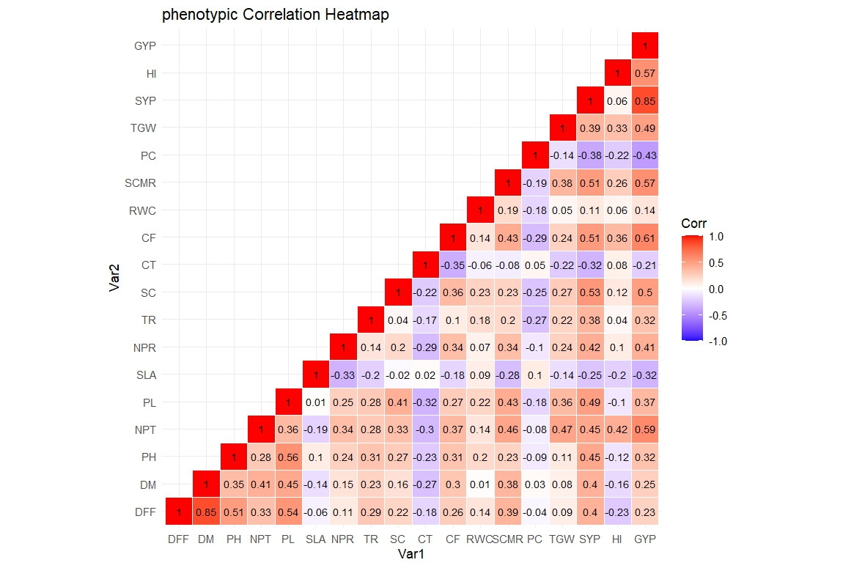
Fig.1 Depiction of phenotypic correlations for 18 morpho-physiological and yield-attributing traits through shaded correlation matrix.
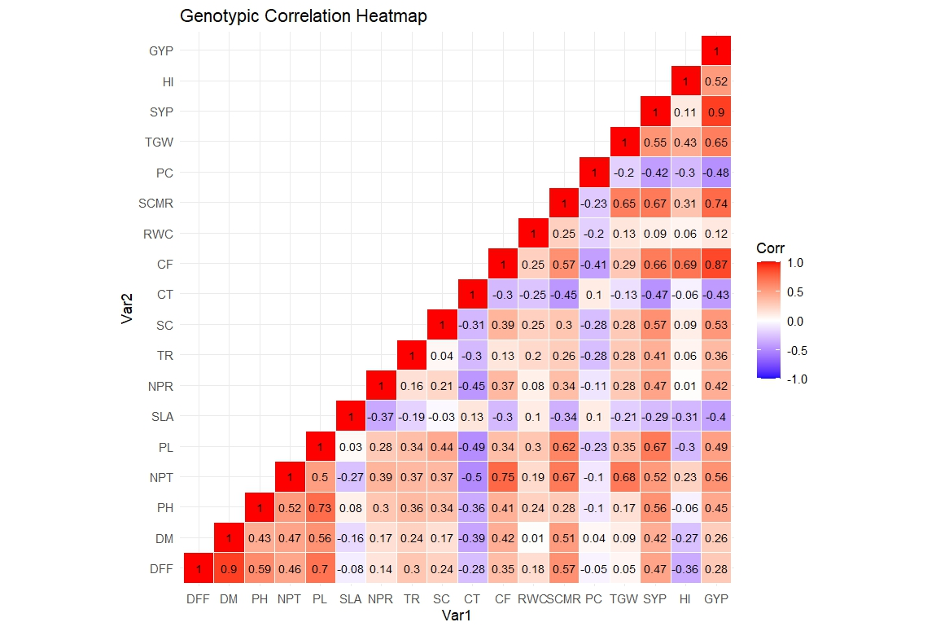
Fig. 2 Depiction of genotypic correlations for 18 morpho-physiological and yield-attributing traits through shaded correlation matrix.

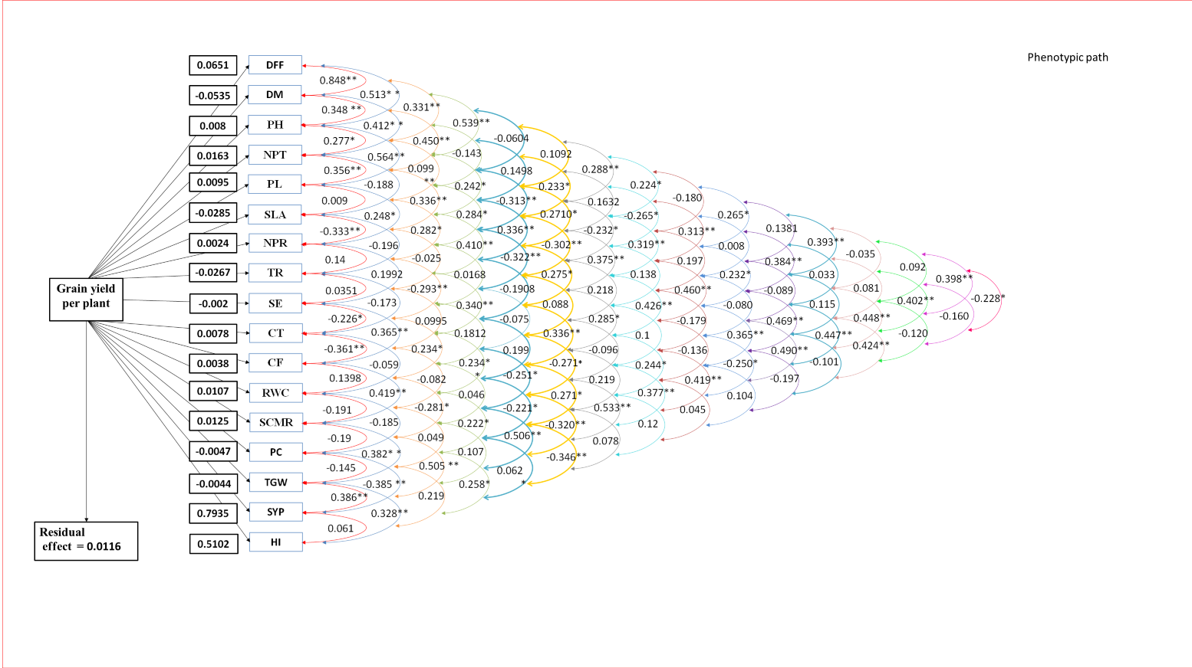
Fig. 3 Phenotypic path diagram for grain yield per plant
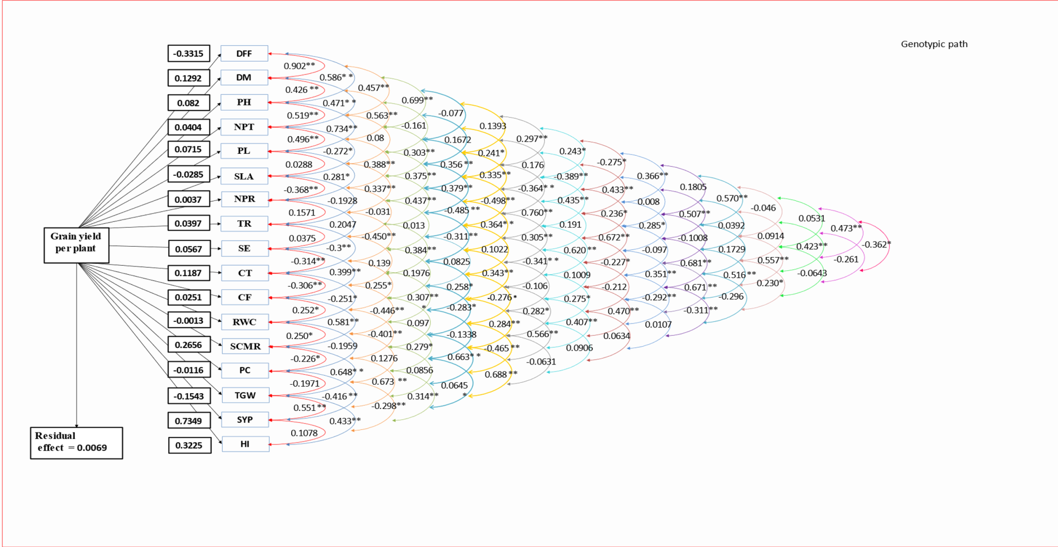
Fig. 4 Genotypic path diagram for grain yield per plant

