Original Research Article
A synergistic combination of Cytokinins and Gibberellins promotes shoot regeneration and proliferation in in vitro cultured nodal explants of Guava (Psidium guajava L.)
ABSTRACT
Guava (Psidium guajava L.) is an important tropical fruit of the Myrtaceae family that was traditionally propagated through seeds, which often led to variations in the seedlings due to natural cross-pollination. Due to the slow multiplication process through vegetative methods, there is a need for the development of an efficient in vitro regeneration technique. The present study was carried out to investigate the shoot induction from nodal segments that were cultured on full-strength MS medium supplemented with different concentrations of BAP, kinetin, and GA₃. Nodal explants cultured in MS media fortified with BAP 1.0 + GA₃ 0.25 mgL⁻¹ took the minimum number of days for shoot initiation (25.14 days). The maximum number of shoots (3.14) per explant was observed in the treatment containing BAP 2.0 + GA₃ 0.5 mgL⁻¹ after 60 days of culture. The highest shooting percentage (71.02 %) with the maximum number of leaves (7.18) was observed in the treatment combination of BAP 1.0 + GA₃ 0.5 mgL⁻¹ after 60 days of culture. Maximum shoot lengths of 3.92 cm (45 days) and 4.16 cm (60 days) with a longer internodal length of 1.44 cm (60 days) were recorded in the treatment containing the combination of BAP 1.0 + GA₃ 0.5 mgL⁻¹.
Keywords: Guava, in vitro, nodal segments, regeneration.

- INTRODUCTION
Guava (Psidium guajava L.) is an evergreen fruit crop belonging to the family Myrtaceae and is native to Tropical America (Singh and Mahato, 2016). In India and other nations of the Asian subcontinent, it is consumed as fresh fruit. Guava is commonly known as the "Apple of the tropics" and plays a significant role in global trade, because of its ease of cultivation, rich nutritional value, and the widespread demand for processed guava products (Rajkumar et al., 2016). Guava contains a notable amount of ascorbic acid, fiber, vitamin A (approximately 250 IU/100 g), pectin, calcium, phosphorus, iron, and other minerals. Guava is traditionally propagated through seeds, although natural cross-pollination results in significant variation in the seedling plants (Purseglove, 1968 and Pontikis, 1996). Therefore, to produce true-to-type planting material for large-scale plantations, vegetative methods (budding, inarching, grafting, air layering, etc.) are used. These vegetative approaches, however, are slow, time-consuming, and season-dependent (Gautam et al., 2010), which is a barrier to quick and mass multiplication. Recently, wilt, nematodes that cause root knots, and lack of cultivars have all significantly affected guava production (Rai et al., 2010). Farmers are interested in adopting guava for cultivation, but the availability of good-quality planting material is a major problem for commercial exploitation.
Due to its potential to regenerate elites while conserving valuable plant genetic resources, micropropagation via in vitro tissue culture is recognized as a key area of biotechnology (Liu and Yang, 2011). It has been shown that tissue culture offers several benefits over traditional propagation methods, including rapid multiplication within a short time, the ability to produce plants independently of seasons, the production of disease-free plants, and the preservation of genetic resources (George et al., 2008).
- MATERIAL AND METHODS
The present study was carried out at the Plant Tissue Culture Laboratory, Department of Horticulture, University of Agricultural Sciences, Gandhi Krishi Vignana Kendra, Bengaluru. Completely Randomized Design was used for statistical analysis of the experiment with 3 replications. The plant material used were the open-pollinated guava (Allahabad Safeda) seedlings maintained under shade net in the fruit nursery, College of Horticulture, UHS Campus, Bengaluru.
The nodal segments were used for initiation. To minimize the risk of contamination, nodal segments were given a 10-minute rinse under running water. Initially, the nodes were subjected to a 15-minute treatment with a 1.0 % solution of Dithane M 45 (a contact fungicide), followed by rinsing with sterile distilled water. In order to prevent fungal contamination, a 1.5 % solution of Bavistin (50% Carbendazim WP) was used, and the nodal segments were subsequently washed three times with sterile distilled water. To ensure thorough disinfection, the nodal segments were then immersed in a 0.10 % (w/v) aqueous HgCl₂ solution for 5 minutes. Subsequently, to ensure the removal of any chemical residues from the surface, they were subjected to three rinses with sterile distilled water. Again, it was given a quick dip in alcohol for 1 minute to eliminate microbial spores. To safeguard against potential bacterial contamination, the explants were immersed in a 0.10 % solution of streptomycin sulfate for a duration of 30 minutes.
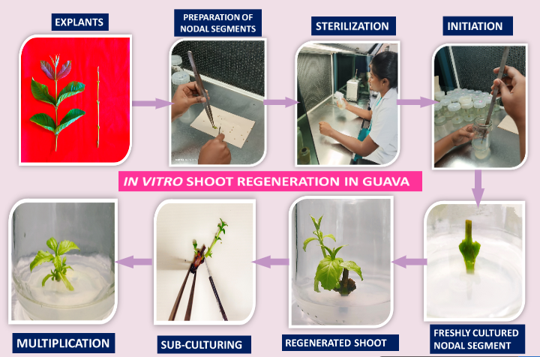
Fig 1: Step-by-step procedure for in vitro regeneration of Guava nodal segments
MS media (Murashige and Skoog, 1962) was used as the basal medium. Sucrose was used at a concentration of 30 gL⁻¹, which was added just before the medium reaches the final volume. Agar at a concentration of 6.0 gL⁻¹ was included in the medium while boiling after pH adjustment to 5.7 and before subjecting it to autoclaving. Explants were inoculated into the nutrient medium in an aseptic manner inside a laminar airflow cabinet. The growth room's temperature was maintained at 24 ± 2⁰ C. Lighting conditions were maintained with white fluorescent tubes, ensuring a light intensity of 2000 lux during an 8-hour light period, followed by a 16-hour dark period.
- RESULTS AND DISCUSSION
3.1 Shooting percentage
In comparison to kinetin, BAP consistently yielded superior results in terms of shoot regeneration percentage (Fig. 1). The results were better in media added with kinetin at concentrations of 0.5, 1.0, and 1.5 mg/L than in the control (Table 1), although there was less regeneration than in BAP treatment. The significantly highest rate of shoot regeneration, reaching 71.02%, was observed when using the treatment combination of BAP 1.0 mgL⁻¹ + GA₃ 0.5 mgL⁻¹. Effectiveness of BAP in promoting shoot development may be attributed to the plant tissues' enhanced capacity to metabolize BAP in comparison to other synthetic growth regulators. Alternatively, it could be linked to BAP's potential to stimulate the production of natural hormones like zeatin within the plant tissues (Malik et al., 2005). The application of cytokinin can induce cell division (mitosis division) in internal meristem, which stimulates the development of transportation tissues on lateral shoots so that the lateral shoots can attain the energy resulting from the metabolism process (Taiz and Zeiger, 2002).
Table 1. Influence of BAP and Kinetin on shoot regeneration parameters in guava
Treatments (mgL⁻¹) | Shooting percentage | Days taken for shoot initiation | Number of shoots produced per explant |  | Number of leaves produced per shoot |  | Shoot length (cm) |  | Internodal length (cm)
Treatments (mgL⁻¹) | Shooting percentage | Days taken for shoot initiation | 45 days | 60 days | 45 days | 60 days | 45 days | 60 days | Internodal length (cm)
T₁ -Control (Basal media) | 13.20 | 57.75 | 0.00 | 0.00 | 0.00 | 0.00 | 0.00 | 0.00 | 0.00
T₂ -BAP 1.0 | 47.26 | 38.36 | 1.88 | 1.96 | 3.76 | 3.83 | 1.41 | 1.45 | 0.56
T₃ -BAP 2.0 | 48.16 | 39.25 | 1.29 | 1.34 | 4.08 | 4.12 | 1.55 | 1.66 | 0.78
T₄ -BAP 3.0 | 51.16 | 40.37 | 1.31 | 1.31 | 3.93 | 3.96 | 1.36 | 1.36 | 0.50
T₅ -Kinetin 0.5 | 44.05 | 41.83 | 0.87 | 0.93 | 2.94 | 2.94 | 0.88 | 0.91 | 0.54
T₆ -Kinetin 1.0 | 45.35 | 42.22 | 1.18 | 1.18 | 3.17 | 3.23 | 1.32 | 1.56 | 0.71
T₇ -Kinetin 1.5 | 45.99 | 40.52 | 1.15 | 1.22 | 3.67 | 3.69 | 1.40 | 1.58 | 0.65
S.Em± | 0.69 | 0.42 | 0.07 | 0.04 | 0.13 | 0.04 | 0.02 | 0.03 | 0.03
CD (1%) | 2.93 | 1.76 | 0.28 | 0.17 | 0.39 | 0.19 | 0.09 | 0.13 | 0.11

3.2 Number of days taken for shoot initiation
Among the different combinations of growth regulators used, BAP 1.0 + GA₃ 0.25 mgL⁻¹ needed the minimum number of days (25.14 days) for shoot initiation (Table 2). In a similar manner, Zamir et al. (2017) reported that when MS media was supplemented with 1.0 mgL⁻¹ of BAP and 0.5 mgL⁻¹ of zeatin, the shortest duration (39 days) was observed for shoot initiation in guava. It's noteworthy that the treatment with the lowest concentration of BAP required the fewest days for initiating shoot growth. These outcomes are consistent with the findings of Perez et al. (2002), Raziuddin et. al. (2004) and Ali et al. (2003) in the context of guava research. In contrast to BAP, kinetin exhibited a lesser response in this present study, with a relatively similar outcome, as reported by Sharma et al. (2018). The response for kinetin was reduced when compared to BAP, with Haradzi et al. (2021) reporting a similar response in Meyer lemon (Citrus x meyeri). Compared to other treatments, the basal medium took the longest duration (57.75 days) to initiate shoot growth. This suggests that the use of growth regulators accelerates the explant for early shoot initiation.
Table 2. Influence of combination of BAP and GA₃ on shoot regeneration parameters in guava
Treatments (mgL⁻¹) | Shooting percentage | Days taken for shoot initiation | Number of shoots produced per explant |  | Number of leaves produced per shoot |  | Shoot length (cm) |  | Internodal length (cm)
Treatments (mgL⁻¹) | Shooting percentage | Days taken for shoot initiation | 45 days | 60 days | 45 days | 60 days | 45 days | 60 days | Internodal length (cm)
T₁ -Control (Basal media) | 13.20 | 57.75 | 0.00 | 0.00 | 0.00 | 0.00 | 0.00 | 0.00 | 0.00
T₂ - BAP 1.0 + GA₃ 0.25 | 68.61 | 25.14 | 2.33 | 2.38 | 5.56 | 6.11 | 3.11 | 3.42 | 1.17
T₃ - BAP 1.0 + GA₃ 0.5 | 71.02 | 27.74 | 2.38 | 2.44 | 7.01 | 7.18 | 3.92 | 4.16 | 1.44
T₄ - BAP 2.0 + GA₃ 0.25 | 61.89 | 34.23 | 2.29 | 2.52 | 6.25 | 6.29 | 2.86 | 2.86 | 1.16
T₅ - BAP 2.0 + GA₃ 0.5 | 63.35 | 31.56 | 2.76 | 3.14 | 6.21 | 6.52 | 2.79 | 3.04 | 1.17
T₆ - BAP 3.0 + GA₃ 0.25 | 59.95 | 35.57 | 2.24 | 2.25 | 5.66 | 5.76 | 2.47 | 2.47 | 0.81
T₇ - BAP 3.0 + GA₃ 0.5 | 61.19 | 34.48 | 2.27 | 2.28 | 6.01 | 5.75 | 2.56 | 2.58 | 1.11
S.Em± | 0.97 | 0.84 | 0.06 | 0.08 | 0.14 | 0.13 | 0.21 | 0.07 | 0.04
CD (1%) | 4.10 | 3.53 | 0.23 | 0.34 | 0.58 | 0.56 | 0.88 | 0.28 | 0.16

3.3 Number of shoots produced per explant
After a period of 60 days, it was observed that the medium containing BAP 2.0 + GA₃ 0.5 mgL⁻¹ resulted in the highest production of adventitious shoots, with 3.14 shoots per explant (Fig. 2a,2b). The number of shoots produced was dependent on BAP and GA₃ concentrations, with Perez-Tornero et al. (2010) reporting the best results in lemon with 2 mg/L BAP and 1 or 2 mg/L GA₃ (Citrus limon). Imtiaz et al. (2014) also found that increased cytokinin content in the media may have induced toxic effects and reversed the growth processes, whilst lesser concentrations were insufficient to stimulate shoots. Additionally, it was noticed that several treatments exhibited an increase in the number of shoots produced per explant after 45 days, indicating that new shoots were developed after 45 days. Rai et al. (2009) observed that BAP outperformed kinetin in stimulating shoot proliferation in guava, and the same trend was evident in the current study.
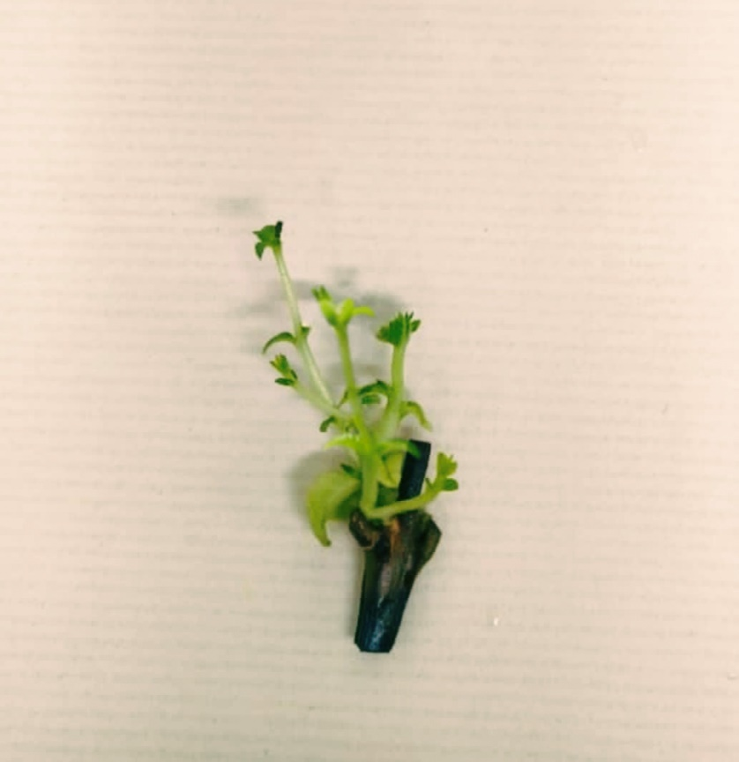
Fig. 2a. Effect of combination of BAP and GA₃ (BAP 2.0 + GA₃ 0.5 mgL⁻¹) on shoot proliferation at 60 days of culture
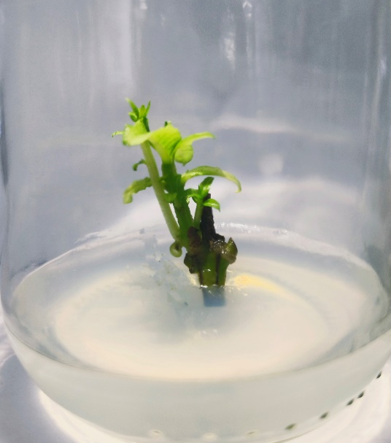
Fig. 2b. Effect of combination of BAP and GA₃ (BAP 2.0 + GA₃ 0.25 mgL⁻¹) on shoot proliferation at 60 days of culture

3.4 Number of leaves produced per shoot
At 45 and 60 days, when the media was added with BAP 1.0 mgL⁻¹ + GA₃ 0.5 mgL⁻¹, a greater number of leaves, 7.01 and 7.18 were produced per shoot in the nodal segment, respectively. GA₃ can enhance the initiation and development of leaf primordia in the shoot. It promotes the transition of meristematic cells into leaf primordia, thereby increasing the potential for leaf formation on each shoot. On the explants cultured in the basal media, no fully developed leaves were produced. Kinetin and its combinations with GA₃, on the other hand, showed a lower response in terms of the number of leaves generated (Table 3). This discrepancy could be attributed to the fact that BAP is effective in promoting cell division, or it might be due to variations in the explant's response to different levels of endogenous hormones.
Table 3. Influence of combination of Kinetin and GA₃ on shoot regeneration parameters in guava
Treatments (mgL⁻¹) | Shooting percentage | Days taken for shoot initiation | Number of shoots produced per explant |  | Number of leaves produced per shoot |  | Shoot length (cm) |  | Internodal length (cm)
Treatments (mgL⁻¹) | Shooting percentage | Days taken for shoot initiation | 45 days | 60 days | 45 days | 60 days | 45 days | 60 days | Internodal length (cm)
T₁ -Control (Basal media) | 13.20 | 57.75 | 0.00 | 0.00 | 0.00 | 0.00 | 0.00 | 0.00 | 0.00
T₂ - Kinetin 0.5 + GA₃ 0.25 | 57.73 | 38.37 | 1.32 | 1.49 | 5.69 | 5.69 | 1.93 | 2.05 | 0.45
T₃ - Kinetin 0.5 + GA₃ 0.5 | 59.60 | 38.18 | 1.57 | 1.60 | 5.39 | 5.47 | 2.05 | 2.16 | 1.04
T₄ - Kinetin 1.0 + GA₃ 0.25 | 56.72 | 37.99 | 1.72 | 1.86 | 5.31 | 5.37 | 2.35 | 2.67 | 1.07
T₅ - Kinetin 1.0 + GA₃ 0.5 | 57.75 | 36.74 | 1.59 | 1.66 | 5.61 | 5.76 | 2.75 | 2.93 | 1.21
T₆ - Kinetin 1.5 + GA₃ 0.25 | 61.15 | 33.02 | 2.05 | 2.07 | 5.06 | 5.19 | 2.29 | 2.30 | 1.10
T₇ - Kinetin 1.5 + GA₃ 0.5 | 62.80 | 32.40 | 2.09 | 2.24 | 5.34 | 5.49 | 2.47 | 2.57 | 1.14
S.Em± | 0.76 | 0.48 | 0.04 | 0.05 | 0.06 | 0.09 | 0.06 | 0.04 | 0.05
CD (1%) | 3.20 | 2.01 | 0.16 | 0.21 | 0.23 | 0.37 | 0.25 | 0.19 | 0.21
3.5 Shoot length (cm)
Media containing BAP 1.0 mgL⁻¹ + GA₃ 0.5 mgL⁻¹ resulted in the maximum length of shoots of about 3.92 cm and 4.16 cm at 45 and 60 days of culture, respectively (Fig. 3.). Similar results were achieved in pear by Rodriguez et al. (1991) and guava by Mishra et al. (2007) and Shah et al. (2008). The presence of BAP and GA₃ in the proliferation medium is required for explant multiplication; however, BAP has a stronger influence on shoot multiplication, while GA₃ has an influence on shoot elongation. BAP outperformed kinetin in terms of lengthening the shoot. The results were consistent with Purohit et al. (2004), who found that TDZ and kinetin alone elicited a lower reaction than BAP alone. Ozden et al. (2005) also found no favorable effect when explants were cultivated in a kinetin-containing medium. In basal media without growth regulators, the sprouts failed to emerge into a complete shoot. This could be attributed to the absence of the necessary growth hormones needed for the sprout's growth and development.

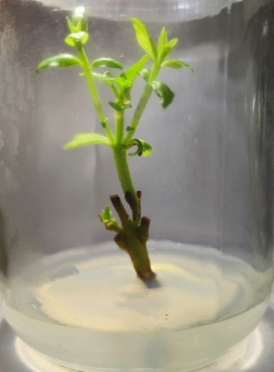
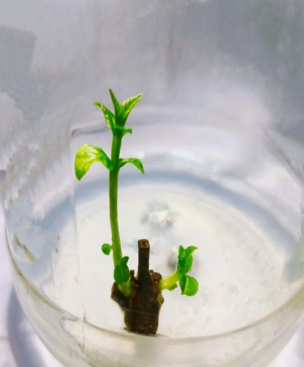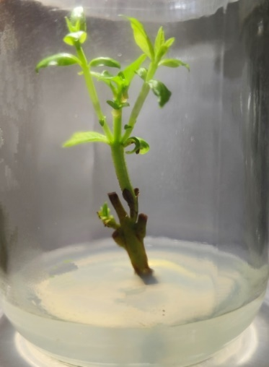
C)
B)
A)

Variables | PC 1 | PC 2 | PC 3
NOD | -0.335 | -0.156 | -0.048
SP | 0.338 | -0.146 | 0.367
NOS.45 | 0.326 | 0.574 | -0.122
NOS.60 | 0.325 | 0.588 | -0.083
NOL.45 | 0.336 | -0.185 | 0.447
NOL.60 | 0.34 | -0.171 | 0.385
SL.45 | 0.339 | -0.211 | -0.201
SL.60 | 0.338 | -0.237 | -0.247
IL | 0.323 | -0.339 | -0.626
Eigen value | 8.298 | 0.339 | 0.175
Percentage of variance | 92.201 | 3.769 | 1.943
Cumulative percentage of variance | 92.201 | 95.969 | 97.912
Fig. 3. Effect of combination of BAP and GA₃ on shoot length after 60 days of culture
A) BAP 1.0 + GA₃ 0.25 mgL⁻¹ B) BAP 1.0 + GA₃ 0.5 mgL⁻¹ C) BAP 2.0 + GA₃ 0.5 mgL⁻¹

3.6 Internodal length (cm)
The treatment of BAP 1.0 + GA3 0.5 mgL⁻¹ resulted in the longest internodal length of around 1.44 cm among the different treatment combinations of BAP and GA₃ (Table 2). This may be due to the reason that GA₃ plays a major role in increasing the internodal length, thereby increasing the shoot length of the regenerated shoots. While GA₃ primarily affects cell elongation, it can also promote cell division in some tissues. In tissue culture, this can lead to the development of longer internodes as more cells are produced, which then elongate. Similarly, Hari Prakash and Tiwari (1996) observed that using a lower concentration of GA₃ with BAP improved shoot length in guava by increasing internodal length. Internodal length was shown to be higher in the same treatment where shoot length was greater, implying that internodal length is directly related to shoot length.
3.7 Principal Component Analysis of shoot growth parameters
In the study, principal component analysis was done for nine growth parameters of in vitro raised guava microshoots to evaluate the significant variable in the dataset. Additionally, principal component analysis helps to understand the contribution of the parameters for selecting the best treatment combination for improving the in vitro shoot production. The principal components and their eigenvectors are presented in Table 4. The PCA shows a tendency to separate the different variables into two principal components, a scatter in the axes corresponding to the PC1 and PC2 that explain 92.2%, and 3.8% variation, respectively. PC 1 captures the vast majority of variation in the data, suggesting that most of the differences among treatments are explained by this component. PC2 captures a much smaller portion of variation, indicating that its contribution to explaining differences among treatments is less significant.
Table 4: Principal component analysis scores for shoot growth parameters of guava.
NOD: Number of days taken for shoot initiation, SP: Shooting percentage, NOS.45: Number of shoots produced after 45days, NOS.60: Number of shoots produced after 60 days, NOL.45: Number of leaves produced after 45 days, NOL.60: Number of leaves produced after 60 days, SL.45: Shoot length after 45 days, SL.60: Shoot length after 60 days, IL: Internodal Length.

Variables like number of shoots at 45 and 60 days (NOS.45 and NOS.60) have the largest contribution towards PC1(Fig. 4). Other variables like NOD (Number of days for shoot initiation), number of leaves, and shoot length are clustered and have moderate influence on both dimensions. T1, T2, and T21 differ significantly from the others, particularly in response to the variables associated with PC1 (Fig. 5). T9, T17, and T15 are farthest along PC2, implying they are influenced more by the variations explained by PC2. T18, T19, and T13 are not highly influenced by any specific variables, indicating similar behavior in terms of the variables in the plot.

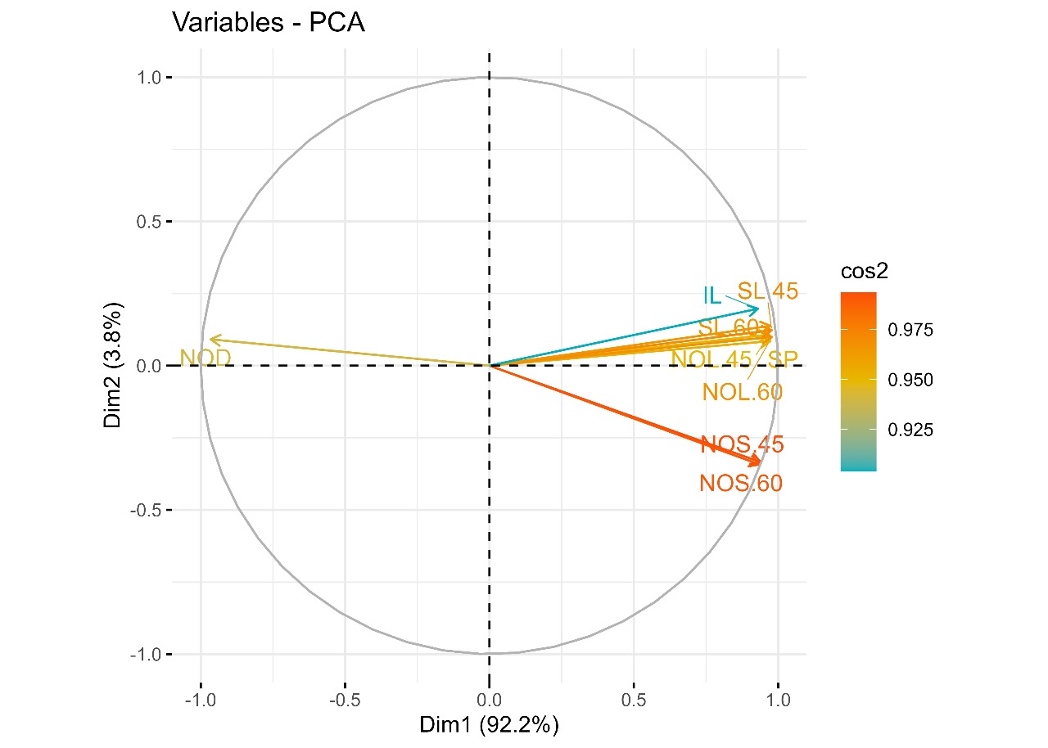
Fig. 4. Correlation circle of principal component analysis for shoot growth parameters of Guava
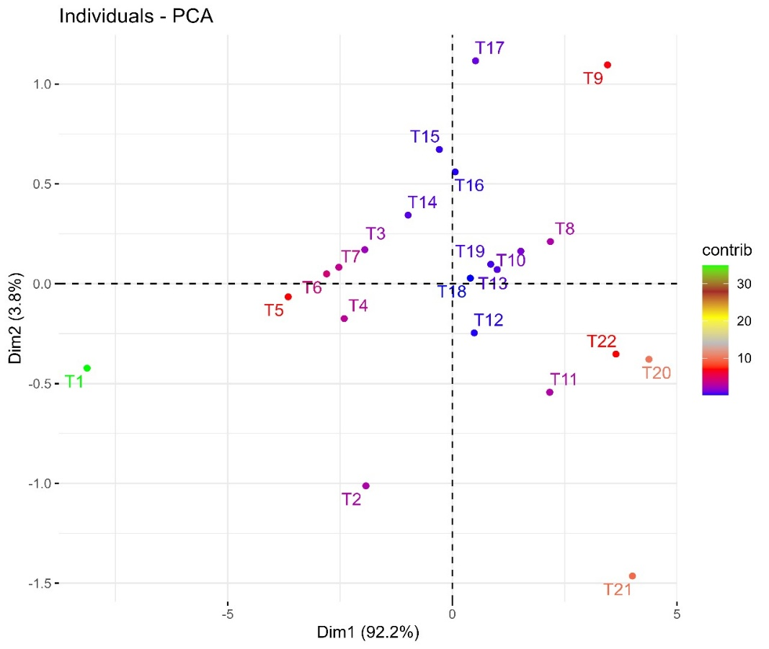
Fig. 5. Biplot diagram of principal component analysis for individual treatments for shoot growth parameters of Guava
T₁ -Control (Basal media) | T9 - BAP 1.0 + GA₃ 0.5 mgL⁻¹ |  |  | T16 - Kinetin 1.0 + GA₃ 0.25 mgL⁻¹
T₂ -BAP 1.0 mgL⁻¹ | T10 - BAP 2.0 + GA₃ 0.25 mgL⁻¹ |  |  | T17- Kinetin 1.0 + GA₃ 0.5 mgL⁻¹
T₃ -BAP 2.0 mgL⁻¹ | T11 - BAP 2.0 + GA₃ 0.5 mgL⁻¹ |  |  | T18 - Kinetin 1.5 + GA₃ 0.25 mgL⁻¹
T₄ -BAP 3.0 mgL⁻¹ | T12- BAP 3.0 + GA₃ 0.25 mgL⁻¹ |  |  | T19 - Kinetin 1.5 + GA₃ 0.5 mgL⁻¹
T₅ -Kinetin 0.5 mgL⁻¹ | T13 - BAP 3.0 + GA₃ 0.5 mgL⁻¹ |  |  | T 20– BAP 1.0 + Kinetin 1.5 mgL⁻¹
T₆ -Kinetin 1. 0 mgL⁻¹ | T14 -Kinetin 0.5 + GA₃ 0.25mgL⁻¹ |  |  | T21 - BAP 2.0 + Kinetin 1.5 mgL⁻¹
T₇ -Kinetin 1.5 mgL⁻¹ | T15 - Kinetin 0.5 + GA₃ 0.5 mgL⁻¹ |  |  | T22 - BAP 3.0 + Kinetin 1.5 mgL⁻¹
T8 - BAP 1.0 + GA₃ 0.25 mgL⁻¹

CONCLUSION
The present research work discloses some important findings: the guava nodal explants cultured in MS media fortified with BAP 1.0 + GA₃ 0.25 mg/L took the minimum number of days for shoot initiation. The maximum number of shoots per explant was observed in the treatment containing BAP 2.0 + GA₃ 0.5 mgL⁻¹. The longest shoots with longer internodal length were observed in the treatment containing the combination of BAP 1.0 mgL⁻¹ and GA₃ 0.5 mgL⁻¹. The current research has unequivocally unveiled the potential of various plant growth regulators, which could open up new avenues for the efficient in vitro mass production of guava plants.

Abbreviations:
BAP : 6-Benzylamino purine
GA3 : Gibberellic Acid
mgL-1 : Milligram per litre
MS : Murashige and Skoog (1962) medium
% : Percent
TDZ: Thidiazuron

- REFERENCES
Ali, N. R., Mulwa, R. M., Norton, M. A., & Skirvin, R. M. (2003). Micropropagation of guava (Psidium guajava L.). The Journal of Horticultural Science and Biotechnology 78(5), 739-41.
Gautam, N. N., Singh, K., Singh, B., Seal, S., Goel, A., & Goel, V. L. (2010). Studies on Clonal Multiplication of Guava (Psidium guajava L.) through Cutting under Controlled Conditions. Australian Journal of Crop Science 4(9), 666-669.
George, E. F., Hall, M. A., & Klerk, G. J. D. (2008). Micropropagation: uses and methods. In Plant Propagation by Tissue Culture: Volume 1. The Background (pp. 29-64). Dordrecht: Springer Netherlands.
Haradzi, N. A., Khor, S. P., Subramaniam, S., & Chew, B. L. (2021). Regeneration and micropropagation of Meyer lemon (Citrus x meyeri) supported by polymorphism analysis via molecular markers. Scientia Horticulturae, 286, 110-225.
Hari Prakash, H., & Tiwari, J. P. (1996). Micropropagation of guava (Psidium guajava L.). Journal of Applied Horticulture 2(1), 98 -101.
Imtiaz, M., Khattak, A. M., Ara, N., Iqbal, A., & Rahman, H. U. (2014). Micropropagation of Jartorpha curcas L. through shoot tip explants using different concentrations of phytohormones. Journal of Animam and Plant Science, 24, 229-233.
Liu, X.,& Yang, G. (2011). Clonal propagation of guava (Psidium guajava L.) on nodal explants of mature elite cultivar. International Journal of Plant Biology 2(1), 2.
Malik, S. K., Chaudhury, R., & Kalia, R. K. (2005). Rapid in vitro multiplication and conservation of Garcinia indica: a tropical medicinal tree species. Scientia Horticulturae 106(4), 539-553.
Mishra, D. S., Tiwari, J. P.,& Lal, S. (2007). In vitro cloning of guava (Psidium guajava L.) cv. Pant Prabhat. Acta Horticulturae 735, 127.
Murashige, T.,& Skoog, F. (1962). A revised medium for rapid growth and bio assays with tobacco tissue cultures. Physiologia plantarum 15(3), 473-497.
Ozden-Tokatli, Y., Ozudogru, E. A., & Akcin, A. (2005). In vitro response of pistachio nodal explants to silver nitrate. Scientia Horticulturae 106(3), 415-426.
Pérez, A. T., Nápoles, L., Concepcion, O., & Trujillo, R. (2002). Multiplicación in vitro de brotes de guayaba (Psidium guajava L.) var. Enana Roja Cubana EEA 18-40 obtenidos a partir de semillas. Cultivos tropicales 23(3), 57-61.
Pontikis, C. A. (1996). Psidium guajava L.(guava). In Trees IV (pp. 308-320). Berlin, Heidelberg: Springer Berlin Heidelberg.
Purohit, S.D., Singhvi, A., & Nagori, R. (2004). In vitro shoot bud differentiation from leaf segments of Achras sapota. Biologia plantarum 48, 109-112.
Purseglove, J. W. (1968). Tropical crops (Dicotyledons) Longmans, Green and Co. Ltd. London, UK, 1: 273-276.
Rai, M. K., Asthana, P., Jaiswal, V. S., & Jaiswal, U. (2010). Biotechnological advances in guava (Psidium guajava L.): recent developments and prospects for further research. Trees 24: 1-12.
Rai, M. K., Jaiswal, V. S., & Jaiswal, U. (2009). Shoot multiplication and plant regeneration of guava (Psidium guajava L.) from nodal explants of in vitro raised plantlets. Journal of fruit and ornamental plant research 17(1), 29-38.
Rajkumar, G. K., Mann, Anita Lata Charu., Singh Anshuman., & Kumar Ashwini. (2016). Biochemical changes in guava (Psidium guajava) cv. Allahabad Safeda fruits as a function of maturity stages. Indian Journal of Agricultural Sciences 86(12), 1595-1600.
Raziuddin, S. S. S., Farhad, A., & Sardar, A. (2004). Micropropagation of guava through shoot culture. Sarhad Journal of Agriculture 20, 523-527.
Rodriguez, R., Diaz-Sala, C., Cuozzo, L., & Ancora, G. (1991). Pear in vitro propagation using a double-phase culture system. Hort Science 26(1), 62-64.
Shah, S. T., Zamir, R., Ahmad, J., Ali, H., & Lutfullah, G. (2008). In vitro regeneration of plantlets from seedlings explants of guava (Psidium guajava L.) cv. Safeda. Pakistan Journal of Botany, 40(3), 1195-1200.
Sharma, M. R., Kumari, S., & Mishra, M. (2018). Micropropagation of wilt resistant, inter-specific (Psidium molle x Psidium guajava) rootstock of guava. Plant Archives 18(1), 1170-1174.
Singh, K. K., & Mahato, S. (2016). Influence of indol-3-butyric acid (IBA) and various time on rooting of guava (Psidium guajava L.) air layering. Journal of Plant Development Sciences 8(4), 193-196.
Taiz, L., & Zeiger, E. (2002). Plant Physiology, California, The Benjamin/ Cummings Pub. Co. Inc., 91(6): 750–751.
Zamir, R., Rab, A., Sajid, M., & Ahmad, I. (2017). Influence of zeatin, glutamin and auxins on root and shoot organogenesis of Guava (Psidium guajava L.) cv. safeda seedling explants. Pure and Applied Biology (PAB) 6(1), 197-206.

