**Morpho-Cultural Characterization of *Fusarium* spp. Causing Wilt Complex of Brinjal (*Solanum melongena* L.) in Kashmir Valley**

**Abstract**

Brinjal (*Solanum melongena* L.) is a widely cultivated vegetable crop across the Himalayan region of Kashmir, India. The production and productivity of brinjal is threatened by various biotic and abiotic factors. Among them wilt disease, primarily caused by *Fusarium* species, poses a significant threat. A systematic field survey was conducted in four districts namely Baramulla, Anantnag, Srinagar and Budgam across 16locations to assess disease incidence and isolate the causative pathogen. Disease incidence was found to be on the highestin district Budgam (17.20%) followed by Srinagar (16.16%), whereas the lowest disease incidence was recorded from Anantnag (13.91%). Atotal of 39 isolates were obtained from wilted brinjal plants, which were grouped into 3 distinct species and were identified based on morphological and cultural characteristics. The isolates were classified as *Fusarium oxysporum*f. sp*. melongenae, F. chlamydosporum,* and *F. incarnatum*. This study provides important insights into the diversity of *Fusarium* spp. affecting brinjal in the Kashmir Valley and underscores the need for integrated disease management strategies.

Keywords: Brinjal, disease incidence, fungal wilt, morpho-cultural, Kashmir.

1. **Introduction**

Brinjal (*Solanum melongena* L.) is one of the most extensively cultivated solanaceous vegetables in India, valued for its nutritional content and economic return. With over 700,000 hectares under cultivation and an annual production exceeding 13 million metric tonnes, India remains a leading global producer (FAO, 2023). However, its productivity is hindered by a range of soil- and seed-borne pathogens, among which *Fusarium* wilt is one of the most persistent and widespread diseases (Gordon, 2017).

*Fusarium oxysporum* f. sp. *melongenae*, the most popular causal agent of wilt in brinjal, invades the vascular tissues through the root system, resulting in chlorosis, necrosis, vascular browning and wilting. It produces chlamydospores that can persist in soil for years in the absence of a host, rendering chemical control measures largely ineffective once the pathogen is established (Gordon & Martyn, 1997). In underreported agro-ecological zones, the pathogen’s ability to persist in soil and its complex interaction with edaphic and environmental factors has made characterization essential.

While studies on *Fusarium* wilt in brinjal have been widely conducted across tropical and subtropical zones of India (Kumar *et al.,* 2025), limited attention has been given to temperate regions such as Jammu and Kashmir, where distinct microclimatic and soil conditions may influence pathogen diversity and virulence. Additionally, detailed cultural and morphological characterizations remain underutilized in field epidemiology, despite being critical for early-stage identification and confirmation of pathogenic *Fusarium* species (Leslie and Summerell, 2006).

Morphological identification based on growth pattern, pigmentation, conidial septation and chlamydospore formation remains a practical and accessible approach for differentiating closely related *Fusarium* taxa (Summerell, 2019). This approach aligns with the fundamental principle followed by Rao *et al.,* (2019) in their study of *Fusarium* spp. in solanaceous hosts, where regional monitoring and classical identification were effectively integrated.

In this context, the present study was conducted to (i) assess the incidence of *Fusarium* wilt of brinjal in four major districts of Kashmir Valley; (ii) isolate and purify *Fusarium* spp. from diseased plants; and (iii) characterize the isolates based on their cultural and morphological traits. The aim is to build a foundation for understanding the diversity and potential threat posed by *Fusarium* spp. under temperate conditions

1. **Materials and Methods**
   1. **Survey and Sample Collection**

During the brinjal growing seasons of 2021 and 2022, extensive field surveys were carried out in four major brinjal-cultivating districts of Jammu and Kashmir namely Budgam, Baramulla, Anantnag and Srinagar. Based on the intensity of brinjal cultivation and previous reports of wilt, four locations were selected in each district. The selected locations included Bugam, Rangar, Narkara and Khansahab in Budgam; Sopore, Arampura, Wadura and Rafiabad in Baramulla; Mattan, Gopalpora, Shangus and Dialgam in Anantnag; and Habak, Noorbagh, Harwan and Hazratbal in Srinagar. At each location, four to five brinjal fields were surveyed, totaling 48 sites. In each field, approximately 50 plants were observed for disease symptoms. Wilt symptoms were characterized by progressive yellowing of leaves, sudden wilting and browning of vascular tissues in the stems. Representative samples were collected from visibly infected plants, labeled and brought to the laboratory under sterile conditions for further analysis. Disease incidence at each site was recorded by calculating the proportion of infected plants relative to the total number of plants observed using the formula:

* 1. **Isolation of Pathogens**

Symptomatic brinjal plant tissues showing clear signs of vascular wilt were collected from the root–stem junction, the primary site of pathogen activity. In the laboratory, the samples were first washed thoroughly under running tap water to remove adhering soil particles and debris. Surface sterilization was carried out using 0.1% mercuric chloride (HgCl₂) solution for 30 to 60 seconds, followed by repeated rinsing (three times) with sterile distilled water to eliminate any residual disinfectant. The sterilized tissues were then blotted dry using sterile filter paper to remove excess surface moisture. Under aseptic conditions in a laminar airflow cabinet, small segments of the sterilized tissues were aseptically transferred to sterilized Petri dishes containing freshly prepared Potato Dextrose Agar (PDA) medium. The inoculated plates were incubated in a BOD incubator at a temperature of 25±2°C for 5 to 7 days. Emerging fungal colonies were observed daily. Actively growing margins of colonies were sub-cultured onto fresh PDA plates to obtain pure cultures. Repeated sub-culturing was performed to ensure the elimination of contaminant microbes and to obtain single-type colonies. Through this process, a total of 39 fungal isolates were successfully obtained from the collected samples, which were then maintained for further morphological and cultural characterization.

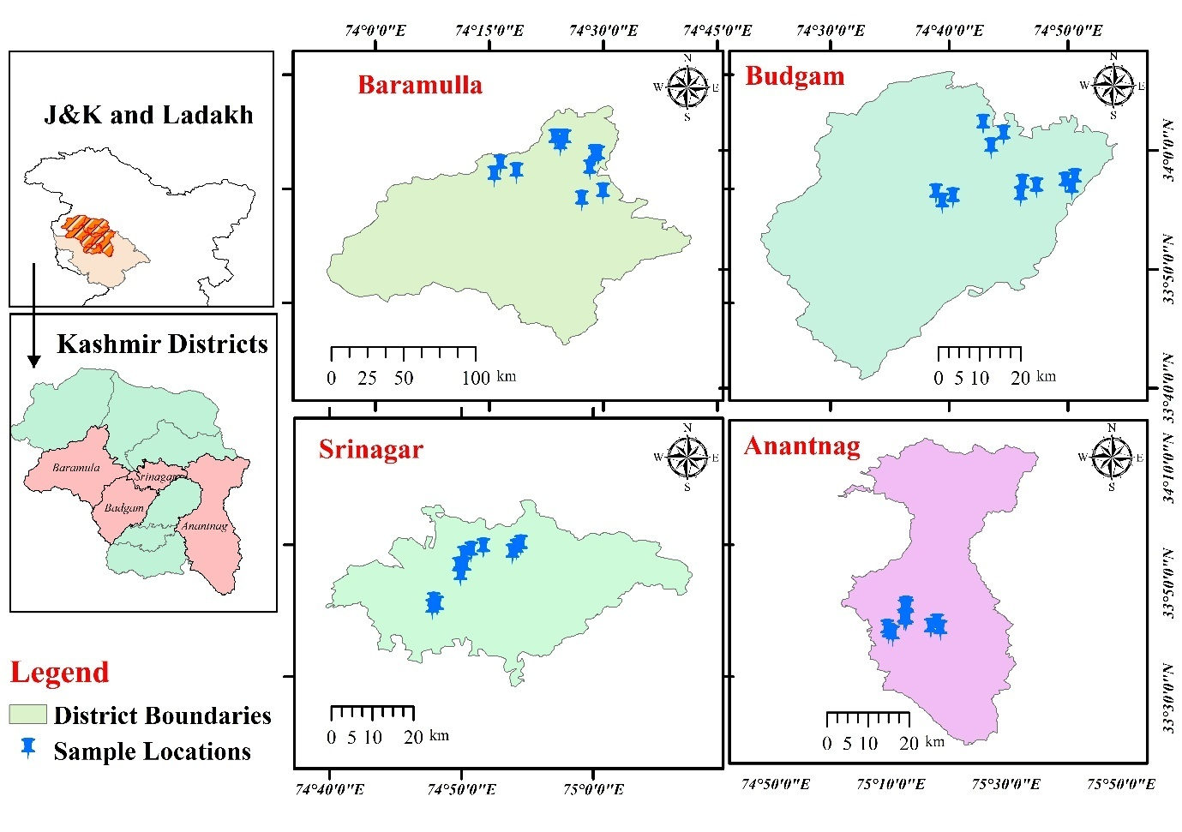

**Fig. 1.** Map showing 16 pinned locations of four surveyed districts of Kashmir.

**Fig. 2.** Isolation of pathogen from symptomatic wilted plants of binjal. (a) Tissue bit method, (b1-b2) fungal growth.

* 1. 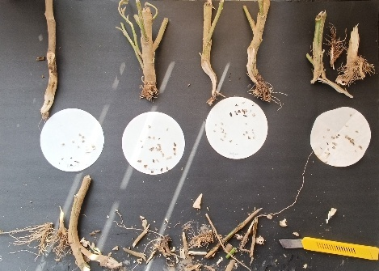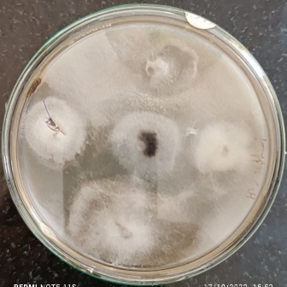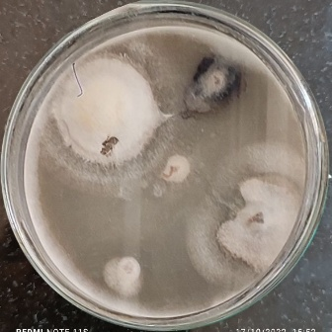**Morphological and Cultural Characterization**

Morpho-cultural studies were carried out on all 39 purified *Fusarium* isolates. Each isolate was grown on Potato Dextrose Agar (PDA) and incubated at 25 ± 2°C for seven days. Observations were recorded based on colony colour, texture, growth rate and pigmentation on the reverse side of the plate. Colony diameter was measured after seven days to assess radial growth. Microscopic examination was also carried out by preparing lactophenol cotton blue mounts from actively growing cultures. Under the microscope, mycelium and spores were observed, along with chlamydospores in some isolates. The morphological and cultural traits were compared with standard descriptions for species level identification.

1. **Results**
   1. **Disease Incidence and Field Survey**

Extensive field surveys conducted during the 2021 and 2022 cropping season revealed widespread occurrence of brinjal wilt in all 48 selected sites across the four surveyed districts. The disease incidence varied not only across districts but also among individual locations within each district. The pooled disease incidence ranged from a minimum of 8.49% to a maximum of 25.66%. Among the districts, Budgam recorded the highest average disease incidence at 17.20%, followed by Srinagar at 16.16%. Within Budgam, the most affected sites included Khansahab (25.66%) and Narkara (20.16%). Three out of four locations in Budgam showed consistently high disease levels, suggesting a favourable environment for disease development, possibly due to repeated cropping, irrigation practices or soil health factors. Srinagar also exhibited considerable wilt incidence, particularly in locations like Noorbagh (20.33%) and Habbak (19.33%). However, some sites like Rangar (8.49%) and Hazratbal (10.33%) showed lower incidence, indicating variability even within the districts. In contrast, Anantnag showed the lowest average disease incidence at 13.91%. All sites in Dialgam, Shangus and Mattan recorded values below 14%, with Dialgam (9.33%) being the least affected. Similarly, Baramulla showed a low average incidence of 15.41%, with two out of four sites below 13%. However, exceptions like Arampura (17.99%) and Rafiabad (20.99%) indicated localized disease pressure in certain pockets.

**Table 1.** Status of fungal wilt of brinjal across four surveyed districts of Kashmir.

|  |  |  |  |  |
| --- | --- | --- | --- | --- |
| **District** | **Location** | Disease Incidence (%) | | Disease Incidence (%) Pooled |
| 2021 | 2022 |
| **Budgam** | Bogam | 15.33 | 13.66 | 14.49 |
| Narkara | 21.66 | 18.66 | 20.16 |
| Rangar | 9.66 | 7.33 | 8.49 |
| Khansahab | 24.33 | 27.00 | 25.66 |
| **Mean ± SE (m)** | **17.74± 3.28** | **16.66± 4.15** | **17.20± 3.69** |
| **Baramulla** | Sopore | 11.33 | 14.00 | 12.66 |
| Arampura | 16.33 | 19.66 | 17.99 |
| Wadura | 8.00 | 12.00 | 10.00 |
| Rafiabad | 18.66 | 23.33 | 20.99 |
| **Mean ± SE (m)** | **13.58± 2.40** | **17.24± 2.69** | **15.41± 2.49** |
| **Srinagar** | Habbak | 13.66 | 15.66 | 14.66 |
| Noorbagh | 21.33 | 19.33 | 20.33 |
| Zakura | 17.66 | 21.00 | 19.33 |
| Hazratbal | 9.00 | 11.66 | 10.33 |
| **Mean ± SE (m)** | **15.41± 2.64** | **16.91± 2.07** | **16.16± 2.30** |
| **Anantnag** | Mattan | 14.00 | 12.00 | 13 |
| Gopalpora | 19.66 | 22.33 | 20.99 |
| Shangus | 11.33 | 13.33 | 12.33 |
| Dialgam | 8.00 | 10.66 | 9.33 |
| **Mean ± SE (m)** | **13.24± 2.46** | **14.58± 2.64** | **13.91± 2.49** |
| **Overall Mean** | **14.99± 1.30** | **16.35± 1.35** | **15.67± 1.28** |

* 1. **Isolation and Frequency of *Fusarium* Species**

A total of 39 fungal isolates were recovered from wilt-infected brinjal plants collected across the 48 surveyed sites. The samples were processed using tissue segment plating on PDA under sterile conditions. Fungal growth appeared within 3 to 5 days of incubation at 25 ± 2°C. All 39 isolates showed cultural and microscopic features consistent with the genus *Fusarium*. Based on morphological characteristics such as colony colour, texture and conidial structures, the isolates were grouped into three distinct species; *Fusarium oxysporum* f. sp. *melongenae*, *Fusarium incarnatum*, and *Fusarium chlamydosporum*. Among these, *F. oxysporum* f. sp. *melongenae* was the most frequently isolated species, accounting for 58.99% of the total isolates (23 out of 39), followed by *F. incarnatum* (9 isolates; 23.07%) and *F. chlamydosporum* (7 isolates; 17.94%).

|  |  |  |  |  |  |
| --- | --- | --- | --- | --- | --- |
| G:\Gh Jeelani\New folder\1748432581022.jpg  **BGM-B1** | G:\Gh Jeelani\New folder\1748432580823.jpg | G:\Gh Jeelani\New folder\1748432580990.jpg  **NRK-N1** | G:\Gh Jeelani\New folder\1748432581006.jpg | G:\Gh Jeelani\New folder\1748432580931.jpg  **RGR-R2** | G:\Gh Jeelani\New folder\1748432580951.jpg |
| G:\Gh Jeelani\New folder\1748432580878.jpg  **SPR-S1** | G:\Gh Jeelani\New folder\1748432580907.jpg | G:\Gh Jeelani\New folder\IMG_20220826_160607.jpg  **KSB-K1** | G:\Gh Jeelani\New folder\IMG_20220826_160618.jpg | G:\Gh Jeelani\New folder\IMG_20240704_151045.jpg  **ARP-A1** | G:\Gh Jeelani\New folder\IMG_20240704_151051.jpg |
| G:\Gh Jeelani\New folder\IMG_20220826_160116.jpg  **RFB-R1** | G:\Gh Jeelani\New folder\IMG_20220826_160151.jpg | G:\Gh Jeelani\New folder\IMG_20220826_160003.jpg  **BGM-B2** | G:\Gh Jeelani\New folder\IMG_20220826_160035.jpg | G:\Gh Jeelani\New folder\IMG_20220826_162555.jpg  **HCP-H1** |  |
| G:\Gh Jeelani\New folder\IMG_20220826_160436.jpg  **RGR-R1** | G:\Gh Jeelani\New folder\IMG_20220826_160456.jpg | G:\Gh Jeelani\New folder\IMG_20220826_160403.jpg  **DYG-D3** | G:\Gh Jeelani\New folder\IMG_20220826_160421.jpg | G:\Gh Jeelani\New folder\IMG_20240611_161401.jpg  **NRB-N1** | G:\Gh Jeelani\New folder\IMG_20240611_161031.jpg |
| G:\Gh Jeelani\New folder\IMG_20221018_130521.jpg  **KSP-K2** | G:\Gh Jeelani\New folder\IMG_20221018_130529.jpg | G:\Gh Jeelani\New folder\IMG_20221018_130458.jpg  **HZB-D1** | G:\Gh Jeelani\New folder\IMG_20221018_130510.jpg | G:\Gh Jeelani\New folder\IMG_20221018_123145.jpg  **HRW-H1** | G:\Gh Jeelani\New folder\IMG_20221017_154512.jpg |
| G:\Gh Jeelani\New folder\IMG_20221017_163433.jpg  **HZB-D2** | G:\Gh Jeelani\New folder\IMG_20221017_163439.jpg | G:\Gh Jeelani\New folder\IMG_20221017_154505.jpg  **GPL-G1** | G:\Gh Jeelani\New folder\IMG_20240704_143857.jpg | G:\Gh Jeelani\New folder\IMG_20221017_123644.jpg  **SGS-S2** | G:\Gh Jeelani\New folder\IMG_20221017_123702.jpg |
| G:\Gh Jeelani\New folder\IMG_20220826_161218.jpg  **DYG-D2** | G:\Gh Jeelani\New folder\IMG_20220826_161225.jpg | G:\Gh Jeelani\New folder\IMG_20220826_161127.jpg  **MTN-M1** | G:\Gh Jeelani\New folder\IMG_20220826_161143.jpg | G:\Gh Jeelani\New folder\IMG_20220826_161021.jpg  **WDR-W2** | G:\Gh Jeelani\New folder\IMG_20220826_161032.jpg |
| G:\Gh Jeelani\New folder\IMG_20220826_160704.jpg  **HRW-H3** | G:\Gh Jeelani\New folder\IMG_20220826_160719.jpg | G:\Gh Jeelani\New folder\IMG_20240704_150539.jpg  **BGM-B3** | G:\Gh Jeelani\New folder\IMG_20240704_150546.jpg | G:\Gh Jeelani\New folder\IMG_20220826_160547.jpg  **SPR-S2** | G:\Gh Jeelani\New folder\IMG_20220826_160557.jpg |
| **MTN-M2** |  | G:\Gh Jeelani\New folder\IMG_20240704_143116.jpg  **HCP-H2** | G:\Gh Jeelani\New folder\IMG_20240704_143124.jpg | G:\Gh Jeelani\New folder\1748432581060.jpg  **NRK-N2** | G:\Gh Jeelani\New folder\1748432581093.jpg |
| G:\Gh Jeelani\New folder\IMG_20220826_160334.jpg  **HRW-H2** | G:\Gh Jeelani\New folder\IMG_20220826_160355.jpg | G:\Gh Jeelani\New folder\IMG_20240704_144737.jpg  **NRB-N2** | G:\Gh Jeelani\New folder\IMG_20240704_144743.jpg | G:\Gh Jeelani\New folder\IMG_20240704_144352.jpg  **RFB-R2** | G:\Gh Jeelani\New folder\IMG_20240704_144401.jpg |
| G:\Gh Jeelani\New folder\IMG_20220826_155637.jpg  **ARP-A2** | G:\Gh Jeelani\New folder\IMG_20220826_155942.jpg | G:\Gh Jeelani\New folder\1748432581149.jpg  **SPR-S3** | G:\Gh Jeelani\New folder\1748432581129.jpg | **RGR-R3** | G:\Gh Jeelani\New folder\IMG_20240611_162806.jpg |
| G:\Gh Jeelani\New folder\IMG_20240704_152515.jpg  **GPL-G2** |  | **RFB-R3** | G:\Gh Jeelani\New folder\1748432580972.jpg | **WDR-W1** |  |
| G:\Gh Jeelani\New folder\IMG_20240704_151751.jpg  **DYG-D2** |  | **DYG-D1** |  | **SGS-S1** | G:\Gh Jeelani\New folder\IMG_20240704_143843.jpg |

**Fig. 3.** Isolates collected across 4 districts of Kashmir. Budgam (BGM-Bugam, NRK-Narkara, RGR-Rangar and KSB-Khansahab); Baramulla (SPR-Sopore, ARP-Arampura, RFB-Rafiabad and WDR-Wadura); Anantnag (GPL-Gopalpura, MTN-Mattan, SGS-Shangus and DYG-Dialgam); Srinagar (HZB-Hazratbal, HCP (Habbak, NRB-Noorbagh and HRW-Harwan)

Fig. 3. Isolates collected across 4 districts of Kashmir. Budgam (BGM-Bugam, NRK-Narkara, RGR-Rangar and KSB-Khansahab); Baramulla (SPR-Sopore, ARP-Arampura, RFB-Rafiabad and WDR-Wadura); Anantnag (GPL-Gopalpura, MTN-Mattan, SGS-Shangus and DYG-Dialgam); Srinagar (HZB-Hazratbal, HCP (Habbak, NRB-Noorbagh and HRW-Harwan)

Fig. 3. Isolates collected across 4 districts of Kashmir. Budgam (BGM-Bugam, NRK-Narkara, RGR-Rangar and KSB-Khansahab); Baramulla (SPR-Sopore, ARP-Arampura, RFB-Rafiabad and WDR-Wadura); Anantnag (GPL-Gopalpura, MTN-Mattan, SGS-Shangus and DYG-Dialgam); Srinagar (HZB-Hazratbal, HCP (Habbak, NRB-Noorbagh and HRW-Harwan)

* 1. **Cultural and Morphological Characterization of Fusarium Isolates**

|  |  |  |  |
| --- | --- | --- | --- |
| **Colony Characteristics** | ***Fusarium oxysporumf.sp. melongenae*** | ***Fusarium incarnatum*** | ***Fusarium chlamydosporum*** |
| Colour | Initially white, turning peach-brown at agar base | White colonies turning brownish-yellow at agar base | Initially white, turning light pink at agar base |
| Texture | Smooth cottony texture | Smooth texture | Smooth texture |
| Growth | 90 mm in 10 days | 90 mm in 18 days | 90 mm in 15 days |
| Colony shape and Margin | Regular margins | Regular | Regular |

The 39 *Fusarium* isolates obtained from wilt-infected brinjal plants were categorized based on cultural features on PDA and microscopic examination.

**Table 2.** Cultural characteristics of the pathogens identified from various isolates collected across different location of Kashmir.

|  |  |  |  |
| --- | --- | --- | --- |
| **Characteristics** | ***Fusarium oxysporumf.sp. melongenae*** | ***Fusarium incarnatum*** | ***Fusarium chlamydosporum*** |
| Mycelium | Smooth, cylindrical, septate; 3.00–4.80 µm wide | Branched, cylindrical; 3.20–4.20 µm wide | Smooth, branched, cylindrical, septate; 3.28–4.82 µm wide |
| Microconidia | Ellipsoidal to cylindrical, straight or curved; hyaline, 0–1 septate; 6.80–16.00 × 3.50–4.00 µm | Single-celled; hyaline, 0–1 septate; 10–12 × 3–4 µm | Spindle-shaped; hyaline, 0–3 septate; 6.0–26.0 × 2.0–4.0 µm |
| Macroconidia | Fusiform, pointed ends; hyaline, 2–4 septate; 32.50–44.00 × 4.00–5.50 µm | Sickle-shaped; hyaline, 4–5 septate; 28–31 × 3–5 µm | Sickle-shaped; hyaline, 3–5 septate; 30.0–38.0 × 3.0–4.5 µm |
| Chlamydospores | Terminal, singly or in chains; nearly spherical, hyaline; 5.00–11.00 µm diameter | Not specified | Intercalary, rough-walled; hyaline; 5.80–9.01 µm diameter |

**Table 3.** Morphological characteristics of the pathogens identified from various isolates collected across different location of Kashmir.

*Fusarium oxysporum*f. sp*. melongenae* isolates exhibited colonies ranging from white to pinkish on the surface, with pale violet pigmentation on the reverse. Colony texture was predominantly fluffy to cottony, with radial growth ranging from 40 to 50 mm after 7 days of incubation at 25 ± 2°C. Microscopically, macroconidia were fusiform to sickle-shaped, slightly curved, with 3–5 septa, measuring 30–45 µm in length. Microconidia were oval to elliptical, single-celled and borne on short monophialides. Chlamydospores were frequently observed, either singly or in chains, supporting the species’ persistence in soil.

*Fusarium incarnatum* isolates showed cream to pale pink colonies with brownish reverse pigmentation. Colony growth was relatively slower, measuring 35–40 mm in diameter after 7 days. The texture varied from cottony to velvety. Under the microscope, macroconidia were shorter and broader than those of *F. oxysporum*, with 3 septa and blunted ends (20–35 µm in length). Microconidia were less abundant and often formed in clusters or false heads. Occasional chlamydospores and sterile hyphal structures were observed.

*Fusarium chlamydosporum* isolates formed colonies with a white to pinkish surface and deep violet to purple pigmentation on the reverse. The texture was typically fluffy and radial growth ranged from 42–45 mm in 7 days. Morphologically, macroconidia were moderately curved with 3–4 septa, measuring 25–40 µm in length. Microconidia were oval and primarily single-celled. A defining trait was the prolific formation of thick-walled chlamydospores, appearing terminally or intercalarily along hyphae.

1. **Discussion**

Brinjal wilt caused by *Fusarium* spp. emerged as a significant constraint across the surveyed districts of Kashmir. The disease incidence varied notably, with Budgam showing the highest pooled incidence (17.20%), followed by Srinagar and Baramulla. The predominance of *F. oxysporum* f. sp. *melongenae* among the 39 isolates, particularly its presence across all districts, confirms it as the main causal agent. Less frequent occurrences of *F. incarnatum* and *F. chlamydosporum* suggest localized adaptation or secondary involvement. Morpho-cultural variability, especially within *F. oxysporum*, points to possible intraspecific variation or strain-level diversity, which may influence virulence. These findings underline the need for molecular confirmation and pathogenicity profiling. The wide distribution and variable incidence stress the importance of early detection and location-specific disease management strategies.

1. **Conclusion**

The present study confirms *Fusarium oxysporum* f. sp. *melongenae* as the dominant causal agent of brinjal wilt in the Kashmir valley, with *F. incarnatum* and *F. chlamydosporum* also identified in some locations. The disease showed widespread distribution, with the highest incidence recorded in Budgam district. Cultural and morphological variations among isolates suggest species and strain level diversity. These findings provide a baseline for targeted management strategies and future molecular characterization to understand pathogenic variability.

1. **References**
2. Gordon, T. R. 2017. *Fusarium oxysporum* and the Fusarium wilt syndrome. *Annual Review of Phytopathology* **55**(1): 23-39.
3. Gordon, T. R. and Martyn, R. D. 1997. The evolutionary biology of *Fusariumoxysporum*. *Annual Review of Phytopathology***35**(1): 111-128.
4. Kumar, A. P., Ranjan, J. K., Tomar, B. S., Lata, S., Singh, J., Mishra, G. P. and Gayacharan. 2025. Phenotypic Reaction of Cultivated and Wild Brinjal Genotypes to Fusarium Wilt Under Sick Plot and Artificially Inoculated Pot Conditions. *Journal of Phytopathology* **173**(1): 70018.
5. Leslie, J. F., and Summerell, B. A. 2006. Fusarium laboratory workshops—A recent history. *Mycotoxin Research* **22**(2): 73-74.
6. Rao, V. G., Kumar, B. P., Dhutraj, D. N., Apet, K. T., Ambadkar, C. V. and Kumar, P. 2019. Characterization and variability of *Fusarium oxysporum* f. sp. *melongenae* (Schlecht) Mutuo and Ishigami from wilting eggplants in Marathwada region of Maharashtra. *Journal of Pharmacognosy and Phytochem*istrty **8**(5): 1436-1443.
7. Summerell, B. A. 2019. Resolving Fusarium: Current status of the genus. *Annual Review of Phytopathology* **57**(1): 323-339.