Bio-control potential of native Trichoderma spp. against soil-borne pathogens in chickpea

.

ABSTRACT

Chickpea (Cicer arietinum L.) is a vital pulse crop in India, which contribute to half of the pulses produced in India and are excellent source of protein, fibres, carbohydrates, minerals and vitamins. They are highly susceptible to several soil-borne fungal pathogens, notably Fusarium oxysporum f. sp. ciceri, Macrophomina phaseolina and Sclerotium rolfsii, causing substantial yield losses. The increasing resistance to chemical fungicides and environmental concerns have led to the exploration of eco-friendly alternatives like biocontrol agents. The present study was undertaken to evaluate the bio-efficacy of native Trichoderma spp. against these pathogens. Seven isolates of Trichoderma spp. obtained from the rhizosphere were morphologically characterized and evaluated in vitro using the dual culture technique. Among them, T. virens (L-Tv-2) emerged as the most potent antagonist, exhibiting maximum mycelial growth inhibition of 77.43%, 83.89% and 64.63% against F. oxysporum f. sp. ciceri, 80.00%,73.43% and100% against Macrophomina phaseolina and 79.46%, 63.52% and 85.81% against Sclerotium rolfsii, on 3rd,5thand 7th day respectively. T. harzianum (L-Thr-2) also exhibited strong antagonistic potential, recording 64.51% inhibition against F. oxysporum,100% against M.phaseolina and 66.18% against Sclerotium rolfsii on the 7th day. T. virens (L-Tv-1) also exhibited maximum antagonistic activity across all pathogens. Likewise, T. virens (L-Tv-1) demonstrated high efficacy, showing 60.03% inhibition against F. oxysporum, 100% against M. phaseolina and 59.74% against Sclerotium rolfsii. These findings emphasize the potential of native Trichoderma spp. as effective and environmentally sustainable biocontrol agents in the integrated disease management strategies for chickpea cultivation.

Keywords: [Chickpea, Trichoderma spp., Fusarium wilt, dry root rot, collar rot, biological control, antagonism, mycelial inhibition,efficacy}

- INTRODUCTION
Chickpea (Cicer arietinum L.) is one of the most important food legumes worldwide (Sharma et al.,1994). The chickpea cultivation around the world is economically important because of its high nutritional value richness in essential protiens (Al-Snafi, 2016), therapeutic effect (Jukanti et al., 2012) and agricultural interest in biological nitrogen fixation (Gaur and Sen, 1979). Among the economically important diseases Fusarium wilt (Fusarium oxysporum f. sp. ciceri), dry root rot (Rhizoctonia bataticola) and collar rot (Sclerotium rolfsii) are the major and widespread diseases affecting chickpea cultivation and production (Nene and Sheila 1999). Traditional control using chemical fungicides often leads to resistance development, residual toxicity and environmental concerns. Thus, biological control using beneficial fungi such as Trichoderma spp. offers an eco-friendly and sustainable alternative. Use of bio-control agents to manage the disease represents a viable alternative in place of chemical fungicides because it is considered to be a safe without having any residual effect, cost effective and eco-friendly method for plant disease management (Benitez et al., 2004).
Trichoderma strains exhibit biocontrol activity against fungal phytopathogens either indirectly, by competing for nutrients and space modifying the environmental conditions, promoting plant growth and plant defensive mechanisms and antibiosis, or directly by mechanisms such as mycoparasitism. The antagonistic activity of Trichoderma depends on multiple synergistic mechanisms (Nallathambi et al., 2009 & Howell, 2003). Considering the variability in environmental adaptation and pathogen suppression potential, the use of native Trichoderma isolates may offer improved efficacy under specific agro-climatic conditions. The present study investigates the bio-efficacy of native Trichoderma isolates collected from the chickpea rhizosphere against major chickpea pathogens under laboratory conditions.

2.material and methods

1. Collection and Isolation of Pathogens
Diseased chickpea roots showing symptoms of wilt, dry root rot and collar rot were collected. Fungi were isolated on PDA and purified by hyphal tip culture.
2. Pathogenicity Test
Pathogenicity was confirmed on chickpea variety JG-62 under sick soil conditions and Koch's postulates were fulfilled.
3. Isolation and Identification of Trichoderma spp.
Soil samples from rhizospheric zones were serially diluted and plated on PDA. Seven isolates were identified based on cultural and morphological traits. Seven isolates of Trichoderma spp., namely T. harzianum (L-Thr-1), T. koningii (L-TK), T. virens (L-Tv-1), T. virens (L-Tv-2), T. hamatum (L-Thm), T. harzianum (L-Thr-2) and T. harzianum (l-Thr-3), were tested against Fusarium oxysporum f. sp. ciceri, Macrophomina phaseolina and Sclerotium rolfsii for their antagonistic potential.
4. In vitro bio-efficacy Test
The dual culture assay given by Dennis and Webster, 1971) was conducted by placing mycelial discs of either of Fusarium oxysporum f. sp. ciceri, Macrophomina phaseolina or Sclerotium rolfsii and Trichoderma spp. on opposite sides of Petri plates containing potato dextrose agar (PDA). After 7 days of incubation at 25 °C, the radial growth of Fusarium oxysporum f. sp. ciceri, Macrophomina phaseolina and Sclerotium rolfsii was measured and percent inhibition of mycelial growth was calculated using the formula given by Vincent (1947).
Percent inhibition = {(C - T)}/{C} x 100
where C is the mycelial growth in the control and T is the growth in the treatment.
Control Plates
Control plates with only pathogens i.e. of Fusarium oxysporum f. sp. ciceri, Macrophomina phaseolina or Sclerotium rolfsii for respective experiment were served as control.
5.Statistical Analysis
The data were subjected to analysis of variance (ANOVA) and the critical difference (CD) was calculated to compare the means at a significance level of 0.05.

results and discussion

The bio-efficacy of seven native Trichoderma isolates was evaluated under in vitro conditions against three major soil-borne pathogens of chickpea, namely Fusarium oxysporum f. sp. ciceri (wilt), Macrophomina phaseolina (dry root rot) and Sclerotium rolfsii (collar rot). All the tested Trichoderma isolates showed significant antagonistic activity, but the degree of inhibition varied among the isolates and pathogens.

(A) Fusarium oxysporum f. sp. ciceri:

Among all isolates, Trichoderma virens (L-Tv-2) was found to be the most effective antagonist. against Fusarium oxysporum f. sp. ciceri which exhibited the highest inhibition of mycelial growth, recording 77.43%, 83.89%, and 64.63% inhibition on the 3rd, 5th, and 7th day, respectively. The next most effective isolates were T. harzianum (L-Thr-2) and T. virens (L-Tv-1), both showing over 70% inhibition on initial days (Table 1 and Fig. 1). Similar results were earlier reported by several workers viz., Chandulal et al., (2015) reported that, of T. harzianum isolate showed maximum per cent inhibition of mycelial growth of F oxysporum f. sp. lycopersici (70.00%). Ambuse et al., (2016) reported that T. harzianum caused maximum mycelial growth inhibition of Fusarium oxysporum sensitive (82.22%) and resistant (77.77%) isolates.

Table 1. In vitro evaluation of isolates of Trichoderma against Fusarium oxysporum f. sp. ciceri
Treatments | Isolates | Avg. colony diameter (mm) | % inhibition of mycelial growth | Avg. colony diameter (mm) | % inhibition of mycelial growth | Avg. colony diameter (mm) | % inhibition of mycelial growth
 |  | 3rd day |  | 5th day |  | 7th day
T₁ | T. harzianum  (L-Thr-1) | 15.83 | 66.65  (54.67) | 19.33 | 71.28  (57.59) | 37.76 | 58.03  (49.62)
T₂ | T. koningii (L-Tk) | 14.93 | 67.18  (55.05) | 19.12 | 71.58  (57.79) | 36.6 | 59.33  (50.38)
T₃ | T.virens (L-Tv-1) | 12.03 | 73.82  (59.23) | 13.9 | 79.34  (62.97) | 30.56 | 60.03  (54.35)
T₄ | T.virens (L-Tv-2) | 10.39 | 77.43  (61.64) | 10.83 | 83.89  (66.34) | 31.83 | 64.63  (53.31)
T₅ | T. hamatum  (L-Thm) | 23.16 | 49.57  (44.76) | 32.04 | 52.39  (46.37) | 46.1 | 48.78  (44.30)
T₆ | T. harzianum  (L-Thr-2) | 12.37 | 73.06  (58.74) | 17.13 | 74.52  (59.69) | 31.93 | 64.51  (53.44)
T₇ | T.harzianum  (L-Thr-3) | 13.23 | 70.98  (57.41) | 20.27 | 69.68  (56.71) | 40.63 | 54.85  (47.79)
T₈ | Control | 45.98 | - | 67.3 | - | 90 | -
SE+ |  | 0.66 | - | 0.57 | - | 0.51 | -
CD at 1% |  | 2.73 | - | 2.38 | - | 2.12 | -
*Values in parenthesis are arcsine transformed.
Fig 1. In vitro evaluation of isolates of Trichoderma against Fusarium oxysporum f. sp. ciceri

(B) Macrophomina phaseolina:

Results on in vitro evaluation of Trichoderma spp. against Macrophomina phaseolina were presented in Table 2, Plate 2 & Fig. 2. Results revealed that all the Trichoderma spp evaluated against Macrophomina phaseolina, among them T. virens (L-Tv-1), T. virens (L-Tv-2), T.harzianum (L-Thr-2)) and T.harzianum (L-Thr-3) were most effecitive across all observations. Among these T. virens (L-Tv-2) again recorded the highest efficacy, with complete mycelial inhibition (100%) by the 7th day, and substantial inhibition of 80% and 73.43% on the 3rd and 5th day, respectively. Similar high levels of inhibition were observed with T. harzianum (L-Thr-2) and T. virens (L-Tv-1), which also achieved complete inhibition on the 7th day. Above results are in agreement with Kumar et al., (2018) who reported that, all the isolates of Trichoderma suppressed the colony growth of R. bataticola. The suppression of the growth pathogen was maximum with T-6 (67.32 %) followed by T-7 (63.61%), T-3 (59.72 %) and T-5 (57.50 %). The minimum inhibition was shown by T-1 (45.56%) followed by T-4 (52.78 %) and T-2 (54.72 %).
Amrutha Veena et al., (2014) reported that, all the native antagonists of Trichoderma isolates showed significant reduction in mycelial growth of R.bataticola, when compared to control. Trichoderma isolate-7 (CT7) showed maximum inhibition of growth of Rhizoctonia bataticola (83.33%) followed by Trichoderma isolate-4 (81.11%) and Trichoderma isolate-10 (74.44%), which were on par with each other. The least inhibition was shown by Trichoderma isolate-9 (45.56%).

Table 2. In vitro evaluation of isolates of Trichoderma against Macrophomina phaseolina

Treatments | Isolates | Avg. colony diameter (mm) | % inhibition of mycelial growth | Avg. colony diameter (mm) | % inhibition of mycelial growth | Avg. colony diameter (mm) | % inhibition of mycelial growth
 |  | 3rd day |  | 5th day |  | 7th day
T₁ | T. harzianum (L-Thr-1) | 15.5 | 71.80  (57.93) | 39 | 51.86  (46.07) | 31.12 | 65.33  (53.93)
T₂ | T. koningii  (L-Tk) | 14.23 | 74.09  (59.40) | 38.69 | 53.33  (46.34) | 32.06 | 64.37  (53.35)
T₃ | T.virens  (L-Tv-1) | 12.06 | 77.73  (61.84) | 36.03 | 55.5  (48.16) | 0 | 100  (90)
T₄ | T.virens  (L-Tv-2) | 11.1 | 80  (63.44) | 21.53 | 73.43  (58.97) | 0 | 100  (90)
T₅ | T. hamatum (L-Thm) | 23.16 | 57.77  (49.47) | 52.1 | 35.7  (36.69) | 54.66 | 39.26  (38.80)
T₆ | T. harzianum (L-Thr-2) | 19.97 | 76.39  (60.93) | 25.3 | 68.76  (56.02) | 0 | 100  (90)
T₇ | T.harzianum (L-Thr-3) | 13.1 | 76.14  (60.76) | 36.43 | 55  (47.87) | 0 | 100  (90)
T₈ | Control | 54.93 | - | 81 | - | 90 | -
SE+ |  | 0.51 | - | 0.35 | - | 0.33 | -
CD at 1% |  | 2.11 | - | 1.47 | - | 1.38 | -
*Values in parenthesis are arcsine transformed.

Fig.2 In vitro evaluation of isolates of Trichoderma against Macrophomina phaseolina

(C)Sclerotium rolfsii

.All the native Trichoderma spp. tested against Sclerotium rolfsii causing collar rot presented in Table 3, Plate 3 and Fig.3. When the native Trichoderma spp. tested against Sclerotium rolfsii, T. virens (L-Tv-2) continued to show superior performance with 79.46%, 63.52% and 85.81% inhibition on the 3rd, 5th, and 7th day, respectively. This was followed closely by T. harzianum (L-Thr-2) and T. virens (L-Tv-1), which also demonstrated strong antagonistic activity with inhibition percentages ranging from approximately 60% to 77% during the evaluation period. Results of the present study on effect of bio-agents viz., Trichoderma viride, T. harzianum and T. hamatum on mycelial growth of Sclerotium rolfsii were in consonance with those reported earlier by several workers. Das et al., (2000) evaluated in vitro and in vivo, the antagonistic potential of Trichoderma harzianum, T. viride and T. koningii against Sclerotium rolfsii, causing collar rot of tomato and reported that, T. harzianum significantly inhibited mycelial growth of the test pathogen as well as, it also caused highest reduction in the disease with increase in fruit yield under field conditions.

Table 3. In vitro evaluation of isolates of Trichoderma against Sclerotium rolfsii
Treatments | Isolates | Avg. colony diameter (mm) | % inhibition of mycelial growth | Avg. colony diameter (mm) | % inhibition of mycelial growth | Avg. colony diameter (mm) | % inhibition of mycelial growth
 |  | 3rd day |  | 5th day |  | 7th day
T₁ | T. harzianum (L-Thr-1) | 16.23 | 68.67  (55.97) | 48.51 | 39.80  (39.12) | 37.58 | 58.24  (49.74)
T₂ | T. koningii  (L-Tk) | 15.16 | 70.74  (57.25) | 38.53 | 52.19  (46.26) | 36.08 | 59.91  (50.72)
T_{3k} | T.virens  (L-Tv-1) | 12.5 | 75.22  (60.15) | 38.76 | 52.23  (46.28) | 36.23 | 59.74  (50.62)
T₄ | T.virens  (L-Tv-2) | 10.62 | 79.46  (63.05) | 29.4 | 63.52  (52.85) | 12.76 | 85.81  (67.87)
T₅ | T. hamatum (L-Thm) | 22.05 | 57.39  (49.25) | 68.88 | 14.59  (22.46) | 66.56 | 26.03  (30.68)
T₆ | T. harzianum (L-Thr-2) | 11.83 | 77.17  (61.46) | 31.66 | 60.71  (51.18) | 30.43 | 66.18  (54.44)
T₇ | T.harzianum (L-Thr-3) | 15.46 | 70.09  (56.85) | 49.3 | 38.83  (38.55) | 37.88 | 57.90  (49.55)
T₈ | Control | 51.83 | - | 80.6 | - | 90 | -
SE+ |  | 0.54 | - | 0.63 | - | 0.51 | -
CD at 1% |  | 2.26 | - | 2.61 | - | 2.13 | -
*values in the parenthesis are arcsine transformed

Fig 3. In vitro evaluation of isolates of Trichoderma against Sclerotium rolfsii

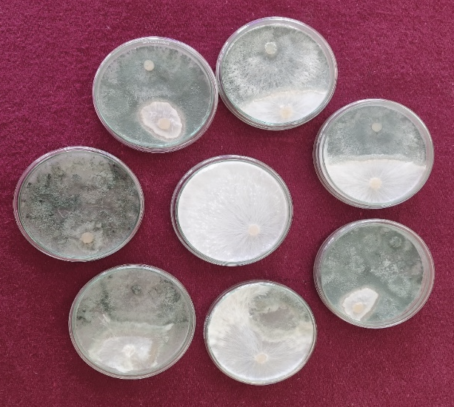
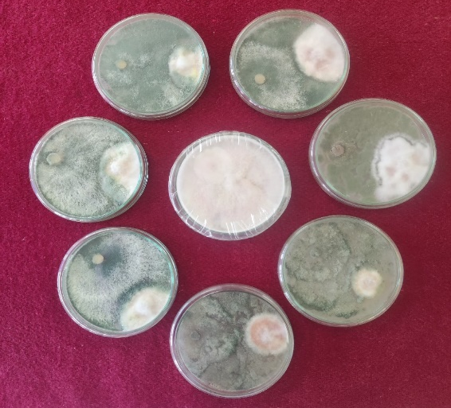
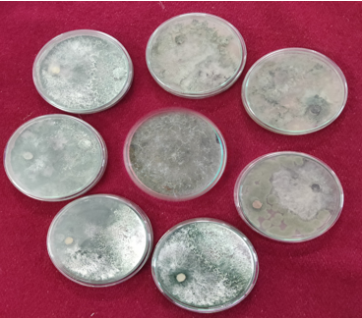
Plate 1: Bio-efficacy of Trichoderma spp. against Fusarium oxysporum
f. sp. ciceri
Plate 2: Bio-efficacy of Trichoderma spp. against M. phaseolina

Plate 3: Bio-efficacy of Trichoderma spp. against S. rolfsii
Plate 3
Plate 2
Plate 1
T₆
T₈
T₇
T₁
T₂
T₃
T₄
T₅
T₈
T₅
T₂
T₆
T₇
T₄
T₃
T₁
T₃
T₅
T₈
T₆
T₄
T₁
T₂
T₇
Treatment No. | Trichoderma Isolates | Treatment  No. | Trichoderma Isolates
T₁ | L-Thr-1 | T₅ | L-Thm
T₂ | L-Tk | T₆ | L-Thr-2
T₃ | L-Tv-1 | T₇ | L-Thr-3
T₄ | L-Tv-2 | T₈ | Control

4. Conclusion

The in vitro study demonstrated that all native Trichoderma isolates inhibited the growth of major soil-borne pathogens of chickpea. Among them, Trichoderma virens (L-Tv-2) consistently showed the highest bio-efficacy against Fusarium oxysporum f. sp. ciceri, Macrophomina phaseolina and Sclerotium rolfsii, followed by T. harzianum (L-Thr-2) and T. virens (L-Tv-1) showing highest inhibition indicating its strong potential as a biocontrol agent in chickpea disease management.

References

- Al-Snafi A. E. (2016). The medical Importance of Cicer arietinum- A review. IOSR Journal of Pharmacy, 6 (3), 29-40.
- Ambuse, M. G. & Bhale, U. N. (2016). Trichoderma as bioagent against pathogenic fungi infecting fenugreek pub. In National Symposium on Plant Health Management for Sustainable Agriculture, 39-46.
- Amrutha Veena, G., Reddy, N. P., Reddy, B. V. & Prasanthi, L. (2014). Potential of Trichoderma spp. as bio-control agents against Rhizoctonia bataticola causing dry root rot of chickpea. International Journal of Plant and Environmental Sciences. 4 (1), 78-81.
- Benitez. T., Rincon, A. M., Limon, M. C. & Codon, A. C. (2004). Bio-control mechanisms of Trichoderma strains. Journal of International Microbiology. 7(4), 249-260.
- Chandulal, K. G. & Priya John (2015). Antagonistic effect of Trichoderma against soilborne pathogens. Bioinfolet 12 (1A), 110 – 112.
- Das, B. C., Dutta, P. & Devi, G. (2000). Management of Sclerotium rolfsii in tomato by fungal antagonists. Journal of Agricultural Science Society. 13 (1),101-103.
- Dennis, K. L. & Webster, J. (1971). Antagonistic properties of species group of Trichoderma and hyphal interaction. Transactions of the British Mycological Society. 57, 363-396.
- Gaur, Y. D. & Sen, A. N. (1979). Cross inoculation group specificity in Cicer-Rhizobium symbiosis. New Phytologist, 83(3),745-754.
- Howell, C. R. (2003). Mechanisms employed by Trichoderma species in the biological control of plant diseases: the history and evolution of current concepts. Journal of Plant Disease. 87, 4-10.
- Jukanti, A. K., Gaur, P. M., Gowda, C. L. L. & Chibbar, R. N. (2012). Nutritional quality and health benefits of chickpea (Cicer arietinum L.): a review. British Journal of Nutrition, 108 (1), 11-26.
- Kumar, J. P., Kumar, P. S., Kashyap, V., Singh, R & Patidar, S. (2018). Evaluation of botanicals and bio-agents against Rhizoctonia bataticola causing dry root rot of chickpea. International Journal of Microbiology Research,10(5),1186-1190.
- Nallathambi, P., Umamaheswari, C., Thakore, B. B. & More. T. A. (2009). Post-harvest management of ber (Ziziphus mauritiana Lamk) fruit rot fungicides and their combinations. Journal of Crop Protection. 28:225-232.
- Nene, Y. L. & Sheila, V. K. (1999). ICRISAT newsletter: Proceeding on International workshop on chickpea improvement. Feb-March: 172-180.
- Sharma, S. B., Sikora, R. A., Greco, N., Di Vito, M. & Caubel, G. 1994. Screening techniques and sources of resistance to nematodes in cool season food legumes. Euphytica, 73: 59-66.
- Vincent, J. M. (1947), Distortion of fungal hyphae in the presence of certain inhibitors. Nature.150: 850.

