Original Research Article
Daniellia oliveri leaf methanol extract suppresses hepatic oxidative damage and expressions of Epithelial Membrane Antigen and Cytokeratin in Dimethylamine-exposed rats

ABSTRACT
Dimethylamine (DMA) is commonly used in the manufacture of various products including rubber, pharmaceuticals, pesticides, and herbicides, leading to several toxicological toxicological consequences. This study investigated the effect of Daniellia oliveri leaf methanol extract (DOLME) on DMA-induced liver toxicity in male Wistar rats. The extract was obtained using Soxhlet extraction. Thirty-five male Wistar rats (average weight: 154 g) were used and divided into seven groups (A–G), with five rats per group. Group A served as the control, while Group B received intraperitoneal injections of DMA alone (10 mg/kg) twice weekly. Groups C, D, E, F and G were treated orally with DOLME at doses of 50, 100, 150, 200, and 250 mg/kg, respectively using distilled water vehicle every other day, while DMA was administered (10 mg/kg) by intraperitoneal injection twice per week. After four weeks, rats were sacrificed by cervical dislocation, and livers were harvested and divided into two portions. One portion was processed into homogenate for biochemical assays, including superoxide dismutase (SOD), catalase, glutathione-S-transferase (GST), reduced glutathione (GSH), and glutathione peroxidase (GPx). The other portion was fixed for histological and immunohistochemical evaluation of epithelial membrane antigen (EMA) and cytokeratin expression. DMA treatment significantly (p < 0.05) reduced hepatic SOD and catalase activities, which were reversed by DOLME at most doses. Hepatic GST and GSH levels were also reduced by DMA but attenuated with DOLME treatment. Histological examination revealed hepatic portal triaditis in DMA-treated rats, which was ameliorated by DOLME. High expressions of EMA and cytokeratin were observed in the hepatocyte cytoplasm of DMA-treated rats, whereas mild to moderate expressions were noted in the DOLME-treated groups. These findings suggest that Daniellia oliveri leaf methanol extract mitigates DMA-induced liver damage through antioxidant mechanisms and by reducing the expression of epithelial membrane antigen and cytokeratin.
Keywords: Antioxidant, cytokeratin, Daniella oliveri, dimethylamine, epithelial membrane antigen.
1.0 Introduction
Daniellia oliveri is very rich in bioactive compounds, capable of exhibiting an array of biological activities, such as anti-inflammatory, antimicrobial (Souza and Passos, 2021). This plant is recognized as "Black Ironwood”, "Ogea” or “Igi iya” which stands out to represent the Fabaceae subfamily Caesalpinioideae, originating from Nigeria, Cameroon, Ghana, and Ivory Coast (Okunade and Olafadehan, 2019). Daniellia oliveri has been reported for its ecological significance, playing a critical role in sustaining the balance of the ecosystems (Dangai et al., 2020); Agha et al., 2022). Daniellia Oliveri leaf has been shown to contain physiological important metals including sodium, potassium, calcium, zinc, magnesium, chromium, copper, iron and manganese (Adeleke et al., 2024). These authors also quantified phytochemicals such kaempferol (16.49%) quercetin (41.48%), L-borneol (10.89%), rhamnetin (14.65%) and α-caryophyllene (6.16%) using HPLC technique. The essential oils of Daniellia oliveri such as limonene and β-caryophyllene offer potential benefits in both aromatherapy for relaxation and emotional well-being, as well as natural antimicrobial properties (Mascarenhas et al., 2021). Flavonoids such as quercetin, kaempferol, and myricetin possess strong antioxidant and anti-inflammatory properties, contributing to the potential of the plant in mitigating oxidative stress and hepatic carcinogenesis (Sabri et al., 2021).
The traditional use of Daniellia Oliveri in West Africa underscores the analgesic, anti-nociceptive and anti-inflammatory effects of the plant (Traore et al., 2021; Harris et al., 2023). Several researches have demonstrated Daniellia oliveri to contain natural compounds with the potential to alleviate inflammation, suppress bacterial growth, and reduce oxidative stress (Atolani et al., 2018). A study by Yaya et al. (2016) documented that the plant could modulate inflammatory responses by modulating critical pathways and mediators, demonstrating their potential as natural anti-inflammatory therapeutic agents. One of our recent studies indicated that DOLME attenuated the levels of RBC, WBC, hematocrit, platelets and monocytes against DMA intoxication in Wistar rats (Ayobami and Adeleke, 2024).
Dimethylamine (DMA) is an aliphatic amine with significant industrial and biochemical relevance (Bugata et al., 2019, Ertl et al., 2020). DMA serves as an intermediary in the synthesis of compounds like solvents, rubber additives and medications (Whba et al., 2024). Environmental exposure to DMA poses risk to humans and ecosystem primarily through inhalation of its vapors and ingestion from crops (Cohen et al., 2006). DMA metabolism primarily occurs in the liver by monoamine oxidase enzyme in which DMA is converted into formaldehyde and nitrosodimethylamine (Lv et al., 2009). Previous studies indicated that N-nitrosodimethylamine nitrosamine (NDMA) caused periportal cell infiltration and strong expression of CD34 in liver of rats (Adeleke et al., 2017).
2.0 Materials and Methods
2.1 Collection and extraction of Daniellia oliveri leaves
Daniellia oliveri leaves were collected at Obamoro village, via Iwo, Osun State, Nigeria in July, 2023. They were authenticated at the Department of Pure and Applied Biology, Ladoke Akintola University of Technology, Ogbomoso, Nigeria, with a voucher number LHO 874. The leaves were air-dried for about four weeks at the room temperature, and then pulverized by a mechanical blender, followed by Sohxlet extraction using methanol. The extract was concentrated using rotary evaporator to obtain Daniellia oliveri leaf methanol extract (DOLME).
2.2 Experimental design
Thirty-five male Wistar rats were purchased and divided into Seven groups (A – G) (average weight of 154 g) with five rats in each group. Group A served as Control and group B was given intraperitoneal injection of DMA (10 mg/kg) alone twice per week. Groups C to G were treated with DOLME (50, 100, 150, 200, 250, mg/kg) in distilled water by oral gavage and DMA (10 mg/kg) by intraperitoneal injection. The DOLME was administered every other day, while DMA was administered twice per week for four weeks.
2.3 Sacrifice and Collection of liver
After four weeks, the rats were fasted overnight and sacrificed by cervical dislocation. Liver was excised and washed with 1.15% potassium chloride (KCl) solution to remove blood stain, and then divided into two portions. One portion of liver tissue was homogenized in pre-chilled Phosphate buffer (0.01M, pH 7.4) using Teflon homogenizer and then centrifuged at 3,000 x g for 15 minutes to obtain homogenate used for antioxidant assays. The other portion of liver was fixed in 10% formosaline for histology and Immunohistochemical assays.
2.4 Determinations of Protein and antioxidant parameters
The total protein in the liver homogenate was measured spectrophotometrically using a method described by Lowry et al. (1951). The levels of superoxide dismutase (Misra and Fridovich, 1971), catalase (Aebi, 1984), glutathione-S-transferase (Habig et al., 1974), reduced glutathione (Mitchell et al., 1973) and glutathione peroxidase (Paglia and Valentine, 1967) in the liver tissue were also measured spectrophotometrically.

2.5 Histopathological examination
Ultra-thin sections (5 µm) of the 10% formosaline-fixed liver were obtained using a microtome knife. The sections were stained with hematoxylin and Eosin (H&E) solutions, and then observed under a light microscope, taking the photomicrographs of the stained slides.
2.6 Immunohistochemical assays
Immunochemical staining of epithelial membrane antigen and cytokeratin of the liver using Avidin immunoperoxidase method was done. The chemicals used were manufactured by Novocastra (LEICA). The antibody dilusion factor used was 1:100 dilusions for all the antigen markers. Liver tissue was sectioned at 2 microns on the hot plate at 70°C for about 1 hour. The sections were passed into water, after being passed through two changes of xylene and three changes of descending grades of alcohol. Antigen retrieval was performed on the sections by heating them on citric acid solution (pH 6.0) using microwave at power 100 for 5 minutes. The sections were equilibrated gradually with cold water to displace the hot citric acid for about 5 mins to allow cooling of the sections. Peroxidase blocking was carried out on the section by covering the section with 3% hydrogen peroxide for 15 mins. Liver sections were washed with PBS and endogenous biotin in the liver was blocked for 15 mins. Liver sections were incubated with 5μg/ml each of epithelial membrane antigen (EMA) and Cytokeratin antibodies. The tissue sections were counterstained with Haematoxylin solution for 2 minutes. The slides were dehydrated in alcohol, cleaned in xylene, mounted in DPX mountant and then observed under microscope. Cells with specific brown color in the cytoplasm, cell membrane or nuclei, depending on the location of the antigen sites were considered positive.

2.7 Statistical Analysis
Values were expressed as mean ± standard deviation and differences in the mean values were estimated statistically by one-way analysis of variance (ANOVA) by using the Statistical Package for Social Sciences (SPSS) software for Windows version 10.0 (USA). Significantly different values were taken at P < 0.05.
3.0 Results
Table 1 shows that DMA treatment significantly (P<0.05) reduced the activities of SOD and catalase relative to control and DOLME-treated groups. The result in figure 1 shows that treatment with DMA alone significantly reduced (P<0.05) hepatic GST activity of the rats compared with control rats. However, treatment with DOLME significantly increased (P<0.05) GST activity against DMA intoxication in a dose-dependent manner. Hepatic GSH concentration in liver of rats treated with DMA alone was significantly reduced (P<0.05) compared with control and other treatment groups as show in figure 2. The result in figure 3 indicates that GPx activity in liver of rats administered with DMA alone was significantly reduced (P<0.05) compared with control rats. However, treatment with DOLME against DMA resulted to increase in hepatic GPx activity at doses 50 and 200mg/kg of the extract.
The results in Plate 1 (A-G) show the effect of the treatments with DMA and DOLME on the histology of the liver tissue of the rats. The tissue shows normal central venules (white arrow), mild portal triditis with normal hepatocytes (blue arrow) and mildly dilated sinusoids (slender arrow) in the control group (Plate 1 A). The DMA alone (Plate 1 B) caused severe portal triditis (black arrow) with normal hepatocyte (blue arrow). The results of liver histology of rats treated with DMA and DOLME in Plate 1 (C,D,E,F and G) show the presence of normal central venules (white arrow), moderate portal triditis (black arrow) and normal morphology of the hepatocytes (blue arrow).
Plate 2 A shows moderate expression of epithelial membrane antigen in the hepatocyte cytoplasm. The DMA alone (Plate 2 B) shows strong expression of EMA in the hepatocyte cytoplasm. The results of liver immunohistochemical study of the rats treated with DOLME and DMA (Plates 2 C, D and E) show moderate and mild EMA in hepatocyte cytoplasm. Plates 3 C, D and E show mild to moderate expression of cytokeratin in the liver of the experimental rats. Liver showed expression of cytokeratin in the hepatocyte cytoplasm in the control group (Plates 3 A) while DMA alone (Plates 3 B), shows high expression of cytokeratin in the hepatocyte cytoplasm. Figures 4 and 5 indicate hepatic EMA and cytokeratin in rats exposed to Daniellia oliveri leaf methanol extract and dimethylamine using image J processing program.

Table 1: Effects of Daniellia Oliveri Leaf Methanol Extract on SOD and Catalase activities in liver of rats administered with Dimethylamine.
TREATMENT  GROUPS | SOD  (U/mg protein) | CATALASE  (U/mg protein)
CONTROL | 1.44±2.41 | 63.21±12.85
DMA (10mg/kg) | 0.54±2.51ª | 44.61±9.786ª
50mg/kg DOLME +DMA | 29.4±7.44^{b} | 55.04±11.91^{b}
100mg/kg DOLME +DMA | 4.52±2.99^{b} | 42.20±9.767
150mg/kg DOLME +DMA | 31.5±17.3^{b} | 40.85±16.48
200mg/kg DOLME +DMA | 27.8±9.39^{b} | 53.85±36.75^{b}
250mg/kg DOLME +DMA | 6.88±0.45^{b} | 58.90±19.49^{b}
Values expressed as mean ± standard deviation, n = 5
a- significantly lower than control (P < 0.05); b - significantly higher than DMA group (P < 0.05);

SOD- Superoxide dismutase, DMA- Dimethylamine, DOLME- Daniellia Oliveri Leaf Methanol extract

Figure 1: Effect of Daniellia Oliveri leaf methanol extract on Glutathione –S-transferase activity in liver of rats treated with dimethylamine.
Data expressed as mean ± standard deviation, n=5
a-significantly lower than control, b-significantly higher than the DMA group (p<0.05)

Figure 2: Effect of Daniellia Oliveri leaf methanol extract on reduced Glutathione activity in liver of rats treated with dimethylamine.
Data expressed as mean ± standard deviation, n=5
a-significantly lower than control, b-significantly higher than the DMA group (p<0.05)

Figure 3: Effect of Daniellia Oliveri leaf methanol extract on Glutathione peroxidase activity in liver of rats treated with dimethylamine.
Data expressed as mean ± standard deviation, n=5
a-significantly lower than control, b-significantly higher than DMA group, c-significantly lower than DMA group (p<0.05)

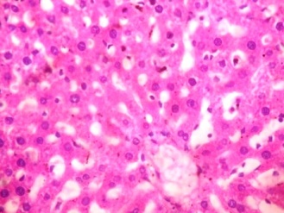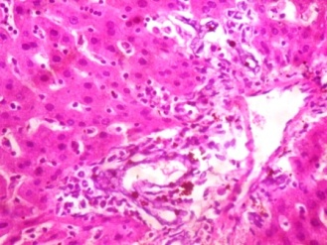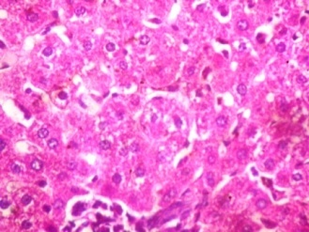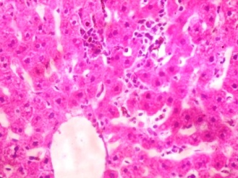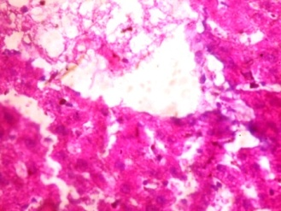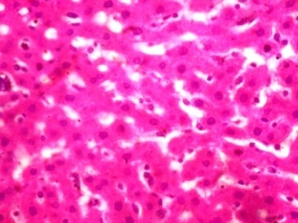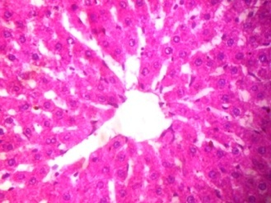
A
G
E
F
D
C
B
Plate 1: Effect of Daniellia oliveri leaf methanol extract on liver histology of rats treated with Dimethylamine. (x400)

Group A (control), Group B (10mg/kg DMA), Group C (50mg/kg DOLME + 10mg/kg DMA), Group D (100mg/kg DOLME + 10mg/kg DMA), Group E (150mg/kg DOLME + 10mg/kg DMA), Group E (200mg/kg DOLME + 10mg/kg DMA), Group E (250mg/kg DOLME + 10mg/kg DMA).
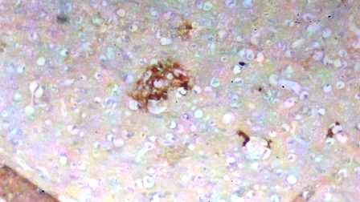
A
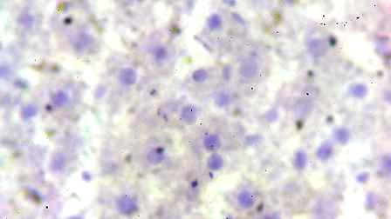
BII
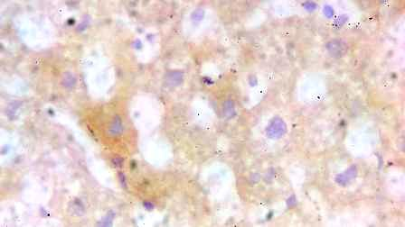
C
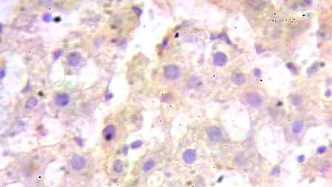
D
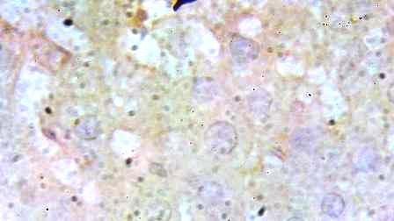
E
Plate 2: Hepatic expression of epithelial membrane antigen in rats exposed to Daniellia oliveri leaf methanol extract and Dimethylamine. (x400)
Group A (control), Group B (10mg/kg DMA), Group C (50mg/kg DOLME + 10mg/kg DMA), Ground D (150mg/kg DOLME + 10mg/kg DMA), Group E (250mg/kg DOLME + 10mg/kg DMA).
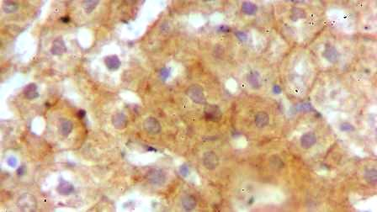
A
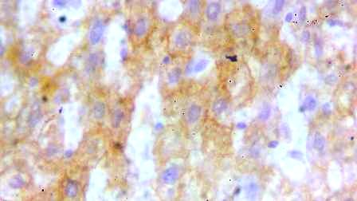
BII
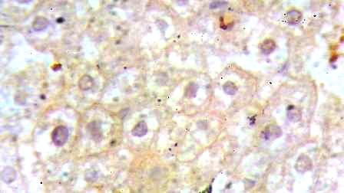
C
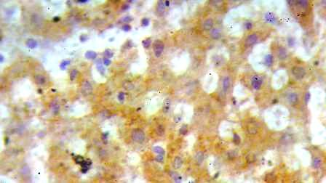
D
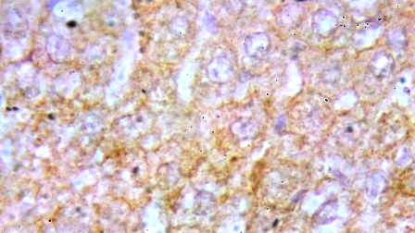
E
Plate 3: Hepatic cytokeratin expression in rats exposed to Daniellia oliveri leaf methanol extract and Dimethylamine. (x400)
Group A (control), Group B (10mg/kg DMA), Group C (50mg/kg DOLME + 10mg/kg DMA), Group D (150mg/kg DOLME + 10mg/kg DMA), Group E (250mg/kg DOLME + 10mg/kg DMA) x400
Figure 4: Hepatic expression of epithelial membrane antigen in rats exposed to Daniellia oliveri leaf methanol extract and Dimethylamine using imageJ processing program.
Data expressed as mean ± standard deviation, n = 5

Figure 5: Hepatic cytokeratin expression in rats exposed to Daniellia oliveri leaf methanol extract and Dimethylamine using imageJ processing program.
Data expressed as mean ± standard deviation, n = 5

4.0 Discussion
This study examines the potential of Daniellia oliveri leaf methanol extract (DOLME) on the toxic effect of dimethylamine, a potent environmental toxicant in the liver of experimental rat model. We examined the effects of the treatments on redox status, histology and expressions of epithelial membrane antigen (EMA) and cytokeratin in the liver of experimental rats.
Superoxide dismutase, catalase, glutathione-S-transferase, reduced glutathione and glutathione peroxidase are key enzymes involved in detoxifying reactive oxygen species (ROS) and maintaining cellular redox balance (Jena et al., 2023). This study revealed that DMA significantly reduced the levels of SOD, catalase, GST, GSH and GPx in the liver. This finding indicates that DMA could cause redox imbalance in the hepatic tissue of rats. The reversal of this imbalance by DOLME is an indication that the extract possesses antioxidant potential. N-Nitrosodimethylamine (NDMA) was documented to cause increase in the levels of GSH and glutathione reductase (GR) while the expressions of GST and GPx were reduced in the experimental rats (Sheweita et al., 2014). A study by Sulaimon et al. (2020) showed the potential of Daniellia oliveri stem bark extract to elevate hepatic levels of SOD, catalase, GSH and GPx in Wistar rats treated with Carbon tetrachloride (CCl-4). Qiu et al. (2021) reported that DMA-induced ROS formation may disrupt mitochondrial function by destroying mitochondrial DNA (mtDNA) and interrupting the electron transport chain, resulting in increased ROS production and mitochondrial damage. Exposure to DMA could trigger an inflammatory pathway in the liver, recruiting immune cells, such as macrophages to generate pro-inflammatory cytokines including TNF-α and IL-6 (Ferrigno et al., 2015). Daniellia oliveri has been reported to be rich in phytochemicals like, flavonoids, alkaloids, tannins, and essential oils that possess antioxidant, anti-inflammatory, neuroprotective and antimicrobial potentials (Yaya et al., 2022). Olaleye et al. (2020) documented the presence of phenolics, proanthocyanidins and flavonoids in Daniellia oliveri, which may possibly be responsible for the antioxidant potential of the plant. Adeleke et al., (2024) showed that DOLME ameliorated the effects of DMA on cardiac antioxidant status in rats. Thus, the plant could potentially reduce the development of cardiovascular problem due to oxidative stress.
Histology of liver tissue of the rats showed normal central venules in the control group, while the DMA group showed severe portal triditis. Hepatic Portal triditis is the inflammation of the portal track, which induces inflammatory cell infiltration primarily lymphocytes, and results in hepatocyte damage or necrosis (Gadd et al., 2014). Chronic inflammation can activate hepatic stellate cells and myofibroblasts, causing fibrosis and cirrhosis, which impair liver function (Czaja et al., 2014). Adeleke et al. (2017) documented that N-nitrosodimethylamine (a nitrosated product of DMA) treatment resulted in periportal cell infiltration in hepatocytes of a rat model. Administration of DOLME against DMA was found with moderate portal triditis, normal central venules sinusoids mildly infiltrated by inflammatory cells, thereby indicating the mitigation of DMA effect by DOLME. Afolabi et al. (2022) revealed that medicinal plants could prevent intestinal and hepatic injuries, thereby suppressing oxidative stress.
Epithelial membrane antigen is a useful marker in cancer pathology, allowing for the identification of tiny deposits of malignant cells in organs including liver (Pinkus et al., 1985). It is a class of highly glycosylated proteins related to milk fat globule proteins that are produced by various epithelial and neoplastic cells and a widely studied broad-spectrum antibody that reacts with a variety of adenocarcinomas (Ormerod et al., 1983). Petersen and Van deurs (1986) characterized EMA in the human mammary epithelium using ultra structural immunoperoxidase cytochemistry, expressing several membrane proteins such as aminopeptidase and Na-K-ATpase. Through immunohistochemical assay, strong expression of epithelial membrane antigen was observed in DMA group of the experimental rats. The control group showed a moderate expression, while the rats co-administered with DOLME and DMA showed mild expression of EMA. Ghalib and Falah (2022) reported the implication of over expression of EMA in the incidence of prostatic adenocarcinoma. The strong expression of EMA in liver of DMA-treatment rats was indicative of DMA potential to induce liver carcinogenesis. Interestingly, DOLME showed the potential to ameliorate the effect of DMA in the rat liver, showing that the extract may have an antitumor effect.
Immunohistochemical investigation of Cytokeratin in the liver of the rats revealed that the control and co-treated groups showed moderate expression of cytokeratin in the hepatocyte cytoplasm. Conversely, DMA alone showed slightly high expression of cytokeratin in the hepatocyte cytoplasm. Cytokeratin is a complex multigene family of protein, mostly produced by epithelial cells and it is an intermediate filament keratin (Awasthi and Bhattacharya 2016). The 20 polypeptides that make up the epithelial cytokeratin family may be distinguished by their molecular weights and can be classified into two groups (Franke et al., 1981). Type 1 (CK 9–20) consists of smaller and acidic polypeptides, while type 2 (CK 1-8) consists of bigger and basic neutral polypeptides (Pastuszak et al., 2015). Ugurlu et al. (2004) explored the influence of cytokeratin on response to chemotherapy in non-small cell lung cancer utilizing monoclonal anti-cytokeratin 18 (CK18), and the significance of immunohistochemical profiling in predicting the prognosis of non-small cell lung cancer (NSCLC). A strong expression of CK18 has been reported in almost all types of adenocarcinomas (Menz et al., (2021). An expression of CK18 could play an important role in the early detection of neoplastic transformation in squamous epithelium, and as a biomarker for drug-induced liver injury (Korver et al., 2021, Nanda et al., 2012). The present study thus indicates the potential of DMA exposure to induce neoplastic transformation in hepatic tissue, which could be reversed by treatment with DOLME via down regulation of cytokeratin.

References

- Souza, S. and Passos M. (2021). Ethnobotanical use of morinda citrifolia: a literature review. Research Society and Development, 15(10), e352101523280.
- Okunade, S. A. and Olafadehan O. A. (2019). Rolfe (Daniellia Oliveri) seed meal as a protein source in locally produced concentrates for lambs fed low quality basal diet. Journal of the Saudi Society of Agricultural Sciences, 1(18): 83-88.
- Dangai, Y., Hamawa, Y., Zh, O., Fawa, G., Mamah, M. and Mapongmetsem P.M. (2020). Caracterisations biophysique et floristique des parcs agroforestiers a Daniellia oliveri dans la zone soudano-sahelienne du cameroun. International Journal of Applied Research, 6, 398-409.
- Agha, H. M., Sidik, N. J., Jawad, A. H., Mohammed, A. A., and Alkamil A. A. (2022). Overview of thaumatococcus daniellii plant, history, uses, benefits, andc. Journal of Asian Scientific Research, 12(2), 80-90.
- Adeleke, G. E., Ajani R. A., Berena G. A., Owolabi O.Q., Adeyi R. O., Ayobami T. E., Adedosu O. T., Orisadiran P. K., Bello M. A., Olasinde T. T., Omidoyin O. S., Akano M., Abdulateef R. B., Shoyinka E. D., Oriaje K. O., Aransi I. A., Elaigwu K. O. and Awoyemi M. B. (2024). Chemical Insights into Hymenocardia Acida Leaf Extract and Computational Effects of its Constituents on Cyclooxygenases-1 and 2 Activities. London Journal of Medical and Health Research, 24(2), 41-57.
- Mascarenhas, V., Caroci-Becker, A. and Riesco M. (2021). Effectiveness of aromatherapy versus standard care on physiological and psychological symptoms in pregnant women: A systematic review protocol. Jbi Evidence Synthesis, 2(20), 658-665.
- Sabri, S., Takruri, H. and Ismail, K. (2021). Nutrient composition, antioxidant activities and anti-inflammatory effect of jujube fruit. Journal of Pharmacy and Nutrition Sciences, v(11): 164-174. https://doi.org/10.29169/1927-5951.2021.11.19
- Traore, M., Coulibaly, A. C., Traore, K. T., Boly, A. G., Kabre, E. W. L. M. B., Ouedraogo, N., and Sawadogo, R. W. (2021). Anti-inflammatory and analgesic activities of the methanolic extract and the residual fraction of the stem bark of Daniellia oliveri (Fabaceae). Annu. Res. Rev. Biol, 104-111.
- Harris, N., Murphy, A., Green, A., Gámez, S. and Nunez-Mir G. (2023). Socio-ecological gap analysis to forecast species range contractions for conservation. Proceedings of the National Academy of Sciences, 7(120). https://doi.org/10.1073/pnas.2201942119
- Atolani, O., Olorundare, O.E., Anoka A.N. and Oluwatomiwa, A. (2018). Antioxidant , proteinase inhibitory and membrane stabilization potentials of moringa oleifera seed oil. Pharmacological Science, 43(2) 91-103.
- Yaya, T., Claude, M.J., Coulibaly, Sirabana, Anthelme, N.S. and Flavien, T. (2016). Anti-inflammatory activity of the aqueous extract of Daniellia oliveri (Fabaceae). Int Arc Integr Med, 2(3): 1-9.
- Ayobami T.E. and Adeleke G.E. (2024). Daniellia oliveri leaf methanol extract mitigates redox imbalance and neuronal degeneration in brain of Wistar rats exposed to dimethylamine. World journal of pharmaceutical, 3(5), 2583-6579.
- Bugata, L. S. P., Pitta Venkata, P., Gundu, A. R., Mohammed Fazlur, R., Reddy, U. A., Kumar, J. M. and Mahboob, M. (2019). Acute and subacute oral toxicity of copper oxide nanoparticles in female albino Wistar rats. Journal of Applied Toxicology, 39(5), 702-716.
- Ertl, P., Altmann, E. and McKenna, J. M. (2020). The most common functional groups in bioactive molecules and how their popularity has evolved over time. Journal of Medicinal Chemistry, 63(15), 8408-8418.
- Whba, R., Su'ait, M. S., Whba, F., Sahinbay, S., Altin, S. and Ahmad, A. (2024). Intrinsic challenges and strategic approaches for enhancing the potential of natural rubber and its derivatives: A review. International Journal of Biological Macromolecules, 276(1) 133796.
- Cohen, S. M., Arnold, L. L., Eldan, M., Lewis, A. S., and Beck, B. D. (2006). Methylated arsenicals: the implications of metabolism and carcinogenicity studies in rodents to human risk assessment. Critical reviews in toxicology, 36(2), 99-133.
- Lv, C. L., Liu, Y. D., and Zhong, R. G. (2009). Theoretical investigation of N-nitrosodimethylamine formation from dimethylamine nitrosation catalyzed by carbonyl compounds. The Journal of Physical Chemistry A, 113(4), 713-718.
- Adeleke, G. E., and Adaramoye, O. A. (2017). Modulatory role of betulinic acid in N-nitrosodimethylamine-induced hepatorenal toxicity in male Wistar rats. Human and Experimental Toxicology, 36(7), 734-743.
- Lowry OH, Rosbrough NJ, Farr AL, et al. Protein measurement with the Folin- phenol reagent. J. Biol. Chem. 1951; 193: 265-275.
- Mistra HP, Fridovich I. The generation of superoxide radical during the autoxidation of ferredoxin. J. Biol. Chem. 1979; 246: 6886-6890.
- Aebi H. (1984). Catalase in-vitro. In: Packer L. Editor. Methods in Enzymology. Academic Press; pp . 121-126.
- Habig W., Pabst M. and Jakoby W. (1974). Glutathione S-transferase. The first enzymatic step in mercapturic acid formation.J Biol Chem. 249: 7130–7139.
- Mitchell J.R., Jollow D.J., Potter W.Z., Davis D.C., Gillette J.R. and Brodi B.B. (1973). Acetaminophen-induced hepatic necrosis. I. Role of drug metabolism. Jour. Pharmacol Exer. Therap.187:185-194.
- Paglia, D.E. and Valentine, W.N. (1967). Studies on the quantitative and qualitative
characterization of erythrocyte glutathione peroxidase. J. Lab Clin. Med. 1967; 70:158-169.
- Jena K., Ananta S. and Akthar J. (2023). Physical, biochemical and antimicrobial characterization of chitosan prepared from tasar silkworm pupae waste. Environmental technology and innovation. 31(4617): 103200.
- Sheweita, S. A., El-Bendery, H. A., and Mostafa, M. H. (2014). Novel Study on N‐Nitrosamines as Risk Factors of Cardiovascular Diseases. BioMed Research International, 2014(1), 817019.
- Sulaimon L.A., Obuotor E.M., Rabiu L.A., Sheu A.M., Aliyu M. and Shiro M.Q. (2020) Antioxidant and hepatoprotective potentials of ethanol stem bark extract of Daniellia oliveri (rolfe) Hutch and Dalz (Caesalpiniaceae). Synergy vol(11): 100067.
- Qiu, Z., Li, G. and An, T. (2021). In vitro toxic synergistic effects of exogenous pollutants-trimethylamine and its metabolites on human respiratory tract cells. Science of the Total Environment, 783-792, 146915.
- Ferrigno, A., Di Pasqua, L. G., Berardo, C., Richelmi, P. and Vairetti, M. (2015). Liver plays a central role in asymmetric dimethylarginine-mediated organ injury. World Journal of Gastroenterology: WJG, 21(17), 5131.
- Yaya, S.T., Claude, M.J., Sirabana, C. and Flavien, T. (2022). Antipyretic activity of aqueous extract of Daniellia oliveri leaves (Rolfe, Hutch Et Dalz) (Fabaceae). Sch Acad J Pharm v(11): 193-199.
- Olaleye O.O., Sofidiya O. M., Ogba O. J. and Lasore W. (2020). Antioxidant activities of Daniellia oliveri (Rolfe) hutch. and dalziel and Daniellia ogea (Harms) rolfe ex holland (Caesalpiniaceae): Tropical Journal of Natural Product Research (TJNPR), 4(5): 210 – 215.
- Gadd, V. L., Skoien, R., Powell, E. E., Fagan, K. J., Winterford, C., Horsfall, L., and Clouston, A. D. (2014). The portal inflammatory infiltrate and ductular reaction in human nonalcoholic fatty liver disease. Hepatology, 59(4), 1393-1405.
- Czaja, A. J. (2014). Hepatic inflammation and progressive liver fibrosis in chronic liver disease. World journal of gastroenterology: WJG, 20(10), 2515.
- Afolabi A.O., Akhigbe T.M., Odetayo A.F., Anyogu D.C., Hamed M.A. and Akhigbe T.M. (2022). Restoration of hepatic and intestinal integrity by phyllanthus amarus is dependent on Bax/caspase 3 modulation in intestinal ischemia-/reperfusion-induced injury. Molecules, 27(16) 5072
- Pinkus, G. S., and Kurtin, P. J. (1985). Epithelial membrane antigen—a diagnostic discriminant in surgical pathology: immunohistochemical profile in epithelial, mesenchymal, and hematopoietic neoplasms using paraffin sections and monoclonal antibodies. Human pathology, 16(9), 929-940.
- Ormerod M.G., Steele K., Westwood J.H. and Mazzini M.N. (1983) Epithelium membrane antigen, partial purification, assays and properties. National Library Medicine 48(4): 533-541.
- Petersen O.W. and Van deurs B. (1986). Characterization of epithelium membrane antigen expression in human mammary epithelium by ultrastructural immunoperoxidase cytochemistry. Journal of His. Cyto. 34(6): 801-809.
- Ghalib R. and Falah A. (2022). The role of epithelial membrane antigen (EMA) overexpression in the prognosis of prostatic adenocarcinoma. Journal of Medicine and Life. 15(4): 504-508.
- Awasthi, P., Thahriani, A., and Bhattacharya, A. (2016). Keratins or cytokeratins-a review article. Journal of Advanced Medical and Dental Sciences Research, 4(4), 140.
- Franke, W. W., Schiller, D. L., Moll, R., Winter, S., Schmid, E., Engelbrecht, I., amd Platzer, B. (1981). Diversity of cytokeratins: differentiation specific expression of cytokeratin polypeptides in epithelial cells and tissues. Journal of molecular biology, 153(4), 933-959.
- Awasthi P., Thahriani A. and Bhattacharya A. (2016). Keratin or cytokeratins. A review Article Journal Advanced Medical dent. Science res 4(4): 140-148.
- Franke, W. W., Schiller, D. L., Moll, R., Winter, S., Schmid, E., Engelbrecht, I., amd Platzer, B. (1981). Diversity of cytokeratins: differentiation specific expression of cytokeratin polypeptides in epithelial cells and tissues. Journal of molecular biology, 153(4), 933-959.
- Pastuszak, M., Groszewski, K., Pastuszak, M., Dyrla, P., Wojtuń, S., and Gil, J. (2015). Cytokeratins in gastroenterology. Systematic review. Gastroenterology Review/Przegląd Gastroenterologiczny, 10(2), 61-70.
- Ugurlu D., Unsal M., Yildiz L., Toplas M. and Kandemir B. (2004) Effect of cytokeratin typing on response to chemotheraphy and survival time on non-small cell lung cancer. Turkish Respiratory Journal 5(1): 27-31.
- Menz A., Bauer R., Kluth M., Von Bargen C.M., Gorbokon N., Viehweger F., Lennartz M., Volkl C., Fraune C., Uhlig R., Hube-magg C., De wispelaere N., Minner S., Sauter G., Kind S., Simon R., Burandt E.,Clauditz T., Lebok P., Jacobsen F. and Bernreuther C. (2021) Diagnostic and prognostic impact of cytokeratin 19 expression analysis in human tumors: a tissue microarray study of 13,172 tumors. Journal Human Pathology v(115): 19-36.
- Korver, S., Bowen, J., Pearson, K., Gonzalez, R. J., French, N., Park, K., and Goldring, C. (2021). The application of cytokeratin-18 as a biomarker for drug-induced liver injury. Archives of Toxicology, 95, 3435-3448.
- Nanda, K. D. S., Ranganathan, K., Devi, U., and Joshua, E. (2012). Increased expression of CK8 and CK18 in leukoplakia, oral submucous fibrosis, and oral squamous cell carcinoma: An immunohistochemistry study. Oral surgery, oral medicine, oral pathology and oral radiology, 113(2), 245-253.

