Strategic Marker-Assisted Selection for Elite Soybean Development: I. Parental Polymorphism Survey Using Core SSR Markers for Null KTI and LOX2 Alleles

Abstract
Soybean (Glycine max) is a globally important legume crop valued for its high protein and oil content, making it a staple in human diets and animal feed. However, its utilization in monogastric animal nutrition is limited by anti-nutritional factors such as Kunitz trypsin inhibitor (KTI), which impairs protein digestion, and by lipoxygenase (LOX)-mediated off-flavors that reduce consumer acceptance of soy-based food products. This study aimed to develop soybean lines deficient in both KTI and lipoxygenase-2 (Lox2) using marker-assisted selection (MAS) with trait-specific simple sequence repeat (SSR) markers. The research was conducted at the Biotechnology Centre and RRC Amravati, Dr. PDKV, Akola, using three genotypes: AMS-100-39 (recipient; high-protein, charcoal rot resistant), NRC-127 (KTI-null donor), and NRC-109 (Lox2-null donor). Controlled hybridizations were carried out during Kharif 2023, and F₁ plants were grown in the Rabi season. A total of 318 SSR markers spanning 20 linkage groups were screened in a parental polymorphism survey (PPS). Genomic DNA was extracted using the CTAB method, and marker analysis revealed 113 polymorphic SSR loci, with polymorphism rates ranging from 29.55% (AMS-100-39 × NRC-127) to 31.76% (AMS-100-39 × NRC-109). Linkage groups D1b and D2 exhibited the highest polymorphism. Molecular validation confirmed hybridity in 17 F₁ plants from AMS-100-39 × NRC-127 and 7 from AMS-100-39 × NRC-109. The results underscore the limited genetic diversity within Indian soybean germplasm and highlight the utility of SSR markers for accurate hybrid identification and background selection. This work paves the way for developing KTI- and Lox2-deficient soybean genotypes with improved nutritional quality, enhanced palatability, and greater suitability for sustainable food and feed applications.
.

Introduction
Soybean (Glycine max) is a significant legume crop with high-quality oil and protein, largely consumed in food and animal feed. Soybean a globally cultivated legume of high economic significance is recognized for its dense nutritional profile, comprising substantial amounts of protein, carbohydrates, essential minerals, and oil. It contributes approximately 30% to the global production of edible vegetable oils, underscoring its pivotal role in both the food and agricultural sectors (Imran, et al., 2023). It is one of the most significant and commonly eaten legumes in the world (CONAB, 2025). Soybean is characterized by a highly favorable seed composition, containing approximately 36–42% protein and 15–23% oil, rendering it a valuable resource for both human consumption and livestock feed (Đurović, et al., 2019). However, raw soybeans are not suitable for feeding monogastric animals due to the presence of anti-nutritional compounds that hinder nutrient absorption. The most prominent of these is the Kunitz trypsin inhibitor (KTI), a serine protease inhibitor that suppresses trypsin activity (Gupta, 1987; Liener, 1989). High levels of trypsin inhibitor activity in soybean seeds can impair growth and weight gain in poultry and livestock and lead to pancreatic hypertrophy. To mitigate these effects, heat treatment is commonly applied to inactivate the inhibitor before soybean products are incorporated into feed. Although effective, this thermal processing can also reduce the availability of essential amino acids and increase the overall cost of the final product (Chung, 2011; Kumar et al., 2013; 2015).
The genetic organization and regulation of Kunitz trypsin inhibitor (KTI) genes in soybean have been well characterized (Kumar et al., 2015; Bulatova et al., 2019; Choi et al., 2020). Soybean expresses at least ten different KTI genes throughout its development, with Kti3 being a mutant gene that encodes the major trypsin inhibitor found in seeds (Jofuku et al., 1989). One of the primary reasons for the limited acceptance of soy-based foods in many Western countries, including Brazil and North America, is the presence of undesirable grassy and beany flavors. These off-flavors are caused by the oxidation of polyunsaturated fatty acids, a reaction catalyzed by lipoxygenase enzymes present in soybean seeds (Carpentieri-Pipolo, 2015; Carpentieri-Pipolo et al., 2021). As a result, soybeans bred without lipoxygenase activity specifically developed for food applications are increasingly valued in the food industry for their potential to improve flavor and enhance consumer acceptance of soy products.
In a significant advancement, (Wang et al. 2020) reported the successful application of CRISPR-Cas9 genome editing to generate targeted mutations in the Lox1, Lox2, and Lox3 genes, producing lipoxygenase-free soybean lines. Soybean varieties that are deficient in both lipoxygenase enzymes and trypsin inhibitors have been developed through the application of marker-assisted selection (MAS) using DNA markers. This technique has proven to be an efficient tool for enhancing and expediting the selection process in breeding programs (Carpentieri-Pipolo, 2015; Carpentieri-Pipolo et al., 2020).
Various molecular techniques have been developed to evaluate genetic variation, with some of the most widely used being isozymes, restriction fragment length polymorphism (RFLP), and a range of PCR-based marker systems such as simple sequence repeats (SSR), random amplified polymorphic DNA (RAPD), and amplified fragment length polymorphism (AFLP) (Karp et al., 1996). Markers generated through methods like RAPD (William et al., 1990; Welsh and McClelland, 1990), RFLP (Botstein et al., 1980), and inter-simple sequence repeats (ISSR) have become increasingly valuable for cultivar identification and the analysis of genetic diversity (Patterson et al., 1996). Among these, SSR markers are especially useful due to their high degree of polymorphism, wide distribution across the genome, and abundance (Cregan et al., 1999). The development and public release of SSR primers have enabled their integration into soybean linkage groups, enhancing their utility in genetic mapping and breeding programs.
To evaluate the level of polymorphism among various parental combinations and to identify suitable SSR markers for background selection, a total of 318 SSR markers distributed across 20 linkage groups (LGs) were utilized. Identified successful crosses for KTI free and Lox2 free by using the trait specific SSR markers.
Material and Method
The plants were grown at Biotechnology centre, Department of Agricultural Botany, and Regional Research Center, Amaravati of the Dr. PDKV, Akola (MS), the phenotyping and genotyping tests were performed at the Laboratory of Biotechnology centre. The F₁ and F₂ population were developed by using 3 different elite parents. Seed material of parental cultivars were obtained from Dr. PDKV, Akola (MS) and IISR Indore (MP). The cultivars were chosen for their special characteristics for human consumption. NRC-127 donor parent for KTI free trait this parent have medium duration maturity: 100-104 days. Also resistant to water logging. Second donor parent is NRC-109 which is free from Lox2 that is lack of beany flavour, and having early maturity: 85 days. The recipient parent was AMS-100-39 (PDKV Amba) developed by Dr. PDKV, Akola. This parent is having Charcoal rot resistant with high protein content (44%) and high yield. Crossing was performed in the Kharif of 2023 in the field and F₁ plants were obtained in the winter of 2023. Authentication of hybrid origin of F₁ plants was carried out by using polymorphic markers and they were compared with their female parental.

DNA isolation from leaf tissue
The young leaves of the selected genotypes were cut and used for the isolation of genomic DNA by the CTAB (Cetyltrimethyl ammonium bromide) method (Murry et al. 1980). The solution for DNA extraction (2% CTAB, 100 mM Tris-HCl, 50 mM ethylene diamine tetra acetate (EDTA), and 100 mM NaCl) was used to grind 15 to 20-day-old soybean leaves (Siva Kumar et al. 2013). A nanodrop spectrophotometer (IMPLEN make Munchen, Germany) were utilized for the estimation of optical density for the quantity and purity of the DNA at 260 and 280 nm and agarose gel electrophoresis was also utilized for determining the quality of DNA. The genomic DNA was diluted to 40ng/µL for the subsequent experiment.
The polymorphic markers were obtained by doing parental polymorphism survey (PPS). In PPS different 318 SSR markers used on 20 linkage groups of 3 parents (AMS-100-39, NRC-127, NRC-109). Genomic DNA was extracted from young leaves of the three genotypes following CTAB (cetyl trimethyl ammonium bromide) procedure. Purified DNA was subjected to PCR amplification in 10 µl reaction mixture containing 1 µl DNA (20 ng/ µl), 5 µl PCR Master mix by Himedia, 0.5 µl each forward and reverse SSR primers (30 ng/ µl), 3 µl double distilled water. In the thermocycler (Veriti 96-well Thermal cycler) the DNA was denatured at 94ºC for 2 min. followed by 30 cycles each consisting of denaturation at 94ºC for 1 min, primer annealing temperature was different for different markers, primer elongation at 72ºC for 3 min. and final elongation at 72ºC for 10 min. Amplified products so obtained were resolved on 0.8% agarose gel stained with ethidium bromide and analysed in Gel Documentation System from VILBER.
For polymorphism study, 318 SSR markers were picked up from the 20 linkage groups at an average density of one SSR marker per 5 cM. For validation and testing utility in foreground selection, the trait specific markers were tested for its polymorphism in the three parental combinations i.e., (AMS-100-39 x NRC-127) and (AMS-100-39 x NRC-127). Each of the three parental combinations exhibited distinct polymorphism for both the trait specific SSR markers indicating its applicability in foreground selection including testing of hybridity of the F₁ plants as well as identification of plants with null KTI allele and null Lox2 allele in different generations.
Result and Discussion
To estimate the level of polymorphism in different parental combinations and select SSR markers for background selection, 318 SSR markers spanning 20 linkage groups (LG) were employed. The level of polymorphism varied from 29.55% in the AMS-100-39 × NRC-127 combination to 31.76% in the AMS-100-39 × NRC-109 combination (Fig. 1). Accordingly, 94 to 101 polymorphic SSR markers were present for background selection, which provided 4 to 7 markers per chromosome. The comparatively low level of polymorphism noticed among Indian soybean genotypes can be largely attributed to the fact that soybean is not native to India. In addition, Indian soybean germplasm consists predominantly of Chinese and American introductions. More significantly, Indian breeders employed a limited set of selected genotypes in their hybridization programs and thereby condensed the genetic diversity of the cultivated germplasm. Comparable low levels of polymorphism have also been noted by earlier studies (Singh et al., 2008 & Talukdar et al., 2009; Jadhav et al., 2025). Hence, it is suggested to implement diverse parental lines in crossing programs to increase the level of polymorphism.
During the determination of the number of polymorphic markers, it was observed that 113 marker loci were polymorphic between the two cross-combinations (Table 1). However, the pattern of the occurrence of these polymorphic loci was different (Fig.2A); it differed between different linkage groups (LG) as well as between the different cross-combinations. The maximum number of polymorphic markers (13) found among the two crossing combinations was on linkage group D1b, while minimum was on LG: C1 and LG: N.

Table 1 SSR markers from different LGs revealed to be polymorphic across all the three soybean parental combinations (AMS-100-39 Χ NRC-127) & (AMS-100-39 Χ NRC-109).
LG | No. of Polymorphic SSRs | Chr. number | SSR markers
A1 | 4 | 5 | Satt684(3.54), Satt717(51.95), Satt648(59.18), Satt236(93.23),
A2 | 8 | 8 | Satt187(54.91), Satt424(60.59), Satt341(77.69), Satt525(96.97), Sat_250(105.18), Satt228(154.11), Sat_319(27.9), Sat_400((49.38).
B1 | 7 | 11 | Sat_270(21.99), Sat_128(53.41), Sat_348(71.97), Satt444(85.91), Satt665(96.36), Satt453(123.95), Satt426(28.33).
B2 | 12 | 14 | Satt168(55.2), Satt304(65.55), Satt070(72.8), Satt556(73.21), Satt534(87.58), Satt063(93.48), Satt560(97.91), Sat_424(100.09), Sat_287(31.87), Satt304(65.55), Sat_182(68.63), Satt687(113.61).
C1 | 2 | 4 | Satt565(0.00), SOYPGPATR(10.34).
C2 | 5 | 6 | Sat_213(90.93), Sat_153(61.98), Satt557(112.19), Satt371(145.47), Satt357(151.91).
D1a | 5 | 1 | Satt184(17.52), Sat_353(36.23), Satt580(62.36), Satt147(108.88), Satt179(56.2)
D1b | 13 | 2 | Sat_289(131.91), Satt271(137.05), Sat_423(67.62), Sat_351(20.61), Satt290(73.34), AI856415(50.11),  Sat_183(112.62), Satt172(100.88),  Satt274(116.34), Satt698(38.04), Satt266(59.61), Satt290(73.34), Satt542(53.02
D2 | 12 | 17 | Satt154(57.07), Satt461(80.19), Sat_209(85.63), Sat_326((112.84),  Satt458(24.52), Sat_284(30.79), Satt461(80.19), Sat543(88.01), Satt310(107.48), Satt672(114.97), Sat_086(118.66), Satt256(124.3)
E | 5 | 15 | Sat_124(15.86), Satt212(32.27), Satt706(43.36),  SSR1766/Satt268(78.49), Sat_273(47.50).
F | 10 | 13 | Satt146(1.92), Satt160(33.18), Satt425(43.43), Sat_297(59.59), Satt657(116.91), AW756935(124.87), Satt656(135.11), Satt335(77.69), AW756935(124.87).
G | 3 | 18 | Sat_315(27.48), Satt472(94.83), Satt199(62.16)
H | 8 | 12 | Satt317(89.51), Sat_127(28.79), Satt442(46.95), Satt629(72.18), Satt302(81.04), Satt181(91.12), Satt314(69.12), Sat_218(99.5).
I | 4 | 20 | Satt354(47.7), Sat_104(65.62), Satt354(47.7), Satt049(58.82).
J | 8 | 16 | Sat_046(24.09), Satt654(38.09), Satt215(44.08), Satt431(78.57), Sat_395(89.48), Sat_412(41.11), Sat_093(46.09), Sat_366(52.84).
K | 7 | 9 | Satt539(1.8), Sat_087(4.85), Sat_119(17.11), Sat_325(54), Sat_126(108.19), Satt588(117.01), Sat_044(58).
L | 5 | 19 | Sat_301(11.12), Sat_071(20.78), Satt278(31.21), Satt513(106.37), Satt408(1.31).
M | 5 | 7 | Satt201(13.56), Sat_244(48.86), Satt175(66.98), Satt494(71.7), Sat_330(140.69).
N | 2 | 3 | Satt549(70.59), Sat_306(93.11).
O | 10 | 10 | Satt345(59.43), Sat_282(63.81), Satt478(71.09), Sat_274(107.58), Sat_108(129.3), Satt358(5.44), Satt679(53.18), Satt479(54.2), Satt478(71.09), Sat_231(128.44).
Table: 2 Intervening regions between two consecutive polymorphic SSR markers on different linkage groups (LG) for different parental combinations in soybean.
Linkage group | Chr. number | (AMS-100-39 Χ NRC-127) | (AMS-100-39 Χ NRC-109)
A1 | 5 | Satt684 - Satt236  (3.54) - (93.23) | Satt684 - Satt236  (3.54) - (93.23)
A2 | 8 | Satt187- Satt228  (54.91) - (154.11) | Sat_319 - Satt228  (27.9) - (154.11)
B1 | 11 | Sat_270 - Satt453  (21.99) - (123.95) | Sat_270 - Sat_348  (21.99) - (71.97)
B2 | 14 | Satt168 - Sat_424  (55.2) - (100.09) | Sat_287 - Satt687  (31.87) - (113.61)
C1 | 4 | Satt565 – SOYPGPATR  (0.00) - (10.34) | Satt565 – SOYPGPATR  (0.00) - (10.34)
C2 | 6 | Sat_153 - Satt357  (61.98) - (151.91) | Sat_153 - Satt357  (61.98) - (151.91)
D1a | 1 | Satt184 - Sat_353  (17.52) - (36.23), | Satt184 - Satt147  (17.52) - (108.88)
D1b | 2 | Sat_351 - Satt271  (20.61) - (137.05) | Sat_351 - Satt271  (20.61) - (137.05)
D2 | 17 | Satt154 - Sat_326  (57.07) - (112.84) | Satt458 - Satt256  (24.52) - (124.3)
E2 | 15 | Sat_124 - SSR1766/Satt268  (15.86) - (78.49) | Sat_124 - SSR1766/Satt268  (15.86) - (78.49)
F | 13 | Satt146- Satt656  (1.92) - (135.11) | Satt160 - Satt656  (33.18) - (135.11)
G | 18 | Sat_315 - Satt472  (27.48) - (94.83) | Satt199 (62.16)
H | 12 | Sat_127 - Satt181  (28.79) - (91.12) | Sat_127 - Sat_218  (28.79) - (99.5)
I | 20 | Satt354 - Sat_104  (47.7) - (65.62) | Satt354 - Sat_104  (47.7) - (65.62)
J | 16 | Sat_046 - Sat_395  (24.09) - (89.48) | Sat_046 - Sat_395  (24.09) - (89.48)
K | 9 | Satt539 - Satt588  (1.8) - (117.01) | Sat_325 - Satt588  (54) - (117.01)
L | 19 | Satt408 - Satt513  (1.31) - (106.37) | Satt408 - Satt513  (1.31) - (106.37)
M | 7 | Satt201 - Sat_330  (13.56) - (140.69) | Satt201 - Sat_330  (13.56) - (140.69)
N | 3 | Satt549 - Sat_306  (70.59) - (93.11) | Satt549 - Sat_306  (70.59) - (93.11)
O | 10 | Satt345 - Sat_108  (59.43) - (129.3) | Satt358 - Sat_231  (5.44) - (128.44)
Such non-uniformity in the distribution of the polymorphic SSR loci has been observed in other researches (Talukdar and Zhang 2007). Such a result points towards the existence of conserved sequences on the chromosomes among genotypically heterogenous genotypes, and due to this, a lower level of polymorphism is being revealed. Therefore, it is necessary to screen a high number of SSR markers (at least one marker per 5 centimorgans) so that at least one polymorphic marker remains per 10 centimorgans in the genome. Such marker density is necessary for efficient background screening in segregating plants. The 113 polymorphic markers found in the present study will be used for the background selection of candidate plants, i.e., plants possessing the titi allele as well as the lox2 allele.
Number of polymorphic markers detected in each of the two crossing combinations has been presented on (Fig.3). Presence of polymorphic SSR markers has been found to be unequal in various linkage groups in various crossing combinations. Linkage group B2 and D1b has been found with maximum number of polymorphic SSR markers (08) in parental combination (AMS-100-39 × NRC-127) and (11 and 10) in parental combination (AMS-100-39 × NRC-109) on linkage group D2 and D1b respectively detected. It is thus explained that different numbers of SSR markers have to be employed for background selection in different crossing combinations; however, at least one SSR marker density per 10 cM has to be maintained for effective background selection. The location of each SSR marker found polymorphic in each separate parental combinations i.e., (AMS-100-39 Χ NRC-127) and (AMS-100-39 Χ NRC-109) has been depicted in (Figure 4A & 4B) respectively.
The type of SSR motif (e.g., di-, tri-, tetra-nucleotide) and the number of repeat units (e.g., n = 5, 10, 15) play a critical role in determining the level of polymorphism detected. In the present study, tri-nucleotide repeat motifs were found to exhibit the highest degree of polymorphism among the SSRs analyzed. In the first parental combination (AMS-100-39 × NRC-127), out of 99 highly polymorphic SSR markers, 51 contained tri-nucleotide repeats, followed by 32 with di-nucleotide repeats. The remaining markers included 8 interrupted, 7 compound, and 1 tetra-nucleotide repeat motifs (Fig.5A). Similarly, in the second parental combination (AMS-100-39 × NRC-109), 48 of the 91 highly polymorphic SSR markers possessed tri-nucleotide repeats, whereas 28 had di-nucleotide repeat motifs. Additionally, 7 markers each exhibited interrupted and compound repeats, while only one marker contained a tetra-nucleotide repeat motif (Fig.5B). These findings underscore the predominance and effectiveness of tri-nucleotide repeat motifs in detecting genetic polymorphism in soybean genotypes (Jadhav et al., 2023).
The intervening intervals between two consecutive polymorphic SSR markers placed on different linkage groups (LG) for different parent combinations are shown in (Table 2). Polymorphic markers on 20 linkage groups found, i.e., A1, A2, B1, B2, C1, C2, D1a, D1b, D2, E2, F, G, H, I, J, K, L, M, N, and O, were found to be nearly within an interval of 5 cM in all parent combinations studied. In order to form a more representative picture of the genome, it is necessary to analyse more SSR markers placed in these particular regions. However, the marker distribution in both parent combinations was predominantly even and there was no gap of any substantial magnitude between any two consecutive polymorphic SSR markers. Therefore, the polymorphic SSR loci found in this study can be very helpful for a number of reasons, such as determining whether F1 plants in soybeans are hybrid.

Fig.1 Parental polymorphism survey of the 3 parental combination using 318 SSR markers

Fig.3 SSR markers found to be polymorphic on different linkage group with respect to each of the five parental combinations

Molecular hybridity
Following PPS analysis, the majority of polymorphic SSR markers were examined and utilized to determine which three parental combinations were true hybrids. The banding patterns of SSR markers were compared in order to identify markers that demonstrated polymorphism between parents and analyse the genetic purity of hybrids. When the F1s displayed both male and female parent alleles or just the male parent allele at the marker locus, their purity was verified (fig.2B & 2C). In the present research work, F1 plants were screened with polymorphic SSR markers to detect the genuine F1 plants of individual cross for generating the KTI free and Lox2 free mapping populations. Seventeen F1 plants from cross I (AMS-100-39 Χ NRC-127) by using Satt556, Satt228 primers and Seven F1 plants from cross II (AMS-100-39 Χ NRC-109) by using Satt308, Satt478, Satt656 primers, validated for hybridity. This is due to the fact that F1 seeds are obtained from female parents, and hence the occurrence of male parent-specific markers definitely confirms that the F1 is a true hybrid. Introduction of new SSR markers into genomic regions known to have low polymorphism can be done via two main methodologies. One of them is by using selection of SSR markers from existing databases, e.g., the genetic map of 2008 published by the USDA, wherein their polymorphism can be screened, or from the portal SOYABASE. The second approach would be designing new SSR markers from sequences of the clones of the respective genomic regions of interest. In such a case, utilization of the physical map along with the soybean complete genome sequence would facilitate easy identification of clones and designing new primers. Such information may prove useful for the selection and/or development of SSR primers in future studies. Hence, from the above studies, it can be inferred that Indian soybean genotypes possess limited diversity and thus require the screening of more SSR markers for overall polymorphism analysis. Distribution of polymorphism is not equal across the genome and is genotype-dependent, and therefore a new set of markers must be utilized for every cross-combination. The degree of polymorphism detected by various SSR markers is a function of motif size, as well as motif repetition number. These basic principles can be utilized to improve accuracy in soybean molecular breeding practice.
Conclusion
This study successfully demonstrated the utility of simple sequence repeat (SSR) markers for the molecular breeding of soybean lines lacking both Kunitz trypsin inhibitor (KTI) and lipoxygenase-2 (Lox2), traits important for improving the nutritional and sensory qualities of soy-based food products. A total of 318 SSR markers, distributed across 20 linkage groups, were used to evaluate parental polymorphism and identify suitable markers for foreground and background selection. Polymorphism frequency varied from 29.55% to 31.76%, which falls within reported values for Indian soybean genotypes due to their narrow genetic base. Notwithstanding this shortcoming, 113 polymorphic markers were found to be equally dispersed throughout the genome with adequate density to cause effective background selection. Trait-specific SSR marker foreground selection also established the existence of null KTI and Lox2 alleles in F1 hybrids, affirming their hybridity and genetic purity by using different primers identified from Parental Polymorphism Survey for cross I (AMS-100-39 Χ NRC-127) Satt556, Satt228 primers and for cross II (AMS-100-39 Χ NRC-109) Satt308, Satt478, Satt656 primers .
In general, this study forms a good basis for marker-assisted selection in soybean breeding programmes to enhance food-grade soybean cultivars. The results underscore the need to employ varied parental lines and high-resolution molecular markers to counter the challenge of poor genetic diversity in Indian soybean germplasm. The successful identification and validation of the polymorphic SSR markers open the door to effective introgression of desirable traits, leading ultimately to the creation of high-quality, consumer-preferred cultivars of soybean good for human consumption.

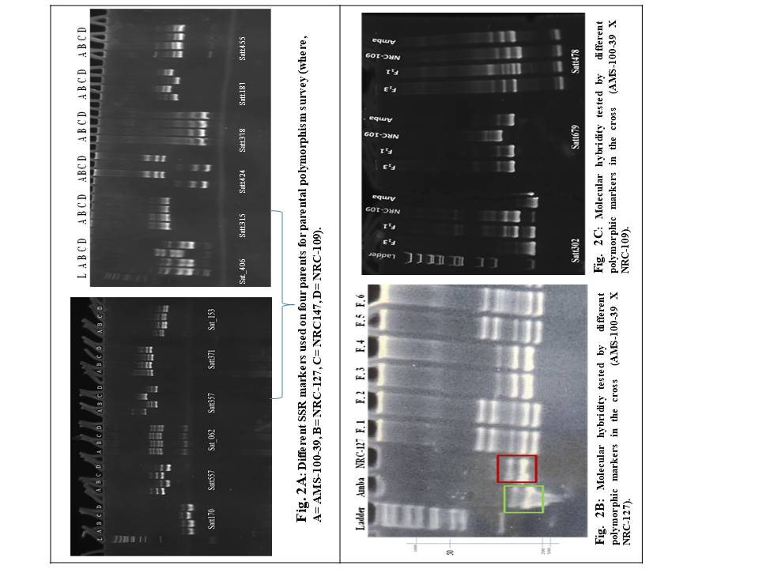

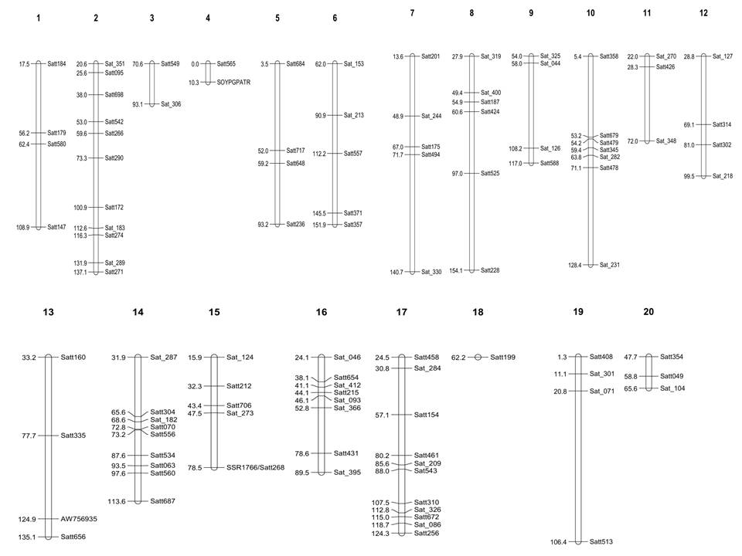
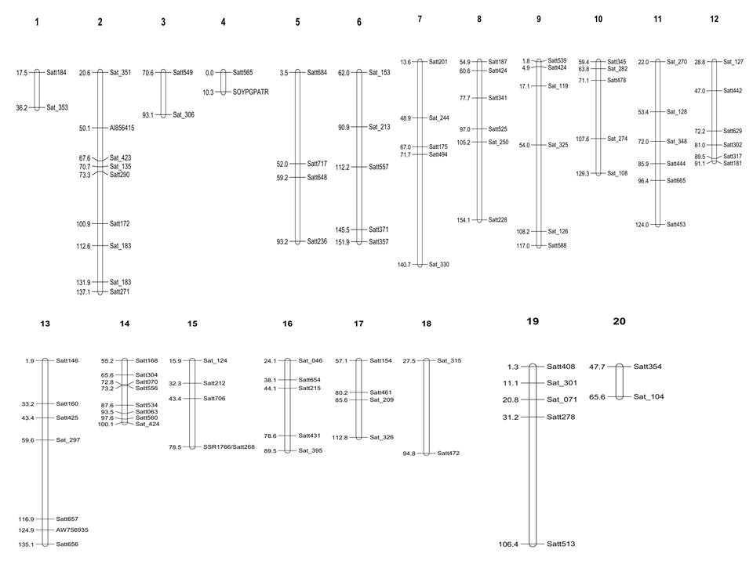
Fig. 4A Chromosome-wise distribution of polymorphic SSR markers in the soybean cross combination AMS-100-39 × NRC-127
Fig. 4 B Chromosome-wise Distribution of Polymorphic SSR Markers in the Soybean Cross Combination AMS-100-39 × NRC-109

Fig. 5A Number of polymorphic markers with di, tri, tetra, compound and interrupted motif in Parental combination (AMS-100-39 Χ NRC-127)

Fig. 5B Number of polymorphic markers with di, tri, tetra, compound and interrupted motif in Parental combination (AMS-100-39 Χ NRC-109)

References
Anonymous USDA. 2008. bldg6.arsusda.gov/ cregan/soymap.htm
CONAB – Companhia Nacional De Abastecimento (2020), “Acompanhamento da safra brasileira de grãos – Safra 2020/2021”, CONAB, Brasília, 8(2),1 62.
Đurović, S., Dragičević, V., Waisi, H., Pagnacco, M., Luković, N., Knežević-Jugović, Z., & Nikolić, B. (2019). Enhancement of antioxidant activity and bioactive compound contents in yellow soybean by plant-extract-based products. Archives of Biological Sciences, 71(3), 425–434.
Furukawa F., Toyoda K., Aba H., Hasegawa R., Sato H., Takahashi M. and Hayashi Y. 1987. Short-term effects of feeding crude soybean trypsin inhibitor on pancreas of rat, hamster and mouse. British National Institute of Hygiene Science (Tokyo), pp. 46-60.
Ge Y. C. and Morgan R. G. H. 1993. The effect of trypsin inhibitor on the pancreas and small intestine of mice. British J. Nutr., 70: 333-345.
Imran, S., Mahamud, M. A., Paul, N. C. ., Chakrobortty, J., Sarker, P., Paul, S., Tahjib-Ul-Arif, M., & Rhaman, M. S. (2023). Seed priming and exogenous application of citric acid enhance seedling growth and photosynthetic pigments and mitigate oxidative damage of soybean (Glycine max) under salt stress. Archives of Biological Sciences, 75(4), 407–418.
Jadhav PV, Shinde AN, Thakur PP, Shinde UD, Mahobia A, et al. (2023) Genome-Wide Microsatellite Survey and Introgression of Null KTI Allele in Charcoal Rot Resistant Soybean. J Hum Nutr Food Sci 11(4): 1172.
Jadhav, P., Magar, S., Sharma, P., Shinde, U., Vaidya, E., Moharil, M., ... & Mane, S. (2025). Comparative Transcriptome and Co-Expression Network Analysis Uncovers the Regulatory Mechanism of Silicon-Induced Soybean Defense Against Charcoal Rot Disease. Current Plant Biology, 100442.
Jadhav, P., Shinde, U., Thakur, P., Gawande, B., Mahobia, A., Moharil, M. P., ... & Mane, S. (2025). Genomic introgression and expression profiling of the KTI null allele in soybean through elite-by-elite backcrossing. Plant Physiology and Biochemistry, 224, 109912.
Kim M. S., Park M. J., Jeong W. H., Nam K. C. and Chung J. 2006. SSR markers tightly linked to the ti locus in soybean [Glycine max (L.) Merr.]. Euphytica, 152: 361-366.
Kumar B., Talukdar A. and Verma K. 2011. Diversity analysis in soybean genotypes using SSR markers. In: Book of Abstracts, National Seminar on “Contemporary approaches to crop improvement”, 22 23 April, 2011, UAS, Bangalore. pp126
Liener I. E. and Kakade M. L. 1980. Protease inhibitors. In: Toxic constituents of Plant Foodstuffs, Liener, I.E. (ed.) 2nd edn. Academic Press Inc., New York, London, pp 7-72.
Shen, Y., Jia, Q.-L., Liu, M.-Z., Li, Z.-W., Wang, L.-L., Zhao, C.-Z., Li, Z.-X., & Zhang, M. (2016). Genome-Wide Characterization And Phylogenetic And Expression Analyses Of The Caleosin Gene Family In Soybean, Common Bean And Barrel Medic. Archives of Biological Sciences, 68(3), 575–585.
Singh R. K., Raipuria R. K., Bhatia V. S., Rani A., Pushpendra, Husan S. M., Chauhan D., Chauhan G. S. and Mohapatra T. 2008. SSR markers associated with seed longevity in soybean. Seed Sci. Tech., 36(1): 162-167.
Talukdar A. and Zhang G. Q. 2007. Construction and characterization of 3-S lines, an alternative population for mapping studies in rice. Euphytica, 156: 237-246.
Talukdar Akshay, Verma K., Gowda D. S. Samrat, Lal S. K., Sapra R. L., Singh R., Singh K. P. and Sinha P. 2009. Molecular breeding of charcoal rot in soybean. I. Screening and mapping population development. Indian J. Genet., 69(4): 367-370.
Wang, C., Croft, K.P.C., Jarlfors, U., and Hildebrand, D.F. (1999), “Subcellular localization studies indi cate that lipoxygenases 1 to 6 are not involved in lip id mobilization during soybean germination”, Plant Physiol. 120(1),227-236.
Wang, W.H., Takano, T., Shibata, D., Kitamura, K., and Takeda, G. (1994), “Molecular basis of a null mutation in soybean lipoxygenase 2: substitution of glutamine for an iron-ligand histidine”, Proc. Natl. Acad. Sci. USA 91(13),5828-5832.
www.sciencedaily.com/releases/2010/ 01100113131457.htm

