**Antagonistic Potential of Endophytic Bacteria Against *Colletotrichum truncatum* ~~(Syn.~~ *~~C. capsici~~*~~) Inciting Fruit Rot~~ In Chilli**

**ABSTRACT**

|  |
| --- |
| **Aim:**To isolate and evaluate root-associated endophytic bacteria from solanaceous plants for their antagonistic activity against *Colletotrichum truncatum* (syn. *C. capsici*), the causal agent of fruit rot in chilli, and to identify potential bacterial biocontrol agents for eco-friendly disease management.  **Study design:** The research utilized a Complete Randomized Design (CRD)  **Place and Duration of study:** SRM College of Agricultural Sciences, Baburayanpettai, Chengalpattu District, Tamil Nadu from 2024 to 2025.  **Methodology:** Infected chilli fruits were collected, and the pathogen was isolated on Potato Dextrose Agar (PDA) medium and identified morphologically and through ITS-based molecular methods. Pathogenicity testing on chilli fruits was performed using different methods, with the pinprick method showing the highest disease severity. Root samples from ten solanaceous plants were collected, surface sterilized and plated on Nutrient Agar (NA) to isolate 80 endophytic bacterial strains. These were screened for antagonistic activity against Colletotrichum truncatum using dual culture and paper disc assays. Inhibition zones and mycelial growth reduction were recorded. Potent bacterial isolates were identified through 16S rRNA sequencing.  **Result:**The pathogen was confirmed as *Colletotrichum truncatum* through ITS-based molecular identification. Among the different inoculation methods, pinprick with mycelial disc (T2) showed the highest disease incidence (80%) and lesion size (20 mm), establishing its reliability for pathogenicity testing. Among the 80 endophytic bacterial isolates screened against *C. truncatum,* twenty bacteria exhibited notable antagonistic activity in preliminary tests. In dual plate assays, isolate EB38 showed the highest mycelial inhibition (48.88%), followed closely by EB40, EB22, and EB01. Paper disc assays further validated the antifungal potential, with EB22 recording 81.44% inhibition and a 12.33 mm zone of inhibition, followed by EB47 and EB01. The potential bacterial endophytes were molecularly identified through 16S rRNA with amplicon size of 1800 bp. The results clearly highlighted that identified endophytic bacteria such as *Bacillus subtilis* (EB22), *Brevundimon asdiminuta* (EB47), and *Stenotrophomonas* sp. (EB01) exhibit significant potential as effective antagonist in combating Chilli fruit rot*.*  **Conclusion:**The study demonstrated that root-associated endophytic bacteria from solanaceous crops effectively suppressed chilli fruit rot caused by Colletotrichum truncatum. Among the isolates tested, Bacillus subtilis (EB22), Brevundimonas diminuta (EB47), and Stenotrophomonas sp. (EB01) showed strong antifungal activity, highlighting their potential as biocontrol agents for sustainable chilli disease management. |

**Keywords:** *Colletotrichum truncatum*, chilli fruit rot, endophytic bacteria, dual plate assay, biocontrol.

**1. INTRODUCTION**

Chilli (*Capsicum annuum* L.) belongs to the family Solanaceae. It is an economically important spice and vegetable crop cultivated widely across tropical and subtropical regions. It is highly valued for its pungency, colour, flavour and rich content of vitamins, antioxidants and capsaicinoids which contribute both culinary uses and medicinal applications (Saxena *et al.,* 2016). India is the largest consumer and exporter which contributes as much as 25 per cent of total chilli production worldwide. In recent years, the total productivity has declined by 10% to 54 % is mainly due to various plant pathogenic organisms, among which fruit rot caused by *Colletotrichum capsici (syn. C. truncatum)* is a significant fungal disease affecting chilli crops (Kumar *et al.,* 2021). The disease results in substantial necrotic lesions on both immature fruits in the field and mature fruits after harvest, leading to severe yield losses ranging from 20% to 70% annually. The extensive use of synthetic fungicides and pesticides remains a common practice in managing plant diseases. However, their prolonged application can reduce soil fertility, harm beneficial organisms, and lead to chemical residues in crops. These effects not only compromise environmental health but may also lower agricultural productivity. Moreover, repeated use of agrochemicals can foster resistance among plant pathogens, diminishing treatment effectiveness. Compounding this issue, phytopathogens produce toxic compounds that may enter the food chain, posing threats to both human and animal health (Srideepthi*et al.,* 2017; Banya *et al.,* 2020). Alternatively, the scientist looks forward to naturally occurring potential endophytic biocontrol agents offering a sustainable and eco-friendly management. Moreover, they are cost-effective, self-replicating, and boost crop yields while defending plants from pathogens without causing long-term environmental damage (Yadav *et al.,* 2021; Le Thanh *et al.,* 2023). Endophytic bacteria suppress pathogens by competing for nutrients and space, secreting cell wall-degrading enzymes, antibiotics, and solubilising soil nutrients, along with producing a variety of antimicrobial substances (Carmona-Hernandez *et al.,* 2019). Bacterial endophytes are integral to plant vitality, contributing to host resilience by producing antimicrobial metabolites, establishing systemic colonization that mitigates biotic and abiotic stress, facilitating nutrient solubilization, and promoting physiological development through phytohormone biosynthesis. (Fadiji &🡪and Babalola 2020, Woźniak *et al.,* 2023). Their disease-suppressing ability is attributed to both direct mechanisms, such as competition, hyperparasitism, and the release of lytic enzymes and volatile antimicrobials (Rajani *et al.,* 2021) and indirect mechanisms like triggering plant defence responses (Pavithra *et al.,* 2021). Endophytic bacteria have been reported for managing bacterial wilt in tomato, either as rhizospheric microbes (Vanitha *et al.,* 2009), or as endophytes isolated from tomato itself (Feng *et al.,* 2013) or from different plant species (Thomas and Upreti, 2014).The present study focused on root-associated endophytic bacteria isolated from solanaceous plants. Root endophytes are particularly significant due to their close interaction with soil and rhizosphere, which often turns into stronger biocontrol and growth-promoting effects. Biochemical characterization of these isolates, such as their ability to produce hydrolytic enzymes, solubilise phosphate, fix nitrogen, and tolerate abiotic stress, helps in identifying strains with potential applications in sustainable agriculture. Thus, the isolation and evaluation of root endophytic bacteria from chilli for their antagonistic activity against *Colletotrichum* spp. present an eco-friendly and promising approach for effective disease management and crop productivity enhancement.

**2. MATERIALS AND METHODS**

**2.1 Isolation of *Colletotrichum truncatum***

The infected chilli fruits were collected from Baburayanpettai, Chengalpattu (12.6819° N, 79.9888° E). The typical symptoms of infected fruits exhibited sunken, dark brown to black lesions often with concentric rings with black pin-head size acervuli (Figure 1). Infected along with healthy portions of the fruits were cut into small pieces and surface sterilized with 1% sodium hypochlorite (NaOCl), followed by three rinses with sterile distilled water and dried. The disinfected tissue fragments were aseptically transferred to sterilized Petri dishes with Potato Dextrose Agar (PDA) and incubated at 28 ± 2 °C for seven days. The hyphal tips from these fungi were then transferred to new PDA dishes and stored at 4°C for further analysis (Joshi *et al.,* 2023).

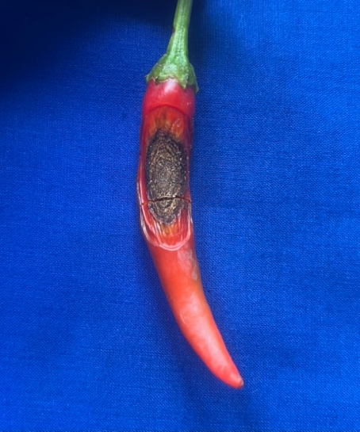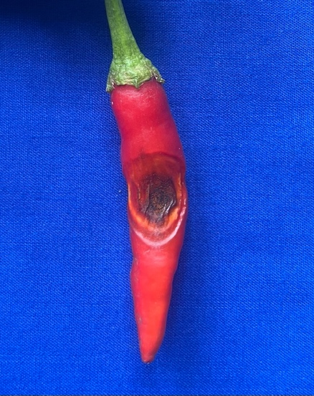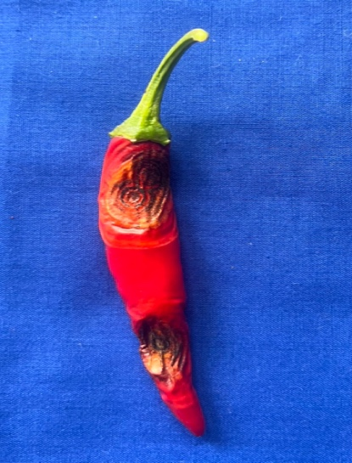

**Fig. 1 Typical Symptoms of fruit rot in Chilli**

**2.2 Morphological identification of pathogen**

The pure culture used for morphological characters such as, mycelial growth, colour, conidial character, shape and size of fruiting bodies of *Colletotrichum truncatum* was observed under compound microscope (Sangdee*et al.,* 2011).

**2.3 Molecular Characterization of *Colletotrichum truncatum***

The pure culture of *Colletotrichum truncatum* was cultivated in ~~Potato Dextrose Broth (~~PDB~~)~~ for seven days at 28 ± 1 °C. Mycelial mats were harvested for genomic DNA extraction using the CTAB method based on Murray and Thompson (1980). Molecular identification involved amplifying the internal transcribed spacer (ITS) region with universal primers ITS1 and ITS4. PCR was performed with thermal cycling conditions such as initial denaturation at 95 °C for 2 minutes, denaturation at 95 °C for 40 seconds, annealing at 55 °C for 45 seconds, and extension at 72 °C for 1 minute, with a final extension at 72 °C for 10 minutes followed by 30 cycles. Amplified products were resolved by electrophoresis on 1.0%??? agarose gel prepared in 1× TAE buffer and stained with ethidium bromide. The gel was loaded with PCR products alongside a 100 bp DNA ladder as a molecular size marker and run under constant voltage. DNA bands were visualized using the Viber E-Box gel documentation system to confirm amplification of the ITS region. The sizes of the PCR products were determined in comparison with standard 100 bp molecular marker (GeneiPvt. Ltd., Bangalore, India).

**2.4 Pathogenicity**

The fresh chilli fruits (Bangaram F1 variety) were used in this study. The spore suspension (5×105 spores/ml) of the pathogen was prepared using sterile water. The fruits were surface sterilized with 0.1% Sodium hypochloride (NaOCl), and rinsed with sterile distilled water. The disinfected fruits were used for different methods of inoculation such as Pinprick with spore suspension inoculation, pinprick with mycelial disc inoculation, pinprick with dip inoculation, spray inoculation and water control. (Raj *et al.,* 2013). After inoculation with the fungal suspension, the inoculated sites on the fruit surface were covered with sterile, moistened cotton to maintain humidity. A total of twenty-five healthy chilli fruits were used. The experimental design included **five replications**, each consisting of five fruits per treatment. Observations were recorded at regular intervals on day 0 (immediately after inoculation), and then at 3,5,7 and 9 days post inoculation (DPI). During each observation, fruits were examined for visible symptoms of infection such as lesion development, discoloration, tissue softening, and fungal sporulation. The percentage of infected fruits in each treatment was calculated based on the number of fruits showing clear signs of fruit rot infection.

**2.5 Isolation of endophytic bacteria**

To explore the diversity of bacterial endophytes we have collected ten Solanaceous host such as *Withania somnifera, Solanum torvum, Solanum viarum, Solanum xanthocarpum, Solanum nigrum, Solanum tribolatum, Datura metel, Capsicum annum, Solanum lycopersicum*and *Solanum melongena.* The roots were initially rinsed with tap water to remove adhering soil particles and debris. Subsequently, root bits were surface sterilized with 1% sodium hypochlorite for 4 minutes, followed by 70% ethanol for 1 minute. Later, the disinfected root bits washed three times with sterile distilled water and air dried. For isolation of endophytic bacteria, the root bits were macerated in pestle and mortar using phosphate buffer saline (PBS) of pH 7.4 to release the endophytic bacteria. The serial dilutions from 10-1 to 10-7 were prepared from the root extract. The 1 ml of root extracts were plated on Nutrient Agar (NA) medium for each dilution (10-2 to 10-7). The plates were then incubated at 37°C. After 24 hours the bacterial colonies were differentiated and purified using streak method and used for further studies (Leonardo *et al*., 2023).

**2.6 Morphological character of Endophytic bacteria**

Morphological analysis of the purified endophytic bacterial isolates was conducted to assess both colony level and cellular characteristics. Each bacterial isolate was streaked onto freshly prepared Nutrient Agar (NA) plates and incubated at 25 ± 2°C for 24 to 48 hours. Following incubation, the colonies were observed for visible features such as colour, growth and their characters.

**2.7 Screening of Endophytic Bacteria against *Colletotrichum truncatum🡪 respect the same character***

**2.7.1 Preliminary screening**

The bacterial isolates were streaked on the four corners of each plate~~s~~ on Potato Dextrose Agar (PDA) medium, placing the mycelial disc of *Colletotrichum truncatum* at the center and incubated at 28°C. Following incubation, the isolates were evaluated based on the zone of inhibition, and the most effective bacteria exhibiting strong antagonistic activity were selected for dual plate assay.

**2.7.2 Dual plate Assay**

The endophytic bacteria were screened against *Colletotrichum truncatum* using a dual plate assay as described by Dennis and Webster (1971). A 9 mm disc of the fungal pathogen was aseptically placed at one edge of the Petri plate, while the endophytic bacteria were streaked on the opposite side. The plate containing pathogen alone maintained as a control. Each treatment was replicated three times, and all plates were incubated at 27 ± 2 °C for seven days. After the incubation period, the radial growth of the pathogen was measured, and the percentage was calculated to assess the inhibitory effect of the endophytic bacteria on the fungal growth using the following formula given by Vincent (1927).

**2.7.3 Paper Disc Assay**

The antagonistic activity of effective endophytic bacterial isolates were tested against *Colletotrichum truncatum* by paper disc assay. The sterilized Whatmann No.42 filter paper disc was immersed in bacterial crude culture and placed at 1cm apart from four corners of sterilized petri dish containing PDA medium. A 5 days old pathogen culture was placed at the center. The paper disc with sterile water was used as a control. The plates were incubated at 25 ± 2 °C for 5 to 7 days. Each plate~~s~~ were replicated 3 times. The mycelial growth and the zone of inhibition ~~was~~🡪were recorded after 7 days of incubation (Chowdary *et al.,* 2024).

**2.7.4 Molecular Characterization of potential endophytic bacteria**

The potential bacterial isolates (EB01, EB22 and EB47) were further characterized for precise identification at the genus and species levels using a molecular technique. Bacterial genomic DNA was extracted using the standard protocol (Yu *et al.,* 2013) and was amplified using 16S rRNA universal primers (Forward- 27F: 5’-AGAGTTTGATCCTGGCTCAG-3’ and Reverse- 1492R: 5’-TACGGCTACCTTGTTACGACTT-3’) (Frank *et al.,* 2008). The closely related species were identified in BLAST-N program from Genbank database (http: [www.ncbi.nlm.gov/BLAST/](http://www.ncbi.nlm.gov/BLAST/)).

**3. RESULTS AND DISCUSSION**

**3.1 Morphological identification of the pathogen**

In the present study, the pathogen *Colletotrichum* sp was isolated from infected chilli fruit using ~~potato dextrose agar medium~~ (PDA), where it exhibited characteristic colony morphology. The colonies initially appeared white to grey in appearance, and the mycelium was dense, filamentous, and cottony fluffy with a smooth circular margin, which rapidly covered the Petri dish within 5 to 7 days. Consistent with the morphological description~~s~~ reported by Salunkhe *et al.,* (2025). The Microscopic examination revealed hyaline, falcate to fusiform conidia produced singly, along with black, disc-shaped acervuli bearing numerous dark, septate, needle-like setae (Figure 2). These morphological features agree with Prajapati *et al.,* (2020) and who described similar conidial and acervuli morphology in *C. truncatum*. However, as noted by Selvakumar and Kumar (2021), considerable variation in colony texture and sporulation intensity has been observed among *Colletotrichum* isolates from different geographic regions, indicating the physiological diversity within the species. Moreover, Joshi *et al.,* (2023) emphasised the importance of combining morphological traits with molecular identification for accurate confirmation.

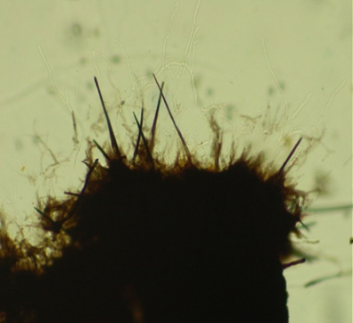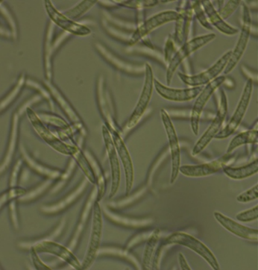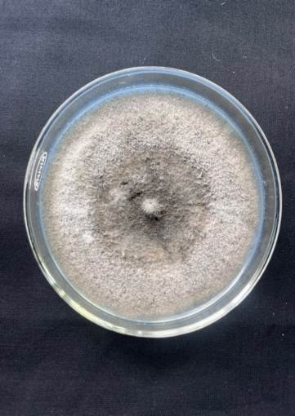

|  |
| --- |
| 1. **c. Conidia of *Colletotrichum*** 2. ***capsici*** |

|  |
| --- |
| 1. **b. Acervuli of *Colletotrichum*** 2. ***capsici*** |

|  |
| --- |
| 1. **a. Colony growth on PDA** 2. **medium** |

**Fig. 2 Cultural and Morphological characters of *Colletotrichum truncatum***

**Fig. 2 Cultural and Morphological characters of *Colletotrichum capsici***

**3.2 Molecular Characterization of *C. truncatum***

The results showed that amplifying the rDNA region of *Colletotrichum* sp. with universal primers ITS1 and ITS4 produced a 560 bp amplicon (Figure 3). The product was then partially sequenced and analyzed using BLAST in the NCBI database showed 100% similarity with *Colletotrichum truncatum*(Accession number: PV973009)*.* Thus, the isolate from the infected fruit was identified as *Colletotrichum truncatum.*

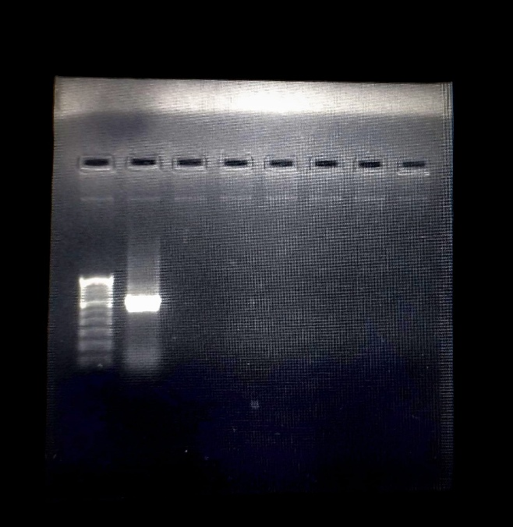

**~560 bp**

**Fig. 3 Molecular characterization of *Colletotrichum truncatum***

**3.3 Pathogenicity test**

The pathogenicity test showed that the method of inoculation significantly influenced symptom development in chilli fruits. The highest lesion size (20 mm) and per cent disease incidence (80%) were recorded in T2 (pinprick with mycelial disc), followed by T1 (spore suspension) and T3 (dip inoculation), which produced smaller lesions and lower disease incidence. In the treatments, T4 (spray inoculation) and T5 (water control), the symptoms were not expressed in chilli fruit, which confirms that artificial wounding is needed to facilitate pathogen entry. However, the enhanced disease development in T2 and T1 can be attributed to the physical injury created by pinpricking, which allowed direct fungal invasion and colonization (Figure 4 and Table 1🡪I). These findings are consistent with Thomas *et al.,* (2021), who demonstrated that artificial wounding methods significantly increased the infection rate of *Colletotrichum* spp. in chilli. Varghese and George (2022) also reported that the method of inoculation plays a critical role in symptom severity, with mycelial disc inoculation leading to more rapid lesion formation compared to other techniques. This supports the hypothesis that direct mycelial contact, combined with host tissue damage, creates favourable conditions for pathogen establishment and disease progression. Therefore, T2 was identified as the most reliable method for consistent and effective pathogenicity studies under laboratory conditions.

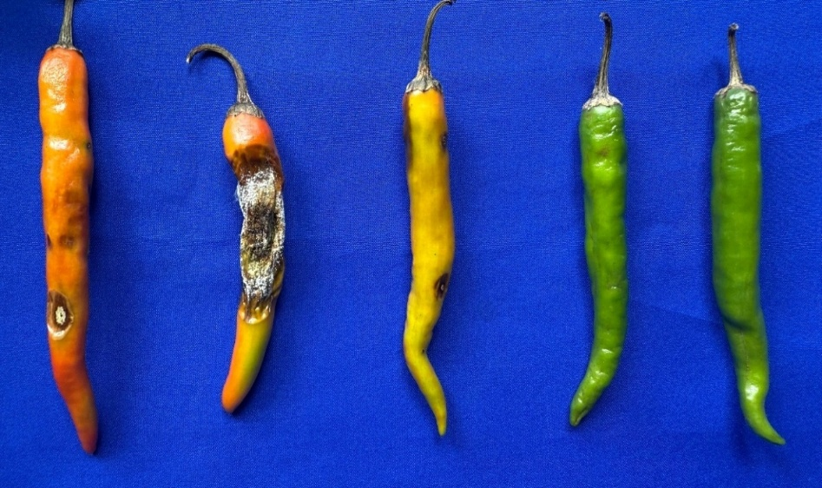

e

d

b

c

aa

**Fig. 4 Method of inoculation of *Colletotrichumtruncatum* for pathogenicity assay**

**a.** Pinprick with spore suspension inoculation **b.** Pinprick with mycelial disc inoculation **c.** Pinprick with

dip inoculation **d.** Spray inoculation **e.** Water Control

**Table I.** Different methods of inoculation of *Colletotrichum truncatum*

|  |  |  |
| --- | --- | --- |
| **Treatments** | **5×105 spore load** | |
| **Size of lesion (mm)** | **PDI (%)** |
| Pinprick with spore suspension inoculation (T1) | 15.00  (22.79) | 60.00 |
| Pinprick with mycelial disc inoculation (T2) | 20.00  (26.57) | 80.00 |
| Pinprick with dip inoculation (T3) | 11.00  (19.37) | 44.00 |
| Spray inoculation (T4) | 0.00 | 0.00 |
| Water control (T5) | 0.00 | 0.00 |
| **SED** | **0.36** | **-** |
| **CD (0.05)** | **0.76** | **-** |

**3.4 Isolation and cultural characters of endophytic bacteria**

A total of 80 bacterial endophytes were isolated from 10 solanaceous hosts and cultured in Nutrient Agar (NA) medium. The purified cultures showed different morphological characters such as, colony colour, texture and growth characters were studied. The morphological and cultural characters of 80 endophytic bacteria are present in Table 2🡪II.The result exhibited that most of the isolate produced white colonies with smooth irregular margin. Followed by, dusty white, greyish white, yellow to light white colour colonies also noticed. However, the colony texture of the many isolates varies from smooth slimy to rough growth were noticed with varied margin type. Likewise, Yang *et al*., (2011) reported the isolation of 72 bacterial endophytes from tomato plants, with a higher frequency of isolates from stem tissues compared to leaves. Their work emphasized the role of tissue type in influencing endophyte colonization, which may relate to internal microenvironment or nutrient accessibility. Sharma *et al*., (2021) found that the majority of bacterial endophytes isolated from tomato seeds were white or creamy in colour, with smooth or mucoid textures and margins that were entire or undulate, depending on the isolate.

**Table II.** Morphological characters of endophytic bacteria

|  |  |  |  |  |  |
| --- | --- | --- | --- | --- | --- |
| **S.No** | **Bacterial Isolate Code** | **Hosts** | **Colour** | **Growth** | **Characters** |
| 1. | EB01 | Ashwagandha (*Withaniasomnifera*) | Yellow | Slimy | Lobate |
| 2. | EB02 | Dusty white | Smooth | Filamentous |
| 3. | EB03 | Greyish white | Rough | Undulate |
| 4. | EB04 | White | Slimy | Entire (smooth) |
| 5. | EB05 | White | Rough | Irregular Undulate |
| 6. | EB06 | Light yellow | Slimy | Scalloped |
| 7. | EB07 | Greyish white | Slimy viscous | Serrated margin |
| 8. | EB08 | Dusty white | Rough | Entire (irregular) |
| 9. | EB09 | White | Slimy | Entire (smooth) |
| 10. | EB10 | Turkey berry/ Sundakkai (*Solanum torvum*) | Dark brown to red | Rough | Serrated margin |
| 11. | EB11 | White | Smooth | Filiform |
| 12. | EB12 | White | Slimy | Filiform |
| 13. | EB13 | White | Smooth, slimy | Entire (smooth) |
| 14. | EB14 | Greyish white | Rough, slimy | Lobate |
| 15. | EB15 | Tropical soda apple/ Mullukathiri (*Solanum viarum*) | White | Smooth | Filiform |
| 16. | EB16 | White | Slimy | Entire (smooth) |
| 17. | EB17 | White | Smooth | Entire (smooth) |
| 18. | EB18 | Light yellow | Rough | Serrated margin |
| 19. | EB19 | Dusty white | Rough | Entire (smooth) |
| 20. | EB20 | White | Slimy | Round |
| 21. | EB21 | Yellow night shade/ Kandankathiri (*Solanum xanthocarpum*) | White | Smooth | Entire |
| 22. | EB22 | White | Slimy | Entire |
| 23. | EB23 | White | Smooth | Round |
| 24. | EB24 | Black night shade/ Manathakkali (*Solanum nigrum*) | White | Smooth | Entire (smooth) |
| 25. | EB25 | white | Rough | Serrated margin |
| 26. | EB26 | White | Slimy | Entire (smooth) |
| 27. | EB27 | Dusty white | Smooth | Filiform |
| 28. | EB28 | White | Smooth | Lobate |
| 29. | EB29 | White | Slimy | Lobate |
| 30. | EB30 | White | Smooth | Round |
| 31. | EB31 | Thuthuvalai (*Solanum tribolatum*) | Dusty white | Rough | Serrated margin |
| 32. | EB32 | White | Smooth | Entire (smooth) |
| 33. | EB33 | White | Rough | Undulate |
| 34. | EB34 | Dusty white | Smooth | Round, Filiform |
| 35. | EB35 | White | Smooth | Undulate |
| 36. | EB36 | Datura (*Datura metel*) | White | Smooth | Round |
| 37. | EB37 | White | Slimy | Round |
| 38. | EB38 | White | Smooth | Round |
| 39. | EB39 | White | Rough | Serrated margin |
| 40. | EB40 | White | Smooth, Slimy | Entire (smooth) |
| 41. | EB41 | White | Smooth | Undulate |
| 42. | EB42 | White | Slimy | Entire (smooth) |
| 43. | EB43 | White | Smooth | Round |
| 44. | EB44 | White | Rough | Undulate |
| 45. | EB45 | White | Smooth | Undulate |
| 46. | EB46 | White | Rough | Undulate |
| 47. | EB47 | White | Rough | Serrated margin |
| 48. | EB48 | White | Slimy | Filiform |
| 49. | EB49 | Chilli (*Capsicum annum*) | Greyish white | Smooth | Filiform |
| 50. | EB50 | Dusty white | Smooth | Round |
| 51. | EB51 | Yellow | Slimy | Lobate |
| 52. | EB52 | Greyish white | Rough | Serrated margin |
| 53. | EB53 | White | Smooth | Undulate |
| 54. | EB54 | White | Smooth | Round |
| 55. | EB55 | Dusty white | Rough, slimy | Serrated margin |
| 56. | EB56 | White | Slimy | Entire (smooth) |
| 57. | EB57 | Yellow to white | Slimy | Undulate |
| 58. | EB58 | Light yellow | Smooth | Entire (irregular) |
| 59. | EB59 | White | Smooth | Entire |
| 60. | EB60 | Tomato (*Solanum lycopersicum*) | White | Rough | Curled |
| 61. | EB61 | White | Smooth | Round |
| 62. | EB62 | White | Rough | Round, lobate |
| 63. | EB63 | Yellow | Slimy | Entire (smooth) |
| 64. | EB64 | Dusty white | Smooth | Lobate |
| 65. | EB65 | White | Smooth | Undulate |
| 66. | EB66 | White | Smooth | Round |
| 67. | EB67 | Light yellow | Slimy | Entire (smooth) |
| 68. | EB68 | Brinjal (*Solanum melongena*) | White | Rough | Lobate |
| 69. | EB69 | White | Rough | Filiform |
| 70. | EB70 | White | Slimy | Entire (smooth) |
| 71. | EB71 | White | Smooth | Filiform |
| 72. | EB72 | White | Smooth | Round |
| 73. | EB73 | White | Slimy | Lobate |
| 74. | EB74 | White | Slimy | Filiform |
| 75. | EB75 | White | Smooth | Filiform |
| 76. | EB76 | White | Rough | Lobate |
| 77. | EB77 | Greyish white | Slimy | Round |
| 78. | EB78 | White | Rough | Undulate |
| 79. | EB79 | White | Rough | Entire (irregular) |
| 80. | EB80 | White | Slimy | Entire, undulate |

**3.5 Preliminary screening of endophytic bacteria**

The preliminary screening was done for 80 endophytic bacteria against *Colletotrichum truncatum*by streak plate method (Figure 5). The result exhibited that the 20 bacterial isolates showed strong antagonistic activity against *C. truncatum.*

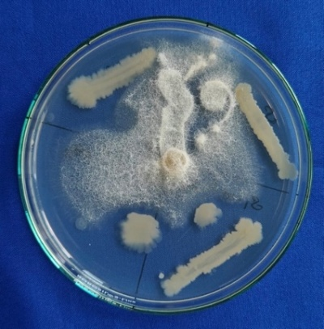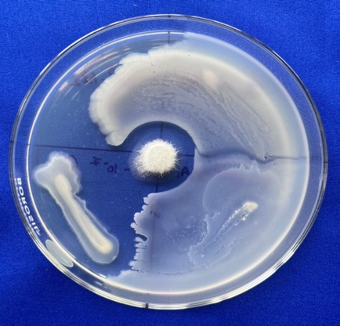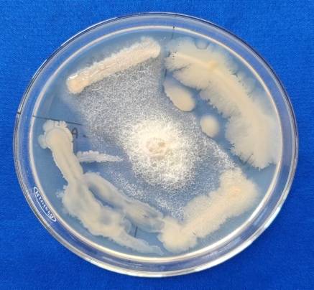

**EB01, EB05, EB06, EB07 EB02,EB09,EB04,EB03EB08,EB11,EB10,EB13**

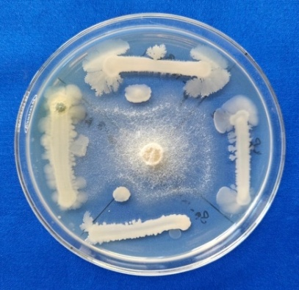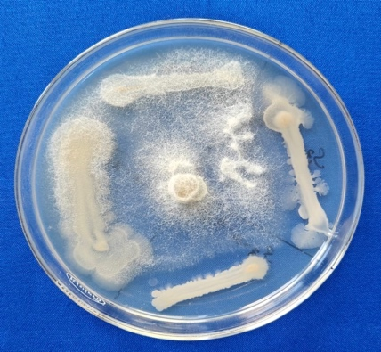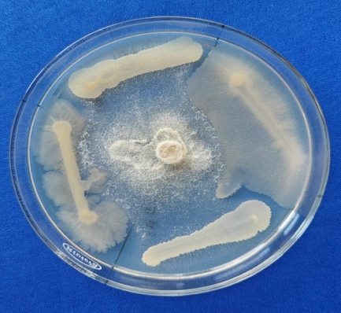

**EB12, EB14, EB17, EB15 EB18,EB16,EB19,EB20 EB22,EB23,EB21,EB24**

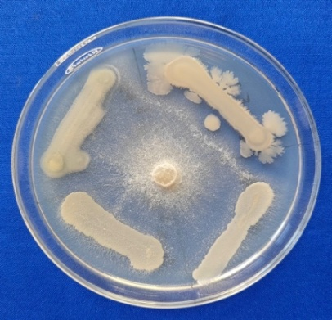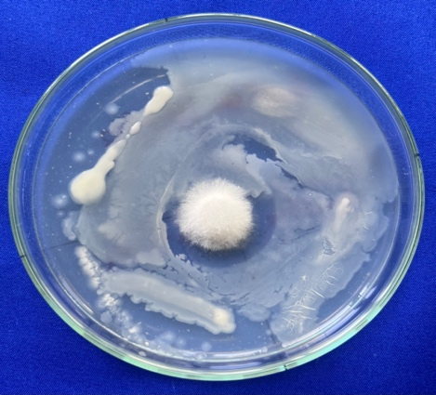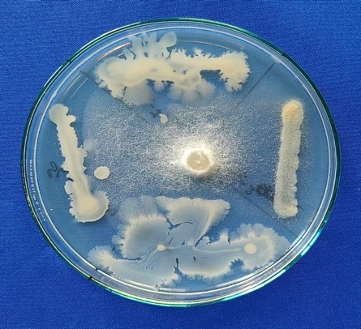

**EB29, EB25, EB27, EB30EB28,EB26,EB33,EB35EB32, EB31, EB34, EB59**

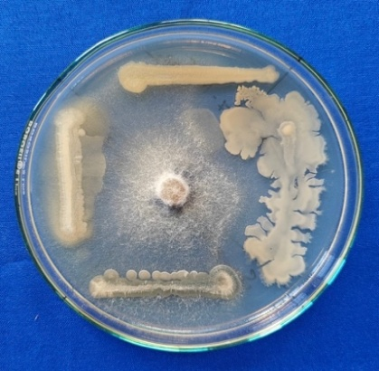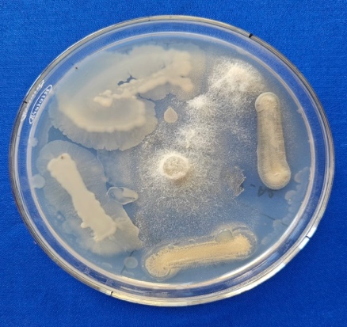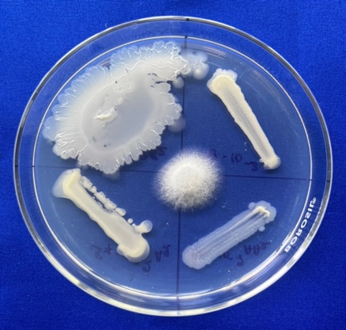

**EB50, EB51, EB52, EB53 EB54,EB55,EB57,EB58EB49,EB56,EB62,EB64**

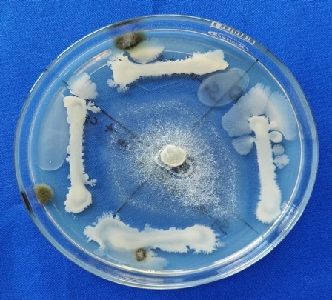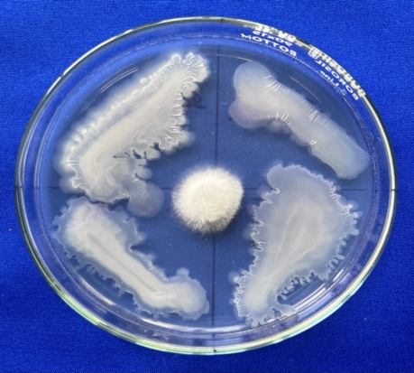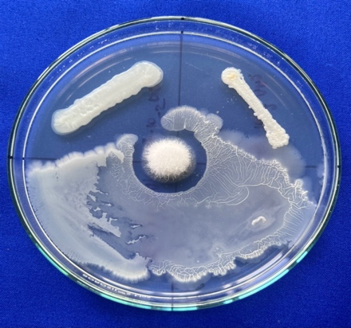

**EB61, EB65, EB67, EB60 EB63,EB66,EB73,EB80EB79,EB75,EB77,EB68**

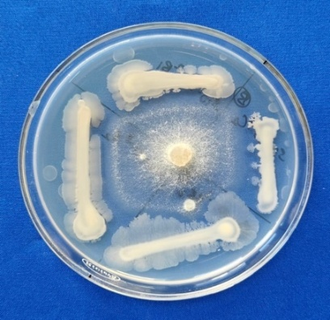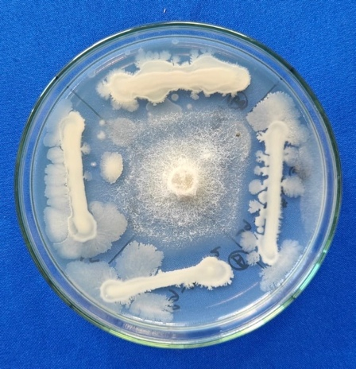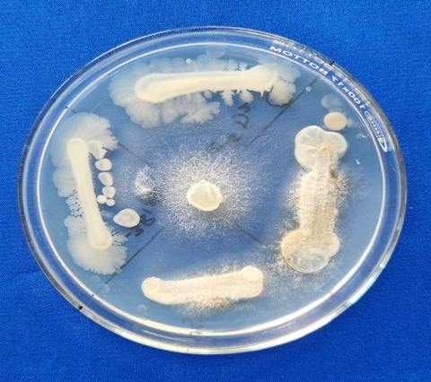

**EB78, EB76, EB69, EB70 EB74,EB71,EB72,EB37EB38,EB44,EB42,EB45**

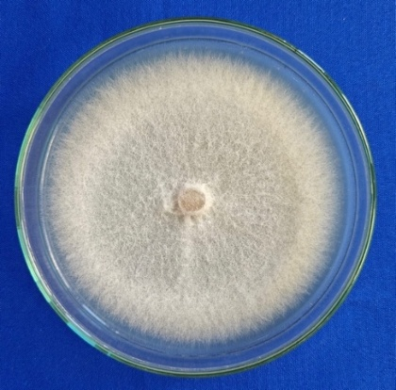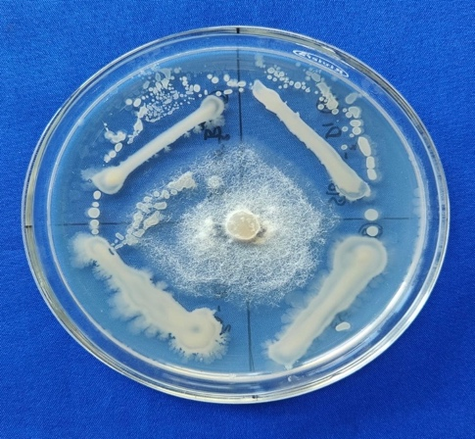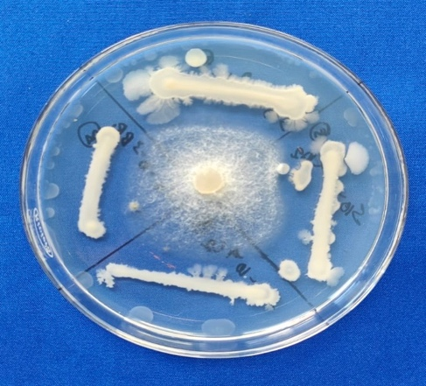

**EB36, EB47, EB46, EB48 EB40,EB43,EB39,EB41 CONTROL**

**Fig. 5 Preliminary screening of endophytic bacteria**

**3.6 Effect of endophytic bacteria against *Colletotrichum truncatum*under *in vitro* conditions**

**3.6.1 Dual Plate Assay**

Twenty endophytic bacterial isolates were tested for their antagonistic activity against *Colletotrichum truncatum* by dual plate assay. The result revealed that the isolate EB38 exhibited the highest mycelial growth inhibition (48.88 per cent), reflecting strong antagonistic potential. This was followed by EB40, EB22, EB01, EB47 and EB75, each showing the mycelial inhibition of 44.81 and 44.07 per cent respectively. The isolates, notably EB08, EB32, EB74 and EB53, showed moderate antagonistic activity with mycelial inhibition of 41.00 to 43.00 per cent. The lowest mycelial growth inhibition was recorded in the isolates of EB49 and EB80 (Figure 6 and Table 3). Moreover, these variations showed differential ability of bacterial endophytes to produce antifungal metabolites, which might be responsible for suppressing the mycelial growth of *C. truncatum*. According to Renjini and Sreeja (2024), the rhizospheric*Bacillus*spp effectively suppressed the mycelial growth of *Colletotrichum*sp through the production of bioactive compounds such as lipopeptides, hydrolytic enzymes and secondary metabolites that disrupt the fungal cell wall integrity. Although *Bacillus subtilis* AKP appeared as a potential antagonist and inhibited the mycelial growth of *C. capsici.* Also, observed the hyphal disintegration, shrunken mycelium with terminal bulging, indicating the cellular degradation of *C. capsici* (Kumar *et al.,* 2021).

|  |  |  |  |
| --- | --- | --- | --- |
| **EB01** | **EB02** | **EB08** | **EB12** |
| **EB17** | **EB18** | **EB22** | **EB29** |
| **EB32** | **EB38** | **EB40** | **EB47** |
| **EB49** | **EB50** | **EB53** | **EB65** |
|  |  |  |  |
| **EB74** | **EB75** | **EB78** | **EB80** |
| **CONTROL** | | | |

**Fig. 6** Antagonistic activity of bacterial endophytes against *Colletotrichum truncatum* by dual plate assay

**Table ~~3~~.-->III** Screening the selected endophytic bacteria against *C. truncatum*by dual plate method

|  |  |  |
| --- | --- | --- |
| **Treatment** | **Average radial mycelial growth (mm)** | **Per cent inhibition** |
| EB01 | 50.33a  (45.19) | 44.07 |
| EB02 | 53.33a  (46.91) | 40.74 |
| EB08 | 52.33a  (46.33) | 41.85 |
| EB12 | 54.00a  (47.29) | 40.00 |
| EB17 | 56.67a  (48.83) | 37.03 |
| EB18 | 58.33a  (49.79) | 35.18 |
| EB22 | 49.67a  (44.81) | 44.81 |
| EB29 | 55.00a  (47.87) | 38.88 |
| EB32 | 51.67a  (45.95) | 42.58 |
| EB38 | 46.00a  (42.70) | 48.88 |
| EB40 | 49.67a  (44.81) | 44.81 |
| EB47 | 50.33a  (45.19) | 44.07 |
| EB49 | 59.67a  (50.57) | 33.70 |
| EB50 | 55.00a  (47.87) | 38.88 |
| EB53 | 52.00a  (46.15) | 42.22 |
| EB65 | 58.33a  (49.79) | 35.18 |
| EB74 | 51.67a  (45.95) | 42.58 |
| EB75 | 50.33a  (45.19) | 44.07 |
| EB78 | 52.33a  (46.34) | 41.85 |
| EB80 | 58.67a  (49.99) | 34.81 |
| Control | 90.00b  (71.56) | 0 |
| **SED** | **4.14** | **-** |
| **CD (0.05)** | **8.71** | **-** |

**3.6.2 Paper Disc Assay**

The ten most effective endophytic bacterial isolates selected from the dual culture assay were further tested for their antifungal activity against *Colletotrichum truncatum*by paper disc assay. The result showed that EB22 recorded the highest mycelial growth inhibition (81.44%) and produced a 12.33 mm zone of inhibition, followed by EB47 (78.52%, 14 mm) and EB01 (77.41%, 12 mm), showing strong antifungal potential. The other cultures show less inhibition zone and mycelial growth, although some showed moderate mycelial suppression, indicating variability in metabolite production or diffusibility (Table 4). Narayan Chandra Paul *et al.,* (2023) also demonstrated that *Bacillus* and *Burkholderia* species could suppress fungal growth through both diffusible and volatile bioactive compounds. Likewise, *Bacillus subtilis* isolates exhibited antifungal activity through the production of secondary metabolites like iturins and surfactins, which alter fungal membrane permeability Le Thanh *et al.* (2023). The results from strains EB22, EB47, and EB01 clearly demonstrate their strong potential as effective antagonists in combating chilli fruit rot. Further studies are necessary to perform the molecular characterization of endophytic bacteria and to examine their interactions with pathogens. These investigations will provide valuable insights into the mechanisms underlying these relationships and their potential applications in disease management.

**Table ~~4~~.-->IV** Screening the effective endophytic bacterial isolates against *C.truncatum* by paper disc assay

|  |  |  |  |
| --- | --- | --- | --- |
| **Treatments** | **Average radial mycelial growth (mm)** | **Zone of inhibition (mm)** | **Per cent inhibition** |
| EB01 | 20.33a  (26.80) | 12.00  (20.27) | 77.41 |
| EB08 | 30.00abc  (33.21) | 6.00  (14.18) | 66.66 |
| EB22 | 19.67a  (26.33) | 12.33  (20.56) | 81.44 |
| EB32 | 33.33bc  (35.26) | 0.00 | 62.96 |
| EB38 | 40.00cd  (39.23) | 0.00 | 55.55 |
| EB40 | 33.33bc  (35.26) | 9.33  (17.79) | 62.96 |
| EB47 | 19.33a  (26.08) | 14.00  (21.97) | 78.52 |
| EB53 | 50.33de  (45.19) | 0.00 | 40.07 |
| EB74 | 52.00e  (46.15) | 0.00 | 42.22 |
| EB75 | 26.67ab  (31.09) | 13.00  (21.13) | 70.36 |
| Control | 90.00f  (71.57) | 90.00  (71.57) | 0.00 |
| **SED** | **2.91** | **1.53** | **-** |
| **CD (0.05)** | **6.11** | **3.21** | **-** |

**3. 7Molecular characterization of potential endophytic bacteria**

The potential bacterial isolates were subjected to molecular characterization by using 16S rRNA forward and reverse primers. The PCR products showed the amplicon size of ~1200 bp (Figure 7). ~~Which🡪~~This was then partially sequenced and analyzed using BLAST in the NCBI database. The result revealed that the EB01 isolated from *Withaniasomnifera*showed 87.66% similarity with *Stenotrophomonas* sp. and EB22 isolated from *Solanum xanthocarpum* showed 88.47% similarity with *Bacillus subtilis* followed by EB47 isolated from *Datura metel* showed 92.44% similarity with *Brevundimonasdiminuta*. Similar findings were reported that endophytic bacterium isolated from seed extract of *Withaniasomnifera* (Ashwagandha) was identified as *Pseudomonas stutzeri* through 16S rRNA gene sequencing with PCR amplicon (~1500 bp) showed 99% similarity with *P. stutzeri* (KJ197178) in BLAST analysis. However, the *P. stutzeri* have its biocontrol potential against *Rhizoctoniasolani* and *Fusarium oxysporum* (Kumar *et al.*, 2022). The present findings suggested the endophytic bacteria isolated from *Withaniasomnifera, Solanum xanthocarpum*and *Datura metel*showed strong antagonistic activity against *C. truncatum.*

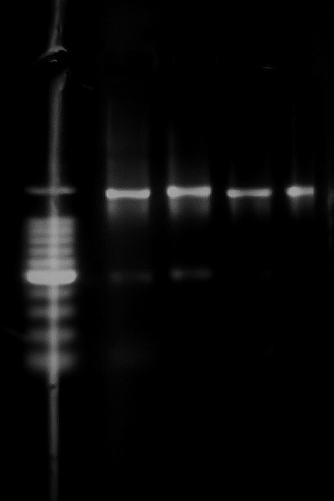

**~1200 bp**

**Fig. 7** Molecular characterization of potential endophytic bacteria

**4. CONCLUSION**

The present study showed the potential of root-associated endophytic bacterial isolates from solanaceous crops in mitigating fruit rot disease in chilli, incited by *Colletotrichum truncatum*. Of the twenty isolates screened, multiple strains exhibited considerable antagonistic and antifungal activity against *C. truncatum*, as determined by dual plate and paper disc assays. Notably, *Bacillus subtilis* (EB22),*Brevundimonasdiminuta*(EB47)and *Stenotrophomonas sp* (EB01) showed significant antifungal efficacy, indicating their potential as effective biocontrol agents. These results advocate for the integration of endophytic bacterial agents into sustainable disease management for chilli cultivation.

**REFERENCES**

1. Banya, M., Garg, S., & Meena, N. L. (2020). A review: Chilli anthracnose, its spread and management. Journal of Pharmacognosy and Phytochemistry, 9(4), 1432–1438.
2. Carmona-Hernandez, S., Reyes-Pérez, J. J., Chiquito-Contreras, R. G., Rincon-Enriquez, G., Cerdan-Cabrera, C. R., & Hernandez-Montiel, L. G. (2019). Biocontrol of postharvest fruit fungal diseases by bacterial antagonists: A review. Agronomy, 9(3), 121.
3. Chowdary, V. R., Rani, P. U., & Sreedhar, A. (2024). Evaluation of endophytic Bacillus strains for antifungal activity against Colletotrichum in chilli. Biological Control, 191, 105622. <https://doi.org/10.1016/j.biocontrol.2023.105622>
4. Dennis, C., & Webster, J. (1971). Antagonistic properties of species-groups of Trichoderma: I. Production of non-volatile antibiotics. Transactions of the British Mycological Society, 57(1), 25–IN3.
5. Fadiji, A. E., & Babalola, O. O. (2020). Exploring the potentialities of beneficial endophytes for improved plant growt h. Saudi Journal of Biological Sciences, 27(12), 3622–3633.
6. Feng, H., Li, Y., & Liu, Q. (2013). Endophytic bacterial communities in tomato plants with differential resistance to Ralstonia solanacearum. African Journal of Microbiology Research, 7(15), 1311–1318.
7. Joshi, R., Sinha, P., & Sharma, K. (2023). Isolation and characterization of Colletotrichum capsici causing anthracnose in chilli. Journal of Applied Biology and Biotechnology, 11(1), 55–61. <https://doi.org/10.7324/JABB.2023.110108>
8. Kumar, A., Kumar, S. J., Chintagunta, A. D., Agarwal, D. K., Pal, G., Singh, A. N., & Simal-Gandara, J. (2022). Biocontrol potential of Pseudomonas stutzeri endophyte from Withaniasomnifera (Ashwagandha) seed extract against pathogenic Fusarium oxysporum and Rhizoctoniasolani. Archives of Phytopathology and Plant Protection, 55(1), 1-18.
9. Kumar, A., Rabha, J., & Jha, D. K. (2021). Antagonistic activity of lipopeptide-biosurfactant producing Bacillus subtilis AKP against Colletotrichum capsici, the causal organism of anthracnose disease of chilli. Biocatalysis and Agricultural Biotechnology, 36, 102133.
10. Le Thanh, D., *et al.,* (2023). Potential of Bacillus subtilis strains in biocontrol of Colletotrichum spp. infecting chilli. Frontiers in Microbiology, 14, Article 1123761. <https://doi.org/10.3389/fmicb.2023.1123761>
11. Leonardo-Silva, L., Silva, L. B. D., Ferreira, E. P. D. B., Reis, K. F. D., Naves, P. L., & Martin-Didonet, C. C. (2023). Assessment of morphophysiological and genotypic diversity of endophytic bacteria isolated from rice (Oryza sativa L.) plants. Revista Caatinga, 36(4), 775–784.
12. Murray, M. G., & Thompson, W. (1980). Rapid isolation of high molecular weight plant DNA. Nucleic Acids Research, 8(19), 4321–4326.
13. Paul, N. C., *et al.,* (2023). Biocontrol potential of Bacillus and Burkholderia spp. against fungal pathogens. Microorganisms, 11(8), Article 2021. <https://doi.org/10.3390/microorganisms11082021>
14. Pavithra, G., Manda, R. R., Addanki, V. A., & Srivastava, S. (2021). Evaluation of isolated endophytes, bio-agents and fungicides against anthracnose of chilli. Biopesticides International, 17(2).
15. Prajapati, M., *et al.,* (2020). Morphological and molecular identification of Colletotrichum capsici causing fruit rot in chilli. Plant Pathology Journal, 36(3), 210–218. <https://doi.org/10.5423/PPJ.OA.01.2020.0002>
16. Raj, T. S., Christopher, D. J., & Suji, H. A. (2013). Evaluation of virulence and methods of inoculation of Colletotrichum capsici (SYD.) Butler and Bisby.
17. Rajani, P., Rajasekaran, C., Vasanthakumari, M. M., Olsson, S. B., Ravikanth, G., &Shaanker, R. U. (2021). Inhibition of plant pathogenic fungi by endophytic Trichoderma spp. through mycoparasitism and volatile organic compounds. Microbiological Research, 242, 126595.
18. Renjini, P. R., & Sreeja, R. (2024). Biocontrol potential of endophytic and rhizosphericBacillus isolates against chilli anthracnose. Journal of Biological Control, 38(1), 42–48. <https://doi.org/10.18311/jbc/2024/32100>
19. Salunkhe, P. S., Khadtare, R. M., Karade, V. M., Nalawade, S. V., & Mulik, S. P. Isolation, purification and morpho-cultural characteristics of Colletotrichum capsici causing anthracnose of chilli. (Missing publication details—please add journal, year, volume, etc.)
20. Sangdee, A., Sachan, S., & Khankhum, S. (2011). Morphological, pathological and molecular variability of Colletotrichum capsici causing anthracnose of chilli in the North-east of Thailand. African Journal of Microbiology Research, 5(25), 4368–4372.
21. Saxena, A., Raghuwanshi, R., Gupta, V. K., & Singh, H. B. (2016). Chilli anthracnose: The epidemiology and management. Frontiers in Microbiology, 7, 1527.
22. Selvakumar, G., & Kumar, R. S. (2021). Variability among isolates of Colletotrichum capsici from chilli in Tamil Nadu. Journal of Mycology and Plant Pathology, 51(2), 189–194.
23. Sharma, R., Meena, M., & Swapnil, P. (2021). Isolation and characterization of endophytic bacteria from tomato (Solanum lycopersicum L.) seeds. Journal of Pharmacognosy and Phytochemistry, 10(2), 739–744.
24. Srideepthi, R., Lakshmisahitya, U., Peddakasim, D., Suneetha, P., & Krishna, M. S. R. (2017). Morphological, pathological and molecular diversity of Colletotrichum capsici inciting fruit rot in chilli (Capsicum annuum L.). Research Journal of Biotechnology, 12, 14–21.
25. Thomas, P., & Upreti, R. (2014). Testing of bacterial endophytes from non-host sources as potential antagonistic agents against tomato wilt pathogen Ralstonia solanacearum. Advances in Microbiology, 4(10), 656–666.
26. Thomas, R., *et al.,* (2021). Comparative efficacy of inoculation methods for Colletotrichum in chilli. Journal of Mycopathological Research, 59(2), 123–128.
27. Vanitha, S. C., Niranjana, S. R., Mortensen, C. N., & Umesha, S. (2009). Bacterial wilt of tomato in Karnataka and its management by Pseudomonas fluorescens. Biocontrol, 54(5), 685–695.
28. Varghese, A., & George, J. (2022). Standardizing artificial inoculation techniques for anthracnose in chilli. Indian Phytopathology, 75(1), 65–70. <https://doi.org/10.1007/s42360-021-00395-6>
29. Vincent, J. M. (1927). Distortion of fungal hyphae in the presence of certain inhibitors. Nature, 59, 850.
30. Woźniak, M., et al. (2023). Genomic insight into host-specific adaptation and diversity of phytopathogenic fungi. Mycological Progress, 22(4), 322–334. <https://doi.org/10.1007/s11557-023-01899-y>
31. Yadav, G., Srivastva, R., & Gupta, P. (2021). Endophytes and their applications as biofertilizers. In Microbial Technology for Sustainable Environment (pp. 95–123). Springer.
32. Yang, J., Kloepper, J.W., & Ryu, C.M. (2011). Rhizosphere bacteria help plants tolerate abiotic stress. Trends in Plant Science, 14(1), 1–4. https://doi.org/10.1016/j.tplants.2008.10.004