Opinion article

Yellowing Disease in Canine and its Different Treatment Modalities

Abstract

The yellowing of the gums, skin and eyes is known as jaundice. Liver disease is frequently linked to jaundice. When bilirubin levels in the blood exceed 3mg/dL then jaundice manifests clinically as scleral icterus. The other symptoms of jaundice include anemia, fever, diarrhea, vomiting, weight loss, thirstiness, inappetence, seizures, weakness, and tachycardia. Treatment includes administration of acetyl cysteine, vitamins E and K and ursodiol are frequently utilized. Supportive care is provided with intravenous fluids, antibiotics, painkillers, appetite stimulants, antacids, anti-nausea drugs. In this script we are discussing the different remedies including herbal. The importance of inclusion of minerals, sea buckthorn, milk thistle, curcumin, zeolite and artichokes in diets for the effective control of jaundice is also narrated. The opinion expressed in this script is based on latest literature in this field.
Keyword: - Blood transfusion; Clinical signs; Dog; Herbal treatment; Jaundice; Pathogenesis; Plants; Treatment
- INTRODUCTION
The yellowing of the gums, skin, and eyes is known as jaundice or icterus. The excessive accumulation of bilirubin in the body causes the yellowing. The breakdown of red blood cells and the decreased body elimination of these cells results in Hyperbilirubinemia. Liver disease is frequently linked to jaundice and it can be lethal. Jaundice can result from any illness that impairs the liver and causes the RBCs to degenerate quickly (Joseph and Samant, 2019). Normal bilirubin levels in the blood are less than 1 mg/dL, and when the levels exceed 3mg/dL then jaundice manifests clinically as scleral icterus. The high elastin concentration of sclera gives a strong affinity for bilirubin. Especially in long standing cases the skin will gradually turn from lemon yellow to apple green as serum bilirubin levels raise and biliverdin is the cause of the green colour (Leung et al., 2019).
- AETIOLOGY (Londoño and Schaer, 2018)
picture 1- Three kinds of Jaundice
Haemolytic
1

2
Hepatocelluar
Obstructive
3

2.1 Haemolytic Jaundice (Pre-hepatic/over production jaundice):- Haemoprotozoan infections, bacterial and viral illnesses, inorganic and organic toxins, plant toxins, and immunological responses can cause haemolytic jaundice. Anaplasmosis, leptospirosis, babesiosis, bacillary haemoglobinuria, infectious anaemia, chronic copper (Cu) poisoning, selenium (Se) toxicity, and over consumption of brassica (Brassica oleracea) or berseem (Trifolium alexandrium) plants are among the conditions that can cause jaundice. Zinc (Zn) toxicosis, hemoparasites like Babesia and Haemobartonella, antibody-mediated RBC destruction, chemicals, toxins like snake venom, and intrinsic inherited erythrocyte abnormalities are other causes of haemolytic anaemia. Pre-hepatic jaundice in dogs, especially in female dogs, can be caused by immune-mediated haemolytic anaemia (IMHA) (Elone et al., 2022). Auto immune haemolytic anaemia accounted for 60 to 75 per cent of jaundice cases in dogs. Serum bilirubin will be rarely elevated above 3 mg/dL in the early stages of pre-hepatic jaundice, and values higher than 3 mg/dL suggested concomitant hepatic illness too. When haemolysis-induced bilirubin overproduction was the main anomaly, icterus was classified as pre-hepatic (Puca et al., 2020).
2.2 Hepatocellular Jaundice (Intrahepatic):- Abnormal hepatic bilirubin absorption, conjugation, or secretion was the intrahepatic causes of hyperbilirubinemia. Hepatic jaundice is a combination of conjugated and unconjugated hyperbilirubinaemia. Impaired bilirubin release from injured hepatocytes or impaired bile flow through bile canaliculi as a result of hepatocyte swelling, inflammation, or fibrosis cause the rise in conjugated bilirubin. The concurrent reduction of hepatic uptake and conjugation, or the deconjugation of conjugated bilirubin by lysosomal enzymes released from injured hepatocytes or by inflammatory cells invading the live, were the causes of the increase in unconjugated bilirubin (Memon et al., 2016).
2.3 Obstructive Jaundice (post-hepatic/extrahepatic):- The obstruction of the bile duct is caused by biliary calculi, nematodes like Ascaris lumbricoides, or trematodes like Fasciola hepatica infections are common causes of bile duct obstruction. Post-hepatic hyperbilirubinemia was brought on by extra hepatic biliary obstruction. Conjugated hyperbilirubinemia was the outcome of conjugated bilirubin regurgitating into the systemic circulation.Due to the deconjugation of bilirubin by inflammatory cell and damaged hepatocyte lysosomal enzymes, concurrent unconjugated hyperbilirubinemia also developed later with post-hepatic jaundice. Some reports say that smooth muscle tumor of the duodenum can lead to post-hepatic icterus and bile duct obstruction. Biliary flow mechanical stagnation can be caused by fibrosed tissue (Ishikawa et al., 2016).
3. PATHOGENESIS (Kalakonda et al., 2017)
Normally, erythrocytes are destroyed after life span (120 days) is ended, which causes the globin and hemoglobin moieties to separate and the hemoglobin to be converted into iron molecules and bilirubin. Bilirubin diglucuronide is created in the liver by conjugating with bilirubin. A certain quantity of bilirubin is also transferred to the kidneys. After being transformed to mesobilirubinogen and stercobilinogen, the conjugated bilirubin is oxidized to produce urobilin and stercobilin. A portion of this urobilin and stercobilin is reabsorbed, while the remainder is excreted in urine and faeces.
picture 2-Pathogenesis of haemolytic Jaundice
Greater amount of unconjugated or haemobilirubin
Haemolytic Jaundice
More Haemoglobin released
Haemolysis
Large amount of cholebilirubin in liver
Haemolytic Jaundice
Enlarged gall bladder
Large urobilinogen
Light yellow urine
Part reabsorbed by intestine
Large amount of stercobilinogen
Faeces intensively yellow

Picture 3-Pathogenesis of Hepatocellular Jaundice
Fatty Change
Hydropic degeneration
Hepatocellular Jaundice

Necrosis
Impair secretion
Impair Conjugation
Degenerating cell
Defect in Glucuronosyltransferase
Unconjugated bilirubin
Compress and block bile capillaries
Hepatic wall rupture
Bile into sinusoids
Bile excretion affected
Plasma contain both conjugated and unconjugated bilirubin
Conjugated bilirubin accumulate

Picture 4-Pathogenesis of Obstructive Jaundice
Obstruction of extrahepatic bile duct
Stasis of cholebilirubin
No bile enters intestine

Enter urine
Enter urine
Urobilinogen not formed
Malabsorption
Vitamin K
Clay colour faeces
Fat not emulsified
Bilirubin and bile
Acid in blood
Greasy faeces
Haemorrhage
Foul smelling faeces
Pruritis

4. CLINICAL SIGNS AND SYMPTOMS (Kearley et al., 2024)
The primary symptom of jaundice in dogs is the yellowing of mucous membranes (Fig. 1); and other symptoms include fever, diarrhea, vomiting, weight loss, thirstiness, inappetence, frequent urination, fatigue, stomach pain, and abdominal swelling, seizures, weakness, tachycardia, anemia, and tachypnea. Severe intravascular haemolysis can result in haemoglobinemia and haemoglobinuria, which is characterized by dark urine.
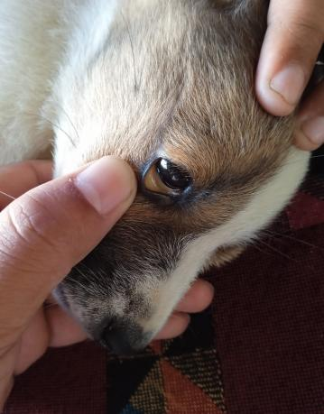 | 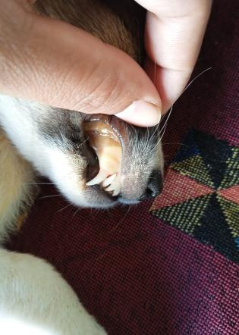 | 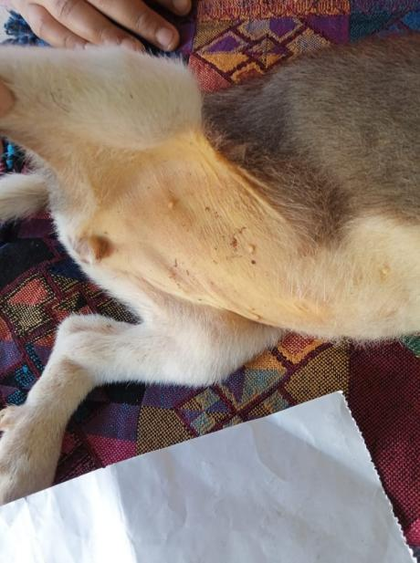
Fig.1. Yellowing of conjunctival and oral mucus membrane and abdominal skin in Dog
- DIAGNOSIS (Lala et al., 2023)
Picture 5- Diagnosis of jaundice in dogs
Total protein Albumin,
Serum bilirubin

History and Clinical signs
International Normalized Ratio
Liver function test
Kidney function test
Diagnosis
Alkaline phosphatase
Alanine transferase
Total Blood Count (CBC)
Gamma-Glutamyl Transferase
Ultrasonography, Radiograph
Analysis of Urine
Prothrombin Time

- DIFFERENT TREATMENT MODALITIES FOR JAUNDICE IN DOGS
Depending on the underlying reason, jaundice may be curable in dogs, and early intervention is essential for a full recovery.
- To treat liver and gallbladder disorders, acetylcysteine, vitamins E and K and ursodiol are frequently utilized. Additionally, supportive care may be provided this includes intravenous fluids, antibiotics, pain killers, appetite stimulants, antacids, anti-nausea drugs. Blood transfusions and long-term immunosuppression with steroids or other drugs like cyclosporine or azathioprine may be required when jaundice is caused by disorders that impact red blood cells. In cases of severe anemia, acute bleeding, coagulation problems, and thrombocytopenia, whole blood transfusions are highly helpful in replacing the lost blood components. Since many years ago, blood transfusions have been used to save the lives of animals in emergency situations. Richard Lower did the first successful animal blood transfusion in 1665, in which blood from one dog was extracted and infused to another dog.15 to 20 minutes prior to the start of the blood transfusion, injections of pheniramine maleate (0.5 mg/kg) and dexamethasone (0.25 mg/kg) were given. Blood was administered IV through cephalic vein via a blood administration set with a micro-pore filter to limit the chance of entry of micro thrombi into the general circulation. For the first 15 minutes, the transfusion rate was 0.25 mL/kg body weight to monitor for any negative reactions. After that, it was progressively raised to 2–10 mL/kg/hr. To reduce the chance of bacterial contamination, the transfusion was finished within four hours of the blood being drawn (Kumar et al., 2020).
- Dexamethasone (0.5mg/kg), doxycycline (10mg/kg IV), maropitant (1mg/kg SQ), famotidine (0.5 mg/kg IV), and balanced isotonic crystalloid intravenous fluids at 84 mL/kg/day are used to treat IMHA (Tovar et al., 2017).
- Alternative remedies for liver disease include herbal remedies and supplementation of minerals, sea buckthorn (Hippophae rhamnoides L), silymarin/milk thistle (Silybum marianum), curcumin (Curcuma longa), zeolite (aluminosilicate) and artichokes (Cynara cardunculus var. scolymus).The herbal and mineral preparations have various antioxidants, and therapeutically these are hepato-protective effective in management of different liver disorders in cats and dogs (Brăteanu et al., 2018).
- Chronic hepatitis is treated by removing Cu from the liver and limiting it in the diet. Cu-restricted diets that give less than 0.12 mg/100 kcal of Cu are advised. The Cu chelator D-penicillamine (D-Pen) binds to hepatic Cu then removed it through urine. D-Pen has modest anti-inflammatory and anti-fibrotic effects and raises metallothionein in hepatocytes (which detoxifies intracellular Cu) and enterocytes (which facilitates fecal excretion). Due to the significant reduction in bio availability by food, D-penicillamine is administered PO on an empty stomach. Within six months, D-pen and dietary Cu restriction normalize hepatic Cu concentrations as high as 1500 mcg/g dry weight. S-adenosylmethionine is a metabolite which is an essential nutrient for hepatic decarboxylation reactions, transsulfuration and transmethylation (Webster et al., 2019).
- Dogs with chronic liver disease treated with intravenous Dextrose 10% @ 10-15 mL/Kg body weight daily for 5 days, amino acid liquid at 5 mL BID for 30 days, Tab Frusemide-Spironolactone at 0.5 mg/Kg body weight daily for 14 days and Cap. Amoxicillin at 10 mg/Kg body weight TID for 7 days, followed by liver tonics orally for 30 days. Pigeon pea, congo pea, toor dal, or Arahar dal are other names for Cajanus cajan (Fig. 3), which possesses preventive properties against liver damage. Cajanus cajan leaf methanol extract can be given at the rate of 100 mg/kg body weight (Bera and Lodh, 2019).
- The pup diagnosed with Ehrlichia canis related jaundice was given injections of Doxycycline (2.5 mg/kg IV) and Ferritas (5 mg/kg IM) every day for a week with fluid therapy. In addition to N-acetyl cystine (30 mg/kg body weight IV), prednisolone (0.5 mg/kg body weight IM), pantoprazole (0.5 mg/kg body weight IV), and furosemide (4 mg/kg body weight IM) were given (Raguvaran et al., 2020).
- Dogs with extra hepatic biliary obstruction (EHBO) from canine adenocarcinoma were regularly monitored for vital signs and fluid therapy was given. Cephradine (30 mg/kg, IV BID or TID), enrofloxacine (10 mg/kg, IM, SID), atropine, and tramadol (2–3 mg/kg IV BID or TID) were given. In addition to these, hepato-protectants (taurine 10 mg/KgIV), gastrointestinal protective agents (cimetidine), and iron dextran (5–10 mg/kg) were given to treat anaemia (Rahman, 2017).
- The broad-spectrum antibiotic Amoxicillin @10 mg/kg BID for seven days is used as supportive therapy for chronic hepatitis in dogs in order to check for secondary bacterial infections. 200 mL of an isotonic solution sodium chloride 0.9% is administered intravenously SID for 7days as part of fluid therapy to address electrolyte imbalance and dehydration while encouraging the excretion of toxins. Three days apart, 25 mcg/kg of cytocobalamin, often known as vitamin B12, was injected subcutaneously to promote metabolism and treat anemia. For 7 days, one tablet of betacarotene, vitamin C and vitamin E was given daily to stop oxidative damage. To treat anemia, a haematinic mixture was given at a rate of 2 mL/day BID, for 15 days. As a hepato-protective medication, used 20–50 mg/kg of silymarin PO, BID for 1 month (Uddin, 2019).
- Fluid therapy for hepatic disorders in dogs should include 10% dextrose based on the degree of dehydration, antibiotics Amoxicillin and Clavulanic acid @ 22 mg/kg PO for 7-14 days, amino acid supplements as needed and diuretics (furosemide ＋ spiranolactone) @ 2 mg/kg every 12 hours as needed. In addition to Inj. B-complex, Phyllanthus niruri (Fig. 4) extract @150 mg/kg PO for 3 weeks and vitamin B12 with liver extract @ 1 mL/day IM. Antiemetics such as Ondansetron (0.5 mg/kg) and cytoprotectants like Sucralfate (1g TID) are used (Sameeksha, 2021).
- A herbal solution containing pomegranate peel extract and Curcuma longa (Fig. 2) extract as hepato-protective were used in the treatment of fatty liver in dogs and it was found effective (Khalphallah et al., 2025).
- Silymarin has been used for centuries as a herbal remedy to treat conditions relating to the liver. In addition to its detoxifying properties, milk thistle has potent anti-inflammatory and antioxidant properties that support hepatic regeneration and cellular repair. As a supplemental food with hepato-protective properties, milk thistle is taken.In dogs with hepatic origin ascites, silymarin @50 mg/kg b.wt. combined with supportive care was more effective in treating the condition (Tara et al., 2020).
- The leaf of green chiretta (Andrographis paniculata) (Fig. 7) has shown strong hepato-protective properties against hepatitis and jaundice. Punarnava (Boerhavia diffusa) (Fig. 6) roots are used traditionally used to treat a variety of liver issues. Numerous pharmacological properties, including hepatoprotective, anticholestatic, antioxidant, and immune-modulating activity have been documented by recent research studies on kutki (Picrorhiza kurroa). In Ayurvedic medicine, Sarapunkha (Tephrosia purpurea), is used to treat diabetes mellitus and it is help to kidney, spleen, and liver problems. The root of Nirmulli or Gokulakanta (Hydrophila auriculata), contains an alkaloid called hygrosterol which is high in antioxidants and is used as diuretic and as a liver tonic. The pharmacological characteristics include anticancer, bactericidal, hepato-protective and anti- diabetic effects.The hepato-protective action of ethyl acetate extract of Malabar nut (Adhatoda vasica) (Fig. 5) (100 mg/kg) is documented (Shakya, 2020).
- The 600 mg capsules of heart-leaved moonseed (Tinospora cordifolia) extract were recommended to give BID and in addition to supportive and complementary therapies as a hepato-protective strategy (Jeena, 2025).
- The dried form of senna leaves (Cassia acutifolia/Cassia angustifolia) or pods help the liver to relieve from Pitta through its primary action on digestive system. Senna leaves are used to purify blood. Dogs received a daily dosage of 500 mg/kg for four weeks has beneficial effects (Ramchander and Middha, 2017).
- A diet that reduces liver stress can be beneficial because the liver is essential for digestion and nutrition processing. The diet should be easy to digest and contain enough calories for a dog to maintain body weight. Specific dog diets which are designed to give enough protein, more antioxidants and less of specific minerals like Cu which can damage their liver are preferred (Betrapally et al., 2022).
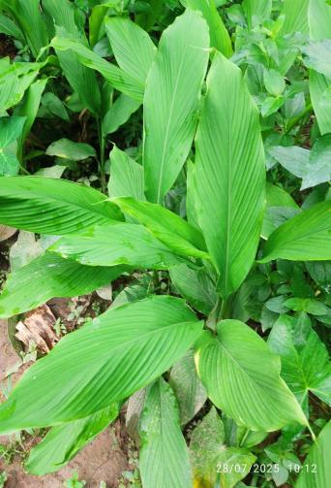 | 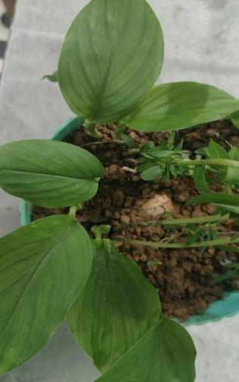 |  | 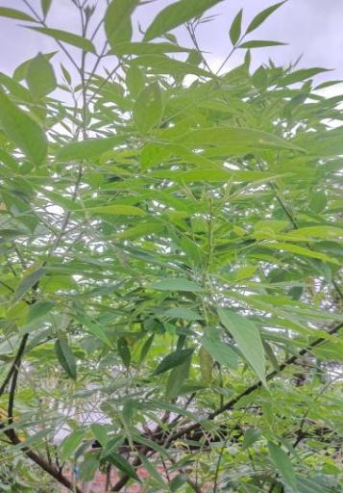 | 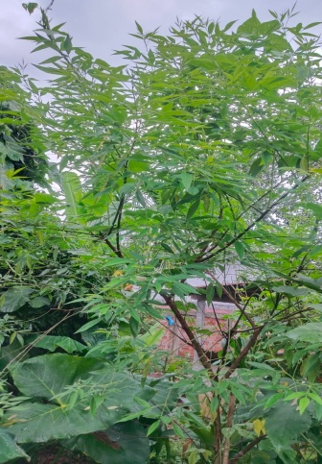
Fig.2. Curcuma longa |  |  | Fig.3. Cajanus cajan
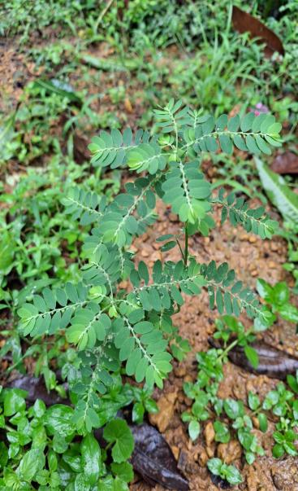 | 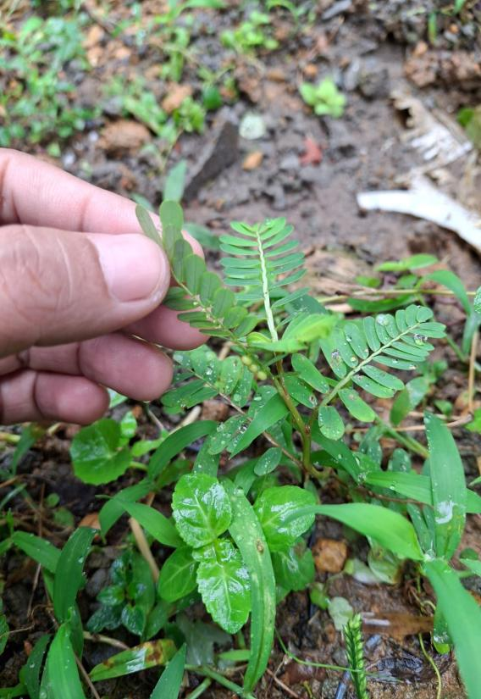 |  | 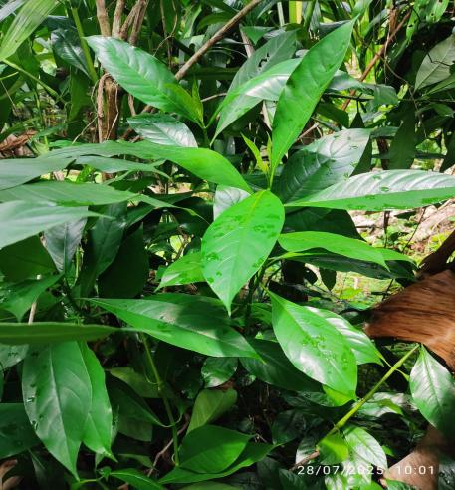
Fig.4. Phyllanthus niruri |  |  | Fig.5. Adhatoda vasica
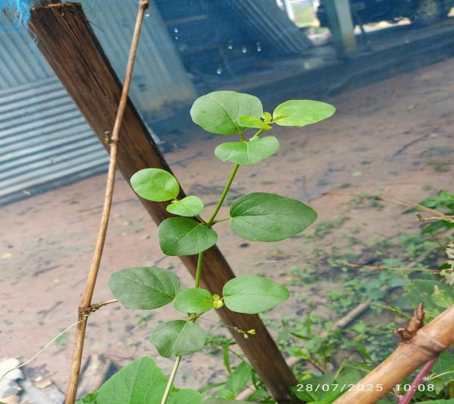 | 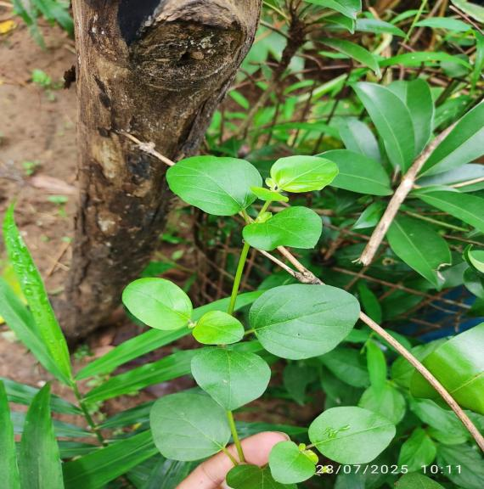 |  | 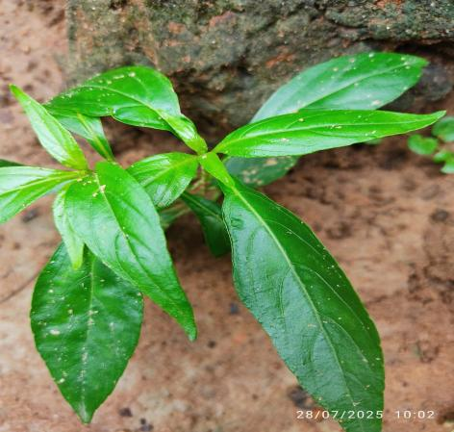
Fig.6. Boerhavia diffusa |  |  | Fig.7. Andrographis paniculata
- CONCLUSION
Jaundice in dogs, which is distinguished by yellow staining of the skin, eyes, and gums, is a dangerous condition that necessitates immediate veterinarian intervention. This colouring frequently indicates serious underlying diseases, such as bile duct obstruction, immune-mediated haemolytic anaemia, or advanced liver disease, all of which can be fatal. Treatment for such complex problems usually requires a multifaceted strategy. Whole blood transfusions are extremely useful for treating difficulties such as severe anaemia, acute bleeding, coagulation disorders, and thrombocytopenia by replacing lost blood components. Supportive treatment is also essential, including intravenous fluids to maintain hydration, antibiotics to combat infections, pain relievers for comfort, appetite stimulants, antacids, and anti-nausea medications to manage digestive upset. Holistic techniques may enhance standard medical treatments. Traditional herbal treatments for liver disorders, such as Silybum marianum and Andrographis paniculata, may have hepato-protective effects. However, their use should always be addressed and approved by a veterinarian to ensure safety and efficacy when combined with prescribed treatments. For the liver's crucial function in digestion and nutrition metabolism, a specialized diet is necessary. In order to reduce liver stress, this diet should be easy to digest, have enough calories for a healthy weight, and be designed with extra antioxidants, enough protein, and controlled quantities of specific minerals. Finally, preventative treatment is essential for a dog's general health and to lower the chance of developing major diseases. This entails limiting interaction with unvaccinated animals, avoiding from human medications, regular deworming, constant tick and flea protection, and regular vaccination.
REFERENCE
- Aravindh, S., & Jacob, N. (2021). Blood transfusion in animals: A review. Journal of Entomology and Zoology Studies, 9(5), 357-361.
https://www.pashudhanpraharee.com/wp-content/uploads/2023/04/Blood-transfusion-in- animals.pdf
- Bera, A. & Lodh, C. (2019). Therapeutic evaluation of Cajanus cajan for the management of hepatic disorder in canine.
http://indianjournalofcaninepractice.com/june2019/JOURNAL-June-2019-5-10.pdf
- Betrapally, N. (2022). The Role of Nutrition in the Management of Liver and Associated Diseases. Frontiers in Nutrition, 9, 919057. https://doi.org/10.3389/fnut.2022.919057
- Brăteanu, M., Hrițcu, L. D., Stanciu, G. D., & Solcan, G. (2018). The hepatoprotective effect of some herbal and mineral preparations in the treatment of various hepatopathies in dogs and cats. https://www.cabidigitallibrary.org/doi/full/10.5555/20193172267
- Lucy, E., Rajesh, J. B., Konwar, B., Arya, R. S., Prasad, H., Sarma, K., Debnath,A., Nama, D., Bordoloi, K. P., & Deka, C. (2022). Clinico-pathological and haemato-biochemical changes associated with immune mediated haemolytic anaemia in dogs. The Pharma Innovation Journal, 11(3), 04-06.
- Ishikawa, T., Meier-Stephenson, V., & Heitman, S. J. (2016). Biliary obstruction caused by the liver fluke, Fasciola hepatica. Canadian Medical Association journal, 188(7), 524-526.
DOI: https://doi.org/10.1503/cmaj.150696
- Jeena, A. (2023). Studies on Ameliorative Efficacy of Boerhavia Diffusa and Tinospora Cordifolia in Paracetamol Induced Hepatotoxicity in Rat Model and its Therapeutic Evaluation in Clinically Affected Dogs With Hepatic Dysfunction (Doctoral Dissertation, GB Pant University of Agriculture and Technology, Pantnagar-263145).

Joseph, A., & Samant, H. (2019). Jaundice. StatPearls [Internet] https://www.ncbi.nlm.nih.gov/books/NBK544252/
- Kalakonda, A., Jenkins, B. A., & John, S. (2017). Physiology, bilirubin. StatPearls.https://europepmc.org/article/NBK/nbk470290
- Kearley, M. E., Hayes, A. W., & Pressman, P. (2024). Canine Mycotoxicosis–A Comprehensive Literature Review. European Journal of Veterinary Medicine, 4(2), 1-7.
https://doi.org/10.24018/ejvetmed.2024.4.2.121
- Khalphallah, A., Mousa, S. A., Almuhanna, A. H., Hassan, D., Al-Shuraym, L. A., Alkeridis, L. A., & Elmeligy, E. (2025). ORNIPURAL® as conventional therapy versus mixture of Curcuma longa extract and pomegranate peel extract as homeotherapy in dogs with dexamethasone-induced hepatopathy: clinicolaboratory, ultrasonographic, and histopathological monitoring. Frontiers in Veterinary Science, 12, 1564648.
https://doi.org/10.3389/fvets.2025.1564648
- Kumar, T., Arya, K., Dhillon, P., Bhagwan, J., Sharma, M., Kumari, D., & Jain, V. K. (2020). Successful Management of Jaundice in a Dog using Therapeutic Blood Transfusion. International Journal of Current Microbiology and Applied Sciences, 9(7), 600-608.DOI: https://doi.org/10.20546/ijcmas.2020.907.067
- Lala, V., Zubair, M., & Minter, D. (2023).Liver function tests. StatPearls.https://www.statpearls.com/point-of-care/20995/
- Leung TS, Outlaw F, MacDonald LW, Meek J, (2019). Jaundice Eye Color Index (JECI): quantifying the yellowness of the sclera in jaundiced neonates with digital photography. Biomed Optics Express, 10(3):1250-1256.
https://doi.org/10.1364/BOE.10.001250
- Londoño, L., & Schaer, M. (2018). Jaundice. Textbook of Small Animal Emergency Medicine, pp. 55-59.
- Memon, N., Weinberger, B. I., Hegyi, T., & Aleksunes, L. M. (2016). Inherited disorders of bilirubin clearance. Pediatric research, 79(3), 378-386.
https://www.nature.com/articles/pr2015247
- Puca, E., Abazaj, E., Pipero, P., Harxhi, A., Ferizaj, R., Como, N., & Puca, E. (2020). A case with high bilirubinemia and hemolytic anemia during leptospirosis and a short review of similar cases. Caspian Journal of Internal Medicine, 11(4), 441.
doi: 10.22088/cjim.11.4.441
- Raguvaran, R., Adarsh, T., Ujjwal, K. D., & Mondal, D. B. (2020). Successful treatment of jaundice secondary to Ehrlichia canis infection in a Labrador retriever puppy. Journal of Indian Veterinary Association, 18 (1).
https://www.jivaonline.net/upload/jiva/2020/07/142-145.pdf
- Rahman, M. (2017). Cholecys-toenterostomy ensures Survival Benefit in Dogs with Clinically Diagnosed with Distal Extra Hepatic Biliary Tract Obstruction: A Retrospective Case Study. Journal of Veterinary Science and Animal Welfare, 2 (2): 1-7.
https://www.researchgate.net/publication/318467506
- Ramchander, P. J., & Middha, A. (2017). Recent advances on senna as a laxative: a comprehensive review. Journal of Pharmacognosy and Phytochemistry, 6(2), 349-53.
https://d1wqtxts1xzle7.cloudfront.net/106880165/6-2-92-932-libre.pdf
- Sameeksha, C. (2021). Efficacy of Phyllanthus niruri on Hepatic Disorders in Dogs (Doctoral dissertation, Maharashtra Animal and Fishery Sciences University).
- Shakya, A. K. (2020). Drug-induced hepatotoxicity and hepatoprotective medicinal plants: a review. Indian Journal of Pharmaceutical Education and Research, 54(2), 234-250.
DOI: 10.5530/ijper.54.2.28
- Tara, S., Roopali, B., Roy, S., & Roy, M. (2020). Efficacy of silymarin in therapeutic management of dogs affected with ascites. Indian Journal of Veterinary Public Health, 7(1), 39-44. https://ijvph.org/wp-content/uploads/2024/01/Resrarch_7__1_6.pdf
- Tovar, T., Deitschel, S., & Guenther, C. (2017). The use of therapeutic plasma exchange to reduce serum bilirubin in a dog with kernicterus. Journal of Veterinary Emergency and Critical Care, 27(4), 458-464. doi: 10.1111/vec.12622
- Uddin, M. T. (2019). A Case Study on Diagnosis and Management of Chronic Hepatitis in A Shelter Bitch. Faculty of Veterinary Medicine Chattogram Veterinary and Animal Sciences University Chattogram-4225, Bangladesh.
http://localhost:8080/jspui/handle/123456789/2883
- Webster, C. R., Center, S. A., Cullen, J. M., Penninck, D. G., Richter, K. P., Twedt, D. C., & Watson, P. J. (2019). ACVIM consensus statement on the diagnosis and treatment of chronic hepatitis in dogs. Journal of veterinary internal medicine, 33(3), 1173-1200.
doi: 10.1111/jvim.15467

