**“Isolation and Identification of Endophytic Fungi associated with roots of Soybean plant and their antagonist activity against *Fusarium* spp.”**

**ABSTRACT:** Soybean (Glycine max), an essential oilseed crop, is severely affected by soil-borne fungal pathogens, particularly Fusarium solani, which causes destructive diseases such as root rot and charcoal rot. The growing prevalence of these diseases, along with the negative environmental impacts associated with chemical control strategies, highlights the need for eco-friendly and sustainable disease management solutions. One promising alternative is the use of endophytic fungi as biological control agents. In the present study, healthy soybean root tissues were collected and subjected to surface sterilization followed by culturing on Potato Dextrose Agar (PDA) for endophyte isolation. Five fungal endophytes—Penicillium chrysogenum, Aspergillus niger, Aspergillus flavus, Cladosporium sp., and Curvularia sp.—were successfully isolated. Morphological and microscopic analyses confirmed their identity, and pathogenicity tests indicated that all isolates were non-pathogenic to the host plant. The antagonistic activity of these endophytes against Fusarium solani was evaluated using the dual culture technique. Among them, Penicillium chrysogenum and Aspergillus flavus showed the highest inhibition (55.56%), followed by Aspergillus niger (46.67%), Cladosporium (44.44%), and Curvularia (30.55%). Overall, the findings demonstrate the biocontrol potential of endophytic fungi associated with soybean roots, supporting their application as a sustainable approach for managing Fusarium-induced root diseases in soybean cultivation.

**Keywords: -** Glycine max, fungal endophytes, antagonistic activity

# **INTRODUCTION**

Soybean (Glycine max), a leguminous crop under the Fabaceae family, stands as one of the most economically and nutritionally significant crops on a global scale. It is believed to have been domesticated over 9000 years ago in China, from where its cultivation extended to other East Asian countries such as Japan and Korea, eventually achieving worldwide agricultural importance. In India, soybean was introduced in the late 1800s (Andole *et al*., 1984) and has since become an essential component of the country's agricultural economy. Its ability to thrive in varied agro-climatic conditions, along with its high nutritional content, has reinforced its role as a key staple crop across the world.

Known as a "miracle crop," soybean is prized for its high protein (about 45%) and oil content (around 18%). It serves multiple purposes, including use in food products, animal feed, and a variety of industrial applications such as the manufacture of paints, plastics, lecithin, resins, and soaps. Additionally, soybeans help combat protein-energy malnutrition, especially in developing countries. In India, the crop is grown on an estimated 11.7 million hectares, with an annual output of around 10.75 million metric tons. The primary soybean-producing regions in the country include Madhya Pradesh and Maharashtra

Despite its numerous benefits, soybean cultivation faces major challenges, particularly from biotic stresses such as fungal infections. Among these, Fusarium solani is a prominent soilborne pathogen that causes diseases like root rot and charcoal rot in soybean plants. This fungus can infect over 500 different plant species and has been linked to considerable yield losses worldwide. In regions like Marathwada, India, yield losses due to F. solani have been reported to reach as high as 70% under favorable conditions (Kumar *et al*., 2019; Agale *et al*., 2018). The pathogen thrives in environments with compacted, waterlogged, and poorly drained soils, where it often coexists with other soil-borne pathogens, complicating management efforts.

Fusarium solani is known for its persistence in the soil, where it survives through long-lasting spores called chlamydospores. Factors such as soil pH, temperature, structure, and the presence of pests like soybean cyst nematodes influence its infection cycle. Symptoms typically start with root browning and decay, followed by stunted growth, leaf yellowing, wilting, and eventual defoliation—leading to reduced plant vigor and productivity.

While chemical fungicides are commonly used to control such infections, prolonged reliance on them poses environmental and health risks and may lead to the development of resistant strains. As a result, there is a growing focus on sustainable biological alternatives. One such promising approach is the use of endophytic fungi—microorganisms that live within plant tissues without causing disease.

First described by Anton de Bary in 1866, endophytes enhance plant health by producing growth-promoting substances, improving stress tolerance, and synthesizing antimicrobial compounds (Suryanarayanan *et al*., 2012; Azevedo *et al*., 2000). In soybean, these fungi produce phytohormones like indole-3-acetic acid (IAA), siderophores, and enzymes that solubilize phosphate (Compant *et al*., 2005; Khan *et al*., 2008). They also serve as natural antagonists to pathogens.

# Given their potential, this study focuses on isolating and identifying endophytic fungi from soybean roots, characterizing them morphologically and molecularly, and assessing their antagonistic activity against Fusarium solani, thereby contributing to sustainable disease management in soybean cultivation.

**METHODOLOGY**

The present research entitled: **“Isolation and Identification of Endophytic Fungi Associated with Roots of Soybean Plant and Its Antagonist Activity Against** Fusarium **spp.”,** was conducted during 2024–2025 at the Department of Plant Biotechnology, Vilasrao Deshmukh College of Agricultural Biotechnology, Latur (Vasantrao Naik Marathwada Krishi Vidyapeeth, Parbhani).

**2.1** **Collection and Isolation of Fusarium spp. from Infected Soybean Roots**

During the Kharif 2024–2025 season, soybean plants showing root and charcoal rot symptoms were collected from fields in Beed, Ambajogai, Latur, Ahemadpur, and Udgir. Suspected to be infected with Fusarium solani, the samples were packed in sterile paper bags and transported to the laboratory. Under aseptic conditions in a laminar airflow cabinet, infected tissues were isolated using Potato Dextrose Agar (PDA) medium. Sterilization protocols included surface disinfection with 70% ethanol, UV exposure, and flaming of tools and glassware to ensure contamination-free processing and successful isolation of Fusarium spp.

**2.2** **Morphological and Pathogenic Evaluation of Fusarium solani Isolates**

To evaluate the characteristics of Fusarium solani, isolates were cultured on Potato Dextrose Agar (PDA) in 90 mm Petri plates and incubated at a temperature of 28 ± 2°C. After 5 to 7 days, morphological features were examined, and colony diameters were measured to categorize isolates based on their growth rates as slow, moderate, or fast-growing. For microscopic examination, small sections of fungal mycelium were stained with lactophenol cotton blue, mounted on a slide, and observed under a compound microscope fitted with a camera. Identification was done based on the unique spore morphology of each isolate.

The pathogenic behavior of F. solani was tested using the root dip method following protocols by Herman and Perl-Treves (2007) and Karimi *et al.* (2010). Spore suspensions were obtained from 7–10-day-old cultures grown in Potato Dextrose Broth (PDB). Roots of 20-day-old soybean seedlings were trimmed and immersed in the spore suspension (1 × 10⁶ spores/mL) for 30 minutes. The seedlings were then transplanted into 15 cm pots containing a 1:1 mixture of sterilized soil and sand. Prior to planting, pots were disinfected with 0.1% mercuric chloride (Dubey and Singh, 2008). Control plants were treated similarly but dipped in sterile distilled water. Disease symptoms were regularly observed to determine the pathogenicity of the isolates.

**2.3 Identification of *Fusarium solani***

The test pathogen (*Fusarium solani*) was identified on the basis of charcoal rot typical symptoms expressed (both on naturally and artificially diseased) on soybean plants, symptoms including browning, decay, and white fungal mycelial growth on the root surface. Pathogenicity test, morphological, cultural and microscopic characteristics.

**2.4 Sample collection Sterilization and Isolation of endophytic fungi**

During the Kharif 2024–2025 season, soybean plants intended for endophytic fungal isolation were collected from experimental plots located near Vilasrao Deshmukh College of Agricultural Biotechnology, Latur, Maharashtra, India. Only healthy, mature, and visibly disease-free plants at the reproductive growth stage were selected. Root tissues were carefully harvested, placed in sterile zip-lock bags, and transported to the laboratory for processing within 24 hours to preserve sample integrity. To eliminate surface contaminants, plant materials were first washed thoroughly under running tap water and then cut into standardized segments—5–6 mm for leaves and 1–2 cm for stems and roots. Surface sterilization was performed under sterile conditions in a laminar airflow chamber, involving sequential treatment with 75% ethanol for 1 minute, 4% sodium hypochlorite for 3–5 minutes, followed by a second rinse in 75% ethanol for 30 seconds. The tissues were then rinsed three times with sterile distilled water and left to dry on sterile filter paper. Sterilized root segments were inoculated onto Potato Dextrose Agar (PDA) plates and incubated at 27 ± 2°C for up to 10 days. Emerging fungal growth was monitored, and actively growing hyphal tips were sub cultured onto fresh PDA to promote sporulation. The resulting pure cultures were preserved on PDA slants at 8°C for further morphological and molecular characterization.

**2.5 Isolation, Identification, and Pathogenicity Testing of Endophytic Fungi from Soybean Roots**

Roots of healthy soybean plants were thoroughly washed and subjected to surface sterilization using 70% ethanol followed by 2% sodium hypochlorite, with final rinses in sterile distilled water. The sterilized root segments were then placed on Potato Dextrose Agar (PDA) and incubated at 27 ± 2°C to promote fungal growth. Emerging colonies were transferred to fresh PDA plates to obtain pure cultures. The isolated endophytic fungi were identified based on their morphological characteristics, including colony appearance, pigmentation, conidial shape, and sporulation pattern, using established identification keys (Barnett & Hunter, 1998; Sutton, 1980). To determine their non-pathogenic nature, a root-drenching technique was applied, where fungal cultures grown in Potato Dextrose Broth (PDB) were introduced to the root zones of soybean seedlings cultivated in a sterilized mixture of soil, sand, and farmyard manure (2:1:1). The seedlings were monitored over a period of 2–3 weeks for any symptom development, while control plants received sterile distilled water for comparative evaluation.

**2.6 *In Vitro* Evaluation of Antagonistic Activity of Endophytic Fungi Against *Fusarium solani***

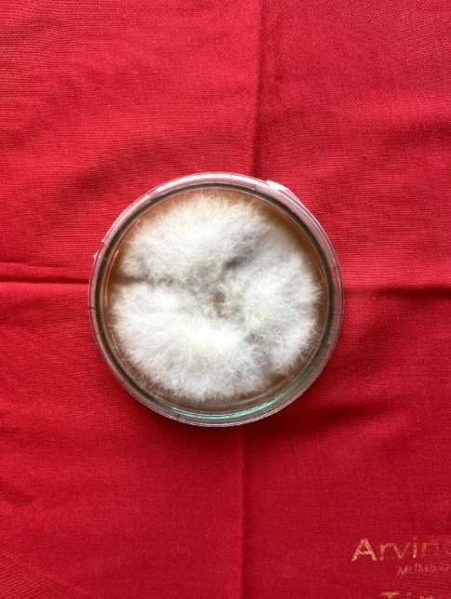The antagonistic potential of selected endophytic fungi against *Fusarium solani* was assessed using the dual culture technique. In this assay, 5 mm diameter mycelial discs of both the endophytic fungus and *F. solani* were placed on opposite sides of Potato Dextrose Agar (PDA) plates. The plates were incubated at 28 ± 2°C, and the radial growth of the pathogen was measured daily until the control plate (inoculated with *F. solani* alone) was completely covered with mycelium.

The experiment was laid out in a Completely Randomized Design (CRD) with three replications. The treatments included five endophytic fungal isolates and one control:

* **T₁**: *Aspergillus niger*
* **T₂**: *Aspergillus flavus*
* **T₃**: *Penicillium chrysogenum*
* **T₄**: *Cladosporium* sp.
* **T₅**: *Curvularia* sp.
* **T₆**: Control (*Fusarium solani* alone)

The percentage of pathogen growth inhibition (PGI) was calculated using the formula:

PGI (%) = R1-​R2​ ​​×100

R2

Where,  
R₁ = Colony diameter in control plate  
R₂ = Colony diameter in treatment plate

**RESULTS AND DISCUSSION**

**3.1. Symptomatology of Fusarium Root Rot in Soybean**

Symptoms of root rot in soybean caused by Fusarium solani were prominently observed during the early growth stages in field conditions. Affected plants exhibited noticeable stunting, foliar chlorosis, wilting, and premature leaf senescence. Root systems developed dark brown to reddish-brown lesions, which progressively led to severe cortical degradation. In advanced stages, the epidermal tissue of the roots detached, exposing a thread-like stele. In some instances, the infection extended upward to the stem base, resulting in vascular discoloration that impaired water uptake and caused pre-mature plant death before pod development. These symptoms were more prevalent in poorly drained or compacted soils.

### **3.2. Isolation and Identification of Fusarium solani**

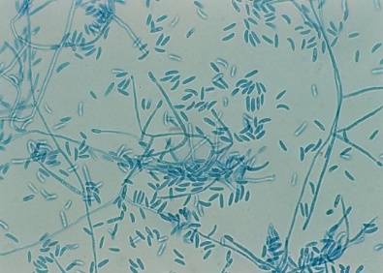Fusarium solani was successfully isolated from infected root tissues of symptomatic soybean plants using Potato Dextrose Agar (PDA) medium. The colonies initially appeared white and fluffy, later forming a pink to violet pigmentation at the center with a whitish margin. Microscopic analysis revealed septate hyphae and three distinct spore types: unicellular, kidney-shaped microconidia; sickle-shaped macroconidia with 3–5 septa; chlamydospores located terminally or intercalarily. These features were in accordance with established morphological descriptions, confirming the pathogen’s identity.

**Fig.No.1: -** Pure Culture of *Fusarium solani* and its microscopic analysis

### **3.3. Pathogenicity Assessment**

To verify pathogenicity, F. solani was inoculated onto soybean seedlings using the root dip method under controlled screen house conditions. The inoculated seedlings displayed typical disease symptoms, such as seed rot, post-emergence damping-off, chlorosis, and decay of both roots and stem bases. Re-isolation of the same fungal species from infected tissues confirmed Koch’s postulates, establishing the pathogenic nature of the isolate.

### **3.4. Isolation and Characterization of Endophytic Fungi**

Five endophytic fungal strains—Penicillium chrysogenum, Cladosporium sp., Curvularia sp., Aspergillus niger, and Aspergillus flavus—were isolated from surface-sterilized roots of healthy soybean plants. The isolates were cultivated on PDA and identified based on colony morphology, spore characteristics, and sporulation patterns through standard mycological techniques.

### **3.5. Non-Pathogenicity Evaluation of Endophytes**

The pathogenic potential of the isolated endophytes was tested using a root drenching method on healthy soybean plants. Over a 2–3-week observation period, none of the treated plants exhibited disease symptoms, confirming the non-pathogenic behavior of all five isolates. This supports their classification as true endophytes, which typically exist in mutualistic or neutral association with their host plants.

### **3. 6. Morphological Characteristics of Endophytes**

Each endophyte displayed distinct morpho-cultural features. The five endophytic fungi isolated from healthy soybean roots were morphologically characterized on Potato Dextrose Agar (PDA) and through microscopic observations:

* + 1. **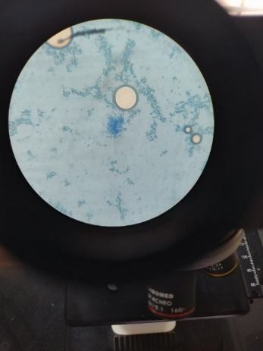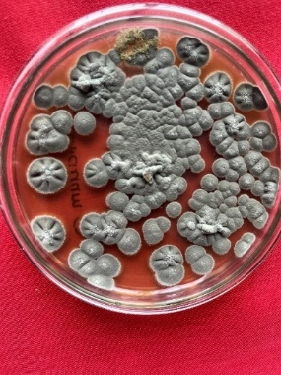*Penicillium chrysogenum*** produced fast-growing, blue-green colonies with a velvety texture and a pale-yellow reverse. Microscopically, conidiophores were branched, forming brush-like structures (penicillin) with flask-shaped phialides and globose conidia in basipetal chains. Morphology matched descriptions by Miller and Roy (1982) and Gaikwad *et al.* (2017).

**Fig.No.2: -** Pure Culture of ***Penicillium chrysogenum*** and its microscopic analysis

* + 1. ***Cladosporium* sp.** formed olive to dark green, suede-like colonies. Conidiophores were septate and branched, producing long chains of ellipsoidal to lemon-shaped, pale to dark brown conidia with visible hila. Observations were consistent with Ellis (1971) and Schubert *et al.* (2007).

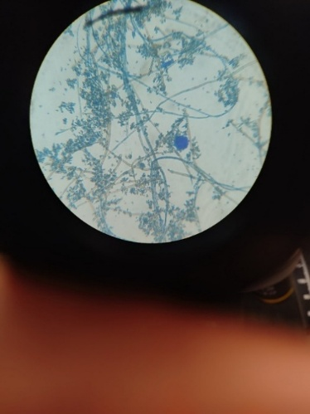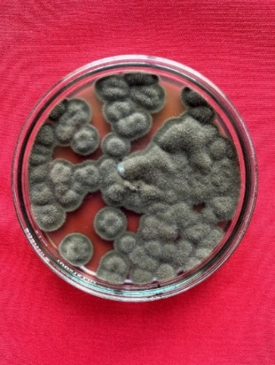

**Fig.No.3: -** Pure Culture of ***Cladosporium*** and its microscopic analysis

* + 1. **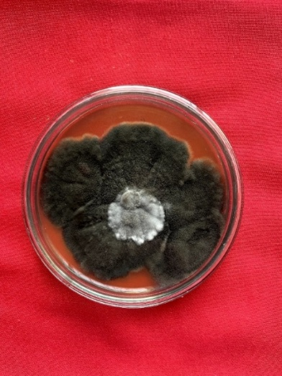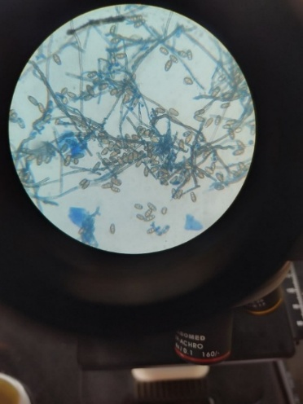*Curvularia* sp.** showed rapid growth with dark brown, woolly colonies. Microscopically, it had curved, 3–5 septate conidia with a wider, darker central cell. The morphological traits aligned with those reported by Manamgoda *et al.* (2012).

**Fig.No.4: -** Pure Culture of ***Curvularia*** and its microscopic analysis

* + 1. **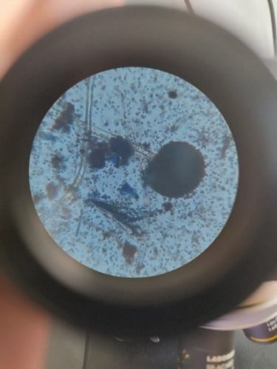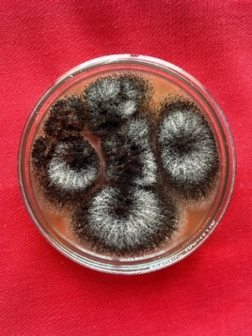*Aspergillus niger*** developed dense, black colonies with granular texture. It had long, septate conidiophores ending in biseriate conidial heads, bearing rough-walled, spherical black conidia. These features matched descriptions by Raper and Fennell (1965).

**Fig.No.5: -** Pure Culture of ***Aspergillus niger*** and its microscopic analysis

* + 1. ***Aspergillus flavus*** exhibited yellow-green colonies with powdery texture. Both uniseriate and biseriate conidial heads were observed, producing echinulate, globose conidia in long chains. Morphology was in agreement with Klich (2002) and Raper and Fennell (1965).

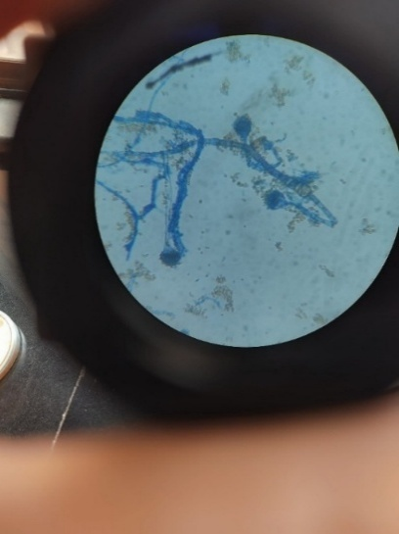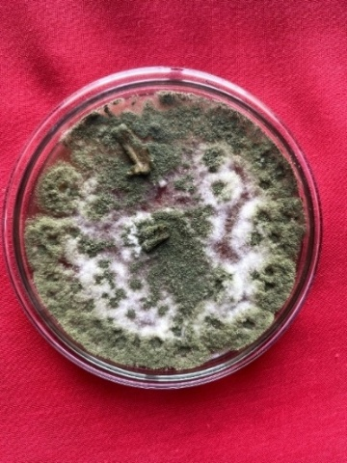

**Fig.No.6: -** Pure Culture of ***Aspergillus flavus and*** its microscopic analysis

### **3.7 *In Vitro* Evaluation of Endophytic Fungi Against Fusarium solani**

The in vitro antagonistic activity of five endophytic fungal isolates derived from healthy soybean roots was assessed against Fusarium solani, the pathogen responsible for root rot, using the dual culture technique. The experiment followed a completely randomized design (CRD) with three replications. The effectiveness of each isolate was measured by comparing the radial growth of F. solani in treated and untreated (control) plates, with results summarized in Table 1.

|  |  |  |  |
| --- | --- | --- | --- |
| **Tr. No.** | **Endophytic Fungal Isolate** | **Colony Diameter (mm)** | **% Inhibition** |
| 1 | Penicillium chrysogenum | 20.0 | 55.56 |
| 2 | Cladosporium sp. | 25.0 | 44.44 |
| 3 | Curvularia sp. | 30.0 | 30.55 |
| 4 | Aspergillus niger | 23.3 | 46.67 |
| 5 | Aspergillus flavus | 20.0 | 55.56 |
| 6 | Control (untreated) | 45.0 | 0.00 |
|  | **SE±** | **0.59** | **0.47** |
|  | **CD (P = 0.01)** | **1.82** | **1.50** |

**Table 1. *In vitro* antagonistic activity of endophytic fungi against Fusarium solani**

All five fungal endophytes significantly inhibited the radial growth of F. solani compared to the control, demonstrating varying degrees of antagonistic potential. Penicillium chrysogenum and Aspergillus flavus were the most effective isolates, each achieving 55.56% inhibition of pathogen growth and reducing the colony diameter from 45.0 mm (in control) to 20.0 mm. Their high level of suppression suggests strong antagonistic interactions, likely involving mechanisms such as antibiosis, competition for nutrients and space, or enzymatic degradation of the pathogen.

Aspergillus niger also showed notable efficacy, inhibiting F. solani by 46.67% with a corresponding colony diameter of 23.3 mm. Cladosporium sp. exhibited moderate suppression (44.44% inhibition), while Curvularia sp. was the least effective among the isolates, reducing pathogen growth by only 30.55%.

In contrast, the untreated control showed the highest colony diameter (45.0 mm) and no inhibition, confirming the virulence of F. solani under in vitro conditions in the absence of antagonistic agents. Overall, the results highlight Penicillium chrysogenum and Aspergillus flavus as promising candidates for biological control of F. solani in soybean.

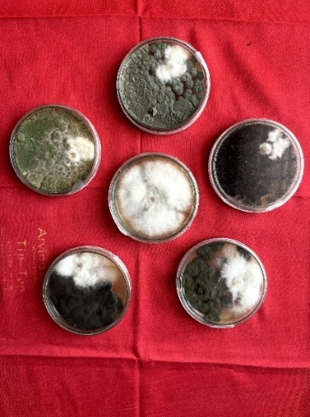

**Fig.No.7:** - *In vitro* efficacy of endophytic fungi of soybean against *Fusarium solani*

**CONCLUSION**

This study successfully isolated and identified five endophytic fungal species—*Penicillium chrysogenum*, *Aspergillus flavus*, *Aspergillus niger*, *Cladosporium* sp., and *Curvularia* sp.—from the root tissues of healthy soybean (*Glycine max*) plants. Using standard sterilization and culturing techniques, the fungi were obtained in pure culture, morphologically characterized, and confirmed to be non-pathogenic through pathogenicity testing on soybean seedlings. These isolates were then evaluated for their antagonistic potential against *Fusarium solani*, a major soil-borne pathogen known to cause root rot and charcoal rot in soybean crops, particularly under poorly drained or compacted soil conditions.

The antagonistic activity of the fungal isolates was tested using the dual culture technique, which clearly demonstrated varied but significant inhibitory effects on the radial growth of *F. solani*. Among all tested isolates, *Penicillium chrysogenum* and *Aspergillus flavus* showed the strongest antagonism, each achieving 55.56% inhibition. *Aspergillus niger* followed with 46.67% inhibition, while *Cladosporium* sp. and *Curvularia* sp. showed moderate suppression at 44.44% and 30.55%, respectively. These findings suggest that the endophytic fungi may act through mechanisms such as antibiosis, competition for space and nutrients, or production of lytic enzymes, thereby limiting the growth and spread of the pathogenic *Fusarium* species.

The results affirm that endophytic fungi associated with soybean roots have significant potential as biological control agents. Their ability to inhibit *F. solani* without causing harm to the host plant underscores their suitability for development into eco-friendly alternatives to synthetic fungicides. Utilizing these fungi in disease management strategies could reduce the environmental and health impacts associated with chemical control methods and help address the issue of fungicide resistance in pathogens.

For broader agricultural application, further research is recommended. Molecular-level identification and functional analysis of the antifungal compounds produced by these endophytes will deepen understanding of their biocontrol mechanisms. Additionally, greenhouse and field trials are necessary to validate their performance under natural environmental conditions and agronomic practices.

In conclusion, the study demonstrates that endophytic fungi from soybean roots, particularly *Penicillium chrysogenum* and *Aspergillus flavus*, hold promise as sustainable biocontrol agents against *Fusarium solani*. These fungi could contribute significantly to the development of integrated, environmentally responsible disease management strategies in soybean cultivation.

**FUTURE SCOPE**

The study emphasizes the potential of endophytic fungi as effective biocontrol agents against Fusarium solani in soybean. Future research should focus on *in vivo* trials under field conditions to validate their efficacy. Molecular characterization and metabolomic profiling can uncover bioactive compounds and antifungal mechanisms. Developing bio fungicide formulations and exploring synergistic effects with other beneficial microbes may enhance plant resistance. Integrating these endophytes into Integrated Pest Management (IPM) strategies could offer a sustainable and eco-friendly solution for managing soybean root diseases.

**REFERENCES**

Agale, R. C., Deshmukh, D. V., Deore, M. A., & Suryawanshi, A. P. (2018). *Studies on occurrence and severity of root rot of soybean caused by Fusarium solani*. Journal of Pharmacognosy and Phytochemistry, 7(2), 1576–1578.

Andole, V. L., Kale, P. N., & Pathak, S. N. (1984). *Soybean in India: Production, utilization and future prospects*. Indian Journal of Agricultural Sciences, 54(8), 585–589.

Azevedo, J. L., Maccheroni, W., Pereira, J. O., & Araujo, W. L. (2000). *Endophytic microorganisms: A review on insect control and recent advances on tropical plants*. Electronic Journal of Biotechnology, 3(1), 40–65.

Barnett, H. L., & Hunter, B. B. (1998). *Illustrated Genera of Imperfect Fungi* (4th ed.). APS Press.

Compant, S., Duffy, B., Nowak, J., Clément, C., & Barka, E. A. (2005). *Use of plant growth-promoting bacteria for biocontrol of plant diseases: Principles, mechanisms of action, and future prospects*. Applied and Environmental Microbiology, 71(9), 4951–4959.

Dubey, S. C., & Singh, B. (2008). *Biological control of plant pathogens using antagonistic fungi*. Indian Phytopathology, 61(1), 1–11.

Ellis, M. B. (1971). *Dematiaceous Hyphomycetes*. CMI, Kew, Surrey, England.

Gaikwad, A. P., Dhopte, A. M., & Pawar, D. B. (2017). *Antagonistic potential of Penicillium chrysogenum against Fusarium spp.* International Journal of Current Microbiology and Applied Sciences, 6(5), 2127–2134.

Herman, R. A., & Perl-Treves, R. (2007). *Plant pathology techniques in disease resistance research*. In Vitro Cellular & Developmental Biology - Plant, 43(3), 261–270.

Karimi, K., Arzanlou, M., & Khodaei, S. (2010). *Pathogenicity assay of Fusarium species on soybean seedlings*. Archives of Phytopathology and Plant Protection, 43(18), 1772–1777.

Khan, A. L., Hamayun, M., Khan, M. A., Kang, S. M., Shin, D. H., Kamran, M., ... & Lee, I. J. (2008). *Endophyte-mediated enhancement of plant growth and physiology*. Biologia, 63(3), 385–390.

Klich, M. A. (2002). *Identification of Common Aspergillus Species*. Centraalbureau voor Schimmelcultures (CBS), Utrecht, The Netherlands.

Kumar, S., Thakur, M., Rani, A., & Kumar, A. (2019). *Fusarium root rot of soybean and its management*. Legume Research, 42(5), 635–639.

Manamgoda, D. S., Rossman, A. Y., Castlebury, L. A., Crous, P. W., Madrid, H., Chukeatirote, E., & Hyde, K. D. (2012). *The genus Curvularia: Phylogenetic overview and revision of species concepts*. Fungal Diversity, 56(1), 131–144.

Miller, J. D., & Roy, R. (1982). *Mycotoxins and metabolites produced by Penicillium chrysogenum*. Canadian Journal of Microbiology, 28(12), 1293–1298.

Raper, K. B., & Fennell, D. I. (1965). *The Genus Aspergillus*. Williams and Wilkins, Baltimore, MD.

Schubert, K., Groenewald, J. Z., Braun, U., Dijksterhuis, J., Starink, M., Hill, C. F., ... & Crous, P. W. (2007). *Biodiversity in the Cladosporium herbarum complex (Davidiellaceae, Capnodiales), with standardisation of methods for Cladosporium taxonomy and diagnostics*. Studies in Mycology, 58, 105–156.

Suryanarayanan, T. S., Thirunavukkarasu, N., Govindarajulu, M. B., Sasse, F., Jansen, R., & Murali, T. S. (2012). *Fungal endophytes and bioprospecting*. Fungal Biology Reviews, 26(3–4), 89–98.

Sutton, B. C. (1980). *The Coelomycetes: Fungi imperfecti with pycnidia, acervuli and stromata*. Commonwealth Mycological Institute, Kew, UK