**Original Research Article**

**Morphological Characterization of *Trichoderma* Isolates Collected from Copper Mining Areas of Uttarakhand**

***Abstract***

A total of 49 *Trichoderma* stains were isolated and purified from rhizospheric soil samples collected from different copper mining sites of Uttarakhand hills. It was observed that *Trichoderma* spp. exhibited light to dark green colony, produced different coloured pigmentation on lower side of culture plates. Among 49 isolates, 21 were dark green, 5 light green, 21 light to dark green and 2 whitish to light green in colour. Thirteen isolates (TCMS-5, 6, 10, 12, 14a, 15, 16, 17, 25, 26, 65, 71 and 77) were showed concentric ring formation as growth characteristic. Twenty-two isolates exhibited rough, spongy and raised colony, 16 isolates exhibited smooth and flat colony topography, nine isolates were having smooth and flat colony with dense sporulation at border and two showed spongy and fluffy growth with dense sporulation at center. Eleven isolates produced dark brown pigmentation, four light brown, nine pinkish, 17 whitish creamy and eight yellowish green pigmentation on lower side of the culture plate. Conidiospores were oval to sub-oval, measuring 2.82 x 2.75 µm to 5.18 x 5.02 µm in diameter with a mean of 4.00 x 3.86 µm. The selected isolates may further screened for their antagonism activity under in vitro and in vivo conditions to use them for disease management under integrated disease management strategies and organic farming systems for sustainable crop production.

***Key words***: Biological control, Characterization, Biopesticides, Sustainability, Organic farming.

**Introduction**

*Trichoderma* sp. present in nearly all types of soil and diverse habitats. In relation to other fungi in soil, they are found to be the most prevalent culturable fungi belonging to the genus under Deuteromycotina, Hyphomycetes, Moniliales, and Moniliaceae. This genus comprises large number of fungal species like *T. asperellum*, *T*. *atroviride*, *T. harzianum*, *T. hamatum*, *T. koningii*, *T. virens* and *T. viride* that are widely used for bio-control of plant diseases incited by fungal pathogens. In addition, it was also found effective in increasing plant growth and development (Harman and Bjorkmann, 1998; Hjeljord and Tronsmo, 1998; Singh *et al*., 2006). These species alone or in combination with other *Trichoderma* species or compatible chemical fungicides have been used for the control of several diseases like root rots, wilts, damping off, white rot, collar rots etc. in a wide variety of crops (Samuels, 1996). Researchers are interested in this genus because of its novel biological properties against several plant pathogens and biotechnological applications. The ecological role of this genus is to play role in the decomposition of plant residues in soil.

*Trichoderma* strains exert bio-control activity against fungal phytopathogens either directly by mechanism of mycoparasitism or indirectly, by competing for nutrients and space, modifying the environmental conditions, or promoting plant growth and plant defensive mechanisms and antibiosis. These indirect and direct mechanisms may act co-ordinately and their importance in the bio-control process depends on the *Trichoderma* strain, the antagonized fungus, the crop plant and the environmental conditions, including nutrient availability, pH, temperature, and iron concentration (Harman, 2000; Harman and Shoresh, 2007). Mycoparasitic *Trichoderma* strains are able to recognize the host hyphae, to coil around them, develop haustoria, penetrate the cell wall of the host with cell-wall degrading enzymes like chitinases, glucanases and proteases, and utilise the contents of the host hyphae as nutrient source. *Trichoderma* strains with effective antagonistic abilities are potential candidates for the biological control of plant diseases. Keeping the above factors in view, a study was carried out on “Morphological, characterization of *Trichoderma* isolates collected from copper mining areas of Uttarakhand ”.

Review of literature

Papavizas and Lumsden (1982) developed *Trichoderma* medium E (TME) for selective isolation from soil. A specific medium named *Trichoderma* selective medium-TSM for quantitative isolation from soil (Elad and Chet, 1983) gave superior results than TME (Saha *et al.,* 1997). The TSM medium was further improved by adding Captan 50 per cent 10 mg/litre (TSMC) to avoid the contaminants like *Mucor, Rhizopus, Penicillium* especially *Fusarium* species (Askew and Lang, 1993). Kullnig *et al.* (2000) isolated *Trichoderma* species from Himalayan soils using PDA and Cellulose agar. *Trichoderma* Colonies usually grow rapidly, at first smooth surfaced and almost translucent or watery white, later becoming floccose or compactly tufted, of various shades of green or pure white. Pigments may be secreted into medium or the reverse of the colony remains unchanged (Bisset, 1991a).

The genus *Trichoderma* was first erected by Persoon (Cook and Baker, 1983; Bisset, 1991 a, b). Genus *Trichoderma* have traditionally been classified as Fungi Imperfectii as they were reported to produce only asexual spores i.e., conidia (Singh *et al*., 2006). With the recent advances in molecular taxonomy, many of the species have been reclassified as belonging to the genus Hypocrea of the class Ascomycetes (Gams and Bisset, 1998; Druzhinina *et al*., 2005). The teleomorph of this genus is Hypocrea Fr. under Hypocreales, Ascomycotina (Rifai and Webster, 1966a).

**Material and Methods**

*Collection of soil samples, isolation and purification of Trichoderma*

Extensive collections of soil samples were carried out in different farming situations from the copper mining areas of Uttarakhand such as Nainital, Bageshwar and Tehri Garwal districts. Approachable locations of copper mining sites were selected and visited for soil sampling. Generally healthy plants were selected from standing crop of a location and rhizospheric soil was collected. Plant was gently and carefully uprooted and soil tightly adhering to root was collected. Five such samples were collected randomly from the crop fields, mixed and 1/4th part of the sample was used as composite rhizospheric soil sample of the region. Soil samples were air dried for four hours. Isolation was done by employing serial dilution technique. Ten gram soil was suspended in 100 ml of sterile distilled water (1:10) and stirred well. The soil particles were allowed to settle down, 10 ml of clear supernatant was then transferred to another flask containing 90 ml sterile distilled water (1:100). Finally, suspension of 1:1000 dilutions was prepared by following same procedure.

*Trichoderma* selective medium (TSM) (Elad *et al.,* 1981; Mukherjee, 1991) was used for isolation of *Trichoderma*. One ml soil suspension was taken with the help of 5 ml pipette and poured on the Petriplate seeded with TSM. The entire process was done in an inoculation chamber under aseptic conditions. The plates were incubated at 28±10 C for 5 days. *Trichoderma* isolates were purified by single spore culture. The spores of the isolates were inoculated onto a Petriplates seeded with PDA medium. Sub-culturing was done from the growing front of the single new colony. Small number of spores were taken on the tip of a sterilized inoculating needle and streaked on potato dextrose agar poured Petri dishes. This process was repeated by taking inoculum from the edges of colonies growing in the freshly streaked Petri plate, and again streaking it in PDA plates. Colony arising from single spore was picked up and inoculated on a fresh plate. This culture was finally maintained and used for further studies.

Out of 116 soil samples collected from different copper mining sites of Uttarakhand, 49 isolates of *Trichoderma* were obtained. Isolates were coded on the bases of location and serial number of the soil sample as *Trichoderma* from copper mining site (TCMS 1 to 116).

*Morphological characterization of Trichoderma isolates (TCMS series)*

For morphological studies of *Trichoderma*, Cornmeal dextrose agar (Cornmeal agar + 2% (w/v) dextrose) (CMD) medium was used. This media promotes morphological characters of the fungus more or less approximate to those found in nature. A block of the fungal mycelium was inoculated onto 90 mm petridishes seeded with CMD. The cultures were incubated at 20±10C. Microscopic preparations for morphological studies were made from pustules with white conidia, after a week of incubation at 200C. For preparing slides a drop of 3 per cent KOH was first placed on a slide where a very small amount of sample was placed. The KOH wets the conidia and allows the conidiophores to spread. Once the mount was prepared, KOH was replaced with lacto phenol cotton blue. Before placing the cover slip, the hyphae and conidiophores were separated using needles. After placing the cover slip, the slide was observed under the microscope. Observations were recorded for the following morphological characters: colony colour, presence or absence of concentric rings, colony morphology/growth pattern, pigmentation on lower side of plate and size of conidia. Based on visible colony colour *Trichoderma* isolates were placed into four groups *viz.,* (1) whitish to light green, (2) light green, (3) light to dark green and (4) dark green.

Based on presence or absence of concentric rings*Trichoderma* isolates were placed into two groups (1) Present, (2) Absent.*Trichoderma* isolates were classified into five groups based on surface topography such as, (i) Smooth and flat, (ii) Smooth, fluffy and raised, (iii) Rough, spongy and raised, (iv) Flat and dense sporulation at border and (v) Spongy, fluffy and dense sporulation at center.Based on pigmentation on lower side of plate, *Trichoderma* isolates were grouped into five group’s *viz*., (i) Whitish creamy, (ii) Yellowish green, (iii) Light brown, (iv) Dark brown and (v) Pinkish colour.

The semi permanent slides of 49 *Trichoderma* isolates (TCMS series) were prepared using five days old fresh cultures grown on PDA medium. A minute quantity of spores were transferred to the slide containing a drop of lactophenol and cotton blue suspension. The spores were then spread over the slide. The glass cover slip was placed on top of it and extra suspension was removed. Canada balsom was applied along the edges of cover slip to avoid the entry of air bubbles inside. The slides were air dried and observed spores under “Olympus live image analyser” (DIC microscope) at 60X. The spore size (diameter, length and breadth) was measured using the software “Image Pro-Express 6.3”. The size of the spores was expressed in microns (µ).

**Results and Discussion**

***Collection of soil samples and isolation of Trichoderma spp.***

One hundred and sixteen rhizosphere soil samples were collected from the copper mining sites of Uttarakhand out of which 49 *Trichoderma* strains were isolated and designated as *Trichoderma* from copper mining sites (TCMS-1 to TCMS-116). Out of these, 35 isolates were from Nainital district (33 from Chirag and two from Dhokone), 11 isolates from Bageshwar (10 from Gaulagoon and one from Jhoshigaon) and 3 isolates from Tehri Garhwal (Agar) (**Table 1).** Six *Trichoderma* isolates (biotic and abiotic stress tolerant) were obtained from the repository maintained in Biocontrol laboratory, Department of Plant Pathology, GBPUA&T, Pantnagar and one *Trichoderma* isolate was obtained from Sri Biotech laboratory India Ltd, Hyderabad. All these isolates were used throughout the experiment.

**Table 1: *Trichoderma* isolates obtained from copper mining areas of Uttarakhand hills**.

|  |  |  |
| --- | --- | --- |
| **District** | **Location** | **Number of Soil samples (*Trichoderma* isolates)** |
| Nainital | 1. Chirag | **33** (TCMS 1, TCMS 2, TCMS 3, TCMS 4 TCMS 5, TCMS 6, TCMS 7, TCMS 9, TCMS 10, TCMS 11, TCMS 12, TCMS 13, TCMS 14a, TCMS 14b, TCMS 15, TCMS 16, TCMS 17, TCMS 20, TCMS 22, TCMS 24, TCMS 25, TCMS 26, TCMS 21, TCMS 32, TCMS 34, TCMS 35, TCMS 36, TCMS 37, TCMS 43, TCMS 46, TCMS 51, TCMS 60 and TCMS 103. |
| 2. Dhokane | **2**  (TCMS 93 and TCMS 95) |
| Bhageshwar | 3. Gaulagaon | **10** (TCMS 62, TCMS 64, TCMS 65, TCMS 66, TCMS 71, TCMS 72, TCMS 73, TCMS 74, TCMS 77 and TCMS 79) |
| 4. Jhoshigaon | **1** (TCMS 82) |
| Tehri Garhwal | 5. Aagar | **3** (TCMS 85, TCMS 90 and TCMS 92 |

**Morphological characterization of *Trichoderma* isolates**

The growth characteristics of mono conidiosporic cultures of the *Trichoderma* isolates were studied on cornmeal dextrose agar medium. Observations on colony colour, presence or absence of concentric rings, surface and topography, pigmentation on lower side of the plate and spore size were recorded as presented in table 2 and plate 1a and 1b.

*Colony colour*

Among 49 isolates, 21 were dark green, five light green, 21 light to dark green and two whitish to light green in colour.

*Concentric rings*

Thirteen isolates (TCMS-5, 6, 10, 12, 14a, 15, 16, 17, 25, 26, 65, 71 and 77) were showed concentric ring formation as growth characteristic.

**Table 2: Morphological characteristics of *Trichoderma* isolates (TCMS series)**

|  |  |  |  |  |  |  |
| --- | --- | --- | --- | --- | --- | --- |
| **Sl. No.** | **Isolate** | **Colony colour** | **Concentric rings** | **Morphology** | **Pigmentation on lower side of plate** | **Spore size**  **(in µ)** |
| 1 | TCMS 1 | Dark green | Absent | Smooth and flat | Dark brown | 3.82 x 3.78 |
| 2 | TCMS 2 | Light to dark green | Absent | Smooth and flat | Pinkish | 4.12 x 3.98 |
| 3 | TCMS 3 | Dark green | Absent | Smooth and flat | Yellowish green | 3.50 x 3.42 |
| 4 | TCMS 4 | Light to dark green | Absent | Rough, spongy and raised | Whitish creamy | 3.28 x 3.20 |
| 5 | TCMS 5 | Dark green | Present | Smooth and flat | Yellowish green | 3.02 x 2.94 |
| 6 | TCMS 6 | Light to dark green | Present | Smooth, flat and dense sporulation at border | Pinkish | 3.12 x 3.02 |
| 7 | TCMS 7 | Light to dark green | Absent | Smooth and flat | Whitish creamy | 3.16 x 3.10 |
| 8 | TCMS 9 | Dark green | Absent | Spongy, fluffy and dense sporulation at centre | Whitish creamy | 3.22 x 3.16 |
| 9 | TCMS 10 | Light to dark green | Present | Smooth and flat | Pinkish | 4.88 x 4.72 |
| 10 | **TCMS 11** | Light to dark green | Absent | Rough, spongy and raised | Dark brown | **4.96 x 4.82** |
| 11 | TCMS 12 | Light to dark green | Present | Rough, spongy and raised | Dark brown | 3.08 x 2.94 |
| 12 | TCMS 13 | Dark green | Absent | Smooth, flat and dense sporulation at border | Whitish creamy | 3.34 x 3.28 |
| 13 | TCMS 14a | Dark green | Present | Smooth, flat and dense sporulation at border | Pinkish | 2.94 x 2.86 |
| 14 | TCMS 14b | Light to dark green | Absent | Rough, fluffy and raised | Dark Brown | 3.60 x 3.28 |
| 15 | TCMS 15 | Light to dark green | Present | Rough, spongy and raised | Whitish creamy | 3.36 x 3.26 |
| 16 | TCMS 16 | Dark green | Present | Rough, spongy and raised | Whitish creamy | 3.48 x 3.32 |
| 17 | **TCMS 17** | Light green | Present | Smooth and flat | Whitish creamy | **3.34 x 3.28** |
| 18 | TCMS 20 | Light to dark green | Absent | Smooth and flat | Whitish creamy | 3.18 x 3.04 |
| 19 | TCMS 22 | Dark green | Absent | Smooth and flat | Whitish creamy | 3.46 x 3.32 |
| 20 | TCMS 24 | Dark green | Absent | Rough, spongy and raised | Whitish creamy | 3.30 x 3.12 |
| 21 | TCMS 25 | Dark green | Present | Rough, spongy and raised | Dark brown | 3.30 x 3.10 |
| 22 | TCMS 26 | Light to dark green | Present | Rough, spongy and raised | Dark brown | 3.22 x 3.36 |
| 23 | TCMS 31 | Dark green | Absent | Smooth, flat and dense sporulation at border | Whitish creamy | 3.74 x 3.46 |
| 24 | TCMS 32 | Light to dark green | Absent | Rough, spongy and raised | Whitish creamy | 4.26 x 4.14 |
| 25 | TCMS 34 | Light to dark green | Absent | Smooth, flat and dense sporulation at border | Light brown | 3.72 x 3.60 |
| 26 | TCMS 35 | Dark green | Absent | Rough, spongy and raised | Pinkish | 3.06 x 2.94 |
| 27 | TCMS 36 | Dark green | Absent | Rough, spongy and raised | Yellowish green | 4.78 x 4.54 |
| 28 | TCMS 37 | Dark green | Absent | Smooth and flat | Dark brown | 4.90 x 4.74 |
| 29 | TCMS 43 | Light green | Absent | Rough, spongy and raised | Dark brown | 3.06 x 2.96 |
| 30 | TCMS 46 | Light to dark green | Absent | Rough, spongy and raised | Dark brown | 3.28 x 3.02 |
| 31 | TCMS 51 | Dark green | Absent | Rough, spongy and raised | Yellowish green | 3.20 x 3.08 |
| 32 | TCMS 60 | Dark green | Absent | Rough, spongy and raised | Whitish creamy | 3.22 x 3.10 |
| 33 | TCMS 62 | Light to dark green | Absent | Rough, spongy and raised | Light brown | 3.10 x 2.98 |
| 34 | TCMS 64 | Dark green | Absent | Rough, spongy and raised | Whitish creamy | 3.84 x 3.70 |
| 35 | TCMS 65 | Whitish to light green | Present | Rough, spongy and raised | Yellowish green | **5.18 x 5.02** |
| 36 | TCMS 66 | Whitish to light green | Absent | Rough, spongy and raised | Whitish creamy | 4.36 x 4.24 |
| 37 | TCMS 71 | Dark green | Present | Rough, spongy and raised | Pinkish | 3.24 x 3.16 |
| 38 | TCMS 72 | Dark green | Absent | Smooth and flat | Pinkish | 3.50 x 3.36 |
| 39 | TCMS 73 | Light to dark green | Absent | Rough, spongy and raised | Light brown | 4.58 x 4.46 |
| 40 | TCMS 74 | Light green | Absent | Smooth and flat | Dark brown | 4.58 x 4.38 |
| 41 | TCMS 77 | Light to dark green | Present | Smooth and flat | Yellowish green | 3.12 x 3.08 |
| 42 | TCMS 79 | Light to dark green | Absent | Smooth and flat | Pinkish | **2.82 x 2.70** |
| 43 | TCMS 82 | Light to dark green | Absent | Smooth and flat | Light brown | 3.90 x 3.66 |
| 44 | TCMS 85 | Dark green | Absent | Smooth, flat and dense sporulation at border | Whitish creamy | 3.90 x 3.86 |
| 45 | TCMS 90 | Light green | Absent | Rough, spongy and raised | Whitish creamy | 3.24 x 3.18 |
| 46 | TCMS 92 | Light to dark green | Absent | Smooth, flat and dense sporulation at border | Pinkish | 3.06 x 2.92 |
| 47 | TCMS 93 | Light green | Absent | Smooth and flat | Yellowish green | 3.46 x 3.36 |
| 48 | TCMS 95 | Light to dark green | Absent | Smooth, flat and dense sporulation at border | Dark brown | 3.82 x 3.78 |
| 49 | TCMS 103 | Dark green | Absent | Spongy, fluffy and dense sporulation at centre | Yellowish green | 3.82 x 3.68 |

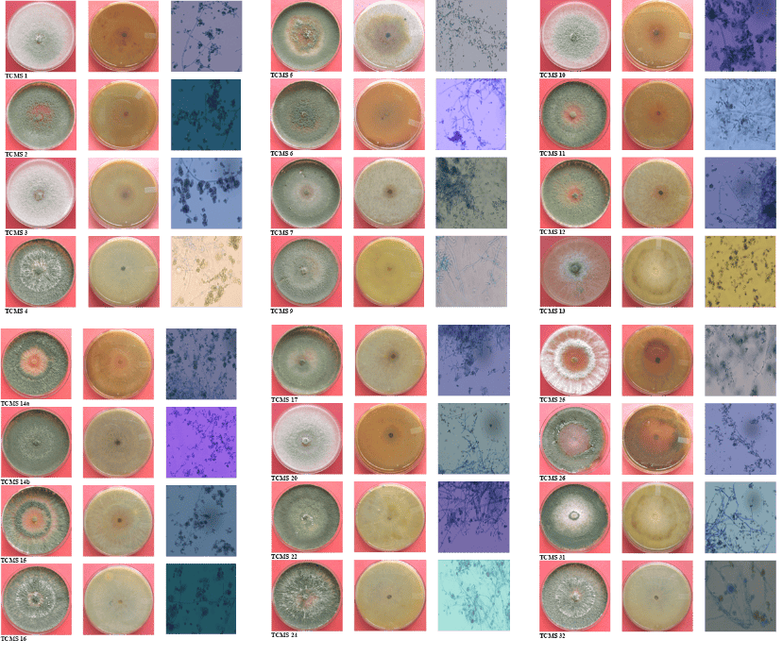

**Plate 1a. Morphological characters of Trichoderma isolate (Radial growth, pigmentation and Microscopic view of sporulation; Isolates: TCMS-1 to TCMS 32)**

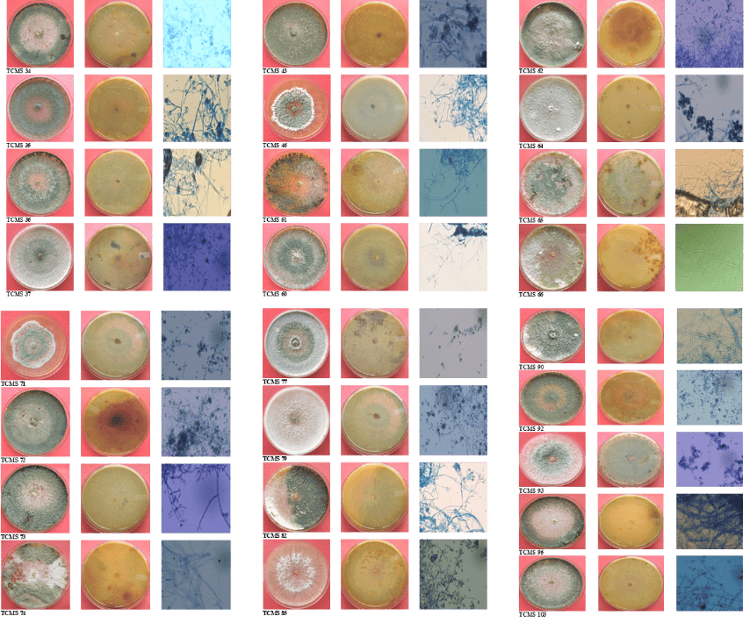

**Plate 1b. Morphological characters of Trichoderma isolate (Radial growth, pigmentation and microscopic view of sporulation; Isolates: TCMS-34 to TCMS 103)**

*Colony morphology/ surface topography*

Twenty two isolates exhibited rough, spongy and raised colony, 16 isolates exhibited smooth and flat colony topography, nine isolates were having smooth and flat colony with dense sporulation at border and two showed spongy and fluffy growth with dense sporulation at center.

*Pigmentation*

Eleven isolates produced dark brown pigmentation, four light brown, nine pinkish, 17 whitish creamy and eight yellowish green pigmentation on lower side of the culture plate.

*Spore size*

The conidiospores were oval to sub-oval, measuring 2.82 x 2.75 mm to 5.18 x 5.02 mm in diameter with a mean of 4.00 x 3.86 mm.

Similar results were reported by several earlier workers on *Trichoderma*. Mukherjee (1991) reported that, *Trichoderma* colonies usually grow rapidly, at first smooth surfaced and almost translucent or watery white, later becoming floccose or compactly tufted, of various shades of green or pure white. Pigments may be secreted into medium or the reverse of the colony remains unchanged. He differentiated *Trichoderma* spp. based on concentric rings like zones. Rifai and Webster (1966) divided *Trichoderma* into nine species aggregates on the basis of morphological features and performed morphological characterization based on the key provided by Bissett (1991 b,c), which included the characters classified under colony, mycelia and spore patterns. These characters were used as descriptors and the variation present within each descriptor was taken as descriptor states. Each isolate was scored for every descriptors based on the rank assigned to the character. Seaby (1996) considered quantitative and qualitative characters for morphological characterization to differentiate *T. viride* isolates into two clusters. Though the morphological characterization results in classifying the *Trichoderma* isolates, it can give only a broader picture. Similarly, Kiffer and Morelet (2000) also grouped different *Trichoderma* isolates based on colony colour, pigmentation, conidiophores, phialid characters, etc. Kuhls *et al.* (1997) considered variation in size and shape of conidia (2.5 to 5µ) to classify *Trichoderma* isolates.

**Conclusion**

The study was conducted for diversity analysis of Trichoderma species isolated from the copper mining areas of Uttarakhand focusing on their morphological characteristics such as colony type, morphology, colour pigmentation on the lower side of the Petri dish, spore size etc. These findings underscore the morphological variability of the Trichoderma isolates/species in taxonomic studies, providing valuable insights into the diversity of Trichoderma species, which have implications for various fields including Plant Pathology, Microbiology, Bioremediation and environmental management.

COMPETING INTERESTS DISCLAIMER:

Authors have declared that they have no known competing financial interests OR non-financial interests OR personal relationships that could have appeared to influence the work reported in this paper.

**References**

**Askew, D.J. and Lang, M.D. 1993.** An adapted selective medium for the quantitative isolation of *Trichoderma* species.*Plant Pathol.* **42**: 686-690.

**Bisset J. 1991c.** A revision of the genus *Trichoderma*. IV Additional notes on section *Longibrachitum*. *Canadian Journal of Botany* **69:** 2418-2420.

**Bisset, J. 1991a**. A revision of the genus *Trichoderma*. II. Infrageneric classification. *Canadian Journal of Botany* **69:** 2357-2372.

**Bisset, J. 1991b**. A revision of the genus *Trichoderma*. III. Section Pachybasium. *Canadian Journal of Botany* **69:** 2373-2417.

**Druzhinina, I. S.; Kopchinskiy, A. G.; Komón, M.; Bissett, J.; Szakacs, G. and Kubicek, C. P., 2005.** An oligonucleotide barcode for species identification in *Trichoderma* and *Hypocrea*, *Fungal Genet. Biol*. **42**: 813–828.

**Elad, Y. and Chet, I. 1983.** Improved media for isolation of *Trichoderma* spp. or *Fusarium* spp. *Phytoparasitica* **11** (1): 55-58.

**Gams, W. and Bisset, J. 1998.** Morphology and identification of *Trichoderma*.In *Trichoderma* and *Gliocladium*, vol. 1.Basic biology, taxonomy and genetics.Edited by G. E. Harman and C. P. Kubicek. London: Taylor and Francis. **pp**. 3-31.

**Harman, G.E. and Bjorkmann, T. 1998.** Potential and existing uses of *Trichoderma* and *Gliocladium* for plant disease control and plant growth enhancement.Edited by G. E. Harman and C. P. Kubicek. London: Taylor and Francis. *Trichoderma* and *Gliocladium*, **vol.2**.Enzymes, biological control and commercial applications, **pp**. 229–265.

**Hjeljord, L. and Tronsmo, A. 1998.** *Trichoderma* and *Gliocladium* in biological control: an overview. In *Trichoderma* and *Gliocladium*, vol. 2. Enzymes, biological control and commercial applications, Edited by G. E. Harman and C. P. Kubicek. London: Taylor and Francis. **pp:** 129-155.

**Kiffer, E. and Morelet, E. 2000.** *The Deuteromycetes Mitosporic Fungi Classification and Generic Keys.* Science Publishers. Inc. USA.

**Kuhls, K.; Lieckfeldt, E.; Samuels, G.J.; Meyer, W.; Kubicek, C.P. and Borner, T. 1997.** Revision of *Trichoderma* sect. *Longibrachiatum* including related teleomorphs based on analysis of ribosomal DNA internal transcribed spacer sequences. *Mycologia* **89:** 442-460.

**Kullnig, C.; Szakacs, G. and Kubicek, C. 2000.** Molecular identification of *Trichoderma* species from Russia, Siberia and the Himalaya. *Mycol. Res.* **104:** 1117–1125.

**Mukherjee, P.K. 1991.** Biological control of Chick-pea wilt complex, Ph. D. Thesis, G. B. Pant Univ. Agri. Tech., Pantnagar, India, **pp**: 188.

**Papavizas, G.C. and Lumsden, D. 1982.** Improved medium for isolation of *Trichoderma* spp. from soil. *Plant Dis.*, **23**: 1019-1020.

**Rifai, M.A. and Webster, J. 1966a.** Culture studies on *Hypocrea* and *Trichoderma.* II. *H. aureoviridis* and *H. rufa, F. sterilis*, *F. nov*. *Trans. Brit. mycol. Soc.* **49** (2): 289-296.

**Saha, D.K.; Sitansu, P. and Pans. 1997.** Quantitative evaluation of some specific media of *Trichoderma* and *Glioeladium* spp. *J. Mycopathol. Res.*, **35** (1): 7-13.

**Samuels G.J. 1996.** *Trichoderma*: a review of biology and systematics of the genus. *Mycological Research*. **100**: 923-935.

**Seaby, D. 1996.** Differentiation of *Trichoderma* taxa associated with mushroom production. *Plant Pathol*. **45:** 905–912**.**

**Singh, S.K.; Sharma, V.P.; Sharma, S.R., Satish Kumar and Mugdha Tiwari 2006.** Molecular characterization of *Trichoderma* taxa causing green mould disease in edible mushrooms. *Current Science* **90**(3): 427-431.