***Original Research Article***

**Microbial Diversity in the Active Slurries and Digestates of selected untreated and alkali-pretreated lignocellulose substrates for biogas production**

**ABSTRACT**

This study aimed at assessing the microbial consortia during (active slurry) and after digestion (digestates) of selected lignocellulosic substrates used in biogas production. The substrates: maize cob (MC), rice straw (RS) and water hyacinth (WH)were mechanically pretreated and the designated batches pretreated with alkali(10% NaOH) and loaded into 54 L capacity metallic batch anaerobic digesters. Codigestion was encouraged with the addition of cow rumen content (CR). The setups were allowed to run for 42 days under mesophilic conditions, while stirring daily. Samples for microbiological analysis were collected on the 28th (for active slurry) and 42nd (for digestates) days respectively. Standard analytical methods were adopted.Higher total heterotrophic counts and diversity was recorded in the digestates than in the active slurries. The bacterial isolates include: *Staphylococcus aureus*, *Enterococcus faecalis*, *Shigella sonnei*, *Bacillus cereus, Escherichia coli, Bacillus subtilis, Pseudomonas aeruginosa, Micrococcus luteus, Micrococcus roseus, Enterobacter aerogenes* and*Salmonella enteric* while the fungal isolates include: *Fusarium solani, Aspergillus niger, Saccharomyces cerevisiae* and *Penicillium notatum*. The trend of biogas generation showed maximum displacement between the 28th – 32nd days for most of the setups, with the highest yield per day (858.36 ml) recorded in MC+WH+CR+AA and the least yield (169.578 ml) in the untreated RS+CR. The slight increase in counts within the last week of digestion may be attributed to the nature of the substrates, extended hydrolysis rate and the fact that large populations of anaerobic and facultative anaerobic organisms are involved in the successive phases of anaerobic digestion.

***Keywords:*** *Lignocellulose, bacteria, fungi, active slurry, digestates, alkaline pre-treatment, biogas.*

**1. INTRODUCTION**

Anaerobic digestion is a collection of processes by which microorganisms break down biodegradable material in the absence of oxygen [11]. The process is used for industrial or domestic purposes to manage waste or to produce fuels. According to a report by Sagagi *et al*. [2]the anaerobic digestion process is divided into four stages, namely: hydrolysis, acidogenesis, acetogenesis and methanogenesis. The digestion process begins withhydrolysis of the input materials (substrates). Insoluble organic polymers, such as carbohydrates, are broken down to soluble derivatives that become available for other microorganisms. Acidogenic bacteria then convert the sugars and amino acids into carbon dioxide, hydrogen, ammonia, and organic acids. These microorganisms convert the resulting organic acids into acetic acid, along with additional ammonia, hydrogen, and carbon dioxide. Finally, methanogens convert these products to methane and carbon dioxide as recorded by Kimming *et al*. [3].

Biogas is a form of renewable energy and comprises a mixture of different gases produced by the breakdown of biomass in the absence of oxygen [1]. It can be produced from organic raw materials, such as agricultural waste, manure, municipal waste, plant material, sewage, green waste or food waste, by anaerobic digestion with methanogens or anaerobic organisms, which digest materials inside a closed system called anaerobic digester, biodigesteror a bioreactor.In biogas production, conversion of complex organic materials to methane and carbon IV oxide is achieved through the synergistic activities of microbial communities such as bacteria, fungi and some groups of protozoa[4]. Biogas production via anaerobic digestion is a viable and efficient waste-to-wealth strategy for safely managing biodegradable wastes, as well as a means of generating clean energy.

**2. MATERIALS AND METHODS**

**2.1 Biodigester Design**

Five (5) metallic anaerobic batch digesters of approximately 54 liters capacity each were locally fabricated by the Centre for Industrial Studies (CIS), FUTO as shown in Plate1 and Figure 1.

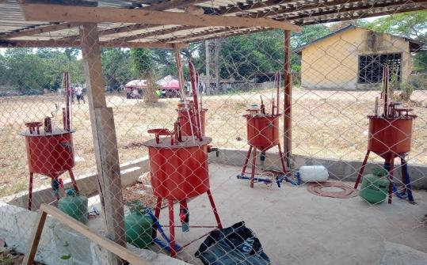

**Plate 1: Locally Fabricated Anaerobic Batch Digesters**

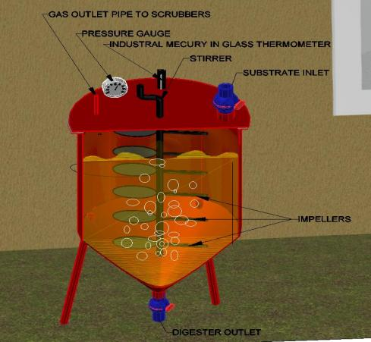

**Figure 1: A Cross-section of the Fabricated Anaerobic Batch Digester**

**2.2 Samples Collection**

The samples used as feedstock for this study weremaize cobs (MC),rice straw (RS) and water hyacinth (WH) plant (*Eichhorniacrassipes*) and were collected from World Bank and Ihiagwa markets in Owerri,OnichaUboma in Ihitte-Uboma,Imo State and River Nun in Bayelsa Staterespectivelyy, using clean sacks.

**2.3 Sample preparation and loading of Digesters**

The samples were prepared and loaded into the digesters, with a slight modification of the method described by Asikong*et al*.[5]and Sagagi*et al*.[2]. The samples were reduced in size with the aid of a surface-sterilized knife, sun-dried for 3 days, shredded, milled and stored in clean sacks. Each of the milled substrateswas weighed out in a 1:1 ratio and then mixed with potable water in a 1:20 ratio. Two (2) kg of cow rumen content was dispersed in 4 litres of potable water and added to the required setups. Separate batches were appropriately pretreated with 10 % NaOH (alkali (AP)). Each of the combinations was thoroughly mixed, transferred in the digester and the digester screwed with stoppers, to create an anaerobic environment. The content was stirred daily by means of a stirrer, while allowing retention time of 42 days.

**2.4 Sampling of Digester content for Microbiological analysis**

Samples were collected from the digesters on the 28th day (active slurry) and the 42nd day (digestates) in sterile sample bottles and immediately transported to the laboratory for analyses.

**2.5 Preparation of the Media and Diluents**

Nutrient agar (NA), Eosin Methylene Blue Agar (EMBA), *Salmonella Shigella* Agar, (SSA) and Potato Dextrose Agar (PDA),all analytical grades, were used and prepared according to the specifications of the manufacturer.

**2.6 Preparation of the Samples and Inoculation**

Tenfold serial dilution of the samples were carried out as described by Cheesbrough[6]by dispensing 1 ml each of the samples into9 ml of sterile distilled water in a test tube, up to the 7th fold and swirled vigorously. Aliquots (0.1 ml) of dilutions107,106 and 105 were inoculated on freshly prepared Nutrient Agar, Potato Dextrose Agar, Eosin Methylene Blue and *Salmonella Shigella* agars respectively, using the spread plate method and incubated for 24h at 35oC for bacteria, and for 72hand ambient temperature for fungi (on PDA).

**2.7 Determination of Microbial Population**

Colonies on the media were counted and expressed as Colony Forming Units per milliliter (CFU/ml) of the total population. The mean of three replicates of each plate was used.

**2.8 Characterization and Identification of Microbial Isolates**

Bacterial isolates were characterized based on cultural (colonial), microscopic (Gram staining, spore staining and motility tests) and biochemical methods (catalase, oxidase coagulase, sugar fermentation, hydrogen sulphide production, urease and IMVIC tests)with reference to standard manuals [6]by cross matching the identities of the isolates. Fungi were identified colonially and microscopically using the slide culture technique. Yeast isolates were identified by shapes of the cells and few biochemical tests. Molds were identified colonially by pigmentation and hyphae formation.

**2.9 Biogas Yield**

The biogas yield of each set up was determined by the method described by Asikong, Idire and Tiku [7]. The volume of biogas generated was measured daily, as an equivalent of the volume of water displaced in a manometric chamber. The manometric chamber consisted of a graduated hose, whose upper end was connected to the anaerobic digester, while the lower end was filled with coloured water and anchored to a support. Gas production was determined by the upward displacement of water in the graduated hose.

**2.10Statistical Analysis**

Statistical analysis of data was carried out using MS Excel and all data expressed as mean standarddeviation of triplicate trials.

**3. RESULTS**

The results of the microbiological evaluations are as shown in figures2 - 3, showing the following bacteria: *Staphylococcus spp, Pseudomonas spp, Shigella, Salmonella, Bacillus spp,Enterococcus spp, E-coli, Pseudomonas spp, Enterobacter spp and Micrococus spp.*

The results of the Colonial and microscopic characterization of fungal isolates revealed the presence of the following fungi:*Fusarium sp, Penicilium notatum, Saccharomyces cerevisiae, Aspergillus niger*. Microbial load and diversity appeared to be greater in the digestates than in the active slurries. This observation was recorded in both the alkali-pretreated substrates and the untreated substrates, as shown in figures 4 and 5.

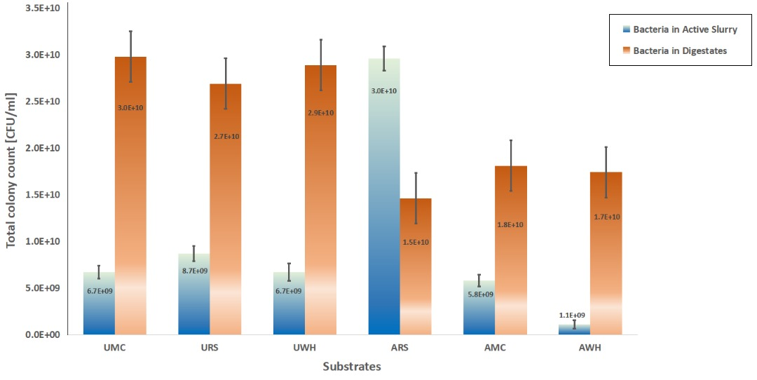

**Figure 2: Mean Total heterotrophic Count of Bacteria in Active Slurries and Digestates.**

**Legend:** UMC = untreated maize cob, URS = untreated rice straw, UWH = untreated water hyacinth, ARS = alkali-treated rice straw, AMC = alkali-treated maize cob and AWH = alkali-treated water hyacinth

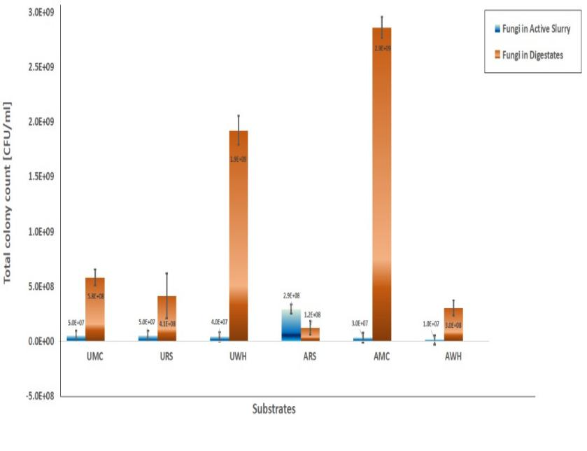

**Figure 3: Mean Total Heterotrophic Count of Fungi in Active Slurries and Digestates.**

**Legend:** UMC = untreated maize cob, URS = untreated rice straw, UWH = untreated water hyacinth, ARS = alkali-treated rice straw, AMC = alkali-treated maize cob and AWH = alkali-treated water hyacinth

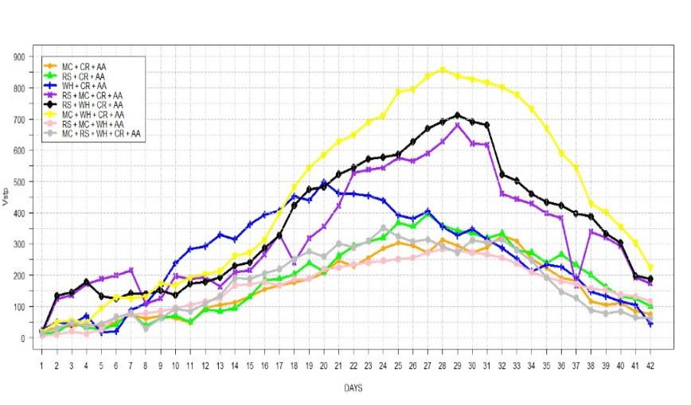

**Figure 4: Daily Biogas Yield of the Alkali-pretreated substrate combinations**

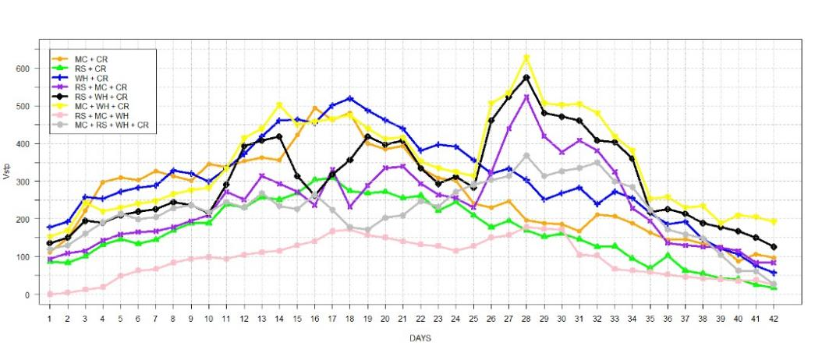

**Figure 5: Daily Biogas Yield of the untreated substrate combinations**

**4. DISCUSSION**

There is wide microbial diversity in anaerobic digesters which either act alone or in synergy, to achieve high yield. The microbial species play a crucial role in biogas production and are substrate-specific [8]. The findings in this study agree with the reports of Asikong *etal*. [7] who reported the presence of the following genera of bacteria: *Pseudomonas sp, Escherichia sp, Bacillus sp, Salmonella sp, Staphylococcus sp, Shigella sp,* and *Micrococcus* sp,whilefungi isolated were reported as *Fusarium sp, Mucor sp*and *Penicillium* sp. However, they did not report on*Aspergillus niger*and *Saccharomyces cerevisiae*, as reported in this study.

Results of the total heterotrophic counts in the untreated and alkali-pretreated lone substrates, during and after anaerobic digestion showed a variation in the anaerobic bacterial and fungal counts, as biodigestion progressed. The counts slightly increased within the last weeksof digestion. This increase in microbial load of the digestates may be because large populations of anaerobic and facultative anaerobic organisms are usually involved in the successivephases of anaerobic digestion [9]. This could alsobe attributed to the nature of the substrates (in this case, lignocellulose) fed into the digester, as it obviously determines the type and extent of fermentative bacteria and fungi present in the digester and the subsequent biogas yield [10]. There may have been an extended hydrolysis rate, responsible for availing the microorganisms of the necessary nutritional requirements, for growth and multiplication. Different substratescontain varying amounts of nutrients, which the microbes feed on and this could also be another underlying reason for the microbial counts during and after digestion, as recorded.

Results obtained from this study also showed that some genera of bacteria such as *Bacillus sp, Staphylococcus sp, Enterococcussp, Pseudomonas sp, Micrococcus* spand fungi such as*Fusariumsp, Penicilliumsp, Saccharomyces spand Aspergillus*spextended from one phase of the digestion to another, suggesting microbial succession during the anaerobic digestion process.

The main objective of pretreatment is to alter the structure of the holocellulose and avail it for bioconversion.Mechanical pretreatment (shredding, grinding, milling, crushing, etc.) to reduce particle size, thereby increasing surface area, improves biogas yieldupto 83 % [11]. It is a suitable procedure to be adopted in the first instance, and then subsequently combined with other pretreatment methods, to achieve a greater improvement in biogas yield. In the untreated set up, Wwater hyacinth (WH+CR) showed the best biogas yield of upto 303.565 ml per day on the 28th day, followed by maize cobs (196.794 ml) and lastly, rice straw (169.578 ml). However, in the alkali pre-treated setup, the highest biogas volume (498.265 ml) was recorded on the 20th day. The best biogas yield of 858.36 ml was recorded on the 28th day, in the alkali pre-treated combination of maize cob, water hyacinth and cow rumen content, followed by its counterpart in the untreated (628.07 ml per day). Lower yields (282.63 ml per day in AA and 177 ml per day in the untreated) were recorded in the composites without cow rumen content. This trend could be attributed to the percentage lignin content and particle size of each of the substrates.

**5. CONCLUSION**

A wide range of microbial consortia are implicated in the process of anaerobic digestion which entails successive stages. Successful anaerobic biodegradation of lignocellulosic wastes, which can be achieved through codigestion and adequate pretreatment strategies such as alkaline pre-treatment, improve biogas yield and quality. This is because the breakdown releases the monomeric units of the biopolymers, making such macro and micronutrients available and accessible to the relevant microbial consortia, majorly facultative anaerobic bacteria and fungi. During anaerobic digestion of lignocellulose substrates, the microbial load and diversity in the digestates appear higher than in the active slurries and certain microbial species extend from one stage of anaerobic digestion to another.

## COMPETING INTERESTS

Authors have declared that no competing interests exist.

**REFERENCES**

1. National Non-food Crops Centre (NNFCC). Anaerobic digestion. 2011

2. Sagagi B, Graba B, Usman, N. Studies on Biogas Production from Fruits and vegetable wastes. Bayero Journal of Pure and Applied Science. 2005;2:115-118.

3. Kimming M., Sundberg C, Nordberg A, Baky A, Bernesson S,Noren O. Biomass from agriculture in small-scale combined heat and power plants – A comparative life cycle assessment. Biomass and Bioenergy. 2011;35:1572–81.

4. Garcia J, Patel B, Olivier B. Taxonomic, Phlogenic and Ecological Diversity of Methanogenic Archae. Anaerobes. 2000;6:105-226

5. Asikong BE, Agbo B, Antai, E, Eja M. Four potentials of biogas yield from cow dung-CD. European Journal of Experimental Biology. 2013;3(3):273-282.

6. Cheesebrough M. District Laboratory Practice in Tropical Countries. Part 2, Cambridge University Press, UK. 2000;35-38, 62-69.

7. Asikong BE, Idire SO, Tiku DR. Microorganisms associated with biogas production with vegetable (Telfairia occidentalis) wastes, banana peel and pig dung as substrates. British Microbiological Research Journal. 2016;16(3):1-12.

8. Asikong BE. Microbial analysis and biogas yield of water hyacinth, cow dung and poultry dropping fed anaerobic digesters. Current Journal of Applied Science and Technology. 2014;4(4):650-661.

9. Nand K., Viswanath P., Devi S.S. Anaerobic Digestion of Fruit and Vegetable Processing Wastes for Biogas Production. Bioresource Technology 1992;40:43-48.

10. Nagamani, A, Manoharachary, C, Kunwar, I.K. Handbook of soil fungi. 2006;496.

11. Hernandez-beltran, JU, Hernandez-delira, IO, Cruz-santos, MM, Saucede-luevanos, A, Hernandez-teran, F, Balagurusamy, N. Insight into pretreatment methods of lignocellulosic biomass to increase biogas yield: current state, challenges and opportunities. Applied Sciences. 2019;9: 3721. Doi: 10.3390/app9183721