Unveiling the Future Artificial Intelligence in Prosthodontics: A Questionnaire-Based Study

ABSTRACT

Background:
Artificial Intelligence (AI) has emerged as a transformative technology in healthcare, offering innovative solutions for diagnosis, treatment planning, and patient management. In dentistry, particularly prosthodontics, AI applications are expanding—from designing prostheses and predicting treatment outcomes to automating diagnostic processes. Despite these advancements, the successful integration of AI into clinical workflows depends largely on the awareness, understanding, and acceptance of dental professionals. Evaluating their perceptions helps identify knowledge gaps, address concerns, and shape educational strategies for future adoption.

Objective:
This study aimed to evaluate the level of awareness, perception, and current usage of AI in prosthodontics among dental students and practitioners, as well as to identify perceived benefits, limitations, and potential barriers to its integration into routine practice.

Methods:
A cross-sectional survey was conducted using a structured online questionnaire comprising nine questions covering AI awareness, clinical application, perceived benefits, challenges, and ethical considerations. The survey link was distributed to dental students, interns, and practicing dentists through professional networks and social media platforms. Responses were collected anonymously, and the data were analyzed using descriptive statistical methods to summarize trends and patterns.

Results:
A total of 201 dental professionals participated. While 80.1% reported having a basic understanding of AI, only 2.5% demonstrated in-depth knowledge of its applications in prosthodontics. Clinical adoption was relatively low, with 30.9% reporting some usage of AI-assisted tools, whereas 39.8% had not used AI at all in their practice. Nevertheless, 59.2% of respondents considered AI a viable adjunct or alternative in prosthodontic treatment, and 74.6% agreed that AI could enhance clinical decision-making and efficiency.

Opinions were divided on whether AI could surpass human intelligence, reflecting both optimism and skepticism. Patient acceptance was considered likely by 55.7% of participants, though 58.7% expressed concerns about data privacy and security. Furthermore, 72.2% anticipated that AI integration would influence treatment costs, with varying views on whether the impact would be positive or negative.

Conclusion:
The study revealed that while general awareness of AI among dental professionals is relatively high, specific knowledge of its applications in prosthodontics remains limited, and actual clinical usage is modest. Positive perceptions toward AI’s potential benefits coexist with notable concerns regarding privacy, cost, and ethical implications. These findings highlight the need for targeted educational initiatives, hands-on training, and policy frameworks to facilitate the safe, effective, and ethical integration of AI into prosthodontic practice.

Keywords: Artificial Intelligence, Prosthodontics, Awareness, Perception, Privacy, Cost.

INTRODUCTION

Artificial intelligence (AI) was developed by humans as a means to replicate human behavior and enhance human experiences.Advancements in computing power, big data analytics, and machine learning in the 21st century have collectively driven the integration of artificial intelligence (AI) into diverse medical specialties, establishing it as an indispensable tool in modern dentistry over the past two decades(1)

The term "artificial intelligence" was first introduced in 1955 by mathematician John McCarthy. (2,3) Artificial Intelligence (AI) refers to computer systems that mimic human cognitive functions such as learning and decision-making. In dentistry, particularly prosthodontics,Dental practices produce large amounts of data, making them ideal for AI integration. AI aids in diagnosis, decision-making, treatment planning, and outcome prediction, with accurate diagnosis being one of its key strengths in dentistry (4,5)

The majority of AI applications rely on machine learning (ML), a method in which algorithms are trained to detect statistical patterns in data and use them for prediction. Within ML, deep learning (DL) represents a specialized approach that employs multi-layered convolutional neural networks (CNNs) with intricate architectures. These DL models often demonstrate superior performance compared to conventional ML techniques, particularly in identifying patterns within large and varied datasets ( 6,12)

In dentistry, AI is being utilized to boost diagnostic precision, optimize treatment planning, and increase efficiency in clinical procedures. Through the analysis of radiographic images, AI systems can identify dental caries, periodontal conditions, and other oral diseases at early stages—sometimes before they are

detectable through conventional examination—thereby supporting timely intervention and better patient outcomes (6,12,16)

However, the clinical utility and technological advancement of AI in prosthodontics are still not fully established. Therefore, it is essential to conduct thorough assessments of AI models designed for prosthodontic applications, focusing on their development, effectiveness, and inherent limitations (12).

Although research on AI in prosthodontics has grown rapidly in recent years, there is still a significant gap in fully understanding and evaluating its effectiveness in performing specific prosthodontic tasks.
Applications of AI in this field span a wide range, including identifying the finishing line in tooth preparations, predicting facial changes in patients with removable prostheses, generating automated tooth morphology designs, selecting appropriate tooth shades, simulating the casting process, and designing removable partial dentures.(13)

This study aimed to evaluate the awareness, perceptions, and perceived challenges of AI integration in prosthodontics among dental students and practitioners using a questionnaire-based survey.

MATERIALS AND METHOD

Study design and duration

The present descriptive, cross-sectional study was conducted to assess the knowledge, awareness, and attitude of general dental practitioners toward the use of AI in prosthodontics. The study was carried out over a period of two months from April to june 2025. The study was conducted and reported according to STROBE guidelines.

2.2 Survey Instrument

A structured questionnaire with 9 closed-ended questions was designed to assess awareness, perceived feasibility, patient acceptance, concerns regarding AI, and potential impact on cost and clinical workflow. The questions were:

- Do you have any idea about Artificial Intelligence?
- Are you aware about the applications of AI in Prosthodontics?
- Do you use AI in clinical practice?
- Do you think AI is feasible over conventional procedures?
- Do you think AI can assist the clinician in various procedures?
- Do you think AI can overpower human intelligence?
- Do you think patients will accept procedures through AI?

- Do you think AI can be a threat to patient privacy?
- Do you think AI assistance in clinical practice will affect the conventional costing?

The questionnaire was validated by prosthodontic faculty members for clarity and relevance.

2.3. Study population and eligibility criteria

The study focused on general dental practitioners in Maharashtra, India, holding a BDS degree or higher and actively involved in clinical practice. This included private practitioners, consultants, teaching faculty, and postgraduate trainees engaged in practice. Exclusions included those outside Maharashtra, students, interns, non-practicing professionals, and incomplete or duplicate responses

2.4. Questionnaire development and validation

A self-administered 9-item questionnaire was developed based on a literature review on artificial intelligence (AI) in prosthodontics. It covered five domains: demographics, theoretical knowledge, clinical experience, practitioner attitude, and sources of awareness. Questions explored familiarity with AI applications, clinical use, perceived challenges, and willingness to adopt AI in prosthodontic practice Content validity of the questionnaire was assessed by a panel of five senior academicians from the fields of prosthodontics and dental technology. Suggestions were incorporated to improve relevance, clarity, and structure.

Questionnaire administration and data collection

The validated questionnaire was created in Google Forms and shared via WhatsApp, email, and social media, with snowball sampling encouraged. A preamble explained the study, ensured confidentiality, and included informed consent. The survey ran for four weeks. Data were analyzed using Excel and SPSS v25, with incomplete, inconsistent, out-of-state, and duplicate responses excluded.

Sampling technique and sample size

Purposive sampling was employed to ensure maximum reach across various regions of Maharashtra, including urban, semi-urban, and rural areas. Although no formal sample size calculation was conducted due to the exploratory nature of the study, efforts were made to ensure inclusion of practitioners from different clinical settings and experience levels. A total of 212 responses were received during the data collection period, out of which 201 complete and valid responses were included in the final analysis.

Data management and statistical analysis

Data collected via Google Forms were exported into Microsoft Excel 2016 for initial cleaning and coding. Final statistical analysis was performed using the Statistical Package for the Social Sciences (SPSS) version 25.0 (IBM Corporation, Armonk, NY, USA).

RESULTS :

Do you have any idea about Artificial Intelligence?

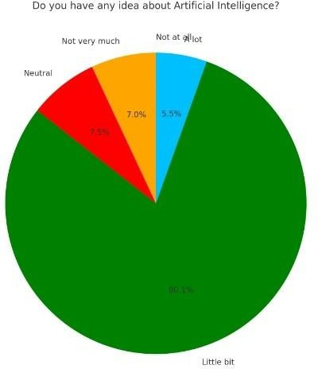
Response | N | %
Not at all | 0 | 0
Not very much | 14 | 7
Neutral | 15 | 7.5
Little bit | 161 | 80.1
A lot | 11 | 5.5

Figure 1 .Percentage wise distribution of Idea about artificial intelligence
Table 1 .Percentage wise distribution of Idea about artificial intelligence
A vast majority (80.1%) have a little bit of understanding about AI, suggesting a basic awareness. Only 5.5% claimed in-depth knowledge (code 5), while no one reported having no idea about AI. This reflects a moderate familiarity among respondents with the concept, with room for deeper educational outreach.

Are you aware about the applications of AI in Prosthodontics?
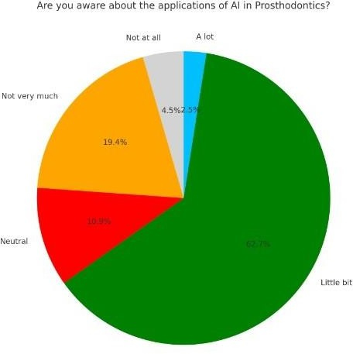
Response | N | %
Not at all | 9 | 4.5
Not very much | 39 | 19.4
Neutral | 22 | 10.9
Little bit | 126 | 62.7
A lot | 5 | 2.5

Figure 2 .Percentage wise distribution of awareness of applications of AI
Table 2 .Percentage wise distribution of awareness of applications of AI

About 62.7% selected little bit, indicating partial awareness of AI applications in prosthodontics. Only 2.5% reported high awareness, while a combined 23.9% (code 1 and 2) indicated minimal or no awareness. This highlights the need for more focused education and training in this area.

Do you use AI in clinical practice ?
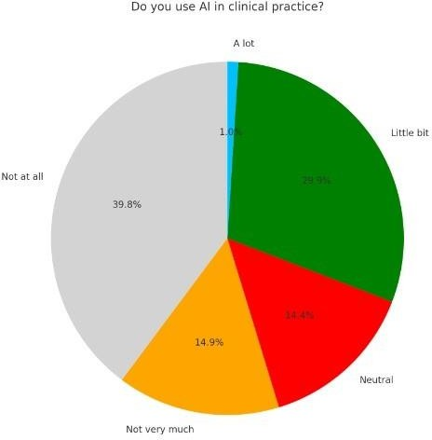
Response | N | %
Not at all | 80 | 39.8
Not very much | 30 | 14.9
Neutral | 29 | 14.4
Little bit | 60 | 29.9
A lot | 2 | 1

Figure 3 .Percentage wise distribution of awareness of AI in clinical practice
TABLE 3 .Percentage wise distribution of awareness of AI in clinical practice

Only 30.9% (code 4 and 5) use AI to any extent in practice, while 39.8% do not use it at all. This reflects low integration of AI tools into clinical workflows, possibly due to limited availability, training, or trust.

Do you think AI is feasible over conventional procedures?

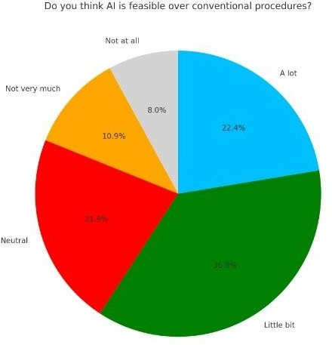
Response | N | %
Not at all | 16 | 8
Not very much | 22 | 10.9
Neutral | 44 | 21.9
Little bit | 74 | 36.8
A lot | 45 | 22.4

Figure 4 .Percentage wise distribution of responses regarding feasibility
Table 4. .Percentage wise distribution of responses regarding feasibility

A majority (59.2%) lean toward AI feasibility (codes 4 and 5). Only 18.9% disagree (codes 1 and 2), and 21.9% remained neutral. Overall, the results indicate a positive perception of AI’s feasibility in clinical settings.

Do you think AI can assist the clinician in various procedures?

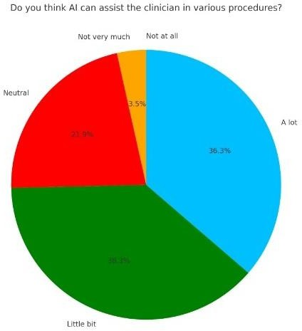
Response | N | %
Not at all | 0 | 0
Not very much | 7 | 3.5
Neutral | 44 | 21.9
Little bit | 77 | 38.3
A lot | 73 | 36.3

Figure 5. Percentage wise distribution of responses regarding assistance
Table 5..Percentage wise distribution of responses regarding assistance

An overwhelming 74.6% believe AI can assist clinicians (codes 4 and 5), with no one outright denying its role. This reflects a strong consensus that AI can enhance clinical capabilities.

Do you think AI can overpower Human Intelligence?

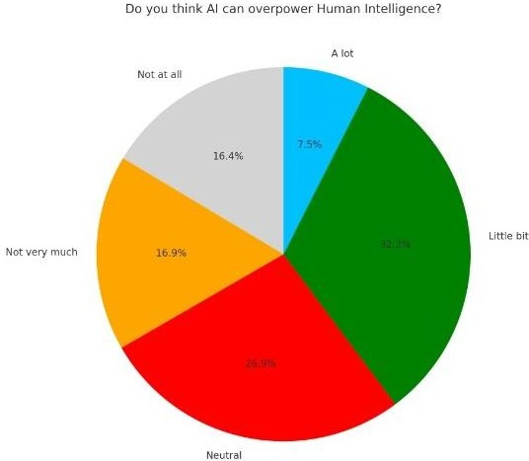
Response | N | %
Not at all | 33 | 16.4
Not very much | 34 | 16.9
Neutral | 54 | 26.9
Little bit | 65 | 32.3
A lot | 15 | 7.5

Figure 6. Percentage wise distribution of responses of prosthodontist regarding assuming overpowering of AI
Table 6. Percentage wise distribution of responses of prosthodontist regarding assuming overpowering of AI

Opinions are divided, with about 39.3% leaning toward AI potentially overpowering human intelligence (codes 4 and 5), while 33.3% disagreed. The 26.9% neutrality indicates ongoing uncertainty, showing this is a controversial topic among respondent.

Do you think patients will accept procedures through AI?
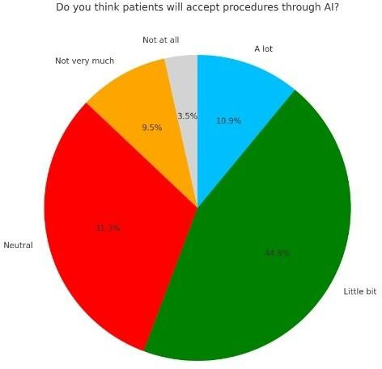
Response | N | %
Not at all | 7 | 3.5
Not very much | 19 | 9.5
Neutral | 63 | 31.3
Little bit | 90 | 44.8
A lot | 22 | 10.9

Figure 7. Percentage wise distribution of responses of prosthodontist regarding patient acceptance
Table 7 Percentage wise distribution of responses of prosthodontist regarding patient acceptance
A majority (55.7%) believe patients may accept AI-assisted procedures to some extent. However, 31.3% remain neutral, and 13% express doubt. These findings suggest moderate optimism toward patient acceptance.

Do you think AI can be a threat to patients privacy?

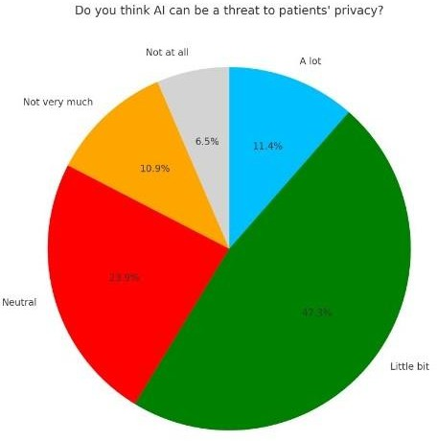
Response | N | %
Not at all | 13 | 6.5
Not very much | 22 | 10.9
Neutral | 48 | 23.9
Little bit | 95 | 47.3
A lot | 23 | 11.4

Figure 8. Percentage wise distribution of responses of prosthodontist regarding threat to privacy
Table 8. Percentage wise distribution of responses of prosthodontist regarding threat to privacy

58.7% (codes 4 and 5) feel AI could be a potential privacy threat, while 17.4% disagree and 23.9% are uncertain. This shows a high level of concern, underlining the importance of data protection frameworks in AI deployment.

Do you think AI assistance in clinical practice will affect the conventional costing?

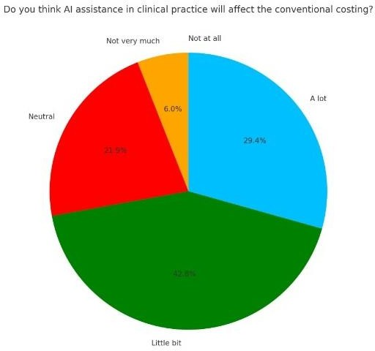
Response | N | %
Not at all | 0 | 0
Not very much | 12 | 6
Neutral | 44 | 21.9
Little bit | 86 | 42.8
A lot | 59 | 29.4

Figure 9. Percentage wise distribution of responses of prosthodontist regarding costing
Table 9. Percentage wise distribution of responses of prosthodontist regarding costing

An overwhelming 72.2% (codes 4 and 5) believe AI will impact treatment costs. With no respondents choosing "Not at all," this reflects broad agreement that AI is likely to influence the economic aspects of clinical care.

DISCUSSION

The main goal of prosthodontics is to deliver high-quality removable and fixed prostheses. The integration of CAD/CAM technology with 3D digital workflows has transformed dental practice. Intraoral scans are used to design and produce restorations such as inlays, onlays, crowns, and bridges through digital fabrication(7,8). This approach conserves time, resources, and effort for both prosthodontists and patients while also minimizing the risk of human error in the final prosthesis (9,10)

Like any emerging technology, artificial intelligence (AI) comes with certain limitations and challenges. Its complex nature makes it difficult to fully comprehend, and its capacity to adapt and modify its behavior autonomously raises additional concerns (9,4)

The findings of this study reveal important insights into the awareness, acceptance, and perception of Artificial Intelligence (AI) in prosthodontics among dental professionals.

While 80.1% of respondents had a basic understanding of AI, only 2.5% were well-informed about its use in prosthodontics, and 62.7% had limited knowledge. This reveals a clear gap between general and domain-specific awareness, emphasizing the need for focused education and training.

Only 30.9% of participants reported using AI in practice, while 39.8% did not use it at all—likely due to limited training, access, or confidence. However, 59.2% viewed AI as a feasible addition or alternative to traditional methods, showing promising perceptions.

A strong majority (74.6%) believed AI could improve clinical practice, indicating growing trust despite limited use. However, views on AI surpassing human intelligence were divided: 39.8% agreed, 33.3% disagreed, and 26.9% were uncertain, highlighting ongoing debate.

About 55.7% believe patients may accept AI-assisted treatments, while 31.3% are unsure, indicating cautious optimism and a need for better patient education on AI’s role in care

On the other hand, concerns about data security were prevalent, with 58.7% expressing apprehension about AI posing a threat to patient privacy. This underscores the importance of robust ethical and legal frameworks to safeguard patient data in an AI-integrated clinical environment.

Lastly, economic considerations were clearly acknowledged, with 72.2% of participants indicating that AI could impact the cost of dental treatments. The absence of responses in the “Not at all” category further reinforces the general belief that AI will influence the financial dynamics of clinical prosthodontics

The clinical use and technological advancement of AI in prosthodontics are still uncertain. Therefore, it is essential to thoroughly assess the development, effectiveness, and limitations of AI models designed for prosthodontic applications (12)

Incorporating AI into current clinical workflows poses multiple challenges. Dental practitioners may resist change, and doubts about the reliability of AI-generated recommendations can further slow its acceptance(14). Additionally, the absence of standardized guidelines for AI implementation in clinical practice presents a significant challenge for practitioners worldwide (15)

AI offers significant potential in dental care by enabling rapid and accurate data analysis. This capability can enhance the efficiency of clinical services by supporting dentists in decision-making and reducing the time required to interpret clinical information. As a result, AI can serve as a valuable decision-support system, especially beneficial for practitioners with limited experience.(16,17)

The integration of AI and digital technologies into an updated dental curriculum is approaching, aiming to prepare students with the skills needed for an AI-driven clinical environment. This advancement should also extend to ongoing professional development for practicing dentists (12,18)

CONCLUSION

The study highlights a growing awareness and cautiously positive perception of AI in prosthodontics. However, actual clinical use remains low, and significant concerns regarding privacy, cost, and the role of AI in clinical decision-making persist. Integrating AI-focused modules into dental education, ensuring data privacy, and providing clinical training may facilitate wider and safer adoption of AI technologies in prosthodontic practice.

REFERENCES –

  - Ding, H.; Wu, J.; Zhao, W.; Matinlinna, J.P.; Burrow, M.F.; Tsoi, J.K.H. Artificial Intelligence in Dentistry—A Review. Front. Dent. Med. 2023, 4, 1085251
  - McCarthy J. Dordrecht: Springer Netherlands. 1989:161. [http://www-formal.stanford.edu/jmc/1990]
  - Al Hendi KD, Alyami MH, Alkahtany M, Dwivedi A, Alsaqour HG. Artificial intelligence in prosthodontics. Bioinformation. 2024 Mar 31;20(3):238-242. doi: 10.6026/973206300200238. PMID: 38712003; PMCID: PMC11069608.
  - Schleyer TK et al. J Am Med Inform Assoc.2006 3:344. [PMID: 16501177]
  - Meyer P et al. Comput Biol Med. 2018 98:126. [PMID: 29787940]
  - Castiglioni, I.; Rundo, L.; Codari, M.; Di Leo, G.; Salvatore, C.; Interlenghi, M.; Gallivanone, F.; Cozzi, A.; D’Amico, N.C.; Sardanelli, F. AI applications to medical images: From machine learning to deep learning. Phys. Medica 2021, 83, 9–24.
  - Abouzeid HL et al. Oral Health Prev Dent. 2021 1:353. [PMID: 34259428]
  - Alexander B et al. Int J Adv Res. 2018 12:1105. [10.21474/IJAR01/8242]
  - Van der Meer WJ et al. PLoS One. 2012 8:e43312. [PMID: 22937030]
  - Hammond P et al. Artif Intell Med. 1993 5:431. [PMID: 8004143]
  - Khan B et al. Biomed Mater Devices. 2023 8:1. [PMID: 36785697]
  - Iosif, L.; T, âncu, A.M.C.; Amza, O.E.; Gheorghe, G.F.; Dimitriu, B.; Imre, M. AI in Prosthodontics: A Narrative Review Bridging Established Knowledge and Innovation Gaps Across Regions and Emerging Frontiers. Prosthesis 2024, 6, 1281–1299. https://doi.org/10.3390/ prosthesis6060092
  - Li H, Lai L, Chen L, et al. The prediction in computer color matching of dentistry based on GA+BP neural network. Comput Math Methods Med. 2015;2015:816719
  - Pareek, M.; Kaushik, B. Artificial Intelligence in Prosthodontics: A Scoping Review on Current Applications and Future Possibilities. Int. J. Adv. Med. 2022, 9, 367.

  - Karnik, A.P.; Chhajer, H.; Venkatesh, S.B. Transforming Prosthodontics and Oral Implantology Using Robotics and Artificial Intelligence. Front. Oral Health 2024, 5, 1442100.
  - Eto N, Yamazoe J, Tsuji A, et al. Development of an artificial intelligencebased algorithm to classify images acquired with an intraoral scanner of individual molar teeth into three categories. PLoS One. 2022;17(1):e0261870 18.
  - Takahashi T, Nozaki K, Gonda T, et al. A system for designing removable partial dentures using artificial intelligence. Part 1. Classification of partially edentulous arches using a convolutional neural network. J Prosthodont Res. 2021;65(1):115-18
  - Costin, L.I.; Vasluianu, R.I.; Baciu, R.-E.; Agop-Forna, D.; Cătălin, T.S.; Forna, C.N. The Integration of Artificial Intelligence in Dental Practice. Rom. J. Oral Rehabil. 2023, 2, 272–279.
  - Allani, H.; Santos, A.T.; Ribeiro-Vidal, H. Multidisciplinary Applications of AI in Dentistry: Bibliometric Review. Appl. Sci. 2024, 14, 7624

