Original Research Article

DUS Characterization of Elite Soybean (Glycine max (L.) Merrill) Lines for Breeding and Varietal Differentiation

ABSTRACT
Soybean (Glycine max L.) is a globally important legume crop valued for its protein-rich seeds and agronomic versatility. This study aimed to characterize 55 soybean genotypes using Distinctness, Uniformity, and Stability (DUS) descriptors to assess morphological diversity and identify traits relevant for breeding and varietal registration. Genotypes were evaluated for hypocotyl pigmentation, leaf morphology, pod pubescence and color, and seed attributes under field conditions. High-polymorphism traits such as anthocyanin pigmentation, leaflet shape, and pod pubescence showed significant variation, offering reliable markers for parent selection and varietal differentiation. Growth habit was predominantly indeterminate, with limited representation of determinate types. Seed trait analysis revealed that 98.2% of genotypes had medium-sized seeds (10.1–13.0 g/100 seeds), and 70.9% exhibited spherical seed shapes were preferred for uniformity and processing. Yellow seed coats were dominant (94.5%), with 78.2% showing shiny lustre, enhancing market appeal and storability. Hilum color was predominantly black (70.9%), aiding in varietal classification. The observed uniformity in seed size and growth habit reflects current selection trends, while the diversity in pigmentation and pubescence traits highlights untapped genetic variation. These findings support targeted hybridization and molecular mapping strategies for soybean improvement. Incorporating large-seeded and determinate-growth genotypes could broaden the breeding base and enhance adaptability. Breeding programs should integrate high-polymorphism morphological traits with market-preferred seed characteristics to develop resilient, high-yielding cultivars suited for diverse agro-climatic zones.
Keywords: soybean Morphological variation, pod colour, grain size
Introduction
Soybean (Glycine max (L.) Merrill) is one of the most important legume crops globally. Often referred to as a “wonder crop,” it is celebrated for its versatility, nutritional richness, and economic significance. Commonly known as the golden bean, super legume, or miracle bean, soybean offers high protein content (36.1- 41.2%), substantial edible oil yield (16.8–20.2%), and a range of essential minerals, amino acids, vitamins (A, B, C, and D), and antioxidants (Amrate et al. 2020; Banerjee et al. 2023).
Globally, Brazil leads in soybean cultivation with 39.17 million hectares, followed by the United States, Argentina, China, and India. In India, soybean ranks as the third most cultivated oilseed crop, covering approximately 12.1 million hectares (Amrate, 2024). The crop originated in East Asia, particularly Central China, and is grown during the kharif season. It belongs to the family Fabaceae and subfamily Papilionaceae (Mehra et al. 2020; Upadhyay et al. 2022). The genus Glycine includes around 30 species, with two annual species under the subgenus Soja: Glycine max (cultivated soybean) and Glycine soja (wild soybean). While Glycine max is widely cultivated for its oil and protein, G. soja retains primitive traits such as twining growth habit, small black seeds, and hard seed coats (Hymowitz and Singh 1987).
Indian soybean cultivars exhibit limited genetic diversity, which poses challenges for crop improvement (Agarwal et al. 2013; Mehra et al. 2020). Characterizing soybean genotypes is essential for enhancing performance and expanding the genetic base (Banerjee et al. 2022). Germplasm serves as the cornerstone of breeding programs, providing the raw material for developing improved varieties. The primary goal of plant breeding is to enhance specific traits by creating new genotypes from existing genetic resources (Mishra et al. 2024d). This requires the collection and evaluation of germplasm based on morphological traits.
Morphological characterization, guided by the Distinctiveness, Uniformity, and Stability (DUS) criteria under the Protection of Plant Varieties and Farmers’ Rights Act (2001), remains a fundamental approach for assessing genetic diversity (Upadhyay et al. 2022; Ramteke et al. 2012). It offers a cost-effective and practical method for evaluating phenotypic traits (Govindaraj et al. 2015). Studying morphological variation among soybean genotypes provides valuable insights for targeted selection and breeding strategies (Asati et al. 2023; Yadav et al. 2023; Salgotra & Chauhan, 2023). In this context, the present study aims to classify soybean genotypes based on their morphological traits to support breeding programs focused on developing improved varieties.
Materials and Methods
The experiment was conducted during the Kharif 2023 and Kharif 2024 at the Seed Breeding Farm, Jawaharlal Nehru Krishi Vishwa Vidyalaya (JNKVV), Jabalpur. Jabalpur, in eastern Madhya Pradesh, lies within the Satpura Plateau agro-climatic zone, between 23.10˚–23.25˚ N latitude and 79.55˚–80.05˚ E longitude. The region has a subtropical climate with seasonal variation. During Kharif, temperatures range from 24.5°C to 36.8°C, and annual rainfall averages ~1,200 mm, mostly from June to September. The experimental site featured deep black cotton soil (Vertisols) with high moisture retention and fertility. These conditions supported optimal soybean growth and reliable expression of morphological traits. A total of 55 elite soybean genotypes were evaluated using a randomized complete block design (RCBD) with three replications. Each genotype was sown in 2 meter long rows, with a row-to-row spacing of 45 cm and plant-to-plant spacing of 7-8 cm. Five widely cultivated varieties namely; JS 20-98, JS 20-34, JS 20-69, JS 335 and JS 20-116-were included as checks.
Morphological data were recorded from whole plot of each genotype. Observations for fifteen traits were taken at physiological maturity or different stages when the complete expression of characters was observed (Table 1). The genotypes were characterized for following characters: Hypocotyl pigmentation; Growth type; Growth habit; Leaf shape; Leaf size; Intensity of green color in leaves; Flower color; Pod pubescence; Pod pubescence color; Pod color; Seed size; Seed shape; Seed coat color; Hilum color; Seed coat lustre. These traits were selected based on their relevance to phenotypic variability and potential utility in soybean breeding programs, as described in previous studies (Upadhyay et al. 2022; Banerjee et al. 2022).
Results and Discussion
A total of 55 soybean genotypes were evaluated for fifteen morphological traits under DUS guidelines (Table 1). Substantial phenotypic variation was observed across hypocotyl pigmentation, growth type and habit, flower and leaf traits, pod characteristics and seed morphology indicating a rich pool of genetic diversity suitable for breeding programs.
Variation for Hypocotyl Pigmentation
Out of 55 genotypes, 24 (43.6%) exhibited anthocyanin pigmentation in the hypocotyl, showing purplish coloration, while 31 genotypes had green hypocotyls (Figure 1). This trait is governed by the W1 locus and is linked to flavonoid biosynthesis pathways, particularly malvidin derivatives (Murai et al. 2016). Anthocyanin-rich hypocotyls are associated with enhanced seedling vigor and stress tolerance, making them valuable for early-stage resilience breeding.
Similar results for variation in pigmentation on hypocotyl are also reported by Upadhyay et al. 2022 in exotic germplasm of soybean, among the studied genotypes colored hypocotyl was predominant.
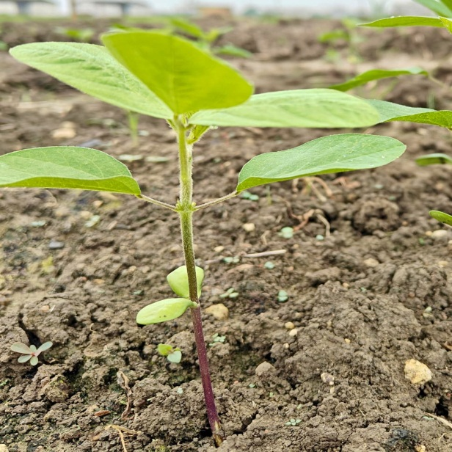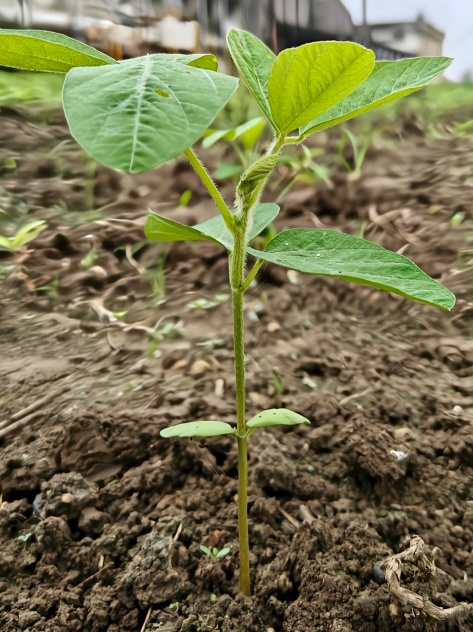
Figure 1 a) Pigment present ; b) Pigment absent

Growth Type and Habit

Semi-determinate growth type and semi-erect growth habit was observed in all 54 genotypes (98.2%). These traits are agronomically desirable for lodging resistance and compatibility with mechanized harvesting (Kim et al 2022). The predominance of semi-determinate architecture reflects breeder selection for adaptability and yield optimization.
Upadhyay et al. 2022 studied forty-eight exotic genotypes of soybean observed that 47 genotypes had semi-determinate growth types. For growth habit traits semi-erect growth habit was predominant. Barela et al. (2022) and Jhariya et al. (2025) also studied soybean germplasm and results showed semi-determinate growth types as well as semierect growth habit characters are predominant.

Flower color types

Violet flowers were present in 24 genotypes, while 31 genotypes had white flowers (Figure 2). Flower colour is a stable varietal marker controlled by loci such as W1 and W47 (Sundaramoorthy et al. 2015). Its utility in varietal identification and purity assessment is well documented.
Akin result for variation in flower colour were also recorded by Dhaliwal et al. (2020) in soybean genotype. Violet flower colour was predominant colour suggesting it important in soybean varietal identification. Similar results are also reported by Singh et al 2021.

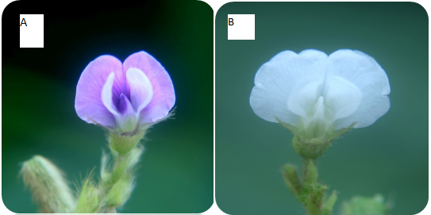

Figure 2: types of flower colour; A . Violet flower, B. White flower

Leaf Traits
Variation in leaf morphology was evident among the 55 soybean genotypes. Leaf size ranged from small to large, with 17 genotypes exhibiting small leaflets, 24 medium-sized and 14 large (Figure 3). Medium-sized leaflets were the most prevalent (43.6%), offering a balance between photosynthetic efficiency and optimal canopy architecture (Li et al 2024). In terms of leaf shape, the pointed ovate form was dominant, observed in 72.7% of genotypes, followed by lanceolate (23.6%) and round ovate shapes (3.6%). These morphological differences influence light interception, canopy structure, and overall plant vigor. Additionally, 17 genotypes displayed dark green foliage, which may reflect higher chlorophyll content and enhanced photosynthetic capacity, traits that are advantageous for biomass accumulation and stress resilience.
Similar results for leaf characters were also observed by Barela et al. 2022 and Upadhyay et al. 2022. Anand et al. 2024 evaluated 165 lines for leaf morphology and found similar observation.

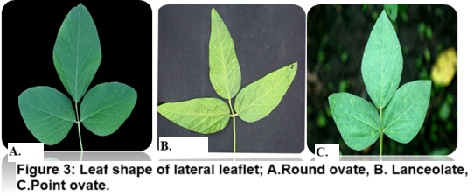

Pod Characters
Pod morphology varied notably among the soybean genotypes. A majority of genotypes (58.2%) exhibited pubescent pods, with tawny brown being the predominant pubescence color (93.8%) (Figure 5). Pod pubescence plays a critical role in pest resistance and moisture regulation, contributing to improved field performance under variable environmental conditions (Barela et al., 2022). In terms of pod color, brown pods were most common (43.6%), followed by yellow (30.9%) and black (25.5%) (Figure 6). This variation reflects underlying genetic diversity and may influence consumer preferences, market classification, and seed coat development. The presence of multiple pod color types within the germplasm pool suggests potential for selection based on both agronomic and commercial traits.
Anand et al. 2024 studied pod morphology in 165 soybean lines and observed pod pubescence in 106 genotypes. Pod hairiness was predominantly pubescent while investigating 90 soybean genotypes, with 76 lines exhibiting trichome-covered pods a trait often linked to insect resistance (Barela et al. 2022). Pod pubescence colour showed tawny brown as the most frequent expression, recorded in 67.77% of genotypes, followed by grey and absence of pubescence.
Another studied by Mishra et al 2025 evaluated soybean genotypes and also observed similar results for pod morphology.
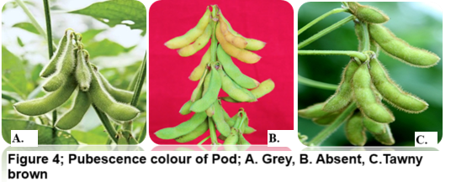

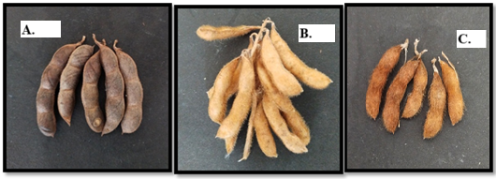
Fig. 5. Variation for pod colour; A. Black, B. Yellow, C.Brown

Variation in Seed Traits
Seed morphology among the evaluated soybean genotypes revealed consistent patterns aligned with breeding and market standards. Most genotypes (98.2%) possessed medium-sized seeds ranging from 10.1 to 13.0 g per 100 seeds, which conforms to agronomic norms for optimal yield and handling (Figure 6). Only one genotype exhibited small seeds, indicating limited variability in seed size. In terms of shape, spherical seeds were predominant (70.9%), followed by elliptical forms (29.1%). Spherical seeds are generally preferred for uniformity, ease of processing, and mechanical sowing (Shrestha et al. 2023). Seed coat colour was largely uniform, with 94.5% of genotypes displaying yellow coats and a minority (5.5%) showing yellow-green hues. Yellow seed coats are favoured in commercial markets due to their visual appeal and consumer acceptance. Additionally, 78.2% of genotypes had shiny seed coats, which enhance storability and seed quality. Hilum colour varied between black (70.9%) and brown (29.1%) serving as a stable varietal marker useful for genotype identification and purity assessment (Palmer et al. 2004).
Seed shape is one of the important descriptors for evaluating soybean genetic resources, with elliptic Fourier descriptors proving useful in quantifying morphological diversity for breeding programs (Sammour 2014). This aligns well with our finding that spherical seeds were predominant (70.9%), followed by elliptical forms (29.1%) and adds weight by referencing established methodology for pod shape analysis

In the study conducted by Barela et al. (2022), morphological characterization of 90 soybean genotypes revealed distinct patterns in seed traits that are valuable for varietal identification and breeding. The predominant seed size observed was medium, present in 64.44% of genotypes, while spherical flattened seed shape was most common, found in 77.77% of the lines. The seed coat colour was predominantly yellow (84.44%), and intermediate seed coat lustre was observed in 77.77% of genotypes, indicating a balanced surface texture across the germplasm. Hilum colour varied among genotypes, with imperfect black being the most frequent (63.33%), followed by brown (34.44%) and black (2.22%). These seed characteristics, along with other DUS descriptors, provide a robust framework for genotype differentiation and can support targeted breeding strategies aimed at improving soybean yield and adaptability.Similar result were also reported by Asati et al 2023 in soybean.

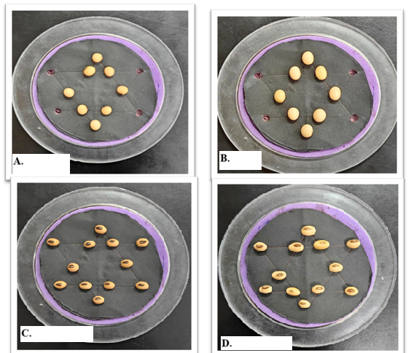
Figure 6 : variation for seed colour and hilum colour A. Spherical shaped seed, B. Elliptical shaped seed , C. Black coloured hilum , D. Brown coloured hilum.
In this study the predominance of semi-determinate and semi-erect types, medium seed size, and yellow shiny seed coats reflects current breeding priorities. However, the limited presence of large seeds and non-yellow testa types suggests opportunities for introgression to meet evolving market demands. Traits like anthocyanin pigmentation, pod pubescence, and leaflet shape offer high polymorphism and can serve as effective markers for parent selection and varietal differentiation. Integrating these morphological markers with molecular tools will enhance precision in varietal release and protection.
Conclusions
The comprehensive DUS-based evaluation of 55 soybean genotypes revealed substantial morphological diversity across key traits, including hypocotyl pigmentation, leaf morphology, pod pubescence and colour and seed characteristics. High polymorphism traits such as anthocyanin pigmentation on hypocotyl, leaflet shape and colour and pod pubescence colour were emerged as robust markers for parent selection and varietal differentiation, offering strategic value for breeding programs. Notably, 98.2% of genotypes exhibited medium-sized seeds (10.1–13.0 g/100 seeds) and 70.9% had spherical seed shapes, indicating strong directional selection for agronomic uniformity and processing efficiency. Yellow seed coats were dominant (94.5%), with 78.2% showing a shiny lustre, traits that align with commercial preferences for marketability and storability. Hilum colour, predominantly black (70.9%), further supports varietal classification efforts.
Despite this uniformity, opportunities remain to diversify the genetic base by incorporating large-seeded genotypes and determinate growth habits, which were underrepresented in the current panel. These findings provide a foundation for targeted hybridization, molecular mapping, and cultivar registration, and underscore the importance of integrating both high-polymorphism and market-relevant traits in soybean improvement strategies. Future efforts may benefit from coupling morphological data with molecular markers and agro-physiological performance to enhance selection accuracy and breeding efficiency.

COMPETING INTERESTS DISCLAIMER:
Authors have declared that they have no known competing financial interests OR non-financial interests OR personal relationships that could have appeared to influence the work reported in this paper.

References
Agarwal, D.K., Billore, S.D., Sharma, A.N., 2013. Soybean: introduction, improvement and utilization in India problems and prospects. Agricultural Research 2, 293–300.
Amrate, P.K., 2024. Survey and present status of soybean diseases in central India. International Journal of Bioresource and Stress Management 15(5), 01–10.
Anand, Kumar Jai; Shrivastava, M. K.; Amrate, Pawan K.; Patel, Teena; Singh, Yogendra Morphological Characterization-based Optimal Trait Selection for Improving Yield and Stability of Soybean (Glycine max L. Merrill). International Journal of Bio-Resource & Stress Management, 2024, Vol 15, Issue 10, p1 ISSN 0976-3988 Publication type Academic Journal DOI 10.23910/1.2024.5604
Asati, R., Tripathi, M. K., Yadav, R. K., Tiwari, S., Chauhan, S., Tripathi, N., Solanki, R. S., & Yasin, M. (2023). Morphological description of chickpea (Cicer arietinum L.) genotypes using DUS characterization. International Journal of Environment and Climate Change, 13(9), 1321–1341.
Banerjee J, Shrivastava MK, Amrate PK, Singh Y, Upadhya A, Soni M. Genetic variability and association of yield contributing traits in advanced breeding lines of soybean. Electronic Journal of Plant Breeding. 2022;13(2).
Banerjee, J., Shrivastava, M.K., Singh, Y., Amrate, P.K., 2023. Estimation of genetic divergence and proximate composition in advanced breeding lines of soybean (Glycine max (L.) Merrill. Environment and Ecology 41(3C), 1960–1968.
Dhaliwal I, Khosla G, Singh TP, Gill GS, Kaushik P. 2020. DUS Characterization of some Released Varieties and Advanced Breeding Lines of Soybean (Glycine max L.) under Punjab Agroclimatic Conditions. International Journal of Current Microbiology and Applied Sciences 9:2124-35.
Govindaraj, M., Vetriventhan, M., & Srinivasan, M. (2015). Importance of genetic diversity assessment in crop plants and its recent advances: An overview of its analytical perspectives. Genetics Research International, 2015, Article 431487.
Hymowitz, T., & Singh, R. J. (1987). Taxonomy and speciation in the genus Glycine (Leguminosae). Theoretical and Applied Genetics, 73(6), 761–768.
Jhariya R, Tripathi MK, Mishra R, Sharma S, Solanki R, and Sikarwar RS. 2025. Appraisal of Variability Across Soybean Genotypes Based on Qualitative Traits. Journal of Biology and Nature 17 (2):58-72.
Kim J-H, Scaboo A, Pantalone V, Li Z and Bilyeu K (2022) Utilization of Plant Architecture Genes in Soybean to Positively Impact Adaptation to High Yield Environments. Front. Plant Sci. 13:891587. doi: 10.3389/fpls.2022.891587
Li W, Wang L, Xue H, Zhang M, Song H, Qin M and Dong Q (2024) Molecular and genetic basis of plant architecture in soybean. Front. Plant Sci. 15:1477616. doi: 10.3389/fpls.2024.1477616
Mehra S, Shrivastava MK, Amrate PK, Yadav RB. Studies on variability, correlation coefficient and path analysis for yield associated traits in soybean [Glycine max (L.) Merrill]. Journal of Oilseeds Research. 2020;37(1):56–59.
Mishra, N., Tripathi, M. K., Tripathi, N., Tiwari, S., Mishra, R., Tripathi, M. K., Shrivastava, M. K., & Amrate, P. K. (2024d). Genetic diversity in crop improvement: A cornerstone for sustainable agriculture and global food security. In M. K. Tripathi & N. Tripathi (Eds.), Advances in Plant Biotechnology, 1, 121.
Ramteke R, Murlidharan P. Characterization of soybean (Glycine max) varieties as per DUS guidelines. Indian Journal of Agricultural Sciences. 2012; 82(7):572–577.
Salgotra, R. K., & Chauhan, B. S. (2023). Genetic diversity, conservation, and utilization of plant genetic resources. Genes, 14(1), 174. Murai, Y., Yan, F., Iwashina, T., & Takahashi, R. (2016). Analysis of anthocyanin pigments in soybean hypocotyl. Canadian Journal of Plant Science, 96(6), 935-938.
Sammour, R. H. (2014). Morphological, cytological and biochemical characterization of soybean germplasm. Res Rev Biosci, 8, 277-284. Amrate, P.K., Shrivastava, M.K., Pancheshwar, D.K., Stuti, S., 2020. Charcoal rot and yellow mosaic virus disease of soybean under hot spot condition: symptoms, incidence and resistance characterization. International Journal of Bio-resource and Stress Management 11(3), 268–273.
Sundaramoorthy, J., Park, G.T., Lee, JD. et al. Genetic and molecular regulation of flower pigmentation in soybean. J Korean Soc Appl Biol Chem 58, 555–562 (2015). https://doi.org/10.1007/s13765-015-0077-z
Upadhyay P, Shrivastava MK, Sharma S, Thakur S, Anand KJ. Morphological characterization of exotic lines of soybean (Glycine max (L.) Merrill) for developing ideotype biological forum – An International Journal. 2022;14(2):546-551.
Yadav, R. K., Tripathi, M. K., Tiwari, S., Asati, R., Chauhan, S., Tripathi, N., Solanki, R. S., Sikarwar, R. S., & Yasin, M. (2023). DUS- based morphological profiling and categorization of chickpea (Cicer arietinum L.) genotypes. Current Journal of Applied Science and Technology, 42(40), 20–36.

Table 1: Characterization and frequency distribution of Morphological and Seed Traits (As per DUS guideline)
Traits |  | Classes | Genotypes | Frequency
Hypocotyl: Anthocyanin pigmentation | 10-15 Days after sowing | Present | AGS 163, AUKS 203, DS 1510, JS 335, EC 350664, NRC 257, JS 21-74, JS 21-75, JS 24-23, JS 25-01, JS 25-02, JS 25-03, JS 22-12, JS 23-09, NRC 256, AMS 56, AMS 269, NRC 166, NRC 190, JS20-53, NRC 264, NRC 268, NRC 270, JS 335 | 24
Hypocotyl: Anthocyanin pigmentation | 10-15 Days after sowing | Absent | DS 1547, DS 3109, NRC 259, PS 1696, RSC 1175, JS 23-02, JS 24-25, JS 24-26, JS 25-06, JS 25-08, JS 21-72, JS 21-13, DS 1318, RVSM 2012-04, JS 20-89, JS 22-01, JS 21-77, JS 30-12, JS 30-13, JS 30-15, JS 30-16, NRC 138, JS 25-55, NRC 150, JS 20-79, JS 25-50, JS 25-52, JS 20-34, JS 20-69, JS 20-98, JS 20-116 | 31
Growth type | About 77 % pods attained full length | Determinate | JS 20-34 | 1
Growth type | About 77 % pods attained full length | Semi-determinate | AGS163, AUKS203, DS 1510, DS 1547, DS 3109, EC 350664, NRC 257, NRC 259, PS 1696, RSC 1175, JS 21-74, JS 21-75, JS 23-02, JS 24-23, JS 24-25, JS 24-26, JS 25-01, JS 25-02, JS 25-03, JS 25-06, JS 25-08, JS 21-72, JS22-12, JS 22-16, JS 23-09, NRC 256, JS21-13, AMS 56, AMS 269, DS 1318, NRC 166, NRC 190, RVSM 2012-04, JS20-53, JS20-89, JS 22-01, JS21-77, JS30-12, JS30-13, JS30-15, JS30-16, NRC 138, NRC 264, JS 25-55, NRC 268, NRC 270, NRC 150, JS20-79, JS 25-50, JS 25-52, JS 20-69, JS 20-98, JS 20-116, JS 335 | 54
Growth habit | About 50% plants have at least one flower open | Erect | JS 20-34 | 1
Growth habit | About 50% plants have at least one flower open | Semi erect | AGS 163, AUKS 203, DS 1510, DS 1547, DS 3109, EC 350664, NRC 257, NRC 259, PS 16-96, RSC 1175, JS 21-74, JS 21-75, JS 23-02, JS 24-23, JS 24-25, JS 24-26, JS 25-01, JS 25-02, JS 25-03, JS 25-06, JS 25-08, JS21-72, JS 22-12, JS 22-16, JS 23-09, NRC 256, JS 21-13, AMS 56, AMS 269, DS 1318, NRC 166, NRC 190, RVSM 2012-04, JS20-53, JS 20-89, JS 22-01, JS 21-77, JS 30-12, JS 30-13, JS 30-15, JS 30-16, NRC 138, NRC 264, JS 25-55, NRC 268, NRC 270, NRC 150, JS 20-79, JS 25-50, JS 25-52, JS 20-69, JS 20-98, JS 20-116, JS 335 | 54
Flower colour | About 50% plants have at least one flower open | White | DS 1547, DS 3109, NRC 259, PS 1696, RSC 1175, JS 23-02, JS 24-25, JS 24-26, JS 25-06, JS 25-08, JS21-72, JS21-13, DS 1318, JS21-13, RVSM 2012-04, JS 20-89, JS 22-01, JS 21-77, JS 30-12, JS 30-13, JS 30-15, JS 30-16, JS 25-55, NRC 150, JS 20-79, JS 25-50, JS 25-52, JS 20-34, JS 20-69, JS 20-98, JS 20-116 | 31
Flower colour |  | Violet | AGS 163, AUKS 203, DS 1510, JS 335, EC 350664, NRC 257, JS21-74, JS 21-75, JS 24-23, JS 25-01, JS 25-02, JS 25-03, JS 22-12, JS 23-09, NRC 256, AMS 56, AMS 269, NRC 166, NRC 190, JS20-53, NRC 138, NRC 264, NRC 268, NRC 270 | 24
Leaf size of lateral leaflet | About 50% plants have at least one flower open | Small | DS 1510, DS 1547, EC 350664, NRC 257, AMS 269, DS 1318, NRC 190, JS 22-01, JS 21-77, NRC 138, NRC 264, NRC 150, JS 22-12, JS 20-34, JS 335, JS 22-16, JS 23-09 | 17
Leaf size of lateral leaflet | About 50% plants have at least one flower open | Medium | AGS 163, AUKS 203, DS 3109, PS 1696, RSC 1175, JS 21-74, JS 23-02, JS 24-23, JS 24-25, JS 24-26, JS 25-01, JS 25-02, JS 25-06, JS 21-72, NRC 256, NRC 166, JS 20-53, JS 20-89, JS 30-12, NRC 270, JS 20-79, JS 25-52, JS 20-69, AMS 56 | 24
Leaf size of lateral leaflet | About 50% plants have at least one flower open | Large | JS 25-50, NRC 268, JS 25-55, JS 30-13, JS 30-15, JS 30-16, NRC 259, JS 21-75, JS 25-03, JS 25-08, JS 21-13, RVSM 2012-04, JS 20-116, JS 20-98 | 14
Leaf shape of lateral leaflet | About 50% plants have at least one flower open | Lanceolate | AGS 163, DS 1547, PS 1696, JS 21-75, JS 24-23, JS 24-25, JS 25-01, JS 25-06, AMS 56, AMS 269, NRC 166, JS 21-77, NRC 264 | 13
Leaf shape of lateral leaflet | About 50% plants have at least one flower open | Pointed  ovate | AUKS 203, DS 1510, DS 3109, EC 350664, NRC 257, NRC 259, RSC 1175, JS 21-74, JS 23-02, JS 24-26, JS 25-02, JS 25-03, JS 25-08, JS 21-72, JS 22-12, JS 22-16, JS 23-09, NRC 256, JS21-13, DS 1318, NRC 190, RVSM 2012-04, JS 20-53, JS 20-89, JS 22-01, JS 30-12, JS 30-13, JS 30-15, JS 30-16, NRC 138, JS 25-55, NRC 150, JS 20-79, JS 25-50, JS 25-52, JS 20-69, JS 20-98, NRC 268, NRC 270, JS 335 | 40
Leaf shape of lateral leaflet | About 50% plants have at least one flower open | Round ovate | JS 20-34, JS 20-116 | 2
Leaf intensity of green colour | About 50% plants have at least one flower open | Green | JS 25-08, JS 25-01, JS 23-02, NRC 259, AGS 163, AUKS 203, DS 1510, DS 1547, DS 3109, EC 350664, RSC 1175, PS 1696, JS 24-23, JS 24-25, JS 25-02, JS21-72, JS 23-09, NRC 256, AMS 269, DS 1318, NRC 190, RVSM 2012-04, JS20-53, JS 22-01, JS 21-77, JS 30-12, JS 30-13, JS 30-15, JS 30-16, NRC 138, JS 25-55, NRC 268, NRC 150, JS 25-52, JS 20-34, JS 20-69, JS 20-98, JS 335 | 38
Leaf intensity of green colour | About 50% plants have at least one flower open | Dark green | NRC 257, JS21-74, JS 21-75, JS 24-26, JS 25-03, JS 25-06, JS 22-12, JS 22-16, JS 21-13, AMS 56, NRC 166, JS 20-89, NRC 264, NRC 270, JS 20-79, JS 25-50, JS 20-116 | 17
Pod Pubescence | About 77 % pods attained full length | Pubescent | AGS 163, AUKS 203, DS 1510, DS 1547, EC 350664, NRC 259, PS 1696, JS 23-02, JS 24-25, JS 24-26, JS 25-08, JS 21-72, JS 22-16, JS 21-13, DS 1318, RVSM 2012-04, JS 20-53, JS 2 0-89, JS 22-01, JS 21-77, JS 30-12,JS 30-13, JS 30-15, JS 30-16, NRC 138, JS 25-55, NRC 150, JS20-79, JS 25-50 ,JS 25-52, JS 20-69, JS 20-98 | 32
Pod Pubescence | About 77 % pods attained full length | Glabrous | DS 3109, NRC 257, RSC 1175, JS 21-74, JS 21-75, JS 24-23, JS 25-01, JS 25-02, JS 25-03, JS 25-06, JS 22-12, JS 23-09, NRC 256, AMS 56, AMS 269, NRC 166, NRC 190, NRC 264, NRC 268, NRC 270, JS 20-34, JS 20-116, JS 335 | 23
Pod: Pubescence colour | About 77 % pods attained full length | Tawny brown | AGS 163, AUKS 203, DS 1510, DS 1547, EC 350664, NRC 259, PS 1696, JS 23-02, JS 24-26, JS 25-08, JS 21-72, JS 22-16, JS 21-13, DS 1318, RVSM 2012-04, JS 20-53, JS 20-89, JS 22-01, JS 21-77, JS 30-12, JS 30-13, JS 30-15, JS 30-16, NRC 138, JS 25-55, NRC 150, JS20-79, JS 25-50, JS 25-52, JS 20-69, JS 20-98 | 30
Pod: Pubescence colour | About 77 % pods attained full length | Gray | JS 24-25 | 1
Pod: Pubescence colour | About 77 % pods attained full length | Absent | DS 3109, NRC 257, RSC 1175, JS21-74, JS21-75, JS 24-23, JS 25-01, JS 22-12, JS 23-09, AMS 56, NRC 264, NRC 268, NRC 270, NRC 166, NRC 190, AMS 269, NRC 256, JS 25-02, JS 25-03, JS 25-06, NRC 257, JS 20-116, JS 335, JS 20-34 | 24
Pod: Colour | About 50 % of pods are ripe | Yellow | AGS 163, EC 350664, NRC 259, JS 25-02, JS 25-03, JS 25-08, JS 23-09, JS21-13, DS 1318, JS 22-01, NRC 268, JS 21-77, JS 30-13, JS 25-55, JS20-79, JS 25-50, JS 25-52 | 17
Pod: Colour | About 50 % of pods are ripe | Brown | AUKS 203, DS 1510, DS 1547, DS 3109, NRC 257, PS 1696, RSC 1175, JS 23-02, JS21-72, JS 22-12, JS 22-16, NRC 166, NRC 190, RVSM 2012-04, JS20-53, JS20-89, JS 30-12, JS 30-16, NRC 138, NRC 150, JS 20-34, JS 20-69, JS 20-98, JS 335 | 24
Pod: Colour | About 50 % of pods are ripe | Black | JS21-74, JS21-75, JS 24-23, JS 24-25, JS 24-26, JS 25-01, JS 25-06, NRC 256, AMS 56, AMS 269, JS 30-15, NRC 264, NRC 270, JS 20-116 | 14
Seed size | Harvested seed | Small  (<10.0 gm) | EC 350664 | 1
Seed size | Harvested seed | Medium (10.1-13.0 gm) | AGS 163, AUKS 203, DS 1510, DS 1547, DS 3109, NRC 257, NRC 259, PS 1696, RSC 11-75, JS21-74, JS21-75, JS 23-02, JS 24-23, JS 24-25, JS 24-26, JS 25-01, JS 25-02, JS 25-03, JS 25-06, JS 25-08, JS21-72, JS 22-12, JS 22-16, JS 23-09, NRC 256, JS21-13, AMS 56, AMS 269, DS 1318, NRC 166, NRC 190, RVSM 2012-04, JS20-53, JS20-89, JS 22-01, JS 21-77, JS 30-12, JS 30-13, JS 30-15, JS 30-16, NRC 138, NRC 264, JS 25-55, NRC 268, NRC 270, NRC 150, JS20-79, JS 25-50, JS 25-52, JS 20-69, JS 20-98, JS 20-116, JS 335, JS 20-34 | 54
Seed size | Harvested seed | Large  (>13.0 gm) | 0
Seed shape | Harvested seed | Spherical | AGS 163, DS 1510, DS 1547, DS 3109, EC 350664, NRC 257, NRC 259, PS 1696,JS 23-02,JS 24-25,JS 24-26,JS 25-01, JS 25-02, JS 25-03, JS 25-06, JS 25-08,JS 23-09, NRC 256, JS21-13, AMS 56, AMS 269, NRC 166, NRC 190, RVSM 2012-04, JS20-53, JS 20-89, JS 22-01, JS 21-77, JS 30-12, NRC 138, NRC 264, NRC 268, NRC 270, JS20-79, JS 25-52, JS 20-69, JS 20-98, JS 20-116, JS 335 | 39
Seed shape | Harvested seed | Elliptical | AUKS 203, RSC 1175, JS 21-74, JS 21-75, JS 24-23, JS 21-72, JS 22-12, JS 22-16, DS 1318, JS 30-13, JS 30-15, JS 30-16, JS 25-55, NRC 150, JS 25-50, JS 20-34 | 16
Seed: The ground colour of testa | Harvested seed | Yellow | AGS 163, AUKS 203, DS 1510, DS 1547, EC 350664, NRC 257, NRC 259, PS 1696, RSC 1175, JS21-74, JS 21-75, JS 23-02, JS 24-23, JS 24-25, JS 24-26, JS 25-01, JS 25-02, JS 25-03, JS 25-06, JS 25-08, JS 21-72,JS 22-12, JS 22-16, JS 23-09, NRC 256, JS 21-13, AMS 56, AMS 269, DS 1318, NRC 190, RVSM 2012-04, JS 20-53, JS 20-89, JS 22-01,JS 21-77, JS 30-12, JS 30-13, JS 30-15, JS 30-16, NRC 138, JS 25-55, NRC 268, NRC 270, NRC 150, JS20-79, JS 25-50 , JS 25-52, JS 20-34, JS 20-69, JS 20-98, JS 20-116, JS 335 | 52
Seed: The ground colour of testa | Harvested seed | yellow-green | DS 3109, NRC 166, NRC 264 | 3
Seed coat luster | Harvested seed | Shiny | AGS 163, AUKS 203, DS 1510, DS 1547, EC 350664, NRC 257, NRC 259, PS 1696, JS21-74, JS21-75,JS 23-02, JS 24-25, JS 25-01, JS 25-02, JS 25-03, JS 22-12, JS 22-16, JS 23-09, NRC 256, JS 21-13, AMS 56, AMS 269, DS 1318, NRC 166, NRC 190, RVSM 2012-04, JS 20-89, JS 22-01, JS 21-77, JS 30-12, JS 30-13, NRC 138,NRC 264,JS 25-55, NRC 268, NRC 270, NRC 150, JS20-79, JS 25-50 ,JS 25-52, JS 20-98, JS 20-116, JS 335 | 43
Seed coat luster | Harvested seed | Dull | DS 3109, RSC 1175, JS 24-23, JS 24-26, JS 25-06, JS 25-08, JS 21-72, JS 20-53, JS 30-15, JS 30-16, JS 20-69, JS 20-34 | 12
Hilum colour | Harvested seed | Black | AUKS 203, DS 1510, DS 1547, DS 3109, JS 24-23, EC 350664, NRC 257, NRC 259, PS 1696, RSC 1175, JS 21-74, JS 21-75, JS 25-01, JS 25-02, JS 25-03, JS 25-06, JS 25-08, JS 21-72, JS 22-12, JS 22-16,JS 23-09, AMS 56, AMS 269, DS 1318, NRC 190, RVSM 2012-04, JS 20-53, NRC 256, JS 21-77, JS 30-15, JS 30-16, NRC 138, NRC 268, NRC 150, JS 20-34, JS 20-69, JS 20-98, JS 20-116, JS 335 | 39
Hilum colour | Harvested seed | Brown | AGS 163, JS 23-02, JS 24-25, JS 24-26, JS 21-13, NRC 166, JS 20-89, JS 22-01, JS 30-12, JS 30-13, JS 25-55, NRC 264, NRC 270, JS 20-79, JS 25-50, JS 25-52, | 16

