Combined Effect of Vermicompost Tea and Effective Microorganisms on the Tillering of Two Rice Varieties in Kakanitchoé, Southern Benin.

ABSTRACT
.Aims: To assess the combined effects of vermicompost tea (VCT) and effective microorganisms (EM) on the tillering of two rice varieties, IR841 and Sahel 108, in order to determine their agronomic value in sustainable rice production systems.
Study design : Split-plot design with two factors (rice varieties and VCT+EM combinations).
Place and Duration of Study: SAIN School Farm, Kakanitchoé, during the 2025 cropping season.
Methodology: The experiment included two rice varieties (IR841 and Sahel 108) and eight treatments of VCT+EM combinations, each replicated three times. Agronomic parameters measured included plant height, leaf number, tiller number, panicle number, and panicle length. Tillering dynamics were monitored weekly from the second to the seventh week after transplanting.
Results: Combined application of VCT and EM significantly improved growth and yield components in both rice varieties (P<0.0001). IR841 achieved the highest plant heights, especially with 10 ml and 15 ml of VCT+EM. Sahel 108 showed superior leaf production and tillering, peaking at 250.93 ± 12.70 leaves and 63.66 ± 2.74 tillers per hill at 20 ml. The highest panicle number (38.60 ± 2.47) was recorded in Sahel 108 at 15 ml, while IR841 had longer panicles. Tillering initiated in the second week after transplanting, peaked in the fifth week, slightly declined, and showed a second peak in the seventh week.
Conclusion : The combined use of VCT and EM enhances rice growth and tillering, with varietal differences in response patterns. These biostimulants hold promise for sustainable rice production, and further research should optimize formulations according to variety type.
**In the abstract mention only research results
Keywords: Vermicompost tea, biofertilizers, effective microorganisms, rice, yield components.
- INTRODUCTION
Rice (Oryza sativa L.) is one of the main staple crops in Benin, playing a strategic role in national food security. However, rice production continues to face major challenges such as low soil fertility, heavy reliance on chemical fertilizers, and climate change, all of which limit both productivity and the sustainability of rice farming systems (Adoukonou et al. 2021). During the 2023–2024 agricultural season, national rice production was estimated at 492,626 tons, marking a 6.2% decline compared to the previous season’s 525,014 tons (INStaD, 2024). This decrease is mainly attributed to a drop in yield, which fell to 3.73 tons per hectare—the lowest level recorded since 2018 (INStaD 2024). The yield reduction can be linked to several factors, including climatic variability, increased incidence of pests and diseases, and most significantly, the gradual degradation of soil fertility.
In conventional rice production systems in Benin, farmers heavily rely on chemical fertilizers to enhance yields. However, the intensive and unregulated use of these inputs has negative consequences, including soil depletion, acidification, and disruption of the soil’s biological balance (Saito et al. 2021).
In response to these constraints, the adoption of agroecological practices—particularly the use of biofertilizers—emerges as a promising alternative for improving rice productivity in a sustainable manner. Biofertilizers, including vermicompost tea (VCT) and effective microorganisms (EM), are known for their ability to enhance soil fertility, stimulate plant growth, and strengthen crop resilience against abiotic stress (Afsharmanesh et al. 2016;Kheyri2017;Obsi et al. 2022).
Vermicompost tea is a nutrient-rich liquid extract containing soluble nutrients and beneficial microorganisms that promote vegetative growth, especially tillering, by improving nutrient availability and activating physiological processes (Afsharmanesh et al. 2016; Obsi et al. 2022). Meanwhile, effective microorganisms—a consortium of lactic acid bacteria, yeasts, actinomycetes, and fungi—are recognized for their role in improving soil structure, accelerating organic matter mineralization, and inducing plant growth (Gómez-Brandón et al. 2015). Rice yield largely depends on the plant’s ability to produce a significant number of tillers, particularly fertile ones that bear well-filled panicles—an essential factor for yield improvement (Gómez-Brandón et al. 2015). In this context, biological inputs offer a major lever for increasing productivity, especially where access to chemical fertilizers is limited.
This study was therefore initiated to explore the synergistic potential of vermicompost tea and effective microorganisms in enhancing the vegetative development of two rice varieties, within a framework of agroecological sustainability.
- MATERIAL AND METHODS
  - Experimental site
The study was conducted at the SAIN Training Farm in Kakanitchoé (N 07°02.705', E 002°39.133'), located in the commune of Adjohoun, in southeastern Benin.The commune is bordered to the south by the commune of Dangbo, to the north by Bonou, to the east by Sakété, and to the west by the communes of Abomey-Calavi and Zè.
  - Rice varieties
Two rice varieties were used in this study: IR841 and Sahel 108. The IR841 variety was provided by the Enterprise for Services and Producers' Organization (ESOP/Vallée de l’Ouémé), located in the Commune of Dangbo. It has a growth cycle of 115 to 120 days, good lodging resistance, and resistance to rice blast disease (Pyriculariaoryzae), making it one of the most widely adopted varieties in southern Benin, particularly in the Ouémé Valley. In contrast, Sahel 108 was supplied by the SAIN Training Farm in Kakanitchoé. It is an early-maturing variety with a growth cycle of 100 to 110 days. It is widely cultivated in the Senegal River Valley and is known for its salinity tolerance (AfricaRice 2021).
  - Biofertilizers
The biofertilizers used in this study were supplied by the SAIN Training Farm in Kakanitchoé and consisted of the following:
- Vermicompost tea: a liquid fertilizer obtained from the decomposition of organic matter by earthworms.
- Effective Microorganisms (EM): produced from yeast and organic waste.
The chemical composition of these two biofertilizers is presented in Table 1.
. Table 1.Chemical Composition of Vermicompost Tea and Effective Microorganisms
Components | Vermicompost Tea | Effective Microorganisms
Ammoniacal nitrogen (mg/L) | 22.960 | 0.00
Nitric nitrogen (mg/L) | 1.680 | 0.00
Total nitrogen (%) | 1.434 | 0.550
P₂O₅ (%) | 1.700 | 0.949
K₂O (%) | 15.024 | 0.667
CaO (%) | 4.467 | 1.985
MgO (%) | 3.442 | 0.429
ZnO (mg/kg) | 213.33 | 46.785
Total carbon (%) | 0.00 | 5.975
C/N ratio | 0.00 | 11
Total organic matter (%) | 0.00 | 13.711
Source:(INRAB, 2021)

  - Experimental design and management
The experiment was conducted using a split-plot design with two factors. The first factor, rice variety, included two (02) levels: IR841 and Sahel 108. The second factor consisted of a mixture of two (02) biofertilizers: 50% vermicompost tea (VCT) and 50% effective microorganisms (EM). This VCT+EM mixture was applied at four (04) different doses. The combination of these two factors resulted in eight treatments (Table 2), each replicated in three blocks, for a total of 24 experimental units.
For the experiment, ten (10) polyethylene bags (40 cm x 40 cm) were used per treatment, i.e., 80 bags per block. Treatments were randomly assigned within each block. A spacing of 0.25 m was maintained between treatments of the same variety, 1 m between blocks, and 0.5 m between varieties to facilitate maintenance operations.

Table 2 Design of experimental treatments
Factors | Levels | Treatments
Factor 1: Rice Varieties | • IR841  • Sahel 108 | T1 = D0_IR841 ; T5 = D0_Sahel 108 T2 = D1_IR841 ; T6 = D1_Sahel 108 T3 = D2_IR841 ; T7 = D2_Sahel 108 T4 = D3_IR841 ; T8 = D3_Sahel 108
Factor 2: VCT+EM mixture | • D0 = 0 ml/hill  • D1 = 10 ml/hill  • D2 = 15 ml/hill  • D3 = 20 ml/hill

  - Trial setup operations
- Basal fertilization: A basal dose of vermicompost was applied two weeks before transplanting in polyethylene bags previously filled with topsoil, at a rate of 62 g per bag.
- Nursery establishment: Seeds of both rice varieties were soaked separately in water for 24 hours. The soaked seeds were then drained and wrapped in cloth to create a favorable environment for germination. This stage lasted 48 hours and promoted the emergence of young shoots. Pre-germinated seeds were then sown on a 1 m² seedbed.
- Transplanting: 8-day-old seedlings of each rice variety were transplanted into bag (40 cm x 40 cm) with a 10 kg capacity of topsoil, at a rate of one plant per bag.
- Watering and weeding: Watering was carried out twice daily (morning and evening), except on rainy days. Weeding was done every two weeks to prevent competition between rice plants and weeds.

  - Fertilization of rice plants in polyethylene Bags
Fertilization consisted of applying different doses of the VCT+EM mixture to rice plants of the two tested varieties. Two applications were performed:
- The first application occurred at the tillering stage (i.e., three weeks after transplanting) (Fig.1a).
- The second application was performed at the panicle initiation stage (i.e., 45 days after transplanting).
Each dose of the VCT+EM mixture (Fig.1b) was drawn using a 10-c.c. syringe and applied directly to the collar of each rice plant (Fig. 1c).
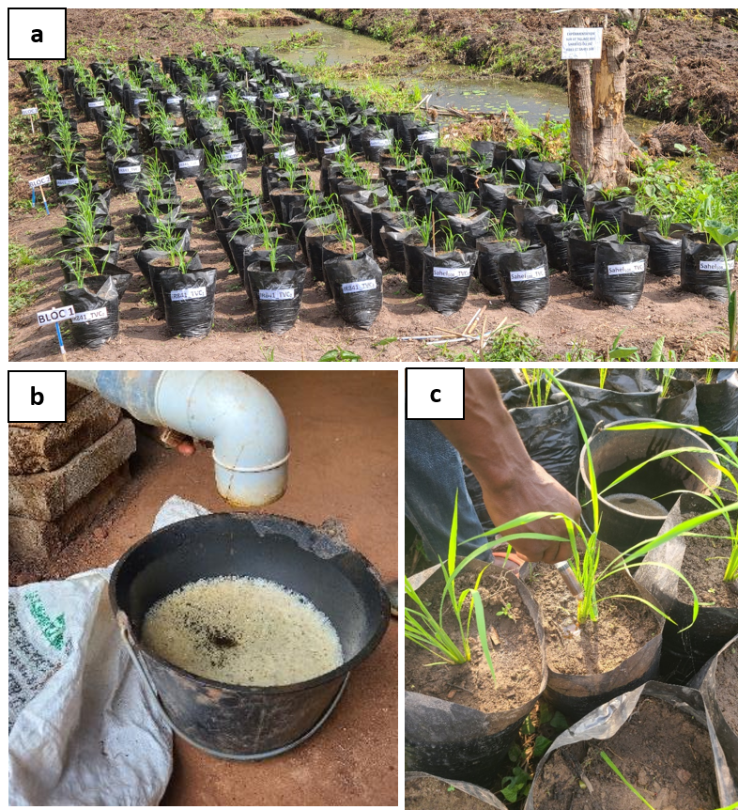
Fig.1 (a) Rice plant at tillering stage, (b) Mixture of vermicompost tea (VCT) and effective microorganisms (EM), (c) Application of VCT+EM doses.

  - Data collection
Data related to plant growth were collected, including the number of tillers per hill, number of panicles per hill, plant height, and tiller emergence rate (TER) for each rice variety. The TER is an important indicator used to assess vegetative growth and canopy development. It was calculated using the following formula (Yoshida, 1981):
$$TER=\frac{Nt-Ni}{tf-ti}$$
Where: Nt = Total number of tillers at the end of the observation period, Ni = Initial number of tillers at the beginning of the observation period, (tf - ti) = Duration of the observation period in days.

  - Statistical analysis
A two-factor analysis of variance (ANOVA) was performed using the PROC GLM procedure in SAS (2009) to evaluate the combined effects of VCT + EM on the growth parameters of the rice varieties IR841 and Sahel 108 (plant height, number of tillers per hill, number of leaves per hill), and on production parameters (number of panicles per hill, panicle length).The means of these different parameters were calculated, and when significant differences were found among treatments, the Least Significant Difference (LSD) test at the 5% level was used for mean separation.To correct for variance homogeneity, the data related to the number of tillers, leaves, and panicles were log-transformed using log₁₀(x + 1) prior to statistical analysis.

- RESULTS AND DISCUSSION
  - Results
3.1.1 Plant height, number of leaves and number of tillers of IR841 and Sahel 108
The results of the analysis of variance revealed that both rice varieties, IR841 and Sahel 108, were significantly influenced (P < 0.0001) by the application of different doses of the vermicompost tea (VCT) and effective microorganisms (EM) mixture (Table 3). This influence resulted in significant variations in the observed means of all growth parameters (plant height, number of leaves, number of tillers) and yield components (number and length of panicles).
For growth parameters, the average plant height ranged from 90.04 ± 0.56 cm for untreated plants of Sahel 108 (0 ml) to 100.55 ± 1.12 cm for plants treated of IR841 with 15 ml of VCT+EM (Table 3). When considering each variety separately, the average plant height of IR841 was higher with 10 ml and 15 ml treatments of the VCT+EM mixture. Plant height of IR841 variety remained statistically unchanged across all doses of the VCT+EM mixture. In contrast, for Sahel 108, the highest average plant height was observed at the 20 ml dose (95.94 ± 0.89 cm), which was significantly higher than the other three treatments.
As for the number of leaves and tillers per hill, the highest averagewas recorded ontreated plant of Sahel 108 with 20 ml of VCT+EM, with averages of 250.93 ± 12.70 leaves/hill and 63.66 ± 2.74 tillers/hill, respectively. Whereas, the lowest values were observed on untreated plants of IR841, with 197.80 ± 11.59 leaves/hill and 47.50 ± 2.19 tillers/hill (Table 3).

    - Yield components of IR841 and Sahel 108 rice varieties
Regarding yield components, the highest average number of panicles was recordedon treated plants of Sahel 108 with 15 ml (38.60 ± 2.47 panicles/hill), followed by those treated with 20 ml (37.40 ± 1.66 panicles/hill) of the VCT+EM mixture. The lowest average number of panicles was recorded in untreated plants of IR841 (Table 3). As for panicle length, it was significantly longer on IR841 plants than on Sahel 108 plants, regardless of the dose applied. For each rice variety, the average panicle lengths across the four VCT+EM doses were statistically similar (Table 3).

Table 3. Combined effects of vermicompost tea and effective microorganisms on the growth parameters and yield components of IR841 and Sahel 108.
Traitements | Hauteur des plants (cm)
Traitements | IR841 | Sahel 108 | ddl | F | P
0ml (TVC + EM) | 99.87 ± 1.19a | 90.04 ± 0.56b | 7 | 9.541 | <0.0001
10ml (TVC + EM) | 100.55 ± 0.93a | 91.28 ± 1.71b | 7 | 9.541 | <0.0001
15ml (TVC + EM) | 100.55 ± 1.12a | 92.29 ± 1.74b | 7 | 9.541 | <0.0001
20ml (TVC + EM) | 99.21 ± 1.05a | 95.94 ± 0.89c | 7 | 9.541 | <0.0001
Traitements | Nombre de feuilles par poquet
Traitements | IR841 | Sahel 108 | ddl | F | P
0ml (TVC + EM) | 197.80 ± 11.59a | 231.80 ± 10.24bc | 7 | 3.974 | 0.0004
10ml (TVC + EM) | 206.12 ± 8.21ab | 236.40 ± 14.11bc | 7 | 3.974 | 0.0004
15ml (TVC + EM) | 205.37 ± 8.25ab | 239.33 ± 11.72bc | 7 | 3.974 | 0.0004
20ml (TVC + EM) | 210.51 ± 8.79ab | 250.93 ± 12.70c | 7 | 3.974 | 0.0004
Traitements | Nombre de talles par poquet
Traitements | IR841 | Sahel 108 | ddl | F | P
0ml (TVC + EM) | 47.50 ± 2.19a | 56.70 ± 2.56bc | 7 | 4.486 | <0.0001
10ml (TVC + EM) | 51.50 ± 2.05ab | 58.10 ± 3.52bc | 7 | 4.486 | <0.0001
15ml (TVC + EM) | 51.34 ± 2.06ab | 59.83 ± 2.93bc | 7 | 4.486 | <0.0001
20ml (TVC + EM) | 49.33 ± 2.91ab | 63.66 ± 2.74c | 7 | 4.486 | <0.0001
Traitements | Nombre de panicules par poquet
Traitements | IR841 | Sahel 108 | ddl | F | P
0ml (TVC + EM) | 21.16 ± 2.58a | 34.86 ± 2.63c | 7 | 7.560 | <0.0001
10ml (TVC + EM) | 23.50 ± 2.57ab | 33.43 ± 3.13c | 7 | 7.560 | <0.0001
15ml (TVC + EM) | 23.37 ± 3.03ab | 38.60 ± 2.47d | 7 | 7.560 | <0.0001
20ml (TVC + EM) | 27.06 ± 1.62b | 37.40 ± 1.66d | 7 | 7.560 | <0.0001
Traitements | Longueur des panicules (cm)
Traitements | IR841 | Sahel 108 | ddl | F | P
0ml (TVC + EM) | 25.74 ± 0.99a | 17.23 ± 0.86b | 7 | 35.47 | <0.0001
10ml (TVC + EM) | 25.77 ± 0.67a | 15.85 ± 0.64b | 7 | 35.47 | <0.0001
15ml (TVC + EM) | 23.21 ± 0.69a | 15.03 ± 0.48b | 7 | 35.47 | <0.0001
20ml (TVC + EM) | 25.87 ± 0.93a | 17.06 ± 1.04b | 7 | 35.47 | <0.0001
Different letters represent the statistical significance at the probability level of 0.05.

    - Tiller emergence rate of IR841 and Sahel 108 rice varieties
The tiller emergence rate varied over time and differed between the two rice varieties, reflecting distinct growth strategies (Fig.2). Both IR841 and Sahel 108 plants began tillering two weeks after transplanting, with the number of tillers steadily increasing until the fifth week before declining in the sixth week, regardless of the doses of the VCT+EM mixture applied. For all doses, the maximum tiller emergence rate occurred at the seventh week after transplanting, reaching 4.02, 4.52, 4.61, and 4.83 tillers per week for Sahel 108 at 0 ml, 10 ml, 15 ml, and 20 ml doses, respectively. InIR841, the peak tiller emergence rates at the seventh week were 3.52, 3.85, 3.69, and 3.77 tillers per week for the same respective doses.
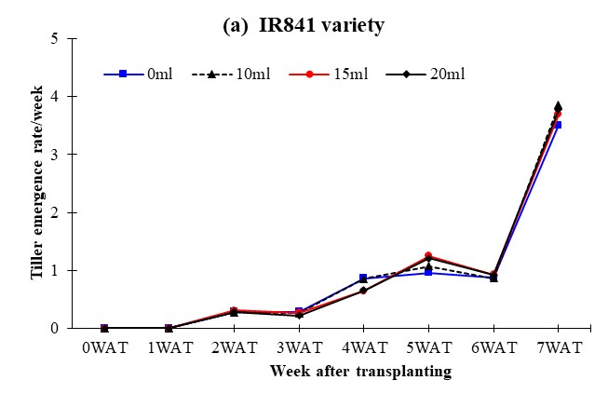
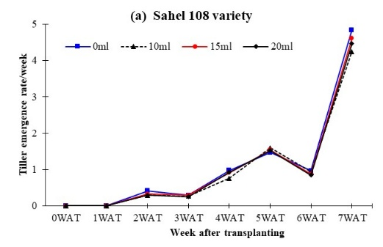
Fig. 2 Temporal evolution of tiller emergence rate of IR841 and Sahel 108 rice varieties. WAT: Week after transplanting
  - Discussion
The results of this study highlight the beneficial effects of the combined application of vermicompost tea (VCT) and effective microorganisms (EM) on vegetative growth and yield components of IR841 and Sahel 108 rice varieties. Overall, these biological inputs significantly improved the performance of both varieties, confirming the findings of several authors regarding the stimulating effects of biofertilizers.
Application of the different VCT+EM doses significantly increased plant height, number of leaves, and tillers in both varieties. These results align with those reported by Afsharmanesh et al. (2016) and Churilova&Midmore (2019), who demonstrated that organic biostimulants enhance nutrient absorption, chlorophyll synthesis, and leaf development, resulting in improved plant growth.
The highest plant height in IR841 was achieved with 10 ml and 15 ml doses of VCT+EM, whereas the best results in Sahel 108 were obtained with the 20 ml dose. This likely reflects varietal differences in responsiveness to biofertilizers. Arancon et al. (2019) also reported that the effectiveness of biological inputs depends both on the crop variety and environmental conditions.
The number of leaves and tillers followed an increasing trend with higher doses, peaking in Sahel 108 at 20 ml. This supports the findings of Manthei (2021), who showed that combining liquid compost with EM promotes greater rooting and tillering due to improved nutrient availability, enhanced microbial activity in the rhizosphere, and the stimulation of natural phytohormones favorable to vegetative development.
Regarding yield components, the number of panicles per hill was significantly higher in Sahel 108, with a peak at 15 ml of VCT+EM. This indicates the contribution of biofertilizers to enhanced floral differentiation, as demonstrated by Arosha&Sarvananda (2022), who found a link between enriched vermicompost tea and increased inflorescence formation per plant.
In contrast, panicle length was consistently greater in IR841 across all doses, suggesting a varietal-specific response. The stability of this variable across doses implies that panicle length is more influenced by varietal characteristics than by biofertilizers, as noted by Mthiyane et al. (2024) in studies on the effects of biostimulants on rice morphological traits. It is also worth noting that IR841 and Sahel 108 have distinct morphological traits, which explains the differences observed in panicle length.
The analysis of tiller emergence rate revealed a similar pattern for both varieties: tillering began in the second week after transplanting, peaked in the fifth week, slightly declined in the sixth, and reached another peak in the seventh week. This dynamic likely results from the combined physiological stimulation by microbial metabolites (e.g., auxins and cytokinins produced by EM) and organic compounds present in vermicompost tea (Kakar et al. 2016;Asgharia et al. 2020), which promote cell division and axillary bud development, thereby enhancing tillering.
It is important to emphasize that the response to treatment varied by variety. IR841 responded better to moderate doses (10–15 ml), while Sahel 108 showed improved performance with higher doses (20 ml). This dose–variety interaction suggests a specific synergy between genotype, the introduced microbiota, and vermicompost tea, as described by Paungfoo-Lonhienne (2020), who emphasized that bioinoculant efficiency is often modulated by host–microbe compatibility.

4.CONCLUSION
This study demonstrates that the combined application of vermicompost tea and effective microorganisms has a positive and significant effect on the growth and yield performance of IR841 and Sahel 108 rice varieties, with varying responses depending on the dose of biofertilizer applied. These findings confirm the agronomic relevance of using biostimulants in sustainable cropping systems and pave the way for further research into optimal formulations based on rice variety type

DISCLAIMER (ARTIFICIAL INTELLIGENCE)
Authors hereby declare that NO generative AI technologies such as Large Language Models (ChatGPT, COPILOT, etc) and text-to-image generators have been used during writing or editing of this manuscript.

COMPETING INTEREST
Authors have declared that no competing interests exist.

COMPETING INTERESTS DISCLAIMER:
Authors have declared that they have no known competing financial interests OR non-financial interests OR personal relationships that could have appeared to influence the work reported in this paper.

REFERENCES
Adoukonou, S. F., Bokossa, A. Y. J., & Dossou, J. (2021). Agronomic performance of different rice varieties (Oryza sativa L.) in off-season cultivation in the commune of Adjohoun in southern Benin. Journal of Scientific Research of the University of Benin, 10(1), 23–32.
AfricaRice. (2021). Technical data sheets of rice varieties adapted to different rice ecosystems in West Africa. Africa Rice Center (AfricaRice), Abidjan, Côte d'Ivoire. 32 p.
Afsharmanesh, R., Rahimi, A., Torabi, B., & Akhgar, A. (2016). Effects of vermicompost and compost tea application on the growth criteria of corn (Zea mays). Iranian Journal of Field Crops Research, 14(1), 185–199. (In Persian).
Arosha, K. P. L., &Sarvananda, L. (2022). Vermicomposting tea: A potential liquid biofertilizer. Frontiers in Life Science Research, 1(1), 1–5. https://doi.org/10.56397/FLSR.2022.10.01
Arancon, N., Owens, J., & Converse, C. (2019). The effects of vermicompost tea on the growth and yield of lettuce and tomato in a non-circulating hydroponics system. Journal of Plant Nutrition, 42(19), 2447–2458.
Asghari, B., Khademian, R., &Sedaghati, B. (2020). Plant growth promoting rhizobacteria (PGPR) confer drought resistance and stimulate biosynthesis of secondary metabolites in pennyroyal (Mentha pulegium L.) under water shortage condition. Scientia Horticulturae, 263, 109132. https://doi.org/10.1016/j.scienta.2019.109132
Atiyeh, R. M., Subler, S., Edwards, C. A., Bachman, G., Metzger, J. D., & Shuster, W. (2000). Effects of vermicomposts and composts on plant growth in horticultural container media and soil. Pedobiologia, 44(5), 579–590.
Churilova, E., &Midmore, D. (2019). Vermiliquer (vermicompost leachate) as a complete liquid fertilizer for hydroponically-grown pakchoi (Brassica chinensis L.) in the tropics. Horticulturae, 5(26), 1–9.
Gómez-Brandón, M., Vela, M., Martínez-Toledo, M. V., Insam, H., & Domínguez, J. (2015). Effects of compost and vermicompost teas as organic fertilizers. In S. Sinha, K. K. Pant, & S. Bajpai (Eds.), Advances in Fertilizer Technology: Synthesis (Vol. 1, pp. 300–318).
Hossain, M. M., Sultana, F., Islam, S. M. A., & Islam, M. R. (2022). Effective microorganisms (EM) and their potential applications in agricultural productivity: A review. Journal of Applied and Natural Science, 14(1), 99–110. https://doi.org/10.31018/jans.v14i1.3291
INStaD. (2024). Agricultural production statistics: 2023–2024 campaign. National Institute of Statistics and Demography, Benin.
Kakar, K. U., Ren, X. L., Nawaz, Z., Cui, Z. Q., Li, B., Xie, G. L., Hassan, M. A., Ali, E., & Sun, G. C. (2016). A consortium of rhizobacterial strains and biochemical growth elicitors improve cold and drought stress tolerance in rice (Oryza sativa L.). Plant Biology, 18(3), 471–483.
Kheyri, N. (2017). Effect of the rate and application time of vermicompost on the yield and yield components of rice (Oryza sativa L. ‘cv. Tarom Hashemi’). Applied Research in Field Crop, 30(2), 90–109. https://doi.org/10.22092/aj.2018.114711.1169
Kour, D., Rana, K. L., Yadav, A. N., Yadav, N., Kumar, M., Kumar, V., Vyas, P., Dhaliwal, H. S., & Saxena, A. K. (2020). Microbial biofertilizers: Bioresources and eco-friendly technologies for agricultural and environmental sustainability. Biocatalysis and Agricultural Biotechnology, 23, 101487. https://doi.org/10.1016/j.bcab.2019.101487
Manthei, R. (2021). A comparison trial of vermicompost teas as hydroponic nutrient solutions against commercial fertilizers: Identifying nutrients and plant production (Master’s thesis). Texas State University. 50 p.
Mthiyane, P., Aycan, M., & Mitsui, T. (2024). Integrating biofertilizers with organic fertilizers enhances photosynthetic efficiency and upregulates chlorophyll-related gene expression in rice. Sustainability, 16(21), 9297. https://doi.org/10.3390/su16219297
Obsi File, Legesse, H., &Tujuba, M. (2022). Effect of farmyard manure and blended fertilizer rates on yield and yield components of hot pepper (Capsicum annuum L.) in East Wollega Zone, Ethiopia. American Journal of Plant Biology, 7(1), 1–12. https://doi.org/10.11648/j.ajpb.20220701.12
Paungfoo-Lonhienne, C., Watanarojanaporn, N., &Jaemsaeng, R. (2020). Plant growth promoting rhizobacteria enhances the efficiency of the combination of organic and chemical fertilizers in sugarcane. Open Journal of Ecology, 10(7), 440–444. https://doi.org/10.4236/oje.2020.107028
Saito, K., Dieng, I., Vandamme, E., Johnson, J.M., & Tanaka, A. (2021). Strategies for improving soil fertility and rice productivity in West Africa. Field Crops Research, 262, 108041. https://doi.org/10.1016/j.fcr.2020.108041

