**Original Research Article**

**Enhancing tomato seed quality attributes with Naphthyl Acetic Acid (NAA) foliar spray and training system strategies**

**Abstract**

The present study was conducted in the Department of Seed Science and Technology at DR Y S Parmar University of Horticulture and Forestry, Solan, Himachal Pradesh, during the summer of 2024. The research aimed to examine the effects of NAA as a foliar spray (at concentrations of 0, 25, 50, and 75 ppm) and various training systems (two-stem, four-stem, and no training) on the seed quality attributes of tomato cv. Solan Lalima. Foliar sprays were applied at 30 days after transplanting and at 50% flowering. Tomatoes were harvested from the twelve treatment plots upon reaching red ripeness, and seeds were extracted through fermentation methods. Seed quality parameters were assessed under laboratory with four replication and observations on quality parameters of seeds were noted. The results indicate that when mother plants of tomato were treated with 50ppm NAA and pruned to two stems, seeds with significantly enhanced characteristics were produced, that includes increased 1000-seed weight, higher germination percentage before and after accelerated ageing, longer seedlings, greater seedling dry weight, improved seed vigour indices, accelerated germination, and reduced EC values of seed leachates. Therefore, the implementation of a two-stem training strategy combined with NAA @50 ppm spray can be recommended for commercial tomato seed production programs.

**Keywords:** NAA, foliar spray, stem-training, seed quality traits.

**Introduction**

Tomato, (*Solanum lycopersicum* L., 2n = 2x = 24) belongs to the Solanaceae family and has its origin in the South American Andes, is one of the most cultivated and relished fruit vegetable worldwide. Beyond its culinary variability, tomato plays a vital role in human nutrition serving as a rich source of antioxidants such as lycopene, vitamins A, B, and C, calcium, minerals, and ß-carotene (Bose and Som, 1990; Ali *et al*., 2020). In India, tomatoes are cultivated across tropical, subtropical and mild cold climate regions on an area of approx. 8,40,000 hectares and the production is estimated at 20,331(000’)MT. In Himachal Pradesh, around 14,000 hectares of land is under tomato cultivation, accounting for a production of 577 thousand metric tonnes during 2021-22 (Anonymous, 2021-22), thus implying its cultivation potential in local economies. In the mid hills of Himachal Pradesh, tomatoes are considered as the most lucrative and remunerative crop and is being cultivated extensively on a large scale annually to ensure off-season availability of produce. This necessitates the need of high-quality seeds of improved tomato varieties. The quality of seed, whether for multiplication or commercial cultivation, is influenced by several factors that affect its planting value. High seed quality, particularly regarding viability and vigour, is crucial for vegetable seedling development in nurseries and successful plant establishment in the field (Doijode, 1988). Researches indicates that growth promoting phytohormones can effectively regulate vegetative and reproductive growth, overcome the problems of pollination and fertilization and are considered as an important signalling molecule in seed development, thereby improving seed yield and quality attributes as well. Also, seeds import hormones from the mother plant influencing its physiological qualities. Extensive application of PGRs has gained traction globally for achieving super-production in agriculture in the 21st century (de Andrade et al., 2023). However, efficacy of PGRs in maximising the benefits depends mainly upon the crop, variety, hormones used, their concentration, stage of administration and intensity of application. Literature documents that auxins are involved in morphogenesis regulation, stimulation and elongation (George et al., 2008; Saini et al., 2013). The natural auxin i.e. Indole-3-acetic acid (IAA) is known to degrade quickly, limiting its applicability (Small and Degenhardt, 2018). In contrast, synthetic auxins like α-Naphthalene acetic acid (NAA), Indole-3-butyric acid (IBA) are more effective due to their resistance to oxidation in plant tissue. Indeterminate tomato sequentially put forth numerous side shoots/suckers with continued flower and fruit formation. If in an indeterminate cultivar, every sucker is retained will lead to competition for vital resources, negatively impacting the yield and quality. Modification of plant architecture through stem-training influence productivity and quality by altering the relative growth and positioning of vegetative and reproductive organs in the canopy. By affecting light interception, nutrient distribution, and airflow, canopy management can contribute to plant's overall health and productivity. Franco et al. (2009) stated that adoption of proper training and pruning techniques creates balance in the source/sink relationship and the carbon/nitrogen (C/N) ratio thereby effectively optimising the performance of indeterminate tomato varieties. However, research on the foliar application of NAA when combined with various stem-training systems is scarce. The present investigation attempts to determine the impact of foliar application of NAA in combination with training systems on the seed quality attributes of tomato.

**Materials and Methods**

The field experiment was conducted during the summer season in the year 2024 at the experimental farm of the Department of Seed Science and Technology, Dr. Y S Parmar University of Horticulture and Forestry, Nauni, Solan, Himachal Pradesh in tomato cv. Solan Lalima. The seeds were sown in nursery beds in lines about 5 cm apart and 1-2 cm deep on the second fortnight of February during both the year and transplanted at 4-5 leafy stage. The experimental plot size was 2.2 m x 1.2 m with 90 cm×30cm accommodating 12 plants per plot. The recommended dose of N, P2O5 and K2O nutrients were added in the form of Urea, SSP and MOP @ 218,475 and 90 kg ha-1, respectively.

Treatment details: The treatments comprised of two factors: foliar application of NAA at four concentrations applied twice i.e. first 30 days after transplanting (DAT) and second at 50% flowering- F1: 25 ppm, F2: 50ppm and F3: 75 ppm and F4: No spray, and three levels of training systems (T)- T1: two-stem, T2: four-stem and T3: untrained control, comprising 12 treatment combinations and were replicated thrice in Randomised Complete Block Design (RCBD).

TABLE 1.

|  |  |
| --- | --- |
| **Treatment No.** | **Details of treatment** |
| T1 | Foliar spray of NAA-25 ppm with Two-stem training system |
| T2 | Foliar spray of NAA-25ppm with Four-stem training system |
| T3 | Foliar spray of NAA -25 ppm with No training |
| T4 | Foliar spray of NAA-50 ppm with Two-stem training system |
| T5 | Foliar spray of NAA-50 ppm with Four-stem training system |
| T6 | Foliar spray of NAA-50 ppm with No training |
| T7 | Foliar spray of NAA-75 ppm with Two-stem training system |
| T8 | Foliar spray of NAA-75 ppm with Four-stem training system |
| T9 | Foliar spray of NAA-75 ppm with No training |
| T10 | No spray with Two-stem training system |
| T11 | No spray with Four-stem training system |
| T12 | No spray with No training |

The meteorological data, including rainfall, maximum and minimum temperature, and relative humidity recorded during the field experimentation is illustrated in Fig.1.

**Fig. 1: Average monthly weather conditions during the experimentation period in the year 2024**

Preparation of stock solution of Naphthalene acetic acid (NAA): 1 g of NAA was carefully measured and first dissolve with ethanol, then added distilled water to the beaker until the total volume reaches 1 litre to make it 1000 ppm. To prepare a working solution from the stock solution, the dilution formula **C1V1=C2V2** used, where: C1​ = concentration of the stock solution, V1​ = volume of the stock solution to be taken, C2 = desired concentration of the working solution, and V2​ = final volume of the working solution.

**Training systems:**

|  |  |  |
| --- | --- | --- |
| Two-stem training | : | First two stems (or branches) that appear on the plant after its established, is retained. These two stems are then trained to grow upward, and the rest of the side shoots or branches are removed to maintain only these two primary stems to bear fruits for seed production. As the two primary stems grow, they are tied to a support structure using plastic wire to keep them upright. |
|  |  |  |
| Four-stem training | : | First four branches (or stems) that appear on the plant are selected to grow and bear fruit for seed production. All other side shoots or branches that emerge from the plant are pruned or removed regularly. The four primary branches are supported and trained to grow upright, by tying them to a support structure using plastic wires. |
|  |  |  |
| No training | : | No physical intervention is made to control the number of stems or branches, or to direct the plant’s growth. The plant is allowed to grow naturally, following its inherent growth patterns without any training. |

All the packages of practices recommended for tomato production were followed from time to time to ensure a good crop stand. Experimental plots were irrigated as and when required, also, plant protection practices were taken up for the control of insect pest and decreases during trial period.

For seed quality analysis, fruits were harvested when they turned red-ripe, and seeds were extracted using natural fermentation methods for 24 hours. Observations for seed quality parameters were recorded in the laboratory with 4 replications. Germination test was conducted by roll towel method with 100 seeds each under controlled condition of 25±2oC and 95±2% of temperature and RH respectively (ISTA, 2020).

$$Germination \%=\frac{Number of seeds germinated}{Total number of seeds sown}×100$$

From the germination test, ten normal seedlings were selected randomly from each treatment on the day of the final count and length was measured from shoot tip to root tip. The same 10 seedlings were dried for 24 hours in a hot-air oven to measure seedling dry weight. Seedling vigour index-length (SVI-I) and Seedling vigour index-mass (SVI-II) was calculated as per the formula given by Abdul-Baki & Anderson (1973):

$$SVI-I=Germination\left(\%\right)×Seedling length \left(cm\right)$$

$$SVI-II=Germination\left(\%\right)×Seedlingdry weight (mg)$$

The Electrical conductivity (EC) of seed leachates was determined using digital EC meter and expressed in micro-Siemens per centimetre (µS/cm).

Speed of germination was calculated by the following formula given by Czabator (1962).

Speed of germination= $\frac{n1}{d1}$ + $\frac{n2}{d2}$ + $\frac{n3}{d3}$ +……

where, n = number of germinated seeds on dth day, and d= number of days (up to 14 days).

The seeds were artificially aged as suggested by Delouche & Baskin (1973) by placing seeds inside the dessicator filled with 100 ml of KOH solution and transferred to accelerated ageing chamber (40 ±1 °C, >95% relative humidity) for eight days. After the ageing period, samples were taken out from the chamber and the seeds of each treatment were tested for germination.

Statistical analysis was carried out using KAU-GRAPES version 1.10. Data were subjected to analysis of variance and means were compared. Conclusions were drawn only on significant differences between the treatment mean at 0.05 level of probability. The least significant difference test was used to decipher the effect of treatments at 5% level of significance (P=0.05).

**Results and Discussions**

After the harvest of crop, the extracted seeds were analysed for various seed quality parameters. The results regarding the combined effect of foliar spray of NAA and training systems on the seed quality of tomato cv. Solan Lalima are presented in Table 2 and discussed below for each recorded observation:

1000-seed weight (g): The 1000-seed weight, or test weight, influence multiple aspects of seed quality, including germination and vigour, and is positively correlated with plant performance. The 1000-seed weight showed no significant differences among treatment T7 (NAA-75ppm with two-stem training), with a numerically higher value of 3.62 g and is comparable with T4 (50ppm NAA+two-stem training) with a value of 3.52g. The lowest value (2.75g) was found in T12 (No spray+No training) and is statistically at par (2.80 g) with T11 (No spray+four-stem training). According to Afshari et al. (2011), test weight is reliant upon the embryo size and the reserve food materials present in the endosperm and the interaction between optimum dose of NAA and two-stem training might have enhanced the efficiency of assimilate transport and utilisation, resulting in optimal seed weight.

Germination percent: Germination percentage (Fig.2) depicted significant differences among treatment. Seeds harvested from plants treated with 50 ppm & 75 ppm NAA, and those trained to two stems (T4 and T7), exhibited the highest germination percentage at 88.50%, which was closely followed by T1@ 25 ppm+ two-stem training (86.75%) and T8 @ 75 ppm NAA+four-stem training (86.25%), whereas, lowest germination (72.50%) was observed in T12 (No spray+No training). The application of NAA is attributed to ensure adequate food reserves supply necessary for the resumption of embryo growth. This also facilitates synthesis of hydrolytic enzymes to degrade starchy endosperm, resulting in enhanced germination. Higher germination percentages were observed in chilli seeds when plants were sprayed with 10 ppm NAA (Sultana et al., 2006). Lal et al. (2016) observed that bell pepper plants retained with two-stems resulted in production of seeds with enhanced stored reserves, leading to improved seed germination.

Seedling length: The length of seedling suggests the initial growth advancement of seed and is an essential component in determining the seed vigour index-I (SVI). Among the various treatments, longer seedlings (18.70cm) were recorded in T4 (NAA@50ppm+two-stem training) and was found statistically at par with T7@75ppm+two-stem training (18.26cm). in contrast, shorter seedlings were found in T11@no spray+four-stem training(15.41cm) and T12@no spray+no training (14.49cm).

Seedling dry weight: An examination of data (Table 2) showed that different treatments exerted significant effect on seedling dry weight. The application of NAA@ 50 ppm with two-stems (T4) recorded significantly the highest seedling dry weight (21.20mg). However, minimum values for this trait were recorded in treatment T11(15.20mg) and T12 (14.93mg).

Seed vigour indices: Maximum seed vigour index-I (1655.60) was observed in case of treatment T4(NAA @50ppm along with two-stem training), which was closely followed by T7@NAA-75ppm and trained to two-stems (1616.53) and the lowest (1050.08) was recorded in case of T12 (No spray+no training). Similarly, SVI-II was also in same trend as of SVI-I with maximum seed vigour index-II (1867.50) was recorded in T4 @NAA-50 ppm and two-stem training and least (1082.25) in T12.

The application of NAA enhanced seedling vigour, as evidenced by increased germination, seedling length, and dry matter production. This improvement may be attributed to auxin's role in enhancing cell wall plasticity and facilitating the deposition of additional cellulose molecules within the cell wall. These outcomes align with the findings of Geetharani et al. (2008) in onion. Arvindkumar et al. (2012) found that spraying bitter gourd plants with NAA at 50 ppm resulted in seeds with enhanced physiological qualities, including improved seed germination, seedling establishment, and increased vigour index. In ridge gourd Lambat et al. (2015) reported better seed quality when crop was sprayed with NAA @50 ppm. Pathirana et al. (2015) showed that pruning tomato plants can improve the vigour indices of the harvested seeds. Hence, the observed increase in the interaction between NAA spray and training methods may be attributed to a higher percentage of bolder seeds and an increased test weight of seeds, resulting from enhanced translocation and assimilation of photosynthates from the source to the sink (seeds).

Speed of germination: Faster germination determinates the better success of seedling establishment under field condition. The values for speed of germination ranged from 14.01 (T12@ no spray with no training) to 23.31(T4@50ppm NAA+two-stem training) in different treatments (Fig.3). Due to absence of prior reports on this treatment combination regarding this trait, it can be inferred that the optimal training system, along with the appropriate dosage of plant growth regulators during the growth period, has resulted in the development of heavy seeds with sufficient storage reserves and hormonal balance. This likely led to a positive correlation between thousand seed weight, germination percentage, and vigour index, thus facilitating the germination process.

Electrical conductivity (µScm-1): The electrical conductivity (EC) of a seed implies the integrity of the cell membrane of its coat. A higher EC value of the seed leachate indicates chance of cell membrane damage (Thakur et al., 2022). There was significant variation in the values of electrical conductivity in given treatments. The lowest EC value of 4.36 µScm-1 was observed in treatment T4 (50 ppm NAA +Two-stem training system) and was found statistically at par with T7 (4.56 µScm-1). In contrast, treatment T12 (No spray+No training) and T3 (NAA-25 ppm+no training) were having the higher values, 7.00 µScm-1and 6.99 µScm-1, respectively. Under treatment T4, sound seeds with better membrane permeability might have developed which might have reduced the EC value.

Germination percent after accelerated ageing test (AAT): Accelerated ageing, also known as controlled deterioration treatment, has been employed to evaluate the vigour and longevity of seed cultivars under conditions of high temperature and high relative humidity (Samarah, 2006; Pournik et al., 2019). Seeds harvested from tomato cv. Solan Lalima exhibited a significant variation in germination after forced ageing (Fig.2). Treatment T7 (NAA@ 50 ppm+ Two-stem training) was superior (74.25%) compared to the other treatments, while the lowest germination percent (59.50%) following accelerated ageing was recorded in T12 (No spray+ no training). Righetti et al. (2015) proposed a potential connection between the regulation of seed longevity and increased auxin levels during seed maturation, possibly through interactions with HSFA9 (HEAT SHOCK FACTOR A9) and ABI3 (ABSCISIC ACID INSENSITIVE3)-regulated genes. Previous research suggests that seeds harvested from double-stemmed tomato plants may tolerate accelerated ageing more effectively due to the production of healthy, well-filled, vigorous seeds (Santhosh, 2020).

Figure 2. Germination percent before and after accelerated ageing test

**Table 2. Effect of NAA foliar spray and training system on seed quality parameters in tomato cv. Solan Lalima**

|  |  |  |  |  |  |  |  |  |  |
| --- | --- | --- | --- | --- | --- | --- | --- | --- | --- |
| Treatment | 1000-seed weight (g) | Germination (%) | Seedling length (cm) | Seedling dry weight (mg) | SVI-Length (SVI-I) | SVI-Mass (SVI-II) | Speed of germination | Electrical conductivity (µScm-1) | Germination % after AAT |
| T1 | 3.28BC | 86.75AB (9.37)* | 16.61D | 17.50E | 1441.01BC | 1518.00C | 21.26C | 4.93E | 71.75ABC (57.88)** |
| T2 | 3.15D | 82.50CD (9.14) | 15.54E | 16.28F | 1282.22D | 1342.98DE | 19.47F | 5.97C | 67.75DE (55.38) |
| T3 | 3.11D | 80.50DE (9.03) | 15.04F | 15.28G | 1210.84D | 1229.75F | 17.55HI | 6.99A | 65.25E (53.86) |
| T4 | 3.52A | 88.50A (9.46) | 18.70A | 21.10A | 1655.60A | 1867.50A | 23.31A | 4.36F | 73.50AB  (59.01) |
| T5 | 3.33B | 84.75BC (9.26) | 17.75B | 18.38C | 1505.21B | 1556.38C | 20.46E | 5.43D | 71.25ABC (57.56) |
| T6 | 3.13D | 82.00CDE (9.11) | 17.03CD | 17.20E | 1396.73C | 1410.13D | 17.70GH | 6.21BC | 69.00CD (56.16) |
| T7 | 3.62A | 88.50A (9.46) | 18.26A | 19.55B | 1616.53A | 1730.38B | 22.93B | 4.56F | 74.25A (59.50) |
| T8 | 3.31B | 86.25AB (9.34) | 17.35BC | 17.93D | 1496.17B | 1546.25C | 20.82D | 5.49D | 72.50AB (58.36) |
| T9 | 3.19CD | 81.75CDE (9.09) | 16.85D | 16.50F | 1377.42C | 1348.85DE | 18.01G | 6.38B | 70.75BCD (57.24) |
| T10 | 3.00E | 80.75DE (9.04) | 15.56E | 16.23F | 1256.18D | 1310.20E | 17.34I | 5.39D | 69.25CD (56.31) |
| T11 | 2.80F | 79.25E (8.96) | 15.41EF | 15.20G | 1220.44D | 1204.70F | 16.19J | 6.07BC | 65.50E (54.03) |
| T12 | 2.75F | 72.50F (8.57) | 14.49F | 14.93G | 1050.08E | 1082.25G | 14.01K | 7.00A | 59.50F (50.46) |
| CD (0.05) | 0.11 | 3.20 | 0.47 | 0.40 | 75.72 | 69.09 | 0.34 | 0.36 | 3.19 |

Figures in the parenthesis are *square root / **arc sine transformed values

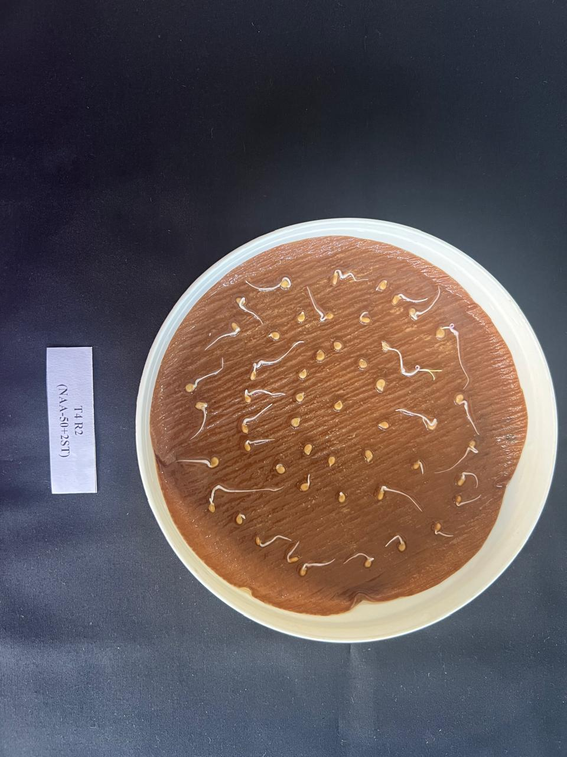 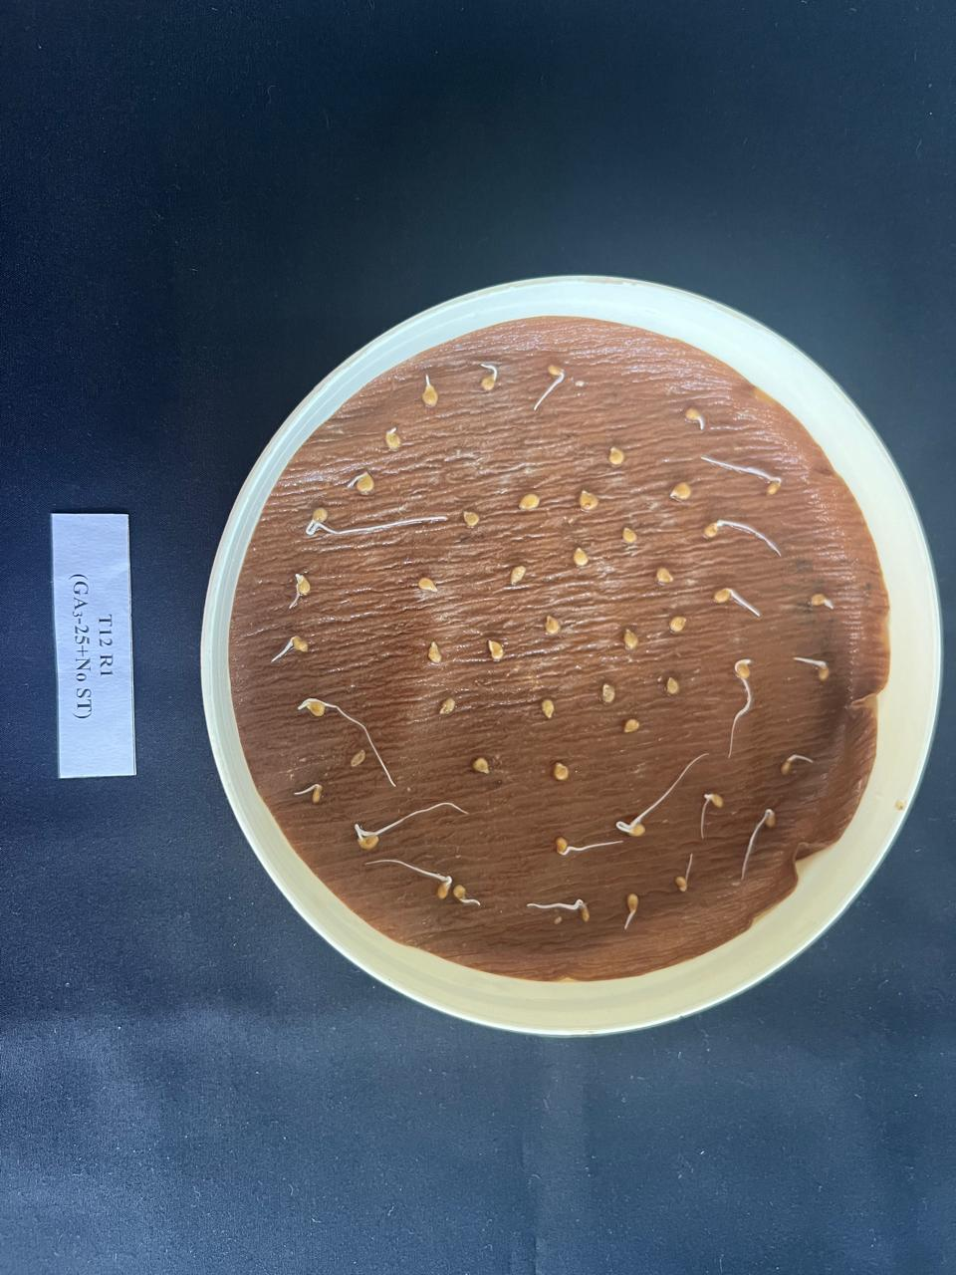

**(B)**

**(A)**

Figure 3: Speed of germination on 3rd day (A): T4 (NAA@50ppm with two-stem training and

(B): T12 (No spray with no training)

**Conclusion**

In general, treatments with foliar spray of NAA and training systems proved to be more effective in comparison to the unsprayed and untrained plants. A critical analysis of the results reveals that in tomato cv. Solan Lalima, application of NAA@50 ppm along with training to two-stems was found to enhance all the seed quality attributes studied. The treatments with NAA coupled with optimised training methods during tomato seed production can be considered as a suitable technique to achieve better quality seed for farmers.

**Conflict of interest**: None.

**COMPETING INTERESTS DISCLAIMER:**

Authors have declared that they have no known competing financial interests OR non-financial interests OR personal relationships that could have appeared to influence the work reported in this paper.

**References**

1. Abdul‐Baki, A. A., & Anderson, J. D. (1973). Vigor determination in soybean seed by multiple criteria 1. Crop science, 13(6), 630-633.
2. Afshari, H., Eftekhari, M., Faraji, M., Ebadi, A. G., & Ghanbarimalidareh, A. (2011). Studying the effect of 1000 grain weight on the sprouting of different species of Salvia L. grown in Iran. Journal of Medicinal Plants Research, *5*(16), 3991-3993.
3. Anonymous. (2021-22). Annual Report of National Horticulture Board, Gurgaon, Haryana.
4. Arvindkumar, P. R., Vasudevan, S. N., Patil, M. G., & Rajrajeshwari, C. (2012). Influence of NAA, triacontanol and boron spray on seed yield and quality of bitter gourd (*Momordica charantia*) cv. PUSA VISESH. Asian Journal of Horticulture, 7(1), 36–39.
5. Czabator, F. J. (1962). Germination value: An index combining speed and completeness of pine seed germination. Forest Science, 8, 386 – 395.
6. de Andrade, J. C., Galvan, D., Kato, L. S., & Conte-Junior, C. A. (2023). Consumption of fruits and vegetables contaminated with pesticide residues in Brazil: A systematic review with health risk assessment. Chemosphere, 322, 138244.
7. Delouche, J. C., & Baskin, C. C. (1973). Accelerated aging techniques for predicting the relative storability of seed lots. Seed Science and Technology, 1, 427-452.
8. Doijode S. D. (1988). Studies on vigour and viability of seeds as influenced by maturity in chilli (Capsicum annuum L.). [Haryana Agricultural University Journal of Research](https://www.cabidigitallibrary.org/action/doSearch?do=Haryana+Agricultural+University+Journal+of+Research), 17(1-2), 94-96.
9. Franco, J. L., Rodriguez, N., Diaz, M., & Camacho, F. (2008). Influence of different pruning methods in cherry tomato grown hydroponically in a cropping spring cycle: effects on the production and quality. Acta Horticulturae**,** 843, 165-170.
10. Geetharani, P., Ponnuswamy, A. S., Manivannan, M. I., Rajangam, J., & Natarajan, S. (2008). Enhancing the sowing quality of seed by grading in onion (*Allium cepa* var. aggregatum). [Asian Journal of Horticulture](https://www.cabidigitallibrary.org/action/doSearch?do=Asian+Journal+of+Horticulture), 3(2), 301-303.
11. George, E. F., Hall, M. A., & Klerk, GJ. D. (2008). Plant growth regulators I: introduction; auxins, their analogues and inhibitors, pp 175–204. In: George, E.F., Hall, M.A., Klerk, GJ.D. (eds.) Plant propagation by tissue culture. Springer, Dordrecht. doi.org/10.1007/978-1-4020-5005-3_5
12. International Seed Testing Association [ISTA]. (2020). International Rules for Seed Testing. ISTA, Bassersdorf, Germany.
13. Lal, M., Kanwar, H. S., Kanwar, R., & Lal, C. (2016). Effect of planting density and training on plant health and seed quality of bell pepper (*Capsicum annuum* L.) under protected conditions. Journal of Applied and Natural Science, 8(3), 1219-1222.
14. Lambat, A., Charjan, S., Gadewar, R., Lambat, P., Mate, G., Parate, R., & Charde, P. N. (2015). Seed quality as influenced by plant growth regulators in ridge gourd. International Journal of Researches in Biosciences, Agriculture and Technology, 2(3), 322-23.
15. Pathirana, C. K., Sajeevika, I. D. C., Pathirana, P. R. S., Fonseka, H., & Fonseka, R. M. (2015). Effects of canopy management and fruit thinning on seed quality of tomato (*Solanum lycopersicum* L.) variety Thilina. Tropical Agricultural Research, 25(2), 171-179.
16. Pournik, S., Abbasi-Rostami, M., Sadeghipour, H. R., & Ghaderi-Far, F. (2019). True lipases beside phospholipases contribute to walnut kernel viability loss during controlled deterioration and natural aging. Environmental and Experimental Botany, 164, 71-83.
17. Righetti, K., Vu, J. L., Pelletier, S., Vu, B. L., Glaab, E., Lalanne, D., Pasha, A., Patel, R. V., Provart, N. J., Verdier, J., Leprince, O., & Buitink, J. (2015). Inference of longevity-related genes from a robust coexpression network of seed maturation identifies regulators linking seed storability to biotic defense-related pathways. The plant cell, 27(10), 2692-2708.
18. Saini, S., Sharma, I., Kaur, N., & Pati, P. K. (2013). Auxin: a master regulator in plant root development. Plant cell reports, 32, 741-757.
19. Samarah, N. H. (2006). Effect of air‐drying immature seeds in harvested pods on seed quality of common vetch (*Vicia sativa* L.). New Zealand Journal of Agricultural Research, 49(3), 331-339.
20. Santhosh, K. (2020). Studies on planting dates and training systems on seed yield and quality in tomato *(Solanum lycopersicum L.)* grown under protected conditions. M Sc Thesis, Dr Y S Parmar University of Horticulture and Forestry, Solan, p 113.
21. Sultana, W., Fattah, Q. A., & Islam, M. S. (2006). Yield and seed quality of chilli (*Capsicum annuum* L.) as affected by different growth regulators. Bangladesh Journal of Botany, 35(2), 195-197.
22. Thakur, N., Vasudevan, S. N., Doddagoudar, S. R., Tembhurne, B. V., MacHa, S. I., & Paul, M. G. (2022). Planting ratio and plant growth regulators affecting seed quality in CGMS based chilli (*Capsicum annuum)* hybrid. Indian Journal of Agricultural Sciences, 92(8), 982-985.