Original Research Article
Onion growth, seed yield and seed quality in response to different nitrogen sources in mid hill of Himachal Pradesh

ABSTRACT
India’s onion productivity lags behind countries like the Republic of Korea, Guyana and the USA. To improve seed yield and quality, a study was conducted in 2020-2021 at Dr YS Parmar University of Horticulture and Forestry, Nauni, Solan (HP), using nine treatments with varying nitrogen sources (CAN, urea and calcium nitrate) in RCBD with three replications. Treatment Trt₁ in which 100% N was applied as CAN showed superior vegetative growth, early bolting (91.33 days), highest umbel size (7.43 cm), seeds per umbel (1143.80), and seed quality traits such as germination (91.50%), seedling vigour and lowest electrical conductivity (0.109 dS m⁻¹). However, Treatment Trt₅ (75% CAN + 25% calcium nitrate) excelled in leaf length and seed yield (766.52 kg ha⁻¹). Both Trt1 and Trt5 showed high nitrogen use efficiency and residual soil nitrogen. Moreover, T₁ recorded the highest benefit-cost ratio (3.53), making it the most effective nitrogen source for enhancing onion seed yield and quality under mid-hill conditions of Himachal Pradesh.
Key words: CAN, Productivity, Nitrogen use efficiency, Urea

Introduction
The genus Allium is highly prevalent among monocotyledonous plants, comprising over 800 species (Fu et al., 2019; Huo et al., 2019). Of these, Allium cepa L. is the most extensively grown and consumed (Kiani et al., 2023; Nissa et al., 2024). Globally, it ranks as the second most produced vegetable, following tomato (FAO, 2022). Onion is a highly nutritious vegetable offering several health benefits, including better cardiovascular health, increased bone mineral density, and improved regulation of blood sugar levels (Esakki et al., 2024). Onion is a major source of flavonoids, and regular intake of these compounds has been associated with a lower risk of diabetes, cancer, and cardiovascular diseases.
India's onion productivity (16.32 t/ha) is considerably lower when compared to countries like the Republic of Korea (67.69 t/ha), Guyana (64.34 t/ha) and the United States of America (56.70 t/ha) (FAO, 2022). In addition to variations in growing conditions, one of the main reasons for low productivity in India is the lack of quality seeds, especially high-yielding hybrid variety. Therefore, increasing the supply of high-quality onion seeds is essential, and this can be done in part by raising the crop's productivity (Yallamale and Tomar 2019).
Nutrients are vital for boosting onion bulb production, which in turn supports the development of high-quality seeds. Therefore, producing superior quality onions is a primary objective for growers. Due to their shallow, unbranched root systems, onions are among the least efficient crops at absorbing nutrients, making them highly dependent on and responsive to fertilizer application. Achieving a good onion yield requires the application of optimal fertilizer levels, the use of suitable varieties, and the implementation of proper agronomic practices tailored to the specific environmental conditions. A highly effective way to boost onion yields is through the careful and proper application of fertilizers, especially nitrogen. Notably, optimizing fertilizer use not only improves crop productivity but also enhances the plant's nutritional quality (Ghosh et al. 2022).
Various nitrogen fertilizers can be used to supply nitrogen to crops. With Nangal Calcium ammonium nitrogen (CAN) no longer in production, most farmers now depend mainly on urea, which is a cost-effective nitrogen source due to its high nitrogen content. However, continuous use of urea can negatively affect soil health and, over time, reduce crop productivity. A new option, Narmada CAN, has recently become available and is soil-neutral, meaning it does not cause issues with soil acidity or alkalinity. Selecting the right nitrogen fertilizer is essential for achieving high seed yield and quality in onions. Therefore, identifying the most suitable nitrogen source for optimal plant growth and development is crucial. Therefore the present research was conducted to standarizes the optium nitrogen source for onion and study its effect on growth, seed yield, seed quality parameters.
Materials and Methods
Experimental Details
The current field and lab experiment was carried out at Dr. Yashwant Singh Parmar University of Horticulture and Forestry's Department of Seed Science and Technology in Nauni, Solan, India. The field experiment was carried out at Pandah Research Farm, which is located in the mid-hill region of Himachal Pradesh, India, at a height of 1250 feet above mean sea level, with latitudes of 35.50º N and longitudes of 77.80º E. The experimental farm's soil was a loam to clay loan with an electrical conductivity of 0.094 dSm-1 and a pH of 5.75. Mean temperature, rainfall and relative humidity recievied during cropping seasson were 26.15⁰C, 58.95 mm and 53.12 (Fig 1)
Onion variety Palam Lohit was used in experiment. Field experiment was conducted during Rabi 2020-21 seasin with 9 treatments with 3 replications and design of experiment was randomized completely block design. Plot size was 2.1 × 1.65 m with spacing of 45 × 45 cm and number of plants per plot was 20 and total number of plots were 27. Treatment used in experiments were Trt 1- 100%N, Trt2- 100%N through urea, Trt3- 100%N through calcium nitrate, Trt4- 75% N through CAN + 25% N through urea, Trt5 - 75% N through CAN + 25% N through calcium nitrate, Trt6- 50 % N through CAN + 25 % N through urea + 25 % N through calcium nitrate, Trt7- 50 % N through CAN + 50 % N through urea, Trt8- 50 % N through CAN + 50 % N through calcium nitrate and Trt9- control.
Sowing, cultural operations and harvesting
The soil was prepared into a fine tilth by performing one deep ploughing, followed by three successive harrowings. All residues from the previous crop and any weeds were cleared from the experimental plot. Finally, the land surface was evened out using a plank. Medium-sized bulbs (approximately 2.5 cm in diameter) of the Palam Lohit onion variety - harvested the previous year and stored in the Department of Seed Science and Technology - served as planting material. On 28 October 2020, they were manually planted at 45 cm × 45 cm spacing. Immediately after planting, irrigation was applied. Farmyard manure was applied at a full rate of 250 q ha⁻¹, along with 475 kg ha⁻¹ of superphosphate and 100 kg ha⁻¹ of muriate of potash, all incorporated at the time of bulb planting. Nitrogen fertilizer was then added according to the treatment plan, divided into three separate applications throughout the growth period.
The experimental plots were inspected regularly in the early mornings to monitor onion growth, development, and identify any emerging issues. Throughout the entire cultivation period, four manual weedings were performed, followed by earthing up. Irrigation was applied to the plots whenever needed. Standard agronomic practices were employed consistently to ensure a healthy and well-established seed crop. Once the seed capsules turned black and about 25–30% of the black seeds were visible on the umbels, each umbel was carefully cut with a 5–7 cm section of flower stalk attached. Harvesting was done in stages, and the umbels were air-dried in the sun. The seeds were then released by gently beating and rubbing the umbels by hand. Following threshing, the seeds were cleaned and sun-dried for three to four days until moisture content dropped below 8 %.

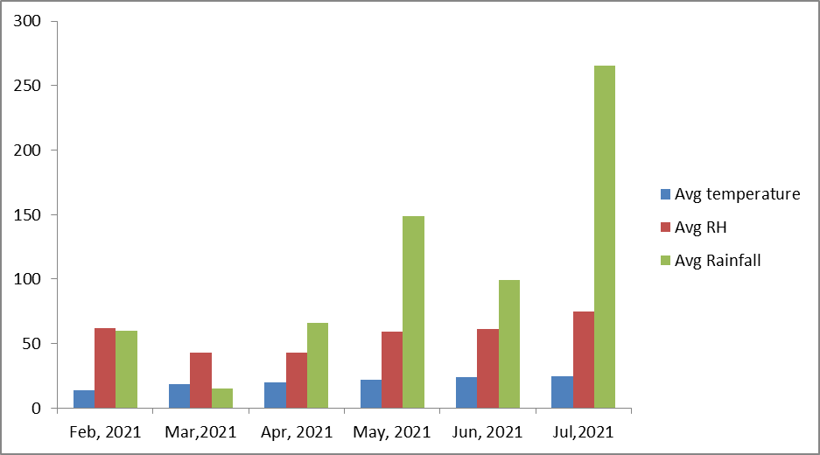
Figure 1: Mean monthly meteorological data for the year 2020-2021

Parameters recorded
Field parameters, seed quality and soil parameters were recorded during the experiment. Field parameters included number of leaves per plant, leaf length (cm), days to 50% bolting, number of bolters per plant, umbel diameter(mm), number of umbels per plant, number of seeds per umbel, seed yield/plot/ha(kg/ha) were recorded at their respective stages.
Ten plants were selected at random, and at 30, 60 and 90 days after bulb planting, the total number of leaves and leaf length from bulb neck to longest leaf on each plant was recorded. The average leaf count and lef length across these ten plants was then calculated for each of the three sampling dates. The number of days from planting until 50 % of the flower stalks had emerged was recorded for each replicate within each treatment group. The number of bolters per plant was counted from the 10 randomly selected plants in each replication. Mean number per plant was then workout. The size of umbel was measured with the help of vernier Calipers from the 25 randomly selected umbels in each replication at the time of harvesting. Ten plants were randomly chosen in each replicate, and the total number of umbels on each plant was counted. The average number of umbels per plant was then calculated. Twenty-five umbels were randomly selected from each treatment, and the seeds on each of those umbels were counted. The mean value was then calculated and expressed as the average number of seeds per umbel. The seed yield per plot was determined by harvesting all plants from each plot, extracting the seeds, and then calculating the average seed output per plant by dividing the total seed weight by the number of plants. Formula used for calculating seed yield/ha -
Seed yield per ha (kg) = Seed yield plot⁻¹ (g) x 8000
Size of plot (m2) × 1000
When calculating seed yield per hectare, 20% of the field area was allocated for the construction of channels, and the remaining 80% was used in the calculations.
Seed quality parameters such as 1000 seed weight, germination (%), seedling length (cm), & dry weight (g), seed vigour index-I & II, speed of germination were also observed. For 1000 seed weight a random sample of 1,000 dried seeds was taken from each replication within each treatment. These seeds were weighed using an electronic balance, and the weight was recorded in gram. Germination (%) was recored by using method of ISTA (1985). Formula used were:
Germination (%) = Number of normal seedlings × 100
Total number of seeds planted
Twelve days after the onset of germination, seedling length was measured using the paper roll method. Ten healthy seedlings were randomly selected from each replication, and each seedling’s total length from the tip of the primary leaf to the tip of the primary root was measured with a scale. The mean length was then calculated and expressed in centimeters and for seedling dry weight 10 of the seedlings previously selected for measuring length were also used. These seedlings were dried in a hot-air oven at 80 °C for 48 hours, weighed on an electronic balance, and the mean dry weight was expressed in milligrams. Seed vigour index- I and II were caluclted using the formula given byAbudul Baki and Anderson (1973):
Seed Vigour index- I = Germination (%) × seedling length (cm)
Seed Vigour index-II = Germination (%)× seedling dry weight(mg)
Speed of germination was calculated using formula given by Maguire (1962):
Speed of germination: $\frac{X1}{Y1}$ +$\frac{X2}{Y2}$+-----------$\frac{Xn}{Yn}$
X1, X2,Xn , are number of seeds germianted on first, second and nth day while Y1,Y2,Yn are number of days from first sowing to nth days.

Soil samples were also analysed for nitrogen (Kg/ha⁻¹) using alakline permagnate method (Subbiah and Asija, 1956) and nitrogen use efficiencey (Kg/ha⁻¹) and caluclated using formula (Fageria and Baligar 2003):
NUE = $\frac{Seed Yield in the fertilized plot \left(\frac{kg}{ha}\right)- Seed yield in control plot (\frac{kg}{ha})}{Qunatity of nitrogen applied (\frac{kg}{ha})}$

Stastical Analysis
The data were analyzed following the statistical methods outlined by Gomez and Gomez (1984) for both the Randomized Complete Block Design (RCBD) and the Completely Randomized Design (CRD).

Results and Discussion
Growth and Seed Yield Parameters
The data on the number of leaves influenced by various nitrogen sources is summarized in Fig 2 At 30 days after field emergence, the highest number of leaves per plant (23.43) was recorded in treatment Trt1 (100% nitrogen applied through CAN), in contrast, the lowest number of leaves (16.50) was observed in Trt9 (Control). At 60 days, the maximum leaf count (33.10) was found in Trt8 (50% N through CAN + 50% N through calcium nitrate), and the minimum number of leaves at this stage (24.76) was again recorded in the control treatment Trt9. At 90 days after emergence, Trt1 (100% N through CAN) produced the highest number of leaves (37.16, while the lowest count (26.76) was observed in Trt9 (Control).
Nitrogen fertilization promotes vegetative growth and increases leaf number by enhancing the plant's absorption and assimilation processes (Aminifard et al., 2012). Nitrogen, being a key component of chlorophyll and other compounds, supports vigorous growth. Higher leaf numbers in CAN-treated plants may be attributed to better nitrogen availability, boosting dry matter accumulation in leaves. Marzi et al. (2020) reported that applying nitrogen at a rate of 200 kg/ha resulted in the maximum number of leaves.
The data on leaf length as affected by various nitrogen sources, presented in Fig3 showed that at 30 days after emergence, the longest leaves (26.02 cm) were recorded in treatment Trt5 which was statistically similar to Trt1 (25.03 cm) and Trt8 (25.55 cm). The shortest leaves (17.24 cm) were noted in the control (Trt9). At 60 days, T5 again showed the greatest leaf length (42.47 cm), which was statistically comparable to Trt1 (40.56 cm) and Trt8 (41.03 cm), while the minimum length (27.52 cm) was recorded in Trt9. At 90 days, the maximum leaf length (54.66 cm) was observed in Trt5, which remained statistically at par with Trt1 (52.54 cm) and Trt8 (50.41 cm), whereas the shortest leaves (37.88 cm) were again found in the control treatment Trt9. Treatments with a higher proportion of CAN resulted in superior vegetative growth, likely due to greater nitrogen uptake and assimilation by the plants, along with reduced leaching losses compared to other nitrogen fertilizers.

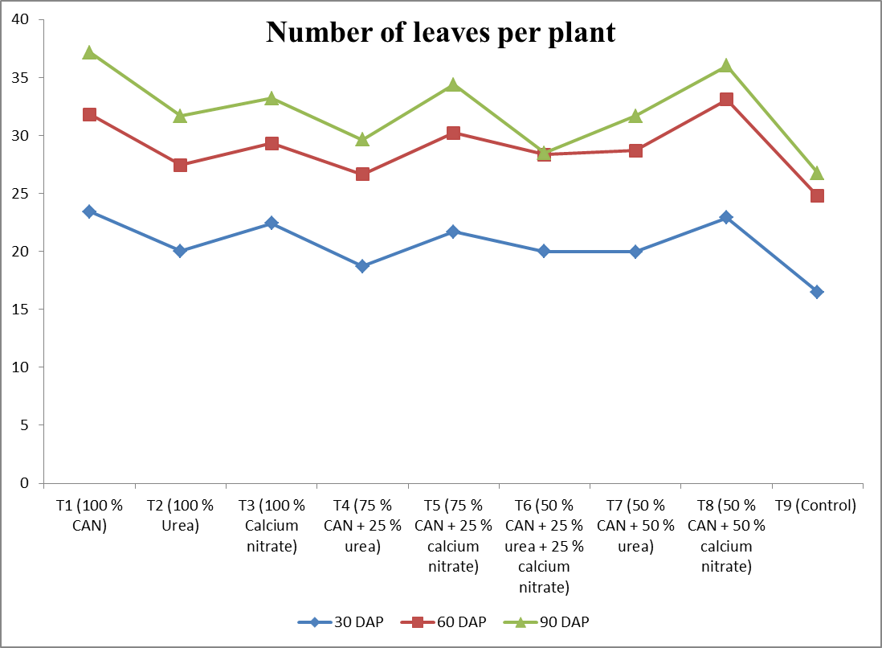
Fig 2. Effect of different nitrogen fertilizers on number of leaves per plant in onion
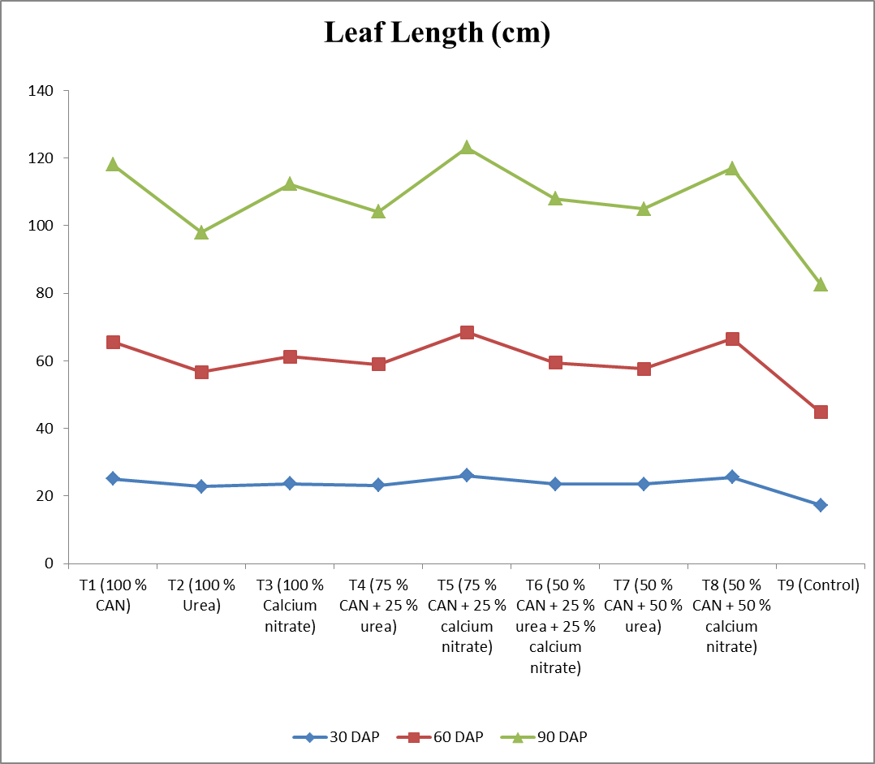
Fig 3. Effect of different nitrogen fertilizers on leaf length (cm) in onion
The highest number of bolters per plant (8.63) was observed in treatment Trt1, which was statistically similar to Trt3 (8.13) and Trt5 (8.53). In contrast, the lowest number of bolters per plant (5.83) was recorded in the control treatment (Trt9) (Table 1).
CAN provides nitrogen in two forms and has minimal leaching losses compared to other nitrogen sources (Sommer and Jensen, 1994). A sufficient nitrogen supply also enhances the uptake of other nutrients like phosphorus, which is crucial for flowering (Brady and Weil, 2002). This may explain why plots receiving CAN alone or in combination had better nitrogen and phosphorus availability, resulting in a higher number of bolters per plant. Antille et al. (2015) noted that urease enzyme activity is reduced at low temperatures (during winter), leading to slower nitrogen release from urea. This slower release may have resulted in lower nitrogen availability in urea-treated plots, thereby reducing the number of bolters per plant.
The shortest time to reach 50% bolting (91.33 days) was recorded in treatment Trt1, which was statistically comparable to Trt2 (92.33 days) and Trt5 (93.33 days). In contrast, the longest duration to 50% bolting (102.67 days) was observed in the control treatment (Trt9) while largest umbel size (7.34 cm) was recorded in treatment Trt1 , showing statistical similarity with Trt3 (6.90 cm), Trt5 (7.10 cm), and Trt8 (7.12 cm). In contrast, the smallest umbel size (5.83 cm) was observed in the control treatment (Trt9). The larger umbel size observed in plants treated with CAN alone or combined with other nitrogen sources may be attributed to increased dry matter accumulation during early growth stages, along with more efficient partitioning of photosynthates from the vegetative parts (source) to the reproductive organs (sink), and their effective translocation to reproductive structures (Malagoli et al., 2005).
The seed count per umbel is an important yield-determining characteristic in onion (Yalamalle et al., 2019). The highest number of seeds per umbel (1134.80) was recorded in treatment Trt1 , which was statistically similar to Trt3 (1101.66) and Trt5 (1079.30). In contrast, the lowest seed count per umbel (686.80) was noted in the control treatment (Trt9). Plants supplied with nitrogen through CAN produced a higher number of seeds per umbel, likely due to the superior umbel quality observed in CAN-treated plants compared to those receiving other nitrogen fertilizers. Jain (2001) in African marigold reported similar results.
The highest seed yield (16.60 g per plant, 0.332 kg per plot, and 766.52 kg per hectare) were obtained in treatment Trt5 (75% N through CAN + 25% N through calcium nitrate), which was statistically comparable to Trt1 (16.55 g per plant, 0.331 kg per plot, and 764.21 kg/ha) and Trt8 (15.46 g per plant, 0.309 kg per plot, and 762.68 kg/ha). In contrast, the lowest seed yields (10.93 g per plant, 0.219 kg per plot, and 504.86 kg/ha) were recorded in the control treatment Trt9. Yield performance is shaped by a complex interplay of genetic traits, environmental conditions, and agronomic practices. A lack of nitrogen can impair plant growth, decrease photosynthetic efficiency, and restrict the energy required for seed development, ultimately resulting in reduced yield (Geisseler et al., 2022; Qi et al., 2023)
Plants receiving nitrogen through CAN produced the highest seed yields compared to other nitrogen sources. This may be due to the greater number of bolters or umbels, larger umbel size, and increased seed count per umbel, all of which contributed to higher overall seed production. Hossain et al. (2017) reported that applying 114 kg of nitrogen resulted in the highest seed yield per plant (4.21 g), whereas the lowest yield (3.20 g) was obtained with 57 kg of nitrogen. Similarly, Debashis et al. (2017) found that a nitrogen dose of 175 kg/ha produced the maximum number of seeds per plant.

Seed Quality Parameters
Onion seeds generally have poor storability, as their viability tends to decline more rapidly than that of many other vegetable crops (Taylor, 2020). Balanced nutrition during crop growth, particularly adequate nitrogen supply, is a major factor affecting seed storability and vigour. Nitrogen is vital for healthy plant development, improved photosynthesis, and the production of proteins and enzymes necessary for seed formation. Sufficient nitrogen enhances seed vigour by promoting efficient nutrient absorption, resulting in robust seedlings with better germination potential (Girase et al., 2025). Maximum seed germination (91.50 %), seedling length (17.13 cm), seedling dry weight (23.30 mg), seed vigour index-I & II (1567.78 &2132.02), and 1000 seed weight (3.90 g) were recorded in Trt1-1(100 % N through CAN) as compared to control, while speed of germination (8.00) highest in Trt-5 (75 % CAN + 25 % calcium nitrate) (Table 2) Nitrogen fertilization boosts seed quality and storability by enhancing germination, seedling development, and overall vigour. These benefits are linked to improved nutrient availability and higher tocopherol levels- antioxidants that safeguard seeds from oxidative damage, preserve membrane integrity, and promote efficient metabolic activity (Girase et al. 2025). Similar results were reported by Girase et al. (2025) in onion when nitrogen @100kg/ha was applied.

Soil Parameters
Intital avilable nitrogen in soil was 265.6 kg ha⁻¹ . The data in Fig indicate that various nitrogen sources significantly affected the level of available soil nitrogen after harvest. The highest value (286.20 kg/ha) was observed in treatment Trt1 (100% N through CAN), which was statistically similar to Trt3 (281.23 kg/ha), Trt5 (283.40 kg/ha), and T8 (280.33 kg/ha). In contrast, the lowest available soil nitrogen (261.43 kg/ha) was recorded in the control treatment (Trt9) (Fig4) The notable rise in available soil nitrogen after harvest may be attributed to the increase in both ammonium and nitrate ions, along with the microbial conversion of ammonium to nitrate through nitrification, which occurs when nitrogen availability in the soil is enhanced by different nitrogen sources. These results align with the findings of Jeet (2016), who reported increased nitrogen levels with the use of various nitrogen fertilizers. , Similarly highest nitrogen use efficiency (0.643 kg/kg) was recorded in treatment Trt5 (75% N through CAN + 25% N through calcium nitrate), which was statistically comparable to Trt1 (0.637 kg/kg), Trt3 (0.627 kg/kg), Trt6 (0.523 kg/kg), and Trt8 (0.640 kg/kg) (Fig 5). In contrast, the lowest nitrogen use efficiency (0.227 kg/kg) was observed in treatment Trt7 (50% N through CAN + 50% N through urea). Higher nitrogen use efficiency in plots treated with CAN may be attributed to greater nitrogen availability for plant uptake.

Economics
The economic analysis of different nitrogen source treatments, as shown in Table 3, revealed that treatment Trt1 generated the highest net returns (2,030.75 USD), followed by T5 (2,148.21). Trt1 also recorded the highest benefit-cost (B:C) ratio of 3.53, with Trt5 close behind at 3.29. In contrast, the lowest net returns (1,832.56) and B:C ratio (2.31) were observed in the control treatment (Trt9).(Table 3).

Treatments | Number of bolters per plant | Days to 50 %  bolting | Size of umbel  (cm) | Number of seeds per umbel | Seed Yield per plant  (g) | Seed yield per plot  (kg) | Seed Yield per hectare (kg)
Trt₁ (100 % CAN) | 8.63 | 91.33 | 7.34 | 1134.80 | 16.55 | 0.331 | 764.21
Trt₂ (100 % Urea) | 7.70 | 92.33 | 6.82 | 975.43 | 14.15 | 0.283 | 653.39
Trt₃ (100 % Calcium nitrate) | 8.13 | 97.66 | 6.90 | 1101.66 | 14.96 | 0.299 | 758.05
Trt₄ (75 % CAN + 25 % urea) | 7.43 | 99.33 | 6.29 | 819.56 | 13.63 | 0.273 | 629.53
Trt₅ (75 % CAN + 25 % calcium nitrate) | 8.53 | 93.33 | 7.10 | 1079.30 | 16.60 | 0.332 | 766.52
Trt₆ (50 % CAN + 25 % urea + 25 % calcium nitrate) | 7.83 | 96.66 | 6.64 | 860.93 | 13.86 | 0.277 | 711.11
Trt₇ (50 % CAN + 50 % urea) | 7.56 | 97.33 | 6.78 | 946.93 | 12.83 | 0.257 | 592.59
Trt₈ (50 % CAN + 50 % calcium nitrate) | 7.73 | 98.00 | 7.12 | 982.00 | 15.46 | 0.309 | 762.68
Trt₉ (Control) | 5.83 | 102.67 | 5.83 | 686.80 | 10.93 | 0.219 | 504.86
Mean | 7.71 | 97.18 | 6.75 | 954.15 | 14.33 | 0.286 | 682.54
CD_{0.05} | 0.65 | 4.94 | 0.45 | 127.71 | 1.54 | 0.031 | 93.93

Table 1 Effect of different nitrogen fertilizers on various growth and yield parameters in onion

Treatments | 1000 seed weight (g) | Germination (%) | Speed of germination | Seedling length (cm) | Seedling dry weight (mg) | Seed Vigour Index-I | Seed Vigour Index-II
Trt₁ (100 % CAN) | 3.90 | 91.50 (9.61) | 7.97 | 17.13 | 23.30 | 1567.78 | 2132.02
Trt₂ (100 % Urea) | 3.72 | 88.25 (9.44) | 6.63 | 14.15 | 22.45 | 1248.94 | 1981.17
Trt₃ (100 % Calcium nitrate) | 3.75 | 90.00 (9.53) | 6.93 | 15.86 | 22.57 | 1427.17 | 2031.70
Trt₄ (75 % CAN + 25 % urea) | 3.61 | 85.25 (9.28) | 7.46 | 14.37 | 21.70 | 1225.46 | 1849.87
Trt₅ (75 % CAN + 25 % calcium nitrate) | 3.88 | 90.75 (9.57) | 8.00 | 16.50 | 23.27 | 1498.23 | 2112.17
Trt₆ (50 % CAN + 25 % urea + 25 % calcium nitrate) | 3.62 | 82.00 (9.11) | 6.79 | 14.61 | 19.67 | 1198.73 | 1613.27
Trt₇ (50 % CAN + 50 % urea) | 3.63 | 83.50 (9.19) | 6.45 | 14.11 | 21.07 | 1178.19 | 1759.70
Trt₈ (50 % CAN + 50 % calcium nitrate) | 3.73 | 89.75 (9.52) | 7.02 | 15.46 | 22.87 | 1388.22 | 2053.02
Trt₉ (Control) | 3.37 | 80.25 (9.01) | 6.52 | 10.50 | 18.37 | 842.90 | 1474.55
Mean | 3.69 | 86.80 | 7.08 | 14.74 | 21.69 | 1286.18 | 1889.71
CD_{0.05} | 0.16 | 0.05 | 0.78 | 0.78 | 0.23 | 70.78 | 23.04
Table 2 Effect of different nitrogen fertilizers on various seed quality parameters of harvested onion seed
Treatments | Cost of Cultivation (USD) | Gross Return (USD) | Net Return (USD) | B:C Ratio
Trt₁ (100 % CAN) | 2,030.75 | 9,204.94 | 7,174.19 | 3.53
Trt₂ (100 % Urea) | 1,891.12 | 7,869.16 | 5,978.88 | 3.16
Trt₃ (100 % Calcium nitrate) | 2,501.84 | 8,325.30 | 6,629.37 | 2.65
Trt₄ (75 % CAN + 25 % urea) | 1,996.75 | 7,582.29 | 5,585.54 | 2.79
Trt₅ (75 % CAN + 25 % calcium nitrate) | 2,148.21 | 9,234.22 | 7,086.01 | 3.29
Trt₆ (50 % CAN + 25 % urea + 25 % calcium nitrate) | 2,113.01 | 8,325.30 | 6,450.97 | 3.05
Trt₇ (50 % CAN + 50 % urea) | 1,961.54 | 7,137.23 | 5,175.69 | 2.63
Trt₈ (50 % CAN + 50 % calcium nitrate) | 2,266.89 | 8,601.08 | 6,334.19 | 3.05
Trt₉ (Control) | 1,832.56 | 6,082.17 | 4,249.61 | 2.31
Mean | 2,030.75 | 9,204.94 | 7,174.19 | 3.53
CD_{0.05} | 1,891.12 | 7,869.16 | 5,978.88 | 3.16

Table 3 Effect of different nitrogen fertilizers on economics of seed production in onion

Fig 4. Effect of different nitrogen fertilizers on available nitrogen after harvest of crop (kg/ha)

Fig 5. Effect of different nitrogen fertilizers on nitrogen use efficiency

Conclusion
It was concluded that treatment Trt1 (100% N through CAN) performed best in terms of plant growth, seed yield, seed quality, nitrogen use efficiency and benefit-cost ratio. Therefore, it appears to be a more effective nitrogen source for promoting healthy growth and higher seed yield in onion under the mid-hill conditions of Himachal Pradesh and may be recommended following multi-location trials.

COMPETING INTERESTS DISCLAIMER:
Authors have declared that they have no known competing financial interests OR non-financial interests OR personal relationships that could have appeared to influence the work reported in this paper.

References :

Aminifard MH, Aroiee H, Nemati H, Azizi M and Khayyat M. 2012. Effect of nitrogen fertilizer on vegetative and reproductive growth of pepper plants under field conditions. Journal of Plant Nutrition 35:235-242.
Antille DL, Hoekstra NJ and Lalor STJ. 2015. Field-scale evaluation of calcium ammonium nitrate, urea and urea treated with N-(N-Butyl) thiophosphosphoric triamide applied to grassland in Ireland. Communication in Soil Science and Plant Analysis 46:1345-1361.
Brady NC and Weil RR. 2002. The nature and properties of soils, 13th ed. Delhi, India: Pearson Education Asia. 960p.
Debashis M, Maity TK and Basu AK. 2017. Response of quality seed production of onion (Allium Cepa L.) to different levels of nitrogen and potassium application. Research Journal of Chemical and Environmental Sciences 5(2):38-45.
FAOSTAT. 2022. Reference database of cropland nutrient budgets and nutrient use efficiency: nitrogen, phosphorus and potassium. Earth System Science Data, 16(1):525-541.
Fu J, Zhang H, Guo F, Ma L, Wu J, Yue M, Zheng X, Qiu Z and Li L. 2019. Identification and characterization of abundant repetitive sequences in Allium cepa. Scientific reports, 9(1):16756.
Geisseler D, Ortiz RS and Diaz J. 2022. Nitrogen nutrition and fertilization of onions (Allium cepa L.)-A literature review. Scientia Horticulturae, 29(1):110591.
Ghosh S, Zhang S, Azam M, Gebregziabher BS, Abdelghany AM, Shaibu AS, Qi J, Feng Y, Agyenim-Boateng KG, Liu Y and Feng H. 2022. Natural variation of seed tocopherol composition in diverse world soybean accessions from maturity group 0 to VI grown in China. Plants, 11(2):206.
Girase IP, Rai PK, Sahi VP, Thangasamy A, Ahammed TS and Yalamalle VR. 2025. Nitrogen enhances seed oil, tocopherols, seed yield and seed quality in onion. Scientia Horticulturae. 349: 114225.
Hossain MM, Khatun K, Haq ME, Ahmed M and Shefat-Al-Maruf M. 2017. Macro and micro nutritional effect on seed yield of onion. Advances in Research, 12(1):1-9.
Huo Y, Gao L, Liu B, Yang Y, Kong S, Sun Y, Yang Y and Wu X. 2019. Complete chloroplast genome sequences of four Allium species: comparative and phylogenetic analyses. Scientific reports, 9(1):12250.
Kiani Z, Mashayekhi K, Golubkina N, Mousavizadeh SJ, Nezhad KZ and Caruso G. 2023. Agronomic, physiological, genetic and phytochemical characteristics of onion varieties influenced by daylength requirements. Agriculture, 13(3):697.
Malagoli P, Laine P, Rossato L and Ourry A. 2005. Dynamics of nitrogen uptake and mobilization in field-grown winter oilseed rape (Brassica napus) from stem extension to harvest. II. AN ¹⁵N-labelling-based simulation model of N partitioning between vegetative and reproductive tissues. Annals of Botany 95:1187-1198.
Marzi M, Shahbazi K, Kharazi N and Rezaei M. 2020. The influence of organic amendment source on carbon and nitrogen mineralization in different soils. Journal of Soil Science and Plant Nutrition, 20(1):177-191.
Nissa K, Sharma R, Bharat NK and Thakur A. 2024. Effect of ZnSO4 Priming on Storability, Seed Quality and Bulb Yield in Onion under mild hills conditions of north-western Himalayas. International Journal of Plant & Soil Science, 36(7):817-825.
Qi J, Li M, Wang L, Hu Y, Liu W, Long Z, Zhou Z, Yin P and Zhou M. 2023. National and subnational trends in cancer burden in China, 2005-20: an analysis of national mortality surveillance data. The Lancet Public Health, 8(12):943-e955.
Sommer S G and Jensen C. 1994. Ammonia volatilization from urea and ammonical fertilizers surface applied to winter wheat and grassland. Springer 37:85-92.
Taylor AG. 2020. Seed storage, germination, quality, and enhancements. In The physiology of vegetable crops (pp. 1-30). Wallingford UK: CABI.
Yalamalle VR and Tomar BS. 2019. Effect of scape regulation on seed yield and quality in onion (Allium cepa). The Indian Journal of Agricultural Sciences, 89(1):56-59.
Yalamalle VR, Tomar BS, Kumar A and Ahammed ST. 2019. Polymer coating for higher pesticide use efficiency, seed yield and quality in onion (Allium cepa). Indian Journal of Agricultural Sciences 89:1195-1199.

