ORIGINAL RESEARCH ARTICLE
Phenotypic and Genetic Detection of Extended-Spectrum Beta-Lactamase (ESBL)-Producing Klebsiella pneumoniae isolates from Urinary Tract Infection Cases in Keffi, Nigeria

ABSTRACT
Background: Multidrug-resistant Klebsiella pneumoniae are often associated with urinary tract infections in the community or hospital settings globally. Resistance as a result of the Extended-Spectrum Beta-Lactamase (ESBL) gene expression has been widely reported.
Aim: The current study focused on the isolation of K. pneumoniae associated with urinary tract infections (UTIs) using standard microbiological methods, as well as the antibiotic susceptibility profile and the detection of Extended-Spectrum Beta-Lactamase (ESBL) genes using phenotypic and genetic procedures.
Study Design: The study was a cross-sectional study utilising random urine samples from patients with UTI in the selected hospitals.
Place and Duration of Study: The study was performed in Keffi from July to October 2024. Keffi is a local government area of Nasarawa State, Nigeria.
Methodology: Early morning midstream urine samples were randomly collected from 160 consenting participants from the six selected hospitals. The samples were cultured following standard microbiological techniques. Antibiotic susceptibility testing was performed using the Kirby-Bauer disc diffusion. ESBL producers were detected using the disk diffusion and PCR methods. Results obtained in this study were analysed using Smith’s Statistical Package (Version 2.8, California, USA) and a P value of ≤ 0.05 was considered statistically significant.
Results: A significantly high resistance to ceftazidime 20(100%) was recorded, closely followed by ceftriaxone 19(95%), streptomycin 19(95%), cefurexime (spell check)19(95%) and augmentin 18(90%), chloramphenicol 17(85%). The least resistance was recorded for ciprofloxacin 8(40%), amoxicillin 6(30%) and ofloxacin 6(30%). Furthermore, the majority of the isolates were found to be multidrug resistant. The blaSHV gene was detected in (60.0%) of the isolates, followed by the blaCTX-M gene (26.7%), and the blaTEM gene (13.3%).
Conclusion: The detection of multidrug-resistant, ESBL-producing K. pneumoniae in this study poses significant concern. The routine detection of ESBL genes using the phenotypic method, especially in low-resource settings is recommended.

Key Words: Urinary tract infection; K. pneumoniae; Antibiotic susceptibility; multi-drug resistance; Extended-Spectrum Beta-Lactamase; Keffi.
Introduction
Enterobacteriaceae are a group of bacteria also referred to as commensals, commonly found in the human gastrointestinal tract. Their presence renders few benefits to the host as long as they do not acquire virulent traits from invading pathogens in the environment (Moriera et al., 2024). Their presence at different anatomical sites, however, can become a problem as they may cause various infections with varying degrees of severity, including urinary tract infections (UTIs), sepsis, meningitis, and soft tissue infections, depending on their loads and the host´s immune system (Abass et al., 2024). Klebsiella pneumoniae, a member of the Enterobacteriaceae, is one such opportunistic bacterial pathogen mostly implicated in nosocomial and community-acquired infections such as meningitis, septicaemia,(spell check) wound infection, pneumonia, and urinary tract infections (UTIs) (Choby et al., 2019). Globally, urinary tract infections affect millions of people of all ages and genders, constituting one of the most common conditions in the emergency unit in hospitals (Alrashid et al., 2022). In Nigeria, there have been reports of K. pneumoniae-associated UTI with varying prevalence ranging from 5.5% to 60% (Yarima et al., 2020; Akinyemi et al., 2021; Innocent et al., 2023; Ashefo et al., 2023). Patients who undergo instrumentation of the urinary tract, including the use of a catheter, are at risk (Narimisa et al., 2022). Also, the proximity and physiology of the female urethra to the opening of the intestinal tract contribute to the fact that UTIs are more frequently reported in women than in men, with an incidence of 50 to 60% (Medina & Castillo-Pino, 2019; Sakamoto et al., 2019). Antibiotic resistance remains a challenge in healthcare due to inappropriate use and the emergence of resistant bacteria with bacteria exhibiting a wide range of resistance mechanisms, including the production of β-lactamase (Antimicrobial Resistance Collaborators, 2022; Devi et al., 2024). One of the mechanisms by which K. pneumoniae acquire resistance to beta-lactam antibiotics is the production of beta-lactamase enzymes (Butt et al., 2017). Plasmid-mediated enzymes known as the extended-spectrum β-lactamases (ESBLs) can hydrolyse and inactivate broad-spectrum β-lactam antimicrobials, namely: third-generation cephalosporins, penicillins and aztreonam, but are inhibited by clavulanic acid (Li et al., 2023). The genes encoding ESBL production in these bacteria have been identified as blaTEM, blaSHV and blaCTX-M with varying proportions across different geographical areas of the world (Zorgani et al., 2017; Husna et al., 2023). This study will contribute to the understanding of the molecular epidemiology of ESBL-producing Klebsiella pneumoniae in UTIs from the study area.
Also, valuable insights into the antibiotic resistance patterns and genetic mechanisms of resistance by the isolates will be made available. The findings will inform the development of effective diagnostic and therapeutic strategies for managing ESBL-producing K. pneumoniae infections, ultimately improving patient outcomes and reducing the burden of antibiotic resistance.
Materials and Methods

Study Design and Population
The investigation was a cross-sectional study which utilised random sampling of patients from six hospitals in Keffi from July to October 2024.
Study Location
Keffi is located in Nasarawa State, the North Central region of Nigeria, approximately 50 km from Abuja, the Federal Capital Territory and 128 km from Lafia, the capital of Nasarawa State. It is located geographically between latitude 8⁰ 3’N of the equator and longitude 7⁰ 50’E and situated at an altitude of 850m above sea level (Awkwa, 2007). The hospitals included in the study are: Federal Medical Centre Keffi (FMCK), General Hospital Keffi (GHK), Primary Health Centre Angwan Waje (PHC AW), Primary Health Centre Kofar Pada (PHC KP), Primary Health Centre Tsohon Kasuwa (PHC TK) and Primary Health Centre Angwan Jaba (PHC AJ).
Sample Size Determination

A total of 160 samples was estimated using the formula described by Ajuwon et al. (2021).
𝑵 = 𝒁 ^{𝟐}𝒑𝒒
𝑫^{𝟐}

Where; N=sample size,
Z = standard normal distribution at 95% confidence interval=1.96,
P = prevalence rate of K. pneumoniae infection from previous studies = 10.13% (Ashefo et al., 2023).
d = level of significance (allowable error) = 5% or 0.05
q = 1-p
Thus, N = (1.96) ² × 0.1013 × (1-0.1013)/ (0.05) ² = 3.8416 × 0.1013 × 0.8987 /0.0025 = 139.893109 ≈ 140
N = 140
However, actual sample size = Calculated sample size + 10% Attrition rate. But 10% Attrition rate = 14
Therefore, actual sample size = 140 + 14= 154
However, to increase the chances of isolation, it was rounded up to 160 samples.
Inclusion and Exclusion Criteria
Participants with suspected UTI who were accessing care in the selected health facilities and gave consent were included in this study. Those with suspected UTIs but on antibiotics attending the selected health facilities were excluded from this study.
Sample Collection
A total of 160 early morning mid-stream urine samples of patients with suspected cases of UTI were collected from six hospitals in the study area designated: Federal Medical Centre Keffi (FMCK), General Hospital Keffi (GHK), Primary Health Centre Angwan Waje (PHC AW), Primary Health Centre Kofar Pada (PHC KP), Primary Health Centre Tsohon Kasuwa (PHC TK), Primary Health Centre Angwan Jaba (PHC AJ) using sterile sample containers and transported to the Microbiology Laboratory of Federal Medical Centre Keffi for analysis.

Isolation of Klebsiella pneumoniae
Urine samples were mixed gently by inverting the containers several times. Using a sterile wire loop, the samples were streaked onto Cysteine Lactose electrolyte-deficient agar (CLED) agar (Oxoid Ltd., UK) and incubated at 37˚C for 24 hours. Yellowish colonies from the 24-hour plates were selected as presumptive K. pneumoniae (Karah et al., 2020).
Identification of Klebsiella pneumoniae
Identification of K. pneumoniae isolates was performed using cultural, morphological, biochemical, and motility testing, following standard procedures (Osman et al., 2020; Aryal, 2022).
Antibiotic Susceptibility Testing
The susceptibility profile of antibiotics commonly prescribed for K. pneumoniae infections was determined using the Kirby-Bauer disc diffusion method following CLSI guidelines (CLSI, 2021). The antimicrobial agents tested included: Ofloxacin (10 μg), Augmentin (30 μg), Ceftazidime (30 μg), Gentamycin (10 μg), Ciprofloxacin (10 μg), Chloramphenicol (30 μg), Ceftriaxone (30 μg), Streptomycin (30 μg), Cefurexime (30 μg), and Amoxicillin (30 μg) (Oxoid Ltd., UK).
Phenotypic Detection of Extended-Spectrum β-Lactamase Production
The Disk Diffusion Method (DDM) was used to test for potential ESBL producers by suspending freshly grown colonies in normal saline, and the turbidity of the suspension was adjusted to 0.5 McFarland’s standard. Freshly prepared Mueller-Hinton agar (MHA: Oxoid UK) was streaked with the suspension, with antibiotic discs placed 20 mm apart. The plates were then incubated for 18 hours at 37 ºC. Isolates with reduced susceptibility to cefotaxime (zone diameter of ≤ 27mm), ceftazidime (zone diameter of ≤ 22mm), and ceftriaxone (zone diameter of ≤ 25mm) around the discs were suspected to be ESBL producers (CLSI, 2021). Also, the Combined Disk Test (CDT) was done to confirm ESBL production by the K. pneumoniae isolates. The CDT confirmatory test for ESBL was performed using ceftazidime and cefotaxime discs with amoxicillin-clavulanate. An isolate was confirmed as ESBL-positive when there was a difference of 5 mm in the growth inhibition of ceftazidime-cefotaxime /amoxicillin-clavulanate (Fig. 1) (CLSI, 2021).

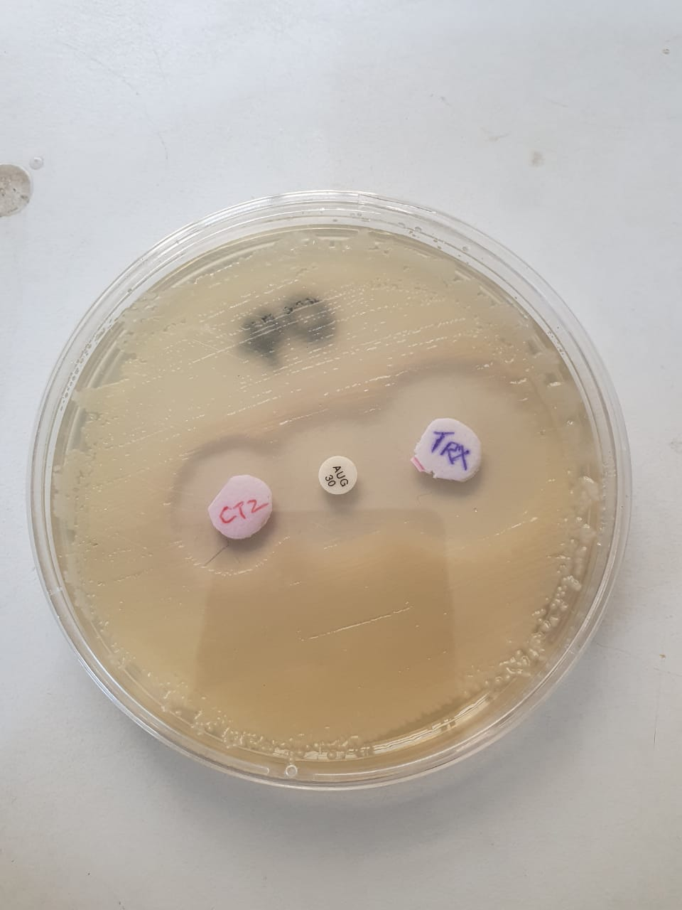
Fig. 1. ESBL- positive K. pneumoniae isolate after the Combined Disk Test

Identification of ESBL Genes by Polymerase Chain Reaction (PCR)
Genomic DNA isolation was done using the boiling lysis method as previously described by Lesiani et al. (2023). The PCR assay was carried out for the detection of extended-spectrum beta-lactamase genes (blaSHV, blaCTX−M, blaTEM) (Table 1) by optimizing the extracted mixture to a volume of 25 μl containing 2 μl of DNA template prepared from each isolate; Taq buffer: 3 μl; dNTP mix (10 mM): 1 μl; MgCl₂ (25 mM): 1.5 μl; three forward primers (10 pmol/μl): each 0.5 μl; three reverse primers (10 pmol/μl): each 0.5μl; TaqDNA polymerase (1 U/μl): 1 μl; and nuclease-free water: 13.5 μl. The amplification condition was set for initial denaturation for 10 minutes at 94°C, followed by 30 cycles of 94°C for 30 seconds, annealing at 55°C for 30 seconds, extension at 72°C for 1 minute, and final extension of 72°C for 10 minutes (Dirar et al., 2020). The PCR products were visualized after resolving them in 1.5 % agarose gel stained with 0.5 μg/ml ethidium bromide at 100 volts. The gel images were captured using the BIORAD Molecular Imager® Gel Doc™ XR⁺ System and comparing them with a standard molecular weight marker (Lagha et al., 2021; Chowdhury et al., 2022).
Table 1. Nucleotides used in the study
Type | Nucleotide Sequences (5’-3’) References | (°C) | Amplicon size (bp) | Reference
BlaSHV | SHV-FCGCCTGTGTATTATCTCCCT  SHV-RCGAGTAGTCCACCAGATCCT | (60°C)  (62°C) | 293 | Hijazi et al., 2016
BlaTEM | TEM-FTTTCGTGTCGCCCTTATTCC  TEM-RATCGTTGTCAGAAGTAAGTTGG | (60°C)  (62°C) | 403 | Hijazi et al., 2016
blaCTX−M | CTX-MFCGCTGTTGTTAGGAAGTGTG  CTX-M RGGCTGGGTGAAGTAAGTGAC | (60°C)  (62°C) | 504 | Hijazi et al., 2016
Data Analysis
The data obtained were analyzed using Smith’s Statistical Package (version 2.8, California, USA). Chi-square test was conducted at 95% confidence interval, and P values ≤ 0.05 were considered statistically significant.
Results
Antimicrobial Resistance Profile of the Urinary Klebsiella pneumoniae Isolates in Selected Hospitals of Keffi.
The antibiotic resistance profile of the Klebsiella pneumoniae isolates was significant (P < 0.05). A high 20(100%) resistance to ceftazidime was recorded, closely followed by ceftriaxone 19(95%), streptomycin 19(95%), cefurexime 19(95%) and augmentin 18(90%), chloramphenicol 17(85%). While the least resistance was recorded for ciprofloxacin 8(40%), amoxicillin 6(30%) and ofloxacin 6(30%) (Fig. 2).

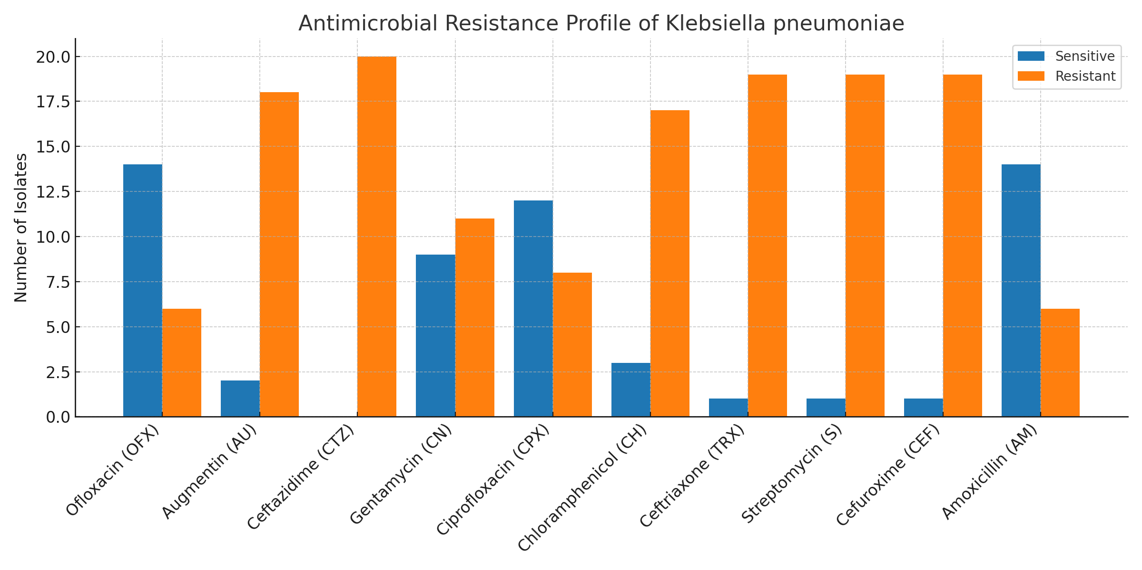
Fig. 2. Antimicrobial Resistance Profile of Klebsiella pneumoniae Isolated from Urine in Selected Hospitals of Keffi, Nasarawa State, Nigeria

Multidrug Resistance Pattern of the Urinary Klebsiella pneumoniae Isolated from Selected Hospitals of Keffi.
Different antimicrobial resistance combinations (Multidrug) by the isolate were recorded (Fig. 3). The highest multidrug profile was AM, AU, CEF, CH, CN, CPX, CTZ, OFX, S, TRX 6(30%), followed by AU, CEF, CH, CTZ, S, TRX 5(25%), AU, CEF, CH, CTZ, S, TRX 4(20%) and AU, CEF, CTZ, S, TRX 2(10%), while the least was CTZ 1(5%) AU, CEF, CH, CTZ, OFX, S, TRX 1(5%) and AU, CEF, CH, CN, CPX, CTZ, S, TRX 1(5%) respectively (P>0.05).

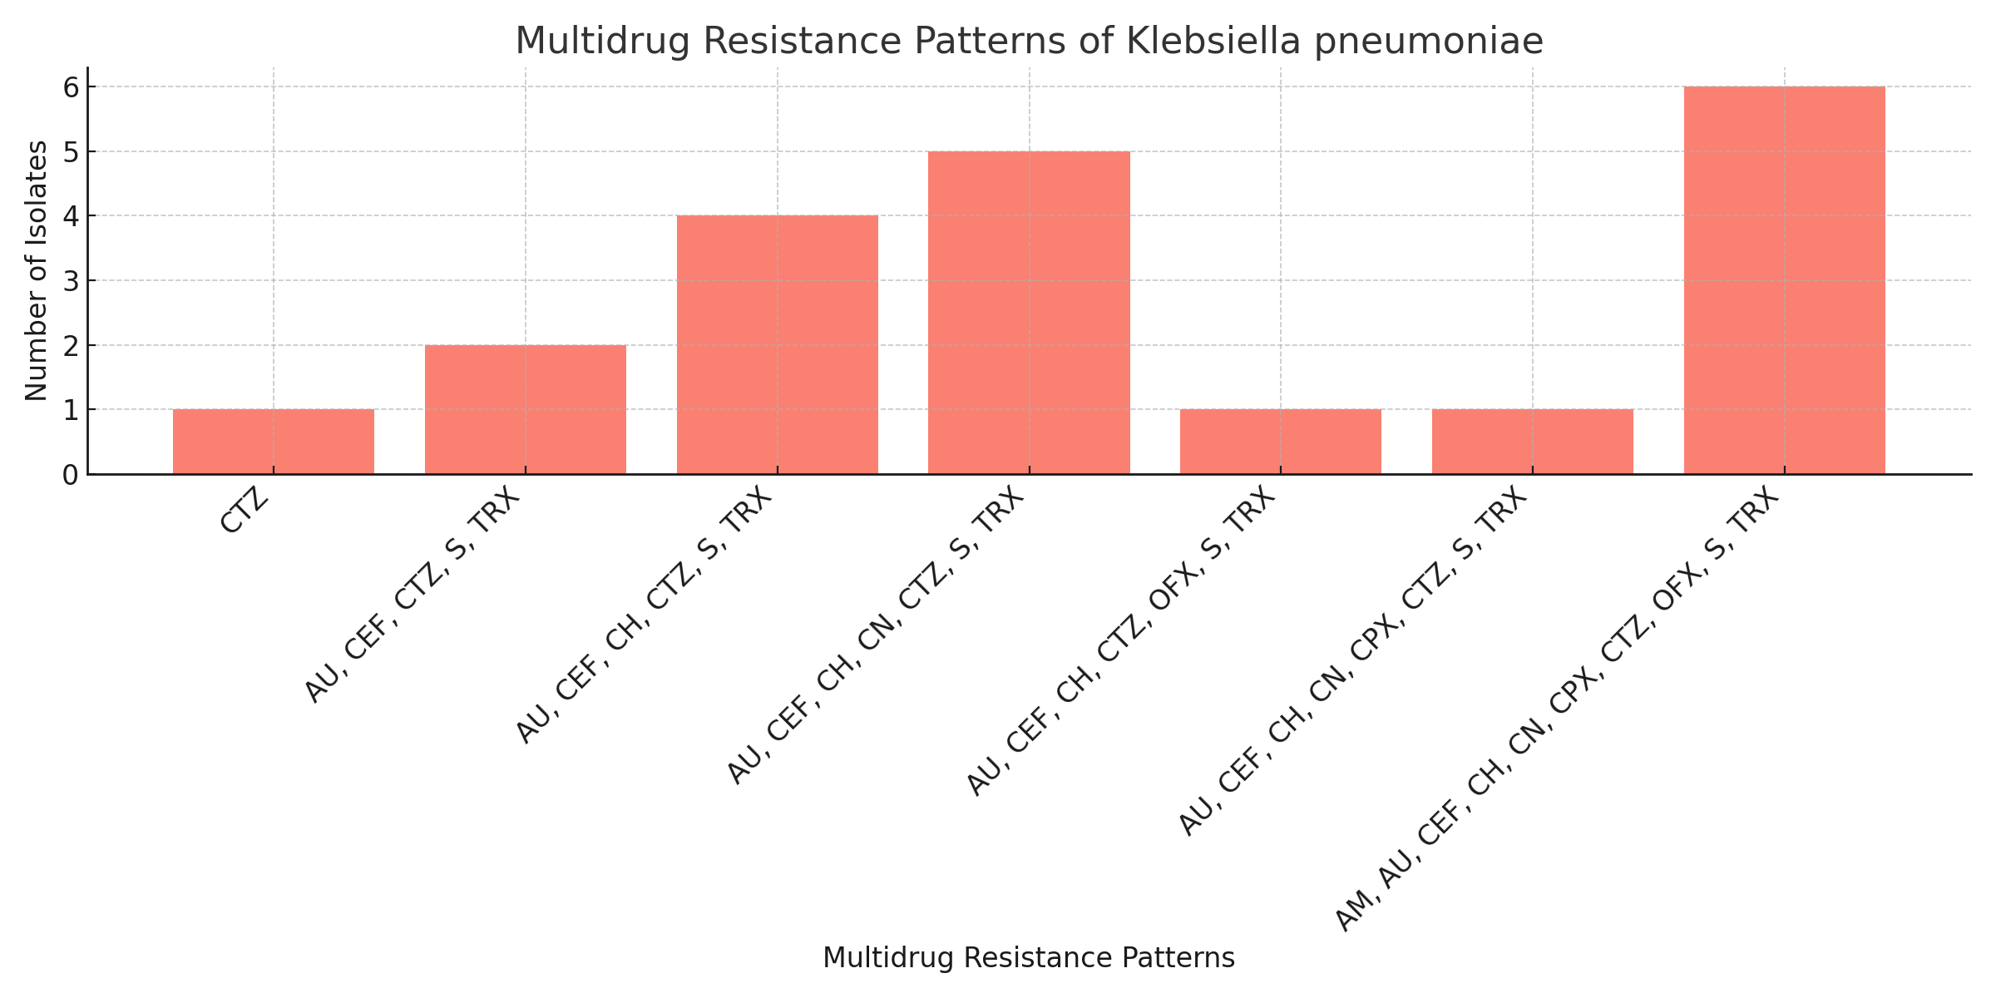
Key: AM= Amoxicillin, AU= Augmentin, CEF= Cefurexime, CH= Chloramphenicol, CN= Gentamycin, CPX= Ciprofloxacin, CTZ= Ceftazidime, OFX= Ofloxacin, S= Streptomycin, TRX= Ceftriaxone
Fig. 3. Multidrug Resistance Pattern of the Urinary Klebsiella pneumoniae Isolated from Selected Hospitals of Keffi, Nasarawa State, Nigeria.

Phenotypic Detection of ESBL-Producing Klebsiella pneumoniae
Out of the 20 positive isolates, 16 were found to be ESBL-producing after screening using the phenotypic disc diffusion method, and 15 were confirmed to be ESBL-producing Klebsiella pneumoniae after the combined disc test (Table 2). FMCK recorded the highest number of ESBL producers, 7(46.6%), followed by GHK 3(20.0%), PHC AW 2(13.3%), while the lowest was recorded from PHC KP, PHC AJ and PHC TK 1(6.7%) respectively (P > 0.05).

Table 2. Phenotypic Detection of ESBL-Producing Klebsiella pneumoniae
Facility | No. Resistant | DDM |  |  | CDT
 |  | ESBL Pos. (%) | ESBL Neg | P value | ESBL Pos. (%) | ESBL Neg | P value
FMCK | 7 | 7(43.75) | 0 | X² = 0.000 | 7(46.6) | 0 | X² = 4.622
GHK | 3 | 3(18.75) | 0 | P = 0.000 | 3(20.0) | 0 | P = 0.464
PHC AW | 3 | 3(18.75) | 0 |  | 2(13.3) | 1
PHC KP | 1 | 1(6.25) | 0 |  | 1(6.7) | 0
PHC AJ | 1 | 1(6.25) | 0 |  | 1(6.7) | 0
PHC TK | 1 | 1(6.25) | 0 |  | 1(6.7) | 0
Total | 16 | 16(100) | 0 |  | 15(100) | 1
Key: FMCK= Federal Medical Centre Keffi, GHK= General Hospital Keffi, PHC AW= Primary Healthcare Clinic Angwan Waje, PHC KP= Primary Healthcare Clinic Kofar Pada, PHC AJ= Primary Healthcare Clinic Angwan Jamaa, PHC TK= Primary Healthcare Clinic Tsohon Kasuwa, ESBL= Extended spectrum beta-Lactamase, DDM= Disc Diffusion Method, CDT= Combination Disk Test.

Molecular Detection of ESBL Resistance Genes of Klebsiella pneumoniae Isolates.

Three ESBL genes (blaSHV, blaCTX-M and blaTEM) were detected in this study. The occurrence of the blaSHV gene was found to be 60.0%, followed by the blaCTX-M gene 26.7%, while the blaTEM gene was the least detected, 13.3% (P < 0.05) (Table 3). The agarose gel electrophoresis showing the separated amplified ESBL resistance genes is shown on Plates 1 and 2.

Table 3. Molecular Detection of ESBL Resistance Genes of Klebsiella pneumoniae Isolates
ESBL GENE | No. Detected (%) | P value
blaSHV | 9(60.0) | X² = 7.564
blaTEM | 2(13.3) | P = 0.023
blaCTX-M | 4(26.7)
Total | 15(100)

1500-bp
100-bp
1 2 3 4 5 6 7 8 9 10 NC M
NC 1 1 12 13 14 15 16 M

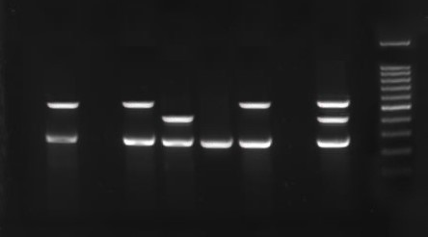
490-bp
249-bp
500-bp
504-bp
100-bp
1500-bp
1 2 3 4 5 6 7 8 9 NC M
Plate 1. Agarose gel Electrophoresis Image Showing Amplification of Klebsiella pneumoniae blaSHV, blaCTX-M and blaTEM resistance genes, where lane M = 1500 bp molecular ladder. NC = negative control, while lanes 2,4, 7 and 9 represent blaCTX-M (504 bp) and blaSHV (249 bp). Lane 5 had a combination of blaTEM (490 bp) and blaSHV. Lane 9 had a combination of all three genes, while lane 6 had blaSHV (249 bp). There was no amplification in lanes 1, 3 and 8.

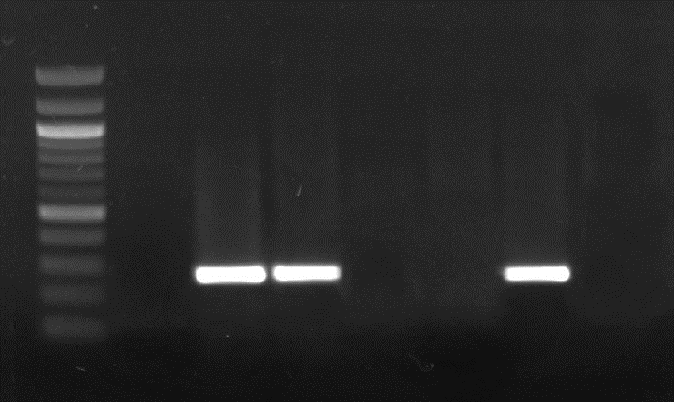
100-bp
500-bp
1000-bp
1500-bp
M NC 10 11 12 13 14 15 1 6
249-bp
Plate 2. Agarose gel Electrophoresis Image Showing Amplification of the Klebsiella pneumoniae blaSHV, blaCTX-M and blaTEM resistance genes. Where lane M = 1500 bp molecular ladder, NC = negative control, while lanes 10, 11, and 15 represent the blaSHV gene (249 bp). There was no amplification in lanes 12, 13 and 16.

Discussion
Urinary tract infections (UTIs) are common among the bacterial infections of humans that affect both genders of all age groups; if not managed properly, they can result in high mortality of infected patients (Bassey et al., 2024). Klebsiella pneumoniae has been reported as an important pathogen commonly associated with UTI (Maldonado-Barragán et al., 2024). Historically, Klebsiella pneumoniae has been associated with infections in patients who have compromised immunity. With the recent appearance and dissemination of hypervirulent strains, however, healthy individuals have also become susceptible to infection (Abbas et al., 2024).
In this study, 16 K. pneumoniae isolates were detected across the six hospitals and were substantially linked to antibiotic resistance (P < 0.05). A 20(100%) resistance to ceftazidime was recorded, closely followed by ceftriaxone 19(95%), streptomycin 19(95%), cefurexime 19(95%), augmentin 18(90%) and chloramphenicol 17(85%). While the least resistance was recorded for ciprofloxacin 8(20%), amoxicillin 6(30%) and ofloxacin 6(30%). This is in agreement with Shaaban et al. (2021), who reported high resistance to ceftazidime (38.46%), ceftriaxone (22.73%) and cefuroxime (28.57%). In contrast, however, Miftade et al. (2021) reported high susceptibility to ceftazidime (90.3%) and cefotaxime (95.1%). Interestingly, in other related studies, carbapenems exhibited the broadest spectrum of β-lactam antibiotics and have been shown to present the highest potency against Gram-negative bacteria. They are characterized by stability to hydrolysis by the majority of β-lactamases. Their use in the treatment of severe ESBL-producing Klebsiella pneumoniae infections is associated with improved outcomes in patients and remains the ‘gold standard’, especially in critically ill patients (Pana & Zaoutis, 2018; Hammoudi & Ayoub, 2020; Armstrong & Hardie, 2021).
There was no statistical significance regarding the multidrug-resistant Klebsiella pneumoniae isolated in the study area (P > 0.05). The occurrence of 6(30%) multidrug-resistant ESBL-producing Klebsiella pneumoniae in the study area is concerning. Several reports are available on the prevalence of multidrug-resistant Klebsiella pneumoniae within and outside Nigeria (Akinyemi et al., 2021; Mbamyah et al., 2021; Mofolorunsho et al., 2021; Odari & Dawadi, 2022; Ashefo et al., 2023; Jalal et al., 2023; Kijineh et al., 2024; Sahoo et al., 2024; Santella et al., 2024). Multidrug-resistant K. pneumoniae have been implicated in several cases of UTI with varying outcomes (Muhammad et al., 2020; Gorrie et al., 2022).
The molecular detection of resistant genes in this study was statistically significant (P< 0.05). The blaSHV gene had the highest prevalence (60.0%), followed by the blaCTX-M gene (26.7%), while the blaTEM gene had the lowest (13.3%). This was similar to a report by AlHashmy & Al-Musawy (2020) but was in contrast to other reports by Al-Gari et al. 2018, Eyinnaya et al. (2021), Ashefo et al. (2023), Verma et al. (2022) and Gosh et al. (2020), who all found the blaCTX-M gene to be higher. The difference in the detected genes may be a result of geographical location, method of detection, irrational use of antibiotics and indiscriminate dumping of hospital wastes (Tanko et al., 2020; Adekanmbi et al., 2021; Husna et al., 2023; Rebecca et al., 2023). Interestingly, three isolates exhibited distinct beta-lactamase gene profiles. One isolate expressed the blaCTX-M, blaTEM, and blaSHV genes, another had the blaTEM and blaSHV genes, and the third had the blaCTX-M and blaSHV genes. This combination of genes has been reported by other authors, indicating varying mechanisms of antibiotic resistance within the K. pneumoniae population (Pishtiwan & Khadija, 2019; Ugbo et al., 2020; El-Sherbiny et al., 2021).

Conclusion
The detection of multidrug-resistant, ESBL-producing K. pneumoniae from the urine of patients with UTI in the study area buttresses the global challenge of antibiotic resistance. Interestingly, K. pneumoniae antibiotic resistance genes, blaSHV, blaCTX-M and blaTEM were isolated from the urine of patients accessing healthcare in primary healthcare centres, which signifies the importance of universal health coverage and the place of PHCs in antimicrobial stewardship (AMS) programs as a strategy to control the spread of antimicrobial resistance. The overprescribing of antimicrobials by healthcare professionals, rising incomes, indiscriminate disposal of hospital waste, and easy access to antibiotics without prescription, driven in part by lack of access to good-quality primary care, are exacerbating the problem of resistance in low and middle-income countries.
Low-income countries are particularly vulnerable because the second-line antibiotics needed to combat the most resistant infections are often unaffordable.
Some limitations were encountered during this study. The short study period made it difficult to draw general conclusions. Additionally, financial constraints restricted both the method used for ESBL detection and the number of genes detected.
Disclaimer (Artificial Intelligence)
Author(s) hereby declare that NO generative AI technologies such as Large Language Models (ChatGPT, COPILOT, etc.) and text-to-image.

Ethical Considerations
Ethical clearance for this research was obtained from the Nasarawa State Ministry of Health (NHREC Protocol number: 18/06/2017) in line with the Declaration of Helsinki on the conduct of biomedical research involving human subjects. All participants gave their consent to participate in the study.

COMPETING INTERESTS DISCLAIMER:
Authors have declared that they have no known competing financial interests OR non-financial interests OR personal relationships that could have appeared to influence the work reported in this paper.

References
Abbas, R., Chakkour, M., Zein El Dine, H., Obaseki, E. F., Obeid, S. T., Jezzini, A., & Ghssein, G., et al. (2024). General Overview of Klebsiella pneumonia: Epidemiology and the Role of Siderophores in Its Pathogenicity. Biology, 13(2), 78. https://doi.org/10.3390/biology13020078
Adekanmbi, A. O., Oluwaseyi, T. A., & Oyelade, A. A. (2021). Dumpsite leachate as a hotspot of multidrug-resistant Enterobacteriaceae harbouring extended-spectrum and AmpC β-lactamase genes; a case study of Awotan municipal solid waste dumpsite in Southwest Nigeria. Meta Gene, 28, 100853. https://doi.org/10.1016/j.mgene.2021.100853
Ajuwon, B. I., Yujuico, I., Roper, K., Richardson, A., Sheel, M., & Lidbury, B. A. (2021). Hepatitis B virus infection in Nigeria: a systematic review and meta-analysis of data published between 2010 and 2019. BMC Infectious Diseases, 21(1). https://doi.org/10.1186/s12879-021-06800-6
Akinyemi, K. O., Abegunrin, R. O., Iwalokun, B. A., Fakorede, C. O., Makarewicz, O., Neubauer, H., Pletz, M. W., & Wareth, G. (2021). The Emergence of Klebsiella pneumoniae with Reduced Susceptibility Against Third-Generation Cephalosporins and Carbapenems in Lagos Hospitals, Nigeria. Antibiotics (Basel, Switzerland), 10(2), 142. https://doi.org/10.3390/antibiotics10020142
Akwa, V.L., Binbol, N.L. Samaila, K.L. & Marcus, N.D. (2007). Geographical perspective of Nasarawa State, Onaive Printing and Publishing Company Ltd, Keffi, 503
Al-Garni, S. M., Ghonaim, M. M., Ahmed, M. M. M., Al-Ghamdi, A. S., & Ganai, F. A. (2018). Risk factors and molecular features of extended-spectrum beta-lactamase-producing bacteria at southwest of Saudi Arabia. Saudi medical journal, 39(12), 1186–1194. https://doi.org/10.15537/smj.2018.12.23273
Al-Hashimy, A. & Al-Musawy, W. (2020). Molecular Study and Antibiotic Susceptibility Patterns of some Extended-Spectrum Beta-Lactamase Genes (ESBL) of Klebsiella pneumoniae in Urinary Tract Infections. Journal of Physics: Conference Series. 1660. 012017. 10.1088/1742-6596/1660/1/012017.
Alrashid, S., Ashoor, R., Alruhaimi, S., Hamed, A., Alzahrani, S., & Al Sayyari, A. (2022). Urinary Tract Infection as the Diagnosis for Admission Through the Emergency Department: Its Prevalence, Seasonality, Diagnostic Methods, and Diagnostic Decisions. Cureus, 14(8), e27808. https://doi.org/10.7759/cureus.27808
Antimicrobial Resistance Collaborators (2022). Global burden of bacterial antimicrobial resistance in 2019: a systematic analysis. Lancet (London, England), 399(10325), 629–655. https://doi.org/10.1016/S0140-6736(21)02724-0
Armstrong, T., Fenn, S. J., & Hardie, K. R. (2021). Carbapenems: a broad-spectrum antibiotic. Journal of Medical Microbiology, 70 (12), 001462. https://doi.org/10.1099/jmm.0.001462
Aryal, S. (2022). Biochemical Test and Identification of Klebsiella pneumoniae. Microbiology Info.com. https://microbiologyinfo.com/biochemical-test-and-identification-of-klebsiella-pneumoniae/
Ashefo, D. P., Ngwai, Y. B., & Ishaleku, D. (2023). Isolation and Antimicrobial Resistance Phenotype of Klebsiella pneumonia from the Urine of Suspected UTI Patients Attending Public Hospitals in Nasarawa South Senatorial District, Nasarawa State, Nigeria. FUDMA Journal of Sciences. 7 (1), 119 – 125. DOI: https://doi.org/10.33003/fjs-2023-0701-1258
Bassey, E. E., Mbah, M., Akpan, S. S., Ikpi, E. E., & Alaribe, A. A. A. (2023). Prevalence of Symptomatic Bacteriuria and Associated Risk Factors among Patients Attending Major Hospitals in Calabar, Nigeria. medRxiv (Cold Spring Harbor Laboratory). https://doi.org/10.1101/2023.09.26.23296138
Butt, T., Raza, S., & Butt, E. (2017). Predicament in Detection and Reporting of Extended-Spectrum Beta-Lactamase Production in Routine Antibiotic Susceptibility Testing. Journal of the College of Physicians and Surgeons--Pakistan: JCPSP, 27(12), 788–790.
Chaudhary, M. K., Jadhav, I., & Banjara, M. R. (2023). Molecular detection of plasmid-mediated bla_{TEM}, bla_{CTX-M,} and bla_{SHV} genes in Extended Spectrum β-Lactamase (ESBL) Escherichia coli from clinical samples. Annals of clinical microbiology and antimicrobials, 22(1), 33. https://doi.org/10.1186/s12941-023-00584-0
Choby, J. E., Howard‐Anderson, J., & Weiss, D. S. (2019). Hypervirulent Klebsiella pneumoniae-clinical and molecular perspectives. Journal of Internal Medicine, 287(3), 283–300. https://doi.org/10.1111/joim.13007
Clinical Laboratory Standards Institute (CLSI) (2021) Performance standards for antimicrobial susceptibility testing, 31st ed. https://clsi.org/about/press-releases/clsi-publishes-m100-performance-standards-for-antimicrobial-susceptibility-testing-31st-edition
Devi, N. S., Mythili, R., Cherian, T., Dineshkumar, R., Sivaraman, G., Jayakumar, R., Prathaban, M., Duraimurugan, M., Chandrasekar, V., & Peijnenburg, W. J. (2024). Overview of antimicrobial resistance and mechanisms: The relative status of the past and current. The Microbe, 3, 100083. https://doi.org/10.1016/j.microb.2024.100083
Dirar, M. H., Bilal, N. E., Ibrahim, M. E., & Hamid, M. E. (2020). Prevalence of extended-spectrum β-lactamase (ESBL) and molecular detection of blaTEM, blaSHV and blaCTX-M genotypes among Enterobacteriaceae isolates from patients in Khartoum, Sudan. The Pan African medical journal, 37, 213. https://doi.org/10.11604/pamj.2020.37.213.24988
El-Sherbiny, G., Sadek, M., Halim, M., & Fouda, A. (2021). Detection of blaTEM, blaSHV, and blaCTX-M genes among the Extended-Spectrum β-Lactamases (ESβLs) producing Enterobacteriaceae isolated from hospital-acquired infections and community in Egypt. Al-Azhar International Medical Journal /Al-Azhar International Medical Journal, 0(0), 0. https://doi.org/10.21608/aimj.2021.61624.1412
Enyinnaya, S., Iregbu, K., Uwaezuoke, N., Abdullahi, N. & Lawson, S. (2021). Molecular Detection and Antibiotic Susceptibility Profile of ESBL-producing Klebsiella pneumoniae Isolates in a Central Nigerian Tertiary Hospital. Greener Journal of Biological Sciences. 11. 181-186.
Ghosh, S. K., Santosh, K., Saha, S., Islam, M., Susanta, D., & Ghosh, K. (2020). Etioclinical profile of urinary tract infection in children. Journal of Medical Science and Clinical Research, 08(04). https://doi.org/10.18535/jmscr/v8i4.35
Gorrie, C. L., Mirčeta, M., Wick, R. R., Judd, L. M., Lam, M. M. C., Gomi, R. & Abbott, I. J. et al. (2022). Genomic dissection of Klebsiella pneumoniae infections in hospital patients reveals insights into an opportunistic pathogen. Nature communications, 13(1), 3017. https://doi.org/10.1038/s41467-022-30717-6
Hammoudi Halat, D., & Ayoub Moubareck, C. (2020). The Current Burden of Carbapenemases: Review of Significant Properties and Dissemination among Gram-Negative Bacteria. Antibiotics (Basel, Switzerland), 9(4), 186. https://doi.org/10.3390/antibiotics9040186
Hijazi, S. M., Fawzi, M. A., Ali, F. M., & Abd El Galil, K. H. (2016). Multidrug-resistant ESBL-producing Enterobacteriaceae and associated risk factors in community infants in Lebanon. Journal of infection in developing countries, 10(9), 947–955. https://doi.org/10.3855/jidc.7593
Husna, A., Rahman, M. M., Badruzzaman, A. T. M., Sikder, M. H., Islam, M. R., Rahman, M. T., Alam, J., & Ashour, H. M. (2023). Extended-Spectrum β-Lactamases (ESBL): Challenges and Opportunities. Biomedicines, 11(11), 2937. https://doi.org/10.3390/biomedicines11112937
Innocent, I. G., Gowon, A. G., Ademah, C., Agbese, J. B., Kuleve, M. I., & Jonah, O. I. (2023). Isolation and Antibiotic Sensitivity of Klebsiella pneumoniae among Urinary Tract Infected Patients in Dalhatu Araf Specialist Hospital, Lafia, Nasarawa State, Nigeria. Journal of Advances in Microbiology, 23(7), 1–6. https://doi.org/10.9734/jamb/2023/v23i7731
Jalal, N. A., Al-Ghamdi, A. M., Momenah, A. M., Ashgar, S. S., Bantun, F., Bahwerth, F. S., & Hariri, S. H. et al. (2023). Prevalence and Antibiogram Pattern of Klebsiella pneumoniae in a Tertiary Care Hospital in Makkah, Saudi Arabia: An 11-Year Experience. Antibiotics (Basel, Switzerland), 12(1), 164. https://doi.org/10.3390/antibiotics12010164
Karah, N., Rafei, R., Elamin, W., Ghazy, A., Abbara, A., Hamze, M., & Uhlin, B. E. (2020). Guideline for Urine Culture and Biochemical Identification of Bacterial Urinary Pathogens in Low-Resource Settings. Diagnostics (Basel, Switzerland), 10(10), 832. https://doi.org/10.3390/diagnostics10100832
Kijineh, B., Alemeyhu, T., Mengistu, M., & Ali, M. M. (2024). Prevalence of phenotypic multi-drug resistant Klebsiella species recovered from different human specimens in Ethiopia: A systematic review and meta-analysis. PLoS ONE, 19(2), e0297407. https://doi.org/10.1371/journal.pone.0297407

Lagha, R., Abdallah, F. B., AlKhammash, A. A., Amor, N., Hassan, M. M., Mabrouk, I., Alhomrani, M., & Gaber, A. (2021). Molecular characterization of multidrug-resistant Klebsiella pneumoniae clinical isolates recovered from King Abdulaziz Specialist Hospital at Taif City, Saudi Arabia. Journal of Infection and Public Health, 14(1), 143–151. https://doi.org/10.1016/j.jiph.2020.12.001
Lesiani, B. R., Abror, Y. K., Merdekawati, F., & Djuminar, A. (2023). Analysis of Purity and Concentration Escherichia coli DNA by Boiling Method Isolation with Addition of Proteinase-K and RNase. INDONESIAN JOURNAL OF MEDICAL LABORATORY SCIENCE AND TECHNOLOGY, 5(2), 160–171. https://doi.org/10.33086/ijmlst.v5i2.4773
Li, Y., Kumar, S., Zhang, L., Wu, H., & Wu, H. (2023). Characteristics of antibiotic resistance mechanisms and genes of Klebsiella pneumoniae. Open Medicine, 18(1). https://doi.org/10.1515/med-2023-0707
Maldonado-Barragán, A., Mshana, S. E., Keenan, K., Ke, X., Gillespie, S. H., Stelling, J., & Maina, J. et al. (2023). Predominance of multidrug-resistant bacteria causing urinary tract infections among symptomatic patients in East Africa: a call for action. JAC-Antimicrobial Resistance, 6(1). https://doi.org/10.1093/jacamr/dlae019
Mbamyah, E. E. L., Enyeji, F. A., Torimiro, J., Mangum, P., Djuissi, M., Teukam, A., & Mbamyah, E. E. L. et al. (2021). High Prevalence of Multidrug Resistant &lt;i&gt;Klebsiella&lt;/i&gt; Species Isolated from the Yaounde University Teaching Hospital, Cameroon. Open Journal of Medical Microbiology, 11(02), 91–99. https://doi.org/10.4236/ojmm.2021.112008
Medina, M., & Castillo-Pino, E. (2019). An introduction to the epidemiology and burden of urinary tract infections. Therapeutic advances in urology, 11, 1756287219832172. https://doi.org/10.1177/1756287219832172
Miftode, I. L., Nastase, E. V., Miftode, R. Ș., Miftode, E. G., Iancu, L. S., Luncă, C., Anton Păduraru, D. T., Costache, I. I., Stafie, C. S., & Dorneanu, O. S. (2021). Insights into multidrug-resistant K. pneumoniae urinary tract infections: From susceptibility to mortality. Experimental and therapeutic medicine, 22(4), 1086. https://doi.org/10.3892/etm.2021.10520

Mofolorunsho, K. C., Ocheni, H. O., Aminu, R. F., Omatola, C. A., & Olowonibi, O. O. (2021). Prevalence and antimicrobial susceptibility of extended-spectrum beta-lactamases-producing Escherichia coli and Klebsiella pneumoniae isolated in selected hospitals of Anyigba, Nigeria. African health sciences, 21(2), 505–512. https://doi.org/10.4314/ahs.v21i2.4
Moreira de Gouveia, M. I., Bernalier-Donadille, A., & Jubelin, G. (2024). Enterobacteriaceae in the Human Gut: Dynamics and Ecological Roles in Health and Disease. Biology, 13(3), 142. https://doi.org/10.3390/biology13030142
Muhammad, A., Khan, S. N., Ali, N., Rehman, M. U., & Ali, I. (2020). Prevalence and antibiotic susceptibility pattern of uropathogens in outpatients at a tertiary care hospital. New Microbes and New Infections, 36, 100716.
Narimisa, N., Goodarzi, F., & Bavari, S. (2022). Prevalence of colistin resistance of Klebsiella pneumoniae isolates in Iran: a systematic review and meta-analysis. Annals of clinical microbiology and antimicrobials, 21(1), 29. https://doi.org/10.1186/s12941-022-00520-8
Odari, R., & Dawadi, P. (2022). Prevalence of Multidrug-Resistant Klebsiella pneumoniae Clinical Isolates in Nepal. Journal of Tropical Medicine, 2022, 5309350. https://doi.org/10.1155/2022/5309350
Osman, E. A., El-Amin, N., Adrees, E. A. E., Al-Hassan, L., & Mukhtar, M. (2020). Comparing conventional, biochemical and genotypic methods for accurate identification of Klebsiella pneumoniae in Sudan. Access microbiology, 2(3), acmi000096. https://doi.org/10.1099/acmi.0.000096
Pana, Z. D., & Zaoutis, T. (2018). Treatment of extended-spectrum β-lactamase-producing Enterobacteriaceae (ESBLs) infections: what have we learned until now?. F1000Research, 7, F1000 Faculty Rev-1347. https://doi.org/10.12688/f1000research.14822.1
Pishtiwan, A. H., & Khadija, K. M. (2019). Prevalence of blaTEM, blaSHV, and blaCTX-M Genes among ESBL-Producing Klebsiella pneumoniae and Escherichia coli Isolated from Thalassemia Patients in Erbil, Iraq. Mediterranean Journal of Hematology and Infectious Diseases, 11(1), e2019041. https://doi.org/10.4084/MJHID.2019.041
Rebecca, R., Ezejiofor, T. I. N., Nsofor, C. A., & Nkene, I. H. (2023). Antibacterial Resistance and Phenotypic Detection of Extended-Spectrum Beta-Lactamase (ESBL) Producing Enterobacteriaceae Isolated from Environmental Sources in Nasarawa State, Nigeria. European Journal of Biology and Biotechnology, 4(5), 6–12. https://doi.org/10.24018/ejbio.2023.4.5.479
Sahoo, S., Mohanty, J., Routray, S., Sarangi, A., Nayak, D., Shah, S., Das, J., Subudhi, E., & Swarnkar, T. (2024). Prevalence of multidrug-resistant Klebsiella pneumoniae in urinary tract infections: A retrospective observational study in eastern India. Microbes and Infectious Diseases /Microbes and Infectious Diseases, 0(0), 0. https://doi.org/10.21608/mid.2024.276619.1844
Sakamoto, S., Miyazawa, K., Yasui, T., Iguchi, T., Fujita, M., Nishimatsu, H., & Masaki, T., et al. (2019). Chronological changes in epidemiological characteristics of lower urinary tract urolithiasis in Japan. International Journal of Urology: official journal of the Japanese Urological Association, 26(1), 96–101. https://doi.org/10.1111/iju.13817
Santella, B., Boccella, M., Folliero, V., Iervolino, D., Pagliano, P., Fortino, L. & Serio, B. et al. (2024). Antimicrobial Susceptibility Profiles of Klebsiella pneumoniae Strains Collected from Clinical Samples in a Hospital in Southern Italy. The Canadian journal of infectious diseases & medical microbiology = Journal canadien des maladies infectieuses et de la microbiologie medicale, 2024, 5548434. https://doi.org/10.1155/2024/5548434
Shaaban, O. A., Mahmoud, N. A., Zeidan, A. A., Kumar, N., & Finan, A. C. (2021). Prevalence and Resistance Patterns of Pediatric Urinary Tract Infections in Bahrain. Cureus, 13(12), e20859. https://doi.org/10.7759/cureus.20859
Tanko, N., Bolaji, R. O., Olayinka, A. T., & Olayinka, B. O. (2020). A systematic review on the prevalence of extended-spectrum beta-lactamase-producing Gram-negative bacteria in Nigeria. Journal of Global Antimicrobial Resistance, 22, 488–496. https://doi.org/10.1016/j.jgar.2020.04.010
Ugbo, E., Anyamene, C., Moses, I., Iroha, I., Babalola, O., Ukpai, E., & Chukwunwejim, C., et al. (2020). Prevalence of blaTEM, blaSHV, and blaCTX-M genes among extended-spectrum beta-lactamase-producing Escherichia coli and Klebsiella pneumoniae of clinical origin. Gene Reports, 21, 100909. https://doi.org/10.1016/j.genrep.2020.100909

Verma, S., Kalyan, R. K., Gupta, P., Khan, M. D., & Venkatesh, V. (2022). Molecular Characterization of Extended-Spectrum β-Lactamase-Producing Escherichia coli and Klebsiella pneumoniae Isolates and Their Antibiotic Resistance Profile in Health Care-Associated Urinary Tract Infections in North India. Journal of Laboratory Physicians, 15(2), 194–201. https://doi.org/10.1055/s-0042-1757416
Yarima, A., Haroun, A. A., Bulus, T., & Manga, M. M. (2020). Occurrence of Extended Spectrum Beta Lactamase Encoding Genes among Urinary Pathogenic &lt;i&gt; Escherichia coli&lt;/i&gt; and &lt;i&gt; Klebsiella pneumoniae&lt;/i&gt; Isolates Obtained from a Tertiary Hospital in Gombe, Nigeria. Journal of Biosciences and Medicines, 08(09), 42–55. https://doi.org/10.4236/jbm.2020.89004
Zorgani, A., Almagatef, A., Sufya, N., Bashein, A., & Tubbal, A. (2017). Detection of CTX-M-15 Among Uropathogenic Escherichia coli Isolated from Five Major Hospitals in Tripoli, Libya. Oman Medical Journal, 32(4), 322–327. https://doi.org/10.5001/omj.2017.61

