**Standardization of Recipe for the Preparation of Prawn Gravy (*Iral Kootu*) and Thermal Processing in Retort Pouch**

**ABSTRACT**

It should be clearly stated that the aim of this study

Three types of prawns like White Prawn (*Penaeus indicus*), Tiger Prawn (*Penaeus mondon*) and Flower Prawn (*Penaeus semisulcatus*) were used to make *Iral Kootu*. It was then packaged in a 15 x 20 cm retort pouch with a three-layer structure made of 15.60 µm polyester, 29.20 µm aluminium foil and 97.20 µm polypropylene. The pouch's suitability for thermal processing was demonstrated by the results of the physico-chemical and barrier tests. The form of the ingredients, the shape of the prawns and the sautéing method were established in the initial testing. Based on sensory evaluation, precooked prawns with sautéed ingredients and gravy in paste form were chosen for additional research. All other ingredients were kept in a fixed proportion while the gravy was made by altering the composition of the condiments and spice mixture. Condiments were applied at 15%, 20% and 25%, respectively, and spice mixes at 5%, 7.5% and 10%. All pouches had a prawn to gravy ratio of 64:36, and thermal processing was done for 15 minutes at 121°C in a pilot-scale horizontal stationary water-spray retorting system. For all three prawn kinds, the sample with the greatest score in all sensory attributes was the one with a 7.5% spice mix and 20% condiments.

*Key words: White prawn; tiger prawn; flower prawn; Iral kootu; retort pouch; sensory evaluation*.

**INTRODUCTION**

As of 2024, India's fish production has increased from 9.6 million tonnes to 19.5 million tonnes, making it the second-largest producer in the world. Approximately 64% of seafood export earnings come from prawns. As a key component of tropical and subtropical fisheries, prawns represent a significant economic resource in the global crustacean fishery industry (Hossain *et al*., 2012). They belong to the Dendrobranchiata suborder of crustaceans. Their branching gills and the fact that they do not brood their eggs but instead release them into the ocean set them apart from other, similar crustaceans like Caridea (shrimp) and Stenopodidea (boxer shrimp) (Bello, 2013). According to Temgire *et al*., (2021), prawns are a great source of a variety of nutrients and bioactive substances, including protein, amino acids, vitamins, calcium, fatty acids and minerals like copper, iron, zinc, iodine, manganese and selenium.

A classic South Indian treat, prawn gravy (*Iral Kootu*) has a special position in Tamil Nadu's culinary legacy, especially in the southern districts of Madurai, Tirunelveli and Thanjavur. By slow-cooking fresh prawns in a spicy stew made with onions, tomatoes, garlic, ginger and a mixture of regional spices, this dish achieves its well-known rich, aromatic tastes. Coconut, either ground or as milk, is often added to enhance the texture and taste, giving the gravy a distinctive Southern touch.

Generally speaking, *Iral Kootu* is a "prepare, cook, and serve" food, which means it is produced fresh and eaten right away with little room for storage or preservation. It is a regional speciality rather than an extensively marketed product because of its short shelf life, which limits its availability mainly to local households, restaurants, and small-scale food merchants. Often prepared during weekends, festivals or special occasions, this dish is not only a staple for seafood lovers but also a representation of the coastal influence on Tamil cuisine. Due to its strong local roots and perishable nature, it remains a cherished yet localized food tradition that reflects the flavours, cooking techniques and cultural identity of southern Tamil Nadu.

**MATERIALS AND METHODS**

**Packaging materials**

The three-ply flexible retort pouches used in the study were bought from M/s. Sabena Packaging in Chennai, Tamil Nadu and contained polyester for the outside layer, aluminium foil for the middle layer and polypropylene for the inside layer. To ascertain if these pouches were suitable for thermal processing, a number of physico-chemical characteristics were examined. The tests carried out for retortable pouches include thickness (IS 2508 – 2016), tensile strength and elongation at break (ASTM D882 – 2018), seal strength (ASTM F88 - 2015), peel strength (ASTM D903 – 2017), overall migration (IS 9845 - 2020), vacuum leakage (ASTM D3078 – 2021), water vapour transmission rate (ASTM F1249 – 2020) and oxygen gas transmission rate (ASTM F3985 – 2017).

**Raw material**

Three varieties of prawn *ie*. White Prawn (*Penaeus indicus*), Tiger Prawn (*Penaeus mondon*) and Flower Prawn (*Penaeus semisulcatus*) with medium body size were procured from wholesale fish market (Fig 1). The prawns were transported under proper refrigerated condition. Prawn was cleaned using water, outer peeling removed and deveined. Again, washed thoroughly with chilled water for 2-3 times. The dressed prawn was stored under frozen condition before processing (C.O. Mohan *et al*., 2008, Majumdar *et al*., 2017 and Puthanangadi Dasan *et al*., 2021).

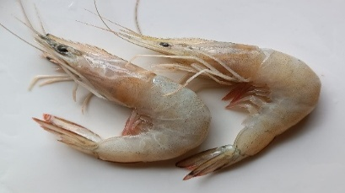 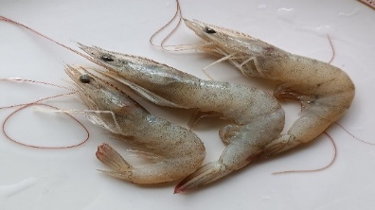 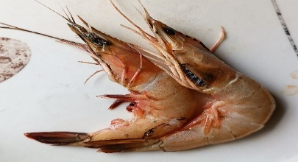

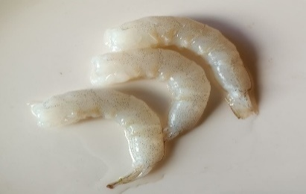 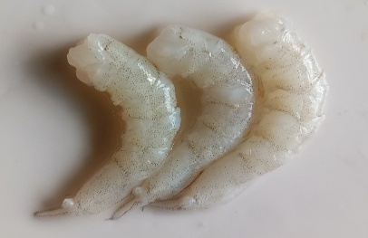 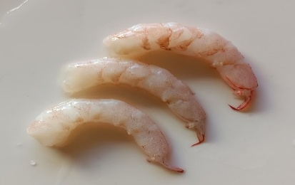

Flower Prawn

(*Penaeus semisulcatus*)

Tiger Prawn

(*Penaeus mondon*)

White Prawn

(*Penaeus indicus*)

**Fig 1**: Varieties of prawn used for prawn gravy (*Iral Kootu*)

**Preparation of Gravy**

The gravy for *Iral Kootu* was prepared by traditional method used in Southern parts of Tamil Nadu. The ingredients used for gravy preparation include condiments, spice mix, tomato, refined sun flower oil, water and salt (Fig 2). Composition of condiments and spice mix was determined by conducting survey using questionnaire among individual persons coming under different age groups. The composition of condiments and spice mix was mentioned in Table 1 and 2. The quantity of all other ingredients was selected based on the studies conducted by T.K.S. Gopal *et al*., (2001), Mallick *et al*., (2010) and Majumdar *et al*. (2015) with slight modifications.

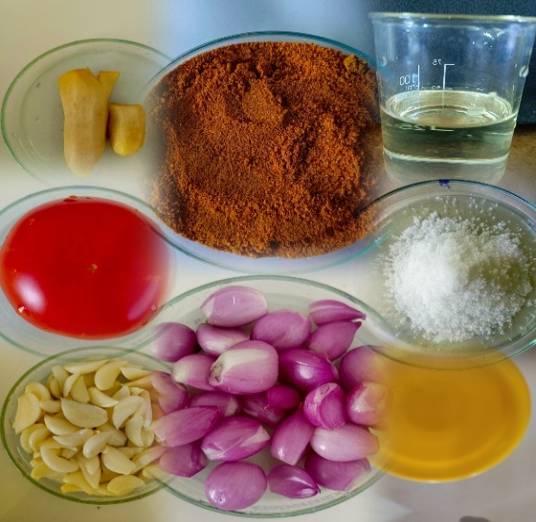

**Fig 2.** Ingredients used for gravy preparation

**Table 1:** **Composition of Condiments (100g)**

|  |  |
| --- | --- |
| **Condiment** | **Quantity (g)** |
| Shallots | 80 |
| Ginger | 10 |
| Garlic | 10 |

**Table 2:** **Composition of spice mix (100g)**

|  |  |
| --- | --- |
| **Ingredient** | **Quantity (g)** |
| Chilli powder | 30 |
| Coriander powder | 30 |
| Garam masala | 20 |
| Turmeric powder | 10 |
| Pepper powder | 5 |
| Cumin seed powder | 5 |

Chopped condiments were sauted in refined sunflower oil for 1 min. Chopped tomato was added to the heated mixture and sauted for 1 min. Then spice mix, salt and water were added, mixed well and then cooled.

**Preliminary standardization of gravy**

**Form of ingredients in gravy**

During the preliminary trials, two types of gravy were prepared.

1. Gravy with ingredients in paste form
2. Gravy with ingredients in chopped form

**Form of prawn in gravy along with sauting**

Next trials were conducted to fix the form of prawn in gravy paste along with sauting. 4 types of gravies were prepared.

1. Pre-cooked prawn with sauted ingredients in gravy
2. Pre-cooked prawn with unsauted ingredients in gravy
3. Raw prawn with sauted ingredients in gravy
4. Raw prawn with unsauted ingredients in gravy

The precooking was done at a temperature of 80 ± 2°C for 1 min and sauting of each ingredient done for 1 min.

**3.3.4 Final standardization of gravy**

Altogether 9 combinations of gravy from each variety of prawn were prepared by varying level of addition of condiments and spice mix and by keeping all other ingredients in fixed amount. Spice mix were added at the level of 5%, 7.5% and 10% while condiments at 15%, 20% and 25% respectively. The treatment details are given in Table 3.

**Thermal Processing**

About 64 ± 2 g of pre-cooked prawns were filled along with 36 ± 2 g gravy into 15x20 cm pouches to maintain equal pack weight of 100 ± 2 g. Thermocouples were inserted into the meat part to record the data. Residual air was removed by steam exhausting. Pouches were sealed and the thermal processing was carried out in pilot-scale horizontal stationary water-spray retorting system (Lakshmi Engineering Works, Chennai, India) at 121°C for 15 min.

**Table 3:** **Combination of spice mix and condiments for prawn gravy**

|  |  |
| --- | --- |
| **Sample** | **Treatment** |
| T1 | 5% Spice mix + 15% condiments |
| T2 | 5% Spice mix + 20% condiments |
| T3 | 5% Spice mix + 25% condiments |
| T4 | 7.5% Spice mix + 15% condiments |
| T5 | 7.5% Spice mix + 20% condiments |
| T6 | 7.5% Spice mix + 25% condiments |
| T7 | 10% Spice mix + 15% condiments |
| T8 | 10% Spice mix + 20% condiments |
| T9 | 10% Spice mix + 25% condiments |

**Sensory Analysis**

The sensory quality of the products was evaluated by a panel of semi-trained fifteen members according to C.O. Mohan *et al*. (2008) with slight modifications. Thermally processed prawn gravy pouches were selected from three varieties of prawn and heated in boiling water for 5 min. The contents of the sample including the gravy were placed in coded plates and served warm to panellists. Water was provided to restore taste sensitivity. 9-point hedonic scale was used for scoring the samples. Panellists were asked to assign a score of 1 to 9 (*1 = dislike extremely; 2 = dislike very much; 3 = dislike moderately; 4 = dislike slightly; 5 = neither like nor dislike; 6 = like slightly; 7 = like moderately; 8 = like very much; 9 = like extremely*) to each sample for colour, flavour, firmness, succulence and overall acceptability, where 1 was least desirable and 9 was most desirable. A score of 6 was the limit of acceptability.

**Statistical Analysis**

The statistical analysis was done by SPSS software package for windows (IBM SPSS Statistics, Version 20.00). The data were analyzed using one-way analysis of variance ANOVA and means were separated using Duncan’s multiple range test and statistical significance was determined at 95% confidence level (p<0.05). All determination was made in triplicate and data were expressed as mean with standard error.

Prawn varieties (White, Tiger Chopped condiments (shallots, ginger

& Flower) and garlic

 

Washing (Normal water) Addition to heated refined sun flower oil

and sauting for 1 min

 

Dressing (Peeled & Deveined) Addition of chopped tomato and sauting

for 1 min

 

Washing (Chilled water) Addition of spice mix salt and water and

mixed well at low flame

 

Frozen storage (below 0°C) Cooling of gravy

 

Thawing to room temperature Grinding of gravy into paste

and precooking at 80°C for 1 min





Addition of 64 ± 2 g dressed pre-cooked prawn into retort pouch at 37°C



Filling of pasted gravy of 36 ± 2 g into retort pouch at 37°C



Manual removal of residual air



Sealing at 200℃ using continuous band sealer



Retort processing (121°C for 15 min)



Cooling to room temperature by spraying water under pressure



Storage at ambient temperature

**Flow chart 1 : for the preparation of standardized retort processed prawn gravy (*Iral Kootu*)**

**RESULTS AND DISCUSSION**

**Suitability of retort pouch**

Several physico-chemical tests were used to determine if retort pouches were suitable for thermal processing (Table 4). The retort pouches used in the investigation had a total thickness of 140 µm and measured 15 × 20 cm (breadth x length). Cast polypropylene was 97.20 µ thick, aluminium foil was 29.20 µ, and polyester was 15.60 µ. The material's resistance to rupture and breakage under tensile forces is determined by its tensile strength, which was higher in machine direction than in cross direction.

Additionally, machine direction had greater elongation at break than cross direction. Ali *et al*. (2001), Ravishankar *et al*. (2002), Vijayalakshmi *et al*. (2003), Manju *et al*. (2004), C.O. Mohan *et al*. (2008), Bindu *et al*. (2011), Kumar *et al*. (2015) and Girish *et al*. (2018) have all reported similar findings. The side seal has a higher seal strength than the bottom seal, which is a crucial characteristic for maintaining packing integrity and ensuring a decent shelf life. The values are nearly identical to those found in research by Kumar *et al*. (2015) and Girish *et al*. (2018). The force needed to separate two bonded materials like typically tapes or adhesives are from one another is known as the peel strength, and it was 0.238 kgf/cm2, which is comparable to work by Girish *et al*. (2018). By producing a vacuum inside a chamber and watching the pouch for any indications of leakage or distortion, the vacuum leakage test verifies the integrity of the seal.

Since additives will inevitably migrate from the pouch into the food, food simulants such as 3% acetic acid and n-heptane were used in the migration test. According to the findings of Vijayalakshmi *et al*. (2003), C.O. Mohan *et al*. (2008) and Bindu *et al*. (2011), the migration into n-heptane was greater than those in 3% acetic acid. This might be because n-heptane and the contact layer of cast polypropylene share structural similarities (Vijayalakshmi *et al*., 1992). Nonetheless, for every food simulant, the migration values were below the allowed limits (IS 10910, 2023). At 9.40 cc/m2/day and 0.50 g/m2/day, respectively, the oxygen gas transmission rate and water vapour transmission rate for the retort pouch were comparatively lower. These figures are similar to those of Kumar *et al*. (2015) and C.O. Mohan *et al*. (2008). These findings imply that the study's retort pouch was appropriate for thermal processing.

**Table 4: Physico-chemical properties of retort pouch**

|  |  |
| --- | --- |
| **Parameters** | **Values** |
| Retort pouch layers | Polyester, Aluminium foil, Polypropylene |
| Size (Breadth x Length, cm) | 15 x 20 |
| Total Thickness (µm) | 142.80±0.374 |
| Polyester | 15.60±0.510 |
| Aluminium foil | 29.20±0.583 |
| Polypropylene | 97.20±0.374 |
| Seal Strength (kgf/cm²) |  |
| Side Seal | 12.20±0.200 |
| Bottom Seal | 11.20±0.200 |
| Elongation at break (%) |  |
| Machine direction | 28.60±0.812 |
| Cross direction | 14.00±0.000 |
| Tensile Strength (kgf/cm²) |  |
| Machine direction | 17.40±0.245 |
| Cross direction | 16.80±0.374 |
| Peel Strength (kgf/cm²) | 0.238±0.000 |
| Vacuum leakage test (mmHg) | 512.00±0.275 |
| Overall migration (mg/l) |  |
| 3% Acetic acid (121°C, 2h) | 2.60±0.509 |
| 3% Acetic acid (40°C, 10 days) | 2.40±0.510 |
| n-heptane 66°C for 2 h | 5.20±0.374 |
| n-heptane 38°C for 30 min | 3.40±0.510 |
| Oxygen Gas Transmission Rate (cc/m2/day) | 9.40±0.509 |
| Water Vapour Transmission Rate (g/m2/day) | 0.50±0.071 |

**Preliminary standardization of gravy**

**Form of ingredients in gravy**

The selection of form of ingredients in gravy was done using sensory evaluation by semi-trained panelists (Table 5). There was no significant difference between two samples in all sensory attributes, but slightly more scores were obtained by T1 and selected for further studies.

**Table 5: Effect of form of ingredients on sensory scores of prawn gravy**

|  |  |  |  |  |  |
| --- | --- | --- | --- | --- | --- |
| **Treatments** | **Sensory Characteristics** | | | | |
| **Colour** | **Flavour** | **Firmness** | **Succulence** | **Overall Acceptability** |
| **T1** | **8.67±0.126** | **8.33±0.159** | **8.60±0.131** | **8.40±0.131** | **8.60±0.131** |
| T2 | 8.40±0.131 | 8.40±0.131 | 8.40±0.131 | 8.20±0.107 | 8.27±0.118 |
| t value | 1.468NS | 0.367NS | 1.080NS | 1.183NS | 1.890NS |

T1 – Gravy with ingredients in paste form T2 – Gravy with ingredients in chopped form

**Form of prawn in gravy along with sauting**

The effect of form of prawn in gravy along with sauting was also studied based on sensory evaluation (Table 6). The colour assessment showed no significant difference between four samples. In case of flavour, firmness, succulence and overall acceptability no significant difference was observed in T2, T3 and T4, while T1 was highly significant than other three samples. Sample T1 secured highest score for all the sensory attributes, so selected for further studies.

**Table 6: Effect of form of prawn along with sauting on sensory scores of prawn gravy**

|  |  |  |  |  |  |
| --- | --- | --- | --- | --- | --- |
| **Treatments** | **Sensory Characteristics** | | | | |
| **Colour** | **Flavour** | **Firmness** | **Succulence** | **Overall Acceptability** |
| **T1** | **8.87±0.091a** | **8.40±0.163b** | **8.27±0.118b** | **8.80±0.107b** | **8.73±0.118b** |
| T2 | 8.60±0.214a | 7.67±0.159a | 7.20±0.145a | 7.27±0.228a | 7.33±0.159a |
| T3 | 8.33±0.211a | 7.60±0.235a | 7.07±0.182a | 7.20±0.262a | 7.20±0.223a |
| T4 | 8.47±0.133a | 7.67±0.159a | 7.47±0.165a | 7.60±0.131a | 7.67±0.159a |
| F value | 1.785NS | 4.332** | 12.133** | 14.804** | 16.904** |

T1 – Pre-cooked prawn with sauted ingredients in gravy T2 – Pre-cooked prawn with unsauted ingredients in gravy

T3 - Raw prawn with sauted ingredients in prawn gravy T4 - Raw prawn with unsauted ingredients in prawn gravy

**Final standardization of gravy**

The final standardization was done using pre-cooked prawn with sauted ingredients and gravy in paste form. Sensory evaluation was conducted for 9 combinations of prawn gravy from each variety of prawn (Fig 3). The sensory scores for each variety of prawn gravy were mentioned in Table 7, 8 and 9. Firmness was found to be non-significant for three varieties of prawn. Colour, flavour, succulence and overall acceptability for three varieties were vary significantly. For all the sensory attributes sample T5 was secured highest score for three varieties of prawn.

The values obtained in this study was on par with trials conducted by C. N. R. Shankar *et al*. (2002), J. Bindu *et al*. (2004), C.O. Mohan *et al*. (2008) and Kumar *et al*. (2015).

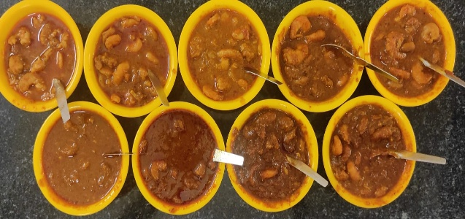

**Fig 3:** Prawn gravy with different combination of spice mix and condiments

**Table 7: Effect of condiments and spice mix on sensory scores of white prawn gravy**

|  |  |  |  |  |  |
| --- | --- | --- | --- | --- | --- |
| **Treatments** | **Sensory Characteristics** | | | | |
| **Colour** | **Flavour** | **Firmness** | **Succulence** | **Overall Acceptability** |
| T1 | 7.70±0.11a | 7.68±0.13a | 7.77±0.13a | 7.80±0.11a | 7.74±0.09a |
| T2 | 7.87±0.17a | 7.80±0.10a | 8.10±0.12b | 7.85±0.09a | 7.91±0.07a |
| T3 | 7.80±0.11a | 8.00±0.19b | 7.93±0.12a | 7.87±0.17a | 7.90±0.11a |
| T4 | 8.50±0.20b | 8.17±0.19b | 7.83±0.12a | 7.99±0.13a | 8.12±0.12b |
| **T5** | **8.73±0.12b** | **8.75±0.11c** | **8.13±0.13b** | **8.53±0.13b** | **8.54±0.07b** |
| T6 | 8.67±0.15b | 8.18±0.22b | 8.00±0.09b | 8.27±0.15b | 8.28±0.09b |
| T7 | 8.00±0.17a | 7.79±0.24a | 8.03±0.12b | 7.99±0.09a | 7.95±0.13a |
| T8 | 7.80±0.17a | 7.23±0.23a | 7.93±0.12a | 7.90±0.12a | 7.72±0.12a |
| T9 | 7.70±0.19a | 7.23±0.23a | 7.90±0.14a | 8.33±0.21b | 7.79±0.14a |
| F value | 7.324** | 6.554** | 0.978NS | 3.394** | 6.660** |

**Table 8: Effect of condiments and spice mix on sensory scores of tiger prawn gravy**

|  |  |  |  |  |  |
| --- | --- | --- | --- | --- | --- |
| **Treatments** | **Sensory Characteristics** | | | | |
| **Colour** | **Flavour** | **Firmness** | **Succulence** | **Overall Acceptability** |
| T1 | 8.00±0.17b | 7.83±0.18a | 7.77±0.13a | 7.67±0.16a | 7.82±0.12a |
| T2 | 8.13±0.17b | 7.90±0.14a | 7.93±0.12a | 7.73±0.118a | 7.925±0.100a |
| T3 | 7.93±0.21a | 7.77±0.22a | 7.83±0.09a | 7.93±0.15a | 7.85±0.15a |
| T4 | 8.40±0.16b | 8.37±0.21b | 8.03±0.14b | 7.90±0.07a | 8.18±0.12b |
| **T5** | **8.33±0.19b** | **8.73±0.12c** | **8.13±0.13b** | **8.40±0.16b** | **8.40±0.11b** |
| T6 | 8.47±0.22b | 8.10±0.21b | 8.10±0.16b | 8.10±0.15b | 8.19±0.14b |
| T7 | 7.47±0.17a | 7.46±0.19a | 8.03±0.12b | 7.50±0.13a | 7.62±0.12a |
| T8 | 7.60±0.21a | 7.30±0.19a | 7.90±0.14a | 7.27±0.12a | 7.52±0.13a |
| T9 | 7.63±0.20a | 7.30±0.17a | 7.77±0.13a | 7.36±0.14a | 7.51±0.12a |
| F value | 3.849** | 6.885** | 1.131NS | 6.954** | 6.499** |

**Table 9: Effect of condiments and spice mix on sensory scores of flower prawn gravy**

|  |  |  |  |  |  |
| --- | --- | --- | --- | --- | --- |
| **Treatments** | **Sensory Characteristics** | | | | |
| **Colour** | **Flavour** | **Firmness** | **Succulence** | **Overall Acceptability** |
| T1 | 7.93±0.18a | 7.07±0.18a | 8.10±0.12b | 7.93±0.15a | 7.76±0.11a |
| T2 | 8.00±0.17a | 7.37±0.19a | 8.10±0.12b | 7.67±0.16a | 7.78±0.10a |
| T3 | 7.73±0.25a | 7.40±0.19a | 7.83±0.11a | 7.66±0.15a | 7.66±0.13a |
| T4 | 8.60±0.14b | 8.30±0.17b | 8.07±0.10b | 8.16±0.14b | 8.28±0.09b |
| **T5** | **8.63±0.12b** | **8.63±0.12c** | **8.30±0.12b** | **8.40±0.16b** | **8.49±0.10b** |
| T6 | 8.43±0.21b | 7.97±0.21b | 8.00±0.09b | 7.93±0.18a | 8.08±0.13b |
| T7 | 7.90±0.22a | 7.06±0.12a | 7.93±0.11a | 7.47±0.13a | 7.59±0.10a |
| T8 | 7.97±0.21a | 7.00±0.17a | 7.96±0.08a | 7.53±0.17a | 7.62±0.11a |
| T9 | 7.90±0.22a | 7.07±0.15a | 7.93±0.12a | 7.47±0.13a | 7.59±0.10a |
| F value | 2.987** | 12.987** | 1.504NS | 4.542** | 9.065** |

** Significant at 0.05% level

From these 9 samples from each variety of prawn, sample T5 (7.5% spice mix and 20% condiments) was selected as the best one and used for further studies. The standardized recipe for the preparation of *Iral Kootu* was given in Table 9.

**Table 10: Standardized recipe for prawn gravy (*Iral Kootu*)**

|  |  |
| --- | --- |
| **Ingredients** | **Quantity** |
| Prawn | 100 g |
| Condiments | 20 g |
| Tomato | 10 g |
| Spice Mix | 7.5 g |
| Water | 10 ml |
| Refined sunflower oil | 10 ml |
| Salt | 2.5 g |

**CONCLUSION**

The retort pouches tested had physico-chemical and barrier properties as per requirements and can be safely used for processing prawn gravy. Three varieties of prawn such as White Prawn (*Penaeus indicus*), Tiger Prawn (*Penaeus mondon*) and Flower Prawn (*Penaeus semisulcatus*) with medium body size were selected based on their surplus availability in Tamil Nadu. Due to the unavailability of written procedure of traditional *Iral Kootu*, the quantity of ingredients required for the preparation was determined by conducting survey using questionnaire among individual persons coming under different age groups. Gravy was prepared by varying composition of condiments and spice mix, while keeping all other ingredients in fixed quantity. The best combination was determined by sensory evaluation and sample with 7.5% spice mix and 20% condiments was secured highest score for all sensory characteristics for three varieties of prawn.

**DISCLAIMER (ARTIFICIAL INTELLIGENCE)**

Author(s) hereby declares that NO generative AI technologies such as Large Language Models (ChatGPT, COPILOT, etc) and text-to-image generators have been used during writing or editing of this manuscript.

**COMPETING INTERESTS**

Authors have declared that they have no known competing financial interests or non-financial interests or personal relationships that could have appeared to influence the work reported in this paper.

**REFERENCE**

Ali, A., Sudhir, B., Gopal, T.K.S. and Vijayan, P.K. (2001). Properties of the indigenous and imported retort pouches for the thermal processing of fresh water fish in riverine and reservoir fisheries of India. Cochin Society of Fisheries Technologists (India), 316–318.

ASTM F88 (2015). Standard test method for seal strength of flexible barrier materials. American Society for Testing and Material. New York, NY: McGraw-Hill Book Co. Inc.

ASTM D903 (2017). Standard method of test for peel or stripping strength of adhesive bonds. American Society for Testing and Materials. New York, NY: McGraw-Hill Book Co. Inc.

ASTM F3985 (2017). Standard test method for measuring the oxygen gas transmission rate (OTR) through plastic films and sheeting. American Society for Testing and Material. New York, NY: McGraw-Hill Book Co. Inc.

ASTM D882 (2018). Standard Test Method for Tensile Properties of Thin Plastic Sheeting. American Society for Testing and Material. New York, NY: McGraw-Hill Book Co. Inc.

ASTM F1249 (2020). Standard Test Method to Determine the Water Vapour Transmission Rate (WVTR) through Flexible Barrier Materials. American Society for Testing and Material. New York, NY: McGraw-Hill Book Co. Inc.

ASTM D3078 (2021). Standard Test Method for Determining Leaks in Flexible Packaging by Bubble Emission. American Society for Testing and Material. New York, NY: McGraw-Hill Book Co. Inc.

Bello B. K. (2013). Effect of Processing Method on the Proximate and Mineral Composition of Prawn (*Penaeus notialis*). Journal of Global Biosciences, 2(2): 42-46.

Bindu J., T.K. Srinivasa Gopal and T.S. Unnikrishnan Nair (2004). Ready-to-eat Mussel Meat Processed in Retort Pouches for the Retail and Export Market. Packaging Technology and Science, 17: 113–117.

Bindu J., C.N. Ravishankar, K. Dinesh, A.K. Mallick and T.K.S. Gopal (2011). Heat Penetration Characteristics and Shelf Life of Ready to Serve Mahseer Curry in Opaque Retortable Pouches. Fishery Technology, 48(2): 141–148.

Chitradurga O. Mohan, Chandragiri N. Ravishankar, Teralandur K. Srinivasa Gopal & Jagannath Bindu (2008). Thermal processing of prawn ‘kuruma’ in retortable pouches and aluminium cans. International Journal of Food Science and Technology, 43: 200–207.

Girish P.S., Lipika Nath, R. Thomas, V. Rajkumar2 and Tanweer Alam (2018). Development of Shelf Stable Ready‑to‑Eat Pork Curry Using Retort Processing Technology. Journal of Packaging Technology and Research, 2: 61–66.

Hossain M.Y., J. Ohtom, A. Jaman J. Saleha and L. V. J. Robert (2012). Life History Traits of the Monsoon River Prawn *Macrobrachium malcolmsonii* (Milne-Edwards, 1844) (*Palaemonidae*) in the Ganges (Padma) River, Northwestern Bangladesh. Journal of Freshwater Ecology, 27: 131-142.

IS 2508 (2016). Specification for Low Density Polyethylene Films. New Delhi: Indian Standard Institute, 32.

IS 9845 (2020). Determination of Overall Migration of Constituents of Plastic Materials and Articles Intended to come in Contact with Foodstuffs – Methods of Analysis. New Delhi: Indian Standard Institute, 26.

IS 10910 (2023). Specification for Polypropylene and its Copolymers for its Safe Use in Contact with Foodstuffs, Pharmaceuticals and Drinking Water. New Delhi: Indian Standard Institute, 22.

Kumar R., Johnsy George, Dhananjay Kumar, Jayaprahash C., Nataraju S., Lakshmana J.H., Kumaraswamy M.R., Kathiravan T., Rajamanickam R., Madhukar N. and Nadanasabapathi S. (2015). Development and Evaluation of Egg based Ready-To-Eat (RTE) Products in Flexible Retort Pouches. African Journal of Food Science, 9(4): 243-251.

Mallick, A.K., T.K. Srinivasa Gopal, C.N. Ravishankar, P.K. Vijayan and V. Geethalakshmi (2010). Changes in Instrumental and Sensory Properties of Indian White Shrimp in Curry Medium During Retort Pouch Processing at Different F0 Values. Journal of Texture Studies, 41: 611–632.

Manju S., Sonaji E.R., Leema J., Gopal T.K.S., Ravishankar C.N. and Vijayan P.K. (2004). Heat Penetration Characteristics and Shelf-life Studies of Seer Fish Moilee Packed in Retort Pouch. Fishery Technology, 41: 37–44.

Puthanangadi Dasan G., Manjanaik Bojayanaik, Devika Gundubilli, Srinu Nayak Banavath, Maga Raju Siravati, Mohan Chitradurga Obaliah and Veena Shetty Alandur (2021). Heat Penetration Characteristics and Quality of Ready-To-Eat Shrimp in Masala (*Litopenaeus* *vannamei*) in Flexible Retortable Pouches. Journal of Food Processing and Preservation, 1-9.

Ranendra K. Majumdar, Bahni Dhar, Deepayan Roy and Apurba Saha (2015). Optimization of Process Conditions for Rohu Fish in Curry Medium in Retortable Pouches using Instrumental and Sensory Characteristics. Journal of Food Science and Technology, DOI 10.1007/s13197-014-1673-3.

Ranendra K. Majumdar, Deepayan Roy & Apurba Saha (2017). Textural and Sensory Characteristics of Retort Processed Freshwater Prawn (*Macrobrachium rosenbergii*) in Curry Medium. International Journal of Food Properties, 20(11): 2487–2498.

Ravi Shankar C.N., Gopal T.K.S. and Vijayan P.K. (2002). Studies on Heat Processing and Storage of Seer Fish Curry in Retort Pouches. Packaging Technology and Science, 15: 3–7.

Temgire S., A. Borah, S. Kumthekar and A. Idate, 2021. Recent trends in ready to eat/cook food products. Pharma Innovations, 10(5): 211-217.

T.K. Srinivasa Gopal, P.K. Vijayan, K.K. Balachandran, P. Madhavan and T.S.G. Iyer (2001). Traditional Kerala Style Fish Curry in Indigenous Retort Pouch. Food Control, Elsevier Science Ltd., 12: 523-527.

Vijayalakshmi N.S., Raj B. and Murthy R.A.N. (1992). Effect of One Side and Two-Side Exposure of Plain Films on the Amount of Extractives into Food Simulants in Migration Tests. Deutsche Lebensmittel Rundschau, 82: 154–156.

Vijayalakshmi N.S., Sathish H.S. and Rangarao G.C.P. (2003). Physico-chemical Studies on Indigenous Aluminium Foil Based Retort Pouches vis-a`-vis their Suitability for Thermal Processing. Popular Plastics & Packaging, 48: 71–74.