A Review on Fertilizer Use Efficiency and Integrated Nutrient Management in Paddy Crop

Abstract

Rice (Oryza sativa L.) is an importantcrop globally with a consumption rate that supports more than one half of the population worldwide. Nonetheless, efficient management of nutrients and fertilization (FUE) for rice continues to be a challenge. Low nutrient use efficiency (NUE), environmental consequences, and high production cost are the result of excessive and imbalanced fertilizers. We are discussing recent developments of nutrient management approaches including Site-Specific Nutrient Management (SSNM), Integrated Nutrient Management (INM), CRF, and organic amendments, which would enhance FUE. Particular emphasis will be placed on the contribution of precision agriculture, biofertilizers, and agronomic interventions to fertilizer use efficiency in an economically sound and sustainable manner. It further outlines the interactions of water management and nutrient absorption, particularly how irrigation practices can dictate the level at which nutrients are absorbed. Finally, this review also highlights the genetic and agronomic innovations that have been applied to improve NUE in modern rice varieties. Conclusions policy driven climate smart nutrient management strategies are necessary to achieve sustainable rice production with minimum environmental hazards in the future. The implications of this study include the suggestion for farmers, researchers and policy makers to improve nutrient management practices towards sustainable rice production.

Keywords: Fertilizer Use Efficiency (FUE), Nitrogen Use Efficiency (NUE), Site-Specific Nutrient Management (SSNM), Integrated Nutrient Management (INM), Controlled-Release Fertilizers (CRF)

I recommend adapting bibliographic citations as indicated in the instructions for authors:

“References must be listed at the end of the manuscript and numbered in the order that they appear in the text. Every reference referred in the text must also present in the reference list and vice versa. In the text, citations should be indicated by the reference number in brackets [3]” (see below).

I also recommend numbering the sections as follows:

“The text, excluding the abstract, if required, can be divided into numbered sections with brief headings. Starting from introduction with section 1. subsections should be numbered (for example 2.1 (then 2.1.1, 2.1.2, 2.2, etc.), up to three levels”.

I recommend referencing Figures 1, 2 and 3, and Tables 1 and 2 in the text, as indicated in the instructions for authors:

“Tables & figures should be placed inside the text. Tables and figures should be presented as per their appearance in the text. It is suggested that the discussion about the tables and figures should appear in the text before the appearance of the respective tables and figures. No tables or figures should be given without discussion or reference inside the text”.

See: https://peerreviewcentral.com/page/general-guideline-for-authors

- Introduction
Rice (Oryza sativa L.) is among the most important (staple) crops in the world, supplying food for about half of the world population human being. The crop is widely grown in Asia as the staple source of dietary energy and nutrition [1] . Population growth, urban migration and dietary shifts are spurring continuous growth in worldwide rice demand. Rice production, however, is threatened by many problems, in particular with respect to nutrient management and fertilizer use efficiency (FUE). Nutrient management plays an important role in maintaining high yields and reducing environmental costs and production costs. Regardless of improvements in agronomic practices, leaching, volatilization and runoff losses of nutrients greatly decrease the efficiency of fertilizer use and is therefore one of the biggest challenges for ensuring sustainable rice production [2] .
Fertilizer use efficiency (FUE) is an important factor associated with productive and sustainable rice cropping systems. Overconsumption of chemical fertilizers, especially N fertilizers, has resulted in declining NUE, enhanced greenhouse effect (GHE), and degradation of natural soil (Bargaz et al., 2018). Despite high utilization of fertilizer by rice farmers, application of fertilizer in most of them are not based on site-specific nutrient requirement and crop demand which cause nutritional imbalance and loss of nutrient. Poor nutrient management practices lead to the eutrophication of surface waters, nitrate contamination of groundwater, and greenhouse gas emissions, which are all aggravating climate change challenges (Buresh et al., 2019). Therefore, enhancing nutrient management strategies to FUE is essential for sustainable rice production. The impacts of using fertilizer inefficiently extend to the entire economy, from smallholder farmers to large-scale agriculture. A significant share of rice production expenses comes from fertilizer, and farmers are losing many revenues by applying fertilizer inefficiently. In addition, over-dependence on chemical fertilizers causes the soil nutrients to be depleted, which in the following seasons will require more applications of higher inputs, which contributes to increasing production costs (Chen et al., 2020). Controlled-release fertilizers (CRF) and slow-release fertilizers (SRF) are innovative products expected to improve FUE whilst reducing environmental risk. Despite their potential benefits, adoption has been limited due to high costs and lack of farmer knowledge on their advantages (Chowdhury et al., 2021).
Therefore, in order to overcome these problems, this review is focusing on nutrient management strategies via improving fertilizer use efficiency in rice production. It will cover site-specific nutrient management (SSNM), integrated nutrient management (INM), controlled-release fertilizers (CRF), and organic amendments. Also discussed are precision agriculture, role of genetic improvements for better nutrient use efficiency. We aim to integrate research and field application of sustainable fertilizer management to derive strategies and tangible insights that could improve rice production, decrease environmental footprint, and increase the economic profitability of rice production.
Beyond nutrient management challenges, economic and policy constraints also impact fertilizer use efficiency (FUE). Inefficient fertilizer application results in financial losses for farmers, necessitating data-driven policies and subsidies to encourage sustainable fertilization (Give to AgEcon Search, n.d.). Conservation agriculture (CA) and precision nutrient management have shown promise in improving soil fertility, nutrient retention, and nitrogen use efficiency (NUE), particularly in rice-wheat systems (Jat, M.L. et al., 2014; Jat, R.D. et al., 2018). Additionally, late-season nitrogen applications significantly influence grain yield and FUE, optimizing nutrient absorption and partitioning in rice crops (Liu et al., 2019). Intelligent soil fertility management strategies, integrating site-specific fertilization and microbial interactions, are also crucial for maintaining soil health and improving nutrient availability (Nair, 2019).
Emerging integrated systems, such as aquaponic farming, optimize nutrient absorption and water use efficiency, offering a sustainable model for circular nutrient management (Yang & Kim, 2019). Similarly, rotational cropping systems, such as rice-oilseed rape rotation, have demonstrated enhanced nitrogen use efficiency and reduced fertilizer dependency (Yousaf et al., 2016). These advancements highlight the need for sustainable, climate-resilient nutrient management strategies that balance productivity with environmental conservation, ensuring long-term rice production sustainability.
- Nutrient Management Strategies in Rice Cultivation
Appropriate strategies of nutrient management are essential tools which affect the efficiency of fertilizer use (FUE), and the sustainability of rice production. As reliance on chemical fertilizers rise, its shortcomings began to surface as well, leading to temporary but increasingly negative effects on plant growth due to nutrient imbalances, soil degradation, and environmental pollution; consequently, modern approaches to fertilization is characterized by site-specific fertilization, integrated nutrient management (INM), controlled-release fertilizers (CRF), and organic amendments (Sapkota et al., 2021). The objective of these approaches is to optimize nutrient availability, minimize losses, and maximize nitrogen use efficiency (NUE) resulting in increased rice productivity, but with lower environmental footprints.

- Site-Specific Nutrient Management (SSNM)
Site-Specific Nutrient Management (SSNM) is a method of fertilization that can adopt local soil, crop, and environmental conditions to determine its ideal application rates (Buresh et al., 2019). SSNM enables the delivery of accurate doses of nutrients to achieve optimum yield and reduce waste as opposed to conventional uniform rate of fertilization applications.
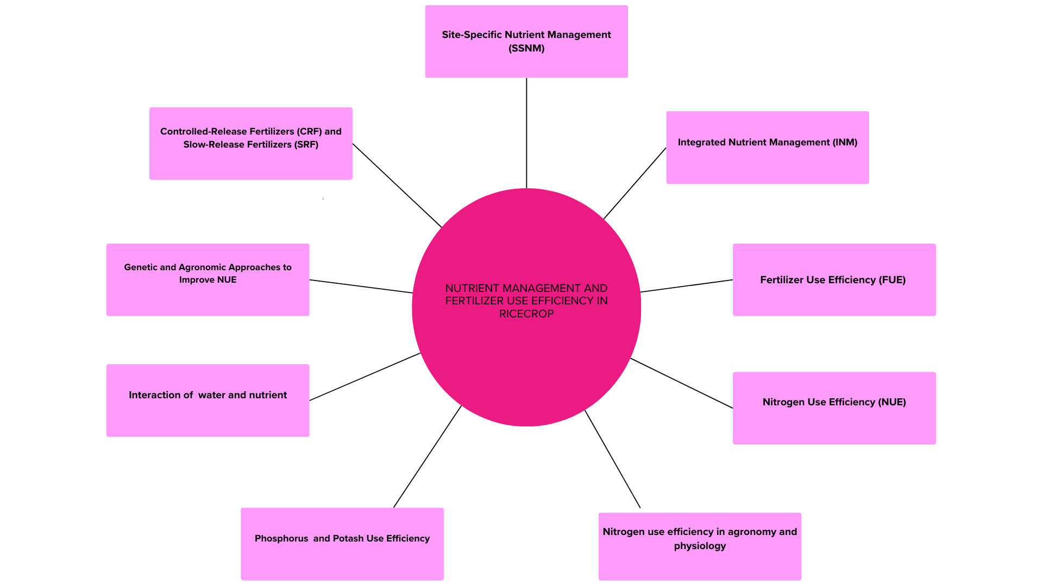
Fig.1:- NUTRIENT MANAGEMENT AND FERTILIZER USE EFFICIENCY IN RICE CROP

  - Precision Fertilizer Application Strategies
The crop nutrition requirements of rice can be identified using sensor-based, soil testing and digital tools, and hence precision fertilization takes place. Remote sensing, soil spectroscopy, and nutrient modeling techniques generate up-to-date spatial data on soil nutrient availability and plant health favouring fertilization at the right time and place (Linquist et al., 2013). Previous work highlighted that NUE could be 20–30% higher and nitrogen leaching may be 15–40% lower than the conventional fertilization technique through precision nutrient management (Zhao et al., 2013).
  - Use of Decision-Support Tools such as Nutrient Expert
The Nutrient Expert (NE) tool is a decision-support software that enables farmers to find the best fertilizer application rates for rice. This approach takes into account soil fertility, residue of previous crops, climate, and requirement of rice varieties for site-specific nutrient recommendations (Sapkota et al., 2021). On average, rice yields increased by 10-15% and fertilizer input costs were reduced by 12-18% with NE-based SSNM adopted by farmers in India and the Philippines (Banayo et al., 2018).
- Integrated Nutrient Management (INM)
Unlike the above-mentioned approaches, Integrated Nutrient Management (INM) emphasis the amalgamation of organic and inorganic nutrient sources either for building soil fertility and/or benefiting Fertilizer use efficiency (FUE) to attain sustainable rice production (Dimkpa et al., 2020). INM helps in enhancing soil structure, microbial diversity and availability of nutrient by combining chemical fertilizers with organic manures, composts and biofertilizers.
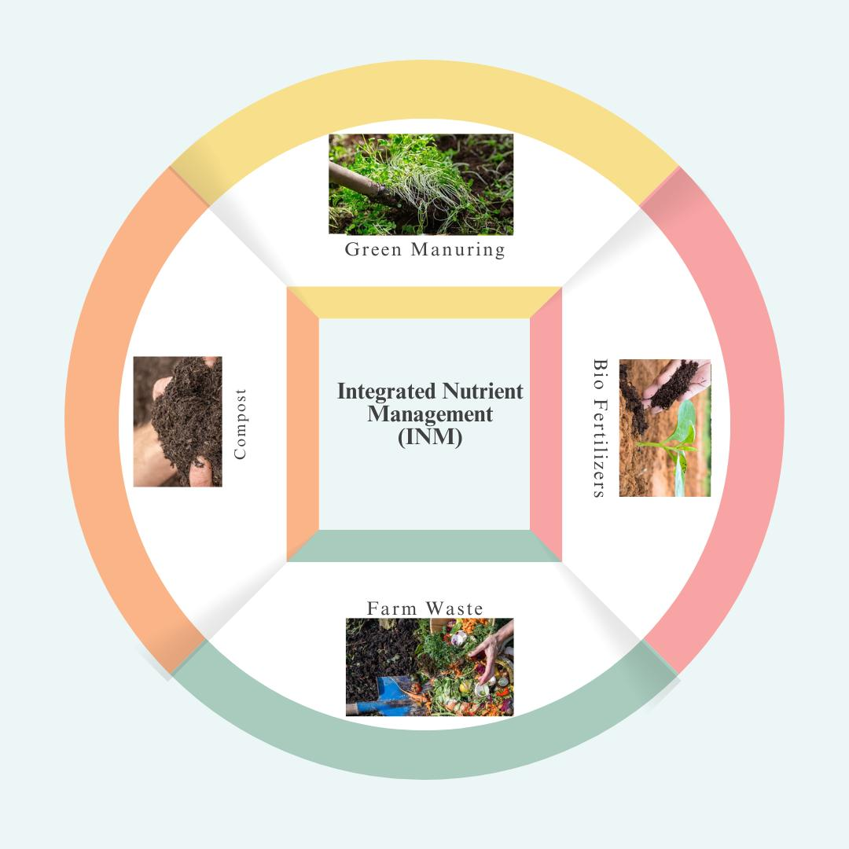Fig.2 Integrated nutrient management (INP)
  - Combination of Organic and Inorganic Fertilizers
Using a hybrid way of fertilizer application makes application of chemical fertilizer while adding organic amendments to it to ensure gradual nutrient release and enhance soil properties (Zhang et al., 2018). Studies have shown that the integrated use of organic manure with chemical fertilizers helps better nutrient uptake, increases grain yields by (8-12%) and soil organic carbon levels (Pan et al., 2017). Furthermore, it relies less on artificial fertilizer which saves money and helps limit nitrate from washing into rivers and lakes.
  - Role of Biofertilizers and Microbial Inoculants
Rhizobia, mycorrhizal fungi, and phosphate-solubilizing bacteria are some biofertilizers which can play a major role in natural nitrogen fixation, phosphorus solubilization, and nutrient uptakes (Bargaz et al., 2018). Research found that rice field application of biofertilizers can lower nitrogen fertilizer need by as much as 25% without loss of yield (Chowdhury et al., 2021). In addition, they also help increase root development, soil enzyme activity, and long-term fertility of the soil.
- Controlled-Release Fertilizers (CRF) and Slow-Release Fertilizers (SRF)
CRF (Controlled-Release Fertilizers) and SRF (Slow-Release Fertilizers), are futuristic approaches in plant nutrient management that allow nutrients to be released slowly to reduce (Mohanty et al., 2020) nutrient losses by leaching, volatilization and denitrification.
  - Impact on Yield, NUE, and Soil Health
Controlled release fertilizers (CRFs) and stabilized fertilizers (SRFs) have the potential to improve nutrient use efficiency by modulating release rates to match plant uptake (Wang et al., 2018). We identified improvement of NUE by 30–50% and reduction of greenhouse gas emissions by 20–25% during corresponding rice growing seasons when CRF was applied (Chen et al., 2020). Moreover, they reduce nutrient leaching, and thus, maintain soil health and alleviate eutrophication problem of water bodies (Li et al., 2018).
- Organic Amendment and Alternative Fertilizer Strategies
Sources of organic amendments such as compost, manure and green manure are crucial to soil fertility, microbial activity and retention of important nutrients (Shah & Wu, 2019). Such fertilization techniques provide more sustainable solutions in the long term by improving the soil structure, organic matter contents and nutrient cycling capabilities.
- Importance of compost, manure, and also green manure
Application of compost and FYM enables a proper aeration of soil as well as helps in retention of water in soil with high water-holding capacity, and along with this also improves cation exchange capacity (Zhang et al. Some crops like Sesbania and Azolla serve as green manure crops in a biological state of nitrogen fixation with a potential to lessen dependency on nitrogen fertilizers that typically are used as synthetic fertilizers (Tsujimoto et al., 2019). Some investigations indicate that soil and manure mixing can achieve 10-15% of the production of residential rice with ordinary composts and huge improvements in microbial biodiversity of soil (Panhwar et al., 2018).
Nutrient management strategies like SSNM, INM, CRF, organic amendments, etc. are key to enhancing fertilizer use efficiency, soil health, and rice production over the long run. These strategies have the capabilities to improve rice harvest and minimize input cost whilst ensuring agricultural sustainability.
Table 1: Summary of Nutrient Management Strategies and Their Impact on Rice Cultivation
Nutrient Management Strategy | Key Features | Impact on Fertilizer Use Efficiency (FUE) and Yield | References
Site-Specific Nutrient Management (SSNM) | Precision application based on soil and crop needs | Increases nitrogen use efficiency (NUE) by 20-30%; reduces excess fertilizer application | Buresh et al. (2019)
Integrated Nutrient Management (INM) | Combination of organic and inorganic fertilizers | Enhances soil health, increases grain yield by 8-12% | Zhang et al. (2018)
Controlled-Release Fertilizers (CRF) & Slow-Release Fertilizers (SRF) | Gradual nutrient release | Improves NUE by 30-50%; reduces nutrient leaching by 20-25% | Mohanty et al. (2020)
Organic Amendments (Compost, Manure, Green Manure) | Enhances microbial activity and soil structure | Increases soil organic matter, improves long-term soil fertility | Bargaz et al. (2018)
Biofertilizers & Microbial Inoculants | Uses beneficial microbes for nitrogen fixation and phosphorus solubilisation | Reduces synthetic fertilizer dependency, enhances nutrient uptake by 15-25% | Chowdhury et al. (2021)

- Fertilizer Use Efficiency (FUE) and Its Determinants
FUE, is an important component of the economic and environmental sustainability and profitability FUE is defined as the proportion of applied nutrients that is absorbed and used by the plants, minimizing losses and maximizing yield (Sapkota et al., 2021). Nitrogen (N), phosphorus (P) and potassium (K) are key macronutrients for rice that play major roles in plant growth and development. Nevertheless, they are misused contributing to at least soil nutrient leaching, soil pollution and environmental pollution (Linquist et al., 2013). Conceptual comprehension of the determinants of FUE, such as nitrogen use efficiency (NUE), phosphorus and potassium utilization, interactions of water and nutrients and genetic advances are imperative for the productivity and sustainability of rice.
- Nitrogen Use Efficiency (NUE)
Despite this, NUE in rice remains very low because, after almost a century of green-revolution practices, farmers are applying excessive nitrogen fertilizer often at the wrong time and much ends up lost to the environment via volatilization, leaching and denitrification (Buresh et al., 2019). Improving NUE is essential to maximize the utilization of applied nitrogen by rice crop with minimum effects to the environment.
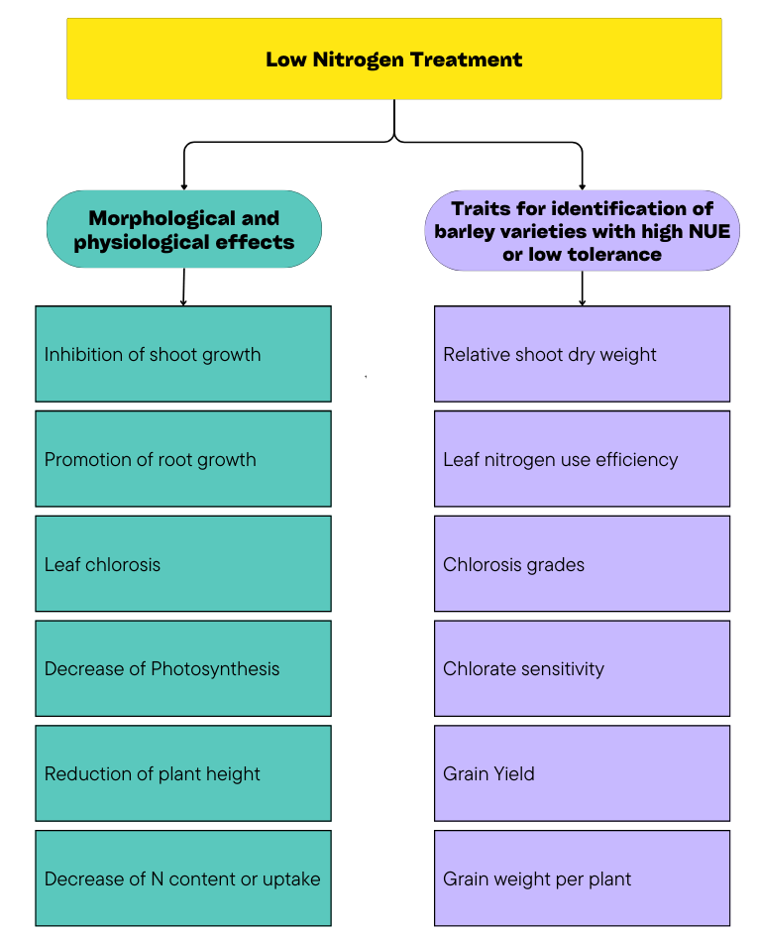
Fig.3: -Nitrogen Use Efficiency (NUE)

- Nutrient uptake efficiency and nitrogen use efficiency in agronomy and physiology
Agronomic NUE is defined as the apparent grain yield per unit nitrogen applied, while physiological NUE is defined as the product of the ratios of nitrogen uptake efficiency and divide by nitrogen utilization efficiency in plants (Wang et al., 2018). Enhanced agronomic practices, including split application of N, deep placement of fertilizer, and alternate wetting and drying (AWD) irrigation, have been reported to increase NUE by 30–40% as compared to conventional N application techniques (Ding et al., 2018). Moreover, the physiological components of NUE are more nitrogen remobilization during the grain-filling of the grain (e.g., higher nitrogen remobilization or from the other parts and soils systems) and efficient root systems (Zhang et al., 2018).

- Phosphorus and Potash Use Efficiency
Although phosphorus (P) and potassium (K) are vital for root development, for grain filling and for plant metabolism, their use efficiencies are low in many rice-growing regions. Soil fixation of away surplus P apply and even lower or even no supply of K causes K shortage, contribute to below-average starch synthesis and growth R Choi (2018) in rice (Li et al. 2018).
- Role in Root Development and Grain Filling
Its seed contributes to the precocity of the roots it generates through phosphorus, so that they can better access the water and nutrients contained in the soil. It has been observed that balanced phosphorus application contributes to enhanced root biomass (25–30%) which in turn increase the potential of nutrient uptake and drought stress (Panhwar et al., 2018) resistance. In contrast, the potassium is involved in enzyme activation, carbohydrate metabolism, and regulation of water, which help in grain filling and improve grain Quality (Zhao et al., 2013). A rational fertilisation approach for N, P and K is required to eliminate the potential nutrient imbalance as it can have an adverse effect on the metabolism and yield of plant (Shrestha et al., 2020). Encouragingly, tailored nutrient management practices that include phosphorus-solubilizing biofertilizers can increase P uptake efficiency by 20–35% (Bargaz et al., 2018), while deep placement of potassium fertilizers enhance K-use efficiency by 15–25% (Bargaz et al.
- Interaction of water and nutrient
Water and irrigation management play a major role in nutrient mobility, nitrogen uptake efficiency, and fertilizer effectiveness against the background of rice cultivation. Nutrient leaching occurs either due to waterlogging or over-irrigation while the root absorptive capacity reduces under water stress, which affects the overall FUE (Mohanty et al., 2020).
- Effect of Irrigation Regimes on Efficiency of Fertiliser
A conventional irrigation method, namely the Alternate Wetting and Drying (AWD) irrigation technique with controlled soil dry-down after irrigation events, has been demonstrated to increase nitrogen uptake by 20–30% and reduce methane emissions by 50% as compared to continuously flooded rice systems (Chen et al., 2020). In addition, precision irrigation technologies such as drip and fertigation systems can improve uptake and limit the loss of nutrients, thus improving FUE under constrained environments (Pan et al., 2017).
Optimal soil moisture allows nutrient diffusion and uptake; it also keeps desired fertilizer in the root zone. Nutrient recovery efficiency and higher grain yield using AWD irrigation has also been observed when SSNM is applied (Tsujimoto et al., 2019).
- Genetic and Agronomic Approaches to Improve NUE
New varieties and proper agronomic practices during cultivation are the most relevant factors to enhance NUE and overall fertilizer efficiency in rice [9] [12]. Recent approaches to rice breeding have emphasized nitrogen uptake efficiency, root depth, and nitrogen remobilization to grains (Ali et al., 2018).
  - Breeding Strategies to Improve NUE
Targeting genes for nitrogen uptake and assimilation discovered from rice molecular genetic mapping studies have also begun to be used for the genetic improvement of rice for high NUE (Zhang et al., 2020). As a result, some of the strategies being applied to nitrogen metabolism through marker-assisted breeding and CRISPR-based gene editing, and optimization of root architecture to maximise yield while minimizing dependence on fertilizers (Shah & Wu, 2019). It has been reported that NUE-improved rice varieties need 20–30% less nitrogen input for an equivalent or higher yield than conventional varieties (Singh et al., 2021).
  - Utilization of Precision Agriculture and Remote Sensing
Innovations in remote sensing, drone-based nutrient mapping, and precision agriculture technologies are changing the way we manage nutrients in rice fields. Real-time plant nitrogen status sensing enables variable-rate fertilizer application, which improves nutrient distributions within fields (Zhao et al., 2013). Moreover, nutrient recommendation models driven by AI improve fertilizer efficiency by delivering site-specific application rates to farmers, reducing over-application and potential losses into the environment (Sapkota et al., 2021).
Integrating genetic breakthroughs, agronomic practices, and precision agriculture would greatly enhance NUE, increase rice yield, and enable sustainable fertilizer use in rice cultivation. Further horizontal long-term integration of smart fertilization technologies and nitrogen-efficient rice varieties will also enhance resource-efficient and environmentally sustainable rice production systems.

Table 2: Comparison of Fertilizer Types and Their Efficiency in Rice Cultivation
Fertilizer Type | Nutrient Release Mechanism | Efficiency Improvement (%) | Environmental Impact | References
Urea (Conventional Nitrogen Fertilizer) | Fast-release, prone to volatilization | 30-40% NUE | High nitrogen losses, contributes to eutrophication | Zhao et al. (2013)
Controlled-Release Fertilizers (CRF) | Slow, regulated nutrient release | 40-60% NUE | Reduces leaching and volatilization losses | Wang et al. (2018)
Slow-Release Fertilizers (SRF) | Nutrients released gradually | 35-50% NUE | Reduces frequency of application, lowers greenhouse gas emissions | Mohanty et al. (2020)
Biofertilizers (Rhizobia, Mycorrhizae, Phosphate-Solubilizing Bacteria) | Microbial-based nutrient mobilization | 20-35% NUE | Environmentally friendly, enhances soil biodiversity | Bargaz et al. (2018)
Organic Manure & Compost | Natural decomposition | 15-25% NUE | Improves soil structure, reduces chemical dependency | Zhang et al. (2018)

- Future Directions
Therefore, sustainable nutrient management in rice cultivation needs a good policy framework that encourages smart use of fertilizers while reducing the environmental harm. Hence, Governments should emphasize site-specific nutrient management (SSNM), controlled-release fertilizers (CRF), and integrated nutrient management (INM) to increase fertilizer use efficiency (FUE) (Buresh et al., 2019). The policies should facilitate subsidies for green fertilizers, extension services for farmer training, and stricter regulations against excessive application of nitrogen (Mohanty et al., 2020). For example, in countries such as China and India, policy interventions have developed less reliance on external nitrogen fertilizer and accelerated uptake of climate-smart nutrient interventions through government leadership (Zhang et al., 2018). Despite these advantages, few farmers have adopted innovative nutrient management strategies, primarily as a result of high costs, lack of awareness and access to precision agriculture tools (Sapkota et al., 2021).
Nevertheless, their implementation, including advanced fertilization technologies like slow-release fertilizers, biofertilizers, and precision agriculture tools, is limited by the cost and lack of infrastructure (Chowdhury et al.,2021). Most farmers still use the traditional blanket fertilizer applications which commonly leads to nutrient losses, soil degradation and higher input costs For instance, smallholder farmers are less likely to use high-efficiency fertilizers or digital decision-support systems (Linquist et al, 2013) owing to the dual challenges of financial and technical capital for the implementation process. Solutions involve improved agricultural extension, economic incentives for resource conservation technologies, and partnerships among research institutions, policymakers, and farmers to expand the adoption of fertilizer efficiency technologies at scale effective high-FE due to limited (Shah & Wu, 2019).
Climate change has significant implications for crop productivity and soil nutrient dynamics, and therefore climate-smart nutrient management (CSNM) options need to be implemented within rice-based systems. Changes in temperature, rain fall, climate patterns and increase in incidence of extreme events affect the availability of nutrients, rate of uptake and utilization of nutrients and soil microbial activity thus adaptive fertilization is a requirement (Zhao et al., 2013). Soil chemical and biological fertility are key components in determining the viability of climate-smart technologies that can minimize environmental impacts while increasing the efficiency of nutrient use, including carbon-based slow-release or controlled-release fertilizers, biofertilizers, and different precision irrigation methods including alternate wetting and drying (AWD) applied to different crops (Rashid et al., 2021). For example, alternate wetting and drying (AWD)) has the potential to enhance NUE by 20–30 % and concurrently reduce methane emissions, therefore, representing a potential sustainable solution for rice production (Pan et al., 2017). Moreover, the application of microbial inoculants, soil phosphorus-solubilizing bacteria, and mycorrhizal fungi improved nutrient cycling and less dependency on synthetic fertilizers (Bargaz et al., 2018).
The need for nutrient management strategies highlighted in this review is essential for possible improvement in fertilizer use efficiency (FUE) towards sustainable rice production. There have been significant enhancements in nitrogen uptake, phosphorus efficiency and soil health with the use of SSNM, INM, CRF and biofertilizers (Buresh et al., 2019). The progress on more genetically bred high NUE rice varieties, together with precision agriculture technologies and climate-resilient nutrient management strategies, will improve the technology transfer more efficiently and sustainably (Zhang et al., 2020). In the near future, efforts from governments and research institutions should be directed to strengthen the existing policy frameworks, awareness among farmers, and investment on the smart fertilization technologies to reduce the gap between scientific advancement and practical field application (Tsujimoto et al., 2019). Incorporating these climate-resilient, economical, and science-proven nutrient management practices are more beneficial as they can provide rice farmers with greater crop productivity with lesser production cost, ensuring a climate-smart agriculture future (Sapkota et al., 2021).

- Conclusions

Sustainable rice production is highly dependent on efficient nutrient management strategies that maximize fertilizer use efficiency (FUE) while minimizing environmental impacts. Despite the extensive use of chemical fertilizers, poor nutrient management practices have led to declining nitrogen use efficiency (NUE), increased greenhouse gas emissions, and soil degradation. Inefficient fertilizer application not only affects rice yields but also contributes to economic losses for farmers and long-term soil fertility decline.
To address these challenges, various strategies have been explored, including Site-Specific Nutrient Management (SSNM), Integrated Nutrient Management (INM), Controlled-Release Fertilizers (CRF), Slow-Release Fertilizers (SRF), and organic amendments.
SSNM and precision fertilization approaches leverage digital tools, soil testing, and decision-support systems to optimize nutrient application, improving NUE by 20-30%. INM, which combines organic andinorganic fertilizers, enhances soil structure and nutrient retention while reducing dependency on synthetic fertilizers.
CRF and SRF technologies further enhance NUE by releasing nutrients gradually, reducing leaching and volatilization losses, and mitigating environmental pollution. Additionally, organic amendments such as compost, manure, and biofertilizers play a crucial role in improving long-term soil fertility and microbial activity. Water and irrigation management also significantly influence FUE.
Techniques such as Alternate Wetting and Drying (AWD) have been shown to increase nitrogen uptake by 20–30% and reduce methane emissions by 50%. Additionally, genetic advancements in rice breeding have introduced nitrogen-efficient rice varieties that require 20-30% less nitrogen input while maintaining high yields.
The integration of precision agriculture, remote sensing, and AI-driven nutrient recommendations further optimizes fertilization, ensuring site-specific application rates and reducing environmental risks.
I recommend closing this section (Conclusions) with a couple of paragraphs highlighting:
1) The importance of moving toward climate-smart nutrient management strategies, driven by local and regional policies; and
2) The recommendation that farmers, researchers, and policymakers improve nutrient management practices to achieve sustainable rice production with minimal environmental risks.

I recommend adapting bibliographic citations as indicated in the instructions for authors:
References must be listed at the end of the manuscript and numbered in the order that they appear in the text. Every reference referred in the text must also present in the reference list and vice versa. In the text, citations should be indicated by the reference number in brackets [3].
For this Section, I also recommend redoing it by following the instructions, according to:
E. g., For Published paper:
1. Hilly M, Adams ML, Nelson SC. A study of digit fusion in the mouse embryo. Clin Exp Allergy. 2002;32(4):489-98.

See: https://peerreviewcentral.com/page/general-guideline-for-authors

XX. References
Ali, J., Jewel, Z. A., Mahender, A., Anandan, A., Hernandez, J., & Li, Z. (2018). Molecular genetics and breeding for nutrient use efficiency in rice. In International Journal of Molecular Sciences (Vol. 19, Issue 6). MDPI AG. https://www.mdpi.com/1422-0067/19/6/1762
Banayo, N. P. M. C., Haefele, S. M., Desamero, N. v., & Kato, Y. (2018). On-farm assessment of site-specific nutrient management for rainfed lowland rice in the Philippines. Field Crops Research, 220, 88–96. https://www.sciencedirect.com/science/article/pii/S0378429017315137?via%3Dihub
Bargaz, A., Lyamlouli, K., Chtouki, M., Zeroual, Y., & Dhiba, D. (2018). Soil Microbial Resources for Improving Fertilizers Efficiency in an Integrated Plant Nutrient Management System. In Frontiers in Microbiology (Vol. 9). Frontiers Media S.A. https://www.frontiersin.org/journals/microbiology/articles/10.3389/fmicb.2018.01606/full
Buresh, R. J., Castillo, R. L., dela Torre, J. C., Laureles, E. v., Samson, M. I., Sinohin, P. J., & Guerra, M. (2019). Site-specific nutrient management for rice in the Philippines: Calculation of field-specific fertilizer requirements by Rice Crop Manager. Field Crops Research, 239, 56–70. https://doi.org/10.1016/j.fcr.2019.05.013
Chen, Z., Wang, Q., Ma, J., Zou, P., & Jiang, L. (2020). Impact of controlled-release urea on rice yield, nitrogen use efficiency and soil fertility in a single rice cropping system. Scientific Reports, 10(1). https://doi.org/10.1038/s41598-020-67110-6
Chowdhury, S., Bolan, N., Farrell, M., Sarkar, B., Sarker, J. R., Kirkham, M. B., Hossain, M. Z., & Kim, G. H. (2021). Role of cultural and nutrient management practices in carbon sequestration in agricultural soil. In Advances in Agronomy (Vol. 166, pp. 131–196). Academic Press Inc. https://doi.org/10.1016/bs.agron.2020.10.001
Dimkpa, C. O., Fugice, J., Singh, U., & Lewis, T. D. (2020). Development of fertilizers for enhanced nitrogen use efficiency – Trends and perspectives. In Science of the Total Environment (Vol. 731). Elsevier B.V. https://doi.org/10.1016/j.scitotenv.2020.139113
Ding, W., Xu, X., He, P., Ullah, S., Zhang, J., Cui, Z., & Zhou, W. (2018). Improving yield and nitrogen use efficiency through alternative fertilization options for rice in China: A meta-analysis. Field Crops Research, 227, 11–18. https://doi.org/10.1016/j.fcr.2018.08.001
Ghosh, D., Brahmachari, K., Brestic, M., Ondrisik, P., Hossain, A., Skalicky, M., Sarkar, S., Moulick, D., Dinda, N. K., Das, A., Pramanick, B., Maitra, S., & Bell, R. W. (2020). Integrated weed and nutrient management improve yield, nutrient uptake and economics of maize in the rice-maize cropping system of eastern India. Agronomy, 10(12). https://doi.org/10.3390/agronomy10121906
Hou, W., Xue, X., Li, X., Khan, M. R., Yan, J., Ren, T., Cong, R., & Lu, J. (2019). Interactive effects of nitrogen and potassium on: Grain yield, nitrogen uptake and nitrogen use efficiency of rice in low potassium fertility soil in China. Field Crops Research, 236, 14–23. https://doi.org/10.1016/j.fcr.2019.03.006
Jat, M. L., Bijay-Singh, & Gerard, B. (2014). Nutrient Management and Use Efficiency in Wheat Systems of South Asia. In Advances in Agronomy (Vol. 125, pp. 171–259). Academic Press Inc. https://doi.org/10.1016/B978-0-12-800137-0.00005-4
Jat, R. D., Jat, H. S., Nanwal, R. K., Yadav, A. K., Bana, A., Choudhary, K. M., Kakraliya, S. K., Sutaliya, J. M., Sapkota, T. B., & Jat, M. L. (2018). Conservation agriculture and precision nutrient management practices in maize-wheat system: Effects on crop and water productivity and economic profitability. Field Crops Research, 222, 111–120. https://doi.org/10.1016/j.fcr.2018.03.025
Li, P., Lu, J., Wang, Y., Wang, S., Hussain, S., Ren, T., Cong, R., & Li, X. (2018). Nitrogen losses, use efficiency, and productivity of early rice under controlled-release urea. Agriculture, Ecosystems and Environment, 251, 78–87. https://doi.org/10.1016/j.agee.2017.09.020
Linquist, B. A., Liu, L., van Kessel, C., & van Groenigen, K. J. (2013). Enhanced efficiency nitrogen fertilizers for rice systems: Meta-analysis of yield and nitrogen uptake. In Field Crops Research (Vol. 154, pp. 246–254). https://doi.org/10.1016/j.fcr.2013.08.014
Liu, H., Won, P. L. P., Banayo, N. P. M., Nie, L., Peng, S., & Kato, Y. (2019). Late-season nitrogen applications improve grain yield and fertilizer-use efficiency of dry direct-seeded rice in the tropics. Field Crops Research, 233, 114–120. https://doi.org/10.1016/j.fcr.2019.01.010
Mohanty, S., Nayak, A. K., Swain, C. K., Dhal, B. R., Kumar, A., Kumar, U., Tripathi, R., Shahid, M., & Behera, K. K. (2020). Impact of integrated nutrient management options on GHG emission, N loss and N use efficiency of low land rice. Soil and Tillage Research, 200. https://doi.org/10.1016/j.still.2020.104616
Nair, K. P. (2019). Soil Fertility and Nutrient Management. In Intelligent Soil Management for Sustainable Agriculture (pp. 165–189). Springer International Publishing. https://doi.org/10.1007/978-3-030-15530-8_17
Pan, J., Liu, Y., Zhong, X., Lampayan, R. M., Singleton, G. R., Huang, N., Liang, K., Peng, B., & Tian, K. (2017). Grain yield, water productivity and nitrogen use efficiency of rice under different water management and fertilizer-N inputs in South China. Agricultural Water Management, 184, 191–200. https://doi.org/10.1016/j.agwat.2017.01.013
Panhwar, Q. A., Ali, A., Naher, U. A., & Memon, M. Y. (2018). Fertilizer management strategies for enhancing nutrient use efficiency and sustainable wheat production. In Organic Farming: Global Perspectives and Methods (pp. 17–39). Elsevier. https://doi.org/10.1016/B978-0-12-813272-2.00002-1
Qureshi, A., Singh, D. K., & Dwivedi, S. (2018). Nano-fertilizers: A Novel Way for Enhancing Nutrient Use Efficiency and Crop Productivity. International Journal of Current Microbiology and Applied Sciences, 7(2), 3325–3335. https://doi.org/10.20546/ijcmas.2018.702.398
Rashid, M., Hussain, Q., Khan, K. S., Alwabel, M. I., Hayat, R., Akmal, M., Ijaz, S. S., Alvi, S., & Obaid-ur-Rehman. (2021). Carbon-Based Slow-Release Fertilizers for Efficient Nutrient Management: Synthesis, Applications, and Future Research Needs. In Journal of Soil Science and Plant Nutrition (Vol. 21, Issue 2, pp. 1144–1169). Springer Science and Business Media Deutschland GmbH. https://doi.org/10.1007/s42729-021-00429-9
Sapkota, T. B., Jat, M. L., Rana, D. S., Khatri-Chhetri, A., Jat, H. S., Bijarniya, D., Sutaliya, J. M., Kumar, M., Singh, L. K., Jat, R. K., Kalvaniya, K., Prasad, G., Sidhu, H. S., Rai, M., Satyanarayana, T., & Majumdar, K. (2021). Crop nutrient management using Nutrient Expert improves yield, increases farmers’ income and reduces greenhouse gas emissions. Scientific Reports, 11(1). https://doi.org/10.1038/s41598-020-79883-x
Shah, F., & Wu, W. (2019). Soil and Crop Management Strategies to Ensure Higher Crop Productivity within Sustainable Environments. Sustainability, 11(5), 1485. https://doi.org/10.3390/su11051485
Shrestha, J., Kandel, M., Subedi, S., & Shah, K. K. (2020). Role of nutrients in rice (Oryza sativa L.): A review . Agrica, 9(1), 53. https://doi.org/10.5958/2394-448x.2020.00008.5
Singh, P., Benbi, D. K., & Verma, G. (2021). Nutrient Management Impacts on Nutrient Use Efficiency and Energy, Carbon, and Net Ecosystem Economic Budget of a Rice–Wheat Cropping System in Northwestern India. Journal of Soil Science and Plant Nutrition, 21(1), 559–577. https://doi.org/10.1007/s42729-020-00383-y
Tsujimoto, Y., Rakotoson, T., Tanaka, A., & Saito, K. (2019). Challenges and opportunities for improving N use efficiency for rice production in sub-Saharan Africa. In Plant Production Science (Vol. 22, Issue 4, pp. 413–427). Taylor and Francis Ltd. https://doi.org/10.1080/1343943X.2019.1617638
Wang, M., Ma, L., Strokal, M., Chu, Y., & Kroeze, C. (2018). Exploring nutrient management options to increase nitrogen and phosphorus use efficiencies in food production of China. Agricultural Systems, 163, 58–72. https://doi.org/10.1016/j.agsy.2017.01.001
Xue, Y., Duan, H., Liu, L., Wang, Z., Yang, J., & Zhang, J. (2013). An improved crop management increases grain yield and nitrogen and water use efficiency in rice. Crop Science, 53(1), 271–284. https://doi.org/10.2135/cropsci2012.06.0360
Yang, T., & Kim, H. J. (2019). Nutrient management regime affects water quality, crop growth, and nitrogen use efficiency of aquaponic systems. Scientia Horticulturae, 256. https://doi.org/10.1016/j.scienta.2019.108619
Yousaf, M., Li, X., Zhang, Z., Ren, T., Cong, R., Ata-Ul-Karim, S. T., Fahad, S., Shah, A. N., & Lu, J. (2016). Nitrogen fertilizer management for enhancing crop productivity and nitrogen use efficiency in a rice-oilseed rape rotation system in China. Frontiers in Plant Science, 7(September2016). https://doi.org/10.3389/fpls.2016.01496
Zhang, M., Yao, Y., Tian, Y., Ceng, K., Zhao, M., Zhao, M., & Yin, B. (2018). Increasing yield and N use efficiency with organic fertilizer in Chinese intensive rice cropping systems. Field Crops Research, 227, 102–109. https://doi.org/10.1016/j.fcr.2018.08.010
Zhang, Z., Gao, S., & Chu, C. (2020). Improvement of nutrient use efficiency in rice: current toolbox and future perspectives. In Theoretical and Applied Genetics (Vol. 133, Issue 5, pp. 1365–1384). Springer. https://doi.org/10.1007/s00122-019-03527-6
Zhao, G., Miao, Y., Wang, H., Su, M., Fan, M., Zhang, F., Jiang, R., Zhang, Z., Liu, C., Liu, P., & Ma, D. (2013). A preliminary precision rice management system for increasing both grain yield and nitrogen use efficiency. Field Crops Research, 154, 23–30. https://doi.org/10.1016/j.fcr.2013.07.019

