Caffeine, Chlorogenic Acid and Antioxidant Properties in Different Clones of Green and Roasted Liberica Coffee Bean Extracts

.
ABSTRACT

Coffee is one of the most important food commodities in the worldwide economy. Liberica coffee (Coffealiberica) is a minor coffee species, commonly grown and consumed in most Southeast Asia countries, especially in Malaysia.However, information on caffeine, chlorogenic acid and antioxidant properties in different clones of Liberica coffee is still scarce.
Aims: The study aimed to evaluate and compare caffeine, chlorogenic acid and antioxidant properties in green and roasted beans of different Liberica coffee clones (MKL8, MKL9, and MKL10), with the goal of identifying the best clone for potential use in highquality coffee production and functional food or nutraceutical applications.
Study design: The study was conducted using a completely randomized design (CRD) involving three Liberica coffee clones; MKL8, MKL9and MKL10, where both green (unroasted) and medium-roasted bean samples were independently analyzed.
Place and Duration of Study: Samples were obtained from Industrial Crops Research Centre, MARDI Research Station,Kluang, Johor, between Mac 2022 and September 2022.
Methodology:Green coffee beans were dried under a hot air oven at 60°C and medium-roasted prior to extraction with 70% ethanol using ultrasonication-assisted extraction method. Both green and medium-roasted bean extracts were analyzed for phytochemical and antioxidant properties using spectroscopic and non-enzymatic antioxidant methods.
Results: Green bean extracts showed significantly (p<0.05) higher antioxidant activity, total phenolic content (TPC) and total flavonoid content (TFC) compared to roasted beans. Among the clones, MKL 10 showed the strongest antioxidant activity (DPPH, IC₅₀ = 0.582 mg/mL; FRAP = 9.636 mM) and MKL 8 recorded the highest TPC (148.708 mg CGAE/g). HPLC analysis revealed that chlorogenic acid (CGA) levels were significantly (p<0.05) higher in green bean extracts (3.345 to 7.172 mg/g), while roasted beans showed significantly (p<0.05) higher caffeine content (11.712 to 13.691 mg/g). After roasting, MKL 8 retained the highest antioxidant activity, TPC and TFC, while MKL 10 maintained the highest CGA content (6.21%).
Conclusion: MKL 8 and 10 were identified as the most promising Liberica coffee clones, exhibiting the highest antioxidant and phytochemical properties. These findings suggest their strong potential as a highperforming Liberica clones for quality enhancement and future product development.

Keywords: Alkaloid, phenolic, HPLC, oven-drying, medium-roasted

1. INTRODUCTION

Coffee is one of the most widely consumed beverages in the world, enjoyed for its rich flavour and stimulating effects. The coffee plant belongs to the Rubiaceae family and the Coffea genus, comprising over 100 species, though only a few are cultivated for commercial consumption (de Souza et al., 2020). The most commonly grown and consumed species are Coffea arabica (Arabica), C. canephora (Robusta), C. liberica(Liberica) and C. excelsa (Excelsa) (Patay et al., 2016). Each of these species offers distinct characteristics in terms of taste, phytochemical composition and health-promoting properties.

Rich in phytochemicals, coffee contain significant amounts of caffeine, chlorogenic acids (CGAs), polyphenols, flavonoid and diterpenes. These compounds contribute significantly to its characteristic flavor and aroma, while also offering a range of potential health benefits. Caffeine is a methylxanthine alkaloid (1,3,7-trimethylxanthine) responsible for its stimulant effects on the central nervous system. It enhances alertness, mood and metabolism, while also contributing to coffee’s characteristic bitterness.

CGAs, in particular, are a major group of phenolic compounds in coffee and are formed from the esterification of cinnamic acids (e.g., caffeic and ferulic acids) with quinic acid. They are typically grouped into caffeoylquinic acids (CQAs), dicaffeoylquinic acids (diCQAs) and feruloylquinic acids (FQAs) (Jeon et al., 2019; Liang et al., 2016). Coffee is considered one of the richest dietary sources of CGAs, with 5-caffeoylquinic acid (5-CQA) being the most abundant isomer (Awwad et al., 2021). Other isomeric forms include3-CQA,4-CQA and diCQAderivatives such as 3,4-diCQA, 3,5-diCQA and 4,5-diCQA. These compounds significantly influence the sensory characteristics and nutritional quality of coffee and are strongly associated with its antioxidant activity, contributing to both consumer appeal and potential health benefits (Anh-Dao et al., 2024).

The levels of caffeine,CGAsand other phytochemicals in coffee are influenced by multiple factors, including species, genotype, altitude, climate, soil conditions, agricultural practices, postharvest processing, roasting degree, storage and brewing technique (Pinheiro et al., 2021; Yahayu et al., 2020). Among the less commonly studied species, C.liberica is a minor commercial species primarily cultivated in West Africa and Southeast Asia, particularly in Malaysia (Halim-Lim et al., 2022). It is distinguished by its large beans and unique flavor profile, often described as smoky and woody. Despite being less researched compared to Arabica and Robusta, Liberica coffee has been found to contain considerable levels of phenolic compounds, contributing to its antioxidant and immune-supportive potential (Belay et al., 2008).

With growing consumer interest in functional beverages and bioactive compounds, there is a pressing need to explore lesser-known species such as Liberica to better understand their potential contributions to both health and product quality. MARDI (Malaysian Agricultural Research and Development Institute) has developed three high yield Liberica coffee clones, MKL 8, MKL 9 and MKL 10 after 15 years of research. Producing 17.4–25 t/ha, up to 60% more than commercial varieties, these clones are expected to increase national coffee output, forming part of a broader strategy to strengthen Malaysia’s coffee industry. This study compares the levels of caffeine, chlorogenic acid, and antioxidant activity in green and roasted beans from these clones, with the goal of identifying the best clone for potential use in high quality coffee production and functional food or nutraceutical applications.

2. material and methods

2.1 Plant materials and preparation of extracts

Three Liberica coffee clones; MKL8, MKL9 and MKL10 (Plate 1) were obtained from the coffee germplasm collection in MARDI Research Station in Kluang, Johor. Upon arrival at the laboratory, the coffee berries were washed thoroughly under running tap water to remove surface contaminants and then cut into small pieces. Whole coffee berries were subjected to dry (natural) processing prior to hulling. The outer skin, pulpand parchment layers were mechanically removed to obtain green coffee beans (G). The beans were then dried in a hot-air oven at 60 °C for 48 hours (Memmert, Germany) until a final moisture content of 8–10% was reached. Medium-roasting (R) was performed at 220 °C for 10 minutes. Both green and roasted beans (Plate 2) were ground to a fine powder (0.25 mm particle size) and stored in aluminium foil pouches under ambient conditions until further analysis.

Extraction was carried out using 70% ethanol at a 1:10 (w/v) ratio via ultrasonication-assisted extraction (JAC Ultrasonic, Korea) operated at 300 W and maintained at 40–50°C. After 1 hour of extraction period, the mixtures were centrifuged at 10,000 rpm for 15 minutes (Heraeus Multifuge X3R, Germany) to separate the supernatant.The resulting mixtures were then filtered to obtain the crude extracts, which were stored at 4 °C until further analysis.

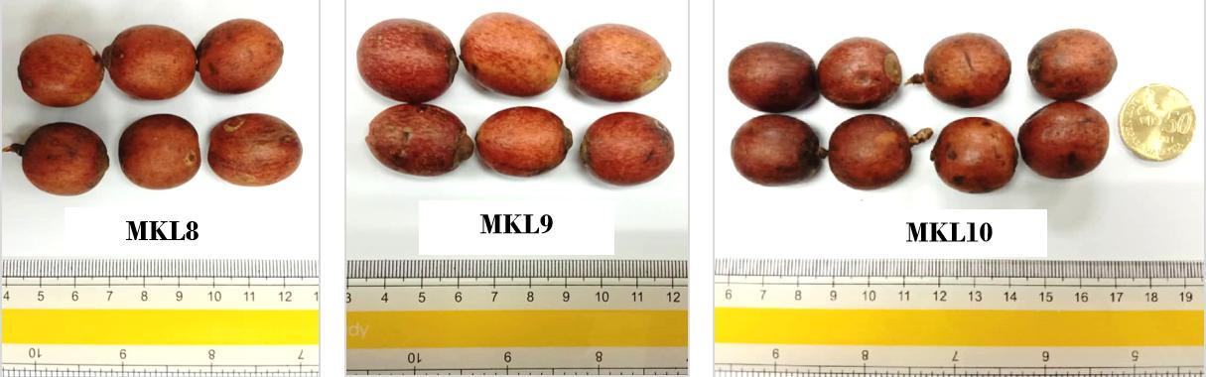
b
c
a
Plate 1. Liberica coffee berries from different clones; (a) MKL 8, (b) MKL9 and (c) MKL10
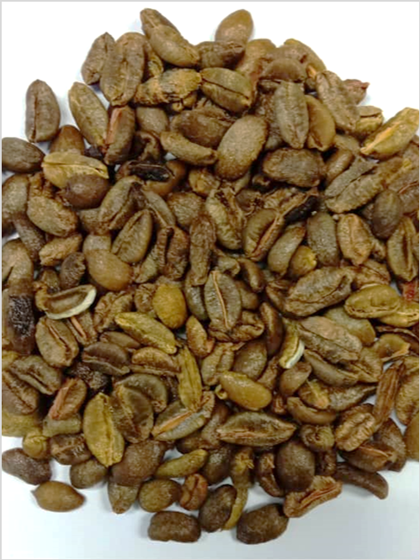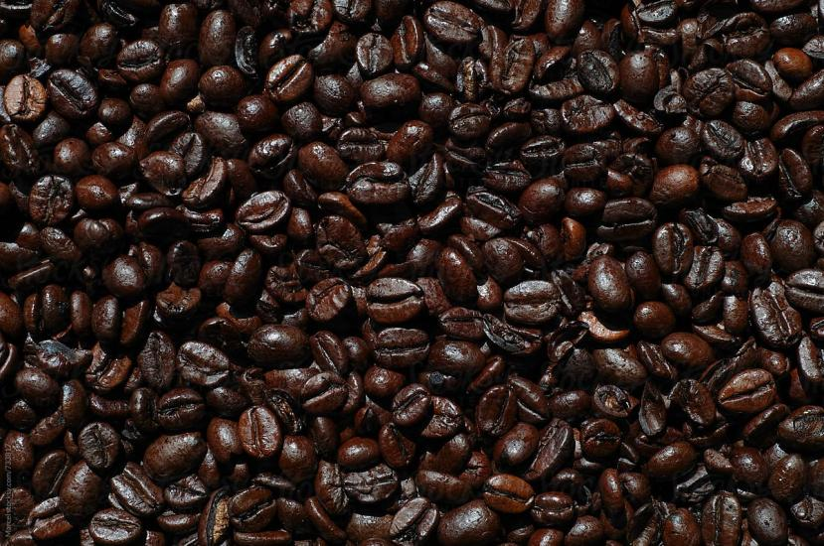
a
b
Plate 2: (a) Green and (b) medium-roasted bean of Liberica coffee

2.2Determination of antioxidant activity

2.2.1 DPPH radical scavenging

The scavenging activity of the extracts on 2,2-diphenyl-1-picrylhydrazyl (DPPH) radicals was evaluated according to our previous work (Mirfat et al., 2024). Various concentrations of the extracts in ethanol were prepared to give a final volume of 7 μL and were mixed with 280 μL of ethanolic solution containing DPPH radicals (Sigma-Aldrich, USA) resulting in a final concentration of 0.06 mM. The reaction mixture was vigorously shaken and left to stand for 30 minutes in the dark. The negative control contained all reagents without the test samples, while ethanol was used as a blank. The DPPH radical scavenging activity was determined by measuring the absorbance at 517 nm using a microplate reader (Eon Biotek, VT, USA). The percentage of inhibition of the DPPH radicals was calculated as follows:

Inhibition (%) = (Absorbance of control − Absorbance of test sample) / (Absorbance control) x 100%

A graph of the DPPH inhibition percentage of each sample against the sample concentration was plotted. The final results were expressed as IC₅₀ value, which is the inhibitory concentration at which DPPH radicals were scavenged by 50%. All procedures were conducted in triplicates with a minimum exposure to light.

2.2.2Ferric reducing antioxidant power

Ferric reducing antioxidant power (FRAP) was determined based on the reduction of ferric-tripiridyltriazine (Fe³⁺-TPTZ) to a blue-coloured ferrous form (Fe²⁺-TPTZ) (Mirfat et al., 2024). The working FRAP reagent was prepared by mixing 300 mM acetate buffer (pH 3.6), 10 mM TPTZ (Sigma–Aldrich, USA) solution and 20 mM ferric chloride hexahydrate (FeCl₃.6H₂O) (Sigma–Aldrich, USA) in a ratio of 10:1:1, prior to use and warmed at 37ºC in water bath. A total of 7 µL of sample and 20 µL of distilled water (dH₂O) were added to 200 µL of FRAP reagent and incubated at 37ºC for 4 minutes. The absorbance of the reaction mixture was measured at 593 nm against a blank. Ferrous sulfate heptahydrate (FeSO₄.7H₂O) (Sigma-Aldrich, USA) was used as a reference standard (100-1000 mM) to produce a calibration curve. The final results were expressed as the concentration of antioxidants having a ferric-reducing ability in Fe mM sample.

2.3Determination of phytochemical content

2.3.1 Total phenolic content

Total phenolic content of the extracts was estimated according to the Folin–Ciocalteucolourimetric method as described in our previous work (Mirfat et al., 2024). Briefly, a 50 μL test sample was mixed with 100 μLFolin-Ciocalteau’s phenol reagent (Sigma-Aldrich, USA). After 3 minutes, 100 μL 10% sodium carbonate (Na₂CO₃) (Merck, Germany) was added to the reaction mixture and allowed to stand in the dark for 60 minutes. The analysis was carried out in triplicates with a minimum exposure of light. The resulting blue-coloured complex was measured at 725 nm against a blank. Chlorogenic acid (Sigma-Aldrich, USA) was used as a reference standard and the content of total phenol was expressed in CGA equivalents (CGAE) in milligram per g samples through the calibration curve.

2.3.2 Total flavonoid content

The aluminium chloride method was used for the determination of total flavonoids following a previously reported by Mirfat et al. (2024). An aliquot of 30 μL of extract was diluted with 120 μL dH₂O. Initially, 9 μL 5% sodium nitrite (NaNO₂) (Merck, Germany) solution was added and allowed to react for 5 minutes. Then, 9 μL 10% aluminium chloride (AlCl₃) (Merck, Germany) solution was added and left to stand for 5 minutes. Finally, 60 μL sodium hydroxide (NaOH) (Merck, Germany) and 72 μL dH₂O were added, and the mixture was well-mixed with a vortex. All samples were analyzed in triplicates and the absorbance was measured immediately at 510 nm against a blank. The total flavonoid content was calculated from the calibration curve using rutin (Sigma-Aldrich, USA) as a standard reference. The data were expressed as rutin equivalents (RE) in milligram per g samples.

2.4 Chromatographic analysis

The quantification of caffeine and CGA in the extracts was carried out using a High Performance Liquid Chromatography (HPLC) system equipped with a Diode Array Detector (DAD). Caffeine separation was achieved using an Agilent Poroshell 120 C18 column (150 mm × 4.6 mm i.d., 4 µm particle size) maintained at 40 °C. The mobile phase consisted of water and methanol (80:20, v/v) containing 0.1% formic acid. The flow rate was set at 0.6 mL/min with an injection volume of 10 µL. Detection was carried out at 275 nm, and the total run time for each analysis was 5 minutes. Calibration of the system was performed using a caffeine standard (Sigma-Aldrich, USA). A 100 ppm stock solution was prepared, followed by serial dilutions to obtain working standards at concentrations of 50, 25, 12.5, and 6.25 ppm.

CGA analysis was performed using a Kinetex 5 µm C18 column (250 mm × 4.6 mm), maintained at 25 °C.The mobile phase consisted of acetonitrile and methanol (80:20, v/v) containing 0.1% formic acid, delivered at a flow rate of 1.0 mL/min. The injection volume was 20 µL, and the total runtime for each analysis was 15 minutes.Calibration of the system was performed using a CGA standard (Sigma-Aldrich, USA). A 1000 ppm stock solution was serially diluted to produce working standards at concentrations of500, 250, 125, 60 and 30 ppm.

All standard solutions were analyzed under identical chromatographic conditions to generate a calibration curve.Quantification of caffeine and CGA in the samples was based on peak area comparison against their respective standard curves. All solvents used were of HPLC grade (Merck, Germany).

2.5 Statistical analysis

All experiments were carried out in triplicates and presented as means ± standard deviations (SD). The data were statistically analyzed by analysis of variance (ANOVA) and Tukey’s post hoc test using SPSS software, version 20 (SPSS Inc; Chicago, IL, USA). A value of P<0.05 was considered to be statistically significant.

- results and discussion

  - Antioxidant activity

The antioxidant activity of green and roasted Liberica coffee extracts was assessed using two complementary non-enzymatic assays: DPPH radical scavenging (expressed as IC₅₀ values) and ferric reducing antioxidant power (FRAP). Lower IC₅₀ values in the DPPH assay indicate stronger free radical scavenging capacity, while higher FRAP values denote greater electron-donating potential. The results are summarized in Table 1.

Among the green bean extracts, G-MKL 10 exhibited the strongest antioxidant activity, with the lowest DPPH IC₅₀ value (0.582 mg/mL) and the highest FRAP value (9.636 mM), indicating superior free radical neutralizationand reducing capacity. G-MKL 8 followed closely with moderate antioxidant activity (IC₅₀ = 1.038 mg/mL, FRAP = 7.831 mM), while G-MKL 9 exhibited the weakest activityin both assays (IC₅₀ = 7.298 mg/mL, FRAP = 7.145 mM), suggesting clear clonal variation in the antioxidant profiles of Liberica green beans. The findings are consistent with de Souza et al. (2020) who reported that the strong DPPH radical scavenging activity in green coffee beans is primarily due to their abundant CGAs.Roasting induces thermal degradation of CGAs, thereby reducing antioxidant activity. This reduction is further attributed to the breakdown of other heat-sensitive compounds, including polyphenols (Anh-dao et al., 2024).
From the results, roasting significantly (p<0.05) reduced antioxidant activity in all clones and altered their relative performance. MKL 10, which was the most potent in its green form (G-MKL 10), showed a marked decline after roasting with its IC₅₀ increasing to 3.844 mg/mL and FRAP value decreasing to 1.056 mM, ultimately becoming the least effective among the roasted samples.R-MKL 8 retained a moderate level of antioxidant capacity (IC₅₀ = 2.477 mg/mL, FRAP = 3.318 mM), while R-MKL 9 showed antioxidant values (IC₅₀ = 3.290 mg/mL, FRAP = 1.702 mM) that were comparable to those of R-MKL 10.

These findings collectively indicate that roasting not only reduces the antioxidant activity of Liberica coffee clones, but may also alters their phytochemical profiles. As stated by Mubarak et al. (2019), roasting induces significant changes in the biological activity and chemical composition of coffee bean. Supporting this, Priftis et al. (2015) described roasting produced contrasting effects on antioxidant activity in both green and roasted bean extracts of the same variety. These differences are likely due to variations in phenolic composition and the relative thermal stability of these compounds,indicating that the final outcome is largely determined by the bean’s specific chemical profile.

Table 1. Antioxidant activity of different clones of green and roasted Liberica extracts

Sample | DPPH radical scavenging, IC₅₀ mg/mL) | FRAP activity  (mM)
not Green bean
G-MKL 8 | 1.038 b | 7.831 b
G-MKL 9 | 7.298 e | 7.145 b
G-MKL 10 | 0.582 a | 9.636 a
Roasted bean
R-MKL 8 | 2.477 c | 3.318 c
R-MKL 9 | 3.254 cd | 1.702 d
R-MKL 10 | 3.844 d | 1.056 d
*Values are presented as means of triplicate determination (n = 3). Values with different superscripts within the same column are statistically significantly different at p<0.05.
3.2 Phytochemical content

The total phenolic content (TPC) and total flavonoid content (TFC) of green and roasted Liberica coffee extracts from different clones are presented in Table 2. Phenolic compounds and flavonoids are important phytochemical compounds that contribute significantly to the antioxidant activity. They help neutralize free radicals and reduce oxidative stress, making them useful indicators of health-promoting properties of food and plant extracts.

The phytochemical results were consistent with the antioxidant activity trends, showing that green Liberica extracts had significantly (p<0.05) higher phytochemical content than their roasted counterparts. Among the green bean extracts, G-MKL 8 recorded the highest TPC (148.708 mg CGAE/g) and a high TFC (32.751 mg RE/g). G-MKL 10 showed a comparable TFC (32.769 mg RE/g) but had the lowest TPC (121.713 mg CGAE/g) among the three clones. Despite these variations in TPC, all extracts exhibited relatively high flavonoid levels, with no significant differences in TFC (p>0.05).

Following roasting, a notable decline in both TPC and TFC was observed in all clones, likely due to the degradation and transformation of phenolic compounds into other forms during the roasting process, leading to an overall reduction in these compounds (Anh-Dao et al., 2024). From the results, R-MKL 8 retained moderate levels of phenolics (113.521 mg CGAE/g) and flavonoids (25.165 mg RE/g), while R-MKL 9 and R-MKL 10 showed substantially lower values. The most pronounced reduction occurred in R-MKL 10, with TPC and TFC reduced to 59.169 mg CGAE/g and 11.712 mg RE/g, respectively.

This reduction aligns with the thermal sensitivity of phenolic compounds, especially chlorogenic acids which degrade progressively under varying temperature conditions during roasting. According to de Souza et al. (2020), flavonoids are also highly heat-sensitive, with significant degradation occurring even under mild roasting conditions. Degradation typically begins at around 180 °C (mild roasting), with higher temperatures and extended roasting periodsaccelerating the loss (Anh-Dao et al., 2024). Consistent with this, Awwad et al. (2021) reported a remarkable decline in phenolic compounds, with longer roasting time. Similarly, Mubarak et al. (2019) observed losses of up to 60% under mild roasting, and nearly 90% under severe conditions.
Table 2. Phytochemical content of different clones of green and roasted Liberica extracts

Sample | Total phenolic content  (mg CGAE/g) | Total flavonoid content  (mg RE/g)
Green bean
G-MKL 8 | 148.708 a | 32.751 a
G-MKL 9 | 138.081 b | 29.845 a
G-MKL 10 | 121.713 c | 32.769 a
Roasted bean
R-MKL 8 | 113.521 c | 25.165 ab
R-MKL 9 | 82.481 d | 16.608 b
- MKL 10 | 59.169 e | 11.712 b
*Values are presented as means of triplicate determination (n = 3). Values with different superscripts within the same column are statistically significantly different at p<0.05.

3.2.1 Caffeine and chlorogenic acid content
The comparative analysis of caffeine and chlorogenic acid (CGA) content in green and roasted Liberica coffee bean clones is illustrated in Figure 1. In general, roasting was found to significantly affect the levels of these two major bioactive compounds, with a consistent increase in caffeine and a marked decrease in CGA observed in all clones.
Modest caffeine accumulation was observed in green (unroasted) Liberica beans, with some variability among clones. G-MKL 10 exhibited the highest caffeine level (9.887%), while G-MKL 8 and G-MKL 10 showed significantly (p<0.05) lower amounts (3.996% and 2.897%, respectively). Roasting led to a notable increase in caffeine levels in all clones, ranging from 12.651% to 14.608%, though no statistically significant differences were observed among the roasted samples. This increase may be attributed to improved extractability of caffeine upon thermal exposure, as caffeine is generally considered thermally stable during roasting.Nonetheless, the degree of roasting significantly influences caffeine content in coffee beans. According to Rzyska-Szczupak et al. (2025), light roast coffee actually has the highest caffeine content compared to green coffee, while dark roast coffee has the lowest.
Conversely, CGA content showed a significant decline following roasting,consistent with its well-documented thermal sensitivity. This agrees with previous findings that CGAs are mostly degraded during roasting, giving rise to the other compounds including caffeic acid, lactones and phenolic derivatives (Anh-Dao et al., 2024; Pinheiro et al., 2021). Among the green bean extracts, G-MKL 9 contained the highest CGA level (12.244%), followed by G-MKL 8 (10.566%) and G-MKL 10 (7.172%). Roasting markedly reduced CGA content by 72.7% in R-MKL 9 and 57.2% in R-MKL 8, with final values of 3.345% and 4.518%, respectively.This reduction is in line with medium-roasted Sumatran coffee, where CGA levels declined by approximately 62.91%, highlighting the substantial degradation of CGA under medium roasting conditions (Liang et a., 2016). Interestingly, R-MKL 10 retained the highest CGA level, decreasing only by 13.4% to 6.210%, compared to other clones, suggesting its unique genetic traits or chemical makeup.

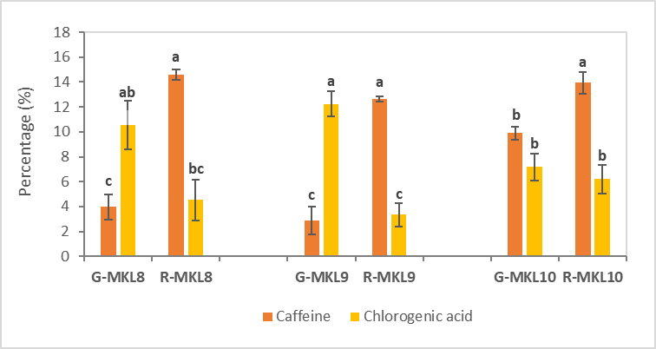
Fig. 1. Caffeine and chlorogenic acid of different clones of green and roasted Liberica extracts
Values with the same letter are not significantly different (p<0.05) according to Tukey’s test

4. Conclusion

This study highlights the significant impact of both genotype and roasting on the antioxidant and phytochemical composition of Liberica coffee beans. Among the clones tested, MKL 10 and MKL 8 demonstrated the greatest potential for developing functional food ingredients due to their superior antioxidant and phytochemical profiles. The findings underscore the importance of selecting suitable clones to enhance health-related benefits and support the use of medium roasting to balance flavor development with the retention of beneficial compounds. Future research should explore improved post-harvest and processing methods, such as alternative roasting techniques or optimized extraction approaches to better preserve the functional properties of Liberica coffee for nutraceutical and specialty beverage applications.

References

Anh-Dao, L.T., Chi-Thien, T., Nhut-Truong, N., Tu-Chi, T., Minh-Huy, D., Thanh-Nho, N., & Cong-Hau, N. (2024). Changes in the total phenolic contents, chlorogenic acid, and caffeine of coffee cups regarding different brewing methods. Food Research, 8(6), 71-79.
Awwad, S., Issa, R., Alnsour, L., Albals, D., & Al-Momani, I. (2021). Quantification of caffeine and chlorogenic acid in green and roasted coffee samples using HPLC-DAD and evaluation of the effect of degree of roasting on their levels. Molecules, 26, 7502.
Belay, A., Ture, K., Redi, M., & Asfaw, A. (2008). Measurement of caffeine in coffee beans with UV/ vis spectrometer. Food Chemistry, 108(1), 310–315.
de Souza, L.D.S., Carrero Horta, I.P., de Souza Rosa, L., Barbosa Lima, L.G., Santos da Rosa, J., Montenegro, J., da Silva Santos, L., Nana de Castro, R.B., Freitas-Silva, O., & Teodoro, A. J. (2020). Effect of the roasting levels of Coffea arabica L. extracts on their potential antioxidant capacity and antiproliferative activity in human prostate cancer cells. RSC advances, 10(50), 30115–30126.
Halim-Lim, S.A., Wan-Mohtar, W.A.A.Q.I., Surapinchai, S., & Azizan, N.A.Z. (2022). Optimum condition of roasting process of Liberica coffee towards the local and international preference. Food Research 6(3), 115-123.
Jeon, J.S., Kim, H.T., Jeong, I.H., Hong, S.R., Oh, M.S., Yoon, M.H., Shim, J.H., Jeong, J.H., & Abd El-Aty, A. (2019) Contents of chlorogenic acids and caffeine in various coffee-related products. Journal of Advanced Research, 17, 85–94.
Liang, N., Xue, W., Kennepohl, P., & Kitts, D.D. (2016). Interactions between major chlorogenic acid isomers and chemical changes in coffee brew that affect antioxidant activities. Food Chemistry, 213, 251–259.
Mirfat A.H.S., Mohd. Effendi M.N., Norma H., Muhammad Faris M.R., Muhammad Faidhi T., Ainon D.Z. and Hanim A. (2024). Evaluation of phytochemical, antioxidant and antimicrobial properties of different accessions of Persicaria minor (kesum). Food Research Journal, 8 (Suppl. 4), 57 – 64.
Mubarak, A., Croft, K.D., Bondonno, C.B. & Din, N.S. (2019). Comparison of Liberica and Arabica coffee: chlorogenic acid, caffeine, total phenolic and DPPH radical scavenging activity. Asian J Agric & Biol., 7(1): 130-136.
Patay, E.B., Bencsik, T., & Papp, N. (2016). Phytochemical overview and medicinal importance of Coffea species from the past until now. Asian Pacific Journal of Tropical Medicine, 9(12), 1127–1135.
Pinheiro, P.F., Pinheiro, C.A., Osório, V.M., & Pereira, L.L. (2021). Chemical constituents of coffee. In L. Louzada Pereira, T. Rizzo Moreira (Eds.) Quality determinants in coffee production. Food Engineering Series (pp. 209-254). Springer, Cham.
Priftis, A., Stagos, D., Konstantinopoulos, K., Tsitsimpikou, C., Spandidos, D.A., Tsatsakis, A.M., Tzatzarakis, M.N., Kouretas, D. (2015). Comparison of antioxidant activity between green and roasted coffee beans using molecular methods. Mol Med Rep., 12(5): 7293-302.
Rzyska-Szczupak, K., Przybylska-Balcerek, A., Buśko, M., Szwajkowska-Michałek, L., Szablewski, T., & Stuper-Szablewska, K. (2025). Roasting temperature as a factor modifying the caffeine and phenolic content of Ethiopian coffee. Processes, 13(7), 2037.

