Evolving Autistic Behavior Patterns & Mental Wellness
across the Lifespan: A 3-Core Experience Domain Perspective

ABSTRACT

This conceptual paper explores the gradual evolving development of autistic behavior patterns (ABPs) across the lifespan, focusing on how the three Core Experience Domains (CEDs), i.e., sensory needs, communication differences, and social interaction patterns, intersect to shape mental health outcomes for individuals with autism. It begins by tracing the historical development of autism, from its early psychiatric roots to the current understandings in neurodiversity-affirming frameworks. The paper highlights how behavioral changes over time are influenced not by a change in the autistic neurotype, but by lifespan developmental stages, environmental factors, support systems, and co-occurring conditions. The author’s proposed CED framework offers a strength-based model for understanding and supporting individuals with autism in ways that affirm their unique identity and promote long-term mental wellness. Using a hypothetical case study (Liam) with a ABP change curve, the author illustrates the critical role of individualized, context-sensitive support in reducing stress, enhancing self-esteem, and improving overall well-being of a person with autism. The CED model encourages autism professionals and caregivers to prioritize autonomy, inclusive communication, and sensory-respectful environments across all lifespan developmental stages when working with individuals with autism.

Keywords: Autistic Behavior Patterns (ABPs), Autism Spectrum Disorder (ASD), Core Experience Domains (CEDs), Mental Health and Wellness, Neurodiversity-Affirming Frameworks

- INTRODUCTION

In 1908, a Swiss psychiatrist, Eugen Bleuler, first introduced the medical term autism to describe a pathological symptom of schizophrenia, referring to extreme self-isolation and detachment from reality (Bleuler, 1911; also see Moskowitz & Heim, 2011). Almost 40 years later, Leo Kanner (b.1894-d.1981), an Austrian-American psychiatrist, redefined autism as a distinct neurodevelopmental disorder, separating it from the pathological condition of schizophrenia (in medical and psychiatric contexts), describing 11 children who manifested early infantile autism with a triad of impairments: (i) social withdrawal, (ii) resistance to change, and (iii) ritualistic obsession with sameness (Kanner, 1943). A year later, an Austrian physician, Hans Asperger (b.1906-d.1980), independently identified a similar condition, which was termed Asperger’s Syndrome, featuring social difficulties but with preserved language and cognitive abilities (Asperger, 1944). However, Asperger’s Syndrome is no longer in use with the publication of the fifth edition of the Diagnostic and Statistical Manual (DSM-5; American Psychiatric Association, 2013). These early descriptions laid the nosological groundwork for what is now known as Autism Spectrum Disorder (ASD), which provides a broader diagnostic category, encompassing a range of symptoms and the varying degrees of severity, officially recognized in the DSM-5 (APA, 2013) as a single spectrum (lumping stance) rather than separate diagnoses (splitting stance) (see Shaw, 2024, for detail). Today, ASD is best understood as a complex neurodevelopmental disorder involving persistent challenges in social communication, restricted interests, and repetitive behaviors, with strong recognition of its constitutional origin or genetic basis and variability across individuals (Lord et al., 2018). Today, autism is not the autism when it was first mentioned by Bleuler (see Evans, 2013).

Under the Section 300.8(c)(1) in the Individuals with Disabilities Education Act (IDEA) 2004, autism is defined as follows:

- “A developmental disability significantly affecting verbal and nonverbal communication and social interaction, generally evident before age three, that adversely affects a child’s educational performance. Other characteristics often associated with autism are engagement in repetitive activities and stereotyped movements, resistance to environmental change or change in daily routines, and unusual responses to sensory experiences.
(ii) Does not apply if a child’s educational performance is adversely affected primarily because the child has an emotional disturbance, as defined in paragraph (c)(4) of this section.
(iii) A child who manifests the characteristics of autism after age three could be identified as having autism if the criteria in paragraph (c)(1)(i) of this section are satisfied.”

US Department of Education (2017, para. i-iii)

The term autism mentioned throughout this paper refers to the same IDEA disability category found in The Educator’s Diagnostic Manual of disabilities and disorders (EDM; Pierangelo & Giuliani, 2007) used by special education professionals (e.g., special education teachers and educational therapists). However, the term has been changed to Autism Spectrum Disorder (ASD) which is widely used today. The EDM still uses autism (when referring to ASD) and has listed the disorder under the EDM code AU (AUtism) at Level 1 with several specific types mentioned at Level 2: “AU1.00-Asperger’s Syndrome, AU2.00-Autistic Disorder, AU3.00-Childhood Disintegrative Disorder (also previously known as Heller Syndrome), AU4.00-High-Functioning Autism, AU5.00-Hyperlexia, AU6.00-Multiplex Developmental Disorder, AU7.00-Rett Syndrome, and AU8.00-Other Types of Autism-Be Specific” (Pierangelo & Giuliani, 2007, p. 249). This is the splitting stance that the EDM still follows when referring to autism.

The impact of autism on mental wellness and overall health is significant and multifaceted. Although autism is not considered a mental disease or illness, individuals with autism often experience and exhibit co-occurring mental health conditions: e.g., stress, anxiety, and depression (also known as SAD syndrome; see Xie & Wang, 2021), and attention-deficit/hyperactivity disorder (ADHD; see Liu et al., 2023), which can affect daily functioning and quality of life (Lai et al., 2019). Social communication challenges, sensory sensitivities, and difficulties with change or unpredictability may lead to increased stress and social isolation (Boldsen, 2022; Hassmén & Hindman, 2025; Sheridan et al., 2023), which in turn can negatively influence mental well-being. Furthermore, the struggle to navigate systems that are not designed with neurodivergent individuals in mind (e.g., education, healthcare, and employment) can contribute to poor mental health outcomes for individuals with autism (Burrell et al., 2025; Gray et al., 2025).

Linking autism to mental wellness requires a strengths-based, holistic approach. Promoting mental health among individuals with autism involves treating co-occurring conditions (Neumeyer et al., 2019; Petrou et al., 2018), and more so in those with syndromic autism (Caglayan, 2010; Ziats, Patterson, & Friez, 2021). However, it also entails fostering environments, where these individuals are engaged appropriately, to accommodate their sensory and communication needs, to support their autonomy or self-independence, as well as to encourage social inclusion (Ghanouni et al., 2024; Maddox et al., 2021). Instead of ‘normalization’ through rehabilitation programs widely used in China (e.g., Zhang, 2020; Zhang et al., 2019) in treating autism for instance, early treatment programs for autism should prioritize self-understanding, acceptance, and support (for both the clients with autism and their caregivers; see Berg et al., 2023; Szlamka et al., 2024) that have been found to show improvement in mental health outcomes (Dudley & Emery, 2014; Kapp et al., 2013). This procedural approach is not rehabilitative but interventionistic, e.g., application of educational therapy that encompasses behavioral therapy, counseling, occupational therapy, speech-language therapy, and others to manage autism. Moreover, access to early intervention, which involves neurodiversity-affirming care and supportive social relationships, provides the key protective factor to mental wellness for individuals with autism (Kroll et al., 2024). This is best supported when society embraces inclusiveness and neurodiversity and provides equitable access to mental health resources tailored to diverse neurological experiences (McMaughan et al., 2024; Wechsler et al., 2025).

Moreover, understanding the mental wellness and health of individuals with autism requires attention to how their autistic behavioral traits change over time, from childhood through adolescence to adulthood (Crespi, 2021; Taylor & Selter, 2010; Waizbard-Bartov & Miller, 2023). Generally, the trajectories of autistic behavior patterns (ABPs; e.g., sensory sensitivities, repetitive actions, or challenges with social interaction) evolve gradually with age, shaped not just by individual lifespan development, but also by their daily encounters in life experiences, appropriate services rendered to them by available support systems, and socio-cultural expectations from the community where they live (Hong et al., 2023). For instance, a young child with autism may manifest explicit repetitive behaviors or hyperfocus on specific interests that may become more internalized or socially adapted in adolescence and adulthood. As autism “is associated with significant difficulties in adaptive behavior and variation in clinical outcomes across the life span” (Pretzsch et al., 2022, p. 336), these adaptations can come at a psychological cost. Many adults with verbal high-functioning autism report engaging in ‘masking’ or camouflaging behaviors, suppressing their atypical or autistic behaviors to fit in socially (Alaghband-Rad, Hajikarim-Hamedani, & Motamed, 2023; Fombonne, 2020; Mandy, 2019). This has been associated with increased anxiety, depression, and even burnout (Hull et al., 2019). Thus, behavioral changes over time should not automatically be seen as improvements, but rather as potential indicators of mental health strain.

To effectively link behavioral changes to mental wellness and health, it is important for autism professionals (e.g., educational therapists, occupational therapists, speech-language therapists) working directly with individuals with autism to adopt a longitudinal (long-term) and individualized lens. For example, an adolescent with autism can become less socially active than they were as a child. This does not mean they are regressing, but rather they are reacting negatively to increasing social pressure, bullying, or lack of understanding (Gkatsa & Antoniou, 2024; Lu, Chen, & Chou, 2022). Such factors can undermine their mental health. Similarly, a decrease in visible self-stimulating (or ‘stimming’) behaviors may indicate increased stress rather than greater self-regulation (Chia, 2025). On the other hand, positive behavioral changes (e.g., improved emotional regulation or more effective communication) are more likely to occur in environments which are supportive, inclusive, and affirming of neurodiversity (Heineman, 2015). Therefore, tracking ABPs without context can be misleading. It is certainly essential for therapists, counselors, teachers as well as parents to understand how ABPs relate to the mental and emotional state of an individual with autism across their development. Hence, promoting mental wellness and health in individuals with autism involves more than just observing how their behaviors change. It is also asking why they change, and ensuring that those changes align with their well-being rather than social conformity.

- DEFINING THE CHANGING PROFILE OF AUTISTIC BEHAVIOR PATTERN (ABP)

The author of this paper has coined the phrase ‘changing profile of autistic behavior pattern (ABP)’ to refer to how the observable characteristics, strengths, challenges, and needs of an individual with autism can shift or change over time, not because autism goes away, but because development, environment, learning, and life experiences influence how these autistic traits are expressed. That is in a real-life situation, where ABP means changes in one’s autistic behavioral profile as presented in Table 1:

Table 1. Changing Profile of ABP
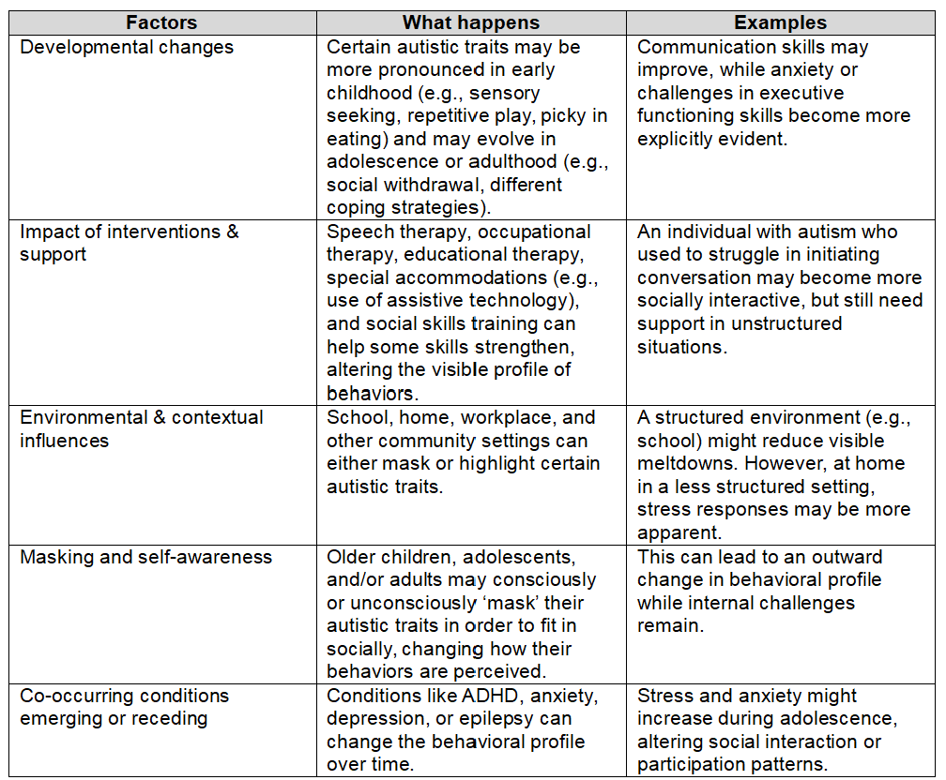

In short, the term changing profile does not mean autism itself changes or is changing. What it means is the way that autism is expressed and observed evolves gradually with age, context, support, and co-occurring factors. Professionals use this concept to adjust their intervention plans as well as to re-evaluate learning goals and expected outcomes at different life stages.

2.1 Changing Profile of Autistic Behavior Pattern (ABP): A Developmental Overview
The profile of autistic behavior continues to evolve to adapt across lifespan developmental stages (also see Tantam, 2012), reflecting a stable neurotype expressed through changing strengths and challenges influenced by development, environment, and experience. The term neurotype refers to an individual’s unique pattern of neurological or cognitive functioning, thinking, and processing, and is often applied to differentiate between neurotypical and neurodivergent experiences.

According to Matson, Cervantes and Peters (2016), research on autism has been focusing more heavily on problems in childhood rather than adolescence and adulthood. That does not mean that the later lifespan development of an individual with autism is less important. In fact, there is a need to delve deeply into the lifespan developmental changes with their challenging issues encountered by individuals with autism as they grow and age. Generally, during the early childhood phase, autistic traits (e.g., intense focus and strong memory) often coexist with communication delays and sensory sensitivities, and these should be addressed through early intervention and structured routines. As children with autism grow and move into the middle childhood phase, vocabulary and practical skills improve, though social misunderstandings, feelings of stress and anxiety may also emerge, shaped by school and peer dynamics. Next, the phase of adolescence brings potential for abstract thinking and self-advocacy, alongside heightened social pressure and executive functioning struggles, often influenced by puberty and academic demands. Moving into the early adulthood phase, individuals with autism may show high attentiveness to detail (known as hyperfocus) and dedication to specific interests, yet face continuous challenges in workplace employment as well as independent living, and, hence, they need to rely on support systems available to them. By the middle adulthood phase, many develop deep expertise and coping strategies, though they may also experience burnout or health-related difficulties (also see Drmic, Szatmari, & Volkmar, 2017), with accommodations and life experience playing key roles (Kuzminski et al., 2024; Maljaars et al., 2023). Throughout life, the autistic behavior profile shifts in its presentation, not in essence, adapting with context (e.g., home, school, and/or work), support (i.e., access to therapy, accommodations, understanding relationships, and/or community services), and personal growth, which involves gaining experience, self-awareness, and skills, as they adapt and interact with their environment (LeBlanc, Riley, & Goldsmith, 2008). More importantly, the quality of life should also be the key concern for individuals with autism (van Heijst, & Geurts, 2015)

Table 2 below shows a developmental timeline chart on how the profile of ABPs can shift across different lifespan developmental stages (also see Bradshaw, Schwichtenberg, & Iverson, 2022; Hong et al., 2023; Waizbard-Bartov & Miller, 2023). It is generalized, i.e., individual experiences in the autistic population vary a lot.

Table 2. Developmental Phases of ABPs
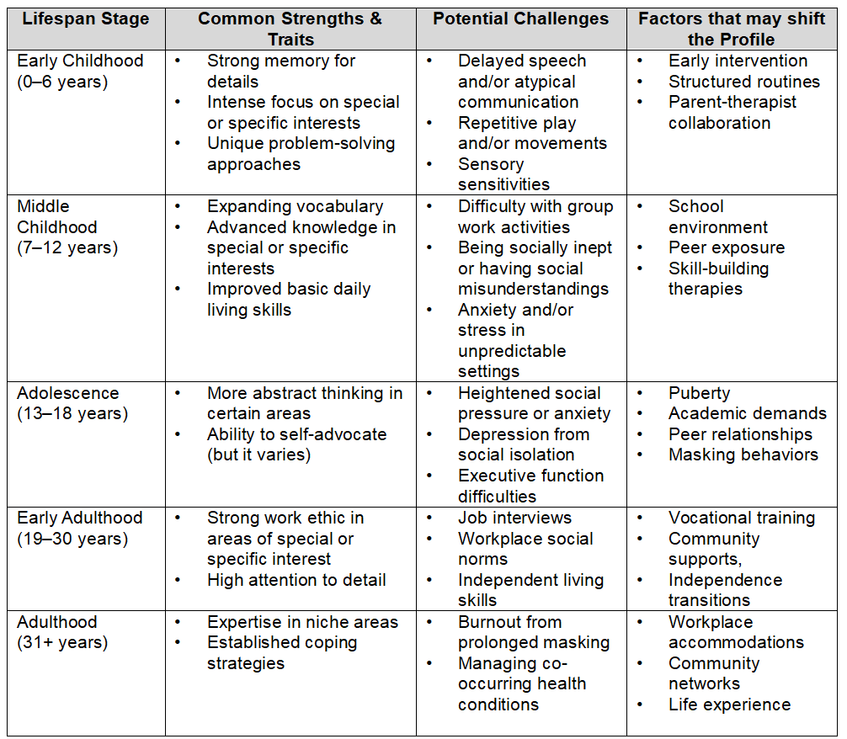

The core autistic neurotype remains very much consistent, though its presentation may change or shift with developmental maturity, acquisition of experiential learning, and varied life contexts. Essential life skills can strengthen, coping strategies can evolve, and certain autistic behavioral challenges can become more or less visible at different times (Matson, Cervantes, & Peters, 2016; Tantum, 2012).

2.1 Changing Profile of Autistic Behavior Patterns (ABPs) across Life Stages
Mental health and wellness in an individual with autism is deeply intertwined with their sensory needs (Dynia et al., 2022), communication differences (Golson et al., 2022), and social interaction differences (Wood-Downie et al., 2021), because these three key areas actually shape how the person with autism experiences, processes, and responds to the immediate environment around them. Collectively, sensory needs, communication differences, and social interaction differences constitute the Core Experience Domains (CEDs) in the autistic behavior pattern (ABP) (see Figure 1). The term CEDs emphasizes that these three key areas are not deficits or impairments, but they should be considered as the fundamental dimensions of how individuals with autism perceive, interpret, and engage with the environment around them. The first word ‘Core’ in CEDs highlights the foundational role of these three key areas in shaping one’s experience, while ‘Experience Domains’ frames them as aspects of neurodivergent processing rather than medicalized symptoms of autism.

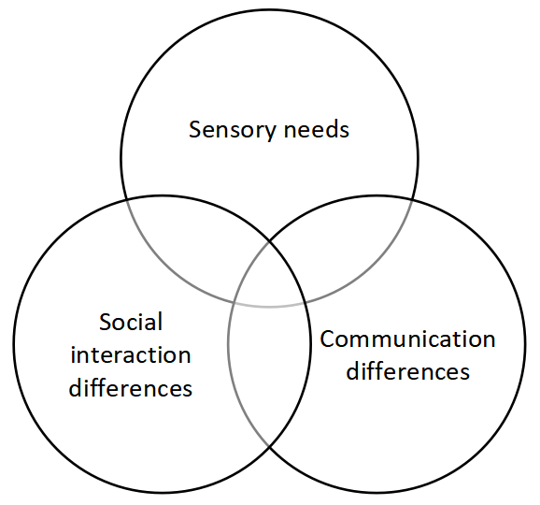
Figure 1. The 3 Core Experience Domains in ABP

Depending on the tone and goal of this proposed framework of CEDs, it can branch out into four other ‘offshoot’ models (OSMs) that can be used to explain the ABPs. The first OSM is the Neurodivergent Experience Pathways (NEPs; see Butcher & Lane, 2025; Hutson & Hutson, 2024; White et al., 2023). Its emphasis is that these are pathways through which neurodivergent individuals (including individuals with autism) interface with their environment. The second OSM concerns the Autism-Linked Processing Domains (ALPDs). This latter is useful in a clinical or research context where specificity is needed for autism-linked traits. The third OSM is the Adaptive Interaction Domains (AIDs; see Kanne et al., 2011; Lai et al., 2020; Mouga et al., 2015), which highlights how these three key domains affect interaction and adaptation, especially useful in educational or therapeutic contexts. The fourth and last OSM is the Triad of Experiential Dimensions (TEDs), which reflects the classical model of ‘Triad of Impairments’ first popularized by Wing and Gould (1979) (also see Cashin & Barker, 2009; Ennis-Cole, 2019; Van Wijngaarden-Cremers et al., 2014) from older diagnostic models but reclaims it through a wellness- and experience-based lens. Figure 2 shows the association of sensory needs, communication differences, and social interaction differences with mental health in autism.

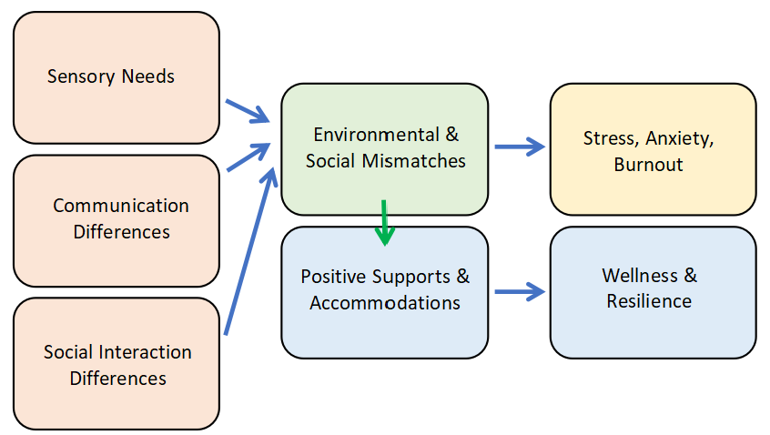
Figure 2. Association of CEDs with Mental Health in Individuals with Autism

In addition, each of the three key areas stated in the model of CEDs is briefly described in Table 3 (below). Each domain highlights how variations in experience, i.e., sensory sensitivities, challenges in social communication, or evolving self-concept, can contribute to emotional well-being or distress, particularly in neurodivergent individuals. The table emphasizes the interconnectedness of these domains in shaping mental wellness trajectories.

Table 3. Core Experience Domains & Their Impacts on Mental Health
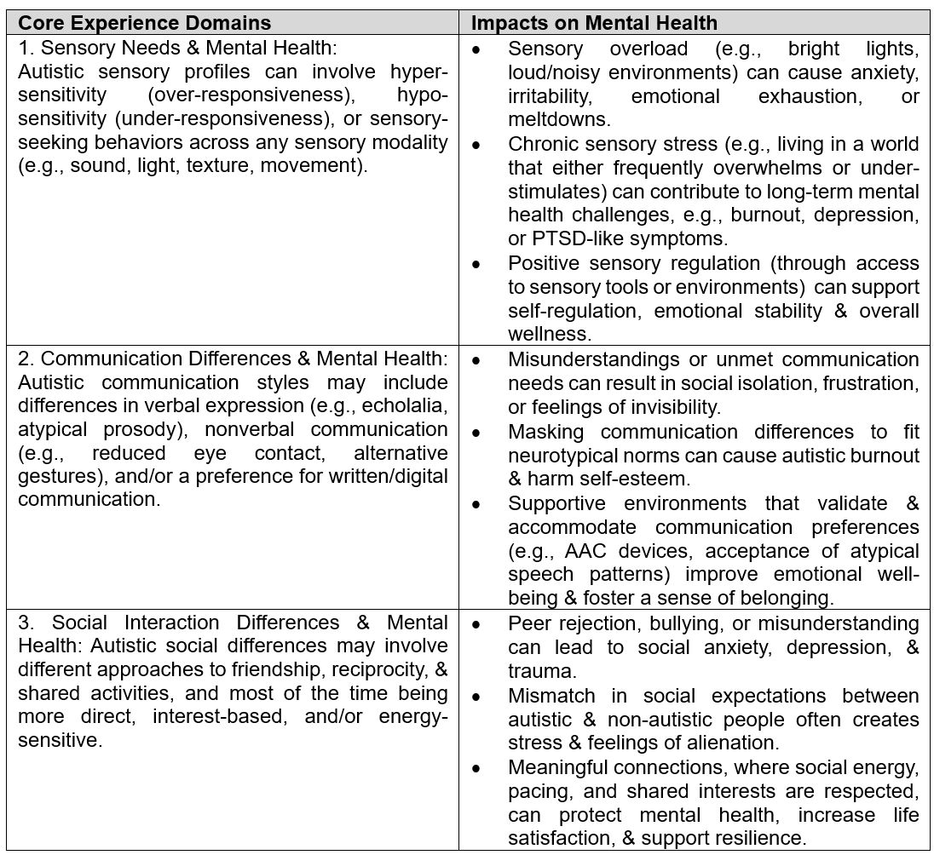

- HOW THE THREE CORE EXPERIENCE DOMAINS (CEDs) INTERCONNECT

The three CEDs (i.e., sensory needs, communication, and social interaction differences) are not separate challenges. In fact, they often overlap. For instance, a noisy classroom (sensory trigger) makes it hard for a student with autism to process spoken instructions (communication difficulty). This, in turn, can lead to social withdrawal or being perceived as ‘uncooperative’ (social impact) that can ultimately increase anxiety. In another example, if sensory needs of an individual with autism are met, communication is supported, and social styles are respected, the likelihood of positive mental health outcomes for that person can increase dramatically (Cooper et al., 2023).

As a wellness framework, the CEDs can provide a supportive approach for autistic mental health by accommodating sensory profiles (e.g., quiet spaces, flexible lighting, sensory tools), supporting authentic communication (e.g., augmentative and alternative communication or AAC for short, written options, acceptance of natural speech patterns), and respecting neurodivergent social styles (e.g., allowing parallel play, interest-based groups, social pacing). When these three CEDs are respected and met as well as treated as unique strengths (see Taylor et al., 2023) rather than weaknesses or deficits, individuals with autism are more likely to experience reduced stress, increased autonomy, better self-esteem, and improved overall mental wellness.

Figure 3 shows the autistic behavior profile change curve, how communication differences, sensory needs, and social interaction patterns may rise or fall in visibility at different life stages. The values in the graph are illustrative, not diagnostic, and help visualize why an autistic individual’s profile might look different over time.

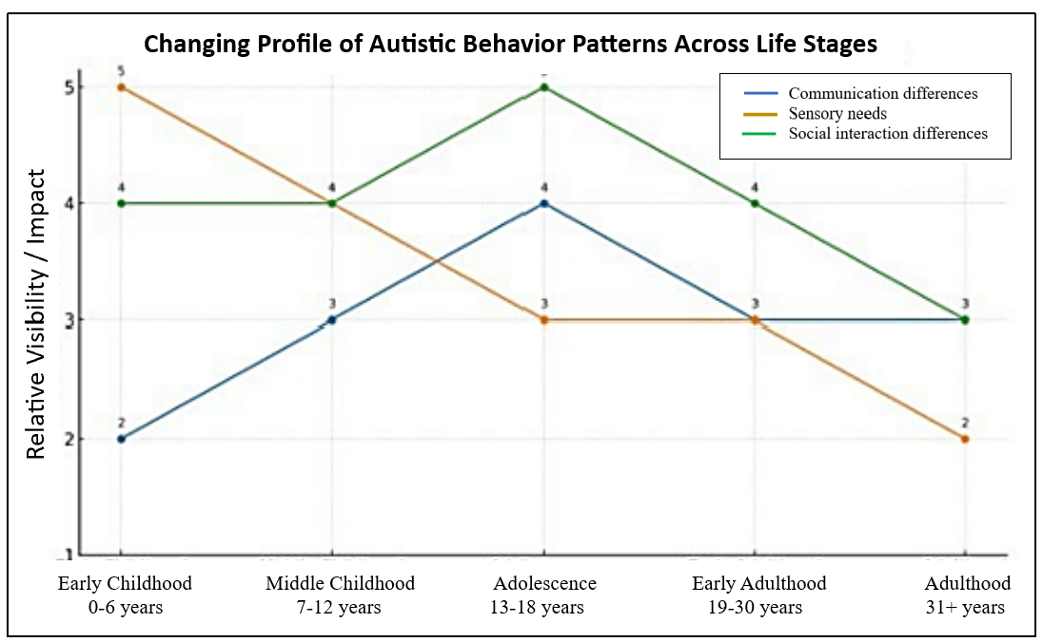
Figure 3. Autistic Behavioral Profile Change Curve

The x-axis in Figure 3 above shows the five lifespan developmental stages, ranging from early childhood to adulthood. The y-axis, on the other hand, labeled ‘Relative Visibility/Impact,’ is scaled from 1-5. Below is a qualitative interpretation of the numeric scores, ranging from 1 to 5, on this scale:
- 1 = Very Low Visibility/Impact: The behavior is minimally noticeable or has little impact on daily functioning or interactions. It may go largely unrecognized by others.
- 2 = Low Visibility/Impact: The behavior is occasionally noticeable and may have a minor impact on functioning or social interactions but is not highly disruptive.
- 3 = Moderate Visibility/Impact: The behavior is somewhat noticeable and has a moderate impact. It may be recognized by peers or caregivers and can influence some aspects of functioning.
- 4 = High Visibility/Impact: The behavior is clearly visible and significantly affects daily activities, communication, or social interaction. It is likely recognized by most people interacting with the individual.
- 5 = Very High Visibility/Impact: The behavior is highly prominent and has a substantial impact on functioning. It may be a defining characteristic in how the individual is perceived or supported.

This scale helps to illustrate how the prominence and effect of the changing autistic behavior patterns vary across the different lifespan developmental stages.

- THE TREATMENT APPROACH FOR AUTISM

Medical approaches, such as pharmacotherapy (Boksha et l., 2023; Hellings, 2023), nutritional and dietary interventions (Amadi et al.,2022; Sathe et al., 2017), and neuromodulation techniques (Oberman, Rotenberg, & Pascual-Leone, 2015; Zhang & Zhang, 2022), are not sufficient to address the challenging issues related to the CEDs (i.e., sensory needs, communication differences, and social interaction differences) of autism. The reason is quite obvious: these three core domains are rooted in neurodevelopmental differences rather than pathological conditions (Hirota & King, 2023; Sauer et al., 2021), which medication can ‘cure.’ While medicine may alleviate co-occurring symptoms (e.g., anxiety or hyperactivity) seen in individuals with autism, it cannot impart adaptive communication strategies, provide support sensory regulation, or foster reciprocal social engagement. Similarly, rehabilitative medicine with is limitations often focuses on restoring lost function after injury or illness, and it does not align with the lifelong, non-degenerative nature of autism (Aarabi, Abdi, & Khanjani, 2021). However, “[I]mproved alignment between parent priority and rehabilitation efforts may also result in reduced parental stress, increased parent satisfaction with their child’s treatment and, perhaps, more efficient and effective rehabilitation programmes” (Lang et al., 2010, p. 154). It provides a much-needed respite for the primary caregivers from the demands of caring for their loved ones with autism.

In contrast, an evidence-based individualized interventionist approach (Frye, 2022; Vivanti, 2022), which encompasses educational, behavioral, sensory-integration, and social-pragmatic supports, actively equips autistic individuals with tailored skills, environmental adaptations, and strategies to thrive, making it far more effective in directly addressing the CEDs.

- A HYPOTHETICAL CASE STUDY

In a hypothetical case study of an individual with autism (let us call him Liam), the goal of this case study is to understand the interconnection of the three CEDs across Liam’s lifespan development.

Liam is an individual diagnosed with autism at age 5. Now 21 years old, he is studying graphic design at a vocational institute and, at the same time, working part-time at a bookstore. His life experiences across early childhood, adolescence, and now early adulthood illustrate how closely or deeply interconnected are the CEDs (i.e., sensory needs, communication differences, and social interaction patterns) and how they have also evolved over time, impacting Liam’s mental wellness at each stage.

  - Early Childhood Stage (Ages 3-6)
In preschool, Liam was highly sensitive to sound. Fire drills, loud group activities, or even other children’s excited voices often overwhelmed him (CED: sensory). During these times, he struggled to follow spoken instructions, especially when multiple directions were given at once (CED: communication). As a result, he often retreated to the corner of the classroom or covered his ears, which teachers misinterpreted as defiance or withdrawal (CED: social). These misinterpretations led to frequent time-outs, increasing his stress and confusion. At this stage, Liam’s behavioral profile rated 4–5 (high to very high visibility/impact) across all three CEDs.

5.2 Adolescence Stage (Ages 13-17)
In high school, Liam had access to a quiet resource room and noise-canceling headphones, which helped manage his sensory environment. With these supports, his ability to participate in class improved (CED: sensory). He still preferred typing responses or using visual supports over verbal class participation (CED: communication), but when teachers accommodated this, he engaged more confidently. Liam did not enjoy large group social activities but thrived in smaller, interest-based clubs like the art society (CED: social). Here, his behaviors were less visible but still present. His profile had shifted to 2-3 (low to moderate visibility/impact), with improved mental wellness and fewer emotional meltdowns.

5.3 Early Adulthood Stage (Ages 18-21)
Now in college, Liam has greater autonomy over his environment. He chooses quiet study spaces and has professors who allow assignment submissions in written or visual formats (CEDs: sensory & communication). He communicates effectively with peers who share his interests and appreciates friendships that do not demand constant interaction (CED: social). With increasing self-awareness, he no longer feels the need to mask his traits, reducing internal stress. Liam reports feeling ‘more like himself’ and describes improved self-esteem and decreased anxiety. His CED profile now aligns with 1-2 (very low to low visibility/impact), illustrating how appropriate supports and respect for neurodivergent needs contribute to better mental wellness outcomes.

The hypothetical case study of Liam shows how the CEDs are interwoven: within a noisy environment (sensory) that affected his ability to understand spoken instructions (communication), and, in turn, influenced how others perceived his social behavior (social interaction). However, when his sensory needs were respected, his communication supported, and his social style honored, Liam not only able to engage more fully, but also experienced significant improvements in mental wellness, self-esteem, and life satisfaction. The CED model, paired with the Autistic Behavioral Profile Change Curve (see Figure 2), helps us to visualize these shifts in visibility and impact across life stages, emphasizing that autistic behavior is not static, and that positive outcomes are possible with the right supports provided.

- CONCLUSION

The changing profile of autistic behavior patterns (ABPs) across the lifespan development underscores a fundamental truth: Autism is certainly not static. However, its expression is dynamic, shaped by lifespan developmental maturity, environmental changes, acqistion of life experiences, and the availability of affirming support services. Through the collective lens of the CEDs, involving sensory needs, communication differences, and social interaction patterns, this paper has highlighted how autistic behavioral traits can fluctuate in visibility and impact over time, not because the underlying neurotype changes, but because the context in which it is expressed evolves.

Knowing and understanding these shifting ABPs becomes crucial for professionals working with both young and old individuals with autism. They need to adjust their focus away from deficit-based interpretations toward a strengths-based, person-centered approach that recognizes the meaning behind these CEDs. Rather than viewing changes in ABPs as linear signs of progress or regression, autism practitioners must consider why behaviors shift, what they signal about mental wellness (see Figure 2), and how external factors (e.g., support systems, expectations, and environments) either constrain or enable the well-being of an individual with autism.

The developmental timeline, the hypothetical case study, and the proposed models of the ABP Change Curve and the CED framework demonstrate that ABPs are certainly deeply intertwined with mental health and personal identity. Positive mental wellness outcomes are most likely when individuals with autism are supported in ways that honor their sensory, communicative, and social needs, without having to imposed on normalization or conformity.

Ultimately, recognizing and responding to the evolving profile of ABPs is not only a matter of clinical or educational importance; it is a matter of dignity, inclusion, and mental health equity. By embracing neurodiversity and adapting the current systems accordingly, professional practitioners as well as caregivers can help ensure that autistic individuals not only able to cope with the world around them, but are empowered to thrive across all stages of their lifespan development.

REFERENCES
Aarabi, M. A., Abdi, K., & Khanjani, M. S. (2021). Challenges of accessing and using rehabilitation services in people with autism spectrum disorder: A systematic review. Archives of Rehabilitation, 22(3), 260-277. https://doi.org/10.32598/RJ.22.3.3259.1
Alaghband-Rad, J., Hajikarim-Hamedani, A., & Motamed, M. (2023). Camouflage and masking behavior in adult autism. Frontiers in Psychiatry, 14. Article ID: 1108110. https://doi.org/10.3389/fpsyt.2023.1108110
Amadi, C. N., Orish, C. N., Frazzoli, C., & Orisakwe, O. E. (2022). Dietary interventions for autism spectrum disorder: An updated systematic review of human studies. Psychiatriki, 33(3), 228-242. https://doi.org/10.22365/jpsych.2022.073
American Psychiatric Association. (2013). Diagnostic and statistical manual of mental disorders (5th ed.). https://doi.org/10.1176/appi.books.9780890425596
Asperger, H. (1944). Die ‘Autistischen psychopathen’ im Kindesalter. Archiv für Psychiatrie und Nervenkrankheiten, 117(1), 76-136. https://doi.org/10.1007/BF01837709
Berg, K. A., Ishler, K. J., Lytle, S., Kaplan, R., Wang, F., Olgac, T., Miner, S., Edguer, M. N., & Biegel, D. E. (2023). “Don’t promise something you can’t deliver:” Caregivers’ advice for improving services to adolescents and young adults with Autism. Autism Research and Treatment, 2023. Article ID: 6597554. https://doi.org/10.1155/2023/6597554
Bleuler, E. (1911). Dementia praecox or the group of schizophrenias (Transl. J. Zinkin). New York, NY: International Universities Press.
Boksha, I. S., Prokhorova, T. A., Tereshkina, E. B., Savushkina, O. K., & Burbaeva, G. S. (2023). Differentiated Approach to pharmacotherapy of autism spectrum disorders: Biochemical aspects. Biochemistry (Moscow), 88(3), 303-318. https://doi.org/10.1134/S0006297923030021
Boldsen S. (2022). Autism and the sensory disruption of social experience. Frontiers in Psychology, 13. Article ID: 874268. https://doi.org/10.3389/fpsyg.2022.874268
Bradshaw, J., Schwichtenberg, A. J., & Iverson, J. M. (2022). Capturing the complexity of autism: Applying a developmental cascades framework. Child Development Perspectives, 16(1), 18-26. https://doi.org/10.1111/cdep.12439
Burrell, D. N., Askarova, S., Morin, S. L., Mondala-Duncan, M., Springs, D., Aridi, A. S., & Finch, A. (2025). Exploring how the lack of inclusive approaches to neurodiversity and invisible disabilities in the workplace creates significant health disparities. Brazilian Journal of Business, 7(1), e76666-e76666. https://doi.org/10.34140/bjbv7n1-005
Butcher, L., & Lane, S.(2025). Neurodivergent (autism and ADHD) student experiences of access and inclusion in higher education: an ecological systems theory perspective. High Education, 90, 243-263. https://doi.org/10.1007/s10734-024-01319-6
Caglayan A. O. (2010). Genetic causes of syndromic and non-syndromic autism. Developmental Medicine and Child Neurology, 52(2), 130-138. https://doi.org/10.1111/j.1469-8749.2009.03523.x
Cashin, A., & Barker, P. (2009). The triad of impairment in autism revisited. Journal of Child and Adolescent Psychiatric Nursing, 22(4), 189-193. https://doi.org/10.1111/j.1744-6171.2009.00198.x
Chia, K. H. (2025). Reframing self-stimulating behaviors (SSBs): Understanding the concept of autotelic autism and supporting engagement in children with profound autism. ISRG Journal of Clinical Medicine and Medical Research, 2(2), 39-47. https://doi.org/0.5281/zenodo.15259266
Cooper, K., Russell, A. J., Lei, J., & Smith, L. G. (2023). The impact of a positive autism identity and autistic community solidarity on social anxiety and mental health in autistic young people. Autism, 27(3), 848-857. https://doi.org/10.1177/13623613221118351
Crespi B. (2021). Pattern unifies autism. Frontiers in Psychiatry, 12. Article ID: 621659. https://doi.org/10.3389/fpsyt.2021.621659
Drmic, I. E., Szatmari, P., & Volkmar, F. (2017). Life course health development in autism spectrum disorders. In N. Halfon, P. Szatmari, & F. Volkmar (Eds.), Handbook of life course health development (pp. 237-274). Cham, Switzerland: Springer. https://doi.org/10.1007/978-3-319-47143-3_11
Dudley, C., & Emery, J.C. (2014). The value of caregiver time: Costs of support and care for individuals living with autism spectrum disorder. School of Public Policy Research Papers, 7(1). https://doi.org/10.11575/SPPP.V710.42454
Dynia, J. M., Walton, K. M., Sagester, G. M., Schmidt, E. K., & Tanner, K. J. (2023). Addressing Sensory Needs for Children With Autism Spectrum Disorder in the Classroom. Intervention in School and Clinic, 58(4), 257-263. https://doi.org/10.1177/10534512221093786
Ennis-Cole, D. (2019). The Triad of Impairment in ASD. In D. Ennis-Cole (Ed.), Seeing autism through parents’ feedback, sketchnotes, technology, and evidence-based practices (pp. 13-23) [Book Series: Educational Communications and Technology: Issues and Innovations]. Cham, Switzerland: Springer Nature. https://doi.org/10.1007/978-3-030-15374-8_2
Evans B. (2013). How autism became autism: The radical transformation of a central concept of child development in Britain. History of the Human Sciences, 26(3), 3-31. https://doi.org/10.1177/0952695113484320
Fombonne, E. (2020). Camouflage and autism. Journal of Child Psychology and Psychiatry, and Allied Disciplines, 61(7), 735-738. https://doi.org/10.1111/jcpp.13296
Frye R. E. (2022). A personalized multidisciplinary approach to evaluating and treating autism spectrum disorder. Journal of Personalized Medicine, 12(3). Aritcle No. 464. https://doi.org/10.3390/jpm12030464
Ghanouni, P., Raphael, R., Seaker, L., & Casey, A. (2024). How to build resiliency in autistic individuals: an implication to advance mental health. BMC Psychology, 12(1). Article No. 420. https://doi.org/10.1186/s40359-024-01916-1
Golson, M. E., Ficklin, E., Haverkamp, C. R., McClain, M. B., & Harris, B. (2022). Cultural differences in social communication and interaction: A gap in autism research. Autism Research, 15(2), 208-214.
Gray, L., McNeill, B., Pecora, L., Macfarlane, S., Hayley, A., Hitch, D., & Evans, S. (2025). Navigating neurodivergence: A scoping review to guide health professions educators. Medical Education. Article ID: 15676. https://doi.org/10.1111/medu.15676 n
Gkatsa, T., & Antoniou, I. (2024). Bullying and autism spectrum disorder: Correlating the victimization of high-functioning autism students with educational practices in the context of inclusion in primary education. International Journal of Bullying Prevention, 6(3), 342-353. https://doi.org/10.1007/s42380-023-00208-3
Hassmén, P., & Hindman, E. (2025). Sensory Sensitivity and Strengths in Autism. In P. Hassmén & E. Hindman (Eds.), Emotion control strategies for peak performance in neurodivergent brains: Wired to thrive (pp. 101-126). Cham: Springer Nature Switzerland.
Hellings J. (2023). Pharmacotherapy in autism spectrum disorders, including promising older drugs warranting trials. World Journal of Psychiatry, 13(6), 262-277. https://doi.org/10.5498/wjp.v13.i6.262
Hieneman M. (2015). Positive behavior support for individuals with behavior challenges. Behavior Analysis in Practice, 8(1), 101-108. https://doi.org/10.1007/s40617-015-0051-6
Hirota, T., & King, B. H. (2023). Autism spectrum disorder: A Review. Journal of the American Medical Association (JAMA), 329(2), 157-168. https://doi.org/10.1001/jama.2022.23661
Hong, J., DaWalt, L. S., Taylor, J. L., Haider, A., & Mailick, M. (2023). Autism through midlife: Trajectories of symptoms, behavioral functioning, and health. Journal of Neurodevelopmental Disorders, 15(1). Article No. 36. https://doi.org/10.1186/s11689-023-09505-w
Hull, L., Mandy, W., Lai, M. C., Baron-Cohen, S., Allison, C., Smith, P., & Petrides, K. V. (2019). Development and Validation of the Camouflaging Autistic Traits Questionnaire (CAT-Q). Journal of Autism and Developmental Disorders, 49(3), 819–833. https://doi.org/10.1007/s10803-018-3792-6
Hutson, P., & Hutson, J. (2024). Enhancing flow states in neurodivergent individuals through cognitive network integration. Global Health Economics and Sustainability, 3(2), 1-10. https://doi.org/10.36922/ghes.4345
Kanne, S. M., Gerber, A. J., Quirmbach, L. M., Sparrow, S. S., Cicchetti, D. V., & Saulnier, C. A. (2011). The role of adaptive behavior in autism spectrum disorders: Implications for functional outcome. Journal of Autism and Developmental Disorders, 41, 1007-1018. https://doi.org/10.1007/s10803-010-1126-4
Kanner, L. (1943). Autistic disturbances of affective contact. Nervous Child, 2, 217-250.
Kapp, S. K., Gillespie-Lynch, K., Sherman, L. E., & Hutman, T. (2013). Deficit, difference, or both? Autism and neurodiversity. Developmental Psychology, 49(1), 59-71. https://doi.org/10.1037/a0028353
Kroll, E., Lederman, M., Kohlmeier, J., Kumar, K., Ballard, J., Zant, I., & Fenkel, C. (2024). The positive impact of identity-affirming mental health treatment for neurodivergent individuals. Frontiers in Psychology, 15. Article ID: 1403129. https://doi.org/10.3389/fpsyg.2024.1403129
Kuzminski, R., Bölte, S., Lawson, W., Falkmer, M., Black, M. H., Girdler, S., & Milbourn, B. (2024). A co-produced exploration of factors influential to quality of life from the perspective of autistic adults. Autism in Adulthood, 0(0). https://doi.org/10.1089/aut.2023.0091
Lai, M. C., Anagnostou, E., Wiznitzer, M., Allison, C., & Baron-Cohen, S. (2020). Evidence-based support for autistic people across the lifespan: Maximizing potential, minimizing barriers, and optimizing the person-environment fit. The Lancet. Neurology, 19(5), 434-451. https://doi.org/10.1016/S1474-4422(20)30034-X
Lai, M. C., Kassee, C., Besney, R., Bonato, S., Hull, L., Mandy, W., Szatmari, P., & Ameis, S. H. (2019). Prevalence of co-occurring mental health diagnoses in the autism population: a systematic review and meta-analysis. The lancet. Psychiatry, 6(10), 819-829. https://doi.org/10.1016/S2215-0366(19)30289-5
Lang, R., Regester, A., Rispoli, M., Pimentel, S., & Camargo, H. (2010). Rehabilitation issues in autism spectrum disorders. Developmental Neurorehabilitation, 13(3), 153-155. https://doi.org/10.3109/17518421003607597
LeBlanc, L. A., Riley, A. R., & Goldsmith, T. R. (2008). Autism spectrum disorders: A lifespan perspective. In J. L. Matson (Ed.), Clinical assessment and intervention for autism spectrum disorders: Practical resources for the mental health professional (pp. 65-87). Academic Press. https://doi.org/10.1016/B978-012373606-2.50005-X
Liu, A., Lu, Y., Gong, C., Sun, J., Wang, B., & Jiang, Z. (2023). Bibliometric analysis of research themes and trends of the co-occurrence of autism and ADHD. Neuropsychiatric Disease and Treatment, 19, 985-1002. https://doi.org/10.2147/NDT.S404801
Lord, C., Elsabbagh, M., Baird, G., & Veenstra-Vanderweele, J. (2018). Autism spectrum disorder. Lancet (London, England), 392(10146), 508–520. https://doi.org/10.1016/S0140-6736(18)31129-2
Lu, H. H., Chen, D. R., & Chou, A. K. (2022). The school environment and bullying victimization among seventh graders with autism spectrum disorder: a cohort study. Child and Adolescent Psychiatry and Mental Health, 16. Article No. 22. https://doi.org/10.1186/s13034-022-00456-z
Maddox, B. B., Dickson, K. S., Stadnick, N. A., Mandell, D. S., & Brookman-Frazee, L. (2021). Mental health services for autistic individuals across the lifespan: Recent advances and current gaps. Current Psychiatry Reports, 23. Article No. 66. https://doi.org/10.1007/s11920-021-01278-0
Maljaars, J., Gijbels, E., Evers, K., Spain, D., Rumball, F., Happé, F., & Noens, I. (2023). Impact of the COVID-19 pandemic on daily life: Diverse experiences for autistic adults. Journal of Autism and Developmental Disorders, 53(1), 319-331. https://doi.org/10.1007/s10803-022-05437-x
Mandy, W. (2019). Social camouflaging in autism: Is it time to lose the mask?. Autism : the International Journal of Research and Practice, 23(8), 1879-1881. https://doi.org/10.1177/1362361319878559
Matson, J. L., Cervantes, P. E., & Peters, W. J. (2016). Autism spectrum disorders: Management over the lifespan. Expert Review of Neurotherapeutics, 16(11), 1301-1310. https://doi.org/10.1080/14737175.2016.1203255
Moskowitz, A., & Heim, G. (2011). Eugen Bleuler’s dementia praecox or the group of schizophrenias (1911): A centenary appreciation and reconsideration. Schizophrenia Bulletin, 37(3), 471-479. https://doi.org/10.1093/schbul/sbr016
Mouga, S., Almeida, J., Café, C., Duque, F., & Oliveira, G. (2015). Adaptive profiles in autism and other neurodevelopmental disorders. Journal of Autism and Developmental disorders, 45(4), 1001-1012. https://doi.org/10.1007/s10803-014-2256-x
Neumeyer, A. M., Anixt, J., Chan, J., Perrin, J. M., Murray, D., Coury, D. L., Bennett, A., Farmer, J., & Parker, R. A. (2019). Identifying associations among co-occurring medical conditions in children with autism spectrum disorders. Academic Pediatrics, 19(3), 300-306. https://doi.org/10.1016/j.acap.2018.06.014
Oberman, L. M., Rotenberg, A., & Pascual-Leone, A. (2015). Use of transcranial magnetic stimulation in autism spectrum disorders. Journal of Autism and Developmental Disorders, 45(2), 524-536. https://doi.org/10.1007/s10803-013-1960-2
Petrou, A. M., Soul, A., Koshy, B., McConachie, H., & Parr, J. R. (2018). The impact on the family of the co-existing conditions of children with autism spectrum disorder. Autism Research, 11(5), 776-787. https://doi.org/10.1002/aur.1932
Pretzsch, C. M., Schäfer, T., Lombardo, M. V., Warrier, V., Mann, C., Bletsch, A., Chatham, C. H., Floris, D. L., Tillmann, J., Yousaf, A., Jones, E., Charman, T., Ambrosino, S., Bourgeron, T., Dumas, G., Loth, E., Oakley, B., Buitelaar, J. K., Cliquet, F., Leblond, C. S., … Ecker, C. (2022). Neurobiological correlates of change in adaptive behavior in autism. The American Journal of Psychiatry, 179(5), 336-349. https://doi.org/10.1176/appi.ajp.21070711
Qin, L., Wang, H., Ning, W., Cui, M., & Wang, Q. (2024). New advances in the diagnosis and treatment of autism spectrum disorders. European Journal of Medical Research, 29(1). Article No. 322. https://doi.org/10.1186/s40001-024-01916-2
Sathe, N., Andrews, J. C., McPheeters, M. L., & Warren, Z. E. (2017). Nutritional and dietary interventions for autism spectrum disorder: A systematic review. Pediatrics, 139(6). Article ID: e20170346. https://doi.org/10.1542/peds.2017-0346
Sauer, A. K., Stanton, J. E., Hans, S., & Grabrucker, A. M. (2021). Autism Spectrum Disorders: Etiology and Pathology. In A. M. Grabrucker (Ed.), Autism spectrum disorders (pp. 1-16). Brisbane, Australia: Exon Publications. https://doi.org/10.36255/exonpublications.autismspectrumdisorders.2021.etiology
Shaw P. (2024). ADHD and ASD: Time to Split or Lump?. The American journal of psychiatry, 181(6), 476-478. https://doi.org/10.1176/appi.ajp.20240264
Sheridan, K., Allen, K. A., Vine Foggo, R., Hurem, A., Leif, E., & Freeman, N. (2023). Uncertainty and autism: How changing with the times is harder for some. In B. C. de Caux, L. Pretorius, & L. Macaulay (Eds.), Research and teaching in a pandemic world: The challenges of establishing academic identities during times of crisis (pp. 195-212). Singapore: Springer Nature. https://doi.org/10.1007/978-981-19-7757-2_13
Szlamka, Z., Sebastián, C., Hanlon, C., & Hoekstra, R. A. (2024). Caregiver-centred empowerment for families raising autistic children: A qualitative case study from Argentina. Autism, 28(11), 2768-2778. https://doi.org/10.1177/13623613241238254
Tantam, D. (2012). Autism spectrum disorders through the life span. London, UK: Jessica Kingsley Publishers. https://doi.org/10.1111/j.1365-2788.2012.01622.x
Taylor, E. C., Livingston, L. A., Clutterbuck, R. A., Callan, M. J., & Shah, P. (2023). Psychological strengths and well-being: Strengths use predicts quality of life, well-being and mental health in autism. Autism, 27(6), 1826-1839. https://doi.org/10.1177/13623613221146440
Taylor, J. L., & Seltzer, M. M. (2010). Changes in the autism behavioral phenotype during the transition to adulthood. Journal of Autism and Developmental Disorders, 40(12), 1431-1446. https://doi.org/10.1007/s10803-010-1005-z
US Department of Education (2017, May 2; updated). Section 300.8 c (1). Available: https://sites.ed.gov/idea/regs/b/a/300.8/c/1
Van Heijst, B. F., & Geurts, H. M. (2015). Quality of life in autism across the lifespan: A meta-analysis. Autism, 19(2), 158-167. https://doi.org/10.1177/1362361313517053
Van Wijngaarden-Cremers, P. J., van Eeten, E., Groen, W. B., Van Deurzen, P. A., Oosterling, I. J., & Van der Gaag, R. J. (2014). Gender and age differences in the core triad of impairments in autism spectrum disorders: a systematic review and meta-analysis. Journal of autism and developmental disorders, 44(3), 627-635. https://doi.org/10.1007/s10803-013-1913-9
Vivanti, G. (2022). What does it mean for an autism intervention to be evidence-based? Autism Research, 15(10), 1787-1793. https://doi.org/10.1002/aur.2792
Waizbard-Bartov, E., & Miller, M. (2023). Does the severity of autism symptoms change over time? A review of the evidence, impacts, and gaps in current knowledge. Clinical Psychology Review, 99. Article ID: 102230. https://doi.org/10.1016/j.cpr.2022.102230
Wechsler, D. L., Mandy, W., Lai, M. C., Boyd, B., Goodwin, M. S., Divan, G., & Leno, V. C. (2025). Advancing health-care equity for autistic people: mental health as a key priority. The Lancet, 405(1049), 1723-1726. https://doi.org/10.1016/S0140-6736(25)00667-1
White, S. W., Siegle, G. J., Kana, R., & Rothman, E. F. (2023). Pathways to Psychopathology Among Autistic Adults. Current Psychiatry Reports, 25(8), 315-325. https://doi.org/10.1007/s11920-023-01429-5
Wing, L., & Gould, J. (1979). Severe impairments of social interaction and associated abnormalities in children: epidemiology and classification. Journal of Autism and Developmental Disorders, 9(1), 11-29. https://doi.org/10.1007/BF01531288
Wood-Downie, H., Wong, B., Kovshoff, H., Cortese, S., & Hadwin, J. A. (2021). Research Review: A systematic review and meta-analysis of sex/gender differences in social interaction and communication in autistic and nonautistic children and adolescents. Journal of Child Psychology and Psychiatry, and Allied Disciplines, 62(8), 922-936. https://doi.org/10.1111/jcpp.13337
Xie, G.H., & Wang, Q. (2021). Mandala coloring as a therapeutic tool in treating stress-anxiety-depression (SAD) syndrome. Asian Journal of Interdisciplinary Research, 4(4), 30-36. https://doi.org/10.54392/ajir2144
Zhang, A. (2020). Rehabilitation training methods for children with autism spectrum disorders in China [Master’s Thesis, University of Wisconsin – Platteville]. MINDS@UW Platteville. https://minds.wisconsin.edu/handle/1793/80770
Zhang, J., & Zhang, H. (2022). Effects of non-invasive neurostimulation on autism spectrum disorder: A systematic review. Frontiers in Psychiatry, 13. Article ID: 989905. https://doi.org/10.3389/fpsyt.2022.989905
Zhang, L, Liu, Y., Zhou, Z., Wei, Y., Wang, J., Yang, J., … Sun, Y. (2019). A follow-up study on the long-term effects of rehabilitation in children with autism spectrum disorders. NeuroRehabilitation, 44(1), 1-7. https://doi.org/10.3233/NRE-182502
Ziats, C. A., Patterson, W. G., & Friez, M. (2021). Syndromic autism revisited: Review of the literature and lessons learned. Pediatric Neurology, 114, 21-25. https://doi.org/10.1016/j.pediatrneurol.2020.06.011

Throughout this paper, the author has adopted the person-first language (e.g., an individual with autism) to emphasize the individual before the condition or diagnosis, so as to affirm that an individual is more than their disability or medical label.

