Case report

An Uncommon Case of Sigmoid Volvulus in a Young Adult with Incidental Meckel’s Diverticulum: A Rare Surgical Encounter

.
ABSTRACT

Sigmoid volvulus is a surgical emergency and is generally a disease of elderly males with a history of constipation. Meckel’s diverticulum is a rare, incidental finding but can sometimes be symptomatic. The combination of sigmoid volvulus and Meckel’s diverticulum in the same patient is a rare encounter with an estimated incidence of around 1 in 2.5 million. We present a case of sigmoid volvulus that was treated by exploratory laparotomy with resection and anastomosis of the Sigmoid Colon. Meckel’s diverticulum was an incidental finding during laparotomy and was also resected. This case report underscores the importance of thorough intraoperative assessment, as incidental findings like Meckel’s may have potential clinical implications if left untreated.

Keywords: Sigmoid Volvulus, Meckel’s diverticulum, GI anomalies, Surgical Emergency, Intestinal Obstruction, Abdominal Surgery, Incidental finding

1. INTRODUCTION

Sigmoid Volvulus is the twisting of the Sigmoid Colon around its mesenteric axis for at least 180 degrees, leading to partial or complete luminal obstruction, and compromising the blood supply to the bowel wall, thus increasing the risk of bowel ischemia, gangrene, and ultimately perforation. Sigmoid Volvulus follows a distinct geographical distribu; it is more common in Asia, Africa and South America, particularly Brazil, than in Western countries (Cirocchi R et al., 2010; Raveenthiran V, et al., 2010).

Sigmoid Volvulus accounts for around 2-50% of all colonic obstructions in Asia. Patients are usually middle-aged men hailing from rural areas. In India, sigmoid volvulus contributes to 17% of cases of large bowel obstruction (Atamanalp SS, 2010).

Meckel’s diverticulum is a congenital anomaly of the Gastrointestinal tract, occurring in 1-3% of the population based on autopsy studie. It was first described by Fabricius Hildanus in 1598 and was later named after Johann Friedrich Meckel, a German anatomist who recognized its developmental origin in 1809 (Turgeon DK, Barnett JL, 1990).
It is a true diverticulum containing all layers of the normal intestinal wall. It is a remnant of the omphalomesenteric duct that connects the primitive gut to the yolk sac in early fetal life. The position of Meckel’s along the length of the small intestine is variable, but is usually found within 100cm of the ileocecal valve.

Meckel’s diverticulum is a known etiological factor for many GI pathologies; In 1742, a small bowel diverticulum strangulated in an inguinal hernia was reported by Littre. In 1898, Kuttner reported small bowel Intussusception secondary to an invaginated Mackel’s diverticulum, Ectopic gastric mucosa and inflammation in Meckel’s diverticulum was first described by Salzer in 1907 and Gramen in 1915, respectively (Yahchouchy EK, et al., 2001).

2. CASE PRESENTATION

A 32-year-old man was admitted to our hospital with a history of severe diffuse abdominal pain that was insidious in onset, gradually progressing, and was associated with abdominal distension, multiple episodes of vomiting, and constipation for 3 days with loss of appetite. He denied any history of comorbidities. On clinical examination, he exhibited signs of intestinal obstruction, including abdominal tenderness, distended abdomen, and tinkling bowel sounds. However, there was no guarding or rigidity, thus ruling out perforation.

An upright abdominal X Ray revealed dilated small and large bowel loops with multiple air fluid levels, and a faint “coffee bean sign” consistent with large bowel obstruction (Frank Gaillard, 2008). Contrast-enhanced computed Tomography with Oral and IV contrast was done to confirm the diagnosis and establish the exact level of obstruction. CECT abdomen revealed distended large bowel loops with a transition point in the mid-sigmoid and “whirling sign” suggestive of Sigmoid Volvulus (Chan A, 2023).

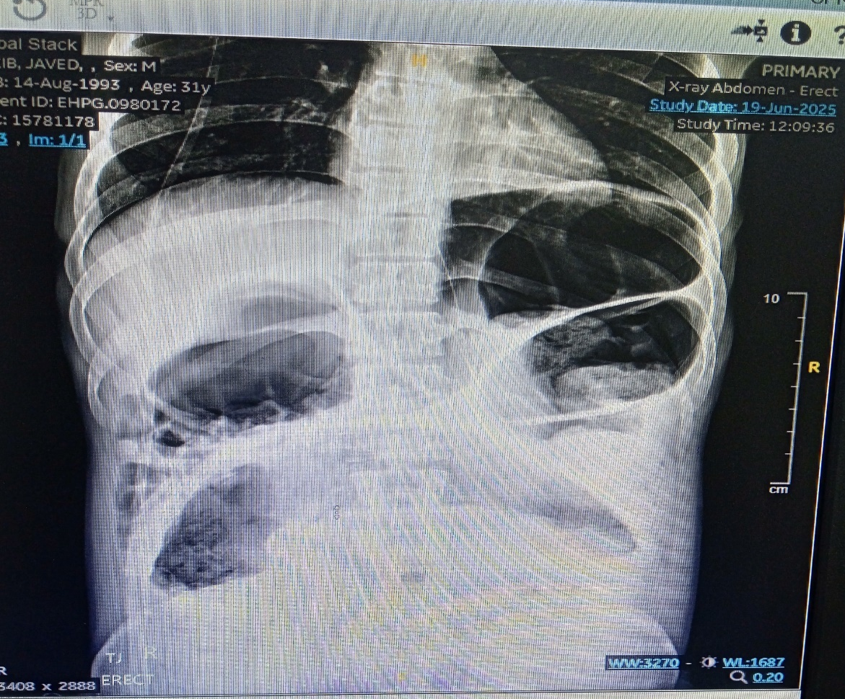

Fig. 1: Erect X Ray showing dilated bowel loops and coffee bean sign

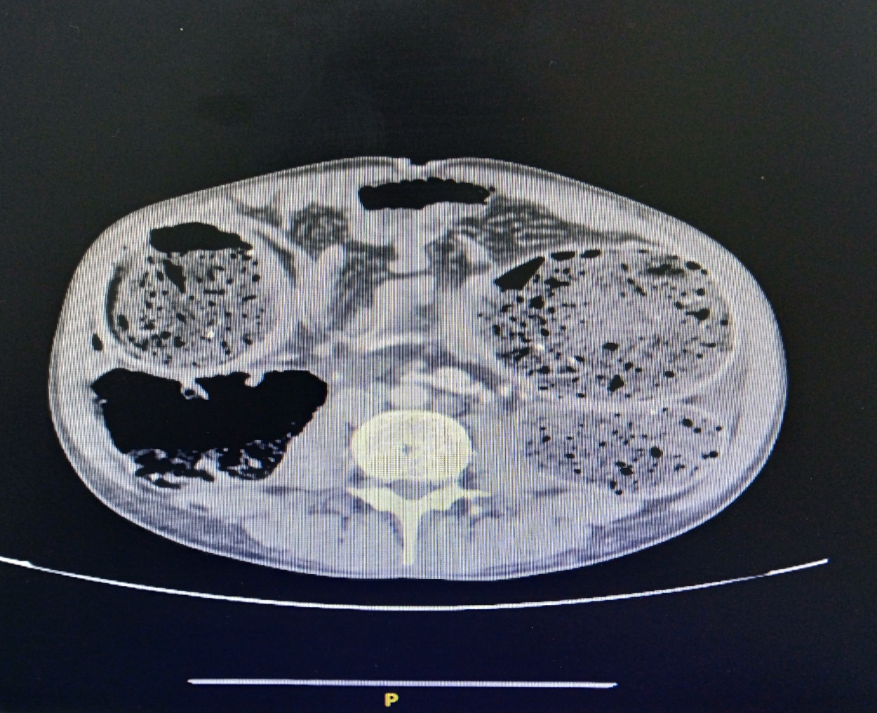
*

Fig 2: CT scan showing dilated large bowel loops and whirl sign (marked with an asterisk)

Laboratory Investigations were within normal limits except for mild hyponatremia and hypokalemia, which could be attributed to decreased appetite and multiple episodes of vomiting, but he was hemodynamically stable.

He was stabilized with IV fluids and kept Nil by mouth, A Ryle’s Tube was passed and secured, A Rectus Tube placement was done to relieve obstruction, as evidenced by patient passing stools and flatus regularly. On third day he again complained of non-passage of flatus and stools with abdominal distension. Abdominal girth charting showed increasing trend suggestive of recurrence.

Under general anesthesia, we performed an emergency exploratory laparotomy with resection of sigmoid colon and end colostomy (Hartmann’s procedure) with resection of Meckel’s diverticulum. A midline vertical incision was made extending from xiphisternum to the pubic symphysis. A grossly dilated sigmoid colon loop was identified with 360-degree clockwise rotation on its mesenteric axis. No signs of bowel wall ischemia or gangrene were seen. The distal end of the loop was found to be adherent to urinary bladder, the adhesions to urinary bladder were lysed using blunt dissection. Minimal peritoneal fluid was present which was sampled and sent for culture and sensitivity.

The volvulus was carefully untwisted to relieve the obstruction; both ends of the sigmoid colon – rectosigmoid junction and proximal end were identified and clamped using Doyen intestinal clamps, Sigmoid colon was resected using Endo GIA stapler. A 5cm incision was made in left lumbar region and the proximal end of resected colon was exteriorized, and end colostomy was fashioned.

A thorough examination of all quadrants of abdomen followed by systematic small bowel examination was conducted during which we found a wide mouthed Meckel’s diverticulum around 70cm from ileocecal junction. This Meckel’s diverticulum poses a risk of stasis leading to enterolith formation and inflammation thus, was resected using Endo GIA stapler.

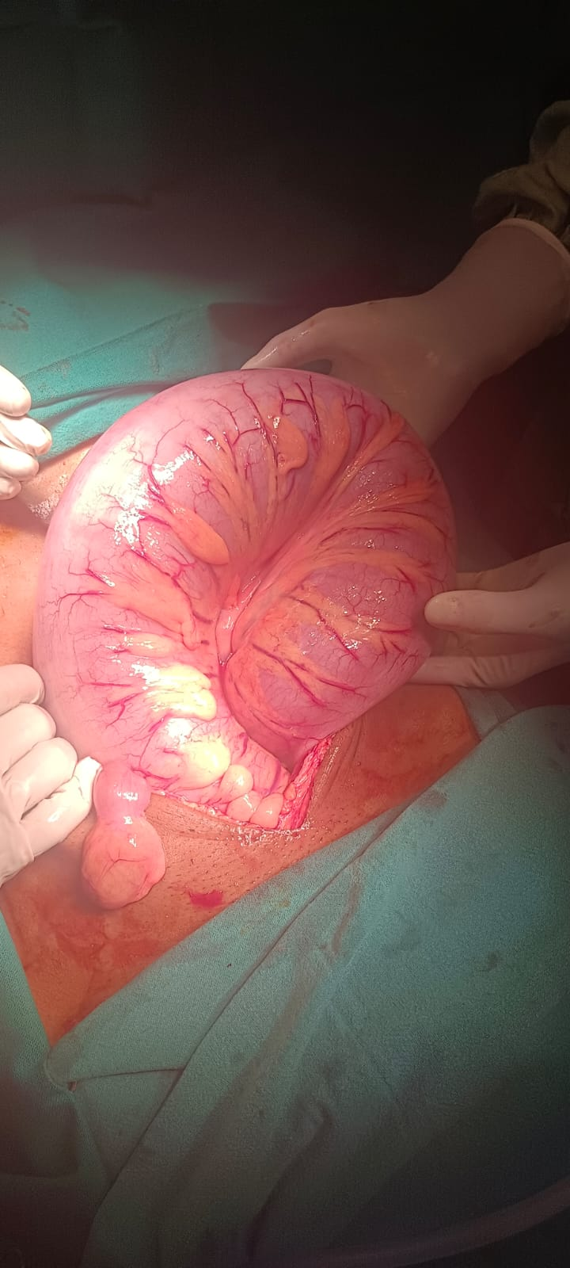
*

Fig 3: Intra-Operative picture showing delivered out grossly dilated sigmoid colon with 360-degree clockwise twisting on mesenteric axis and Meckel’s diverticulum (asterisk)
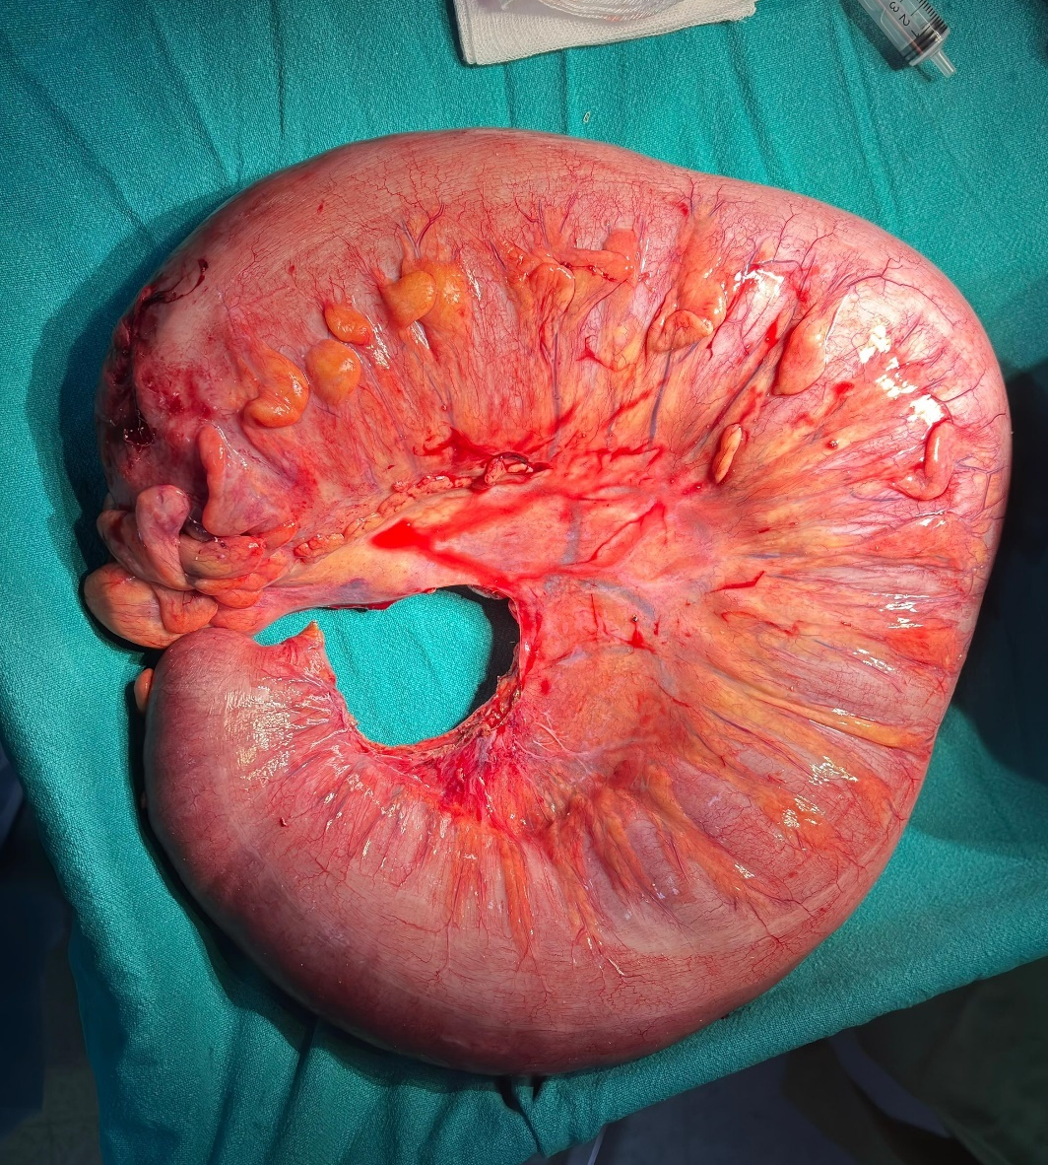

Fig 4: Resected specimen of sigmoid colon
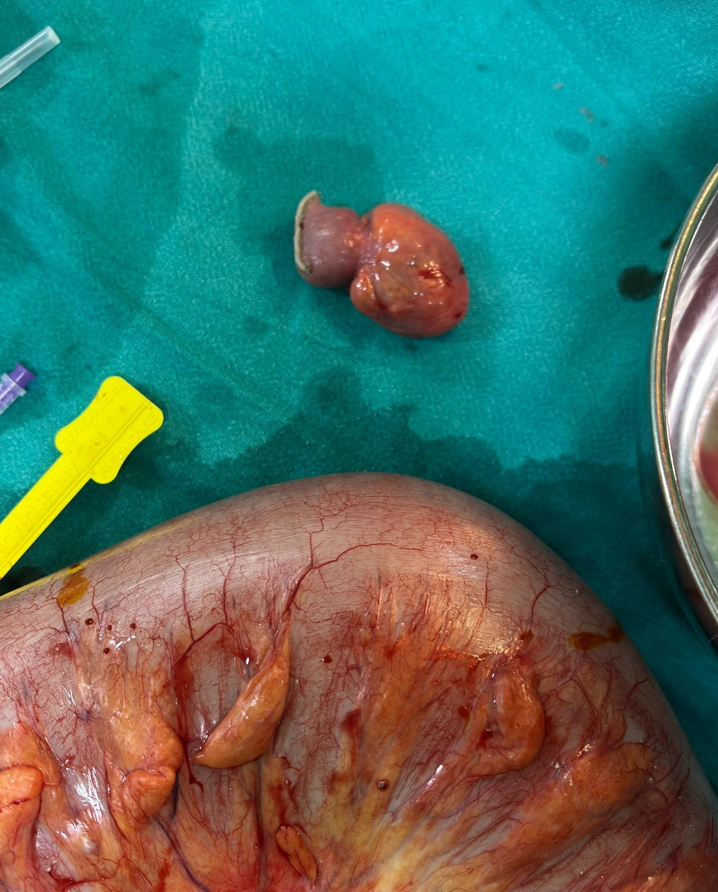

Fig 5: Resected Meckel’s Diverticulum specimen next to resected sigmoid colon

A pelvic drain was placed and secured to skin with silk No. 1 suture, Incision closed in standard technique, Skin was closed using staples over a Romovac drain. Romovac and Pelvic drains were removed at 5 and 7 days respectively. Patient was discharged in stable condition on 10th post operative day. At 2-week follow up the man was in good health and carrying his regular day to day activities with precautions as advised [Figs 1-5].

3. discussion

3.1 Pathophysiology

3.1.1 Sigmoid Volvulus
The Sigmoid volvulus occurs when the large redundant loop of colon twists upon itself on a narrow mesenteric base. This torsion occurs more commonly in a clockwise direction, usually >180 degrees, and may reach 360 degrees or more. This causes luminal obstruction with arterial compromise, predisposing the intestinal wall to gangrene and perforation.

The Sigmoid volvulus is more common dietary habits, lifestyle factors, and anatomical predisposition. Dietary habits, Lifestyle factors, in parts of Africa, South America, the Middle East, and India. Dietary habits, Lifestyle factors and anatomical predisposition strongly influence this geographical distribution. High-fibre, Bulky diets lead to chronic colon overloading, gradual elongation, and redundancy of the colon. Rural populations often squat for defecation, which may increase sigmoid motility. In western countries, it seen in institutionalized or bed-ridden older populations due to constipation and decreased mobility (Bettina Lieske, 2023; Atamanalp SS, 2010).

3.1.1 Meckel’s Diverticulum
It is a true diverticulum as it contains all three layers (mucosa, submucosa and muscularis), located at the anti-mesenteric border, it is usually 2 feet away from the ileocecal junction, is 2 inches long and presents only in 2% of the population. Although Meckel’s is the most common congenital Gastrointestinal anomaly, it is seldom found on radiological imaging. It is generally asymptomatic but most commonly presents with bleeding in children caused by acid and enzyme secretion from ectopic gastric or pancreatic tissue found in 50% of Meckel’s diverticulum, causing ulceration (Jason An, 2023).

In adults, Meckel’s can obstruct by acting as a lead point in intussusception and small bowel volvulus around fibrous adhesions. The adhesions can also cause kinking and finally obstruction. Tumors can develop in Meckel’s but is very rare. Inflammation of diverticulum causes diverticulitis that presents similar to appendicitis (Osman Toktaş, 2016).

3.2 Management
Management of Sigmoid volvulus is based on presence of ischemia or perforation of colonic wall:

In absence of ischemia or perforation flexible endoscopy should be performed as a first line to decompress the sigmoid colon. It is effective in about 60-95% of patients. Successful detorsion implies that the endoscopist must visualize and go beyond the 2 transition points. At the end of detorsion, endoscopic view of mucosa to assess sigmoid colon viability is mandatory.

After successful detorsion, a decompression flatus tube should be left in place to maintain the reduction, allow for continued colonic decompression. The long-term recurrence rate has been observed to be around 43 – 75%.

In cases where there are signs of peritonitis like rigidity and guarding, signs of septic shock, or there is evidence of impending ischemia or gangrene of mucosa on endoscopy or failure of endoscopic decompression the procedure should be aborted immediately and emergency colectomy is warranted.

Using a midline approach, sigmoid colectomy should be performed in above mentioned cases. Intraoperatively, resection of infarcted bowel should be performed without detorsion and with minimal manipulation to prevent release of endotoxin, bacteria and potassium from dying tissue and avoid perforation of the bowel. The decision to perform an isolated sigmoid colectomy versus a high anterior resection should be individualized. (Bettina Lieske, 2023; Garfinkle R, 2018).
Symptomatic Meckel’s diverticula should be resected with primary closure of the small intestine. This may be done tangentially on the antimesenteric border with closure of the small intestine in a transverse fashion to avoid narrowing the lumen. Segmental resection of the intestine can also be carried out using an intestinal stapling device. It should be ensured to remove all the ectopic mucosa if present. If the lesion is resected for bleeding, the intestinal mucosa should be inspected for the presence of an ulcer, which will tend to recur at the junction of the ectopic gastric mucosa and normal bowel mucosa, as well as the mesenteric side of the ileal lumen (Stallion A, 2001).

The treatment of asymptomatic Meckel’s diverticula encountered at laparotomy remains controversial. The data suggest that, with the possible exception of male sex, there is no factor predictive of the development of symptoms in incidentally found Meckel’s. Taking into consideration the low morbidity and mortality associated with the resection and risk of complications in future from Meckel’s, the risk-to-benefit ratio favours the resection of Meckel’s when found incidentally, unless absolutely contraindicated, as in patients with omphalocele (Arnold JF et al., 1997; Cullen JJ et al, 1994).

4. CONCLUSION

This case highlights the diagnostic and therapeutic challenges of managing sigmoid volvulus in a young patient with an incidental Meckel’s diverticulum. This case underscores the importance of careful intraoperative assessment of the entire bowel, as additional pathology may coexist. The incidental finding of Meckel’s diverticulum raises the important surgical dilemma of whether to resect. In this case, considering the patient's young age, male sex, and the concomitant pathology requiring surgical intervention, the decision to resect was appropriate.

Competing interests

Authors have declared that no competing interests exist.

Consent

All authors declare that ‘written informed consent was obtained from the patient (or other approved parties) for publication of this case report and accompanying images. A copy of the written consent is available for review by the Editorial office/Chief Editor/Editorial Board members of this journal.

Ethical approval

It is not applicable.

References

- Cirocchi R, Farinella E, La Mura F, Morelli U, Trastulli S, Milani D, Di Patrizi MS, Rossetti B, Spizzirri A, Galanou I, Kopanakis K, Mecarelli V, Sciannameo F. The sigmoid volvulus: surgical timing and mortality for different clinical types. World J Emerg Surg. 2010 Jan 13;5:1. doi: 10.1186/1749-7922-5-1. PMID: 20148115; PMCID: PMC2820010.

- Raveenthiran V, Madiba TE, Atamanalp SS, De U. Volvulus of the sigmoid colon. Colorectal Disease. 2010 Jul;12(7Online):e1-7.

- Atamanalp SS. Sigmoid volvulus. Eurasian J Med. 2010 Dec;42(3):142-7. doi: 10.5152/eajm.2010.39. PMID: 25610145; PMCID: PMC4261258.

- DK Turgeon, JL Barnett - 1990 - deepblue.lib.umich.edu

- Yahchouchy EK, Marano AF, Etienne JC, Fingerhut AL. Meckel's diverticulum. Journal of the American College of Surgeons. 2001 May 1;192(5):658-62.

- Gaillard F, Sharma R, Bell D, et al. Coffee bean sign (sigmoid colon). Reference article, Radiopaedia.org. https://doi.org/10.53347/rID-1145

- Chan A, Sigmoid volvulus with whirl sign. Case study, Radiopaedia.org. https://doi.org/10.53347/rID-167410

- Lieske B, Antunes C. Sigmoid Volvulus. [Updated 2023 May 28]. In: StatPearls [Internet]. Treasure Island (FL): StatPearls Publishing; 2025 Jan-. Available from: https://www.ncbi.nlm.nih.gov/books/NBK441925/

- An J, Zabbo CP. Meckel Diverticulum. [Updated 2023 Jan 30]. In: StatPearls [Internet]. Treasure Island (FL): StatPearls Publishing; 2025 Jan-. Available from: https://www.ncbi.nlm.nih.gov/books/NBK499960/

- Toktaş O, Batur A. Small Bowel Obstruction Caused by Giant Meckel’s Diverticulum. Turk J Colorectal Dis. 2016 Jun;26(2):56-58. doi: 10.4274/tjcd.98852.

- Garfinkle R, Morin N, Ghitulescu G, Vasilevsky CA, Boutros M. From Endoscopic Detorsion to Sigmoid Colectomy-The Art of Managing Patients with Sigmoid Volvulus: A Survey of the Members of the American Society of Colon and Rectal Surgeons. Am Surg. 2018 Sep 1;84(9):1518-1525. PMID: 30268187.

- Stallion A, Shuck JM. Meckel's diverticulum. In: Holzheimer RG, Mannick JA, editors. Surgical Treatment: Evidence-Based and Problem-Oriented. Munich: Zuckschwerdt; 2001. Available from: https://www.ncbi.nlm.nih.gov/books/NBK6918/

- Arnold JF, Pellicane JV. Meckel's diverticulum: a ten-year experience. Am Surg. 1997 Apr;63(4):354-5. PMID: 9124758.

- Cullen JJ, Kelly KA, Moir CR, Hodge DO, Zinsmeister AR, Melton LJ 3rd. Surgical management of Meckel's diverticulum. An epidemiologic, population-based study. Ann Surg. 1994 Oct;220(4):564-8; discussion 568-9. doi: 10.1097/00000658-199410000-00014. PMID: 7944666; PMCID: PMC1234434.

