Review Article

Deep Fake Detection Using Deep learning; A review

Abstract
In recent years social media has increased rapidly. Because of this enhancement anyone can easily create propaganda .Technology has advanced in a way that enables users to mimic celebrity or other higher officers, spreading misinformation by uses of Deepfakes. Due to wide availability of content on social media along with advanced tools has made it easy for people to produce Deep fake . Hence, differentiating between real and fake content has become crucial
.
Recent studies suggest an automated method to detect deep fake by employing deep learning and machine learning based methodologies . There are various ways to detect deep fake, including methods that focus on images, videos, audio, or a combination of these. One can use advanced computer models, like Convolutional Neural Networks (CNNs) and Recurrent Neural Networks (RNNs,) to find Deep Fakes . Another study combines two techniques, one for detecting deep fake in images and another for checking how consistent the video is over time. There’s also a platform called Papers with Code that lists various detection algorithms and their code. All these resources show that detecting deep fakes is a growing area of research, and there’s a strong need for ongoing advancements.

Introduction
Deep learning is a subset of machine learning that uses multilayered neural networks, to simulate decision making power of human brain . It also includes latent variables organized layer wise in deep generative models such as in deep belief networks and deep Boltzmann machines .[1]
The main difference between deep learning and machine learning is the underlying neural network architecture. Traditional machine learning models use one to two computational layers, but deep learning models use hundreds to thousands of layers to train the model. Deep learning, unsupervised learning models can extract the characteristics from raw and unstructured data , and make accurate outputs .[2],[3]
Deep learning is a part of data science that drives many applications and services, performing physical and analytical tasks without human intervention . This enables many everyday products and services such as digital assistant, self-driving cars, credit card fraud detection, fake video detection and generative AI.[4]

Convolutional Neural Network
Convolutional Neural Networks (CNNs) aid in object detection, image detection and pattern recognition within images and videos. These networks are based on linear algebra, particularly matrix manipulation, to identify patterns within an image. CNN is composed of node layers, containing an input and an output layer. Each node joins with another and has an associate weight and threshold. If the output of any individual node is greater than the threshold value, it is activated and sends data to the next layer of the network. (Figure 1)
There are three main layers in a CNN: convolutional layer, pooling layer and fully connected layer. Starting layers focus on simple features, such as color and edges, with increase in layer CNN increases in its complexity, identifying a larger portion of the image. As image data progresses through CNN layers, it recognizes elements or shapes of the object until it finally reaches the object of interest. [5]
CNN has superior performance with image or audio signal inputs, as compared to other neural networks. CNN can exchange data between layers to deliver more significant data processing.
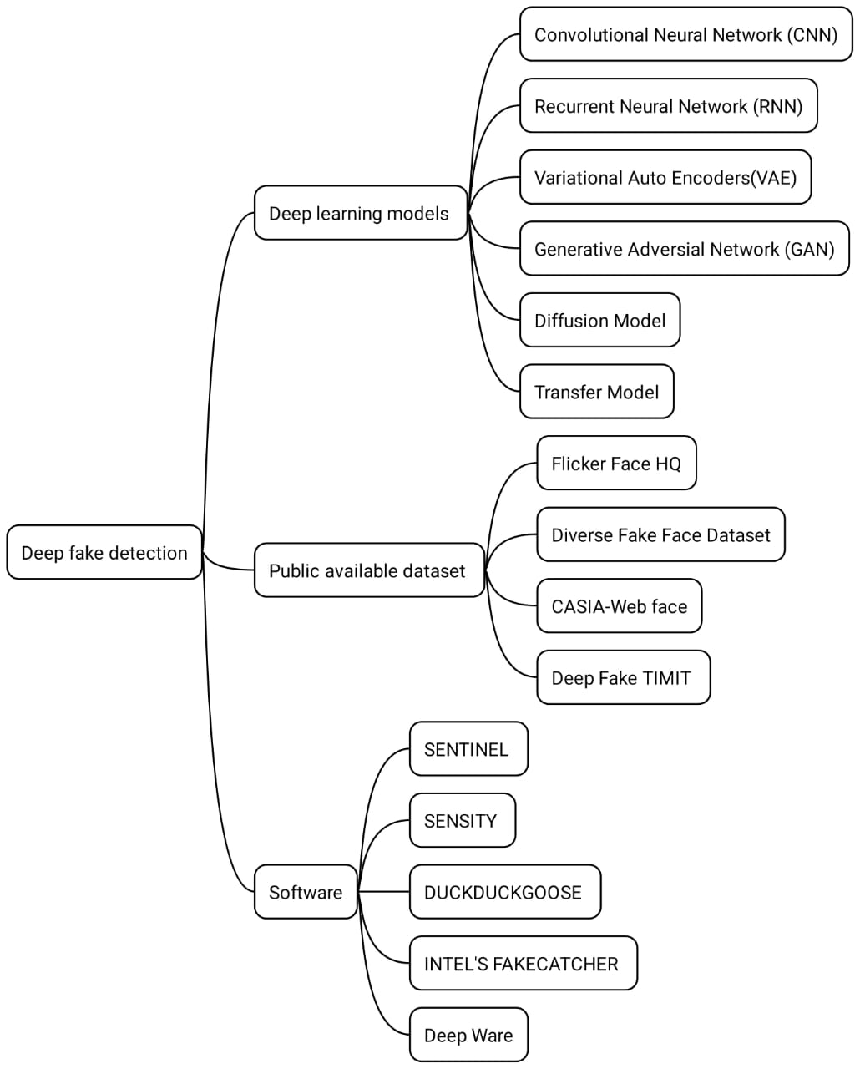

Figure 1: The deep learning models, the dataset and the software methodology applied in Deep fake detection

Types of Deep Learning Models

Disadvantages
Information might be lost in data processing. Requiring many graphical processing units (GPU) Requires highly trained experts with cross domain knowledge, hyperparameter and configuration.

Recurrent Neural Network (RNN)
RNN Use in speech recognition applications, they use time series data. These time series data help in future prediction.[5] Use in language translation, natural language processing (NLP), speech recognition and image captioning. Common applications such as Siri, voice search and Google translate. RNN shares weight parameters within each layer of the network. Back propagation and gradient descent help in reinforcement learning with the adjustment of weight.[6]
Traditional back propagation is specific to sequence of data, but the RNN uses a Back Propagation Through Time (BPTT) algorithm to determine the gradient.

Auto Encoders and Variational Auto Encoders
Variational Auto Encoders (VAE) are widely used for generating realistic images and speech. It is the base of generative AI. Autoencoders encode unlabeled data into compress representation, and decode the data back to its original form. Plain Auto encoders were used for reconstructing blurry images. Variations Auto encoders not only reconstruct data, but also to output variations on the original data.
This ability to generate new data ignited a rapid fire succession of new technologies. From Generative Adversarial Networks (GANs) to diffusion models capable of producing more realistic, but fake images.
Autoencoders are made up of blocks of encoder and decoder that also support today’s large language model. Encoders arrange similar data closer together in an abstract form, and compress data sets into a dense presentation. [7]

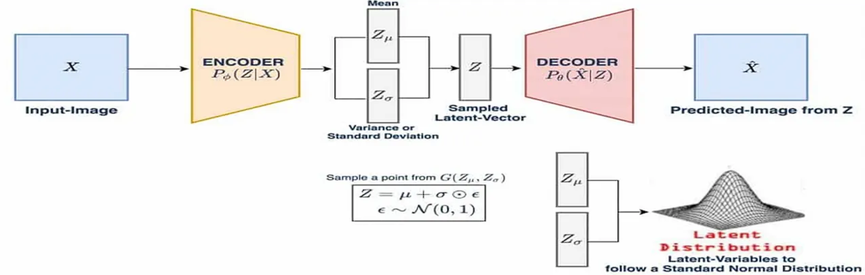
Figure 2: The Variational Autoencoders (VAEs); (Source: https://medium.com/ tech-ai-made-easy /what-are-variational-autoencoders-vaes-449e3ba9d208 by Francesco Franco)

Advantages
Auto encoders have the ability to handle large batches of data. The significant aspect is anomaly detection and classification of tasks. It also speeds transmission and reduces storage requirements. VAE can produce new sample data for text or image generation.[8]

Disadvantages
The training of deep can be a drain on computational resources. It doesn’t identify complex relationships correctly.[9]

Generative Adversarial Network (GANs)
GANs are used both in and outside of AI to create new data resembling original training data. It has a two part generator and discriminator. The generator creates an artefact, maybe image, video or audio and produces a twisted output. For example, a polar bear can be transformed into a sloth bear with high accuracy. The discriminator is opposite where the generative result (fake image, video or audio) is compared with real data. The discriminator tries to differentiate between real and fake image, video or audio. [10]

Diffusion Models
Diffusion models are generative models that use both forward and reverse diffusion processes of progressive noise addition and deletion. It generates data mostly images similar to trained data, but then overwrites the data to train them. They progressively add gaussian data to train data until it is unrecognizable, then learn a reverse denoising process that can synthesize output from random noise input. [11]
It can minimize the difference between the generated sample versus the desired target. Any discrepancy is detected and the model’s parameters are updated to minimize the loss. The model is trained to produce samples similar to the authentic training data.
The diffusion models have advantages that without the need for adversarial training, speed up the learning process. The diffusion models can require more computing resources to train, including more fine tuning compared to GANs. Information Business Machine (IBM) research also discovered that GAN can be hijacked with hidden back doors giving control to the attacker over the image creation process so that Artificial Intelligence (AI) diffusion models can be tricked into generating manipulated images.

Transformer Models
Transformer models combines both encoders and decoders with a text processing mechanism. An encoder embeds the raw text; the decoders take this embedding together and sequentially predicts each word in a sentence. Using fill in the blanks guessing, the encoder learns how words and sentences are related to each other to make a representation of the language. The Transformer processes the word in a sentence along with enabling text processing to speed up the training. Unlike advanced techniques, RNNs process words one by one. Transformers also know the position of words and their relationship. [12]
Previously, labelled data was gathered to train one model on a specific task. In Transformers a model trained on a large amount of data can be adapted to multiple tasks by fine tuning it on a small amount of labelled task specific data. Currently, language transformers are used for both non generative tasks such as classification and entity extraction, and generative tasks such as question answering, summarizing and machine translation.
Transformers enable users to understand the overall context more clearly, and create superior output by tracking long term dependencies in text. As to limitations, because of their complexity, Transformers require huge computational resources and extensive training.

Deepfake Detection

Image detection
Different methods have been used to detect artificially generated images. The neural network-based method employs preprocessing techniques to examine the statistical features of images, and detection of fake images created by humans.[13] Another method utilises a deep learning network to extract face features based on face recognition. After that, a fine-tuning step is used to make face features easy to detect real or fake images. These methods produce good results.
Some researchers ignore the critical issue of forensic models generalisation capabilities i.e. they use the same type of dataset to train and test their models. To tackle this problem introduces a forensic convolutional neural network (CNN) that uses two steps to detect fake images: Gaussian blur and Gaussian images. The aim behind this model is to use preprocessing steps to neglect low level high frequency artifacts in generated images and improve high frequency pixel noise in low level pixel statistics. This helps forensic experts to distinguish between real and fake images on certain facial characteristics. [14]
In addition to the traditional deep fake detection model, a hybrid approach was introduced to accurately detect fake images. For example, a two-stream neural network used for detection of face tampering. The Goggle Net uses a face classification stream to train the model on authentic and tampered images. Then, steganalysis feature extractor use patch triplet stream captures low level camera characteristics and local noise residual. The results show that this approach can learn both real and fake images.[15]
Another hybrid method was used which uses pairwise learning for Deep Fake image detection. Here GANs were used to create a fake image, then a pair wise learning model was used to capture the discriminant information between the real and fake image. The experimental result show that this method can overcome the shortcomings of the existing state of the art fake image detectors. [16]

Video Detection
In the last year, deep learning methods have been successfully used for fake image detection. However, the current deep learning methods of image identification cannot be used for fake video detection due to loss of frame information after video compression. The deep fake video detection task divided into two categories: Biological singles analysis, and spatial and temporal features analysis.[17]

Biological Signals Analysis
This method considers eye blinking to detect fake videos. It uses the convolutional neural network (CNN) with recurrent neural network (RNN) to find the physiological signals such as eye movements and eye blinking. Then it uses a binary classifier to detect close and open eye test. This method is tested with a dataset called eye blinking crawled from the internet. The eye blinking dataset is the first dataset which is specifically designed for eye blinking detection.[18]
Another biological signal such as heartbeat is also used for real video. The model has several detectors, where input to this model is real video. Subsequently, the pair of real and fake videos is assigned to another layer called registration, which extracts facial Region of Interest (ROI) and biological signals to create PPG cells. The PPG cells are spatiotemporal windows containing multiple faces extracted using a face detector. The last layer classifies the video as real or fake. By performing various tests on publicly available dataset, it shows 97.3% accuracy in deep fake detection.[19]
In addition to biological signals, there is a close relationship between various audio-visual modalities of the sample. Another deep learning framework for detecting deep fake in multimedia mate- rials. The goal of this model is to examine the interaction of audio and video modalities. So, the model uses a siamese network-based architecture to extract both face and image modalities. To differentiate between real and fake videos, the vector representation for the video and audio sample are extracted using two modalities embedding networks: Open Face and py by audio analysis. At last, a Triplet loss function is used to calculate the similarity and recognised the real from fake one. This method is used on Deepfake TIMIT dataset and DFDC dataset. The model gives a high accuracy of results.[20]

Spatial and Temporal Features Analysis
Current deep fake detection uses only a single video frame. But video manipulation is carried out on multiple frame level features. Analyzing temporal sequences between frames successfully helps to distinguish the real video from the fake one. Temporally aware models first use a CNN for frame features extraction. Then these features are passed to the Long Short-Term Memory (LSTM) layer to analyze a temporal sequence for face manipulation between frames. At last, a SoftMax function is used to classify the video as real or fake. [21]
Based on the previous version of Cycle-GAN, a new approach called Recycle-GAN uses conditional GAN to merge spatial and temporal data. The results show that combining spatial and temporal constraints can produce effective output. [22]
Another method consists of two stages: face processing and face manipulation detection. In the face processing stage of the Spatial Transformer Network (STN), crop and align the face. The output of the processing stage is transferred to face manipulation detection using recurrent neural network (RNN), where temporal information across the frame is analyzed.[23]

Publicly available dataset

Flicker Face HQ
Flickr Faces HQ consists of 70,000 high quality images with a resolution of 1024 pixels. The dataset includes more variations in terms of age, ethnicity, image background and also has better coverage of accessories such as eye glasses, hats etc. The images were crawled from Flickr and aligned automatically. It collects only those images that are under permissive license. Many filters are used to prune the set, and then Mechanical Turk allowed us to remove the occasional statues, paintings, or photos of photos.[24]

Diverse Fake Face Dataset (DFFD)
Diverse Fake Face Dataset (DFFD) contains 1,00,000 to 2,00,000 fake images generated by adopting respective state-of-the-art methods ( Pro GAN and style GAN methods). It contains 47.7% percent male photographs, 52.3% female images, and most of the sample’s range between 21 to 50 years old. [25]

CASIA- Web Face
CASIA-Web Face (Chinese Academy of Sciences Institute of Automation) contains 10,000 subjects and 50,000 images. The dataset was crawled from IMDB websites which contains 10,575 images of actors and actresses of (Internet Movie Database) IMDB. [26]

Deepfake TIMIT
Deep Fake Texas Instruments/Massachusetts Institute of Technology (TIMIT) is a database containing a collection of swapped faces videos generated by GAN. The database was produced by both a lower quality model with 64×64 size and a higher quality model with 128×128 size. Each fake video collection contains 32 subjects, and for each subject there were 10 fictitious videos. [27]

Deepfake Detection Software

Sentinel (The Guard)
The platform works by analysing critical visual and auditory cues to detect deep fakes. The architecture of Sentinel is based on a multi-layer defence system that includes a vast database of deepfakes and neural network classifiers. This advanced AI detection system is specifically designed to recognize deepfake videos and audio through the analysis of facial expressions, blinking patterns, and audio manipulation. The incorporation of CNNs further enhances its detection capabilities, allowing for a comprehensive examination of various media types.[28]

Sensity
Sensity (All-In-One Deepfake Detection) is a leading platform dedicated to deep fake detection in 2025. The company employs advanced artificial intelligence and deep learning algorithms to analyse various attributes of digital content, identifying inconsistencies that could indicate a deepfake. Sensity’s architecture is built on a multi-layered detection framework that combines visual, audio, and metadata analyses. The system inspects textures and edges within media files to identify signs of manipulation, particularly around facial features where deepfakes often struggle to maintain realism. Sensity’s working mechanism involves submitting media content through its platform, where various algorithms conduct automatic analyses to detect potential manipulations . Specifically, the detection process examines pixel data, voice inconsistencies, and structural attributes of the media to ascertain its authenticity. This real-time capability enables immediate alerts and assessments regarding suspicious content, which is crucial for timely intervention in instances of misinformation or fraud.[29]

DuckDuckGoose
DuckDuckGoose is a multi-layered system that analyses various aspects of media files, including textures and edges, to pinpoint signs of manipulation, especially around facial features where deepfakes can be most difficult to detect. The company’s software offers solutions for detecting a wide range of deep fakes, including videos, images, voices, and texts, serving as vital tools for identity verification and fraud prevention. The deep fake detector enables real-time detection capabilities, as the software can provide results in under a second, offering users immediate insights into the authenticity of the content they are evaluating. [30]
INTEL’S FAKECATCHER
Intel’s Fake Catcher is a real-time deepfake detection system introduced in November 2022 that aims to combat the rising threat posed by manipulated videos . It claims a 96% accuracy rate by utilizing a unique method that analyses subtle blood flow changes within the pixels of a video. It leverages Intel’s Xeon Scalable processors and employs specialized software libraries such as Open Vino, Intel® Integrated Performance Primitives, and OpenCV for optimized performance in real-time environments.
Fake Catcher operates by analysing the pixel data in videos to detect blood flow signals using a technique known as Photoplethysmography (PPG). When a person is filmed, changes in blood circulation cause variations in pixel colour, which are difficult for deepfakes to replicate accurately. The system collects these signals from strategic points on the face and translates them into spatiotemporal maps, then applies deep learning algorithms to assess whether the video is real or fake, all in real-time.[31]

Deepware
The Deepware is an AI-powered software specifically developed to detect and combat deepfakes, utilizing machine learning algorithms to analyse videos . Deepware provides real-time deepfake detection services accessible to individuals, businesses, and researchers, making it a versatile tool in addressing the challenge of synthetic media.
The architecture of Deepware relies on advanced machine learning algorithms and utilizes the EfficientNet-B7 model, which is a convolutional neural network optimized for deepfake detection tasks . This model is trained on the CFDC dataset, consisting of 120,000 consented videos, and incorporates additional technologies such as facial landmark analysis, temporal consistency checks, and flicker detection to enhance detection effectiveness. When a video is submitted for analysis, Deepware applies its AI algorithms to detect inconsistencies, giving results that include a confidence score indicating the likelihood of deepfake manipulation. [32]

Deepfake Challenges
There are various applications and tools that create Deepfake images and videos. It has become a great challenge for academic researchers when studying and analysing deep fake images and videos. One of the most important challenges is the lack of high-quality dataset. Deepfake method uses fragmented data set to detect tampering. Deep learning models require large datasets during training to produce good results, which are not freely accessible. The rapid development of deepfake GAN models can also bring new challenge where the obscene types of generated images and videos may not be discovered by the current deep learning models. Hence all these challenges show the great demand to develop robust and scalable deep learning models to detect the deep fake images and videos. [33]

Conclusion
The battle against deepfakes is an ongoing arms race. As deepfake generation techniques become increasingly sophisticated, detection methods must also evolve to remain effective. A multi-pronged approach that combines technological advancements with media literacy and policy interventions will be crucial in mitigating the threats posed by deep fakes. Continued research and development of robust, adaptable, and accessible detection methods are paramount to preserving the integrity of our digital information landscape. Furthermore, fostering public awareness and critical media consumption habits will empower individuals to identify and counter the spread of deep fakes. Ultimately, a collaborative effort involving researchers, policymakers, technology companies, and the public is essential to navigate the challenges and safeguard trust in the digital age.

COMPETING INTERESTS DISCLAIMER:
Authors have declared that they have no known competing financial interests OR non-financial interests OR personal relationships that could have appeared to influence the work reported in this paper.

References
- Nguyen, T.T.; Nguyen, Q.V.H.; Nguyen, D.T.; Nguyen, D.T.; Huynh-The, T.; Nahavandi, S.; Nguyen, T.T.; Pham, Q.V.; Nguyen, C.M. Deep learning for deepfakes creation and detection: A survey. Comput. Vis. Image Underst. 2022, 223, 103525. https://doi.org/10.1016/j.cviu.
2022.103525
- Brock, A.; Lim, T.; Ritchie, J.M.; Weston, N. Neural photo editing with introspective adversar- ial networks. arXiv 2016, arXiv:1609.07093. https://scholar.google.com/scholar_lookup? title=Neural+photo+editing+with+introspective+adversarial+networks&author= Brock,+A.&author=Lim,+T.&author=Ritchie,+J.M.&author=Weston,+N.&publication_ year=2016&journal=arXiv
- Yu, P.; Xia, Z.; Fei, J.; Lu, Y. A survey on deepfake video detection. Iet Biom. 2021, 10, 607–624. https://www.sciencedirect.com/science/article/abs/pii/S1077314222001114
- Rossler, A.; Cozzolino, D.; Verdoliva, L.; Riess, C.; Thies, J.; Nießner, M. Faceforensics++: Learning to detect manipulated facial images. In Proceedings of the IEEE/CVF Interna- tional Conference on Computer Vision, Seoul, Repubic of Korea, 27 October–2 November 2019; pp. 1–11. https://scholar.google.com/scholar_lookup?title=Faceforensics++:
+Learning+to+detect+manipulated+facial+images&conference=Proceedings+of+ the+IEEE/CVF+International+Conference+on+Computer+Vision&author=Rossler,+A. &author=Cozzolino,+D.&author=Verdoliva,+L.&author=Riess,+C.&author=Thies,+J. &author=Nie%C3%9Fner,+M.&publication_year=2019&pages=1%E2%80%9311
- ,Elman, J.L. (1990) Finding Structure in Time. Cognitive Science, 14, 179-211. https://doi. org/10.1145/3267357.3267367
- , Bengio, Y., Simard, P. and Frasconi, P. (1994) Learning Long-Term Dependencies with Gradient Descent Is Difficult. IEEE Transactions on Neural Networks, 5, 157-166.https:
//doi.org/10.1109/72.279181
- ,Chauhan. BS. Introduction to Auto-Encoder and Variational auto Encoder (VAE). https: //www.theaidream.com/post/an-introduction-to-autoencoder-and-variational-autoencoder-vae
- D. Huang, F. De La Torre, Facial action transfer with personalized bilinear regression in Euro- pean Conference on Computer Vision (Springer, 2012), pp. 144–158. https://link.springer. com/chapter/10.1007/978-3-642-33709-3_11
- E. Zakharov, A. Shysheya, E. Burkov, V. Lempitsky, “Few-shot adversarial learning of real- istic neural talking head models” in Proceedings of the IEEE/CVF International Conference on Computer Vision (Institute of Electrical and Electronics Engineers, 2019), pp. 9459–9468. https://ieeexplore.ieee.org/document/9009591
- ,Lakshmanan Nataraj, Tajuddin Manhar Mohammed, B. S. Manjunath, Shivkumar Chan- drasekaran, Arjuna Flenner, Jawadul H. Bappy, Amit K. Roy-Chowdhury.Detecting GAN gen- erated Fake Images using Co-occurrence Matrices, Electronic Imaging: Media Watermarking, Security, and Forensics, 2019, pp 532-1 - 532-7. https://doi.org/10.2352/ISSN.2470-1173. 2019.5.MWSF-532
- , Jonathan Ho, Ajay Jain, Literacy Abbeel. Denoising diffusion probabilistic models. https:// proceedings.neurips.cc/paper/2020/file/4c5bcfec8584af0d967f1ab10179ca4b-Paper. pdf
- ,Ashish Vaswani,Noam Shazeer,Niki Parmar,Jakob Uskoreit,Llion Jones,Adin N. Gomez,Lukasz Kaiser,Illia Polosukhin.Attention is all your need.https://papers.neurips. cc/paper/7181-attention-is-all-you-need.pdf
- Tariq, S., Lee, S., Kim, H., Shin, Y. and Woo, S.S. (2018) Detecting Both Machine and Human Created Fake Face Images in the Wild. Proceedings of the 2nd International Workshop on Multimedia Privacy and Security, Toronto, 15 October 2018, https://doi.org/10.1145/ 3267357.3267367
- uan, X., Peng, B., Wang, W. and Dong, J. (2019) On the Generalization of GAN Image Forensics. In: Chinese Conference on Biometric Recognition, Springer, Berlin, 134-141.https:
//doi.org/10.1007/978-3-030-31456-9_15
- Zhou, P., Han, X.,Morariu, V.I. and Davis, L.S. (2017) Two-Stream Neural Networks for Tampered Face Detection. 2017 IEEE Conference on Computer Vision and Pattern Recogni- tion Workshops (CVPRW), Honolulu, 21-26 July 2017, 1831-1839.https://doi.org/10.1109/ CVPRW.2017.229
- su, C.-C., Zhuang, Y.-X. and Lee, C.-Y. (2020) Deep Fake Image Detection Based on Pairwise Learning. Applied Sciences, 10, 370.https://doi.org/10.3390/app10010370
- fchar, D., Nozick, V., Yamagishi, J. and Echizen, I. (2018) Mesonet: A Compact Facial Video Forgery Detection Network. 2018 IEEE International Workshop on Information Forensics and Security (WIFS), Hong Kong, 11-13 December 2018,1-7. https://doi.org/10.1109/WIFS. 2018.8630761
- Li, Y., Chang, M.-C. and Lyu, S. (2018) In Ictu Oculi: Exposing AI Generated Fake Face Videos by Detecting Eye Blinking. 2018 IEEE International Workshop on Information Forensics and Security (WIFS), Hong Kong, 11-13 December 2018, 1-7. https://doi.org/10.1109/ WIFS.2018.8630787
- Ciftci, U.A., Demir, I. and Yin, L. (2020) How Do the Hearts of Deep Fakes Beat? Deep Fake Source Detection via Interpreting Residuals with Biological Signals. 2020 IEEE International Joint Conference on Biometrics (IJCB), Houston, 28 September-1 October 2020, 1-10. https:
//doi.org/10.1109/IJCB48548.2020.9304909
- Gu¨era, D. and Delp, E.J. (2018) Deepfake Video Detection Using Recurrent Neural Net- works. 2018 15th IEEE International Conference on Advanced Video and Signal Based Surveil- lance (AVSS), Auckland, 27-30 November 2018, 1-6. https://doi.org/10.1109/AVSS.2018.
8639163
- Mittal, T., Bhattacharya, U., Chandra, R., Bera, A. and Manocha, D. (2020) Emotions Don’t Lie: An Audio-Visual Deepfake Detection Method Using Affective Cues. Proceedings of the 28th ACM International Conference on Multimedia, Seattle, 12-16 October 2020, 2823-2832. https://doi.org/10.1109/AVSS.2018.8639163
- Zhu, J.-Y., Park, T., Isola, P. and Efros, A.A. (2017) Unpaired Image to Image Translation Using Cycle-Consistent Adversarial Networks. Proceedings of the IEEE International Confer- ence on Computer Vision, Venice, 22-29 October 2017, 2223-2232. https://doi.org/10.1109/ ICCV.2017.244
- Sabir, E., Cheng, J. Jaiswal, A., AbdAlmageed, W., Masi, I. and Natarajan, P. (2019) Recur- rent Convolutional Strategies for Face Manipulation Detection in Videos. CVPR Workshops. https://arxiv.org/abs/1905.00582
- Dang, H., Liu, F., Stehouwer, J., Liu, X. and Jain, A.K. (2020) On the Detection of Digital Face Manipulation. Proceedings of the IEEE/CVF Conference on Computer Vision and Pat- tern Recognition, Seattle, 13-19 June 2020, 5781-5790. https://doi.org/10.1109/CVPR42600. 2020.00582
- B. Dolhansky et al., The deepfake detection challenge dataset. arXiv [Preprint] (2020).(Ac- cessed 15 May 2021). https://arxiv.org/abs/2006.07397
- Yi, D., Lei, Z., Liao, S. and Li, S.Z. (2014) Learning Face Representation from Scratch.
https://arxiv.org/abs/1411.7923
- Korshunov, P. and Marcel, S. (2018) Deepfakes: A New Threat to Face Recognition? Assess- ment and Detection. https://www.researchgate.net/publication/329841498_DeepFakes_ a_New_Threat_to_Face_Recognition_Assessment_and_Detection
- Sam Romain(2023), Sentinel AI: The New Frontier in Deepfake De- tection. https://www.romainberg.com/blog/artificial-intelligence/ sentinel-ai-your-ultimate-deepfake-detection-solution/
- Matthew Groh, Ziv Epstein, Chaz Firestone, Rosalind Picard(2021) On Deep fake detection by Human crowds,machines and machine informed crowds ,119 (1) e2110013119. https://doi. org/10.1073/pnas.2110013119
- Aurelien Mahl, Katie Melnnis, Megan Gray.(2021) DuckDuckGo:White pa- per on the search engine market. https://staticcdn.duckduckgo.com/press/ DuckDuckGo-White-Paper-on-search_March-2021.pdf
- Umur Aybars Ciftci, Ilke Demir, Lijun Yin, Senior Member, IEEE. (2020)Fake Catcher: Detection of Synthetic Portrait Videos Using Biological Signals. https:
//scholar.google.co.in/scholar?cluster=7679454506026536068&hl=en&as_sdt=2005& sciodt=0,5#d=gs_qabs&t=1726484609784&u=%23p%3DZbFhirwRY7UJ
- G. O. Ganfure, C. -F. Wu, Y. -H. Chang and W. -K. Shih, ”DeepWare: Imaging Performance Counters With Deep Learning to Detect Ransomware,” in IEEE Transactions on Computers, vol. 72, no. 3, pp. 600-613, 1 March 2023, doi: 10.1109/TC.2022.3173149. https://ieeexplore. ieee.org/document/9770351
- Afzal, S.; Ghani, S.; Hittawe, M.M.; Rashid, S.F.; Knio, O.M.; Hadwiger, M.; Hoteit, I. Visualization and Visual Analytics Approaches for Image and Video Datasets: A Survey. ACM Trans. Interact. Intell. Syst. 2023, 13, 5. https://scholar.google.com/scholar?cluster= 9085184973270738522&hl=en&as_sdt=2005&sciodt=0,5#d=gs_qabs&t=1726503965437&u=
%23p%3DWuaECpkPFX4J

