White-centered retinal hemorrhage revealing acute leukemia: case report

.
ABSTRACT
Aims: To report a rare case of acute leukemia revealed by white-centered retinal hemorrhages (Roth spots), highlighting the importance of early ophthalmologic findings in systemic malignancies
Presentation of Case:
A 17-year-old male with no significant medical history was admitted for systemic symptoms including fever, weight loss, and a pulmonary infection. Within 24 hours, he developed sudden bilateral visual loss. Ophthalmologic evaluation revealed severely reduced visual acuity (hand motion) in both eyes. Anterior segment examination and intraocular pressure were normal. Fundus examination showed multiple bilateral, white-centered retinal hemorrhages, associated with superficial and deep macular and peripapillary hemorrhages. Fluorescein angiography revealed blocked fluorescence due to the hemorrhages. Laboratory tests demonstrated leukocytosis (32,200/mm³), anemia (Hb 10.7 g/dL), and thrombocytopenia (86,000/mm³). Bone marrow aspiration confirmed the diagnosis of acute leukemia. The patient was referred to a specialized center and received systemic chemotherapy, resulting in complete remission.
Discussion:
Ocular manifestations occur in up to 80% of acute leukemia cases, though they are rarely the initial sign. Chorioretinal involvement may result from bone marrow failure or leukemic infiltration. White-centered retinal hemorrhages may indicate capillary rupture or direct leukemic cell invasion; the latter being associated with a worse prognosis. Other ocular sites such as the anterior segment, orbit, or optic nerve may also be affected but were not involved in this case.
Conclusion: This case emphasizes the diagnostic value of a thorough ophthalmological examination. White-centered retinal hemorrhages can be a key early sign of acute leukemia, warranting urgent systemic evaluation.

Keywords: Acute leukemia, Roth spots, Retinal hemorrhage, Ocular manifestations

1. INTRODUCTION

Acute leukemias are a heterogeneous group of hematological malignancies characterized by the clonal proliferation of undifferentiated hematopoietic precursor cells. Without rapid diagnosis and appropriate treatment, they progress swiftly and are life-threatening conditions (Pui et al, 2008; Estey & Döhner, 2006). Although their clinical presentation is typically dominated by signs of bone marrow failure such as anemia, infections, and bleeding, extramedullary involvement including ocular manifestations is not uncommon.
The eye can serve as a site of both primary leukemic infiltration and secondary complications due to hematologic abnormalities. These ocular signs, although frequent, are often underestimated or misinterpreted, and may precede systemic symptoms in rare cases (Kincaid & Green, 1983). Among the most notable findings are retinal hemorrhages, including white-centered retinal hemorrhages, which may reflect vascular fragility from thrombocytopenia or direct leukemic infiltration (Sharma et al., 2004). These manifestations can offer an early diagnostic clue in otherwise non-specific systemic presentations.
Despite this, ocular involvement remains underreported as an initial sign of leukemia in literature. This case report illustrates a rare presentation of acute leukemia initially revealed by bilateral, white-centered retinal hemorrhages, highlighting the critical role of the ophthalmologist in the early detection of systemic malignancies.

2. PRESENTATION OF CASE

We report the case of a 17-year-old child with no particular medical history who was hospitalized in the internal medicine department for general impairment with fever, weight loss, anorexia, and pulmonary infection and who subsequently had a sudden bilateral decrease in visual acuity for the last 24 hours. A complete ophthalmologic examination showed a visual acuity reduced to HM (hand motion). The anterior segment examination was unremarkable. The dilated examination of the fundus finds bilateral white-centered retinal hemorrhages associated with multiple superficial and deep-retinal and pre-retinal hemorrhages in the macular and peripapillary regions (Figure 1). Fundus fluorescein angiography shows a blocked fluorescence due to retinal hemorrhages. The biological examinations show a leukocytosis at 32 200 elts / mm3 with anemia (Hb = 10.7g/dl) and thrombocytopenia (PLT = 86000 / mm). The myelogram confirms the diagnosis of acute leukemia by highlighting the presence of leukoblastosis. The extension assessment was negative.The child is cared for in a specialized service and recieved chemotherapy with complete remission.

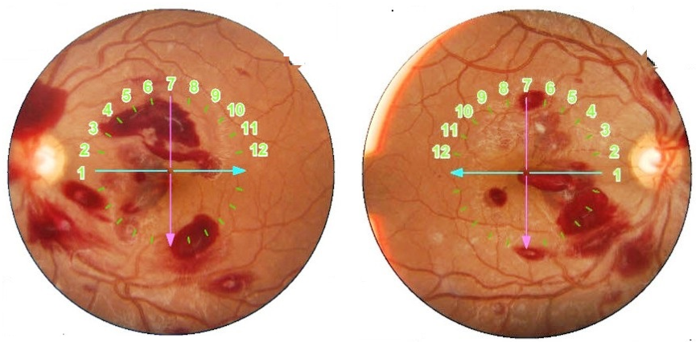
Fig. 1. Superficial and deep diffuse retinal hemorrhages with Roth stains. Please remove the ink notations on the fundus picture and just highlight the Roth spots by black/white arrowheads, for the sake of clarity.

3. discussion

The ocular manifestations of acute leukemia are frequent and multiple, with incidence ranging from 9% to over 80% (Karkhaneh R et al, 2018). Chorioretinal involvement is the most visually significant of these ocular manifestations and is mainly due to two consequences of the disease: primary leukemic infiltration or secondary to hematological abnormalities, the latter being more common (https://eyewiki.org/Retinal_Manifestations_of_Leukemia_-_Leukemic_Retinopathy)(Sharma et al., 2004). White-centered retinal hemorrhage, also known as the Roth spot, is most often a manifestation of retinal capillary rupture and extrusion of blood followed by coagulation, that will form the central white platelet-fibrin thrombus, but sometimes it is due to true leukemic infiltrates, ewhich is a sign of bad prognosis (Schachat AP et al 1989). anterior segment inflammation is rare and includes leukemic hypopyon or nodular infiltrationof the iris (Kincaid & Green1983). Orbital locations lead to eyelid edema, sometimes ecchymotic and painful exophthalmos (Zimmerman LE et al,1964). Optic nerve infiltration is more rarely observed and is a medical emergency often leading to irreversible vision loss; it was found histologically in 18% of cases in necropsy studies (Reddy SC et al, 2003). The vitreous localization is rarely reported in the literature; it is due to vitreous invasion via the optic nerve or hematogenously (Nagaki et al, 2000). In our observation, no other ocular manifestations were found.

4. Conclusion

This case highlights white-centered retinal hemorrhage as a potentially revealing sign of acute leukemia. A thorough ophthalmologic examination in patients with sudden bilateral visual loss may facilitate early diagnosis of life-threatening hematologic malignancies. Prompt recognition and systemic evaluation are essential to initiate appropriate treatment and improve prognosis.

CONSENT
All authors declare that ‘written informed consent was obtained from the patient for publication of this case report and accompanying images.
DATA AVAILABILITY
Not applicable
ETHICAL APPROVAL
As per international standards or university standards written ethical approval has been collected and preserved by the author(s).
COMPETING INTERESTS
Authors have declared that no competing interests exist.

References (please add more recent ophthalmic references)

Pui CH, Robison LL, Look AT. Acute lymphoblastic leukaemia. Lancet. 2008;371(9617):1030-43.
Estey EH, Döhner H. Acute myeloid leukaemia. Lancet. 2006;368(9550):1894-907.
Kincaid MC, Green WR. Ocular and orbital involvement in leukemia. Surv Ophthalmol. 1983;27(4):211-32.
Sharma T, Grewal J, Gupta S, Murray PI. Ophthalmic manifestations of acute leukaemias: the ophthalmologist's role. Eye (Lond). 2004;18(7):663-72.

Karkhaneh R, Mirshahi R, Rajabi MB, et al. Ophthalmic manifestations of acute leukemia: A prospective study. Int Ophthalmol. 2018;38(1):229-36.
Schachat AP, Markowitz JA, Guy J, Burke PJ, Karp JE. Ocular manifestations of leukemia. Arch Ophthalmol. 1989;107(5):697-700.
Zimmerman LE. Ocular manifestations of leukemia: a review of 675 cases. Trans Am Acad Ophthalmol Otolaryngol. 1964;68:474-95.
Reddy SC, Jackson N. Retinal findings in acute leukaemia at presentation. Med J Malaysia. 2003;58(5):689-94.
Nagaki Y, Hayashi H, Kado M, Matsumoto M, Tamura H, Shinohara H. Vitreous involvement of acute leukemia. Jpn J Ophthalmol. 2000;44(1):76-81.

