DUS Characterization of Soybean Genotypes

Abstract
Soybean is a significantly important leguminous crop known for its high protein (~40%) and oil (~20%) content, making it essential in human nutrition and animal feed. The current research was conducted during the Kharif, 2024 at the Zonal Agricultural Research Station, Morena, RVSKVV, Gwalior to assess qualitative characters among 60 soybean genotypes acquired from different institutions in a Randomized Block Design (RBD) with two replications. Eleven qualitative traits including hypocotyl and flower colour, leaf shape and shade, pod pubescence, growth habit, seed shape, seed coat and hilum colour and luster were recorded visually. Substantial phenotypic variation was observed. Anthocyanin pigmentation in the hypocotyl was present in 37 genotypes; flower colour was violet in 37 and white in 23 genotypes. Seed coat lustre also varied where 38 genotypes were shiny while 22 were dull. Variation was also seen in leaf shape, pod surface, growth habit and hilum colour. A dendrogram was also constructed based on the qualitative traits which classified the genotypes into two primary clusters: a major contained 37 genotypes and a minor comprehend 23 genotypes. This morphological characterization provides valuable baseline information for selecting superior genotype (s) for further utilization in breeding programmes. The observed diversity can be effectively utilized for genetic improvement and conservation.
Keywords: Genetic diversity, germplasm evaluation, morphological characterization, phenotypic variation, soybean (Glycine max), qualitative traits.
Introduction
Glycine max [L.] Merrill stands as one of the most economically valuable and nutritionally rich leguminous crops cultivated worldwide. Its seeds are notable for their high content of quality protein (~40%) and oil (~20%), positioning it as a staple in plant-based human diets and a major ingredient in livestock feed (Mishra et al., 2020; Mishra et al., 2021a; Mishra et al., 2024a; Jhariya et al., 2025a). The protein profile of soybean is particularly advantageous due to its abundance of essential amino acids, including lysine, leucine and isoleucine making it an ideal source of complete plant protein and a critical component in vegetarian and vegan nutrition (Upadhyay et al., 2020; Mishra et al., 2024b; Jhariya et al., 2025b; Gautam et al., 2025a). Beyond its nutritional contributions, soybean plays a pivotal role as a raw material in numerous industrial applications. It serves as a sustainable feedstock for biodiesel production, thereby supporting global efforts toward renewable energy solutions (Mishra et al., 2021b; Sharma et al., 2021; Jhariya et al., 2025c; Gautam et al., 2025b). Additionally, soybean-based products are extensively utilized across diverse sectors, including food processing, pharmaceuticals, cosmetics, adhesives and lubricants, highlighting the crop's vast industrial applicability and economic significance (Tripathi et al., 2022; Sharma et al., 2023; Mishra et al., 2024c; Jhariya et al., 2025d).
From an agronomic perspective, soybean exhibits exceptional adaptability to a wide range of agro-climatic conditions, encompassing both temperate and tropical environments. This adaptability is complemented by its symbiotic relationship with Bradyrhizobium spp., which enables atmospheric nitrogen fixation within root nodules (Almeida Ribeiro et al., 2015; Mishra et al., 2021c; de Namozov et al., 2022; Gautam et al., 2025c). This biological nitrogen fixation substantially reduces the dependence on synthetic nitrogen fertilizers, lowering input costs and contributing to sustainable farming systems by enhancing soil fertility and reducing environmental impact (Bender et al., 2022; Hu et al., 2023; Jhariya et al., 2025e). Soybean’s relatively short growth cycle, ability to improve soil structure and compatibility with multiple cropping systems make it a vital component in sustainable agricultural practices. Its integration into crop rotation schemes, particularly with cereals helps in breaking pest and disease cycles, restoring soil nutrients and boosting overall farm productivity (Yang et al., 2020; Shah et al., 2021; Mishra et al., 2025a; Mishra et al., 2025b).
The efficiency of crop improvement programmes relies heavily on a comprehensive understanding of the extent and nature of genetic diversity available within the germplasm (Mishra et al., 2022; Asati et al., 2023; Khadivi, 2023; Salgotra & Chauhan, 2023; Mishra et al., 2024d). Morphological characterization is the first and most fundamental step in the evaluation of genetic resources as it allows for the identification and selection of desirable traits based on visible and measurable features (Makwana et al., 2023; Yadav et al., 2023; Paliwal et al., 2024; Mishra et al., 2025a). These traits such as plant height, branching pattern, pod number, seed weight and phenological stages serve as key indicators of agronomic performance and yield potential. In soybean, morphological traits are often influenced by both genetic and environmental factors, making their evaluation critical for identifying genotypes with stable and superior performance under specific conditions (Karyawati et al., 2025; Amjid & Ustun, 2025). Characterization based on morphological descriptors not only aids in the classification and conservation of germplasm but also provides valuable insights for parent selection for further use in hybridization programmes, trait inheritance studies and the development of ideotype (Ramteke et al., 2010; Ramteke & Muralitharan, 2012; Mishra et al., 2022; Sharma et al., 2023; Mishra et al., 2025b).
Given the increasing demand for high-yielding and climate-resilient soybean cultivars, morphological characterization offers a cost-effective and accessible approach to phenotyping of a wide range of genotypes. It forms the foundation for advanced genetic investigations and supports the selection of parental lines for accomplishing breeding programmes aimed to enhance productivity and adaptability (Fang et al., 2024; Mishra et al., 2024e; Rather et al., 2025; Tlahig et al., 2025). In this context, the present investigation was undertaken to evaluate the morphological variability among diverse soybean genotypes employing main agro-morphological descriptors. The objective was to identify phenotypically distinct and agronomically superior genotype (s) that can be utilized in future breeding efforts for the development of improved cultivar (s) with enhanced yield potential and environmental flexibility.
2. Materials & Method
2.1 Experimental Site
The field experiment was carried out during the kharif, 2024 at the Research Farm, Zonal Agricultural Research Station, Morena, Rajmata Vijayaraje Scindia Krishi Vishwa Vidyalaya, Gwalior, Madhya Pradesh, India. Geographically, the experimental site is located at 26.5°N latitude and 78.0°E longitude with an elevation of approximately 177 meters above mean sea level. The soil type of the experimental field was medium-black (Vertisol), characterized by good drainage capacity and uniform topography making it suitable for field experimentation. The site is representative of a semi-arid, monsoonal climate with ambient temperatures during the cropping period ranging between 25°C and 30°C, conditions favourable for optimal soybean growth and development. Rainfall during the season was within the low to moderate range, consistent with the crop’s agro-climatic adaptability. However, the region remains vulnerable to occasional climatic aberrations, including intermittent drought, prolonged rainfall and episodic water logging, which may contribute to variability in crop performance and yield outcomes.
2.2 Experimental Details
The experiment was designed in a Randomized Block Design (RBD) with two replications to ensure statistical competence and minimize environmental variability. A total of 60 soybean genotypes were evaluated, acquired from diverse institutions including the College of Agriculture, JNKVV, Jabalpur, M.P., India, RAK College of Agriculture, Sehore, M. P., India and Zonal Agricultural Research Station, Morena, RVSKVV, Gwalior, M.P., India, thereby encompassing a broad genetic base. Each experimental plot comprised rows spaced 30 cm apart, with a plant-to-plant distance of 10 cm and each row extended to a length of 5 meters. Standard agronomical practices including land preparation, sowing, nutrient management and plant protection measures were uniformly implemented across all plots to ensure optimal crop growth and the generation of accurate and reproducible phenotypic data. Data were collected from 5 randomly selected from each replication of each genotype.
3. Results & Discussion
In the present study, sixty soybean genotypes were evaluated for eleven qualitative traits to assess phenotypic variation and aid in genotype identification. Visual observation revealed presence of significant variability across several traits (Table 1; Table 2; Fig. 1). Hypocotyl colour displayed the presence of anthocyanin pigmentation in 37 genotypes, while 23 exhibited no pigmentation. Regarding flower colour (Fig. 1: A), 37 genotypes had violet flowers while 23 had white flowers. The intensity of green colour in leaves (Fig. 1: B) also differed, with 43 genotypes showing dark green while 17 genotypes had green foliage. Pod pubescence (Fig. 1: C) was present in 28 genotypes, while the remaining 32 were glabrous; however, all genotypes exhibited tawny pubescence colour, indicating uniformity in this trait. Leaf shape (Fig. 1: D) also varied, where 50 genotypes displayed pointed ovate leaves, six lanceolate and four with round ovate leaflets. Growth habit analysis exhibited that 48 genotypes had a semi-erect growth habit while 12 were erect. Seed shape (Fig. 1: E) was predominantly spherical in 56 genotypes while only four exhibited an elliptical form. Seed coat colour (Fig. 1: F), excluding the hilum, was mainly yellow of 54 genotypes, while six genotypes showed a yellow-green colour. None of the genotype exhibited green or black seed coats. In terms of seed coat luster (Fig. 1: G), 38 genotypes were shiny whereas, 22 were dull. Hilum colour (Fig. 1: H)) also varied among genotypes, as 29 genotypes exhibiting black, 17 brown, nine grey whereas five yellow hilum colours. This observed morphological diversity provides important baseline information for selecting parental genotype (s) to further use in breeding programmes and contributes to the classification, conservation and improvement of soybean germplasm.
A dendrogram was also constructed based on the qualitative traits of 60 soybean genotypes (Fig. 2), which classified the genotypes into two primary clusters: one major and one minor. The minor cluster comprised 23 genotypes and was further divided into two sub-clusters-designated as the major sub-cluster and the minor sub-cluster. The major sub-cluster of the minor cluster contained 16 genotypes, including Cat-87, PS-1569, ASB-93, JS-22-01, RVS-23-26, JS-24-26, RVS-23-20, Himso-1695, JS-23-05, JS-26, JS-20-79, NRC-138, AMS-2021-3, RVSM-2012-4, JS-21-17 and NRC-201. The minor sub-cluster included seven genotypes: RVS-23-5, Rajsoya-24, DLSB-40, JS-20-116, NRC-192, KDSIS-1394 and BAUS(M)-6. Similarly, the major cluster, consisting of 37 genotypes, was also divided into major and minor sub-clusters. The major sub-cluster contained 24 genotypes viz., MAUS-787, MACS-824, RVS-23-10, RVS-23-12, AS-26, NRC-255, NRC-152, NRCSL-7, VLS-104, AMS-264, KDS-1203, RSC-10-52, AMS-100-39, NRC-166, RVS-2001-4, MAUS-791, KDS-1201, JS-21-07, Pusa Sipani BS-8, NRCSL-4, RSC-10-46, RVS-23-15, JS-22-12 and JS-25-03. The minor sub-cluster comprised 13 genotypes i. e., ASB-85, Cat 492-A, SL-1315, KBSL-23-36, SL-311, NRC-142, AUKS-21-5, RVS-23-23, KSS-213, TS-208, DS-1510, JS-20-94 and CAUMS-3.
Several researchers have also undertaken similar studies to assess genetic diversity in soybean using morphological and agronomical traits (Gupta et al., 2010; Ramteke & Murlidharan, 2012; Pawale et al., 2019; Singh et al., 2021; Mishra et al., 2022; Sivabharati et al., 2022; Pachori et al., 2023; Thakur et al., 2024). Consistent with the findings of the present investigation, Kachare et al. (2019) evaluated 45 soybean genotypes based on eleven qualitative traits. Their analysis revealed the classification of plant growth habit into four distinct categories: erect, semi-erect, spreading and semi-spreading. Among the genotypes examined, the majority (27 genotypes) exhibited a semi-erect growth habit followed by 14 genotypes classified as erect, three as spreading and one genotype as semi-spreading. Sharma et al. (2023) conducted a controlled environment study involving 60 soybean genotypes to characterize genetic diversity based on 12 qualitative morphological descriptors. The analysis revealed existence of substantial phenotypic variability enabling the classification of genotypes into distinct dendrogram clusters and facilitating the identification of unique traits for future breeding and germplasm conservation efforts. Likewise, Ullah et al. (2024) evaluated 59 soybean genotypes across two consecutive seasons under rainfed conditions using an augmented block design to assess both qualitative and quantitative trait variability. Sharma et al. (2025) also investigated 30 soybean genotypes and classified them according to the Distinctness, Uniformity and Stability (DUS) guidelines. Significant variation was reported in traits such as growth habit, flower colour, seed morphology and disease resistance. The findings underscore the potential of these traits in developing pest-resistant varieties suitable for mechanized farming and varietal differentiation. In a related study, Mishra et al. (2025a) assessed 118 soybean genotypes. The evaluation was made based on 16 morphological traits in accordance with DUS criteria revealed presence of moderate to high phenotypic diversity, particularly in seed-related characteristics. The study identified promising RILs possessing traits valuable for the development of high-yielding, stress-tolerant soybean cultivars.

Table 1 Distribution of soybean genotypes based on qualitative traits
Characters | Classes | Genotypes
Hypocotyl colour | Present | JS-22-12, JS-25-03, JS-21-07, JS-20-94, RVS-23-10, RVS-23-15, RVS-23-23, RVS-2001-4, RVS-23-12, RSC-10-46, RSC-10-52, AS-26, ASB-85, AMS-264, AMS-100-39, AUKS-21-5, TS-208, DS 1510, CAUMS-3, Cat492A, NRC-142, NRC-255, NRC-166, NRC-152, NRCSL-7, NRCSL-4, KDS-1203, KDS-1201, KSS-213, KBSL-23-36, Pusa Sipani BS 8, MAUS-787, MAUS-791, MACS-824, SL-311, SL-1315, VLS-104
Hypocotyl colour | Absent | JS-26, JS-20-79, JS-20-116, JS-22-01, JS-23-05, JS-24-26, JS-21-17, RVS-23-26, RVS-23-5, RVS-23-20, RVSM-2012-4, ASB-93, AMS-2021-3, Rajsoya-24, DLSB-40, Himso 1695, Cat 87, NRC-201, NRC-138, NRC-192, KDSIS-1394, BAUS(M)-6, PS 1569
Flower colour | Violet | JS-22-12, JS-25-03, JS-21-07, JS-20-94, RVS-23-10, RVS-23-15, RVS-23-23, RVS-2001-4, RVS-23-12, RSC-10-46, RSC-10-52, AS-26, ASB-85, AMS-264, AMS-100-39, AUKS-21-5, TS-208, DS 1510, CAUMS-3, Cat492A, NRC-142, NRC-255, NRC-166, NRC-152, NRCSL-7, NRCSL-4, KDS-1203, KDS-1201, KSS-213, KBSL-23-36, Pusa Sipani BS 8, MAUS-787, MAUS-791, MACS-824, SL-311, SL-1315, VLS-104
Flower colour | White | JS-26, JS-20-79, JS-20-116, JS-22-01, JS-23-05, JS-24-26, JS-21-17, RVS-23-26, RVS-23-5, RVS-23-20, RVSM-2012-4, ASB-93, AMS-2021-3, Rajsoya-24, DLSB-40, Himso 1695, Cat 87, NRC-201, NRC-138, NRC-192, KDSIS-1394, BAUS(M)-6, PS 1569
Leaf shape | Round Ovate | RVS-23-5, TS-208, NRC-152, NRCSL-7
Leaf shape | Pointed Ovate | JS-26, JS-20-79, JS-20-116, JS-22-01, JS-23-05, JS-24-26, JS-21-17, JS-22-12, JS-25-03, JS-21-07, JS-20-94, RVS-23-10, RVS-23-15, RVS-23-23, RVS-2001-4, RVS-23-12, RVS-23-26, RVS-23-20, RVSM-2012-4, RSC-10-46, RSC-10-52, AS-26, ASB-93, AMS-100-39, AMS-2021-3, AUKS-21-5, DS 1510, CAUMS-3, Cat492A, Cat 87, NRC-142, NRC-255, NRC-201, NRC-138, NRC-192, NRCSL-4, KDS-1203, KDS-1201, KSS-213, KBSL-23-36, Pusa Sipani BS 8, MACS-824, Rajsoya-24, DLSB-40, Himso 1695, KDSIS-1394, BAUS(M)-6, SL-311, SL-1315, VLS-104
Leaf shape | Lanceolate | ASB-85, AMS-264, NRC-166, PS 1569, MAUS-787, MAUS-791,
Leaf colour | Dark green | JS-26, JS-20-79, JS-20-116, JS-22-12, JS-23-05, JS-25-03, JS-20-94, RVS-23-15, RVS-23-23, RVS-23-5, RVS-23-20, RVSM-2012-4, RSC-10-46, RSC-10-52, ASB-85, ASB-93, AMS-264, AMS-100-39, AUKS-21-5, TS-208, NRC-166, NRCSL-4, CAUMS-3, Cat492A, Cat 87, DS 1510, Rajsoya-24, DLSB-40, Himso 1695, KDS-1203, KDS-1201, KDSIS-1394, KSS-213, KBSL-23-36, BAUS(M)-6, Pusa Sipani BS 8, PS 1569, MAUS-787, MAUS-791, MACS-824, SL-311, SL-1315, VLS-104
Leaf colour | Green | JS-22-01, JS-24-26, JS-21-07, JS-21-17, RVS-23-26, RVS-23-10, RVS-23-12, RVS-2001-4, AS-26, NRC-152, NRC-138, NRC-192, NRC-142, NRC-255, NRC-201, AMS-2021-3, RVS-23-23,
Pod pubescence | Pubescent | JS-26, JS-20-79, JS-22-01, JS-23-05, JS-24-26, JS-21-17, JS-20-94, RVS-23-26, RVS-23-20, RVSM-2012-4, ASB-85, ASB-93, AMS-2021-3, AUKS-21-5, TS-208, CAUMS-3, Cat492A, Cat 87, DS 1510, Himso 1695, NRC-142, NRC-201, NRC-138, KSS-213, KBSL-23-36, PS 1569, SL-311, SL-1315
Pod pubescence | Glabrous | JS-20-116, JS-22-12, JS-25-03, JS-21-07, RVS-23-10, RVS-23-15, RVS-2001-4, RVS-23-5, RVS-23-12, RSC-10-46, RSC-10-52, AS-26, AMS-264, AMS-100-39, Rajsoya-24, DLSB-40, NRC-166, NRC-255, NRC-152, NRC-192, NRCSL-4, NRCSL-7, KDS-1203, KDS-1201, KDSIS-1394, KSS-213, BAUS(M)-6, Pusa Sipani BS 8, MAUS-787, MAUS-791, MACS-824, VLS-104
Pod pubescence colour | Tawny | JS-26, JS-20-79, JS-22-01, JS-23-05, JS-24-26, JS-21-17, JS-20-94, RVS-23-26, RVS-23-20, RVSM-2012-4, ASB-85, ASB-93, AMS-2021-3, AUKS-21-5, TS-208, CAUMS-3, Cat492A, Cat 87, DS 1510, Himso 1695, NRC-142, NRC-201, NRC-138, KSS-213, KBSL-23-36, PS 1569, SL-311, SL-1315
Plant growth habit | Semi erect | JS-20-116, JS-22-12, JS-22-01, JS-24-26, JS-25-03, JS-21-07, JS-21-17, JS-20-94, RVS-23-26, RVS-23-10, RVS-23-15, RVS-23-23, RVS-23-5, RVS-23-12, RVS-23-20, RVSM-2012-4, RVS-2001-4, RSC-10-46, RSC-10-52, ASB-85, ASB-93, AMS-2021-3, AMS-264, AMS-100-39, TS-208, Rajsoya-24, DLSB-40, DS 1510, CAUMS-3, NRC-142, NRC-201, NRC-152, NRC-138, NRC-192, NRCSL-7, NRCSL-4, KDS-1203, KDS-1201, KDSIS-1394, KSS-213, KBSL-23-36, BAUS(M)-6, Pusa Sipani BS 8, MAUS-787, MAUS-791, MACS-824, SL-311, VLS-104
Plant growth habit | Erect | JS-26, JS-20-79, JS-23-05, AS-26, AUKS-21-5, Himso 1695, Cat492A, Cat 87, NRC-166, NRC-255, PS 1569, SL-1315
Seed shape | Spherical | VLS-104, MAUS-787, NRC-138, ASB-85
Seed shape | Elliptical | JS-26, JS-20-79, JS-23-05, JS-20-116, JS-22-12, JS-22-01, JS-24-26, JS-25-03, JS-21-07, JS-21-17, JS-20-94, RVS-23-26, RVS-23-10, RVS-23-15, RVS-23-23, RVS-23-5, RVS-23-12, RVS-23-20, RVSM-2012-4, RVS-2001-4, RSC-10-46, RSC-10-52, ASB-93, AMS-2021-3, AMS-264, AMS-100-39, TS-208, Rajsoya-24, DLSB-40, DS 1510, CAUMS-3, NRC-142, NRC-201, NRC-152, NRC-192, NRC-166, NRC-255, NRCSL-7, NRCSL-4, KDS-1203, KDS-1201, KDSIS-1394, KSS-213, KBSL-23-36, BAUS(M)-6, Pusa Sipani BS 8, MAUS-791, MACS-824, AS-26, AUKS-21-5, Himso 1695, Cat492A, Cat 87, PS 1569, SL-311, SL-1315
Seed coat colour | Yellow | JS-26, JS-20-79, JS-23-05, JS-20-116, JS-22-12, JS-22-01, JS-24-26, JS-25-03, JS-21-07, JS-21-17, JS-20-94, RVS-23-26, RVS-23-10, RVS-23-15, RVS-23-23, RVS-23-5, RVS-23-12, RVS-23-20, RVSM-2012-4, RSC-10-46, RSC-10-52, ASB-93, AMS-264, AMS-100-39, TS-208, Rajsoya-24, DLSB-40, CAUMS-3, NRC-142, NRC-201, NRC-152, NRC-192, NRC-255, NRCSL-7, NRCSL-4, KDS-1203, KDS-1201, KDSIS-1394, KSS-213, KBSL-23-36, BAUS(M)-6, Pusa Sipani BS 8, MAUS-787, NRC-138, ASB-85, MAUS-791, MACS-824, AS-26, AUKS-21-5, Himso 1695, Cat 87, PS 1569, SL-311, VLS-104
Seed coat colour | Yellow Green | RVS-2001-4, AMS-2021-3, DS 1510, Cat492A, NRC-166, SL-1315
Seed luster | Shiny | JS-20-116, JS-22-12, JS-22-01, JS-25-03, JS-21-07, RVS-23-26, RVS-23-15, RVS-23-23, RVS-2001-4, RSC-10-46, RSC-10-52, ASB-93, AMS-264, AMS-100-39, NRC-142, NRC-152, NRC-192, NRC-166, NRC-255, NRCSL-7, NRCSL-4, KDS-1203, KDS-1201, KDSIS-1394, KSS-213, KBSL-23-36, BAUS(M)-6, Pusa Sipani BS 8, MAUS-791, AS-26, AUKS-21-5, ASB-85, Cat492A, Cat 87, PS 1569, SL-311, SL-1315, VLS-104
Seed luster | Dull | JS-26, JS-20-79, JS-24-26, JS-23-05, JS-21-17, JS-20-94, RVS-23-10, RVS-23-5, RVS-23-12, RVS-23-20, RVSM-2012-4, AMS-2021-3, TS-208, Rajsoya-24, DLSB-40, DS 1510, Himso 1695, CAUMS-3, NRC-201, NRC-138, MAUS-787, MACS-824
Seed hilum colour | Brown | JS-26, JS-20-79, JS-22-01, JS-23-05, JS-21-17, RVS-23-5, RVS-23-12, RVS-23-20, ASB-85, ASB-93, Himso 1695, Cat492A, NRC-166, NRC-138, KDS-1201, KBSL-23-36, SL-311
Seed hilum colour | Grey | RSC-10-52, AMS-264, AMS-100-39, TS-208, NRC-255, NRC-152, KDS-1203, KDSIS-1394, MACS-824
Seed hilum colour | Yellow | JS-24-26, AS-26, NRCSL-7, BAUS(M)-6, VLS-104
Seed hilum colour | Black | JS-20-116, JS-22-12, JS-25-03, JS-21-07, JS-20-94, RVS-23-26, RVSM-2012-4, RVS-23-10, RVS-23-15, RVS-23-23, RVS-2001-4, RSC-10-46, AMS-2021-3, AUKS-21-5, Rajsoya-24, DLSB-40, Cat 87, NRC-142, NRCSL-4, NRC-201, NRC-192, PS 1569, DS 1510, CAUMS-3, KSS-213, Pusa Sipani BS 8, MAUS-787, MAUS-791, SL-1315

Table: 2 Morphological characterizations of soybean genotypes for different qualitative characters
S. No. | Genotype | Hypocotyl colour | Flower colour | Leaf shape | Leaf colour | Pod pubescence | Pod pubescence colour | Plant growth habit | Seed shape | Seed colour | Seed luster | Seed hilum colour
1 | JS-26 | Absent | White | PO | DG | Present | Tawny | Erect | Elliptical | Yellow | Dull | Brown
2 | JS-20-79 | Absent | White | PO | DG | Present | Tawny | Erect | Elliptical | Yellow | Dull | Brown
3 | JS-20-116 | Absent | White | PO | DG | Absent | Absent | Semi-erect | Elliptical | Yellow | Shiny | Black
4 | JS-22-01 | Absent | White | PO | G | Present | Tawny | Semi-erect | Elliptical | Yellow | Shiny | Brown
5 | JS-22-12 | Present | Purple | PO | DG | Absent | Absent | Semi-erect | Elliptical | Yellow | Shiny | Black
6 | JS-23-05 | Absent | White | PO | DG | Present | Tawny | Erect | Elliptical | Yellow | Dull | Brown
7 | JS-24-26 | Absent | White | PO | G | Present | Tawny | Semi-erect | Elliptical | Yellow | Dull | Yellow
8 | JS-25-03 | Present | Purple | PO | DG | Absent | Absent | Semi-erect | Elliptical | Yellow | Shiny | Black
9 | JS-21-07 | Present | Purple | PO | G | Absent | Absent | Semi-erect | Elliptical | Yellow | Shiny | Black
10 | JS-21-17 | Absent | White | PO | G | Present | Tawny | Semi-erect | Elliptical | Yellow | Dull | Brown
11 | JS-20-94 | Present | Purple | PO | DG | Present | Tawny | Semi-erect | Elliptical | Yellow | Dull | Black
12 | RVS-23-26 | Absent | White | PO | G | Present | Tawny | Semi-erect | Elliptical | Yellow | Shiny | Black
13 | RVS-23-10 | Present | Purple | PO | G | Absent | Absent | Semi-erect | Elliptical | Yellow | Dull | Black
14 | RVS-23-15 | Present | Purple | PO | DG | Absent | Absent | Semi-erect | Elliptical | Yellow | Shiny | Black
15 | RVS-23-23 | Present | Purple | PO | DG | Present | Tawny | Semi-erect | Elliptical | Yellow | Shiny | Black
16 | RVS-2001-4 | Present | Purple | PO | G | Absent | Absent | Semi-erect | Elliptical | Yellow Green | Shiny | Black
17 | RVS-23-5 | Absent | White | RO | DG | Absent | Absent | Semi-erect | Elliptical | Yellow | Dull | Brown
18 | RVS-23-12 | Present | Purple | PO | G | Absent | Absent | Semi-erect | Elliptical | Yellow | Dull | Brown
19 | RVS-23-20 | Absent | White | PO | DG | Present | Tawny | Semi-erect | Elliptical | Yellow | Dull | Brown
20 | RVSM-2012-4 | Absent | White | PO | DG | Present | Tawny | Semi-erect | Elliptical | Yellow | Dull | Black
21 | RSC-10-46 | Present | Purple | PO | DG | Absent | Absent | Semi-erect | Elliptical | Yellow | Shiny | Black
22 | RSC-10-52 | Present | Purple | PO | DG | Absent | Absent | Semi-erect | Elliptical | Yellow | Shiny | Gray
23 | AS-26 | Present | Purple | PO | G | Absent | Absent | Erect | Elliptical | Yellow | Shiny | Yellow
24 | ASB-85 | Present | Purple | L | DG | Present | Tawny | Semi-erect | Spherical | Yellow | Shiny | Brown
25 | ASB-93 | Absent | White | PO | DG | Present | Tawny | Semi-erect | Elliptical | Yellow | Shiny | Brown
26 | AMS-264 | Present | Purple | L | DG | Absent | Absent | Semi-erect | Elliptical | Yellow | Shiny | Gray
27 | AMS-2021-3 | Absent | White | PO | G | Present | Tawny | Semi-erect | Elliptical | Yellow Green | Dull | Black
28 | AMS-100-39 | Present | Purple | PO | DG | Absent | Absent | Semi-erect | Elliptical | Yellow | Shiny | Gray
29 | AUKS-21-5 | Present | Purple | PO | DG | Present | Tawny | Erect | Elliptical | Yellow | Shiny | Black
30 | TS-208 | Present | Purple | RO | DG | Present | Tawny | Semi-erect | Elliptical | Yellow | Dull | Gray
31 | Rajsoya-24 | Absent | White | PO | DG | Absent | Absent | Semi-erect | Elliptical | Yellow | Dull | Black
32 | DLSB-40 | Absent | White | PO | DG | Absent | Absent | Semi-erect | Elliptical | Yellow | Dull | Black
33 | DS 1510 | Present | Purple | PO | DG | Present | Tawny | Semi-erect | Elliptical | Yellow Green | Dull | Black
34 | Himso 1695 | Absent | White | PO | DG | Present | Tawny | Erect | Elliptical | Yellow | Dull | Brown
35 | CAUMS-3 | Present | Purple | PO | DG | Present | Tawny | Semi-erect | Elliptical | Yellow | Dull | Black
36 | Cat 492-A | Present | Purple | PO | DG | Present | Tawny | Erect | Elliptical | Yellow Green | Shiny | Brown
37 | Cat-87 | Absent | White | PO | DG | Present | Tawny | Erect | Elliptical | Yellow | Shiny | Black
38 | NRC-142 | Present | Purple | PO | G | Present | Tawny | Semi-erect | Elliptical | Yellow | Shiny | Black
39 | NRC-201 | Absent | White | PO | G | Present | Tawny | Semi-erect | Elliptical | Yellow | Dull | Black
40 | NRC-255 | Present | Purple | PO | G | Absent | Absent | Erect | Elliptical | Yellow | Shiny | Gray
41 | NRC-166 | Present | Purple | L | DG | Absent | Absent | Erect | Elliptical | Yellow Green | Shiny | Brown
42 | NRC-152 | Present | Purple | RO | G | Absent | Absent | Semi-erect | Elliptical | Yellow | Shiny | Gray
43 | NRC-138 | Absent | White | PO | G | Present | Tawny | Semi-erect | Spherical | Yellow | Dull | Brown
44 | NRC-192 | Absent | White | PO | G | Absent | Absent | Semi-erect | Elliptical | Yellow | Shiny | Black
45 | NRCSL-7 | Present | Purple | RO | DG | Absent | Absent | Semi-erect | Elliptical | Yellow | Shiny | Yellow
46 | NRCSL-4 | Present | Purple | PO | DG | Absent | Absent | Semi-erect | Elliptical | Yellow | Shiny | Black
47 | KDS-1203 | Present | Purple | PO | DG | Absent | Absent | Semi-erect | Elliptical | Yellow | Shiny | Gray
48 | KDS-1201 | Present | Purple | PO | DG | Absent | Absent | Semi-erect | Elliptical | Yellow | Shiny | Brown
49 | KDSIS-1394 | Absent | White | PO | DG | Absent | Absent | Semi-erect | Elliptical | Yellow | Shiny | Gray
50 | KSS-213 | Present | Purple | PO | DG | Present | Tawny | Semi-erect | Elliptical | Yellow | Shiny | Black
51 | KBSL-23-36 | Present | Purple | PO | DG | Present | Tawny | Semi-erect | Elliptical | Yellow | Shiny | Brown
52 | BAUS(M)-6 | Absent | White | PO | DG | Absent | Absent | Semi-erect | Elliptical | Yellow | Shiny | Yellow
53 | Pusa Sipani BS 8 | Present | Purple | PO | DG | Absent | Absent | Semi-erect | Elliptical | Yellow | Shiny | Black
54 | PS-1569 | Absent | White | L | DG | Present | Tawny | Erect | Elliptical | Yellow | Shiny | Black
55 | MAUS-787 | Present | Purple | L | DG | Absent | Absent | Semi-erect | Spherical | Yellow | Dull | Black
56 | MAUS-791 | Present | Purple | L | DG | Absent | Absent | Semi-erect | Elliptical | Yellow | Shiny | Black
57 | MACS-824 | Present | Purple | PO | DG | Absent | Absent | Semi-erect | Elliptical | Yellow | Dull | Gray
58 | SL-311 | Present | Purple | PO | DG | Present | Tawny | Semi-erect | Elliptical | Yellow | Shiny | Brown
59 | SL-1315 | Present | Purple | PO | DG | Present | Tawny | Erect | Elliptical | Yellow Green | Shiny | Black
60 | VLS-104 | Present | Purple | PO | DG | Absent | Absent | Semi-erect | Spherical | Yellow | Shiny | Yellow

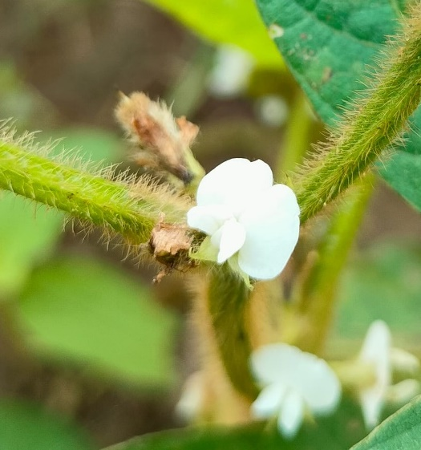 |  | 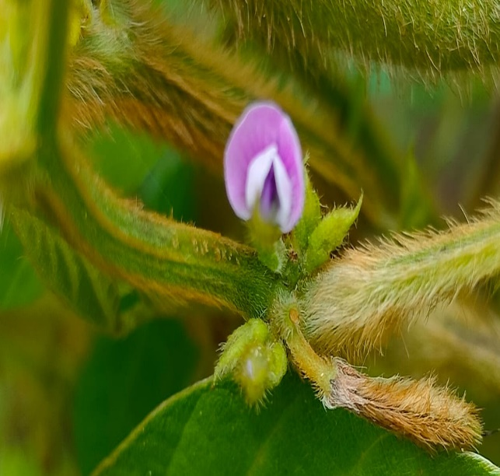
- White |  | - Purple
- Flower Colour
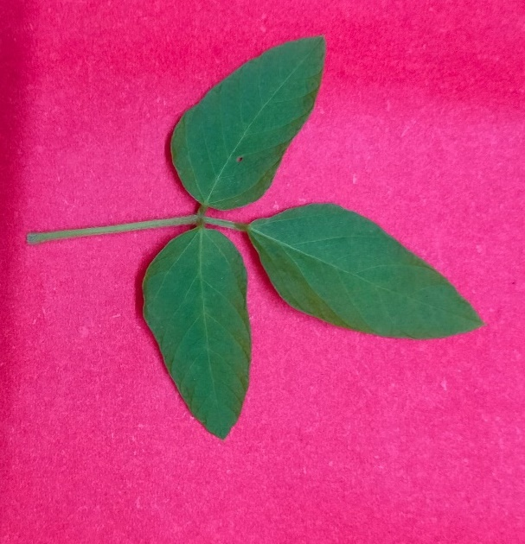 |  | 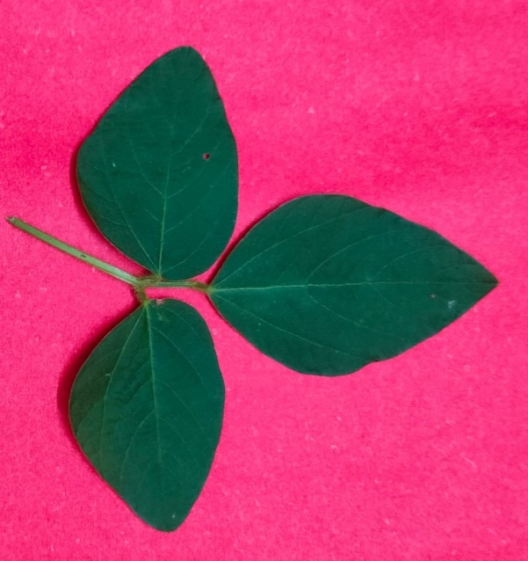
- Green |  | - Dark Green
B. Leaf Colour Intensity
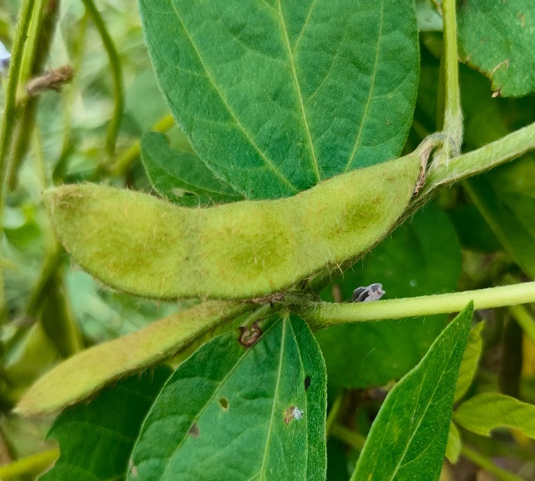 |  | 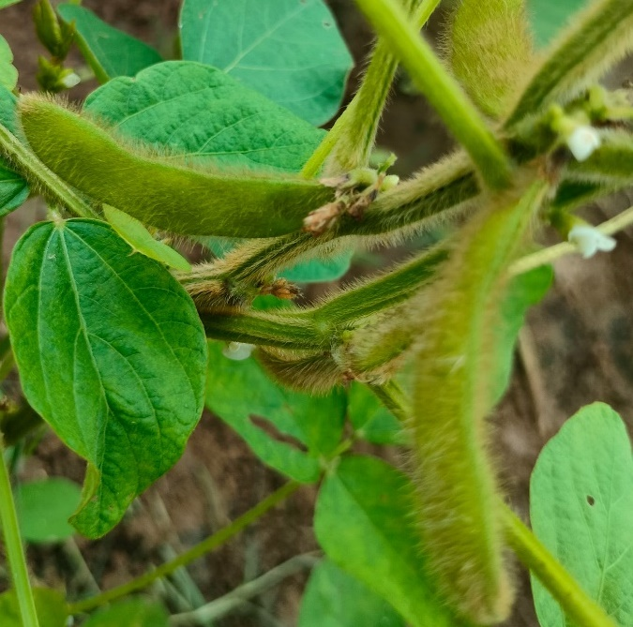
- Glabrous |  | - Pubescent (Tawny)
- Pod pubescence
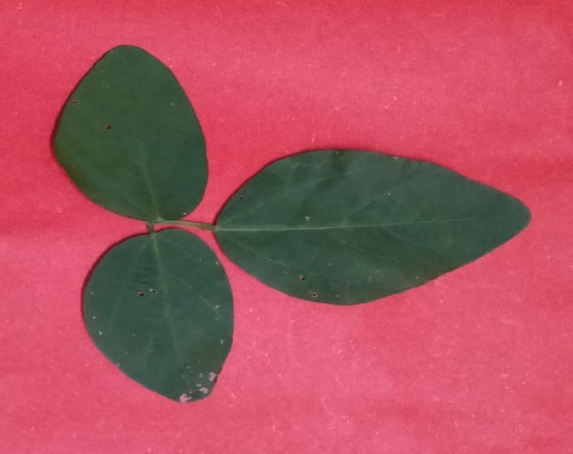 | 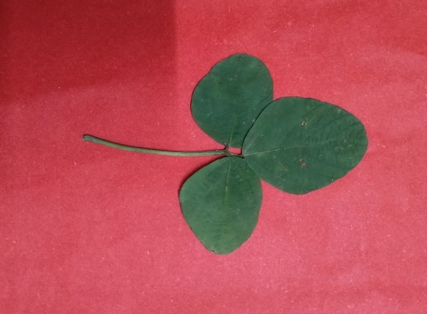 |  | 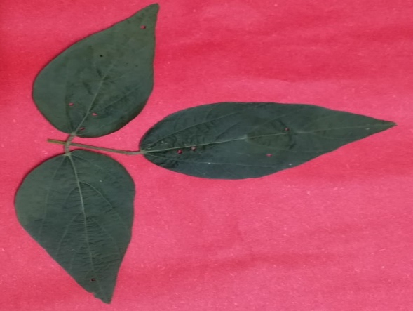
A. Pointed ovate | B. Round ovate |  | - Lanceolate
- Leaf Shape

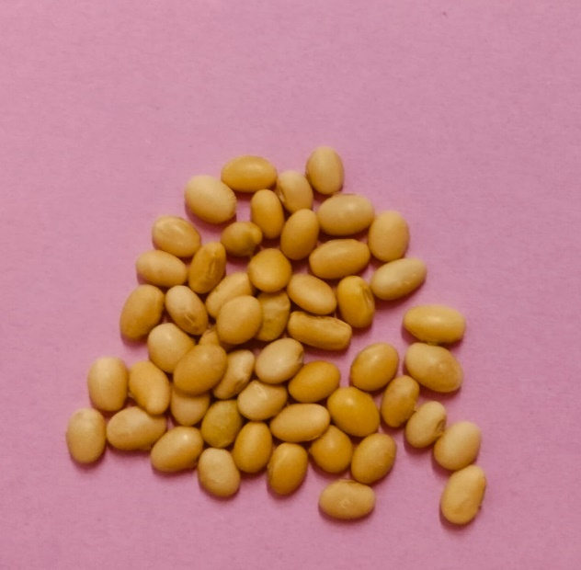 |  | 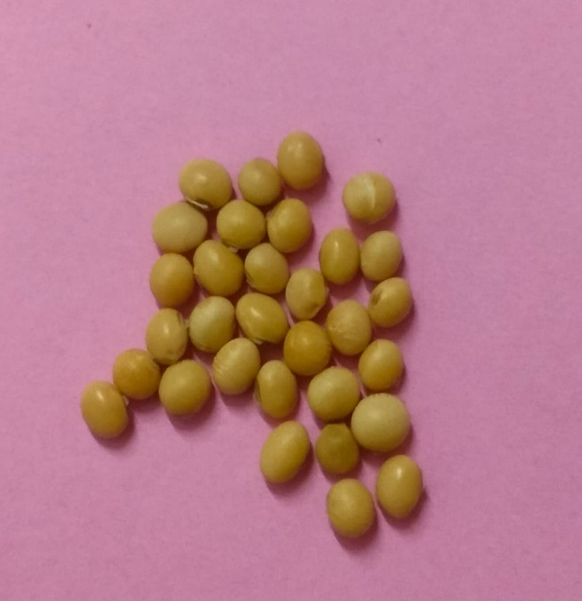
- Elliptical |  | - Spherical
- Seed shape
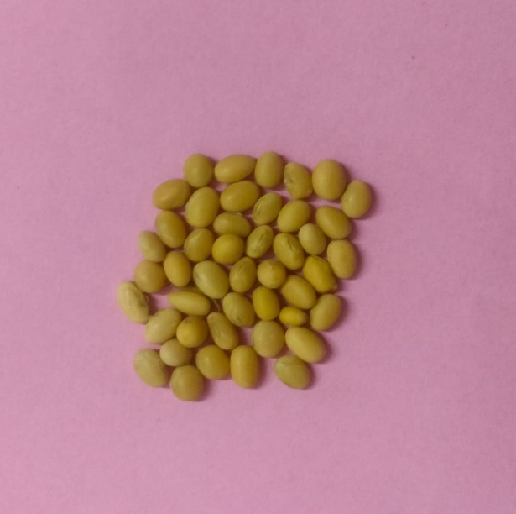 |  | 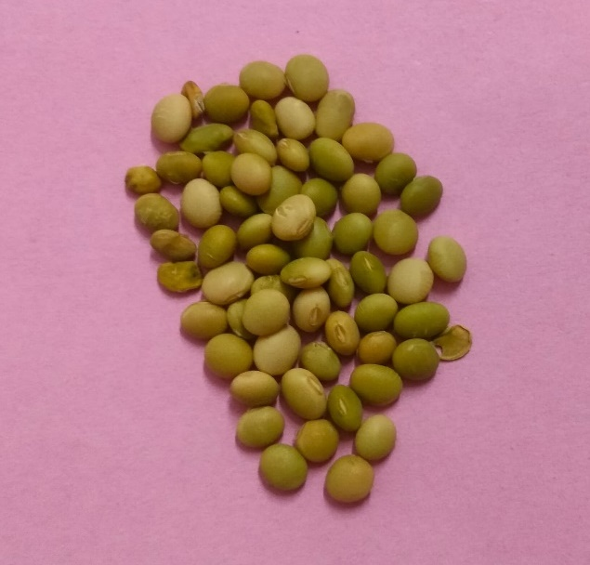
- Yellow |  | - Yellow Green
- Seed colour
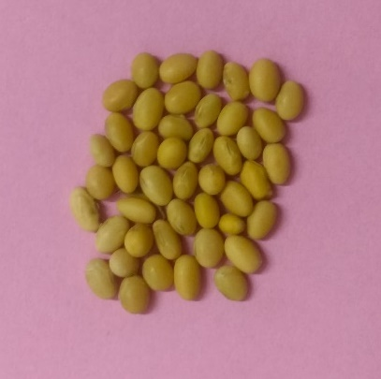 |  | 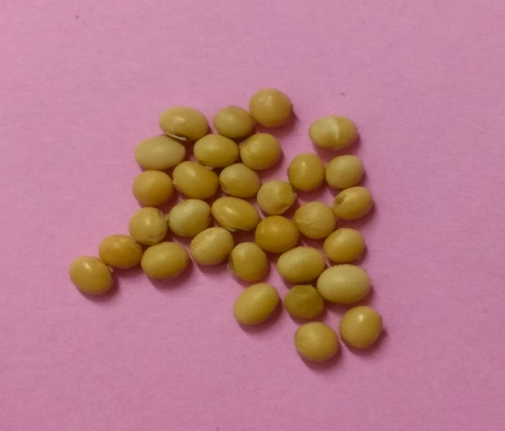
- Dull |  | - Shiny
- Seed lustre
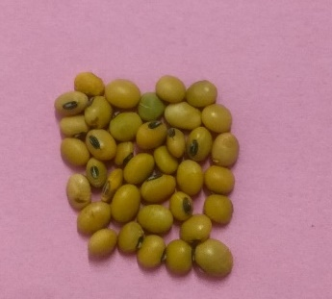 | 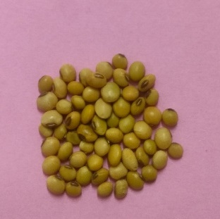 | 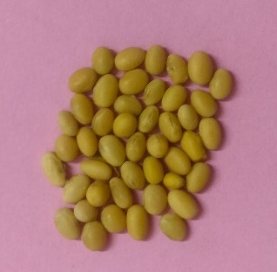 | 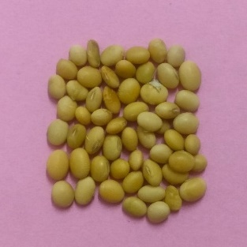
- Black | - Brown | - Yellow | - Grey
- Seed Hilum colour

Fig. 1 Distinct morphological features of soybean genotypes
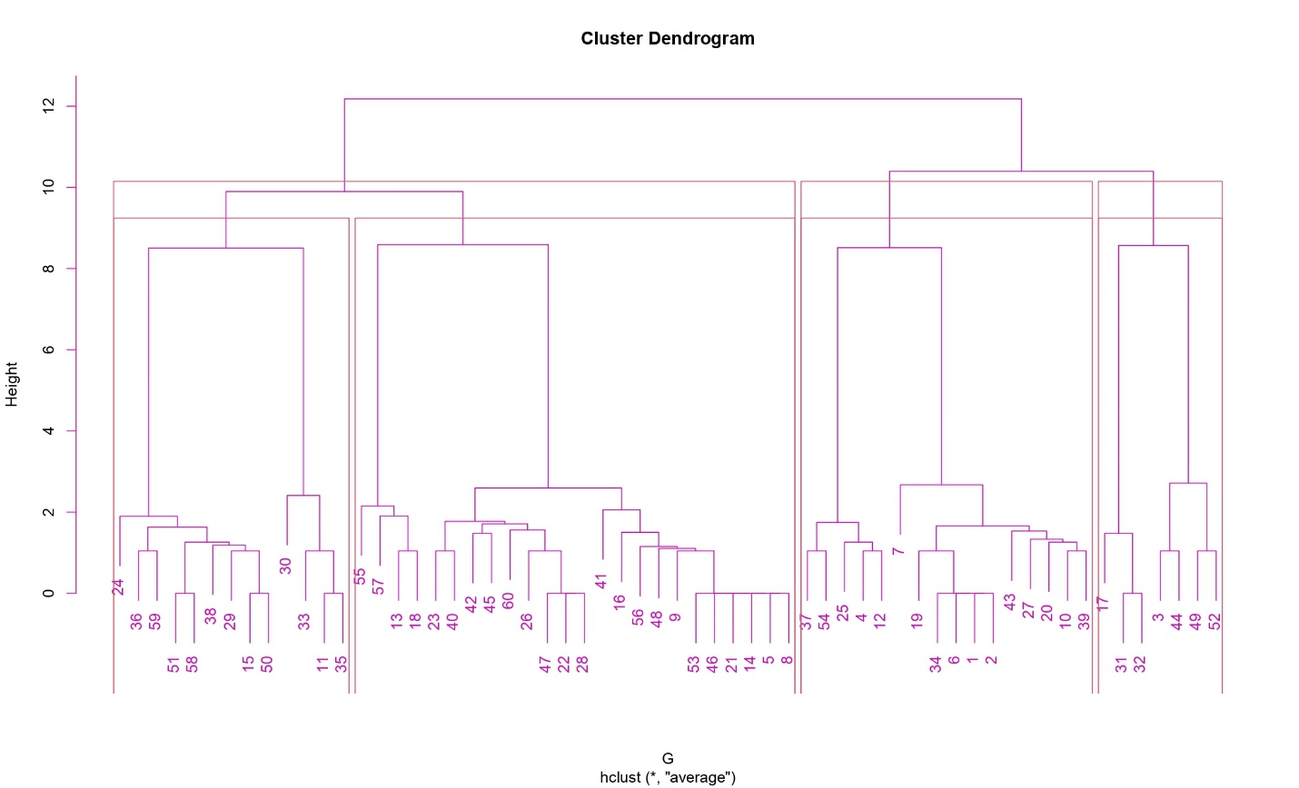
Fig. 2 Dendrogram showing relationship among soybean genotypes based upon different qualitative traits
(Note: The number denoted in Fig. 2 denotes the name of genotypes, which can be referred from Table 2.)
Conclusion
The present investigation revealed existence of considerable morphological variability among sixty soybean genotypes, indicating a broad genetic base and significant potential for selection and genetic improvement. Distinct differences were observed across eleven qualitative traits, including hypocotyl and flower colour, leaf shape and shade, pod pubescence, seed morphology, and growth habit. Such diversity is crucial for identifying unique genotype (s) that possess desirable agronomical and morphological traits. The variation recorded in hypocotyl pigmentation, flower and seed coat characteristics and plant architecture provides valuable phenotypic markers that can aid in genotype differentiation and parent selection for future breeding programmes. These findings contribute to the initial phase of genotype screening and germplasm categorization, which is essential for effective crop improvement strategies. Given the increasing need for climate-resilient and high-yielding soybean varieties, the diverse genotypes identified in this investigation offer promising material for further evaluation. To fully exploit this morphological variability, it is recommended that selected genotype (s) be subjected to molecular characterization, trait-specific screening and multi-location trials to determine their genetic stability and adaptability across environments. The integration of morphological and molecular data may enhance breeding precision and support the development of superior soybean cultivars to be tailored for diverse agro-ecological circumstances.
Disclaimer (Artificial Intelligence)
Author(s) hereby declares that no generative AI technologies such as Large Language Models (ChatGPT, COPILOT, etc.) and text-to-image generators have been used during the writing or editing of this manuscript.
References
- Amjid, M., & Üstün, R. (2025). Selection of soybean genotypes exhibiting drought resistance by assessing morphological and yield traits. Euphytica, 221(4), 44. https://doi.org/10.1007/s10681-025-03493-9
- Asati, R., Tripathi, M.K., Yadav, R.K., Tiwari, S., Chauhan, S., & Tripathi, N. et al. (2023). Morphological description of chickpea (Cicer arietanum L) genotypes using DUS characterization. Int. J. Environ. Clim. Change, 1341(9): 1321-41.
- Bender, F. R., Nagamatsu, S. T., Delamuta, J. R. M., Ribeiro, R. A., Nogueira, M. A., & Hungria, M. (2022). Genetic variation in symbiotic islands of natural variant strains of soybean Bradyrhizobium japonicum and Bradyrhizobium diazoefficiens differing in competitiveness and in the efficiency of nitrogen fixation. Microbial Genomics, 8(4). https://doi.org/10.1099/mgen.0.000795
- de Almeida Ribeiro, P. R., dos Santos, J. V., Martins da Costa, E., Lebbe, L., Silva Assis, E., Oliveira Louzada, M., Azarias Guimarães, A., Willems, A., & de Souza Moreira, F. M. (2015). Symbiotic efficiency and genetic diversity of soybean bradyrhizobia in Brazilian soils. Agriculture, Ecosystems & Environment, 212, 85–93. https://doi.org/10.1016/j.agee.2015.06.017
- Fang, C., Du, H., Wang, L., Liu, B., & Kong, F. (2024). Mechanisms underlying key agronomic traits and implications for molecular breeding in soybean. Journal of Genetics and Genomics, 51(4), 379–393. https://doi.org/10.1016/j.jgg.2023.09.004
- Gautam, Y., Mohbe, G., Bishnoi, L., Sharma, A., Mishra, R., Sharma, S., Singh, J., & Tripathi, M. K. (2025c). Genetic Diversity Assessment of Soybean Genotypes Using D² and Principal Component Analysis for Breeding Advancements. International Journal of Plant & Soil Science, 37(6), 581–593. https://doi.org/10.9734/ijpss/2025/v37i65537
- Gautam, Y., Tripathi, M. K., Mishra, R., Bishnoi, L., Mohbe, G., Singh, J., Sharma, S., Mahkul, A., & Sharma, A. (2025a). Screening of Soybean Genotypes Against Yellow Mosaic Virus Disease Under Field Conditions. Plant Cell Biotechnology and Molecular Biology, 26(7–8), 224–234. https://doi.org/10.56557/pcbmb/2025/v26i7-89449
- Gautam, Y., Tripathi, M. K., Mishra, R., Mohbe, G., Sharma, A., Sharma, S., Singh, J., & Bishnoi, L. (2025b). Genetic Evaluation and Trait Association Analysis for Yield Enhancement in Soybean (Glycine max L. Merrill). Archives of Current Research International, 25(6), 589–603. https://doi.org/10.9734/acri/2025/v25i61304
- Gupta, A., Mahajan, V., Khati, P., & Srivastva, A. K. (2010). Distinctness in Indian soybean (Glycine max) varieties using DUS characters. Indian Journal of Agricultural Sciences, 80(12), 1081.
- Jhariya, R., Tripathi, M. K., Mishra, R., Sharma, S., Sikarwar, R. S., & Solanki, R. (2025b). Investigation of Genetic Variability and Character Connotation for Yield Augmentation in Soybean (Glycine max [L.] Merrill). Journal of Experimental Agriculture International, 47(7), 85–98. https://doi.org/10.9734/jeai/2025/v47i73549
- Jhariya, R., Tripathi, M. K., Mishra, R., Sharma, S., Solanki, R., & Singh, J. (2025a). Assessment of Genetic Divergence in Soybean (Glycine max [L.] Merrill) Using Mahalanobis D² Statistics and Principal Component Analysis. Journal of Advances in Biology & Biotechnology, 28(8), 346–360. https://doi.org/10.9734/jabb/2025/v28i82711
- Jhariya, R., Tripathi, M. K., Mishra, R., Sharma, S., Solanki, R., & Sikarwar, R. S. (2025c). Appraisal of Variability Across Soybean Genotypes Based on Qualitative Traits. Journal of Biology and Nature, 17(2), 58–72. https://doi.org/10.56557/joban/2025/v17i29443
- Jhariya, R., Tripathi, M. K., Mishra, R., Solanki, R., & Sharma, S. (2025d). Assessment of Soybean (Glycine max L.) Genotypes on the Basis of Biochemical Parameters. Plant Cell Biotechnology and Molecular Biology, 26(7–8), 212–223. https://doi.org/10.56557/pcbmb/2025/v26i7-89433
- Jhariya, R., Tripathi, M. K., Mishra, R., Solanki, R., & Sharma, S. (2025e). Field Based Disease Indexing of Soybean Genotypes Against Yellow Mosaic Virus. Journal of Scientific Research and Reports, 31(6), 719–728. https://doi.org/10.9734/jsrr/2025/v31i63167
- Kachare, S., Tiwari, S., Tripathi, N., & Thakur, V. V. (2020). Assessment of genetic diversity of soybean (Glycine max) genotypes using qualitative traits and microsatellite markers. Agricultural Research, 9(1), 23–34. https://doi.org/10.1007/s40003-019-00412-y
- Karyawati, A. S., Larasati, A., Ghina, S., Sumarsono, S., & Ula, V. M. (2025). Quantitative analysis of morphometric traits affecting yield performance in diverse soybean lines (Glycine max L. Merr). Cogent Food & Agriculture, 11(1). https://doi.org/10.1080/23311932.2025.2514580
- Khadivi, A. (2023). Morphological characterization and interspecific variation among five species of Ziziphus genus to select superiors in Iran. BMC Plant Biology, 23(1), 550. https://doi.org/10.1186/s12870-023-04566-4
- Makwana, K., Tiwari, S., Tripathi, M.K., & Patel V. (2023). Morphological diversity analysis of foxtail Millet (Sateria Italica (L.) Beauv.) using qualitative and quantitative traits. Scientist, 2(2), 319-326.DOI: https://doi.org/10.5281/zenodo.7654168
- Mishra N, Tripathi MK, Tiwari S, Tripathi N, Trivedi HK. (2020). Morphological and molecular screening of soybean genotypes against yellow mosaic virus disease. Legume Research. https://doi.org/10.18805/LR-4240
- Mishra, D. N., Tripathi, M. K., & Sikarwar, R. S. (2022). Evaluation of qualitative trait based variability among soybean genotypes. The Pharma Innovation. 11(9):1115-1121.
- Mishra, N., Tripathi, M.K., Tiwari, S., Tripathi, N., Gupta, N., Sharma, A., & Solanki1 R.S. (2021b). Evaluation of diversity among soybean genotypes via yield attributing traits and SSR molecular markers. Current Journal of Applied Science and Technology, 40, 21: 9-24.
- Mishra, N., Tripathi, M.K., Tiwari, S., Tripathi, N., Sapre, S. & Ahuja, A. et al. (2021a). Cell suspension culture and in vitro screening for drought tolerance in soybean using poly-ethylene glycol. Plants.; 10;10(3):517. https://doi.org/10.3390/plants10030517
- Mishra, N., Tripathi, M.K., Tripathi, N., Tiwari, S., Gupta, N., & Sharma, A. (2021c). Validation of drought tolerance gene-linked microsatellite markers and their efficiency for diversity assessment in a set of soybean genotypes. Current Journal of Applied Science and Technology. 30,48–57. https://doi.org/10.9734/cjast/2021/v40i2531515
- Mishra, R., Shrivastava, M.K., Amrate, P.K., Sharma, S., Singh, Y., Tripathi, & M.K. (2025a). Phenotypic diversity and trait analysis of soybean recombinant inbred lines. Plant Cell Biotechnology and Molecular Biology. May 17;26(7–8):32–52. https://doi.org/10.56557/pcbmb/2025/v26i7-89345
- Mishra, R., Shrivastava, M.K., Tripathi, M.K., Amrate, P.K., Singh, Y. & Solanki R. et al. (2025b). Unravelling soybean yield potential: Exploring trait synergy, impact pathways, multidimensional patterns and biochemical insights. Plant Science Today. https://doi.org/10.14719/pst.6401
- Mishra, R., Tripathi, M. K., Shrivastava, M. K., Amrate, P. K., Singh, J., & Singh, Y. (2024e). From conventional to modern plant breeding: How far have we come? In M. K. Tripathi & R. Mishra (Eds.), Recent Advances in Plant Breeding (Vol. 1, pp. 1–20). Cornous Publications LLP. https://doi.org/10.37446/volbook102024/1-20
- Mishra, R., Tripathi, M. K., Sikarwar, R. S., Singh, Y., & Tripathi, N. (2024a). Soybean (Glycine max L. Merrill): A multipurpose legume shaping our world. Plant Cell Biotechnology and Molecular Biology, 25(3–4), 17–37. https://doi.org/10.56557/pcbmb/2024/v25i3-48643
- Mishra, R., Tripathi, M., Tripathi, N., Singh, J. & Tiwari S. (2024b). Nutritional and anti-nutritional factors in soybean. Acta Scientific Agriculture. 3: 8(11):46–63. https://doi.org/10.31080/ASAG.2024.08.1432
- Mishra, R., Tripathi, M.K., Shrivastava, M.K., & Amrate, P.K. (2024d). Genetic diversity in crop improvement: A cornerstone for sustainable agriculture and global food security. In: Tripathi MK, Tripathi N, editors. Advances in Plant Biotechnology. Cornous Publications LLP; p. 1–21. https://doi.org/https://doi.org/10.37446/volbook032024/1-21
- Mishra, R., Tripathi, M.K., Tripathi, N., Singh, J., Yadav, P.K. & Sikarwar, R.S. et al. (2024c). Breeding for major genes against drought stress in soybean. In: Tripathi MK, Tripathi N, editors. Advances in Plant Biotechnology. Cornous Publications LLP, Puducherry, India. p. 22–68. https://doi.org/https://doi.org/10.37446/volbook032024/22-68
- Namozov, F., Islamov, S., Atabaev, M., Allanov, K., Karimov, A., Khaitov, B., & Park, K. W. (2022). Agronomic Performance of Soybean with Bradyrhizobium Inoculation in Double-Cropped Farming. Agriculture, 12(6), 855. https://doi.org/10.3390/agriculture12060855
- Pachori, S., Tiwari, S., Shrivastava, M. K., Amrate, P. K., Thakur, S., & Gupta, S. (2023). Unveiling genetic diversity in soybean germplasm: A comprehensive snalysis through DUS characteristics. Electronic Journal of Plant Breeding, 14(4), 1541-1548. Retrieved from https://ejplantbreeding.org/index.php/EJPB/article/view/4498
- Paliwal, S., Tripathi, M.K., Sikarwar, R.S. (2024). Elucidating diversity of linseed (Linum usitatissimum) germplasms by applying DUS guideline to examine morphological features. Plant Cell Biotechnology & Molecular Biology. 25(5-6), 76–86. Available: https://doi.org/10.56557/pcbmb/2 024/v25i5-68702
- Pawale, S. T., Chimote, V. P., & Deshmukh, M. P. (2019). Morphological observations for various DUS characters in crossed between trypsin inhibitor free and expressing soybean (Glycine Max L. Merrill.) genotypes. Journal of Pharmacognosy and Phytochemistry, 8(6), 1082-1086.
- Rajpoot, N.S., Tripathi, M.K., Tiwari, S., Tomar, R.S., Tripathi, N., Sikarwar, R.S., & Tomar, S.S. (2022). Morphological and molecular characterization of Indian mustard germplasm lines. In book: Research Developments in Science and Technology 4, 151-165. DOI: 10.9734/bpi/rdst/v4/2307B
- Ramteke, R., & Murlidharan, P. (2012). Characterization of soybean (Glycine max) varieties as per DUS guidelines. The Indian Journal of Agricultural Sciences, 82(7), 572–577. https://doi.org/10.56093/ijas.v82i7.21637
- Ramteke, R., Kumar, V., Murlidharan, P., & Agarwal, D. K. (2010). Study on genetic variability and traits interrelationship among released soybean varieties of India (Glycine max [L.] Merrill). Electronic Journal of Plant Breeding, 1(1), 1483–1487.
- Rather, M. A., Lone, A. A., Dar, Z. A., Fayaz, S., Mir, B. A., & Peer, L. A. (2025). Comprehensive Morphological Characterization of Cowpea (Vigna unguiculata (L.) Walp.) Genotypes for Enhanced Breeding Programs in Jammu and Kashmir. Current Agriculture Research Journal, 12(3), 1257–1267. https://doi.org/10.12944/CARJ.12.3.20
- Salgotra, R. K., & Chauhan, B. S. (2023). Genetic Diversity, Conservation, and Utilization of Plant Genetic Resources. Genes, 14(1), 174. https://doi.org/10.3390/genes14010174
- Shah, K. K., Modi, B., Pandey, H. P., Subedi, A., Aryal, G., Pandey, M., & Shrestha, J. (2021). Diversified Crop Rotation: An Approach for Sustainable Agriculture Production. Advances in Agriculture, 2021, 1–9. https://doi.org/10.1155/2021/8924087
- Sharma, A., Mishra, N., Tripathi, N., Nehra, S., Singh, J., & Tiwari S. et al. (2023). Qualitative trait based variability among soybean genotypes. Acta Scientific Agriculture. 1;02–13. https://doi.org/10.31080/ASAG.2023.07.1212
- Sharma, A., Tripathi, M. K., Tiwari, S., Gupta, N., Tripathi, N., & Mishra, N. (2021). Evaluation of Soybean (Glycine max L.) Genotypes on the Basis of Biochemical Contents and Anti-oxidant Enzyme Activities. Legume Research - An International Journal. https://doi.org/10.18805/LR-4678
- Sharma, R., Sayyed, M., & Dangi, V. (2025). Morphological characterization of soybean (Glycine max L.) varieties using qualitative traits. International Journal of Advanced Biochemistry Research, 9(3), 787–789. https://doi.org/10.33545/26174693.2025.v9.i3j.4242
- Singh, R. K., Singh, C., Ambika, Chandana, B. S., Mahto, R. K., Patial, R., Gupta, A., Gahlaut, V., Gayacharan, Hamwieh, A., Upadhyaya, H. D., & Kumar, R. (2022). Exploring Chickpea Germplasm Diversity for Broadening the Genetic Base Utilizing Genomic Resourses. Frontiers in Genetics, 13. https://doi.org/10.3389/fgene.2022.905771
- Sivabharathi, R. C., Muthuswamy, A., Anandhi, K., & Karthiba, L. (2022). Characterization of soybean [Glycine max (L.) Merrill] genotypes using DUS descriptors. Electronic Journal of Plant Breeding, 13(2), 455-464. Retrieved from https://www.ejplantbreeding.org/index.php/EJPB/article/view/4306
- Thakur, R., Kumari, V., Kumari, J., Khajuria, D., Kumari, A., & Kapoor, R. (2024). DUS characterization of indigenous and exotic soybean [Glycine max (L.) Merrill] germplasm in North Western Himalayas. Himachal Journal of Agricultural Research, 190-200. Retrieved from https://www.hjar.org/index.php/hjar/article/view/172588
- Tlahig, S., Mohamed, A., Triki, T., Yahia, Y., Yehmed, J., Yahia, H., Guasmi, F., & Loumerem, M. (2025). Integrated agro-morphological and molecular characterization for progeny testing to enhance alfalfa breeding in arid regions of Tunisia. Journal of Agriculture and Food Research, 20, 101793. https://doi.org/10.1016/j.jafr.2025.101793
- Tripathi, N., Tripathi, M. K., Tiwari, S., & Payasi, D. K. (2022). Molecular breeding to overcome biotic stresses in soybean: update. Plants, 11(15), 1967. https://doi.org/10.3390/plants11151967
- Ullah, A., Akram, Z., Rasool, G., Waris, M., & Khurshid, H. (2024). Agro-morphological characterization and genetic variability assessment of soybean [Glycine max (L.) Merr.] germplasm for yield and quality traits. Euphytica, 220(4), 67. https://doi.org/10.1007/s10681-024-03322-5
- Upadhyay, S., Singh, A.K., Tripathi, M.K., Tiwari, S., & Tripathi, N. (2020). Validation of simple sequence repeats markers for charcoal rot and Rhizoctonia root rot resistance in soybean genotypes. I.J.A.B.R. 10(2),137-144.
- Yadav, R.K., Tripathi, M.K., Tiwari, S., Asati, R., Chauhan, S., Tripathi, N., Solanki, R.S., Sikarwar, R.S., & Yasin, M. (2023). DUS-based morphological profiling and categorization of chickpea (Cicer arietinum L.) genotypes. Current Journal of Applied Science and Technology, 42(40):20-36.
Yang, T., Siddique, K. H. M., & Liu, K. (2020). Cropping systems in agriculture and their impact on soil health-A review. Global Ecology and Conservation, 23, e01118.

