Research on the Mechanism by Which Digital Transformation Drives the Development of New Quality Productivity in Manufacturing

Abstract: Against the backdrop of the Fifth Industrial Revolution and deep integration of digital technologies, major industrialized countries worldwide are adopting development strategies centered on the convergence of digital and physical systems. As the "world's factory," China's manufacturing sector has long faced challenges of being large but not strong, comprehensive but not optimal. It urgently needs to overcome development bottlenecks and build new competitive advantages through digital transformation. Based on the Resource-Based View and Dynamic Capabilities Theory, this study systematically examines how digital transformation in manufacturing firms drives new quality productivity through multiple pathways. The research finds that: (1) Digital transformation reshapes the value creation model in manufacturing through three pathways—technological innovation, business model innovation, and management innovation; (2) The coupling effect among digital technologies, digital-green synergy, data processing capabilities, and core enterprise competencies is the key to fostering new quality productivity. Accordingly, this paper proposes a stepwise transformation pathway model and a differentiated policy intervention framework, offering theoretical support and practical guidance for China's strategic transition from "Made in China" to "Intelligent Manufacturing in China."
Keywords: Digital transformation; New quality productivity; Manufacturing industry

- Introduction.
The report of the 20th National Congress of the Communist Party of China proposed to "accelerate the construction of a manufacturing power" and "promote the development of manufacturing towards high-end, intelligent, and green directions," clearly identifying digital transformation as the core path for cultivating new productive forces in the manufacturing industry. Currently, a new round of technological revolution and industrial transformation is accelerating, with new-generation digital technologies such as artificial intelligence and 5G deeply integrating into the entire value chain of manufacturing. According to data from International Data Corporation (IDC), 67% of the world's top 1000 companies have included digital transformation in their core strategies (Xu et al., 2019), indicating that it has become a key choice for manufacturing enterprises. In June 2020, the General Office of the State Council issued the "Guiding Opinions on the Integration of New-Generation Information Technology and Manufacturing," requiring the acceleration of transformation in production models and enterprise forms through technological integration, thus providing support for the cultivation of new productive forces. Although the trend of transformation is clear, the manufacturing industry still faces deep-seated challenges.
Faced with complex domestic and international conditions, developing new quality productivity has become an internal requirement and a key focus for manufacturing enterprises to achieve high-end transformation and promote high-quality development. In January 2024, General Secretary Xi Jinping, during the 11th group study session of the Political Bureau of the CPC Central Committee, defined new quality productivity as "a form of advanced productive force characterized by high technology, high efficiency, and high quality, driven primarily by innovation, and moving beyond traditional models of economic growth and paths of productivity development, in line with the new development philosophy." Exploring the background, mechanisms, and pathways of the emergence of new quality productivity has become a current research focus. The emergence of new quality productivity results from the joint effect of multiple factors. Digitalization plays a crucial role in its formation and development. Especially in the manufacturing sector, digital transformation drives the continuous emergence of new quality productivity through cross-sector integration, tool innovation, technological change, and data value discovery.
Then, how can manufacturing enterprises use digital transformation to enable new quality productivity? Current academic research mainly focuses on the drivers of enterprise digital transformation, while studies on how digital transformation in manufacturing enables new quality productivity remain limited. To address this gap, this study draws on dynamic capabilities theory and the resource-based view to explore the mechanisms through which digital transformation influences new quality productivity in manufacturing. The findings can help manufacturing enterprises deepen their theoretical understanding. They also offer theoretical support and practical implementation pathways for enterprises to adapt to technological and market changes and cultivate new quality productivity.
- Literature Review.
  - Digital transformation
Traditional views define digital transformation in two core ways: first, by formulating an information technology strategy that covers all business areas of a firm; second, by using digital technologies to improve the efficiency of organizational processes. Another definition highlights its role in business model innovation, suggesting that digital transformation means optimizing products and services, improving processes, and enhancing relationships with customers and suppliers through digital technologies. In the manufacturing context, Pan and Zhao propose that digital transformation involves the deep integration of the internet with development concepts, production models, business models, and profit models. It creates combined economic effects by blurring industry boundaries and reshaping competitive and cooperative relationships. This is specifically reflected in integrated innovation activities by manufacturing firms at the technological, operational, and market levels. Zhao and Peng define it from a value chain perspective as "a symbiotic phenomenon of deconstructing the physical value chain and cross-chain reorganization of the virtual value chain." In terms of evolution, Yan Zichun et al. (2021) divide digital transformation into three stages: the period of digital technology innovation and development, the period of creating business value and industrial growth through digital technologies, and the period of rapid development driven by deep integration between industries and digitalization. The conceptual framework of digital transformation is shown in Figure 1.
Based on definitions in the literature and the focus of this study, digital transformation in manufacturing enterprises is defined as the process of transforming value-creation activities—such as production, R&D, sales, and services—through integration of internal and external resources, enabled by new-generation information technologies like mobile internet, cloud computing, the Internet of Things (IoT), and big data, aiming for intelligence, sustainability, and innovation.
As shown in Figure 1, the drivers of digital transformation fall into two broad categories: external and internal. External drivers include multiple dimensions such as environment, technology, and policy. An Xiaopeng (2019) pointed out that the evolution of internet technologies has created new supply-demand mismatches for enterprises. Internal drivers relate to enterprise development needs. Wang Zhitao et al. (2022) argued that strategic transformation becomes necessary when a firm’s current strategy does not align with its internal conditions or when resource utilization is suboptimal, to achieve optimal resource allocation.
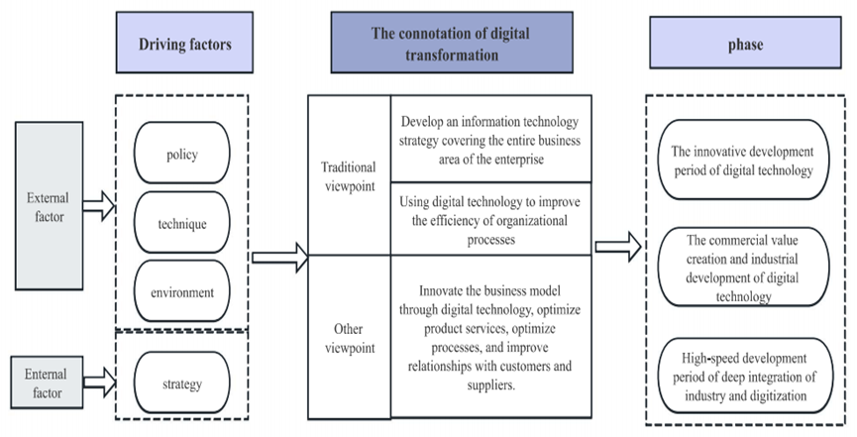
Fig.1 The connotation of digital transformation
  - New mass productivity
New quality productivity, as an advanced form of productivity emerging in the new era, requires a clear understanding of its theoretical foundations and development trajectory to grasp its essential characteristics. Since President Xi Jinping introduced the important concept of "new quality productivity," scholars have conducted systematic explorations into its meaning. Among them, Lu Jiang et al. (2024), responding to this issue of the times, constructed a multidimensional comprehensive evaluation framework. They clearly defined new quality productivity as an integrated system shaped by the interaction and joint support of three core dimensions: technological empowerment, green transformation, and digital integration. This highlights the symbiotic relationship among technological innovation, ecological orientation, and digital transformation in upgrading productivity.
In terms of characteristic analysis, scholars have reached a multi-perspective consensus. Li Xiaohua (2023) focuses on how technological change reshapes production methods. He points out that digitization and green development are clear markers distinguishing new quality productivity from traditional forms. Its core driving force comes from continuous innovation and breakthroughs in high-tech fields. Jiang Yongmu and Xue Weiran (2024) approach from the perspective of value orientation. They emphasize that high-quality development is both the core goal and direct purpose of new quality productivity, reflecting the intrinsic alignment between productivity advancement and economic transformation. Su Xijian and Sun Jiuyun shift the focus to industrial carriers. They argue that strategic emerging industries and future industries are key areas for new quality productivity. This highlights the supporting role and forward-looking nature of industrial structure upgrading in driving productivity leaps.
Compared to traditional forms of productivity, the advancement of new quality productivity is not limited to partial optimization of production factors or simple iterative application of a single technology. Instead, it is a systemic transformation driven by the joint effect of three elements: revolutionary technological breakthroughs that guide the direction, innovative allocation of production factors that provide support, and deep transformation and upgrading of industrial systems that inject momentum. This represents an advanced and higher-level direction for productivity development.
- Theoretical basis.
  - Dynamic capability theory
Teece's dynamic capabilities theory suggests that organizations need the strategic ability to quickly integrate internal and external resources and seize market opportunities to achieve sustained competitive advantage. In short, this theory emphasizes that firms must adapt to external changes through resource reconfiguration and strategic decision-making. The core elements of the theory are threefold. First, environmental adaptability, which means responding quickly and flexibly to market trends and technological changes. Second, organizational flexibility requires efficient internal change through process reengineering, resource reallocation, and workforce adjustments. Third, innovation drive, which focuses on continuous improvement of products, services, and processes to maintain a competitive advantage.
  - Resource-based theory
The Resource-Based View (RBV) was established by Birger Wernerfelt in his seminal 1984 paper "A Resource-Based View of the Firm," published in the Strategic Management Journal. This theory broke from traditional competitive analysis by proposing that differences in firm performance stem from internal resource endowments. Barney made a key contribution to this theory by developing a framework (VRIN/VRIO) to identify strategic resources and define the conditions for sustainable competitive advantage. The core argument is that only resources that are valuable, rare, inimitable, and non-substitutable (or organizationally supported to exploit these traits) can serve as the source of a firm's competitive advantage.
- Mechanism analysis.
Digital transformation has a significant positive impact on the development of new quality productivity in firms, and scholars have reached multidimensional conclusions. Li Yating (2024) and Zhang Huiheng with Zhang Weicheng (2024) both confirm this positive effect. The latter further indicates that the mechanism lies in enhancing managerial capability and improving information transparency. Based on dynamic capabilities theory, Yang Yin and Chen Feier (2024) find that digital transformation drives new quality productivity by strengthening firms’ abilities in digital sensing, resource integration, and organizational change. Li Zicheng, Wang Jue, and colleagues (2024) highlight the critical role of data as a production factor in advancing new quality productivity. At the supply chain level, Wang Ying and Hu Hanhui (2024) show that digital transformation boosts new quality productivity by improving supply chain efficiency and increasing supply chain influence. Shi Jin, Xu Minghao, and colleagues (2024) further reveal a positive spillover effect: the digital progress of customer firms positively impacts the new quality productivity of their suppliers. In addition, Fu Dongping and colleagues (2025) point out that improving digital infrastructure, advancing digital finance, and fostering digital industrial clusters through urban data trading platforms can help firms achieve a qualitative leap in productivity.
Overall, enterprise digital transformation drives the development of strategic emerging industries and future industries through three synergistic pathways—technological innovation, business model innovation, and management innovation—thereby fostering the emergence of new quality productivity. Specifically, digital transformation can improve operational efficiency, enhance performance and green innovation output, and promote the upgrading of human capital toward higher-end and more specialized profiles. Its impact extends beyond the firm, generating external spillovers through supply chain networks and peer effects. In terms of mechanisms, digital transformation supports the cultivation of new quality productivity by increasing investment in innovation factors, advancing talent ecosystems, and strengthening strategic alignment. This aligns with the qualitative changes required in workers, means of labor, objects of labor, and their configurations under new quality productivity. In turn, new quality productivity promotes high-quality economic development through technological application, reshaping of growth drivers, and industrial advancement, driving transformations in quality, efficiency, and momentum. As shown in Figure 2, for manufacturing firms, an evaluation system for new quality productivity can be constructed along the dimensions of intelligence, green development, and innovation. The heterogeneous characteristics of this new quality development hold significant practical implications for high-quality industrial advancement.
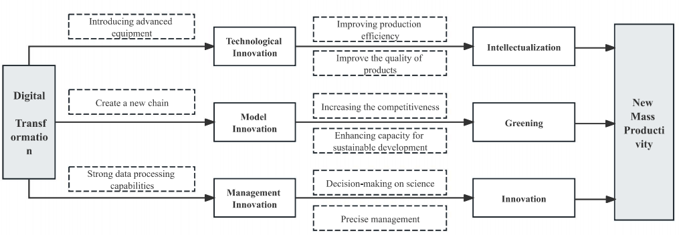
Fig.2 The mechanism of digital transformation on new productivity
- Conclusions.
Enterprise digital transformation drives the formation and development of new quality productivity through the combined effects of technological innovation, business model innovation, and management innovation. Based on this mechanism, policy frameworks to promote the advancement of new quality productivity can be systematically developed from these three dimensions.
First, strengthen technological innovation and enhance human-machine collaboration. To achieve comprehensive digital transformation, manufacturing enterprises need to build intelligent production systems supported by core technologies such as the Internet of Things (IoT), big data analytics, and cloud computing. On this basis, they should deepen the integration of digital, intelligent, and automated technologies to drive systematic restructuring of production processes. By connecting data across the entire chain—from customer demand to design and R&D to manufacturing—enterprises can shift from standardized production to large-scale personalized customization. Customers can directly participate in product design, while production systems flexibly adjust process parameters based on real-time order data to quickly meet customized demands. This transformation promotes the reconfiguration of production factors and the evolution of production models, providing core momentum for the emergence of new quality productivity.
Second, cultivating a new industrial ecosystem: digital-physical integration and digital-green synergy. At the supply chain level, digital transformation provides core technological support for building green supply chains in the manufacturing industry. By integrating IoT sensing devices, big data analytics platforms, and blockchain-based verification systems, enterprises promote deep integration between digital technologies and green, low-carbon industries. This drives a shift in production models toward green smart manufacturing, ultimately forming green new quality productivity characterized by efficient resource recycling and precise carbon emission control. Digital and intelligent upgrades in production processes enhance the flexibility and efficiency of production systems. At the same time, the development of digital green supply chains promotes low-carbon industrial transformation. Together, these two aspects constitute a key supporting dimension through which digital transformation drives the development of new quality productivity in manufacturing.
Third, strengthening data processing and cultivating innovative talent. For manufacturing enterprises, enhancing data processing capability is not merely a technical upgrade. It is a systematic effort that includes data governance, technology application, and organizational change. At the level of data governance, firms need to establish a full lifecycle management system covering standardized data collection, secure data storage, and regulated data sharing. This helps address issues such as "data silos" and "data redundancy," and reshapes business processes and performance evaluation systems around "data-driven decision-making." The core goal of this systematic effort is to overcome the limitations of experience-based decisions through data empowerment. Ultimately, it aims to establish a scientific decision-making approach across all business processes, providing sustained momentum for the development of innovation-driven new quality productivity.
- References.
[1] Kraus, S., Jones, P., Kailer, N., Weinmann, A., Chaparro-Banegas, N., & Roig-Tierno, N. (2021). Digital transformation: An overview of the current state of the art of research. Sage Open, 11(3), 21582440211047576.
[2] Zaoui, F., & Souissi, N. (2020). Roadmap for digital transformation: A literature review. Procedia Computer Science, 175, 621-628.
[3] Matt, C., Hess, T., & Benlian, A. (2015). Digital transformation strategies. Business & information systems engineering, 57(5), 339-343.
[4] Tabrizi, B., Lam, E., Girard, K., & Irvin, V. (2019). Digital transformation is not about technology. Harvard business review, 13(March), 1-6.
[5] Henriette, E., Feki, M., & Boughzala, I. (2016). Digital transformation challenges.
[6] Gong, C., & Ribiere, V. (2021). Develo** a unified definition of digital transformation. Technovation, 102, 102217.
[7] Oliveira, K. K. D. S., & De Souza, R. A. (2022). Digital transformation towards education 4.0. Informatics in Education, 21(2), 283-309.
[8] Istvan, R. L. (1992). A new productivity paradigm for competitive advantage. Strategic Management Journal, 13(7), 525-537.
[9] Lieberman, M. B., & Asaba, S. (2006). Why do firms imitate each other?. Academy of management review, 31(2), 366-385.
[10] Yin, Z., Gong, X., Guo, P., & Wu, T. (2019). What drives entrepreneurship in digital economy? Evidence from China. Economic Modelling, 82, 66-73.

