**Original Research Article**

**Development of *Lactobacillus gasseri* based Nanoemulsion, Characterization, and its Potential Biomedical Application**

**ABSTRACT**

**Aims:** This study aimed to synthesize silver nanoparticles (AgNPs) using *Lactobacillus gasseri* and to evaluate their antimicrobial, anti-biofilm, and cytotoxic properties after formulation into a Carbopol-based nanoemulsion. The goal was to assess their potential as safe and effective agents for biomedical applications, particularly for use in wound healing and medical device coatings.

**Study design:** This was an experimental laboratory-based study involving synthesis, physicochemical characterization, and biological evaluation of silver nanoparticles.

**Place and Duration of Study:** Conducted at the Department of Biotechnology, Centre for Bioscience and Nanoscience Research from March to April 2025.

**Methodology:**  
Silver nanoparticles were synthesized using the probiotic strain *Lactobacillus gasseri* through a green synthesis approach and embedded into Carbopol 940 hydrogel. Characterization was performed using UV-Visible spectroscopy (200–600 nm), FTIR spectroscopy (4000–400 cm⁻¹), and FESEM, confirming the formation of spherical nanoparticles ranging from 60 to 140 nm. Anti-biofilm activity was assessed via crystal violet assay against bacterial biofilms at varying nanoparticle concentrations (10–50 µg/mL). Cytotoxicity was tested using the MTT assay on mammalian cells across concentrations ranging from 2 to 10 µg/mL.

**Results:**  
Biofilm inhibition increased in a dose-dependent manner, with maximum inhibition of 55.96% observed at 50 µg/mL (OD 0.181 vs. control OD 0.411). Cytotoxicity analysis revealed a mild reduction in cell viability, with values ranging from 11.26% to 19.56% as concentration increased from 2 µg/mL to 10 µg/mL. The results suggest that biosynthesized AgNPs are both biologically active and relatively safe at lower concentrations. Statistical analysis confirmed a significant inverse relationship between nanoparticle concentration and cell viability.

***Keywords****: Nanoemulsion, Lactobacillus gasseri, Antimicrobial activity, Anti-biofilm, Cell viability, Biocompatibility, Carbopol hydrogel*

1. **INTRODUCTION**

Green nanotechnology has evolved as a potential substitute to the traditional chemical and physical approaches in synthesis of nanoparticles, especially in developing the nanoparticles in biomedical applications in recent years. Silver nanoparticles (AgNPs) in particular, have received a lot of attention as they possess broad-spectrum of antimicrobial, antibiofilm, antioxidant, and cytotoxic effects among many others besides the varied nanostructures (Gunyakti *et al* 2021). Nevertheless, conventional synthesis methods most of the time utilize toxic reagents and extreme reaction conditions that restrain their biocompatibility and clinical application. To counter these shortcomings biological synthesis by probiotic organisms has been increasingly considered, which can provide all benefits in terms of being environmentally sustainable, low cost and non-toxic production of nanoparticles.

*Lactobacillus gasseri* is a famous probiotic strain to be studied well regarding its health effects and production of secondary metabolites including peptides, organic acids, and exopolysaccharides. These natural bioactive chemicals may serve as reducing and stabilizing chemicals in reaction of metal nanoparticles (Umekar *et al* 2025). The second technique involves the integration of the nanoparticles synthesized in a living system into nanoemulsion and causes even greater improvement of their rather poor solubility, dispersibility, and efficacy of therapeutic application (Srinivasan *et al* 2023). The high surface area and small droplet size will enable nanoemulsions to be used in drug delivery, as well as in antimicrobial applications and provide a desirable absorption, release, interaction with biological membranes.

The silver nanoemulsions prepared by probiotic metabolites have a different value of biomedical relevance because of their multipurpose functionality. Besides this antimicrobial and antibiofilm ability, they can also be tested on their cytotoxicity that can be used in cancer treatment and in wound healing. Characterization of material should be done properly using techniques as UV-visible spectroscopy, FTIR, FESEM and this will provide evidence of synthesis process and the structural and chemical attributes of the nanoemulsion. Moreover, in-vitro experiments involving mammalian cell lines, including an example of L929 fibroblasts, can give invaluable information regarding the biocompatibility and safety profile of the formulation (McClements, 2013). Thus, the purpose of the current study is to synthesize silver nanoemulsion with the cell-free extracts of *Lactobacillus gasseri,* characterize it by applying different physicochemical methods and determine its suitability in biomedical biomedicine such as antimicrobial, antibiofilm, and cytotoxic properties.

1. **MATERIALS AND METHODS**
   1. **Collection and Isolation of *Lactobacillus***

*Lactobacillus gasseri* strain employed in this study was obtained at SykroMax Biotech Pvt. Ltd., Chennai, India. The culture was serially diluted upto 10-5. Morphologically similar colonies of *Lactobacillus* was inoculated in aseptic manner on to de Man, Rogosa, and Sharpe agar plates (MRS) to confirm viability and purity by incubation of agar plates at 37o C for 24 - 48 hours under anaerobic conditions. Clear colonies were picked and streaked into MRS broth to sub cultured and propagate further. The actively growing cultures were stored in MRS broth at 4o C

* 1. **Silver Nanoemulsion Biosynthesis**

Fresh MRS broth was inoculated with an active culture of *Lactobacillus gasseri* and incubated in a static environment at 37oC for 24 hours. Following incubation, cell-free extract was extracted by centrifuging the culture at 5000 rpm for 5 minutes. The resulting supernatant, which comprised the extracellular metabolites, was retrieved gently and served as the biological reducing and stabilizing agent during nanoparticle synthesis.

To biosynthesize silver nanoparticles, 10 mL of a 1 mM silver nitrate (AgNO3) solution was added to 10 mL of *L. gasseri* supernatant to an equal volume and then incubated in the dark at room temperature. The presence of silver nanoparticles was determined by visual color change that occurred, where it was observed that the color of silver nanoparticles solution changed upon the reduction of silver ions through the microbial metabolites (Umekar *et al* 2025).

To prepare the nanoemulsion, 0.5% Carbopol 940 was added to the AgNP solution to enhance the viscosity, stability, and consistency of the mixture. Carbopol has been demonstrated to improve the long term stability and homogeneity of nanoparticle-based emulsions (McClements, 2013). The mixture was continuously agitated till a homogenous silver nanoemulsion was attained.

* 1. **Characterization of Silver Nanoemulsion**

**2.3.1 U.V-Visible Spectroscopy**

UV Vis spectroscopy (Labtronics LT291 spectrophotometer) monitored the formation and optical stability of silver nanoparticles in the nano-emulsion. The spectral scan was recorded between 200 and 600 nm to determine the surface plasmon resonance (SPR) wavelength peak that signals nanoparticle production (Alim-Al-Razy *et al* 2020). The stability of nanoparticles in time was measured with the help of the absorbance intensity.

**2.3.2 Fourier Transform Infrared Spectroscopy (FTIR)**

The FTIR analysis was done to determine the functional groups in the cell-free extract and also identifying the biomolecules that reduced and stabilized silver nanoparticles. A SHIMADZU FTIR spectrometer was employed to record the spectra between 4000 and 400 cm -1 (Hu *et al* 2020). These peaks were interpreted to estimate the occurrence of proteins, carbohydrates and other metabolites in the synthesis of nanoparticles.

**2.3.3 Field Emission Scanning Electron Microscope (FESEM)**

Field Emission Scanning Electron Microscopy (FESEM) was used to study morphological properties and surface structure of the synthesized silver nanoemulsion using ZEISS Sigma equipment. Gold coating was performed prior to imaging, and micrographs were taken at different magnifications to ascertain particle shape, surface texture, and aggregation patterns (Ang *et al* 2013).

* 1. **Antibacterial and Antifungal Activity**

The antimicrobial activity of the synthesized silver nanoemulsion was evaluated using the agar well diffusion method against selected bacterial and fungal pathogens.

**2.4.1 Antibacterial Activity**

Fresh bacterial cultures of *Escherichia coli*, *Shigella dysenteriae*, *Salmonella typhi*, and *Klebsiella pneumoniae* were used as test organisms (Jesteena *et al.,* 2016). Mueller-Hinton agar (MHA) was prepared by dissolving 39 g of the medium in 1000mL of distilled water, followed by sterilization at 121°C for 15 minutes. Once cooled and solidified in sterile Petri dishes, 70µL of each bacterial suspension was inoculated onto the surface and uniformly spread using sterile cotton swabs. Wells of 6mm diameter were made using a sterile cork borer. A 50µL aliquot of the silver nanoemulsion was added into each well. Dimethyl sulfoxide (DMSO) served as the negative control, and Vancomycin (VA-30mcg) was used as the positive control. The plates were incubated at 37°C for 24 hours. Antibacterial activity was assessed by measuring the zone of inhibition (excluding the diameter of the well) in millimeters using an antibiotic zone scale (HiMedia, India).

**2.4.2 Antifungal Activity**

Antifungal activity was tested against *Aspergillus niger* and *Aspergillus flavus* using malt agar medium. Malt agar was prepared by dissolving 45g of medium in 1000mL of distilled water and autoclaved at 121°C for 15 minutes (Jesteena *et al* 2016). The medium was poured into Petri plates and allowed to solidify. Each plate was swabbed with 70µL of actively growing fungal culture using a sterile cotton swab. Wells of 6 mm diameter were made with a sterile cork borer, and 50µL of the silver nanoemulsion was added to the respective wells. Fluconazole served as the positive control, and DMSO as the negative control. The plates were incubated at 30°C for 3 to 5 days. Following incubation, antifungal activity was determined by measuring the zone of inhibition in millimetres.

* 1. **Antibiofilm assay**

To assess the antibiofilm potential of the synthesized silver nanoemulsion on *Shigella dysenteriae*, crystal violet microtiter plate assay was performed as already reported by (Haney *et al* 2021) with minor modifications. An overnight culture of *S. dysenteriae* was incubated in Luria-Bertani (LB) broth at 37o C with shaking. After washing, 100 uL of bacterial suspension was added to each well of a sterile flat-bottom 96-well microtiter plate and incubated at 37 degrees Celsius, for 24 hours under static conditions to facilitate biofilm development. After incubation, planktonic cells and media were carefully discarded to eliminate detached cells. The wells were subsequently stained with a 0.1% solution of crystal violet and incubated at room temperature for 10-15 minutes. The wells were then rinsed 3-4 times in ethanol to eliminate excess stain. This plate was inverted, blotted on absorbent paper towels to remove excess liquid and dried thoroughly at room temperature. Solubilisation of the retained crystal violet was performed by adding 125 µL of 30% acetic acid per well in the experiment to be quantified. The absorbance was determined by reading 550nm of the incubated solution with the use of micro plate reader after 10 to 15 minutes by Robonik, India. The antibiofilm efficacy of the nanoemulsion was resolved by measuring the reduction in absorbance compared to controls that were untreated.

* 1. **Assessment of Biocompatibility on L929 Cells Using MTT Assay**

The cytotoxicity and biocompatibility of the synthesized silver nanoemulsion were evaluated using the MTT (3-(4,5-dimethylthiazol-2-yl)-2,5-diphenyltetrazolium bromide assay on L929 fibroblast cell lines (Rajesh *et al* 2025). The L929 cell line was obtained from the National Centre for Cell Science (NCCS), Pune, India, and maintained at the Centre for Bioscience and Nanoscience Research Laboratory, Eachanari, Coimbatore, Tamil Nadu. The cells were cultured in Dulbecco’s Modified Eagle Medium (DMEM) supplemented with sodium carbonate, glucose, and 10% bovine serum albumin (BSA). Cultures were maintained in a CO₂ incubator under controlled conditions of pH 7.0–7.5, 37°C temperature, and 70–80% relative humidity. Cell growth and morphology were monitored regularly using an inverted phase-contrast microscope.

For the MTT assay, cells were seeded into 96-well plates at a density sufficient to form a monolayer and allowed to adhere for 24 hours in a 5% CO₂ incubator. After adhesion, the cells were treated with varying concentrations of the silver nanoemulsion and incubated for an additional 24 hours. Experimental controls included untreated cells (negative control), DMSO (blank), and Doxorubicin at 12.5µg/mL as the standard positive control. Following treatment, the medium was removed, and 20µL of MTT solution (5mg/mL in PBS) was added to each well. The plate was gently mixed and incubated at 37°C for 4 hours to allow formazan crystal formation. After incubation, 100µL of DMSO was added to solubilize the crystals, and the absorbance was measured at 570nm using a microplate ELISA reader (Robonik, India).

1. **RESULT AND DISCUSSION**
   1. **Sub culturing and Viability Assessment of *Lactobacillus gasseri***

In this study, the strain *Lactobacillus gasseri* was selected, which was supplied by SykroMax Biotech Pvt. Ltd., Chennai. The strain was plated to ensure its viability and suitability through the serial dilution method to be utilized further in probiotic applications. The cultured colonies on MRS agar were observed with visual inspection, displaying a unique round colony phenotype with off-white to cream pigmentation, which is characteristic in previous studies of lactic acid bacteria (Heeney *et al* 2018) Out of the serial dilutions examined, the 10-2 dilution plate exhibited the best colony growth amounting to a countable number of colony-forming units, (CFUs) hence the choice to proceed with further subculture. There was a measure of stability in CFU/mL of replicate counts which demonstrated high microbial viability and cultural stability. This reproducibility is critical in probiotic formulation research, as noted by Wang *et al* (2020), who pointed out that standardized mounts of microbes are needed to design effective probiotic products.

The effective cultivation of *L. gasseri* at 37OC also confirmed that it is a mesophilic species capable of adapting to conditions resembling those in the gastrointestinal tract of humans. This temperature ensures not only the best growth but also preservation of some important physiological characteristics that are relevant to probiotic functionality, such as acid and bile salt tolerance (Mu *et al* 2018). The results could confirm that the strain is still biologically active and phenotypically stable in customary laboratory conditions, which makes it an ideal prospect in downstream applications including nanoemulsion fabrication or biomedical analysis.

* 1. **Synthesis of silver nanoemulsion**

Silver nanoparticle synthesis (AgNPs) was carried out through a cell-free supernatant of *Lactobacillus gasseri* prepared in MRS broth at 37 o C in 24-48 hours. After incubation, the phosphate buffer was used to extract the bioactive metabolites that were centrifuged to obtain a clear supernatant. The bacteria cells and supernatant were dipped in 1mM silver nitrate (AgNO3) to provide nanoparticle formation. Examples of microbial-based studies of nanoparticles also confirmed that the visual darkening of the solution by changing to a pale yellow to brown color was an indication of successful transformation of Ag ions to silver nanoparticles (Ahmed *et al* 2016; Singh *et al* 2018). Such a metamorphosis is explained by microbial metabolites that play the roles of natural reducing and capping agents.

In order to enhance the stability of the resulting formulation, Carbopol 940 (an appropriate stabilizer), weight 0.5% in the AgNP solution, was added to create a viscous silver nanoemulsion. Stability of this gel-based approach was better than that of suspension of unmodified nanoparticles, which had evident sedimentation in 24 hours. Carbopol-stabilized emulsion exhibited the similar distribution of the particles particles due to the hydrogen bonding and the electrostatic forces between the chains of the polymer and the surface of the nanoparticle. Such interactions are reported to increase the formulation stability of biomedical gels (Hajipour *et al* 2012). The control experiment, where Carbopol was dispersed in distilled water in absence of AgNO3 and *L. gasseri* extracts did not change color or yield any nanoparticle reflects that the nanoparticle synthesis was of biological nature. It confirms that *L. gasseri* metabolites play a key role in the reduction of silver ions and strengthens the ideology of this green synthesis method which is eco-friendly, as well as bio-compatible. The probiotics-mediated biosynthetic pathway is distinctive in that it is less toxic, environmentally friendly, and non-toxic to the body, aptitude mandatory to generate therapeutic products (Rai *et al* 2016). Moreover, *L. gasseri* species have been documented to produce bio-reductive compounds that can be used to generate nanoparticles at ambient conditions (Hajipour *et al* 2012).

* 1. **Characterization of the synthesized silver nanocomposite**

The successful biosynthesis of silver nanoparticles (AgNPs) was primarily confirmed through UV-Visible spectroscopy. The UV-Vis spectrum of the synthesized nanocomposite revealed a characteristic absorption peak in the range of 400–420 nm, corresponding to the surface plasmon resonance (SPR) of silver nanoparticles. This optical phenomenon arises due to the collective oscillation of conduction electrons on the nanoparticle surface when excited by light, and is a signature feature of AgNP formation. The broad nature of the SPR band indicated a degree of polydispersity in particle size, which is typical in biologically synthesized nanoparticles due to varying reducing and capping conditions. Additional minor absorption bands were noted in the 240–260 nm range, which are commonly attributed to aromatic amino acids and proteins present in the *L. gasseri* supernatant. These biomolecules likely acted as both reducing and capping agents, facilitating the transformation of Ag⁺ ions to metallic Ag⁰ and simultaneously stabilizing the nanoparticles (Ahmed *et al* 2016; Song & Kim, 2009). The incorporation of Carbopol 940, a high molecular weight cross-linked polyacrylic acid, significantly influenced the optical behaviour and physical stability of the nanocomposite. Notably, the SPR peak of the Carbopol-modified AgNPs showed a slight redshift and enhanced absorbance intensity, implying more efficient nanoparticle dispersion within the polymeric matrix. This shift is believed to result from strong interactions between silver nanoparticles and the functional groups of Carbopol, particularly hydroxyl and carboxylic acid moieties. These groups can form hydrogen bonds and electrostatic interactions with the nanoparticle surface, thereby reducing aggregation and enhancing colloidal stability (Sarfraz *et al* 2022). Moreover, the UV-Vis spectral profile remained stable over time, with no significant peak broadening or shift, confirming that the Carbopol matrix effectively preserved the optical integrity and dispersion state of the AgNPs over extended periods.

Fourier Transform Infrared (FTIR) spectroscopy provided deeper insights into the functional groups involved in the biosynthesis and stabilization of AgNPs within the Carbopol matrix. The FTIR spectrum of the nanocomposite exhibited a strong and broad O–H stretching vibration at 3315.63cm⁻¹, indicative of hydroxyl groups present in alcohols, phenols, and the carboxylic groups of Carbopol. These hydroxyl groups likely played a critical role in nanoparticle stabilization via hydrogen bonding with the nanoparticle surface. A band at 2937.59cm⁻¹, corresponding to C–H stretching, confirmed the presence of aliphatic chains within the Carbopol backbone. Importantly, a sharp peak at 1726.29cm⁻¹ corresponded to C=O stretching vibrations from carboxylic acid groups, suggesting their involvement in silver ion coordination and reduction. In addition to polymeric interactions, evidence from FTIR data showed the involvement of microbial proteins in the formation and stabilization of silver nanoparticles. The amide I band observed at 1641.07cm⁻¹ is typically attributed to C=O stretching in the peptide backbone of proteins and indicates the presence of microbial secretions from *L. gasseri*. These proteins likely served as reducing and capping agents during biosynthesis, guiding nanoparticle formation while preventing aggregation (Shameli *et al* 2012). The C–O–C stretching vibration at 1244.09cm⁻¹ and the peaks at 1041.56, 981.77, and 704.02cm⁻¹ were attributed to Carbopol’s ether linkages and polymer skeletal vibrations, confirming that the polymer structure remained intact post-synthesis. Additionally, the minor peak at 925.83cm⁻¹ indicated out-of-plane bending motions, further supporting strong nanoparticle–polymer interactions.

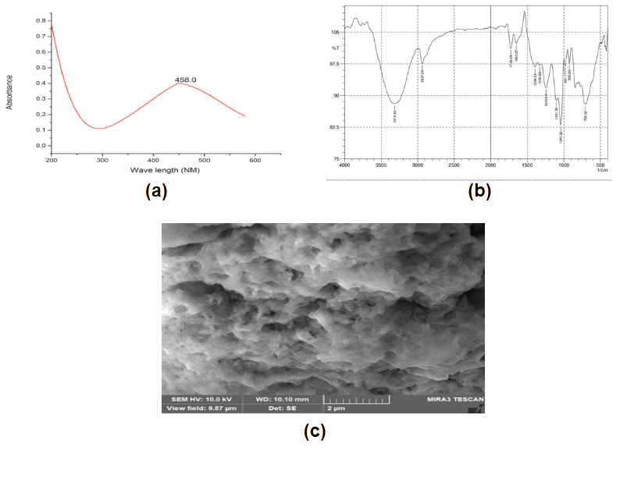

**Fig.1. Characterization of the carbopol silver nanocomposites; (a) UV Visible spectrum; (b) FTIR Spectrum and (c) FESEM image**

Scanning Electron Microscopy (SEM) was employed to visualize the morphological features and size distribution of the synthesized silver nanocomposites. SEM images revealed that the nanoparticles exhibited relatively uniform spherical morphology with diameters ranging between 60nm and 140nm. This uniformity in shape and size demonstrates the efficiency of both *L. gasseri* metabolites and Carbopol in directing nanoparticle formation and stabilization. The images also showed that the nanoparticles were embedded within a smooth and clustered polymer matrix, likely formed due to the presence of biological macromolecules and Carbopol polymer chains. These structural attributes support their application in biomedical formulations where uniformity and nanoscale dimensions are essential for consistent biological activity and interaction. The biosynthesized Carbopol–silver nanocomposites present significant advantages in terms of stability, biocompatibility, and potential application scope. The presence of biomolecules such as proteins and polysaccharides from *L. gasseri* provides an eco-friendly, non-toxic approach to nanoparticle production. Coupling this with Carbopol not only improves the rheological and structural properties of the system but also ensures sustained release and targeted delivery of silver nanoparticles. The small particle size, combined with the stability imparted by Carbopol and biological capping agents, results in a formulation that can be effectively used in antimicrobial gels, wound dressings, and cosmeceuticals. The antibacterial potential of AgNPs against both Gram-positive and Gram-negative pathogens, along with their synergistic action with biological carriers, opens new avenues for developing safe and efficient nanoformulations (Rai *et al* 2016; Franci *et al* 2015; Singh *et al* 2018).

* 1. **Anti- Biofilm Assay**

The anti-biofilm activity of silver nanoparticles (AgNPs) synthesized using *Lactobacillus gasseri* was assessed using the crystal violet staining method, with absorbance readings taken at 530nm. To understand how different doses affect biofilm formation, the assay was performed using a range of AgNP concentrations from 10 µg/mL to 50 µg/mL. In the control group—where no nanoparticles were added—the optical density (OD) value was 0.411, indicating strong biofilm formation. This served as a baseline (0% inhibition) against which the effects of nanoparticle treatment could be compared. As the concentration of AgNPs increased, there was a noticeable and progressive reduction in OD values, clearly suggesting a dose-dependent inhibition of biofilm formation. At 10µg/mL, the OD value dropped to 0.364, corresponding to an inhibition of 11.43%. With each step up in concentration, the inhibition became more distinct; 25.79% at 20µg/mL, 40.14% at 30µg/mL, and 46.22% at 40µg/mL. The most significant reduction was seen at the highest concentration tested (50µg/mL), which brought the OD down to 0.181 and achieved an impressive 55.96% inhibition.

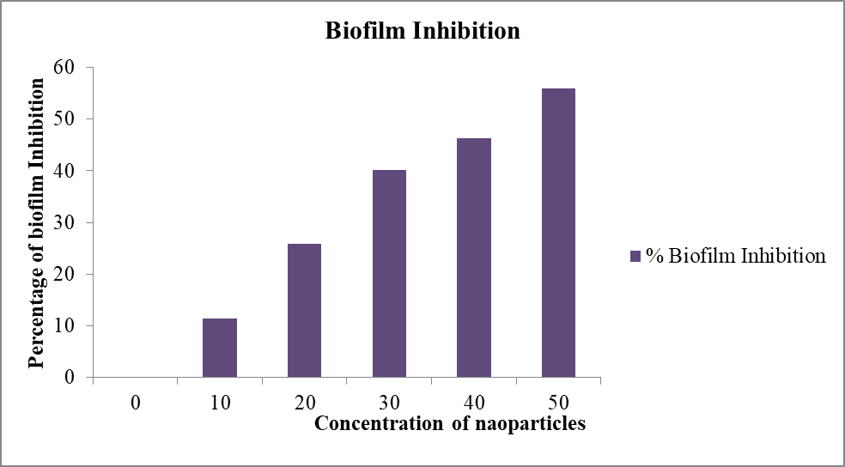

**Fig.2. Graph showing the percentage of Biofilm inhibition against different concentrations of nanoemulsions**

This increasing inhibition trend can be explained by the known mechanisms of silver nanoparticles. AgNPs are effective at interfering with quorum sensing—the process by which bacteria communicate to form biofilms—and they also disrupt the production of extracellular polymeric substances (EPS), which provide structural support to the biofilm (Durán et al., 2016). Their ultra-small size and high surface area allow them to penetrate deep into biofilm layers, making them more effective at breaking them down (Rai *et al* 2016). In addition, as the concentration increases, the interaction between the nanoparticles and bacterial cells intensifies. This often leads to oxidative stress and damage to bacterial membranes, which can prevent the bacteria from adhering and maturing into a full biofilm. These results are consistent with earlier findings where biosynthesized silver nanoparticles exhibited strong anti-biofilm effects against a variety of pathogens (Kalishwaralal *et al* 2010).

* 1. **Assessment of Cell Viability by MTT assay**

To assess the safety profile of silver nanoparticles (AgNPs) synthesized using *Lactobacillus gasseri*, a cell viability assay was conducted, with optical density (OD) readings taken at 570 nm. The results revealed a clear dose-dependent trend—higher concentrations of AgNPs led to lower OD values, indicating a gradual reduction in cell viability. The control group (untreated cells) showed the highest OD value of 0.506, confirming 100% cell viability and no cytotoxic effect. As the concentration of nanoparticles increased from 2 µg/mL to 10 µg/mL, OD values decreased from 0.449 to 0.407, corresponding to a viability reduction of approximately 11.26% to 19.56%. This slight decline in cell viability at lower nanoparticle concentrations suggests that the biosynthesized AgNPs are relatively biocompatible, especially when compared to their chemically synthesized counterparts. Previous research has shown that biologically derived AgNPs often have lower toxicity, largely due to the presence of natural capping agents such as proteins, enzymes, or other biomolecules from the microbial source (Agarwal et al 2017). In the case of *L. gasseri*, these organic molecules likely provide a protective layer around the nanoparticles, improving their compatibility with human cells.

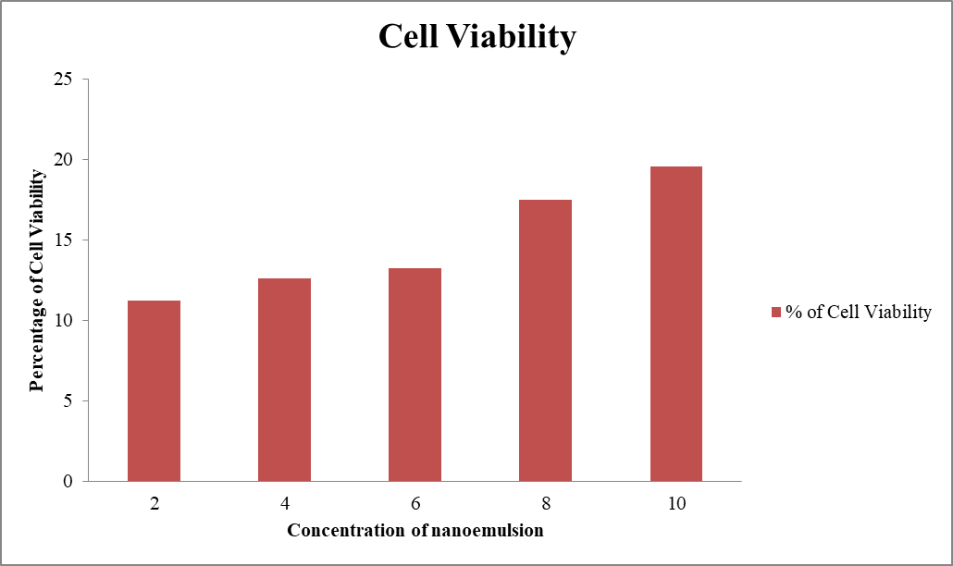

**Fig.3.Graph showing the results of Cell viability Assay**

Additionally, the low cytotoxicity observed supports their potential use in biomedical applications, such as antimicrobial coatings, wound dressings, and drug delivery systems, where both safety and efficacy are critical. The mode of cytotoxicity commonly associated with AgNPs includes oxidative stress, damage to cell membranes, and interference with mitochondrial function. However, in this study, the nanoparticles remained well within safe biological limits up to a concentration of 10 µg/mL. These findings highlight the advantages of green synthesis methods in producing nanoparticles with controlled toxicity. The biogenic approach not only ensures better compatibility with living tissues but also aligns with environmentally sustainable practices. Importantly, the moderate cytotoxic effect observed here does not compromise the therapeutic potential of these AgNPs, particularly at lower concentrations. In conclusion, silver nanoparticles synthesized from *Lactobacillus gasseri* display acceptable cytotoxicity profiles and hold strong promise for further in vivo studies. Their favorable safety margin at lower doses makes them excellent candidates for developing next-generation antimicrobial and therapeutic agents with minimal adverse effects on host tissues.

1. **Conclusion**

The current work proves that silver nanoparticles (AgNPs) can be biosynthesized efficiently by using *Lactobacillus gasseri* and can be successfully added into a polymer matrix of Carbopol 940 to obtain a stable nanocomposite. UV-Vis, FTIR, and SEM characterization confirmed the formation and stability of the synthesized AgNPs along with morphology. Acceptable anti-biofilm potential was found in nanocomposites, as a dose-dependent inhibition was observed against the microbial biofilms. Moreover, in the cell viability test, the biosynthesized AgNPs were shown to be biocompatible up to concentrations of 50, 100, and 150 which fall in line with their potential use in biomedical applications. Overall, the present findings indicate that stabilized in a Carbopol matrix, *L. gasseri* derived AgNPs can emerge as efficient and safe products used in medical devices, wound healing formulations, and antimicrobial treatment. To truly confirm their clinical viability, future studies ought to aim at conducting in vivo tests as well as long-term stability.

**DISCLAIMER (ARTIFICIAL INTELLIGENCE)**

Author(s) hereby declare that NO generative AI technologies such as Large Language Models (ChatGPT, COPILOT, etc.) and text-to-image generators have been used during the writing or editing of this manuscript.

**CONFLICTS OF INTEREST**

The authors declare that there is no conflict of interest.

COMPETING INTERESTS DISCLAIMER:

Authors have declared that they have no known competing financial interests OR non-financial interests OR personal relationships that could have appeared to influence the work reported in this paper.

**REFERENCES**

Srinivasan, S., Jayaraman, A., Ramasamy, A., Mohanraj, K., Raja, M. R. C., & Mahapatra, S. K. (2023). Isolation and characterization of glycoprotein (CNP) isolated from *Cocos nucifera* L. nutshell and its immunomodulatory role on macrophage activation. *Journal of Functional Foods*, *100*, 105380. <https://doi.org/10.1016/j.jff.2022.105380>

Gunyakti, A., & Asan-Ozusaglam, M. (2019). *Lactobacillus gasseri* from human milk with probiotic potential and some technological properties. *LWT*, *109*, 261–269. <https://doi.org/10.1016/j.lwt.2019.04.043>

Umekar, M., Chaudhary, A. A., Manghani, M., Shidhaye, S., Khajone, P., Mahore, J., ... Trivedi, R. (2025). Probiotics in nanotechnology-driven wound healing: From mechanistic insight to clinical promise. *Pharmaceutics*, *17*(7), 805.

<https://doi.org/10.3390/pharmaceutics17070805>

McClements, D. J. (2013). Nanoemulsion-based oral delivery systems for lipophilic bioactive components: Nutraceuticals and pharmaceuticals. *Therapeutic Delivery*, *4*(7), 841–857. <https://doi.org/10.4155/tde.13.46>

Alim-Al-Razy, M., Bayazid, G. A., Rahman, R. U., Bosu, R., & Shamma, S. S. (2020, December). Silver nanoparticle synthesis, UV-Vis spectroscopy to find particle size and measure resistance of colloidal solution. *Journal of Physics: Conference Series*, *1706*(1), 012020. <https://doi.org/10.1088/1742-6596/1706/1/012020>

Hu, D., Ogawa, K., Kajiyama, M., & Enomae, T. (2020). Characterization of self-assembled silver nanoparticle ink based on nanoemulsion method. *Royal Society Open Science*, *7*(5), 200296. <https://doi.org/10.1098/rsos.200296>

Ang, B. C., Yaacob, I. I., & Nurdin, I. (2013). Investigation of Fe₂O₃/SiO₂ nanocomposite by FESEM and TEM. *Journal of Nanomaterials*, *2013*(1), 980390.

<https://doi.org/10.1155/2013/980390>

Jesteena Johney., Kannan Eagappan., & Ragunathan, R. R. (2016). Microbial extraction of chitin and chitosan from *Pleurotus* spp., its characterization and antimicrobial activity. *International Journal of Current Pharmaceutical Research*, *9*(1), 88–93. <https://doi.org/10.22159/ijcpr.2017v9i1.16623>

Haney, E. F., Trimble, M. J., & Hancock, R. E. (2021). Microtiter plate assays to assess antibiofilm activity against bacteria. *Nature Protocols*, *16*(5), 2615–2632. <https://doi.org/10.1038/s41596-021-00515-3>

Rajesh, G., Ragunathan, R., & Johney, J. (2025). Assessment of antimicrobial and cytotoxicity effect of GABA extracted from *Lactiplantibacillus plantarum*. *Biosciences Biotechnology Research Asia*, *22*(2), 699.

<https://doi.org/10.13005/bbra/3395>

Ahmed, S., Ahmad, M., Swami, B. L., & Ikram, S. (2016). A review on plant extract mediated synthesis of silver nanoparticles for antimicrobial applications: A green expertise. *Journal of Advanced Research*, *7*(1), 17–28.

<https://doi.org/10.1016/j.jare.2015.02.007>

Franci, G., Falanga, A., Galdiero, S., Palomba, L., Rai, M., Morelli, G., & Galdiero, M. (2015). Silver nanoparticles as potential antibacterial agents. *Molecules*, *20*(5), 8856–8874. <https://doi.org/10.3390/molecules20058856>

Hajipour, M. J., Fromm, K. M., Ashkarran, A. A., de Aberasturi, D. J., de Larramendi, I. R., Rojo, T., ... Parak, W. J. (2012). Antibacterial properties of nanoparticles. *Trends in Biotechnology*, *30*(10), 499–511. <https://doi.org/10.1016/j.tibtech.2012.06.004>

Rai, M., Deshmukh, S. D., Ingle, A. P., & Gade, A. K. (2016). Silver nanoparticles: The powerful nanoweapon against multidrug‐resistant bacteria. *Journal of Applied Microbiology*, *112*(5), 841–852. <https://doi.org/10.1111/j.1365-2672.2012.05253.x>

Singh, P., Kim, Y. J., Zhang, D., & Yang, D. C. (2018). Biological synthesis of nanoparticles from plants and microorganisms. *Trends in Biotechnology*, *34*(7), 588–599. <https://doi.org/10.1016/j.tibtech.2016.02.006>

Durán, N., Durán, M., de Jesus, M. B., Seabra, A. B., Fávaro, W. J., & Nakazato, G. (2016). Silver nanoparticles: A new view on mechanistic aspects on antimicrobial activity. *Nanomedicine*, *12*(3), 789–799. <https://doi.org/10.1016/j.nano.2015.11.016>

Kalishwaralal, K., BarathManiKanth, S., Pandian, S. R. K., Deepak, V., & Gurunathan, S. (2010). Silver nanoparticles impede the biofilm formation by *Pseudomonas aeruginosa* and *Staphylococcus epidermidis*. *Colloids and Surfaces B: Biointerfaces*, *79*(2), 340–344. <https://doi.org/10.1016/j.colsurfb.2010.04.014>

Sarfraz, M., Iqbal, R., Khan, K. U., & Minhas, M. U. (2022). Carbopol based hydrogels for itopride hydrochloride delivery: Synthesis, characterization and comparative assessment with various monomers. *Journal of Functional Biomaterials*, *13*(4), 295. <https://doi.org/10.3390/jfb13040295>

Shameli, K., Ahmad, M. B., Zargar, M., Yunus, W. M. Z. W., & Ibrahim, N. A. (2012). Green biosynthesis of silver nanoparticles using *Curcuma longa* tuber powder. *International Journal of Nanomedicine*, *7*, 5603–5610. <https://doi.org/10.2147/IJN.S36868>