Investigating the use of local materials for the construction of a solar/biomass hybrid cooker

ABSTRACT
There are many locally available materials that can be used in the construction of cooking devices. Materials account for a significant portion of construction costs, and reducing their cost can help lower the overall cost of such projects. One of the most effective ways to reduce costs in the development of affordable cooking systems is to promote the use of local materials. This study therefore explores the use of local materials in the construction of solar-biomass hybrid cookers. The objectives are to identify the types of local materials used, the factors influencing their use, their thermophysical properties, and the benefits they offer.This work focuses on the design and construction of a solar-biomass hybrid cooker, made from locally available and low-cost materials. The characterization of these materials allowed for the determination of their thermo-physical properties. The thermal conductivity was measured at 0.675 ± 0.010 W/(m·K) for compressed earth bricks and 0.120 ± 0.007 W/(m·K) for plywood. The density was found to be 2048.77 kg/m³ for compressed earth bricks and 500 kg/m³ for plywood. The specific heat capacity was 1749 ± 4 J/(kg·K) for compressed earth bricks and 1600 ± 3 J/(kg·K) for plywood. Infrared images show that the materials used provide effective thermal insulation by minimizing heat loss and directing it towards the cooking vessel. The evaluation of the cooker’s energy quality through exergy, which ranged from 0.15 W to 6.61 W (i.e., 0.092 kJ to 3.968 kJ), and exergetic efficiency, which ranged from 0.008% to 2.38%, shows that a significant portion of the energy is used for cooking food After manufacturing the device, cooking tests conducted on beans and rice yielded successful results. It was also found that this solar cooker can prepare an average of 510 meals per year using only the available solar energy in Burkina Faso, with an additional 221 meals made possible through biomass when solar energy is insufficient for cooking.

Keywords: design, locally, materials characterization solar-biomass hybrid cooker.

- INTRODUCTION
Firewood accounts for nearly 81% of energy consumption in sub-Saharan Africa (Bildirici & Özaksoy, 2016). However, this heavy reliance on solid biomass presents numerous drawbacks for both the population and the environment (Otte, 2013). In 2010, Africa was responsible for 34% of global greenhouse gas emissions related to firewood consumption (Fekadu Kedir et al., 2019; Ouedraogo, 2017).
To reduce this consumption and ensure an affordable and sufficient cooking energy supply for a continuously growing population, various solar technologies have been developed(Cuce & Cuce, 2013; Saxena et al., 2011). However, their adoption remains limited due to several constraints, including glare risks, food scorching, technological complexity, and the need for constant supervision (S. Kumar et al., 1996). This is why box-type solar cookers are widely preferred for their ease of use (Ambarita, 2018; R. Bazile, B. Alan, M. Port, 2018). Moreover, these devices are well suited to the energy needs of rural households and low-income urban areas in Africa(Carmody & Sarkar, 1997).
Over the past two decades, numerous studies have been conducted to improve the performance of box-type solar cookers. These studies have explored various aspects, such as the impact of cooker orientation on thermal efficiency, the number of reflectors, absorber configuration, insulation, and geometry (Algifri AH, 2001; I. L. Mohammed, U. J. Rumah, 2013; Mahavar et al., 2013; Mirdha USÃ, 2008). Other research has focused on models incorporating a concentrator placed beneath the cooker to direct solar radiation downward (Aliyu & Garba, 2018).
However, during cloudy periods or prolonged absence of sunlight, the use of solar cookers, including box-type models, becomes impractical.
This study aims to design and develop a solar-biomass hybrid cooker made from locally available, affordable, and easily accessible materials. This device will maximize the use of solar energy in Burkina Faso and, in cases of insufficient sunlight, utilize available biomass, such as agricultural residues or biochar, to ensure continuous cooking.

LITERATURE REVIEW

2.1- Compressed Earth Blocks (CEB)
Compressed Earth Blocks (CEB), also known as BTC (Briques de Terre Compressée BTC in French), are construction materials commonly used in Burkina Faso. They are made from raw earth mixed with a small amount of binder (usually cement) and compressed under high pressure to form solid blocks.
Their main characteristics are (Kabre et al., 2019):
- Compressed earth blocks are made from natural and locally sourced materials, such as soil from the construction site itself, which helps reduce the environmental impact associated with transporting materials;
- CEBs are generally quite durable, especially when they are properly manufactured and maintained. The cement added as a binder improves their resistance to water and wear;
- compressed earth blocks have interesting thermal insulation properties due to their natural composition and thickness.
The use of local and natural materials reduces production costs, making compressed earth blocks more economical compared to other construction materials. In addition, they can be produced locally using simple compression machines, which is especially advantageous in regions with limited financial resources.
The use of local materials and the low energy requirements for manufacturing compressed earth blocks make them compatible with sustainable and environmentally friendly construction approaches.
Given these properties, these materials will be used for insulating the combustion chamber due to the high temperatures generated during biomass combustion. Figure 1 shows the compressed earth blocks used in the construction of our cooker.

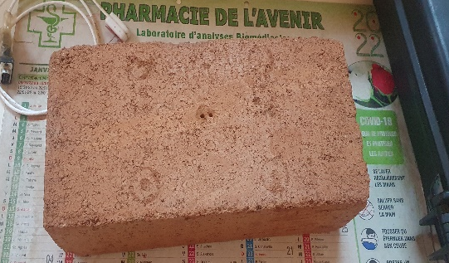
Compressed earth blocks
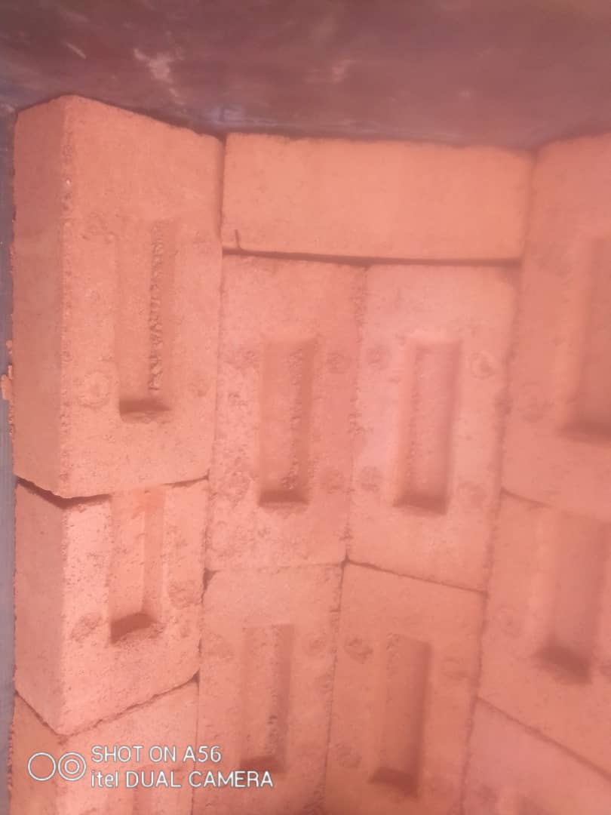
Figure 1 : Compressed earth blocks

2.2- Glass fiber insulation
Glass fiber insulation is a widely used insulating material in the construction industry due to its excellent thermal and acoustic insulation properties (Doumouro, 2021). It is made from sand and recycled glass that are melted at high temperatures to form fine, lightweight fibers. These fibers are then bonded together into panels, rolls, or loose fill to be used in various types of structures and applications (Doumouro, 2021).
It has a fibrous structure, as shown in Figure 2, which traps air, thereby providing excellent thermal insulation properties. Additionally, being lightweight, it is easy to handle and install, making it a practical choice for insulating various structures without adding excessive weight.
Glass fiber insulation is resistant to most chemicals and does not easily decompose. It does not promote the growth of mold, insects, or rodents, making it a durable material over time. Often made from recycled materials, it helps reduce the amount of glass waste. Additionally, it can be recycled at the end of its use. Its more affordable cost compared to other insulation materials makes it widely used for many applications (Bala et al., 2023).
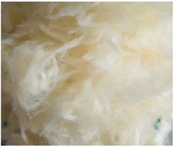 | 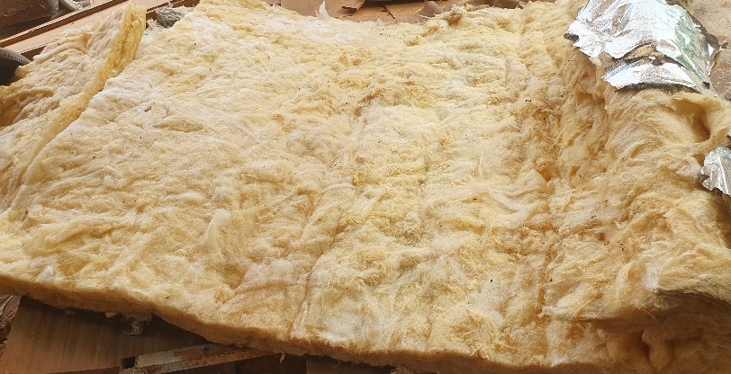
Figure 2: Glass fiber insulation

2.3- Plywood
Plywood is a fibrous material widely used, especially in building insulation, due to its low cost and remarkable thermophysical properties. It is easily accessible and has interesting characteristics for thermal insulation in ovens. On the market, plywood is available in thicknesses of 5 mm, 10 mm, 15 mm, and 20 mm. The most commonly used plywood types are birch plywood (Figure 3a) and hardwood plywood (Figure 3b).
Plywood, also known as laminated wood, is a construction material made by gluing together multiple thin layers of wood veneers (BONGARD., 2019).
Thanks to its cross-layered construction, plywood is more stable and less prone to warping or twisting than solid wood. This makes it an ideal material for applications where dimensional stability is essential, such as furniture making and door manufacturing. Plywood is stronger than solid wood due to its multilayered structure. It can support heavier loads without breaking, which is why it is widely used for flooring, roofing, and other structural applications.
Some types of plywood are designed to be moisture-resistant and are suitable for outdoor use and environments with frequent water exposure.
With these advantages, using plywood for the construction of the solar box in our cooker offers several benefits, including effective thermal insulation, versatility in use, and affordability.
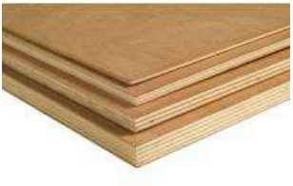  Figure 3. a : Plywood (BONGARD., 2019) | 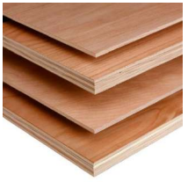  Figure 3.b : Plywood (BONGARD., 2019)

DETERMINATION OF THE THERMAL PROPERTIES OF MATERIALS
In addition to the already known thermal properties of the materials used, we determine other thermal properties using the KD2 Pro analyzer.
The KD2 Pro analyzer is a portable device developed by DECAGON Inc. (Figure 4) according to IEEE 442-1981 and ASTM D5334-08 standards. It can be used both in the laboratory and in the field, and its principle is based on the hot-wire method. Thirty years of research on the thermal properties of soil and other porous materials have led to the design of this sophisticated analyzer for measuring thermal properties (Decagon Devices, 2021).
The KD2 Pro analyzer contains three sensors: the "SH-1" sensor, the "TR-1" sensor, and the "KS-1" sensor.
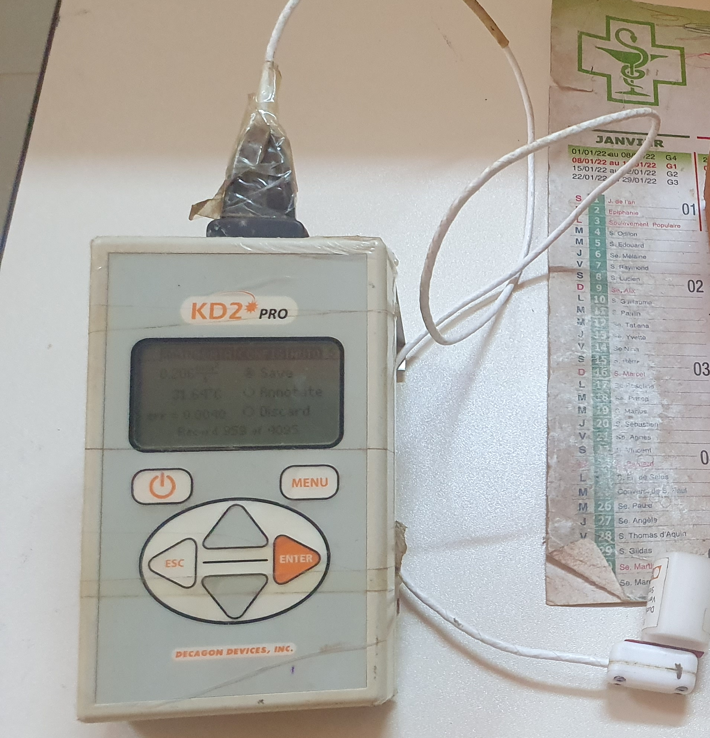 | 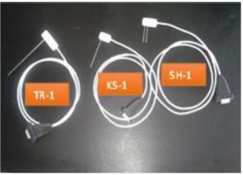
Figure 4 : KD2 Pro Thermal Properties Analyzer
The appropriate usage conditions for each of these sensors, their reading time, accuracy, measurement range, as well as minimum and maximum operating temperatures, are detailed in the user manual. Table 1 indicates the types of materials for which each sensor is suitable.
Table 1: Application domain of each sensor type
Types of Materials | KS-1 | TR-1 | SH-1
Low-viscosity liquid (e.g., water) | Best | No | No
High-viscosity liquid (e.g., glycerol, oil) | Best | Okay | No
Insulating materials | Okay | Okay | Okay
Soils, powders, dry granular materials | No | Best | Okay
Concrete | No | Best | Okay
Rock | No | Best | Okay
Other solids | No | Best | Okay

After identifying the appropriate sensor for the material to be characterized (CEB, glass fiber insulation, and plywood), these materials are analyzed to determine their thermophysical properties.

RESULTS AND DISCUSSION

4.1- Thermal properties of the materials used
Table 2 presents the thermal properties of compressed earth bricks, plywood, and glass fiber insulation.

Table 2: Thermal properties of the materials used in the cooker
 | $$λ$$  (W/ (m.K)) | R  (m.K/W) | $$ρ$$  (kg/$m^{3})$ | Cp  (J/ (kg. K)) | $$α$$  (${mm}^{2}$/s) | E  (J/$S^{1/2}.m^{2}.K)$
Compressed earth bricks (C.E.B.) | 0,675$±$0,010 | 1,482$±$0,008 | 2048,77 | 1749$±$4 | 0,19$±$0,01 | 1555,6$±$0,2
plywood | 0,120$±$0,007 | 8,3$±$0,3 | 500 | 1600$±$3 | 0,11$0±$0,003 | 309,8$±$0,2
Glass fiber insulation | 0,046$±$0,001 | 21,9$±$0,2 | 200 | 1030(VERRE, 2012) | 0,0022 | 97,34$±$0,10

Thermal conductivity, specific heat, diffusivity, and effusivity are the main thermal properties evaluated in this study. Indeed, these key thermal properties allow a qualitative assessment of a material’s thermal performance because they help understand how a material reacts to heat—how it transfers, stores, and dissipates it. This understanding is essential for designing efficient thermal systems, ranging from insulation to thermal management in building materials.
The values of these parameters obtained from testing with the KD2 Pro analyzer are presented in Table 2.
CEBs have relatively low thermal conductivities, which is favorable for thermal insulation. Indeed, a material is considered a thermal insulator if it has low thermal conductivity. Given the high temperatures generated by biomass combustion compared to the absorber temperature in a box-type solar cooker, CEBs will be used as insulation for the combustion chamber.
Regarding thermal resistance, glass fiber insulation has the highest thermal resistance compared to CEB and plywood, as it effectively reduces heat flow. This makes it important in various applications such as thermal insulation for box-type solar cookers. Indeed, materials that generally resist high temperatures tend to be expensive and less insulating.
The results also show that the heat capacity of CEB is higher (Cₚ = 1749 ± 4 J/(kg·K)). Specific heat capacity is particularly important because, in a cooker, a large portion of the energy consumed is absorbed by the walls during the temperature rise and released during cooling (R. C. Brown, 2012).
Regarding thermal diffusivity, CEB is more diffusive than plywood and glass fiber insulation. Indeed, compact materials tend to have higher diffusivity than fibrous materials (Nshimiyimana, 2020).
The higher the thermal diffusivity, the faster heat propagates. Materials with low thermal diffusivity take longer to heat up or cool down, while materials with high thermal diffusivity can reach thermal equilibrium more quickly. The shorter the heating time of the combustion chamber, the lower the fuel consumption.
Thermal diffusivity is an important concept in modeling heat transfer and designing applications involving thermal processes. For example, in construction, understanding the thermal diffusivity of materials used can help predict how heat will propagate and how thermal insulation will perform.
Finally, the thermal effusivity obtained for all samples consistently shows that CEB has a high effusivity. ZOMA et al., in their research, demonstrated that materials with high thermal effusivity have the ability to impose their temperature; that is, to absorb heat without warming up (F. Zoma, D. Y. K. Toguyeni, O. Coulibaly, I. Hassel, 2017). The diffusivity and effusivity results indicate that for high temperatures, such as those in the combustion chamber, compact materials like CEB are more suitable for insulation. They act both as insulation and thermal storage, helping to maintain the temperature in the combustion chamber for a longer time.
In general, we can say that the materials we characterized have good thermal insulation due to their low thermal conductivity, high effusivity, and diffusivity. The choice of insulation material is very important. In the field of thermal insulation, materials must also meet certain environmental standards, especially regarding their manufacturing, use, and recyclability.
The determined thermodynamic properties show that the characterized materials will be advantageous for the construction of the device in sub-Saharan regions with large temperature variations, such as Burkina Faso. Additionally, these properties will be used for modeling the heat transfer of our device to optimize its performance.

Construction of the proposed hybrid solar cooker
Box-type solar cookers are relatively simple to build using locally available and inexpensive materials, and their size is not overly bulky.
The combination of the solar cooker and the combustion chamber creates a hybrid cooking system that uses both solar energy and biomass (typically charcoal, biochar, firewood, etc.) to cook food.
The following precautions were considered during the design and construction phases:
- The combustion chamber must be sufficiently robust and capable of supporting the various components, including the solar part;
- the solar section and the combustion chamber must be thermally insulated;
- the coupling between the two must be carefully executed to avoid creating thermal bridges or thermal inertia (see Figure 5).
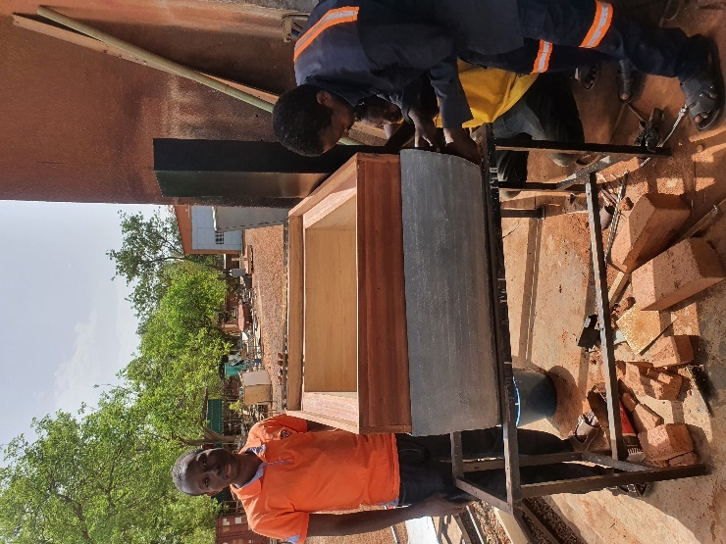 | 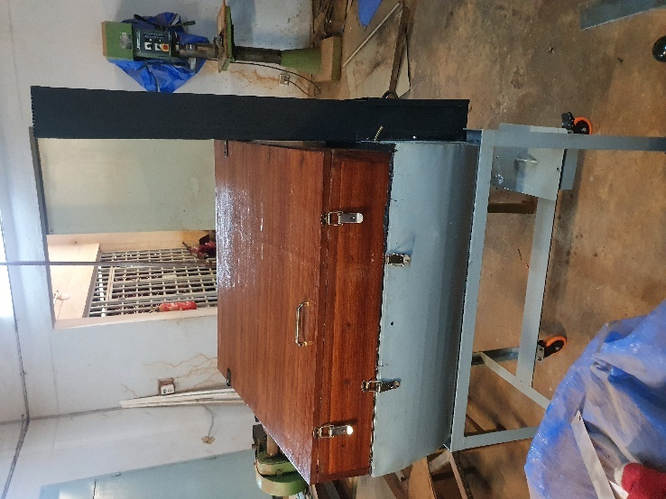
Figure 5: Coupling of the solar box and the combustion chamber

Constructed device
Figure 6 shows the device designed as part of our work. In sub-section 6.a, we observe the use of the device in solar-only mode. The combustion chamber is thermally insulated to prevent heat loss. When solar radiation is insufficient for solar mode operation, the charcoal container and chimney are inserted, as illustrated in Figure 6.b.
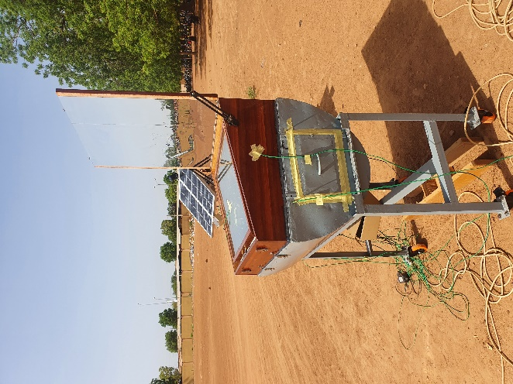  a | 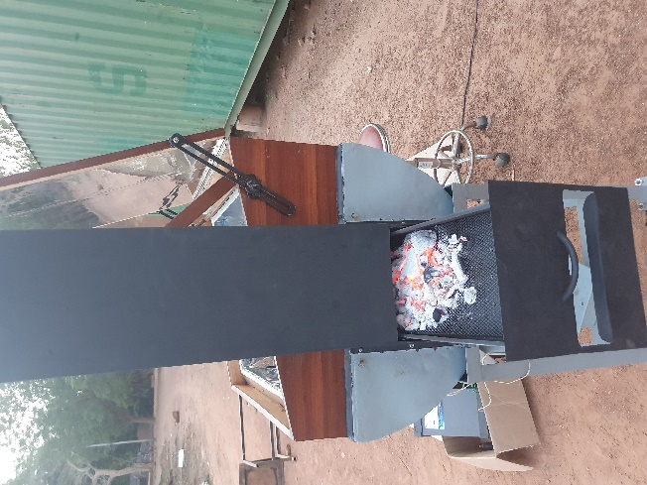  b
Figure 6 : Constructed system

Infrared Thermography
Infrared images were used to monitor the temperature distribution on the walls of the cooker. Figures 7 and 8 show infrared captures (IR) during the cooker's operation in biomass mode. Figure 7 shows the temperature distribution on the outer walls of the cooker and the inner glass. Figure 8 shows the temperature distribution on the absorber. These images were taken 42 minutes after the start of the tests.
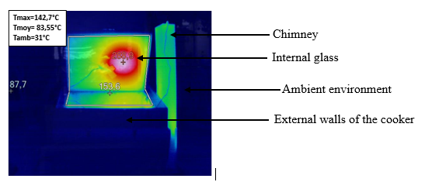  Figure 7:Thermal capture 42 minutes after the start of the tests | 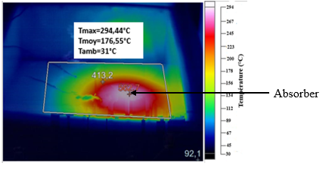  Figure 8:Thermal capture 42 minutes after the start of the tests

It was observed that the absorber reached 294.44 °C and the inner glass reached 142 °C, while the ambient temperature was 31 °C, after only 42 minutes of testing. The heat starts spreading on the aluminum absorber from one point — the point closest to the combustion area — and then gradually spreads over the entire absorber and inside the cooker.
The high temperature at one point on the inner glass could cause it to crack. This is why a simulation is needed to reduce this sharp temperature rise on the glass, since the clear glass used tends to crack at temperatures around 120 °C.
The temperatures of the cooker’s outer walls are almost the same as the ambient temperature, which shows that the insulation is effective. Good insulation greatly reduces heat loss from the cooker.
Thanks to the infrared images, we can see that by limiting heat transfer through the walls, the thermal insulation helps keep a high temperature inside. This reduces energy consumption, which means less fuel is needed for cooking and the cooker works more efficiently.

Exergetic Evaluation of the Cooker’s Performance
Exergy means the maximum amount of useful work that can be obtained from a system. It is based on the first and second laws of thermodynamics and addresses the limitations of energy analysis (Panwar et al., 2013).
Exergy analysis identifies where energy is degraded in a process and can therefore lead to improvements in the operation or technology of a system.
Also, energy analysis is the quantitative evaluation of energy, while exergy analysis is the qualitative evaluation of energy.
The thermal exergy of a quantity of water at temperature $T_{wi}$​​ is given by the equation 1:
(1)
The absorption of solar rays by the solar cooker produces heat that warms the water in the container. The water temperature rises from $T_{wi}$​​ to $T_{wf}$. Thus, the exergy gain is expressed by equation 2
(2)
The exergetic efficiency Ψ is given by equation 3.
(3)
with:
$E_{xi}$​: exergy received by the cooker, in joules (J)
$E_{xo}$: exergy delivered (or output exergy), in joules (J)
$T_{amb}$​: ambient temperature, in kelvin (K)
$T_{sol}$​: temperature of the sun’s surface, $T_{sol}$ = 5800 K
$T_{sol}^{*}$​: effective temperature of the diffuse radiation
$I_{G}$​: global solar radiation

Figure 9 shows the time evolution of the exergy and exergetic efficiency of the cooker loaded with 1.5 kg of water in a cooking container.
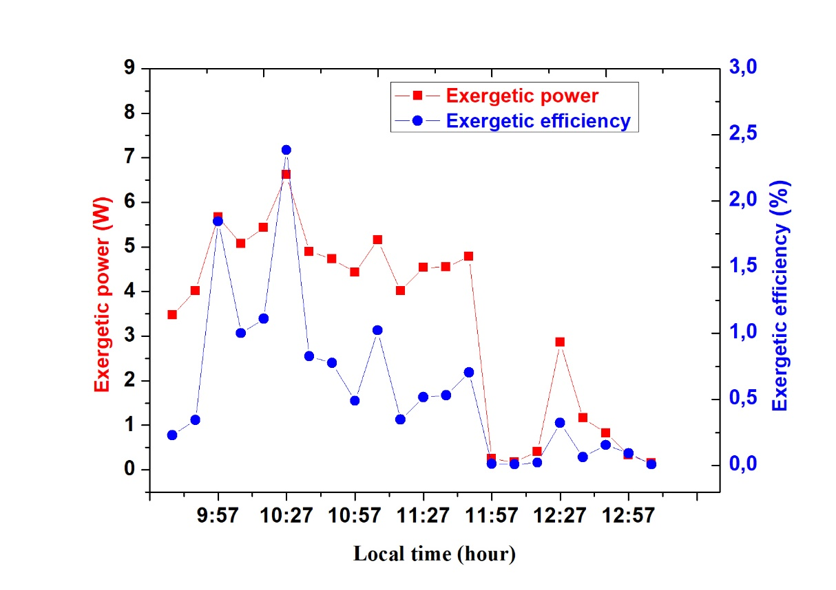
Figure 9: Exergetic Power and Exergetic Efficiency of the Cooker
The output exergy of the cooker, as calculated, ranges from 0.15 W to 6.61 W (i.e., 0.092 kJ to 3.968 kJ). As for the exergetic efficiency, it ranges from 0.008% to 2.38%. This result shows that exergy is much lower compared to energy. This difference is due to the fact that the quality of energy is considered when calculating exergy (Huseyin Ozturk, 2020).
These results are of the same order as those found in the literature for solar cookers (Huseyin Ozturk, 2020) (Shukla, 2009). Nébié et al. determined the output exergy of their solar cooker, which ranged from 0.68 W to 6.97 W (i.e., 0.408 kJ to 4.182 kJ), and the exergetic efficiency ranged from 0.36% to 2.53% (Nebie, 2021).
Yettou et al. conducted two tests on a similar type of solar cooker to determine the exergetic efficiency. In the first test, the exergetic efficiency ranged from 1.27% to 2.75%, and from 1.60% to 3.44% in the second test (Yettou et al., 2016).
Kumar et al. studied the exergetic power of a box-type solar cooker with a collector surface area of 0.25 m². A maximum exergetic power of 6.46 W was obtained in that study (N. Kumar et al., 2012).

- CONCLUSION
In this study, locally available materials used for the hybrid cooker were analyzed. After its construction, the images showed good insulation of the cooking chamber as well as effective heat concentration on the absorber, where the cooking container is placed.
The evaluation of the cooker’s energy quality through exergy, which ranged from 0.15 W to 6.61 W (i.e., 0.092 kJ to 3.968 kJ), and exergetic efficiency, which ranged from 0.008% to 2.38%, shows that a significant portion of the energy is used for cooking food.
This made it possible to prepare local dishes using solar radiation when available, and biomass mode when it was not. Moreover, this approach highlights an opportunity for developing countries with high solar potential to reduce household energy consumption in rural areas, while incorporating a cooking chamber suitable for year-round use.

COMPETING INTERESTS DISCLAIMER:
Authors have declared that they have no known competing financial interests OR non-financial interests OR personal relationships that could have appeared to influence the work reported in this paper.

REFERENCES
A lgifri AH, A.-T. H. (2001). Efficient orientation impacts of box-type solar cooker on the cooker performance. Solar Energy, 70(2), 165–70.
Aliyu, S., & Garba, M. M. (2018). Development of A Novel Double Exposure Solar Cooker And Its Comparative Performance With The Conventional Box Type Solar Cooker. IOSR Journal of Mechanical and Civil Engineering, 15(1), 35–40. https://doi.org/10.9790/1684-1501013540
Ambarita, H. (2018). Numerical study on the effect of configuration of a simple box solar cooker for boiling water. IOP Conference Series: Materials Science and Engineering, 308(1). https://doi.org/10.1088/1757-899X/308/1/012028
Bala, A., Gupta, S., & Matsagar, V. (2023). Influence of glass wool fiber reinforcement and heat resistant coating on behavior of self-compacting mortar at elevated temperatures. Construction and Building Materials, 392(May), 131876. https://doi.org/10.1016/j.conbuildmat.2023.131876
Bildirici, M., & Özaksoy, F. (2016). Woody Biomass Energy Consumption and Economic Growth in Sub-Saharan Africa. Procedia Economics and Finance, 38(October 2015), 287–293. https://doi.org/10.1016/s2212-5671(16)30202-7
BONGARD. (2019). [Online]. Available: http://www.bongard.fr. [Accessed September 1, 2019].
Carmody, E. R., & Sarkar, A. U. (1997). Solar Box Cookers: Towards a Decentralized Sustainable Energy Strategy for Sub-Saharan Africa. Renewable and Sustainable Energy Reviews, 1(4), 291–301. https://doi.org/10.1016/S1364-0321(97)00008-7
Cuce, E., & Cuce, P. M. (2013). Theoretical investigation of hot box solar cookers having conventional and finned absorber plates. International Journal of Low-Carbon Technologies, 10(3), 238–245. https://doi.org/10.1093/ijlct/ctt052
Decagon Devices, I. (2021). “KD2 Pro Thermal Properties Analyzer.”
Doumouro, J. (2021). Characterization of Glass Wool: Study of Heat Transfers between Glass Fibers at the Micrometer Scale Joris Doumouro To cite this version: HAL Id: tel-03135212 Characterization of Glass Wool: Study of Heat Transfers between Glass Fibers.
F. Zoma, D. Y. K. Toguyeni, O. Coulibaly, I. Hassel, and A. O. (2017). Potentials of an Eco-Friendly Composite in Hot-Dry Climate. J Renew Mater, 6, no. 1, 47-54.
Fekadu Kedir, M., Bekele, T., & Feleke, S. (2019). Problems of Mirt, and potentials of improved Gonzie and traditional open cook stoves in biomass consumption and end use emission in rural wooden houses of Southern Ethiopia. Scientific African, 3. https://doi.org/10.1016/j.sciaf.2019.e00064
- Huseyin Ozturk. (2020). Energy and exergy efficiencies of a solar box cooker. Int J Exergy, 1(2), :202–14.
I. L. Mohammed, U. J. Rumah, and A. T. A. (2013). Performance Testing of a Truncated Pyramid Solar Thermal Cooker. Int. J. Eng. Res. Appl., 3, no. 4, 1174–1178.
Kabre, S., Ouedraogo, F., Naon, B., Messan, A., Benet, J. C., & Zougmore, F. (2019). ISSN 1813-548X, http://www.afriquescience.net Evaluation of the thermo-hydro-mechanical properties of compressed earth bricks (CEB) from the Matourkou quarry, Burkina Faso. Afrique SCIENCE, 15(3), 12–22. http://www.afriquescience.net
Kumar, N., Vishwanath, G., & Gupta, A. (2012). An exergy based unified test protocol for solar cookers of different geometries. Renewable Energy, 44, 457–462. https://doi.org/10.1016/j.renene.2012.01.085
Kumar, S., Rubab, S., Kandpal, T. C., & Mullick, S. C. (1996). Financial feasibility analysis of box-type solar cookers in India. Energy, 21(12), 1257–1264. https://doi.org/10.1016/0360-5442(96)00054-0
Mahavar, S., Rajawat, P., Marwal, V. K., Punia, R. C., & Dashora, P. (2013). Modeling and on-field testing of a Solar Rice Cooker. Energy, 49(1), 404–412. https://doi.org/10.1016/j.energy.2012.10.014
Mirdha USÃ, D. S. (2008). Design optimization of solar cooker. 33, 530–544.
Nebie, J. (2021). Presented by Simulation and experimental study of a box-type solar cooker equipped with a thermal energy storage system.
Nshimiyimana, A. M. (2020). Physico-Mechanical and Hygro-Thermal Properties of Compressed Earth Blocks Stabilized with Industrial and Agro-Product Binders. Materials, Doi: 10.3390/Ma13173769., 13, no. 17, 3769.
Otte, P. P. (2013). Solar cookers in developing countries-What is their key to success? Energy Policy, 63, 375–381. https://doi.org/10.1016/j.enpol.2013.08.075
Ouedraogo, N.S. (2017). Africa energy future: Alternative scenarios and their implications for sustainable development strategies. Energy Policy, 106(March), 457–471. https://doi.org/10.1016/j.enpol.2017.03.021
Panwar, N. L., Kothari, S., & Kaushik, S. C. (2013). Energetic and exergetic analysis of three different solar cookers. Journal of Renewable and Sustainable Energy, 5(2). https://doi.org/10.1063/1.4793784
Bazile, R, Alan, B., Port, M., and J.G. (2018). Solar cooking bases. Introductory Handbook, 1–127,.
R. C. Brown, P. T. C. H. (2012). Alkaline earth silicate wools- A new generation of high temperature insulation. Regulatory Toxicology and Pharmacology, 64, 296–304.
Saxena, A., Pandey, S.P., & Srivastav, G. (2011). A thermodynamic review on solar box type cookers. Renewable and Sustainable Energy Reviews, 15(6), 3301–3318. https://doi.org/10.1016/j.rser.2011.04.017
Shukla, S.K. (2009). Comparison of Energy and Exergy Efficiency of Community and Domestic Type Parabolic Solar Cookers. International Journal of Green Energy, 6(5), 437–449. https://doi.org/10.1080/15435070903227912
VERRE, F. D. L. DU. (2012). Applications and Technical Characteristics.
Yettou, F., Panwar, N. L., Ali, M., Yettou, F., Gama, A., Malek, A., & Azoui, B. (2016). Experimental Investigation for the Determination of the Performance Characteristics of a Trapezoidal Box Solar Cooker Tested in the Algerian Sahara. The 4th International Seminar on New and Renewable Energies. January 4, 2019. https://www.researchgate.net/publication/330145816

