Original Research Article

**Kekulene: Investigating its Vibrational Modes in** **Circumstellar Medium**

**Abstract**

Aims/ objectives: To investigate the vibrational properties of Kekulene (C48 H24 ), a large, highly symmetric polycyclic aromatic hydrocarbon (PAH), and evaluate its potential as a carrier of the Aromatic Infrared Bands (AIBs) observed in circumstellar and interstellar environments. The work aims to assess Kekulene’s astrochemical relevance and diagnostic utility in modeling PAH populations in space.

Methodology: Density Functional Theory (DFT) calculations were performed using the GAMESS quantum chemistry package. The B3LYP/6-31G(d) level of theory is employed to optimize geometries and compute infrared (IR) frequencies. For the neutral molecule, restricted Hartree–Fock (RHF) was used,while the unrestricted Hartree–Fock (UHF) method was applied to the cation to obtain well-defined orbital energies. Mulliken population analysis is used to assess the electronic charge and its redistribution upon ionization. Simulated IR spectra were constructed using Lorentzian profiles with 5 cm−1 full width at a half maximum (FWHM).

Results: Kekulene exhibits distinct vibrational features attributed to its unique ring topology and

superaromatic character. The neutral form shows strong CH out-of-plane bending at 860.9 and

884.4 cm−1 and prominent CH stretching near 3096.7 cm−1 , comparing well with the observed

11.2 µm and 3.3 µm AIBs, respectively. Upon ionization, charge redistribution enhances the intensity of CC stretching and CH in-plane bending modes, from 1600 to 1000 −1 region. The most intense peak in the cation is at 1221.1 cm−1 , close to the 8.2 µm AIB. Comparison with compact circumcoronene points to unique spectral signatures of Kekulene’s inner hydrogen modes. Conclusion: The results suggest that Kekulene, especially in its cationic form, could significantly contribute to the composite PAH emission observed in UV-rich astrophysical environments.

Keywords: Kekulene, Aromatic Infrared Bands, Interstellar molecules, DFT calculations, Astrochemistry

**1 Introduction**

The interstellar medium (ISM) and various circumstellar environments are characterized by a series of prominent emission features in the infrared (IR) spectrum. These features are at wavelengths 3.3,

6.2, 7.7, 8.6, 11.3, and 12.7 µm and are ubiquitous across a diverse range of astrophysical objects, including reflection nebulae, planetary nebulae, HII regions, and protoplanetary disks (Tielens, 2008; Onaka et al., 1996; Verstraete et al., 1996; Hony et al., 2001; Peeters et al., 2002b; Acke & van den Ancker, 2004; Anand et al., 2023). Extensive spectroscopic investigations, which include both astronomical observations and laboratory simulations, strongly indicate polycyclic aromatic hydrocarbons (PAHs)

as the primary carriers of the bands (Puget & Leger, 1989; Allamandola et al., 1989). These IR emission bands are called Aromatic Infrared Bands (AIBs), because of their aromatic origin, and attributed to the characteristic vibrational modes of PAHs. The CH stretching vibrations are near 3.3

µm, CC stretching vibrations near 6.2 µm, CC strtching and CH in-plane-bend vibrations at 7.7 and

8.6 µm region and CH out-of-plane bending vibrations at 11.3 and 12.7 µm, alongwith other minor features. Variations in the profiles and relative intensities of these AIBs correlate with the type of object (Peeters et al., 2002a, 2004; Van Diedenhoven et al., 2004a) and serve as valuable diagnostics to identify the population of PAHs and their derivatives in different astrophysical environments, thus aiding in the understanding of physical conditions and chemical evolution in various astrophysical environments.

The modelled emission spectra using normal mode vibrations obtained by quantum chemical calculations for a large set of PAHs show good match for the 7.0–9.0 µm AIB range from different sources (Pathak & Rastogi, 2008; Andrews et al., 2015; Peeters et al., 2017; Boersma et al., 2018). Despite the general similarity of AIBs to PAH vibrational spectrum and some feature correlations, the simultaneous matching of all AIBs has not been possible. In particular the blue side of 6.2 µm feature and few features between 10–15 µm remain unmatched. When plain PAHs are considered, the aromatic CC stretching modes fall short by 30–40 cm−1 of the AIB (Pathak & Rastogi, 2008). In an effort to overcome these challenges, various studies have explored wide range of PAH derivatives such as hydrogenated, dehydrogenated, protonated and substituted PAHs (Beegle et al., 2001; Hudgins et al., 2005; Maurya & Rastogi, 2015; Buragohain et al., 2018; Maurya et al., 2023). However, these efforts have resulted in no improvement or only partial success.

Kekulene (C48 H24 ) is a large, doughnut-shaped, highly symmetric PAH that belongs to the class of cycloarenes. Such stable structures are likely to be formed in core of dense molecular clouds or be in circumstellar region of carbon rich stars. Its unique molecular structure comprises twelve fused benzene rings arranged in a cyclic configuration. Its superaromatic nature is due to enhanced aromatic stabilization resulting from cyclic delocalization of π-electrons across multiple conjugated rings (Diederich & Staab, 1978; Staab & Diederich, 1993). Investigating the vibrational spectrum of Kekulene is important, as its specific modes, particularly those associated with its substantial size and inherent curvature, could potentially account for previously unassigned or poorly matched features within the complex AIB ensemble.

The study investigate the intrinsic vibrational spectrum of Kekulene through theoretical calculations and, where feasible, comparison with experimental data. By systematically analyzing the predicted infrared absorption features of kekulene, we seek to compare them with the observed Aromatic Infrared Bands from various astrophysical sources. This comparative analysis will enable us to assess the extent to which Kekulene’s unique vibrational signatures align with, or diverge from, the observed AIBs, thereby evaluating its potential role as a significant carrier within the intricate mixture of PAHs responsible for these pervasive astrophysical emission features.

**2 Methodology**

Density functional theory (DFT) is employed using the GAMESS (Schmidt et al., 1993; Zahariev et al.,

2023) ab initio program in the present study. Initially, optimized geometry is obtained using B3LYP functionals combined with the 6-31G(d) basis set. The infrared (IR) frequencies of neutral Kekulene is calculated using the restricted Hartree–Fock (RHF) method. For cation, calculation is performed using the unrestricted Hartree–Fock (UHF) method. This choice was made because, in open-shell systems, orbital energies derived from the ROHF wave function are not uniquely defined, whereas the UHF method provides well-defined orbital energies by not imposing restrictions on the form of spatial orbitals. Although the UHF method incurs extra computational time, it was preferred for the Kekulene cation.

Mulliken population is used to characterize the electronic charge distribution in a molecule and the bonding, antibonding or non-bonding nature of the molecular orbitals for particular pairs of atoms (Pathak & Rastogi, 2005, 2006). Therefore, it is effective in examining the variations in charge distribution from neutrals to cations.

Since the calculated vibrational frequencies are usually overestimated in Quantum chemical methods, they need to be scaled down. In this study, the calculated vibrational frequencies of Kekulene, are scaled using scale factor of 0.970, which is obtained by compairing with the available experimental data (Schweitzer et al., 1982). The vibrational spectrum of Kekulene is simulated using Lorentzian line profile with 5 cm−1 full-width at half-maximum [FWHM].

**3 Results and Discussion**

**3.1 Optimized structure**

The optimized geometry of the molecule studied in the present work is shown in Figure 1. The optimization energy for neutral and cation is -1842.5674 and -1842.3393 (Kcal/mol), respectively. It shows that the neutral form is more stable than the cationic form. In the optimized structure of neutral Kekulene, two distinct types of CC bond lengths are observed, (Figure 1; Table 1). The outer CC bonds (CC bonds between outer carbons) have a uniform length of 1.363 A˚ , while the inner CC bond lengths vary in the range of 1.394–1.461 A˚ (Gorter et al., 1995). The values obtained in the present study closely agree with those reported in a previous study, which found an outer CC bond length of

1.360 A˚

and inner CC bond lengths ranging from 1.390 to 1.460 A˚

(Pozo et al., 2019).

In Kekulene cation, a similar trend is observed. The outer CC bond lengths range from 1.364 to

1.377 A˚ , while the inner CC bonds range between 1.391–1.458 A˚ . Ionization increases the outer CC bond length and decreases the inner CC bond length. This results in enhanced π-electron delocalization across the entire framework, reducing bond length alternation and diminishing the localization of Clar sextets (Pozo et al., 2019), indicating a shift toward a more globally delocalized aromatic system.

**3.2 Charge analysis**

Analysis of the Mulliken charge distribution reveals interesting patterns in both the neutral and cationic forms of Kekulene. Carbon atoms bonded to hydrogen generally exhibit a partial negative charge, while carbon atoms not bonded to hydrogen tend to carry a partial positive charge in both neutral and cation (Figure 1, Table 1).

Specifically, within the outer carbon skeleton of Kekulene, carbon atoms that initially carried partial negative charges in the neutral state exhibit a notable increase in positive charge upon formation of the cation. In contrast, those that originally bore partial positive charges show a relative decrease in their positive character. Within the inner carbon framework, both electron-rich and electron-deficient

carbon atoms undergo a net increase in positive charge in the cationic state, indicating a generalized redistribution of electron density toward the molecular core. This internal polarization effect underscores the significant electronic reorganization accompanying ionization, which may influence the vibrational properties and spectral behavior of Kekulene.

Furthermore, the charge distribution on the hydrogen atoms also undergoes significant changes. The outer hydrogen atoms experience an increase in positive charge in the cationic form, which is consistent with the general trend of charge delocalization upon ionization in PAHs. Interestingly, the inner hydrogen atoms, in contrast, exhibit a decrease in positive charge in the cationic species. These observed variations in charge distribution across different regions of the kekulene molecule, particularly between the outer and inner frameworks and on the associated hydrogen atoms, provide crucial insights into the electronic structure and stability of kekulene in its ionized state, which is highly relevant for its behavior in astrophysical environments.

Table 1: The bond length and charge distribution in Kekulene

Bond Length (A˚ ) Charge Distribution

|  |  |  |  |  |  |
| --- | --- | --- | --- | --- | --- |
| Bond | Neutral | Cation | Atoms | Neutral | Cation |
| a (*) | 1.363 | 1.377 | C1 | 0.049 | 0.058 |
| b | 1.444 | 1.430 | C2 | 0.182 | 0.181 |
| c | 1.430 | 1.430 | C3 | -0.197 | -0.189 |
| d | 1.461 | 1.458 | C4 | -0.197 | -0.189 |
| e | 1.430 | 1.430 | C5 | 0.182 | 0.181 |
| f | 1.444 | 1.430 | C6 | 0.049 | 0.058 |
| g | 1.405 | 1.416 | C7 | -0.268 | -0.255 |
| h | 1.405 | 1.401 | C8 | 0.048 | 0.053 |
| i | 1.430 | 1.431 | C9 | 0.182 | 0.180 |
| j | 1.394 | 1.397 | C10 | -0.343 | -0.317 |
| k | 1.394 | 1.391 | C11 | -0.197 | -0.184 |
| l | 1.444 | 1.445 | C12 | -0.197 | -0.191 |
| m (*) | 1.363 | 1.364 | C13 | 0.182 | 0.190 |
| n | 1.444 | 1.441 | C14 | 0.049 | 0.051 |
| o | 1.430 | 1.438 | C15 | -0.269 | -0.256 |
| p | 1.461 | 1.454 | C16 | 0.343 | -0.331 |
| q | 1.405 | 1.405 | H4 | 0.131 | 0.166 |
| r | 1.394 | 1.393 | H7 | 0.848 | 0.158 |
|  |  |  | H10 | 0.130 | 0.163 |
|  |  |  | H11 | 0.131 | 0.161 |
|  |  |  | H12 | 0.869 | 0.161 |
|  |  |  | H15 | 0.848 | 0.156 |
|  |  |  | H16 | 0.870 | 0.159 |

(*) CC bond between outer carbons.

**3.3 Vibrational analysis and comparison of the vibrational modes of**

**Kekulene with Circumcoronene (C**54 **H**18 **) PAH**

The vibrational spectrum of neutral Kekulene and its cationic form is shown in Figure 2,3 & 4 for different frequency range. In Figure 3, the vibrational frequencies and their corresponding relative intensities for the CH in-plane-bend and CC stretch vibrations are plotted. In the cationic form,

the intrinsic intensities of the CC stretching modes increase significantly, dominating the spectrum and thereby suppressing the relative intensities of other vibrational features. As a result, in the CH out-of-plane bending and CH stretching regions, the cation spectrum does not display prominent features when plotted using relative intensity. To address this, the vibrational frequencies and their corresponding intrinsic (absolute) intensities—rather than relative intensities—are shown in Figures 2 and 4 for the CH out-of-plane bending and CH stretching modes, respectively. The calculated normal mode vibrations are given for only those lines that have relative intensities ≥0.01 in Table 2. Similar to the typical PAHs, (Pathak & Rastogi, 2005, 2006; Pathak & Rastogi, 2007; Maurya et al.,

2023), the vibrational spectrum of neutral kekulene displays prominent features in the CH out-of- plane bending and CH stretching regions. Upon ionization, the CC stretching modes exhibit a pronounced enhancement in their intrinsic intensity. However, CH stretching modes do not show a drastic decrease in their intrinsic intensities upon ionization, as has been generally observed in typical PAHs (Pathak & Rastogi, 2005, 2006; Pathak & Rastogi, 2007; Maurya et al., 2023).

Due to structural similarities, especially the high symmetry (D6h point group) and the peripheral structure, we have compared the vibrational spectrum of Kekulene and circumcoronene (C54 H18 ) to investigate how the vibrational characteristics of circumcoronene are influenced by the disruption or absence of its inner carbon framework.

**CH out-of-plane vibrations:** At the lower frequency end of the spectrum, the neutral form of Kekulene exhibits weak bands that appear at 697.5 and 773.5 cm−1 assigned by the skeleton deformation mode and CH out-of-plane vibrations due to outer solo and duo hydrogens (vibrating in opposite direction),respectively, and two strong features appear at 860.9 and 884.4 cm−1 , corresponding to CH out-of-plane vibrations of inner and outer hydrogens, respectively, Figure 2.

Upon ionization, the intrinsic intensity and frequency position of the strong CH out-of-plane vibrational modes present in neutral Kekulene show a slight change, consistent with behavior observed in typical PAHs. The strong CH out-of-plane vibrational mode involving both inner and outer hydrogens appears at 897.7 cm−1 , exhibiting a slight blue shift of 13 cm−1 . At lower frequency, additional strong peaks appear at 625.1 and 647.0 cm−1 as a doublet, Figure 2.

The spectrum of circumcoronene (C54 H18 ) also exhibits characteristic CH out-of-plane modes in its neutral state, such as weak modes at 570.0 and 790.8 cm−1 corresponding to skeleton deformation mode and CH out-of-plane motion involving solo and duo hydrogens, respectively. In Kekulene, the skeleton deformation mode and CH out-of-plane motion involving solo and duo hydrogens modes appear at 697.5 and 773.5 cm−1 , respectively. Due to the disruption of the inner carbon skeleton, the reduced mass of the carbon framework decreases, resulting in an increase in the frequency of

the skeletal deformation vibration mode in Kekulene. However, the out-of-plane vibration due to outer hydrogens are present at lower frequency. In place of the strong peak at 915.2 cm−1 , which arises from out-of-plane vibrations of solo hydrogens in circumcoronene (Bauschlicher et al., 2018; Boersma et al., 2014; Mattioda et al., 2020), the spectrum of Kekulene exhibits two strong peaks at 860.9 and

884.4 cm−1 , attributed to the CH out-of-plane motion of both inner and outer hydrogens. The lowering of frequency is likely due to the presence of inner hydrogens, which are absent in circumcoronene.

In cationic form, C54 H18 maintains strong out-of-plane features, with 930.6 cm−1 as mainly the CH out-of-plane motion of solo hydrogen (Boersma et al., 2014; Bauschlicher et al., 2018; Mattioda et al., 2020). While in Kekulene cation, the CH out-of-plane mode due to vibration in inner and outer hydrogens appear at lower frequency, 897.7 cm−1 , possibly due to the presence of inner hydrogens.

**CH in-plane-bend and CC stretch vibrations:**

The mid-frequency range (1000–1700 cm−1 ) reveals mixed CC stretching and CH bending contributions. In neutral Kekulene, no intense feature is observed in this frequency range, similar to that observed in

the case of typical PAHs (Pathak & Rastogi, 2005, 2006; Pathak & Rastogi, 2007). A weak vibrational peak at 1223.3 cm−1 and two moderately intense peaks at 1520.2 and 1525.6 cm−1 are observed, corresponding to a combination of inner and outer solo CH in-plane-bend and CC stretch vibrations across the carbon skeleton, Figure 2.

In cationic form, Kekulene exhibits largely enhanced vibrational activity with the strongest mode

at 1221.1 cm−1 , Figure 3, involving both outer duo and inner hydrogen in-plane bending and CC stretch in inner CC bonds. The increase in intensity could be as a result of localized charge effects. Other notable contributions include the medium intensity peaks at 1071.9, 1145.2 and 1237.4 cm−1 due to CH in-plane-bend motion in outer duo and solo hydrogens and CC stretch in outer and inner CC bonds. However, the peaks at 1284.4 and 1377.7 cm−1 are attributed to CC stretch involves both inner and outer CC bonds. The peak at 1527.2 cm−1 attributed to CC stretch in inner CC bonds and 1567.0 cm−1 vibrational mode involve dominate CC stretch in outer CC bonds. Along with these medium intensity peaks, a strong feature appears at 1531.7 cm−1 CC stretching vibrations in outer CC bonds.

The vibrational mode associated only with CC stretching in the outer CC bonds appears at a higher frequency compared to the mode involving CC stretching in the inner CC bonds. This frequency difference indicates stronger bonding in the outer carbons, consistent with the shorter outer CC bonds length observed in our structural analysis.

As in neutral Kekulene, the spectrum of neutral circumcoronene (C54 H18 ) shows weak peaks at

1302.2 and 1627.7 cm−1 , attributed to CH in-plane-bend vibrations in duo-hydrogen and CC stretch

vibrations, respectively (Bauschlicher et al., 2018; Boersma et al., 2014; Mattioda et al., 2020). The spectrum of C54 H18 cation reveals intense vibrational bands throughout the same region, including medium intensity peak at 1272.5, 1331.1 and 1502.0 cm−1 due to CC stretch and CH in-plane-bend motion. Whereas, the strongest peak appear at 1590.7 cm−1 due to CC stretch across the carbon skeleton (Bauschlicher et al., 2018; Boersma et al., 2014; Mattioda et al., 2020). Disruption of inner skeleton of circumcoronene introduces loclization of charge which results in non-uniform CC bond

lengths in the carbon skeleton of Kekulene. Consequently, the CC stretching modes appear at lower frequencies compared to those in circumcoronene.

**CH Stretching Modes:** In the neutral state, Kekulene exhibits a moderately intense broad feature peaked at 3075.0 cm−1 , which is a combination of two close peaks at 3073.9 and 3076.0 cm−1 , due to CH stretching in outer solo hydrogens. While, the strongest feature peaked at 3096.2 cm−1 , composed of three peaks at 3095.6, 3096.4 and 3096.7 cm−1 , attributed to the symmetric CH stretch motion in outer duo hydrogens, Figure 4. No significant feature is observed due to the CH stretching in inner hydrogens, probably due to their lower number. The spectrum of neutral C54 H18 shows similar behavior with the strongest peak at 3103.5 cm−1 attributed to symmetric duo hydrogen stretching.

The spectrum of the Kekulene cation exhibits smilar vibrational modes with slightly blue-shifted frequency positions. The intrinsic intensities of the modes are slightly changed in place of drastic change as observed in typical PAHs (Pathak & Rastogi, 2005, 2006; Pathak & Rastogi, 2007). The spectrum lacks significant absorption peaks in this frequency region, Figure 4, due to the large enhancement in the intrinsic intensity of the CC stretching modes. The spectrum of C54 H18 cation

preserves these high-frequency modes at 3117.9 and 3118.0 cm−1 with drastically reduced intensity

(Bauschlicher et al., 2018; Boersma et al., 2014; Mattioda et al., 2020).

**4 Astrophysical Relevance**

The vibrational spectrum of neutral Kekulene and its cation exhibit distinct infrared features in different frequency regions; CH out-of-plane bend, CC stretch and CH in-plane-bend, CH stretch region (Figure 2, 3 & 4). Comparison of these calculated absorption bands to the observed AIBs may help to understand the contribution of Kekulene type structures towards observed AIBs.

The astrophysical infrared emission bands are generally attributed to vibrational transitions in PAH molecules pumped by background UV radiation. After the absorption of a UV photon, a moderate sized PAH gets excited to a higher electronic state and reaches a temperature of around 1000

K. Then, through internal conversion and intersystem crossing processes, it relaxes to a higher vibrational state. Subsequently, it returns to the ground state via a cascade transitions, resulting in infrared fluorescence. This may cause the emission features to be broader and slightly ( 10

cm−1 ) red shifted with respect to gas phase absorption bands (Allamandola et al., 1989). The exact magnitude of this effect varies between molecules and between vibrational modes and both are less than the natural line width of the interstellar emitters, i.e. 30 cm−1 (Brenner & Barker, 1992; Cook & Saykally, 1998). There are few laboratory emission studies available which show no drastic changes between emission and absorption bands (Kim et al., 2001; Kim & Saykally, 2002) and are also in good agreement with theoretical calculations. Therefore, the spectral data of Kekulene presented here do not include correction for the redshift expected between the calculated absorption peaks and the emission frequencies of vibrationally excited PAHs.

CH out-of-plane bend (670-1000 cm−1 ):

Neutral kekulene shows strong CH out-of-plane bend mode at 884.4 cm−1 due to the out-of-plane vibration of the outer and inner hydrogens, respectively. These modes match well with the observed

11.2 µm AIB (890 cm−1 ) assigned by CH out-of-plane vibration associated with solo hydrogen and is often the most prominent out-of-plane mode in large, compact PAHs. In cation, the strong out-of- plane CH vibration mode involving both inner and outer hydrogens appears at 897.7 cm−1 , exhibiting a slight blue shift and also closely matched to 11.2 µm AIB. However, in Circumcoronen a strong peak present at 915.2 cm−1 corresponding to solo CH out-of-plane motion. Present work shows that Kekulene seems more suitable carrier in comprison to circumcoronene for 11.2 µm AIB.

The presence of distinct inner and outer hydrogen wag modes in neutral kekulene could provide specific diagnostics for the peripheral structure and degree of hydrogenation/dehydrogenation of PAHs in astrophysical regions where neutral species are prevalent (Ricca et al., 2024; Hudgins & Allamandola, 1999). The cation also shows a good match to 11.2 µm AIB. Therefore, the Kekulene cation would also help in understanding astrophysical regions with harsh environments, where Kekulene could be formed through a top-down PAH formation mechanism (Micelotta et al., 2010; Tielens, 2013).

CC stretch and CH in-plane bend (1000-1600 cm−1 ):

The cationic kekulene spectrum is dominated by a cluster of intense features in this region, with the most intense peak at 1221.1 cm−1 , assigned to a CC stretch and CH bending mode involving outer duo and inner hydrogens. Other significant features include 1145.2, 1237.4, 1377.7, 1531.7 and 1567.0 cm−1 .

The most intense peak at 1221.1 cm−1 is in good correlation to the observed 8.2 µm features. The vibrational band present at 1567.0 cm−1 gives close match to C-type 6.2 µm observed AIB. The presence of multiple strong features in this region suggests that if kekulene is ionized in the interstellar medium, it would be a significant contributor to the overall profile of these AIBs, particularly in environments with strong ultraviolet (UV) radiation fields, such as star-forming regions(Berne´ & et al., 2019; Joblin et al., 1994; Galliano et al., 2008).

CH Stretch (around 3030 cm−1 ):

The spectrum of neutral kekulene shows the most intense infrared feature peaked at 3096.2 cm−1 (3.23 µm). The other medium intesity broad feature is peaked at 3075 cm−1 (3.25 µm). The spectrum shows a good correlation to 3.2–3.3 µm absorption feature observed in the diffuse interstellar medium toward three Milky Way sources: 2MASS J17470898-2829561 (2M1747) and the Quintuplet Cluster, both located in the Galactic center, and Cygnus OB2-12, (Bernstein & Geballe, 2024). If Kekulene type structures are present in these astrophysical objects, It would contribute significantly to the observed 3.3 µm AIB (Berne et al., 2024; Kim et al., 2012; Van Diedenhoven et al., 2004b; Peeters et al., 2004; Boersma et al., 2021; Smith et al., 2020; Sadjadi et al., 2017).

**5 Conclusion**

Present work shows that Kekulene type structures seems more suitable carrier in comparison to circumcoronene for 11.2 µm AIB. The presence of distinct inner and outer hydrogen wag modes in neutral kekulene could provide specific diagnostics for the peripheral structure and degree of hydrogenation/dehydrogenation of PAHs in astrophysical regions where fresh PAHs are formed (Ricca

et al., 2024; Hudgins & Allamandola, 1999). The cation also shows a good match to 11.2 µm AIB. Therefore, the Kekulene cation would also help in understanding astrophysical regions with harsh environments, where Kekulene could be formed through a top-down PAH formation mechanism (Micelotta et al., 2010; Tielens, 2013).

Disruption of inner skeleton of circumcoronene introduces loclization of charge which results in non-uniform CC bond lengths in the carbon skeleton of Kekulene. Consequently, the CC stretching modes appear at lower frequencies compared to those in circumcoronene. Therefore, CC stretch vibration give good correlation to C-type 6.2 µm AIB. A good correlation to 8.2 µm AIB is also observed.

The spectra of neutral and cationic form of kekulene show intense infrared features in 3.2–3.3

µm range, which points towards the presence of Kekeulene in different astrophysical objects from star forming regions to late type objects. Large number of these types of structures are need to be studied for a clearer insight.

COMPETING INTERESTS DISCLAIMER:

Authors have declared that they have no known competing financial interests OR non-financial interests OR personal relationships that could have appeared to influence the work reported in this paper.

**References**

Acke B., van den Ancker M. E., 2004, Astronomy & Astrophysics, 426, 151

Allamandola L. J., Tielens A. G. G. M., Barker J. R., 1989, [Astrophys. J. Supp. Ser.,](http://dx.doi.org/10.1086/191396) [71, 733](http://cdsads.u-strasbg.fr/abs/1989ApJS...71..733A)

Anand R. K., Rastogi S., Kumar B., 2023, [Journal of Astrophysics and Astronomy,](http://dx.doi.org/10.1007/s12036-023-09881-0) 44, 47

Andrews H., Boersma C., Werner M. W., Livingston J., Allamandola L. J., Tielens A. G. G. M., 2015, [Astrophys. J.,](http://dx.doi.org/10.1088/0004-637X/807/1/99) [807, 99](https://ui.adsabs.harvard.edu/abs/2015ApJ...807...99A)

Bauschlicher C. W., Ricca A., Boersma C., Allamandola L. J., 2018, [The Astrophysical Journal](http://dx.doi.org/10.3847/1538-4365/aaa019)

[Supplement Series,](http://dx.doi.org/10.3847/1538-4365/aaa019) 234, 32

Beegle L. W., Wdowiak T. J., Harrison J. G., 2001, Spectrochimica Acta Part A: Molecular and

Biomolecular Spectroscopy, [57, 737](http://cdsads.u-strasbg.fr/abs/2001AcSpe..57..737B)

Berne O., Peeters E., Joblin C., et al., 2024, [Astronomy & Astrophysics,](http://dx.doi.org/10.1051/0004-6361/202348974) 685, A16

Bernstein L. S., Geballe T. R., 2024, [The Astrophysical Journal,](http://dx.doi.org/10.3847/1538-4357/ad1245) 962, 114

Berne´ O., et al. 2019, [Astronomy & Astrophysics,](http://dx.doi.org/10.1051/0004-6361/201834130) 629, A75

Boersma C., et al., 2014, [The Astrophysical Journal Supplement Series,](http://dx.doi.org/10.1088/0067-0049/211/1/8) 211, 8

Boersma C., Bregman J., Allamandola L. J., 2018, [Astrophys. J.,](http://dx.doi.org/10.3847/1538-4357/aabcbe) [858, 67](https://ui.adsabs.harvard.edu/abs/2018ApJ...858...67B)

Boersma C., Berne O., Peeters E., 2021, [Monthly Notices of the Royal Astronomical Society,](http://dx.doi.org/10.1093/mnras/stac898) 514,

342

Brenner J., Barker J., 1992, [The Astrophysical Journal,](http://dx.doi.org/10.1086/186325) 388, L39

Buragohain M., Pathak A., Sarre P., Gour N. K., 2018, [Monthly Notices of the Royal Astronomical](http://dx.doi.org/10.1093/mnras/stx3060)

[Society,](http://dx.doi.org/10.1093/mnras/stx3060) [474, 4594](http://adsabs.harvard.edu/abs/2018MNRAS.474.4594B)

Cook D. J., Saykally R. J., 1998, [The Astrophysical Journal,](http://dx.doi.org/10.1086/305156) 493, 793

Diederich F., Staab H. A., 1978, Angewandte Chemie International Edition in English, 17, 372

Galliano F., Madden S. C., Tielens A. G. G. M., Peeters E., Jones A. P., 2008, [Astrophysical Journal,](http://dx.doi.org/10.1086/529060)

679, 310

Gorter S., Rutten-Keulemans E., Krever M., Romers C., Cruickshank D. W. J., 1995, [Acta](http://dx.doi.org/10.1107/S0108768195004927)

[Crystallographica Section B,](http://dx.doi.org/10.1107/S0108768195004927) 51, 1036

Hony S., Van Kerckhoven C., Peeters E., Tielens A., Hudgins D., Allamandola L., 2001, Astronomy & Astrophysics, 370, 1030

Hudgins D. M., Allamandola L. J., 1999, The Journal of Physical Chemistry A, 103, 655

Hudgins D. M., Bauschlicher Jr. C. W., Allamandola L. J., 2005, [Astrophys. J.,](http://dx.doi.org/10.1086/432495) [632, 316](http://cdsads.u-strasbg.fr/abs/2005ApJ...632..316H)

Joblin C., Le´ ger A., Martin P., d’Hendecourt L., 1994, Astronomy Astrophysics, 281, 923

Kim H.-S., Saykally R. J., 2002, [Astrophys. J. Supp. Ser.,](http://dx.doi.org/10.1086/343078) 143, 455

Kim H.-S., Wagner D. R., Saykally R. J., 2001, [Phys. Rev. Lett.,](http://dx.doi.org/10.1103/PhysRevLett.86.5691) 86, 5691

Kim H., Im M., Ko J., 2012, [Astrophysical Journal Letters,](http://dx.doi.org/10.1088/2041-8205/756/2/L22) 756, L22

Mattioda A. L., et al., 2020, [The Astrophysical Journal Supplement Series,](http://dx.doi.org/10.3847/1538-4365/abc2c8) 251, 22

Maurya A., Rastogi S., 2015, [Spectrochimica Acta Part A: Molecular and Biomolecular Spectroscopy,](http://dx.doi.org/https://doi.org/10.1016/j.saa.2015.06.069)

151, 1

Maurya A., Singh R., Rastogi S., 2023, Journal of Molecular Spectroscopy, 391, 111720

Micelotta E. R., Jones A. P., Tielens A. G. G. M., 2010, [Astronomy & Astrophysics,](http://dx.doi.org/10.1051/0004-6361/200913765) 510, A36

Onaka T., Yamamura I., Tanabe´ T., Roellig T. L., Yuen L., 1996, Publications of the Astronomical

Society of Japan, 48, L59

Pathak A., Rastogi S., 2005, [Chemical Physics,](http://dx.doi.org/10.1016/j.chemphys.2005.01.007) [313, 133](https://ui.adsabs.harvard.edu/abs/2005CP....313..133P)

Pathak A., Rastogi S., 2006, [Chemical Physics,](http://dx.doi.org/10.1016/j.chemphys.2006.02.008) [326, 315](https://ui.adsabs.harvard.edu/abs/2006CP....326..315P)

Pathak A., Rastogi S., 2007, [Spectrochimica Acta Part A: Molecular and Biomolecular Spectroscopy,](http://dx.doi.org/https://doi.org/10.1016/j.saa.2006.09.007)

67, 898

Pathak A., Rastogi S., 2008, [Astron. Astrophys.,](http://dx.doi.org/10.1051/0004-6361:20066618) [485, 735](http://adsabs.harvard.edu/abs/2008A%26A...485..735P)

Peeters E., Hony S., Van Kerckhoven C., Tielens A. G. G. M., Allamandola L. J., Bauschlicher C. W., Devlin J. P., 2002a, Astronomy & Astrophysics, 381, 571

Peeters E., Hony S., Van Kerckhoven C., Tielens A. G. G. M., Allamandola L. J., Hudgins D. M., Bauschlicher C. W., 2002b, [Astron. Astrophys.,](http://dx.doi.org/10.1051/0004-6361:20020773) [390, 1089](http://adsabs.harvard.edu/abs/2002A%26A...390.1089P)

Peeters E., Allamandola L. J., Hudgins D. M., Hony S., Tielens A. G. G. M., 2004, [Astrophysical](http://dx.doi.org/10.1086/381751)

[Journal,](http://dx.doi.org/10.1086/381751) 604, 252

Peeters E., Bauschlicher Charles W. J., Allamand ola L. J., Tielens A. G. G. M., Ricca A. r., Wolfire

M. G., 2017, [Astrophys. J.,](http://dx.doi.org/10.3847/1538-4357/836/2/198) [836, 198](https://ui.adsabs.harvard.edu/abs/2017ApJ...836..198P)

Pozo I., Majzik Z., Pavlicˇ ek N., Melle-Franco M., Guitia´ n E., Pen˜ a D., Gross L., Pe´ rez D., 2019, [Journal of the American Chemical Society,](http://dx.doi.org/10.1021/jacs.9b07926) 141, 15488

Puget J. L., Leger A., 1989, , [27, 161](https://ui.adsabs.harvard.edu/abs/1989ARA&A..27..161P)

Ricca A., Roser J. E., Boersma C., Peeters E., Maragkoudakis A., 2024, Astrophysical Journal, XX, YY–ZZ

Sadjadi S. A., Zhang Y., Kwok S., 2017, [Astrophysical Journal,](http://dx.doi.org/10.3847/1538-4357/aa7fe1) 845, 123

Schmidt M. W., et al., 1993, [Journal of Computational Chemistry,](http://dx.doi.org/10.1002/jcc.540141112) [14, 1347](https://ui.adsabs.harvard.edu/abs/1993JCoCh..14.1347S)

Schweitzer D., Hausser K. H., Vogler H., Diederich F. N., Staab H. A., 1982, [Molecular Physics,](http://dx.doi.org/10.1080/00268978200101861) 46,

1141

Smith J. D., Tielens A. G. G. M., Draine B. T., 2020, [Nature Astronomy,](http://dx.doi.org/10.1038/s41550-020-1051-1) 4, 206

Staab H. A., Diederich F., 1993, Angewandte Chemie International Edition in English, 32, 1450

Tielens A. G. G. M., 2008, , [46, 289](https://ui.adsabs.harvard.edu/abs/2008ARA&A..46..289T)

Tielens A. G. G. M., 2013, [Reviews of Modern Physics,](http://dx.doi.org/10.1103/RevModPhys.85.1021) 85, 1021

Van Diedenhoven B., Peeters E., Van Kerckhoven C., et al., 2004b, [Astrophysical Journal,](http://dx.doi.org/10.1086/422420) 611, 928

Van Diedenhoven B., Peeters E., Van Kerckhoven C., Hony S., Hudgins D. M., Allamandola L. J., Tielens A. G. G. M., 2004a, [Astrophys. J.,](http://dx.doi.org/10.1086/422404) [611, 928](http://cdsads.u-strasbg.fr/abs/2004ApJ...611..928V)

Verstraete L., Puget J., Falgarone E., Drapatz S., Wright C., Timmermann R., 1996, Astronomy and

Astrophysics, v. 315, p. L337-L340, 315, L337

Zahariev F., et al., 2023, [Journal of Chemical Theory and Computation,](http://dx.doi.org/10.1021/acs.jctc.3c00379) 19, 7031

C11 C12

C13

q n m

C16

o l

C10

C5

C4

C3

C2

C9 C14

C8

C7

C6

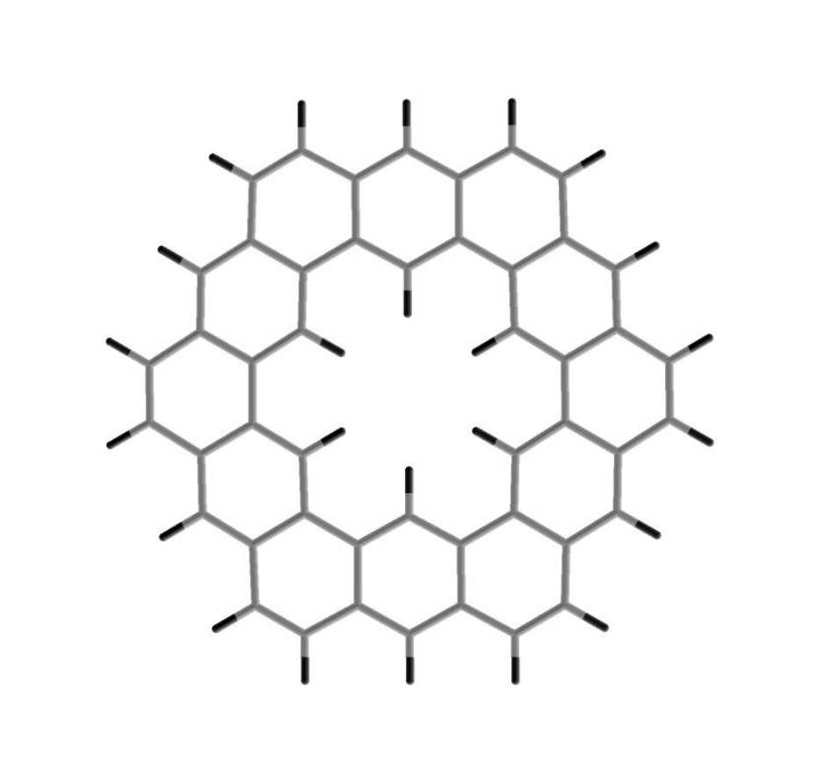

C1

r i h

C15p

j g

c b k

d a

e f

Figure 1: Optimized structure of Kekulene, showing bond and atom number for

Table 1 .

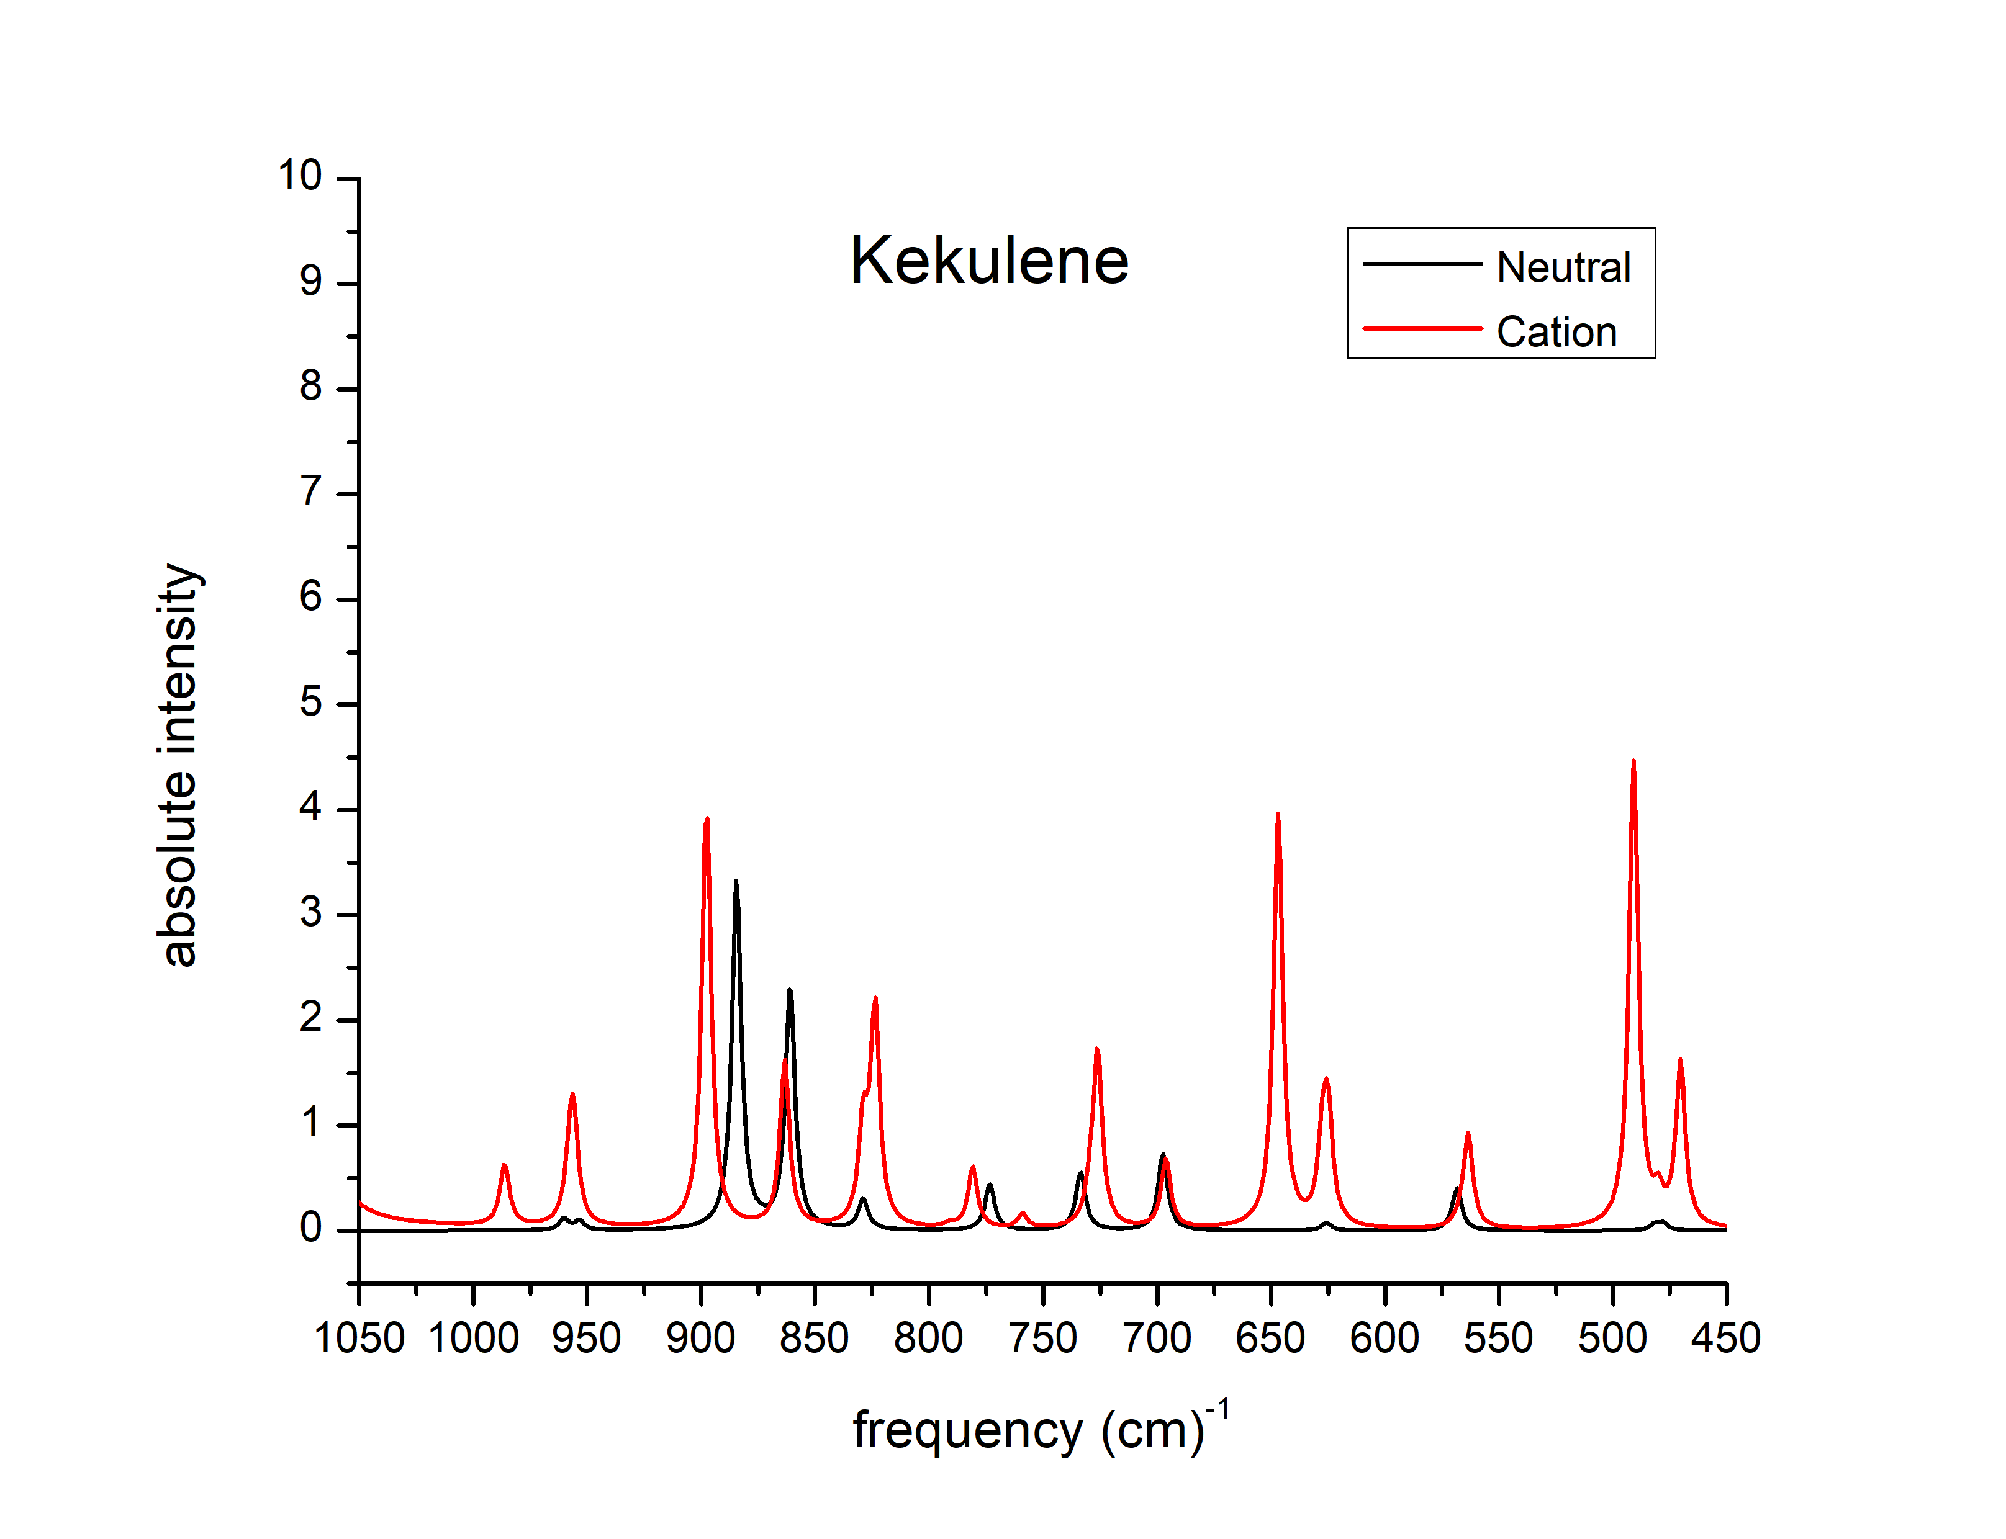

Figure 2: Vibrational spectra of Kekulene and its cation for the CH out-of-plane vibtration modes (450–1050 cm−1)

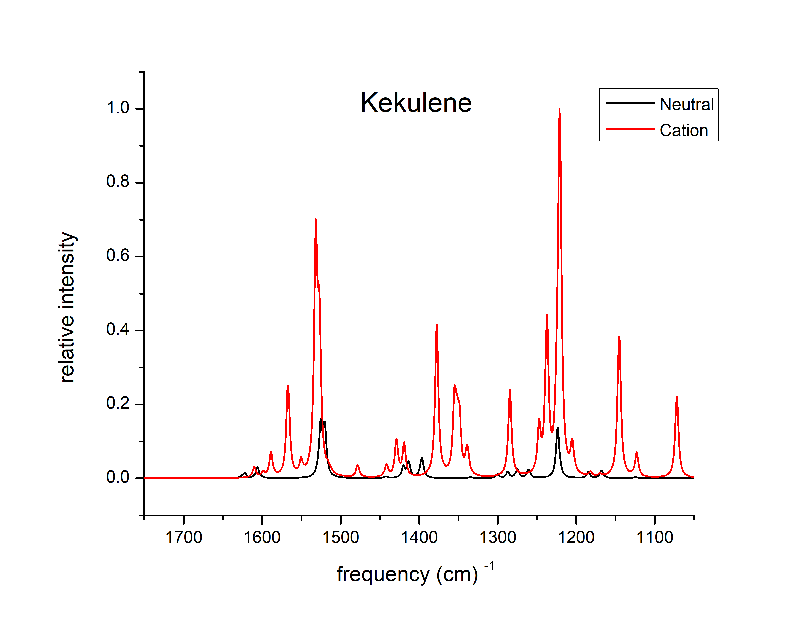

Figure 3: Vibrational spectra of Kekulene and its cation for the CH in-plane-bend and CC stretch vibration modes (1150–1750 cm−1). The vibrational frequencies along with their relative intensities are shown in the plot. The intenties of the vibrational modes are normlized by the maximum absolute intensity; neutral, 4.204

Debye2/AMU A˚ 2 ; cation, 72.522 Debye2/AMU A˚ 2.

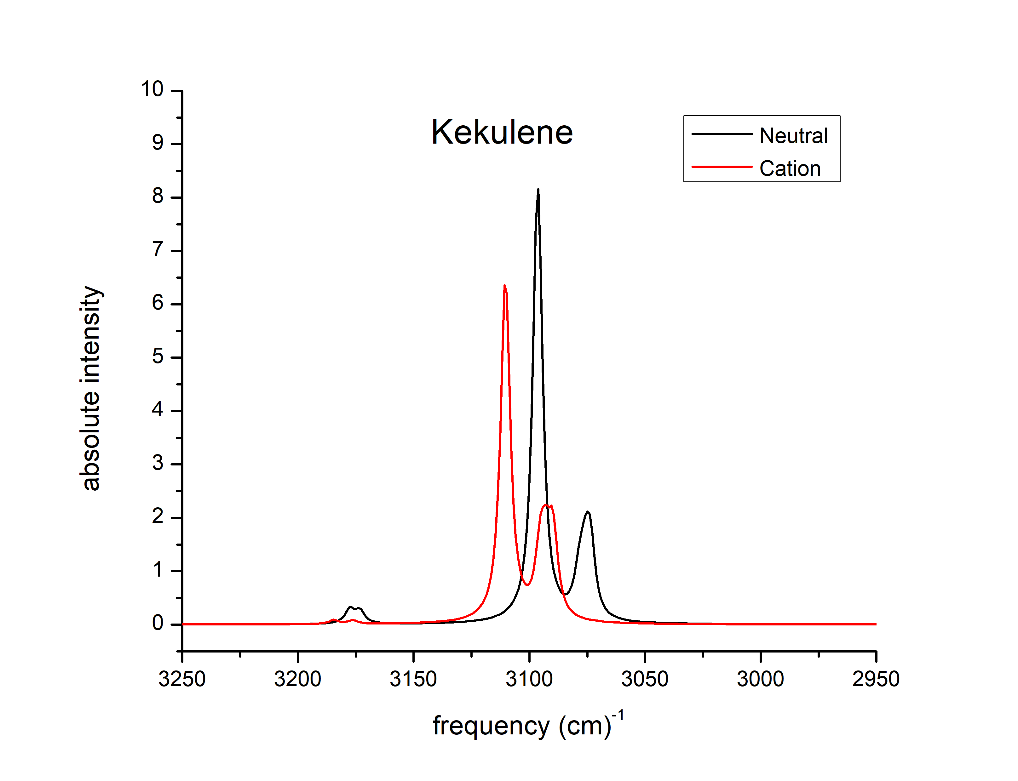

Figure 4: Vibrational spectra of Kekulene and its cation for the CH stretch vibrations

Table 2: Computed infrared frequencies (cm−1) and relative intensities for Kekulene

Kekulene

|  |  |  |  |  |
| --- | --- | --- | --- | --- |
| Neutral |  |  | Cation |  |
| Frequency | Relative Intensity |  | Frequency | Relative Intensity |
| 697.5 | 0.17 |  | 259.5 | 0.06 |
| 733.2 | 0.07 |  | 265.2 | 0.01 |
| 734.0 | 0.07 |  | 470.4 | 0.02 |
| 773.5 | 0.11 |  | 491.0 | 0.06 |
| 828.9 | 0.03 |  | 563.5 | 0.01 |
| 829.2 | 0.04 |  | 625.1 | 0.01 |
| 860.9 | 0.55 |  | 647.0 | 0.05 |
| 884.4 | 0.79 |  | 726.2 | 0.02 |
| 953.4 | 0.02 |  | 823.7 | 0.03 |
| 960.2 | 0.03 |  | 828.9 | 0.01 |
| 1,167.4 | 0.04 |  | 863.3 | 0.02 |
| 1,184.3 | 0.03 |  | 897.7 | 0.06 |
| 1,223.3 | 0.14 |  | 955.9 | 0.01 |
| 1,223.9 | 0.14 |  | 1,071.9 | 0.23 |
| 1,259.7 | 0.02 |  | 1,122.9 | 0.07 |
| 1,261.3 | 0.03 |  | 1,145.2 | 0.41 |
| 1,275.0 | 0.05 |  | 1,181.8 | 0.01 |
| 1,287.1 | 0.03 |  | 1,205.1 | 0.09 |
| 1,300.0 | 0.02 |  | 1,221.1 | 1.00 |
| 1,396.1 | 0.06 |  | 1,224.7 | 0.12 |
| 1,397.5 | 0.05 |  | 1,237.4 | 0.44 |
| 1,413.4 | 0.08 |  | 1,247.2 | 0.13 |
| 1,420.2 | 0.06 |  | 1,284.4 | 0.25 |
| 1,520.2 | 0.26 |  | 1,337.9 | 0.05 |
| 1,525.6 | 0.27 |  | 1,339.6 | 0.04 |
| 1,605.6 | 0.04 |  | 1,348.8 | 0.14 |
| 1,606.2 | 0.02 |  | 1,351.8 | 0.10 |
| 1,621.7 | 0.02 |  | 1,355.1 | 0.20 |
| 3,073.2 | 0.06 |  | 1,377.7 | 0.44 |
| 3,073.9 | 0.27 |  | 1,419.3 | 0.09 |
| 3,076.0 | 0.19 |  | 1,428.9 | 0.10 |
| 3,078.1 | 0.09 |  | 1,441.8 | 0.03 |
| 3,078.8 | 0.07 |  | 1,478.1 | 0.03 |
| 3,079.7 | 0.01 |  | 1,516.4 | 0.02 |
| 3,095.6 | 0.27 |  | 1,527.2 | 0.39 |
| 3,096.4 | 0.71 |  | 1,531.7 | 0.64 |
| 3,096.7 | 1.00 |  | 1,550.2 | 0.04 |
| 3,173.3 | 0.06 |  | 1,567.0 | 0.27 |
| 3,177.6 | 0.06 |  | 1,588.5 | 0.07 |
|  |  |  | 1,598.5 | 0.01 |
|  |  |  | 1,609.8 | 0.03 |
|  |  |  | 3,089.9 | 0.02 |
|  |  |  | 3,092.8 | 0.01 |
|  |  |  | 3,109.8 | 0.03 |
|  |  |  | 3,110.6 | 0.05 |
|  |  |  | 3,110.7 | 0.02 |

The relative intensities are obtained by normlizing with the strongest band of each set.

Maximum absolute intensity: neutral, 4.204 Debye2 /AMU A˚ 2 ; cation, 72.522 Debye2 /AMU A˚ 2 .