**Case Report**

**Beyond the spicules: Atypical Retinitis Pigmentosa in Bardet-Biedl Syndrome**

**ABSTRACT**

Bardet-Biedl Syndrome (BBS) is a rare autosomal recessive ciliopathy with multisystem involvement. We present the case of a 7-year-old boy who presented with photophobia and difficulty seeing in dim light. Examination revealed central obesity, bilateral post-axial polydactyly of the feet, crowded teeth, and micropenis. His best-corrected visual acuity was 6/9 in both eyes. Fundus examination showed pale optic discs and attenuated arterioles without classical bone spicule pigmentation, suggestive of retinitis pigmentosa sine pigmento. A clinical diagnosis of BBS was established based on the presence of multiple primary diagnostic features. The presence of dental and genital anomalies highlights the need for a multidisciplinary approach to diagnosis and care. This report contributes to the limited literature on BBS from India and reinforces the significance of recognizing atypical phenotypes, especially in resource-limited settings.

*Keywords: Bardet-Biedl Syndrome, Retinal Dystrophies, Ciliopathies Paediatric Genetic Disorders.*

**INTRODUCTION**

Bardet-Biedl Syndrome (BBS) is a rare, pleiotropic ciliopathy with significant clinical and genetic heterogeneity. It is traditionally inherited in an autosomal recessive manner, though oligogenic inheritance has also been described. [1,2] The condition is characterized by six primary features: rod-cone dystrophy, post-axial polydactyly, central obesity, hypogonadism, learning difficulties, and renal abnormalities.[1] Secondary manifestations include speech delay, ataxia, diabetes mellitus, cardiovascular anomalies, and dental defects such as microdontia and hypodontia. [3]

BBS is uncommon in the general population, with an estimated prevalence of 1 in 150,000–160,000 in Europe and North America. However, higher rates are seen in populations with increased consanguinity: 1 in 13,500 in Kuwait and 1 in 17,000 in Newfoundland. [1,4] In India, population-based prevalence data are lacking, but hospital-based studies have reported BBS-associated retinitis pigmentosa in children, particularly in consanguineous communities, highlighting probable underdiagnosis. [5]

Ocular involvement, especially retinal dystrophy, is often the earliest presenting sign. Most patients show early-onset rod-cone degeneration, with severely reduced or extinguished electroretinogram responses. [1,6] Retinitis pigmentosa sine pigmento and optic atrophy may be seen. Progressive vision loss often leads to blindness by the third decade. [5,6]

Over 20 BBS genes have been identified, including BBS1 and BBS10, which are the most common. These genes encode proteins involved in ciliary function. [2] Early recognition is critical, as renal failure is a major cause of mortality. Multidisciplinary evaluation aids diagnosis, systemic monitoring, and genetic counselling. [1]

**PRESENTATION OF CASE**

A 7-year-old boy was brought to the ophthalmology outpatient department with complaints of photophobia and difficulty seeing in dim light for the past one year. There was no history of eye pain or floaters. His parents also reported that he struggled academically and had poor attention in school. He was the youngest of four siblings; the other three siblings were healthy with no ocular or systemic complaints. There was no history of parental consanguinity.

On general examination, the child had central truncal obesity [Fig 1a], with weight and BMI above the 95th percentile for age. Bilateral post-axial polydactyly was noted on both feet [Fig 1b]. Oral examination revealed crowded and crooked teeth [Fig 1d]. Genital examination showed micropenis [Fig 1e].   
  
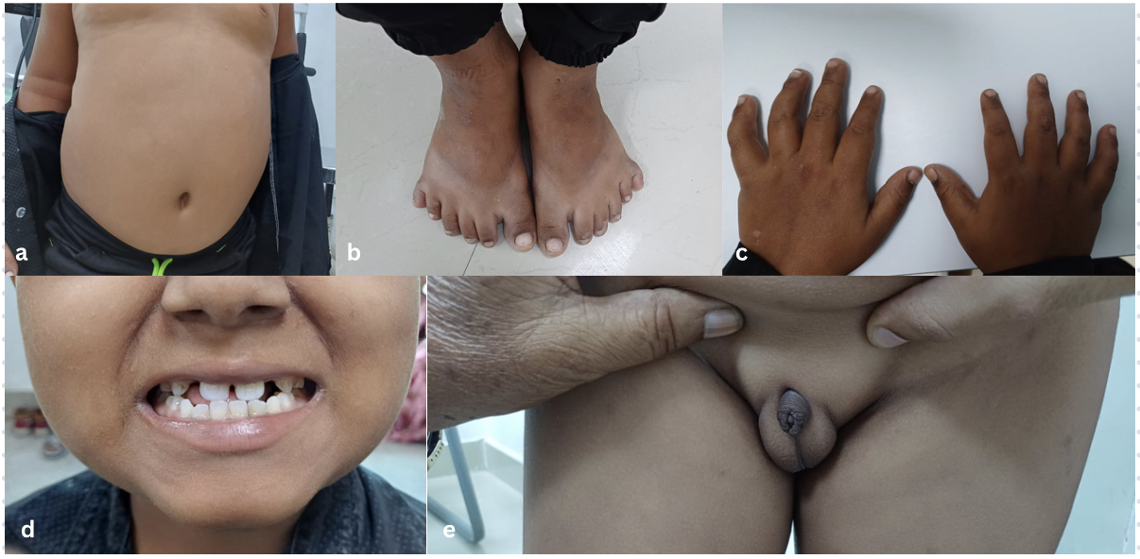

**Figure 1: Clinical features of Bardet-Biedl Syndrome in the patient. (a)** Central truncal obesity with abdominal fat accumulation. **(b)** Bilateral post-axial polydactyly of the feet. **(c)** Normal fingers without polydactyly of the hands. **(d)** Dental anomalies showing crowded, crooked, and malaligned teeth. **(e)** Genital hypoplasia with micropenis and underdeveloped scrotum.

Best-corrected visual acuity was 6/9 in both eyes. Slit-lamp examination of the anterior segment was normal. Fundus examination revealed pale optic discs and attenuated arterioles without characteristic bone spicule pigmentation, suggestive of retinitis pigmentosa sine pigmento [Fig 2]. Renal function was normal, and abdominal ultrasound showed no structural abnormalities in the kidneys.

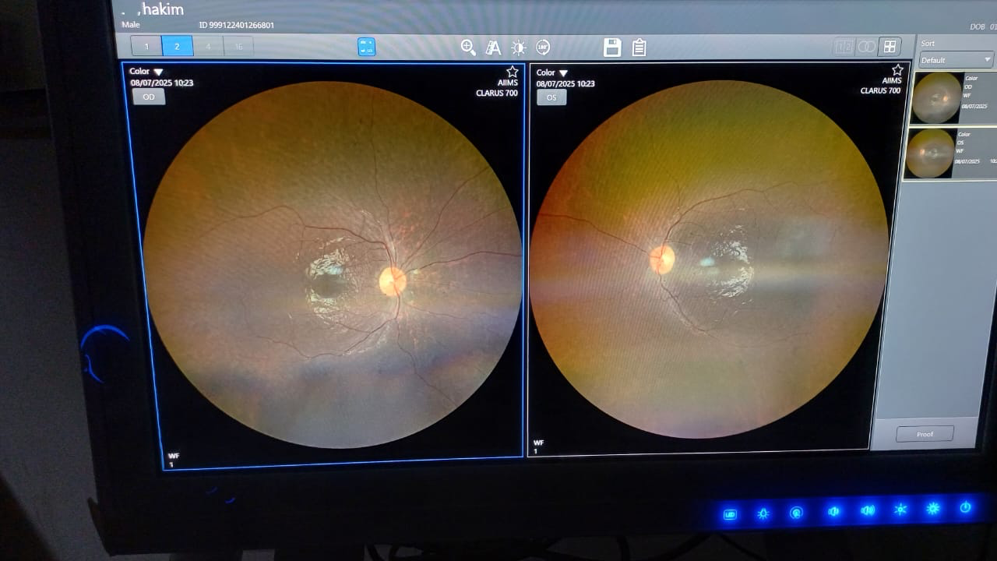

**FIGURE 2: Fundus photographs of both eyes showing atypical retinal features in Bardet-Biedl Syndrome.**

Based on the combination of retinal dystrophy, central obesity, polydactyly, learning difficulties, and genital hypoplasia, a clinical diagnosis of Bardet-Biedl syndrome was made. The child was referred for genetic evaluation and multidisciplinary care. His parents were counselled regarding the risk of progressive visual loss and the importance of ongoing systemic monitoring, especially for renal and metabolic complications.

**DISCUSSION**

Bardet-Biedl Syndrome (BBS) is a clinically heterogeneous ciliopathy often diagnosed through a constellation of cardinal features such as retinal dystrophy, obesity, postaxial polydactyly, hypogonadism, renal anomalies, and cognitive impairment. [1] Our 7-year-old patient exhibited multiple primary features—central obesity, bilateral postaxial polydactyly, micropenis, poor school performance, and retinal dysfunction—meeting established clinical criteria for BBS diagnosis. [1]

What sets this case apart is the atypical ocular presentation of retinitis pigmentosa sine pigmento. Despite a history of photophobia and clinical signs such as optic disc pallor and arteriolar narrowing, there was an absence of classic bone spicule pigmentation. Early retinal degeneration in BBS may precede pigment migration from retinal pigment epithelial cells, explaining this phenotype. [5,7] ERG, the preferred modality to assess rod-cone function, was not performed due to cognitive limitations, and genetic testing was deferred due to financial constraints—common barriers in resource-limited healthcare settings. Nevertheless, clinical findings were sufficient to support the diagnosis.

Retinal degeneration in BBS typically follows a rod-cone pattern, with progressive night blindness, peripheral field loss, and later central vision decline. Though visual prognosis is poor in most cases, our patient retained good visual acuity (6/9 OU), reinforcing the known inter-individual variability in disease progression. [5,6,8]

The presence of dental abnormalities and genital anomalies in this case highlights the importance of a multidisciplinary approach, involving ophthalmology, pediatrics, nephrology, endocrinology, and clinical genetics. Additionally, our patient’s three unaffected siblings, in the absence of consanguinity, support the classical autosomal recessive inheritance pattern of BBS. [2] A thorough family and developmental history proved crucial in the clinical evaluation.

This case contributes to the limited BBS literature from India, where the condition remains underdiagnosed, particularly in rural or consanguineous populations. [5] Documenting such atypical cases—especially those presenting with RP sine pigmento—can help clinicians recognize non-classical presentations early, initiate systemic monitoring, and offer timely genetic counselling. [9]

**CONCLUSION**

Bardet-Biedl Syndrome is a multisystemic ciliopathy that often goes unrecognized due to its phenotypic variability and overlap with other genetic syndromes. This case highlights the importance of considering BBS in children presenting with early retinal dystrophy—especially RP sine pigmento—alongside systemic features such as obesity, polydactyly, dental anomalies, and genital hypoplasia. Timely diagnosis is essential for initiating appropriate visual rehabilitation, systemic monitoring, and genetic counselling. In resource-limited settings where advanced diagnostics like genetic testing or ERG may not be feasible, clinical acumen and a multidisciplinary approach remain the cornerstone of effective diagnosis and management. Early recognition and awareness of atypical presentations can help improve long-term outcomes and reduce morbidity in patients with BBS.

Consent: All authors declare that ‘written informed consent was obtained from the patient (or other approved parties) for publication of this case report and accompanying images.

ETHICAL APPROVAL: As per international standard or university standard written ethical approval has been collected and preserved by the author(s).

**COMPETING INTERESTS DISCLAIMER:**

Authors have declared that they have no known competing financial interests OR non-financial interests OR personal relationships that could have appeared to influence the work reported in this paper.

**References**

1. Forsythe E, Beales PL. Bardet–Biedl syndrome. *Eur J Hum Genet*. 2013 Jan;21(1):8–13. doi:10.1038/ejhg.2012.115.
2. Badano JL, Katsanis N. Beyond Mendel: an evolving view of human genetic disease transmission. *Nat Rev Genet*. 2002 Oct;3(10):779–89. doi:10.1038/nrg917.
3. Hattab FN, Rawashdeh MA, Yassin OM. Dental manifestations of Bardet-Biedl syndrome: report of a case and review of the literature. *J Clin Pediatr Dent*. 1998 Spring;22(3):225–9.
4. Green JS, Parfrey PS, Harnett JD, Farid NR, Cramer BC, Johnson G, et al. The cardinal manifestations of Bardet-Biedl syndrome, a form of Laurence-Moon-Biedl syndrome. *N Engl J Med*. 1989 Oct 12;321(15):1002–9. doi:10.1056/NEJM198910123211503.
5. Parameswarappa DC, Das AV, Thakur PS, Takkar B, Multani PK, Padhy SK, et al. Retinitis pigmentosa in Laurence-Moon-Bardet-Biedl syndrome in India: Electronic medical records driven big data analytics: Report II. *Indian J Ophthalmol*. 2022 Jul;70(7):2533–8. doi:10.4103/ijo.IJO_2268_21.
6. Jacobson SG, Roman AJ, Roman MI, Gass JD, Parker JA. Relatively preserved central retinal function in advanced retinitis pigmentosa. *Invest Ophthalmol Vis Sci*. 1985 Sep;26(9):1043–55.
7. Bittencourt AV, Andrade LJ. Pigmentary retinopathy due to Bardet-Biedl syndrome: case report and literature review. *Arq Bras Oftalmol*. 2009 Sep-Oct;72(5):694–6. doi:10.1590/s0004-27492009000500019.
8. Jacobson SG, Stone EM. Retinal degeneration in Bardet–Biedl syndrome: insights from molecular genetics and therapeutic approaches. *Curr Opin Ophthalmol*. 2006 Sep;17(5):495–501. doi:10.1097/01.icu.0000233969.89344.18.
9. Beales PL, Elcioglu N, Woolf AS, Parker D, Flinter FA. New criteria for improved diagnosis of Bardet–Biedl syndrome: results of a population survey. *J Med Genet*. 1999 Jun;36(6):437–46. PMID:10353778.