Seasonal incidence and management of European foulbrood diseases in Apis mellifera L. Colonies of Kangra Valley of Himachal Pradesh

ABSTRACT
The present study, conducted from July 2024 to June 2025 in both the stationary apiaries of Kangra Valley (Himachal Pradesh) and migratory regions of Anupgarh (Rajasthan), aimed to assess the seasonal incidence and management of European foul brood (EFB) in Apis mellifera colonies. Seasonal observations indicated significant fluctuations in colony strength, brood area, pollen stores, and honey reserves, with optimal colony performance occurring between April and August.The incidence of European foul brood ranged from 1.00% to 48.00% in stationary colonies and from 2.40% to 40.00% under migratory conditions. A positive, though statistically non-significant, correlation was observed between EFB incidence and environmental factors such as minimum temperature, rainfall, and relative humidity, as well as internal hive parameters like brood area. Field level management trials were conducted to evaluate eco-friendly control strategies for EFB. Among the treatments tested, the fungal extract Agaricus bisporus at a concentration of 3 ml per 250 ml sugar solution proved most effective, achieving a reduction of up to 75.38% in EFB infestation. Other notable treatments included Agaricus bisporus (1.0 ml/250 ml sugar solution), Phyllanthus emblica, the shook swarm method, and Ficus religiosa, which recorded reductions of 57.88%, 46.78%, 35.07%, and 28.45% respectively. In contrast, Melia azedarach and Azadirachta indica were the least effective, with only 12.65% and 20.46% reduction in EFB incidence, respectively.
Keywords: Apis mellifera, European foul brood, Seasonal incidence, Management, Colony Parameters and Plant and fungal extracts.

Introduction
Honey bees (Apis spp.) are eusocial insects that play a vital role in both natural ecosystems and agriculture. They provide valuable products such as honey, pollen, royal jelly, beeswax, propolis, and bee venom. More importantly, they serve as crucial pollinators for a wide variety of crops, supporting food security and biodiversity (Johannesmeier & Mostert, 2001). However, like all living organisms, honey bees are vulnerable to numerous diseases and environmental threats that affect colony health and productivity. Their brood is particularly susceptible to infections caused by bacteria, fungi, viruses, protozoa, and mites (Chen et al., 2006). Factors such as the presence of honey, pollen, brood, nectar, and favourable environmental conditions in the hive often attract pests and predators, further exacerbating these challenges. Globally there is no single cause responsible for colony losses; rather, a combination of biotic and abiotic stressors can severely impact bee colony longevity (Genersch, 2010). Diseases and parasitic infestations, especially, have been linked to increased mortality. The introduction of the European honey bee (Apis mellifera) into Asia has contributed to the spread of various pathogens, including Acarapis woodi, European foulbrood (EFB), and Sac brood. Parasites such as Varroa destructor and Tropilaelaps spp. have transitioned from their native hosts to A. mellifera, changing the disease landscape in Asia. Additionally, the movement of bees by beekeepers has enabled the rapid spread of viruses to new regions, causing significant economic losses to both small- and large-scale apiarists.Well-known honey bee diseases worldwide include American foul brood (AFB), EFB, chalk brood, Sac brood, Thai Sac brood virus (TSBV), acarine, nosema, stone brood, and varroosis. Among these, AFB, EFB, and Sac brood are particularly harmful as they target and destroy developing brood. In India, AFB in Apis cerana was first reported in Jeolikot, Nainital (Singh, 1961), while EFB was initially detected in Maharashtra in 1970 (Diwan et al., 1971). In A. mellifera, EFB and Sac brood were first reported in Himachal Pradesh in 1998 (Anonymous, 1998). The disease reemerged in northwest India in 2002 after nearly three decades (Rana et al., 2004), showing symptoms similar to TSBV, though without viral particles. The bacterial agent Melissococcus plutonius was confirmed as the causative pathogen (Rana et al., 2012) TSBV is a viral disease affecting A. cerana, causing larval mortality due to pupation failure. First reported in India in 1979 in Meghalaya, it spread to Uttar Pradesh by 1982 (Kshirsagar et al., 1982). Sac brood virus in A. mellifera was confirmed in Himachal Pradesh in 1998 and has since been reported in other northern states (Rana et al., 2011). The virus infects brood, causing perforation of sealed cells and formation of fluid-filled sacs, with brood turning pale yellow. EFB, first reported in the UK in 1885 (Cheshire and Cheyne) and in the USA by 1907 (White), has since been detected worldwide, including in Canada, Europe, South America, Nepal, Thailand, and India (Camugli) 1962; Thapa et al., 2000). In A. mellifera, it was confirmed in 1998 (Viraktamath,1998), and in A. cerana, it reappeared in 2002 in Himachal Pradesh (Rana et al., 2004). M.plutonius is a gram-positive bacterium that inhabits the gut of larvae, competing with them for nutrients. Under food-limited conditions, it leads to larval starvation and death (Abrol & Ball, 2006). EFB typically affects 4–5-day-old larvae in the coiled stage. Infected larvae become yellowish, misaligned, and produce a vinegar-like odor, later drying into brown, twisted scales (Bailey, 1983; Morse, 1980) In a field study conducted in the Kumaon region of Nainital district, Uttarakhand, beekeepers were found using antibiotics such as oxytetracycline, erythromycin, and tyrosine to treat AFB, EFB, and Sac brood. These antibiotics, dissolved in sugar syrup (80–100 mg/l), are fed to bees. While effective, antibiotic use results in honey contamination, posing health risks to humans, including allergies and obesity, especially in infants (Mutinelli, 2003). As a safer alternative, researchers have tested plant and fungal extracts. Phyllanthus niruri (leaves), Ficus religiosa (roots), and Azadirachta indica (bark) have shown efficacy against Sac brood (Aruna et al., 2017). Clove oil, Ocimum basilicum oil, and Agaricus bisporus extract are effective against EFB. Additionally, bee-derived products like propolis, royal jelly, and honey also exhibit antimicrobial activity (Hassona,2023). Supplementary sugar feeding further boosts colony strength during recovery. Understanding disease etiology and adopting non-chemical interventions are essential for maintaining healthy bee populations and ensuring sustainable apiculture.
Material and Method
The study entitled Seasonal incidence and management of European foul brood of diseases in Apis mellifera L. Colonies of Kangra Valley of Himachal Pradesh" was conducted from July 2024 to June 2025.The region lies at a latitude of 32.0996° N and longitude of 76.2691° E, at an elevation of 1,457 meters above sea level. The climate of Jandpur, Kangra, Himachal Pradesh is classified as humid-subtropical, characterised by distinct seasonal changes. Summers from April to June, are typically hot and dry with temperatures reaching around 29°C. In contrast, winters, which last from November to March, are cold with temperatures dropping to approximately 11°C. The monsoon season, from July to September, brings significant rainfall, contributing to an annual average precipitation of around 1,251 mm. Dharamshala, located nearby, records one of the highest rainfall levels in the state, approximately 3,400 mm annually. Relative humidity fluctuates between 80-90%, particularly during the rainy season. These climatic conditions play a significant role in the local agriculture, biodiversity, and beekeeping, affecting the prevalence and management of honeybee pests and diseases in the region.
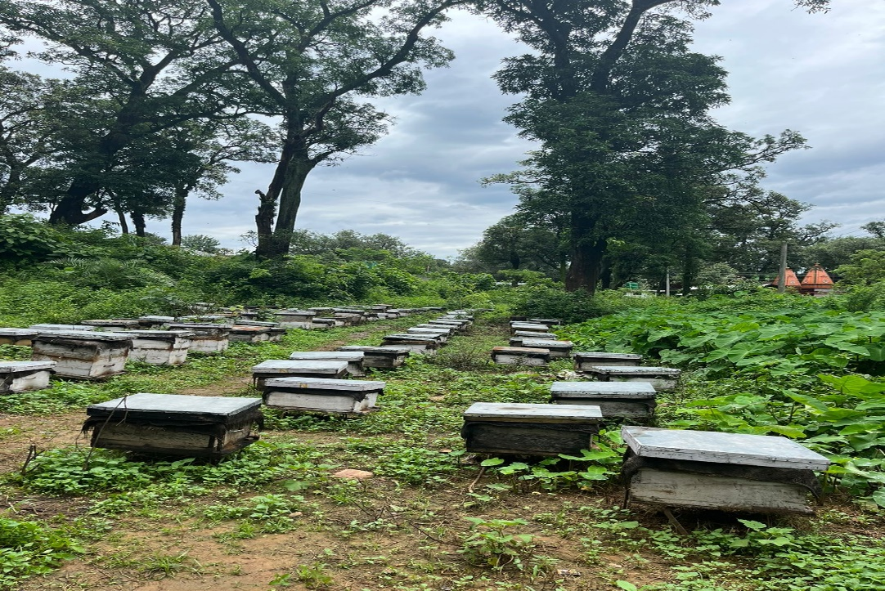
Plate 1: Apiary at Jandpur, Palampur

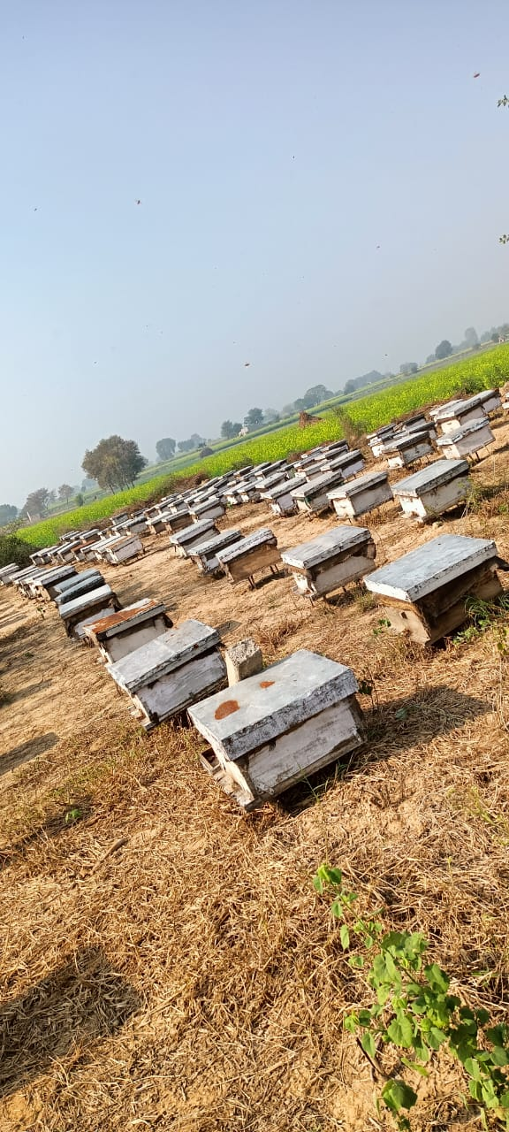
Plate 2: Apiary at Anupgarh, Rajasthan
The details of the colony records and treatments used for different experiment is given below:

EXPERIMENTAL DETAILS
3.1 Colony Records:
Data was collected on various characteristics of experimental colonies of Apis mellifera under both stationary and migratory conditions. Observations were made at monthly intervals over the course of one year. Five colonies were selected to monitor seasonal changes and hive parameters.
3.1.1 Colony Strength:
Colony strength refers to the total number of frames covered with bees. Observations of colony strength were conducted either in the morning or evening when the majority of honey bees are present in the hive. The strength of each selected colony was estimated by counting the number of frames covered by honey bees. For data recording, each bee frame was removed and the adult honey bee population was assessed. If a frame was fully covered by bees, it was counted as one full bee frame; if half of the frame was covered, it was counted as half a bee frame, and so on. This method was used to estimate and record the colony strength for each colony.
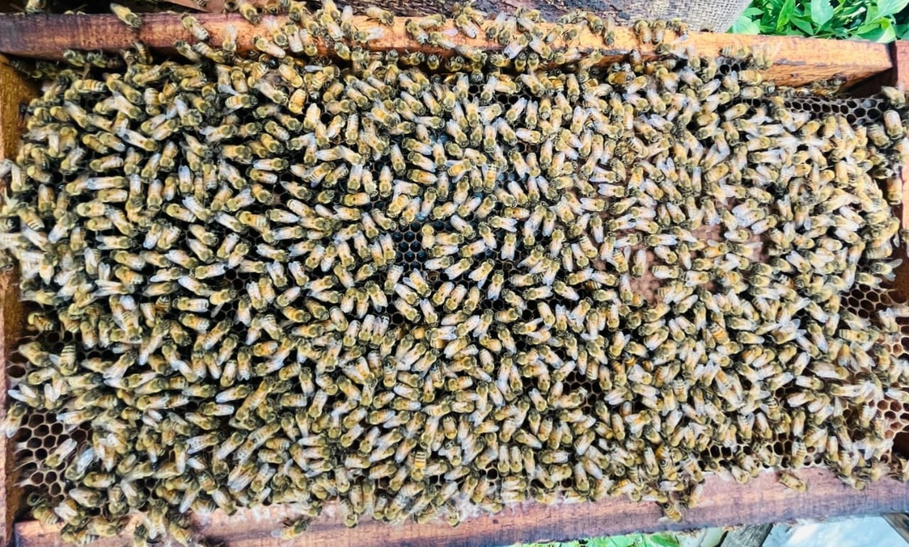
Plate 3: Colony strength

3.1.2 Brood and Pollen Area
The area was measured using a grid system. The brood area was then calculated, and the pollen area was measured by multiplying the number of squares by a factor of 6.45.
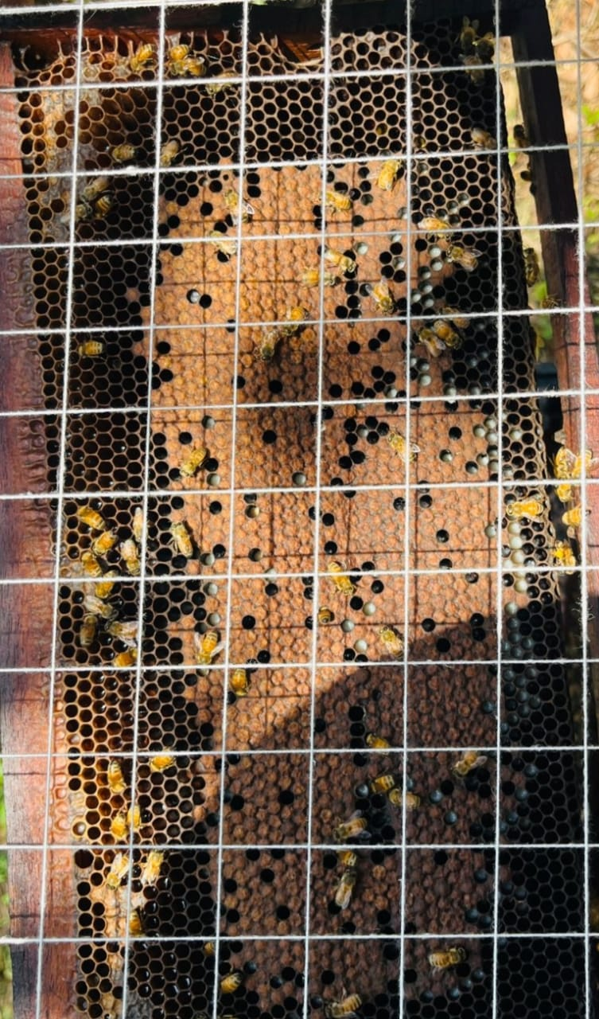
Plate 4: Measuring brood area and pollen area
3.1.3 Honey/Nectar Store
The amount of honey or nectar stored was estimated visually, based on the assumption that one frame of Apis mellifera sealed with honey contains approximately 2 kg of honey.
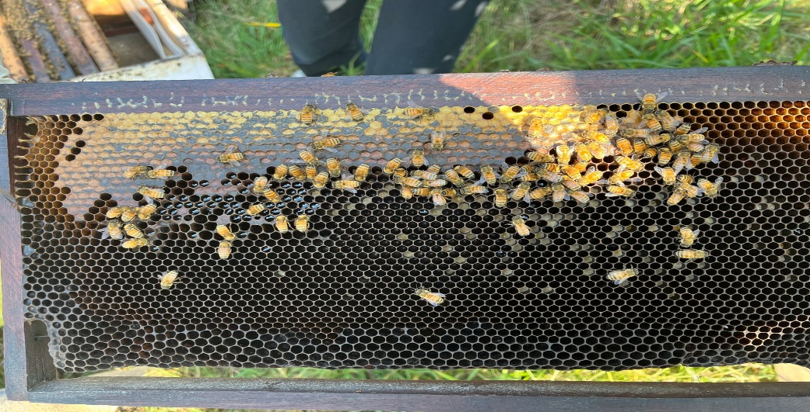
Plate 5 : Sealed and unsealed honey in Apis mellifera colonies

Table 1. Plant , fungal extracts and essential oils used for the management of European foulbrood diseases in Apis mellifera colonies.
Sr.NO. | Treatment | Part of plant/fungus used | Dose (in gm or ml/250ml of 50% sugar solution)
 | Agaricus bisporus | Matured whole plant | 3.0ml and 1.0ml
 | Clove oil | Oil | 2.0ml
 | Ocimum basilicum | Oil | 2.0ml
 | Azadirachta indica(Neem) | Bark | 2.0g
 | Control | - | -

Observations recorded
Observations were recorded on number of European foul brood infected larvae to total number of cells observed after seven days of first and second treatment. The percent infection can be calculated by using formula:
Per cent infection = Number of diseased larvae x100
Total number of cells observed
Percent reduction in disease with respect to control was calculated as per Henderson & Tilton's formula:
% disease reduction= 100 x 1-n in Co before treatment on in T after treatment
n in Co after treatment x n in T before treatment
Where, n= larval population, T=Treated, Co- control.
RESULT AND DISCUSSION
Seasonal incidence and management of European foul brood diseases in Apis mellifera L. colonies of Kangra Valley of Himachal Pradesh ( Stationary and Migratory conditions 2024-2025)
The experimental results and discussion of present investigation entitled “Seasonal incidence and management of European foul brood disease in Apis mellifera L. colonies of Kangra Valley of Himachal Pradesh” are presented and discussed in this chapter.
Stationary Conditions (Palampur, Kangra, H.P)
Table 2. Incidence of European foul brood disease in A. mellifera colonies under stationary conditions (Palampur, Kangra, Himachal Pradesh) during July,2024 to June, 2025
Period | EFB incidence (%) | Colony parameters |  | Weather parameters
Period | EFB incidence (%) | Colony strength (bee frame) | Brood area(cm²) | Temperature  (C) |  | Rainfall  m) | Relative humidity (%)
 |  |  |  | Max. | Min. | Rainfall  m) | Relative humidity (%)
July 2024 | 36.00  (5.91) | 4.95 | 655.43  (25.53) | 26.5 | 20.5 | 410 | 87.4
August | 20.00  (4.58) | 5.15 | 465.49  (21.58) | 25.8 | 20.0 | 440 | 87.4
September | 48.00  (6.96) | 4.65 | 395.05  (19.80) | 25.0 | 18.5 | 200 | 80.0
October | 16.00  (3.92) | 4.90 | 262.02  (16.07) | 23.5 | 15.0 | 50 | 65.0
November | 10.00  (3.31) | 4.25 | 198.12  (14.07) | 20.0 | 11.0 | 28 | 60.0
December | 1.00  (1.41) | 3.90 | 197.13  (13.84) | 16.0 | 5.0 | 40 | 62.0
January 2025 | 2.00  (1.92) | 2.95 | 178.63  (13.28) | 12.0 | 4.0 | 60 | 65.0
February | 8.60  (3.05) | 3.65 | 694.81  (26.27) | 17.0 | 6.0 | 80 | 63.0
March | 6.20  (2.60) | 4.90 | 1,108.50  (33.02) | 18.0 | 8.0 | 90 | 60.0
April | 10.00  (3.31) | 5.25 | 1,351.50  (36.72) | 22.0 | 12.0 | 60 | 55.0
May | 26.00  (5.14) | 6.45 | 1,133.22  (33.62) | 24.1 | 15.0 | 40 | 45.1
June | 40.00  (6.30) | 5.85 | 655.43  (25.53) | 24.1 | 17.0 | 100 | 50.0
C.D | 1.06 | 0.71 | 3.05

The incidence of European foulbrood (EFB) in Apis mellifera colonies maintained under stationary conditions exhibited marked seasonal variation from January to December. The data revealed that maximum incidence occurred in September (48.00%), coinciding with moderate temperatures (around 25°C) and a relatively low brood area (395.05 cm²). The disease incidence during this period was significantly higher than other months and statistically at par with June (40.00%) and July (36.00%). EFB,caused by Melissococcus plutonius, primarily affects unsealed larvae and is strongly influenced by environmental conditions, particularly temperature, humidity, and colony stress (Forsgren, 2010). The peak incidence in September corresponds to post-monsoon stress, a period often marked by forage scarcity, high humidity, and reduced colony activity, all of which can predispose colonies to bacterial infections. The decreased brood area during this period may also reflect a suppression of brood rearing due to disease stress or vice versa.The disease remained relatively high during May (26.00%), a time when colonies are typically strong but possibly exposed to nutritional stress due to changing floral conditions and management stress, such as supering or honey harvesting, which can weaken immunity and increase susceptibility (Shimanuki and Knox, 2000). Disease incidence gradually declined from August (20.00%) through October (16.00%), April (11.00%), and November (10.00%), indicating a possible recovery phase, improved colony resilience, or reduced environmental stress.The lowest incidence was recorded in December (1.00%) and January (2.00%), which is consistent with cold winter conditions, during which colonies typically reduce brood rearing and metabolic activity. Since EFB primarily affects larval stages, its incidence naturally declines when brood production is at a minimum (Bailey and Ball, 1991).These seasonal patterns suggest that EFB outbreaks are strongly correlated with brood density, environmental temperature, and colony nutritional status. Management practices that support strong, well-nourished colonies—such as supplemental feeding during dearth periods and regular hive inspection—can help to reduce EFB incidence, particularly during vulnerable months like June to September.

Fig.1. EFB disease in colony strength and brood area (Stationary conditions)

Fig.2. EFB disease in relation to maximum and minimum temperature

Fig.3. EFB disease in relation to rainfall and relative humidity
Table 3. Pearson correlation coefficient (r) between incidence of European foul brood with colony and weather parameters under stationary condition
Method  Parameters | Brood infestation (%)
Max. temperature | -0.386
Min. temperature | 0.141
Rainfall | 0.267
Relative humidity | 0.193
Colony strength | -0.196
Brood area | 0.131

A significant negative correlation was found between EFB incidence and maximum temperature (r = -0.386), suggesting that higher daytime temperatures may inhibit the proliferation or transmission of Melissococcus plutonius, the causative agent of EFB. Similar findings have been reported by Forsgren (2010), who noted that the pathogen thrives best in cooler, moist condition and is less active in hot, dry environments. Higher temperatures may also suppress larval susceptibility due to increased metabolic activity or enhanced hygienic behavior by bees.The negative correlation with colony strength (r = -0.196) implies that weaker colonies are more vulnerable to EFB, likely due to reduced hygienic behavior, lower brood care efficiency, and compromised immune defenses (Evans and Spivak, 2010). Strong colonies, by contrast, exhibit better resistance through practices such as removal of infected larvae and strong thermoregulation (Seeley, 1985). Positive Correlation with Minimum Temperature, Rainfall, Relative Humidity, and Brood area indicates that milder night support EFB development, possibly by reducing the colony’s ability to suppress bacterial growth during cooler periods. The positive relationship with rainfall and relative humidity further supports the view that EFB outbreaks are favored by moist, humid conditions. High humidity can prolong the survival of Melissococcus plutonius in the brood comb and reduce the effectiveness of hygienic removal (Bailey and Ball, 1991).

Table 4. Incidence of European foul brood disease in A. mellifera colonies under migratory conditions (Anupgarh , Rajasthan) during July, 2024 to June, 2025
Period | EFB incidence (%) | Colony parameters |  | Weather parameters
Period | EFB incidence (%) | Colony strength (bee frame) | Brood area(cm²) | Temperature  (C) |  | Rainfall  (mm) | Relative humidity (%)
 |  |  |  | Max. | Min. | Rainfall  (mm)
July 2024 | 40.00  (6.31) | 5.35 | 1604.32  (39.23) | 26.5 | 20.5 | 410 | 87.4
August | 38.00  (5.85) | 4.20 | 879.96  (28.77) | 25.8 | 20.0 | 440 | 87.4
September | 29.00  (4.82) | 4.25 | 981.49  (29.59) | 25.0 | 18.5 | 200 | 80.0
October | 16.00  (4.20) | 4.00 | 667.33  (24.21) | 23.5 | 15.0 | 50 | 65.0
November** | 4.40  (2.18) | 4.25 | 807.83  (26.10) | 27.5 | 12.5 | 1.3 | 41.5
December** | 0.00  (0.00) | 4.65 | 1493.15  (36.59) | 23.7 | 8.3 | 1.3 | 46.5
January2025** | 2.80  (1.90) | 5.45 | 2661.79  (49.67) | 22.3 | 8.7 | 1.2 | 51.5
February** | 4.00  (2.19) | 7.30 | 3029.98  (54.10) | 24.7 | 11.3 | 3.7 | 46.6
March** | 2.40  (1.78) | 8.05 | 5300.03  (72.56) | 30.3 | 15.7 | 5.3 | 41.5
April | 2.42  (1.80) | 4.35 | 2093.60  (45.14) | 22.0 | 12.0 | 60 | 55.0
May | 4.40  (2.28) | 6.20 | 3144.19  (54.87) | 24.1 | 15.0 | 40 | 45.1
June | 6.40  (2.70) | 6.05 | 2542.64  (48.89) | 24.1 | 18.0 | 100 | 50.0
C.D | 1.36 | 1.85 | 14.39

The incidence of European foulbrood (EFB) under migratory conditions showed distinct seasonal patterns, with the highest disease prevalence recorded in July (40.00%), coinciding with a high ambient temperature (26.5°C) and moderate brood area (1604.32 cm²). This high incidence was statistically at par with August (38.00%) and followed by a significant decline in September (29.00%), which was statistically at par with October (16.00%).These findings are consistent with earlier reports that EFB incidence is closely tied to environmental stressors and colony conditions, both of which are significantly influenced under migratory beekeeping practices. Migratory colonies often experience transportation stress, fluctuating foraging availability, and abrupt environmental transitions, all of which can impair the colony’s immune response and increase disease vulnerability (Genersch, 2010 and Forsgren, 2010). Additionally, frequent brood turnover in summer months creates a conducive environment for Melissococcus plutonius, the causative agent of EFB, to spread rapidly among vulnerable unsealed larvae. Interestingly, the highest EFB incidence (July–August) under migratory conditions occurred at a time of elevated temperatures, which differs from stationary condition observations where disease prevalence was linked more closely to moderate or lower temperatures. This suggests that temperature alone may not be the sole driver but colony stress, brood density, and nutritional imbalance are common under migratory setups and play an equally or more significant role (Shimanuki & Knox, 2000 and Bailey & Ball, 1991). The moderate brood area during these months indicates active colony development, which can paradoxically both reflect colony strength and increase susceptibility due to higher larval population densities. The progressive decline in EFB incidence from September (29.00%) to October (16.00%) likely reflects a transition to more stable foraging conditions or a natural decrease in brood rearing. The drop could also indicate improved colony adaptation post-migration or enhanced hygienic behavior after peak stress periods (Fries and Camazine, 2001).On the contrary, minimal EFB incidence was observed in March (2.40%) and April (1.80%), with no disease was detected in December. These months typically correspond with cooler, more stable environmental conditions and reduced brood activity, which inherently lower the likelihood of EFB outbreaks. The absence of EFB in December may also be attributed to natural colony dormancy and reduced larval availability, aligning with known EFB pathology that targets early larval stages (Forsgren, 2010).Furthermore, low disease levels in May, June, January, February, and November (2.8–6.4%) highlight that early spring and late autumn months pose lower risk periods, likely due to favorable climatic conditions, better nutritional availability, and reduced colony stress.

Fig.4. EFB disease in Average colony strength and brood area

Fig.5. EFB disease in Rainfall and relative humidity

Fig.6. EFB disease in relation to maximum and minimum temperature (migratory conditions)
Table 5: Pearson correlation coefficient (r) between incidence of European foul brood with colony and weather parameters under migratory condition

Methods  Parameters | Brood infestation (%)
Max. temperature | -0.210
Min. temperature | 0.158
Rainfall | 0.257
Relative humidity | 0.177
Colony strength | -0.166
Brood area | 0.180

A statistically significant negative correlation was observed between EFB incidence and maximum temperature (r = -0.210), suggesting that higher daytime temperatures may suppress the development or transmission of Melissococcus plutonius, the causative agent of EFB. While EFB generally thrives in cool, moist environments (Forsgren, 2010), high temperatures might limit bacterial viability or stimulate hygienic behaviors that help to eliminate the infected brood. Bailey and Ball (1991) also noted that warm conditions tend to reduce EFB outbreaks due to increased brood care efficiency and better larval survival.The negative correlation with colony strength (r = -0.166) further reinforces the idea that stronger colonies are more resilient to EFB infections. This could be attributed to more effective social immunity, including grooming, removal of infected larvae, and improved thermoregulation (Evans & Spivak, 2010 and Seeley, 1985). Migratory stress often weakens colony structure and coherence, making colonies more prone to infections (Smith, 2013). EFB incidence showed positive correlations with minimum temperature, rainfall, relative humidity, and brood area, indicating that cool, moist nights and active brood rearing periods support the disease’s spread and development. Moisture plays a critical role in bacterial survival and transmission (Genersch, 2010). Increased relative humidity and rainfall can cause condensation within the hive, creating a favourable environment for bacterial proliferation.

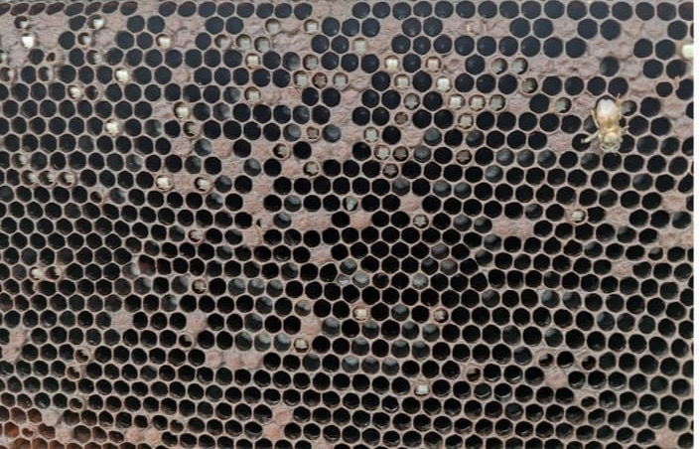

Plate 6: European foul brood infected colony with uncovered pupae

Table 6. Effectiveness of plant and fungal extract against on A. mellifera European foul brood infected colonies.

Treatment | Dose | Initial infestation | % infestation 7 DAFT | % Reduction in disease over control | % infestation 7 DAST | % Reduction in disease over control | Brood area one day after two treatment | Brood area 30 days after two treatment
Agaricus bisporus (Mushroom) | 3.00 ml/250ml of sugar solution | 37.00  (6.08) | 19.33  (4.48) | 61.50% | 14.00  (3.80) | 75.38% | 2391.53  (48.90) | 3242.07  (56.74)
Agaricus bisporus (Mushroom) | 1.00 ml/250ml of sugar solution | 38.00  (6.16) | 23.33  (4.91) | 55.00% | 21.00  (4.68) | 64.04% | 1901.73  (43.60) | 2119.53  (46.02)
Clove oil | 1.00 ml/ 100 ml of distilled water | 35.56  (5.96) | 25.00  (4.83) | 45.00% | 24.00  (4.98) | 56.08% | 1674.95  (40.92) | 1876.16  (43.31)
Ocimum basilicum | 2.00 ml/250ml of water | 40.00  (6.32) | 38.33  (5.34) | 24.00% | 39.00  (6.45) | 36.55% | 622.95  (22.88) | 926.62  (30.42)
Azadirachta indica (Neem) | 1.00 ml/250ml of sugar solution | 36.00  (6.00) | 43.00  (6.65) | 11.00% | 44.00  (6.70) | 20.46% | 561.48  (21.85) | 729.38  (20.92)
Control |  | 41.00  (6.40) | 54.00  (7.43) | - | 63.00  (7.99) | - | 325.32  (15.67) | 319.26  (15.34)
C.D |  | NS | 1.11 | - | 0.87 | - | 4.71 | 7.07

*figures in parentheses are square root (x+1) transformed
This study shows that fungal and plant extracts, such as Agaricus bisporus (mushroom), clove oil, Ocimum basilicum (basil), and Azadirachta indica (neem), can reduce European foulbrood (EFB) infections and improve colony health in honey bees (Apis mellifera). These natural treatments lowered EFB infection rates and increased brood area, which is a sign of healthier bee colonies. These results support the use of eco-friendly alternatives to antibiotics like oxytetracycline, which can lead to antibiotic resistance and leave residues in honey (Genersch, 2010; Waite et al., 2003). Seven days after the first treatment (DAFT), Agaricus bisporus ( 1 ml and 3 ml per 250 ml of sugar syrup) and clove oil showed the biggest reductions in EFB-infected cells. The higher dose of Agaricus bisporus (3 ml/250 ml) reduced infection by 61.50% compared to the untreated group followed by Agaricus bisporus (1 ml/250 ml) at 55.00% and clove oil at 45.00%. These findings suggest that Agaricus bisporus extracts, especially at the higher dose, are highly effective against the EFB-causing bacterium Melissococcus plutonius. Compounds like β-glucans and phenolics in mushrooms may damage bacterial cell walls and inhibit the growth of bacteria (Alves et al., 2012). Clove oil, which contains eugenol, also has strong antibacterial properties, likely helping to lower EFB infection (Burt, 2004). Similar results for Agaricus bisporus (1 ml and 3 ml) and clove oil (with infection rates of 23.33–25.33%) suggest they may work in similar ways to fight the bacteria. Seven days after the second treatment (DAST), Agaricus bisporus (1 ml and 3 ml/250 ml) further reduced infection This shows that Agaricus bisporus works better with repeated treatments, and the higher dose is slightly more effective. Clove oil also performed well (56.08% reduction), while Ocimum basilicum and Azadirachta indica showed smaller reductions. The lower effectiveness of basil and neem may be due to their active compounds, like linalool in basil and azadirachtin in neem, which seem less effective against M. plutonius compared to mushroom or clove oil compounds (Bakkali et al., 2008; Miresmailli & Isman, 2014). The untreated colonies had high infection rates (43.33–54.00%), showing how serious EFB can be without treatment.
Effects on brood area showed that one day after two treatments, Agaricus bisporus (3 ml/250 ml) led to the highest brood area (2391.53 cm²), similar to Agaricus bisporus (1 ml/250 ml) at 1901.73 cm² and clove oil at 1674.95 cm². Thirty days after two treatments, Agaricus bisporus (3 ml/250 ml) still had the largest brood area (3242.07 cm²), followed by Agaricus bisporus (1 ml/250 ml) and clove oil. These results suggest that Agaricus bisporus and clove oil not only fight EFB but also help colonies recover by supporting healthy brood growth. Lower infection levels likely allow nurse bees to care for larvae better, helping the queen lay more eggs (Spivak & Reuter, 2001).However, Ocimum basilicum and Azadirachta indica had brood areas similar to the untreated group (319.26–926.62 cm²), suggesting they had little effect on colony recovery. Neem’s lower performance might be due to its compounds being toxic or repellent to bees at the tested dose (Mordue & Nisbet, 2000). Basil’s moderate results may indicate weaker antibacterial effects or an unsuitable dose, which needs further study.
Agaricus bisporus and clove oil are promising natural options for controlling EFB. They reduce infection and boost brood growth, making them sustainable alternatives to antibiotics. However, Ocimum basilicum and Azadirachta indica were less effective, so their use might need adjustments, such as different doses or combining them with other treatments. Other research has shown that plant-based treatments, like thyme and oregano essential oils, can fight Paenibacillus larvae, the bacterium causing American foulbrood (AFB), due to their phenolic compounds (Gende et al., 2008). This study extends those findings to EFB, showing that clove oil’s eugenol may also target M. plutonius. The strong performance of Agaricus bisporus is a new discovery, as fungal extracts are rarely studied in beekeeping. Their antibacterial effects align with studies on mushroom compounds in other systems (Alves et al., 2012). Neem’s limited effectiveness was surprising, as it has antibacterial properties in other contexts (Mordue & Nisbet, 2000). This suggests M. plutonius may resist neem’s compounds, or the sugar syrup delivery method needs improvement.

Fig.7. Effect of fungal, plant extracts and essential oils on EFB infected A. mellifera colonies

Fig.8. Effect of fungal, plant extracts and essential oils on brood area of treated EFB infected A. mellifera colonies
CONCLUSION
The study entitled Seasonal incidence and management of European foul brood of diseases in Apis mellifera L. Colonies of Kangra Valley of Himachal Pradesh" was conducted from July 2024 to June 2025. European foul brood (EFB) incidence in Apis mellifera colonies showed a seasonal pattern, with the highest occurrence recorded in September (48.00), particularly under stationary conditions. The disease first appeared in March and increased during periods of reduced colony strength, diminished brood area, high temperatures, and moderate humidity and rainfall. Among various treatments tested, Agaricus bisporus extract at a concentration of 3 ml per 250 ml of 50% sugar solution was the most effective, reducing EFB infestation by up to 75.38%. Lower concentrations also showed considerable efficacy. Additionally, clove oil and Ocimum basilicum extracts were effective in reducing EFB infestation.
REFERENCES
Abrol, D. P., and Ball, B. V. (2006). Honeybee diseases and their management. Current Science, 90(4), 486–491.
Anonymous. (1998). Annual Report of All India Coordinated Research Project on Honey Bees and Pollinators, ICAR.
Aruna, R. K., Radhika, K., and Sivaram, V. (2017). Evaluation of plant extracts against Sac brood virus disease in Indian honey bees (Apis cerana indica F.). Journal of Entomology and Zoology Studies, 5(1), 594–598.
Bailey, L. (1983). Melissococcus pluton, the cause of European foul brood of honey bees (Apis spp.). Journal of Applied Bacteriology, 55(1), 65–69.
Camugli, L. (1962). References on global distribution of EFB – likely archival, not fully accessible.
Chen, Y. P., Evans, J. D., Smith, I. B., & Pettis, J. S. (2006). Nosema ceranae is a long-present and widespread microsporidian infection of the European honey bee (Apis mellifera) in the United States. Journal of Invertebrate Pathology, 92(2), 152–159.
Cheshire, F. R., & Cheyne, W. W. (1885). The pathogenic history and description of Bacillus alvei, the cause of foul brood in bees. British Medical Journal, 1, 265–268.
Diwan, V., Pawar, V. M., & Bansal, N. C. (1971). Occurrence of European foul brood in Maharashtra. Indian Bee Journal, 33, 90–92.
Genersch, E. (2010). Honey bee pathology: current threats to honey bees and beekeeping. Applied Microbiology and Biotechnology, 87(1), 87–97.
Hassona, Y. (2023). Antimicrobial activity of bee products against honey bee pathogens. Veterinary World, 16(3), 509–517.
Johannesmeier, M. F., and Mostert, S. H. (2001). Beekeeping in South Africa. Department of Agriculture, Forestry and Fisheries, Republic of South Africa.
Kshirsagar, K. K., Ghatge, P. R., and Patil, S. R. (1982). Incidence of Thai sac brood virus in Apis cerana indica. Indian Bee Journal, 44, 73–75.
Morse, R. A. (1980). Honey Bee Pests, Predators, and Diseases. Cornell University Press.
Mutinelli, F. (2003). European legislation governing the authorisation of veterinary medicinal products with particular reference to antibiotics: present and future. Apiacta, 38, 156–168.
Rana, B. S., Chandel, R. S., & Dogra, G. S. (2004). Reoccurrence of European foul brood in honey bees (Apis mellifera L.) in Himachal Pradesh. Pest Management and Economic Zoology, 12(1), 43–48.
Rana, B. S., Kumar, R., & Sharma, H. K. (2011). Occurrence of sac brood virus in Apis mellifera in northern India. Indian Journal of Entomology, 73(3), 221–225.
Rana, B. S., Dogra, G. S., & Chandel, R. S. (2012). Confirmation of Melissococcus plutonius in European foul brood of honey bees in India. Journal of Apicultural Research, 51(1), 87–89.
Singh, R. (1961). First record of American foul brood disease in Apis cerana indica in India. Indian Bee Journal, 23, 35–36.
Thapa, R., Shrestha, S. M., & Neupane, F. P. (2000). Status of honey bee diseases and enemies in Nepal. Journal of the Institute of Agriculture and Animal Science, 21, 117–122.
Vikratanath,C.A (1998). Occurrence of European foul brood disease in Himachal Pradesh and Karnataka, India. Indian Bee Journal, 60(4), 123-125

