Technological Characterization and Socioeconomic Significance of *Djir*, a Fermented Cereal Flour Consumed in Chad

.

ABSTRACT

|  |
| --- |
| **Aims:** To characterize the traditional processing technology, hygiene practices, and socioeconomic significance of *djir* production in Chad, with a particular focus on women’s empowerment, food safety, and commercialization potential.  **Study design:** Cross-sectional descriptive study based on field surveys, observational hygiene assessments, and technological process documentation.  **Place and Duration of Study:** The study was conducted in five locations across Chad namely *N'Djamena*, *Abéché, Oum-Hadjar*, *Guéréda*, and *Ati*. between October 2021 and October 2022.  **Methodology:** A structured field survey was administered to 255 participants, including 15 female *djir* producers, 100 vendors, and 140 consumers. Data collection focused on sociodemographic characteristics, processing techniques, fermentation practices, hygiene behaviors, pricing, and consumer perceptions. Hygiene assessments were based on observational checklists and scoring systems adapted from prior literature.  **Results:** *djir* production was found to be exclusively female-led, with high levels of illiteracy (53.3%) and limited hygiene training. The artisanal process, spanning 2–3 weeks, included partial dehulling, spontaneous fermentation (86.7%), and sun-drying. Only 13% of producers disinfected their equipment, and 90% of units operated under poor hygienic conditions. Price disparities were evident across regions (1,000–1,600 FCFA/kg). Although 97.86% of consumers were familiar with *djir*, only 31% perceived health benefits, and 3% reported adverse effects such as constipation.  **Conclusion:** This study presents the first detailed process diagram of *djir* production and highlights critical gaps in fermentation control and hygiene. To improve product safety and support women-led food systems, the integration of starter cultures, hygiene training, and gender-sensitive development policies is recommended. *djir* serves as both a culturally important food and a tool for rural women's economic empowerment in Chad. |

*Keywords: djir, pearl millet, processing technology, traditional fermentation, women’s empowerment, socioeconomic impact, food security*

1. INTRODUCTION

Cereals serve as the staple food for rural populations in sub-Saharan Africa, comprising approximately 70% of dietary intake (Macia et al., 2021; Adamou et al., 2025). Pearl millet ranks as the world's sixth most cultivated cereal after wheat, rice, maize, barley, and sorghum (Nadembèga et al., 2020). Despite its widespread cultivation, many regions struggle with food self-sufficiency due to consistently low yields of millet and sorghum (Ndiaye & Diatta, 2021; Janin, 2021; Diop et al., 2022). Africa produces nearly 40% of global pearl millet, primarily processed into traditional foods in countries including Mali, Burkina Faso, and Chad. Pearl millet is transformed into various local products such as porridges, fermented pastes, couscous, tô (millet dough), and semi-industrial derivatives (Kagambèga et al., 2019). In Chad, traditional processing yields both amylaceous and non-amylaceous products (Maïworé et al., 2021). This includes djir, a fermented flour used as a base ingredient for local foods like porridges (Sourounda et al., 2024), tô, and kissar (fermented flatbread), particularly in eastern and central regions (Zinho & Affo, 2024). djir holds deep cultural significance in Chad, where its production and trade provide vital income, especially for women. The flour occupies an important place in culinary traditions and is commercially available across regions at varying prices. djir porridge is traditionally consumed during Ramadan and at ceremonies like weddings, where it's served to newlyweds, a practice common to millet porridges regionally (Doudjo et al., 2017). However, djir production remains largely artisanal and unstandardized, similar to other fermented millet products like Burkina Faso's Bensaalga and Benkida, raising concerns about hygiene, safety, and quality (Kagambèga et al., 2019). Despite its cultural and economic value, few studies have examined djir production conditions in Chad or assessed its socioeconomic impact. This study therefore systematically documents djir processing practices and analyzes technological parameters in Chad, providing evidence-based foundations for improving safety, quality, and sustainability.

.

2. material and methods

**2.1 Study area and period**

The study was conducted from October 20, 2021, to October 22, 2022, in five locations across Chad: the capital city *N'Djamena*, *Abéché* (Ouaddaï region), *Oum-Hadjar* (Batha East region), *Guéréda* (Wadi-Fira region), and *Ati* (Batha West region). The survey assessed the sociocultural characteristics of participants, production practices, marketing conditions, and potential public health risks related to *djir* flour. Study sites were chosen based on two factors: the regional importance of djir production and local market availability

. Figure 1 shows the geographic distribution of selected areas and their relevance to *djir* flour production. The survey examined *djir* flour production, commercialization, and consumption patterns among three target groups: female producers, female vendors, and consumers.

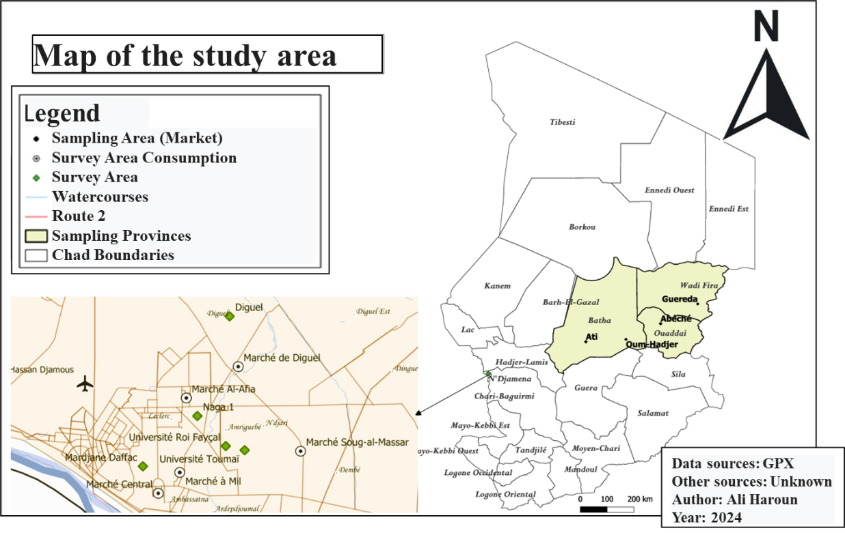

**Fig. 1. Geographic Location of the Study Area**

**2.2 Data collection**

Data were collected using structured survey forms from three participant groups: producers (15 women), vendors (100), and consumers (140). The surveys captured sociocultural characteristics, demographic profiles, educational levels, knowledge of processing practices, hygiene behaviors, and product usage patterns. These data enabled evaluation of technological and socioeconomic aspects of *djir* flour production and commercialization. Table 1 summarizes key collected information.

**Table 1. Information collected from survey participants**

|  |  |
| --- | --- |
| **Survey Participants** | **Information collected** |
| Producers | Age and gender  Selection of raw materials and supply sources  Measurement tools for purchasing and storage methods for the final product |
| Compliance with good hygiene and manufacturing practices |
| Level of education and professional qualifications |
| Vendors | Price per unit of measurement  Supply sources and hygiene conditions  Packaging (bags) and product storage practices |
| Consumers | Awareness and knowledge of *djir*  Reported health benefits and adverse effects  Frequency of consumption (daily, weekly, or monthly) |

*\*Moisture content on oven dry weight basis*

**2.3 Traditional processing of *djir* flour**

The production process involves the following stages:

**-Sorting and cleaning:** This initial stage involves the removal of damaged grains and physical contaminants such as stones, dust, and plant debris to ensure the quality of the raw material

**-Partial dehulling**: This operation aims to remove the outer husk (bran) of the pearl millet to facilitate subsequent fermentation processes.

-**Soaking:** Before being used, cleaned millet is soaked for seven to fourteen days.

After fermentation, the grains undergo a series of four successive washes to reduce acidity levels.

-**Draining and pounding:** Soaked grains are drained for 30 minutes, then pounded and wet-milled into a slurry. These steps are repeated until a smooth and well-ground slurry is obtained.

**-Filtration:** Filtration is performed using a two-layer membrane system, one filter placed over another, both inserted into a large clay pot (canari). The slurry is gradually poured onto the top layer and agitated with lateral movements (left to right) to facilitate draining through the membranes. This process yields a homogeneous filtered liquid inside the canari, while sediment (referred to as *mou*) is retained between the two membranes.

- **Settling and Fermentation:** The filtrate is left undisturbed for 24 hours to allow sedimentation and spontaneous fermentation. This results in the formation of four distinct layers (top to bottom), each with different characteristics.

-**Solidification and Drying:** The uppermost layer is discarded. The second and third layers are left to solidify for 24 hours, then sun-dried to yield *délké* and *riguébé* flours, respectively. The fourth and bottom layer is left to solidify over a 24-hour period and is then sun-dried for 24 to 48 hours. This final product constitutes the *djir* flour.

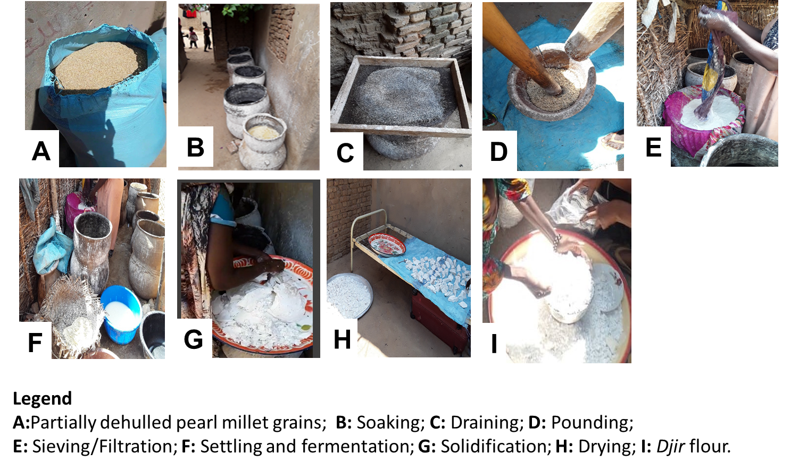**Fig. 2. Artisanal Processing Steps and Tools for *djir* Preparation**

**2.4 Criteria for Evaluating Hygienic Characteristics of Production and Sales**

The hygienic characteristics of producers were evaluated based on six key parameters: production site conditions, raw material quality and sourcing, sales location hygiene, equipment sanitation, water source purity, and worker attire. Following Barro *et al.* (2003), each parameter was scored to assess hygienic performance. A modified participatory approach (Temple *et al.*, 2005) was then used to evaluate hygiene knowledge. Based on the composite scores (out of 10), producers were categorized into three hygiene tiers: Poor (<5/10), Average (5 - 7/10), and Good (>7/10 with valid public health certificates) (Table II).

**Table 2. Scoring Criteria for Hygienic Characteristics**

|  |  |
| --- | --- |
| **Setting** | **Scores/10** |
| Production Environment | 0.5 |
| Quality of Raw Materials  Production Tools and Equipment  Hygienic Characteristics of Producers | 0.5  0.5  0.5 |
| Sales Environment | 0.5 |
| Sales Equipment | 0.5 |
| Hygienic Characteristics of Vendors | 1 |
| Product Protection and Preservation | 1 |
| Condition of Product Packaging | 1 |
| Cleaning/Disinfection of Equipment | 1 |
| Training on Good Practices | 2 |
| Public Service Recognition Certificate | 2 |

*Source: Temple et al. (2005) modified*

**2.5 Data processing**

Survey data analysis was conducted using Microsoft Excel 2013 for frequency calculations of all measured variables. Image processing and resizing were performed using Paint.NET software (version 4.0.6).

3. results and discussion

**3.1 Results**

**3.1.1 Sociocultural Characteristics of Producers, Vendors, and Consumers**

Table 3 presents the sociocultural profiles of *djir* flour stakeholders. All producers were female, with 46.7% aged over 45 years. Educational attainment among producers showed 53.3% illiteracy, 26.7% primary education, 6.7% secondary education, and 13.3% higher education. Notably, 87% self-identified as professionally qualified.

Vendor demographics revealed 83% female participation, with peak representation (41.8%) in the 26-35 age group. Consumer data indicated 60% female consumption, most prevalent (43.6%) among 26–35-year-olds. Marital status analysis showed 54.3% of consumers were married versus 2.1% widowed. Educationally, secondary-educated consumers formed the largest cohort (27.1%).

**Table 3. Sociocultural Characteristics of Producers, Vendors, and Consumers**

|  |  |  |
| --- | --- | --- |
| **Variables** | **Parameters** | **Frequencies (%)** |
| Producers | | |
| Gender | Male | 00 |
| Female | 100 |
| Age | 15-25 | 6.7 |
| 26-35 | 26.7 |
| 36-45 | 20 |
| >45 | 46.7 |
| Education level | Iliterate | 53.3 |
| Primary | 26.7 |
| Secondary | 6.7 |
| Higher education | 13.3 |
| Professional Qualification | Yes | 87 |
| No | 13 |
| Vendors | | |
| Gender | Male | 17 |
| Female | 83 |
| Age | 15-25 | 9 |
| 26-35 | 41.8 |
| 36-45 | 33.6 |
| >45 | 15.6 |
| Consumers | | |
| Gender | Male | 40 |
| Female | 60 |
| Age | 15 25 | 25.7 |
| 26 35 | 43.6 |
| 36 45 | 22.9 |
| >45 | 7.9 |
| Marital status | Married | 54.3 |
| Single | 27.1 |
| Divorced | 16.4 |
| Widowed | 2.1 |
| Education level | Illiterate | 08.6 |
| Literate | 25.7 |
| Primary | 20 |
| Secondary | 27.1 |
| Higher education | 18.6 |

**3.1.2 Quality of Raw Materials and Uses of *djir***

The survey showed that 73.3% of producers selected raw materials based on color, while 20% used purity and 6.7% used size as their main criteria. For sourcing materials, 67% of producers obtained them from local markets and 33% from suppliers in other regions. In terms of usage, 55% of *djir* flour was used for making porridge, compared to just 0.7% used for *kissar*. The survey also found that cereals were the most common products marketed alongside *djir* products, appearing in 41% of cases (Table 4).

**Table 4. Raw Materials and Uses of *djir* Flour**

|  |  |  |
| --- | --- | --- |
| **Variables** | **Parameters** | **Frequencies (%)** |
| Selection criteria | Size | 06.7 |
| Purity | 20 |
| Color | 73.3 |
| Availability | 00 |
| At least two criteria | 00 |
| Source of supply | Market | 67 |
| Supplier outside region | 33 |
| Uses of *djir* | Porridge | 55 |
| Millet dough (t*ô*) | 25 |
| *Kissar* | 0.7 |
| Mutiple forms | 19.3 |
| Products Sold Near *djir* Products | *Cereal* | 41 |
| *Vegetables* | 21.30 |
| *Spices* | 13.10 |
| *Various products* | 23 |
| Others | 1.6 |

**3.1.3 Regional Usage Patterns of *djir* in Food Preparation**

Figure 3 illustrates the various uses of *djir* across surveyed regions. Porridge was the predominant preparation (24.09% of cases), particularly in Batha . In contrast, *kissar* (fermented flatbread) showed higher prevalence in Ouaddaï (2.19%) compared to other areas.

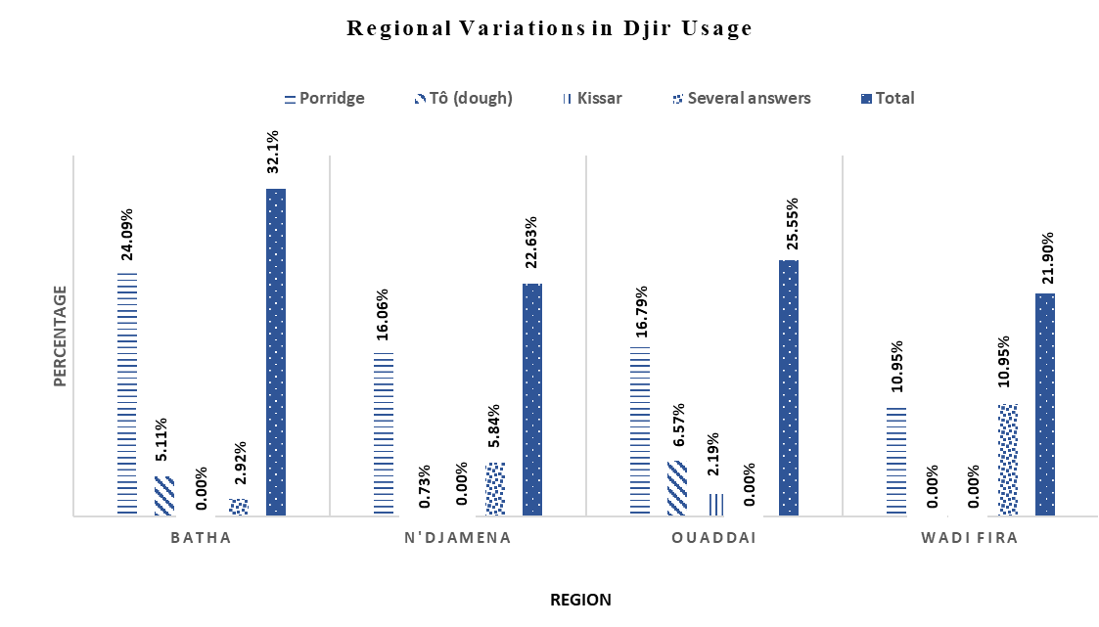

**Fig. 3. Regional Variations in *djir* Usage**

**3.1.4 Technological Process**

The production of *djir* follows a defined sequence of operations. First, raw grains undergo cleaning, sorting, and partial dehulling. The processed grains are then soaked for 7 to14 days, after which the fermented water is separated and discarded. The remaining solid material is washed, pounded, and soaked again before being sieved and filtered. The filtered product undergoes a 24-hour fermentation period.

Following fermentation, the product separates naturally into four distinct layers. The bottom layer (fourth layer) is the most important, consisting of a coagulated phase that solidifies during an additional 48 to 72 hour fermentation. This final product is then sun-dried for 1 to 2 days to produce the flour. The complete production process is detailed in Figure 4.

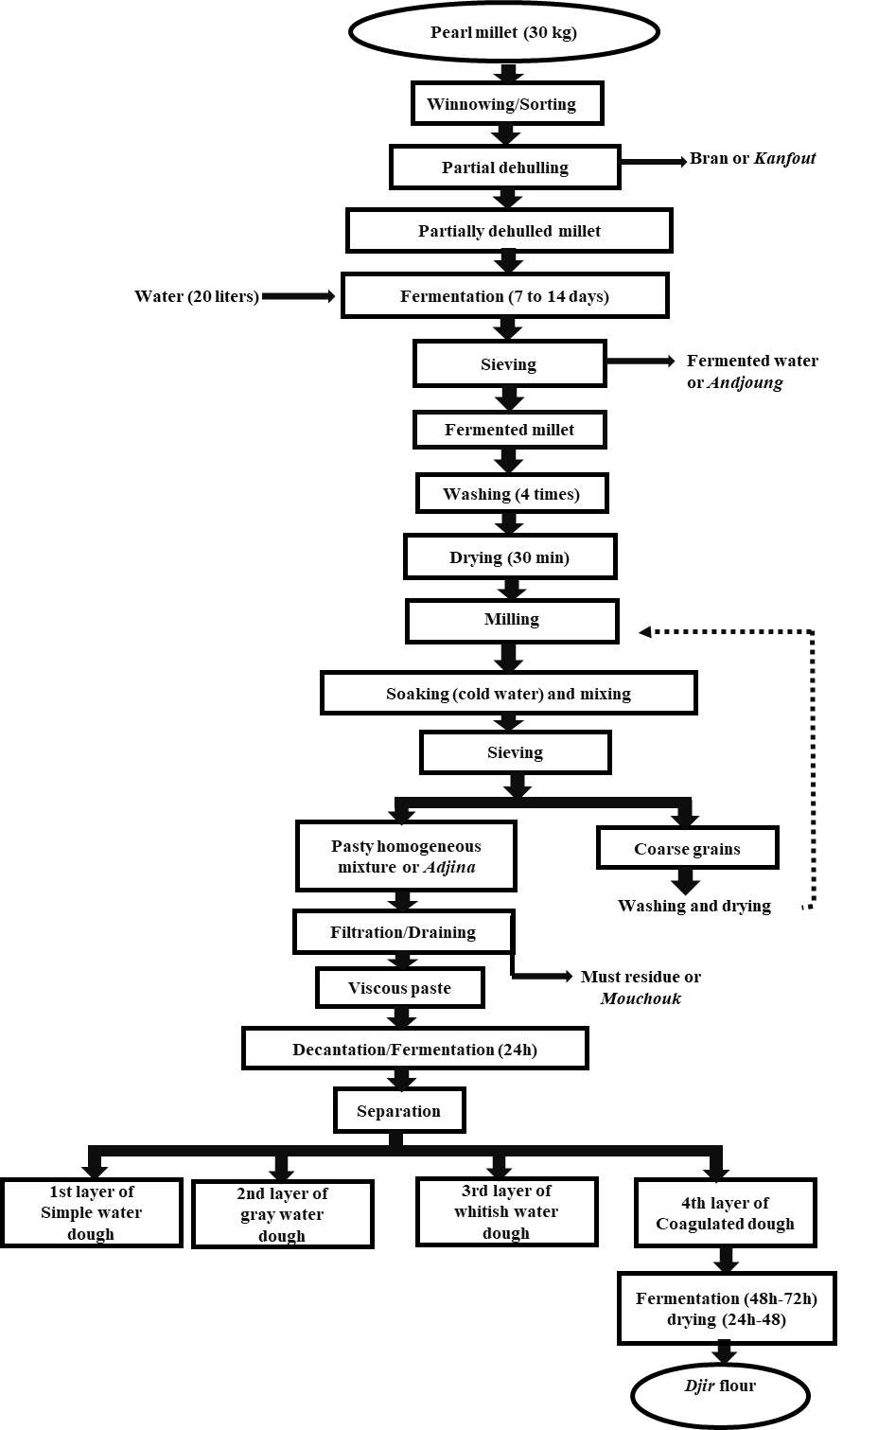**Fig. 4. Technological Diagram of *Djir* flour production**

Figure 5 displays *djir* flour (A) and its prepared milk porridge (B).

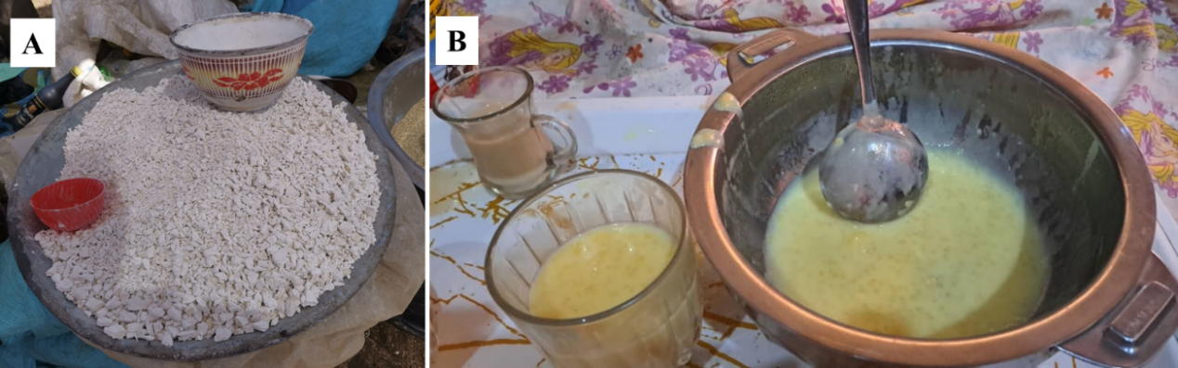

**Fig. 5. D*jir* Flour and Porridge**

**Caption**: A (*djir* Flour); B (*djir* Porridge with Milk)

**3.1.5 Production Duration and Fermentation Methods**

Production timelines varied across units: 33% completed *djir* in three weeks, 47% in two weeks, and 20% within ten days or more. For fermentation, 86.7% of units used spontaneous fermentation, while 13.3% employed traditional methods. No units utilized controlled or industrial fermentation (Figure 6).

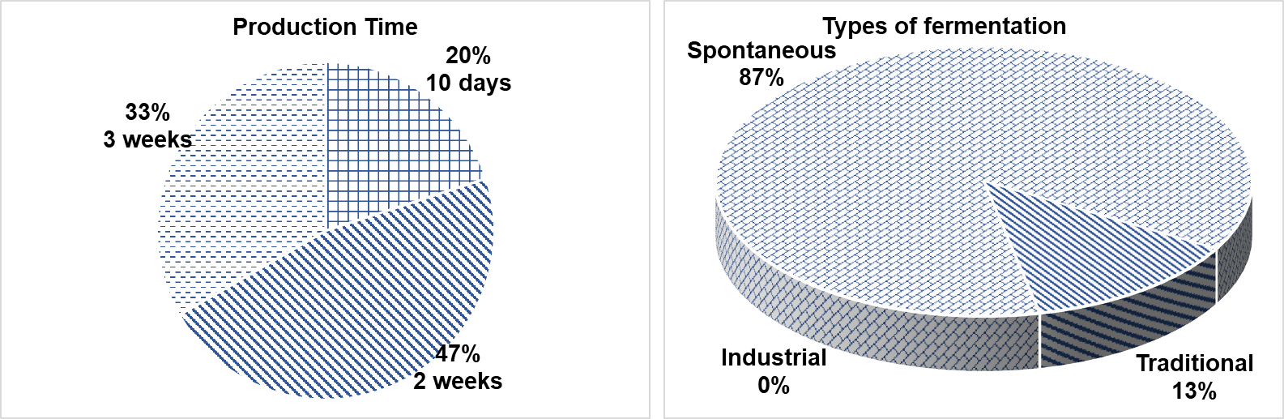

**Fig. 6. Production Duration and Types of Fermentation**

**3.1.6 Consumption Patterns**

*3.1.6.1 Age and gender Based Consumption Frequency*

Figure 7 reveals age-related consumption trends. Consumers aged 26-35 years showed the highest representation across all frequency categories, with occasional consumption being most prevalent (10.22%). Notably, while individuals over 45 years were primarily associated with "more than one month" consumption intervals, they also accounted for 9.49% of occasional consumers.

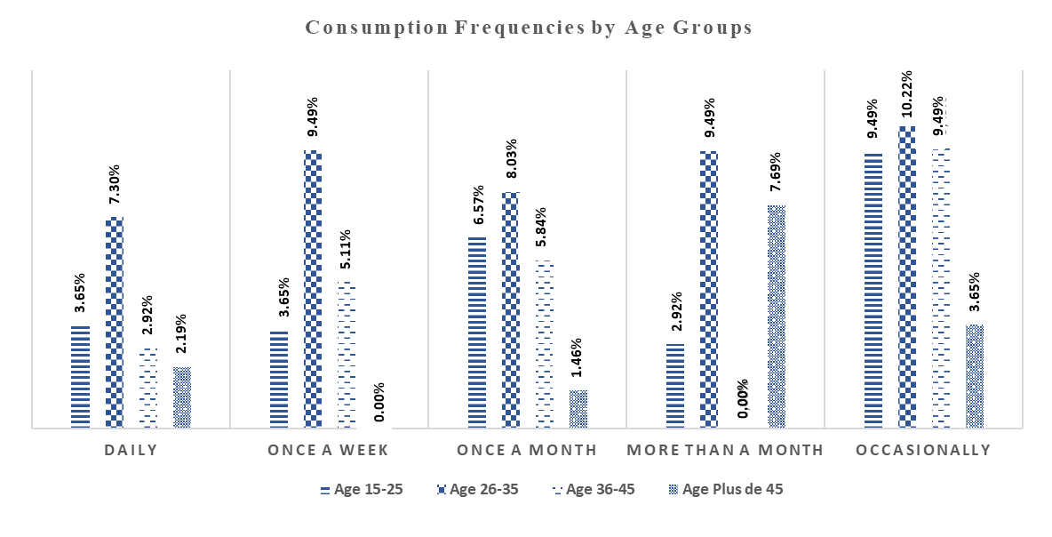**Fig. 7. *Djir* consumption Frequency by Age Group**

Figure 8 illustrates significant gender-based differences in *djir* consumption patterns (p = 0.021). Women showed higher regular consumption, particularly in monthly intake (15.33% of female respondents). In contrast, men predominated in occasional consumption (19.71%).

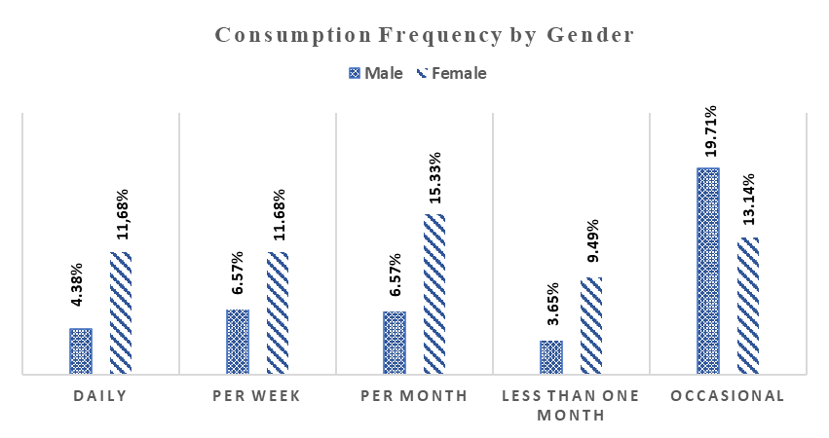

**Fig. 8. Gender-based *djir* Consumption Frequencies**

*3.1.7.2 Regional Patterns of djir Awareness and Consumption*

Table 5 shows *djir* awareness and consumption trends across regions. While all regions reported some awareness, recognition rates stayed below 50%. *Batha* had the highest awareness (32.12%), followed by *Wadi Fira* (21.90%). Consumption patterns varied by region with occasional consumption most common in *Wadi Fira* (13.14%), but less frequent in *Ouaddaï*.

**Table 5. Territorial Differences in *djir* Awareness and Consumption Frequency**

|  |  |  |  |  |  |  |
| --- | --- | --- | --- | --- | --- | --- |
| **Knowledge of *djir*** | **Region** | | | | | |
| Batha | N’Djamena | Ouaddaï | Wadi Fira | Total | P value |
| Yes | 32.12% | 22.63% | 23.36% | 21.90% | 97.86% | 0.027 |
| No | 0.00% | 0.00% | 2.19% | 0.00% | 2.14% |
| **Frequency of Consumption** | | | | | | |
| Daily | 2.31% | 3.65% | 5.84% | 3.65% | 16.06% | 0.000 |
| Weekly (1) | 8.76% | 3.65% | 2.19% | 3.65% | 18.25% |
| Monthly (1) | 10.95% | 4.38% | 5.11% | 1.46% | 21.90% |
| More than a month (1) | 1.46% | 0.00% | 11.68% | 0.00% | 13.14% |
| Occasionnal | 8.03% | 10.95% | 0.73% | 13.14% | 32.85% |

**3.1.8 Health Implications of *djir* Consumption**

*3.1.8.1 Reported Benefits and Adverse Effects*

Survey responses revealed three perspectives on *djir*'s benefits: 33% cited nutritional value, 31% reported general health benefits, and 31% identified both. Conversely, only 2.9% of consumers reported adverse effects (primarily constipation), with 97.1% experiencing no negative symptoms (Figure 9).

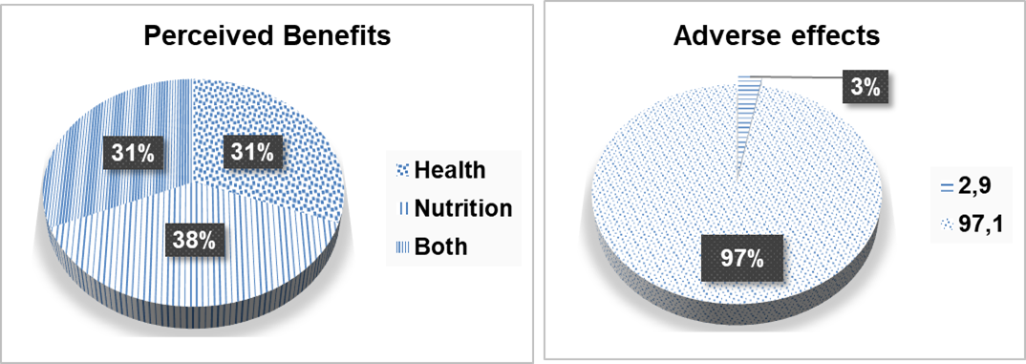

**Fig. 9. Perceived Benefits and Adverse Effects related to the *djir* consumption**

*3.1.8.2 Health Risks*

Field assessments identified critical hygiene gaps throughout the *djir* production and sales chain. In production units, 90% operated in poor sanitary conditions, while only 3% were rated satisfactory, and 7% moderate. Although all producers (100%) reported cleaning their equipment, only 13% implemented proper disinfection procedures, a serious deficiency in microbial risk management. These risks are exacerbated by the 87% rate of untrained producers, who had never received formal training on good hygiene and manufacturing practices (GHP/GMP), suggesting elevated contamination risks throughout the production chain.

As illustrated by figure 10, hygiene conditions at points of sale also exhibited significant regional disparities (p < 0.0001). Regions such as Batha (16. 39%) and Ouaddaï (22.95%) had the highest proportions of markets with acceptable hygiene conditions, while N'Djamena (24.59%) and Wadi-Fira (21.31%) reported the highest rates of poor hygiene. These differences are statistically meaningful and suggest inconsistent enforcement of sanitation norms across urban and rural markets. The combination of insufficient sanitation in both production and retail environments raises serious public health concerns regarding microbial contamination, especially given the long fermentation periods, the use of non-treated water, and the lack of packaging or protective equipment during handling

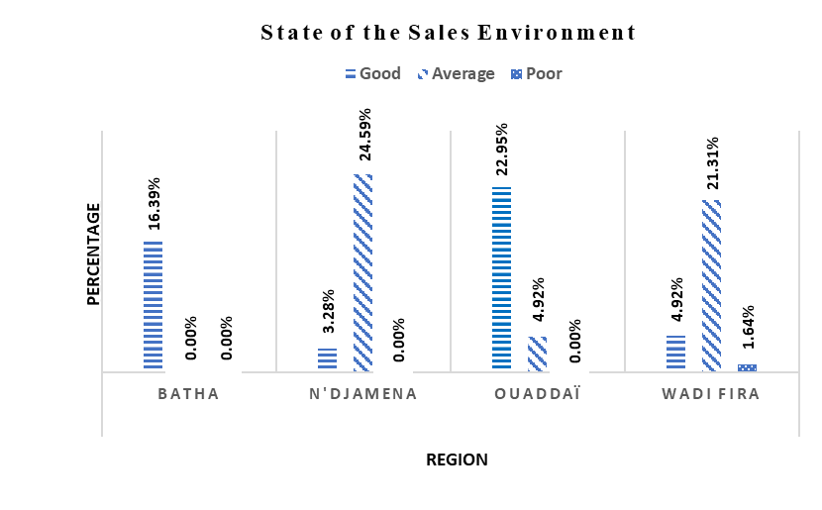**Fig. 10. Hygienic Conditions of *Djir* Sales Environments Across Regions**

**3.1.1 Economic Impact** (ARIAL, BOLD, 10 FONT, LEFT ALIGNED, underlined)- third level heading

The economic data further underscore structural challenges within the *djir* value chain. Price disparities were observed between regions, with the cost of an 80–85 kg sack of raw millet reaching 32,500 FCFA in N’Djamena, compared to 25,000 FCFA in Ouaddaï. The corresponding prices for 80 kg of *djir* flour ranged from 128,000 FCFA in N’Djamena (1,600 FCFA/kg) to 80,000 FCFA in Ouaddaï (1,000 FCFA/kg). On average, producers obtain 43 kg of *djir*, 7 kg of dèlké, and 10 kg of *riguèbé* per sack of raw millet, as detailed in Table 6. These figures illustrate not only economic potential but also the need for improved sanitary conditions to sustain product quality and market competitiveness.

**Table 6. Costs of Millet, *djir* Flour, and Production Yield**

|  |  |  |  |
| --- | --- | --- | --- |
| **Regions / Cities** | **Millet Sack**  **80 85 kg (Fcfa)** | ***Djir* Flour**  **80 Kg (Fcfa)** | ***Djir* Flour**  **(Fcfa)** |
| Ouaddaï | 25000 | 80 000 | 1000 |
| Wadi Fuira | 30000 | 96 000 | 1200 |
| Batha East et West | 27500 | 96 000 | 1200 |
| Ndjamena | 32500 | 128 000 | 1600 |
| **Yield After Millet Transformation** | | | |
| Quantity/Floor | *Djir* (Kg) | *Dèlké* (Kg) | *Riguèbé* (Kg) |
| 80-85 kg | 43 | 7 | 10 |

**3.2 Discussion**

**3.2.1 Socio-Demographic Characteristics and Cultural Roles of *Djir* Stakeholders**

The survey results revealed that *djir* flour production is carried out exclusively by women, reflecting a common pattern in sub-Saharan Africa where women are key actors in the processing and valorization of traditional cereal-based products. This gender-specific involvement is rooted in household food responsibilities and community-based knowledge systems. Similar observations were made in Burkina Faso, where women represented 100% of the producers of the traditional beverage *Zoom-Koom* (Massieke *et al.*, 2017; Kagambèga *et al.*, 2019), and in broader studies of fermented cereal foods (Bokossa *et al.*, 2016).

In Cameroon, Maïworé *et al.* (2021) also reported that the production of Kounou, a traditional fermented cereal beverage, was exclusively managed by women, further illustrating the regional consistency of gendered food production roles. Konaté *et al.* (2024) emphasized that this dominance of women in traditional processing results from their dual status as housewives and agricultural workers, often charged with food preparation responsibilities. These findings align with our data, which show that women are not only central to production (100%) but also dominate marketing activities (83%) and represent 60% of the consumer group.

In terms of educational and marital status, *djir* producers tend to be older, married, and non-literate women, consistent with the profiles described by Djana *et al.* (2003, 2007), who highlighted the importance of experiential knowledge in the production of traditional flours. This suggests that the transmission of *djir* processing knowledge occurs through informal, women-led knowledge systems and community practices.

On the other hand, vendors and consumers displayed more demographic diversity across age, sex, marital status, and education level. The growing urban demand and the spread of djir outside of its initial cultural basis may be connected to this wider representation. The fundamental phases of manufacturing, however, are still fiercely protected inside certain networks of women.. As N’zi *et al.* (2023) note, such systems of traditional food production are often anchored in ancestral knowledge, which naturally limits external participation and ensures cultural continuity.

**3.2.2 Selection of Raw Materials and Regional Culinary Applications**

The selection of pearl millet grains by djir producers is based primarily on empirical criteria, with color (73.3%) being the most dominant parameter, followed by purity (20%) and grain size (6.7%). These visual qualities, especially color, are often connected to how mature the grain is thought to be and the quality of the flour that is expected. In traditional food systems where standardized quality control measures are absent, such criteria serve as practical indicators for producers (Boudi et al., 2022).

In terms of sourcing, 67% of producers procure their raw materials directly from local markets, benefiting from availability, proximity, and cost-effectiveness. The remaining 33% rely on suppliers from outside the region, typically in bulk quantities. This distinction reflects both logistical constraints and market integration levels across different production zones.

djir flour is used for the preparation of various traditional dishes, with porridge being the most common application (55%), followed by tô (millet dough) at 25%, and kissar (fermented flatbread) at only 0.7%. 19.3% of those who answered said they used it in different ways for different recipes. The relatively marginal use of djir for kissar preparation can be attributed to strong regional culinary differentiation, especially in the Ouaddaï region, where this dish holds particular symbolic value. The preparation of kissar, according to Kadri et al. (2019), has traditionally been associated with elite or noble families and was originally prepared solely with pearl millet before being adapted to include other cereal flours such as sorghum, rice, and maize.

Figure 3 illustrates the regional variation in the culinary uses of djir across the surveyed regions. Porridge was particularly dominant in Batha (24.09%), confirming its status as the most popular form of consumption. Conversely, Ouaddaï stands out as the only region where kissar was mentioned as a food prepared from djir (2.19%), which confirms its local cultural specificity.

Furthermore, djir is often sold in open markets alongside other staple food items. According to survey responses, the most common neighboring product category was cereals (41%), followed by vegetables (21.3%), various dry goods (23%), and spices (13.1%). These findings suggest that djir is embedded in a broader local food ecosystem, where it competes with and complements other essential food commodities.

The empirical data highlight the multi-functional nature of djir in regional food systems, reflecting not only its nutritional role but also its symbolic and economic significance. While porridge remains the dominant usage across all regions, localized practices such as the preparation of kissar show that culinary identity and tradition continue to shape how djir is processed, marketed, and consumed in different parts of Chad

**3.2.3 Traditional Fermentation Process and Technological Variability**

The production process of *djir* flour follows traditional artisanal methods, similar to those used for other fermented cereal-based products across Africa. The initial steps, cleaning, sorting, and partial dehulling, ensure better quality of the raw material. Soaking, which lasts between 7 and 14 days, softens the grains and promotes microbial activity, making subsequent milling and fermentation more efficient (Samaké *et al.*, 2022; N’zi *et al.*, 2023). After repeated washing and wet milling, the resulting slurry is filtered and left to settle, yielding four distinct layers. The fourth and bottom layer, after fermentation and sun-drying, becomes the final *djir* flour.

Fermentation is predominantly spontaneous (86.7%), with the remaining 13.3% using a traditional starter method. No units reported the use of industrial or controlled fermentation. Spontaneous fermentation facilitates the natural growth of lactic acid bacteria and yeasts, enhancing aroma, texture, and nutritional properties of the final product (Dan *et al.*, 2021; Limingui *et al.*, 2021). However, it also introduces inconsistencies in product quality due to regional variability and uncontrolled microbial populations.

The decantation process generates three by-products, *dèlké*, *riguèbé*, and the final *djir* each derived from successive sedimentation layers. The final fermentation phase for *djir* lasts 48 to 72 hours, depending on climatic conditions and local practices. In Batha (e.g., Ati and Oum-Hadjar), production cycles span 3 to 5 days, whereas in Ouaddaï and Wadi-Fira (e.g., Abéché and Guéréda), fermentation can last up to 3 weeks. These regional differences reflect the heterogeneity of traditional techniques and highlight the need for standardization.

Prolonged fermentation periods, especially under uncontrolled temperature and humidity, increase the risk of biogenic amine accumulation and product spoilage. According to Bennato *et al.* (2022), the use of controlled starter cultures could reduce fermentation time, enhance reproducibility, and limit microbial risks offering a pathway toward improved food safety and commercialization.

**3.2.4 Hygiene Practices and Potential Microbiological Risks**

The field assessment revealed major deficiencies in hygiene across *djir* production and sales chains. While all producers (100%) reported cleaning their equipment, only a small fraction (13%) practiced proper disinfection following cleaning. Furthermore, 90% of production sites were categorized as poor sanitary environments, with only 3% achieving a satisfactory hygiene rating. This widespread lack of sanitary control reflects a deeper structural issue: 87% of women involved in *djir* production have never received any formal training on hygiene or good manufacturing practices (GMP). These findings are consistent with earlier observations in similar artisanal processing environments, where low literacy and poverty impede access to training and sanitation infrastructure (Barro *et al.*, 2003; Temple *et al.*, 2005).

From a microbiological safety perspective, the absence of equipment disinfection, use of non-treated water sources, and exposure to ambient contaminants during sun-drying represent significant risks for foodborne illness. The long fermentation time, combined with spontaneous microbial activity, can encourage the growth of opportunistic or pathogenic bacteria if hygiene is not rigorously maintained.

Hygienic conditions at sales points were also highly variable across regions. In Ouaddaï and Batha, 22.95% and 16.39% of market sites, respectively, were judged as having acceptable hygienic environments. However, the situation was far worse in N’Djamena and Wadi-Fira, where 24.59% and 21.31% of sites, respectively, were considered unsanitary. These disparities are statistically significant (p < 0.0001) and reflect differences in urban infrastructure, enforcement of food safety regulations, and producer awareness.

The poor sanitary conditions identified in both production and sales environments increase the likelihood of cross-contamination, particularly since *djir* flour is often handled manually, stored in open containers, and sold in informal market settings. As similar studies on fermented foods have shown (Kagambèga *et al.*, 2019), such gaps in food hygiene can compromise product quality, consumer safety, and market credibility. Addressing these challenges will require targeted hygiene training, affordable sanitation materials, and stronger regulatory oversight within the *djir* value chain.

**3.2.5 Consumer Awareness, Perceived Benefits, and Adverse Effects**

Consumer awareness of *djir* is exceptionally high, with 97.86% of respondents across all surveyed regions reporting familiarity with the product. However, awareness levels vary significantly by region. For example, Batha region recorded the highest recognition rate (32.12%), while Wadi-Fira and Ouaddaï had lower scores (21.9% and 23.36%, respectively). The relatively low awareness in Ouaddaï, despite being a major production zone may be linked to its cosmopolitan nature and the presence of refugee and humanitarian populations, which alter local dietary practices and reduce exposure to traditional foods.

In terms of consumption patterns, the 26–35 age group emerged as the most consistent demographic across all consumption frequency levels. *djir* is most commonly consumed occasionally (32.85%), with only 16.06% reporting daily consumption. This intermittent pattern reflects its cultural and ceremonial use, especially during weddings, baptisms, and religious observances such as Ramadan, where *djir* porridge holds symbolic value (Doudjo *et al.*, 2017). These findings are consistent with patterns observed for other traditional beverages like *zoom Koom*, which are reserved for festive or communal events.

Regarding perceived health benefits, 33% of consumers associated *djir* consumption with nutritional value, 31% with health benefits, and another 31% with both. These perceptions align with the general understanding of fermented foods as functional products, often credited with improving digestion and enhancing nutrient bioavailability (Konaté *et al.*, 2024). However, the scientific basis for these claims remains underexplored in the case of *djir* and warrants further biochemical and nutritional analysis.

Adverse effects were reported by 2.9% of consumers, mainly involving constipation. This may be attributed to the texture of the product or to complementary ingredients (e.g., milk) often added during consumption, which could lead to lactose intolerance symptoms in certain populations. These minor but noteworthy reactions suggest that consumer health feedback should be integrated into future quality improvement initiatives.

Overall, while *djir* enjoys strong cultural and sensory acceptance, there is a disconnect between high awareness and clear understanding of its functional value. Public health campaigns and food education strategies could help bridge this gap by promoting not only the safety but also the nutritional profile of *djir* and other traditional fermented products.

**3.6. Economic Value and Implications for Local Food Systems**

The transformation process generates value-added outputs from a single 80–85 kg sack of pearl millet, yielding approximately 43 kg of *djir* flour, 7 kg of dèlké, and 10 kg of riguèbé. Despite the weight loss during processing, the final products command higher per-unit prices, thus enhancing profit margins. This value addition is particularly important for female producers, who dominate the *djir* value chain from processing to marketing, and depend on it for household income and financial autonomy.

In rural regions like Ouaddaï and Batha, lower raw millet prices (25,000–27,500 FCFA per sack) help reduce input costs, while urban centers like N’Djamena experience significantly higher costs (32,500 FCFA per sack), largely due to transportation, scarcity, and urbanization. These dynamics mirror findings in other parts of Sub-Saharan Africa, where cross-border trade, post-harvest losses, and urban demand drive cereal price volatility (John *et al.*, 2022; Kambou *et al.*, 2021).

Despite its informal nature, the *djir* sector holds untapped potential for inclusive local economic development. Organizing producers into cooperatives, improving processing efficiency, and facilitating access to storage and hygiene infrastructure would increase income predictability and improve quality standards. However, any attempt at formalization must respect *djir*’s cultural roots, preserving the traditional knowledge embedded in its production while aligning with public health and commercialization goals.

In conclusion, *djir* is more than a nutritional product, it represents a culturally embedded, female-driven microeconomy. Empowering women through capacity-building, training, and market access, while ensuring sanitary compliance and product standardization, will be crucial to unlocking the full potential of *djir* within local food systems and beyond.

4. Conclusion

This study successfully defined the traditional technological process used to produce djir flour and published the first detailed flow diagram outlining its essential processing processes. According to survey data, djir is made from pearl millet (Pennisetum glaucum) under artisanal conditions by nearly entirely female workers, the majority of whom have no formal education and no training in good hygiene or manufacturing procedures (GHP/GMP). The observed heterogeneity in production length between areas adds to inconsistencies in product quality and safety. In addition to its nutritional and cultural significance, djir is an important part of local food systems since it provides women with an income. However, the marketing and handling conditions of *djir* and its by-products indicate serious hygienic flaws, raising the possibility of cross-contamination and microbiological dangers. Given its widespread public acceptance and socioeconomic importance, it is critical to create a standardized production technique that retains traditional expertise while increasing food safety and product quality. This would increase *djir*'s commercial viability while also promoting women's economic empowerment. To that purpose, more research is needed to evaluate the physicochemical, nutritional, and microbiological properties of *djir* flour, as well as to identify and functionally analyze the indigenous fermentative microbiota engaged in its spontaneous fermentation. These activities are critical to ensuring the product's safety, consistency, and possibility for further market integration.

**DISCLAIMER (ARTIFICIAL INTELLIGENCE)**

Author(s) hereby declares that NO generative AI technologies such as Large Language Models (ChatGPT, COPILOT, etc) and text-to-image generators have been used during writing or editing of this manuscript

References

Temple L., Kwa M., Efanden C., Tomekpe K. (2005) Methodological contribution to the field validation of new plantain varieties. Fruits; 60(3):163-177. Available: https://doi.org/10.1051/fruits:2005023

Barro, N., Ouattara C.A., Nikiema; P. A., Ouattara, A. S., Traoré, A. S. (2003). Evaluation of the microbiological quality of some street foods in the city of Ouagadougou, Burkina Faso. Cahiers Santé; 12(4):369 74. Available at: http://www.jle.com/fr/revues/san/edocs/evaluation_de_la_qualite_microbiologique_de_quelques_aliments_de_rue_dans_la_ville_de_ouagadougou_au_burkina_faso_220003/article.phtml

Massieke, A.A.R.S., Tapsoba, F.W.B., Kabore, D., Seogo I., Tankoano A., Dicko M.H., Toguyeni A., Sawadogo Lingani H. (2017). Study on the production capacity, marketing channel, and consumption of zoom koom sold in the city of Ouagadougou, Burkina Faso. International Journal of Biological and Chemical Sciences; 11(5):2294-2305. Available: DOI: https://dx.doi.org/10.4314/ijbcs.v11i5.27

Bokossa, I.Y., Banon, J.S., Tchekessi, C.C., Sachi P., Djogbe, A., Bleoussi, R. (2016). Production of Ablo, a fermented cereal food from Benin: Bibliographic synthesis. International Journal of Innovation and Applied Studies; 16(2):356-369. Available on: http://www.ijias.issr journals.org/

Boudi, M., Chehat, F., Cheriet, F. (2022). Proximity, familiarity and consumer perceptions of food products of geographical origin. The Case of Olive Oil from Kabylie in Algeria. Rural Economy; 29-46. http://journals.openedition.org/economierurale/9643

Moctar, R. M., Oumarou, H., Salissou, I. R., Soumaila, A.A., Ousmane, B.N., Ibrahim, B. (2024). Study of the Constraints of Millet Production (Pennisetum glaucum (L.) R. Br.) and the Peasant Perception of Biological Control in the Tahoua Region. Agricultural Sciences, 15, 1-14. https://doi.org/10.4236/as.2024.15100

Kadri B.K., Halilou H., Karimou I. (2019). Millet cultivation [Pennisetum glaucum (L) R. Br] and its production constraints: A review. International Journal of Biological and Chemical Sciences, 13, 503 524. https://doi.org/10.4314/ijbcs.v13i1.40

Bennato F., Di Domenico M., Ianni A., Di Gialleonardo L., Cammà, C., Martino G. (2022). Grape Pomace in Ewes Diet Affects Metagenomic Profile, Volatile Compounds and Biogenic Amines Contents of Ripened Cheese. Fermentation, 8, 598. https://doi.org/10.3390/fermentation8110598

Bougma S., Oboulbiga E.B., Tarnagda B., Zongo O., Kaboré B., Ouedraogo H.S., Songré Ouattara L.T., Savadogo A. (2022) Evaluation of the Physicochemical and Microbiological Quality of Some Local Infant Flours Sold in Ouagadougou, Burkina Faso. One Health, 9(25). https://doi.org/10.11604/pamj oh.2022.9.25.37566

Crenn C., Gobatto I., Ndiaye A., Tibère L., Seye M., Kadir A. (2023). Les Afriques de l'alimentation. Anthropology of Food, 17: 1253. https://doi.org/10.4000/aof.13954

Dan C.G., Yao K., Nomel M.A.C. (2021). Effect of artisanal plant-based potash on the functional properties of five cereal flours used in the preparation of traditional Ivorian dishes, "Tôh." Afrique Science, 18(6): 6276. https://www.afriquescience.net/admin/postpdfs/6d5a3c8d2bfb201c41a3875173cebf111727950997.pdf

Diop S., Ndiaye M.M., Diallo I., Sené B. (2022). Analysis of the effects of intensification factors on types of Sanio millet farms in Senegal. Moroccan Journal of Agronomic and Veterinary Sciences, 10(3):517-523. <https://core.ac.uk/download/pdf/542864878.pdf>

Janin P. (2021). Africa's Food Empowerment in Perspective. In Le Déméter 2021. IRIS éditions, 61 78. https://ird.hal.science/ird 03154810/document

Konaté A., N’Zebo J M. N’., Don O.R., Ahi A.P. (2024). Knowledge and Uses of "Datou," a Fermented Condiment Made from Hibiscus Sabdariffa Seeds, from the Poro and Tchologo Regions (Northern Côte d'Ivoire). Journal of Animal & Plant Sciences, 61(1):11153-11167. https://doi.org/10.35759/JAnmPlSci.v61 1.3

Macia E., Tibère L., Ka A., Seksik P., Faye B., Boëtsch G., Duboz P. (2021). "The Diet of the Fulani of Senegal." Anthropology of Food, 1 19: http://journals.openedition.org/aof/11708

Maïworé J., Baane M P., Djetadom L., Doulanni H., Ngoune L.T. (2021). Influence of the Manufacturing Process on the Physicochemical and Microbiological Quality of "Kounou," a Local Grain-Based Beverage Consumed in Maroua (Cameroon). American Journal of Innovative Research and Applied Sciences, 13(2):370-378. http://creativecommons.org/licenses/by nc/4.0/

N’zi F.A. J.A., N’Guessan F.K., Kouakou Kouamé C.A., Teyssier C., Montet D. (2023). Production, preparation, and storage practices for artisanal infant flours in Côte d’Ivoire. Journal of Applied Biosciences, 183: 19212–19232. https://doi.org/10.35759/JABs.183.8

Nadembèga S., Dama Balima M.M., Barry S. (2020). Challenges and constraints of millet and sorghum processing in the Centre-Nord and Boucle du Mouhoun regions of Burkina Faso. Science and Technology, Letters, Social Sciences and Humanities, 36(1):11-33. file:///C:/Users/User/Downloads/Mont+Article+1+corrig%C3%A9+Transformation+du+mil.pdf

Ndiaye T.M.N., and Diatta J.N.E. (2021). Cereal Availability and Production Constraints in the Oussouye Department, Senegal. Africa Science 18(6) 107-116. https://www.researchgate.net/profile/Jean Noel Diatta/publication/354023849_Disponibilite_cerealiere_et_contraintes_a_la_production_dans_le_Departement_d'Oussouye_Senegal/links/611f97f11e95fe241ae3c6a7/Disponibilite céréalière et constraints a la production dans le Département d'Oussouye Sénégal.pdf

Samaké O., Traoré K., Bengaly A., Yens A., Traoré B., Cissé F. (2022). Effects of Different Seed Soaking Methods on Maize Yield in Flood Recession Agriculture in Yélimané, Sahelian Zone of Mali. International Journal of Biological and Chemical Sciences, 16(6): 2549 2559. https://dx.doi.org/10.4314/ijbcs.v16i6.7

Kagambèga B., Cissé H., Sawadogo A., Tarnagda B., Odetokun I., Zongo C., Traoré T., Savadogo A. (2019). Technological diversity of fermented porridges produced in Ouagadougou and associated health risks. American Journal of Innovative Research and Applied Sciences, 8(2): 63-74. https://www.researchgate.net/profile/Jean Noel Diatta/publication/354023849_Disponibilite_cerealiere_et_contraintes_a_la_production_dans_le_Departement_d'Oussouye_Senegal/links/611f97f11e95fe241ae3c6a7/Disponibilite céréalière et constraints a la production dans le Département d'Oussouye Sénégal.pdf

Zinho E.M. and Affo F. (2024). State of Knowledge on Nutrition and Food Practices of Pastoral Communities in East and West Africa. Journal of Multidisciplinary Studies in Economic and Social Sciences, 9(2): 119-139. file:///C:/Users/User/Downloads/139.+Zinho+&+Affo.pdf

Doudjo S., Sadat A., David A. K., Emmanuel A. N. (2017). Evaluation of the Physicochemical and Microbiological Characteristics of a Traditional Fermented Millet-Based Fritter (Gnomy) Marketed in the City of Yamoussoukro (Ivory Coast). European Scientific Journal, 13(9): 227-241. http://dx.doi.org/10.19044/esj.2017.v13n9p227

Innocent M., Guillemot S., Gabriel P., Tamaro, A. (2023). Accelerating the Transition to a More Sustainable Diet: A New Perspective on the Linkages Within a System of Practices. Marketing Research and Applications (French Edition), 38(3): 80112. https://doi.org/10.1177/07673701231166312

Akpo J.M.K., Guinnin F.F., Sangare Oumar M.M., Issotina, A.Z., Senou M. (2022). Research into the therapeutic properties of the white variety of Hibiscus sabdariffa L. (Malvacea), a food plant among populations in central and northern Benin. Afrique Science, 20(6):72-87.

https://www.afriquescience.net/admin/postpdfs/cf2952ed3a93cf558290edda08bd9237170201168.pdf

Sourounda I.S., Sabiou S.M.M., Sabi A.I.M.N., Sangaré S.A., Sambo B.G., Karimou S., Seini H.S. (2024). Consumption patterns, dietary and therapeutic uses of 15 local plant species frequently used in Niger. ESI Preprints, 35:512-512.

<https://doi.org/10.19044/esipreprint.11.2024.p512>

John T.K., Helène K.K.J., Jules N.M.F., Felix K.T., Patrick M.M., Moïse K.B.M.M. (2022). Cross-border trade in agricultural products between the DRC and Zambia through Kipushi Customs: Analysis of trade routes. International Journal of Multidisciplinary and Current Research, 10: 204-212. https://doi.org/10.14741/ijmcr/v.10.3.2

Kambou S.F., Ilboudo Z., Ouedraogo D., Sanon A. (2021). Assessment of post-harvest losses of millet and sorghum in the communes of Ziniaré and Komki Ipala (Burkina Faso). International Journal of Innovation and Applied Studies, 35(1): 63 71. http://www.ijias.issr journals.org/