PREVALENCE AND DISTRIBUTION OF URD BEAN WEB BLIGHT DISEASE (RHIZOCTONIA SOLANI) IN TARAI REGION OF UTTARAKHAND

.
ABSTRACT

Aims: The present investigation was undertaken to study the severity and incidence of web blight in three districts i.e.,Udham Singh Nagar, Nainital and Champawat of Uttarakhand.
Study design: using random sampling methods sampling
Place and Duration of Study: Periodic surveys were carried out in various black gram growing areas in the Tarai region of Uttarakhand during two consecutive Kharif seasons i.e. 2022, and 2023 from September to November.
Methodology: In order to record the occurrence of disease, incidence and severity of web blight were recorded periodically in black gram fields in different localities surveyed at each location in a village, two fields 10 plants were selected randomly and in every field, using random sampling methods sampling was done at four corners, and centre of the field (“X” fashion) taking an area of 1 m² at all the five positions. For all the survey locations, altitude, latitude, longitude, crop growth stage, percent disease incidence and severity of the disease was recorded.
Results: The highest disease incidence (78.90%) and disease severity (84.40%) were recorded in Pantnagar, followed by Nagla of Udham Singh Nagar. Conversely, the lowest disease incidence and severity was recorded in Puranpur, Haripur Roopsingh of Nainital and Matkota of Udham Singh Nagar.
Conclusion: The extensive survey revealed web blight across most of the black gram fields in the region. In 2022 and 2023, disease incidence and severity varied across locations, with Pantnagar consistently showing the highest values. The study also observed a correlation between disease occurrence and cropping patterns, with sole cropping areas experiencing higher incidence and severity.

Keywords: [Urd bean,emergence, web blight, prevalence, incidence, severity}

- INTRODUCTION
Black gram, scientifically known as Vigna mungo (L.) Hepper, is an annual plant characterized by its upright growth, fine hairs, and slender roots, reaching a height of 30-100 cm. The plant has three-lobed leaves arranged alternately on long petioles, with each oval-shaped leaf featuring serrated edges. It produces numerous small, butterfly-like pale flowers that are self-pollinating. Following pollination, cylindrical pods develop, each containing 4-10 black or dark brown, egg-shaped seeds—commonly known as black gram. Black gram is valued for its remarkable nutritional profile, making it a vital dietary component. It contains approximately 25-26% easily digestible protein, 60% carbohydrates, and 1.5% fat, along with significant amounts of essential minerals such as phosphorus (345 mg/100 g), iron (8.7 mg/100 g), and calcium (185 mg/100 g). Additionally, it is an excellent source of vitamins B1, A, and B2, as well as essential amino acids including arginine, leucine, lysine, valine, and isoleucine (Jobersen et al.,2018).Beyond its nutritional benefits, black gram has been widely used since ancient times for its medicinal and cosmetic properties. The oil extracted from its seeds has been traditionally employed to treat various ailments, including nervous disorders, sexual dysfunctions, diabetes, hemiplegia, rheumatism, and digestive disorders (Suneja et al., 2011).
Black gram plays a crucial role in enhancing soil fertility and improving soil properties through its biological nitrogen fixation ability, similar to other leguminous plants. Studies indicate that black gram can fix approximately 273 mg of nitrogen per plant, contributing significantly to soil enrichment (Sanerate and Ratnasinghe, 1993). In addition to its agricultural benefits, the immature seeds, green pods, and plant residues such as hay and straw are widely used as animal feed. Furthermore, research has demonstrated the potential of black gram leaf meal as a highly nutritious feed for fish (Shahoo et al., 2020). Beyond its agricultural and nutritional value, black gram's versatility extends to its prominent role in various culinary traditions and food preparations, making it a staple ingredient in many diets worldwide. From soups and stews to snacks and desserts, black gram is a valuable ingredient, contributing to cultural diversity and culinary enjoyment across various cuisines.
Black gram (Vigna mungo) is native to the Indian subcontinent (Arora et al., 1989) and is primarily cultivated in India, followed by other countries such as Myanmar, Pakistan, Bangladesh, and Thailand. India is the largest global producer, contributing approximately 70% of the world’s black gram production, which stands at around 2.84 million tonnes. Notably, Myanmar is the leading importer, accounting for 98% of total black gram imports, while Singapore follows with a 2% share. On the export front, major destinations for Indian black gram include the United States (37%), Nepal (27%), Canada (8%), the United Arab Emirates (5%), the United Kingdom (5%), Singapore (4%), Australia (3%), and Malaysia (2%). In India, black gram cultivation covers an extensive area of 40.05 lakh hectares, with the leading producing states being Madhya Pradesh, Andhra Pradesh, Uttar Pradesh, Rajasthan, and Tamil Nadu. Among these, Madhya Pradesh holds the top position, contributing 36% of the total cultivated area and 31% of the overall production, as per the Ministry of Agriculture & Farmers Welfare, Government of India (2021-22).
Web blight disease of black gram caused by Rhizoctonia solani Kuhn [Teleomorph: Thanatephorous cucumeris (Frank) Donk] is considered an important constraint accountable for losses in production as well as productivity in India up to 20-30% depending on cultivars, environmental conditions, crop stages and cultivation practices (Dubey and Patel, 2001; Shailbala and Tripathi, 2007). Seed quality and grain yield are heavily affected by this disease. The disease has been reported in other countries; Pakistan, Sri Lanka, West Indies, Japan, Philippines, Myanmar, North America, South America, Argentina, Brazil, and Mexico besides India. There are also reports of this disease from India including a few major producing states; Punjab, Haryana, Bihar, Rajasthan, Uttarakhand, Uttar Pradesh, West Bengal, Himachal Pradesh, and Jammu & Kashmir. Thanatephorous cucumeris (Frank) Donk in India was reported by Saksena and Dwivedi in 1973. This disease is known to occur in other leguminous crops like mungbean (Dwivedi and Saksena, 1975) pigeonpea (Dwivedi and Saksena, 1975), cowpea (Lakshman et al., 1979), soybean (Verma and Thapliyal,1976), groundnut (Dwivedi and Dubey, 1986) and ricebean (Jalali, 1989).
Rawate et al., (2022) Random survey was conducted during the kharif season at 2020-21 to study the incidence of web blight in mung bean growing areas of Chhattisgarh i.e. Raipur, Balod, Kanker, Narayanpur and Rajnandgaon. Disease incidence ranged from 15.5% to 78.85%. The maximum incidence of web blight disease was recorded in Raipur District i.e.78.85%, while minimum incidence was recorded in Narayanpur District i.e.15.5%. Dwivedi and Saksena (1974) surveyed 1973-74 and revealed that web blight, which is caused by Thanatephorus cucumeris (Rhzoctonia solani), was affecting mung bean. The pathogen was found to cause leaf spots on several plants, such as Chenopodium album, Brassica oleracea Sorghum vulgare, Zea mays, Saccharum officinarum, Triticum aestivum, Hordeum vulgare, Cicer arietinum and Pisum sativum.
OBJECTIVE OF THIS STUDY: Survey for severity and incidence of web blight of black gram in Udham Singh Nagar, Nainital, Champawat and Almora districts of Uttarakhand.

2. material and methods

2.1 Survey for assessment of the prevalence and distribution of web blight disease.
Periodic surveys were carried out in various black gram growing areas in the Tarai region of Uttarakhand during two consecutive Kharif seasons i.e. 2022, and 2023 from September to November. In order to record the occurrence of disease, incidence and severity of web blight were recorded periodically in black gram fields in different localities surveyed at each location in a village, two fields 10 plants were selected randomly and in every field, using random sampling methods sampling was done at four corners, and centre of the field (“X” fashion) taking an area of 1 m² at all the five positions. For all the survey locations, altitude, latitude, longitude, crop growth stage, percent disease incidence and severity of the disease was recorded. The percent disease incidence was calculated by using the formula given by Wheeler (1969).
Percent disease incidence (%) = (Number of diseased plants)/ (Total number of plants observed) ×100
To record the data on web blight disease severity, 10 Plants were selected at random and 0-9 rating scale developed by Annual Report of All India Coordinated Research Project (AICRP) on Kharif Pulses (2024) was employed (Table 1) (Fig 1). The disease severity score obtained from the survey were converted into a percent disease severity (PDI) following the formula given by Wheeler (1969) for further analysis.
Percent disease severity = (Sum of all ratings)/ (Total number of observations × Maximum disease rating) ×100.

Table 1 Disease rating scale to be used for web blight severity in black gram
S. No. | Rating score | Area of leaf/pods infected (%) | Disease Description
1. | 0 | 0% | No lesion/ leaves apparently free from spots
2. | 1 | 0.1-10% | Very small area of leaf covered with lesions
3. | 3 | 10.1-20.0% | Considerable leaf area covered with spots, no spots on stems
4. | 5 | 20.1-30.0% | One-fourth of leaf area covered with spots, no defoliation of plants; little damage
5. | 7 | 30.1-50.0% | Some leaves dropped, death of few plants, damage to plants is conspicuous
6. | 9 | >50% | More than half of leaf area covered with spots, lesions very common of all plants, defoliation common, death of plants is common

Figure 1 Survey areas in kharif season of Uttarakhand, India.
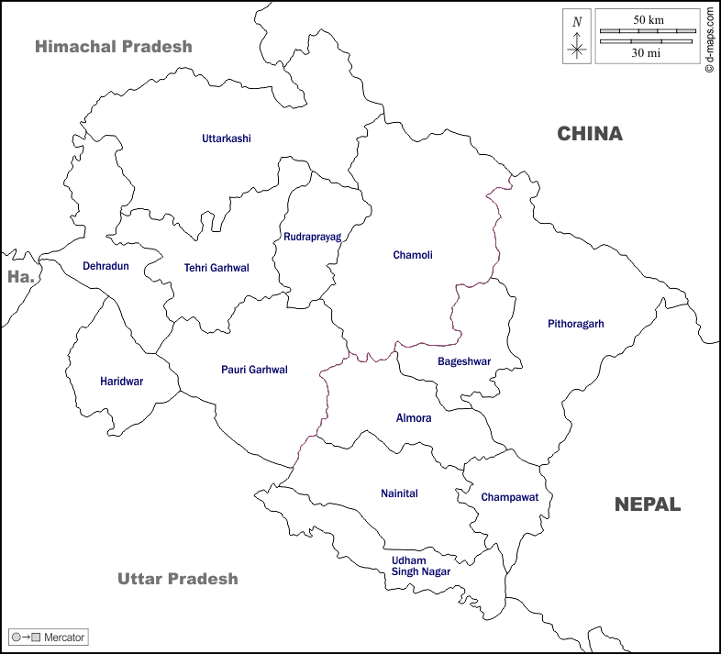
Survey areas

- results and discussion
3.1 ResultS
The present investigation was undertaken to assess the severity and incidence of web blight in three districts of Uttarakhand, namely Udham Singh Nagar, Nainital, and Champawat. A total of 40 black gram–growing areas were surveyed during the 2022 and 2023 seasons (Table 2.; Fig..1 and Fig. 2; Plate 1). Periodic roving surveys were conducted in the selected districts during the Kharif seasons of 2022 and 2023.
In 2022, the incidence and severity of web blight ranged from 78.90% to 10.75%, whereas in 2023, they varied from 84.40% to 10.90%. The highest disease incidence (78.90%) in 2022 and the highest disease severity (84.40%) in 2023 were recorded at Pantnagar, followed by Nagla in Udham Singh Nagar, where incidence and severity reached 76.22% and 80.31%, respectively. In contrast, the lowest disease incidence and severity were observed at Puranpur (36.74% and 37.66%, respectively), Haripur Roopsingh in Nainital (10.23% and 12.15%, respectively), and Matkota in Udham Singh Nagar (10.75% and 10.90%, respectively).
3.2 DISCUSSION
Dwivedi and Saksena (1974) conducted a survey during 1973–74 and reported that web blight, caused by Thanatephorus cucumeris (syn. Rhizoctonia solani), were affecting mung bean (Vigna radiata). The pathogen was also found to cause leaf spot symptoms on several other plant species, including Chenopodium album, Brassica oleracea, Sorghum vulgare, Zea mays, Saccharum officinarum, *Triticum aestivum*, *Hordeum vulgare, Cicer arietinum, and Pisum sativum.
Rawate et al. (2022) conducted a random survey during the Kharif season of 2020–21 to assess the incidence of web blight in mung bean–growing areas of Chhattisgarh, namely Raipur, Balod, Kanker, Narayanpur, and Rajnandgaon districts. The disease incidence ranged from 15.50% to 78.85%. The highest incidence (78.85%) was recorded in Raipur district, whereas the lowest incidence (15.50%) was observed in Narayanpur district.
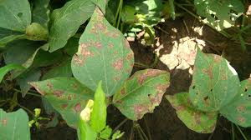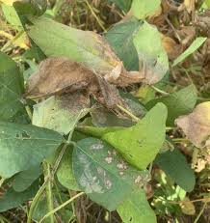
- (C)
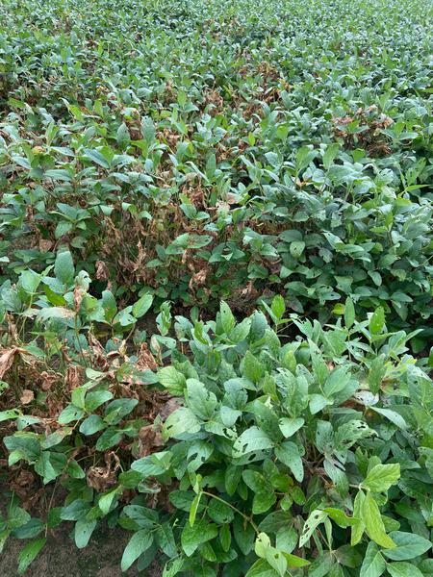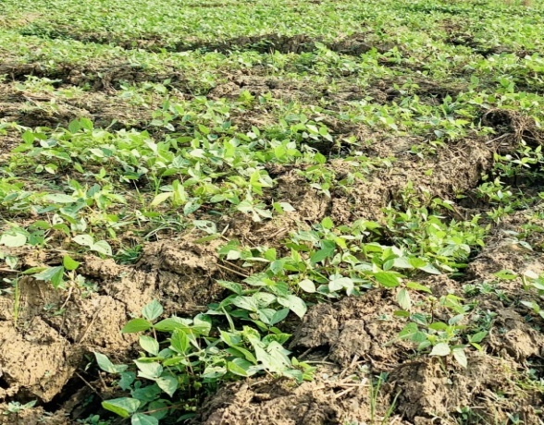
- (D)
Plate.1 Symptoms of web blight observed at different places during survey.

Table 2 Status and distribution of black gram web blight in Kharif season of Uttarakhand.

District | Area | Latitude/  Longitude | Altitude (m) | Cropping Pattern | Disease incidence (%) |  |  | Disease Severity (%)
 |  |  |  |  | 2022 | 2023 | Mean | 2022 | 2023 | Mean
Udham  Singh  Nagar | Angadpur | 29.3278°N78.7675°E | 218.00 | Sole Crop | 42.23 | 40.23 | 41.23 | 41.53 | 45.82 | 43.67
Udham  Singh  Nagar | Balrampur | 29.0537°N 79.2751°E | 234.87 | Sole Crop | 57.42 | 66.6 | 62.01 | 59.85 | 68.48 | 64.16
Udham  Singh  Nagar | Barkheri | 29.1531°N78.9924°E | 228.52 | Sole Crop | 50.67 | 49.23 | 49.95 | 54.78 | 59.27 | 57.25
Udham  Singh  Nagar | Barwala | 29.1180°N79.1958°E | 218.53 | Sole Crop | 14.01 | 24.13 | 19.07 | 12.01 | 26.85 | 19.43
Udham  Singh  Nagar | Bharatpur | 29.0367°N79.3218°E | 235.74 | Sole Crop | 60.45 | 62.12 | 61.28 | 62.23 | 65.45 | 63.84
Udham  Singh  Nagar | Bichpuri | 29.1082°N79.1633°E | 224.00 | Intercropping | 25.84 | 30.63 | 28.25 | 31.25 | 33.78 | 32.51
Udham  Singh  Nagar | Buksore | 29.1624°N79.1521°E | 208.00 | Sole Crop | 58.55 | 56.55 | 57.55 | 59.66 | 61.25 | 60.45
Udham  Singh  Nagar | Bagichi | 29.0286°N79.3887°E | 208.32 | Sole Crop | 34.02 | 28.65 | 31.35 | 34.57 | 29.34 | 31.95
Udham  Singh  Nagar | Chhatarpur | 29.0236°N79.1537°E | 218.00 | Sole Crop | 34.11 | 35.32 | 34.71 | 36.14 | 40.53 | 38.33
Udham  Singh  Nagar | Dineshpur | 29.0462°N 79.3212°E | 221.00 | Sole Crop | 41.68 | 42.85 | 42.25 | 40.45 | 46.28 | 43.36
Udham  Singh  Nagar | Fazalpur | 29.0846°N79.1407°E | , 240.02 | Intercropping | 12.01 | 22.13 | 17.07 | 13.025 | 24.63 | 18.82
Udham  Singh  Nagar | Gadarpur | 29.0397°N 79.2504°E | 234.31 | Sole Crop | 63.94 | 69.34 | 66.64 | 58.32 | 65.27 | 61.79
Udham  Singh  Nagar | Gopipura | 29.2913°N 79.0165°E | 228.03 | Sole Crop | 30.97 | 38.42 | 34.69 | 36.37 | 24.85 | 30.61
Udham  Singh  Nagar | Hridaypur | 29.0360°N79.3678°E | 230.13 | Sole Crop | 26.01 | 31.57 | 28.79 | 28.85 | 32.49 | 30.67
Udham  Singh  Nagar | Haripura | 29.2318°N79.3332°E | 234.67 | Sole Crop | 30.85 | 39.84 | 35.34 | 32.23 | 40.05 | 36.14
Udham  Singh  Nagar | Jainagar | 29.0383°N79.3663°E | 234.78 | Sole Crop | 43.13 | 45.71 | 44.42 | 45.74 | 46.13 | 45.93
Udham  Singh  Nagar | Jhagarpuri | 29.0578°N79.2324°E | 234.13 | Sole Crop | 19.6 | 17.68 | 18.64 | 21.34 | 19.58 | 20.46
Udham  Singh  Nagar | Kelakhera | 29.0862°N79.1746°E | 216.07 | Sole Crop | 48.05 | 50.84 | 49.44 | 50.88 | 52.48 | 51.68
Udham  Singh  Nagar | Kichha | 28.9115°N79.5154°E | 293.16 | Sole Crop | 38.41 | 39.02 | 38.71 | 39.44 | 40.39 | 39.91
Udham  Singh  Nagar | Lakhanpur | 29.1540°N79.1788°E | 234.04 | Sole Crop | 22.24 | 23.95 | 23.09 | 20.33 | 25.48 | 22.90
Udham  Singh  Nagar | Matkota | 29.0080°N79.3766°E | 234.23 | Intercropping | 10.92 | 10.58 | 10.75 | 10.92 | 10.88 | 10.9
Udham  Singh  Nagar | Mundia Pistor | 29.1470°N79.1464°E | 230.45 | Sole Crop | 12.13 | 15.25 | 13.69 | 11.35 | 13.38 | 12.36
Udham  Singh  Nagar | Nagla | 29.595°N, 79.3045°E | 212.25 | Sole Crop | 75.43 | 77.02 | 76.22 | 77.66 | 82.97 | 80.31
Udham  Singh  Nagar | Narayanpur | 28.9631°N79.4644°E | 218.11 | Sole Crop | 34.01 | 41.94 | 37.97 | 40.95 | 36.06 | 38.50
Udham  Singh  Nagar | Pantnagar | 29.0222°N79.4908°E | 243.89 | Sole Crop | 76.95 | 80.86 | 78.90 | 86.2 | 82.6 | 84.4
Udham  Singh  Nagar | Patori | 29.7030°N79.1611°E | 345.53 | Sole Crop | 25.13 | 32.03 | 28.58 | 27.06 | 33.81 | 30.43
Udham  Singh  Nagar | Ratanpuri | 28.9980°N 79.2930°E | 234.22 | Sole Crop | 19.83 | 20.53 | 20.18 | 18.28 | 21.97 | 20.12
Udham  Singh  Nagar | Ramchandrapur | 28.9235°N79.7007°E | 298.16 | Sole Crop | 55.32 | 57.6 | 56.46 | 56.67 | 59.23 | 57.95
Udham  Singh  Nagar | Tanda Azam | 29.1044°N79.1702°E | 228.00 | Sole Crop | 39.68 | 42.19 | 40.93 | 40.24 | 40.52 | 40.38
 | Kishanpur | 29.1989°N79.1159°E | 250.00 | Intercropping | 55.63 | 58.82 | 57.22 | 58.62 | 53.04 | 55.83
 | Seetarganj | 29.1192°N79.1526°E | 298.00 | Sole Crop | 49.95 | 55.96 | 52.95 | 50.85 | 58.62 | 54.73
 | Muknadpur | 29.0463°N79.2747°E | 234.00 | Sole Crop | 53.72 | 60.23 | 56.97 | 57.64 | 59.62 | 58.63
 | Bindukhatta | 29.2091°N79.0248°E | 250.12 | Sole Crop | 50.98 | 55.62 | 53.3 | 52.02 | 55.13 | 53.57
 | Pahaniya | 29.03675°N 79.3218°E | 250.33 | Sole Crop | 61.48 | 57.96 | 59.72 | 63.25 | 60.49 | 61.87
Nainital | Bajuniya Haldu | 29.3538°N 79.3181°E | 443.50 | Sole Crop | 13.23 | 25.52 | 19.37 | 12.73 | 25.34 | 19.03
Nainital | Chakaluwa | 29.2474°N79.3569°E | 444.04 | Sole Crop | 22.68 | 35.05 | 28.86 | 24.45 | 37.96 | 31.20
Nainital | Devpura Devka | 29.2166°N 79.4394°E | 443.64 | Sole Crop | 11.54 | 15.7 | 13.62 | 15.43 | 11.33 | 13.38
Nainital | Dohniya | 29.3918°N29.2895°E | 344.64 | Sole Crop | 34.16 | 40.24 | 37.2 | 32.97 | 42.1 | 37.53
Nainital | Ginti Gram | 29.3915°N79.3113°E | 328.05 | Sole Crop | 37.18 | 39.75 | 38.46 | 40.04 | 38.86 | 39.45
Nainital | Haripur Roop Singh | 29.3998°N 79.3129°E | 345.02 | Intercropping | 10.23 | 11.46 | 10.84 | 11.68 | 12.63 | 12.15
Nainital | Haripur Kalia Jala | 29.4020°N 79.3293°E | 345.71 | Sole Crop | 10.98 | 15.06 | 13.02 | 10.92 | 16.35 | 13.63
Nainital | Kalyanpur | 29.0023°N 79.4002°E | 238.42 | Sole Crop | 13.86 | 16.13 | 14.99 | 14.02 | 17.6 | 15.81
Nainital | Lamachaur | 29.2316°N 79.4205°E | 443.04 | Intercropping | 24.92 | 35.34 | 30.13 | 21.25 | 31.31 | 26.28
Nainital | Puranpur | 29.1859°N79.4690°E | 349.91 | Sole Crop | 38.02 | 35.46 | 36.74 | 40.57 | 34.75 | 37.66
Nainital | Daulatpur | 29.16127N79.59477E | 392.05 | Sole Crop | 48.62 | 43.56 | 46.09 | 48.82 | 50.69 | 49.75
Nainital | Lalkuan | 29.06563N79.52750E | 355.03 | Sole Crop | 50.96 | 45.98 | 48.47 | 51.36 | 49.52 | 50.44
Nainital | Kusumkhera | 29.22277N79.50158E | 322.74 | Sole Crop | 55.68 | 57.23 | 56.45 | 53.96 | 58.95 | 56.45
Nainital | Majhera | 29.5032579.47905°E | 430.25 | Intercropping | 10.46 | 11.96 | 11.21 | 41.43 | 35.67 | 38.55
Champawat | Tanakpur | 29.0722°N 80.1066°E | 255.16 | Sole Crop | 43.7 | 47.73 | 45.71 | 44.53 | 48.68 | 46.60
Champawat | Banbasa | 28.9911°N 80.0800°E | 255.00 | Sole Crop | 47.12 | 57.6 | 52.36 | 48.86 | 59.21 | 54.03

Figure 2 : Disease incidence of different black gram growing areas in kharif season of Uttarakahnd.
Survey areas
Disease incidence

Figure 3 : Disease severity of different black gram growing areas in kharif season of Uttarakahnd.

Disease Severity
Survey area

4. Conclusion
A systematic survey was carried out during the Kharif seasons of 2022 and 2023 in Uttarakhand, India, to assess the prevalence and distribution of pod rot disease in black gram (Vigna mungo). Using a random sampling approach, farmer fields were visited across major black gram–growing areas, and disease incidence and severity were recorded following standard assessment protocols. The survey revealed that web blight was widespread, affecting the majority of black gram fields in the surveyed regions.
Across both years, considerable variation in disease incidence and severity was observed among locations, with Pantnagar consistently recording the highest levels. Analysis of field data also indicated a positive association between disease occurrence and cropping patterns, wherein sole-cropped black gram fields exhibited notably higher incidence and severity compared to intercropped systems.

REFERENCES
Ahmed, S. And Hasan, M. M. (2014). Legumes: An Overview. J. Pharm. Pharm. Sci., 2: 34-38.
Alam, S. S., Qureshi, S. H. And Bashir, M. (1985). A Report On Web Blight Of Mungbean In Pakistan. Pak. J. Bot., 17(1): 165.
Bains, S. S., Dhaliwal, H. S. And Basandrai, A. K. (1988). A New Blight Of Mungbean And Mash In Punjab. Ann. Biol. Ludhiana, 4(1-2): 113-114.
De Candolle, A. P. (1815). Memoir Swiles Rhizoctonines, Houvean Gnre De Champignons Quialtaqueless Sicines, Des Plantes Et In Particular Celle DE LA Lazurene Cultivee. Mem Mus Natl. Hist. Nat. Ser, (2): 209-216.
. Dubey, S. C., Tripathi, A., Upadhyay, B. K. And Deka, U. K. (2014). Diversity Of Rhizoctonia Solani Associated With Pulse Crops In Different Agro Ecological Regions In India. World J. Microbiol. BIOTECHNOL, 30: 1699-1715.
Dwivedi, R. P. And Saksena, H. K. (1974). Occurrence Of Web Blight Caused By Thanatephorus Cucumeris Is On Blackgram. Int. J. Farm Sci. 2: 100.
Gomez, K. A. And Gomez, A. A. (1984). Statistical Procedures For Agricultural Research. John Wiley And Sons’ Publication. New York 680p
Harikrishnan, R. And Yang, X.B. (2004). Recovery Of Anastomosis Groups Of Rhizoctonia Solani From Different Latitudinal Positions And Influence Of Temperatures On Their Growth And Survival. Plant Diseases. 88(8): 817-823.
Kuhn, J. (1858). Die Krankenheiten Der Kulturwachse, Ihre Ursachen Und Ihre Verhutung. Gustav Bosselman, Berlin, 312pp.
Kumar, T., Dantre, R.K. And Verma, K.P. (2016). Studies On Aerial Blight Of Soybean Caused By Rhizoctonia Solani Kuhn. Journal Of Plant Development. 8(10): 475-482.
Mathpal, M. (2016). Epidemiology And Management Of Rhizoctonia Aerial Blight Soybean (Glycine Max L. Merrill). Thesis, Ph.D. G. B. Pant University Of Agriculture And Technology, Pantnagar. 221p. Mckinney, H. H. (1923). Influence Of Soil Temperature And Moisture On Infection Of Wheat Seedlings By Helminthosporium Sativum. J. Agric. Res., 26:195-210.
Nacien, C. C. (1924). Studies On Rhizoctonia Blight Of Beans. Philippine AGRICULTURIST, 8: 315-321.
Naz, H., Usmani, M. K., Ali, M., Mobin, S. And Khan, M. I. (2021). Acridoid Diversity, Species Composition And Distributional Pattern In Tarai Region Of Uttarakhand, India. Int. J. Trop. Insect Sci., 41(1): 547-553. Parmeter, J. R. And Whitney, H. S. (1970). Taxonomy And Nomenclature Of The Imperfect Stage In Rhizoctonia Solani. Biology And Pathology, Ed. Parameter, J. R. Jr. And Berkley, Los Angeles And London, University Of California Press. 78-80pp.
Rawate, R., Kaushal, A., Awadhiya, G. K. And Patel, D. P. (2022). Survey And Management Of Web Blight Diseases Of Mungbean. Ann. Plant Prot. Sci., 21(5): 352-356.
SAKSENA, H. K. AND DWIVEDI, R. P. (1973). WEB BLIGHT OF BLACKGRAM CAUSED BY THANATEPHORUS CUCUMERIS. INDIAN J. FARM SCI., 1: 58-61.
SIKORA, E.J., MURPHY, J.F., LAWRENCE, K.S. AND MULLEN, J.M. (2011). SURVEY OF FUNGAL, NEMATODE AND VIRAL DISEASES OF SOYBEAN IN ALABAMA. ONLINE. PLANT HEALTH PROGRESS. DOI: 10.1094/ PHP-2011-1227-01-RS.
SUNEJA, Y., KAUR, S., GUPTA, A. K. AND KAUR, N. (2011). LEVELS OF NUTRITIONAL CONSTITUENTS AND ANTINUTRITIONAL FACTORS IN BLACK GRAM (VIGNA MUNGO L.). FOOD RES. INT., 44(2): 621-628.
VINCENT, J. M. 1947. DISTORTION OF FUNGAL HYPHAE IN THE PRESENCE OF CERTAIN INHIBITORS. NATURE, 159: 850.
WHEELER, B. E. 1969. AN INTRODUCTION TO PLANT DISEASES. LONDON, U.K.: JOHN WILEY AND SONS LTD.

