Occurrence of Albinism in wild ungulates of Rajasthan, India

Abstract
Colour aberration or albinism is characterized by the total absence or partial absence of skin pigmentation due to absence of active tyrosinase enzymes in pigment cells. Absence of pigment cells affects skin and hair coloration, resulting in a total white fur or skin coat colour with red eyes. Present observations deal with the colour aberration of three species of wild ungulates, namely Nilgai (Boselaphus tragocamelus), Blackbuck (Antilope cervicapra) and Indian Gazelle (Gazella bennettii) from the different districts of Rajasthan state, India. Nilgai individual was observed in Udaipur district, Blackbuck from Jodhpur district and Indian Gazelle from Jalore district. During behavioral observation, all three species individuals performed normal behavioral activities.
Keywords: Albinism, Ungulates, Nilgai, Blackbuck, Indian Gazelle, Rajasthan.
Introduction
Albinism primarily affects integumentary coloration and epidermal features in most animals, including humans, due to a lack of melanin pigment. It is characterized by abnormal coloration of the skin, hair, feathers, scales or eyes. Mammalian skin is typically covered with fur or hair, and its ability to blend in can be affect by the colour and pattern of coat. Usually changes in coat colour occur due to seasonal climatic conditions and the geographic region where the animal reside (Menon, 2003). Furthermore, coat colouration is affected by various factors such as age, sex, health and amount of nutrient availability in animal body largely influenced the body colouration of animals. Mammals can exhibit individual difference in their coat or pelage, particularly in cases of genetic mutations like albinism, melanism (Menon, 2003); leucism, piebaldism, hypomelanism and blue eyed white morph (Mahabal et al., 2019). Animal coloration is classified into three categories on the basis of properties such as concealment, commination and regulation of physiological process (Caro, 2005). Albinism is a condition characterized by a complete lack of melanin pigment in hair, eyes and skin due to the inherited absence of functional tyrosinase enzymes in pigment cells. This affects skin and hair coloration and results in entirely white fur or plumage and red eye colour (Smielowski, 1987). Albinism is controlled by inheritance of autosomal recessive genes in all animal species, including mammals (Hale et al., 2005; Van-Grow, 2006 & 2013). According to Sage (1962), complete or partial albinism may be present at birth, emerge later in life, or diminish with age. Other possible causes of albinism include diet, senility, shock, infection, and injury. According to recent classification quoted by Eiserberg (1980) (Ride, 1964 & Mckenna, 1975) the family Bovides has been divided into five sub-families. The subfamily Antilopinae is divided into two tribes: Neotragini and Antilopini. Neotragini include all small, mostly browsers like Klipspringer and Dik-dik whereas Antilopini include Asian and African forms: the Blackbuck, antelope of India and the widespread genus Gazella found over Central Asia and across North Africa and south to the Cape. The subfamily Bovinae includes three tribes:(1) the African strepsicerotini, which includes the Kudu, strepsicerous, and the eland, Taurotragus; (2) the Boselopini, the nilgani and Tetracerus, the four-horned antelope, both confined to India only; and (3) Bovini, which includes Asiatic, African, and Holartic forms like Anoa, Bibos, Bison, Bos Bubalus, and Syncerus.
Rajasthan is home to a wide range of ungulate species and major species are Nilgai or Blue Bull (Boselaphus tragocamelus), Chousingha or Four-horned antelope (Tetracerus quadricornis), Chinkara or Indian Gazelle (Gazella bennettii) and Blackbuck (Antilope cervicapra) etc. Commonly, the Blackbuck and Nilgai are called antelopes, whereas the Chinkara is called Indian gazelle. Blackbuck and Nilgai have distinct sexual dimorphisms in adulthood. Male Nilgai are gray-blue in color and have short, stout, conical, and smooth horns, and females are brown in color with white patches under the lower jaw. Indian gazelles are characterized by their coloring and distinctive white streaks on each side of the face. While an adult male blackbuck has a black skin coat, it has a brownish color in the sub adult age. At the age of three years, the dorsal coat of the male begins to turn black, including the outer flanks of the hind and fore legs, and the face and neck. The females are light brownish on the upper parts of the body, tail, outer flanks of hind and fore legs, face and neck however the under parts of the body and inner flank of the legs are white, with a similar coloured patch around each eye (Gehlot, 2006). This paper aims to document albinism in wild ungulates of Rajasthan, providing insights into color aberration in three ungulate species, Nilgai, Blackbuck and Chinkara.

Material and Methods
Albinism or Color aberration patterns among three species of wild ungulates from different areas of Rajasthan were identified by random and opportunistic sightings. Photographs and behavioral activities of these individuals were captured using a Nikon P1000 and Canon D series DSLR cameras. Direct visual observation, focal and scan sampling methods (Altmann, 1974) and ad libitum sampling methods were used to observe behavioral and daily activity patterns of ungulates in their natural habitats, as well as the Indian Gazelle and Blackbuck were observed at wildlife rescue centers.
Result and Discussion
The occurrence of albinism in three wild ungulate species of Rajasthan and it were observed at different region of Rajasthan state. The specific details of three undulate species are summarized as below.
1. Nilgai or Blue Bull (Boselaphus tragocamelus): The Nilgai, or Blue Bull, is the largest Asian antelope. The body is usually 190-230 cm in height and long, tail measures 45-55 cm in length. The height of the shoulder is 130-150 cm and the maximum weight was 190-210 kg (Sheffield et al., 1983). Male have horns, whereas females have no horns (Figure 1, 2). The horn of the male animal reaches up to 15-20 cm and has a tuft of black hair hanging from below the throat, which is approximately 13 cm in length in males (Sheffield et al., 1983).
But, on April 28, 2018, at 8:30 am during a field visit, we recorded a male of Blue bull or Nilgai grazing on Typha grass (Typha angustifolia) at the Sarjana Dam, Vallabhnagar tehsil of the Udaipur district. The Sarjana dam is located at 24°39'34.61"N Latitude and 73°59'26.45"E Longitude. In normal cases, males typically exhibit bluish-grey coat coloration. However, in this case, we observed that the albino Blue bull exhibited white-body coloration across various parts of the body. White pigmentation was notably present around the mouth, under the neck, on both the fore and hind limbs, as well as along the back and tail regions of the body (Figure 3). The surrounding habitat around the Sarjana dam encompasses dominant aquatic, terrestrial, and agricultural landscapes. Dam serves as a significant water source, which promotes the growth of aquatic plants and tall grasses, such as Typha angustifolia, and provides favourable foraging and feeding habitats for Blue bulls in this region.

2. Blackbuck (Antilope cervicapra): During study, we observed many blackbuck herds and recorded their morphology and average body measurements. A well-grown buck is approximately 80-90 cm. at the shoulder and weighs approximately 44–45 kg on average. The body measures 100-130 cm and the tail was 13-17 cm. Long and spirally twisted horns that occur only in males seldom exceed 50-55 cm. The coat colour in the dorsal and lateral parts of the male is blackish-brown, with white patches on the muzzle and white rings around the eyes (Figure 4). The dorsal and lateral coats of the females are fawn coloured. The under parts of both males and females were always white or off-white (Figure 5). Young Blackbuck individuals usually exhibit yellowish coat colour, but at maturity, or three-year-old male individuals, coat colour turns black in colour. The dark black coloration is a secondary sexual characteristic of the blackbuck and is generally responsible for major sexual and aggressive display (Gehlot, 2006).
But, on May 20, 2021, at 3:30 pm during the field survey, we saw albino male of Blackbuck they feeding on the dry pods and dry leaves of Khejri tree (Prosopis cineraria) in agricultural field at Salavas-Kanakni road, Jodhpur district (Latitude: 26° 4'36.77" N and Longitude: 73° 3'16.62" E). Adult Blackbuck male is characterized by a darker, nearly blackback with white underparts, while females and juvenile males display a tan or yellowish fawn colour with white parts. Moreover, Adult males also possess long spiral horns, but are absent in females and juvenile males. However, we observed a complete male black albino buck in these regions. Their body coloration is completely white, except for the horns. We monitored more than five days in the wild, after which the forest department rescued the blackbuck and kept it in captivity in a Machia Biological Park. During captive conditions, they performed normal daily activity patterns similar to those of other Blackbuck individuals (Figure 6).

3. Chinkara or Indian Gazelle (Gazella bennettii): Throughout the study period, we encountered multiple Chinkara herds and documented their physical characteristics along with the mean body measurements. A fully grown male Chinkara measured approximately 65 cm. The shoulder weighs approximately 23-25 kg. The dorsal and lateral coat coloration of Chinkara is a light chestnut hue, which intensifies at the junction with the white under parts on the flank and buttocks. A distinctive white streak is present on each side of the face, which is a characteristic feature of gazelles, accompanied by a dusky patch above the nose. Both male and female Chinkara have horns. When viewed from the front, the horns of the male appear almost straight; in the profile, they exhibit a slight curvature. Horns usually range between 10 cm to 13 cm in female and 40 cm in male (Prater, 1971) (Figure 7, 8).
But, on October 30, 2022, at early morning 8:15 O’ clock, we saw albino male of Indian gazelle or Chinkara siting on under shade of Jaal tree (Salvodora persica) in village of Siwara village, Sanchor tehsil of Jalore district (Latitude: 24°53'55.36"N and Longitude: 71°43'16.28" E). In male albino Chinkara, the body coloration is completely white. After this report, the individual was rescued by a local NGO and kept in Amrita Devi Udhyan, Dhamana Ka Goliya. Moreover, albino male performed normal behavioural activity (Figure 9). Albinism is a genetic condition characterized by the absence of melanin pigment, the pigment responsible for producing coloration in various body parts, including the skin, hair and eyes. Occurrence of colour aberration or albino in three ungulate’s species, including Nilgai, Blackbuck and Indian Gazelle for a single state is rare in wild or natural habitats.
Pattern of color variation or aberrations is referred to by different terms, such as color variation (Hofreiter & Schoneberg, 2010), anomalous coloration (Abreu et al., 2013), chromatic disorder (Lucati & Lopez-Baucells, 2016) and atypical coloration (Zalapa et al., 2016). In mammalian taxa, coloration is primarily determined by the presence or absence of melanin pigments in the skin, hair and eyes. Melanin is synthesized through a step-by-step biochemical pathway in which the tyrosine amino acid is converted to a melanin pigment. Tyrosinae plays an important role in the synthesis and production of melanin pigments in the body. Any alteration or mutation in the tyrosinase gene can lead to an enzyme that cannot synthesize or produce melanin pigment or does so a produces a small quantity of melanin.
Melanin is the most prominent pigment found in birds and mammals, and is largely responsible for the coloration of bird feathers and mammalian hairs and skins (Fox and Vevers, 1960; Lubnow, 1963; Van Grouw, 2013). Melanin is primarily found in two forms or types: eumelanin and phaeomelanin (Lubnow, 1963; Mahabal et al., 2019). Among these, the concentrations and distributions of eumelanin is largely responsible for the black, gray, and dark brown coloration of skin and feather color, while phaeomelanin contributes to warm, reddish-brown to pale buff shades (Mahabal et al., 2019). Combination of eumelanin and phaeomelanin produces a wide range of grayish-brown coloration of the skin and feathers (Lubnow, 1963; Van Grouw, 2013). Melanin is produced by a biochemical pathway known as melanin synthesis, and occurs in melanocytes. Melanin synthesis pathway requires tyrosine amino acids and tyrosinase enzymes. Furthermore, any disruption, alteration or genetic mutation at any point during melanin synthesis pathways can lead to alterations in the concentration and distribution of melanin pigment and lead to unusual coloration of the skin, such as albinism, melanism, leucism, piebaldism, hypomelanim, and blue-eyed white morph (Menon, 2003; Van Grouw, 2006 & 2013; Mahabal et al., 2016 & 2019; Chishty et al., 2021). Variations in body coloration in mammalian taxa have been described in different terms, such as albinism (pure/complete), partial albinism, melanism, and erythrism (Mahabal et al., 2019). In addition, Abreu et al. (2013), Lucati & Lopez-Baucells (2016) described color aberration patterns among the different species of bats.
Individuals with albinism were more conspicuous than those without albinism. Moreover, this unusual colour pattern due to albinism significantly decreases the survival rate because of increased visibility to predators (Samson et al., 2017). For this reason, both antelopes, Indian Gazelle and Blackbuck, were kept in captivity to ensure protection from potential predators and other possible threats. Moreover, albino organisms are linked to visual problems due to the decreased melanin levels in the body, which cause eye-related problems because melanin plays a crucial role in the development of the retina of eyes (Grant et al., 2001; Garipis & Hoffmann, 2003). Furthermore, albinism poses a direct disadvantage to the survival of organisms, with only a few albinos managing to avoid predators and survives to reach sexual maturity (Mahabal et al., 2019). Therefore; reports of albino individuals are rare and infrequent. A few instances were not documented, possibly due to collectors and collection managers lacking awareness of this important phenomenon in skin colour aberration (Samson et al., 2017; Samson et al., 2021). We captured the photographs of these albino and colour aberration Blue bull, Blackbuck and Indian Gazelle. During observation, it was found that albino performed normal daily activity, including grazing, drinking water, and residing in a group of other normal individuals.
Mahabal et al. (2019) conducted a review study on colour aberration in mammals from 1886 to 2017 and observed 239 instances of colour aberration belonging to 56 mammalian species belonging to eight orders and 19 families. Occurrence of albinism in Chinkara was previously recorded also from three localities of Rajasthan: Dhava-Doli conservation reserve area, Jodhpur (Mehra et al., 2010); Viratra Mata Oran (sacred land) of Chohtan, Barmer (Kumar et al., 2016); and Siyaho-ka-tala, Village post Kheda, Dhanau area of Barmer district (Kumar & Gharu, 2025) and albinism has been observed in Chinkara at central India by Divyabhanusinh, (1987) and Smielowski, (1987). But it is first record of albinism found in Blackbuck and Blue bull from the Rajasthan state. Similarly, Akash et al. (2024) recorded albinism in Blue bull from Mahan village, Katepurna Wildlife Sanctuary of Maharashtra, India.
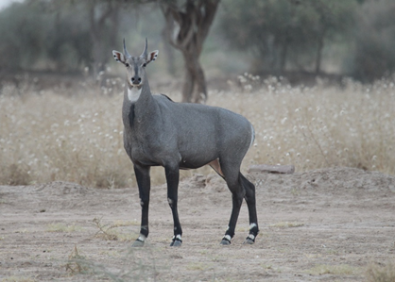
Figure 1: Male Blue Bull
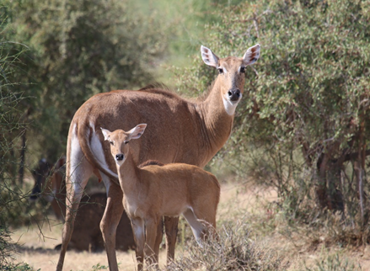
Figure 2: Female Blue Bull
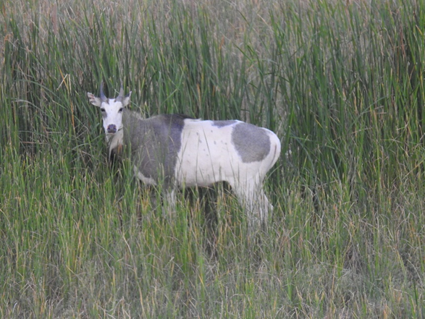
Figure 3: Albinism in Blue Bull
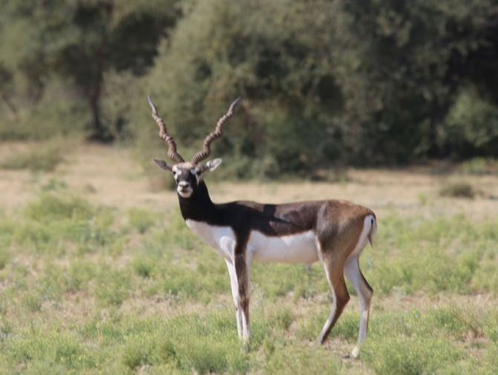
Figure 4: Male Blackbuck
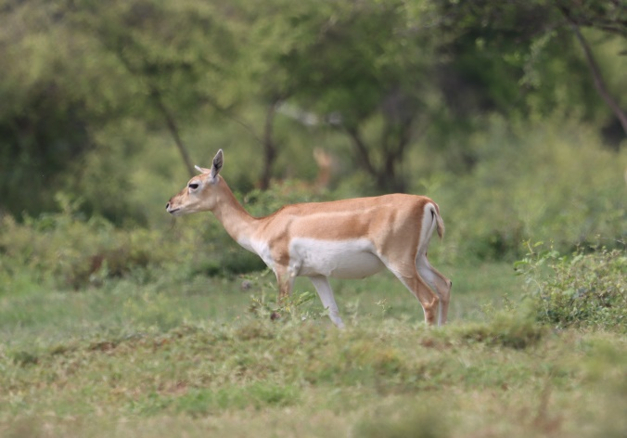
Figure 5: Blackbuck (Female and fawn)
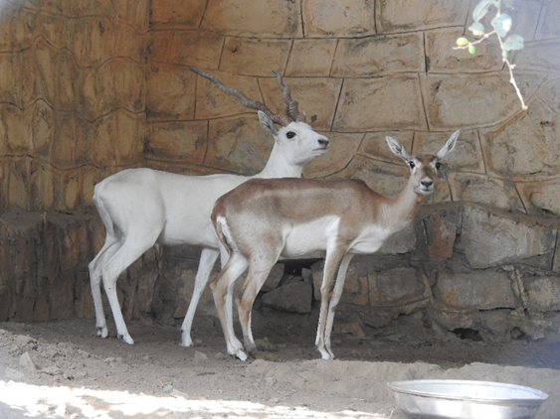
Figure 6: Albinism in Male Blackbuck
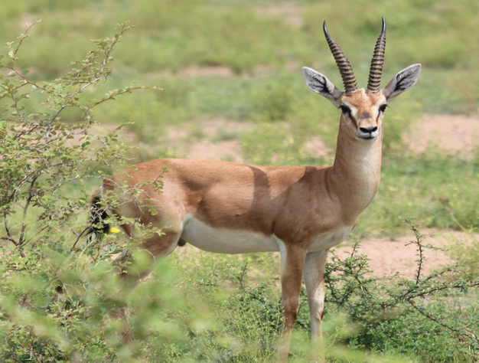
Figure 7: Male Chinkara
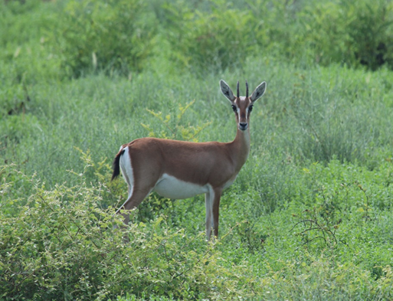
Figure 8: Female Chinkara
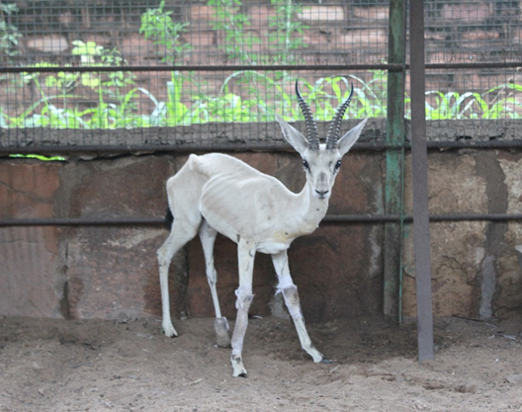
Figure 9: Albinism in Chinkara (Male)

Conclusions
Photography of the wild animals and nature is an invaluable tool for documenting the habitat, ecology and behavioral biology of particular species by providing visual evidence of unique phenomenon and characteristics such as albinism and rare behavior. Photographic records of unusual organisms, such as albinos, are crucial for the analyses and comparison of color abnormalities across different species, populations and geographical regions. In this paper, we describe the occurrence of albinism in three wild ungulate species: Blue bull, Blackbuck and Indian Gazelle also known as Chinkara, in Rajasthan, India.
References
- Abreu, M.S.L., Machado, R., Barbieri, F., Freitas, N.S., & Oliveira, L.R. (2013). Anomalous colour in Neotropical mammals: a review with new records for Didelphis sp. (Didelphidae, Didelphimorphia) and Arctocephalus australis (Otariidae, Carnivora). Brazilian Journal of Biology, 73, 185-194. doi: 10.1590/s1519-69842013000100020.
- Akash, A., Munna, S., & Nisha, P. Record of the Albino Blue Bull (Boselaphus tragocamelus) from Katepurna Wildlife Sanctuary, Akola District, Maharashtra. Prithivya, 4 (1), 12-16.
- Altmann, J. (1974). Observational study of behavior: sampling methods. Behaviour, 49(3), 227-266. doi: 10.1163/156853974x00534.
- Caro, T. (2005). The Adaptive Significance of Coloration in Mammals. BioScience 55(2), 125–136. https://doi.org/10.1641/0006-3568(2005)055[0125:TASOCI]2.0.CO;2
- Chishty, N., Choudhary, N.L., Parveen, R., Bano, H., Patel, P. and Kumawat, P. A. (2021). Chronicle on Pycnonotus cafer the Red vented bulbul. Booksclinic Publishing, 1-191.
- Divyabhanusinh (1987). The earliest record of a white tiger (Panthera tigris). Journal of the Bombay Natural History Society, 83, 163–165.
- Eisenberg, J. E. (1981): The Mammalian Radiations: an analysis of trends in evolution, adaptation and behaviour. The Athlone Press Limited, London. 610 pp.
- Fox, H.M. & Vevers, G. (1960). The Nature of Animal Colours. Sidgwick & Jackson, London, 246pp.
- Garipis, N., & Hoffmann, K. P. (2003). Visual field defects in albino ferrets (Mustela putorius furo). Vision Research, 43(7), 793-800. https://doi.org/10.1016/S0042-6989(03)00015-4
- Gehlot, H.S. (2006). Social Organization, behavioural and Resources selection patterns in Antelope cervicapra and Gazelle bennetti of Thar Desert. Ph.D Thesis, Jai Narain Vyas University, Jodhpur (Rajasthan), 195p.
- Grant, S., Patel, N. N., Philp, A. R., Grey, C. N., Lucas, R. D., Foster, R. G., ... & Jeffery, G. (2001). Rod photopigment deficits in albinos are specific to mammals and arise during retinal development. Visual Neuroscience, 18(2), 245-251. DOI: https://doi.org/10.1017/S095252380118209X
- Hale, W.G., Saunders, V.A., and Margham, J.P. (2005). Collins Dictionary of Biology, 3rd ed. Available at https://medical dictionary.thefreedictionary.com/. Accessed on 10 May, 2017.
- Hofreiter, M. & T. Schoneberg (2010). The genetic and evolutionary basis of colour variation in vertebrates. Cellular and Molecular Life Science, 67: 2591–2603. https://doi.org/10.1007/s00018-010-0333-7
- Kumar, K., & Gharu, C.P. (2025). First Record of Leucism in Albino Gazella bennettii from the Western Thar Desert, Barmer, Rajasthan, India. International Journal of Environmental & Agriculture Research (IJOEAR), 11 (2): 69-74.
- Kumar, K., Vaishnav, V., Ojha, A. P., Parihar, P., Barmera, R., & Parihar, G. R. (2016). Occurrence of Albino Gazella bennetti in Viratra mata Oran (Sacred land) of Chohtan, Barmer (Thar Desert of Rajasthan) India. International Journal of Agriculture and Environmental Research, 2(11), 87-90.
- Lubnow, E. (1963). Melanine bei Vögel und säugetieren. Journal für Ornithologie 104(1): 69–81.
- Lucati, F. & A. López-Baucells (2016). Chromatic disorders in bats: a review of pigmentation anomalies and the misuse of terms to describe them. Mammal Review 47(2): 112–123. https://doi.org/10.1111/mam.12083
- Mahabal, A., Sharma, R. M., Patil, R. N., & Jadhav, S. (2019). Colour aberration in Indian mammals: a review from 1886 to 2017. Journal of Threatened Taxa, 11(6), 13690-13719. DOI: https://doi.org/10.11609/jott.3843.11.6.13690-13719
- Mahabal, A., Van Grouw, H., Sharma, R.M., & Thakur, S. (2016). How common is albinism really? Colour aberrations in Indian birds reviewed. Dutch Birding, 38: 301–309.
- McKenna, M. C. (1975). Towards a Phylogenetic classification of the Mammalia. In : Phylogeny of the Primates. (Eds. Luckett, W. P. and Szalay, F. S.). Plenum Press, New York. : 21-26.
- Mehra, S.P., N.S. Kharwar & P. Singh (2010). Field Notes on albinism in Five-striped Palm Squirrel Funambulus pennanti Wroughton from Udaipur, Rajasthan, India. Small Mammal Mail, 2(1): 18.
- Menon, V. (2003). Variations within species, pp14–15. In: A Field Guide to Indian Mammals. Dorling Kindersley (India) Pvt. Ltd. and Penguin Book of India Pvt. Ltd., Delhi, 201pp.
- Prater, S. H. (1971). The book of Indian animals. Bombay Natural History Society, Bombay. Pp. 324.
- Ride, W. D. L. (1964). A review of Austrilian fossil marsupials. Journal of the Royal Society of Western Australia. Vol. 74 : 97-131.
- Sage, B. L. (1962). Albinism and melanism in birds. British birds, 55(6), 201-225.
- Samson, A., Krishnakumar, N., Ramakrishnan, B., & Princy, J. L. (2021). Albino wild boar (Sus scrofa) in Tamil Nadu, Southern India. Therya Notes, 2, 109-111.
- Samson, A., Ramakrishnan, B., & Bargavi, S. (2017). Leucism in the three-striped palm squirrel (Funambulus palmarum) at Gudalur Forest Division, Tamil Nadu, Southern India. Therya, 8(3), 261-262.
- Sheffield, W.J., Fall, B.A. and Brown, B.A. 1983. The Nilgal Antelope. The Caesar Kleberg Program in Wildlife Ecology and Department of Wildlife and Fisheries Sciences. The Texas A&M Univ. 100 Pp.
- Smielowski, J. (1987). Albinism in the blue bull or nilgai, Bose laphus tragocamelus (Pallas, 1766). Journal of the Bombay Natural History Society, 84:427-429.
- Van Grouw, H. (2006). Not every white bird is an albino: sense and nonsense about colour aberrations in birds. Dutch Birding, 28:79-89.
- van Grouw, H. (2013). What colour is that bird? The causes and recognition of common colour aberrations in birds. British Birds, 106:17-29.
- Zalapa, S.S., S. Guerrero, M.L. Romero–Almaraz & C. Sánchez Hernández (2016). Coloración atípica en murciélagos: frecuencia y fenotipos en Norte y Centroamérica e islas del Caribe y nuevos casos para México y Costa Rica [Atypical coloration in bats: frequency and phenotypes in North and Central America, and the Caribbean islands, and new cases from Mexico and Costa Rica]. Revista Mexicana de Biodiversidad, 87: 474–482.

