Generation study of fall armyworm, Spodoptera frugiperda (J. E. Smith) in laboratory condition on maize

ABSTRACT
Aims: To understand its life stages and biological parameters for planning effective strategy for control measures to harness better yield and maximizing the profit.
Place and Duration of Study: Department of Entomology, C. P. College of Agriculture, SDAU, Sardarkrushinagar during kharif, 2023-24.
Methodology: The eggs were transferred into Petri dishes and were examined for hatching. After hatching, thirty larvae were reared individually and fed on fresh maize leaf bits which were changed daily. These procedures of rearing adults and larvae were repeated during the whole year and annual generations of the fall armyworm were observed.
Results: Total nine generations of fall armyworm were recorded during one year on maize. The incubation period was recorded as 2-3, 2-4, 3-4, 3-5, 3-5, 3-4, 2-3, 2-3 and 2-3 days, larval period was noticed as 15-19, 17-22, 18-24, 23-35, 19-27, 16-23, 13-20, 11-17 and 14-19 days, pupal period was 8-12, 8-14, 10-15, 16-22, 13-17, 8-14, 8-12, 7-10 and 7-12 days and adult longevity was recorded as 4-8, 5-9, 5-12, 6-14, 4-10, 3-8, 3-6, 3-5 and 4-7 days in 1st, 2nd, 3rd, 4th, 5th, 6th, 7th, 8th and 9th generation, respectively. The average length and breadth of egg was 0.39 ± 0.03 and 0.36 ± 0.01 mm with 85.10 ± 5.55 per cent hatching percentage. The length of first, second, third, fourth, fifth and sixth instars larvae were 1.63 ± 0.06, 2.78 ± 0.20, 6.77 ± 0.25, 15.10 ± 0.33, 21.23 ± 0.75 and 31.26 ± 0.67 mm, respectively. The breadth of corresponding instars were 0.23 ± 0.01, 0.35 ± 0.01, 0.90 ± 0.01, 1.92 ± 0.01, 3.26 ± 0.08 and 3.90 ± 0.22 mm, respectively. Total life cycle of S. frugiperda was recorded as 32-40, 35-42, 38-45, 56-68, 43-54, 32-45, 28-39, 25-34 and 30-37 days, in 1st, 2nd, 3rd, 4th, 5th, 6th, 7th, 8th and 9th generation, respectively.
Keywords: Spodoptera frugiperda, generation study, fall armyworm, maize.
INTRODUCTION
The invasive pest known as fall armyworm, Spodoptera frugiperda (J. E. Smith, 1797) (Lepidoptera: Noctuidae) had spread quickly throughout every Indian maize-growing ecology (Kashyap and Malik, 2024). It is a key pest of maize and appears on maize usually after 20-25 days of sowing. It is a new destructive insect pest has gained a major pest importance causing damage to the crop at all the growing stages and the yield losses range up to 73 per cent. It is a lepidopteron insect has been suspected first time in the maize research fields of the University of Agricultural and Horticultural Sciences, Shivamogga, Karnataka (Sharanabasappa et al., 2018ª). It’s incidence also reported on other crops in India viz., pearl millet and sorghum in Andhra Pradesh (Venkateswarlu et al., 2018), sugarcane in Tamil Nadu (Srikanth et al., 2018), paddy in Bihar (Ali & Masroor, 2018), sugarcane and sorghum in Maharashtra (Chormule et al., 2019). The word frugiperda means "lost fruit" in Latin. Fall armyworm is not a "worm," but rather a caterpillar. As suggested by its name, it conjures up images of hordes of larvae marching in unison and spreading destruction in their wake (Sisay et al., 2019). It has become devasting because of its feature such as polyphagous nature, high reproductive potential, overlapping generation, year around availability of host plants, his good ability to travel and disperse long distance annually during the summer months may be the key reason for its rapid spread. As a new invasive pest, it is important to understand its life stages and biological parameters for planning effective strategy for control measures to harness better yield and maximizing the profit.
MATERIAL AND METHODS
Laboratory experiment on the generation study of fall armyworm was conducted in laboratory at Department of Entomology, C. P. College of Agriculture, SDAU, Sardarkrushinagar during kharif, 2023-24. Average temperature and relative humidity were recorded daily during the course of study. The initial culture of S. frugiperda were established in the laboratory by collecting the larvae from maize fields of S. D. Agricultural University, Sardarkrushinagar. These larvae were reared in the laboratory at room temperature. Fresh maize leaves were provided daily in each plastic bottle with pin holes on the cap for aeration till it attain the pupation stage. Pupae were kept in the jars till the emergence of adults. A pair of newly emerged male and female adults from the pupa were transferred into the separate iron cage. Maize plants grown in the flask were provided for egg laying in the iron cage. The honey solution was provided as food for the adults by dipping a piece of sponge in the solution. The sponge was changed daily. Every morning the leaves and cage were observed to check the egg laying. The eggs were transferred into Petri dishes and were examined for hatching. After hatching, thirty larvae were reared individually and fed on fresh maize leaf bits which were changed daily. Thus, the laboratory culture was maintained for further investigations. These procedures of rearing adults and larvae were repeated during the whole year and annual generations of the fall armyworm were observed.
Egg
Twenty eggs were examined under the microscope to study their colour, shape and size. To study the incubation period and hatching percentage of eggs, freshly laid eggs were observed under a microscope daily in the morning and evening till they hatched. The eggs were considered as hatched when tiny larvae come out from the egg. The average incubation period was also calculated. The hatching percentage was calculated from the number of eggs hatched, out of a total number of eggs kept under observation.
Larva
Generally, six larval instars were observed in fall armyworm. For determining the number and duration of different larval instars and total larval period, the newly emerged larvae (first instar) were transferred with the help of a fine camel hair brush individually in the plastic bottle with pin holes on the cap for aeration and fresh maize leaves were kept inside the plastic bottle as food at room temperature. The leaves in each plastic bottle were changed daily in the morning. The moulting will be confirmed by casted off head capsule and increased size of the larva of subsequent instars. The larvae in each instar were studied for their colour, shape and size.
Pre-pupa
When full grown larva stops feeding, contracted in size and become sluggish in movement, it was considered to be in the pre-pupal stage. The pre-pupa was observed critically under the microscope for their colour, shape and size. The pre-pupal period was recorded individually from the inactive stage to complete pupal formation.

Pupa
The pupa was studied for their colour, shape, size and duration of the pupal period. The pupal period was considered from the date of formation of pupa to the date of adult emergence.
Adult
The newly emerged male and female adults were used for studying the oviposition. Such preserved adults were observed to study colour, shape, size and appearance of adult moths.
Pre-oviposition, oviposition and post-oviposition period
The period between the time of emergence of the female from the pupa and commencement of egg laying was considered as pre-oviposition period. The period between starting of egg laying and cessation of egg laying was considered as oviposition period and cessation of egg laying to the death of female was considered as post-oviposition period.
Fecundity
A number of eggs laid by each female were recorded daily till the death of the female. From the recorded observations, the average fecundity of each female was worked out individually.
Longevity
The longevity of males and females was calculated separately from the date of emergence till the death of the adult.
Sex ratio
To study the sex ratio of fall armyworm, each individual was observed for their differences in morphological characters to separate them into male and female and the sex ratio was worked out.
RESULTS AND DISCUSSION
The generation study of S. frugiperda on maize was studied in the laboratory at Department of Entomology, C. P. College of Agriculture, SDAU, Sardarkrushinagar during kharif, 2023-24. The result of experiment revealed that the pest completed total nine generations in one year. The first generation commenced from the month of August 2023 and the last generation terminated by the month of August 2024. The period occupied by each generation, the probable incubation period, larval period, pupal period and moth longevity have been presented in the Table 1 and graphically depicted in Figure 1. The biological parameters and morphometric of particular stage was observed and recorded during August 2023. The room temperature and relative humidity also noted during particular generation. Details on morphometrics and biological parameters have been described in Table 2 and 3, respectively.
Details on number of generations recorded during one year under laboratory condition
The first generation
The first generation commenced from 1st August, 2023 and continue until 2 to 9 days over a month period. During this generation, incubation period noticed in range from 2 to 3 days. The larval period observed in range from 15 to 19 days. Pupal period founded from 8 to 12 days. The duration of adult longevity were 4 to 8 days. Total life cycle completed in 32 to 40 days. This generation studied at 27.80℃ temperature and 70.84 per cent relative humidity, respectively.

Table 1: Generations of fall armyworm recorded during a period of one year under laboratory conditions
Generations | Months | Incubation period  (Days) | Larval period (Days) | Pupal period (Days) | Adult longevity (Days) | Total life cycle  (Days) | Temperature (℃) | Relative humidity  (%)
1st | Aug.; Sep. | 2-3 | 15-19 | 8-12 | 4-8 | 32-40 | 27.80 | 70.84
2nd | Sep.; Oct. | 2-4 | 17-22 | 8-14 | 5-9 | 35-42 | 26.00 | 69.07
3rd | Oct.; Nov. | 3-4 | 18-24 | 10-15 | 5-12 | 38-45 | 23.75 | 65.00
4th | Dec.; Jan.; Feb. | 3-5 | 23-35 | 16-22 | 6-14 | 56-68 | 20.24 | 59.24
5th | Feb., Mar. | 3-5 | 19-27 | 13-17 | 4-10 | 43-54 | 22.61 | 60.06
6th | Mar.; Apr. | 3-4 | 16-23 | 8-14 | 3-8 | 32-45 | 24.09 | 60.93
7th | May; Jun. | 2-3 | 13-20 | 8-12 | 3-6 | 28-39 | 29.97 | 59.47
8th | Jun.; Jul. | 2-3 | 11-17 | 7-10 | 3-5 | 25-34 | 32.83 | 63.25
9th | Jul.; Aug. | 2-3 | 14-19 | 7-12 | 4-7 | 30-37 | 28.30 | 67.58
Observations recorded from August 2023 to August 2024
The second generation
From 2nd week of September second generation was started and continue until 4 to 11 days over a month period with average of 26.00 ℃ temperature and 69.07 per cent relative humidity. During this
generation, eggs incubate for 2 to 4 days, 17 to 22 days of the larval period, 8 to 14 days of pupal period, adult lived for 5 to 9 days and total life cycle was completed in 35-42 days.
The third generation
The third generation began from third week of October and extend until 8 to 15 days over a month period. During this time, incubation period, larval period, pupal period and adult longevity founded in range from 3 to 4, 18 to 24, 10 to 15 and 5 to 12 days, respectively. Total life cycle of fall armyworm during this generation was completed in 38 to 45 days with 23.75℃ temperature and 65 per cent relative humidity, respectively.
The fourth generation
The initiation period of fourth generation was first week of December which was continue until 7 days over two month period. During this incubation period noted in range from 3 to 5 days. Larval period founded from 23 to 35 days. Pupal duration stated from 16 to 22 days. Adults were lived for 6 to 14 days. During this generation, 56 to 68 days of total life cycle was observed in laboratory with 20.24℃ and 59.24 per cent relative humidity.
The fifth generation
The fifth generation commenced from second week of February, 2024 and proceed until 12 to 23 days over a month period. Eggs were incubate from 3 to 5 days. The larval period observed in range from 19 to 27 days. Pupal period founded from 13 to 17 days. The duration of adult longevity were 4 to 10 days. Total life cycle was completed in 43 to 54 days. Average temperature 22.61℃ and relative humidity 60.06 per cent recorded during this generation.
The sixth generation
Fourth week of March was starting period of sixth generation, which was continue until 2 to 14 days over a month period with average 24.09℃ and 60.93 per cent relative humidity, respectively. During this time, incubation period, larval period, pupal period, adult longevity recorded from 3 to 4, 16 to 23, 8 to 14, 3 to 8 days and total life cycle of fall armyworm was completed in 32 to 45 days.
The seventh generation
The seventh generation founded from first week of May and continue until 8 days over a month period. During this time, 2 to 3 days of incubation period, 13 to 20 days of larval, 8 to 12 days of pupal period and 3 to 6 days of adult longevity were recorded. Total life cycle completed in range of 28 to 39 days with average 29.97℃ and 59.47 per cent relative humidity, respectively.
The eighth generation
The initiation period of eighth generation was first week of June, which was continue until 3 days over a month period. During this incubation period, larval period, pupal period and adult longevity were recorded range from 2 to 3, 11 to 17, 7 to 10 and 3 to 5 days, respectively. Total life cycle completed in range of 25 to 34 days with average 32.83℃ temperature and 63.25 per cent relative humidity, respectively.

The ninth generation
From second week of July the ninth generation commenced and continue until 6 days over a month period with average 28.30℃ and 67.58 per cent relative humidity. During this generation, eggs incubate for 2 to 3 days, 14 to 19 days of the larval period, 7 to 12 days of pupal period, adult lived for 4 to 7 days and total life cycle was completed in 30-37 days, respectively.
The present study were in agreements with the results recorded by Castro and Pitre (1988) stated that total eight generation of S. frugiperda recorded during one year under laboratory condition. Abraham et al. (2017) mentioned that fall armyworm breeds continually and its life cycle takes one month in summer, two months in spring and autumn and three months in winter in Florida. Kona et al. (2021) recorded six generations of the fall armyworm during its development within twelve months under normal laboratory condition. On the other hand, Tendeng et al. (2019) observed fifteen generations per year which is not in agreements with this results because of the number of annual generations of fall armyworm differs according to the different areas and different seasons.
Description and duration of different life stages of S. frugiperda
The S. frugiperda is a lepidopteran nocturnal pest which undergoes complete metamorphosis having egg, larva, pupa and adult as different life stages. The results related to description, morphometric data and duration of different life stages of S. frugiperda are presented and discussed below.
Egg
Adult females were deposited their eggs on upper or lower surface of leaves (lower surface was mostly preferred) and also in whorls in a mass. A gravid female laid egg masses ranged from five to seven. The eggs of S. frugiperda were small, round and somewhat dome shaped with flattened base and rounded apex. The eggs were pale green to creamy white coloured initially which changed to black before hatching which is the developing head of larvae and were covered in greyish white female abdomen scales, which gave moldy appearance. On higher magnification, shining reticulated surface could be easily noticed. The eggs were 0.30 to 0.50 mm in length with an average of 0.39 ± 0.03 mm and 0.30 to 0.40 mm in breadth with an average of 0.36 ± 0.01 (Table 2).
Sharanabasappa et al. (2018b) noted that the length and breadth of egg were measured 0.40 mm and 0.30 mm, respectively. Reddy et al. (2020) recorded that eggs were dome shaped and covered with greyish white scales from female abdomen. Devi et al. (2024) observed that gravid females deposit their eggs in masses on the underside or upper surface of the corn leaves, the plant's base and in whorls. All these reports are close in agreement with the present investigation.
Egg hatching (%)
The egg hatching per cent of the eggs laid by female of S. frugiperda moths was varied from 80 to 94 per cent with an average of 85.10 ± 5.55 per cent (Table 3). The current findings are supported by Devi et al. (2024) and Siddhapara et al. (2021) who observed that a hatching rate of S. frugiperda was 86.90 per cent and 83.34 ± 9.87 per cent, respectively.
Larval stage
The larval stage of S. frugiperda completed in six instar stages, which statement agree with Siddhapara et al. (2021) concluded that the larvae of S. frugiperda passed through six larval instars. The characteristics and morphometric data of each larval instar were observed, recorded and discussed below.
First instar
The soft bodied neonate larva hatched out from the egg by making a hole in the surface of eggshell. Larva were very tiny in size (Plate I). They had a comparatively large flattened circular black head and pale green to yellowish in colour with minute hairs. The length and breadth of first larval instar varied from 1.40 to 1.86 mm and 0.22 to 0.24 mm with an average of 1.63 ± 0.06 mm and 0.23 ± 0.01 mm, respectively.
The present findings are in close with findings of Devi et al. (2024) who reported that first instar larvae had a mean length of 1.68 ± 0.14 mm. Reddy et al. (2024) stated 1.91 mm length of first larval instar.
Second instar
After completion of the first molting, the larvae appeared greenish brown in colour. Two to four setae were sparsed on the dorsal side of each segment with a black head. Three pairs of thoracic legs developed on ventral side of the body. The faint white dorsal and sub-dorsal lines also developed on the body at this stage. They were also increased in length as well as in breadth. The average length and breadth of second instar larvae was 2.78 ± 0.20 and 0.35 ± 0.01 mm which ranged between 2.38 to 3.80 and 0.34 to 0.37 mm (Table 2).
Khatun et al. (2022) observed that the length and width of second larval instar ranged between 2.71 to 3.71 mm and 0.34 to 0.48 mm with an average of 3.03 ± 0.15 and 0.41 ± 0.03 mm. Tura et al. (2025) stated 2.54 ± 0.01 mm length and 0.31 ± 0.01 mm width of second larval instar of S. frugiperda. The present findings are more or less agreed with the above earlier researchers.
Third instar
The dorsal surface of the body of the third instar larvae was brownish, while on the ventral side they were greenish with a dark brown head capsule and lateral three white lines began to form. The dorsal and sub-dorsal white lines were plainly visible and black markings became more prominent. On head, the Y-shape epicranial suture was observed, which a characteristic symptom of fall armyworm is. The two spots on the posterior lateral were larger in size. The length of this instar was 5.64 to 7.30 mm and breadth was 0.90 to 0.93 mm in range with average of 6.77 ± 0.25 mm and 0.90 ± 0.01 mm, respectively.
These readings similar with Khatun et al. (2022) stated the length and width ranged between 5.75 to 7.90 mm and 0.77 to 0.89 mm with an average of 6.75 ± 0.54 and 0.85 ± 0.031 mm, respectively. Fourth instar
The colour of fourth instar larva brownish black body with reddish pigmentation (Plate I). The elevated dark coloured black spots with spines were observed on the dorsal side of the abdomen. All the spots were arranged as in the case of the third instar with the increase in size and darkness. The spiracles on the pro-thorax and eighth abdominal segments were elliptical while the rest were circular. The length and breadth of fourth larval instar varied from 14.00 to 16.24 mm and 1.90 to 1.94 mm with an average of 15.10 ± 0.33 mm and 1.92 ± 0.01 mm, respectively.

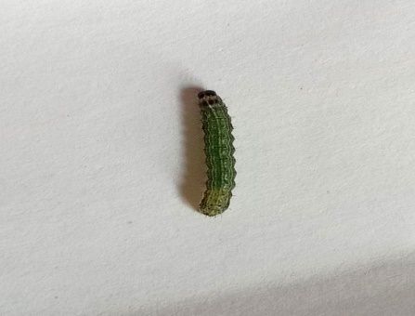
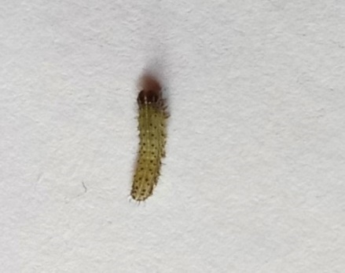
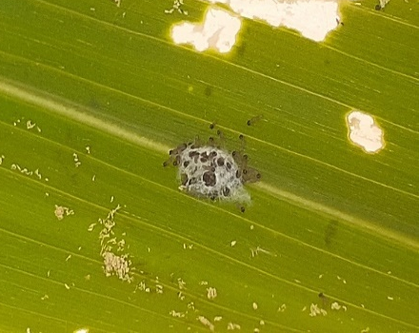
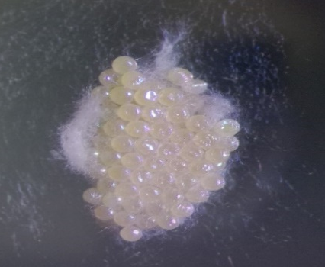

Second instar
First instar
Third instar
Eggs
Life cycle of
fall armyworm
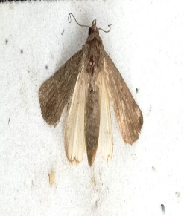
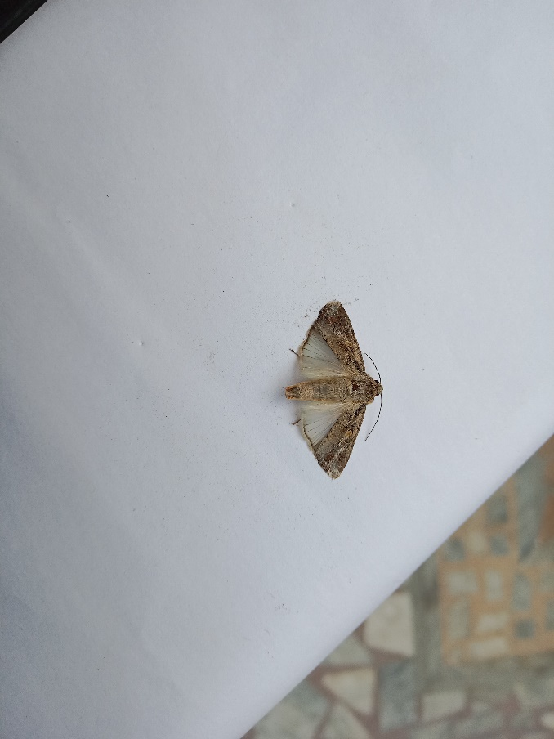
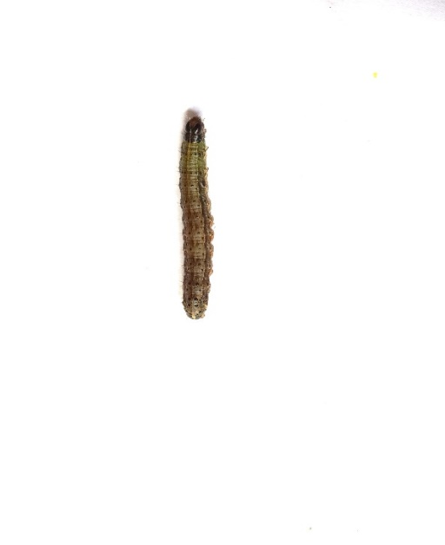

Fourth instar

Male
Female
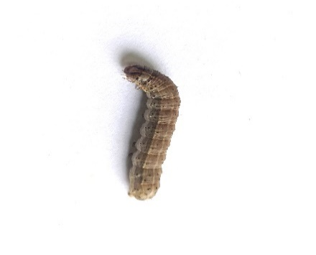
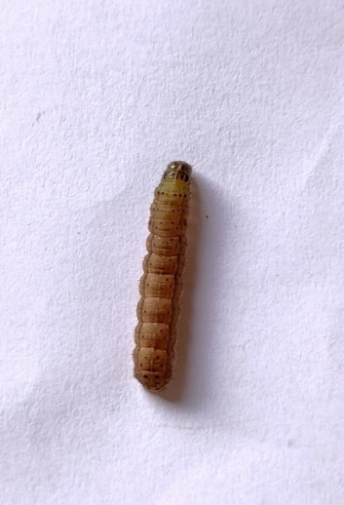
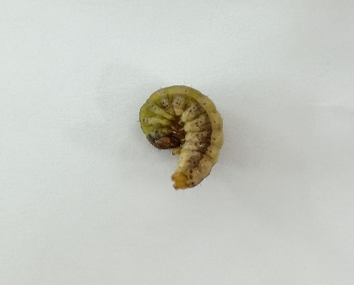
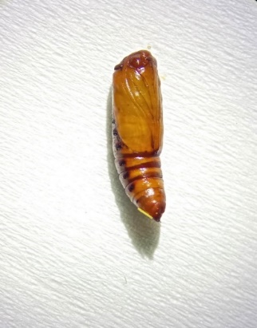
Fifth instar
Sixth instar
Pupa
Pre-pupa
Plate I: Different life stages of fall armyworm, S. frugiperda

Plate I: Different life stages of fall armyworm, S. frugiperda

Table 2: Measurement of different life stages of fall armyworm, S. frugiperda
Sr. No. | Life stage | Particulars | Measurement (mm)
Sr. No. | Life stage | Particulars | Min. | Max. | Mean ± SD
1. | Eggs | Length | 0.30 | 0.50 | 0.39 ± 0.03
1. | Eggs | Breadth | 0.30 | 0.40 | 0.36 ± 0.01
2. | Larva
2. | I instar | Length | 1.40 | 1.86 | 1.63 ± 0.06
2. | I instar | Breadth | 0.22 | 0.24 | 0.23 ± 0.01
2. | II instar | Length | 2.38 | 3.80 | 2.78 ± 0.20
2. | II instar | Breadth | 0.34 | 0.37 | 0.35 ± 0.01
2. | III instar | Length | 5.64 | 7.30 | 6.77 ± 0.25
2. | III instar | Breadth | 0.90 | 0.93 | 0.90 ± 0.01
2. | IV instar | Length | 14.00 | 16.24 | 15.10 ± 0.33
2. | IV instar | Breadth | 1.90 | 1.94 | 1.92 ± 0.01
2. | V instar | Length | 19.88 | 22.60 | 21.23 ± 0.75
2. | V instar | Breadth | 3.10 | 3.40 | 3.26 ± 0.08
2. | VI instar | Length | 29.90 | 33.10 | 31.26 ± 0.67
2. | VI instar | Breadth | 3.20 | 4.20 | 3.90 ± 0.22
3. | Pre-pupa | Length | 20.00 | 22.10 | 20.61 ± 0.66
3. | Pre-pupa | Breadth | 3.82 | 4.60 | 4.27 ± 0.19
4. | Pupa | Length | 12.50 | 16.00 | 15.28 ± 0.59
4. | Pupa | Breadth | 3.90 | 5.10 | 4.89 ± 0.24
5. | Adult
5. | Male | Length of body | 12.90 | 13.94 | 13.33 ± 0.20
5. | Male | Wing expanse | 31.90 | 32.60 | 32.04 ± 0.17
5. | Female | Length of body | 12.20 | 13.10 | 12.66 ± 0.26
5. | Female | Wing expanse | 32.40 | 33.00 | 32.92 ± 0.23
SD: Standard deviation, Observations recorded during August 2023
The result reported by Chaudhary et al. (2023) recorded 10.09 ± 1.96 mm of the average length and 1.32 ± 0.37 mm average breadth of fourth instar larvae. Bankar et al. (2024) stated that length of fourth larval instar was 15.10 ± 0.31 mm. Here, Bankar et al.’s reports are in
agreement with the present investigation whereas, Chaudhary et al.’s finding does not match with present investigation.
Fifth instar
The fifth instar larvae were observed like those in their earlier instars, but larger in size. Larvae were dark brown in colour. These instars had a row of black dots running all along with its side. The head was reddish brown, mottled with white colour. In this instar, the length was varied from 19.88 to 22.60 mm and breadth was 3.10 to 3.40 mm with average of 21.23 ± 0.75 mm and 3.26 ± 0.08 mm (Table 2), respectively.
According to Chaudhary et al. (2023) the length of fifth instar in average of 21.29 ± 2.64 mm. Tura et al. (2025) observed 20.20 ± 1.61 mm body length and 2.34 ± 0.28 mm body width of S. frugiperda. Here, Chaudhary et al.’s reports support the present findings whereas, Tura et al.’s finding was less similar with these findings.
Sixth instar
This stage was the most robust and were big with well-defined segmentation. The body was reddish cream, the head was brown. Dorsal lines and lateral dark areas became light. Spots became black in colour, surrounding areas reduced in size, the ring was black and the surrounding area was light in colour. On the first thoracic segments, spots were very small. On the abdomen and on the 2nd thoracic segment, the spots were large. Spiracles were found very black in light brown lateral areas. The key identification characters viz., an inverted “Y” shape on head capsule and four dark raised spots arranged in a square on the 8th abdominal segment and in a trapezoid manner on other abdominal segments (Plate II). The length and breadth of sixth instar larva varied from 22.90 to 33.10 mm and 3.20 to 4.20 mm with average of 31.26 ± 0.67 and 3.90 ± 0.22 mm, respectively.
The present findings agreed with the finding of Reddy et al. (2024) who stated that the length and breadth of sixth instar larva in range between 28.0 to 39.0 mm and 3.0 to 4.0 mm with an average of 32.30 ± 1.23 mm and 3.53 ± 0.13 mm. Tura et al. (2025) reported average 28.35 ± 2.05 mm length and 3.59 ± 0.47 mm breadth of sixth instar larva, respectively.
Pre-pupal period
Pre-pupa was greenish to bright brown colour, lazy, wrinkled, cessation of feeding and contracted their body. The length and breadth of pre-pupa was varied from 20.00 to 22.10 mm and 3.82 to 4.60 mm with an average of 20.61 ± 0.66 mm and 4.27 ± 0.19 mm, respectively (Table 2). Similar observation was also made by Sharanabasappa et al. (2018^{b}) who also reported cessation of feeding and colour changing from greenish to the bright brown.
Pupa
Newly formed pupae of S. frugiperda were orange greenish in colour. Static movement of pupae was observed in this condition. After 12 to 14 hours, the pupa was changed to a dark reddish-brown colour (Plate I). The length and breadth of pupa ranged from 12.50 to 16.00 mm and 3.90 to 5.10 mm with an average of 15.28 ± 0.59 mm and 4.89 ± 0.24 mm, respectively.
According to Helen et al. (2021) pupal length of S. frugiperda was varied from14.39 to 15.93 mm in range with an average of 15.28 ± 0.78 mm. Marcela and Mario (2020) observed 15.28 ± 0.67 mm length
Sr. No. | Life stage | Range | Mean ± SD
1 | Pre-oviposition period | 3-4 | 3.4 ± 0.48
2 | Oviposition period | 1-2 | 1.91 ± 0.24
3 | Post-oviposition period | 3-4 | 3.86 ± 0.33
4 | Adult male longevity | 4-8 | 6.73 ± 0.81
5 | Adult female longevity | 8-12 | 9.41 ± 0.83
6 | Male life cycle (Egg – Adult) | 32-36 | 34.63 ± 0.94
7 | Female life cycle (Egg – Adult) | 36-40 | 38.16 ± 1.21
8 | Female fecundity (No. of eggs) | 953-1220 | 1056 ± 116
9 | Egg hatching (%) | 80%-94% | 85.10 ± 5.55
10 | Sex ratio (Male: Female) | 1:1.30
Table 3: Biology of fall armyworm, S. frugiperda recorded during one month under laboratory conditions
SD: Standard deviation, Observations recorded during August 2023
and 4.81 ± 0.25 mm width of pupa in laboratory condition. These all statements are in accordance with present findings.
Adult
The adult S. frugiperda is a small to medium sized moth. Sexual dimorphism is present in these moths. Males are slightly larger than females. The forewings of the male moth were greyish brown with a reniform blurry spot, faintly outlined in black with a small V-shaped mark, a pale brown orbicular spot, somewhat oval and oblique in shape and a white patch at the apical margin of the wing. Whereas, the forewings of the female were grey and brown in colour i.e., with a mottled coloration of grey and brown with brown markings and without a white patch near the apical margin of the wing. The hind wings were silvery white coloured with border in both male and female moths.
Morphometric of moths observed were, the body length of male and female was found varied from 12.90 to 13.94 mm with an average of 13.33 ± 0.20 mm and 12.20 to 13.10 with an average of 12.66 ± 0.26 mm, respectively. It shows that female moth was little bit smaller than male moth. The wing span of male ranged from 31.90 to 32.60 mm with average of 32.04 ± 0.17 mm and for female moth it ranged from 32.40 to 33.00 mm with average of 32.92 ± 0.23 mm.
These present findings are in agreement with the findings of Sharanabasappa et al. (2018^{b}) who recorded wing span of male was 32.50 mm and female was 32.00 mm, respectively. Marcela and Mario (2020) noted 13.30 ± 0.77 mm wing length of male and 12.20 ± 0.44 mm wing length of female of S. frugiperda. They also observed that the wing span of male and female moth was 32.66 ± 1.43 mm and 32.81 ± 1.60 mm, respectively. Reddy et al. (2020) also recorded 30 to 35 mm of wing span of male moth with an average of 32.40 mm, respectively.
Pre-oviposition period
The pre-oviposition period of female moth varied from 3 to 4 days with mean of 3.4 ± 0.48 days which is in accordance with observations of Helen et al. (2021) who recorded that average pre-oviposition period of 3.4 days with range between 3 to 4 days and Kulkarni et al. (2023) observed 3.71 ± 0.45 days of mean pre-oviposition period.
Oviposition period
The oviposition period of female moths of S. frugiperda ranged from 1 to 2 days with an average of 1.91 ± 0.24 days (Table 3). Bankar et al. (2024) founded that oviposition period of S. frugiperda 1 to 2 days with average of 1.84 ± 0.33 days, which is close to present findings. Sharanabasappa et al. (2018^{b}) recorded that oviposition period of female moth ranged between 2 to 3 days with mean of 2.8 days. Here, Bankar et al.’s reports are close to the present investigation whereas, Sharanabasappa et al.’s finding less match with present investigation.
Post-oviposition period
Post-oviposition period of female moths of S. frugiperda varied from 3 to 4 days with mean of 3.86 ± 0.33 days. These findings are similar with Bankar et al. (2024) who reported that post-oviposition period of S. frugiperda 3.53 ± 0.23 days which was varying between 3.00 to 4.00 days and Choudhari et al. (2024) recorded 3.92 ± 0.00 days of post-oviposition period in range of 3 to 4 days.
Fecundity
The number of eggs laid per female moth of S. frugiperda ranged from 953 to 1220 with an average of 1056.13 ± 116 (Table 3). The results are in accordance with work of Helen et al. (2021) who reported that the female laid average eggs of 1094 ranging from 957-1289 number of eggs per female. Kulkarni et al. (2023) observed 1083.6 ± 188.13 fecundity of female moth of fall armyworm.
Sex ratio
The sex ratio (male: female) was 1:1.30 presented in Table 3. Choudhari et al. (2024) reported the sex ratio of fall armyworm on maize as 1:1.28 which is close with the present finding.
Longevity
Longevity of male moths of S. frugiperda varied from 4 to 8 days with mean of 6.73 ± 0.81 days, whereas that of female moth varied from 8 to 12 days with mean of 9.41 ± 0.83 days after mating. From this we observed that female lived more days compared to male moths. Sharanabasappa et al. (2018^{b}) reported that adult longevity of male moth ranged from 7 to 9 days with mean of 8.2 days and longevity of female moth ranged between 9 to 12 days with mean of 10.8 days. Choudhari et al. (2024) recorded that adult longevity of male moth was 7.05 ± 0.02 days and female was 8.74 ± 0.04 days which was varied from 7 to 8 days and 8 to 9 days, respectively. All these findings are similar with present results.
Total life span
Males of S. frugiperda completed its life cycle with an average duration of 34.63 ± 0.94 days which was varied from 32 to 36 days and females completed its life cycle with an average duration of 38.16 ± 1.21 days varied from 36 to 40 days under laboratory conditions. These findings are similar to the work done by Sharanabasappa et al. (2018^{b}) who reported the total life cycle of male was 32 to 43 days with mean of 37.5 days and female was 34 to 46 days with mean of 40.5 days. Helen et al. (2021) also stated that the total life cycle of male and female of S. frugiperda was observed to be 35 to 38 days and 37 to 40.5 days with average of 36.2 ± 1.25 and 38.2 ± 1.35 days, respectively.
CONCLUSION
The regular observations made on the fall armyworm in the present study indicated that, its breeding is continuous through the year round and so it represents a menace for the different crops in the field. Therefore, it is recommended that, more studies on the biology and ecology of the fall armyworm would be of prime importance to determine a suitable time for its effective management in the future.
REFERENCES
Abraham, P., Bateman, M., Beale, T., Clottey, V., Cock, M., Colmenarez, Y., Corniani, N., Day, R., Early, R., Godwin, J., Gomez, J., Moreno, P. G., Murphy, S. T., Oppong-Mensah, B., Phiri, N., Pratt, C., Richards, G., Silvestri, S. & Witt, A. (2017). Fall Armyworm: Impacts and Implications for Africa. Scientific Research, 11.

Ali, S. M. & Masroor M. D. (2018). First record of the fall armyworm, Spodoptera frugiperda (J. E. Smith, 1797) (Lepidoptera: Noctuidae), an evil attack on paddy in Magadh, Bihar (India). Journal of Emerging Technologies and Innovative Research, 5(2), 546-549.
Bankar, D. R., Bhamare, V. K., Mahajan, R. S., Hajare, P. B. & More, A. S. (2024). Biology and life tables of invasive fall armyworm, Spodoptera frugiperda (J. E. Smith) on sunflower, Helianthus annuus L. Journal of Environmental Biology, 46, 212-221.
Castro, M. T. & Pitre, H. N. (1988). Development of fall Armyworm, Spodoptera frugiperda (J. E. Smith), from honduras and mississippi on sorghum or corn in the laboratory. Florida Entomologist, 71(1), 49-56.
Chaudhary, L. S., Patel, C. J. & Ghetiya, L. V. (2023). Biology and morphometrics of fall armyworm, Spodoptera frugiperda (J. E. Smith) on maize. International Journal of Current Microbiology and Applied Sciences, 12(5), 184-198.
Chormule, A., Shejawal, N., Sharanabasappa, D., Kalleshwaraswamy, C., Asokan, R. & Swamy, H. M. (2019). First report of the fall Armyworm, Spodoptera frugiperda (J. E. Smith) (Lepidoptera, Noctuidae) on sugarcane and other crops from Maharashtra, India. Journal of Entomology Zoology Studies, 7(1), 114-117.
Choudhari, V. N., Bhamare, V. K., More, D. G., Magar, S. J. & Hinge, V. R. (2024). Biology and biometrics of fall armyworm, Spodoptera frugiperda (J. E. Smith) on fodder maize. International Journal of Advanced Biochemistry Research, 8(12), 767-773.
Devi, R., Chandra, U., Kumar, R. R., Kumar, P., Singh, S. K. & Veer, R. (2024). Biology of fall armyworm, Spodoptera frugiperda (J. E. Smith) on maize under laboratory conditions. International Journal of Environment and Climate Change, 14(2), 463-469.
Helen, P. A., Tamboli, N. D., More, S. A. & Kulkarni, S. R. (2021). Bio-efficacy of biocontrol agents against fall armyworm, Spodoptera frugiperda (J. E. Smith) under laboratory conditions. Journal of Entomology and Zoology Studies, 9(4), 277-280.
Kashyap & Malik (2024). Biology and management of fall armyworm (Spodoptera Frugiperda, J. E. Smith) in maize. Agritech Magazine, 2(8).
Khatun, M., Ali, M. R., Hossain, M. S., Haque, M. M. & Latif, M. A. (2022). Biology and morphometrics of fall armyworm, Spodoptra frugiperda (J. E. Smith) on maize plant. Bangladesh Journal of Agricultural Research, 47(2), 225-239.
Kona, N. E. M., Mohammed, A. K., Mahmoud, E. E. & Adam, A. M. (2021). The biology of fall armyworm, Spodoptera frugiperda (J. E. Smith) in Sudan. Journal of Agronomy Research, 4(1), 1-5.
Kulkarni, N. S., Keerthi, M. C. & Shivakumar, B. G. (2023). Seasonal incidence, biology and management of fall armyworm (Spodoptera frugiperda, J. E. Smith) on fodder maize. Range Management and Agroforestry, 44(2), 397-402.
Marcela, M. N. & Mario, V. N. (2020). Life cycle, morphometric and natural enemies of fall armyworm, Spodoptera frugiperda (J. E. Smith) (Lepidoptera: Noctuidae) on Zea mays L. in the Philippines. Journal of International Society for Southeast Asian Agricultural Sciences, 26(2), 17-29.
Reddy, K. J. M., Kumari, K., Saha, T. & Singh, S. N. (2020). First record, seasonal incidence and life cycle of fall armyworm, Spodoptera frugiperda (J. E. Smith) in maize at Sabour, Bhagalpur, Bihar. Journal of Entomology and Zoology Studies, 8(5), 1631-1635.
Reddy, V. S., Konsama, J., Dayanandab, S. & Nabakishorcand, N. K. (2024). Study on biology of fall armyworm, Spodoptera frugiperda (J. E. Smith) on maize, Zea mays L. in Manipur, India. International Journal of Environment and Climate Change, 14(3), 32-41.
Sharanabasappa, K. C., Asokan, R., Swamy, H. M., Marutid, M. S., Pavithra, H. B., Hegde, K. & Goergen, G. (2018ª). First report of the fall armyworm, Spodoptera frugiperda (J. E. Smith) (Lepidoptera: Noctuidae), an alien invasive pest on maize in India. Pest Management in Horticultural Ecosystems, 24(1), 23-29.
Sharanabasappa, K. C., Kalleshwaraswamy, C. M., Maruthi, M. S. & Pavithra, H. B. (2018^{b}). Biology of invasive fall armyworm, Spodoptera frugiperda (J. E. Smith) (Lepidoptera: Noctuidae) on maize. Indian Journal of Entomology, 80(3), 540-543.
Siddhapara, M. R., Patel, K. M. & Patel, A. G. (2021). Biology and morphometrics of fall armyworm, Spodoptera frugiperda (J. E. Smith) (Lepidoptera: Noctuidae) on maize. Indian Journal of Entomology, 83.
Sisay, B., Simiyu, J., Mendesil. E., Likhayo, P., Ayalew, G., Mohamed, S., Subramanian, S. & Tefera, T. (2019). Fall armyworm, Spodoptera frugiperda (J. E. Smith) infestations in East Africa: Assessment of Damage and Parasitism. Insects, 10(7), 195.
Srikanth, J., Geetha, N., Singaravelu, B., Ramasubramanian, T., Mahesh, P. & Saravanan, L. (2018). First report of occurrence of fall armyworm, Spodoptera frugiperda (J. E. Smith) in sugarcane from Tamil Nadu, India. Journal of Sugarcane Research, 8(2), 195-202.
Tendeng, E., Labou, B., Diatte, M., Djiba, S. & Diarra, K. (2019). The fall armyworm Spodoptera frugiperda (J. E. Smith), a new pest of maize in Africa: Biology and first native natural enemies detected. International Journal of Biological Chemistry Science, 13(2), 1011-1026.
Tura, C. L., Larry, V. A. & Joshi, R. C. (2025). Life history of fall armyworm, Spodoptera frugiperda (J. E. Smith) on hedgehog sedge, Cyperus compressus L. in Philippines. Hexapoda, 32(1), 1-7.

