A Comparative Analysis of Efficient Cropping Zones for Sugarcane in Tamil Nadu Using Different Indices

ABSTRACT
Sugarcane is a vital commercial crop in Tamil Nadu, playing a significant role in the state's agro-industrial landscape. This study evaluates and delineates Efficient Cropping Zones (ECZ) using the Relative Yield Index (RYI) and the Relative Spread Index (RSI), offering a detailed assessment of sugarcane productivity and spatial distribution across Tamil Nadu districts. The study classified Cuddalore, Erode, Kallakurichi, Namakkal, and Vilupuram as the Most Efficient Cropping Zones (MECZ) for sugarcane. These districts benefit from favorable agro-climatic conditions, high-yielding practices, fertile loamy soils, and advanced irrigation systems. Thirteen districts were identified as Yield Efficient Cropping Zones (YECZ), one district as an Area Efficient Cropping Zone (AECZ), and thirteen as Non-Efficient Cropping Zones (NECZ). These findings provide essential guidance for agricultural planners and stakeholders to target investments and resources, optimize sugarcane production, and ensure sustainable development of the sector. The identification of these zones allows for a more targeted approach to agricultural policy and resource allocation. By understanding which districts excel in yield and which have potential for area expansion, policymakers can tailor support systems more effectively. This strategic planning is crucial for mitigating risks associated with climate change and ensuring the long-term economic viability of sugarcane cultivation.
KEYWORDS: Sugarcane, Efficient Cropping Zone, Relative Yield Index (RYI), Relative Spread Index (RSI), Tamil Nadu

INTRODUCTION
Sugarcane (Saccharum officinarum L.) is an economically significant tropical grass crop cultivated extensively for its juice-rich stalks, which are used in the production of sugar, ethanol, and various byproducts. Globally, sugarcane accounts for approximately 80% of total sugar production (FAO, 2021), making it a cornerstone of the agro-industrial sector in many tropical and subtropical countries. In India—the second-largest producer of sugarcane after Brazil—Tamil Nadu plays a vital role due to its favorable agro-climatic environment, irrigation infrastructure, and established sugar-processing industries (Kumar et al., 2018).
Sugarcane production in Tamil Nadu not only contributes significantly to the state's agricultural GDP but also supports downstream industries such as sugar refining and ethanol distillation, thereby influencing both domestic consumption patterns and export potential. However, climate variability poses a growing threat to sustained sugarcane productivity. Studies (e.g., Singh et al., 2020; Ramesh & Krishnan, 2019) have reported that shifts in rainfall distribution, increasing temperature trends, and declining groundwater levels have already begun to affect sugarcane yields and water-use efficiency in several regions of the state.
Given the high water demand and long crop duration of sugarcane, adapting to climate-induced stress is critical. Recent research emphasizes the importance of site-specific crop planning as a strategy to mitigate these challenges (Mohanraj et al., 2021). The delineation of Efficient Cropping Zones (ECZ), using geospatial and statistical tools such as the Relative Yield Index (RYI) and Relative Spread Index (RSI), has emerged as an effective approach to identify areas with consistently high performance in both yield and area coverage (Patil & Kale, 2016).
This methodological framework, first proposed by Kanwar (1972), allows for a quantitative and objective assessment of a region's performance against state-level averages. By categorizing districts based on their relative performance using the RYI and RSI, this approach helps to reveal the underlying agronomic, infrastructural, and economic factors that drive efficiency. Districts with a high RYI but low RSI, for instance, demonstrate excellent yield potential but may be limited by competition from other crops or a lack of suitable infrastructure. Conversely, districts with a high RSI and low RYI have a large area under cultivation but struggle with productivity, highlighting a need for improved farming practices or better input management.
The agricultural landscape of Tamil Nadu is characterized by diverse microclimates, and sugarcane, as a long-duration and water-intensive crop, is particularly sensitive to these regional variations. The state's reliance on both surface water from canal systems and groundwater from borewells makes it highly vulnerable to the impacts of monsoon failures and prolonged dry spells. These climatic fluctuations not only affect the quantity of the cane produced but also compromise its quality, including the crucial sucrose content, which is the ultimate determinant of a sugar mill's efficiency and a farmer's income. Therefore, understanding the spatial patterns of sugarcane performance is not merely an academic exercise; it is an urgent necessity for ensuring food security and economic stability for thousands of farmers.
This study applies the ECZ framework to a decadal dataset (10 years) of sugarcane cultivation in Tamil Nadu, with the objective of identifying spatially significant and high-performing districts. The findings aim to inform regional planning, promote resource-efficient farming practices, and support climate-resilient sugarcane cultivation.

MATERIALS AND METHODS

Study Area
The study encompasses the entire Tamil Nadu region, spanning from 7.875°S to 13.083°N in latitude and 76.5°E to 80.375°E in longitude.

Datasets
District-level statistics on sugarcane area, production, and productivity were sourced from the Season and Crop Report (https://www.tn.gov.in/crop/) for the period 2011–2020 to determine the Efficient Cropping Zone of Sugarcane for Tamil Nadu.

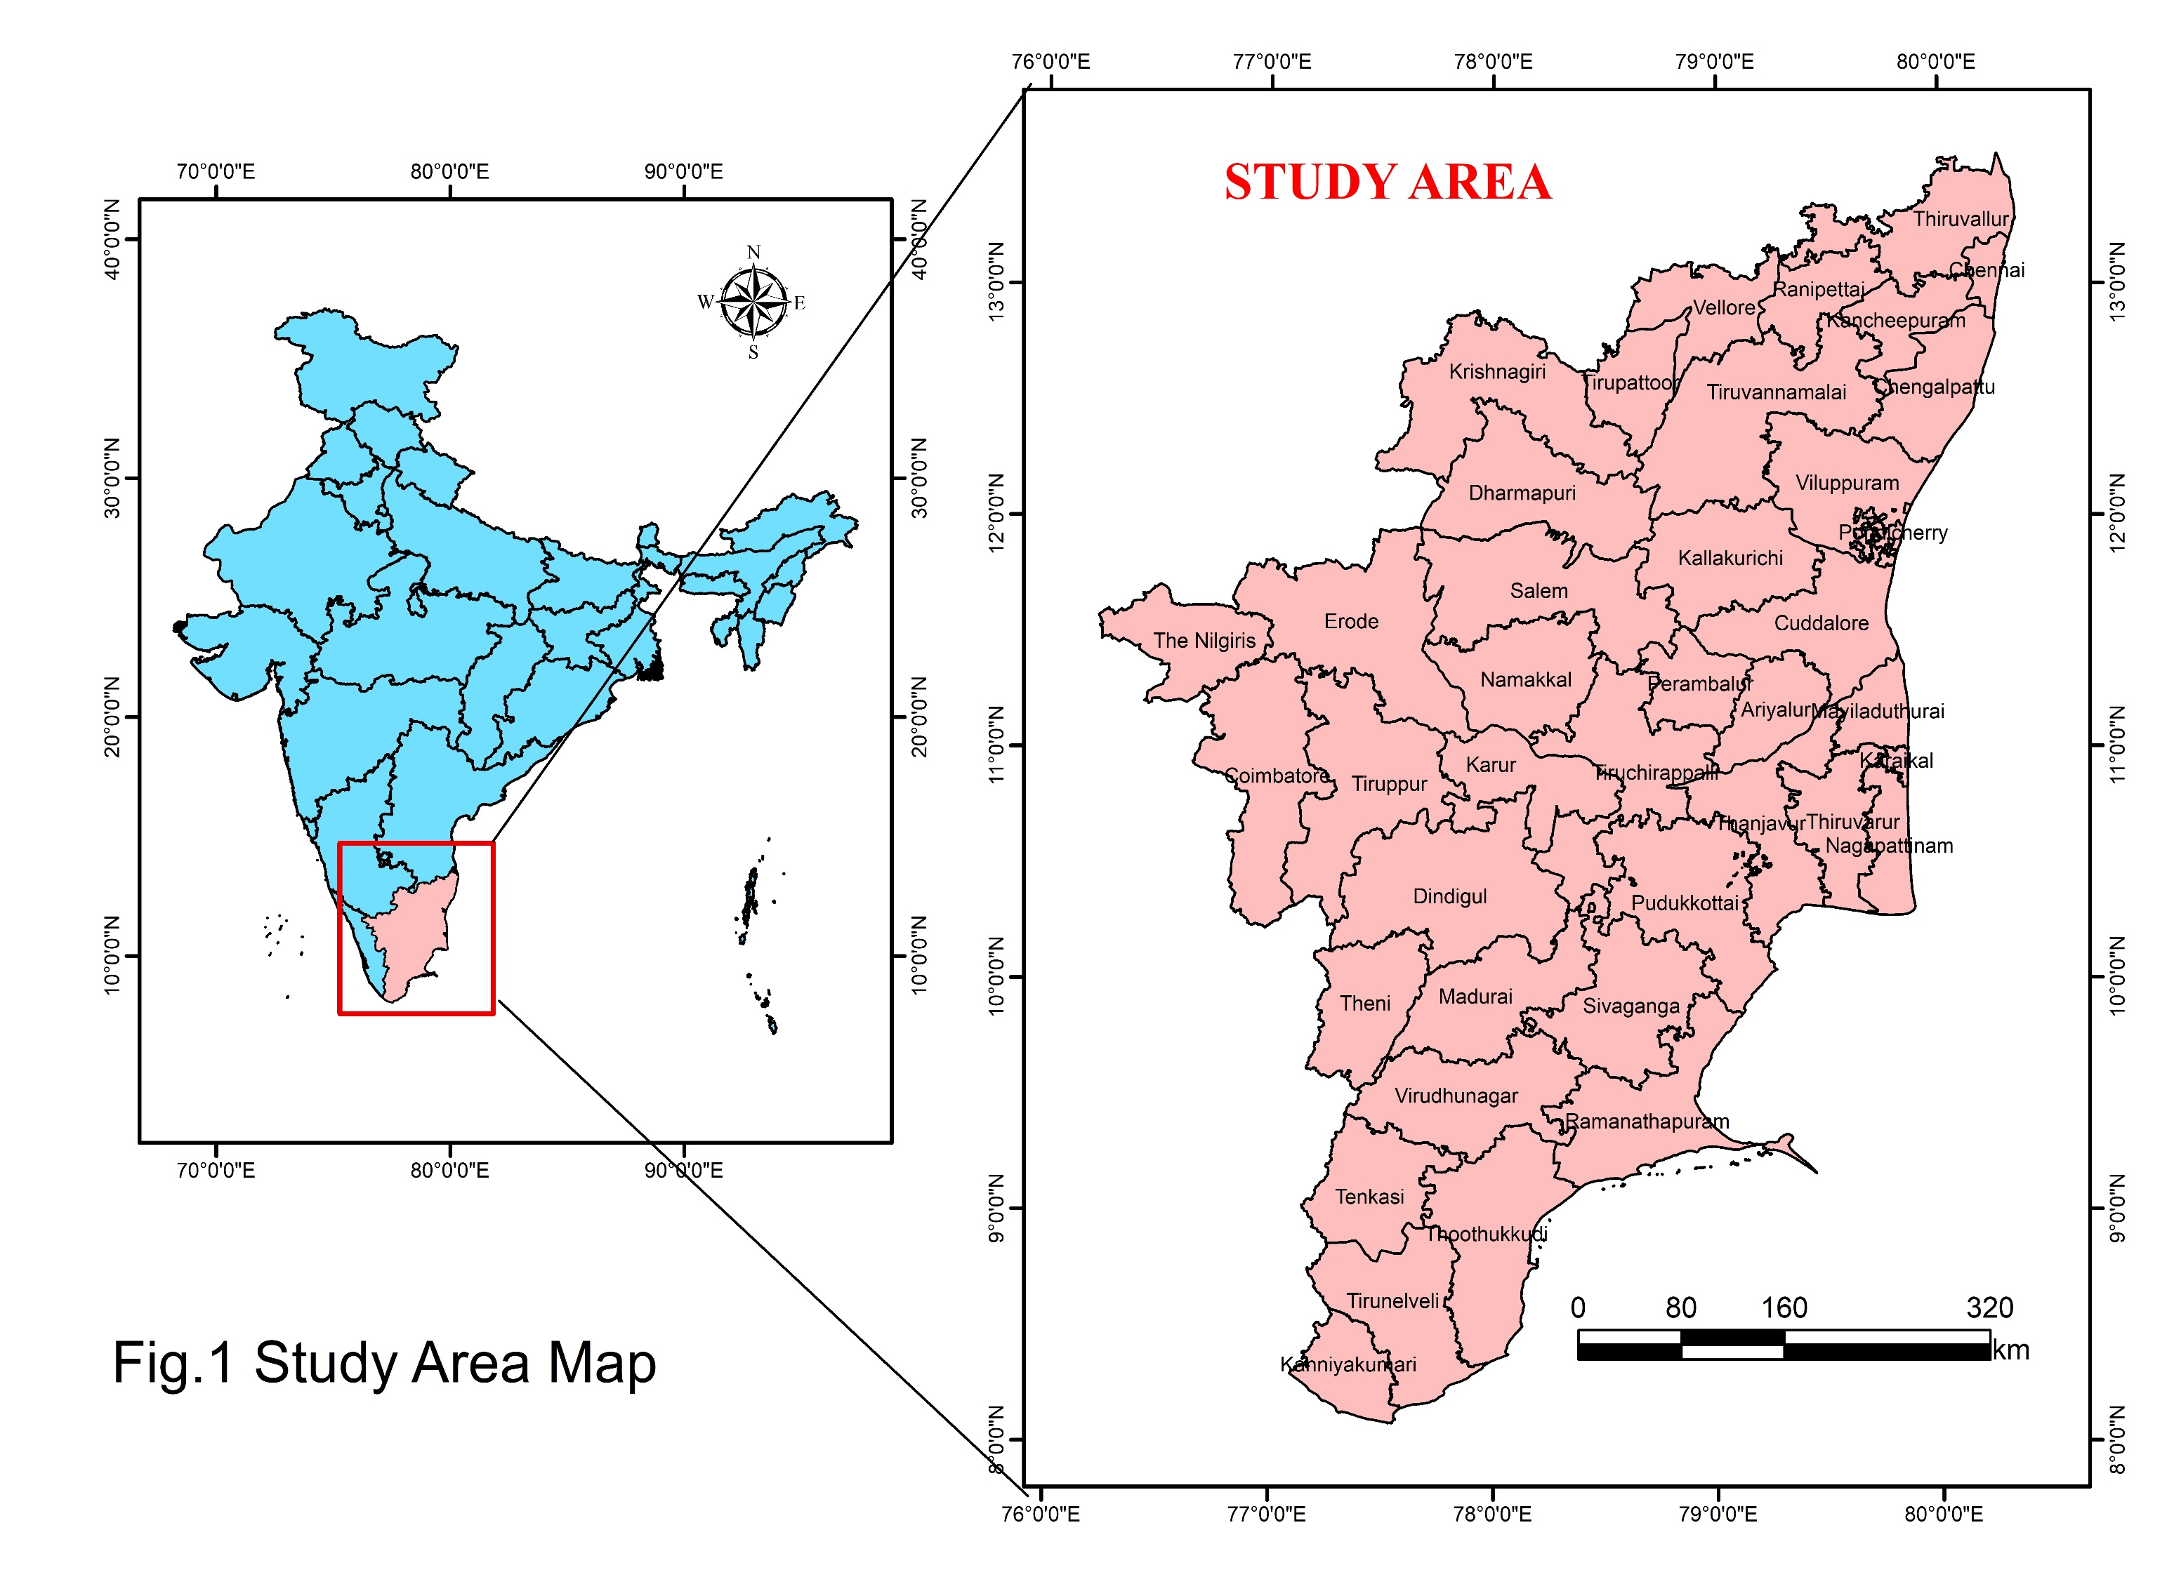
The Relative Yield Index (RYI) and Relative Spread Index (RSI) were computed following Kanwar’s (1972) method:
Area of a particular crop expressed as a percent of the
total cultivable area in the district
RSI= x100
Area of crop expressed as a percentage to the
total cultivable area in the State
Where in RSI: Relative Spread Index

Mean yield of a particular crop in a district (Kg/ha)
RYI= x100
Mean yield of the crop in the State (Kg/ha)
Where in RYI: Relative Yield Index

Table 1. Criteria for ECZ Classification

RYI | RSI | Cropping Zone
>100 | >100 | Most Efficient Cropping Zone
>100 | <100 | Yield Efficient Cropping Zone
<100 | >100 | Area Efficient Cropping Zone
<100 | <100 | Non-Efficient Cropping Zone

RESULTS AND DISCUSSION

The analysis based on the Relative Yield Index and Relative Spread Index revealed the signature spatial pattern of sugarcane efficiency in various districts of Tamil Nadu. The very efficient zones of the districts are grouped as Most Efficient Cropping Zones (MECZ), Yield Efficient Cropping Zones (YECZ), Area Efficient Cropping Zones (AECZ), and Non-Efficient Cropping Zones (NECZ), which performed in terms of productivity and area under cultivation over a 10-year period.

1. Most Efficient Cropping Zones (MECZ)
Five districts-Cuddalore, Erode, Kallakurichi, Namakkal, and Viluppuram-met the two criteria for being both high-yielding and widely cultivated (i.e., RYI> 100 and RSI > 100) and fell firmly within the definition of Most Efficient Cropping Zones. Such areas consist mainly of sugarcane cultivation zones in the state with sustained performance over the decade. A few agro-ecological determinants of efficiency are:
Climatic suitability: These districts receive well-distributed rainfall every year and moderate temperatures, which are closely aligned with those considered optimal for sugarcane growth.
Soil fertility: Fertile loamy and alluvial soils prevalent in such areas promote cane growth by offering good water retention and availability of nutrients in a proper amount.
Proper irrigation: By using proper irrigation infrastructure consisting of well-installed canal systems and borewell networks, it will be assured that water is available reliably during cropping time.
Proximity to sugar mills: Logistical advantages from near post-processing units reduce transportation costs and post-harvest losses, thus augmenting farmer income and support for continuous cultivation.
Hence, such locations can be prioritized for the intensification of sugarcane-based industries and extension services, based on their agronomic and economic merits. These highly productive zones serve as a crucial benchmark for the state, providing a model for sustainable and high-performing sugarcane cultivation. Their success highlights the importance of integrating favorable environmental conditions with robust infrastructure and farmer support.

2. Yield Efficient Cropping Zones (YECZ)
Thirteen districts that would be classified under this category included Coimbatore, Kanchipuram, Karur, Krishnagiri, Pudukkottai, Ramanathapuram, Thanjavur, Theni, Thoothukudi, Tiruppur, Tiruvallur, Tiruvarur, and Vellore. These districts have an RYI score of more than RYI > 100 and below the threshold area of cultivation (RSI < 100). They showed above-average yield except for an area under cultivation.
This shows that despite boasting favorable microclimatic and agronomic conditions conducive for high productivity, sugarcane has not increased much in area. The probable reasons include:
Competition for land use: Sugarcane faces stiff competition from other highly profitable crops such as paddy, banana, or various horticulture crops. For instance, districts like Thanjavur and Tiruvarur, known as the "rice bowl" of Tamil Nadu, prioritize paddy cultivation due to cultural significance and robust government support.
Water constraints: Several of these districts, particularly those in semi-arid zones like Ramanathapuram and Thoothukudi, face severe water constraints. Even with high-efficiency cultivation practices, the limited water resources make large-scale expansion of a water-intensive crop like sugarcane economically unviable.
Infrastructural gaps: The absence of sufficient marketing or processing infrastructure may turn out to be among the factors discouraging expansion despite yield potential. In some areas, a lack of nearby sugar mills increases transportation costs and logistical challenges, disincentivizing new farmers from adopting the crop.
There would be potential for further expansion and scaling up of these areas toward sugarcane cultivation; improved policy leverage, infrastructural development, and awareness programs would be vigorous in pouring out about their underlying potential.

3. Area Efficient Cropping Zone (AECZ)
The district of Salem scored high in terms of an area under cultivation (RSI > 100) yet recorded sub-optimal productivity (RYI < 100). It indicates that sugarcane occupies wide areas of the district, but yields are lower than the average yield for the state. Some of the possible reasons for such a divergence may be:
Improper crop management practices: This is a key factor impacting yield. Issues such as imbalanced fertilizer applications, where farmers might apply an excess of one nutrient while neglecting others, can lead to nutrient deficiencies and reduced cane growth. Similarly, a failure to apply fertilizers at the optimal time or to manage pests and diseases effectively can result in a substantial loss of the harvestable crop. The timing of harvesting is also critical; late harvesting often leads to a reduction in juice quality and sucrose content, which directly impacts the final sugar recovery and the farmer's income.
Soil and water stress: The widespread cultivation of a water-intensive crop like sugarcane in Salem has likely led to over-withdrawal of groundwater, contributing to declining water tables. This water stress, combined with poor soil conservation practices, can lead to nutrient depletion and soil erosion. Over time, these conditions degrade the soil's fertility and its capacity to support a high-yielding crop, making the cane more vulnerable to environmental stresses and diseases.
Limited access to high-yielding varieties or extension services: A major hurdle for farmers is often the lack of access to and adoption of improved, high-yielding sugarcane varieties. Farmers may continue to rely on traditional, less productive varieties that are not well-suited to the local climate or soil. Furthermore, a deficiency in effective agricultural extension services means that farmers may not receive timely information or training on modern agronomic practices, such as precision farming techniques, integrated pest management, and water-saving irrigation methods.
This district, therefore, becomes a case for improvement in agronomy with respect to high yield via better inputs, precision farming, and the right adoption of Best Management Practices (BMPs).

4. Non-Efficient Cropping Zones (NECZ)
Thirteen districts-Ariyalur, Chennai, Dharmapuri, Dindigul, Kanniyakumari, Madurai, Nagapattinam, Nilgiris, Perambalur, Sivaganga, Tiruchirappalli, Tirunelveli, and Virudhunagar-falls under the NECZ since values of both RYI and RSI were below 100.
These areas demonstrated small areas of cultivation and low productivity. However, there may be several reasons underlying this:
Adverse Agro-Climatic Conditions and Soil Quality: Many of these districts are characterized by unsuitable geographical or climatic conditions for sugarcane. The Nilgiris, for instance, is a hilly region with a temperate climate, which is not ideal for this tropical crop. Other areas like Sivaganga and Virudhunagar are part of the dry, rain-fed zones of the state, where erratic rainfall and poor soil quality make cultivation of a water-intensive crop like sugarcane highly precarious and economically unviable.
Competing Land Use and Economic Factors: In some districts, even with seemingly adequate conditions, sugarcane is a low-priority crop. Farmers may find other crops, such as pulses, millets, or specific horticulture crops, to be more profitable or better supported by local markets and government schemes. This results in minimal area allocation to sugarcane, regardless of any yield potential.
Infrastructural Deficiencies: The lack of a robust support system further disincentivizes sugarcane cultivation. This includes the absence of nearby sugar mills, poor connectivity to major markets, and a weak agricultural extension network, which together make it difficult for farmers to access inputs, sell their produce, and adopt modern farming techniques.
In such zones, the promotion of alternative crops better suited to local conditions may be more appropriate and in the better but strategic de-emphasized or converted approach such systems of cropping would be replaced with climate-resilient cropping systems.

Table 2: Most Efficient Cropping Zones (MECZ)
District | RSI | RYI | Classification
Cuddalore | 314.77 | 117.03 | MECZ
Erode | 269.38 | 119.93 | MECZ
Kallakurichi | 374.86 | 114.04 | MECZ
Namakkal | 189.42 | 125.86 | MECZ
Vilupuram | 744.12 | 115.67 | MECZ
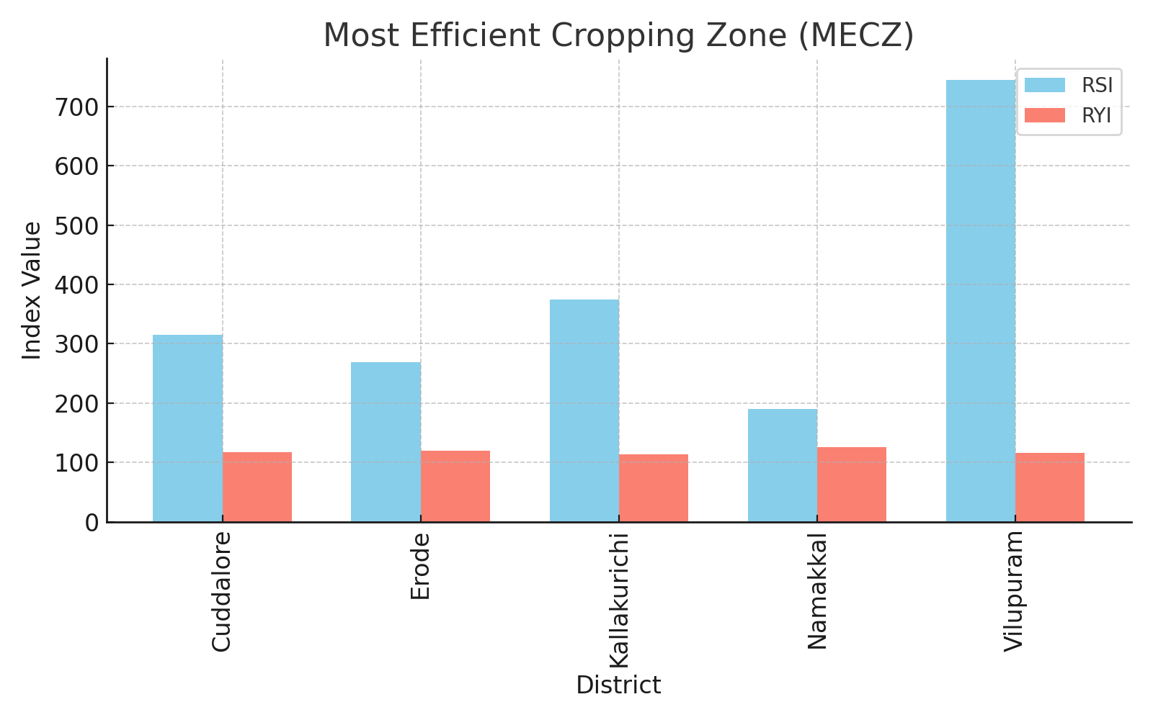

Figure 2. Most effective cropping zone

Table 3: Yield Efficient Cropping Zones (YECZ)
District | RSI | RYI | Classification
Coimbatore | 10.21 | 109.03 | YECZ
Kanchipuram | 22.53 | 115.04 | YECZ
Karur | 27.60 | 108.47 | YECZ
Krishnagiri | 8.26 | 107.12 | YECZ
Pudukkottai | 52.14 | 101.90 | YECZ
Ramanathapuram | 3.19 | 109.11 | YECZ
Thanjavur | 88.02 | 104.55 | YECZ
Theni | 61.18 | 107.30 | YECZ
Thoothukudi | 1.19 | 112.14 | YECZ
Tiruppur | 53.79 | 119.37 | YECZ
Tiruvallur | 83.88 | 105.38 | YECZ
Tiruvarur | 3.60 | 108.82 | YECZ
Vellore | 80.33 | 100.95 | YECZ
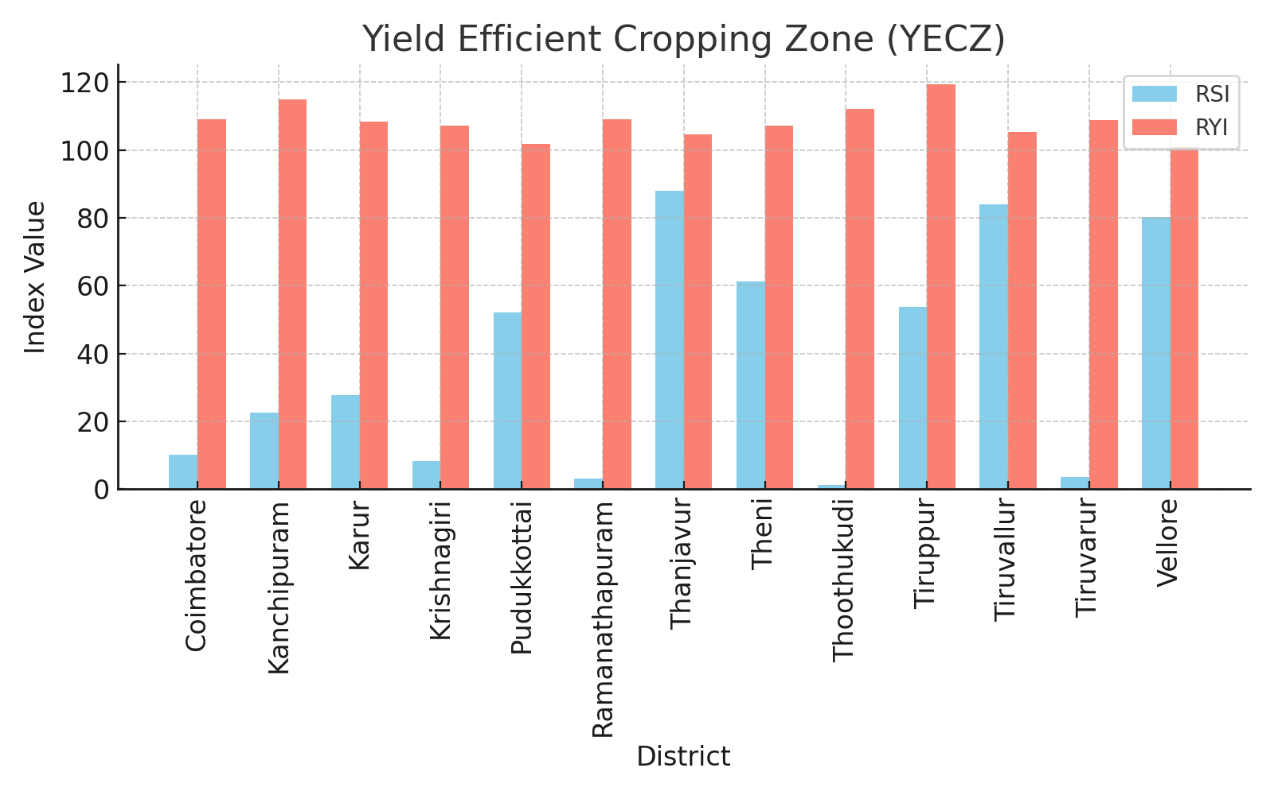

Figure 3. yield efficient cropping zone

Table 4: Area Efficient Cropping Zone (AECZ)
District | RSI | RYI | Classification
Salem | 106.27 | 99.13 | AECZ
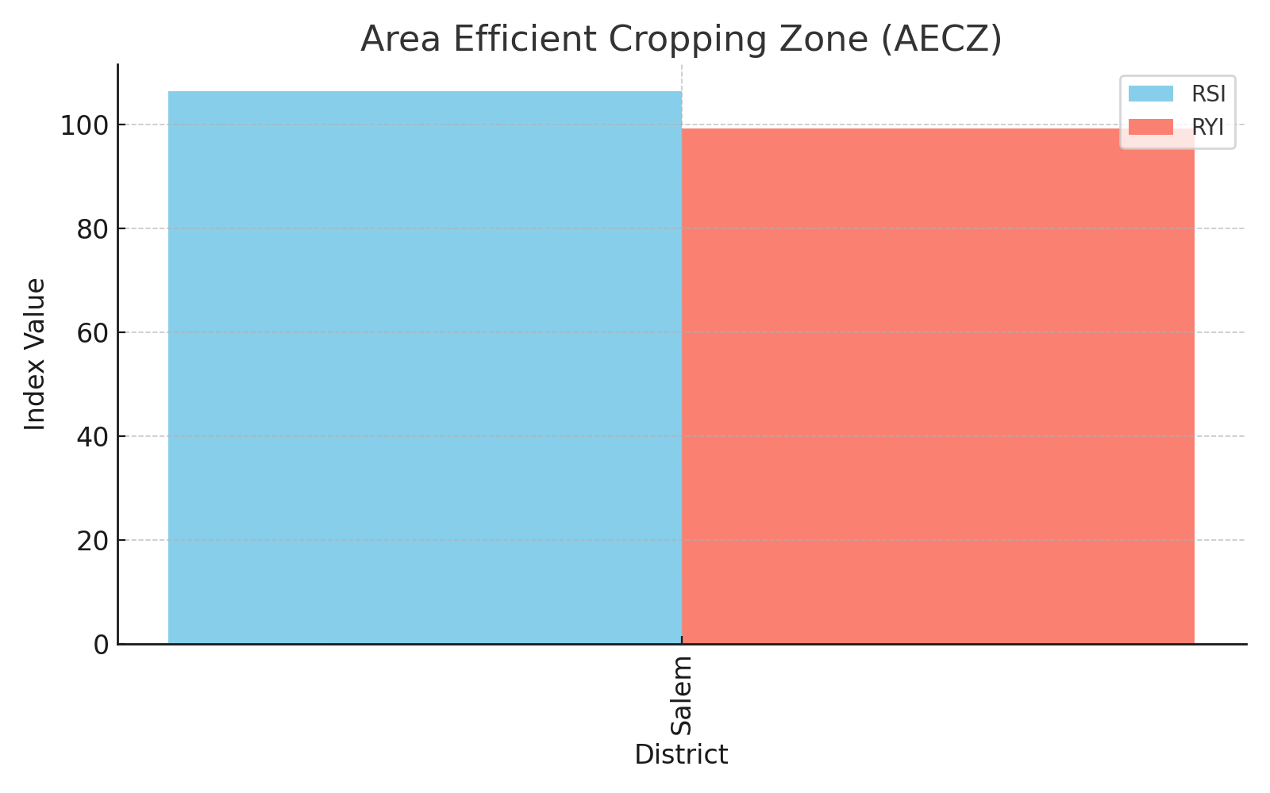
Fig 4: Area Efficient Cropping Zone (AECZ)

Table 5: Non-Efficient Cropping Zones (NECZ)
District | RSI | RYI | Classification
Ariyalur | 88.15 | 97.95 | NECZ
Chennai | 0 | 0 | NECZ
Dharmapuri | 78.07 | 95.17 | NECZ
Dindigul | 33.37 | 97.42 | NECZ
Kanniyakumari | 0.002 | 12.11 | NECZ
Madurai | 35.04 | 88.35 | NECZ
Nagapattinam | 28.47 | 83.40 | NECZ
Nilgiris | 0.041 | 71.73 | NECZ
Perambalur | 71.97 | 95.77 | NECZ
Sivaganga | 47.71 | 82.27 | NECZ
Tiruchirappalli | 35.36 | 95.28 | NECZ
Tirunelveli | 29.38 | 95.25 | NECZ
Viruthunagar | 27.34 | 97.91 | NECZ

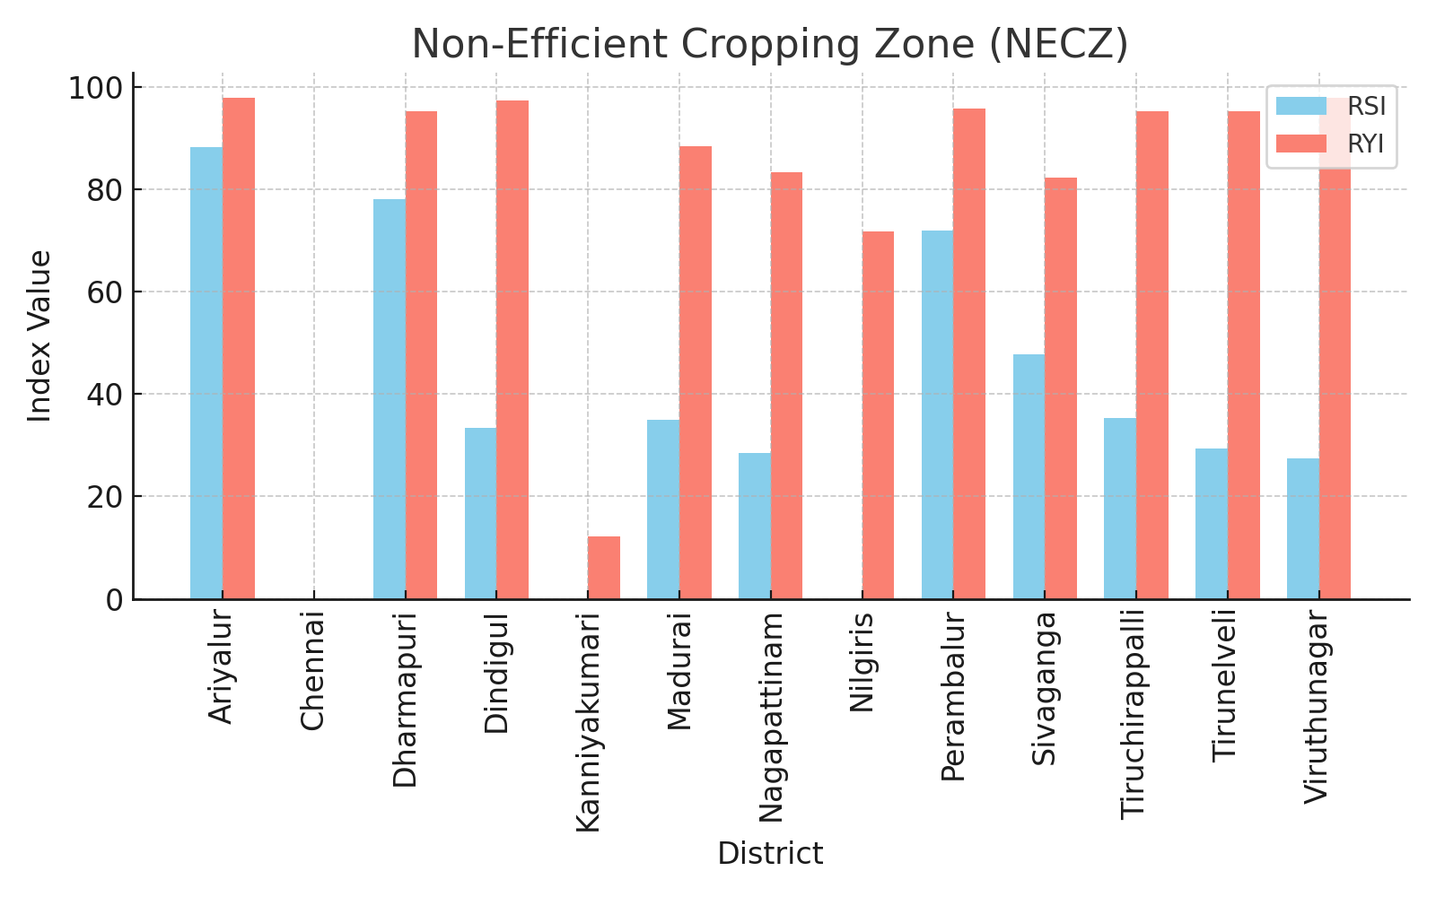

Fig 5: Non-Efficient Cropping Zones (NECZ)

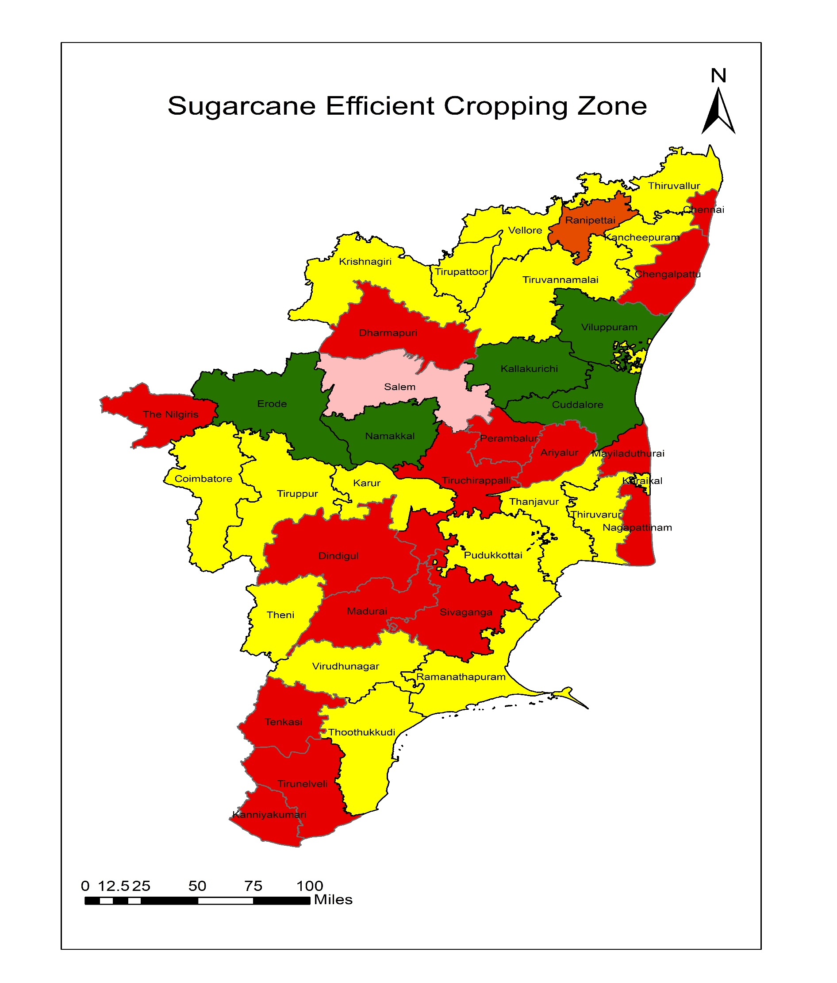

Fig.6 Sugarcane Efficient Cropping Zone

CONCLUSION
This study delineates, using two primary indices - the Relative Yield Index (RYI) and the Relative Spread Index (RSI) - spatio-temporal patterns in sugarcane cultivation efficiency between the districts in Tamil Nadu. These measures offer a robust framework for measuring productivity and cultivation extent for sugarcane over a decade and then classifying these districts into four cropping zones.
In this context, the districts of Cuddalore, Erode, Kallakurichi, Namakkal, and Viluppuram are Most Efficient Cropping Zones (MECZ). Since these areas have reported high but extensive results (RYI > 100 and RSI > 100), they were likely to be assisted by the synergisms of good climate, fertile soils, well-developed irrigation networks, and proximity to sugar factories, thus establishing them as the core production areas and serving as benchmarks for sustainable sugarcane intensification.
The study also considered a few Yield Efficient Cropping Zones (YECZ)- those being districts where performance in terms of yield of sugarcane is above average (RYI > 100) with rather less under cultivation (RSI < 100). These include areas like Coimbatore, Theni, and Thanjavur. Area expansion investments on irrigation, easy access to inputs, and good marketing linkages with policy support could turn a resource-rich future growth hub for these districts.
In contrast, the case of Salem is indicative of the Area Efficient Cropping Zones, which has a very high cultivation area but low productivity (RSI > 100, RYI < 100). The results therefore suggest the need for agronomic improvements, such as better crop management practices, varietal improvement and interventions for soil fertility that can result in yield improvements in the existing sugarcane lands.
Perhaps most importantly, the study conclusively identifies a great many districts such as Ariyalur, Sivaganga, Dindigul, and Virudhunagar as Non-Efficient Cropping Zones (NECZ)- that is, districts in state averages of both yield and area indicators of that state (RYI < 100, RSI < 100). These places suffer from multiple limitations affecting their viability, such as adverse agro-climatic conditions, poor quality of soil, less availability of water, and poor infrastructures. The study therefore advocates for some focused and strategic agronomic intervention approaches for these sites like growing drought-resistant varieties, improving water management practices, and possibly crop diversification to more suitable alternatives.
In conclusion, the spatial analysis undertaken in this study calls for a region-specific plan to be drawn up for sugarcane development. The present study can, therefore, form a very good basis for prioritizing resources, targeting agricultural extension, and planning with climate resilience in mind. Policymakers, agribusiness stakeholders, and farmers can use such insights to boost productivity, profit, and sustainability in Tamil Nadu's sugarcane sector.

COMPETING INTERESTS DISCLAIMER:
Authors have declared that they have no known competing financial interests OR non-financial interests OR personal relationships that could have appeared to influence the work reported in this paper.

REFERENCES

1. Gowtham, R., V. Geethalakshmi, and S. Panneerselvam. (2019). Delineation of efficient cropping zone for sugarcane over the southern Indian states. Madras Agricultural Journal.
2. Kanwar, J.S. (1972). Cropping patterns, scope and concept. ICAR Symposium on Cropping Patterns in India.
3. Iqbal, Z., S. Shahid, K. Ahmed, T. Ismail, G.F. Ziarh, E.-S. Chung, and X. Wang. 2021. "Evaluation of CMIP6 GCM rainfall in mainland Southeast Asia." Atmospheric Research 254:105525.
4. Yadu, A., and G. Das. 2021. "Identification of efficient cropping zone for major field crops in 27 districts of Chhattisgarh."
5. Pavithra, S., S. Sanbagavalli, and K. Nagarajan. 2020. "Identification of efficient cropping zone for Redgram in Tamil Nadu." Journal of Pharmacognosy and Phytochemistry 9 (3):265-267.
6. Poornima, S., S. Kokilavani, N. Thavaprakaash, C. Babu, V. Geethalakshmi, and R. Jagannathan. 2008. "Examining the prospective cropping zone of important field crops of Tamil Nadu." Madras Agricultural Journal 95 (jul-dec):1.
7. Kanwar JS. Cropping patterns, scope and concept. In Proceeding of the Symposium, on Cropping Pattern in India, ICAR, New Delhi, 1972, 11-32.
8. FAO. (2021). FAOSTAT Statistical Database. Food and Agriculture Organization of the United Nations.
9. Kumar, S., Rani, P., & Suresh, A. (2018). "Performance of Sugarcane in Tamil Nadu: A Regional Analysis." Agricultural Economics Research Review.
10. Singh, A. K., Rao, K. V., & Ramachandran, K. (2020). "Climate Change Impacts on Sugarcane Productivity in India." Journal of Agrometeorology.
11. Ramesh, T., & Krishnan, P. (2019). "Impact of Climate Variability on Sugarcane Yields in Tamil Nadu." Current Science, 116(3), 398–403.
12. Mohanraj, R., et al. (2021). "Geospatial Analysis of Sugarcane Zones under Climate Stress in Tamil Nadu." Geocarto International.
13. Patil, R. G., & Kale, R. B. (2016). "Delineation of Efficient Cropping Zones Using RYI and RSI." Indian Journal of Agricultural Sciences.
14. Kugan, M.S., and A. Anitha. (2019). "An Economic Analysis of Sugarcane Production in Tamilnadu." Thematics Journal of Geography.
15. Shrivastav, P., and J. Lal. (2020). "Web-Based Geographic Information Systems for Precision Agriculture in Sugarcane Farming: A Comprehensive Review." International Journal of Modern Research in Engineering & Technology.
16. Nivetha, N., et al. (2024). "A Comparative Economic Analysis of Resource Use Efficiency between Insured and Non-Insured Sugarcane Farms in Tamil Nadu, India." Journal of Scientific Research and Reports.

