***Original Research Article***

**Investigation of optimal tapping method for *Moringa oleifera* gum production and its influence on physical characteristics**

**Abstract**

Traditional gum tapping in *M. oleifera* involves making multiple injuries using sharp tools which are tedious and risk of tree death due to infections. The present study aimed to standardize a more sustainable method for gum tapping in moringa. The experiment tested various methods: mechanical tapping, chemical tapping with different concentrations of ethephon, and tapping seasons (Winter and Summer). Among all the treatment combinations, the summer season (S1) combined with T5 (4 ml) resulted in the highest fresh gum yield (355.47 g/tree) and dry gum yield (320.53 g/tree). This was followed by S1T4, which produced 261.67 g/tree (fresh) and 237.01 g/tree (dry). The preformulation studies also expressed its applicability in food, pharmaceutical and cosmetics industries and ensured safety by responding to different physical characteristics. The chemical tapping method using 4 ml of ethephon per tree during summer season proved to produce high gum yield and effective without altering the physical characteristics of the gum.

**Keywords:** *Moringa oleifera,* tapping, ethephon, pH, solubility, swelling index

**Introduction**

*Moringa oleifera*, member of Moringaceae family, is renowned for its medicinal benefits and thrives in tropical and subtropical regions around the world. Its various components are rich in essential phenols, amino acids, proteins, vitamins, and β-carotene. This plant exhibits a range of medicinal properties, including antiulcer, diuretic, antitumor, antipyretic, anti-inflammatory, antispasmodic, antiepileptic, antihypertensive, antidiabetic, cholesterol-lowering, and antioxidant effects. Extensively used in indigenous healthcare systems for its therapeutic advantages (Bibi et al., 2023), *M. oleifera* is commonly referred to as the "Miracle Tree," "Never Die Tree," Horseradish tree, Ben oil tree, and Drumstick tree (Panda et al., 2008; Sonika et al., 2020). The stems of *Moringa oleifera* produce a significant non-timber forest product in the form of sticky exudates, known as gum, in response to natural or man-made injury. This gum serves as a healing mechanism for the trees and provides a valuable source of income for forest dwellers and farmers. Moringa gum has a wide range of applications in both traditional and modern food and medicine. It is versatile in pharmaceutical and industrial settings, functioning as stabilizers, binders, mucoadhesives, disintegrants, and matrices for persistent and controlled release (Wang et al., 2005). Globally recognized as a nutraceutical, moringa gum offers therapeutic benefits and cost-effectiveness. As a natural ingredient, it supports overall body health by providing essential nutrients and act as a therapeutic agent in prevention and treatment of various diseases. Moringa gum is utilized to treat a range of abnormalities, including intestinal cancer, fevers, headaches, diarrhea, and asthma. It also has abortifacient properties and functions as a remedy for asthma, with diuretic and astringent qualities (Das, 2014; Dzuvor et al., 2021). Additionally, it helps in addressing rheumatism and exhibits astringent properties (Rashid et al., 2008; Atawodi et al., 2010; Paliwal et al., 2011). When combined with sesame oil, moringa gum is effective in alleviating fevers, headaches, dysentery, intestinal issues, and asthma. It is commonly employed in the treatment of rheumatism and syphilis and contributes to dental care (Fugile, 2000; Anwar et al., 2007). Conducting preformulation studies is essential for any pharmaceutical and nutraceutical application, as it lays the groundwork for the formulation of dosage forms. This process requires a comprehensive understanding of physical chemistry and the determination of physicochemical properties. Such a systematic approach has become a standard requirement in pharmacopoeias due to its logical framework (Wells, 2002). The primary objectives of preformulation studies, as outlined by Wells (2002) and Niebergall (1985), include establishing physicochemical parameters, assessing compatibility with drugs, and ensuring safety.

The quantity of gum produced by each *M. oleifera* tree depends on its genetic makeup and environmental conditions. Both internal and external factors influence gum production. Internal factors, such as genetic traits, trunk circumference, tree height, and overall health, play a significant role (Tiwari and Ram, 2010). Some of these factors are linked to the plant's physiological response to stress. A larger trunk circumference generally results in higher gum production due to the increased number of sap channels within thicker logs (Harsh et al., 2013). External factors affecting gum production include light exposure, temperature, tapping techniques, and induction methods (Abdullah and Eqbal, 2013). Traditionally, forest dwellers collect natural gums in limited quantities using conventional tapping methods (Sharma et al., 2016). The benefits of gum collection hinge on the quality of the yield, highlighting significant potential for increasing production by tapping selected tree species. While standard tools and techniques for tapping commercially are standardized and well-established for gums like gum karaya, gum arabic, and guggul, the current methods for tapping in *M. oleifera* gum are tedious, with limited knowledge on production methods and uses primarily confined to research laboratories. To optimize the use of *M. oleifera* gum exudates at an industrial scale, developing a standardized gum production method is essential. This approach can lead to sustainable production of moringa gum for both traditional and industrial purposes, aiming to maximize gum yield while minimizing tree damage. Tapping the gum of *Moringa oleifera* trees holds the potential to generate additional income for farmers. Establishing a standardized gum production method is the first crucial step in optimizing the use of these gum exudates on an industrial scale, ensuring sustainable production and maximizing yield.

**Materials and methods**

***Study site***

The experiment was conducted on a four-year-old M. oleifera plantation with a girth of 40-55 cm, located in Tadava, Jalore, Rajasthan. The site is situated at a latitude of 25°18'35.96"N and a longitude of 72°32'48.72"E, with an elevation of 256 meters above sea level. Jalore falls within the lower transect of arid western Rajasthan (Fig. 1).

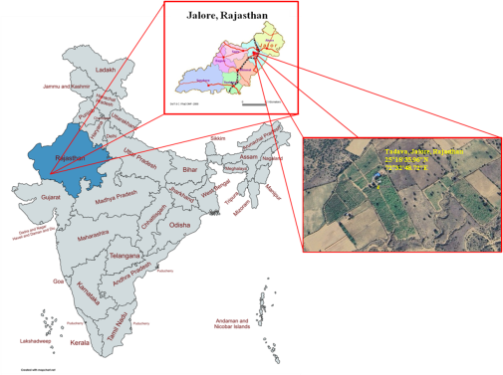

**Fig. 1. View of study site**

**Treatments**

Current method of gum tapping in *M. oleifera* are tedious, in which they make multiple injuries using sharp axe or billhook to exudates the gum which lead to gradual depletion in gum production in some cases it cause damage leading to death due to infection (Sharma et al., 2018b) (Fig 5 Supplementary material 1.). To determine the optimal tapping technique, mechanical and chemical tapping methods were applied using a Factorial Randomized Block Design with two seasons, summer i.e. March- April (S1) and winter i.e December-January (S2) and tapping methods (T1 to T6) with twelve treatment combinations in three replication. Fifteen trees included in each treatment (5 in each replication) having girth of 45-60 cm. The different tapping method both mechanical and chemical tapping methods (with varying concentration) used in different species (Harsh et al., 2013, Sharma et al., 2013, Sharma et al., 2018b, Sharma et al., 2024) for gum production were adopted in order to standardize a method that can ensures sustainable gum production in *M. oleifera*. The following techniques were investigated:

**Mechanical tapping method (Fig.2)**

T1- Drill hole- 1.5 to 2 cm width and 4 inch deep and sealing with pond soil.

T2-V shape cut -9 cm length and 3 cm width 0.5 cm depth done with the help of chisel.

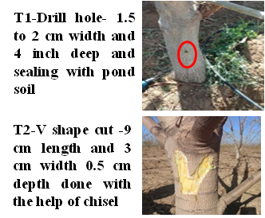

**Fig. 2. Mechanical method of gum tapping followed in *M. oleifera***

**Chemical tapping method (Fig. 3)**

T3-2ml, T4-3ml, T5-4ml, & T6- 5 ml of CAZRI gum inducer (ethephon) is used. The inducer technique adopted in the study was developed ICAR-CAZRI, Jodhpur (Sharma et al., 2018).

**Drilling**: Drill 1 to 2 cm width and 4 inch deep at 30 to 45 cm height from the ground level.

**Injection of ethephon**: CAZRI Gum inducer (ethephon) is Inject using injection syringe into the drilled hole.

**Sealing the hole**: Seal the hole with the help of clay or wet pond soil or using wax in order to release the stress inducing chemicals into the plant.

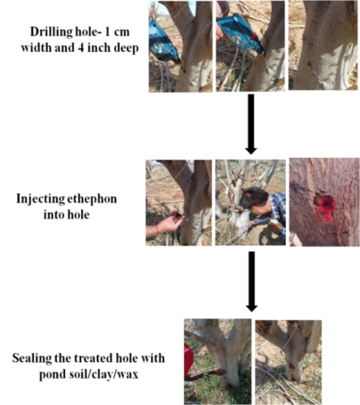

**Fig.3. Procedure for injection of gum inducer (ethephon) into moringa plant.**

**Physical Characterization of Gum**

**Colour:** The colour characteristics was also observed.

**Solubility:** The gum was assessed for solubility in water and acetone, following the specifications outlined in the Indian Pharmacopoeia (Martins et al., 2009).

**Bulk Density:** 10.0 g quantity of each powder sample was placed in a 50 ml measuring cylinder, and the initial volume occupied by the samples was recorded without tapping. After 100 taps on the table, the volume was measured again. The bulk and tap densities were then calculated as the ratio of weight to volume (Martins et al., 2009).

**Tap density:** To determine the tap density, 10 grams of powder were placed into a 100 ml graduated measuring cylinder. The volume occupied by the powder was measured after tapping the cylinder (X1000) according to Aulton (2004).

**Hausner's index:** was calculated as the ratio of tapped density to bulk density of the samples (Martins et al., 2009).

**Compressibility index (C%):** This was calculated using the equation from Martins et al. (2009): Compressibility = (Tapped density – bulk density) / Tapped

**Swelling index:** 1.0 g of each sample was placed in plastic centrifuge tubes, and the initial volume was noted. 10 ml of distilled water was added from a 10 ml measuring cylinder and the tubes were stoppard. The contents were shaken for 2 minutes, allowed to stand for 10 minutes, and then centrifuged at 1000 rpm for 10 minutes. The supernatant was carefully decanted, and the volume of sediment was measured. The swelling index was computed using the equation from Martins et al. (2009): S = V2 /V1 Where, S = Swelling index V1 = Volume occupied by the gum prior to hydration. V2 = Volume occupied by the gum after hydration.

**Determination of pH:** A 1% w/v dispersion of the sample in water was shaken for 5 minutes, and the pH was then determined using a pH meter (Martins et al., 2009).

**Angle of repose:** The static angle of repose was measured using the fixed funnel and free-standing cone method. A funnel was clamped with its tip 2 cm above a graph paper placed on a flat horizontal surface. The powders were carefully poured through the funnel until the apex of the cone formed just reached the tip of the funnel. The mean diameters of the base of the powder cones were determined, and the tangent of the angle of repose was calculated using the equation from Martins et al. (2009): tan(α)=2h​/d.

**Result and discussion**

The fresh gum yield per tree for the season was highest in summer (S1-151.29 g/tree), followed by winter (S2-53.84 g/tree). The dry gum yield followed a similar trend, with S1 at 136.65 g/tree and S2 at 47.80 g/tree. However, the moisture content (%) showed a different pattern, being higher in winter (S2-13.37%) compared to summer (S1-9.59%).

Among the various tapping techniques (T), treatment T5 resulted in the highest fresh gum yield (243.33 g/tree), followed by T4 (182.71 g/tree) and T6 (104.17 g/tree). This pattern was also seen in the dry gum yield: T5 (219.84 g/tree), T4 (164.92 g/tree), and T6 (93.01 g/tree). Moisture content was lowest in T5 (9.50%), followed by T4 (9.99%) and T3 (11.70%). The interaction between season and tapping method was highly significant regarding fresh and dry gum yields. The combination of the summer season (S1) with T5 (4 ml CAZRI Gum inducer, ethephon) resulted in the highest fresh (355.47 g/tree) and dry gum yields (320.53 g/tree), followed by S1T4 (3 ml CAZRI Gum inducer, ethephon) with 261.67 g/tree (fresh) and 237.01 g/tree (dry). In the winter season (S2), the T5 combination also exhibited higher fresh and dry gum yields, followed by S2T4 and S2T6 treatments (131.18, 119.16, 103.76, and 92.84 g/tree, respectively). The interaction effect on moisture content varied from 8.87% to 15.77%. In the summer season (S1), the lowest moisture content was recorded in S1T2 (8.87%) and the highest in S1T5 (9.79%). In the winter season (S2), the moisture content was highest was observed in S2T6 (15.77%) and the lowest in S2T2 (9.22%) (Table.1). Percent change in fresh and dry gum yield was prevalent among treatments and seasons. The highest percent change in fresh and dry gum yield was observed in the chemical tapping method T5 for summer (88.27%, 85.30%) and winter season (88.28%, 86.33%), followed by T4 (84.07%, 81.41% and 84.16%, 82.45%) and T6 (76.03%, 43.85% and 76.08%, 43.65%), whereas the lowest was recorded in the mechanical tapping method (T1 & T2) (Fig. 4). Increased gum exudation at different concentrations of ethephon is probably a result of the plants' developmental response to dehydration stress caused by the ethylene released from the ethephon application, rather than from mechanical methods. Ethephon, which consists of ethylene, phosphate, and chloride ions, transforms into ethylene gas when introduced into the plants, initiating a range of developmental responses (Hall and Smith, 1995). Gum production is influenced by both internal and external factors. Internal factors that impact gum production include genetic traits and the trunk diameter, as larger trunks contain more sap channels (Harsh et. al. 2013, Wiyono et. al. 2021), tree height, and the overall condition of the tree (Tiwari and Ram, 2010). Many of these internal factors are linked to the plant's physiological activity and its response to stress. External factors affecting gum production encompass light, temperature, tapping methods, and the application of induction (Abdullah and Eqbal, 2013). Our findings are consistent with those of Bhatt and Ram (1990), who reported that higher concentrations of ethephon led to increased gum yield in *Acacia senegal*. Similar trends have been observed in *Anogeissus latifolia* with elevated ethephon concentrations (Kuruwanshi and Katiyar, 2017; Prasad et al., 2016). These results also align with studies on A. senegal and Butea monosperma in arid and semi-arid regions of India (Harsh et al., 2013; Prasad et al., 2014).

**Table 1. Gum yield in *M. oleifera* as influenced by season and tapping methods (summer Mean Max – 45 °C and Min – 25 °C and winter Mean Max – 36 °C and Min – 14 °C )**

|  |  |  |  |
| --- | --- | --- | --- |
| **.Treatment** | **Fresh gum yield (g tree-1)** | **Dry gum yield** (g tree-1) | **Moisture content (%)** |
| **Season (S)** | | | |
| S1 | 151.294 | 136.66 | 9.59 |
| S2 | 53.841 | 47.80 | 13.37 |
| SEm± | 0.639 | 1.71 | 0.15 |
| CD (5%) | 1.886 | 0.58 | 0.46 |
| **Gum production method (T)** | | | |
| T1 | 30.48 | 26.92 | 12.88 |
| T2 | 16.72 | 14.84 | 12.11 |
| T3 | 37.99 | 33.86 | 11.70 |
| T4 | 182.71 | 164.92 | 9.99 |
| T5 | 243.33 | 219.84 | 9.50 |
| T6 | 104.17 | 93.01 | 12.71 |
| SEm± | 1.11 | 1.01 | 0.27 |
| CD (5%) | 3.27 | 2.97 | 0.79 |
| **Interaction (S × T)** | | | |
| S1T1 | 41.67 | 37.54 | 9.99 |
| S1T2 | 20.89 | 19.01 | 8.87 |
| S1T3 | 54.20 | 48.91 | 9.77 |
| S1T4 | 261.67 | 237.01 | 9.46 |
| S1T5 | 355.47 | 320.53 | 9.79 |
| S1T6 | 173.87 | 156.95 | 9.66 |
| S2T1 | 19.29 | 16.30 | 15.75 |
| S2T2 | 12.56 | 10.66 | 9.22 |
| S2T3 | 21.78 | 18.81 | 13.63 |
| S2T4 | 103.76 | 92.84 | 10.52 |
| S2T5 | 131.18 | 119.16 | 15.36 |
| S2T6 | 34.48 | 29.06 | 15.77 |
| SEm± | 1.56 | 1.42 | 0.380 |
| CD (5%) | 4.62 | 4.20 | 1.121 |

**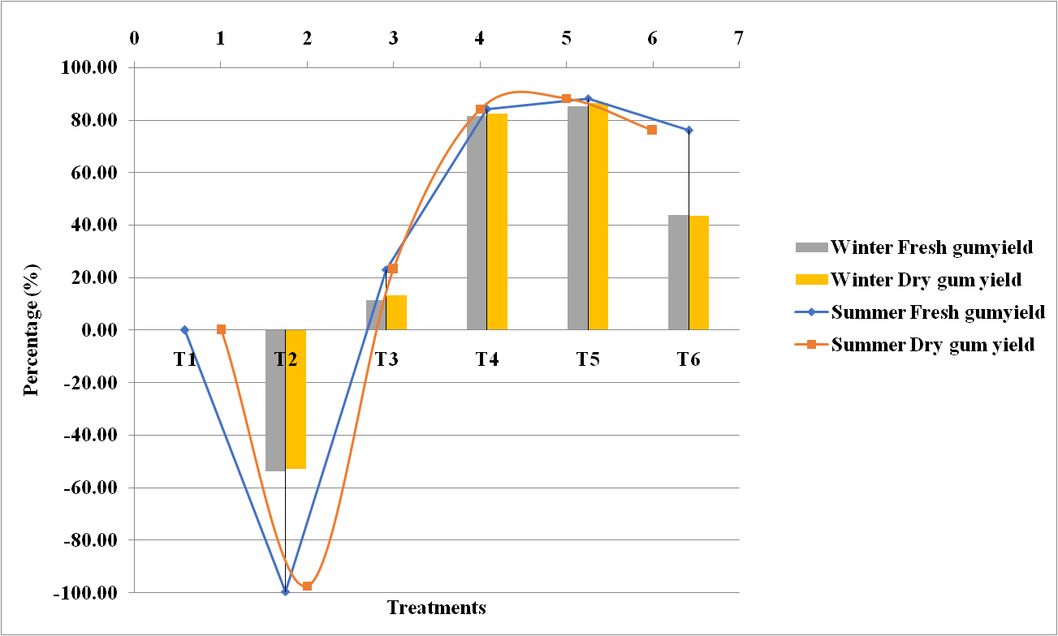**

**Fig. 4. Percent change in fresh gum and dry gum yield among treatments and season.**

**Physical Characterization of Gum**

Physical characterization determined for extracted moringa gum is very much important and determines its applicability in food, pharmaceutical and cosmetics industries. The moisture content on a dry basis was significant for the season, treatment, and their combination. Moisture content was lower in gum extracted during the summer season, ranging from 8.87% to 9.99%, compared to 9.22% to 15.77% in the winter season due to the seasonal effect (temperature) (Table 1). The lower moisture content of moringa gum obtained from both mechanical and chemical tapping methods suggests its suitability for formulations containing moisture-sensitive drugs. Maintaining appropriate moisture levels is essential as it prevents enzyme activation and the growth of microorganisms, which in turn enhances the shelf life of most formulations. Analyzing the moisture content of a material is vital because the economic value of an excipient for industrial applications relies not only on the cost-effective and readily available biomaterial but also on the optimization of production processes, including drying, packaging, and storage (Jarald et al., 2012).

The physical characteristics of both all the treatment displayed similar characteristics (Supplementary material Table 3) so we compared the characteristics in broader sense i.e. average of mechanical method versus best among the chemical methods. The gum from *M. oleifera*, sourced from both mechanical and chemical tapping, displayed similar characteristics regarding color and solubility. It appeared yellowish when freshly harvested and turned to brownish hue upon drying. When exposed to the environment, the gum from the *M. oleifera* Lam. tree changed from white to reddish brown and eventually to brownish black (Shah et al., 2011; Panda and Ansari, 2013; Panda et al., 2006; Thombare et al., 2018; Sharma et al., 2024). The gum was slightly soluble in water, forming a yellowish, slimy solution upon dispersion, while it was nearly insoluble in acetone (Table 2). 1% w/v suspension of moringa gum in water exhibited a near-neutral pH of 6.16 for both tapping methods. As a pH-responsive polymer, moringa gum can be categorized as a "smart polymer," making it suitable for applications in controlled-release dosage formulations. Its near-neutral pH suggests it may be less irritating to the gastrointestinal tract when used in uncoated tablets (Nasipuri et al., 1996), which enhances its potential for formulating acidic, basic, and neutral drugs. Understanding the pH of an excipient is crucial for assessing its suitability for formulation, as the stability and physiological activity of most preparations are influenced by pH (Table 2).

The bulk (0.86 & 0.79 g/ml) and tapped density (1.12 & 1.13 g/ml) for mechanical and chemical tapping methods provided insights into the packing, particle arrangement, and compaction profile of the material (WHO, 1998). The compressibility index was higher in the mechanical tapping method (22.60%) compared to the chemical tapping method (20.00%). A similar trend was observed in the Hausner index (1.29 & 1.25). However, the angle of repose showed the opposite response (33.42° & 34.99°). Despite these differences, the data imply that moringa gum has good flow properties with moderate compressibility for both mechanical and chemical tapping methods. This characteristic is crucial for enhancing processes that utilize this material as an excipient in pharmaceutical formulations. Unlike other plant-based gums, formulations containing this gum will require minimal modifications to improve flow properties during process development (Jarald et al., 2012; Emeje et al., 2009; Panda et al., 2008). The physical properties of chemically tapped moringa gum were found to be quite similar to those of mechanically tapped gum, indicating that using 4 ml of CAZRI gum inducer (ethephon) for chemical tapping can be advantageous for achieving higher gum yields during the summer season.

**Table 2.** **Physical characterization studies in moringa gum obtained by different treatments.**

|  |  |  |  |
| --- | --- | --- | --- |
| **Particulars** | **Mechanical tapping** | **Chemical tapping** | **Upshots and links** |
| Colour | Yellow to brown | | E:\Agriculture University Jodhpur\Projects\DST ASACODER project\Sanctioned ASACODER\Data DST ASACODER\Moringa field photos\Gum experiment\Gum photos\V cut gum.jpg E:\Agriculture University Jodhpur\Projects\DST ASACODER project\Sanctioned ASACODER\Data DST ASACODER\Moringa field photos\Gum experiment\Gum photos\IMG_20230603_122211_317.jpg  Yellow Brown |
| pH | 6.16 | 6.16 | E:\Agriculture University Jodhpur\Projects\DST ASACODER project\Sanctioned ASACODER\Posters\Pictures\IMG_20240429_153141.jpg  pH of gum solution |
| Solubility | Sparingly soluble in water forming a viscous solution, practically insoluble in acetone | | E:\Agriculture University Jodhpur\Projects\DST ASACODER project\Sanctioned ASACODER\Data DST ASACODER\Moringa field photos\Gum experiment\Gum photos\Lab expt\IMG_20240427_170716_544.jpg  a. Water b. Acetone |
| Swelling Index | 8.0 | 9.0 | E:\Agriculture University Jodhpur\Projects\DST ASACODER project\Sanctioned ASACODER\Data DST ASACODER\Moringa field photos\Gum experiment\Gum photos\Lab expt\IMG_20240427_170626_6631.jpg  Swelling of gum in water |
| Bulk Density (g/ml) | 0.86 | 0.79 | E:\Agriculture University Jodhpur\Projects\DST ASACODER project\Sanctioned ASACODER\Data DST ASACODER\Moringa field photos\Gum experiment\Gum photos\Lab expt\IMG_20240425_161206_393.jpg  Bulk density of gum powder |
| Tapped density (g/ml) | 1.12 | 1.13 | <https://studio.youtube.com/video/EmeWsaWlajk/edit> |
| Compressibility (%) | 22.60 | 20.00 |
| Hausner index | 1.29 | 1.25 |
| Angle of repose | 33.42 o | 34.99o | E:\Agriculture University Jodhpur\Projects\DST ASACODER project\Sanctioned ASACODER\Data DST ASACODER\Moringa field photos\Gum experiment\Gum photos\Lab expt\IMG_20240427_110654_689.jpgE:\Agriculture University Jodhpur\Projects\DST ASACODER project\Sanctioned ASACODER\Data DST ASACODER\Moringa field photos\Gum experiment\Gum photos\Lab expt\IMG_20240427_111419_197.jpgE:\Agriculture University Jodhpur\Projects\DST ASACODER project\Sanctioned ASACODER\Data DST ASACODER\Moringa field photos\Gum experiment\Gum photos\Lab expt\IMG_20240427_111433_978.jpg  <https://studio.youtube.com/video/OCvievAg09c/edit> |

**Conclusion**

Chemical method of tapping with 4 ml/tree of ethephon (CAZRI gum inducer) during summer season found effective for higher gum production in *Moringa oleifera* with all physical characteristic intact in it.

**Declaration**

The authors report there are no competing interests to declare, ethics approval, and consent to participate. This research does not involve any human participants or animal-related and hence is not applicable.

**Ethics Approval Statement**

The present study doesn’t involve any animals or humans so this research doesn’t require any ethical approval statement.

**Permission to Reproduce Material from Other Sources**

This manuscript does not contain any material (such as figures, tables, etc.) reproduced from other copyrighted sources. Therefore, no permission was required

**Data availability**

The original data generated for the current study has been included in the supplementary material. Further inquiries can be directed to the corresponding author.

**References**

Abdullah D and Eqbal A (2013), “Utilization of Gum Arabic for Industries dan Human Health”. *J. Appl. Sci.*, 10(1): 1270–1279.

Anwar F, Ashraf M and Gilani AH (2007). *Moringa oleifera:* A food plant with multiples medicinal uses. *Phyto. Res*. 21, 17–25 <https://onlinelibrary.wiley.com/doi/10.1002/ptr.2023>.

Atawodi SE, Atawodi JC, Idakwo GA, Pfundstein B, Haubner R, Wurtele G, Bartsch H and Owen RW (2010). Evaluation of the polyphenol content and antioxidant properties of methanol extracts of the leaves, stem, and root barks of *Moringa oleifera* Lam. *J. Med. Food* 13: 710–716. <https://www.liebertpub.com/doi/10.1089/jmf.2009.0057>

Aulton ME (2004). Pharmaceutics-The science of dosage form design. 2nd reprint edi. London: Churchill Livingstone; 113-8.

Bhatt JR. and Ram Mohan YH (1990). Ethephon-induced gum production in *Acacia senegal* and its potential value in the semiarid regions of India. *Curt Sci*, 59(23): 1247-1250.

Bibi N, Rahman N, Ali MQ, Ahmad N and Sarwar F (2023). Nutritional value and therapeutic potential of *Moringa oleifera*: a short overview of current research. *Natu. Prod. Rese*, 1–19. <https://doi.org/10.1080/14786419.2023.2284862> .

Das IB (2014). Identification of physiological tools for gum extraction. M.Sc. (Ag.) Thesis, Department of Plant Physiology, Agricultural Biochemistry, Medicinal and Aromatic Plants Indira Gandhi Krishi Vishwavidyalaya, Raipur (C.G.), 83 pp.

Dzuvor CKO, Pan S, Amanze C, Amuzu P, Asakiya C, and Kubi F (2021). Bioactive components from *Moringa oleifera*seeds: production, functionalities and applications – a critical review. *Crit. Revi. in Biotech.* 42(2), 271–293. <https://doi.org/10.1080/07388551.2021.1931804>

Emeje M, Phyllis Nwabunike, Christiana Isimi, Joseph Fortunak, James W. Mitchell, Stephen Byrn, Olobayo Kunle, Sabinus Ofoefule. 2009. Isolation, characterization and formulation properties of a new plant gum obtained from *Cissus refescence. Intern Jourl of Green Pharm,* January-March: 16-23.

Fugile LJ (2000) “New uses of *Moringa* studied in Nicaragua. ECHO Development Notes #68. Available at <http://www.echotech.org/network/modules.php?nmae=News>.

Hall MA. and Smith AR (1995). Ethylene and the responses of plants to stress. *Bulgarian J. Plant Physio*, **21**(2-3): 71-79.

Harsh LN, Tewari JC, Khan HA and Ram M (2013). “Ethephon-induced gum Arabic exudation technique and its sustainability in arid and semi-arid regions of India,” *For. Trees Liveli*, 22 (3): 204–211. doi: <https://doi.org/10.1080/14728028.2013.818514> .

Jarald EE, Sharma Sumati, Sheeja Edwin, Ahmad S, Patni S and Daud A (2012). Characterization of *Moringa oleifera* Lam. Gum to Establish it as a Pharmaceutical Excipient. *Ind J Pharm Edu Res*, 46 (3): 211-216.

Kuruwanshi VB and Katiyar P (2017). Establishment of sustainable gum tapping techniques in dhawda (*Anogeiussus latifolia)* using ethephon. *Trends in Biosci,* 10(6): 11376-11380.

Martins E, Phyllis N, Christiana I, Joseph F, James WM, Stephen B, Olabayo K, Sabinus O (2009). Isolation, characterization and formulation properties of a new plant gum obtained from *Cissus refescence*. Inter Joun of Green Pharm. 3(1):16-23.

Nasipuri RN, Igwilo CI, Brown SA and Kunle OO (1996). Mucilage from *Abelmoschus esculentus* (okra) Fruit: A potential pharmaceutical raw material; Part 1; Physicochemical properties. *J Phytomed Ther* 1:22-88.

Niebergall, PJ (1985). Preformulation, IN: A. R. Gennaro (Ed.). Remington’s *pharmaceutical science*, 17th edition, pp. 1409–1423 (Easton, Pennsylvania, USA: Mack Publishing Co.).

Paliwal, R., Sharma, V., Pracheta, 2011. A review on horse radish tree (*Moringa oleifera*): A multipurpose tree with high economic and commercial importance. *Asian J. Biotechnol.* 3, 317–328. <https://doi.org/10.3923/ajbkr.2011.317.328> .

Panda DS and Ansari SA (2013). Preformulation study on the gum of *Moringa oleifera. Malaysian Journal of Pharm. Sci.* 11(2): 41–47.

Panda DS, Choudhury NSK, Yedukondalu M, Si S and Gupta R (2008). Evaluation of Gum of *Moringa oleifera* as a Binder and Release Retardant in Tablet Formulation. *Indian Jour. of Pharm. Sci.* 70 (5): 614-618.

Panda DS, Si S, Swain S, Kanungo SK, Gupta R (2006). Preparation and evaluation of gels from gum of *Moringa oleifera*. *Indian J. Pharm. Sci.* 68, 777–780. <https://doi.org/10.4103/0250-474X.31014> .

Prasad R, Uikey NK, Tripathi VD. and Dhyani SK (2014). Effect of gum inducer (ethephon) on yield and physico-chemical properties of gum exudate from *Butea monosperma* L. *Indian J. Agrofor*. 16(2): 73-80.

Prasad R., Venkatesh A., Tripathi VD and Dhyani SK (2016). Indigenous method of tapping gum-butea and its impact on livelihood of Saharia tribe in Central India. *Indian Forester*, 142(3): 221-226.

Rashid, Umer, Anwar, Farooq, Moser, Bryan R., Knothe, Gerhard (2008). *Moringa oleifera* oil: A possible source of biodiesel. *Bioresour. Technol.* 99: 8175–8179. <https://doi.org/10.1016/j.biortech.2008.03.066> .

Shah, Dhiren P., Jain, Vineet C, Dalvadi, Hitesh P, Ramani, Vinod D, Patel Kajal G, Saralai, Mahesh, G., Jani, Girish K., 2011. A preliminary investigation of *Moringa oleifera* Lam gum as a pharmaceutical excipient. *Int. J. Pharm. Res. Technol.* 1: 12–16. <https://doi.org/10.31838/ijprt/01.01.03>.

Sharma SC, Pandey SK, Prasad N and Raj H (2024). Unveiling the potential of *Moringa oleifera* Lam. gums: An investigation into optimal tapping strategies. *Industrial Crops & Products* 214: 118511. <https://doi.org/10.1016/j.indcrop.2024.118511> .

Sharma SC, Prasad N, Pandey SK and Singh R (2018). Mechanization status in commercially important NRGs production - a review. *Multilogic Sci.* VIII: 353–357*.*

Sharma SC, Prasad N, Pandey SK, Giri SK (2016). A review on status of gum tapping and scope for improvement. Agricultural Mechanization in Asia. *Afr. Lat. Am.* 47: 68–75.

Sonika, Dhiman S, Thakur GS, Arora G and Arora S (2020). *Moringa gum*: a comprehensive review on its physicochemical and functional properties, *Plant Archives* 20(Supplement 1): 3794-3805.

Thombare, Nandkishore, Lohot, Vaibhav D, Prasad, Niranjan, Sharma KK (2018). Major gum and resin plants of India: A field guide. ICAR – Indian Institute of Natural Resins and Gums, Ranchi. pp i-vi, 1-128.

Tiwari JC and Ram M (2010). “Tree gum exudation techniques. Networking project on harvesting, processing, and value addition of natural resins and gums,” *Curr Sci.* 59 (23): 1247– 1250.

Wang Q, and Cui SW (2005). Understanding the physical properties of food polysaccharides. Food carbohydrates: chemistry, physical properties, and applications, 162-214.

Wells J (2002). *The science of dosage form design*, pp. 113–197 (New York: Churchill Livingstone).

WHO (World Health Organization) (1998). Quality control methods for medicinal plants materials. 28: S29.

Wiyono HT, Prihasinta SM and Setyati D (2021). The Influence of Gum Inducer Solution Administration on the Gum Production of the Jaranan Plant (*Lannea coromandelica*) (Houtt.) Merr.) A. Lelono et al. (Eds.): ICOLIB 2021, ABSR 27: 579–587. <https://doi.org/10.2991/978-94-6463-062-6_59>

**Supplementary materials**

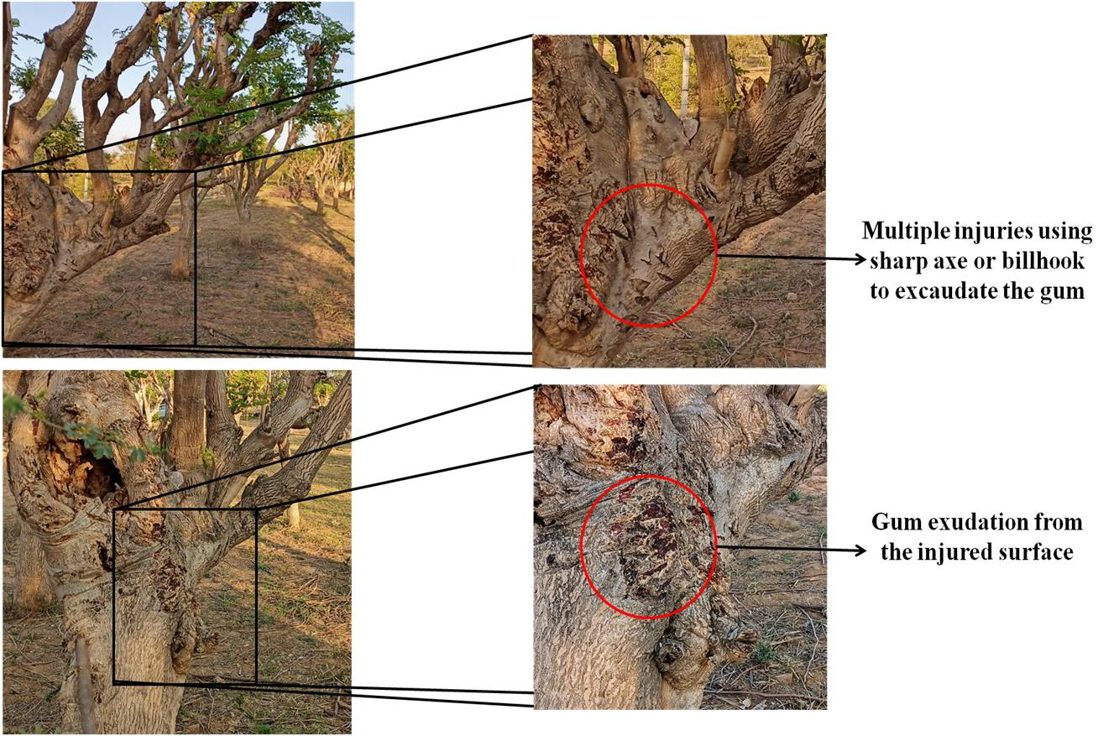

**Fig. 5. Traditional method of gum tapping**

**Table 3. Physical characterization studies in moringa gum obtained from different treatments.**

|  |  |  |  |  |  |  |  |  |
| --- | --- | --- | --- | --- | --- | --- | --- | --- |
| **Tapping Method** | Mechanical tapping | | | **Chemical tapping** | | | | |
| **Parameter** | **T1** | **T2** | **Average** | **T3** | **T4** | **T5** | **T6** | **Average** |
| Colour | Yellow to brown | Yellow to brown | **Yellow to brown** | Yellow to brown | Yellow to brown | Yellow to brown | Yellow-brown | **Yellow-brown** |
| pH | 6.16 | 6.16 | **6.16** | 6.1 | 6.2 | 6.16 | 6.3 | **6.16** |
| Solubility | Sparingly soluble in water forming a viscous solution, practically insoluble in acetone | Sparingly soluble in water forming a viscous solution, practically insoluble in acetone | **Sparingly soluble in water forming a viscous solution, practically insoluble in acetone** | Sparingly soluble in water forming a viscous solution, practically insoluble in acetone | Sparingly soluble in water forming a viscous solution, practically insoluble in acetone | Sparingly soluble in water forming a viscous solution, practically insoluble in acetone | Sparingly soluble in water forming a viscous solution, practically insoluble in acetone | **Sparingly soluble in water forming a viscous solution, practically insoluble in acetone** |
| Swelling Index | 7 | 9 | **8** | 10 | 9 | 9 | 8 | **9** |
| Bulk Density (g/cm³) | 0.84 | 0.88 | **0.86** | 0.8 | 0.76 | 0.78 | 0.82 | **0.79** |
| Tapped Density (g/cm³) | 1.1 | 1.14 | **1.12** | 1.14 | 1.12 | 1.13 | 1.13 | **1.13** |
| Compressibility (%) | 20 | 25.2 | **22.6** | 19 | 21 | 20 | 20 | **20** |
| Hausner Ratio | 1.28 | 1.3 | **1.29** | 1.26 | 1.24 | 1.25 | 1.25 | **1.25** |
| Angle of Repose (°) | 32.5° | 34.34° | **33.42 o** | 35.10° | 34.80° | 34.90° | 35.15° | **34.99o** |