Impact of different compositions of ingredients on physical parameters of ecofriendly incense sticks

Abstract
In India, every year, 8 tons of floral waste are disposed of in rivers and water bodies, polluting them in huge amounts. If this floral waste is used, the amount of waste can be significantly reduced to a huge content. These flowers are widely used in the preparation of incense sticks and value-added products. This study identified the use of different flowers for the preparation of incense sticks. In this study, we identified the best composition for incense stick making, in which a good amount of flower powder was used. Out of all the combination treatments, T₁₀ (Charcoal 10% + sawdust 10% + jigat 20% + jasmine 60%) produced the best results in terms of incense stick character stick length, stick diameter, stick thickness, test weight, burning duration, and smell present in the room after burning.
Key words: Incense stick, floral waste, eco- friendly, burning duration, charcoal, sawdust, Jigat
Introduction
An incense stick is a natural material that emits a pleasant aroma upon burning. It is available in various shapes and sizes worldwide and is composed of fragrant substances combined with combustible agents. It is used to eliminate unpleasant odours and negative energy to replace them with positive energy (Yadav et al., 2020). A lot of religious use incense to help people focus, be aware, and feel spiritually good as they meditate (Saoji et al.,2021). Traditional incense sticks are harmful to human health and environment. It releases volatile compounds that pollute the air and irritate the respiratory system. Eco friendly incense sticks are a more environmentally friendly option than regular incense sticks. These sticks are derived from natural, biodegradable materials, such as flower waste, herbs, and plant-based binders. Manufacturers can reduce environmental pollution and create valuable products by repurposing discarded flowers during religious ceremonies and events. The use of natural ingredients such as marigold, jasmine, and rose petals not only provides pleasant fragrances but also harnesses the beneficial compounds found in these flowers (Hongratanaworakit, 2010). Eco-friendly incense sticks often utilize sustainable packaging and avoid the use of synthetic fragrances and harmful chemicals. This approach minimizes negative impacts on air quality and aquatic ecosystems while supporting a circular economy. By choosing eco-friendly incense, consumers can enjoy the aromatic and spiritual benefits of incense while contributing to more sustainable practices in the fragrance industry.
Flower waste, particularly marigold, chrysanthemum, rose, and jasmine, is a sustainable solution for reducing environmental pollution while creating economically viable products. By repurposing discarded flowers, particularly those from religious ceremonies and events, into incense sticks, natural dyes, and organic fertilizers, we can significantly reduce the contribution of flower waste to river pollution (Waghmode et al., 2016). This approach not only minimizes the negative impact on aquatic ecosystems but also prevents the clogging of drains and waterways. Furthermore, raising awareness of the environmental consequences of flower waste can encourage consumers to make more eco-friendly choices when purchasing and disposing floral arrangements. Flower waste can be utilized in making incense stick chrysanthemum petals which mainly consist of natural sources of flavonoids, volatiles, myricetin and quercitrin (wu et al.,2010). Jasmine derives primarily from volatile aromatic compounds such as benzyl acetate, linalool, indole, and jasmone, which are extracted and incorporated into incense paste or coating for show release during combustion (Singh et al.,2021). Rose flowers are rich in riboflavin, sugars, tannins, pectin, mineral salts of tartaric acid (Thakre et al.,2017).
Eco-friendly incense sticks utilize natural and biodegradable materials to create a sustainable alternative to traditional incense products. The key components include floral waste, such as marigold, jasmine, rose, and chrysanthemum petals, which are dehydrated and pulverized. These floral elements provide pleasant fragrances and contain beneficial compounds. Additional incorporated natural materials include charcoal powder, which functions as an adsorbent and facilitates proper combustion, and finely sieved sawdust for consistency (Waghmode et al., 2016). Jigat powder, which is made from tree bark, is a very important binding agent. Bamboo sticks form the structural base of incense. Natural oils can be incorporated to enhance fragrance and reduce evaporation rates. The utilization of these environmentally conscious ingredients contributes to the reduction of environmental pollution, supports the circular economy, and minimizes the adverse effects on air quality and aquatic ecosystems (Omer & Hassan, 2024).
Material and method
Collection of flowers
Fresh and used rose, jasmine, and chrysanthemum flowers were gathered from wedding ceremonies, trash garlands, and fields in Raipur (C.G.). For approximately 12–15 days, the gathered material was spread out in thin layers and rotated occasionally to ensure adequate drying. Sun-dried flower petals were pulverized using a grinder.
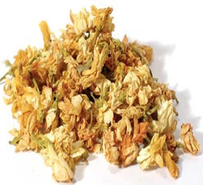
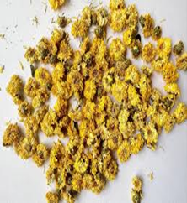
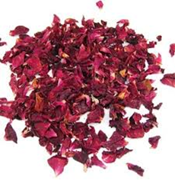
Fig. 1: Drying of flower petals

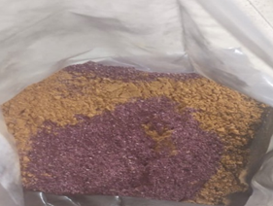
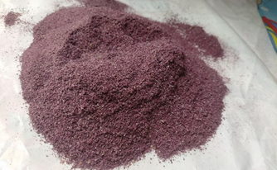

Fig. 2: Dried flower powder
Other ingredients
Charcoal
Charcoal is mostly made of pure carbon, and it is made by cooking wood with very little oxygen. Approximately 25% of the initial weight remains as black lumps and powder after the process, which may take days to burn off volatile substances, including water, methane, hydrogen, and tar. This is necessary for the correct burning of incense sticks and serves as an adsorbent for the generated smoke.
Sawdust
When wood is cut or sanded, tiny wood particles known as sawdust are produced. To achieve uniform particle sizes, the wood dust was cleaned and finely sieved after being collected from a factory that manufactured wooden furniture.
Jigat powder
Jigat is a necessary component in the production of incense sticks and is a binding material. Tree species, such as Listea chinensis, have bark that can be peeled off to separate them. Jigat, “sticky, “is a colloquial term used in the Indian state of Karnataka. Now,Jigat was imported from Malaysia and Thailand to meet half of the demand. The present interest in Jigat is estimated by the All India Agarbatti Manufacturers Association (AIAMA) to be 10,000 tons annually.
DEP oil
Diethyl phthalate (DEP) oil, a colorless material is insoluble in water. When used as a fragrance evaporation retardant, delaying evaporation increase the scents shelf life.
Fragrance
One of the selling points of incense sticks is their pleasant aroma, which is produced by fragrances.
Bamboo stick
Bamboo sticks are long (15–20 cm), spherical, and extremely thin plant parts with a firm, hollow joined stem. Incense-stick vendors sell high-quality, finished bamboo sticks. Because fungi can grow and weaken sticks, care must be taken when storing them in damp and humid environments.
Formulation of incense stick
All the ingredients listed above were precisely weighed and combined. The powder was converted into dough by gradually additional of high-quality water. After kneading the dough, a small amount was removed, rolled around thin, tiny bamboo sticks, and hand-pressed. Subsequently, the mixture was rolled into a homogeneous incense stick. Subsequently, the incense sticks were left to dry at room temperature overnight at room temperature. For aroma, analysis, the sticks were immersed in diluted DEP oil. After a few minutes of drying, the sticks were prepared for use.
Quality characteristics of incense stick
Physical parameters, viz., length and diameter of sticks, thickness, test weight, burning duration and smell present in the room were measured under ambient room conditions since the incense sticks were handmade, their diameters varied, so by measuring the diameter of three distinct locations with the aid of a vernier caliper, the mean was taken as the diameter of the incense sticks. Five samples of incense sticks for the test weight, stick from every treatment were chosen at random. All incense sticks were weighted separately their mean weight was calculated. For the burning duration test, five incense sticks samples from each treatment were randomly selected. Duration was recorded using a stopwatch.
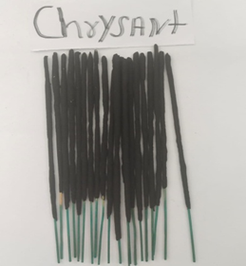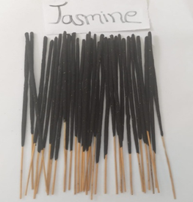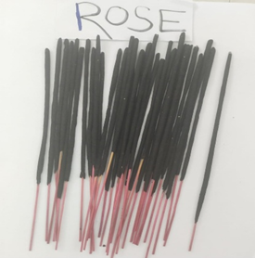
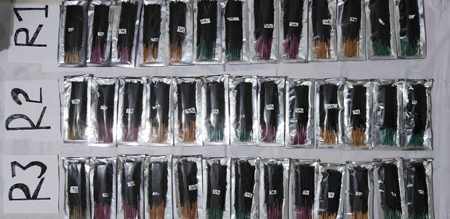

Fig. 3: Incense sticks

Table 1: Treatment details
Treatment | Treatments combination
T₀ | Charcoal 80% + Jigat 20% (Control)
T₁ | Charcoal 60% + Jigat 15% + Rose 25%
T₂ | Charcoal 40% + Jigat 20% + Rose 40 %
T₃ | Charcoal 60% + Jigat 15% + Jasmine 25%
T₄ | Charcoal 40% + Jigat 20% + Jasmine 40%
T₅ | Charcoal 60% + Jigat 15% + Chrysanthemum 25%
T₆ | Charcoal 40% + Jigat 20% + Chrysanthemum 40%
T₇ | Charcoal 30% + Sawdust 10% + Jigat 20% + Rose 40%
T₈ | Charcoal 10% + Sawdust 10% + Jigat 20% + Rose 60%
T₉ | Charcoal 30% + Sawdust 10% + Jigat 20% + Jasmine 40%
T₁₀ | Charcoal 10% + Sawdust 10% + Jigat 20% + Jasmine 60%
T₁₁ | Charcoal 30% + Sawdust 10% + Jigat 20% + Chrysanthemum 40%
T₁₂ | Charcoal 10% + Sawdust 10% + Jigat 20% + Chrysanthemum 60%

The experimental data were analyzed using one-way ANOVA, and the CRD was used to analyze the data in the present study.
Result and Discussion
Preferred length of stick (cm).
The minimum length of the stick 12.82 cm was observed in T₂. However, this was significantly lower than that of the other treatments. A maximum length of 16.29 cm was observed in treatment T₁₁.Because there was less charcoal and sawdust in treatment T₁₁, the incense stick length was shorter and did not adhere to the hands when rolling., making it easier to roll the incense stick.
Preferred length of the sticks that was found maximum in 8 inches (20cm). our results are in accordance with that of Jenner et al (2021).

Fig. 4: Impact of compositions of ingredients on preferred length of incense sticks (cm)
Preferred stick diameter (mm).
The diameter of the incense sticks varied significantly among treatments. At T₀, the minimum diameter of 2.50 mm was observed, which was noticeably less than that of the other treatments. A maximum diameter of 3.35 mm was obtained in treatment T₁₁.The reduced diameter in which T₀ could be attributed to the lower proportion of charcoal and jigat, that reduced adherence to the hands during rolling, thereby facilitating the formation of thinner incense sticks.
Preferred thickness of the sticks (mm).
A minimum thickness of 2.97 mm was observed at T₀, which was significantly lower than that in all other treatments. A maximum thickness of 3.79 mm was observed in T₁₀.The smaller thickness in T₀ was due to the lower thickness of the incense sticks in this treatment because of the absence of flower and sawdust powders, which reduces material adhesion during rolling and facilitates the formation of thinner sticks.
Preferred thickness of the sticks that was found maximum in 1.3 mm.our results are in accordance with studies of Jenner et al (2021).

Fig. 5: Impact of compositions of ingredients on preferred incense sticks diameter and thickness (mm)
Test weight (g) was measured.
The minimum test weight of 3.09 g was observed in T₁. However, this was significantly lower than that of the other treatments. Maximum test weight (4.47 g) was recorded at T₀. The higher test weight at T₀ results from the greater proportion of this material contributing to charcoal and jigat in stick density.

Fig. 6: Impact of compositions of ingredients on test weight of incense sticks (g)
Burning duration (min).
The highest burning duration 44.33 min was observed for T₁₀ (Charcoal 10% + sawdust 10% + jigat 20%+ jasmine 60%). However, it was significantly higher than that of the other treatments. A minimum duration of 18.00 min was observed in treatment T₀. The longest burning duration of incense sticks in treatment T₁₀ was due to the moderate amount of burning material in the treatment premix.
Burning duration that was found maximum in treatment T₁₁ (Charcoal 10%+ sawdust 10%+ jigat powder 20%+ flower powder 60%) may be due to most accurate filling of incense sticks by delicate flower powder, and according to Raja et al (2023). At jigat powder has low viscosity can give good heat transfer, easier pumping and more accurate filling which led to proper compaction of incense sticks and provided better burning quality when combined with flower powder.

Fig. 7: Impact of compositions of ingredients on burning durations and smell present in room after burning
Smell present in the room after burning the sticks (min).
Duration of smell retention in the room after burning the incense sticks. The minimum smell retention of 10.40 min was observed in treatment T₁₀, whereas the maximum smell retention of 17.87 min was observed in treatment T₀. A prolonged presence of smoke in the room was observed when the treatment contained a higher proportion of charcoal and jigat powder.
Discussion
Incense sticks have long been an integral component of Indian rituals and religious and cultural boundaries, as they are traditionally used to create an appositive ambiance and enhance concentration, ultimately fostering a spiritual connection. In the present study, the prepared incense sticks were fragrances with dried floral petals, which produced a pleasant aroma upon burning, that persisted even after the sticks were completely burnt, contributing to the environment. The developed incense sticks demonstrated eco-friendly characteristics, as they produced minimal ash and burned completely, leaving no residue. They also remained stable at room temperature, indicating a good storage quality. Furthermore, the sticks exhibited desirable physical and organoleptic properties, which confirmed their suitability for household and ritual applications.
Conclusion
This study demonstrated the effective utilization of (Rose, Jasmine, and Chrysanthemum) flowers for eco-friendly incense stock production. Among all treatments, T₁₀(charcoal 10% + sawdust 10% + jigat 20% + Jasmine60%) was identified as the best composition, exhibiting the longest burning duration (44.33 min), smaller diameter, and lower test weight, which are ideal for physical incense sticks. The reduced charcoal content in T₁₀ also minimized air pollution compared with conventional sticks (80-90% charcoal). The environmentally friendly flower incense sticks that were made were deemed safe for use, produced acceptable results, and had good aromatic qualities.
This study could lead to the commiseration of products and has the potential to create new opportunities in the business sector.

Disclaimer (Artificial Intelligence)
Authors hereby declare that NO generative AI technologies such as Large Language Models (ChatGPT, COPILOT, etc.) and text-to-image generators have been used during the writing or editing of this manuscript.
Competing Interests
Authors have declared that no competing interests exist.
References
Hongratanaworakit, T. (2010). Stimulating Effect of Aromatherapy Massage with Jasmine Oil: Natural Product Communications, 5(1), 1934578X1000500. https://doi.org/10.1177/1934578x1000500136
Jenner G, Selvan T, Kumaresan P. (2021). Preferred Physical Parameters of Industrial Agarbatti Sticks: International journal of Researches in biosciences, agriculture and technology, ISSN 2347 – 517, I J R B A T, Issue (Special-17): 515-524.
Omer, S., & Hassan, N. (2024). Application of biodegradable plastics and their environmental impacts: A review. World Journal of Advanced Research and Reviews, 21(1), 2139–2148. https://doi.org/10.30574/wjarr.2024.21.1.0155
Raja s, Verma L.S, Sagar S K and Tigga N K. (2023). Study of different composition for preparation of incense stick using marigold flower waste. The Pharma Innovation Journal 12(9): 154-157.
Saoji, R. Y., Zalte, A., & Guleccha, V. (2021). Preparation of incense sticks using marigold floral waste from the Nasik region. Journal of Pharmaceutical Sciences and Research, 13(10), 635-637.
Singh, R., & Sharma, R. K. (2021). Jasmine Essential Oil: Composition and Applications in Aromatherapy and Spiritual Products. International Journal of Plant Science and Research, 11(1), 88-94.
Thakare, P., et al. (2017). Impact of floral waste on development of bio-incense sticks. Journal of Environmental Research, 10(2), 45–52.
Waghmode M. S., Gunjal A. B., Nawani N. N., & Patil, N. N. (2016). Management of Floral Waste by Conversion to Value-Added Products and Their Applications. Waste and Biomass Valorization, 9(1), 33–43. https://doi.org/10.1007/s12649-016-9763-2
Wu, L. Y., Gao, H. Z., Wang, X. L., Ye, J. H., Lu, J. L., & Liang, Y. R. (2010). Analysis of the chemical composition of Chrysanthemum indicum flowers by GC/MS and HPLC. Journal of Medicinal Plants Research, 4(5), 421-426.
Yadav, V. K., Choudhary, N., Heena Khan, S., Khayal, A., Ravi, R. K., Kumar, P., & Gnanamoorthy, G. (2020). Incense and incense sticks: types, components, origin, and their religious beliefs and importance among different religions. J. Bio Innov, 9, 1420-1439.

