Review Article
ROLE OF ARTIFICIAL INTELLIGENCE IN HORTICULTURE- A REVIEW

ABSTRACT
The application of Artificial Intelligence (AI) in the horticultural sector has become increasingly prominent, addressing key challenges such as poor soil management, pest and disease outbreaks, data overload, low crop yields, and the knowledge gap between farmers and advanced technologies. To overcome these obstacles, innovative solutions are needed, and AI offers a promising approach due to its flexibility, precision, cost-efficiency, and superior performance. By mimicking human problem-solving abilities, AI enhances decision-making in agricultural processes, making them more efficient while minimizing human intervention. One of the major advantages of AI in agriculture lies in its diverse applications, such as in irrigation, weeding, and pesticide spraying. These technologies, often integrated into robots and drones, enable precise control over water, pesticide, and herbicide usage, conserve soil fertility, and optimize labor utilization, ultimately boosting both the quantity and quality of agricultural output.
Key words: Artificial intelligence, Horticulture, drone, grafting, robotics, crop production and protection
INTRODUCTION
Agriculture is not only the primary source of food and income but also the backbone of our country’s economy. It provides essential raw materials for industrial production, driving economic growth in various sectors (El Hoummaidi et al., 2021). However, agricultural practices are increasingly threatened by issues such as climate change and dwindling resources, particularly water, which directly impacts food security (Dwivedi et al., 2023). These challenges highlight the critical need for sustainable agricultural land management, which requires accurate spatial data on soil, water, and crops (Herrera-Franco et al., 2023). Effective management involves controlling, monitoring, and evaluating agricultural systems, supported by technologies like artificial intelligence (AI), to address and resolve farming-related issues.
AI methods in agricultural mapping offer several benefits, including resource optimization, reduced labor requirements, and minimized risk of environmental contamination and natural disasters. These technologies contribute to farm sustainability by integrating innovative solutions (Dhanush et al., 2023). Moreover, artificial intelligence enhances farmers' income, boosts agricultural productivity, and helps reduce waste.
The term "Artificial Intelligence" combines the words "artificial" (meaning man-made or not occurring naturally) and "intelligence" (the ability to acquire and apply knowledge and skills). While Herbert Simon first introduced the concept in 1965, it was John McCarthy who coined the term. Artificial intelligence (AI) refers to the simulation of human intelligence in machines that are programmed to think and learn like humans. As a multidisciplinary field within computer science, AI aims to develop intelligent machines capable of performing tasks that usually require human cognition. AI includes a variety of techniques such as machine learning, natural language processing, computer vision, expert systems, and robotics. These methods enable machines to perceive and interpret data, reason and make decisions, and adapt by learning from experience.
APPLICATIONS OF ARTIFICIAL INTELLIGENCE IN HORTICULTURE
AI has numerous applications in the agriculture industry, including supply chain management, smart farming, autonomous transportation, and smart retail. By analyzing weather patterns, temperature, water usage, and soil conditions, AI helps farmers make more informed decisions about crop production and yields. In precision horticulture, AI systems are used to enhance both the quality and accuracy of harvests. In precision agriculture, AI aids in detecting plant diseases, pest infestations, and nutritional deficiencies on farms. AI-powered sensors can identify weeds and target them specifically, enabling the precise application of herbicides in the correct areas. This reduces the use of pesticides and other harmful substances, ensuring they don’t contaminate our food supply (Blasco et al., 2002).

Role of AI in Horticulture
- Artificial intelligence in crop production
- Artificial intelligence in crop protection
- Artificial intelligence in green house management
- Use of robotics in grafting
- Artificial intelligence in crop breeding
- Kisan GPT
I. Artificial intelligence in crop production
1. AI in Agriculture for land preparation before planting
The Green Bot robot is designed to perform tasks such as fertilizing, plowing, and seeding continuously throughout the day. Equipped with a Four-Wheel Steering (4WS) system and powered by a 100 HP diesel engine, it can transport up to 750 kg in its front compartment and 1500 kg in the rear. Additionally, the robot is fitted with collision detection sensors that can identify obstacles ahead and trigger emergency stops if necessary (Jung et al., 2021).
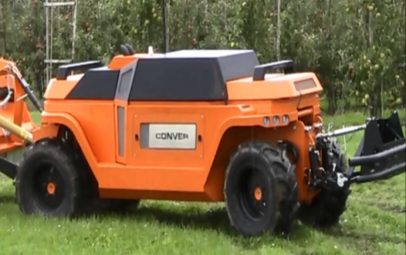
2. AI in Agriculture for Sowing and Planting:
The robot, with adjustable wheel spacing to accommodate different crop types, is designed for precision tasks like seeding, spraying, and weeding. Its electronic components are centrally located for efficiency. Recognizing that the high cost of robotic systems is a major barrier for small-scale producers, the Di-Wheel offers a feature that allows smartphones to be mounted at an optimal height and angle. This setup enables the use of the smartphone’s internal sensors, including temperature, light, and humidity sensors, RGB cameras, as well as gyroscopes, accelerometers, and GNSS (Global Navigation Satellite System) devices (Jung et al., 2021).
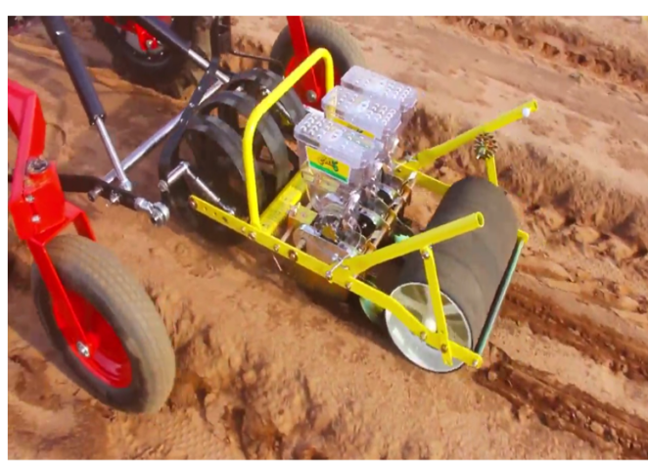
3. Weather Forecasting:
Weather forecasts have become essential for crop yields, as farmers can no longer rely solely on traditional knowledge. More accurate predictions help farmers select the best days for planting and harvesting. Meteorologists use a combination of sensors, satellites, and computer models to forecast weather patterns, including temperature, precipitation, wind speed, and solar radiation. In this process, AI plays a crucial role in improving predictions, reducing the risk of crop losses, and enhancing overall productivity (Diksha, 2020).
4. Irrigation Systems:
AI-powered automated irrigation systems significantly enhance the efficiency of the agricultural supply chain. Through the integration of IoT and AI-driven decision support systems, the entire irrigation process can be intelligently automated. In areas facing water scarcity and power shortages, IoT-based solar-powered smart irrigation systems can be developed (Talaviya et al., 2020). Like other irrigation systems, these setups are equipped with sensors to monitor soil moisture, humidity, and temperature. They are specifically designed with energy-saving in mind, and remote monitoring via mobile or web applications allows farmers to manage the system from anywhere (Tanha et al., 2020).
Various artificial intelligence algorithms, including Support Vector Machines (SVM), Random Forest (RF), K-Nearest Neighbors (KNN), and Adaptive Boosting, have been used to predict crop evapotranspiration for sugar beet in semi-arid regions. Among these, the SVM method was found to be the most effective for estimating the evapotranspiration of sugar beet (Levine et al., 1996). Accurate estimation of crop evapotranspiration is crucial for managing water supply to crops, making it an essential aspect of irrigation management. For example, determining the irrigation depth and schedule for watermelon crops can be more efficiently achieved using Artificial Neural Networks than through Volumetric Water Balance methods (Elshorbagy and Parasuraman, 2008).
Kumar (2014) discussed various irrigation methods with the goal of creating systems that reduce resource consumption while enhancing efficiency. Devices such as fertility meters and pH meters were deployed in the field to assess soil fertility by measuring the levels of primary nutrients like nitrogen, phosphorus, and potassium. Additionally, automatic plant irrigators were installed using wireless technology for drip irrigation. This approach not only maintains soil fertility but also ensures the efficient use of water resources.
Shekhar et al. (2017) created an automated robotic model using Arduino and Raspberry Pi3 to detect soil moisture content and temperature. Similarly, Jha et al. (2019) developed an automated irrigation system based on Arduino technology, aiming to reduce labor and time consumption in the irrigation process.
5. Fertilizer Application
UAVs equipped with computer vision AI can evenly spray fertilizers across a field with remarkable precision. The accuracy of the computer vision system ensures that fertilizers are applied in a way that minimizes collateral damage to crops and the environment. This is a significant improvement over manual spraying, where farmers often apply inconsistent amounts, sometimes over-applying in certain areas, which can be harmful. Rather than relying solely on chemicals, it's important to consider using organic alternatives such as manure, cow dung, and kitchen waste. Chemicals can be extremely harmful to humans, so we must be mindful of their use (De Oca et al., 2018).
IoT technology enables smarter fertilizer application by allowing precise measurements of NPK (Nitrogen, Phosphorus, Potassium) levels. An NPK sensor, which can be built using light-emitting diodes (LEDs), light-dependent resistors, and other components, provides accurate readings. These sensor values are then transmitted to a processing unit or system-on-chip for analysis (Talaviya et al., 2020). In addition, a low-cost SPAD (Soil Plant Analysis Development) device has been developed at CIAE, Bhopal, to indirectly measure the chlorophyll content in crop leaves. This compact, portable unit can be connected to an OTG-enabled Android smartphone for real-time display and data logging of SPAD values, aiding in the assessment of a crop's nitrogen needs. Recommended fertilizer quantities are typically sent directly to farmers' mobile phones via text messages (Jung et al., 2021).

6. UAV (Unmanned Aerial Vehicle) or drones
Drones, a type of Unmanned Aerial Vehicles (UAVs), are aircraft without a human pilot on board. Equipped with multi-spectral and photographic cameras, drones are used to monitor crop stress, plant growth, and predict yields. In agriculture, drones are increasingly being used for tasks such as crop health monitoring, irrigation system checks, weed identification, herd and wildlife observation, and disaster management (Ahirwar et al., 2019). Remote sensing with UAVs for capturing, processing, and analyzing images is making a significant impact on the agricultural sector (Abdullahi et al., 2015). This technology saves both time and labor by eliminating the need for manual visual inspections of crops. More advanced drones are also capable of carrying and delivering payloads such as herbicides, fertilizers, and water (Diksha, 2020).
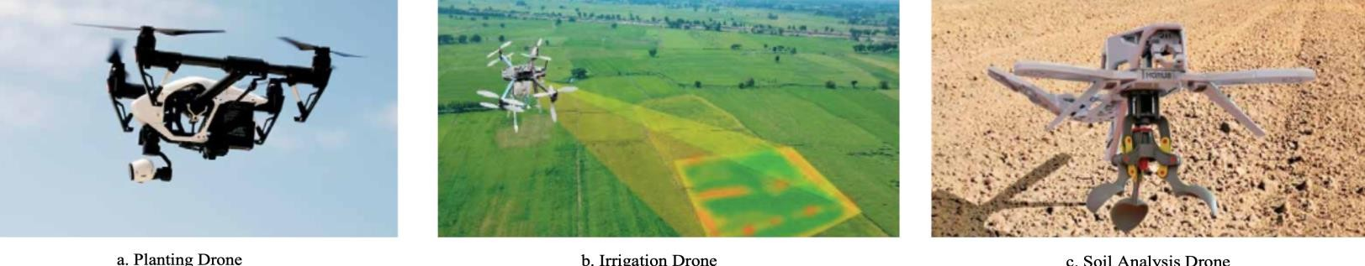

Kale et al. (2015) used drones for spraying chemical fertilizers on crops, incorporating a control loop for agricultural applications. These drones were equipped with remote sensor networks (WSN) placed on crops, which guided the drones in applying chemicals only to designated areas, based on the data collected by the sensors.
Agricultural drone applications include:
- Planting seeds
- Monitoring crop health
- Spraying pesticides and fertilizers
- Irrigation management
- Identifying and managing weeds
- Assessing crop yield predictions
- Livestock tracking and management
- Disaster management and crop damage assessment

7. AI – Harvesting:
Artificial intelligence in harvesting focuses on automating crop management to reduce labor costs and increase productivity. AI enhances the monitoring of crops, streamlining the harvesting, processing, and marketing processes. This reduces the need for a large workforce, as AI systems can perform tasks more efficiently than human laborers. Robots, for instance, are programmed to harvest crops at a faster rate, making the process more efficient (Senthilnath et al., 2016). In the past, farmers would check the ripeness of tomatoes by visiting the field daily, manually inspecting them to assess their development. Today, with the help of AI, the maturity of tomatoes can be checked on an industrial scale without direct physical contact. Computers and machines can assess the ripeness and quality of tomatoes in the field, using various AI technologies to determine their freshness without the need for manual inspection (Chung et al., 2016).
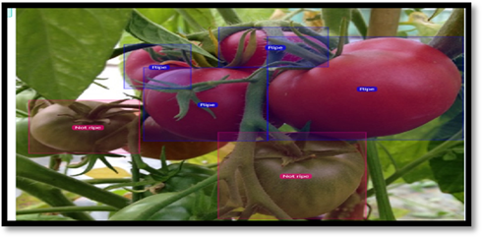
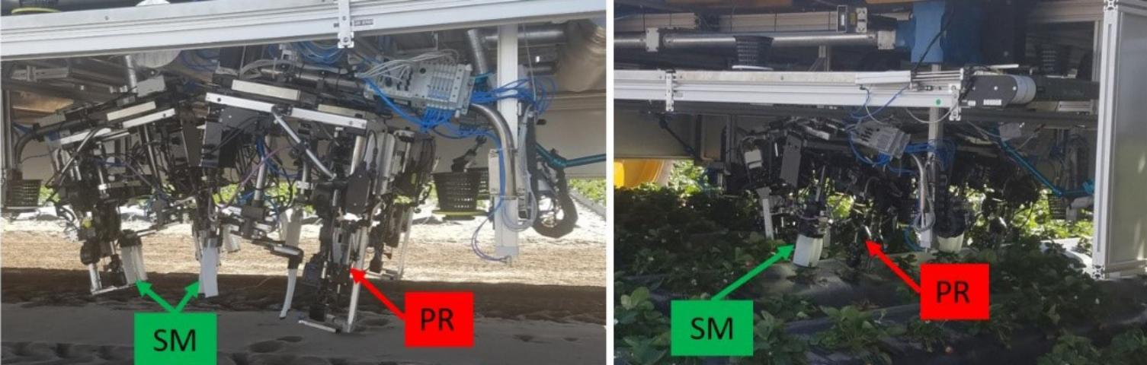 SM-Support mechanism for moving leaf foliage PR-Strawberry picking robots
The Artificial Neural Network (ANN) linear model is effective for determining the ripeness of watermelons by analyzing their firmness through an acoustic impulse (Mao et al., 2016). Federated Learning (FL) has been applied to automate the storage of cassava roots, potatoes, and fruits in designated areas, ensuring postharvest quality control (Sahni et al., 2021).

II. Artificial intelligence in crop protection
1. Weed detection and control
Weed detection and management is a critical challenge in agriculture. Accurately identifying weeds is essential for sustainable farming, as weeds are often hard to distinguish from crops. AI-powered image analysis allows for precise weed identification, enabling targeted herbicide application that reduces chemical waste and minimizes environmental harm. However, an important, yet often overlooked, aspect of weed management is distinguishing between live and dead weeds. This differentiation helps prevent unnecessary herbicide use or activation of other weeding methods, which can waste resources and increase operational costs. By reducing reliance on chemicals, this approach promotes a more eco-friendly and sustainable agricultural process (Dela Cruz et al., 2017).

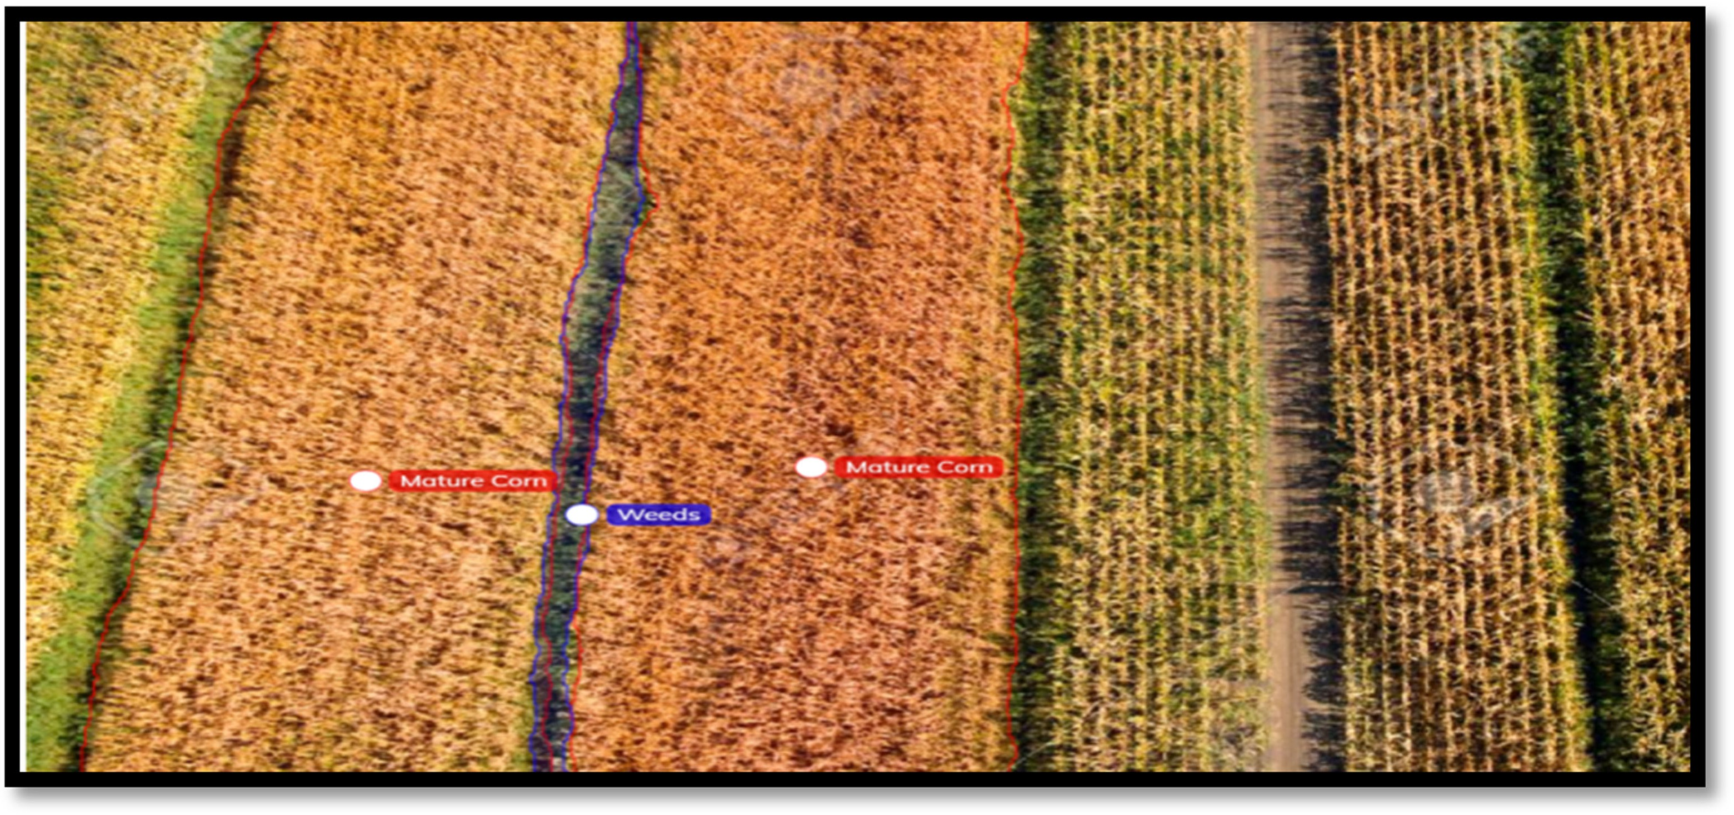
Aitkenhead et al. (2003) compared image analysis and neural network-based methods for distinguishing weeds from carrot crops. Lottes et al. (2016) created a machine learning-based classification system to differentiate sugar beets from weeds. Raja et al. (2020) developed a real-time, crop signaling-based method for identifying and classifying weeds and crops in lettuce plants. This method uses crop signaling, which has a machine-readable visual signature, making weed and crop classification easier and more accurate. The technology also leverages computer vision capabilities to detect and locate both lettuce plants and weeds.

Summary of Applications of AI in Weeding Operations
S.No. | Application | Crop | Algorithms for weed detection | Weed removal method | Accuracy | References
 | Precision Weed management | Pepper plant | Machine Vision artificial intelligence | A smart sprayer | - | Partel et al., 2019
 | Autonomous Weeding robot | Sugar beet | Machine vision algorithm | High power laser for intra row weeding | - | Bakker et al.,
 | Robot for weed control | Sugar beet | Machine vision | Rotaryhoe/mechanical removal | 92 ( %) detection | Astrand and Baerveld, 2002
 | Weed control system | Lettuce | Machine vision algorithm based on mathematical morphology | Chemical spraying | 88.8 (%) sprayed | Lamm et al., 2002

2. AI in Pest and Disease Detection
Accurate detection and classification of crop quality characteristics can boost product prices and minimize waste. For monitoring insect infestations and plant diseases, deep learning-based image identification technology is employed to detect plant pathogens and pests. This technique uses classification, detection, and image segmentation methods, such as Artificial Neural Network-Based Segmentation, to continuously monitor plant health (Cillis et al., 2018).
The PhytAi AI system was used to assess disease severity in pepper plants. It evaluated the biological activity of Pseudomonas lini (PCA17) against Phytophthora blight disease in pepper. A comparison between AI system results and visual scores showed that the AI was highly accurate. The system assessed disease severity based on visual plant conditions (Ozyilmaz, 2020).
Wang et al. (2008) proposed the use of an Artificial Neural Network (ANN) for spectral prediction of Phytophthora infestans (Late-blight fungus) on tomatoes, utilizing a back- propagation (BP) neural network and a gradient descent learning algorithm. Thanjaivadivel and Suguna (2021) analyzed and compared various methods for detecting plant diseases by classifying plant leaves based on texture, shape, and color. Their enhanced learning method achieved an impressive 99.76 % accuracy in detecting tomato diseases.

III. Artificial intelligence in green house management
Modern greenhouses use sensors to measure local climate and environmental parameters. Wireless Sensor Networks (WSNs), consisting of numerous nodes, can sense, actuate, and communicate data to stakeholders. The typical architecture includes a wireless sensor network, data management subsystems, and a base station responsible for monitoring. These systems can connect via protocols such as Bluetooth to collect soil moisture data. When moisture levels drop below a set threshold, the connected micro-irrigation system is automatically activated. Similar automated responses can be triggered for temperature and humidity levels as well.
IV. Robotics in Vegetable Grafting
The term “automatic grafting technology” refers to the use of mechanical automation to replace traditional manual grafting methods. Automation and in some cases, intelligent systems have enhanced the grafting process, improving crop efficiency and the survival rate of grafted seedlings. This includes automating various steps such as seedling selection, supply, grafting, and planting. By replacing manual labor with mechanical automation, robotic grafting increases both the survival rates of grafted seedlings and overall grafting efficiency. Additionally, robotic grafting reduces the need for skilled labor, enabling untrained individuals to perform these tasks more easily (Yan et al., 2022).
Advantages of robotic grafting
- Robots can make highly precise and consistent cuts, ensuring the best possible graft union and increasing the success rate.
- Automated devices work faster than humans, significantly boosting the number of grafted plants produced within a given timeframe.
- Consistent use of robotic grafting leads to higher survival rates of grafted plants, reducing waste and improving overall productivity.
- Robots minimize human contact with plants, lowering the risk of contamination and the spread of diseases and pests.
- Operating in controlled, sterile environments allows robots to optimize plant growth while minimizing external factors.

Time | Model | Research  Unit | Suitable Object | Productivity  (Plants/h) | Survival  Rate | Automaticity
1992 | MGM600 | Mitsubishi  Group, Japan | Solanaceae  Vegetables | 600 | 95% | Semi-  Automatic
1998 | 2JSZ-600 | China Agricultural  University | Melons | 600 | 95% | Semi- automatic
2004 | 1 | Ideal system, Korea | Solanaceae  Vegetables | 1200 | 95% | Full automatic
2006 | 2JC-350 | Northeast  Agricultural University | Melons | 350 | >90% | Semi- automatic
2010 | Graft1200 | ISO Group, Netherlands | Melon and Solanaceae  Vegetables | 1050 | 99% | Full-automatic
2013 | AFGR- 800CS | Helper Robotech,  Korea | Solanaceae  Vegetables | 800 | 95% | Full-automatic
2018 | JS-6 | China Agricultural University | Solanaceae  Vegetables | 720 | 96 % | Full-automatic
2021 | JFT- A1500T | Hefei Jiafute Robot Technology  Co., Ltd. | Melon and Solanaceae vegetables | 1500 | 98% | Semi- automatic
2021 | Graft1100 | China company | Solanaceae  Vegetables | 1000 | 98 % | Semi- automatic
2022 | HAU-22 | Huazhong Agricultural  University | Melon vegetables | 2134 | 67% | Full-automatic

Vegetable grafting robots developed in world
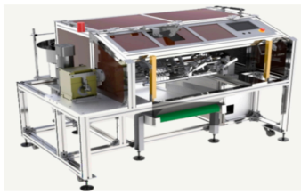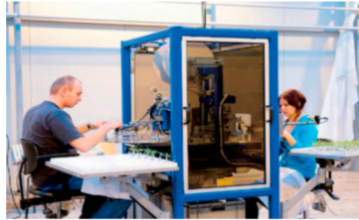
V. Artificial intelligence in crop breeding
Germplasm collection and mapping populations can effectively differentiate phenomics and genomics data using AI. Large datasets generated from crop diversity studies, single nucleotide polymorphism (SNP) detection and selection, quantitative trait loci (QTL) analysis, genome-wide association studies (GWAS), genomic selection, and sequencing require advanced analysis. AI can analyze and integrate phenomics and genomics data from these extensive datasets to enhance breeding strategies. Computational AI models can predict gene functions, enable high-throughput crop phenotyping, and forecast crop yield and trait performance (Khan et al., 2022). Combining AI with phenomics and genomics tools accelerates rapid gene identification linked to crop phenotypes, thereby speeding up crop improvement programs (Batley and Edwards, 2016). The figure summarizes how AI technology can be applied to connect high-throughput genomics and phenomics, ultimately leading to more effective breeding strategies.
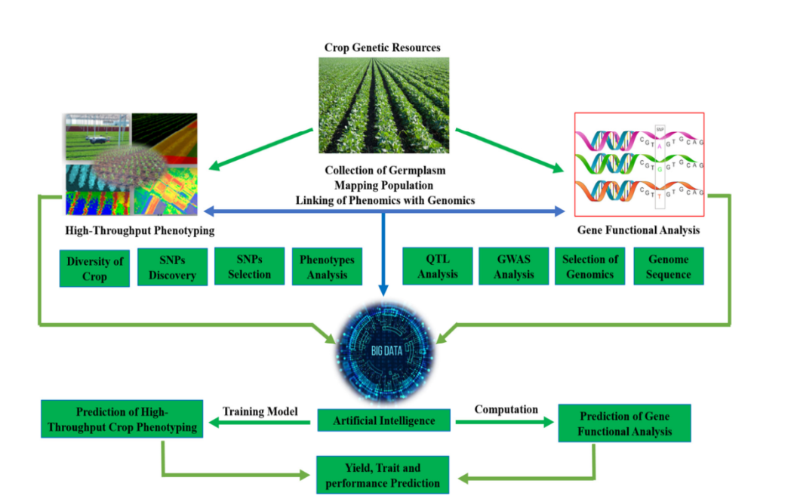

Integrating genotypic, phenotypic, and environmental information enhances breeding efficiency. High-throughput robotic systems collect phenotypic data from crop plants grown in both indoor and outdoor environments. This phenotypic data from various locations is transmitted to a high-throughput phenotyping (HTP) server via the Internet. The combined datasets incorporate genotypic, phenotypic, and environmental information, allowing for the quantification of genotype-by-environment interactions (G × E) across multiple environments (Caudai et al., 2021). AI technologies, especially machine learning (ML) and deep learning (DL), are applied in selecting cultivars tailored for specific or multiple key environments. This approach supports informed decisions on whether selected cultivars are suitable for cultivation in limited or broad environmental conditions (Wang et al., 2020).
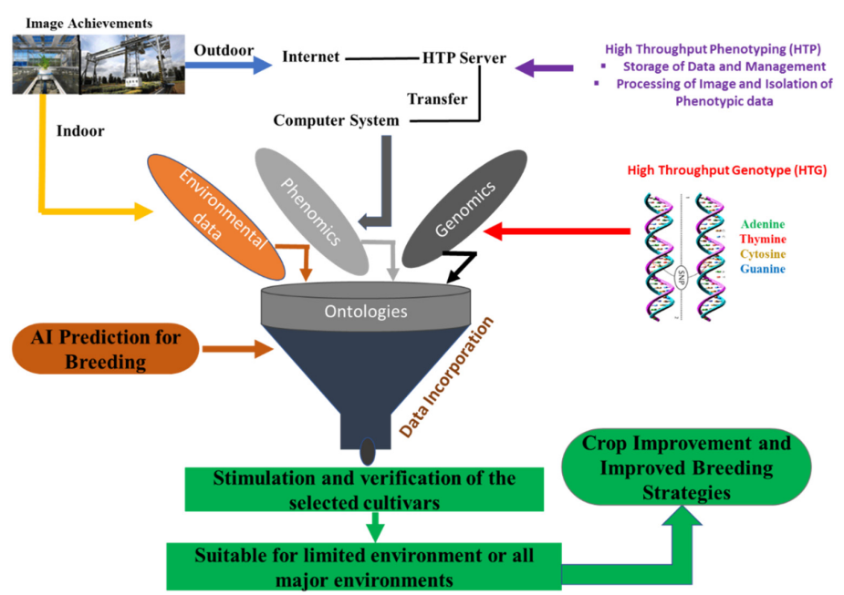
Integration and management of Genomics, Phenomics and Enviromics data by artificial intelligence for crop-breeding improvement
VI. Kissan GPT
Amid the growing popularity of AI tools like ChatGPT, a new chatbot called Kissan GPT was launched in India on March 15, 2023, to help farmers increase their profits. Designed to be user-friendly for farmers nationwide, regardless of their location or education level, Kissan GPT allows users to ask questions verbally in their own language using a microphone, rather than typing queries. The chatbot provides detailed guidance on various topics such as irrigation, pest control, and crop cultivation. Recently, Kissan GPT was used to demonstrate how Indian squash farmers can potentially earn profits of up to Rs 5 lakhs.

CURRENT APPROACHES AND ACHEIVEMENTS OF ARTIFICIAL ITELLIGENCE IN HORTICULTURE:
1. Blue river technology – weed control
2. Harvest CROO robotics – crop harvesting
3. AI - driver less tractor
4. Crop and soil health monitoring AI
5. Farm shots-satellites for monitoring crop health and sustainability
6. Sky squirrel technologies inc - Drones and computer vision for crop analysis
1. Blue River Technology
Weed control is a major concern for farmers, especially as around 250 weed species have developed resistance to herbicides. A California-based startup has developed a robot called “See & Spray” that uses computer vision to detect and target weeds with precise spraying. This precision spraying helps prevent herbicide resistance by applying herbicides only where needed. Additionally, it delivers fertilizers directly to the plants that require them, potentially reducing herbicide use by up to 90% compared to spraying an entire field.
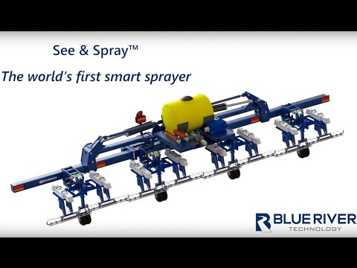
2. Harvest Croo Robotics – Crop Harvesting
A shortage of laborers has reportedly caused millions of dollars in revenue losses. To address this, Florida-based Wish Farms announced in June 2017 that it would implement the Harvest CROO Robotics strawberry harvester during the summer of 2017 to assist strawberry farmers with picking and packing their crops.
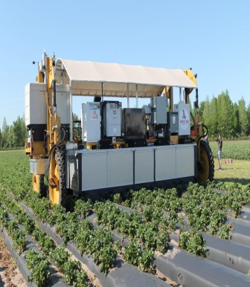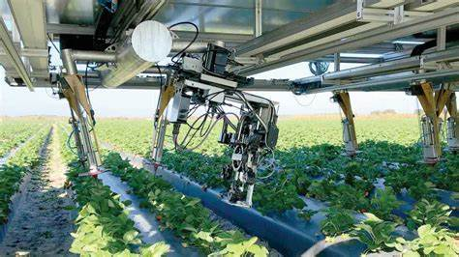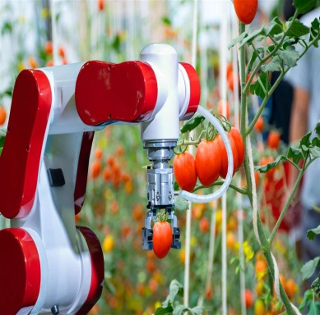
3. AI Driver less tractor
Driverless tractors have been introduced by combining advanced software with readily available technologies such as sensors, radar, and GPS. This system enables an operator working a combine harvester to set the path for a driverless tractor to follow. In 2016, both Case IH and New Holland unveiled their new autonomous tractors for the first time at the Farm Progress Show.
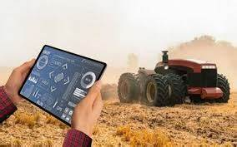
4. Crop and Soil Health Monitoring -AI
A. PEAT – A machine vision for diagnosing pests / soil defects:
Berlin-based agricultural tech startup PEAT has developed a deep learning application called Plantix, which identifies potential soil defects and nutrient deficiencies. The software uses algorithms to analyze specific foliage patterns, linking them to soil issues, plant pests, and diseases. The company claims that Plantix can detect these patterns quickly with an accuracy of up to 95%. By using images captured with a user’s smartphone camera, the app identifies plant diseases and other defects and provides recommended treatment measures.
B. Trace Genomics –Machine learning for diagnosing soil defects:
Similar to the Plantix app, California-based Trace Genomics offers soil analysis services to farmers. Developed with support from lead investor Illumina, the system uses machine learning to help clients understand the strengths and weaknesses of their soil. After submitting a soil sample to Trace Genomics, users receive a detailed report summarizing the composition and condition of their soil.
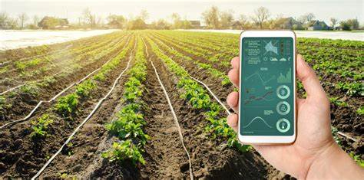
6. Sky Squirrel Technologies Inc.-Drones and Computer vision for crop analysis
Sky Squirrel Technologies Inc. is among the companies introducing drone technology to vineyards, aiming to help users boost crop yields and reduce costs. Users pre-program the drone’s flight path, and once deployed, the drone uses computer vision to capture images for analysis. Sky Squirrel applies algorithms to integrate and analyze the collected data, delivering detailed reports on the health of the vineyard, with a particular focus on the condition of grapevine leaves.
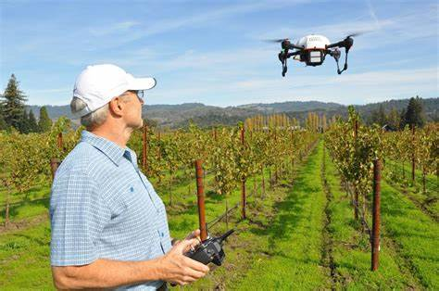
LIMITATIONS OF AI IN HORTICULTURE
- Lack of familiarity with high tech machine learning solutions in farms across most parts of the world.
- Cost is a big challenge.
- AI systems also need a lot of data to train machines and to make precise predictions.

CONCLUSION
Agricultural challenges such as inadequate irrigation systems, weed management, difficulties related to crop height, and harsh weather conditions can be effectively addressed with the help of technology. AI-driven solutions like remote sensors for measuring soil moisture and GPS-guided automated irrigation systems can significantly improve farm performance. While farmers have expressed concerns about whether precision weeding techniques can compensate for crop losses during the weeding process, self-driving robots not only boost productivity but also reduce the unnecessary use of pesticides and herbicides. Additionally, drones can be efficiently used for spraying pesticides and herbicides, simplifying plant monitoring. Human expertise can then be focused on analyzing resource and labor constraints in agriculture. Traditional methods of collecting agricultural data—such as measuring plant height or analyzing soil texture and content—often involved time-consuming physical tests. However, modern technologies enable rapid, non-invasive high-throughput phenotyping, offering flexible, on-demand access to spatial data and critical information, thereby streamlining agricultural practices.
SCOPE OF AI IN HORTICULTURE
- In a country like India where over 50 % of the population is directly engaged on 28.44 million hectares of Horticultural land in direct or indirect manner, bringing AI tools and technologies can be game changing.
- Satellite data is also being used for assessing the farm imageries and offering production regarding future yields.
- Various start ups like PEAT, Sar Sure, Earth Food and V drone Agro are empowering the farmers with varied solutions that are based on AI, Machine learning, Data science, analytics and cloud.
- Several AI- powered technologies like robotics, Agri tech, drones, predictive analysis, soil monitoring devices, satellite imagery, automated irrigation systems, etc. are here to change the face of Indian agriculture.

REFERENCE
Abdullahi, H. S., Mahieddine, F and Sheriff, R. E. (2015). Technology impact on agricultural productivity: A review of precision agriculture using unmanned aerial vehicles. In Wireless and Satellite Systems: 7th International Conference, 388–400.
Ahirwar, S., Swarnkar, R., Bhukya, S and Namwade, G. (2019). Application of drone in agriculture. International Journal of Current Microbiology and Applied Sciences, 8: 2500–2505.
Aitkenhead, M. J., McDonald, A. J. S., Dawson, J. J., Couper, G., Smart, R. P., Billett, M., Hope, D and Palmer, S. (2003). A novel method for training neural networks for time-series prediction in environmental systems. Ecological Modelling, 162: 87–95.
Åstrand, B and Baerveldt, A.J. (2002). An agricultural mobile robot with vision-based perception for mechanical weed control. Autonomous Robots, 13 (1): 21–35.
Bakker, T., Asselt, V. K., Bontsema, J., Müller, J and Straten, V.G. (2006). An autonomous weeding robot for organic farming. In Field and Service Robotics: Results of the 5th International Conference, 579–590.
Batley, J and Edwards, D. (2016).The application of genomics and bioinformatics to accelerate crop improvement in a changing climate. Current Opinion in Plant Biology, 30: 78–81.
Blasco, J., Aleixos, N., Roger, J. M., Rabatel, G and Molto, E. (2002). Robotic weed control using machine vision. Biosystems Engineering 83(2) :149–157.
Caudai, C., Galizia, A., Geraci, F., Le Pera, L., Morea, V., Salerno, E. and Via, A and Colombo, T. (2021). AI applications in functional genomics. Computational Structural Biotechnology Journal, 19: 5762–5790.
Chung, S., Choi, M., Lee, K., Kim, Y., Hong, S and Li, M. (2016). Sensing technologies for grain crop yield monitoring systems: A review. Journal of Biosystems Engineering, 41(4): 408–417.
Cillis, D., Pezzuolo, A., Marinello, F and Sartori, L. (2018). Field-scale electrical resistivity profiling mapping for delineating soil condition in a nitrate vulnerable zone. Applied Soil Ecology, 123: 780–786.
De Oca, A. M., Arreola, L., Flores, A., Sanchez, J and Flores, G. (2018). Low-cost multispectral imaging system for crop monitoring. In 2018 International Conference on Unmanned Aircraft Systems, 443–451.
Dela Cruz, J. R., Baldovino, R. G., Bandala, A. A and Dadios, E. P. (2017). Water usage optimization of smart farm automated irrigation system using artificial neural network. In 2017 5th International Conference on Information and Communication Technology, 1–5.
Dhanush, G., Khatri, N., Kumar, S and Shukla, P.K.(2023). A Comprehensive Review of Machine Vision Systems and Artificial Intelligence Algorithms for the Detection and Harvesting of Agricultural Produce. Scientific African Journal, 21 :01798.
Diksha, M. (2020). Artificial intelligence: A New Way to Improve Indian Agriculture. International Journal of Current Microbiology and Applied Sciences, 9(3): 1095-1102.
Dwivedi, A.K., Singh, A.K., Singh, D and Kumar, H. (2023). Development of an Adaptive Linear Mixture Model for Decomposition of Mixed Pixels to Improve Crop Area Estimation Using Artificial Neural Network. IEEE Access, 11: 5714–5723.
El Hoummaidi, L., Larabi, A and Alam, K. (2021). Using Unmanned Aerial Systems and Deep Learning for Agriculture Mapping in Dubai. Heliyon, 7 : 108-154.
Elshorbagy, A and Parasuraman, K. (2008). On the relevance of using artificial neural networks for estimating soil moisture content. Journal of Hydrology, 362 (1-2) : 1-18
Herrera-Franco, G., Bollmann, H.A., Pasqual Lofhagen, J.C., Bravo-Montero, L and Carrión-Mero, P. (2023). Approach on Water-Energy-Food (WEF) Nexus and Climate Change: A Tool in Decision-Making Processes. Journal Environment development, 46 : 100858.
Jha, K., Doshi, A., Patel, P and Shah, M. (2019). A comprehensive review on automation in agriculture using artificial intelligence. KeAi Communications Co.
Jung, J., Maeda, M., Chang, A., Bhandari, M., Ashapure, A and Landivar-Bowles, J. (2021). The potential of remote sensing and artificial intelligence as tools to improve the resilience of agriculture production systems. Current Opinion Biotechnology, 70, 15–22.
Kale, S.D., Khandagale, S.V., Gaikwad, S.S., Narve, S.S and Gangal, P.V. (2015). Agriculture drone for spraying fertilizer and pesticides. International Journal of Advanced Research in Computer Science and Software Engineering, 5(12) : 804-807.
Khan, U.H.M., Wang, S., Wang, J., Ahmar, S., Sumbul Saeed, S., Khan, S.U., Xu,X., Chen, H., Bhat, A.J and Feng, X. (2022). Applications of Artificial Intelligence in Climate-Resilient Smart-Crop Breeding. International Journal Molecular Science- 11156.
Kumar, G. (2014). Research paper on water irrigation by using wireless sensor network. International Journal of Scientific Engineering and Technology, IEERT conference Paper, 123-125.
Lamm, R.D., Slaughter, D.C and Giles, D.K. (2002). Precision weed control system for cotton
Trans. American Society of Agricultural and Biological Engineers, 45 (1): 231-238.

Levine, E.R., Kimes, D.S and Sigillito, V.G. (1996). Classifying soil structure using neural networks. Ecological Modelling, 92 (1): 101-108.
Lottes, P., Hoeferlin, M., Sander, S., Muter, M., Schulze, P and Stachniss, L.C. (2016). An effective classification system for separating sugar beets and weeds for precision farming applications. Proceedings - IEEE International Conference on Robotics and Automation, 5157–5163.
Mao, J., Yu,Y., Rao, X and Wang, J. (2016). Firmness prediction and modeling by optimizing acoustic device for watermelons. Journal of Food Engineering, 168: 1–6.
Ozyilmaz, U. (2020). Evaluation of the effectiveness of antagonistic bacteria against Phytophthora blight disease in pepper with artificial intelligence. Biological Control, 151: 104379.
Partel, V., Kakarla, S.C and Ampatzidis, Y. (2019). Development and evaluation of a low-cost and smart technology for precision weed management utilizing artificial intelligence, Comput. Electron. Agriculture, 157: 339–350.
Raja, R., Nguyen, T.T., Slaughter, D.C and Fennimore, S.A. (2020). Real-time weed-crop classification and localisation technique for robotic weed control in lettuce. Biosystems Engineering 192: 257–274.
Sahni, V., Srivastava, S and Khan, R. (2021). Modelling techniques to improve the quality of food using artificial intelligence, Journal Food Quality, 2140010.
Senthilnath, J., Dokania, A., Kandukuri, M., Ramesh, K.N., Anand, G and Omkar, S.N. (2016). Detection of tomatoes using spectral-spatial methods in remotely sensed RGB images captured by UAV. Biosystem Engineering, 146: 16–32.
Shekhar, Y., Dagur, E., Mishra, S., Tom, R.J., Veeramanikandan, M and Sankaranarayanan,S. (2017). Intelligent IoT based automated irrigation system. International Journal Applied Engineering Research, 12 (18) : 7306-7320.
Talaviya, T., Shah, D., Patel, N., Yagnik, H and Shah, M. (2020). Implementation of artificial intelligence in agriculture for optimisation of irrigation and application of pesticides and herbicides. Artificial. Intelligence in Agriculture, 4: 58–73.
Talaviya, T., Shah, D., Patel, N., Yagnik, H and Shah, M. (2020). Implementation of artificial intelligence in agriculture for optimisation of irrigation and application of pesticides and herbicides. Artificial Intelligence Agriculture, 4: 58–73.
Tanha, T., Dhara, S., Patel, N., Yagnik, H and Shahd, M. (2020). Implementation of artificial intelligence in agriculture for optimization of irrigation and application of pesticides and herbicides. Artificial Intelligence in Agriculture. 4: 58-73.
Thanjaivadivel, M and Suguna, R. (2021). Leaf disease prediction using fast enhanced learning method. International Journal of Engineering Trends and Technology 69(9): 34–44.
Wang, X., Zhang, M., Zhu, J and Geng, S. (2008). Spectral prediction of Phytophthora infestans infection on tomatoes using artificial neural network (ANN). International Journal of Remote Sensing 29(6): 1693–1706.
Yan, G. P., Feng, M. S., Lin, W. G., Huang, Y., Tong, R. Z and Cheng, Y. (2022). Review and prospect for vegetable grafting robot and relevant key technologies. Agriculture, 12 (11): 1578.

