Seedling Growth Dynamics of Terminalia arjuna in Nursery Conditions: A Comprehensive Review

Abstract: Terminalia arjuna (Roxb.) Wight & Arn., a widely recognized medicinal and ecologically significant tree species, faces propagation challenges due to seed dormancy, irregular germination, and environmental stress sensitivity. This review explores the key factors influencing the seedling growth of T. arjuna under controlled nursery conditions, focusing on soil composition, water availability, light intensity, temperature, and the impact of industrial residues such as fly ash. Evidence indicates that seedling development is highly responsive to nursery management practices, including pre-sowing seed treatments, shade regulation, watering regimes, and soil amendments. While environmental pollutants such as heavy metals pose threats to seedling health, their bioavailability can be mitigated through responsible use of materials like fly ash, which may also enhance soil fertility. Furthermore, integrating hormonal priming and biotechnological approaches shows promise in improving germination rates and seedling vigor. This synthesis underlines the importance of optimized nursery practices for successful seedling establishment and long-term conservation of T. arjuna.
Keyword: Environmental pollutants, Fly ash ,Germination, Heavy metal stress, Light intensity, Nursery management, Pre-sowing seed treatment, Seed dormancy, Seedling growth, Soil amendments, Soil composition, Temperature, Water availability.
1. Introduction:
Seed germination is a complex process that leads to the resumption of active growth in the embryonic axis, rupture of the seed cover and emergence of the young plants. For physiologists and biochemists, germination is complete when the radicle ruptures and the cover becomes visible. For seed technologists, foresters, nursery growers, etc.(Bargah et al ., 2025)Terminalia arjuna (Roxb.) Wight & Arn., commonly known as Arjuna, is a prominent evergreen tree species belonging to the Combretaceae family. The genus name Terminalia is derived from the Latin word “Terminus” or “Terminalis”, meaning “end,” which refers to the characteristic arrangement of its leaves clustered at the tips of branches (Wadhai, 2012). Fly ash is a waste product that is produced by coalfired thermal power stations after generating large amounts of energy. About 57% of the electricity in India is generated by thermal power plants using coal as fuel, where it includes significant levels of ash (up to 40%), sulfur (0.2–6%), and various quantities of heavy metals such as Hg, Mn, Cu, Pb, Ni, Fe, Cr and Cd (Sharma et al., 2024). T. arjuna is widely distributed across the Indian subcontinent, particularly in regions such as Uttar Pradesh, Bihar, Maharashtra, Madhya Pradesh, West Bengal, Odisha, southern and central India, and also extends to Sri Lanka and Bangladesh (Soni & Singh, 2019). The tamarind tree (Tamarindus indica) is a valuable perennial legume of significant economic, health, and nutritional importance, deeply rooted in Indian and African heritage. This review examines its systematics, botanical description, chemical composition, and applications. The tamarind fruit is notable for its pulp, rich in tartaric acid, carbohydrates, vitamins, and essential minerals. The pulp of a mature fruit comprises 30% to 50%, whereas the seeds constitute approximately 25% to 40% of the fruit(Sharma et al., 2025) It thrives in tropical and subtropical climates (Kumar & Prabhakar, 1987) and produces large orthodox seeds, making it a suitable species for propagation (Chandrashekar et al., 2013).
The species plays a vital role in sericulture, serving as an important host plant for the Tasar silkworm (Antheraea mylitta), which feeds on its leaves (Dutta, 1995). Additionally, the Arjuna tree holds mythological and cultural significance in Indian traditions (Agarwal, 1981). Nurseries provide the means to control moisture, light physical and chemical soil constituents in such a way as to produce healthy and uniform seedlings for planting. Several factors can influence seedling growth in the nursery. But potting substrate is the most important factor from the nursery environment. This is because, first it is basically a plant's first food; secondly, it physically supports a growing seedling and thirdly, it stores and supplies nutrients, water and air to the root system(Bargah et al.,2024)
Terminalia arjuna is best known for its extensive use in traditional Ayurvedic medicine. For nearly three centuries, its stem bark has been utilized for preparing herbal formulations, primarily as a cardiac tonic, and is particularly beneficial in treating heart-related disorders such as heart failure, ischemia, cardiomyopathy, atherosclerosis, and myocardial necrosis (Ram et al., 1997; Sultana et al., 2007; Phani et al., 2013). In addition, it is used to manage anemia, blood disorders, venereal and viral diseases, and other general health issues. Pharmacologically, T. arjuna exhibits a wide spectrum of biological activities, including antioxidant, hypocholesterolemic, antibacterial, antimicrobial, antitumoral, antiallergic, antifertility, antifeedant, and anti-HIV properties.
Another critical aspect of T. arjuna research pertains to its seed germination, a vital phase in the plant’s life cycle. Germination requires suitable environmental factors such as water, oxygen, temperature, and light, and proceeds through phases of imbibition, physiological activation, and visible growth (Biswas et al., 2011; Chandra et al., 2021b; Kumar et al., 2023). The manufacturing of forest seedlings is therefore a constantly developing technique in reforestation. Understanding the development of seedlings in the nursery and their future growth and survival in the field depend heavily on the evaluation of seedling quality. On the other hand, stock quality is frequently evaluated imperfectly and infrequently. While some forestry managers and nurseries evaluate their stock extensively every year, others only do so when an issue occurs(Sahu and Nema et al.,2025). However, the germination and growth of such trees can be significantly influenced by external factors like fly ash—a major industrial by-product.
Fly ash contains numerous toxic heavy metals, including mercury (Hg), arsenic (As), cadmium (Cd), barium (Ba), selenium (Se), nickel (Ni), chromium (Cr), vanadium (V), zinc (Zn), and lead (Pb) (Dwivedi & Jain, 2014). These elements are known to inhibit seed germination and adversely affect plant development (Ahmad et al., 2014). Despite its toxicity, fly ash has found widespread industrial applications in cement, bricks, concrete, synthetic wood, reclamation of degraded land, road construction, and mine filling (Kaur & Goyal, 2015). Plants are propagated and grown to a size that can be planted in a nursery. A quality nursery stock is necessary to create a good plantation. The necessity of forest nurseries in order to properly nurture seedlings before planting them on land that needs to be replanted. Some essential benefits of the standard or functional medium are that it yields robust seedlings that can establish themselves in field conditions; it promotes seedling growth, which shortens the time the seedlings spend in the nursery and increases costs; it establishes the standard or proportion of potting mixture, which prevents the wastage of media ingredients; and more (Bargah et al.,2024). More recently, its use in forestry and nurseries has gained attention. When applied cautiously, fly ash can assist in tree plantation and may aid in immobilizing heavy metals within plant biomass, potentially reducing their environmental impact (Chandra et al., 2021a).
2. Seed Germination: Seed germination is the process in which the embryo develops into a seedling under favorable conditions (Bargah et al., 2025). It involves a series of physiological, biochemical, and morphological changes that together lead to germination.( Fig:1).
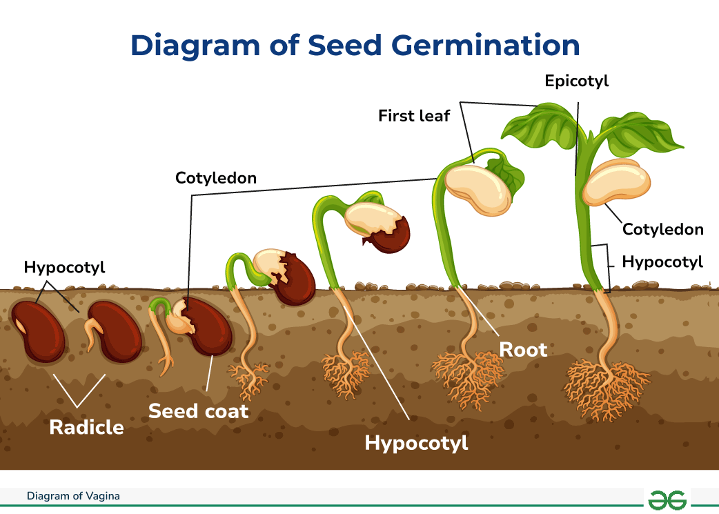
Fig:1 Seed germination.
Source: https://www.geeksforgeeks.org/biology/diagram-of-seed-germination-process/
2.1 Epigeal Germination: This process involves the cotyledon being pushed out of the soil due to the rapid growth and elongation of the hypocotyl, as seen in species like Acacia, Adenanthera, Albizia, Cassia, Dipteryx, Diphysa, Erythrina, Gliricidia, Haematoxylum, Hymenaea, Hymenolobium, Parkia, Parkinsonia, Pterocarpus, Samaneasaman, Sclerolobium, Tamarindus, Casuarina, Annona, Cordia alliodora, Myrcia, Capparis, Cedrela, Melia, Zizyphus, Anacardium excelsum, Jacaranda, Ulmus, Ilex, and Elaeocarpus.( Fig: 2)

2.2 Hypogeal Germination:
In this type, cotyledons remain below the soil due to the rapid elongation of the epicotyl. This predominantly occurs in monocotyledonous seeds, e.g., Calophyllum, Swartzia, Syzygium, Swietenia, Prunus, catappa, etc.( Fig: 2)
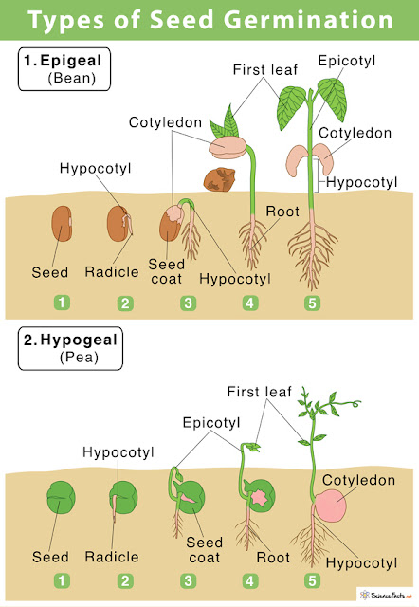
Fig: 2 Seed Germination Types.
Source: https://www.preachbio.com/2024/04/exploring-types-and-physiological.html

3.MECHANISM OF SEED GERMINATION
Germination is a multifaceted biological process that begins with imbibition, where the seed absorbs water. Following this, enzymes are activated to convert starches into sugars, supplying the embryo with vital nutrients. The initial indication of germination is the swelling of the radicle, marking the start of growth. The time required for seedlings to emerge depends on the size of the seed. Larger seeds, with more nutrient reserves, can germinate at greater depths and extend their epicotyl to the surface. Smaller seeds, however, tend to emerge more rapidly and typically grow closer to the surface (Bargah et al.,2025)( Fig:3).
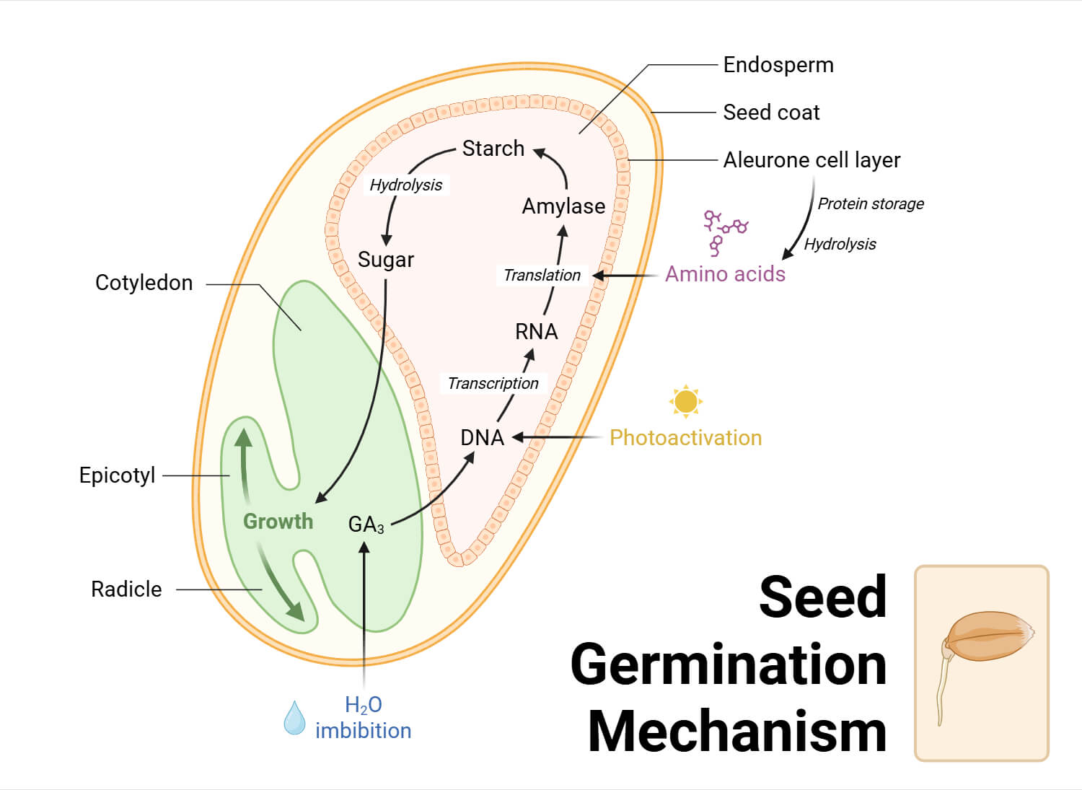
Fig:3 Mechanism of seed germination.
Source: https://microbenotes.com/seed-germination/

4.Factors Affecting Seed Germination
Germination is affected by both internal and external factors. Internal factors, such as genetic traits, seed viability, and dormancy, are inherited from the parent plants and significantly influence the seed’s germination potential and subsequent growth (Bargah et al., 2025). External factors include moisture, temperature, oxygen, light, and soil conditions. Additionally, internal aspects like the maturity of the embryo, seed viability, and dormancy play a critical role in the germination process. A thorough understanding and manipulation of thesefactors are essential for optimizing the germination of tree seedlings (Fig:4).

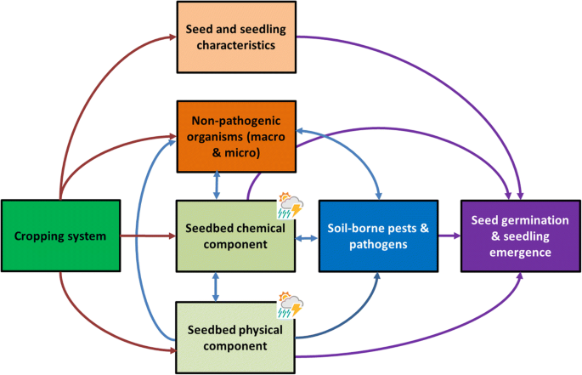
Fig:4 Factors Affecting Seed Germination
Source: https://link.springer.com/article/10.1007/s11104-018-3780-9

5. SEED DORMANCY
Seed dormancy is a physiological condition that prevents a viable seed from germinating, even when conditions are ideal for growth (Baskin and Baskin, 2004). The duration of dormancy varies significantly among species, with some seeds remaining viable for months, while others quickly lose their ability to germinate. Seeds consist of an outer protective coat and an inner embryo that eventually develops into a plant. Germination begins when water enters the seed coat, causing it to swell and triggering the growth of the plant (Bargah et al., 2025).( Fig:5)
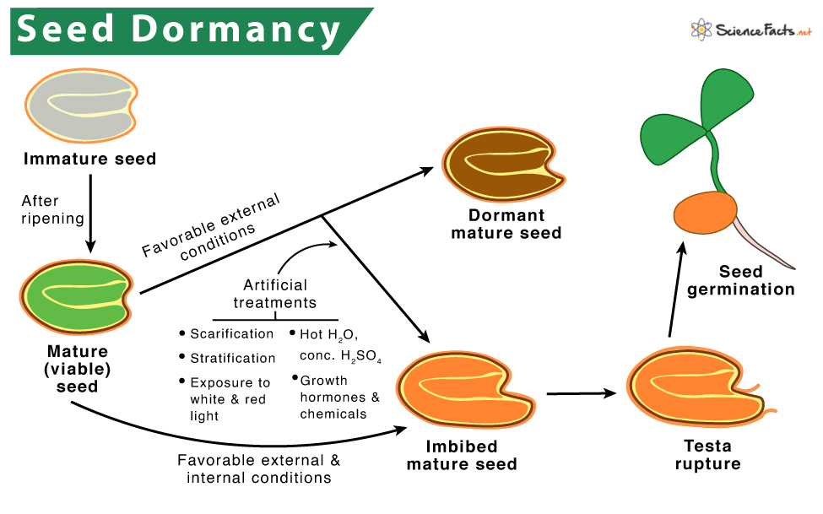
Fig:5 Seed Dormancy.
Source: https://www.sciencefacts.net/seed-dormancy.html
6.SEED TREATMENT
Seed treatment refers to the application of physical, chemical, or biological methods to seeds before sowing to enhance their germination, improve seedling vigor, and protect them from diseases, pests, and environmental stresses. The goal of seed treatment is to improve the overallsuccess of seed germination and establishment, leading to healthier and more productive plants (Bargah et al., 2025) (Fig:6)

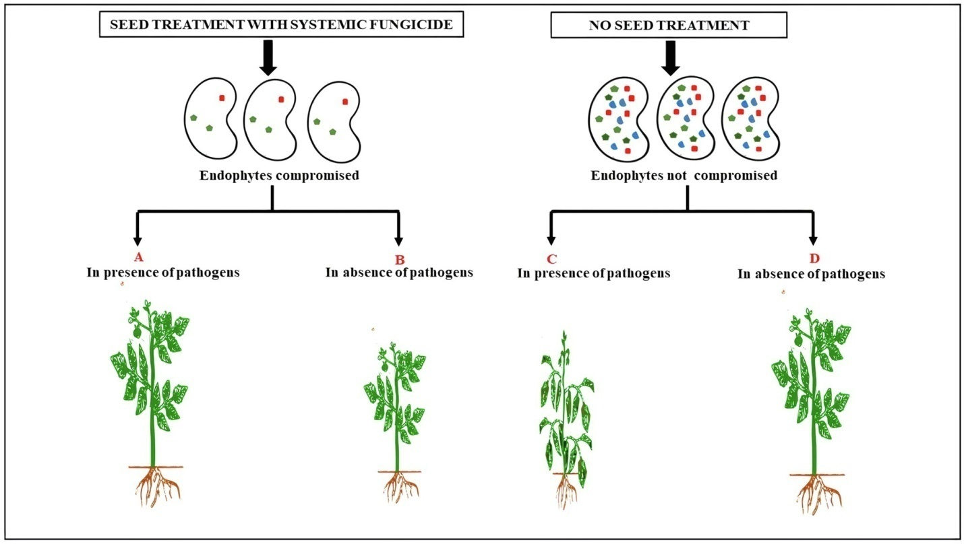
Fig:6 Seed Dormancy.
Source:https://www.frontiersin.org/journals/plantscience/articles/10.3389/fpls.2021.654512/full

Table: 1 Types of Seed Treatement
Type of Seed Treatment | Description | Purpose | Reference
1. Scarification | Mechanical or chemical abrasion of the seed coat to promote germination. | To break physical dormancy and enhance germination rates. | Bewley et.al,(1994).
2. Stratification | Cooling seeds for a period to simulate winter conditions. | To break physiological dormancy and synchronize germination. | Gutterman, Y. (2000).
3. Priming | Pre-soaking seeds in a solution to initiate germination processes without full germination. | To improve seed vigor and uniformity of germination. | Bradford et al, (1995).
4. Hot Water Treatment | Immersing seeds in hot water for a specific time. | To kill pathogens and break dormancy. | McDonald et al, (2004)
5. Chemical Treatment | Using fungicides, insecticides, or growth regulators to treat seeds. | To protect seeds from diseases and pests. | Delouche et al, (1973).
6. Coating | Applying a layer of materials (e.g., polymers, nutrients) to the seed surface. | To improve seed handling, protect seeds, and supply nutrients. | Anderson et al, (2015).
7. Dry Heat Treatment | Exposing seeds to high temperatures for a short period. | To kill pathogens and insects. | Harlan et al,(1971).

7. Propagation and Seedling Growth Process of Terminalia arjuna with key steps:
1. Seed Collection
2. Pre-sowing Treatments (Soaking, Scarification, Chemical treatment)
3. Seed Sowing in Nursery (Prepared soil + amendments)
4. Germination Monitoring (Temperature, moisture, light control)
5. Seedling Growth Assessment (Height, collar diameter, leaf number, biomass)
6. Nursery Management (Watering, shading, weeding, pest control)
7. Seedling Hardening (Gradual exposure to outdoor conditions)
8. Transplantation / Plantation
9. Growth and Survival Monitoring
8. Botanical Profile of Terminalia arjuna:
Terminalia arjuna (Roxb.) Wight & Arn. is a prominent tree species in the Combretaceae family, known for being large and either deciduous or evergreen in nature. It commonly thrives in moist forested areas and along riverbanks, reaching heights of 20 to 25 meters, with a broad canopy and gracefully drooping branches. Its bark is smooth, pale grey to pinkish-white, and peels away in large flakes. The leaves are simple, sub-opposite, and oblong to elliptic, typically appearing in clusters at the tips of branches—a distinctive trait that inspired the genus name Terminalia, derived from the Latin term “Terminalis”, meaning "end" (Wadhai, 2012). The tree yields large, winged fruits with prominent fibrous ridges. Its seeds are classified as orthodox, indicating that they require specific environmental conditions for successful germination (Chandrashekar et al., 2013). Native to the Indian subcontinent, T. arjuna flourishes in tropical and subtropical climates, especially in well-drained alluvial soils along river valleys (Kumar & Prabhakar, 1987; Orwa et al., 2009). Aside from its ecological role, the species is highly valued for its medicinal bark and holds cultural significance, establishing it as a versatile and important tree in India and neighboring regions.
9. Importance of Seedling Growth Studies :
Studying seedling growth is essential for the effective propagation and preservation of Terminalia arjuna, a tree known for its ecological importance and medicinal uses. The successful establishment of seedlings significantly impacts the tree’s survival, development, and productivity in both natural habitats and managed plantations (Chandrashekar et al., 2013). Since T. arjuna is widely employed in reforestation and agroforestry initiatives, it is crucial to optimize factors like germination percentage, seedling vigor, and biomass growth to ensure successful planting and conserve genetic diversity (Sultana et al., 2007). Additionally, investigating seedling growth allows for the identification of key environmental and physiological influences during early development stages, which aids in enhancing nursery practices and producing healthy, resilient plants for restoration efforts (Kumar & Prabhakar, 1987). Consequently, research on the seedling growth of Terminalia arjuna is fundamental for sustainable forest management and the continued utilization of this species in medicinal and ecological contexts.
10. Environmental Factors Affecting Seedling Growth
The growth and development of Terminalia arjuna seedlings are affected by several environmental factors that are crucial for their survival and establishment both in natural habitats and nursery conditions. Important elements include soil fertility, water availability, temperature, light exposure, and air quality. Proper soil nutrition and well-drained conditions are necessary to support healthy root growth and vigorous seedlings (Kumar & Prabhakar, 1987). Water availability is especially important, as drought stress can significantly decrease germination rates and hinder seedling development (Chandrashekar et al., 2013). Additionally, temperature and light influence key physiological activities like photosynthesis and respiration, which in turn affect the overall growth and biomass of seedlings (Biswas et al., 2011). Furthermore, pollutants such as heavy metals—commonly found in industrial waste products like fly ash—can negatively impact seedling growth by disrupting cellular processes and nutrient absorption (Dwivedi & Jain, 2014; Chandra et al., 2021a). Therefore, a thorough understanding and proper management of these factors are essential for enhancing nursery performance and promoting the sustainable regeneration of T. arjuna.
11. Pre-sowing Treatments and Germination Enhancement
Pre-sowing treatments play a vital role in enhancing the germination of Terminalia arjuna seeds, which often exhibit dormancy due to their hard seed coats. Techniques such as soaking seeds in water for specific durations have been shown to soften the seed coat, facilitating water uptake and activating metabolic processes essential for germination (Biswas et al., 2011). Mechanical scarification, involving gentle abrasion of the seed surface, is another effective method that breaks physical dormancy and promotes quicker germination (Chandrashekar et al., 2013). Additionally, chemical treatments using growth regulators or nutrients, such as potassium nitrate and gibberellic acid, have been found to improve germination percentage and uniformity (Kumar & Prabhakar, 1987). Implementing these pre-sowing treatments is critical in nursery practices to achieve higher germination rates and vigorous seedling growth, which ultimately supports successful establishment of T. arjuna plantations.
12. Nursery Management Practices
Effective nursery management is crucial for the successful propagation and healthy growth of Terminalia arjuna seedlings. Proper seedbed preparation, including the use of well-drained, fertile soil mixed with organic matter, provides an optimal environment for seed germination and seedling development (Kumar & Prabhakar, 1987). Maintaining adequate moisture levels through regular watering is essential, as T. arjuna seeds are sensitive to water stress during germination and early growth stages (Chandrashekar et al., 2013). Shade management is also important; young seedlings benefit from partial shade to protect them from excessive sunlight and temperature fluctuations (Biswas et al., 2011). Furthermore, the use of soil amendments such as fly ash in appropriate quantities has shown potential in enhancing soil fertility and supporting seedling vigor, although care must be taken to avoid heavy metal toxicity (Dwivedi & Jain, 2014; Chandra et al., 2021a). Proper pest and disease control measures, alongside timely weeding and thinning, ensure that seedlings receive adequate nutrients and space for robust growth. Overall, meticulous nursery practices directly influence the survival and quality of Terminalia arjuna seedlings, contributing to successful plantation establishment.
13. Role of Fly Ash and Other Industrial Amendments
Fly ash, an industrial waste from thermal power plants, has been investigated for its application in improving soil conditions for the growth of Terminalia arjuna seedlings. When incorporated in suitable proportions, fly ash enhances soil texture, nutrient content, and moisture retention, creating a favorable environment for Arjun seedling development (Kaur & Goyal, 2015). However, the presence of heavy metals such as mercury, arsenic, and cadmium in fly ash poses potential toxicity risks that can inhibit seed germination and seedling growth of T. arjuna if not carefully managed (Dwivedi & Jain, 2014). Research indicates that fly ash amendments in nursery soils can help in immobilizing these heavy metals within the biomass of Terminalia arjuna, thereby reducing their bioavailability and promoting safer seedling growth (Chandra et al., 2021a). Alongside fly ash, other industrial by-products like biochar have shown promise in enhancing soil fertility and supporting the propagation of Arjun trees, contributing to sustainable forestry practices and effective afforestation programs.
14. Growth Parameters for Assessment
Assessing the growth of Terminalia arjuna seedlings involves measuring several vital parameters that indicate their overall health and development. Key indicators typically include germination rate, seedling height, collar diameter, leaf count, and biomass production (Chandrashekar et al., 2013). The root-to-shoot ratio is also a significant measure of seedling vigor and stability, which affects their ability to successfully establish after transplantation (Sultana et al., 2007). Tracking these growth factors under various nursery conditions or treatment methods aids in refining propagation practices and enhancing seedling quality. Furthermore, the survival rate during the nursery stage is an essential metric for predicting the success of plantation efforts and the species’ regeneration potential in natural settings (Kumar & Prabhakar, 1987). Together, these growth evaluations offer important insights into how nursery management and environmental factors impact the performance of T. arjuna seedlings.
15. Summary of Past Research Findings
Previous studies on Terminalia arjuna have revealed important insights into seed dormancy, germination, and seedling growth. Research shows that pre-sowing treatments such as soaking, mechanical scarification, and chemical applications significantly enhance germination rates and seedling vigor (Biswas et al., 2011; Chandrashekar et al., 2013; Kumar & Prabhakar, 1987). Environmental conditions including soil fertility, moisture levels, temperature, and light availability are critical factors influencing seedling development and survival (Kumar & Prabhakar, 1987; Biswas et al., 2011). Moreover, recent investigations into the use of industrial by-products like fly ash in nursery media demonstrate potential benefits for soil improvement and seedling growth, although attention to heavy metal toxicity remains essential (Dwivedi & Jain, 2014; Chandra et al., 2021a). Collectively, these findings underscore the importance of integrating effective pre-sowing treatments, environmental management, and sustainable soil amendments to optimize T. arjuna propagation and contribute to successful afforestation efforts.
16. Challenges and Opportunities
The propagation of Terminalia arjuna encounters multiple challenges, mainly due to seed dormancy, inconsistent and slow germination, and vulnerability to environmental stresses such as drought and soil pollution. The species’ hard seed coat restricts water absorption, requiring pre-sowing treatments that may not always yield consistent results (Chandrashekar et al., 2013). Additionally, environmental contaminants like heavy metals from industrial wastes—including fly ash—pose further threats by impairing seedling growth and health (Dwivedi & Jain, 2014). Effective nursery management demands a delicate balance of water, light, and nutrient supply, which can be resource-demanding. Nevertheless, several promising opportunities exist to improve T. arjuna propagation. Innovations in seed treatment methods, such as hormonal priming and biotechnological interventions, have the potential to enhance germination efficiency and seedling robustness. The responsible use of industrial by-products like fly ash may boost soil fertility and contribute to waste recycling (Chandra et al., 2021a). Moreover, combining advanced nursery techniques with ecological restoration efforts can facilitate large-scale afforestation, supporting both environmental sustainability and the medicinal plant sector. Ongoing research and flexible management strategies are crucial to capitalize on these opportunities and ensure the long-term sustainable cultivation of Terminalia arjuna.
17. Conclusion:
Terminalia arjuna is a valuable multipurpose tree species with significant ecological, medicinal, and economic importance. Successful propagation and seedling establishment are vital for its conservation and large-scale cultivation. Research highlights that overcoming seed dormancy through effective pre-sowing treatments, managing key environmental factors, and applying sound nursery practices are crucial to improving seed germination and seedling vigor. The integration of industrial amendments such as fly ash, when carefully managed, offers promising avenues for enhancing soil fertility and sustainable nursery management. Despite existing challenges like seed dormancy and environmental stressors, advances in seed technology and adaptive nursery management provide opportunities to enhance propagation success. Continued research and innovation are essential to support afforestation programs, conservation efforts, and the sustainable utilization of T. arjuna for future generations.
Abbreviation | Full Form
T. arjuna | Terminalia arjuna
FA | Fly Ash
GA3 | Gibberellic Acid
NPK | Nitrogen, Phosphorus, Potassium
RH | Relative Humidity
DW | Dry Weight
PEG | Polyethylene Glycol
°C | Degree Celsius
Cm | Centimeter
ppm | Parts Per Million
mg/L | Milligrams per Liter
FYM | Farmyard Manure

REFERENCE:

Ahmad, M., et al. (2014). Impact of heavy metals on seed germination and plant growth. Environmental Toxicology and Chemistry, 33(5), 1000–1008
Bargah, A. S., Pratap Toppo, D. L. S., Tuteja, S. S., Mankur, M. K., & Painkra andPankaj, D. S. Effect of nutrient management on growth performance of Geranium (Pelargonium graveolens) under Karanj (Pongamia pinnata) based agroforestry system in Chhattisgarh plain.
Bargah, A. S., Sharma, D., Kumar, R., Nag, R., & Pradhan, R. (2025). Enhancing Germination of Forest Tree Seeds in Chhattisgarh through PGR-Based Treatments: A Review. Journal of Advances in Biology & Biotechnology, 28(7), 851-863.
Baskin, C. C., & Baskin, J. M. (2004). Seeds: Ecology, biogeography, and evolution of dormancy and germination
Bewley, J. D., & Black, M. (1994). Dormancy and the control of germination. In Seeds: physiology of development and germination (pp. 199-271). Boston, MA: Springer US.
Biswas, S., Ghosh, A., & Roy, M. (2011). Influence of temperature and light on seed germination and seedling growth in some multipurpose tree species. Journal of Tropical Forest Science, 23(2), 175–181.
Bradford, M. J. (1995). Comparative review of Pacific salmon survival rates. Canadian Journal of Fisheries and Aquatic Sciences, 52(6), 1327-1338.
Chandra, R., et al. (2021b). Seed germination and growth dynamics of Terminalia arjuna under environmental stress. Forest Ecology and Management, 489, 119057.
Chandra, R., Yadav, S., & Srivastava, R. K. (2021a). Application of fly ash in forestry: Implications for sustainable soil and plant health. Environmental Science and Pollution Research, 28(3), 3267–3281. https://doi.org/10.1007/s11356-020-10758-2
Chandra, R., Yadav, S., & Srivastava, R. K. (2021a). Application of fly ash in forestry: Implications for sustainable soil and plant health. Environmental Science and Pollution Research, 28(3), 3267–3281. https://doi.org/10.1007/s11356-020-10758-2
Chandra, R., Yadav, S., & Srivastava, R. K. (2021a). Application of fly ash in forestry: Implications for sustainable soil and plant health. Environmental Science and Pollution Research, 28(3), 3267–3281. https://doi.org/10.1007/s11356-020-10758-2
Chandrashekar, V., et al. (2013). Propagation and seed dormancy in Terminalia arjuna. Indian Forester, 139(10), 978–985.
Chandrashekar, V., Prakash, B. G., & Ramesh, S. (2013). Studies on seed dormancy and germination in Terminalia arjuna (Roxb.) Wight & Arn. Indian Forester, 139(10), 978– 985.
Chandrashekar, V., Prakash, B. G., & Ramesh, S. (2013). Studies on seed dormancy and germination in Terminalia arjuna (Roxb.) Wight & Arn. Indian Forester, 139(10), 978– 985.
Chandrashekar, V., Prakash, B. G., & Ramesh, S. (2013). Studies on seed dormancy and germination in Terminalia arjuna (Roxb.) Wight & Arn. Indian Forester, 139(10), 978– 985.
Chandrashekar, V., Prakash, B. G., & Ramesh, S. (2013). Studies on seed dormancy and germination in Terminalia arjuna (Roxb.) Wight & Arn. Indian Forester, 139(10), 978– 985.
Chandrashekar, V., Prakash, B. G., & Ramesh, S. (2013). Studies on seed dormancy and germination in Terminalia arjuna (Roxb.) Wight & Arn. Indian Forester, 139(10), 978– 985.
Dutta, P. (1995). Tasar silkworm and host plant relationships. Sericultural Journal, 12(3), 45-52.
Dwivedi, S. K., & Jain, N. (2014). Effect of heavy metals on seed germination and seedling growth: A review. International Journal of Environmental Sciences, 5(1), 89–96.
Harlan, J. R., & de Wet, J. M. (1971). Toward a rational classification of cultivated plants. Taxon, 20(4), 509-517.
Kaur, R., & Goyal, D. (2015). Fly ash utilization in forestry: a review. International Journal of Forestry Research, 2015, Article ID 783462.
Kumar, A., & Prabhakar, S. (1987). Ecology and distribution of Terminalia arjuna in tropical India. Tropical Ecology, 28(2), 170–175.
Kumar, S., et al. (2023). Environmental factors affecting seed germination of Terminalia arjuna. Plant Biology, 25(4), 567–574.
Minj, N., Toppo, P., Tuteja, S. S., Singh, L., Mankur, M. K., Bargah, A. S., & Verma, S. Effect of Different Potting Media on Seeds Germination & Growth of Dahiman (Cordia macleodii Hook.) in Nursery.
Niemi, G. J., & McDonald, M. E. (2004). Application of ecological indicators. Annu. Rev. Ecol. Evol. Syst., 35(1), 89-111.
Orwa, C., Mutua, A., Kindt, R., Jamnadass, R., & Simons, A. (2009). Agroforestree database: A tree reference and selection guide version 4.0. World Agroforestry Centre (ICRAF), Nairobi, Kenya. Retrieved from https://www.worldagroforestry.org/
Phani, R. S., et al. (2013). Therapeutic potential of Terminalia arjuna in cardiovascular diseases. Journal of Ethnopharmacology, 146(1), 91–100.
Priya Gupta, Damini Sharma, Yamini Baghel, Nalini and Alok Singh Bargah. Physical and biological characteristics of Tamarindus indica: A review. Int. J. Adv. Biochem. Res. 2025;9(6):416-424.
Ram, S., et al. (1997). Pharmacological actions of Terminalia arjuna bark extracts. Phytotherapy Research, 11(6), 484–488.
Ramesh, G. P., Shah, P., Sharma, D., & Kamesh, A. M. (2024). Impacts of fly ash on different vegetation near industrial areas: a review. Environment and Ecology, 42(2), 470-478.
Shiva Sahu and Sharad Nema. Assessment of seed germination and seedling biomass of endangered species Pterocarpus santalinus. Int. J. Adv. Biochem. Res. 2025;9(4):249- 253.
Soni, A., & Singh, N. (2019). Distribution and uses of Terminalia arjuna in India. Indian Journal of Forestry, 42(1), 12-18.
Sultana, S., et al. (2007). Cardioprotective effect of Terminalia arjuna in animal models. Phytomedicine, 14(5), 301–309.
Sultana, S., Verma, S., & Sinha, R. (2007). Current status of Terminalia arjuna in cardiovascular therapy: A review. Journal of Ethnopharmacology, 110(2), 232–244. https://doi.org/10.1016/j.jep.2006.09.036
Verma, S., Toppo, P., Bhariya, S. K., Singh, L., Mankur, M. K., Bargah, A. S., & Minj, N. Effect of different potting mixture on seedling growth and performance of wild jackfruit (Artocarpus lacucha Buch.) in nursery.
Wadhai, S. (2012). Morphological characteristics of Terminalia species. International Journal of Botany, 8(4), 234–240.
Wadhai, S. A. (2012). Morphological characteristics of Terminalia species with reference to taxonomy and ecological distribution. International Journal of Botany, 8(4), 234–240.

