**Peering into the Future: A Comparative Analysis of Traditional and Machine Learning Approaches for Forecasting of Weekly Price of Garbled Black Pepper**

**Abstract**

The present study has made an attempt to identify the best forecasting model to predict the prices of black pepper from January, 2000 to December, 2020.The volatility in prices of black pepper throughout the year poses a significant challenge for both farmers and consumers, being a perennial crop. Understanding the predictability of these price fluctuations in the near future is crucial for devising relevant policy recommendations. Consequently, the modeling and forecasting of time series data related to prices of black pepper are of paramount importance in the Kochi market. The weekly prices of garbled black pepper were modeled using the Seasonal Autoregressive Moving Average model (SARIMA), Time-delay Neural Network (TDNN) model, and Long Short-Term Memory model (LSTM). Assessing the models based on accuracy measures revealed that TDNN(13:8s:1l) emerged as the most effective model for forecasting the weekly price of black pepper.

**Keywords**: Garbled black pepper, SARIMA, TDNN, LSTM, Forecasting

**INTRODUCTION**

Black pepper, renowned as the 'king of spices,' stands as one of the most popular and widely used seasonings, often found alongside salt on dinner tables worldwide. India, holding the position of the world's third-largest producer according to the International Pepper Community (2023), assumes a crucial role as both a significant consumer and exporter of black pepper. The states of Kerala and Karnataka contribute substantially to the nation's overall output, with Kerala ranking second in terms of black pepper acreage (76,160 ha) and production (33.29 MT), albeit seventh in productivity (0.44 MT/ha) (GOI, 2023). The historical market value of pepper played a pivotal role in shaping the city of Kochi into a hub of international commerce. Kochi proudly hosts India's first exclusive pepper exchange, established by the Indian Pepper and Spice Traders Association (IPSTA), known for its well-regulated operations by traditional players, ensuring a lack of defaults on supply or delivery and minimizing volatility.

Recent records from the Spices Board indicate that the price of black pepper in the Kochi market has exceeded Rs.500/kg, marking the highest price since 2022. This surge underscores the highly volatile nature of prices of black pepper, posing a significant challenge for both farmers and consumers. Given the perennial nature of the crop, the substantial price variations within a year present a major concern that needs to be addressed. Understanding the extent to which these fluctuations can be forecasted for the foreseeable future is essential for drawing appropriate policy conclusions. Consequently, the analysis of time series data on prices of black pepper becomes paramount.

Forecasting agricultural commodity prices holds great significance for farmers, governments, and agribusiness industries. Such forecasts assist policymakers, producers, and consumers in making informed decisions, ultimately mitigating risks associated with price fluctuations (Gu et al., 2022). Time series forecast models come in various forms, broadly categorized into linear models, including Autoregressive Integrated Moving Average (ARIMA), and nonlinear models like artificial intelligence techniques.

Box- Jenkins have introduced ARIMA model in times series forecasting and the model was popularized due to its statistical properties and methodology for model building. Price forecasting of agricultural commodities are being done for ages for various crops using traditional time series approaches. However, studies have found that in reality these series often have unknown nonlinear structure, which can be better understood using machine learning techniques like artificial neural network (ANN). A multivariate, non-linear, non-parametric statistical technique that is driven by data and is self-adaptive is called an artificial neural network (ANN). Its advantage being its flexible functional form and it is a universal functional approximator (Zhang *et. al*.,1998). Mahato *et. al*. , in their study on sunflower and soyabean price data concluded that ANN is a better forecasting model for forecasting agriculture commodity price than the ARIMA model. A Recurrent Neural Network (RNN) is a type of artificial neural network designed for processing sequential data by incorporating feedback loops that allow information to persist and be used in subsequent steps.

**METHODOLOGY**

In this study, time series data on weekly average prices of garbled black pepper (1094 data points) at Kochi market from January 2000 to December 2020, collected from Spices Board, Kochi was used for evaluating and comparing forecast performance of different individual models. The data for subsequent period i.e., from January 2021 to December 2022 were used for validation for Kochi market using the best model. All model building and forecasting have been done by using R software.

**Models**

1. **SARIMA model**

In the ARIMA model introduced by Box and Jenkins (1976), the estimated value of a variable is considered to be a linear combination of past values and past errors. The Seasonal Autoregressive Integrated Moving Average (SARIMA) model stands as a versatile and robust approach for time series forecasting, seamlessly incorporating both non-seasonal and seasonal components. Expressed as SARIMA (p, d, q) x (P, D, Q) S, this model encompasses parameters for non-seasonal autoregressive (AR), differencing (I), and moving average (MA) aspects, alongside their seasonal counterparts. The non-seasonal components (p, d, q) capture temporal patterns, while the seasonal elements (P, D, Q) with a seasonality 'S' account for recurring seasonal patterns. This multiplicative model offers a comprehensive framework for the analysis and prediction of time series data, enabling a nuanced understanding of both short-term and long-term trends.

The seasonal components of the SARIMA (Seasonal Autoregressive Integrated Moving Average) model consist of autoregressive (AR) and moving average (MA) expressions, represented as Φ(Bs) and Θ(Bs), respectively, with Bs indicating the seasonal lag. The non-seasonal components are similarly expressed through φ(B) and θ(B). Seasonal differencing, defined as the difference between a value and a lagged value that is a multiple of s (with s = 12 for monthly data), is given by ${(1-B}_{12)})y_{t}=y_{t}-y_{t-12}$. This process aims to create a stationary series, making the differences approximately uniform across each month and effectively removing both seasonal trends and non-stationary seasonal random walks. If a trend exists in the data, non-seasonal differencing is also necessary, often achieved through a first non-seasonal difference to detrend the data. The mathematical formulation of the

${SARIMA (p, d, q) (P, D, Q)}_{s}$ model in terms of lag polynomials is presented,

$\left(1-\sum_{i=1}^{p}{φ_{i }}B^{i }\right){{\left(1-\sum_{i=1}^{p}{φ_{i }}B^{is }\right)\left(1-B\right)}^{d}{(1-B^{s})}^{D} Y}_{t}=(1-\sum_{j=1}^{q}{θ_{j}}B^{js} )(1-\sum_{j=1}^{Q}{Θ_{j}}B^{s} )ε_{t}$

The main stages in setting up a forecasting ARIMA model are: (i) Model identification, (ii) Parameters estimation, (iii) Diagnostic checking and (iv) Forecasting.

1. **Time-delayed Neural Network Model (TDNN)**

Neural networks excel in modeling the relationships between inputs and outputs, even in the presence of noisy data. One of the most significant benefits of neural networks lies in their capability to capture intricate non-linear relationships without requiring predefined assumptions about the nature of these relationships.

The architecture of Time Delay Neural Networks (TDNN) includes an input layer for external data, one or more hidden layers introducing non-linearities to the model, and an output layer delivering the desired outcome. TDNN's capability to effectively model non-linear systems, coupled with its elevated forecasting accuracy, has substantially enhanced its attractiveness for time series forecasting applications. A single hidden layer neural network has the capacity to approximate any non-linear function, provided an adequate number of hidden nodes and a sufficient amount of training data points (Jha and Sinha, 2013).

An example of such an architectural design is a Time-Delay Neural Network (TDNN), which is employed in the present research. The incorporation of time delays in neural networks is inspired by neurobiology, as single delays are widely observed in the brain and hold significance in the neurobiological processing of information. In TDNN, the activation function for node *i* at time *t* can be expressed as follows:

$$y_{t}=\left(t\right)=f\left(\sum_{j-1}^{q}{\sum_{d-0}^{p}{w_{ij}}(t-d)y_{j}(t-d)}\right)$$

where $y_{i}(t)$ the output node *i* at time *t*, $w_{ij}(t)$ is the connection weight between node *i* and *j* at time t, *p* is the number of tapped delays, *q* is the number of nodes connected to node *i* from preceding layer, d denotes the time delays and *f* is the activation function, typically the logistic sigmoid**.**

In this research study, attention is specifically directed towards situations where tapped delays exist exclusively in the input layer. The configurations of TDNN involving a solitary hidden layer can be represented as I:Hs:Ol, where I denotes the number of nodes in the input layer, H represents the number of nodes in the hidden layer, O signifies the number of nodes in the output layer, s indicates the logistic sigmoid transfer function, and l denotes the linear transfer function. Figure 1 provides a visual representation of a time delay neural network (TDNN).

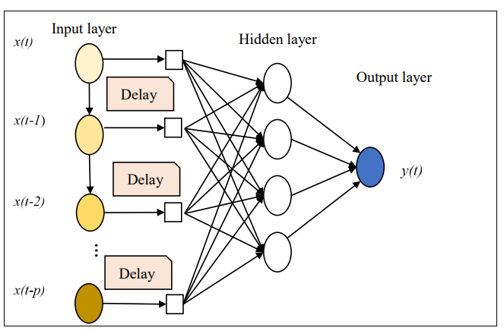

**Figure 1. Architecture of TDNN model**

Developing a TDNN model usually requires the utilization of both training and testing samples. Here, 80% of the weekly prices of black pepper (data) is used as training set and rest 20% is used as the testing set. An accurate TDNN model is modeled using ‘nnetar’ package in R software.

1. **Long Short-Term Memory Model (LSTM)**

LSTM, a type of deep learning model, is widely used for time series forecasting due to its effectiveness in capturing long-term dependencies. Unlike other models such as feedforward control neural networks and Support Vector Machines, LSTM's feedback control network is beneficial as it maintains a memory state, allowing it to consider correlations in lagged values. The sequential data processing capability of RNNs, including LSTM, makes them especially useful for time series forecasting.

The primary limitation of traditional RNNs is the vanishing gradient problem, where the gradient diminishes and eventually approaches zero (Hochreiter *et*. *al*.). This issue is addressed by the LSTM network model, a specific type of RNN that incorporates memory and forget cells. LSTM is composed of read, write, and delete operations using different cells in the hidden layers enabled by the three gates: input gate, output gate and forget gate.

The LSTM model was implemented using the Python libraries Keras and TensorFlow. The dataset was split into 80% for training and 20% for testing. Prior to training, the data underwent normalization and differencing during preprocessing. The LSTM model consisted of three layers: input, hidden, and output, with a total of 126,452 parameters. These parameters were utilized for training the model, where predictions on the training data were made during the training process. A loss function calculated the error between these predictions and actual target values, with the goal of adjusting weights and biases to minimize this training loss.

The training process occurred over multiple epochs, each epoch involving an update of the model's weights based on the training data. The Mean Absolute Error (MAE) was employed as the measure to continue the epoch until it reached a minimum. Subsequently, the trained LSTM model was tested using the testing data. Forecast evaluation metrics, including Mean Absolute Percentage Error (MAPE) and Root Mean Square Error (RMSE), were computed for model assessment.

Determining hyperparameter values involved a search, testing various combinations, and selecting values that yielded optimal results for the final model. The chosen hyperparameters included those for the neuron input layer, sequence length determining LSTM memory duration, epoch count to address overfitting, neuron count for hidden and output layers, as well as the activation and optimization functions, as summarized in Table 1.

**Table 1. Values/Functions used for the parameters in the LSTM model**

|  |  |
| --- | --- |
| **Parameters** | **Chosen value/function** |
| Neurons input layer | 100 |
| Sequence length | 10 |
| Epochs | 50 |
| Neurons hidden layer | 100 |
| Neurons output layer | 1 |
| Activation Function | tanh |
| Optimization Function | adam |

**Diagnostics**

**Portmanteau test: Ljung-Box test**

It is crucial to carry out diagnostic checks to evaluate the suitability of the model and recommend any necessary revisions after the tentative model has been fitted to the data (Armstrong, 2009). Non-significance of autocorrelations of residuals can also be tested by using Portmanteau test. Ljung-Box $Q^{*}$ statistic is the commonly used Portmanteau test and is given by

$Q^{*}= n(n+2)\sum_{k=1}^{h}{\frac{1}{n-k}r_{k}^{2}}$

where $‘h’$ is the maximum lag being considered and ‘ $n$’ is the number of observations in the series. If the residuals are white noise, the statistic $Q^{*}$ has a chi-square ($χ^{2})$ distribution with $(h-m)$ degrees of freedom where ‘m’ is the number of parameters fitted in the model which has been fitted. The series is not white noise when $Q^{*}$ is greater than table value of chi-square at $(h-m)$ degrees of freedom.

**Forecast Accuracy Measures**

The best suitable model among SARIMA and TDNN models are evaluated using lowest MAPE and RMSE values, the forecast accuracy indicators (Prathima, 2018).

MAPE is given by,

$MAPE$ = $\frac{1}{n} \sum_{i=1}^{n}{\frac{|Y_{t }- \hat{Y_{t}}|}{Y_{t}}} *100$

Where,

$Y_{t}$– Actual price at time t

- Fitted price

- Number of observations

Root Mean Square Error (RMSE) is given by,

$RMSE =$ $\sqrt{\frac{1}{n}\sum_{i=1}^{n}{e_{t}^{2}}}$

Where,

${e_{t}=Y}_{t }- \hat{Y_{t}}$, $e_{t}$ is the difference between actual and fitted price

$n$-Number of observations

**RESULTS AND DISCUSSION**

1. **SARIMA Model**

The ARIMA model was then estimated after transforming the weekly price data of garbled black pepper in the Kochi market into a stationary series. The model selection was based on criteria such as minimum Mean Absolute Percentage Error (MAPE) and minimum Root Mean Square Error (RMSE). Through this evaluation, it was found that the model (2,1,2)(1,0,0)52 appropriately fitted the series for forecasting prices. The accuracy measures for this model are presented in Table 2, and the results indicate that (2,1,2)(1,0,0)52 outperforms other models as it satisfies the criteria of minimum MAPE and RMSE.

**Table 2. SARIMA(p,d,q)(P,D,Q)52 model**

|  |  |  |
| --- | --- | --- |
| **Model** | **MAPE** | **RMSE** |
| **SARIMA(2,1,2)(1,0,0)52** | **3.23** | **9.96** |

The SARIMA(2,1,2)(1,0,0)52 model equation is as follows:

(1−0.328*B*−0.639*B*2)(1-*B*)(1+0.025*B*52)yt=(1+0.238*B*+0.704*B2*)*ϵt*​

The plot of actual and fit values for weekly price of garbled black pepper using SARIMA(2,1,2)(1,0,0)52 model is given in Figure 2.

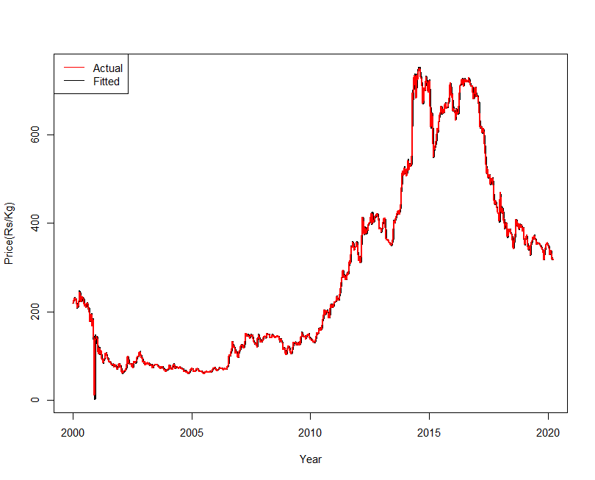

**Figure 2. Actual and fitted plot of SARIMA(2,1,2) (3,0,2)12  of weekly price of garbled black pepper**

The adequacy of the model was also tested using the value of Box-Pierce Q statistics and was found to be insignificant. So, overall we can say SARIMA(2,1,2)(1,0,0)52model show satisfactory result, among different ARIMA models.

**Table 3. Ljung-Box ‘Q’ statistic for residuals of SARIMA(2,1,2)(1,0,0)52 model**

|  |  |
| --- | --- |
| **Statistic** | **p-value** |
| **93.023** | **0.6502NS** |

**NS: Non-significant**

1. **TDNN Model**

Time delayed neural network (TDNN) model was fitted for weekly price of garbled black pepper.The best time lagged neural network with single hidden layer was found for each series by conducting experiments with the basic cross validation method. Out of a total of 112 neural network structures, a neural network model with thirteen lagged observations as input nodes and eight hidden layers (13:8s:1l) performed better than other competing models in respect of forecasting accuracy measures. This means that most accurate price forecast for the given series is obtained when the price of thirteen preceding weeks is used as inputs.

The selected TDNN model is described in Table 4 along with the forecasting accuracy measures for both training and testing set.

**Table 4. Model accuracy measures by TDNN model of weekly price of garbled**

**black pepper**

|  |  |  |  |  |  |
| --- | --- | --- | --- | --- | --- |
| **Model** | **No. of parameters** | **MAPE** | | **RMSE** | |
| **Train** | **Test** | **Train** | **Test** |
| 13:8s:1l | 121 | 3.95 | 1.99 | 8.49 | 6.78 |

The actual weekly price along with the predicted values of weekly price of garbled black pepper using TDNN model is provided in Figure 3.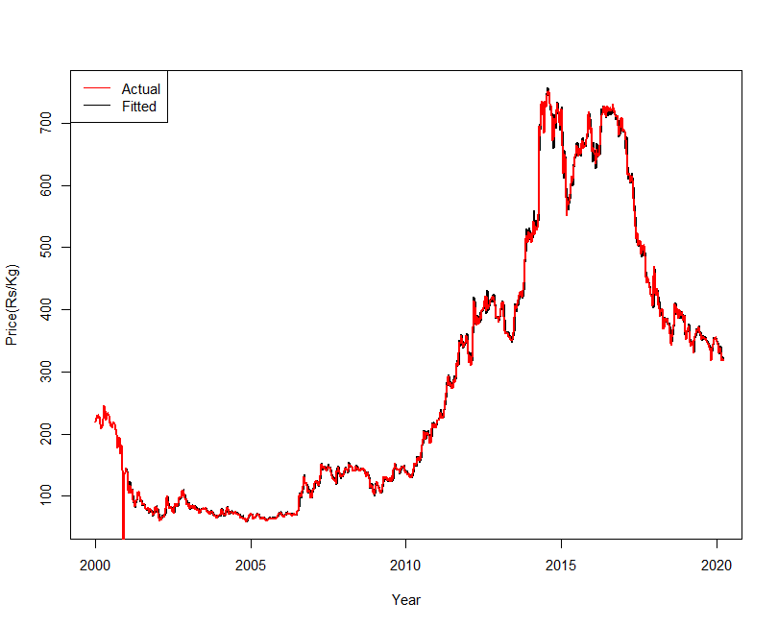

**Figure 3. Actual and fitted plots of TDNN model of weekly price of garbled**

**black pepper**

The adequacy of the model was also evaluated using the value of Ljung-Box ‘Q’ statisticand was found to be insignificant which is shown in Table 5. So, overall we can say TDNN model shows satisfactory result.

**Table 5. Ljung-Box ‘Q’ statistic for residuals of TDNN model**

|  |  |
| --- | --- |
| **Statistic** | **p-value** |
| **159.57** | **0.3783NS** |

**NS: Non-significant**

1. **LSTM Model**

LSTM model was fitted for weekly price of garbled black pepper. The parameters used for the model was provided in Table 1. The LSTM model has been created with three layers by performing epoch of 50 times. During the training process, the model makes predictions on the training data, and the loss function is used to calculate the error between these predictions and the actual target values. The training loss is the average of these errors across all training samples. The goal of training is to adjust the weights and biases of the model to minimize this training loss. After each epoch, the weights of the model get updated and the new epoch works on those updated values that process continues in every epoch. In this modelling, Mean Absolute Error (MAE) has been used as a measure to continue the epoch until MAE reaches to a minimum which is shown in Figure 4.

**Figure 4. Training loss for LSTM model of weekly price of garbled black**

**pepper**

Various accuracy measures for LSTM model are provided in Table 6.

**Table 6. Model accuracy measures by LSTM model of weekly price of garbled**

**black pepper**

|  |  |
| --- | --- |
| **Accuracy measure** | **Value** |
| RMSE | 16.36 |
| MAPE | 5.57 |

The actual price along with the predicted values of weekly price of garbled black pepper using LSTM model is provided in Figure 5.

**Figure 5. Actual and fitted plot of LSTM model of weekly price of garbled**

**black pepper**

The adequacy of the model was also tested using the value of Ljung-Box ‘Q’ statisticand wasfound to be insignificant which is shown in Table 7. So overall, we can say LSTM model shows a satisfactory result.

**Table 7. Ljung-Box ‘Q’ statistic for residuals of LSTM model**

|  |  |
| --- | --- |
| **Statistic** | **p-value** |
| **624.52** | **0.610NS** |

**NS: Non-significant**

**Comparison of models**

In present study, a comparison of different models has been done in order to know the best model for forecasting weekly price of garbled black pepper in Kochi market. According to the Table 8, the TDNN model with least MAPE and RMSE values was considered to be best among all the models considered.

**Table 8. Comparison of time series forecasting models for weekly price of**

**garbled black pepper**

|  |  |  |
| --- | --- | --- |
| **Model** | **MAPE** | **RMSE** |
| SARIMA(2,1,2)(1,0,0)52 | 3.23 | 9.96 |
| **TDNN(13:8s:1l)** | **1.99** | **6.78** |
| LSTM | 5.57 | 16.36 |

The plot of actual and fit values along with the forecasts for the weekly price of garbled black pepper using TDNN model is given in Figure 6. The figure showed that the actual and predicted prices are in agreement.

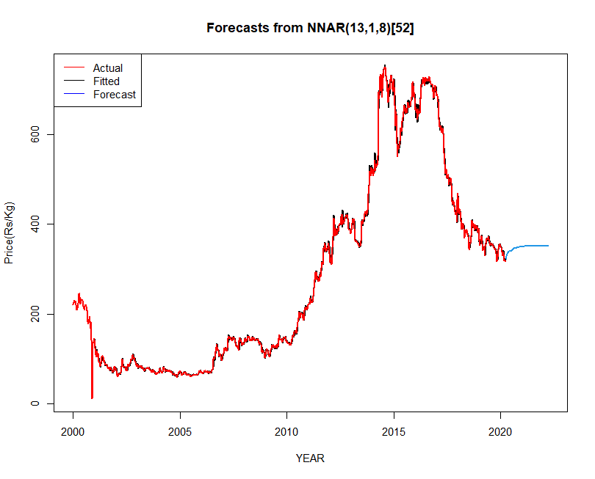The MAPE value are found to be 3.11 and 3.16 respectively based on the actual and forecasted weekly price of garbled black pepper using the TDNN model for the year 2021 and 2022.

**Figure 6. Actual, predicted and forecasted plot of TDNN model of weekly price of garbled black pepper**

The TDNN model captures the pattern of the weekly price of garbled black pepper. The MAPE value was 1.99. The LSTM model, being a type of recurrent neural network, would have been a better model if data points increase. It stands out in handling sequences by effectively remembering and utilizing information over longer data points through its unique gating mechanism. This makes LSTMs well-suited for tasks like predicting time series, where capturing complex patterns and dependencies in the data is crucial. As the dataset grows, LSTMs prove advantageous over simpler models in retaining context and making more accurate predictions by considering the relationships between past inputs. Thus, for weekly price of garbled black pepper price at Kochi market, TDNN model was selected as the best forecast model.

**CONCLUSIONS**

In this study, various time series models were employed to determine the most effective model for predicting prices of black pepper in the Kochi market. The forecasted prices were then compared with real-time prices, revealing that the TDNN model exhibited predictions that closely aligned with the actual weekly prices of processed black pepper. The forecasted values indicated an upward trend in prices in the coming months. Identifying the optimal forecasting model and achieving accurate predictions of market prices holds significant implications for farmers, consumers, wholesalers, and government decision-making. Short-term forecasting of future prices is particularly crucial for farmers in planning black pepper production throughout the seasons, considering resource availability and profitability compared to other crops. This enables strategic production planning to anticipate favourable prices in the near future, aiding informed decisions before planting and facilitating crop selection. With insight from forecasted prices, farmers can decide whether to sell their produce immediately or opt for storage post-harvest to secure a remunerative price.

**REFERENCES**

Armstrong, J.S. (2009). Selecting Forecasting Methods, *Principles of Forecasting : A Handbook for Researchers and Practitioners*, M.A: Kluwer Academic Publishers.

Gu, Y.H., Jin, D., Yin, H., Zheng, R., Piao, X., Yoo, & S.J. (2022). Forecasting Agricultural Commodity Prices Using Dual Input Attention LSTM. *Agriculture,* 12, 256.

Indiastat. (2023). Indiastat. home page [on-line]. Available: <https://www.indiastat.com>.[ 28 Nov. 2023].

International Pepper Community. (2023). International Pepper Community. Home page [on-line]. Available: <https://www.ipcnet.org/> [28 Nov.2023].

Jha, G.K., & Sinha, K. (2013). Agricultural Price Forecasting Using Neural Network Model: An Innovative Information Delivery System*. Agricultural Economics Research Review,* 26 (2), 229 – 239.

Haykin, S. (1999). *Artificial neural networks* (2nd ed.). Pearson Education.

Hochreiter, S., Schmidhuber. J..(1997) Long short-term memory, *Neural computation*, 9

(8)1735–1780.

Makridakis, S., & Hibbon, M. (1979). Accuracy of forecasting : An empirical investigation. *Journal of the Royal Statistical Society*, 41(2), 97-145.

Mahto, A.K., Biswas, R., Ahmed, A. Short Term Forecasting of Agriculture Commodity Price by Using ARIMA: Based on Indian Market, pages 452{461. *Advances in Computing and Data Sciences*. ICACDS 2019. Springer, Singapore, 452-461.

Prathima, C.M. (2018). Statistical modelling of arrivals and prices of tender coconut in Maddur market. M.Sc. Thesis. University of Agricultural Sciences, Bengaluru, Karnataka.

Zhang, G., Patuwo, B. E., Hu, & M. Y. (1998). Forecasting with artificial neural networks: The state of the Art. *International Journal of Forecast*. 14: 35-62.