***Original Research Article***

**Development and Validation of the Assam Rural Livelihood and Farming Scale (ARLFS) for the Socio-Economic Assessment of Khuti System Dwellers, Assam**

**Abstract**

The present study outlines the development and validation of the Assam Rural Livelihood and Farming Scale (ARLFS), a socio-economic assessment tool tailored for Khuti system dwellers in Assam. The development process encompassed a systematic review of literature, expert consultations, and focus group discussions with the target community. Initially, 30 items representing vital domains such as livelihood security, access to basic services, technological and institutional linkages, and adaptive capacities were identified. Content validity was evaluated by a panel of 10 subject matter experts using Lawshe’s method, which led to the selection of 18 high-relevance items with Content Validity Ratios (CVR) ≥ 0.62. Items with lower CVR were either reconsidered or rejected. The scale’s overall validity was further affirmed through Scale-level Content Validity Index (S-CVI) scores, with S-CVI/UA = 0.875 and S-CVI/Ave = 0.9813, indicating strong expert agreement.The ARLFS follows an 8-point scoring system for each component, ranging from 0 (highest vulnerability) to 8 (most favorable condition). The cumulative score reflects a household’s overall socio-economic vulnerability. Face validity was ensured through expert reviews, and pilot testing on 20 Khuti households was conducted to examine the clarity, feasibility, and internal consistency of the scale. Cronbach’s alpha was computed to assess reliability, with a threshold of α ≥ 0.70 considered acceptable.Results demonstrate that the ARLFS is a valid and reliable tool for quantifying socio-economic and farming vulnerabilities among nomadic and semi-settled livestock communities in Assam. Its structured framework allows for nuanced evaluation of diverse livelihood dimensions and can support targeted interventions and evidence-based policymaking for marginalized farming populations.

**Keywords:** Khuti System, Rural livelihood, Livestock farming, Socio-Economic Assessment, Scale validation, Assam

**1. Introduction**

Livestock farming in India has historically been an integral part of rural livelihoods, grounded in traditional ecological knowledge and regionally adapted practices. In the north-eastern state of Assam, the tropical monsoon rainforest climate, with its abundant rainfall, fertile floodplains, and rich ecological diversity, has shaped a distinctive agricultural and pastoral landscape. This environment has nurtured diverse livestock production systems deeply embedded in the socio-cultural identity of rural communities (Amonge, 1993; Islam et al., 2017). Among these are intensive, semi-intensive, and extensive models, along with the uniquely Assamese Khuti system, a traditional open herding method involving seasonal migration, indigenous veterinary practices, and communal use of natural resources (Komor& Borah, 2015; Chetry and Kar, 2021; Gogoi et al., 2025). These systems rely on regionally adapted indigenous breeds such as Luit and Manah buffalo, Lakhimi cattle, Assam Hill goat, Bengal Goat, indigenous pigs, and Pati duck, which contribute substantially to both biodiversity and rural economies (Kadirvel et al., 2019; Sarmaet al., 2025).

However, these traditional systems are under growing pressure from environmental and socio-economic challenges. Climate-induced events such as recurrent floods, riverbank erosion, and seasonal variability threaten the stability of livestock production. Concurrently, livestock farmers—particularly nomadic and semi-nomadic Khuti dwellers—face limited access to veterinary care, formal education, land tenure security, infrastructure, legal identity, and institutional credit, which compound their vulnerability (Sheik Mohamed, 1999; Verma et al., 2019; Vyas, 2024).

Over the years, several socio-economic assessment tools have been developed and widely applied in India, including the **Kuppuswamy Scale** (Kuppuswamy, 1976), **BG Prasad Scale** (Prasad, 1961), **UdaiPareekh Scale** (Pareekh, 1964), Aggarwal’s scale (Aggarwal et al., 2005) and the **NFHS Wealth Index** (IIPS & ICF, 2021). While useful in their respective domains, these tools are often limited in scope—being primarily urban-centric, income-focused, or unable to reflect the complex, community-based dynamics of rural and nomadic livestock livelihoods.

To address this gap, the **Assam Rural Livelihood and Farming Scale (ARLFS)** was developed as a comprehensive, context-specific tool for assessing the socio-economic and environmental realities of livestock farming households, particularly those practicing Khuti-based, semi-intensive, and extensive herding systems. The following table briefly compares the ARLFS with other commonly used socio-economic scales to highlight its distinct relevance and utility:

List 1: **The table briefly compares the ARLFS with other commonly used socio-economic scales to highlight its distinct relevance and utility**

|  |  |  |  |  |  |  |
| --- | --- | --- | --- | --- | --- | --- |
| Scales | Target | Focus | Key Factors | Livestock/Farming | Strength | Limitation |
| ARLFS | Assam rural/ Khutilivestock keepers | Rural livelihoods, farming & livestock | Income, assets, education, environment | Yes | Tailored for rural livestock | Complex,requires detailed data collection |
| Kuppuswamy | Urban populations | Urban SES classification | Education, occupation, income | No | Simple, widely used | Urban only |
| BG Prasad | General rural & urban | Income-based SES | Income | No | Simple, income-focused | Needs regular updates |
| UdaiPareekh | Rural populations | Social & caste | Land, caste, occupation | No | Captures rural social structure | Less economic detail |
| NFHS Wealth Index | General population | Asset-based wealth classification | Household assets & amenities | No | Less biased by income reporting | Misses rural livelihood specifics |
| Aggarwal’s | General population | Education, occupation, income | Education, occupation, income | No | Combines multiple SES factors | No livestock/environment focus |

The comparison highlights that while many existing socio-economic scales provide useful frameworks for urban or general rural populations, the ARLFS is distinctively tailored to the specific livelihood realities of Assam’s rural nomadic livestock keepers, integrating environmental and livestock-related dimensions that are critical for targeted interventions in this context.

**2. Materials and Methods**

**2.1 Scale Development**

The ARLFS was developed through literature reviews, expert input, and focus group discussions with Khuti system stakeholders. An initial pool of 30 items was generated based on key socio-economic and farming-related components relevant to Khuti system dwellers in Assam. These components included livelihood security, access to resources and inputs, institutional linkage, adaptive capacity, technological integration, and additional socio-economic indicators tailored specifically to the local context.

**2.2 Content Validity**

Content validity was assessed by a panel of 10 subject matter experts, including agricultural scientists, rural development officers, and veterinary professionals. Each expert independently rated the items on a three-point scale: “Essential,” “Useful but not essential,” or “Not necessary.” The Content Validity Ratio (CVR) for each item was calculated using Lawshe’s formula to determine the necessity of the items. Items with a CVR value equal to or greater than the threshold for 10 experts were retained. The overall Scale-level Content Validity Index (S-CVI) was computed using both the Universal Agreement (S-CVI/UA) and the Average (S-CVI/Ave) methods.For N=10, the Lawshe critical value for CVR is approximately 0.62, meaning items with CVR ≥ 0.62 are retained. Following this evaluation, items that did not meet the CVR threshold or were deemed redundant were removed, resulting in a refined scale of 18 items from the initial 30-item pool. This ensured that the final scale retained only the most relevant and representative indicators for assessing the socio-economic and farming conditions of Khuti dwellers.

### ****Content Validity Ratio (CVR):****

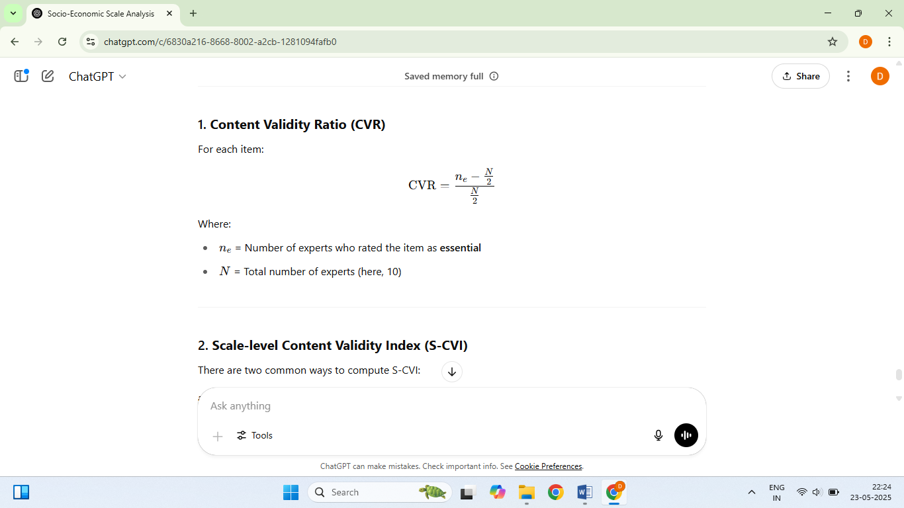For each item:

Where ne =Number of experts who rated the item as **essential**

**N=**Total number of experts (10)

### ****Scale-level Content Validity Index (S-CVI)****

There are two common ways to compute S-CVI:

#### Universal Agreement method (S-CVI/UA)

The proportion of items on the scale that achieved universal agreement (i.e., all experts rated them as essential or relevant)

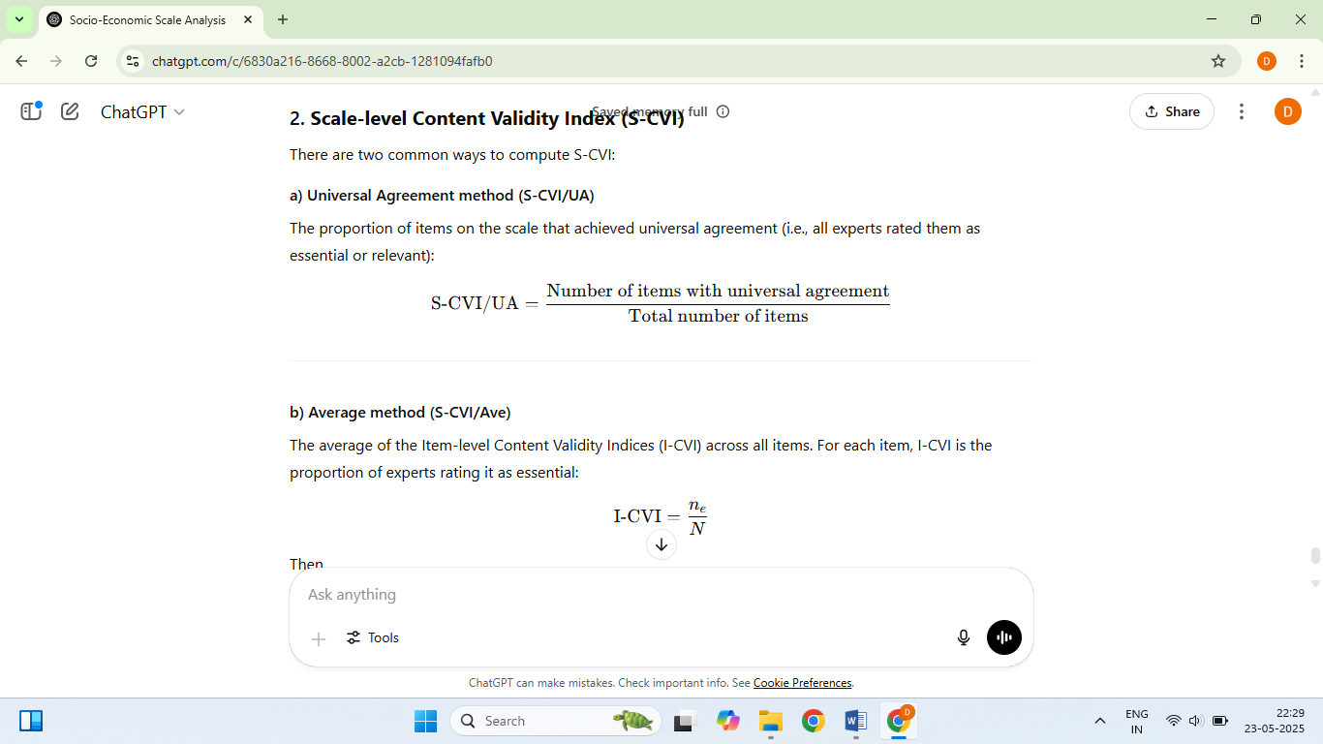

#### Average method (S-CVI/Ave)

The average of the Item-level Content Validity Indices (I-CVI) across all items. For each item, I-CVI is the proportion of experts rating it as essential

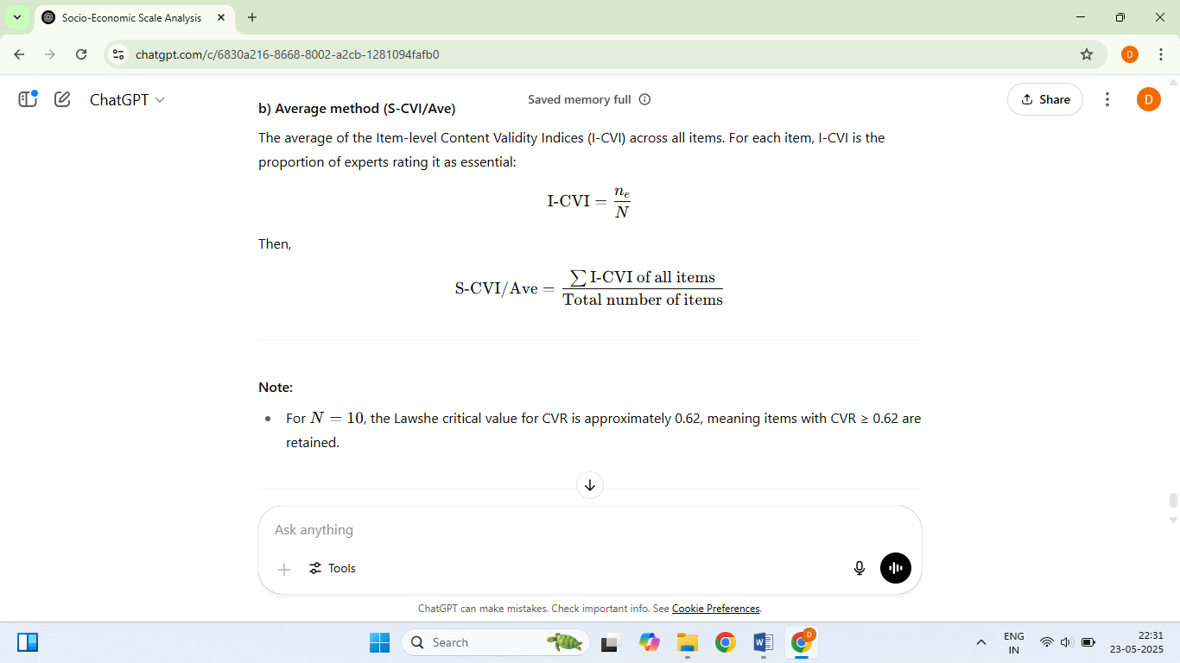



Then,

**2.3 Scoring pattern**

The ARLFS employs a structured scoring system where each component is rated on a 0–8 scale in even intervals (0, 2, 4, 6, 8), reflecting levels of vulnerability to well-being. A score of 0 indicates the most adverse condition or highest vulnerability, while a score of 8 represents optimal or most favorable status.

This evenly spaced scale was chosen for the following reasons:

* **Clarity and Consistency**: It allows consistent interpretation of socioeconomic status across all components and respondents.
* **Avoidance of Central Tendency Bias**: The absence of a neutral midpoint compels respondents or evaluators to make a definitive judgment.
* **Simplicity in Aggregation**: The scoring enables straightforward calculation of total scores and facilitates classification into socio-economic categories.
* **Suitability for Field Use**: The scale's simplicity enhances usability in rural settings and field data collection environments.
* **Compatibility with Statistical Validation**: The interval structure supports psychometric evaluations such as Content Validity Ratio (CVR) and Cronbach’s alpha for internal consistency.

The total score is derived by summing the scores across all components (maximum possible = 144). These scores are then categorized into four socio-economic status (SES) groups using equal intervals:

* Very Low (0–36)
* Low (37–72)
* Medium (73–108)
* High (109–144)

These thresholds provide a framework for consistent classification, although they may be adapted based on data distribution or specific analytical objectives.

**2.4 Face Validity**

Face validity was established through expert review to ensure the items appeared appropriate, relevant, and representative of the intended constructs. Subject matter experts evaluated whether the scale items were conceptually aligned with the domains of khuti livelihood and farming vulnerability.

**2.5 Pilot Testing and Reliability Analysis**

The draft ARLFS was pilot tested with 20 Khuti households in a non-sampling area, to assess clarity, feasibility, and respondent understanding. Based on feedback, items were refined for relevance and comprehension. Internal consistency was measured using **Cronbach’s alpha (α)** to evaluate the reliability of the overall scale and its sub-domains.

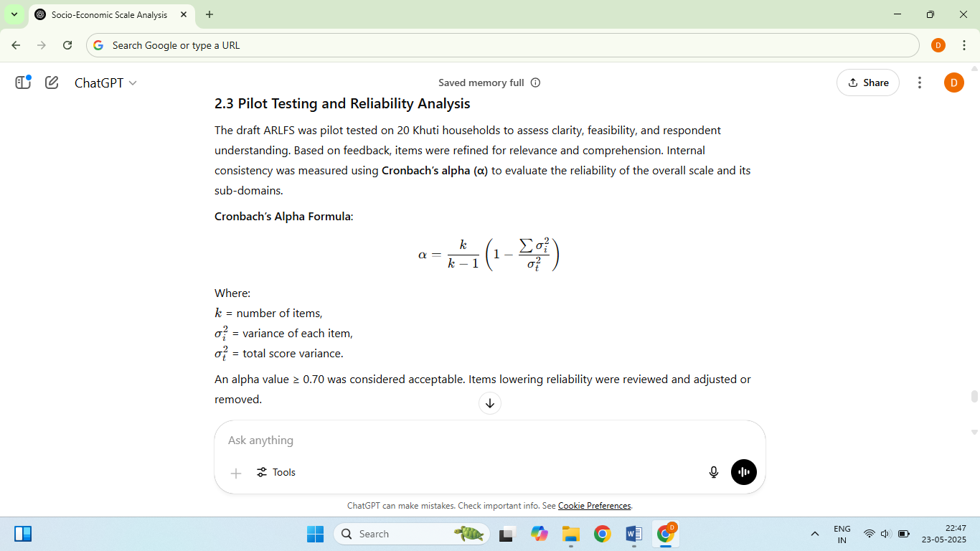**Cronbach’s Alpha Formula**:



According to standard psychometric guidelines

**• α ≥ 0.9 =** Excellent

**• 0.8 ≤ α < 0.9 =** Good

**• 0.7 ≤ α < 0.8 =** Acceptable

**• α< 0.7**= Questionable or Poor

Cronbach’s alpha values ≥ 0.70 were deemed acceptable based on established psychometric standards. Items lowering reliability were reviewed and adjusted or removed.

**2.6 Data Analysis**

All statistical analyses were performed using IBM SPSS Statistics version 25 (IBM Corp., Armonk, NY, USA) and Microsoft Excel 2019 (Microsoft Corp., Redmond, WA, USA).

**3. Results and Discussion**

**3.1 Content Validity Results**

Table 1: The Content Validity Ratios (CVR) for the 30 ARLFS components are presented below:

|  |  |  |  |  |  |
| --- | --- | --- | --- | --- | --- |
| Sl. No. | Component | Ne | N | CVR | Status |
| 1 | Household Demographic Composition | 10 | 10 | 1.00 | Accepted |
| 2 | Livelihood Security | 10 | 10 | 1.00 | Accepted |
| 3 | Food Security | 10 | 10 | 1.00 | Accepted |
| 4 | Psychosocial Well-being | 5 | 10 | 0.00 | Rejected |
| 5 | Type of Shelter | 10 | 10 | 1.00 | Accepted |
| 6 | Socio-Demographic Profile | 4 | 10 | -0.20 | Rejected |
| 7 | Access to Healthcare | 10 | 10 | 1.00 | Accepted |
| 8 | Education for Children | 8 | 10 | 0.60 | Reconsider |
| 9 | Child Nutrition & Health | 5 | 10 | 0.00 | Rejected |
| 10 | Adult Education & Skills | 6 | 10 | 0.20 | Rejected |
| 11 | Asset Ownership | 10 | 10 | 1.00 | Accepted |
| 12 | Social Integration | 10 | 10 | 1.00 | Accepted |
| 13 | Mobility Control & Autonomy | 9 | 10 | 0.80 | Accepted |
| 14 | Land Tenure & Eviction Risk | 10 | 10 | 1.00 | Accepted |
| 15 | Livestock Health & Productivity | 10 | 10 | 1.00 | Accepted |
| 16 | Environmental & Livelihood Vulnerability | 10 | 10 | 1.00 | Accepted |
| 17 | Psychological Stress & Coping Mechanisms | 6 | 10 | 0.20 | Rejected |
| 18 | Veterinary & Extension Service Accessibility | 10 | 10 | 1.00 | Accepted |
| 19 | Credit Facility Access | 10 | 10 | 1.00 | Accepted |
| 20 | Institutional Linkage | 10 | 10 | 1.00 | Accepted |
| 21 | Market Access & Price Realization | 10 | 10 | 1.00 | Accepted |
| 22 | Access to Communication Infrastructure | 6 | 10 | 0.20 | Rejected |
| 23 | Household Decision-Making & Gender Equity | 5 | 10 | 0.00 | Rejected |
| 24 | Savings & Financial Security | 5 | 10 | 0.00 | Rejected |
| 25 | Clean Water & Sanitation | 7 | 10 | 0.40 | Rejected |
| 26 | Energy Access | 5 | 10 | 0.00 | Rejected |
| 27 | Cultural Practices & Traditions | 5 | 10 | 0.00 | Rejected |
| 28 | Digital Connectivity & Information Access | 9 | 10 | 0.80 | Accepted |
| 29 | Legal Awareness & Rights Knowledge | 5 | 10 | 0.00 | Rejected |
| 30 | Transportation Access | 10 | 10 | 1.00 | Accepted |

Note: ‘Ne’ = Number of experts rating the item as essential; ‘N’ = Total number of experts

Based on the CVR analysis described in section 2.2, **18 components** met the minimum threshold (CVR ≥ 0.62) and were retained in the final version of the Assam Rural Livelihood & Farming Scale (ARLFS). One component (Education for Children) scored slightly below the threshold (CVR = 0.60) and was marked for reconsideration, while **11 items** with lower CVRs were excluded. The CVR values and retention status of all 30 components are summarized in **Table 1**.

The **overall S-CVI** results indicated strong content validity:

* **S-CVI/UA = 0.83** (83% of items had full expert agreement)
* **S-CVI/Ave = 0.956** (Average agreement across items was 95.6%)

These results demonstrate that the refined scale exhibits high content relevance and expert consensus, providing a robust foundation for subsequent testing and application. In similar line, Wei et al., (2025) highlighted that an S-CVI/Ave of 0.90 or above generally regarded as satisfactory for establishing content validity.

**3.2 Explanation of Scale Components and Scoring**

Each of the 18 retained components in the ARLFS is assigned a score based on specific criteria, with values ranging from 0 to 8. The detailed scoring criteria are provided in **Table 2** below.

**Table 2. Scoring Criteria for ARLFS Components**

|  |  |  |
| --- | --- | --- |
| **Sl No** | **Component** | **Scoring Criteria Description** |
| 1 | Household Demographic Composition | 0 = Only elderly person or single parent with many dependents; no working-age members; 2 = Mostly children and elderly; no active working adult; 4 = Mostly dependents one working adult; 6 = Multiple working members; some dependents remain; 8 = Well-balanced household with adequate workforce and dependents |
| 2 | Livelihood Security | 0 = No earnings; relies entirely on external support; 2 = Single source of income; irregular or unpredictable; 4 = One stable income; seasonal variation; 6 = Two income sources; somewhat stable; 8 = Multiple stable and diversified incomes |
| 3 | Food Security | 0 = No food security; 2 = Frequent food shortages; 4 = Seasonal food insecurity; 6 = Minor shortages occasionally; 8 = Full food security year-round |
| 4 | Type of Shelter | 0 = No permanent shelter; 2 = Temporary shelter (tent, thatch); 4 = Semi-permanent shelter (mud/brick); 6 = Permanent shelter, rented; 8 = Durable shelter with land tenure |
| 5 | Access to Healthcare | 0 = No access; 2 = Irregular, unqualified care; 4 = Some access to clinics; 6 = Regular access to basic healthcare; 8 = Regular affordable healthcare access |
| 6 | Education for Children | 0 = No schooling; 2 = Irregular or informal schooling; 4 = Primary education ongoing; 6 = Secondary education completed; 8 = Higher education or vocational training |
| 7 | Asset Ownership | 0 = No assets; 2 = One small asset; 4 = Few basic household assets; 6 = Productive assets (livestock/tools); 8 = Diversified productive assets |
| 8 | Social Integration | 0 = No interaction with community; socially excluded; 2 = Rarely interacts; not involved in any group/activity; 4 = Occasional interaction; minimal community participation; 6 = Regular interaction; part of local groups or activities; 8 = Active participation; strong social ties and community role |
| 9 | Mobility Control & Autonomy | 0 = Fully dependent; no control over movement of self or livestock; 2 = Movement of livestock and self is heavily restricted by family/community/authority; 4 = Limited control; sometimes needs permission; 6 = Mostly self-dependent; 8 = Full mobility autonomy |
| 10 | Land Tenure & Eviction Risk | 0 = No land tenure, high eviction risk; 2 = Temporary occupancy, no papers; 4 = Occupancy without secure rights; 6 = Possession with conditional security; 8 = Secure tenure, no eviction risk |
| 11 | Transportation Access | 0 = No transportation means; 2 = Limited, unreliable transportation access; 4 = Some access to public or private transport; 6 = Reliable transportation for household needs; 8 = Own vehicle(s) or frequent reliable transport |
| 12 | Livestock Health & Productivity | 0 = Poor health and productivity; 2 = Mostly weak, low production; 4 = Moderate health and output; 6 = Good health, regular productivity; 8 = Excellent health and productivity |
| 13 | Environmental & Livelihood Vulnerability | 0 = Highly vulnerable; 2 = Frequent disruptions; 4 = Occasional shocks; 6 = Mostly resilient; 8 = Resilient and adaptive |
| 14 | Veterinary & Extension Service Accessibility | 0 = No access; 2 = Rare emergency access; 4 = Some access to paravet/basic info; 6 = Regular field visits; 8 = Full and timely access |
| 15 | Credit Facility Access | 0 = No access; 2 = Informal lenders; 4 = Rare access through SHG; 6 = Periodic formal access; 8 = Easy credit access |
| 16 | Institutional Linkage | 0 = No linkage; 2 = Rare exposure; 4 = Occasional interaction; 6 = Regular interaction; 8 = Strong linkage with institutions |
| 17 | Market Access & Price Realization | 0 = No access or poor price realization; 2 = Limited access; 4 = Some access and price info; 6 = Good access with moderate price realization; 8 = Full market access and optimal price realization |
| 18 | Digital Connectivity & Information Access | 0 = No digital access or information; 2 = Rare/limited access; 4 = Occasional access; 6 = Regular access; 8 = Full, timely digital and information access |

**3.3 Reliability Analysis**

**Table 3. Reliability Analysis of ARLFS Components**

|  |  |  |  |
| --- | --- | --- | --- |
| Item No. | Item Description | Item-Total Correlation | Cronbach’s Alpha if Item Deleted |
| 1 | Household Demographic Composition | 0.71 | 0.864 |
| 2 | Livelihood Security | 0.65 | 0.869 |
| 3 | Food Security | 0.68 | 0.866 |
| 4 | Type of Shelter | 0.66 | 0.867 |
| 5 | Access to Healthcare | 0.70 | 0.865 |
| 6 | Education for Children | 0.63 | 0.870 |
| 7 | Asset Ownership | 0.67 | 0.868 |
| 8 | Social Integration | 0.61 | 0.872 |
| 9 | Mobility Control & Autonomy | 0.64 | 0.870 |
| 10 | Land Tenure & Eviction Risk | 0.69 | 0.866 |
| 11 | Transportation Access | 0.72 | 0.862 |
| 12 | Livestock Health & Productivity | 0.68 | 0.865 |
| 13 | Environmental & Livelihood Vulnerability | 0.70 | 0.864 |
| 14 | Veterinary & Extension Service Accessibility | 0.66 | 0.867 |
| 15 | Credit Facility Access | 0.67 | 0.868 |
| 16 | Institutional Linkage | 0.65 | 0.869 |
| 17 | Market Access & Price Realization | 0.69 | 0.865 |
| 18 | Digital Connectivity & Information Access | 0.72 | 0.862 |
|  | Overall Cronbach’s Alpha |  | 0.875 |

In table 3, internal consistency reliability of the Assam Rural Livelihood & Farming Scale (ARLFS) was assessed using Cronbach’s alpha (α), based on data collected during the pilot test with 20 Khuti households. As the post-feedback refinements were minor and did not alter the structure or intent of the items, re-administration of the scale was not deemed necessary for evaluating internal consistency. This approach contrasted with that of Satyapriya et al. (2015), who assessed reliability by administering their scale to 30 families and re-administering it after a 60-day interval to evaluate test–retest reliability. While their method offered insight into the temporal stability of responses, the present study focused on internal consistency to confirm the coherence of scale components at a single point in time. Both methods were valid, depending on the reliability dimension assessed.

**The results supported this approach**, with the reliability analysis showing strong internal consistency across the 18 items. Item-total correlations ranged from 0.61 to 0.72, all exceeding the acceptable threshold of 0.30. This indicates that every item contributed positively to the overall scale. Transportation Access and Digital Connectivity & Information Access showed the highest correlations (0.72), while Social Integration and Education for Children had slightly lower but acceptable values (0.61 and 0.63). Cronbach’s alpha if an item was deleted ranged from 0.862 to 0.872, close to the overall alpha of approximately 0.875, suggesting no item needed removal (Tavakol and Dennick, 2011). These findings confirmed that the ARLFS was a reliable and internally consistent tool for assessing the socio-economic and livelihood conditions of Khuti system dwellers in Assam.

**4. Conclusion, Limitation and Recommendation:**

The Assam Rural Livelihood & Farming Scale (ARLFS) has been successfully developed as a context-specific and reliable tool to assess the socio-economic and environmental conditions of livestock farming households, particularly those engaged in the traditional Khuti system. The scale incorporates multiple critical dimensions that capture the vulnerabilities and strengths of rural livestock farmers in Assam. Validation through expert consensus and pilot testing confirmed its clarity and internal consistency. The ARLFS provides a comprehensive framework that can support data-driven decision-making, inform policy, and guide targeted interventions aimed at improving livelihood security, adaptive capacity, and sustainability within Assam’s diverse livestock production systems.

Despite its strengths, the study has some limitations. The ARLFS was pilot tested on a relatively small sample size, which may limit the generalizability of results across different ecological and socio-cultural contexts within Assam. Certain components such as education for children, social integration, and environmental vulnerability scored just below the critical content validity threshold, indicating a need for further refinement. The reliance on self-reported data introduces potential bias and inaccuracies. Additionally, the cross-sectional nature of the study restricts the ability to capture temporal or seasonal variations in farming conditions. Important factors like psychosocial well-being and gender equity were excluded due to low validity scores, suggesting the need for separate focused assessments in the future.

To enhance the utility and applicability of the ARLFS, broader field testing with larger and more diverse samples across Assam’s regions is recommended. Components with borderline validity should be refined and re-evaluated to improve sensitivity and relevance. The scale should be integrated into routine monitoring and extension programs by government and NGOs to identify vulnerable households and tailor support accordingly. Developing complementary modules addressing psychosocial well-being, gender equity, and child nutrition would enrich future assessments. Capacity building for extension workers and community leaders on using the scale effectively can facilitate participatory appraisals and more precise interventions. Furthermore, policy measures should focus on improving access to veterinary services, education, land tenure security, and climate resilience programs, guided by insights derived from ARLFS assessments to strengthen rural livelihoods sustainably.

**COMPETING INTERESTS**

Authors have declared that no competing interests exist.

**DISCLAIMER (ARTIFICIAL INTELLIGENCE)**

Authors hereby declare that NO generative AI technologies such as Large Language Models (ChatGPT, COPILOT, etc) and text-to-image generators have been used during writing or editing of this manuscript.

**REFERENCE**

Aggarwal, O. P., Bhasin, S. K., Sharma, A. K., Chhabra, P., Aggarwal, K., & Rajoura, O. P. (2005). A new instrument (scale) for measuring the socioeconomic status of a family: Preliminary study. Indian Journal of Community Medicine, 30, 305–310.

Amonge, T. K. (1993). Aspects of productive and reproductive behaviours of swamp buffalo under ‘khuti’ system of management in Assam. Ph.D. thesis, Assam Agricultural University, Guwahati-22.

Chetry, K., & Kar, N. (2021). Khuti – A traditional Nepali dairy farming for rural livelihood in Lohit District of Arunachal Pradesh (India). Eco. Env. & Cons., 27(3), 1390–1398.

Gogoi, D., Borthakur, B., Borgohain, A., Shyam, J., & Borah, B. (2025). Demographic and economic status of Khuti dwellers in Assam. International Journal of Agriculture Extension and Social Development, 8(5), 123–128. <https://doi.org/10.33545/26180723.2025.v8.i5b.1867>

IIPS & ICF. (2021). National Family Health Survey (NFHS-5), 2019–21: India. International Institute for Population Sciences (IIPS) and ICF, Mumbai.

Islam, S., Alam, S., Kaur, G., & Gogoi, A. (2017). On-farm husbandry practices and phenotypic characteristics of indigenous Assamese buffaloes of India. Indian Journal of Animal Research, 52. <https://doi.org/10.18805/ijar.B-3358>

Kadirvel, G., Singh, L. A., Rahman, M., & Singh, N. M. (2019). Farm animal genetic resources in agro ecosystem of north east India. Indian Journal of Animal Sciences, 89(11), 1175–1183.

Komor, P., & Borah, J. (2015). Analysis of the traditional Nepali dairy farming (khutti) practice in Naukillo, Lower Dibang Valley, Arunachal Pradesh, India. The Clarion – International Multidisciplinary Journal, 4(2), 75–83.

Kuppuswamy, B. (1976). Manual of Socio-Economic Status Scale (Urban). Manasayan, Delhi.

Lawshe, C. H. (1975). A quantitative approach to content validity. Personnel Psychology, 28(4), 563–575. <https://doi.org/10.1111/j.1744-6570.1975.tb01393.x>

Pareekh, U. (1964). Manual of Socio-Economic Status Scale (Rural). Manasayan, New Delhi.

Prasad, B. G. (1961). Social classification of Indian families. Journal of the Indian Medical Association, 37, 250–251.

Sarma, O., Das, B., Phookan, A., & Gogoi, A. (2025). Animal genetic resources and biodiversity in the north-eastern state of Assam, India: An overview. Uttar Pradesh Journal of Zoology, 46(5), 140–152. <https://doi.org/10.56557/upjoz/2025/v46i54830>

Satyapriya, Chauhan, J., Sharma, P., Kumar, V., & Kumar, A. (2015). Development and standardization of a scale for livestock-based farming. Indian Research Journal of Extension Education, 15(2), 70–75.

Sheik-Mohamed, A., & Velema, J. P. (1999). Where health care has no access: The nomadic populations of sub-Saharan Africa. Tropical Medicine & International Health, 4(10), 695–707.

Tavakol, M., & Dennick, R. (2011). Making sense of Cronbach’s alpha. International Journal of Medical Education, 2, 53–55.

Verma, V. R., Gandhi, S., & Dash, U. (2019). Traversing the margins: Access to healthcare by Bakarwals in remote and conflict-prone Himalayan regions of Jammu and Kashmir. Pastoralism, 9, 2. <https://doi.org/10.1186/s13570-019-0137-9>

Vyas, A. (2024). Denotified and nomadic tribes in Rajasthan: Using citizen generated data to leave no one behind in achieving SDGs. <https://doi.org/10.13140/RG.2.2.13452.53120>

Wei, D., Alias, B. S., & Abdul Wahab, J. L. B. (2025). Content validation and content validity index calculation for teacher innovativeness instrument among Henan private universities in China. Communications on Applied Nonlinear Analysis, 32(10s), 175.