***Original Research Article***

**Population dynamics of gram pod borer (*Helicoverpa armigera* Hüb) on Birsa Chana-3 variety in Ranchi**

**Abstract**

The present investigation was carried out at the Pulses Research Plots of Birsa Agricultural University, Kanke, Ranchi. The trial was laid out during *Rabi* 2022-23 and 2023-24. The larval population was initially recorded in 49th standard week (1st week of December) (1.78 larva/plant) 2022-23 and (1.95 larva/plant) in 2023-24, with a peak in 8th standard week (4th week of February) (2.74 larva/plant). Mean larval population of *Helicoverpa armigera* on chickpea variety Birsa Chana -3 was found positively correlated with maximum temperature (0.459), minimum temperature (0.414), (0.026) and relative humidity (2 PM) (0.256), (0.492) in two consecutive year (2022-23) and (2023-24) whereas, relative humidity (7 AM) shows negative and non-significant correlation (-0.118), (-0.301) 2022-23 and 2023-24 respectively. Correlation between rainfall and larval population was found positive and non-significant (0.121), (0.232). during *Rabi* 2022-23 and 2023-24 respectively.

**Keywords:** Population dynamics, gram pod borer, chickpea, temperature, relative humidity

**Introduction**

Chickpea (*Cicer arietinum L.*) is the most important pulse crop, which is commonly known as “Gram” or ‘Bengal gram, its, play an important role in food security, nutritional security, income security and environmental sustainability, besides of their nutritional value, it’s enhanced the fertility of soil in terms of yield of subsequent crops (Srivastava *et al.* 2010). India accounts for 75 per cent of the world chickpea production and consumption (Das *et al.,* 2017). Chickpea is a rich source of carbohydrates (60.7%), protein (21.5%), fat (6.0%) and contains essential nutrients such as niacin (B3), riboflavin (B2), pantothenic acid (B5) and vitamin C (Ahlawat and Om Prakash 1996; Jukanti *et al.,* 2012). India cultivated approximately 10.91 million hectares of chickpea with a productivity of 10.12 quintals per hectare. The total supply of chickpea was 101.65 lakh tonnes. India is the world's largest chickpea producer, contributing 75% of global production. Major producing states include Madhya Pradesh, Maharashtra, Rajasthan, Uttar Pradesh, Karnataka, and Gujarat. The production of chickpea in Jharkhand is 2.86 lakh tonnes with productivity 1,172 kg per ha which covered nearly 2.39 lakh hectares of area (DES 2022-23).

Even though India is the largest producer of chickpea, it still imports chickpea from other countries. Keeping in view, the ever-increasing demand for this legume crop; it is essential to increase the production and area under cultivation, at the same time minimizing the stress on this crop plant.

It is damaged by over 50 insect species in different parts of the world, of which the gram pod borer, *Helicoverpa armigera* (Hübner) (Noctuidae: Lepidoptera) is the most important biotic constraint. It is a polyphagous, multi-voltine and cosmopolitan pest and is reported to feed and breed on 182 species of host plants belonging to 47 families in India (Pawar, 1998).*Helicoverpa armigera* is known to be the key pest and most important limiting factor in the successful cultivation of chickpea (Lateef, 1985 and Reed *et al*., 1987) due to high reproduction rates, wide genetic diversity and an ability to withstand, metabolize and avoid toxic chemicals. A single larva can consume 30-40 pods in its life time (Taggar and Singh, 2012). Yield losses due to gram pod borer in chickpea may range from 70 to 95 percent (Prakash *et al*., 2007). Hence, an attempt has been made to investigate the incidence of pod borer infesting chickpea to the different meteorological parameters.

**Materials and Methods**

In order to study the population dynamics of *Helicoverpa armigera* on chickpea variety, Research was conducted at the Pulses Research Plots of Birsa Agricultural University, Kanke, Ranchi. The trial will be laid out during *Rabi* 2022-23 and 2023-24. The crop was sown on 17th November, 2022 and 2023. All the agronomic practices were followed except insecticidal application. The larval population was recorded on five randomly selected plants from each quadrate at weekly interval on standard week basis. Data on weather factor viz., atmospheric temperature (maximum and minimum), relative humidity (maximum and minimum) and total rainfall were obtained from Department of Agrometeorology and Environmental Science, BAU Ranchi. Data recorded on larval population and meteorological parameters were analysed statistically according to the method as described by (Pearson,1920).



Where,

rxy = Simple correlation coefficient

x = Variable, i.e. abiotic component.

(Maximum temperature, minimum temperature, relative humidity and total rainfall)

y = Variable, i.e. mean number of insect pests

n = Number of observations.

**Results and Discussion**

The data summarized in Table 1 and depicted in fig 1 indicated that the pest population of pod borer on Birsa Chana-3 ranged from 1.78 to 2.78 larvae per plant during the season. The larval population occurred on gram throughout the growth phase, being low at vegetative stage and high at pod development stage. The maximum and minimum larval population was recorded in 8th (2.78 larva/plant) (3rd week of February) standard week, The data recorded on population dynamics of *H. armigera* during *Rabi*, 2022-23 & *Rabi*, 2023-24 have been presented in Table- 1&2 (Fig.1, & Fig. 2). It is evident from the data that the pest activity started since initial infestation and continued till peak stages of the crop.

The larvae of *H. armigera* were noticed for the first time during 49th standard meteorological week (SMW) of *Rabi*, 2022-23 and 2023-24 at the maximum temperature of 31.6 0C & 27.8 0C, minimum temperature of 2.5 0C & 3.9 0C, relative humidity 67.2 & 68.3 per cent and there were no rains during *Rabi*, 2022-23 & *Rabi*, 2023-24. Over all mean larvae were recorded during first observation in 49th SMW were 0.24 & 0.39 larvae/ plant. Thereafter activity of *H*. *armigera* continued though in fluctuating number throughout crop season. In 49h SMW at the minimum temperature 11.8 0C & 14.1 0C, maximum temperature 29.0 0C &30.3 0C and relative humidity 67.4 & 71.2 per cent and no rainfall, respective larvae recorded was respectively recorded during 47th and 48th SMW during *Rabi*, 2022-23 and 2023-24.

The present investigation was conformity with that of Choudhary *et al.* (2024) conducted the population dynamics of *H. armigera* on chickpea. The incidence commenced from first and second week of December i.e. 49th and 50th SMW. Which, increased gradually and reached peak (6.4 and 5.2 larvae/ m row) in the third and second week of February (8th and 9th SMW).

Likewise, Shinde *et al*. (2013); Patidar *et al.* (2020); Bajya *et al.* (2022); Yadav *et al.* (2024); Kumawat *et al*. (2024) also noticed the incidence of *H. armigera* throughout the crop growth stages. The population appeared from second fortnight of November being minimum in second fortnight of December to first fortnight of January and peak during second fortnight of February to first fortnight of April depending on the climatic conditions.

Correlation between larval population and weather parameters *viz*., maximum temperature, minimum temperature, relative humidity (morning and evening) and rainfall has been given in Table- 3. It is manifest from data that larval population showed non-significant positive correlation with maximum temperature (0.459), minimum temperature (0.414) and relative humidity evening (0.256) and rainfall (0.121) while showed non-significant negative correlation in relative humidity morning and (-0.118) during *Rabi*, 2022-23. It is evident from data that larval population showed non-significant negative correlation with maximum temperature (-0.106), relative humidity morning (-0.301) and while minimum temperature (0.026), relative humidity evening (0.492) and rainfall (0.232) showed non- significant with positive correlation in *Rabi*, 2023-24.

The present findings are also in accordance with the larval population had positive significant correlation with maximum and minimum temperatures (r = 0.528 and 0.572; p<.05) while, non-significant negative correlation with morning and evening relative humidity (r = -0.278: p<.05, r = -0.314; p<.05) and non-significant positive correlation with rainfall during Rabi, 2022-23. Likewise, the population of *H. armigera* had significant positive correlation with maximum and minimum temperatures (r = 0.539 and 0.562; p<.05) and significant negative correlation with morning (r = -0.578; p<.05) relative humidity while, non-significant negative correlation with evening relative humidity and non-significant positive correlation with rainfall during Rabi, 2023-24 Bajya *et.al*., (2025). Patel (2015) who stated that the significant negative correlation between larval population of *H. armigera* and evaporation (-0.551) and non-significant effect was observed between larval population of *H. armigera* and maximum temperature, evening relative humidity. Alok *et al.* (2022) observed that the larval counts of *H. armigera* when correlated with abiotic parameters revealed a negative non-significant correlation with maximum and minimum temperatures; however, it showed a positive correlation with relative humidity in the morning which was non-significant; and with evening relative humidity, it was significant. Kumar *et al.* (2022) reported that larval incidence of *H. armigera* on chickpea was found positively correlated with maximum temperature, while minimum temperature and relative humidity showed negative and non-significant correlation. Correlation between rainfall and larval incidence was found negative and significant.

**Table 1: Seasonal incidence of *H. armigera* on chickpea (Birsa Chana-3) variety in relation to abiotic factors during *Rabi,* 2022-23**

|  |  |  |  |  |  |  |  |
| --- | --- | --- | --- | --- | --- | --- | --- |
|  |  |  | **Temperature(°C)** | | **R.H. (%)** | | |
| **SMW** | **Date** | **Mean**  **Larval Population** | **Temp.**  **(Max)** | **Temp. (Min.)** | **7.00 AM** | **2.00 P.M** | **Rainfall (mm)** |
| 49 | 04/12/2022 | 1.78 | 24.3 | 4.7 | 88 | 69 | 0 |
| 50 | 11/12/2022 | 1.60 | 25.4 | 6.7 | 86 | 69 | 0 |
| 51 | 18/12/2022 | 1.40 | 23.7 | 3.9 | 86 | 69 | 0 |
| 52 | 25/12/2022 | 1.23 | 25.6 | 7.0 | 87 | 69 | 0 |
| 1 | 01/01/2023 | 1.54 | 22.8 | 5.4 | 86 | 69 | 0 |
| 2 | 08/01/2023 | 1.32 | 20.4 | **2.5** | 85 | 69 | 0 |
| 3 | 15/01/2023 | 2.40 | 24.2 | 5.2 | 86 | 70 | 0 |
| 4 | 22/01/2023 | 1.06 | 27.8 | 12.6 | 87 | 70 | 0 |
| 5 | 29/01/2023 | 1.57 | 26.5 | 8.4 | 87 | 70 | 0 |
| 6 | 05/02/2023 | 1.61 | 26.8 | 8.7 | 86 | 70 | 0 |
| 7 | 12/02/2023 | 1.93 | 26.4 | 9.1 | 86 | 69 | 0 |
| 8 | 19/02/2023 | **2.71** | 29.3 | 14.1 | 86 | 70 | 0 |
| 9 | 26/02/2023 | 2.27 | **31.6** | 13.2 | 86 | 70 | 0 |
| 10 | 05/03/2023 | 1.94 | 31.3 | 13.6 | 86 | 68 | 2 |

**#SMW – Standard Meteorological Weeks**

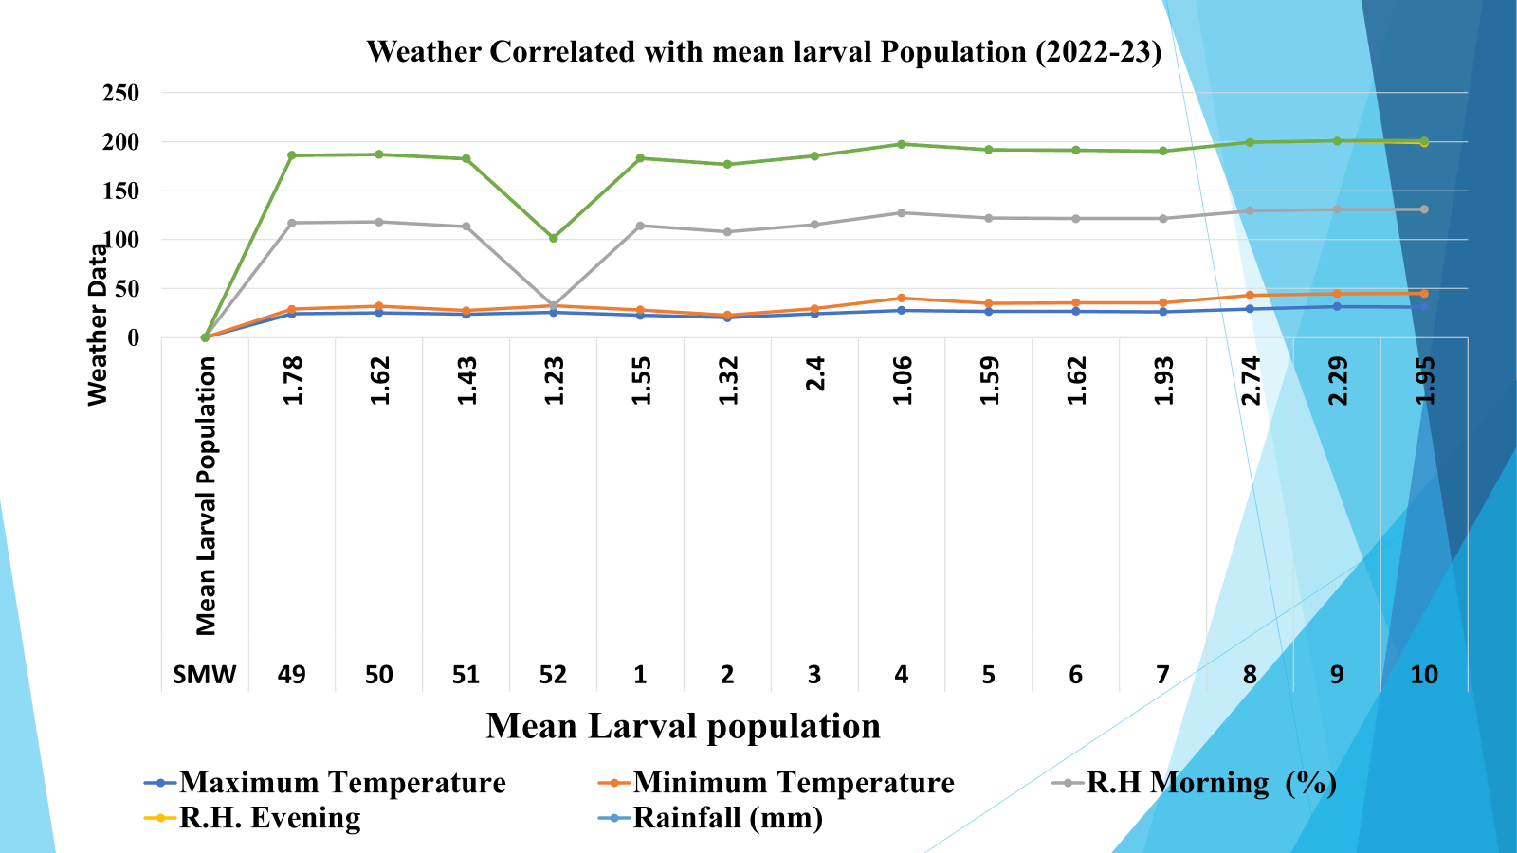

**Fig. 1. Population dynamics of *H. armigera* on chickpea in relation to abiotic factors during Rabi 2022-23.**

**Table 2: Seasonal incidence of *H. armigera* on chickpea (Birsa Chana-3) variety in relation to abiotic factors during *Rabi,* 2023-24**

|  |  |  |  |  |  |  |  |
| --- | --- | --- | --- | --- | --- | --- | --- |
|  |  |  | **Temperature(°C)** | | **R.H. (%)** | | |
| **SMW** | **Date** | **Mean**  **Larval Population** | **Temp.**  **(Max)** | **Temp. (Min.)** | **7.00 AM** | **2.00 P.M** | **Rainfall (mm)** |
| **49** | 4/12/2023 | 1.95 | 25.0 | 15.6 | 86 | 70 | 38.8 |
| **50** | 11/12/2023 | 1.12 | 22.5 | 5.9 | 85 | 70 | 0 |
| **51** | 18/12/2023 | 1.56 | 21.7 | **3.9** | 85 | 70 | 0 |
| **52** | 25/12/2023 | 1.50 | 24.0 | 4.9 | 85 | 70 | 0 |
| **1** | 01/01/2024 | 1.67 | 24.2 | 5.3 | 85 | 70 | 3 |
| **2** | 08/01/2024 | 0.00 | 23.6 | 5.1 | 88 | 69 | 0 |
| **3** | 15/01/2024 | 0.40 | 21.4 | 4.4 | 84 | 70 | 0 |
| **4** | 22/01/2024 | 0.00 | 21.6 | 4.0 | 86 | 69 | 0 |
| **5** | 29/01/2024 | 0 .00 | 25.6 | 8.8 | 86 | 70 | 10.4 |
| **6** | 05/02/2024 | 0.62 | 25.0 | 8.4 | 84 | 70 | 0 |
| **7** | 12/02/2024 | 0.72 | 26.0 | 11.6 | 86 | 70 | 30.6 |
| **8** | 19/02/2024 | 0.43 | **27.8** | 13.2 | 87 | 70 | 0 |
| **9** | 26/02/2024 | 0.21 | 25.9 | 13.6 | 85 | 70 | 20.6 |
| **10** | 04/03/2024 | 0.74 | 25.3 | 13.4 | 87 | 70 | 2 |

**#SMW – Standard Meteorological Meeks;**

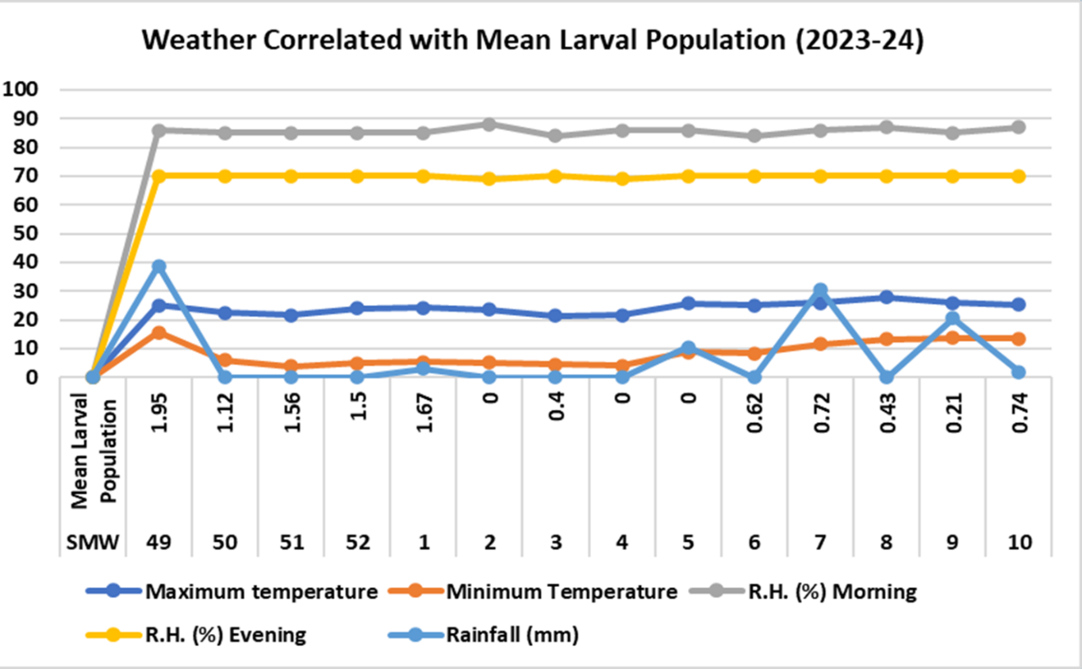

**Fig. 2. Population dynamics of *H. armigera* on chickpea in relation to abiotic factors during Rabi 2023-24.**

**Table 3: Correlation between Larval population of *H. armigera* (Hub.) and abiotic factors on chickpea during *Rabi*, 2022-23 and 2023-24**

|  |  |  |  |  |  |
| --- | --- | --- | --- | --- | --- |
| **Larval population** | **Temperature (ºC)** | | **R.H. (%)** | | **Rainfall (mm)** |
| **Maximum** | **Minimum** |
| **7 AM** | **2PM** |
| ***Rabi*, 2022-23** | 0.459 | 0.414 | -0.118 | 0.256 | 0.121 |
| ***Rabi*, 2023-24** | -0.106 | 0.026 | -0.301 | 0.492 | 0.232 |

**CONCLUSIONS**

The incidence of gram pod borer, *H. armigera* in chickpea study in early December, peaked in mid - February. Non-Significant positive correlations were observed between larval population and maximum and minimum temperatures and non-significant negative correlations were found with morning relative humidity in (2022-23) and (2023-24) respectively.

**References**

Ahlawat, I. P. S. and Prakash, O. M. (1996). Nutritional value of chickpea grains. Principles of agronomy and crops, pp. 43.

Alok N. K, Singh, S.K, Chandra, U. (2022) Population dynamics of gram pod borer*, Helicoverpa armigera* (Hübner) in relation to abiotic factors on chickpea. Journal of Experimental Zoology India **1**(1): 25.

Anonymous (2024). Agriculture Statistics. Reports of Directorate of Economics and Statistics, Department of Agriculture and Cooperation, Government of India, pp. 04.

Awasthi, A. K., Tiwari, R. B., Thakur, B. S., Shrivastava, D. K. and Chaure, N. K. (2003). Seasonal incidence of pod borer, *H. armigera* (Hub.) and yield losses in chickpea crop. Journal of Entomological Research, **19**, 249-253.

Bajya, R., Bairwa, D.K., Jat, B.L., Bana, J.K. Hussain, A., Sharma, S.L., Saini, L.S., Bajya, D.R., and Choudhary, S. (2025). Seasonal Incidence of *Helicoverpa armigera* (Hub.) on Chickpea in Relation to Abiotic Factors Semi-arid Region of Rajasthan Biological Forum- An International Journal, **17**(1): 64-68

Bajya, R., Patel, Y., Garg, V. K. and Kumar, N. (2022). Effect of Weather Factors on Population Dynamics of *Helicoverpa armigera* Hubner (Noctuidae: Lepidoptera) in Chickpea. Biological Forum - An International Journal, **14** (4a), 242-245.

Chatar, V. P., Raghvani, K. L., Joshi, M. D., Ghadge, S. M., Deshmukh, S. G. and Dalave, S. K. (2010). Population dynamics of pod borer, *H. armigera* (Hub.) infesting chickpea. International Journal of Plant Protection, **3** (1), 65-67.

Choudhary, S., Deshwal, H. L. and Bana, J. K. (2024). Population dynamics of pod borer *H. armigera* on chickpea. Indian Journal of Entomology, **10**, 55446.

Das, A., Datta, S., Thakur, S., Shukla, A., Chaturvedi, S. K., Kumar, P. A. and Singh, N. P. (2017). Expression of a chimeric gene encoding insecticidal crystal protein Cry1A abc of *Bacillus thuringiensis* in chickpea (*Cicer arietinum* L.) confers resistance to gram pod borer, *H. armigera* (Hub.). Frontiers in Plant Science, **8**, 1423.

Jukanti, A. K., Gaur, P. M., Gowda, C. L. L. and Chibbar, R. N. (2012). Nutritional quality and health benefits of chickpea (*Cicer arietinum* L.): a review. British Journal of Nutrition, 108, S11-S26.

Kumar P, Mishra D N, Singh D V, Singh R, Mishra P. 2022. Population fluctuation of pod borer, *Helicoverpa armigera* (Hübner) in relation with abiotic factors. The Pharma Innovation Journal **11**(6): 1471-1474.

Kumawat, S., Sharma, S. Kumari, H., Naga, B. L., Meena, R. K., Meena, S. K. and Arvind (2024). Population dynamics of *H. armigera* (Hubner) in chickpea. Indian Journal of Entomology, **10**, 55446

Lateef, S.S, Bhagat, V.R, Reed, W. (1985) Field screening of chickpea genotypes for resistance to *H. armigera*. International Chickpea Newsletter. **13**:29-32.

Malik, R., Kumar, R., Prasad, C. S. and Rana, R. (2015). Seasonal dynamics of *H. armigera* (Hub.) on chickpea and relative abundance of larval parasitoid *Campoletis chlorideae* in correlation with weather parameters. International Journal of Multidisciplinary Research and Advanced, **1**, 1-6.

Patel, S. R., Patel, K. G. and Ghetiya, L. V. (2015). Population dynamics of pod borer*, H. armigera* (Hub.) in relation to abiotic factors. An International e-Journal, **4**(2), 163-170.

Patidar, D., Nayak, M. K., Jaiswal, S. K., Patel, K. and Patel, K. (2020). Seasonal variation of *H. armigera* (Hub.) population and their correlation with weather parameters under agro-climatic condition of Tikamgarh district, Madhya Pradesh. International Archive of Applied Sciences and Technology, **11**, 53-56.

Pawar VM. (1998) Microbial control of *Helicoverpa armigera* sp. on pulses crops In: IPM System in Agriculture(Upadhyaya R.K., Mukarji K.G. and Rajak RL Eds.)New Delhi, India, Aditya books Private Ltd, 55-7811.

Pearson, K.1920. Notes on the history of correlation. Biometrika,13(1), 25-45. Reprinted in E.S. Pearson & Kendall (1970).

Prakash, M.R, Ram, U, Tariq, A. (2006) Evaluation of chickpea (*Cicer arietinum* L.) germplasm for the resistance to gram pod borer, *Helicoverpa armigera* Hubner (Lepidoptera: Noctuidae). Journal of Entomology Research. **31**:215-218.

Reed, W., Cardona, C., Sithanantham. S, Lateef, S.S. (1987) The chickpea insect pests and their control. In: Saxena MC and Singh, K. B (Eds.). The Chickpea. CAB International, Wallington, UK. 283-318

Shinde, Y. A., Veeda, O. P. and Patel, B. R. (2013). Observed the larval population of *H. armigera* (Hub.) during Rabi, 2009-10 and 2010-11. Current Biotica, **7 (**3), 222-227.

Srivastava SK, Sivaramane N, Mathur VC. (2010) Diagnosis of pulses performance of India. Agricultural Economics Research Review. **23** (1):137-148.

Taggar GK, Singh R. (2012) Integrated management of insect pests of rabi pulses. In: Arora R, Singh, B and Dhawan, A.K. (ed.) Theory and practice of Integrated pest management. Scientific Publishers, India.; 454-72.

Yadav, S. K., Singha, D. R., Umraoa, R. S., Yadav, A. and Yadav, V., Yadav, G. (2024). Studies on seasonal incidence of gram pod borer, *H. armigera* (Hub.) on chickpea crop. International Journal of Environment and Climate Change, **14** (3), 349-354.