Original Research Article

DEEP LEARNING FOR EMOTION RECOGNITION: FACIAL EXPRESSION ANALYSIS USING CNNS

Abstract

Facial expression recognition is crucial in computer vision, impacting human-computer interaction, emotion-aware AI, and mental health assessment. Deep learning, particularly with models like VGG16, has transformed this field by automating accurate emotion recognition without manual feature engineering. VGG16's hierarchical feature extraction captures complex facial patterns, offering better generalization across diverse datasets. This study highlights deep learning's role in enhancing facial expression recognition and suggests future advancements such as transfer learning, data augmentation, and lightweight architectures for real-time applications, leading to more efficient and adaptive emotion recognition systems.

Keywords- CNN, Emotion Recognition, Facial Expression, machine learning, deep learning

Introduction
Facial expressions play a crucial role in human communication, conveying vital nonverbal information that enhances verbal messages. Research suggests that 60–80% of communication is nonverbal [1], which includes facial expressions, eye contact, tone of voice, gestures, and physical distance. Facial emotion recognition (FER) has become a significant focus in human–computer interaction (HCI) across various fields such as education, healthcare, and surveillance. Emotions can be classified using categorical models (e.g., happiness, anger, sadness) or dimensional models (assessing valence and arousal). Recent advances in deep neural networks have led to a surge in FER studies, highlighting its importance in computer vision with numerous practical applications [2]. Convolutional neural networks (CNNs) excel in feature extraction, and the introduction of residual neural networks (ResNet) in 2015 helped mitigate the vanishing gradient problem in deep architectures. Various studies have adapted ResNet for emotion recognition by applying residual blocks to VGG CNNs, leading to better accuracy. For instance, Mao et al. developed POSTER V2, which enhances facial emotion recognition through a window-based cross-attention mechanism and multi-scale facial landmarks while reducing computational costs [3]. Recent research has combined multiple modalities—tempo, audio, and visual data—and employed attention mechanisms to boost performance [2]. Attention modules have proven effective in computer vision; for example, utilizing class activation mapping reveals critical features, particularly around the mouth and eyes for different emotions.
Despite the advantages, deploying facial recognition systems is challenging due to noise and complex environments. The study introduced a lightweight FER model using the squeeze-and-excitation module (SENet) with ResNet-18, comprising about 11.27 million parameters, compared to ResNet-50's 23 million. Evaluations were conducted on AfectNet and the Real-World Affective Faces Database (RAF-DB), with AfectNet providing greater diversity due to its larger image dataset [4]. A neural network was trained to extract emotional information from AfectNet and RAF-DB, achieving training accuracies of 79.08% and 76.51%, and validation accuracies of 56.54% and 65.67%, respectively. Transfer learning from AfectNet improved predictions on RAF-DB, showing promise for smaller datasets. The model detected key facial landmarks, with shallow layers capturing fine lines and deep layers focusing on the mouth and nose. Face detection is essential for facial emotion recognition (FER), which utilizes various strategies, including expression-based and feature-based approaches [5-6]. The facial expression recognition process can be represented in a three-stage flow map as given in Fig. 1.

Figure 1. Summary flowchart for the three phases of the Facial Expression Recognition (FER) method.
Classification
Happy
Sad
Surprise
Disgust
Angry
Neutral
Input face Image
Preprocessing
Fusion Feature Extraction
Database Face
Image
Preprocessing
Fusion Feature Extraction

Zi-Yu Huang et al. [12] explored the application of a deep neural network (DNN) for facial emotion recognition (FER) using a combination of convolutional neural networks (CNN), squeeze-and-excitation networks, and residual neural networks. They identified critical facial features for FER, focusing on areas around the nose and mouth. The study utilized AfectNet and the Real-World Affective Faces Database (RAF-DB) for training. The model trained on AfectNet achieved 77.37% accuracy on RAF-DB, while transfer learning improved this to 83.37%. The outcomes of this study would improve the understanding of neural networks and assist with improving computer vision accuracy. Lingzhao Ju et al. [13] addressed the challenges of posture and occlusion in understanding facial expressions, highlighting that traditional attention methods often fall short. They propose MAPNet, a mask-based attention parallel network. First, it uses key landmarks to create a binary mask for locating expression-related areas. Second, mask-based focus modules are integrated at different layers of the network to capture a comprehensive range of facial traits. Third, the identified features are segmented into independent blocks for expression prediction. Finally, the expression label is derived by merging predictions from the parallel network, along with a new loss function to handle unbalanced facial emotion distribution. The method is tested on three well-known real-world datasets. The results show that our MANPnet algorithm works better than the state-of-the-art methods used by RAFDB, AffectNet, and FEDRO [2].

In addition, Zahraa Aqeel Salih et al. [14] discussed the rapid growth of techniques and apps that alter facial images (FIM), particularly after the emergence of "DeepFakes." Researchers recognize the need for effective FIM detection methods. Current algorithms have limitations, often requiring prior knowledge of the manipulation technique used. This study introduces a new method called face image manipulation reveal (FIMR), which combines a face recognition algorithm with an image watermarking method in the transform domain. Unlike existing methods, FIMR does not need prior knowledge of the FIM technique and can detect various manipulations. Experiments demonstrate its efficacy across different facial image shapes. The results showed that the proposed system can find a wide range of manipulation methods, such as face swapping, expression swapping, attribute attacks, retouching attacks, and morphing attacks [9].

Materials and Methods
The proposed methodology employs a deep learning approach for facial emotion recognition using the VGG-16 model. It begins with dataset loading and pre-processing through an imageDatastore, ensuring class balance by splitting the dataset evenly before dividing it into 70% training and 30% testing sets. Images are resized for VGG-16 input, and greyscale images are converted to RGB. Augmented image data stores apply pre-processing techniques to enhance generalization. The pre-trained VGG-16 model is used for feature extraction, with the fully connected (fc8) layer fine-tuned for the number of emotion categories. The model is trained using back propagation to optimize accuracy (Fig. 2).

Fig. 2. proposed flow diagram
Input Image Data
Pre-Processing
Feature Selection
Training Dataset
Testing Dataset
Expression classification

During testing, images undergo the same pre-processing before classification. Performance evaluation utilizes a confusion matrix to measure accuracy, sensitivity, specificity, precision, recall, Jaccard coefficient, and Dice coefficient. Additionally, a user interface allows real-time emotion recognition, processing input images while visualizing the first convolution layer weights. Key contributions include leveraging transfer learning for efficient classification, ensuring dataset balance, implementing robust pre-processing, and enabling real-time recognition, making the system suitable for various applications in human-computer interaction and affective computing. The proposed system has an architecture consisting of various modules for processing input images and storing recognition results. The first module resizes and normalizes the images, converting them to grayscale before detecting faces. Next, detected faces are extracted from the image, and the module can also identify objects within the face area, transforming and resizing them. Finally, the feature extraction module creates facial representations.
A binary image is a digital image with only two pixel values, typically black (0) and white (1). Each pixel represents a single piece of information, conveying a specific pattern or structure. Similarly, a Grayscale images, or monochrome images, consist of pixels represented by a single intensity value ranging from 0 (black) to 255 (white) [10]. They lack color information and display only shades of gray, with each pixel's intensity indicating its brightness. In contrast, color images use the RGB model (red, green, blue), where each pixel has 24 bits. The RGB values convey both brightness and color, allowing for various data processing techniques. Further, Images (or picture in colour) are typically represented using the RGB model (red, green, blue), with each pixel containing 24 bits. Brightness and color information are interconnected and can be organized into groups by processing the RGB data through a mathematical function. Moreover, RGB (Red, Green, and Blue) images use the RGB color model to represent colors digitally. Each pixel consists of three color channels: red, green, and blue, with intensity values ranging from 0 to 255. A value of 0 means no intensity (black), while 255 indicates full brightness. For example, pure red is represented by (255, 0, 0), pure green by (0, 255, 0), and pure blue by (0, 0, 255). By adjusting the intensities of these channels, a wide spectrum of colors can be created (Fig 3a, b, c and d).
System Implementation
The system implementation includes:
(a) Input of Image
(b) Pre-processing
(c) Face Detection/ Expression Recognition
d) Performance Estimation
(a) Input of Image
The input to the system is a facial image, which can be captured using a camera or obtained from a dataset. The image may contain one or multiple faces.
(b) Pre-processing
In this stage, the input image is pre-processed to enhance quality for analysis. This includes resizing, normalization, denoising, and illumination adjustments to ensure consistency.
(c) Face Detection/ Expression Recognition
VGG is a deep CNN architecture used for image classification and feature extraction, particularly in FER automatically extracts hierarchical features from facial images through multiple convolution and pooling layers, capturing patterns like contours and textures. These features are then classified into emotions such as happiness, sadness, anger, surprise, and neutrality using fully connected layers and a Softmax classifier. Its deep structure allows for learning complex patterns effectively.
(d) Performance Estimation
To evaluate the performance of the system, the predicted expression labels are compared against the ground truth labels of a separate test dataset. Performance metrics such as accuracy, precision, recall, or F1 score can be used to measure the effectiveness of the facial expression recognition system. These metrics provide insights into the system's ability to correctly identify and classify facial expressions, etc. However, the facial expression recognition pipeline typically consists of several stages; these stages (input image, pre-processing, and expression recognition and performance estimation) were used along with DRLBP, expression recognition, using CNN, and performance estimation in this research.
Result and Discussion
The implementation of Facial Expression Recognition (FER) using VGG in MATLAB involves several key steps, including dataset pre-processing, feature selection , training, and classification. The results obtained from this approach are analyzed based on accuracy, sensitivity, specificity, and performance metrics.
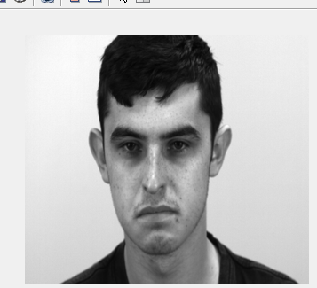
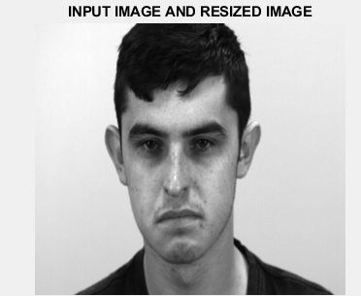
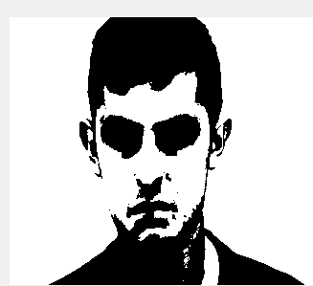
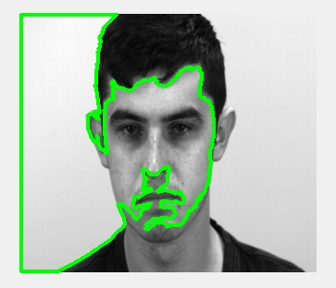
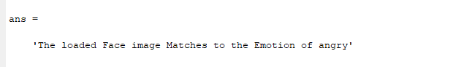
Fig.3. (a) Input image, (b) Pre-processing, (c) Gray scale image and (d) Face detection.

Fig. 4. expression classification

V PERFORMANCE EVOLUTION

When evaluating the performance of a facial expression recognition system, accuracy, sensitivity, and specificity are commonly used metrics. Here's a brief explanation of each metric:
True Positive (TP): TP represents the number of samples that are correctly classified as positive (correctly recognized expressions).
True Negative (TN): TN represents the number of samples that are correctly classified as negative (correctly rejected expressions).
False Positive (FP): FP represents the number of samples that are incorrectly classified as positive (expressions mistakenly recognized when they are negative).
False Negative (FN): FN represents the number of samples that are incorrectly classified as negative (expressions mistakenly rejected when they are positive).
Accuracy: Accuracy measures the overall correctness of the system's predictions by comparing them to the ground truth labels. It is calculated as the ratio of the number of correct predictions to the total number of predictions, expressed as a percentage. Accuracy provides an overall assessment of how well the system performs across all expression classes.
Accuracy = (Number of Correct Predictions / Total Number of Predictions) * 100
Sensitivity (Recall): Sensitivity, also known as recall or true positive rate, measures the system's ability to correctly identify positive instances (expressions) out of the total positive instances in the dataset. It is calculated as the ratio of true positive predictions to the sum of true positives and false negatives.
Sensitivity = (True Positives / (True Positives + False Negatives)) * 100
Sensitivity is particularly relevant in scenarios where correctly detecting positive instances is critical, such as identifying specific expressions associated with particular emotional states.
Specificity: Specificity measures the system's ability to correctly identify negative instances (non-expressions) out of the total negative instances in the dataset. It is calculated as the ratio of true negative predictions to the sum of true negatives and false positives.
Specificity = (True Negatives / (True Negatives + False Positives)) * 10
Specificity is important when accurately identifying non-expressions is crucial, such as distinguishing neutral or non-emotional states from specific expressions.
Table 1 Performance of Proposed Model
Model | Sensitivity (%) | Specificity (%) | Precision (%) | Recall(%) | Jaccard coefficient (%) | dice coefficient (%)
VGG16 | 95.45 | 94.69 | 94.69 | 94.69 | 98.48 | 99.23
Table 1 presents the performance metrics of the proposed model, VGG16, in terms of Sensitivity, Specificity, Precision, Recall, Jaccard Coefficient, and Dice Coefficient. The model achieves a high Sensitivity (95.45%) and Specificity (94.69%), indicating its ability to correctly classify positive and negative instances. The Precision and Recall values are both 94.69%, reflecting the model’s balance in identifying relevant instances. The Jaccard Coefficient (98.48%) and Dice Coefficient (99.23%) further confirm the model's effectiveness in segmenting and classifying data with high accuracy. However, the Table 2 compares the classification accuracy of the existing system (SVM) with the proposed VGG16-based system. The existing SVM-based system achieves an accuracy of 83.01%, whereas the proposed VGG16 model significantly improves accuracy to 95.45%. This comparison highlights the superiority of the proposed deep learning approach over traditional machine learning techniques in classification tasks (Fig. 5 and 6).
Table2 Accuracy Comparison with Existing Work
Systems | Classification technique | Accuracy (%)
Existing system | FER-former | 90.96
Proposed system | VGG 16 | 95.45

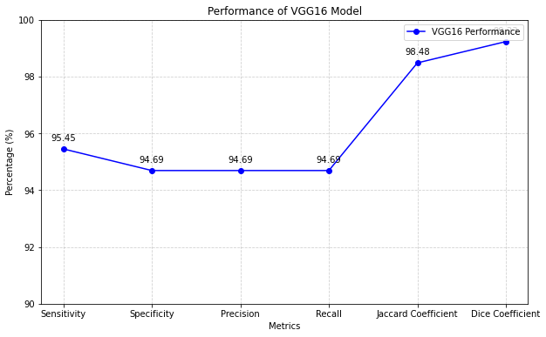
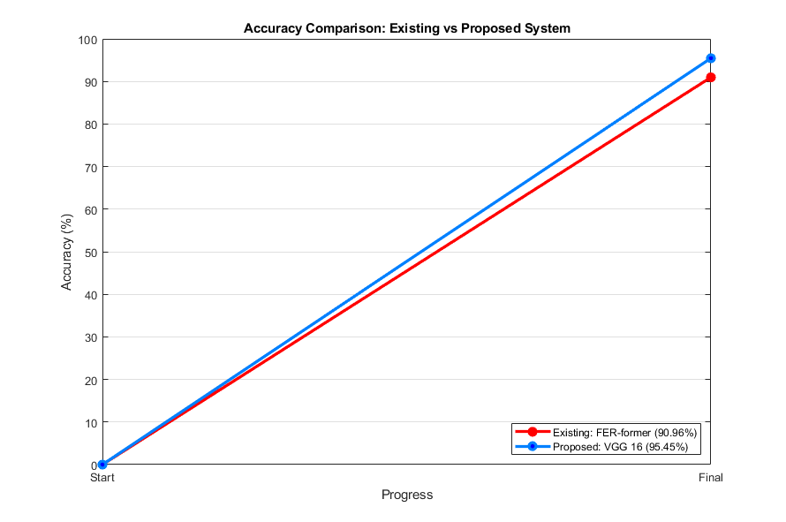
Fig. 5. Performance of Proposed Model

Fig. 6. Accuracy Comparison with Existing Work.

Conclusions
The study showcases the VGG16 model's effectiveness for facial expression recognition, achieving high accuracy (95.45%) and strong metrics like sensitivity, specificity, precision, and recall. Its Jaccard Coefficient (98.48%) and Dice Coefficient (99.23%) further affirm its robustness with minimal misclassification. VGG16’s deep hierarchical structure efficiently extracts intricate facial features, making it superior to traditional machine learning models that rely on handcrafted features. This capability positions deep learning as a promising approach for applications in human-computer interaction and emotion-aware AI systems. Future work may focus on optimizing VGG16 with transfer learning, data augmentation, and lightweight architectures for real-time use.
Conflict of Interest/ Competing Interests: Authors have no conflict of interest. The authors declare that they have no competing interests.
References
- Vo, T. H., Lee, G. S., Yang, H. J. & Kim, S. H. Pyramid with super resolution for in-the-wild facial expression recognition. IEEE Access 8, 131988–132001 (2020).
- Farzaneh, A. H. & Qi, X. Facial expression recognition in the wild via deep attentive center loss in 2021 IEEE winter conference on applications of computer vision (WACV) 2401–2410 (IEEE, 2021).
- Kumari, H. M. L. S. Facial expression recognition using convolution neural network along with data augmentation and transfer learning (2022).
- Maithri, M. et al. Automated emotion recognition: Current trends and future perspectives. Comput. Method Prog. Biomed. 215, 106646 (2022).
- Li, S. & Deng, W. Deep facial expression recognition: A survey. IEEE Trans. Afect. Comput. 13, 1195–1215 (2022).
- Canal, F. Z. et al. A survey on facial emotion recognition techniques: A state-of-the-art literature review. Inf. Sci. 582, 593–617 (2022)
- He, K., Zhang, X., Ren, S. & Sun, J. Deep residual learning for image recognition in 2016 IEEE conference on computer vision and pattern recognition (CVPR) 770–778 (IEEE, 2016).
- Mollahosseini, A., Hasani, B. & Mahoor, M. H. AfectNet: A database for facial expression, valence, and arousal computing in the wild. IEEE Trans. Affect. Comput. 10, 18–31 (2019).
- Schoneveld, L. & Othmani, A. Towards a general deep feature extractor for facial expression recognition in 2021 IEEE international conference on image processing (ICIP) 2339–2342 (IEEE, 2021).
- Rajan, V., Brutti, A. & Cavallaro, A. Is cross-attention preferable to self-attention for multi-modal emotion recognition? in ICASSP 2022–2022 IEEE international conference on acoustics, speech and signal processing (ICASSP) 4693–4697 (IEEE, 2022).
- Zhuang, X., Liu, F., Hou, J., Hao, J. & Cai, X. Transformer-based interactive multi-modal attention network for video sentiment detection. Neural Process. Lett. 54, 1943–1960 (2022)
- Zi-Yu Huang , Chia-Chin Chiang , Jian-Hao Chen ,Yi-Chian Chen, Hsin-Lung Chung, Yu-Ping Cai & Hsiu-Chuan Hsu A study on computer vision for facial emotion recognition Scientifc Reports | (2023) 13:8425
- Lingzhao Ju;Xu Zhao Mask-Based Attention Parallel Network for in-the-Wild Facial Expression Recognition ICASSP 2022 - 2022 IEEE International Conference on Acoustics, Speech and Signal Processing (ICASSP)Year: 2022
- Zahraa Aqeel Salih;Rasha Thabit;Khamis A. Zidan;Bee Ee Khoo A new face image manipulation reveal scheme based on face detection and image watermarking 2022 IEEE International Conference on Artificial Intelligence in Engineering and Technology (IICAIET) Year: 2022.

