***Original Research Article***

**ASSOCIATION BETWEEN PROFILE OF FARMERS AND THEIR VULNERABILITY TOWARD CLIMATE CHANGE IN SOUTH GUJARAT**

**ABSTRACT**

Climate change has emerged as one of the most persistent global challenges affecting the farmers in developing countries like India especially the small and marginal farmers whose primary source of livelihood is agriculture. They are most vulnerable to climate change due to their high dependence on natural resources, limited adaptive capacity, lack of access to modern technology, financial support and timely information. This study aims to assess the vulnerability of farmers due to climate change and their association with a focus on socio-economic, environmental and institutional factors. The present study was conducted in Navsari, Surat and Tapi districts of South Gujarat using ex-post facto research design. From each district, three talukas were selected and from each taluka two villages were selected. From each village 15 respondents were selected randomly comprising a total of 270 respondents. It was found that the majority of the farmers had medium to high level of vulnerability towards climate change. Age and farming experience had positively associated at five per cent level of significance while, extension contacts is positively and significantly associated with the vulnerability of farmers toward climate change relationship at one per cent level of significance. Annual income has negatively associated with the vulnerability of farmers toward climate change at five per cent level of significance whereas social participation and decision making ability is negatively associated with the vulnerability of farmers toward climate change at five per cent level of significance. Social participation, extension contacts and decision making ability were accounting about 15.10 per cent variation on the vulnerability of farmers toward climate change.

**Keywords:** Vulnerability, farmers, climate change, correlation, regression, arbitrary

1. **INTRODUCTION**

Climate refers to conditions of the [atmosphere](https://www.britannica.com/science/atmosphere) at a particular location over a long period of time – it includes patterns of temperature, precipitation (rain or snow), humidity, wind patterns and seasons (Krishnamurti and David, 2025). Climate change is affecting agriculture by inducing changes on farmers’ behaviour, quantity and quality, cost of production, changes in production, consumption, prices and trade patterns, fluctuations in market responses at global and local levels. These changes are not only depending on the domestic and global adaptive capacity but their economic impact also varies by region, sector and various stakeholder groups (Watson *et. al*., 1996). A decrease in the availability of water for irrigation is likely due to rainfall deficits caused by the intensity of droughts, reducing the amount of irrigated food production (Anon., 2002). Crop losses may raise due to increased climate variability, and this impact will be one of the deciding issues that manipulate future food security (Ranganathan *et al.*, 2010).

The developing countries, India may be most vulnerable to climate change due to its high reliance on natural resources mainly agriculture, inability to adapt financially and institutionally, low per capita GDP, extreme poverty and huge population. Temperature and rainfall are the most important crucial factors which affect plant development, growth and yield. So, any changes in the climate will adversely affect the productivity of the major crops through changes in the phenological process of the crop. Rawson (1995) reported that biomass and yield of major crops tend to decline with increasing temperature, as higher temperature shortens crop duration, enhances respiration and reduces time for radiation interception. The frequency of different climatic extreme events like drought, flood, cyclone, sea surge etc. tends to increase under changing climatic scenario. All these changes will affect our agricultural production negatively in long run. However, climate change not only affects agriculture but our faulty agriculture practices also contribute a lot to climate change. So, our farmers should have scientifically accurate information about the role of agriculture as a contributory factor to climate change and its potential to address the issue.

Gujarat, located in the dry and semi-arid region of India, is particularly vulnerable to these processes due to its dependence on monsoon precipitation, which is characterized by significant variability (Bhatla *et al.*, 2025). The Gujarat suffers from water scarcity every year, particularly during the summer (Bandyopadhyay, 2022). Coastal regions of Gujarat are particularly vulnerable to the impacts of climate change, including sea-level rise and increased coastal erosion.

Understanding the dimensions and drivers of farmers' vulnerability is critical for designing effective adaptation strategies and resilience-building interventions. The main aim of this study to understand the extent of vulnerability experienced by farmers due to climate change, identify the major contributing factors and provide insights into potential policy and extension interventions that can enhance the adaptive capacity of farming communities. With this background present study was conducted with following objectives;

**1.1 OBJECTIVES**

* To analyse the vulnerability of farmers due to climate change
* To study the association between profile of farmers and their vulnerability toward climate change

1. **METHODOLOGY**

The present study was conducted in South Gujarat region.The districts of South Gujarat region are Bharuch, Narmada, Surat, Tapi, Valsad, Navsari and The Dangs. Out of these districts, three district Navsari, Surat and Tapi were selected purposively. From each district, three talukas will be selected. From each taluka, two villages will be selected randomly. From each village, 15 farmers will be selected randomly. Thus, total 270 farmers will be selected for the present study. An *ex-post-facto* research design was used in the present investigation. The vulnerability of farmers due to climate change was measured with the help of structured interview schedule. The data was collected through personal interview method by farm and home visit. The collected data was classified, tabulated, analyzed and interpreted in order to make the findings meaningful. The statistical measures mean, frequency, percentage, standard deviation, range, arbitrary method, correlation and regression were used in the study by using IBM SPSS Version 29 and Python.

1. **RESULTS AND DISCUSSION**

**3.1 Vulnerability of farmers due to climate change**

Vulnerability was operationalized as the inability of individuals/households to cope up with or adapt to climate change induced stresses placed on their livelihood and well-being.

The data were collected from respondents and grouped into five categories *viz.,* as presented in table 1 and figure 1.

**Table 1: Distribution of farmers according to their level of vulnerability to climate change (n=270)**

|  |  |  |  |  |
| --- | --- | --- | --- | --- |
| **Sr. No.** | **Categories** | **Range** | **Frequency (f)** | **Percentage (%)** |
| 1 | Very low vulnerability | 30 to 54 | 29 | 10.74 |
| 2 | Low vulnerability | 54 to 78 | 27 | 10.00 |
| 3 | Medium vulnerability | 78 to 102 | 136 | 50.37 |
| 4 | High vulnerability | 102 to 126 | 60 | 22.22 |
| 5 | Very high vulnerability | 126 to 150 | 18 | 06.67 |
| Mean = SD = | | | | |

**Figure 1:** **Distribution of farmers according to their level of vulnerability to climate change**

The data presented in table 1 revealed that 50.37 per cent farmers had medium level of vulnerability followed by 22.22 per cent had high level, 10.74 per cent very low level, 10.00 per cent had low level and 06.67 per cent had very high level of vulnerability, respectively. Hence, it has been concluded that majority (72.22 %) of the farmers had medium to high level of vulnerability. The probable reason may be socio-economic constraints such as small landholdings, limited income sources, low access to formal credit and minimal asset ownership reduce their ability to cope with and recover from climate-induced stresses. This finding has been supported by the findings of Das (2021).

**3.2 Association between profile of farmers and their vulnerability toward climate change**

The association between vulnerability of farmers toward climate change and independents variables *viz.,* age, education, family size, farming experience, occupation, land holding, annual income, social participation, extension contacts, mass media exposure, innovativeness, information seeking behaviour, scientific orientation, risk orientation, economic orientation and decision making ability were worked out with the help of correlation coefficient (*r*) and data are presented in table 2 and figure 2.

**Table 2:** **Association between profile of farmers and their vulnerability toward climate change**

**(n=270)**

|  |  |  |
| --- | --- | --- |
| **Sr. No.** | **Independent variables** | **Correlation coefficient (*r*)** |
| 1. | Age | 0.133* |
| 2. | Education | -0.103NS |
| 3. | Family size | 0.010NS |
| 4. | Farming experience | 0.130* |
| 5. | Occupation | 0.104NS |
| 6. | Land holding | -0.114NS |
| 7. | Annual income | -0.130* |
| 8. | Social participation | -0.259** |
| 9. | Extension contacts | 0.230** |
| 10. | Mass media exposure | 0.034NS |
| 11. | Innovativeness | -0.046NS |
| 12. | Information seeking behaviour | -0.050NS |
| 13. | Scientific orientation | -0.025NS |
| 14. | Risk orientation | 0.109NS |
| 15. | Economic orientation | 0.040NS |
| 16. | Decision making ability | -0.200** |
| *Significance at 5 % ** Significance at 1 % NS= Non Significant | | |

The data presented in table 2 revealed that age had positive and significant relationship with vulnerability of farmers toward climate change at 5 per cent level of significance while, extension contacts positive and significant relationship with vulnerability of farmers toward climate change at 1 per cent level of significance. Education, land holding, innovativeness, information seeking behaviour and scientific orientation had negative and non-significant relationship with vulnerability of farmers toward climate change. Family, occupation, risk orientation and economic orientation had positive and non-significant relationship with vulnerability of farmers toward climate change. Annual income had negative and significant relationship with vulnerability of farmers toward climate change at 5 per cent level of significance. Decision making ability had negative and significant relationship with vulnerability of farmers toward climate change at 1 per cent level of significance. These findings are conformity with Das (2021), Shankara *et al*. (2023), Baisakhee (2024) and Shinde (2024). The correlation heatmap is represented below in the figure.2

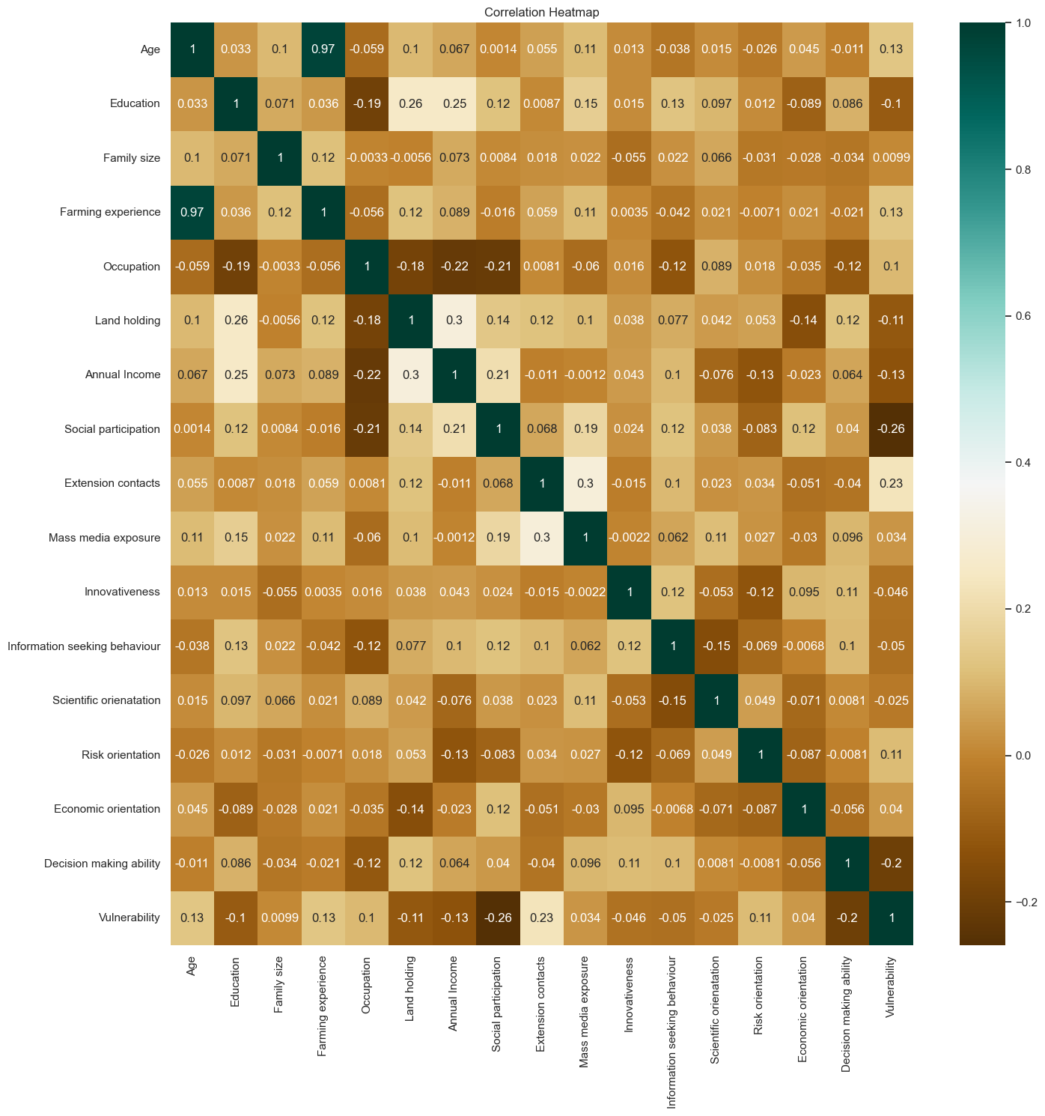

**Figure 2:** **Correlation heatmap of association of profile of farmers with their vulnerability towards climate change**

**3.3 Stepwise Regression Analysis of Independent Variables and Vulnerability towards climate change**

Stepwise multiple regression analysis was carried out with 16 independent variables and vulnerability towards climate change as dependent variable. The data are presented in table 3.

**Table 3: Stepwise multiple regression analysis of independent variables and vulnerability**

**(n=270)**

|  |  |  |  |  |  |
| --- | --- | --- | --- | --- | --- |
| **Sr. No.** | **Independent variable** | **Partial regression coefficient (b)** | **Standard error** | **Multiple Correlation Coefficient ‘R’** | **Adjusted R2** |
| 1. | (Constant) | 92.034 | 7.350 | 0.401 | 0.151 |
| 2. | Social participation (X8) | -6.439 | 1.351 |
| 3. | Extension contacts (X9) | 0.976 | 0.228 |
| 4. | Decision making ability (X16) | -0.809 | 0.254 |

As a result of stepwise regression analysis, the following model was obtained:

*Y2 = a +b8X8+ b9X9+ b16X16*

Where,

*Y2*= Resilience

*a* = the intercept i.e., -92.034

*bi* = Regression coefficient, *i* = 1,2,3…., n

*X8*=Social participation

*X9*= Extension contacts

*X16*= Decision making ability

Therefore, the fitted equation would be as under:

*Y2* = 92.034+ -6.439 *X8*+ 0.976 *X9* + -0.809 *X16*

The data presented in table 3 revealed that out of 16 independent variables, three variables namely social participation (-6.439), extension contacts (0.976) and decision making ability (-0.809) were significantly influencing on the vulnerability of farmers toward climate change. All the three independent variables together accounted 15.10 per cent variation as indicated by adjusted R2 value for vulnerability of farmers towards climate change.

**4.**  **CONCLUSION**

It can be concluded that majority of the farmers had medium to high level of vulnerability. Age and farming experience had positive and significant relationship with vulnerability of farmers toward climate change at five per cent level of significance while, extension contact has positive and significant relationship with vulnerability of farmers toward climate change at one per cent level of significance. Annual income had negative and significant relationship with vulnerability of farmers toward climate change at five per cent level of significance. Decision making ability and social participation had negative and significant relationship with vulnerability of farmers toward climate change at one per cent level of significance. Out of the 16 independent variables social participation, extension contacts and decision making ability were accounting about 15.10 per cent variation in the vulnerability of farmers toward climate change.

**DISCLAIMER (ARTIFICIAL INTELLIGENCE)**

Author(s) hereby declares that no generative AI technologies such as Large Language Models (ChatGPT, COPILOT, etc.) and text-to-image generators have been used during the writing or editing of this manuscript.

**REFERENCES**

Anonymous (2002). Farming system and best practices for drought-prone areas of Asia and the Pacific Region. Food and Agricultural Organisation of United Nations. Published by Central Research Institute for Dryland Agriculture, Hyderabad, India.

Baisakhee, S. (2024). Study on vulnerability and resilience among farmers in cyclone affected districts of odisha. *Ph.D*. *(Agri.) Thesis,* Acharya Narendra Deva University of Agriculture and Technology Kumarganj, Ayodhya.

Bandyopadhyay, N. (2022). Impact of climate change on water crisis in Gujarat (India). Ecology Footprints of Climate Change, 201-217.

Bhatla, R., Singh, R., Priyanka, Mall, R. K., & Bist, S. (2025). Does climate change induce desertification in Gujarat?. *Environmental Earth Sciences*, 84(12), 317.

Das, T. (2021). Revisiting the extension strategies to avert climate change vulnerabilities in agriculture for ensuring food security. *Thesis Ph. D. (Agri.).* Uttar Banga Krishi Vishwavidyalaya.

Krishnamurti, T. N. and David, B. E. (2025). <https://www.britannica.com/science/climate-meteorology>

Ranganathan C., Palanisami K., Kakumanu K. and Baulraj A. (2010). Mainstreaming the adaptations and reducing the vulnerability of the poor due to climate change. ADBI Working Paper 333. Tokyo: Asian Development Bank Institute.

Rawson, H.M., Gifford, R.M. and Condon, B.N. (1995). Temperature gradient chambers for research on global environment change. I. Portable chambers for research on short-stature vegetation. Plant cell environment, 18(9):1048-1054.

Shankara, M. H., Shivamurthy, M., Shivalingiah, Y. N., Sahana, S. and Padma, S. R. (2023). Vulnerability of farmers to climate change in Central Dry Zone of Karnataka. *International Journal of Environment and Climate Change,* **13** (7):183-88.

Shinde, S. S. (2024). Impact of Maharashtra Project on Climate Resilient Agriculture (PoCRA) as perceived by beneficiary farmers of Marathwada Region. *Thesis Ph. D. (Agri.);* Vasantrao Naik Marathwada Krishi Vidyapeeth, Parbhani.

Watson, R.T., Zinyoera, M. C. and Moss, R. H. (1996). Climate Change 1995: Impacts, Adaptations and Mitigation of Climate Change: Scientific-Technical Analysis.” Contribution of Working Group II to the Second Assessment Report of the Intergovernmental Panel on Climate Change. Cambridge: Cambridge University Press.